A Modified Galvanic Cell Synthesis of Pd@Pt Core-Shell Nanowire Catalysts: Structural Insights and Enhanced ORR Performance
Weijie Cao¹, Mukesh Kumar*¹, Neha Thakur¹, Tomoki Uchiyama¹, Yunfei Gao¹, Satoshi Tominaka², Akihiko Machida³, Toshiki Watanabe¹, Ryota Sato⁴, Toshiharu Teranishi⁴, Masashi Matsumoto⁵, Hideto Imai⁵, Yoshiharu Sakurai⁶, Yoshiharu Uchimoto¹

¹Graduate School of Human and Environmental Studies, Kyoto University, Yoshida Nihonmatsu-cho, Sakyo-ku, Kyoto 606-8501, Japan
²International Centre for Materials Nanoarchitectonics (MANA), National Institute for Materials Science (NIMS), 1-1 Namiki, Tsukuba, Ibaraki 305-0044, Japan
³Synchrotron Radiation Research Center, National Institutes for Quantum and Radiological Science and Technology, 1-1-1, Kouto, Sayo-cho, Sayo-gun, Hyogo 679-5148, Japan
⁴Institute for Chemical Research, Kyoto University, Uji, Kyoto 611-0011, Japan
⁵Fuel Cell Cutting-Edge Research Center Technology Research Association, Aomi, Koto, Tokyo, 135-0064 Japan
⁶Japan Synchrotron Radiation Research Institute (JASRI), Koto, Sayo, Hyogo, 679-5198, Japan

*Corresponding author: kumar.mukesh.5x@kyoto-u.ac.jp

Abstract
One-dimensional nanostructures, specifically Pd@Pt core-shell nanowire catalysts, have garnered significant attention because of their potential to enhance the sluggish kinetics of the oxygen reduction reaction (ORR). However, fully realizing their potential depends on achieving consistent and uniform synthesis. In this study, we introduce an improved galvanic synthesis method for Pd@Pt core-shell nanowire catalysts (Pd-NW@Pt/C) that eliminates the need for electrochemical control or reducing agents, making it more accessible and efficient than the traditional Cu underpotential deposition (Cu-UPD) method. Our approach ensures a uniform Pt shell, resulting in superior ORR activity, with a mass activity of 1.06 A mg_{Pt}⁻¹ and a specific activity of 0.80 mA cm_{Pt}⁻². Detailed operando X-ray absorption spectroscopy (XAS) measurements, including high-energy resolution fluorescence detection (HERFD-XAS), revealed that Pd-NW@Pt/C catalysts with a fully-covered Pt shell exhibit shorter Pt-Pt bond lengths and weaker oxygen binding energies compared to partially-covered Pt shell nanowire catalysts (Pd-NW@Pt/C-ref) and nanoparticle catalysts (Pd-NP@Pt/C), leading to significantly enhanced ORR activity. This study demonstrates the effectiveness of a modified galvanic cell method for producing high-performance Pd@Pt core-shell nanowire catalysts, offering insights into their structural and electronic properties.

Keywords: oxygen reduction reaction, Pd@Pt nanowire, core-shell, galvanic method, operando X-ray absorption spectroscopy, nanoparticle

Introduction
Reliance on non-renewable energy exacerbates global warming and pollution. Hydrogen energy, with water as its only byproduct, offers an efficient, carbon-free alternative.^{1, 2} Proton-exchange membrane fuel cells (PEMFCs) efficiently convert chemical energy into electricity, but their application is hindered by the slow kinetics of the oxygen reduction reaction (ORR) and the limitations of conventional Pt/C catalysts in terms of cost, performance, and durability.³⁻⁵ Therefore, the development of novel catalysts is crucial for overcoming these challenges.
Fine-tuning the catalyst surface structure optimizes the relationship between molecular adsorption energy and lattice strain, thereby improving catalytic efficiency. Core-shell structures, such as Metal@Pt, effectively introduce strain due to lattice mismatches between the core and shell, which enhances atomic utilization and exposes more active sites.^{6, 7} Among various Metal@Pt structures, Pd@Pt stands out for its distinctive ORR activities due to optimized compressive strain.^{8, 9} The Pd core exerts a compressive force on the Pt layer, producing a "ligand effect" that shifts the Pt d-band center, weakening interactions with oxygen species and thereby boosting ORR activity.^{10, 11} Thus, the moderate compressive strain of the Pt surface layer can be enhanced by modulating the Pd core, such as by changing its morphology, which further improves ORR activity.
One-dimensional (1D) nanowires (NWs) exhibit a high surface-area-to-volume ratio, increasing the availability of active sites for catalytic reactions.^{12, 13} Unlike zero-dimensional nanoparticles (NPs) that suffer from aggregation and Ostwald ripening, NWs maintain their structural integrity and surface area during reactions, providing more stable catalytic activity.¹⁴⁻¹⁶ And structural defects like grain boundaries (GBs), surface atomic steps (exposing high-index facets), and a few amorphous regions form during NW growth, enhancing catalytic activity by disrupting the interface water network, destabilizing ORR intermediates, and promoting proton transfer.¹⁷ Additionally, their relatively long length reduces dependency on carbon supports for NP dispersion and electron conduction, potentially mitigating support corrosion issues common in Pt/C catalysts.¹⁸
Therefore, combining the advantages of 1D NWs with the tunable properties of core-shell structures results in a superior catalyst with enhanced performance and stability. Both experimental¹⁹ and theoretical²⁰ evidence suggests that noble metal NWs, such as Pd NWs with 2–3 nm diameters, exhibit significant surface contraction, intensifying the strain on the Pt layer in the core-shell structure, thereby enhancing ORR activity. Adzic et al. pioneered a technique for carbon-supported Pd core Pt shell catalysts known as Pt@Pd/C.²¹ Their method involved the formation of a monolayer of Cu on the Pd core via Cu underpotential deposition (Cu-UPD), which was later replaced by a Pt monolayer shell. This approach was also adapted to produce Pd@Pt NWs, resulting in superior ORR performance.²² However, the highly precise potential control and limited yield of this method make it less suitable for widespread application. The characteristics of the metal core, such as particle size distribution, morphology, and surface structure, make potential control more challenging, easily resulting in an incomplete Pt shell layer.²³ This incomplete structure can lead to the clustering of surface Pt and dissolution of inner Pd, reducing ORR activity.^{24, 25} Yu et al. created Pd NWs using Te as a template, forming Pd@Pt core-shell NWs with specific thicknesses using bromide ions.²⁶ However, this intricate process still requires particular agents for reduction, stabilization, and temperature control.
Building on our previous research, the Cu-UPD/Pt displacement technique was improved to synthesize Pd@Pt core-shell nanoparticles.^{24, 27} In this method, carbon-supported Pd cores (Pd/C) were mixed in an acidic CuSO₄ solution with metallic Cu sheets. The interaction between Pd/C and metallic Cu establishes a Cu/Cu²⁺ equilibrium potential, initiating the Cu-UPD process, followed by Pt replacement. This efficient method eliminates the need for complex three-electrode systems and precise potential control, making the production of Pd@Pt catalysts with different morphologies and sizes more feasible, as well as increasing the yield.
In this study, a modified galvanic cell technique was used to produce Pd@Pt core-shell NW catalysts. Inductively coupled plasma atomic emission spectroscopy (ICP-AES), high-resolution transmission electron microscopy (HR-TEM), and energy-dispersive X-ray spectroscopy (EDS) mapping confirmed the fully-covered Pt shell in the galvanic cell-produced Pd-NW@Pt/C catalyst. This catalyst demonstrated enhanced catalytic performance compared to the partially-covered Pt shell layer in catalysts synthesized using the Cu-UPD method (Pd-NW@Pt/C-ref). Additionally, the advantages of the NW structure are also highlighted when compared to core-shell nanoparticles (Pd-NP@Pt/C) synthesized by the galvanic method. Further investigations using a pair distribution function (PDF) and X-ray diffraction (XRD) indicated that the catalyst consisted of fcc and hcp phases with compact lattice structures. The operando high-energy resolution fluorescence detection-X-ray absorption spectroscopy (HEARD-XAS) and conventional XAS provided insight into the behavior of the catalyst, emphasizing the Pt-Pt bond lengths and surface electronic properties. These findings revealed that the Pd-NW@Pt/C catalyst with a uniform Pt shell exhibits weaker oxygen binding energy and shorter Pt-Pt bond lengths, which enhance ORR activity and durability.
Experimental section
Materials and reagents
Palladium nitrate (Pd(NO₃)₂, 97.0%), Dodecyltrimethylammonium bromide (DTAB, 96.0%), Toluene (99.0%), Ethanol (99.5%), Sulfuric acid (H₂SO₄, 95.0%), Potassium tetrachloroplatinate (II) (K₂PtCl₄, 44.0%), 2-propanol (99.7%), Chloroform (99.0%) and Copper (II) sulfate pentahydrate (CuSO₄, 99.5%) were acquired from Fujifilm. Octadecylamine (ODA 99.0%) and Sodium borohydride (NaBH₄, 98.0%) were purchased from Sigma-Aldrich. The electrolyte was prepared from ultra-pure water (Milli-Q, 18.2 MΩ) and perchloric acid (ultra-pure, Kanto Chemical Co. Inc.). The Vulcan XC-72 was purchased from Cabot Corporation. O₂ (99.995%), N₂ (99.999%), H₂ (5%, 95% N₂ balanced) gases were purchased from Kyoto Teisan Co., Ltd.
A Pt/C catalyst (29.1 wt. %; TEC10V30E) was purchased from Tanaka Kikinzoku Kogyo Co. Ltd., Japan.
Synthesis of Pd-NW/C and Pd-NP/C
Pd NWs were synthesized using an improved phase-transfer method based on Teng et al.²⁸ Initially, 13 mg of Pd(NO₃)₂, 60 mg of DTAB, and 400 mg of ODA were added to a three-necked flask containing 7 mL of toluene. The mixture was sonicated for 20 min under a nitrogen atmosphere to achieve proper dispersion. Subsequently, 13 mg NaBH₄ dissolved in 2 mL deoxygenated deionized water was added dropwise to the mixture, which was allowed to react for 1 h. The reaction product was extracted with 2 mL each of water and chloroform, and the organic phase was collected. After dilution with 10 mL of ethanol, the mixture was centrifuged at 8000 rpm for 10 min to obtain a black precipitate. The precipitate was washed three times with ethanol and dispersed in chloroform for storage. Vulcan carbon (6 mg) was then added to the solution, followed by sonication for 30 min. The Pd-NW/C (~13wt% Pd) was obtained by centrifugation. To immobilize the Pd NWs on the carbon support and remove the residual organic matter, the Pd-NW/C powder was dispersed in hexane, soaked for 12 h, filtered, and dried at room temperature.
The synthesis process of Pd nanoparticle (Pd-NP/C: ~15wt% Pd) is similar to that of Pd NWs but does not require a nitrogen atmosphere.
Synthesis of Pd-NW@Pt/C and Pd-NP@Pt/C by Galvanic Cell method
A solution containing 0.01 M CuSO₄ and 0.5 M H₂SO₄ was subjected to nitrogen bubbling for 1 h, and then the Pd-NW/C or Pd-NP/C powder was dispersed in the above solution under vigorous magnetic stirring. The copper sheet was submerged in the above solution and stirred for a certain time (30 min to 5 h). Upon completion of the reaction, the copper sheet was removed, and N₂-saturated 10 mM K₂PtCl₄ solution was added to the suspension. The Pd-NW@Pt/C or Pd-NP@Pt/C catalyst was obtained after stirring for 10 min, followed by filtration and drying.
Synthesis of Pd-NW@Pt/C-ref by Cu-UPD method
Pd-NW@Pt/C-ref catalysts were synthesized using the Cu underpotential deposition (Cu-UPD) method in a standard three-electrode electrochemical cell. A reversible hydrogen electrode (RHE) with 5% H₂ was used as the reference electrode, a platinum mesh as the counter electrode, and a glassy carbon rotating disk electrode (GC RDE, 0.196 cm²) as the working electrode. The GC RDE was polished with alumina and rinsed with ultrapure water prior to use.
A catalyst ink was prepared by dispersing 2 mg of Pd-NW/C catalysts in a mixture of ultrapure water and 2-propanol (1:1 ratio, 2 mL total) along with 40 µL of Nafion® solution. The mixture was then sonicated for 30 min. Then, 10 µL of the ink was deposited onto the GC RDE, which was rotated at 400 rpm to ensure even coating.
For the Cu-UPD, the RDE was immersed in a nitrogen-saturated solution of 10 mM CuSO₄ and 0.5 M H₂SO₄. The electrode underwent five cycles of cyclic voltammetry (CV) within the potential range of 0.27 V to 0.72 V vs. RHE at 50 mV/s. The optimal potential for Cu deposition was maintained for 10 min to form a Cu monolayer on the Pd NWs. Following Cu deposition, the electrode was transferred to a nitrogen-saturated solution of 10 mM K₂PtCl₄ and 0.5 M H₂SO₄. The Cu monolayer was replaced with Pt via a galvanic displacement reaction that proceeded for 10 min.
Characterization
The X-ray diffraction (XRD) of the prepared catalysts was conducted at a scanning rate of 2° min⁻¹ with a step at 0.02° to analyze the structure of the catalysts with Cu Kα radiation (λ = 1.54056 Å) (Rigaku Ultima IV, Japan). Transmission electron microscopy (TEM) images were obtained using a JEM-2200FS microscope (JEOL, Ltd.) at 200 kV. A JEOL-JEM-ARM200F electron microscope was used for the high-resolution (HR) TEM analysis at 200 kV. EDX and EELS were performed using a JEOL-Dual SDD and Gatan-GIF Quantum-ER, respectively. Inductively coupled plasma (ICP) measurements were performed using an ICPE-9820 instrument (Shimadzu Corporation). X-ray photoelectron spectroscopy (XPS) was performed on a PHI Quantum 2000 system (ULVAC-PHI, Inc., Japan) using a monochromate Al Kα X-ray source operating at 40 W and 1486.6 eV. X-ray total scattering data were collected on a Varex Imaging XRD1621 ﬂat panel detector with a two-second exposure time and 150 integration time using synchrotron irradiation at BL22XU beamline of SPring-8. The optics, including the beam center coordinates, the tilt of the detector, and the sample-to-detector distance (225.7759 mm), were calibrated using the PIXIA program²⁹ for the image data obtained for CeO₂ (NIST, 674B; lattice constant, a = 5.41165 Å). The wavelength (λ = 0.181140 Å) was calibrated through the PDF fitting for the CeO₂ data using the PDFfit2 program.³⁰ The ex-situ XAS measurements of Pt L_{Ⅲ}-edge and Co K-edge were measured by synchrotron irradiation at beamlines BL36XU and BL14B2 of Spring-8. The operando XAS measurements of the Pt L_{Ⅲ}-edge were carried out at beamlines BL36XU and BL37XU; the detailed information for the RDE test was similar to our previous report⁴².^{31, 32} And the data analysis was carried out by ATHENA and ARTEMIS using the IFEFFIT program. ³³ The operando HERFD-XAS spectra for the Pt L_{Ⅲ}-edge were conducted at beamline BL39XU. The collected HERFD-XAS spectra were further fitted using an arrangement equation (eq 1) for the background and two pseudo-Voigt (Gaussian−Lorentzian, GL, product) equations (eq 2) for the peaks, as shown in the following:
$$\frac{A_{bg}}{π}\left[\tan^{-1}\left(\frac{E-E_{bg}}{∆E_{bg}}\right)+\frac{π}{2}\right] (1)$$
$$\frac{A_{n}}{1+4m_{n}\frac{{(E-E_{n})}^{2}}{∆E_{n}^{2}}}\exp\left[-4∙ln2∙\left(1-m_{n}\right)∙\frac{{\left(E-E_{n}\right)}^{2}}{∆E_{n}^{2}}\right] (2)$$
Here, $A_{bg}$ denotes the height for the arctan, which was adjusted to match the $μ_{E}$ within the range of 11568-11570 eV. $E_{bg}$ and $E_{n}$ were determined as previous research.³⁴ $m_{n}$ was set as 0.5.
Electrochemical testing
Preliminary cleaning involved 50 Cyclic voltammetry (CV) cycles from 0.02 to 1.20 V vs. RHE at 100 mV/s to remove residual organics. Final CV curves were recorded from 0.02 to 1.10 V vs. RHE at 50 mV/s in an N₂-saturated 0.1 M HClO₄ solution. Linear sweep voltammetry (LSV) was performed from 0.2 to 1.2 V vs. RHE at 10 mV/s with RDE rotation rates of 100, 400, 900, 1600, and 2500 rpm in an O₂-saturated 0.1 M HClO₄ solution. Specific activity (SA) at 0.9 V vs. RHE was calculated using the Koutecky-Levich equation. The oxygen coverage tests were performed by LSV (0.50, 0.60, 0.70, 0.80, 0.90, 1.00, and 1.10 V vs. RHE), with each potential maintained for 5 min. The oxygen coverage charge was determined by dividing the reduction peak area of the Pt oxide species by the H_{upd} area. Accelerated durability testing (ADT) involved cycling between 0.65 and 1.00 V vs. RHE for 3 seconds each. After 10,000 cycles, the LSV was recorded to evaluate the catalyst stability. CO-stripping voltammetry was conducted by exposing the working electrode to CO-saturated 0.1 M HClO₄ at 0.12 V vs. RHE for 20 seconds, followed by N₂ bubbling for 40 min. Stripping voltammetry was then performed from 0.05 to 1.00 V vs. RHE.
Result and discussion
Synthesis and characterization of Pd nanowires
The Pd-NW cores were synthesized using surfactant templates (ODA and DTAB). The growth mechanism of Pd NWs was investigated using TEM, HR-TEM, and HAADF-STEM. After adding an excess of the reducing agent NaBH₄, the Pd cation content rapidly decreased, as shown in Figure 1a. This results in the formation of thermodynamically unstable nanoparticles without complete NW structures. During the secondary growth of the particles, they preferred to grow along the equivalent and [111] direction due to the guiding effect of the long carbon chains of the surfactant.²⁸ Following the above process for 30 minutes, the generation of distinct NW structures could be more clearly observed (Figure 1b). After 1 h of reaction, a complete NWs network structure with an average diameter of 2.0 nm can be obtained and well-defined lattice plane with the d-spacing of the lattice fringes in the marked area was 0.23 nm and 0.19 nm in Figure 1c and Figure S1. As observed from Figure 1d and S1f, NWs formed by interconnecting small single-crystal particles or elongated primary nanostructures,^{12, 22, 35} resulting in a polycrystalline structure with amorphous regions, GBs, and surface steps, which induce structural micro-strain and regulate surface oxygen adsorption.^{17, 36}
Ensuring an inert gas reaction environment during secondary NW growth is crucial for stacking and joining nanoparticles at different angles, which generates defects. These defects are susceptible to oxygen and tend to absorb oxygen molecules, leading to oxidative etching. Upon exposing the reaction mixture to air, a continuous NW structure was not observed; instead, particles with a diameter of about 2-5 nm and a regular lattice structure were formed (Figure S2). Adzic et al. prepared Pd-Ni NWs to minimize the use of precious metals, demonstrating excellent electrochemical properties.³⁵ The same synthesis method was used to incorporate transition metals into Pd NWs, forming the NW structure shown in Figures S3-5. However, increasing the transition metal content complicates NW formation due to oxygen adsorption and etching.
XRD results were used to probe the crystal structure, as shown in Figure 1e, with no impurity peaks observed. The observed data were fitted to the curves simulated using the fcc model (Figure S6), but the results were less impressive than those of the fcc+hcp model, which demonstrates the formation of hexagonal Pd domains (~10%). The total scattering pattern indicates a lattice constant of a =3.960 Å in the fcc phase and a = 2.949 Å / c = 4.505 Å in the second hcp phase (Table S1). However, the Bragg reflections are relatively weak and broad in XRD, making it difficult to analyze the symmetry of the crystals and the analyzed results are less reliable.
The PDF technique, which provides the weighted probability of detecting any pair of atoms at a distance r, establishes the distribution of interatomic distances in real space and is a powerful tool for resolving material structures. According to the PDF analysis in Figure 1f, the observed data were also fitted with a curve simulated by an fcc+hcp Pd model with a shaped envelope for the NWs. The calculated lattice constants are a =3.958 Å in the fcc phase and a = 2.870 Å / c = 4.641 Å in the second hcp phase (Figure S6 and Table S1). This lattice constant in the fcc structures is larger than standard Pd crystals (a =3.89 Å). This may be attributed to the potential effects of the organic matter residues on the surfaces during the synthesis or formation of the hydride phases.
Synthesis and characterization of Pd-NW@Pt/C catalysts
A schematic representation of the synthesis of the core-shell structure catalysts using the galvanic cell method,²⁴ in accordance with our previous studies on Pd@Pt nanoparticles, is shown in Figure 2a and Figure S7. The process involved dispersing a certain amount of Pd-NW/C powder in a mixed solution of CuSO₄ and H₂SO₄, after which a Cu sheet was inserted and stirred continuously under a nitrogen atmosphere. This continuous stirring facilitated constant contact between the Pd particles and the Cu sheet, forming an electrochemical cell. Consequently, at the anode, the copper sheet dissolved to produce copper ions and generated a weak current (Cu to Cu²⁺), whereas, at the cathode, a layer of copper atoms was deposited on the surface of the Pd NWs to achieve electrochemical equilibrium (Cu²⁺ to Cu). The reaction was automatically stopped once a complete Cu monolayer structure formed on the metal surface. After a certain reaction time, the copper sheet was removed, and an N₂-saturated K₂PtCl₄ solution was introduced to obtain the Pd-NW@Pt/C catalysts. Compared to the conventional Cu-UPD approach (Figure S8), this method did not require any potential control throughout the synthesis process, and the amount of catalyst that could be synthesized was not limited. Moreover, owing to the generalization of Cu deposition and the characteristics of the replacement reactions, the galvanic cell method can be applied to synthesizing other Metal@Pt core-shell structures in addition to Pd metal, making large-scale generation possible.
The amount of Cu deposited on the Pd surface was controlled by regulating the stirring time, and after the PtCl₄²⁻ replacement, the Pt content in the obtained catalysts was determined by ICP measurements. As shown in Figure 2b, the Pt content increases linearly with increasing reaction time until reaching a stable monolayer structure after approximately 4-5 h of reaction, and a further increase in stirring time only leads to a slight increase in the Pt content. From this result, it can be concluded that once Cu forms a monolayer structure on the Pd surface, the subsequent deposition of the second layer is limited because of the lack of potential difference, preventing the formation of galvanic cells between the metals. Based on the theoretical calculations proposed by Abruña et al.,³⁷ approximating the nanowire structure as a column, it is inferred that the Pt content in PdPt is approximately 50 wt% when forming a monolayer Pt.
A similar trend can be seen in the CV curves in Figure 2c, where the Pd hydrogen adsorption peak located around ~0.02V vs. RHE decreases with increasing reaction time,³⁸ and a noticeable positive shift of the redox peak in the potential range of 0.6 to 0.8 V vs. RHE can be observed, representing a gradual shift of the redox potential from Pd (~0.7 V vs. RHE) to Pt (~0.8 V vs. RHE) after the generation of the core-shell structure. Comparing the ORR activities of Pt-NW@Pt/C catalysts at different reaction times (Figure S9) showed that catalysts with 4–5-hour reaction times had consistent and higher activity than those with shorter reaction times. This phenomenon also demonstrates the gradual formation of a complete Pt monolayer on the Pd surface.
Similarly, core-shell NW catalysts (Pd-NW@Pt/C-ref) were also synthesized using the conventional Cu-UPD method. By comparing the CV curves before and after the replacement reaction, the shift in the redox peak demonstrates the formation of a core-shell structure (Figure S10). Moreover, the obvious Pd hydrogen adsorption peak proves that the synthesized catalysts can encapsulate a layer of Pt atoms on the Pd surface, but not uniformly or fully covered. The mass ratio of Pt shells, calculated from the charge (Q) during the chronoamperogram of the corresponding Cu underpotential,⁸ is around 41%, which does not reach the theoretically calculated value for the formation of a complete core-shell structure (Figure S11). STEM-EDX results (Figure S12) also confirm the incomplete core-shell formation. This finding demonstrates that more precise potential control is required when synthesizing core-shell structures via Cu-UPD for catalysts with irregular surfaces, making it more challenging to form complete core-shell structures.
Figure 3a-c showed TEM and HR-TEM images of Pd-NW@Pt/C after five hours of reaction. The NW structure with a diameter of approximately 2–4 nm is uniformly distributed on the carbon support, and both the apparent surface step and GBs can be clearly observed. The core-shell structure and elemental distribution of Pd-NW@Pt/C were examined using STEM-EDX line profiling (Figure 3d and 3e). The results show that after the substitution reaction, Pt atoms were introduced into the NW structure, forming a complete Pt shell on the surface.
Figure S13a presents the Pd K-edge XANES of Pd-NW@Pt/C and Pd-NP@Pt/C. The absorption features were like those of the Pd foil, indicating the presence of metallic Pd. This observation agrees with the FT-EXAFS spectrum shown in Figure S13c. Two notable peaks between 2-3 Å are attributed to Pd-Pd/Pt bond pairs, while the radial peak near 1.3 Å is linked to the Pd-O signal.³⁹ Further fitting analysis shows that the Pd-Pd bond lengths of the Pd-NW@Pt/C and Pd-NP@Pt/C catalysts are 2.779 Å and 2.789 Å, respectively. The shorter bond lengths of NWs are attributed to their polycrystalline structure and structural defects, which produce local micro-strain that further tunes the adsorption of oxygen on the Pt surface.¹⁷
Figures S13b show the normalized Pt L_{Ⅲ}-edge XANES of Pd-NW@Pt/C, Pd-NP@Pt/C and Pt/C, respectively. The intensity of the white line revealed that all the catalysts were in the metallic state. Pt/C showed a higher white-line absorption peak, which was often linked to oxygen chemisorption on the surface. Furthermore, the significant difference between the two prominent peaks in the FT-EXAFS spectra can be attributed mainly to Pt-Pt/Pd bonds (Figures S13d).⁸ A comparison of Pt-Pt bond lengths shows that the Pd-NW@Pt/C and Pd-NP@Pt/C core-shell catalysts, with bond lengths of 2.726 Å and 2.732 Å respectively, are influenced by the ligand effect, leading to shorter distances than conventional Pt/C particles (2.750 Å). This bond contraction likely alters the d-band center, enhancing ORR activity and highlighting the advantages of the NW structure.⁴⁰
In the Pt 4f XPS spectrum (Figure S14), the Pt 4f_{7/2} peak of the Pd-NW@Pt/C catalyst shows a negative shift of ~0.10 eV. This observation indicates a charge transfer from Pd to Pt due to their different electronegativities, further supporting the formation of the Pt@Pd core-shell structure and electronic interactions.^{41, 42}
The XRD and PDF data of Pd-NW@Pt/C (Figure S15, Figure S16, Figure 3f and 3g) were also fitted with a curve simulated by fcc and hcp Pd mode. We calculated its lattice constant as a=3.893 Å by XRD and a=3.900 Å by PDF in the fcc phase from the total scattering patterns (Table S2). The core-shell structure exhibits a lattice similar to that of a standard Pd crystal (a=3.89 Å) and smaller than that of a Pt crystal (a=3.92 Å). The shrinkage of the lattice strain helps maintain a stable lattice structure, which can improve the stability and activity of the catalyst.³²
Electrochemical measurement
The electrocatalytic properties of the catalysts with core-shell NW structure were measured using the RDE method. Before the ORR measurements, the catalysts were subjected to 50 CV cycles to remove residual organic matter from the surface. Figure 4a shows the CV curves of the Pd-NW@Pt/C-ref, Pd-NW@Pt/C, and Pt/C catalysts obtained after cleaning; the redox peaks in the core-shell NW structured catalysts shifted to higher potentials compared to the Pt/C catalysts, indicating that they are less likely to oxidize and provide higher activity.⁸
To determine their ORR activity, LSVs were measured in oxygen-saturated 0.1 M HClO₄, as shown in Figure 4b and Figure S17-19. These results also indicate that the reaction follows a four-electron pathway, and there is a clear trend of a positive shift in the half-wave potential of the core-shell NW structured catalyst compared to Pt/C, confirming that this unique structure can significantly increase the ORR activity, which is further supported by its lower Tafel slope (Figure S20). Moreover, the core-shell structure can reduce Pt metal usage while improving the efficiency of Pt utilization. The results in Table S3 also show that the core-shell NW catalysts exhibited high electrochemically active surface areas of 132 and 113 m² g_{Pt}⁻¹ for the Pd-NW@Pt/C and Pd-NW@Pt/C-ref, respectively (ECSA normalized by Pt loading). The mass activity of Pd-NW@Pt/C is even as high as 1.06 A mg_{Pt}⁻¹.
To investigate the impact of surface Pt coverage on ORR activity, the catalysts synthesized by the two methods were fully compared. The Pd-NW@Pt/C synthesized by the galvanic cell method with a fully-covered Pt shell layer showed a higher specific activity (0.80 mA cm_{Pt}⁻²) compared to the Pd-NW@Pt/C-ref with an incomplete shell layer (0.55 mA cm_{Pt}⁻²) (Figure 4f). This result indicates that the complete coating of Pt significantly increases catalytic activity. The long-term durability of the core-shell NWs catalysts was further investigated by ADT, as shown in Figure 4c. After 10 K cycles, the Pd-NW@Pt/C exhibits a small negative shift of ~2.3 mV in the half-wave potential. In contrast, under the same test conditions, Pd-NW@Pt/C-ref exhibited more severe degradation, with a significant half-wave potential decrease of 18.6 mV after ADT tests. This could be due to insufficient protection of exposed Pd, leading to accelerated dissolution and promoting the formation of Pt clusters and holes as reported previously.^{25, 43}
Additionally, the developed Pd-NW@Pt/C catalyst demonstrated higher ORR activity and stability compared to the core-shell nanoparticle catalyst (Pd-NP@Pt/C) (Figure S21). The NW structure contains numerous GBs, ⁴⁴ leading to more surface atomic deformation and strain, which exposes more high-index facets, effectively enhancing ORR activity. ^{45, 46} Beside nanoparticles tend to aggregate and undergo Ostwald ripening during ADT, whereas nanowires preserve their structural integrity, leading to more stable catalytic activity.⁴⁷
The CO-stripping results (Figure 4d) show that the peaks of the core-shell NW- structured catalysts are significantly shifted to the left compared to those of the Pd-NW/C catalysts, indicating the formation of the Pt layer. The Pd-NW@Pt/C-ref catalyst exhibits a broad CO-stripping peak with a small peak near ~0.92 V vs. RHE, the same position as the CO-stripping peak of Pd-NW/C, indicating an incomplete core-shell structure. In contrast, the Pd-NW@Pt/C catalyst shows a significant negative shift, suggesting weaker binding energy with oxygenated species, which favors ORR.⁴⁸
Oxygen coverage plays an important role in determining the extent of oxide binding on the catalyst surfaces.⁴⁹ Analysis from Figure S22 and Figure 4e reveals the reduction current profiles of the three catalysts. As the polarization potential increases from 0.50 to 1.10 V vs. RHE, oxygen coverage also increases. At 0.8 V vs. RHE, Q_{O}/Q_{H} surpasses 0.0, signifying the inception of Pt-OH oxide on the catalyst surface, which involves a single electron transfer.⁵⁰ At 1.1 V vs. RHE, Q_{O}/Q_{H} goes beyond 1.0, indicating a shift from Pt-OH to Pt-O oxide, necessitating two electron transfers for each platinum site.⁴⁹ Due to active site occupancy, Pt no longer engages in the ORR process in this state. Lower oxygen coverage of Pd-NW@Pt/C compared with the other catalysts suggests that fewer oxygen species are adsorbed on the surface at high potentials, and the Pt-O binding energy was weaker. The increased oxygen coverage observed in the Pd-NW@Pt/C-ref catalyst is attributed to the involvement of both Pt and Pd atoms in the oxidation process. The incomplete core-shell structure exposes Pd atoms with stronger oxygen binding energy, leading to secondary adsorption as oxygen molecules diffuse into the inner Pd layer.^{51, 52} This result demonstrates that the incomplete core-shell structure promotes further oxidation and solubilization of Pt and Pd, thereby decreasing ORR activity.
Chemisorption observation from operando HERFD-XANES
To clarify the electronic states of Pt in the different catalysts during ORR, operando HERFD-XANES was employed. This approach outperforms traditional XAS in its ability to shorten the effective core-hole lifetime, particularly at the Pt L_{Ⅲ}-edge. By stimulating 2p electrons towards either a single resonance tied to 5d holes or the s and d continuum states, HERFD-XAS achieves a sharper clarity than conventional XAS.^{34, 53-56}
A notable peak broadening and positive shift in the Pt L_{Ⅲ}-edge white line intensity was observed with increasing polarization potential, especially in the Pt/C catalyst, due to Pt oxidation (Figure 5a and 5b and Figure S23). During 0.5 to 0.8 V vs. RHE, Pt showed hydroxyl (OH) adsorption,⁵⁷ as indicated by a slight shift in the peak and enhanced white line intensity. At potentials above 1.0 V vs. RHE, the Pt/C catalyst underwent a distinct oxidation process, eventually forming Pt-O bonds.⁵³ However, this change was not significant for Pd-NW@Pt/C, Pd-NW@Pt/C-ref, which suggests that the interaction between Pt and Pd in the core-shell structure reduces the binding energy of Pt with oxygen species, thereby inhibiting significant oxidation of Pt to PtO or PtO₂.
In the spectral analysis, the arctangent function and two pseudo-Voigt peaks were used to map the two prominent peaks representing the metallic and oxidized forms of Pt.³⁴ As illustrated in Figures S23, S24, Figure 5c, and 5d, it is evident that the Pt oxide component is amplified with an increase in the polarization potential. In contrast to nanoparticle catalysts like Pt/C and Pd-NP@Pt/C (Figure S23), the core-shell NWs catalyst inhibits this oxidation because of its unique structural defects, which can weaken oxygen adsorption energy. It is worth noting that although the Pd-NW@Pt/C-ref can limit the production of PtO_{X}, the high polarization potential still leads to its conversion, which may cause Pt corrosion and reduce catalyst efficiency.⁵⁸ Differently, the oxidation of Pd-NW@Pt/C was significantly lower than that of Pd-NW@Pt/C-ref. The antioxidant property is attributed to the homogeneous Pt shell, which effectively protects the internal Pd, slows surface agglomeration and dissolution, and consequently reduces the binding energy to oxygen.
Conventional operando XAS measurements
Figure S25 shows the normalized Pt L_{Ⅲ}-edge XANES of the four catalysts at different potentials (0.5 to 1.1 V vs. RHE) to investigate the surface Pt oxidation state. Changes in the Pt oxidation state is detected by variations in the white line intensity (ΔXANES). As shown in Figure 6c, the Pt L_{Ⅲ}-edge white line intensity peaks of both Pd-NW@Pt/C and Pd-NW@Pt/C-ref catalysts pronounced with increasing potential. The more complete Pt layer structure of Pd-NW@Pt/C exhibits a lower white line intensity, consistent with the HERFD-XANES results. This phenomenon was also observed in the results of Pt L_{Ⅱ}-edge XANES spectra (Figure S26). FT-EXAFS and fitting results for Pd-NW@Pt/C, Pd-NW@Pt/C-ref, and Pd-NP@Pt/C are shown in Figure S27, Figure 6a, and Figure 6b, respectively. As higher polarization potential is applied, the Pt-O signal increases while the Pt-Pt signal decreases. Additionally, the wavelet-transform EXAFS spectra (Figure S28) show the formation of Pt-O bonds at high potentials. However, Pd-NW@Pt/C showed smaller changes in the Pt-O regions than the other catalysts, suggesting lower binding energy with oxygenated species and less Pt-O bond formation on the Pt surface.
Pt–Pt bond lengths were obtained from the FT-EXAFS results to understand the local structures, which is an important factor that can respond to the d-band center and thus affect the ORR activity.²⁵ Figure 6d, Figure S29, Table S4, S5 and S6 show the results of fitting and detailed fitting information. The Pt–Pt bond lengths of Pd-NW@Pt/C at 0.5 V vs. RHE is 2.721 Å, which is shorter compared to Pd-NW@Pt/C-ref (2.730 Å) and Pd-NP@Pt/C (2.735 Å). The difference in Pt-Pt bond lengths between the Pd-NW@Pt/C and Pd-NW@Pt/C-ref catalysts is attributed to variations in their Pt layer structures. Pd-NW@Pt/C has a uniform and dense Pt layer, while Pd-NW@Pt/C-ref exhibits heterogeneous Pt deposits due to the uneven nanowire surface and less precise control over the UPD potential. As a result, the average Pt-Pt bond length is shorter in Pd-NW@Pt/C due to its more consistent coverage. With increasing potential, the Pt-Pt bond length gradually becomes longer due to the decrease of Pt-Pt coordination number and the formation of Pt-O,⁴⁹ which reaches 2.766 Å for Pd-NW@Pt/C-ref, 2.761 Å for Pd-NP@Pt/C and only 2.740 Å for Pd-NW@Pt/C at 1.1 V. The longer Pt-Pt bond length and increase in Pt-O coordination number indicate a rise in oxygenated species, which is detrimental to the ORR process.
Moreover, at 1.1 V, the Pt-Pd bond length of Pd-NW@Pt/C-ref increases significantly to 2.760 Å, indicating a tendency for some Pt atoms to detach from Pd and form surface clusters.²⁵ In contrast, the change in Pd-NW@Pt/C is small, with the bond length at 2.741 Å and the Pt-Pd coordination number remaining almost constant. Some research showed that the Pt layer can reorganize to form Pt clusters and holes, exposing internal Pd atoms to the electrolyte. During the ORR process, these internal Pd atoms are gradually etched, with some Pd ions reducing and depositing on the carbon support. This results in a loss of core-shell structural dominance and a decrease in ORR activity, a phenomenon exacerbated by incomplete Pt shell layers.^{25, 43, 59, 60} Therefore, protecting the Pd core is crucial in developing Pd@Pt catalysts. The Pd-NW@Pt/C catalyst prepared using our proposed method, features a complete Pt layer, resulting in a shorter Pt-Pt bond length, better protection for the internal Pd core, and reduced binding energy between Pt and oxygen-containing species, thus enhancing catalytic activity.
Conclusion
In conclusion, the Pd NWs core with Pt shell catalysts was synthesized using the galvanic cell method without any precise potential control and reducing agents. This method enables large-scale synthesis of core-shell NW catalysts and facilitates obtaining uniform platinum shells, as confirmed by ICP, CO stripping, and STEM analysis. Structural analysis by XRD and PDF showed that Pd-NW@Pt/C had a mixed fcc and hcp phase with shorter lattice constants than those of standard Pt crystals, reflecting the stability of the structure. As a result, the ORR activity was improved with the high ECSA of 132 m² g_{Pt}⁻¹ and superior mass activity of 1.06 A mg_{Pt}⁻¹, which is 5.1 times than Pt/C. Both operando HERFD and conventional XAS analyses revealed that the Pd-NW@Pt/C catalysts have shorter Pt-Pt bond lengths and weaker oxygen binding energies compared to partially-covered Pt shell layer catalysts (Pd-NW@Pt/C-ref) and nanoparticles (Pd-NP@Pt/C), thereby effectively enhancing catalytic activity.
Supporting Information
TEM images of Pd nanowire, PdNi nanowire, and PdCo nanowire; XRD pattern for PdNi nanowire and PdCo nanowire; Total scattering patterns and PDF pattern of Pd nanowire; STEM and EDX mapping of Pd-NP@Pt/C; Schematic diagram of the Cu-UPD process; Comparison of ORR activities of the Pd-NW@Pt/C catalyst in different reaction time; Cyclic voltammograms of Pd-NW/C and Pd-NW@Pt/C; Cyclic voltammograms of Cu underpotential deposition and chronoamperogram for Pd-NW/C; STEM-EDX element mapping spectrum, and elemental analysis of of Pd-NW@Pt/C-ref; Pd K-edge, Pt L_{Ⅲ}-edge FT-EXAFS spectra; XRD pattern of Pd-NW and Pd-NW@Pt/C; Total scattering patterns and PDF pattern of Pd-NW@Pt/C; CV, LSV curves and Koutecky-Levich plots; Tafel plots of specific activity; Reduction current profiles; Least-square fits for all HERFD-XAS spectra; operando HERFD- Pt L_{Ⅲ}-edge XAS analysis; Pt L_{Ⅲ}-edge XANES spectra; Pt L_{Ⅱ}-edge XANES spectra; FT-EXAFS spectra; WT-EXAFS spectra; Comparing of Pt-Pt bond length; Fitting model and the extracted parameters; Lattice constants of Pd and Pd-NW@Pt/C.

Author Contributions
W. Cao collected the data, performed the analyses, and wrote the manuscript. T. Uchiyama validated the data, supervised the project, and revised the manuscript. M. Kumar and N. Thakur revised the manuscript. S. Tominaka and A. Machida conducted the crystal structure analysis. T. Watanabe and Y. Gao performed the XAS analysis. R. Sato and T. Teranishi supported with the TEM and ICP measurements. Matsumoto and Imai conducted the High-resolution TEM measurements. Y. Sakurai supported the HERFDXANES measurements. Y. Uchimoto validated the data, supervised the project, provided the resources, and revised the manuscript.

Notes
The authors declare no conflict of interest.

Acknowledgments
This work was supported by the PEFC project (20001199－0) and NEDO FC-Platform project (20001310-0) commissioned by the New Energy and Industrial Technology Development Organization (NEDO). Synchrotron radiation experiments were performed at several beamlines at SPring-8 (Proposal 2021A1014, 2021B1016, 2020A1799, 2021B1048, 2020A1800, 2021A1665, 2021B1047, 2021B1010, 2022A1020, 2022B1012, and 2023A1013). The XAFS measurements were performed using BL36XU and SPring-8. High-resolution transmission electron microscopy (TEM) and operando HERFD-XANES were performed using the NEDO FC-Platform.

Reference
(1) Staffell, I.; Scamman, D.; Velazquez Abad, A.; Balcombe, P.; Dodds, P. E.; Ekins, P.; Shah, N.; Ward, K. R. The role of hydrogen and fuel cells in the global energy system. Energy Environ. Sci. 2019, 12 (2), 463-491.
(2) Jewell, J.; McCollum, D.; Emmerling, J.; Bertram, C.; Gernaat, D. E. H. J.; Krey, V.; Paroussos, L.; Berger, L.; Fragkiadakis, K.; Keppo, I.; Saadi, N.; Tavoni, M.; V. Vuuren, D.; Vinichenko, V.; Riahi, K. Limited emission reductions from fuel subsidy removal except in energy-exporting regions. Nature 2018, 554 (7691), 229-233.
(3) Jiao, K.; Xuan, J.; Du, Q.; Bao, Z.; Xie, B.; Wang, B.; Zhao, Y.; Fan, L.; Wang, H.; Hou, Z.; Huo, S.; Brandon, N. P.; Yin, Y.; Guiver, M. D. Designing the next generation of proton-exchange membrane fuel cells. Nature 2021, 595 (7867), 361-369.
(4) Cano, Z. P.; Banham, D.; Ye, S.; Hintennach, A.; Lu, J.; Fowler, M.; Chen, Z. Batteries and fuel cells for emerging electric vehicle markets. Nat. Energy 2018, 3 (4), 279-289.
(5) Wang, Y.; Seo, B.; Wang, B.; Zamel, N.; Jiao, K.; Adroher, X. C. Fundamentals, materials, and machine learning of polymer electrolyte membrane fuel cell technology. Energy and AI 2020, 1, 100014.
(6) Mavrikakis, M.; Hammer, B.; Nørskov, J. K. Effect of Strain on the Reactivity of Metal Surfaces. Phys. Rev. Lett. 1998, 81 (13), 2819-2822.
(7) Liu, J.; Zhang, J. Nanointerface Chemistry: Lattice-Mismatch-Directed Synthesis and Application of Hybrid Nanocrystals. Chem. Rev. 2020, 120 (4), 2123-2170.
(8) Liu, C.; Uchiyama, T.; Yamamoto, K.; Watanabe, T.; Gao, X.; Imai, H.; Matsumoto, M.; Sugawara, S.; Shinohara, K.; Oshima, K.; Sakurai, S.; Uchimoto, Y. Effect of Temperature on Oxygen Reduction Reaction Kinetics for Pd Core–Pt Shell Catalyst with Different Core Size. ACS Appl. Energy Mater. 2021, 4 (1), 810-818.
(9) Chen, Q.; Yang, H.; Ali, A.; Wang, R.; Shen, P. Heterostructure PtNi supported by Pd nanosheets high-performance catalysts for multifunctional fuel cell. Int. J. Hydrogen Energy 2023, 48 (54), 20655-20666.
(10) Rossmeisl, J.; Nørskov, J. K. Electrochemistry on the computer: Understanding how to tailor the metal overlayers for the oxygen reduction reaction. Surf. Sci. 2008, 602 (14), 2337-2338.
(11) Greeley, J.; Nørskov, J. K. Combinatorial Density Functional Theory-Based Screening of Surface Alloys for the Oxygen Reduction Reaction. J. Phys. Chem. C 2009, 113 (12), 4932-4939.
(12) Wu, L.; Liu, Z.; Xu, M.; Zhang, J.; Yang, X.; Huang, Y.; Lin, J.; Sun, D.; Xu, L.; Tang, Y. Facile synthesis of ultrathin Pd–Pt alloy nanowires as highly active and durable catalysts for oxygen reduction reaction. Int. J. Hydrogen Energy 2016, 41 (16), 6805-6813.
(13) V. S. Almeida, C.; Colmati, F.; Ciapina, E. G.; I. B. Eguiluz, K.; Salazar-Banda, G. R. Nanowires of Pd and Pd alloys for fuel cell applications: A review of the current state-of-the-art. J. Electroanal. Chem. 2024, 955, 118073.
(14) Jin, H.; Xu, Z.; Hu, Z. Y.; Yin, Z.; Wang, Z.; Deng, Z.; Wei, P.; Feng, S.; Dong, S.; Liu, J.; Luo, S.; Qiu, Z.; Zhou, L.; Mai, L.; Su, B.; Zhao, D.; Liu, Y. Mesoporous Pt@Pt-skin Pt₃Ni core-shell framework nanowire electrocatalyst for efficient oxygen reduction. Nat. Commun. 2023, 14 (1), 1518.
(15) Kato, M.; Iguchi, Y.; Li, T.; Kato, Y.; Zhuang, Y.; Higashi, K.; Uruga, T.; Saida, T.; Miyabayashi, K.; Yagi, I. Structural Transformation of Pt–Ni Nanowires as Oxygen Reduction Electrocatalysts to Branched Nanostructures during Potential Cycles. ACS Catal. 2021, 12 (1), 259-264.
(16) Lu, Y.; Du, S.; Steinberger-Wilckens, R. Temperature-controlled growth of single-crystal Pt nanowire arrays for high performance catalyst electrodes in polymer electrolyte fuel cells. Appl. Catal., B 2015, 164, 389-395.
(17) Zhao, X.; Takao, S.; Yoshida, Y.; Kaneko, T.; Gunji, T.; Higashi, K.; Uruga, T.; Iwasawa, Y. Roles of structural defects in polycrystalline platinum nanowires for enhanced oxygen reduction activity. Appl. Catal. B 2023, 324, 122268.
(18) Lu, Y.; Du, S.; Steinberger-Wilckens, R. One-dimensional nanostructured electrocatalysts for polymer electrolyte membrane fuel cells—A review. Appl. Catal., B 2016, 199, 292-314.
(19) Kondo, Y.; Takayanagi, K. Synthesis and Characterization of Helical Multi-Shell Gold Nanowires. Science 2000, 289 (5479), 606-608.
(20) Haftel, M. I.; Gall, K. Density functional theory investigation of surface-stress-induced phase transformations in fcc metal nanowires. Phys. Rev. B 2006, 74 (3), 035420.
(21) Brankovic, S. R.; Wang, J. X.; Adzic, R. R. Metal monolayer deposition by replacement of metal adlayers on electrode surfaces. Surf. Sci. 2001, 474 (1), L173-L179.
(22) Koenigsmann, C.; Santulli, A. C.; Gong, K.; Vukmirovic, M. B.; Zhou, W.-p.; Sutter, E.; Wong, S. S.; Adzic, R. R. Enhanced Electrocatalytic Performance of Processed, Ultrathin, Supported Pd–Pt Core–Shell Nanowire Catalysts for the Oxygen Reduction Reaction. J. Am. Chem. Soc. 2011, 133 (25), 9783-9795.
(23) Price, S. W. T.; Speed, J. D.; Kannan, P.; Russell, A. E. Exploring the First Steps in Core–Shell Electrocatalyst Preparation: In Situ Characterization of the Underpotential Deposition of Cu on Supported Au Nanoparticles. J. Am. Chem. Soc. 2011, 133 (48), 19448-19458.
(24) Wang, X.; Orikasa, Y.; Inaba, M.; Uchimoto, Y. Reviving Galvanic Cells To Synthesize Core–Shell Nanoparticles with a Quasi-Monolayer Pt Shell for Electrocatalytic Oxygen Reduction. ACS Catal. 2020, 10 (1), 430-434.
(25) Dong, Y.; Li, Z.; Zheng, G.; Zhang, J.; Zhou, J.; Orikasa, Y.; Uchimoto, Y.; Wang, X. Observing the Structural Evolution of Quasi-Monolayer Pt Shell on Pd Core in the Electrocatalytic Oxygen-Reduction Reaction. J. Phys. Chem. Lett. 2023, 14 (31), 7027-7031.
(26) Li, H.; Ma, S.; Fu, Q.; Liu, X.; Wu, L.; Yu, S. Scalable Bromide-Triggered Synthesis of Pd@Pt Core–Shell Ultrathin Nanowires with Enhanced Electrocatalytic Performance toward Oxygen Reduction Reaction. J. Am. Chem. Soc. 2015, 137 (24), 7862-7868.
(27) Aoki, N.; Inoue, H.; Yoshiura, R.; Hasegawa, Y.; Miyazaki, S.; Suzuki, A.; Daimon, H.; Doi, T.; Inaba, M.; Higashi, K.; Uruga, T.; Iwasawa, Y.; Tanida, H.; Yuan, Q.; Takao, N.; Imai, H., Mikami, T.; Daimaru, A. Electrochemical Properties and Single Cell Performance of Pd Core-Pt Shell Structured Catalyst Synthesized by a Simple Direct Displacement Reaction. J. Electrochem. Soc. 2020, 167 (4), 044513.
(28) Teng, X.; Han, W.; Ku, W.; Hücker, M. Synthesis of Ultrathin Palladium and Platinum Nanowires and a Study of Their Magnetic Properties. Angew. Chem. Int. Ed. 2008, 47 (11), 2055-2058.
(29) Tominaka, S.; Yamada, H.; Hiroi, S.; Kawaguchi, S. I.; Ohara, K. Lepidocrocite-Type Titanate Formation from Isostructural Prestructures under Hydrothermal Reactions: Observation by Synchrotron X-ray Total Scattering Analyses. ACS Omega 2018, 3 (8), 8874-8881.
(30) Farrow, C. L.; Juhas, P.; Liu, J. W.; Bryndin, D.; Božin, E. S.; Bloch, J.; Proffen, T.; Billinge, S. J. L. PDFfit2 and PDFgui: computer programs for studying nanostructure in crystals. J. Phys.: Condens. Matter 2007, 19 (33), 335219.
(31) Gao, Y.; Thakur, N.; Uchiyama, T.; Cao, W.; Yamamoto, K.; Watanabe, T.; Kumar, M.; Sato, R.; Teranishi, T.; Imai, H.; Sakurai, Y.; Uchimoto, Y. Investigating Degradation Mechanisms in PtCo Alloy Catalysts: The Role of Co Content and a Pt-Rich Shell Using Operando High-Energy Resolution Fluorescence Detection X-ray Absorption Spectroscopy. ACS Appl. Mater. Interfaces 2023, 15 (45), 52473-52484.
(32) Gao, Y. F.; Uchiyama, T.; Yamamoto, K.; Watanabe, T.; Tominaka, S.; Thakur, N.; Sato, R.; Teranishi, T.; Imai, H.; Sakurai, Y.; Uchimoto, Y. Origin of High Activity and Durability of Confined Ordered Intermetallic PtCo Catalysts for the Oxygen Reduction Reaction in Rotating Disk Electrode and Fuel Cell Operating Conditions. ACS Catal. 2023, 13 (16), 10988-11000.
(33) Ravel, B.; Newville, M. ATHENA, ARTEMIS, HEPHAESTUS: data analysis for X-ray absorption spectroscopy using IFEFFIT. J. Synchrotron Radiat. 2005, 12 (Pt 4), 537-541.
(34) Merte, L. R.; Behafarid, F.; Miller, D. J.; Friebel, D.; Cho, S.; Mbuga, F.; Sokaras, D.; Alonso-Mori, R.; Weng, T.-C.; Nordlund, D.; Nilsson, A.; Roldan Cuenya, B. Electrochemical Oxidation of Size-Selected Pt Nanoparticles Studied Using in Situ High-Energy-Resolution X-ray Absorption Spectroscopy. ACS Catal. 2012, 2 (11), 2371-2376.
(35) Liu, H.; Koenigsmann, C.; Adzic, R. R.; Wong, S. S. Probing Ultrathin One-Dimensional Pd–Ni Nanostructures As Oxygen Reduction Reaction Catalysts. ACS Catal. 2014, 4 (8), 2544-2555.
(36) Chen, Q.; Jin, H.; Cheng, T.; Wang, Z.; Ren, Y.; Tian, J.; Zhu, Y. Small amounts of main group metal atoms matter: ultrathin Pd-based alloy nanowires enabling high activity and stability towards efficient oxygen reduction reaction and ethanol oxidation. Nanoscale 2023, 15 (8), 3772-3779.
(37) Xiong, Y.; Yang, Y.; DiSalvo, F. J.; Abruña, H. D. Pt-Decorated Composition-Tunable Pd–Fe@Pd/C Core–Shell Nanoparticles with Enhanced Electrocatalytic Activity toward the Oxygen Reduction Reaction. J. Am. Chem. Soc. 2018, 140 (23), 7248-7255.
(38) Aoki, N.; Inoue, H.; Okawa, T.; Ikehata, Y.; Shirai, A.; Daimon, H.; Doi, T.; Orikasa, Y.; Uchimoto, Y.; Jinnai, H.; Inamoto, S.; Otsuka, Y.; Inaba, M. Enhancement of Oxygen Reduction Reaction Activity of Pd Core-Pt Shell Structured Catalyst on a Potential Cycling Accelerated Durability Test. Electrocatalysis 2018, 9 (2), 125-138.
(39) Li, X.; Shen, P.; Luo, Y.; Li, Y.; Guo, Y.; Zhang, H.; Chu, K. PdFe Single-Atom Alloy Metallene for N₂ Electroreduction. Angew. Chem. Int. Ed. 2022, 61 (28), e202205923.
(40) Kaito, T.; Tanaka, H.; Mitsumoto, H.; Sugawara, S.; Shinohara, K.; Ariga, H.; Uehara, H.; Takakusagi, S.; Asakura, K. In Situ X-ray Absorption Fine Structure Analysis of PtCo, PtCu, and PtNi Alloy Electrocatalysts: The Correlation of Enhanced Oxygen Reduction Reaction Activity and Structure. J. Phys. Chem. C 2016, 120 (21), 11519-11527.
(41) Jiang, Y.; Ding, Y.; Li, F.; Yin, S.; Li, D.; Li, X.; Chen, Y. Ultrafine Pd@PdPt nanowires with a single-atom alloy shell for efficient formate oxidation. J. Mater. Chem. A 2022, 10 (46), 24701-24707.
(42) Wang, C.; Jiang, X.; Liu, Q.; Ding, J.; Zhou, J.; Tang, Y.; Fu, G.; Lee, J.-M. Ultrathin core–shell–satellite structured Au@PtPd@Pt nanowires for superior electrocatalytic hydrogen evolution. Mater. Chem. Front. 2024, 8 (1), 265-273.
(43) Shi, F.; Tieu, P.; Hu, H.; Peng, J.; Zhang, W.; Li, F.; Tao, P.; Song, C.; Shang, W.; Deng, T.; Gao, W.; Pan, X.; Wu, J. Direct in-situ imaging of electrochemical corrosion of Pd-Pt core-shell electrocatalysts. Nat. Commun. 2024, 15 (1), 5084.
(44) Mariano, R. G.; McKelvey, K.; White, H. S.; Kanan, M. W. Selective increase in CO₂ electroreduction activity at grain-boundary surface terminations. Science 2017, 358 (6367), 1187-1192.
(45) Li, S.; Jin, H.; Wang, Y. Recent progress on the synthesis of metal alloy nanowires as electrocatalysts. Nanoscale 2023, 15 (6), 2488-2515.
(46) Zhao, Y.; Tao, L.; Dang, W.; Wang, L.; Xia, M.; Wang, B.; Liu, M.; Gao, F.; Zhang, J.; Zhao, Y. High-Indexed PtNi Alloy Skin Spiraled on Pd Nanowires for Highly Efficient Oxygen Reduction Reaction Catalysis. Small 2019, 15 (17), 1900288.
(47) Jin, H.; Xu, Z.; Hu, Z.-Y.; Yin, Z.; Wang, Z.; Deng, Z.; Wei, P.; Feng, S.; Dong, S.; Liu, J.; Luo, S.; Qiu, Z.; Zhou, L.; Mai, L.; Su, B.; Zhao, D.; Liu, Y. Mesoporous Pt@Pt-skin Pt3Ni core-shell framework nanowire electrocatalyst for efficient oxygen reduction. Nat. Commun. 2023, 14 (1), 1518.
(48) Molochas, C.; Tsiakaras, P. Carbon Monoxide Tolerant Pt-Based Electrocatalysts for H2-PEMFC Applications: Current Progress and Challenges. Catalysts 2021, 11 (9), 1127.
(49) Liu, C.; Uchiyama, T.; Nagata, N.; Arao, M.; Yamamoto, K.; Watanabe, T.; Gao, X.; Imai, H.; Katayama, S.; Sugawara, S.; Shinohara, K.; Oshima, K.; Sakurai, S.; Uchimoto, Y. Operando X-ray Absorption Spectroscopic Study on the Influence of Specific Adsorption of the Sulfo Group in the Perfluorosulfonic Acid Ionomer on the Oxygen Reduction Reaction Activity of the Pt/C Catalyst. ACS Appl. Energy Mater. 2021, 4 (2), 1143-1149.
(50) Imai, H.; Izumi, K.; Matsumoto, M.; Kubo, Y.; Kato, K.; Imai, Y. In situ and real-time monitoring of oxide growth in a few monolayers at surfaces of platinum nanoparticles in aqueous media. J. Am. Chem. Soc. 2009, 131 (17), 6293-6300.
(51) Shah, J.; Kansara, S.; Gupta, S. K.; Sonvane, Y. Oxygen adsorption on palladium monolayer as a surface catalyst. Phys. Lett. A 2017, 381 (36), 3084-3088.
(52) Jacob, T.; Muller, R. P.; Goddard, W. A. Chemisorption of Atomic Oxygen on Pt(111) from DFT Studies of Pt-Clusters. J. Phys. Chem. B 2003, 107 (35), 9465-9476.
(53) Yamamoto, N.; Matsumura, D.; Hagihara, Y.; Tanaka, K.; Hasegawa, Y.; Ishii, K.; Tanaka, H. Investigation of hydrogen superoxide adsorption during ORR on Pt/C catalyst in acidic solution for PEFC by in-situ high energy resolution XAFS. J. Power Sources 2023, 557, 232508.
(54) Friebel, D.; Mbuga, F.; Rajasekaran, S.; Miller, D. J.; Ogasawara, H.; Alonso-Mori, R.; Sokaras, D.; Nordlund, D.; Weng, T. C.; Nilsson, A. Structure, Redox Chemistry, and Interfacial Alloy Formation in Monolayer and Multilayer Cu/Au(111) Model Catalysts for CO₂ Electroreduction. J. Phys. Chem. C 2014, 118 (15), 7954-7961.
(55) Szlachetko, J.; Ferri, D.; Marchionni, V.; Kambolis, A.; Safonova, O. V.; Milne, C. J.; Krocher, O.; Nachtegaal, M.; Sa, J. Subsecond and in situ chemical speciation of Pt/Al₂O₃ during oxidation-reduction cycles monitored by high-energy resolution off-resonant X-ray spectroscopy. J. Am. Chem. Soc. 2013, 135 (51), 19071-19074.
(56) Porsgaard, S.; Merte, L. R.; Ono, L. K.; Behafarid, F.; Matos, J.; Helveg, S.; Salmeron, M.; Roldan Cuenya, B.; Besenbacher, F. Stability of platinum nanoparticles supported on SiO₂/Si(111): a high-pressure X-ray photoelectron spectroscopy study. ACS Nano 2012, 6 (12), 10743-10749.
(57) Kukunuri, S.; Noguchi, H. In Situ Spectroscopy Study of Oxygen Reduction Reaction Intermediates at the Pt/Acid Interface: Surface-Enhanced Infrared Absorbance Spectroscopy. J. Phys. Chem. C 2020, 124 (13), 7267-7273.
(58) Arruda, T. M.; Shyam, B.; Ziegelbauer, J. M.; Mukerjee, S.; Ramaker, D. E. Investigation into the Competitive and Site-Specific Nature of Anion Adsorption on Pt Using In Situ X-ray Absorption Spectroscopy. J. Phys. Chem. C 2008, 112 (46), 18087-18097.
(59) Xing, Y.; Cai, Y.; Vukmirovic, M. B.; Zhou, W.-P.; Karan, H.; Wang, J. X.; Adzic, R. R. Enhancing Oxygen Reduction Reaction Activity via Pd−Au Alloy Sublayer Mediation of Pt Monolayer Electrocatalysts. J. Phys. Chem. Lett. 2010, 1 (21), 3238-3242.
(60) Sasaki, K.; Naohara, H.; Choi, Y.; Cai, Y.; Chen, W.-F.; Liu, P.; Adzic, R. R. Highly stable Pt monolayer on PdAu nanoparticle electrocatalysts for the oxygen reduction reaction. Nat. Commun. 2012, 3 (1), 1115.
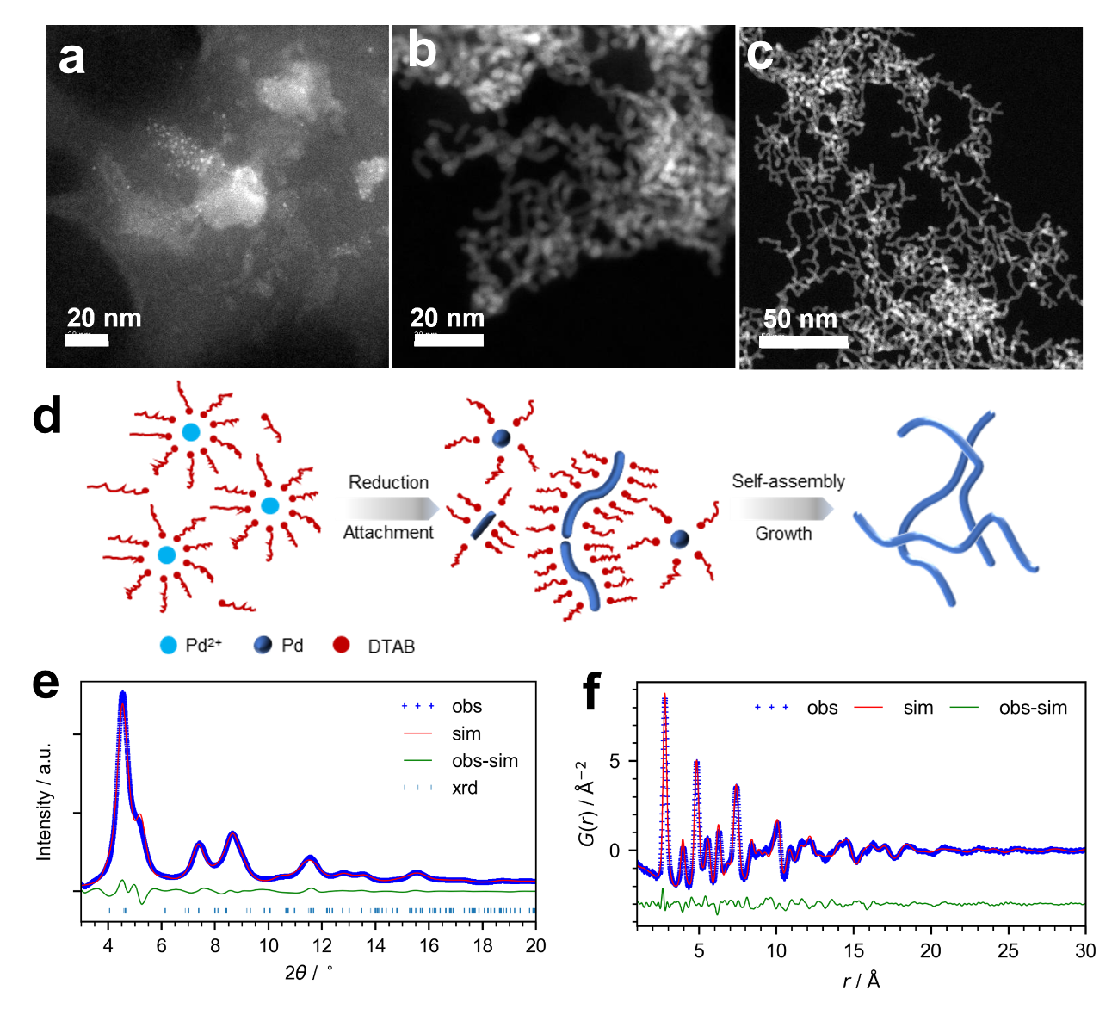
Figure 1. STEM images of Pd nanowires obtained after 10 min (a), 30 min(b), 1 h (c) reaction time in N₂; (d) Schematic illustration of Pd nanowire formation; (e) XRD and (f) PDF pattern of Pd nanowire.

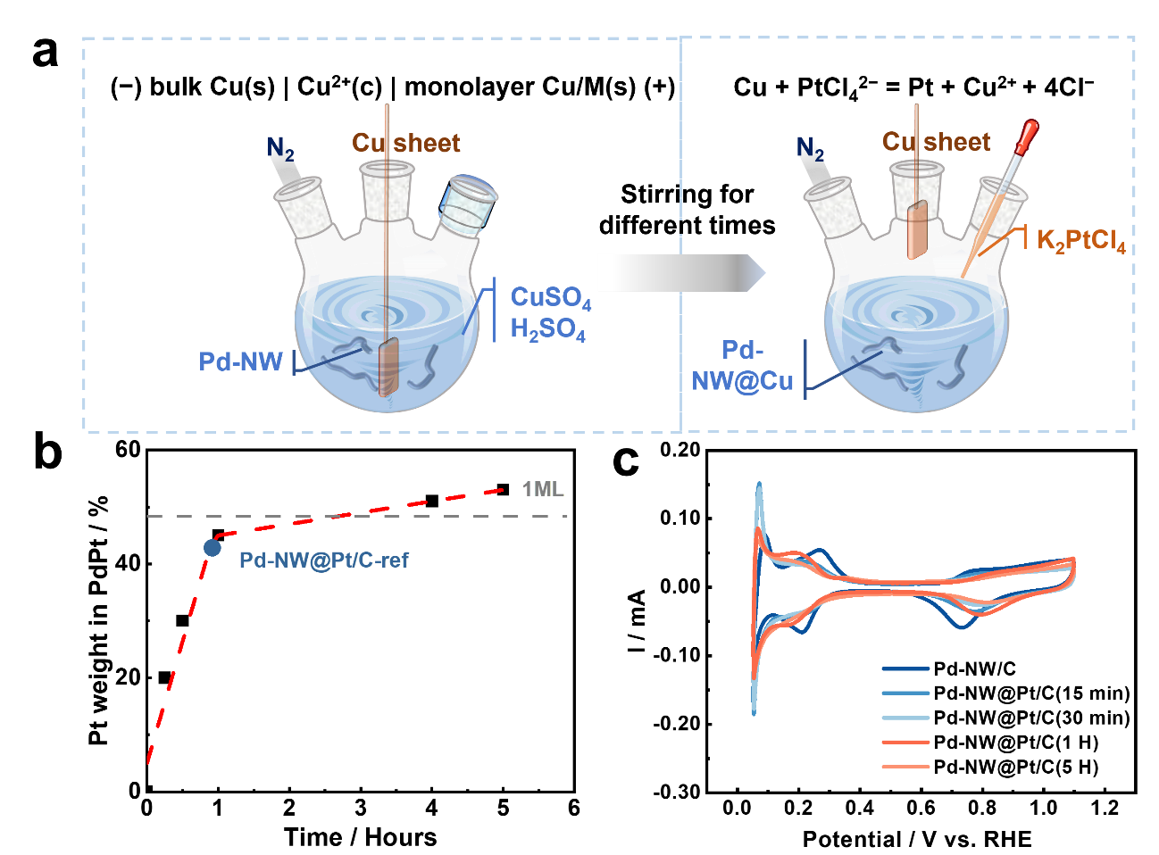
Figure 2. (a) Schematic diagram of the Galvanic Cell method (b) Pt weight percent in PtPd and (c) CVs of Pd-NW@Pt/C derived from Pd-NW@Cu/C with different stirring times.

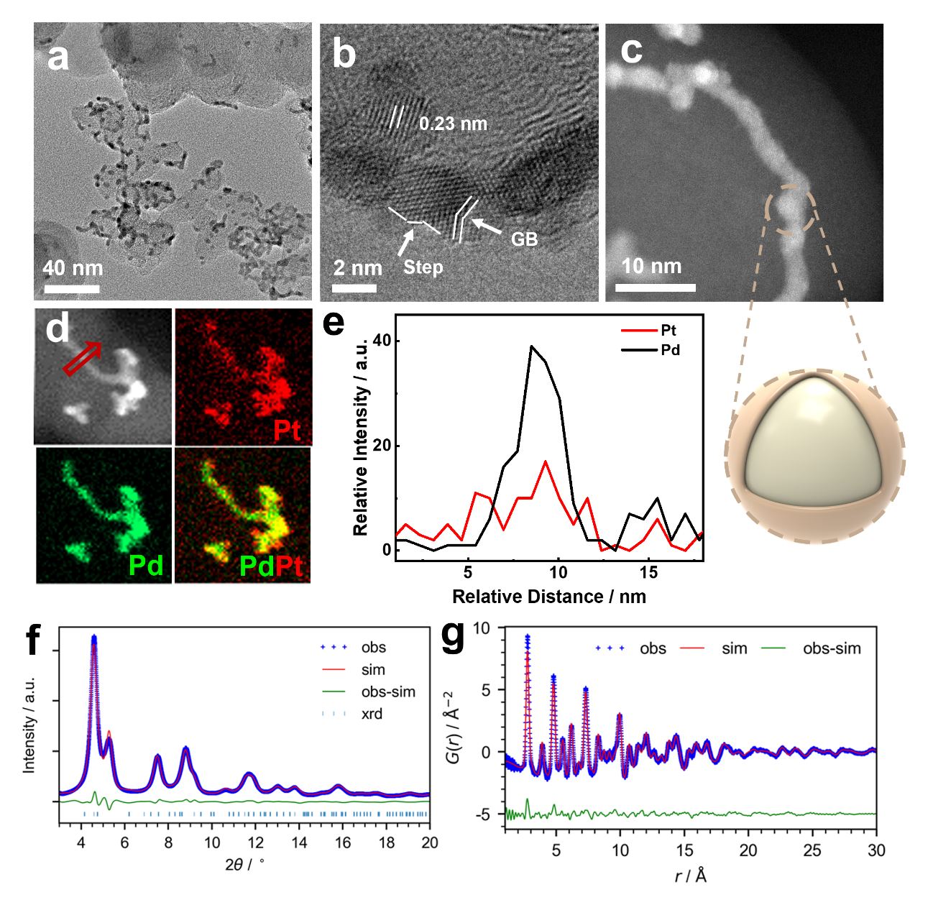
Figure 3. (a, b, c) TEM images, (d) STEM-EDX element mapping spectrum, and (e) line scanning profiles of Pd-NW@Pt/C obtained after 5 h reaction. (f) XRD and (g) PDF pattern of Pd-NW@Pt/C.

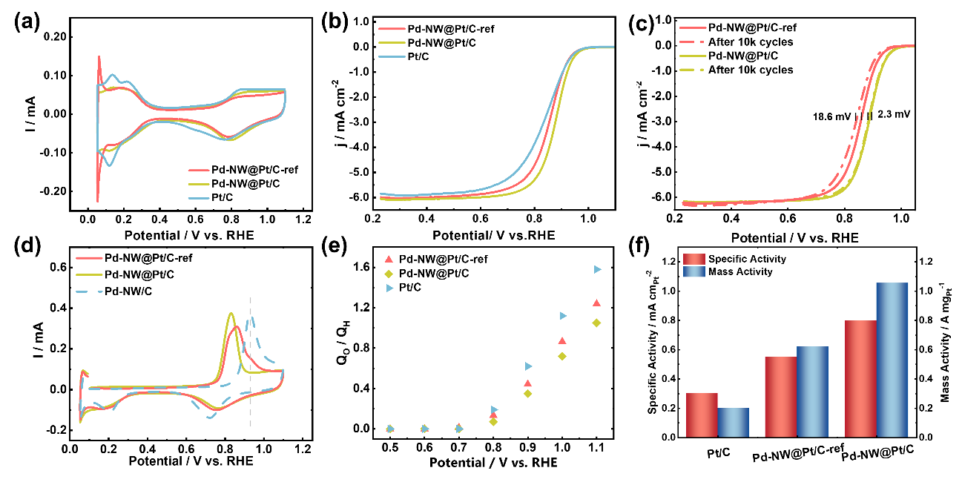
Figure 4. (a) CVs and (b) ORR polarization curves (1600 rpm) for the Pd-NW@Pt/C-ref, Pd-NW@Pt/C and Pt/C catalyst, respectively, in O₂-saturated 0.1M HClO₄. (c) ORR polarization curves before and after ADT. (d) The CO-stripping curves and (e) oxygen coverage of the Pd-NW@Pt/C-ref, Pd-NW@Pt/C and Pt/C catalyst. (f) Comparison of specific activities and mass activities.

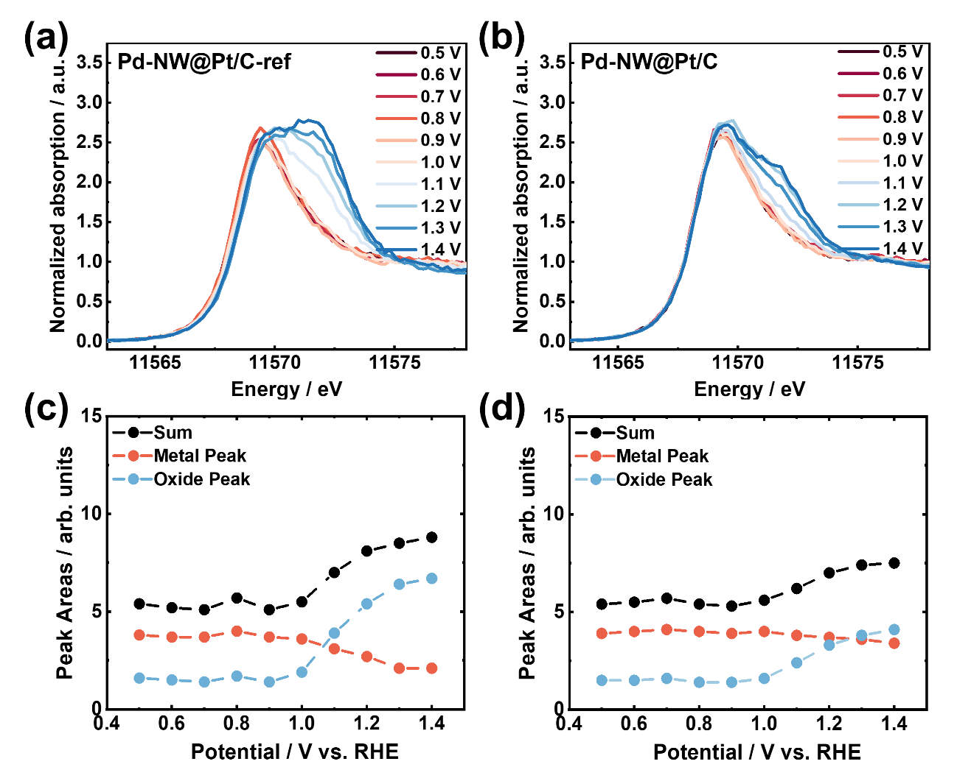
Figure 5. operando HERFD- Pt L_{Ⅲ}-edge XAS analysis for (a) Pd-NW@Pt/C-ref and (b) Pd-NW@Pt/C catalyst at different polarization potential. Integrated peak areas of metal peak, oxides peak, and sum peak for (c) Pd-NW@Pt/C-ref and (d) Pd-NW@Pt/C.

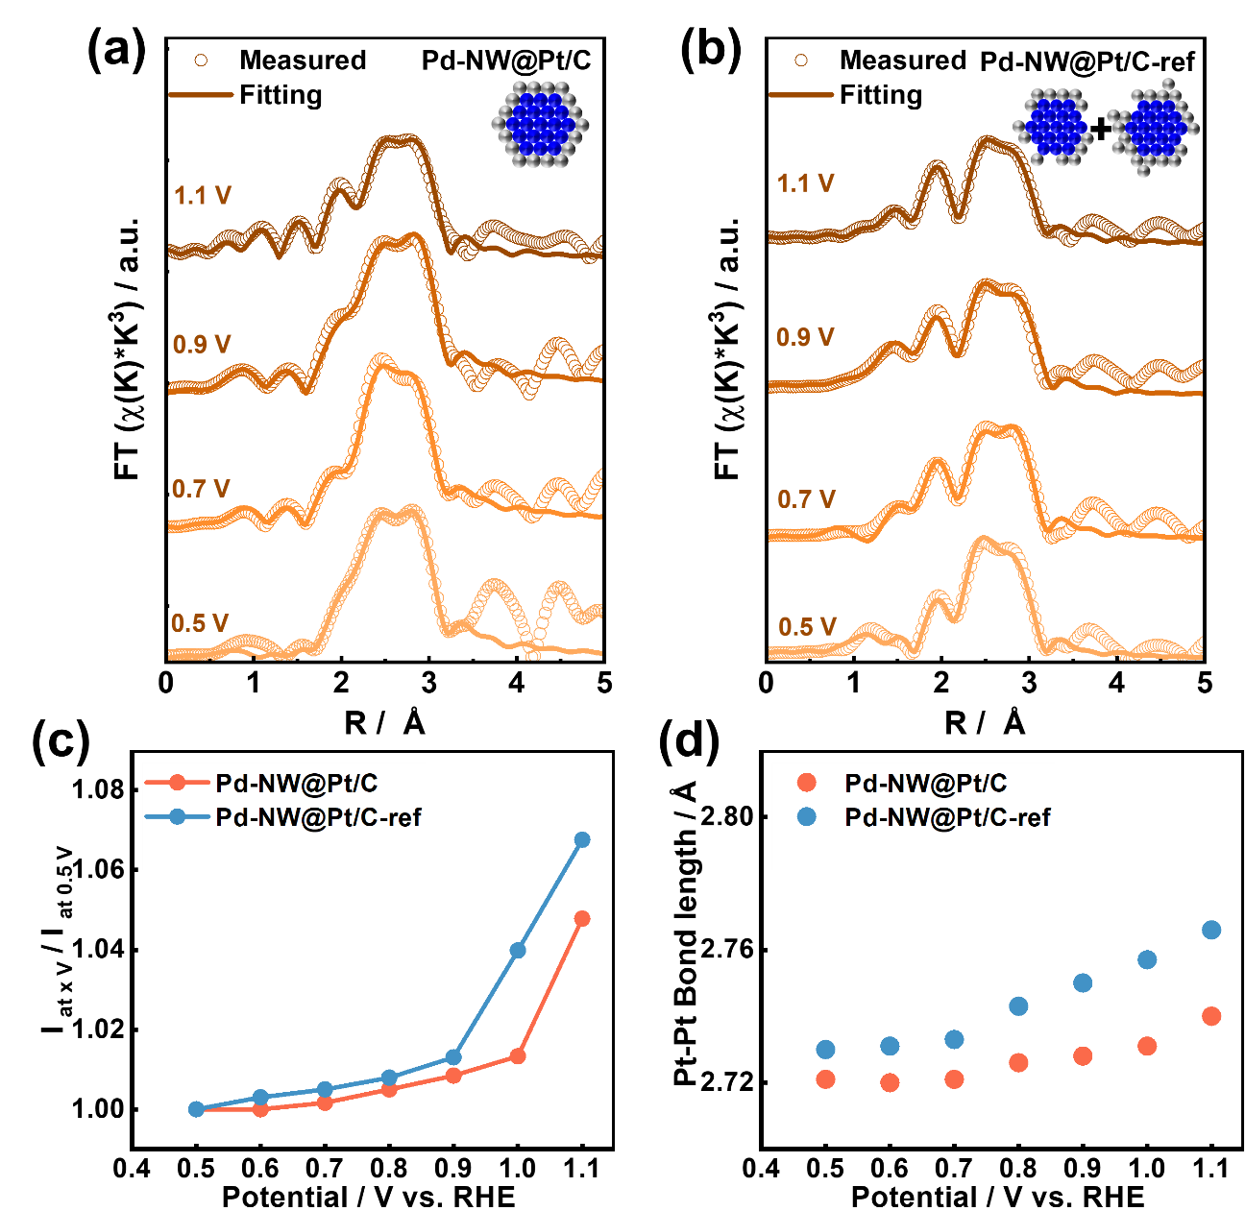
Figure 6. Pt L_{Ⅲ}-edge FT-EXAFS spectra and corresponding fits for (a) Pd-NW@Pt/C and (b) Pd-NW@Pt/C-ref catalyst at different polarization potentials. (c) Δμ of the white line peak heights and (d) Pt-Pt bond length from the corresponding fitting results for Pd-NW@Pt/C and Pd-NW@Pt/C-ref catalyst.
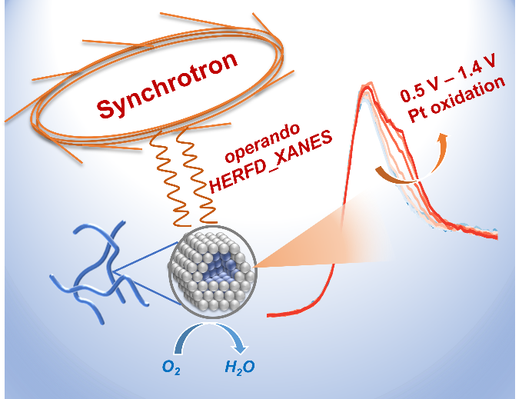
For Table of Contents Only

