- Prepared for submission to JINST
- Development of high radiation tolerance detector 3 with CIGS

- K. Itabashi¹ M. Togawa^{1,2} J. Nishinaga³ M. Miyahara^{1,2} H. Okumura⁴ M. Imura⁵
- T. Isobe⁶
1International Center for Quantum-field Measurement Systems for Studies of the Universe and Particles
6
7 (QUP,WPI), High Energy Accelerator Research Organization (KEK), Oho 1-1, Tsukuba, Ibaraki 3058 0801, Japan.
2Institute of Particle and Nuclear Studies, High Energy Accelerator Research Organization (KEK), Tsukuba, 9
10 Ibaraki 305-0801, Japan.
3Global Zero Emission Research Center, National Institute of Advanced Industrial Science and Technology
11
12 (AIST), Tsukuba, Ibaraki 305-8568, Japan. 4Faculty of Pure and Applied Sciences, University of Tsukuba, Tsukuba, Ibaraki 305-8573, Japan.
13
5Research Center for Electronic and Optical Materials, National Institute for Material Science (NIMS),
14
15 Tsukuba, Ibaraki 305-0044, Japan. 6Institute of Physical and Chemical Research (RIKEN), Wako, Sitama, 351-098, Japan.
16
- E-mail: kosuke.itabashi@cern.ch
- Abstract: We have been developing a CIGS detector for particle detection with high radiation 19 tolerance. We irradiated the CIGS detector with a ¹³²Xe⁵⁴⁺ ion beam, delivering a total ionizing
- dose (TID) of 0.6 MGy at the HIMAC, and confirmed the recovery of leakage current and collected
- charge from radiation damage with heat annealing. To investigate higher radiation tolerance of
- the CIGS semiconductor, we irradiated CIGS solar cells with a 70 MeV proton beam with a non23 ionizing energy loss (NIEL) for 10¹⁶n_{eq} ·MeV/cm² at the RARiS. The V_{In} and In_{Cu} defects created 24 by 70 MeV proton irradiation were observed by deep level transient spectroscopy (DLTS). During 25 thermal annealing at around 100◦C, the Cu⁺ and V_{Cu}⁻ ions are excited to react with defects. These 26 ions interact with V_{In} and In_{Cu} defects, creating electrical neutrality : 2Cu⁺ + V²_{In}⁻ → Cu₂V_{In} and 27 2V_{In}⁻ + In_{Cu}²⁺ → 2V_{In}In_{Cu}. By these reaction process, it is confirmed that both V_{In} and In_{Cu} defects 28 were reduced by the thermal annealing at 130◦C for two hours.

29 Contents
- 1 Introduction 1
- 2 Particle detector with CIGS semiconductor 1
- 2.1 CIGS detector performance study with ¹³²Xe⁵⁴⁺ beam at the HIMAC 2
- 3 70 MeV proton irradiation experiment at the RARiS 2
- 3.1 Defect levels measurement with DLTS method 4
- 4 Conclusion 4

36 1 Introduction
37 A Cu(In, Ga)Se₂ (CIGS) is an alloy semiconductor of CuInSe₂ and CuGaSe₂. Since the CIGS is a 38 direct band gap semiconductor, it has a high light absorption coefficient among solar cell materials
39 and can absorb a broad spectrum of wavelengths, including in the infrared region. Therefore, 40 the solar cell with thin CIGS layer (∼ 2 𝜇m) has achieved a high energy conversion efficiency 41 (𝜂 ∼ 20%), comparable to silicon solar cells [1]. Japan Aerospace Exploration Agency (JAXA) 42 performed ground radiation test using 3 MeV a proton beam with a fluence of 3.0 ×10¹⁶cm⁻², 43 and 1 MeV electron beam with a fluence of 3.0 ×10¹⁴cm⁻², respectively [2]. The short-circuit 44 current I_{SC} and open-circuit voltage (V_{OC}) of CIGS solar cells degraded to 85% for I_{SC} and 55% 45 for V_{OC} after proton irradiation. However, the I_{SC} of CIGS solar cells was recovered by the thermal 46 annealing in the dark condition at 400 K. Since the CIGS semiconductor has a lightweight and high 47 radiation tolerance, the CIGS solar cell is a promising candidate for space thin-film solar cells.
- In the high energy collider experiment such as High-Luminosity Large Hadron Collider ( HL-LHC),
- particledetectorsrequireradiationtoleranceofnon-ionizingenergyloss(NIEL)for10¹⁶ n_{eq}MeV/cm²
- and total ionizing dose (TID) for 10 MGy. In this study, we have developed a particle detector
- with CIGS and evaluated high radiation tolerance of CIGS semiconductor by proton irradiation 52 experiment at the RARiS.

53 2 Particle detector with CIGS semiconductor
- We have developed the CIGS detector shown in Fig. 1. The CIGS sensor is constructed based on a
- pn-junction consisting of a p-type CIGS layer and an n-type ZnO layer. A back contact of Mo with 56 0.8 𝜇m thickness is deposited by DC magnetron sputtering on an soda-lime glass (SLG) substrate.
57 An anode electrode and a cathode were directly bonded to an Al layer and the Mo layer with the 58 Au wires, respectively. A 2 𝜇m thick of CIGS layer was deposited onto a substrate by evaporation 59 method through a three-stage process at Advance Industrial Science and Technology (AIST) [3]. 60 The p-type CIGS layer has carrier density with 10¹⁴ cm⁻³ and achieves to full depletion at a negative 61 bias voltage of 2V. We conducted the heavy ion irradiation experiment at the Heavy Ion Medical 62 Accelerator in Chiba (HIMAC) for evaluating the CIGS detector performance.
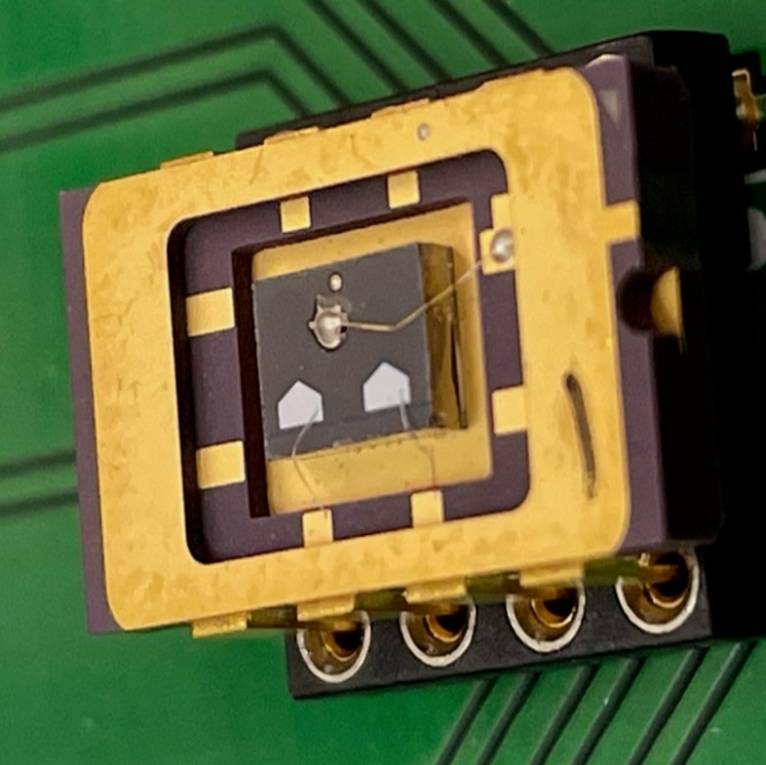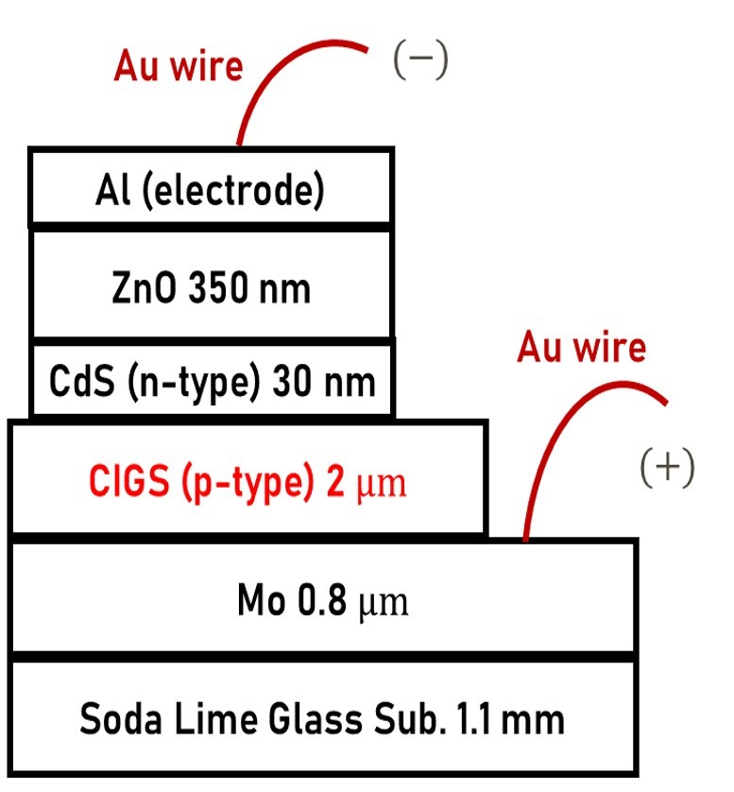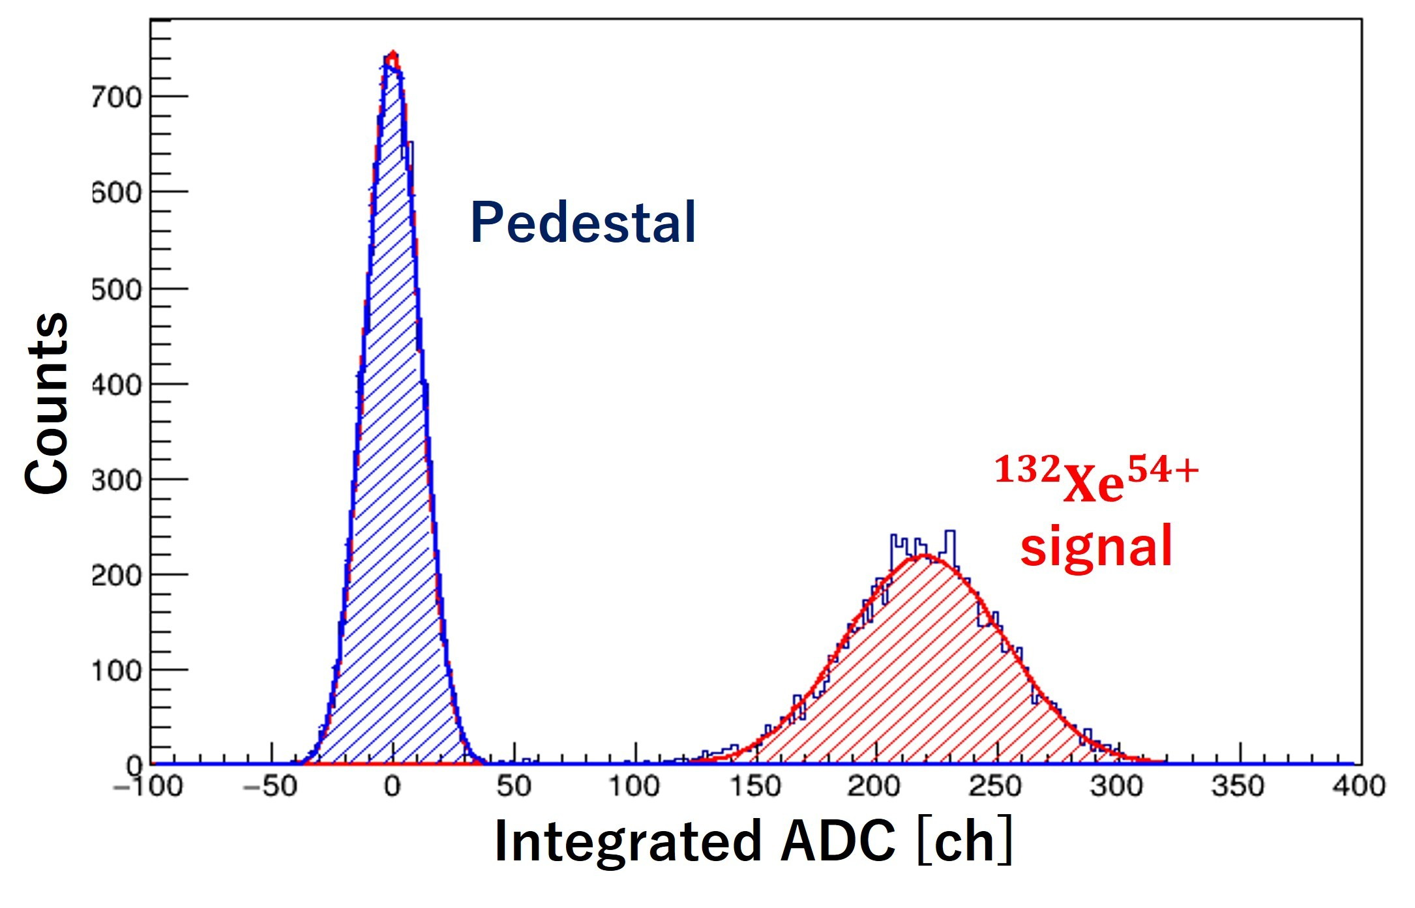
Figure 1. Left and Center) The design of 2 𝜇m-CIGS detector. Right) Signal from ¹³²Xe⁵⁴⁺ beam with a kinematic energy of 400 MeV/u.
- 2.1 CIGS detector performance study with ¹³²Xe⁵⁴⁺ beam at the HIMAC
- The HIMAC is a heavy ion accelerator facility in Japan. A ¹³²Xe⁵⁴⁺ ion beam with a kinematic 65 energy of 400 MeV/u was employed. Figure 1 (right) presents the integrated ADC value derived
- from Xe ion signal. This marks the first observation of a single particle using CIGS detector [4]. To
- evaluate the radiation tolerance of the CIGS detector, it was continuously irradiated with a ¹³²Xe⁵⁴⁺ 68 beam delivering a total amount of 0.6 MGy of ¹³²Xe⁵⁴⁺ beam. Figure 2 shows the degradation in the 69 performance of the CIGS detector under ¹³²Xe⁵⁴⁺ ion beam irradiation. The collected charge from 70 Xe ion signals gradually decreased to 50% of its initial value after Xe ion beam irradiation with an 71 amount of 0.6 MGy, while the leakage current increased from a few nA to 30 nA. After the xenon 72 ion beam irradiation, we treated thermal annealing on the CIGS detector for two hours at 130 ◦C. 73 As a result, both collected charge and leakage current recovered to levels comparable to these of
- the initial value. Therefore, the CIGS detector can maintain high performance through thermal
- annealing even after exposure to 0.6 MGy radiation damage. For the future collider experiment, a 76 particle detector is required higher radiation tolerance up to a fluence of 10¹⁷n_{eq}MeV/cm² and a 77 dose of 10 MGy. In this study, we evaluated the high radiation tolerance of the CIGS semiconductor 78 using a 70 MeV proton beam at the RARiS in Japan.

79 3 70 MeV proton irradiation experiment at the RARiS
- The Research Center for Accelerator and Radioisotope Science (RARiS) has a cyclotron accelerator
- facility at Tohoku University in Japan. We irradiated CIGS solar cells with a proton beam,
- accelerated to an energy of 70 MeV by the RARiS facility, with a fluence of 7.5×10¹⁵ MeV · n_{eq}/cm²
- and with a dose of 4.1 MGy at -15 ◦C using a cold dry-nitrogen gas flow. To evaluate the radiation 84 tolerance of CIGS solar cells, We measured the short-circuit current density (J_{SC}) of the CIGS 85 samples under an AM1.5 spectrum, with 1-sun simulated light illumination at room temperature 86 [3]. Figure 3 (left) shows the annealing time dependence of the relative ratio of the short-circuit 87 current density (J_{SC}). After proton irradiation, the J_{SC} degraded to about half of its initial value. 88 However, the thermal annealing at around 100◦C in dark condition allowed the recovery of defects 89 induced by 70 MeV proton irradiation. A certain ion may become activated during heating. The
- activated ion is expected to react and contribute to recovery process. In this model, the activation
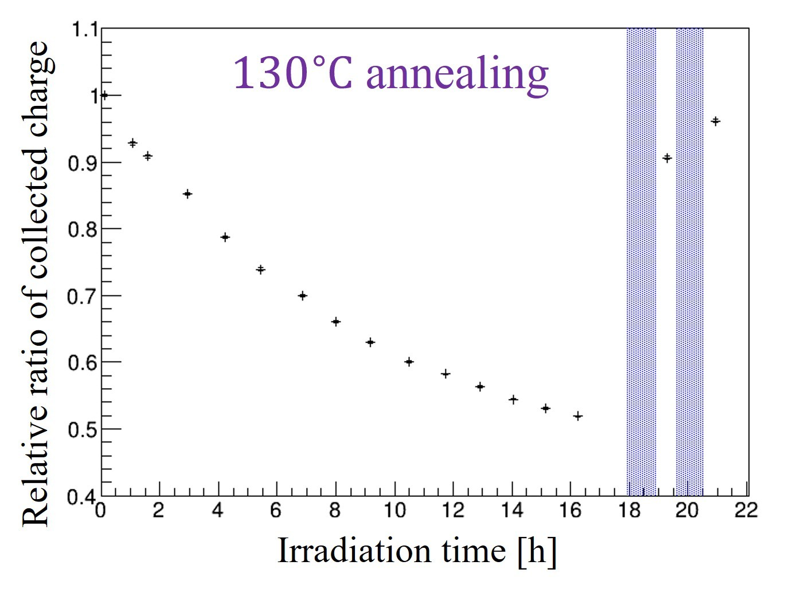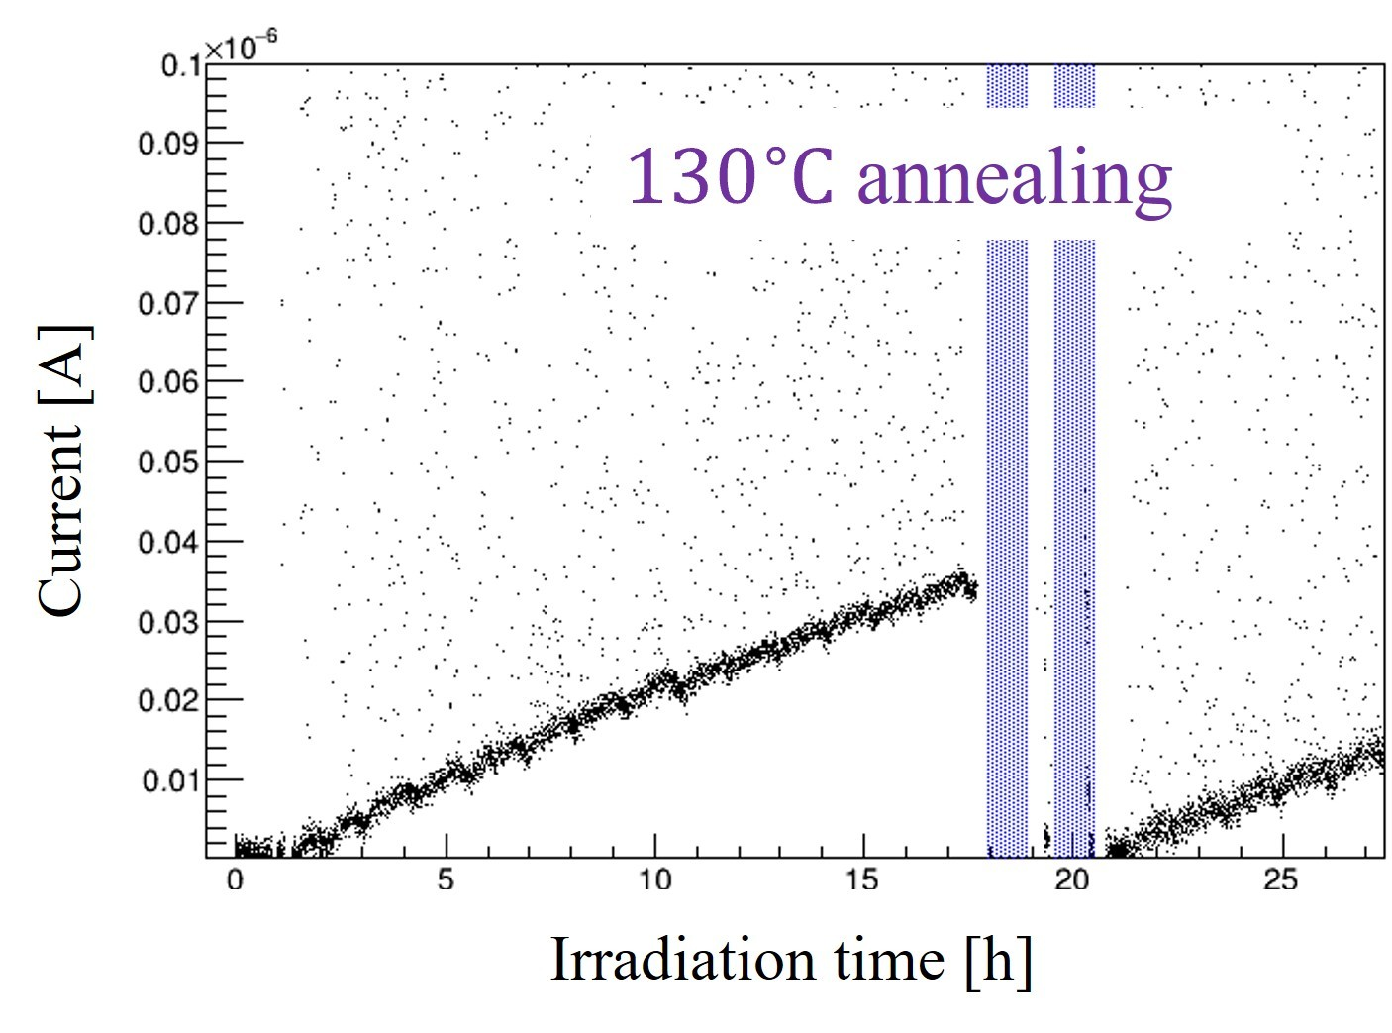
Figure 2. Left) A relative ratio of collected charge to that before irradiation during ¹³²Xe⁵⁴⁺ ion irradiation with a TID of 0.6 MGy. The purple regions indicate the annealing period at 130 ◦C. Right) A leakage current during ¹³²Xe⁵⁴⁺ ion irradiation with a TID of 0.6 MGy.
- energy (E_{a}) during thermal annealing can be described using Arrhenius equation as follows:
−E_{a}
k = Aexp , (3.1) kbt
- where A is a constant factor, k_{bt} is the Boltzmann constant, and k is the reaction rate constant, which 93 depends on temperature (𝑇). In this study, the reaction rate constant (k) is evaluated through the 94 current density-voltage (J-V) characteristic under irradiating the sunlight with an AM1.5 spectrum 95 with 100 mW/cm² at 25 ◦C. As a result of Arrhenius plot fitting shown in right figure of Fig. 3 96 (right), an excited energy during thermal annealing is obtained as 1.07 eV.
97 From the first-principles analysis in Ref. [5], copper ions (Cu⁺) and copper vacancies (V_{Cu}⁻ ) are 98 activated during the thermal annealing at around 100 ◦C, and mainly contribute to recovery from 99 defects. In order to investigate the defects generated by 70 MeV proton irradiation, we conducted 100 the deep level transient spectroscopy (DLTS).
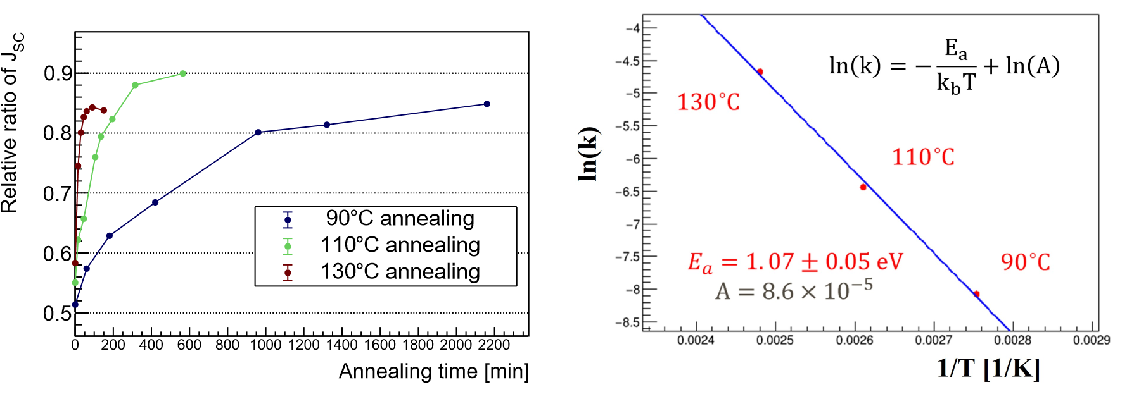
Figure 3. Left) Annealing time dependence of J_{SC} at 90, 110 and 130◦C. Right) The fitting result with Arrhenius equation. Each reaction rate constant (k) is estimatad by recovery speed in J_{SC} value (shown in left figure).
- 3.1 Defect levels measurement with DLTS method
- The DLTS method is a powerful experimental technique used to investigate charge carrier traps in
- semiconductors. In this study, the DLTS measurement were performed using the SemiLab DLS-
- 83D instrument. The target temperature was controlled by an automatic liquid nitrogen cryostat,
- which covered a temperature range from 77K to 400 K. Figure 4 (left) shows the DLTS signal 106 observed through integrated capacitance transients after an injection pulse from -5V to zero-bias.
107 As results of DLTS measurements, two clear peaks that did not appear before irradiation, were 108 observed after proton irradiation. Moreover, both defects decreased by the thermal annealing at 130
◦
109 C for one hour. In the p-type semiconductor layer such as CIGS, a positive and a negative peaks 110 indicate an acceptor and a donor defect levels, respectively. These defect levels (𝐸_{𝑔}) and capture 111 cross section (sigma) follow the Arrhenius equation as
en,p Eg
ln( ) = ln(K𝜎) − (3.2) T2 kbtT
- The K is a constant depending on the effective mass of the semiconductor, and the k_{bt} is the
- Boltzmannconstant. Theelectronorholethermalemissionratefromadeepstate, e_{n},_{p}, isdetermined
- by the injection frequency where f = e_{n},_{p}/2.17 in the SemiLab DLS-83D instrument. Figure 4
- (right) shows the Arrhenius plots of defect peaks from the CIGS solar cells. The energy level of the
- negative peak is 0.55 eV below the conduction band, while that of the positive peak is 0.44 eV above 117 valence band. According to first-principles calculations in CIS crystals, the negative and positive 118 peaks in Fig. 4 correspond to In_{Cu} and V_{In} defects, respectively.
- In Ref. [6], a copper vacancy (V_{Cu}) and In_{Cu} defects were observed in the CIGS solar cells with
- admittance spectroscopy (AS) method after 0.38 MeV proton irradiation. On the other hand, our 121 DLTS instrument did not have sensitivity to detect the V_{Cu} defect because this defect is expected to 122 appear in a lower temperature region (< 77K). However, we observed the V_{In} defect, which is not 123 reported in Ref. [6].
124 The reduction of both V_{In} and In_{Cu} defects was observed during thermal annealing at around 100◦C. 125 ThisresultindicatesthatactivatingionsofCu⁺ andV_{Cu}⁻ reactwiththeV_{In} andIn_{Cu} defectsandcreate 126 an electrical neutrality reaction: 2Cu⁺+V²_{In}⁻ → Cu₂V_{In} and 2V_{In}⁻ +In²_{Cu}⁺ → 2V_{In}In_{Cu}. The electrical 127 neutrality states prevent carrier trapping and facilitates recovery of semiconductor performances.
128 This recovery process is also effective in the CIGS detector because the recovery of leakage current 129 and collected charge from radiation damage were observed in the HIMAC experiment.

130 4 Conclusion
131 We investigated the radiation tolerance of the CIGS semiconductor by 70 MeV proton irradiation 132 with a fluence of 7.5×10¹⁵ MeV·n_{eq}/cm². The short-circuit current density (J_{SC}) during 1-sunlight 133 injection was decreased to half of its initial value after proton irradiation, but it was recovered to 134 85% with two-hour thermal annealing at 130◦C. Therefore, it is clear that the CIGS semiconductor 135 exhibits the high radiation tolerance with a fluence of 7.5 × 10¹⁵MeV · n_{eq}/cm². We identified two 136 defect, V_{In} and In_{Cu}, created by 70 MeV proton irradiation using the DLTS method. This study 137 demonstrates that the CIGS detector has a potential to tolerant higher radiation level expected in 138 the future collider experiment (10¹⁷MeV · n_{eq}/cm²).
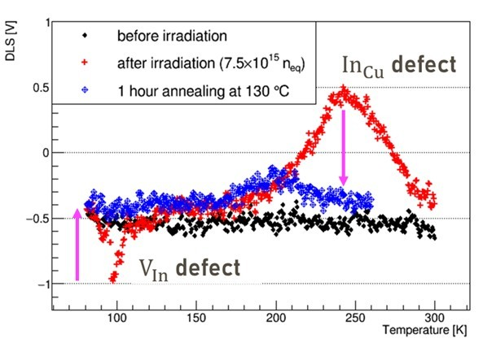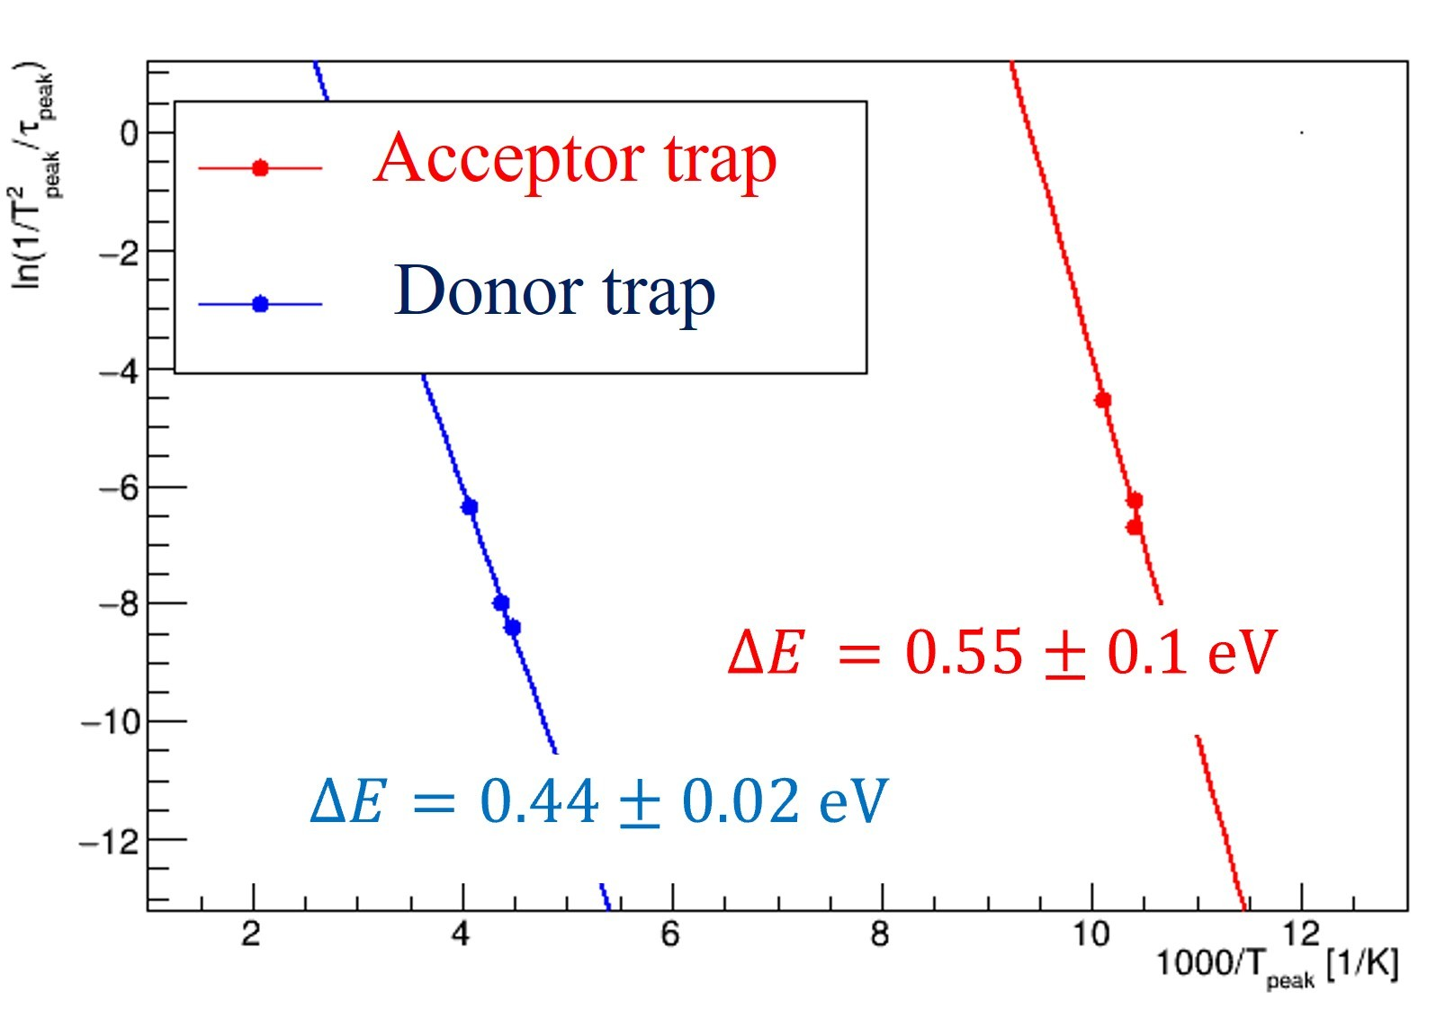
Figure 4. Left) DLTS signal plots, before irradiation (black plot), after irradiation (red plot) and after one hour heating at 130◦C (blue plot). Right) Fitting result of Arrhenius plots. The accepter trap (red line) indicates V_{In} defect with defect level of 0.55 eV, and the donor trap (blue line) shows In_{Cu} defect with defect level of 0.44 eV.

139 Acknowledgments
- This work was supported by World Premier International Research Center Initiative (WPI), the
- Ministry of Education, Culture, Sports, Science and Technology (MEXT), Japan. This work was
- also supported by JSPS KAKENHI Grant No. 21K18635, 23H01191 and 23K25887 from MEXT,
- Japan and the Tsukuba Innovation Area (TIA). We appreciate the support provided for the Research
- Project with Heavy Ions at NIRS-HIMAC (Program No. 21H455) that contributed to part of
- this study. We also thank the Research Center for Accelerator and Radioisotope Science, Tohoku 146 University, for providing us with the proton beam used in this study.

147 References
148 [1] S. Niki et al., "CIGS absorbers and processes", Prog. Photovolt. Res. Appl. 18 (2010) 453-466, 149 https://doi.org/10.1002/pip.969.
- [2] M. Imaizumi et al., "Activity and Current Status of R&D on Space Solar Cells in Japan", Prog.
- Photovolt. Res. Appl. 13 (2005) 529–543.
- [3] J. Nishinaga et al., "Annealing effects on Cu(In, Ga)Se₂ solar cells irradiated by high-fluence proton 153 beam", Jpn. J. Appl. Phys. 62 (2023) SK1014, https://doi.org/10.35848/1347-4065/acc53b.
154 [4] M. Togawa et al., "The CIGS semiconductor detector for particle physics", JINST 19 (2024) C05042, 155 https://doi.org/10.1088/1748-0221/19/05/C05042.
- [5] S. Nakamura et al., "First-Principles Study of Diffusion of Cu and In Atoms in CuInSe₂",Jpn. J. Appl.
- Phys. 52 (2013) 04CR01, http://dx.doi.org/10.7567/JJAP.52.04CR01.
- [6] S. Kawakita et al., "Analysis of Anomalous Degradation of CuInSe₂ Thin-Filim Solar Cells Irradiated 159 with Protons",Jpn. J. Appl. Phys. 46 (2007) L670, https://doi.org/10.1143/JJAP.46.L670.

