High-resistivity anisotropic hot-deformed Nd-Fe-B magnets prepared from DyF₃ electrophoretic deposited powders
Z.H. Kautsar ^{a,b}, H. Sepehri-Amin ^{a,b}, Xin Tang ^{a,c}, R. Iguchi ª, K. Uchida ^{a,d}, T. Ohkubo ª, and K. Hono ^{a,b}
ª Research Center for Magnetic and Spintronic Materials, National Institute for Materials Science (NIMS), Tsukuba 305-0047, Japan
^{b} Graduate School of Science and Technology, University of Tsukuba, Tsukuba 305-8577, Japan
^{c} International Center for Young Scientist (ICYS), National Institute for Materials Science, Tsukuba 305-0047, Japan
^{d} Institute for Materials Research, Tohoku University, Sendai 980-8577, Japan

Abstract
The electrical resistivities of anisotropic Nd-Fe-B-based magnets were successfully increased in both parallel and perpendicular directions to the c-axis by hot-deforming Nd-Fe-B melt-spun flakes that were coated with DyF₃ using electrophoretic deposition. Consequently, the operating temperature under high-frequency AC magnetic field was reduced by 20 °C because of the reduction of eddy current loss. The resistive layer formed at the interface of original ribbons in the hot-deformed magnet was found to be NdF₃ rather than DyF₃. Transmission electron microscopy and atom probe tomography revealed that liquid Nd-rich intergranular phase reduces DyF₃ to form NdF₃ at the ribbon interfaces during hot-deformation at elevated temperature. Excess Dy diffuses into the original ribbon flakes through grain boundaries to form a Dy-rich shell in Nd₂Fe₁₄B grains, giving rise to a high coercivity of 1.8 T. This study demonstrates an alternative way to solve the thermal demagnetization problem of Nd-Fe-B-based permanent magnets during operation in electric motors via the resistivity increase of the magnet.
KEYWORDS: Permanent magnets; Nd-Fe-B; electrical resistivity; electrodeposition; microstructure

1. Introduction
Nd-Fe-B-based permanent magnets that can achieve the largest maximum energy product have been widely used in various applications, including traction motors for electric/hybrid vehicles [1–3]. For these applications, the coercivity of the magnets at operating temperatures of 120–160 °C must be sufficiently large (µ₀H_{c} > 0.8 T). The current approach is to enhance the room temperature coercivity of the Nd-Fe-B-based magnet to above 3.0 T by partially substituting Nd with heavy-rare-earth (HRE) elements such as Dy to form (Nd,Dy)₂Fe₁₄B phase with an increased magnetocrystalline anisotropy [4,5]. However, the limited natural abundance of Dy has motivated researchers to develop high coercivity Nd-Fe-B magnets that do not require Dy [6].
One method to develop high coercivity in Nd-Fe-B magnets is to employ the well-established grain boundary diffusion process (GBDP) [7–12], by which Dy or Tb is locally introduced along grain boundaries (GBs) of 2:14:1 grains to form (Nd,HRE)₂Fe₁₄B shells to strengthen the nucleation field and coercivity, where HRE is either Dy or Tb. Another method is to weaken the ferromagnetism of intergranular phase to magnetically isolate the 2:14:1 grains. For this purpose, low melting point eutectic alloys such as Nd-Cu were infiltrated into the grain boundaries of ultra-fine grain sized Nd-Fe-B magnets [13–18]. This method has been demonstrated to increase the coercivity and thermal stability of hot-deformed magnets that have submicron sized grains [19]. Although a large coercivity of 2.5 T was achieved using the eutectic diffusion process in bulk hot-deformed magnets [20,21], the coercivity increase has always been achieved at the substantial expense of magnetization. An alternative approach is to relax the requirement for the very large room temperature coercivity for traction motor applications via the reduction of the temperature rise during operation of the permanent magnet motors.
The origin of the temperature rise of the magnets during high frequency operation in an electric motor is the eddy current loss. The eddy current loss is inversely proportional to the electrical resistivity of the magnets [22]. Hence, an increase in resistivity can suppress the temperature rise of the magnets during operation. There have been several studies that investigated methods to increase the resistivity of Nd-Fe-B-based magnets, which is typically ~150 μΩcm [23,24]. A large resistivity was reported in hot-deformed magnets produced from a mixture of melt-spun Nd-Fe-B flakes with resistive additives such as fluorides [23–26] or oxides [27], followed by hot-pressing and hot-deformation. Zheng et al. [25] reported a large resistivity of 420 μΩcm parallel to the easy axis (c-axis) by introducing 10 wt.% of NdF₃, resulting in a magnet with coercivity of 1.44 T and remanence of 1.26 T. Further improvement of resistivity to 466 μΩcm was reported by using CaF₂ additives [23] but at the cost of coercivity being reduced to 1.35 T. However, the major issue in the hot-deformed magnets is that the resistivity increase was only realized parallel to the c-axis. This originates from the fabrication process that involves hot-pressing and hot-deforming a mixture of rapidly-solidified powders with resistive materials; hence, the resistive materials are laminated parallel to the c-plane of the hot-deformed magnet [28]. To overcome this problem, it is necessary to develop a method to enhance resistivity perpendicular to the c-axis of the anisotropic magnet. In this study, we demonstrate that electrophoretic deposition coating of fluoride materials, such as DyF₃, to the Nd-Fe-B melt-spun powders followed by hot-pressing and hot-deformation can increase the electrical resistivities of the anisotropic magnets both parallel and perpendicular to the c-axis. The magnetic properties and resistivity of the obtained hot-deformed magnets are compared to that produced from the mixture of DyF₃ and Nd-Fe-B melt spun flakes. The microstructure origin of the resistivity enhancement of the magnets while maintaining a large coercivity is discussed based on detailed microstructure characterizations.

2. Experimental
Commercial melt-spun ribbon powder (Magnequench, MQU-F) with a composition of Nd_{13.6}Fe_{73.6}Co_{6.6}Ga_{0.6}B_{5.6} (at.%) was used as a precursor. The surface of the powder was coated by submicron-sized DyF₃ particles using electrophoretic deposition (EPD). DyF₃ suspension was prepared by dispersing the powder in ethanol, followed by sonication. EPD was carried out under 32 V/cm DC voltage with a Pt-coated Ti rod as the anode and a Ta foil as the cathode. During the EPD process, MQU-F powder was placed on the cathode and was stirred slowly. The dried powder was hot-pressed at 650 °C under 150 MPa for 5 mins in a vacuum to achieve a near full-density magnet with a thickness of ~32 mm and diameter of 12.5 mm. Thereafter, the sample was hot-deformed at 680 °C with a 75% height reduction for 30 mins. The hot-deformed magnet was 8 mm in thickness with a diameter of 25.0 mm. DyF₃ content of this magnet was analyzed using inductively coupled plasma – atomic emission spectroscopy (ICP-AES) chemical analysis; 3 wt.% of DyF₃ was detected in the magnet. For comparison, another hot-deformed magnet with the same DyF₃ content was prepared by mixing MQU-F and DyF₃ powder, followed by hot-pressing and hot-deformation under the same processing conditions. A simple hot-deformed magnet without addition of DyF₃ was also prepared.
2 different samples were cut from each magnet: 4.5 (c-axis) ✕ 6.0 ✕ 6.0 mm³ for magnetic properties measurement and 2.8 ✕ 7.5 ✕ 7.5 (c-axis) mm³ for resistivity measurement. Room temperature magnetization curves were measured using a BH tracer after magnetizing the samples under 5 T using a pulse magnetizer while temperature dependence of coercivity was measured using a superconducting quantum interference device vibrating sample magnetometer (SQUID-VSM). Resistivity was measured using a four-point probe method parallel and perpendicular to the c-axis of anisotropic hot-deformed magnets. An infrared camera (InfraTec GmbH, VarioCAM HD 880) was used to measure the temperature rise of the magnet under application of an AC magnetic field. The samples (4.5 ✕ 6.0 ✕ 6.0 mm³) were coated with an insulating black ink (Japan Sensor, JSC-3) to ensure constant infrared emissivity of >0.94. Thereafter, an AC magnetic field of 5–9 mT (peak to peak) with a frequency of 110.1 kHz was applied to the magnet by an AC magnetic field generator system (nanoTheric, Magnetherm V 1.5). The general microstructure was investigated using a scanning electron microscope (SEM) (NeoScope JCM-6000 Plus and Carl ZEISS CrossBeam 1540EsB). Further detailed microstructure characterizations were conducted using a scanning transmission electron microscope (STEM) (FEI Titan G2 80-200) and atom probe tomography (APT) (LEAP5000XS).
3. Results
For naming purposes, “additive-free sample”, “DyF₃-mixed sample”, and “DyF₃-coated sample” will be used to refer to the hot-deformed magnet prepared from additive-free melt-spun ribbon, DyF₃-mixed melt-spun ribbon, and DyF₃-coated melt-spun ribbon, respectively. Figure 1 schematically shows the sample shape and direction of the four-point probe resistivity measurements with regards to the c-axis of the magnets. The measured resistivity of the additive-free, DyF₃-mixed, and DyF₃-coated samples are given in Table 1. The resistivity of the DyF₃-coated sample shows the highest value both parallel and perpendicular to the c-axis, followed by the DyF₃-mixed sample and then the additive-free sample. This indicates that the surface coating of the initial melt-spun flakes with the EPD method can substantially increase the resistivity of final hot-deformed magnets in both directions. Unlike the isotropic resistivity in the additive-free and DyF₃-mixed samples, the resistivity parallel to the c-axis of the DyF₃-coated sample is two times higher than that in the perpendicular direction. The resistivity in parallel and perpendicular directions to the c-axis of DyF₃-coated sample is 3.5 times and 1.7 times larger than that for the additive-free sample, respectively.
Figure 2(a) shows the demagnetization curves of the additive-free, DyF₃-mixed, and DyF₃-coated samples. The additive free sample shows remanent magnetization of 1.38 T with a coercivity of 1.49 T. DyF₃-mixed and DyF₃-coated samples have a comparable remanence of 1.2 T and coercivity of 1.8 T. Partial reduction of remanence is caused by the addition of DyF₃. Note that the squareness of the demagnetization curves deteriorates after the addition of DyF₃. Figure 2(b) shows the temperature dependence of coercivity of the samples. Temperature coefficient of coercivity (β) was calculated for each sample from 27–227 ºC. Thermal stability of coercivity was improved from – 0.460%/ºC in additive-free sample to – 0.429%/ºC and – 0.435%/ºC in the DyF₃-mixed and DyF₃-coated samples, respectively. M_{r}/M_{s} ratios of the additive-free, DyF₃-mixed, and DyF₃-coated samples are 0.89, 0.87, and 0.85, respectively, indicating texture deterioration as DyF₃ was coated and mixed to the magnet.
Backscattered electron (BSE)-SEM images from the additive-free sample are shown in Figs. 3(a,b). The bright regions are the bonded interface between the original flakes, which are not clear in these images. BSE-SEM images of the DyF₃-mixed sample (Figs. 3(c,d)) show much brighter contrast from the boundaries of the original flakes, which is caused by the existence of REF₃ phase, where RE is either Nd or Dy. However, the agglomeration of the brightly-imaged phase indicated by arrowheads suggests the heterogeneous distribution of additives in the powder mixing process. The EPD coating of MQU-F powders can solve this heterogenous distribution of fluorides in the final hot-deformed magnet. As shown in Figs. 3(e,f), brightly imaged thin layers uniformly envelop the original melt-spun powders. This uniform distribution of the fluoride layer should be responsible for the high resistivity in both parallel and perpendicular directions to the c-axis of the hot-deformed magnet. Figures 3(g,h) show SEM-EDS maps obtained from a DyF₃-coated sample. To our surprise, the fluoride region after hot-deformation is not DyF₃ but NdF_{x}. Figure 3(g) shows that Dy is more likely to diffuse into the Nd-Fe-B flakes.
Figures 4(a–g) show high magnification BSE-SEM images of additive-free, DyF₃-mixed, and DyF₃-coated samples taken from inside of the hot-deformed magnets far from the original flakes’ interfaces. Well textured platelet-shaped grains are observed in the additive-free sample enveloped by a faintly bright intergranular phase (Figs. 4(a,d)), some grain misalignments are found in the DyF₃-mixed sample (Figs. 4(b,e)), while texture of 2:14:1 grains seems to be slightly deteriorated in the DyF₃-coated sample (Figs. 4(c,f)). This different level of grain texture should be responsible for the deterioration of magnetization curve squareness shown in Fig. 2(a). In addition, the areal fraction of Nd-rich phases, brightly imaged in BSE-SEM images, calculated from Figs. 4(a-c) reduces from around 7.8% in additive-free to around 6.5% and 4.1% in DyF₃-mixed and DyF₃-coated respectively. It is known that sufficient amount of Nd-rich phase is necessary to achieve a good texture during hot-deformation [29,30].
Figures 5(a-c) show STEM-EDS maps of Fe, F, Nd, and Dy obtained from a fluoride/2:14:1 interface in the microstructure of DyF₃ coated sample. The concentration line profile taken across the interface shows there is no Dy in the fluoride region (Fig. 5(d)). Note that Dy is dissolved inside the original Nd-Fe-B flakes. Selected area electron diffraction (SAED) patterns shown in Figs. 5(e,f) obtained from the fluoride region indicate this phase is NdF₃ with the HoH₃-type crystal structure (space group 165). Thus, it can be concluded that DyF₃ initially coated on the powders is transformed to NdF₃ during the hot-deformation process. Similar finding of DyF₃ conversion to NdF₃ was reported in the DyF₃ added hot-deformed magnets [31], complete Nd-Dy interchange was occurred in the thin layered DyF₃ while Dy remains in the fluoride region when is it agglomerated with a large thickness. In the sintered magnets, however, the product of the reaction was mainly NdOF [8,31]. Lower processing temperature and shorter processing time of hot-deformation compared to sintering is believed to be the main cause of this difference.
In order to evaluate the microstructure of the DyF₃-coated sample in more detail, we conducted TEM observations. Figure 6(a) shows a schematic illustration of the microstructure of the DyF₃-coated sample. TEM observations were conducted from two regions; one located close to the NdF₃ layer and the other ~5 µm away from the NdF₃ resistive layer. Figure 6(b) shows STEM-EDS maps of Nd and Dy taken from near the interface with the fluoride region. Typical platelet-shaped Nd₂Fe₁₄B grains are observed, which are enveloped by Nd-rich intergranular phase. Dy diffused into the original melt-spun flake resulting in the formation of distinct (Nd,Dy)₂Fe₁₄B shells at the outer region of Nd₂Fe₁₄B grains. Figure 6(c) shows a STEM-EDS map taken from an inner part of the flake, such as region (ii) in Fig. 6(a). The Dy-rich shell is still observed, but the shell thickness appears to be slightly reduced compared to that in Fig. 6(b). APT was conducted to compare the composition of the intergranular phase. Figures 7(b,c) show APT maps taken from the two regions as shown schematically in Fig. 7 (a). Figure 7(b) shows 3D atom maps of Fe, Nd, Dy, Co, B, and Ga obtained from the Nd-Fe-B region close to the fluoride interfaces. Several intergranular phases are observed within the analyzed volume, in which Nd, Co, and Cu atoms are enriched. Note that Dy is located in the shell regions of the 2-14-1 grains. Figure 7(d) shows concentration line profiles of the constituent elements obtained from the selected volume perpendicular to an intergranular phase, shown in the Fe, Nd, and Dy map in Fig. 7(b). The intergranular phase at this region contains ~36 at.% Nd. The Dy-rich shell has a composition of (Nd_{0.70}Dy_{0.30})₂(Fe,Co)₁₄B. No fluorine is observed in the intergranular phase. Figure 7(c) shows 3D atom maps of constituent elements obtained from a region ~5 µm away from the interface with a NdF₃ layer. The concentration line profiles calculated from the selected volume in Fig. 7(e) indicates that Dy is localized in the intergranular phase with a concentration of 2.6 at.% (Fig. 7(e)). Nd content in the intergranular phase was found to be ~27 at.%. No F was detected in the intergranular phase inside of original Nd-Fe-B flakes.
To evaluate the temperature rise of the hot-deformed magnets under an external AC magnetic field, an open-loop magnetic circuit was used. The experiment setup is schematically illustrated in Figs. 8(a,b). Fully-magnetized samples were placed in the middle of a solenoid. Styrofoam vessel was used to minimize heat loss while Kapton tape was used to fix samples position on a borosilicate glass container. An infrared image of the heated samples was taken every 30 seconds; Fig. 8(c) shows an example of the images. The recorded temperature is the average of measured temperature of selected region shown in Fig. 8(c).
Figure 8(d) shows the temperature of the top surface of the hot-deformed magnets as a function of time, measured using the infrared camera under different AC magnetic field strengths at a fixed frequency of 110.1 kHz. The temperature of each magnet rapidly increases and becomes saturated after around 8 min. Regardless of the strength of applied AC magnetic field, the saturated temperature of the additive-free hot-deformed magnet is always higher than its additive-containing counterparts. With an increase of an external AC magnetic field, the saturated temperatures increase and their differences are more pronounced with different resistivity. For example, under 9 mT external AC field, the temperature of the Dy-coated sample is 180 °C, while it is 190 and 200 °C for the Dy-mixed and additive-free samples, respectively. These results demonstrate that uniform distribution of resistive fluoride materials in the microstructure more effectively suppresses the temperature rise of magnets in motor applications.

4. Discussion
Previous studies on the development of high resistivity Nd-Fe-B hot-deformed magnets were mainly focused on the search for materials which can substantially increase magnet resistivity while maintaining high coercivity and remanence [23–27]. However, a trade-off between resistivity and magnetic properties was always apparent. Moreover, there was less attention on increasing the resistivity of anisotropic magnets perpendicular to their c-axis, which involves mainly in controlling the eddy current losses. In this work, we demonstrated that the resistivity of Nd-Fe-B hot-deformed magnet can be increased in both parallel and perpendicular to the c-axis of the magnet. This is attributed to the formation of a uniform high-resistivity lamination layer surrounding the original melt-spun ribbon flakes. This is achieved in the hot-deformed magnet using DyF₃-coated powder, as shown in Figs. 3(e,f). Electrophoretic deposition coating on the original melt-spun ribbon can suppress the DyF₃ agglomeration that was observed in the magnet hot-deformed from mixed powder. The differences of the microstructural features obtained for additive-free, DyF₃-mixed, and DyF₃-coated samples are schematically shown in Fig. 9. It can be seen that the DyF₃-coated sample has thin but uniform fluoride coatings surrounding the Nd-Fe-B flakes.
Remanence reduction and coercivity enhancement after Dy addition were expected since (Nd,Dy)₂Fe₁₄B shells were formed at the outer region of Nd-Fe-B grains (Fig. 6(c)), texture deterioration (Figs. 4(a–c)) should also contributes to the excess of remanence loss. Smaller coercivity in the DyF₃-sample is believed to have microstructural origin. For example, smaller areal fraction of Nd-rich phase observed in DyF₃-coated sample Fig. 4(c) may cause weaker pinning on this magnet which results in lower coercivity.
The detailed microstructure observation (Fig. 5) revealed that the fluorides at the surface of particles were mainly composed of NdF₃ rather than the slightly more thermodynamically stable DyF₃ [32]. DyF₃ has often been used for the grain boundary diffusion process of Nd-Fe-B sintered magnets to increase their coercivity [8,9,33]. In this process, DyF₃ is decomposed at the elevated temperatures and Dy diffuses into Nd₂Fe₁₄B grains resulting in the formation of (Nd,Dy)₂Fe₁₄B shells [31,34,35]. Inspired by this, the following mechanisms are proposed to explain the formation of NdF₃ and (Nd,Dy)₂Fe₁₄B shells in the Nd-Fe-B hot-deformed magnet.
- During hot-deformation process, Nd-rich liquid intergranular phase reacts with DyF₃ on the ribbon surface to form NdF₃ and (Nd,Dy)-rich liquid phase.
Nd_{(l)} + DyF_{3(s)} $→$Dy_{(l)} + NdF_{3(s)}
- Dy-rich liquid diffuses into the magnet through GBs to form (Nd,Dy)₂Fe₁₄B shell.
Dy_{(l)} + Nd₂Fe₁₄B_{(s)} $→$ Dy₂Fe₁₄B_{(s)} + Nd_{(l)}
Note that DyF₃ is slightly more thermodynamically stable than NdF₃ at 600–700 °C because DyF₃ has ~8 kJ/mol more negative Gibbs free energy of formation compared to NdF₃ [29]. On the other hand, the formation of (Nd,Dy)₂Fe₁₄B is highly favored energetically because of the ~408 kJ/mol more negative value of Gibbs free energy of formation of Dy₂Fe₁₄B compared to Nd₂Fe₁₄B [36,37]. Hence, the combination of step (i) and step (ii) are becoming energetically favored because of the negative total Gibbs free energy of reaction, resulting in spontaneous net reaction of 2DyF_{3(s)} + Nd₂Fe₁₄B_{(s)} $→$ 2NdF_{3(s)} + Dy₂Fe₁₄B_{(s)}, which is schematically shown in Fig. 9(d).
The properties of magnets achieved in this work are compared with those reported in the literature and summarized in Fig. 10. The resistivity value parallel to the c-axis in the CaF₂-added hot-deformed magnet reported by Zhang et al. [23] is the highest value. However, this magnet shows rather low coercivity as compared to the properties achieved in this work. For the given comparable coercivities, the resistivity achieved in this work is 300 μΩcm higher than those reported by Kim et al. [24] for the DyF₃-added hot-deformed magnet and 130 μΩcm higher for the DyF₃-LiF eutectic mixture-added hot-deformed magnet. Another merit of the magnets developed in this work is the simultaneous increase of resistivity both parallel and perpendicular to the c-axis. The largest resistivity perpendicular to the c-axis reported to date is 200 μΩcm for Pr-Fe-B hot-deformed magnet with 5 wt.% of CaF₂ reported by Marinescu et al. [28] , which is inferior to 250 μΩcm achieved in this work.
4. Conclusions
We have shown that electrical resistivities parallel and perpendicular to the easy magnetization direction of Nd-Fe-B hot-deformed magnets can be increased from ρ = 150 μΩcm to ρ// = 530 μΩcm and ρ⊥ = 250 μΩcm, respectively, by coating the Nd-Fe-B melt-spun precursor ribbon with DyF₃ before hot-deformation. Microstructure observation reveals that the formation of a uniform NdF₃ layer enveloping the original melt-spun flakes plays an important role in increasing the resistivities. The reduced Dy diffuses through the grain boundaries within the original ribbons, forming a Dy-rich shell in the Nd₂Fe₁₄B grains, increasing the coercivity to 1.8 T. The eddy current loss heating under a high-frequency AC magnetic field demonstrated that the resistivity increase resulted in reduction of the temperature rise of the magnets in an AC magnetic field. Thus, this study demonstrates that electrically-resistive magnets have the potential to tackle the thermal demagnetization problem of Nd-Fe-B-based permanent magnets by reduction of their operation temperature. A further search for additives that can substantially improve the resistivity with an enhanced coercivity above 2 T without relying on Dy/Tb should be considered in future work.

References
[1] M. Sagawa, S. Fujimura, N. Togawa, H. Yamamoto, and Y. Matsuura, New material for permanent magnets on a base of Nd and Fe (Invited), J. Appl. Phys 55, (1984) 2083-2087.
[2] J. J. Croat, J. F. Herbst, R. W. Lee, and F. E. Pinkerton, Pr‐Fe and Nd‐Fe‐based Materials: A new class of high‐performance permanent magnets (Invited), J Appl Phys 55, (1984) 2078-2082.
[3] O. Gutfleisch, M. A. Willard, E. Brück, C. H. Chen, S. G. Sankar, and J. P. Liu, Magnetic materials and devices for the 21st century: stronger, lighter, and more energy efficient, Adv. Mater. 23, (2011) 821-842.
[4] M. Sagawa, S. Fujimura, H. Yamamoto, Y. Matsuura, and K. Hiraga, Permanent magnet materials based on the rare earth-iron-boron tetragonal compounds, IEEE Trans. Magn. 20, (1984) 1584-1589.
[5] S. Hirosawa, Y. Matsuura, H. Yamamoto, S. Fujimura, M. Sagawa, and H. Yamauchi, Magnetization and magnetic anisotropy of R ₂ Fe ₁ ₄ B measured on single crystals, J. Appl. Phys. 59, (1986) 873-879.
[6] N. Haque, A. Hughes, S. Lim, and C. Vernon, Rare earth elements: overview of mining, mineralogy, uses, sustainability and environmental impact, Resources 3, (2014) 614-635.
[7] K. T. Park, K. Hiraga, and M. Sagawa, Effect of metal-coating and consecutive heat treatment on coercivity of thin Nd-Fe-B sintered magnets, in The 16th Workshop on Rare Earth Permanent Magnet and Their Applications (Sendai, Japan, 2000).
[8] H. Nakamura, K. Hirota, M. Shimao, T. Minowa, and M. Honshima, Magnetic properties of extremely small Nd-Fe-B sintered magnets, IEEE Trans. Magn. 41, (2005) 3844-3846.
[9] K. Hirota, H. Nakamura, T. Minowa, and M. Honshima, Coercivity enhancement by the grain boundary diffusion process to Nd–Fe–B sintered magnets, IEEE Trans. Magn. 42, (2006) 2909-2911.
[10] N. Watanabe, M. Itakura, N. Kuwano, D. Li, S. Suzuki, and K. Machida, Microstructure analysis of sintered Nd-Fe-B magnets improved by Tb-vapor sorption, Mater. Trans. 48, (2007) 915-918.
[11] D. Li, S. Suzuki, T. Kawasaki, and K. Machida, Grain interface modification and magnetic properties of Nd–Fe–B sintered magnets, Jpn. J. Appl. Phys. 47, (2008) 7876-7878.
[12] H. Suzuki, Y. Satsu, and M. Komuro, Magnetic properties of a Nd–Fe–B sintered magnet with Dy segregation, J. Appl. Phys. 105, (2009) 07A734.
[13] H. Sepehri-Amin, T. Ohkubo, T. Nishiuchi, S. Hirosawa, and K. Hono, Coercivity enhancement of hydrogenation–disproportionation–desorption–recombination processed Nd–Fe–B powders by the diffusion of Nd–Cu eutectic alloys, Scripta Materialia 63, (2010) 1124-1127.
[14] H. Sepehri-Amin, T. Ohkubo, S. Nagashima, M. Yano, T. Shoji, A. Kato, T. Schrefl, and K. Hono, High-coercivity ultrafine-grained anisotropic Nd–Fe–B magnets processed by hot deformation and the Nd–Cu grain boundary diffusion process, Acta Materialia 61, (2013) 6622-6634.
[15] H. Sepehri-Amin, J. Liu, T. Ohkubo, K. Hioki, A. Hattori, and K. Hono, Enhancement of coercivity of hot-deformed Nd–Fe–B anisotropic magnet by low-temperature grain boundary diffusion of Nd60Dy20Cu20 eutectic alloy, Scripta Materialia 69, (2013) 647-650.
[16] T. Akiya, J. Liu, H. Sepehri-Amin, T. Ohkubo, K. Hioki, A. Hattori, and K. Hono, Low temperature diffusion process using rare earth-Cu eutectic alloys for hot-deformed Nd-Fe-B bulk magnets, J. Appl. Phys. 115, (2014) 17A766.
[17] H. Sepehri-Amin, L. Liu, T. Ohkubo, M. Yano, T. Shoji, A. Kato, T. Schrefl, and K. Hono, Microstructure and temperature dependent of coercivity of hot-deformed Nd–Fe–B magnets diffusion processed with Pr–Cu alloy, Acta Materialia 99, (2015) 297-306.
[18] L. Liu, H. Sepehri-Amin, T. Ohkubo, M. Yano, A. Kato, T. Shoji, and K. Hono, Coercivity enhancement of hot-deformed Nd-Fe-B magnets by the eutectic grain boundary diffusion process, J. Alloys Compd. 666, (2016) 432-439.
[19] J. Li, L. Liu, H. Sepehri-Amin, X. Tang, T. Ohkubo, N. Sakuma, T. Shoji, A. Kato, T. Schrefl, and K. Hono, Coercivity and its thermal stability of Nd Fe B hot-deformed magnets enhanced by the eutectic grain boundary diffusion process, Acta Materialia 161, (2018) 171-181.
[20] M. Korent, X. Tang, H. Sepehri-Amin, K. Hioki, K. Ž. Soderžnik, S. Kobe, T. Ohkubo, and K. Hono, Significant coercivity enhancement of hot-deformed bulk magnets by two-step diffusion process using a minimal amount of Dy, Scripta Materialia 205, (2021) 114207.
[21] X. Tang, J. Li, H. Sepehri-Amin, T. Ohkubo, K. Hioki, A. Hattori, and K. Hono, Improved coercivity and squareness in bulk hot-deformed Nd–Fe–B magnets by two-step eutectic grain boundary diffusion process, Acta Materialia 203, (2021) 116479.
[22] D. A. Stone, P. H. Mellor, D. Howe, and K. Atallah, Rotor loss in permanent-magnet brushless ac machines, IEEE Trans. Ind. Appl. 36, (2000) 1612-1618.
[23] L. Zheng, W. Li, M. Zhu, H. Xin, D. Zheng, and L. Zhao, Nd₂Fe₁₄B/CaF₂; Composite magnet synthesized by liquid-phase coating, IEEE Trans. Magn. 51, (2015) 1-4.
[24] K. M. Kim, J. Y. Kim, H. W. Kwon, D. H. Kim, J. G. Lee, and J. H. Yu, High electrical resistivity Nd-Fe-B die-upset magnet doped with eutectic DyF₃–LiF salt mixture, AIP Adv. 7, (2017) 056232.
[25] L. Zheng, D. Zheng, H. Xin, W. Li, M. Zhu, H. Feng, and W. Sun, Microstructure, Magnetic properties, and electrical resistivity of Nd-Fe-B/NdF₃ composite magnets, IEEE Trans. Magn. 50, (2014) 1-4.
[26] S. Sawatzki, I. Dirba, L. Schultz, and O. Gutfleisch, Electrical and magnetic properties of hot-deformed Nd-Fe-B magnets with different DyF₃ additions, J. Appl. Phys. 114, (2013) 133902.
[27] L. Zheng, W. Li, M. Zhu, L. Ye, and W. Bi, Magnetic and electrical properties of the composite magnets of Nd–Fe–B powders coated with silica layer, J. Alloys Compd. 560, (2013) 80-83.
[28] M. Marinescu, A. M. Gabay, J. F. Liu, and G. C. Hadjipanayis, Fluoride-added Pr–Fe–B die-upset magnets with increased electrical resistivity, J. Appl. Phys. 105, (2009) 07A711.
[29] R. K. Mishra, Microstructure of hot‐pressed and die‐upset NdFeB magnets, J. Appl. Phys. 62, (1987) 967-971.
[30] L. Li and C. D. Graham, Mechanism of texture formation by hot deformation in rapidly quenched FeNdB, J. Appl. Phys. 67, (1990) 4756-4758.
[31] S. Sawatzki, I. Dirba, H. Wendrock, L. Schultz, and O. Gutfleisch, Diffusion processes in hot-deformed Nd–Fe–B magnets with DyF₃ additions, J. Magn. Magn. Mater 358–359, (2014) 163-169.
[32] J. H. Yoo, Thermodynamic Data-Base for Metal Fluorides, Technical Report Number: TR-1824, (Korea Atomic Energy Research Institute) KAERI, (2001).
[33] A.S. Kim, D.H. Kim, S. Namkung, T.S. Jang, D.H. Lee, H.W. Kwon, D.H. Hwang, Development of high coercive powder from the Nd-Fe-B sintered magnet scrap, IEEE Trans. Magn. 40 (2004) 2877–2879.
[34] S.-E. Park, T.-H. Kim, S.-R. Lee, D.-H. Kim, S. Nam-Kung, T.-S. Jang, Magnetic and microstructural characteristics of Nd-Fe-B sintered magnets doped with Dy₂O₃ and DyF₃ powders, IEEE Trans. Magn. 47 (2001) 3259–3262.
[35] J.Y. Kim, H.W. Kwon, J.G. Lee, J.H. Yu, Decomposition of DyF ₃ and its effect on magnetic performance of DyF₃-doped Nd-Fe-B-type hot-deformed magnet, J. Appl. Phys. 117 (2015) 17B505.
[36] H. Hong-Fei, W. Jing, S. Feng, Z. Lan-Ting, First-principles calculation of preferential site occupation of Dy ions in Nd₂Fe₁₄B lattice and its effect on local magnetic moments of Fe ions, Acta Physica Sinica 62 (2013) 117501.
[37] U.M.R. Seelam, T. Ohkubo, T. Abe, S. Hirosawa, K. Hono, Faceted shell structure in grain boundary diffusion-processed sintered Nd–Fe–B magnets, J. Alloys Compd. 617 (2014) 884–892.

Figure 1. Schematic of the hot-deformed sample and the direction of resistivity measurements.

Table 1. The resistivity of additive-free, DyF₃-mixed, and DyF₃-coated samples.
Samples | ρ// c-axis (μΩcm) | ρ⊥ c-axis (μΩcm)
Additive-free | 150 | 150
DyF₃-mixed | 179 | 183
DyF₃-coated | 530 | 250

Figure 2. (a) Demagnetization curves and (b) temperature dependence of coercivity of additive-free, DyF₃-mixed, and DyF₃-coated samples.

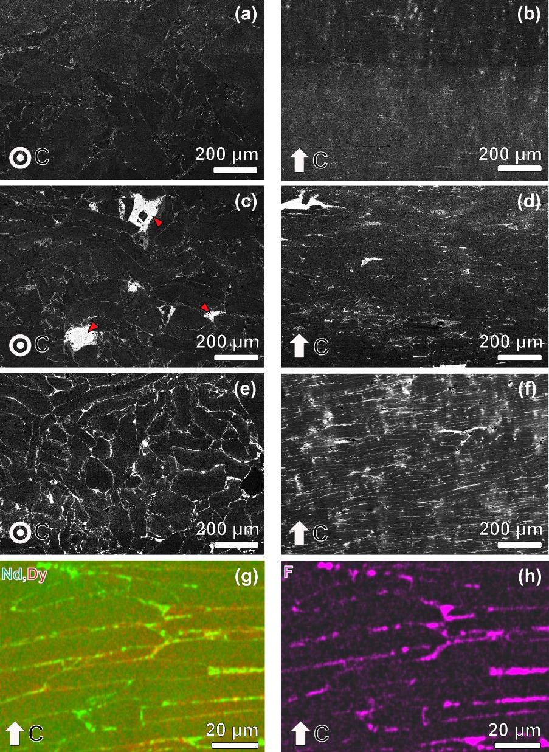
Figure 3. Low magnification BSE-SEM images obtained from (a and b) additive-free, (c and d) DyF₃ mixed, and (e and f) DyF₃-coated samples. SEM-EDS elemental mappings of (g) Nd+Dy and (h) F obtained from DyF₃-coated sample.
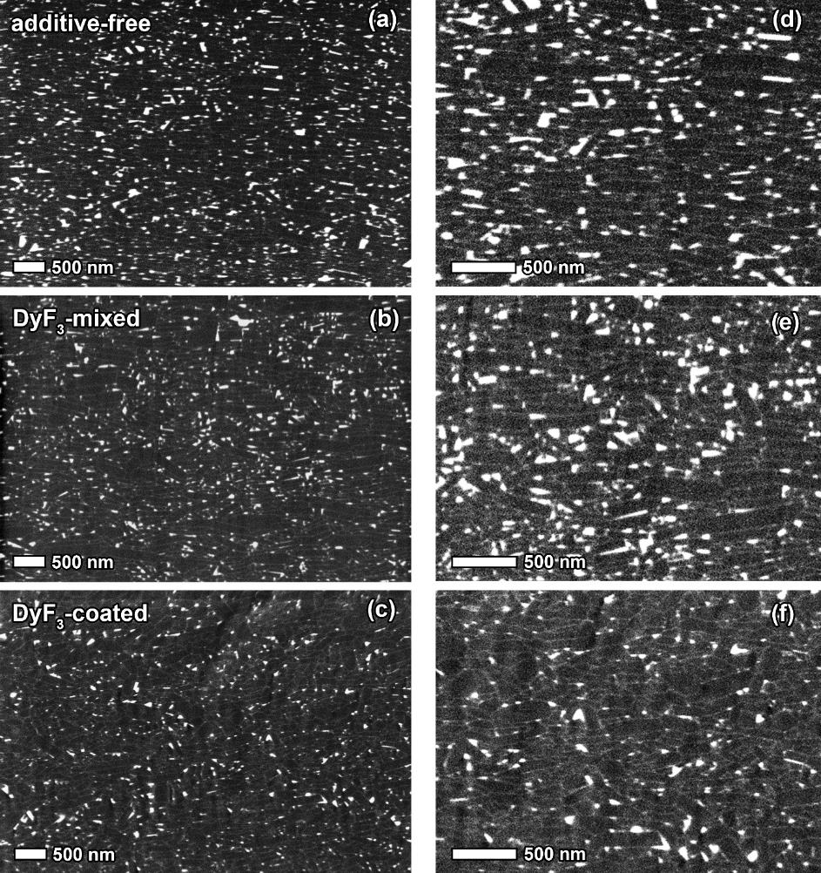
Figure 4. High magnification BSE-SEM images of (a,d) additive-free, (b,e) DyF₃ mixed, and (c,f) DyF₃-coated samples taken from inside of the magnet far from original flakes’ interfaces.
Figure 5. STEM-EDS mappings of the region close to high resistivity RE-rich layer in DyF₃-coated sample for (a) Fe, (b) F, and (c) Nd+Dy. (d) concentration profiles for Nd, Fe, F, Dy, and Ga obtained from line scan in selected rectangle shown in (b). (e and f) SAED pattern taken from high resistivity RE-rich layer.

Figure 6. (a) Schematic of the microstructure features of the DyF₃-coated sample. STEM-EDS maps of (b) region (i) and (c) region (ii).

Figure 7. (a) Schematic of the microstructure feature of the DyF₃-coated sample. APT maps of Fe, Nd, Dy, Co, B, and Ga taken from (b) region (i) and (c) region (ii). Concentration depth profiles for Fe, Nd, Dy, Co, B, and Ga determined from APT analysis for the selected boxes shown in (d) Fig. 7(b) and (e) Fig. 7(c)

Figure 8. Schematic illustration of experimental setup for evaluating the operating temperature of hot-deformed magnets under an AC magnetic field (peak to peak) with high frequency drawn from (a) Top v and (b) Side view. (c) Example of infrared image of heated sample, recorded temperatures are the average temperature of area defined by yellow circle. (d) Magnet temperature versus experiment time profile of additive-free, DyF₃-mixed, and DyF₃-coated samples under different magnetic field strengths of a 110.1 kHz sinusoidal AC field.

Figure 9. Schematic illustrations of the microstructure features of (a) additive-free, (b) DyF₃-mixed, and (c) DyF₃-coated samples. (d) Schematic illustration of the DyF₃-NdF₃ interchange during hot-deformation.

Figure 10. Remanent magnetization vs coercivity and resistivity (measured parallel to c-axis of the magnets) of the hot-deformed magnets produced in this work compared to the resistive hot-deformed magnet reported in the literature [23–26].

