Supplemental Material

Controllable Andreev Bound states in Bilayer Graphene Josephson Junctions from Short to Long Junction Limits

Geon-Hyoung Park¹, Wonjun Lee^{1,2}, Sein Park¹, Kenji Watanabe³, Takashi Taniguchi⁴,
Gil Young Cho^{1,2,5}, and Gil-Ho Lee^{1,5*}

¹Deparment of Physics, Pohang University of Science and Technology, Pohang, Republic of Korea
²Center for Artificial Low Dimensional Electronic Systems, Institute for Basic Science, Pohang, Republic of Korea
³Research Center for Electronic and Optical Materials, National Institute for Materials Science, 1-1 Namiki, Tsukuba 305-0044, Japan
⁴ Research Center for Materials Nanoarchitectonics, National Institute for Materials Science, 1-1 Namiki, Tsukuba 305-0044, Japan
⁵Asia Pacific Center for Theoretical Physics, Pohang, Republic of Korea

S1. General information on the bilayer graphene Josephson junction devices

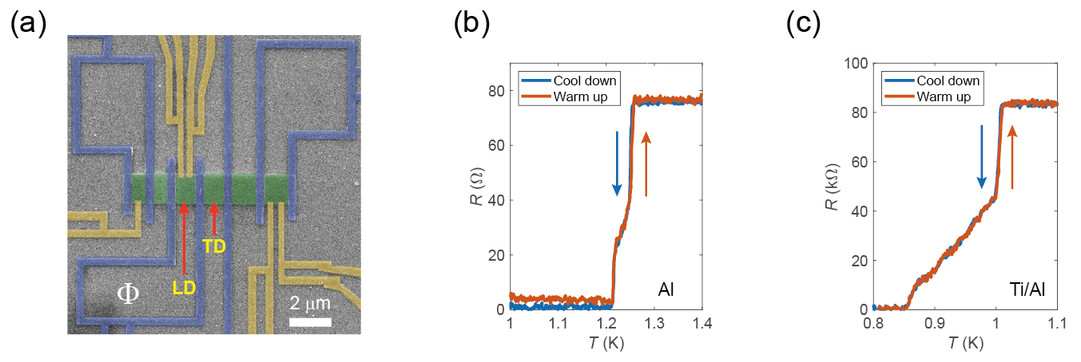

Figure S1. (a) A false-colored scanning electron microscope image of the loop type (LD) and the two-terminal type (TD) Josephson junction devices. The green area represents the bilayer graphene (BLG) layer encapsulated by top and bottom hexagonal boron nitride sheets. The blue electrodes are Ti/Al double layer for inducing Josephson coupling into the BLG and the yellow electrodes are Al tunnel probes. (b)-(c) Temperature dependence of resistance for the Al tunnel probe electrode (b) and the Ti/Al electrode (c), respectively. Each data point excluded offset resistance from the DC measurement lines using two-stage RC filters $\sim 6.2 kΩ$.

S2. Transport measurements of the two-terminal type device (device TD)
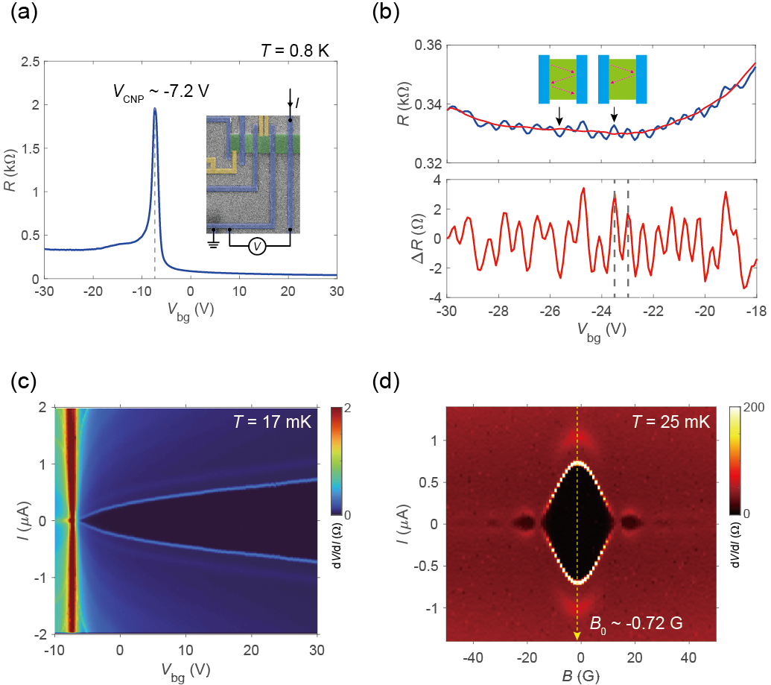

Figure S2. (a) Two-terminal resistance ($R≡{dV}/{dI}$) of the device TD as a function of backgate voltage V_{bg} at T = 0.8 K. The inset shows the measurement configuration for (a)-(d). (b) Ballistic charge transport in the BLG. (Upper panel) Fabry-Pérot-like interference occurred at the hole-doped region (blue line). The red curve represents the moving average of the original values. (Lower panel) Background subtracted periodic oscillation from the upper panel. (c) A color map of differential resistance (dV/dI) of the device TD as a function of biasing current I and V_{bg}. (d) Fraunhofer diffraction pattern of the device TD. The yellow dashed line indicates the offset value of the perpendicular magnetic field, B₀ ~ -0.72 G.

Since the loop-type device, LD is inappropriate for measuring the voltage drop in the junction, instead, we performed conventional two-terminal measurements on the device TD to confirm the quality of the BLG and JJs. The device TD has an equivalent geometry of conducting channel as the device LD, and both devices share the same BLG sheet. The electrostatic field effect of the BLG of the device TD is shown in Fig. S2(a). We refer to the charge neutral point (CNP) of the BLG where the highest resistance peak exhibits, V_{CNP} ~ -7.2 V. Slightly higher resistance in the p-doped area (V_{bg} < V_{CNP}) than in the n-doped area (V_{bg} > V_{CNP}) results from the formation of p-n junctions at the contact interfaces of BLG and Ti/Al [1-4]. Here, we also confirmed the ballistic property of the BLG channel by Fabry-Pérot-like oscillations in the p-doped region [1,2,4]. As shown in Fig. S1(b), the interference occurs when the quasiparticles undergo a series of reflections at the contact interfaces when they satisfy the resonance condition ${2L}^{*}=mλ_{F}$, where $L^{*}$ is the effective length of the cavity, m is an integer, and $λ_{F}$ is the Fermi wavelength. The moving-averaged slowly varying background (red curve in upper panel) is taken for removing the background of the oscillation. For mth $ΔR$ peak, one can use the relation $L^{*}=\frac{\sqrt{π}}{\sqrt{n_{m+1}}-\sqrt{n_{m}}}$ [5]. The average effective cavity length for selected neighbor peaks in Fig. S2(b) is $L^{*} \sim 0.94 μm$, which well matches with the designed channel length $L=1 μm$. For some reasons, the lengths of p-n junctions at the interfaces are estimated shorter (~ 30 nm) than those in other graphene Josephson junctions reported previously [1,2,4]. Figure S2(c) shows the gate dependence of differential resistance (dV/dI) as a function of I and V_{bg}. The zero resistance observed in the black region indicates the presence of proximitized superconductivity in the normal channel. The ${{eI}_{c}R_{N}}/{Δ_{TD}}$ reaches up to ~ 0.21 as the gate voltage increases to 30 V. Here, I_{c} is the critical current of Josephson junction, R_{N} is the normal resistance of the junction, and $Δ_{TD}$ is the proximity superconducting gap. Figure S2(d) shows the Fraunhofer diffraction pattern (FP) of the device TD at V_{bg} = 30 V. The period of the FP, $ΔB \sim 13.8 G$ is larger than the expected value $ΔB=Φ_{0}/[\left(L+2λ\right)×A] \sim 20.67/(1.4×1.5) \sim 9.8 G$, which is calculated with the area of the junction $A=1.5 μm$ and the magnetic field penetration depth $λ \sim 0.2 μm$ into the superconductors [6,7]. The origin of the large oscillation period is uncertain; however, it is considered to be related to the increase in the periodicity when the aspect ratio of the junction $L/W$ is large enough (1.5 for the device TD) [8].

S3. Magnetoresistance of the device TD

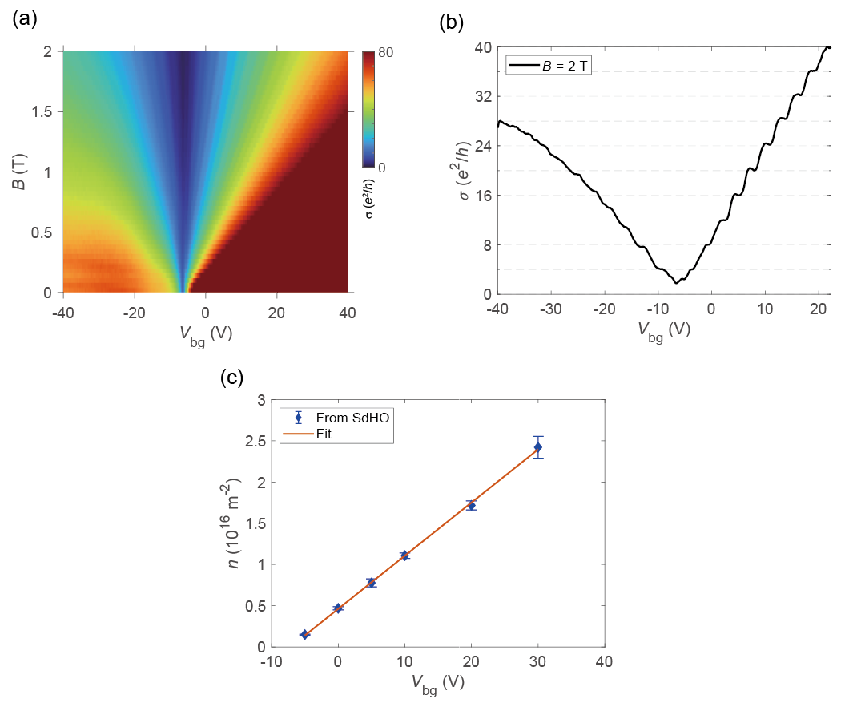
Figure S3. (a) A colormap of Landau fan diagram as a function of backgate voltage V_{bg} and magnetic field B measured from device TD. (b) A line-cut from (a) at B = 2 T. (c) Backgate dependence of the charge carrier density n extracted from Shubnikov de Haas oscillations (SdHO). All the data were measured at T = 1.6 K.

The magnetoresistance of the device TD at a high magnetic field was measured to estimate the charge carrier density of the BLG. All the measurements with a high magnetic field were performed at the Oxford Telsatron fridge with a variable temperature insert (VTI) system after the tunneling spectroscopy measurement of ABS in the main text. The two-terminal conductance in Fig. S3(b) exhibits a pronounced quantized conductance step for BLG, $σ=\frac{4e^{2}}{h}∙N$ for $N≥1$, where N is an integer, confirming our graphene sheet is a bilayer. Fig. S3(c) shows the charge carrier density n at different back gate voltages which can be estimated from the relation $n=\frac{4e}{h} ⋅{\left(\frac{1}{B_{N}}-\frac{1}{B_{N+1}}\right)}^{-1}$, where B_{N} is the magnetic field at the amplitude peak of Shubnikov de Haas oscillation (SdHO) and N is an integer. Since $n=\frac{ε_{0}ε_{r}}{de}{(V}_{bg}-V_{CNP})$, we used the linear regression method to obtain the gate efficiency coefficient $α≡\frac{ε_{0}ε_{r}}{de}\sim 6.44×{10}^{14} m^{-2}V^{-1}$ of the device, where $ε_{0}$ is the permittivity of free space, $ε_{r}$ is the relative permittivity of the dielectric layer, d is the thickness of the dielectric layer, and e is the elementary charge. Considering each thickness and permittivity of the SiO₂ layer ($d \sim 300 nm$, $ε_{r} \sim 3.9$) and the bottom hexagonal boron nitride sheet ($d \sim 26 nm$, $ε_{r} \sim 3$) [9] also expect $α$ $\sim 6.46×{10}^{14} m^{-2}V^{-1}$.

S4. Estimation of the effective mass in bilayer graphene (device TD)

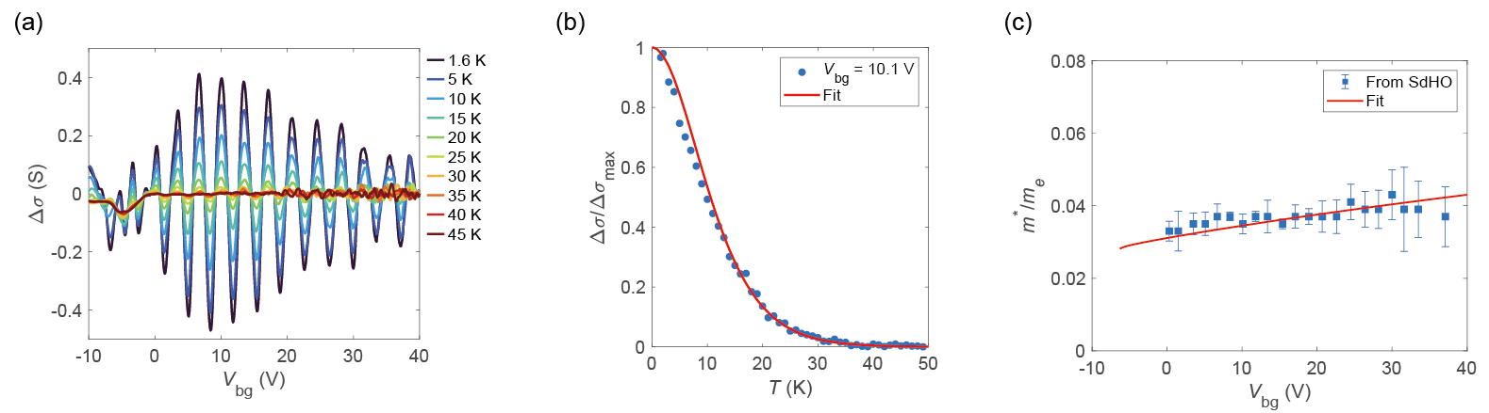

Figure S4. (a) Background subtracted SdHO amplitudes at different temperatures with B = 2 T. (b) A temperature dependence of normalized SdHO amplitudes (blue circles) at V_{bg} = 10.1 V. The red solid curve from the Lifshitz-Kosevich formula well fits the experimental data. (c) Estimated effective masses ($m_{e}^{*}$) normalized by the electron rest mass ($m_{e}$) at specific backgate voltages (blue squares). The red solid curve is the theoretical fit.

Continuing from Fig. S3, one can extract the effective mass of BLG from SdHO at different backgate voltages. We exploited the temperature dependence of SdHO amplitude following Lifshitz-Kosevich (L-K) formula which can be written as the following [10,11]:
$Amplitude \sim \frac{T}{\sinh\left(\frac{2π^{2}k_{B}Tm_{e}^{*}}{ℏeB}\right)}$,
where $m_{e}^{*}$ is the effective mass of BLG, $ℏ$ is the reduced Planck constant, and B is the magnetic field. Figure S4 (b) shows normalized SdHO amplitudes as a function of temperature (blue circles) and the best L-K fit (red solid line) at V_{bg} = 10.1 V. From the fitting, we estimated effective masses of BLG at different backgate voltages as shown in Fig. S4 (c). The estimated $m_{e}^{*}$ exhibits 0.03$\sim 0.04 m_{e}$, where $m_{e}$ is the electron rest mass. We found that these values are similar to the $m_{e}^{*}$ from references 10 and 11 using the same method. The red fitting curve is calculated $m_{e}^{*}$ from the quadratic energy dispersion relation: $m_{e}^{*}=ℏ^{2}{\left(\frac{∂^{2}E}{∂k_{F}^{2}}\right)}^{-1}$. The lowest energy band $E$ was calculated using an approximated tight-binding method, neglecting interlayer asymmetry [12]. The following dispersion relation quotes the notations from the Slonczewski-Weiss-McClure model [13-15].
$E≈\frac{1}{2}γ_{1}[\sqrt{1+4v^{2}p^{2}/γ_{1}^{2}}-1]$,
where $γ_{1}$ is the hopping parameter between interlayer atoms (dimer sites), and $v=\sqrt{3}aγ_{0}/2ℏ$ is the band velocity of monolayer graphene, with $γ_{0}$ representing the hopping parameter between nearest-neighbor intralayer atoms. We used $γ_{0}=3.43 eV$ and $γ_{1}=0.4 eV$ for the best fit to the experimental data in Fig. S4 (c).

S5. Additional data for phase dependence of ABS (device LD)
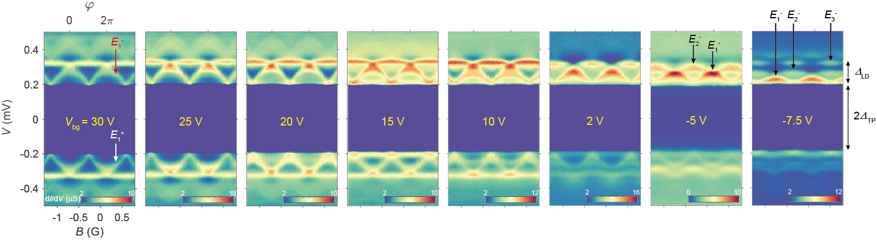
Figure S5. Additional dataset of differential tunnel conductance dI/dV as a function of bias voltage V and magnetic field B. All the data were measured at T = 17 mK.

S6. Numerical calculation of ABS in a bilayer graphene Josephson junction
In this section, we will discuss the details of calculating the spectrum of ABS in a BLG Josephson junction used in the main text. To achieve this, we will first introduce our theoretical model for the system, followed by detailed steps for computing the spectrum specifically using the scattering formalism.
We consider a situation in which superconductors are placed on both sides of a BLG strip with length $L$. A tunneling probe is located at one-third along the longitudinal direction of the strip, resembling the configuration of the device LD. The presence of this tunneling probe will be effectively modeled as a scatterer at its position [16].
Next, let us move on to the computation of the spectrum of ABS in BLG JJ. In the ballistic limit, electrons form freely propagating waves within the BLG strip. These waves scatter upon reaching the boundaries of the superconductors [17] or some other impurities and potential walls within the bulk [18-20]. Due to these scatterers, only some resonant waves known as ABS with specific energies are allowed, not all wave numbers [21]. Our goal here is to find such a resonant wave using the scattering formalism [18,22].
Formally, the freely propagating waves of BLG JJ can be obtained by solving the Dirac-Bogoliubov-De-Gennes (DBdG) equation [22,23]
$$\left[\begin{matrix}H-μ & 0 \\ 0 & μ-H\end{matrix}\right]\left[\begin{aligned}Ψ_{e} \\ Ψ_{h}\end{aligned}\right]=ϵ\left[\begin{aligned}Ψ_{e} \\ Ψ_{h}\end{aligned}\right]$$
with the energy $ϵ$ and the chemical potential $μ$. Here, $Ψ_{e}$ and $Ψ_{h}$ are electron and hole waves in the strip, and $H$ is the Hamiltonian of BLG which is given by [12,19,24]
$$H=\left[\begin{matrix}U & v_{F}π^{†} & 0 & 0 \\ v_{F}π & U & γ_{1} & 0 \\ 0 & γ_{1} & U & v_{F}π^{†} \\ 0 & 0 & v_{F}π & U\end{matrix}\right]$$
with the momentum $π=-iℏ\left(∂_{x}+ik_{y}\right)$, the on-site energy $U$, the Fermi velocity $v_{F}$, and the interlayer coupling $γ_{1}=0.39 eV$. The y-directional momentum $k_{y}$ is a free parameter that can be independently fixed from $ϵ$ via fitting. The Hamiltonian can be simplified by rescaling the coordinates $x→\frac{γ_{1}}{ℏv_{F}}x$ and $k_{y}→\frac{ℏv_{F}}{γ_{1}}k_{y}$. The eigenstates of the Hamiltonian are given as the columns of $M\left(ϵ\right)$ up to normalization factors
$$M\left(ϵ\right)=\left[\begin{matrix}θ_{00} & θ_{10} & θ_{01} & θ_{11} \\ 1 & 1 & 1 & 1 \\ -1 & 1 & -1 & 1 \\ θ_{01} & -θ_{10} & θ_{00} & -θ_{10}\end{matrix}\right]$$
with the energy $ϵ$. Here, $θ_{ab}$ is given by
$$θ_{ab}=-i\left[k_{y}+{\left(-1\right)}^{b}k_{x,a}\right]/ϵ^{'}$$
with $ϵ^{'}=ϵ-U/γ_{1}$ and the wave numbers $k_{x,a}={\left[{ϵ^{'}}^{2}+{\left(-1\right)}^{a}ϵ^{'}-k_{y}^{2}\right]}^{\frac{1}{2}}$. The electron and hole waves are coupled by the superconductors at the boundaries of the strip by [22-24]
$$Ψ_{h}=UΨ_{e}$$
with $U=I⊗e^{-iφ/2-iβ\hat{n}⋅σ}$, $β=\arccos\left(ϵ/Δ_{0}\right)$, the phase difference $φ$ between the superconductors, and the superconducting gap $Δ_{0}$.
The spectrum of ABS in the BLG JJ can be obtained by finding the solutions to the resonance condition introduced by the scattering formalism [18,22]:
$\det\left(I-{\left[M\left(-ϵ\right)\right]}^{-1}UM\left(ϵ\right)Λ\left(-L/3\right)T_{M}^{-1}Λ\left(-2L/3\right){\left[M\left(ϵ\right)\right]}^{-1}UM\left(-ϵ\right)Λ\left(2L/3\right)T_{M}Λ\left(L/3\right)\right)=0$.
Here, $Λ\left(l\right)=diag\left\{e^{ik_{x,0}},e^{ik_{x,1}},e^{-ik_{x,0}},e^{-ik_{x,1}}\right\}$ is the diagonal matrix whose entries are phases accumulated when the waves propagate to the distance $l$. In addition, $T_{M}$ represents the transfer matrix of the effective scatterer, which accounts for the effect of the tunneling probe [16]. We designed this scatterer to mix left and right propagating waves within each layer, considering that the interlayer coupling is relatively small compared to the experimentally relevant range of chemical potential. Formally, the transfer matrix of the scatterer is set by $T=-i\left[I⊗I-rσ_{x}⊗I\right]/ t$, where$t$ and $r$ denote the transmission and reflection components of the scattering matrix of the scatterer. They are related by $t=\sqrt{1-r^{2}}$, and one of them serves as a free parameter determined through fitting. The transmission component $t$ is related to the transparency $τ$ of the junction by $τ={\left|t\right|}^{2}$. Intuitively, the resonance condition finds a bound state that regains the initial state after completing a round trip along the strip with scatterings. Therefore, solutions to the resonance condition can be found by varying the energy $ϵ$ of the bound state and checking if the determinant vanishes.
The remainder of this section is dedicated to the discussion of the fitting process. There are two parameters that influence the spectrum of the ABS: the y-directional momentum and the transmission component $t$ of the scattering matrix. We need to identify these parameters in a way that aligns the theoretical expectations with the experimentally measured ones. To this end, we find that low y-directional momentums of $k_{y}≤16π/W$ with the width of the junction $W=1.5 μm$ adequately explain the experimental data, as shown in Fig. S6(a). The suppression of the large y-directional momentum is consistent with what we intuitively expect: the ABSs with the finite y-directional momentum(scattering with oblique angles at the interface of superconductors and normal metal) require electrons to travel much longer lengths to experience the “constructive interference” (the origin of the ABS). However, the longer the electrons travel, the more decoherence the electrons would feel. This will naturally suppress the formation of such bound states in experiments. Furthermore, we take the ABS with the zero y-directional momentum as the representative of the low y-directional ABSs as their spectral properties are indistinguishable within the experimental resolution of our tunneling probes, as shown in Fig. S6(b). Subsequently, we search the optimal transmission matrix component for each backgate voltage by minimizing the difference between the theoretical and experimentally measured spectra, which nicely reproduces the experimental data.

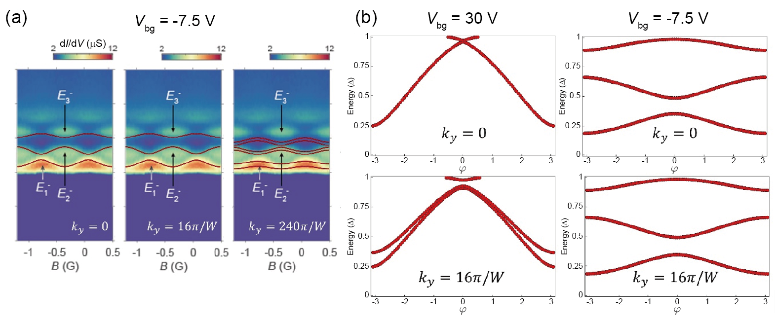
Figure S6. (a) The energy spectrum of Andreev bound states with various y-directional momentum over the experimentally-measured differential conductance at the backgate voltage V_{bg} = -7.5 V. The transmission matrix component of the effective scatterer is set as t = 0.75. (b) The energy spectrum of Andreev bound states with various y-directional momentums at the given backgate voltages. Calculations are done with the transmission matrix components t = 0.95 and t = 0.75 of the effective scatterers for the backgate voltages V_{bg} = 30 V and V_{bg} = -7.5 V, respectively.

S7. Temperature dependence of Andreev bound states (device LD)
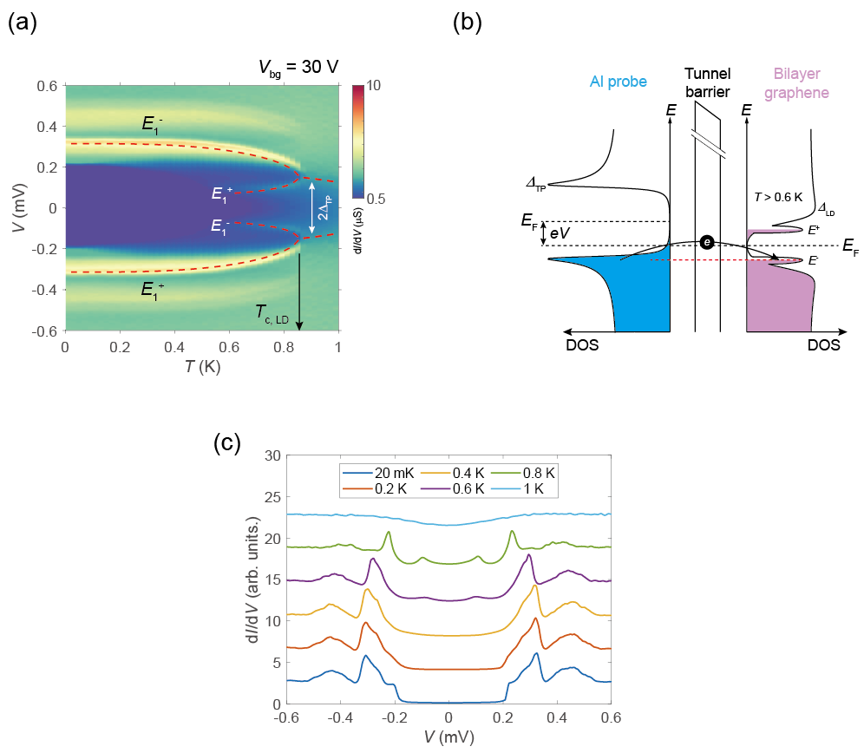

Figure S7. (a) A color map of tunneling differential conductance (dI/dV) as a function of bias voltage and temperature. Red dashed curves represent the theoretical calculation of temperature dependence of $E_{1}^{±}$, $Δ_{LD}$ and $Δ_{TP}$. (b) A schematic of the energy diagram for additional electron tunneling from the tunneling probe to the ABS below the Fermi level ($E^{-}$) at $T>0.6 K$. (c) A set of voltage bias line cuts at selected temperatures from (a). For visibility, each line cut has y-axis offsets except for the one measured at 20 mK.

Figure S7 shows the temperature dependence of ABS at a fixed phase difference $φ=0$ with V_{bg} = 30 V. In Fig. S7(a), two differential tunnel conductance peaks from $E_{1}^{±}$ are clearly shown under $T_{c,LD}=0.85 K$. We found that the temperature dependence of the superconducting gap from the Bardeen-Cooper-Schrieffer (BCS) theory (red dashed curves) well fits our experimental data [25]. For the convenience in calculation, we used the following interpolating function instead of the original equation [26]:
$Δ\left(T\right)=1.76k_{B}T_{c}\tanh\left(1.74\sqrt{\frac{T_{c}-T}{T}}\right)$,
where $k_{B}$ is the Boltzmann constant, and $T_{c}$ is the critical temperature of the superconductor. Here, we assume that $Δ_{LD}≈E_{1}^{±}\left(φ=0\right)$since the transparency of the channel is 0.95 at V_{bg} = 30 V (See the discussion about transparencies of the device LD in the main text). At ${T>T}_{c,LD}$, the dI/dV peaks from ABS disappear, and only the conductance dip structure from $Δ_{TP}$ survives.
We observed weak dI/dV peaks at $eV<|Δ_{TP}|$ at $0.6 K<T<T_{c,LD}$ which were also found in the previous report with monolayer graphene JJ [27]. As shown in Fig. S7(b), a portion of the electrons in the $E_{1}^{-}$state can be thermally excited when the temperature is high enough, forming an empty state inside $E_{1}^{-}$. In that case, tunnel current can additionally occur even below the bias energy $eV<\left|Δ_{TP}\right|$.

S8. Replicas of Andreev bound states

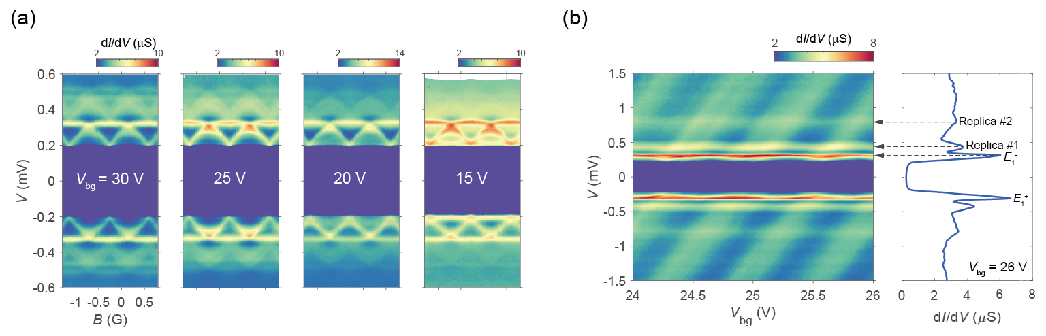

Figure S8. (a) A set of differential tunnel conductance (dI/dV) color maps as a function of bias voltage V and magnetic field B for selected backgate voltages. (b) (Left panel) Bias dependence of differential tunnel conductance as a function of backgate voltage at a fixed phase difference $φ=0$. (Right panel) A bias voltage line cut from the left panel at V_{bg} = 26 V. The dashed arrows indicate replicas of the original ABS ($E_{1}^{-}$).

While measuring the tunneling conductance, we observed additional dI/dV peaks even when $eV>|{Δ_{TP}+Δ}_{LD}|$. In Fig. S8(a), the above gap peaks appear to be replicas of the original peaks including both phase-dependent ABS and the non-phase-dependent proximity gap, $Δ_{LD}$. Below V_{bg} < 15 V, observing these replicas becomes challenging (see Fig. S5). Moreover, extended bias energy measurement in Fig. S8(b) shows that secondary replica peaks (Replica #2) appear around $eV=±0.8 meV$. It seems that the replica peaks have little gate voltage dependence. However, separately from this, we observed gate-dependent dI/dV peaks (slanted dI/dV peaks in Fig. S8(b)) that appear to be the result of unintentional quantum dots inside the tunnel barrier or within the BLG channels [28,29].
To the best of our knowledge, we have not found any reports identical to our observation. Instead, we found explanations for the additional conductance or resistance peaks at specific bias energies in S-N-S or S-N devices by multiple Andreev reflections [30], or McMillan-Rowell oscillation [31]. Note that photon-assisted tunneling [32] has been excluded as the origin since we did not apply any photon irradiations on the device.

References

[1] V. E. Calado, S. Goswami, G. Nanda, M. Diez, A. R. Akhmerov, K. Watanabe, T. Taniguchi, T. M. Klapwijk, and L. M. K. Vandersypen, Nat. Nanotechnol. 10, 761 (2015).
[2] M. Ben Shalom et al., Nat. Phys. 12, 318 (2016).
[3] I. V. Borzenets et al., Phys. Rev. Lett. 117, 237002 (2016).
[4] J. Park, J. H. Lee, G.-H. Lee, Y. Takane, K.-I. Imura, T. Taniguchi, K. Watanabe, and H.-J. Lee, Phys. Rev. Lett. 120, 077701 (2018).
[5] C. Handschin, P. Makk, P. Rickhaus, M.-H. Liu, K. Watanabe, T. Taniguchi, K. Richter, and C. Schönenberger, Nano Lett. 17, 328 (2017).
[6] H. B. Heersche, P. Jarillo-Herrero, J. B. Oostinga, L. M. K. Vandersypen, and A. F. Morpurgo, Nature 446, 56 (2007).
[7] D. Jeong, J.-H. Choi, G.-H. Lee, S. Jo, Y.-J. Doh, and H.-J. Lee, Phys. Rev. B 83, 094503 (2011).
[8] V. Barzykin and A. M. Zagoskin, Superlattices Microstruct. 25, 797 (1999).
[9] A. Laturia, M. L. Van de Put, and W. G. Vandenberghe, NPJ 2D Mater Appl. 2, 6 (2018).
[10] K. Zou, X. Hong, and J. Zhu, Phys. Rev. B 84, 085408 (2011).
[11] J. Li, L. Z. Tan, K. Zou, A. A. Stabile, D. J. Seiwell, K. Watanabe, T. Taniguchi, S. G. Louie, and J. Zhu, Phys. Rev. B 94, 161406(R) (2016).
[12] M. Edward and K. Mikito, Rep. Prog. Phys. 76, 056503 (2013).
[13] J. W. McClure, Phys. Rev. 108, 612 (1957).
[14] J. C. Slonczewski and P. R. Weiss, Phys. Rev. 109, 272 (1958).
[15] J. W. McClure, Phys. Rev. 119, 606 (1960).
[16] P. Samuelsson, J. Lantz, V. S. Shumeiko, and G. Wendin, Phys. Rev. B 62, 1319 (2000).
[17] C. W. J. Beenakker, Phys. Rev. Lett. 97, 067007 (2006).
[18] G. B. Lesovik and I. A. Sadovskyy, Phys.-Usp. 54, 1007 (2011).
[19] M. Barbier, P. Vasilopoulos, and F. M. Peeters, Phys. Rev. B 82, 235408 (2010).
[20] S. Pinon, V. Kaladzhyan, and C. Bena, Phys. Rev. B 101, 205136 (2020).
[21] J. A. Sauls, Phil. Trans. R. Soc. A 376, 20180140 (2018).
[22] M. Titov and C. W. J. Beenakker, Phys. Rev. B 74, 041401 (2006).
[23] T. Ludwig, Phys. Rev. B 75, 195322 (2007).
[24] I. Snyman and C. W. J. Beenakker, Phys. Rev. B 75, 045322 (2007).
[25] J. Bardeen, L. N. Cooper, and J. R. Schrieffer, Phys. Rev. 108, 1175 (1957).
[26] F. Gross, B. S. Chandrasekhar, D. Einzel, K. Andres, P. J. Hirschfeld, H. R. Ott, J. Beuers, Z. Fisk, and J. L. Smith, Z. Phys. B 64, 175 (1986).
[27] S. Park et al., Nature 603, 421 (2022).
[28] J. I.-J. Wang, L. Bretheau, D. Rodan-Legrain, R. Pisoni, K. Watanabe, T. Taniguchi, and P. Jarillo-Herrero, Phys. Rev. B 98, 121411(R) (2018).
[29] J. D. Pillet, C. H. L. Quay, P. Morfin, C. Bena, A. L. Yeyati, and P. Joyez, Nat. Phys. 6, 965 (2010).
[30] J. Lantz, V. S. Shumeiko, E. Bratus, and G. Wendin, Phys. Rev. B 65, 134523 (2002).
[31] J. M. Rowell and W. L. McMillan, Phys. Rev. Lett. 16, 453 (1966).
[32] B. W. Heinrich, L. Braun, J. I. Pascual, and K. J. Franke, Nat. Phys. 9, 765 (2013).

