Bulks of Al-B-C obtained by reactively spark plasma sintering and impact properties by Split Hopkinson Pressure Bar

O. Vasylkiv^{1*}, H. Borodianska¹, D. Demirskyi^{1,2*}, P. Li^{3,4}, T.S. Suzuki¹, M. Grigoroscuta⁵, I. Pasuk⁵, A. Kuncser⁵, P. Badica^{5*}

¹National Institute for Materials Science, 1-2-1 Sengen, Tsukuba, Ibaraki 305-0047, Japan
²WPI-Advanced Institute for Materials Research (WPI-AIMR), Tohoku University, 2-1-1 Katahira, Aoba-ku, Sendai, 980-8577 Japan
³James Watt School of Engineering, University of Glasgow, Glasgow G12 8QQ, U.K.
⁴School of Mechanical and Aerospace Engineering, Nanyang Technological University, Singapore
⁵National Institute of Materials Physics, street Atomistilor 405A, 077125 Magurele, Ilfov, Romania

*Corresponding authors:
Oleg Vasylkiv, oleg.vasylkiv@nims.go.jp /phone +81-(0)80-4144-4747
Dmytro Demirskyi, demirskyi.dmytro.e2@tohoku.ac.jp /phone +81-(0)70-2010-6281
Petre Badica, badica2003@yahoo.com /phone: +40-21-3690185

Submitted to Scientific Reports, Springer
Bulks of Al-B-C obtained by reactively spark plasma sintering and impact properties by Split Hopkinson Pressure Bar

O. Vasylkiv^{1*}, H. Borodianska¹, D. Demirskyi^{1,2*}, P. Li^{3,4}, T.S. Suzuki¹, M. Grigoroscuta⁵, I. Pasuk⁵, A. Kuncser⁵, P. Badica^{5*}

¹National Institute for Materials Science, 1-2-1 Sengen, Tsukuba, Ibaraki 305-0047, Japan
²WPI-Advanced Institute for Materials Research (WPI-AIMR), Tohoku University, 2-1-1 Katahira, Aoba-ku, Sendai, 980-8577 Japan
³James Watt School of Engineering, University of Glasgow, Glasgow G12 8QQ, U.K.
⁴School of Mechanical and Aerospace Engineering, Nanyang Technological University, Singapore
⁵National Institute of Materials Physics, street Atomistilor 405A, 077125 Magurele, Ilfov, Romania

Abstract
Mixtures of B₄C, α-AlB₁₂ and B powders were reactively spark plasma sintered at 1800 °C. Crystalline and amorphous boron powders were used. Samples were tested for their impact behavior by the Split Hopkinson Pressure Bar method. When the ratio R = B₄C/α-AlB₁₂ ≥ 1.3 for a constant B-amount, the major phase in the samples was the orthorhombic AlB₂₄C₄, and when R < 1 the amount of AlB₂₄C₄ significantly decreased. Predictions that AlB₂₄C₄ has the best mechanical impact properties since it is the most compact and close to the ideal cubic packing among the Al-B-C phases containing B12-type icosahedra were partially confirmed. Namely, the highest values of Vickers hardness (32.4 GPa), dynamic strength (1323 MPa), strain and toughness were determined for the samples with R =1.3, i.e. for the samples with a high amount of AlB₂₄C₄. However, the existence of a maximum, visible especially in the dynamic strength vs. R, indicated the additional influence of the phases and the composites microstructure in the samples. The type of boron does not influence the dependencies of the indicated mechanical parameters with R, but the curves are shifted to slightly higher values for the samples in which amorphous boron was used.

Keywords: Al-B-C system, icosahedron B₁₂-like containing phases, spark plasma sintering, impact properties
1. Introduction

Compounds such as borides with a strongly covalent character show excellent wear resistance and hardness, refractoriness, and chemical inertness properties. Boron carbide (BC) which is traditionally described by chemical formula B₄C fits this category. Boron carbide is also a light-weight material with low density of 2.51 g/cm³. Although fabrication of BC does not need high processing pressures as in the case of diamond or cubic BN, due to its covalent character processing temperatures are high and it is difficult to obtain it into high density parts and with complex shapes. Under compressive high velocity impact, resistance of BC is considered to decrease due to a local process of amorphization [1]. Presented advantages and problems of BC, on the one hand led to fabrication and assessment of new BC- based materials, and on the other hand prompted search for new materials with crystal structures inspired by BC. In the first case, strategies are designed to overcome the difficulties by using additives for chemical substitutions in the crystal structure of boron carbide or for formation of novel BC-based composites, where the effort is directed towards control of the interfaces between the component phases. In the second case, of much interest are materials in the Al-B-C system [2-7] especially those in which, similar to BC, there are icosahedral units. Icosahedral units are considered to play an important role in defining outstanding mechanical properties of these materials. The most studied is phase α-AlB₁₂ composed of B₁₂ icosahedra. This material can serve as a model for other structurally alike phases, e.g. AlB₂₄C₄ (known also in early refs. as AlB₁₀). The crystal structure of BC phases, namely α-AlB₁₂ (Al_{0.083}B) AlB₁₂C₂ (Al_{0.5}B₆C or Al_{0.083}BC_{0.167}) or AlB₂₄C₄ (Al_{0.25}B₆C or Al_{0.0416}BC_{0.167}) can be viewed as a stack of B12-like icosahedra packed into rhombohedral, tetragonal, rhombohedral, and orthorhombic unit cells, respectively [2]. In between icosahedra there are chains (e.g. C-B-C in B₄C [1]). Koroglu and Thomson [2] suggested that impact resistance of these materials depends on icosahedra sliding. Sliding of icosahedra is influenced by their packing, chains formation, and the elements composing the chain. A more compact and as close as possible to a cubic ideal packing is expected to provide the best impact resistance properties, but no evidence was presented in support of this idea. Limited information is available on the assessment of impact properties of the mentioned Al-containing phases in the Al-B-C system. To the authors knowledge there are only few articles on this topic [7-9]. Ref. [7] considers α-AlB₁₂ for armor in aircraft protection, while in ref [8] authors discuss fractography details in ballistic impact experiments for body armor applications. Limited literature on impact properties of Al-B-C materials is partially explained by difficult synthesis and processing of these materials as single phases and dense bulks. Some phase diagrams were reported [5], but they are not fully resolved. Stoichiometry, crystal structure and stability domains of different B₁₂-like icosahedra-containing phases, including B₄C, need further clarifications. Another problem is the quality of the available raw materials. For example, commercial powders of B₄C are prepared by metalothermal methods [10] and impurity elements are often detected. These elements can stabilize the main phases or generate new ones. It is worthy to note that Al-B-C system is sensitive to Si [11] or N [12] presence. Selection of the optimum processing parameters vs. raw powders and vs. targeted phase deserves extended attention.
Our work explores fabrication of dense samples in the Al-B-C system by spark plasma sintering and their compressive impact resistance assessment by SHPB (Split Hopkinson Pressure Bar) tests. Sintering temperature is 1800 °C. We use as raw powders B₄C, α-AlB₁₂ and B. Boron is supplied as crystalline and amorphous. Compositions are selected in the B-rich corner of the Al-B-C system (Fig. 1, Table 1). Structurally, the major phase is identified from x-ray diffraction (XRD) patterns as the orthorhombic AlB₂₄C₄ when the B₄C amount relative to α-AlB₁₂ is high for the constant B-amount, i.e. when the ratio R = B₄C/α-AlB₁₂ ≥ 1.3. As the major phase is the most compact and close to ideal cubic packing among the Al-B-C B12-type phases, expectations are according to ref. [2] that samples with R ≥ 1.3 should have the best impact mechanical properties. Our results partially confirm this assumption: indeed samples with R=1.3 rich in AlB₂₄C₄ show the maximum values of Vickers Hardness (HV), the dynamic strength (σ_{SHPB}), strain (e_{SHPB}), and toughness (T_{SHPB}). When R<1, the amount of AlB₂₄C₄ significantly decreases, new phases form and the indicated mechanical parameters rapidly deteriorate. The existence of a maximum in the curves of mechanical parameters as a function of R, clearly revealed for the σ_{SHPB}(R) curve, suggests that the phase assembly and the composite microstructure of the samples are also important. Use of amorphous boron promotes slightly higher values of the mechanical parameters without influencing their dependence on R.
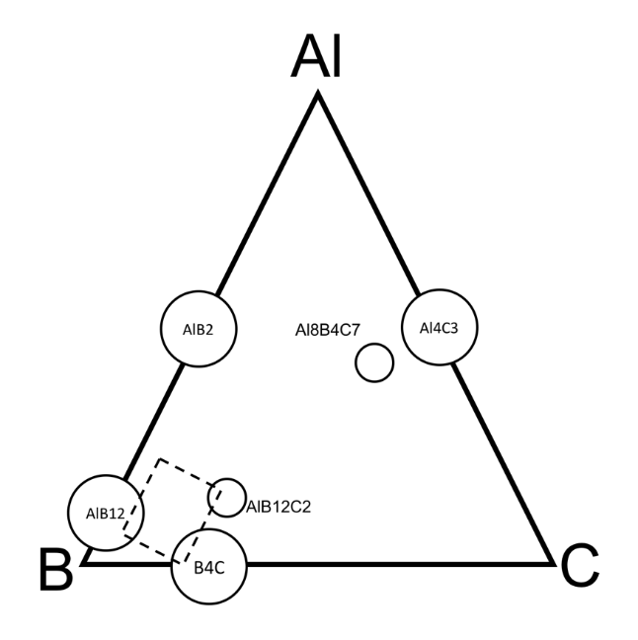
Fig. 1 Phases in the Al-B-C system (adapted from ref. 5] Dashed area show powder mixtures investigated in the present study (see Table 1 for composition details).

Table 1 Samples, starting composition, density, and relative density. With index 1 and 2 are indicated amorphous (B1) and crystalline (B2) boron, respectively.
Sample | Starting  Composition (wt. %) | Ratio B₄C/α-AlB₁₂ when B is normalized to 1 | Theoretical density, ρ_{T} [g/cm³] | Apparent bulk density, ρ_{a}  [g/cm³] | Relative density, ρ_{R} (%)
2711 | 80 (80 B₄C + 20 B1) +  20 (90 AlB₁₂ + 10 B1) | 3.5 : 1 = 3.5 | 2.513 | 2.49 | 0.99
2612 | 80 (80 B₄C + 20 B2) +  20 (90 AlB₁₂ + 10 B2) | 3.5 : 1 = 3.5 | 2.513 | 2.45 | 0.97
3021 | 60 (80 B₄C + 20 B1) +  40 (90 AlB₁₂ + 10 B1) | 3 : 2.25 = 1.33 | 2.520 | 2.47 | 0.98
3122 | 60 (80 B₄C + 20 B2) +  40 (90 AlB₁₂ + 10 B2) | 3 : 2.25 = 1.33 | 2.520 | 2.42 | 0.96
3631 | 40 (80 B₄C + 20 B1) +  60 (90 AlB₁₂ + 10 B1) | 2.28 : 3.85 = 0.59 | 2.527 | 2.49 | 0.98
3532 | 40 (80 B₄C + 20 B2) +  60 (90 AlB₁₂ + 10 B2) | 2.28 : 3.85 = 0.59 | 2.527 | 2.50 | 0.99
3341 | 20 (80 B₄C + 20 B1) +  80 (90 AlB₁₂ + 10 B1) | 1.33 : 6 = 0.22 | 2.534 | 2.46 | 0.97
3442 | 20 (80 B₄C + 20 B2) +  80 (90 AlB₁₂ + 10 B2) | 1.33 : 6 = 0.22 | 2.534 | 2.49 | 0.98

2. Methods

2.1 Materials and SPS processing

Raw powders were B₄C, α-AlB₁₂ and B. Boron carbide was supplied by Kojundo Chemical Laboratory Co. Ltd, Japan. The BC powder has shown by energy dispersive spectroscopy (EDS) traces of mostly Ca, and others impurity elements such as Mg, Si, Fe, Cu, and Na. The powder of α-AlB₁₂ was synthesized from B₄C and Al powders in vacuum at 1400 °C followed by chemical leaching of impurity phases [13]. The X-ray diffraction (XRD) pattern is presented in Fig. 2. Boron was used in two forms: amorphous denoted B1 produced by Chim Reactiv co. Ltd., Donetsk, Ukraine and crystalline denoted B2 supplied by Wako Pure Chemical Industries, Ltd., Osaka, Japan. XRD patterns and other details of these boron powders were reported in ref. [14]. Raw powders were mixed in ethanol using a plastic jar and balls. Starting compositions are presented in Table 1. After drying in air at 100°C, powder mixtures were screened through sieves of 200 and 400 mesh (74 and 37 μm).

Powder mixtures were wrapped into Ta-foil (Sigma-Aldrich Chemie, 0.025 mm thick), then into a graphite foil and introduced in a graphite die system. Loaded dies were placed in the processing chamber of a ‘Dr. Sinter’ SPS apparatus (Sumitomo, Japan).

Preliminary SPS experiments to find sintering window were conducted on α-AlB₁₂ powder. For a force pressure of 8 kN 100 MPa, sample was heated with 50 °C/min up to 2000 °C and displacement of the punches was in-situ recorded by the SPS machine. By this procedure it was established that a temperature of 1800 °C is necessary for sample consolidation. At temperatures of 1400 and 1600 °C phase AlB₁₂C₂ forms according to refs. [3] and [2], respectively. Phase AlB₂₄C₄ was not found implying that its domain of stability is at higher temperatures. Therefore, the selected SPS temperature of 1800 °C was expected to promote not only fabrication of high density bulk samples, but also reactive formation of AlB₂₄C₄ phase.

Considering preliminary SPS experiments, samples from Table 1 were processed at 1800 °C for 6 min under a flow of Ar gas (2 l/min). Furnace cooling was used. Samples were 10 mm in diameter and ∼3 mm thickness.

2.2 Materials characterization

The apparent bulk density ρ_{a} (Table 1) of the SPS-ed samples was determined by Archimedes method using ethanol and according to ASTM B 963–08. The relative density ρ_{R} (Table 1) was estimated as the ratio between the apparent (ρ_{a}) and theoretical densities (ρ_{T}). Theoretical density was calculated considering starting compositions and theoretical densities of B₄C, α-AlB₁₂, and B (2.54, 2.51 and 2.37 g/cm³).

X-ray diffraction (XRD) measurements were made with a Bruker AXS D8 Advance diffractometer (Cu_{Kα} radiation).

Microstructure and fractography details of the SPS-ed samples were observed with scanning electron microscopes (SEM, Tescan Lyra 3 and Hitachi SU 8000) equipped with energy dispersive spectroscopy (EDS) detectors. Investigations by transmission electron microscopy were undertaken with JEM 2100 TEM.
The average Vickers hardness (ASTM C 1327–15) was determined for at least 8 indentations performed at a load of 9.8 N (1 Kgf) by using a MMT-7 tester apparatus produced by Matsuzawa SEIKI Co., Ltd., Japan.
The uniaxial dynamic compression tests on SPS-ed samples from Table 1 were conducted at high strain rates of approximately 1000 s⁻¹ in a SHPB system, which has been successfully used to characterize various other ceramics including silicon carbide [15], alumina [16, 17], boron carbide [18, 19] and MgB₂ [20]. The end surfaces of the SPS-ed samples were polished and then examined in optical microscope prior to mechanical testing; only the samples without surface defects were tested. The sample ends were lubricated with Castrol LMX grease to minimize the interfacial friction. The SHPB system consists of 20 mm diameter YAG300 maraging steel striker (length 400 mm), input (length 1200 mm) and output (length 1200 mm) bars. A pair of wave impedance-matched cylindrical tungsten carbide inserts (diameter 17 mm and length 17 mm) was sandwiched between the bars and specimen to prevent the indentation into the steel bars by the hard ceramic sample. The steel sleeves were used to confine and further strengthen the inserts such that they could remain intact prior to the sample failure. Both input and output bars were instrumented with TML strain gauges (Tokyo Sokki Kenkyujo Co. Ltd., Japan, gauge factor of 2.11). Signals recorded from strain gauges were used to calculate the stress and strain histories based on the one-dimensional elastic bar wave theory for a pulse propagating in a uniform bar. The SHPB dynamic toughness (T_{SHPB}) was evaluated as the area below the measured strain–stress curve. The details about the SHPB system and subsequent analysis of measured strain waves can be found in the previous work [16, 17].

3. Results
3.1 Phase assembly and microstructure of the bulk samples obtained by SPS
XRD patterns of the SPSed samples (Table 1) fabricated from the amorphous boron raw powder B1 are presented in Fig. 2. Similar results are recorded for samples fabricated by using the crystalline boron powder B2 (Fig. 1 Supplementary material). The following observations are of interest:

Fig. 2 XRD patterns of the α-AlB₁₂ raw powder and of SPS-ed samples fabricated from amorphous boron powder (B1) from Table 1. For sintered samples, XRD spectra are normalized to the intensity of the peak of B₄C at 2θ=23.28°. Identified phases are: 1-AlB₂₄C₄ (PDF 04-008-1822), 2-Al_{0.3}B_{13.3}C_{1.3} (PDF 04-009-9091), 3-Al₃BC (PDF 04-011-6299), 4-Al₄B₂O₉ (PDF 00-029-0010), 5-Al₂O₃ (PDF 00-046-1212), 6-AlB₃₁ (PDF 01-080-0621), 7- SiO₂ (PDF 04-005-4719), *-TaB₂ (PDF 04-003-6084), **-C (PDF 00-056-0159), ***-AlBO₃ (PDF 00-032-0004), and ****-B_{0.38}C_{0.62} (PDF – 04-014-0540).

(i) - The α-AlB₁₂ peaks in the XRD pattern of the raw powder cannot be visualized in the patterns of the sintered samples. It results that this phase consumes during SPS heating processes reacting with B₄C and B to form Al boride (AlB₃₁), borocarbide (AlB₂₄C₄, Al_{0.3}B_{13.3}C_{1.3}, Al₃BC), oxide (Al₂O₃) or boroxide (Al₄B₂O₉) phases. Traces of AlBO₃ and of B_{0.38}C_{0.62} are possibly also present in our samples, but their identification is difficult due to their low amount. Phases TaB₂ and free-C are residuals from the surface of the sintered samples because of the Ta and C foils used in the SPS processing. Some peaks were ascribed to SiO₂ from the XRD glass holder.
(ii) Use of a different type of Boron, amorphous (B1) or crystalline (B2), does not show a significant influence on XRD patterns (compare patterns for samples ‘2711’ and ‘2612’, ‘3021’ and ‘3122’, ‘3631’ and ‘3532’, ‘3341’ and ‘3442’ from Fig. 2 and Fig. 1 in Supplementary material). The result also suggests a good reproducibility of the SPS processes for a fixed starting composition.
(iii) There are two groups of patterns. In the first group are samples ‘2711’ (‘2612’) and ‘3021’ (‘3122’). The major phase in the samples with high ratio (R) of B₄C/α-AlB₁₂ (R ≥ 1.3, i.e. samples ‘2711’ (‘2612’) and ‘3021’ (‘3122’) when B is normalized to 1, is the orthorhombic Al-BC B12-type phase, AlB₂₄C₄. Impurity phases are Al_{0.3}B_{13.3}C_{1.3}, Al₄B₂O₉, and Al₂O₃. The differences between samples ‘3021’ (‘3122’) (R = 3.5) and ‘2711’ (‘2612’) (R = 1.3) is a higher amount of phases Al_{0.3}B_{13.3}C_{1.3} and Al₂O₃ in the first samples. This suggests that when the amount of AlB₁₂ is low (R = 3.5), Al from this phase is mainly used to obtain the solid solution between Al and B₄C, i.e. the phase AlB₂₄C₄. At higher amounts of AlB₁₂ (R=1.3), Al from AlB₁₂ oxidizes and also participates in formation of new BC phases such as Al_{0.3}B_{13.3}C_{1.3}. When the amount of AlB₁₂ further increases and the ratio B₄C/α-AlB₁₂ decreases below 1 (i.e. samples ‘3631’ (‘3532’) and ‘3341’ (‘3442’)) the amount of secondary phases vs. AlB₂₄C₄ significantly increases with a shift in equilibrium towards formation of new phases such as AlB₃₁ and Al₃BC. Considering this change in the behavior, a second group of patterns is defined for samples ‘3631’ (‘3532’) and ‘3341’ (‘3442’).
The two groups of samples identified in XRD are supported by electron microscopy observations and by mechanical properties that will be addressed in the Section 3.2. When normalized to C, the SEM/EDS composition of the matrix in the samples ‘2711’ (‘2612’) and ‘3021’ (‘3122’) from the first group is Al_{0.04-0.07}B_{3.3-5.6}C, while for samples ‘3631’ (‘3532’) and ‘3341’ (‘3442’) from the second group it is Al_{0.5-0.7}B_{3.6-7}C. One observes that in the matrix from the samples in the second group (R<1) there is about 10 fold more Al than in the first group. This is in good agreement with XRD observation that AlB₂₄C₄ (or Al_{0.25}B₆C when normalized to C) is the major phase in the first group (R≥1.3) and, in the second group, the amount of other phases with a higher amount of Al (e.g. Al₃BC) is high. However, we note that SEM/EDS compositions are often found to be different from the stoichiometry of the phases proposed by Powder Diffraction Files (PDF) and identified in our XRD spectra (Fig. 2). This issue is often mentioned in literature (e.g. [2, 9]) and it needs further studies. The reason is on the one hand the small dimensionality of the observed phases vs. the larger electron spot size in EDS, and, on the other hand, the fundamental uncertainties related to structure and stoichiometry of the Al-BC phases make difficult deep analysis of the experimental data and caution is necessary to avoid misleading conclusions.
The SEM microstructures observed in secondary (SE) or back scattering (BSE) electrons of the samples ‘3021’ and ‘3631’ are presented in Figs. 3, 4 while EDS maps are in Fig. 5. TEM results for both samples are shown in Figs. 5 and 6.
In BSE mode, phases can be distinguished according to their gray nuance and considering also EDS maps (Fig. 5) they are ascribed to the phases identified in XRD. A phase containing much of the heaviest element from the studied system i.e. Al will have a lighter gray color in the BSE contrast image.
For sample ‘3021’ the darkest black phase is associated with the matrix phase AlB₂₄C₄ (Fig. 3 a, c, e) which is the major phase according to XRD. In the matrix are embedded secondary phases with a relatively higher amount of Al: dark gray phase Al_{0.3}B_{13.3}C_{1.3}, light gray phase Al₄B₂O₉, and white phase Al₂O₃. According to XRD also some AlB₃₁ is possibly available in this sample, although the amount of this phase enhances significantly in the samples from the group 2 (‘3631’ (‘3532’) and ‘3341’ (‘3442’)). The grains of dark gray phase, (Al_{0.3}B_{13.3}C_{1.3}) are of 10-20 μm in diameter and have an irregular shape. There are also extended elongated regions of this phase of a large size (∼100 μm in length, Fig. 3e). Aluminum-based oxide grains are the smallest ones, have mostly a plate- or bar- like morphology sometimes with sharp edges and tips of ∼120°, and they are present in all sintered samples. (see Fig. 5).
For sample ‘3631’, in SEM micrographs images taken in BSE mode from Fig. 4 d, f, two dark gray phases defining the matrix can be observed with difficulty. These phases show an irregular morphology of an extended size. In the matrix of sample ‘3631’, as in the case of sample ‘3021’, are embedded Al-based oxide phases. Their size in sample ‘3631’ is larger than for sample ‘3021’. According to XRD, the major phases to form the matrix are Al_{0.3}B_{13.3}C_{1.3}, AlB₃₁ and Al₃BC. The largest relative amount of Al is for phase Al₃BC and based on this result we suppose that in BSE mode image the light gray phase in the matrix is this phase, while a distinction between phases Al_{0.3}B_{13.3}C_{1.3} and AlB₃₁ is not possible.
Our analysis up to this level of presentation is based on assumption that stoichiometry of the phases observed by XRD is as proposed in literature and in the powder diffraction (PDF) files. We also take into account the phase evolution as determined from variation of the XRD patterns (Fig. 2) when starting composition is systematically modified (Table 1). Actually, local EDS measurements in TEM present a complex situation in which there are some unresolved details deserving attention. Selected area electron diffraction (SAED) pattern in Fig. 6, area 1 is identified with the structure of AlB₃₁ (Al_{0.031}B, normalized to B), but experimental EDS composition (Al_{0.023-0.047}BC_{0.016-0.018}, normalized to B) shows the presence of C inside this phase (Table 2). This phase is identified by SAED in samples ‘3021’ and ‘3631’. Typical for the sample’3021’ from group 1 is the SAED pattern from Fig. 6, area 2. Stoichiometry as determined by EDS (Table 2) is Al_{0.011-0.0175}BC_{0.058-0.097} and it is Al and C deficient when compared with the theoretically accepted one for the XRD majority phase AlB₂₄C₄ (written as Al_{0.042}BC_{0.167} when normalized to B). For sample ‘3631’ from the second group, apart from AlB₃₁, another typical phase is Al_{0.3}B₁₃C_{1.3} (Al_{0.023}BC_{0.1}, normalized to B). The experimental EDS stoichiometry (Table 1) is Al_{0.02}BC_{0.097} (normalized to B). The theoretical and experimental stoichiometry matches well each other, while SAED and HTEM patterns (Fig. 7 a) correspond to phase Al_{0.3}B₁₃C_{1.3}. Despite apparently good theoretical and experimental agreement, it is important to note that a clear identification between AlB₂₄C₄ and Al_{0.3}B₁₃C_{1.3} is not possible. This is because crystal structures are similar and SAED patterns cannot distinguish fine structural details, while EDS data show large Al and Al/C ratio scattering (Table 2). XRD evolution provides additional useful information that can provide some guidance, but in
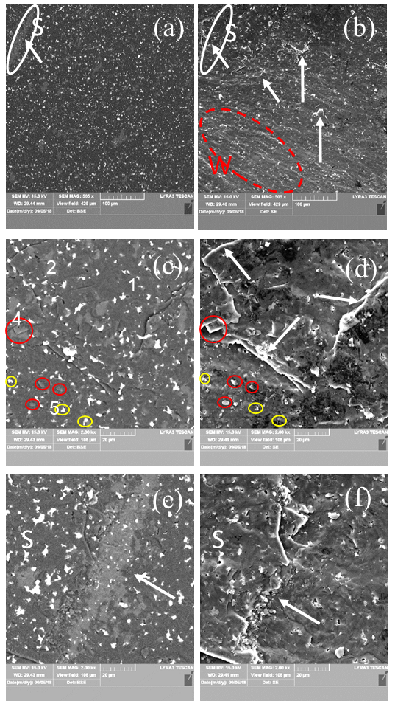
Fig. 3 SEM micrographs images of sample ‘3021’ at different magnifications taken on a freshly fractured surface. Images (a), (c), (e) and (b), (d), (f) are taken in backscattering and secondary electrons modes. Ascribed phases in BSE mode are: 1 - AlB₂₄C₄ (dark matrix), 2 - Al_{0.3}B_{13.3}C_{1.3} (dark gray impurity phase of relatively large size), 4 - Al₄B₂O₉ (light gray impurity phase of relatively small size indicated within red circles), and 5 – Al₂O₃ (white small impurity grains indicated within yellow circles). ‘Steps’ are marked with arrows. Steps area S from (a) and (b) is presented at higher magnification in (e) and (f). In (b), W is a region with ‘waves’.
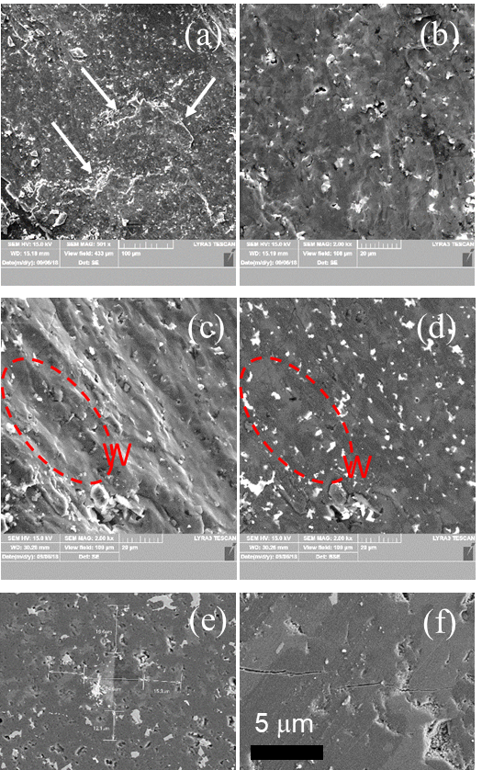

Fig. 4 SEM micrographs images of sample ‘3631’ at different magnifications of: (a)-(d) - a freshly fractured surface (static load) and (e), (f) - on a polished surface. Images (a)-(c) and (d)-(f) are taken in secondary electrons and backscattering modes, respectively. On images (e) and (f) one can visualize the Vickers imprint and the resulting cracks. ‘Steps’ are indicated with arrows and a ‘waves’ region is marked with W.

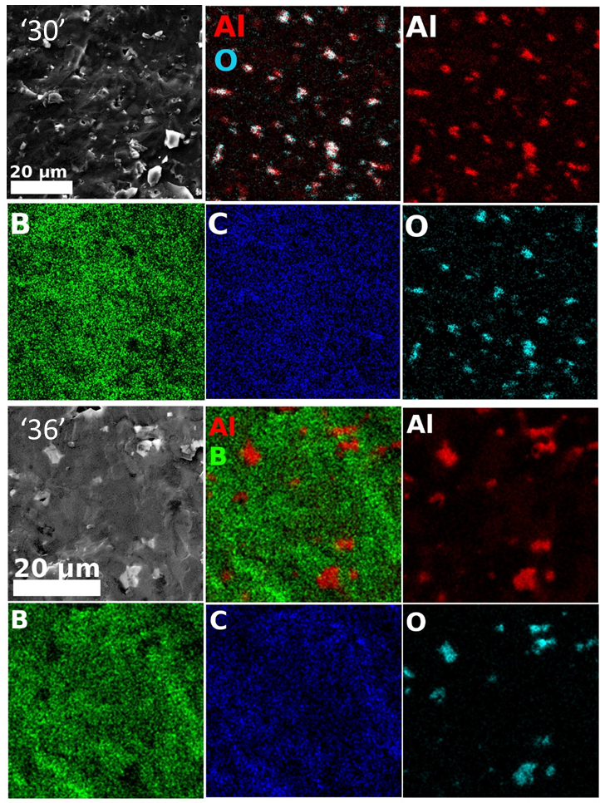
Fig. 5 EDS elemental maps of Al, B, C and O taken on samples ‘3021’ and ‘3631’. Red-green-blue (RGB) images obtained by overlapping the maps of Al and O for sample ‘3021’ and Al and B for sample ‘3631’ are also presented.

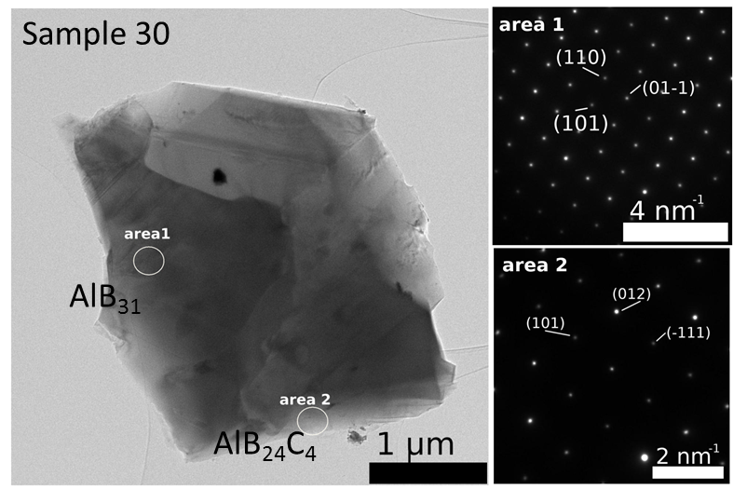
Fig. 6 TEM and SAED micrographs images taken on sample ‘3021’.
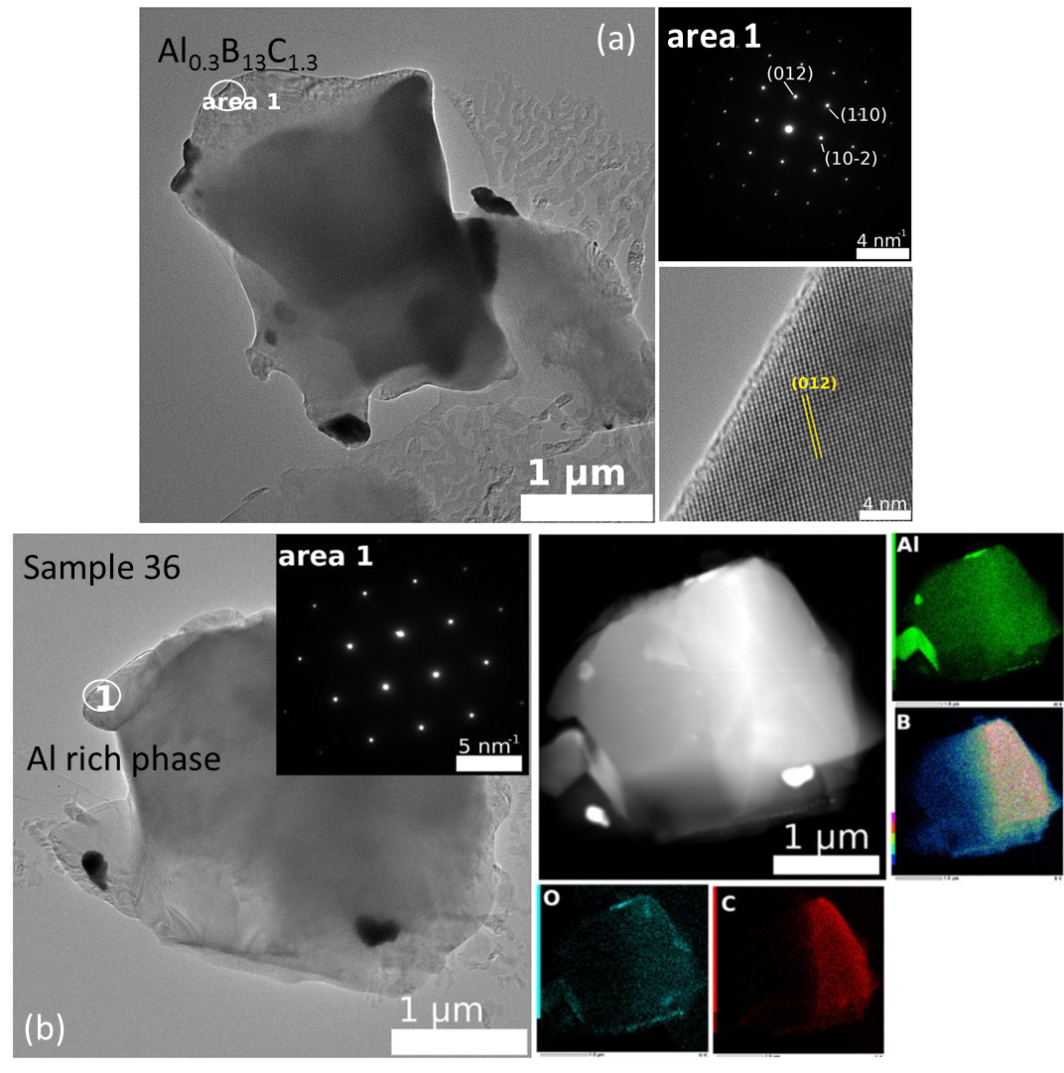
Fig. 7 TEM, SAED micrographs images and EDS elemental maps of Al, B, C, and O taken on sample ‘3631’.
Table 2 Most probable phases from the structural viewpoint identified by selected electron diffraction investigations (SAED), their theoretical and experimentally measured stoichiometry (normalized to B) and the theoretical and experimental Al/C ratio.
Sample | Phase | Normalized phase to B | Phase  Ratio  Al/C | Experimental EDS stoichiometry (Normalized to B) | Experimental EDS ratio (Al/C) | SAED representative image is presented in:
‘3021’ | AlB₃₁ | Al_{0.031}B | - | Al_{0.023-0.047}BC_{0.016-0.018} | 1.44-2.61 | Fig. 6 area 1
‘3021’ | AlB₂₄C₄ | Al_{0.042}BC_{0.167} | 0.25 | Al_{0.011-0.0175}BC_{0.058-0.097} | 0.19-0.18 | Fig. 6 area 2
‘3631’ | Al_{0.3}B₁₃C_{1.3} | Al_{0.023}BC_{0.1} | 0.23 | Al_{0.02}BC_{0.097} | 0.21 | Fig. 7 (a) area 1
‘3631’ | Al rich | - | - | Al_{0.126-0.224}BC_{0.094-0.11} | 1.34-2.04 | Fig. 7 (b) area 1

some cases unidentified phases are observed. An example of an Al-rich BC phase (Al_{0.126-0.224}BC_{0.094-0.11}, Table 2) in sample ‘3631’ with an identified structure from SAED is presented in Fig. 7b. The phase does not contain oxygen and this can be easily observed in the EDS maps in which Al-O phase is also visible.
SEM observations show also the presence of a low amount of closed sintering pores, often with round edges. The pores edges are brighter than the surroundings in the BSE contrast images, thus suggesting the presence of a relatively high amount of heavier elements such as Al or other impurities. The size of the pores is below 4 μm.
The microstructural investigation of similar samples (‘2711’ and ‘2612’, ‘3021’ and ‘3122’, ‘3631’ and ‘3532’, or ‘3341’ and ‘3442’) when using amorphous (B1) and crystalline (B2) boron could not reveal any significant differences.

3.2 Fractography analysis, static and impact mechanical properties of the bulk Al-B-C samples

Mechanical parameters determined for static and dynamic loading are gathered in Fig. 8.
Curves of Vickers Hardness HV(R), dynamic strain e_{SHPB}(R), and dynamic toughness T_{SHPB}(R) for each type of raw boron (amorphous B1 or crystalline B2) show a plateau for the AlB₂₄C₄-rich samples with R =1.3 – 3.5 from the first group. A decrease of R below 1.3 results in rapid decrease of the indicated parameters. As already addressed in Section 3.1, in samples from the second group with R < 1.3 the amount of AlB₂₄C₄ is low and equilibrium shifts towards formation of a significant amount of new phases such as Al_{0.3}B_{13.3}C_{1.3}, AlB₃₁ and Al₃BC. Results indicate on the strong and positive influence on the mechanical parameters of the AlB₂₄C₄. This partially confirms prediction from ref. [2] of the highest impact mechanical properties for the AlB₂₄C₄ phase.
However, one observes that the curves of dynamic strength σ_{SHPB}(R) show a shape with a maximum located at R = 1.3. The result suggests that the presence of secondary phases and the composite microstructure of the AlB₂₄C₄-rich samples (for R ≥1.3) improves the dynamic strength. In the AlB₂₄C₄-poor samples, for the decreasing R (R<1.3), σ_{SHPB} decreases following the similar trend of the HV(R), e_{SHPB}(R), and T_{SHPB}(R) curves. To reveal the strengthening mechanisms, the fractography analysis is addressed in the next paragraphs.

(a) | (b)
(c) | (d)

Fig. 8 (a) - Vickers hardness (HV), (b) - dynamic strength (σ_{SHPB}), (c) - strain (e_{SHPB}) and (d) -toughness (T_{SHPB}) as a function of the ratio (R) between the amount of B₄C and AlB₁₂ in the initial powder mixtures. Samples were obtained by SPS by using amorphous (B1) or crystalline (B2) boron (see Table 1).

Fractured surfaces of the samples ‘3021’ and ‘3631’ obtained under quasi static and impact loading are presented in Figs. 3, 9 (sample ‘3021’) and in Fig. 4, 9 (sample ‘3631’), respectively. Surfaces are typical for the brittle fracture by a transgranular mechanism. For example, the crack

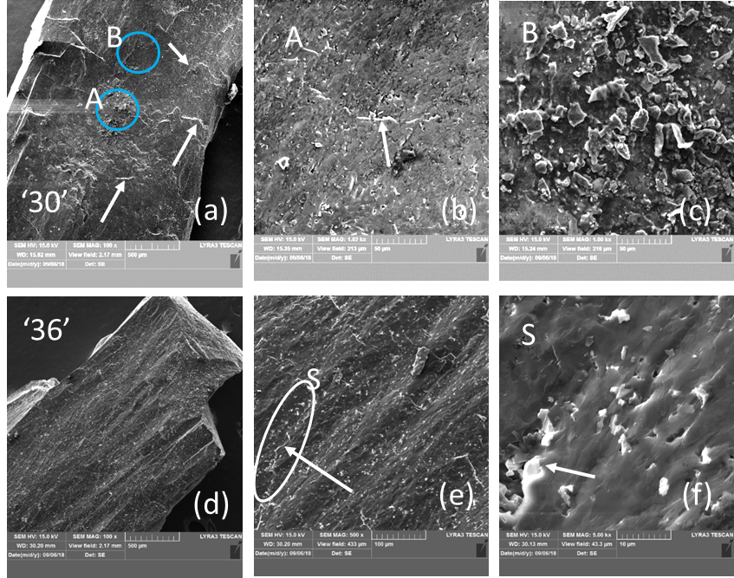

Fig. 9 SEM micrographs images on the surface of the pieces from samples ‘3021’ and ‘3631’ at different magnifications after the SHPB impact test. The details of regions A, B and S from (a) and (e) are presented in (b), (c), and (f), respectively. Arrows indicate ‘steps’.

in Fig. 4f develops linearly under quasi static loading in the HV indentation over different large-size phases. Nevertheless, from the same image it is also visible that crack’s bridging and deflection occur when small impurity phases interfere with the crack. This effect and an inter granular sliding with a ‘pull out’ of the small Al-based oxides (Fig. 3 c, d) provides ductility to our samples. Some plasticity is inferred also from the wavy fractured surface (denoted W) resulting from both static (Fig. 3b, 4c) and dynamic loading (Fig. 9 e, f). Other elements, as evidence for plasticity, are the ‘steps’ (Fig. 3 b, d, f, 4a, 9 a,b,e,f, follow arrows and regions S). Formation of the wavy surface and of the ‘steps’ is related to the presence of large and softer phases than AlB₂₄C₄ (compare Fig. 3 e with f, Fig. 4 c and d, and see 9 e, f region S). Depending on the type, amount, size, morphology and distribution of these phases, the pattern of the fractured surface modifies and, thus, it serves as a fingerprint of the changing mechanical parameters. We shall note that in the dynamically fractured surface of the sample ‘3021’ are visible less ‘waves’ perhaps due to the lower concentration of the secondary large and soft phases relative to the amount of hard AlB₂₄C₄ than in the sample ‘3631’. On the other hand, in sample ‘3021’ apart from the flat surfaces (region A in Fig 9 a, b), regions with small fractured grains may occur (region B, Fig. 9 a, c). Large regions of a secondary phase (ascribed mainly to Al_{0.3}B_{13.3}C_{1.3}) composed of small grains resulting from fracturing and which defines a ‘step’ or more are also observed in Fig. 3 e, f for sample ‘3021’ fractured under quasi static loading. Fracturing of the large regions of the secondary phases into small grains and considering the irregular morphology of these phases and of their irregular interface with Al-BC main phase may indicate on a mechanical anchoring of the phases. It is inferred that this kind of ‘reinforced’ grain boundaries in the composite can provide for the optimum phase assembly and microstructure an enhancement of the dynamic strength as observed for our samples with R=1.3. The result deserves attention as a useful and general route to control and improve dynamic properties of hard ceramic composite materials, but further research is necessary.
The described dependencies are preserved when using different boron types, but use of an amorphous boron pushes the values of Vickers Hardness (HV), dynamic strength (σ_{SHPB}), strain (e_{SHPB}), and dynamic toughness T_{SHPB} to higher values: the maximum values in the sample with R=1.3 are 32.4 GPa, 1323 MPa, 0.0072, and 12.9 MJ/m². The reason why amorphous boron leads to better mechanical properties is unclear. We believe that this is related to different reactivity of the two types of boron (expected higher for the amorphous form). In our previous work on B₄C samples, the values of dynamic strength measured with SHPB machine used in this article attained maximum values of 1400 MPa and 1270 MPa: in the first case the sample was obtained by SPS in vacuum at 1600 °C under a high uniaxial pressure of 300 MPa, and in the second by SPS in nitrogen at 1800 °C under a uniaxial pressure of 100 MPa [18, 19]. The maximum value of σ_{SHPB} determined for the Al-B-C composite from this work is relatively high, comparable to the best our values for B₄C, thus enabling the use of this material in different applications.

4. Conclusion
High density samples of Al-B-C were prepared by reactive spark plasma sintering and were characterized by compressive impact tests with Split Hopkinson Pressure Bar method. Raw materials were B₄C, α-AlB₁₂ and B powders. Boron was used in the amorphous or crystalline forms. When the ratio R= B₄C/α-AlB₁₂ ≥ 1.3, the main phase in the samples is AlB₂₄C₄, and when R < 1 other phases occur and the amount of AlB₂₄C₄ significantly decreases. The highest Vickers hardness, dynamic strength, strain and toughness are obtained for samples with R = 1.3. The orthorhombic phase AlB₂₄C₄ is the most compact with the closest packing to ideal cubic one among the Al-B-C phases containing B12-type icosahedra. As a consequence of this feature, literature predicts the highest impact properties for the AlB₂₄C₄ among all the Al borocarbide phases. Our results partially support this assumption, but the presence of other phases and specifics of the microstructure also play an important role. Although the type of boron does not influence the observed material – mechanical properties dependences, slightly higher values of the dynamic mechanical characteristics are determined for samples fabricated with amorphous boron.

Acknowledgments
PB acknowledges MEC-UEFISCDI project POC 37_697 no. 28/01.09.2016 REBMAT, Romania.
Authors thank Dr. V. B. Muratov for supplying AlB₁₂ powder.

Competing interests
Declarations of interest: none.

Author Contributions Statement
Conceptualization, O.V., D.D., and P.B.; methodology, all authors; validation, O.V., D.D., and P.B.; formal analysis, all authors; investigation, H.B., P.L., M.G., A.K., D.D. and I.P.; resources, T.S., O.V., and P.B.; writing—original draft preparation, P.B.; writing—review and editing, O.V., D.D., and P.B.; visualization, M.G. and P.B.; supervision, O.V. and P.B.; project administration, O.V. and P.B.; funding acquisition, T.S., O.V., and P.B.

References
[1] Domnich, V., Reynaud, S., Haber, R. A., Chowalla, M. Boron Carbide: Structure, Properties, and Stability under Stress. J. Am. Ceram. Soc. 94 (11) 3605–3628 (2011).
[2] Koroglu, A., Thomson, D. T. In vacuo production of α-AlB₁₂, Ca₄AlB₂₄, AlB₁₂C₂ and Al₃B₄₈C₂ powders. J. Eur. Ceram. Soc. 32 3501-3507 (2012).
[3] Halverson, D. K., Pyzik, A. J., Aksay, I. A., Snowden, W. E. Processing of boron carbide aluminium composites. J. Am. Ceram. Soc. 72 775-780 (1989).
[4] Matkovich, V.I, Economy, J., Giese Jr, R.F. Presence of Carbon in Aluminum Borides. J. Am. Chem. Soc. 86 2337-2340 (1964).
[5] Viala, J.C., Bouix, J., Gonzalez, G., Esnouf, C. Chemical reactivity of aluminium with boron carbide. J. Mater. Sci. 32 4559-4573 (1997).
[6] Chernishova, T.A, Rebrov, V. Interaction kinetics of boron carbide and silicon carbide with liquid aluminium. J. Less-Common Met. 34 1041-1055 (1996).
[7] Wilkins, M.K. Boron and Refractory Borides in Springer, New York (ed. Matkovich, V.I.) 633-648 (1977).
[8] Katz, R.N., Brantley, W.A. Fractography of high boron ceramics subjected to ballistic loading, in Ceramics in Severe Environments. Materials Science Research 5, Springer, Boston, MA (eds. Kriegel W.W., Palmour H.) 271-282 (1971).
[9] Prikhna, T.A et al. Lightweight ceramics based on aluminum dodecaboride, boron carbide and self-bonded silicon carbide. Ceram. Int. 45 9580-9588 (2019).
[10] Suri, A.K., Subramanian, C., Sonber, J.K., Murthy, T.S.R.Ch. Synthesis and consolidation of boron carbide: a review. Int. Mater. Rev. 55, 4–40 (2010).
[11] Grobner, J., Lukas, H.L., Aldinger, F. Thermodynamic calculation of the ternary sustem Al-Si-C. Calphad 20, 247-254 (1996).
[12] Rizzoli, C., Slamakha, P.S., Sologub, O.L., Bocelli, G. X-ray investigation of the Al-B-N ternary system: isothermal section at 1500 °C: crystal structure of the Al_{0.185}B₆CN_{0.256}. J. Alloys Comp. 343, 135-141. (2002).
[13] Mazur, P. V., Muratov, V. B., Garbuz, V. V., Kartuzov, V. V., Vasyliev, O. O. Method of aluminum dodecaboride AlB₁₂ preparation. Patent (Ukraine) no UA107193U (2016).
[14] Solodkyi, I., Demirskyi, D., Sakka, Y., Vasylkiv, O. Synthesis of multilayered star-shaped B₆O particles using the seed-mediated growth method. Am. Ceram. Soc. 98, 3635-3638 (2015).
[15] Wang, Z., Li, P., Song, W. Inelastic deformation micromechanism and modified fragmentation model for silicon carbide under dynamic compression. Materials & Design 157, 244-250 (2018).
[16] Wang, Z., Li, P. Characterisation of dynamic behaviour of alumina ceramics: evaluation of stress uniformity. AIP Advances 5 (10) 107224 (2015).
[17] Wang, Z., Li, P. Dynamic failure and fracture mechanism in alumina ceramics: experimental observations and finite element modelling. Ceram. Int. 41 (10) 12763-12772 (2015).
[18] Badica, P. et al. Tough and dense boron carbide obtained by high-pressure (300MPa) and low-temperature (1600°C) spark plasma sintering. Journal of the Ceramic Society of Japan 122, 271-275 (2014).
[19] Badica, P. (2014) Toughness control of boron carbide obtained by spark plasma sintering in nitrogen atmosphere. Ceram. Int. 40 (2) 3053-3061.
[20] Badica, P. et al. Compressive properties of pristine and SiC-Te-added MgB₂ powders, green compacts and spark-plasma-sintered bulks. Ceram. Int. 44, 10181-10191 (2018).

