Supporting Information

Assessing Degradation in Perovskite Solar Cells via Thermal Hysteresis of Photocurrent and Device Simulation

Dhruba B. Khadka¹*, Masatoshi Yanagida¹, and Yasuhiro Shirai¹

1 Photovoltaic Materials Group, Center for GREEN Research on Energy and Environmental Materials, National Institute for Materials Science (NIMS), 1-1 Namiki, Tsukuba, Ibaraki 305-0044, Japan

Corresponding Author
*E-mail: KHADKA.B.Dhruba@nims.go.jp

Experimental Sections:
Materials
All chemicals were bought from commercial suppliers as mentioned and unless otherwise specified, they were used as received. [6,6]-Phenyl C₆₁ butyric acid methyl ester (PC₆₁BM) (99% purity) used for ETL deposition. Aluminium-doped zinc oxide (AZO) nanoparticle ink (Nanograde N-21X) was used to prepare the AZO layer. Methylammonium halides (MAI, MACl) and PbI₂ were purchased from Wako Chemical Company. The NiO_{x} (~20 nm) film was deposited by sputtering as mentioned in our earlier reports.^{1–3} In brief, the pre-cleaned ITO substrates were loaded in the deposition chamber and evacuated until <2$×$10⁻³ Pa then pure argon gas was introduced at the rate of 20 sccm. The deposition was carried out in an argon gas pressure of 3.5 Pa and rf power supply of 50 W for 20 min at room temperature. We used NiOx target (99.9% pure) from Kojundo Chemical Laboratory Co. Ltd, Japan. The details of the precursor solution and device fabrication can be found in the earlier reports.^{4–6} We have also briefly described in the device fabrication section
Device Fabrication:
The patterned indium tin oxide (ITO) coated glass substrates (15 Ω square^{–1}) were pre-cleaned in an ultrasonic bath with detergent, pure water, and 2-propanol, followed by an ultraviolet-ozone treatment for 5 min to remove the organic residuals. Nickel oxide (NiO_{x}) was prepared by a sputtering method as described in our reports.⁷ For the fabrication of perovskite films, the PbI₂ solution was prepared by dissolving PbI₂ (500 mg/ml) in a mixture of anhydrous DMF/DMSO (5:1 ratio) at 500 rpm/ 70ºC for 12 hours. The MAX (MAI and MACl) solution (50 mg ml⁻¹; 19:1 ratio) in ethanol at 300 rpm/ 50ºC for 12 hours. The PbI₂ precursor solution was spin-coated at 3000 rpm for 90 s and the MAX precursor solution (a mixture of MAI + MACl) was subsequently spun onto the PbI₂ layer at 4000 rpm, for 30 s. Those as-grown CH₃NH₃PbI_{3-x}Cl_{x} (x=0.002)perovskite films were simply placed on the hot plate with MACl powder covered with a petri dish at 100 ºC to promote the crystallization.⁴ For ETL deposition, PCBM (20 mg/ml in CB) was spun-coated on top of the films at 700 rpm for 30 s and 4000 rpm for 10 s and annealed at 100 ºC for 15 min. Then a thin AZO layer was deposited at 2500 rpm for 25 s and annealed at 100 ºC for 10 min. To complete the device structure, samples were then transferred into the evaporation chamber connected to the glove box for metal contact deposition. Finally, 140 nm of Ag was thermally evaporated at a pressure <10⁻⁴ Pa. Devices with an area of 0.185 cm² were sealed by encapsulation glass and UV-curable resins (UV-RESIN XNR5516Z; Nagase ChemteX, Japan) before the subsequent measurement in ambient conditions.
Device characterization:
The J–V curves were measured at a scan rate of 0.05 V/s under 1 sun with an AM 1.5G spectral filter (100 mW cm⁻²) coupled to an MPPT system. For stability monitoring, we placed the encapsulated NiO_{x} devices in an enclosed system under air ambient. The devices were kept under constant illumination and set temperatures at 50-60 ºC for 1500 hours to get aged J-V characteristics.
For thermal hysteresis of photocurrent (THPC) measurement, the devices were placed under 1 sun white light illumination and photocurrent was monitored using the PAIOS measurement system by changing temperature from 240 to 360 K under different heating and cooling rates. THPC spectra were obtained from the absolute difference between the heating and cooling photocurrent. We have used dT/dt= 20 K/min and 2 K/min to monitor the photocurrent under heating and cooling rates for THPC measurement of fresh and aged devices.
Capacitance–response (C–f) was obtained for capacitance analysis using an LCR meter (IM3536, Hioki), which probes from 20 Hz to 2 MHz. Capacitance-voltage (C–V) measurements were carried out at 20 kHz under dark conditions at different temperatures.

Theoretical analysis: THPC was accounted from thermally stimulated current (TSC) for Theoretical analysis.
In semiconductor physics, the kinetic equation of the electron density (n_{t}) as a function of time (t) is given as Equation (1): ^{8,9}
$\frac{{dn}_{t}}{dt}= -n_{t}N_{C}σ_{t}v e^{\left(-\frac{E_{t}}{kT}\right)}+n\left(N_{t}-n_{t}\right)σ_{t}v$ [1]
Where N_{t} is the concentration of the electronic defect, n_{t} is the concentration of electron occupied by the electronic defect, n is the concentration of electron in the conduction band, ΔE_{i} is the defect level, σ_{t} is the capture cross-section of the defect, $v$ is the thermal velocity, N_{C} is the effective state density of the electron, k is the Boltzmann constant, T is the absolute temperature, and τ is the average carrier lifetime.
As the semiconductor is placed under thermal agitation, the T_{t} resonance peak is observed in the TSC under heating or cooling rate $β$ (K/s). Thermally activated carriers are captured by all kinds of recombination centers while a negligible fraction of carriers can be re-captured by trapping centers, this means $σ_{t}v$ « 1/τ. This leads equation [1] to [2].
$\frac{E_{t}}{kT}=ln\left[\frac{T_{t}^{2}}{β}\right]+ln\left[\frac{N_{C}σ_{t}v k}{E_{t}}\right]$ [2]
Since the N_{C} is inversely proportional to the square of temperature (N_{C} $∝$ T⁻²).
$ln\left[\frac{T_{t}^{4}}{β}\right]=\frac{E_{t}}{kT}+ln\left[\frac{ _{E_{t}}}{σ_{t}v k}\right]$ [3]
For high resistance perovskite photo observer, the capture cross section (σ_{t}) is usually very small, then the equation [3] can be simplified as,
$\frac{E_{t}}{kT_{t}}=ln\left[\frac{T_{t}^{4}}{β}\right]$ [4]
This equation estimates the energy level related to the defect responsible for the TSC peak.
But in our case, we have taken into account the heat and light agitation at a time. Therefore, we use thermal activation energy (E_{th}) rather than the defect state layer (E_{t}) as in TSC.
$E_{th}$= $k_{B}$T

Moreover, the effective collecting charge (Q_{Tmax}) can be obtained by the integral of the THPC spectra, which can be given below.
$Q_{T_{t}}$=$\int{I_{THPC}^{T_{t}}} dt$ = $\frac{1}{β}$ $\int_{T_{1}}^{T_{2}}{I_{T_{HPC}}^{T_{t}}}dT$ [5]
where $dT$= $βdt$ and T₂ and T₁ are the initial and final temperature points of THPC resonance spectra.
The photocurrent is given by
I = qnvA [6]
Then the corresponding carrier concentration ($N_{Tmax}$) can be calculated by combining equations [1,4,5, and 6] as given in equation [7]⁹
$N_{T_{t}}$= $\frac{Q_{Tt}}{2AμτeE_{t}}$ [7]
Where, μτ - carrier mobility and lifetime product of perovskite device and A- area of device.

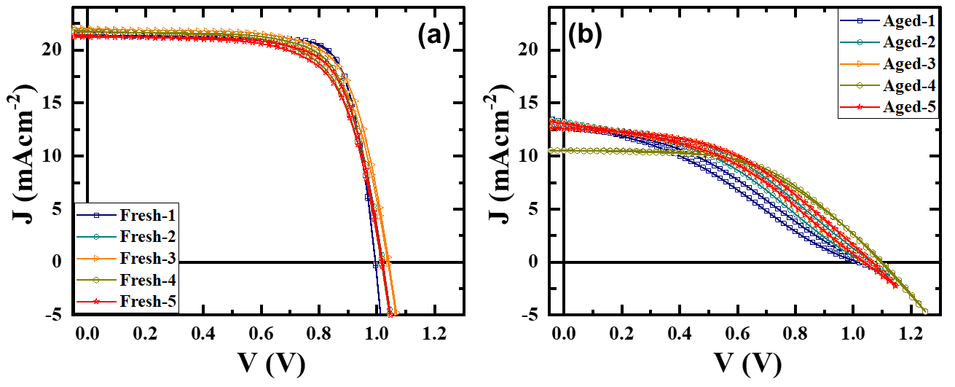
Figure S1. J-V curves of fresh (a) and aged (b) PSCs.

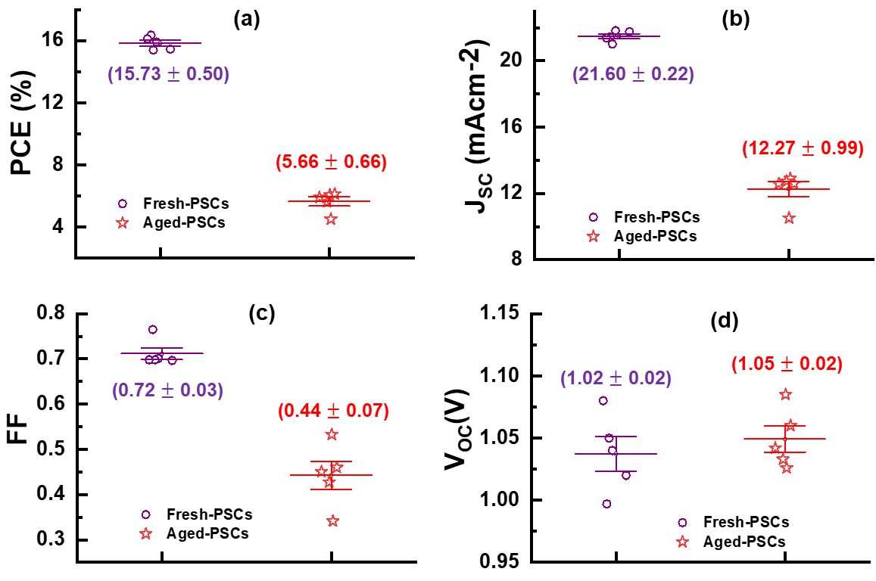
Figure S2. Device parameters statistics for fresh and aged PSCs. (a) power conversion efficiency (PCE), (b) short circuit current density (J_{SC}), (c) fill factor (FF), and (d) open circuit voltage (V_{OC}). The parameters listed in the parenthesis are average $±$ standard deviation (SD) of respective PSCs (5 devices). In these statistics, J_{SC} and FF dropped by ~43 and 38% while V_{OC} slightly increased by 3%.

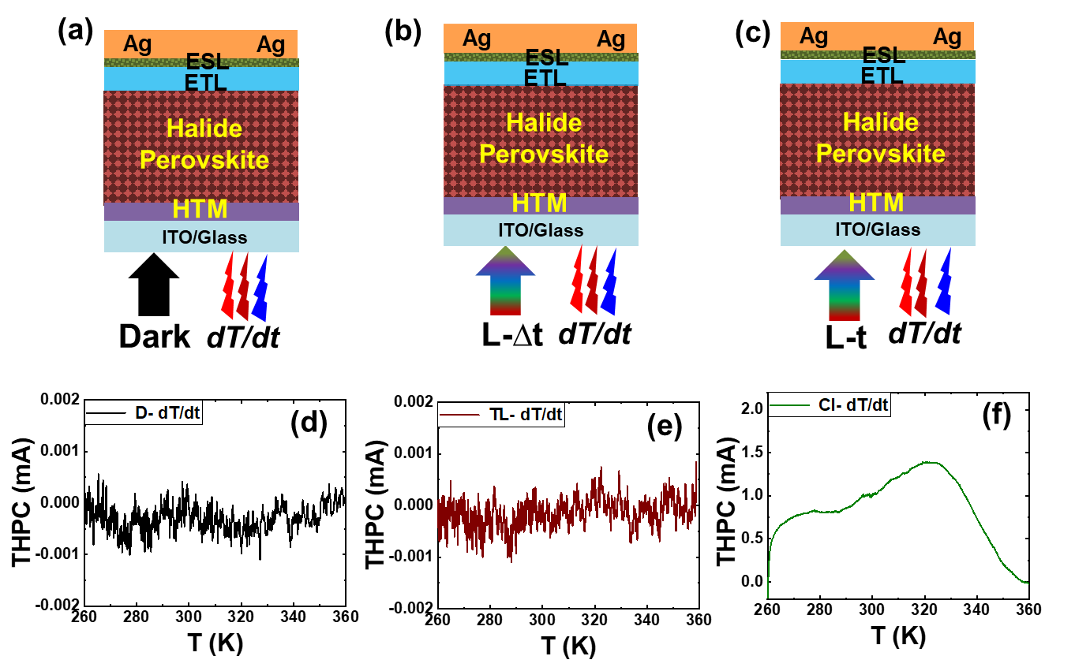
Figure S3. Schematic of the THPC measurement and corresponding spectra. THPC spectra (a,d) under dark (D-dT/dt), (b,e) under transient illumination (TL-dT/dt)), and (c,f) under continuous illumination (CI-dT/dt)).

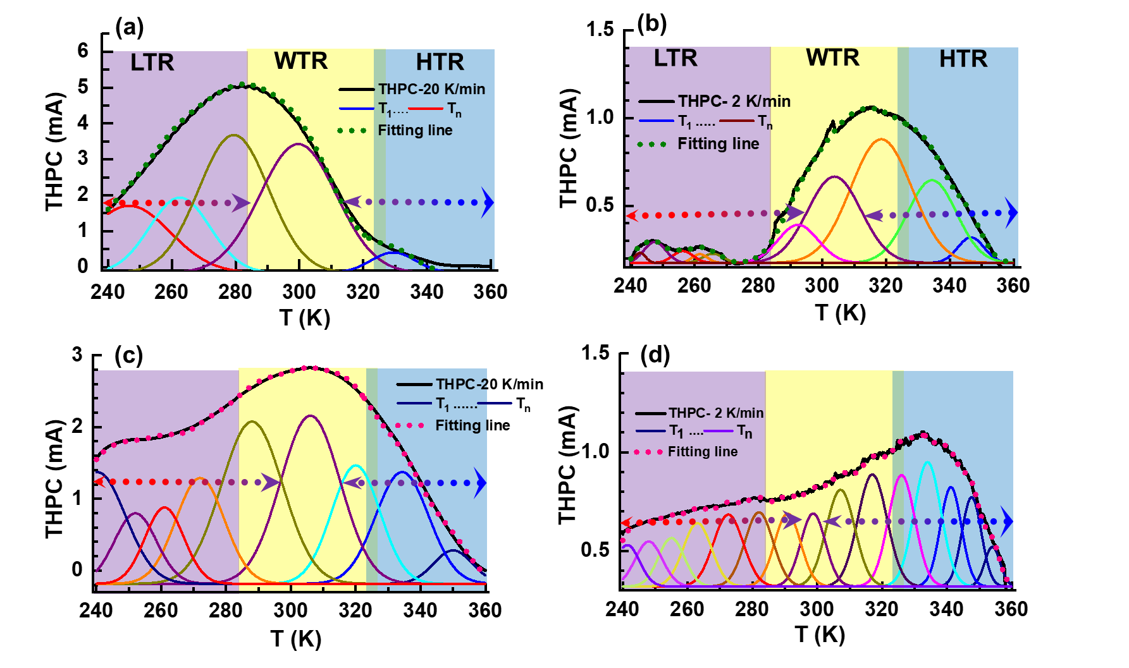
Figure S4. THPC spectra of the fresh (a, b) and aged (c, d) PSCs under different temperature drifting rates: 20 K/min and 2 K/min in the temperature range (240-360 K) and corresponding fitting spectra, respectively. Here the shaded regions indicate a low-temperature range (LTR), working temperature range (WTR), and high-temperature range (HTR). The three curves under THPC spectra display representative spectral fitting under the LTR, WTR, and HTR regimes. The dotted arrows represent arbitrary multiple peaks (T₁,…,T_{n}) fitting of THPC spectra. The accumulated charge in respective temperature regime is calculated by evaluating the area under respected fitted curves and shaded regions.

Table S1. THPC spectra analysis: accumulated charge (Q_{THPC}) (extracted from Fig. S4a,b) and percentage sharing in fresh PSC in different temperature ranges .

Thermal drifting rate$→$  Temperature Range $↓$ | 20 K/min |  | 2 K/min
Thermal drifting rate$→$  Temperature Range $↓$ | Q_{THPC} (mC) | Q_{THPC} (%) | Q_{THPC} (mC) | Q_{THPC} %)
LTR (240-283 K) | 1.703 | 48.07 | 0.429 | 10.24
WTR (283-323 K) | 1.749 | 49.36 | 2.452 | 58.52
HTR (323- 363 K) | 0.091 | 2.57 | 1.309 | 31.24
$Total (Σ$) | 3.543 | 100 | 4.191 | 100

Table S2. THPC spectra analysis: accumulated charge (Q_{THPC}) (extracted from Fig. S4c,d) and percentage sharing in aged PSC in defined temperature ranges.
Thermal drifting rate$→$  Temperature Range $↓$ | 20 K/min |  | 2 K/min
Thermal drifting rate$→$  Temperature Range $↓$ | Q_{THPC} (mC) | Q_{THPC} (%) | Q_{THPC} (mC) | Q_{THPC} %)
LTR (240-283 K) | 1.714 | 47.92 | 1.927 | 33.95
WTR (283-323 K) | 1.334 | 37.29 | 2.105 | 37.08
HTR (323- 363 K) | 0.529 | 14.79 | 1.644 | 28.97
$Total (Σ$) | 3.578 | 100 | 5.677 | 100

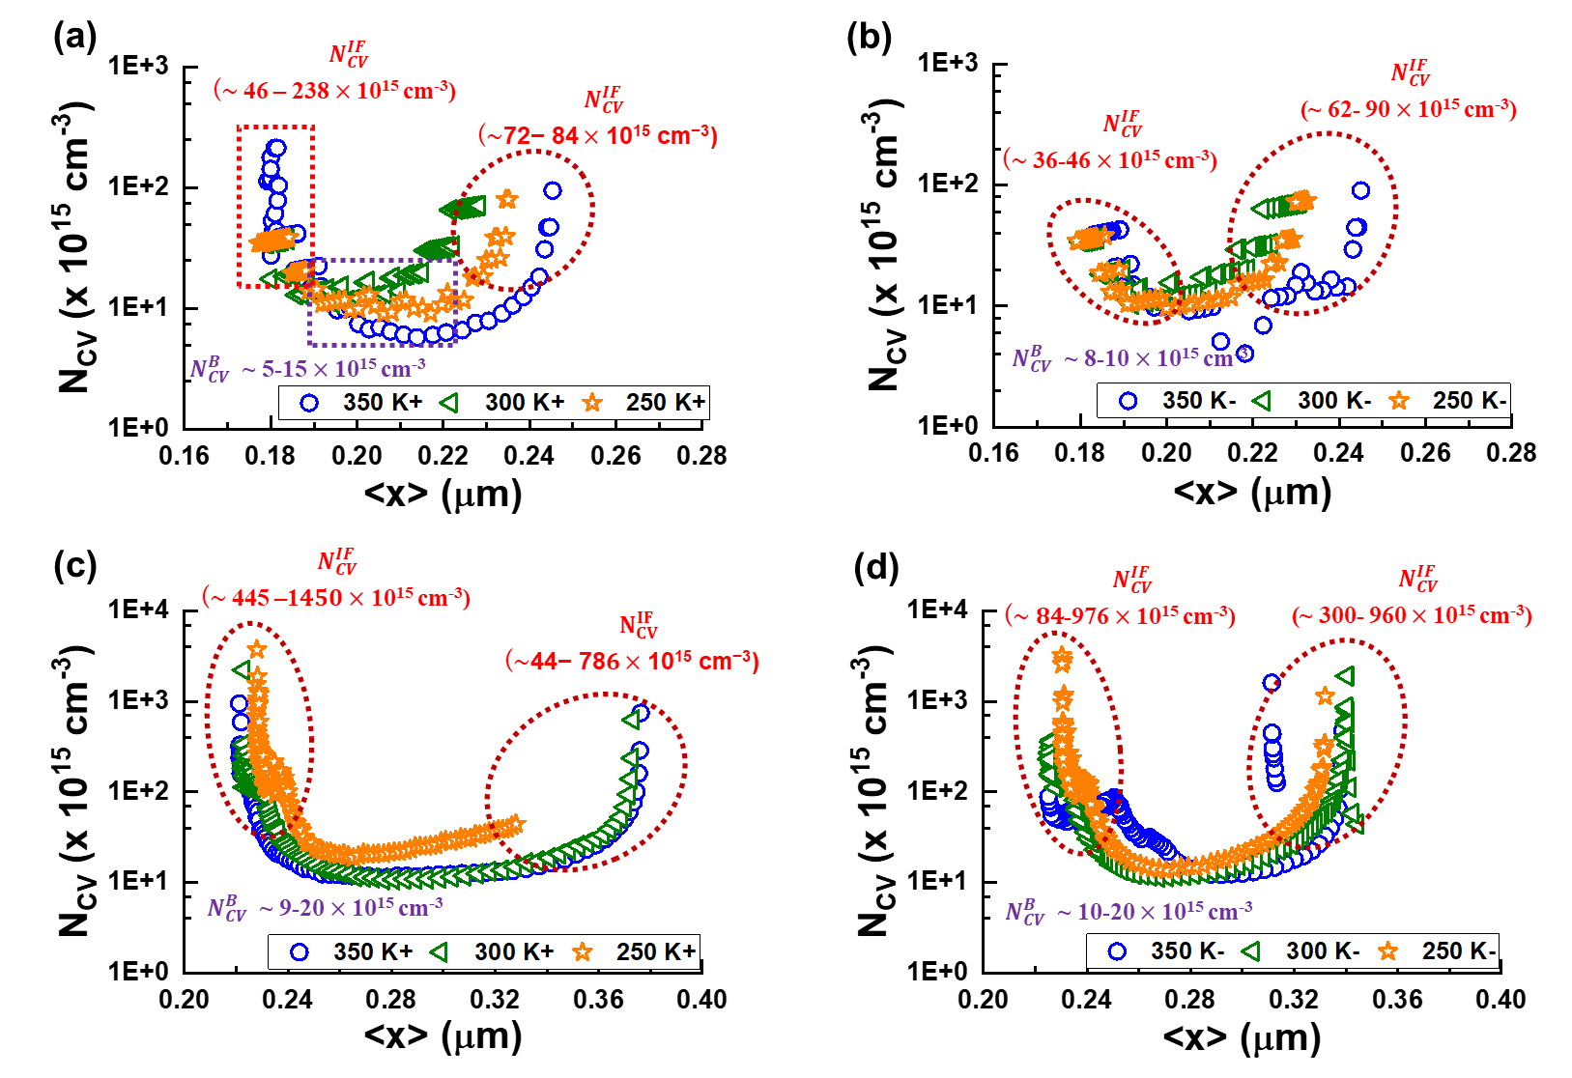
Figure S5. Carrier distribution profiles (N_{CV}) of fresh (a,b) and aged (c,d) devices under thermal stress: The C–V carrier profiles are obtained from C–V curves (Fig. 4 in main text). $N_{CV}^{B}{ and N}_{CV}^{IF}$ give the carrier profile at bulk and at interfaces of PSCs.

Device Simulations:

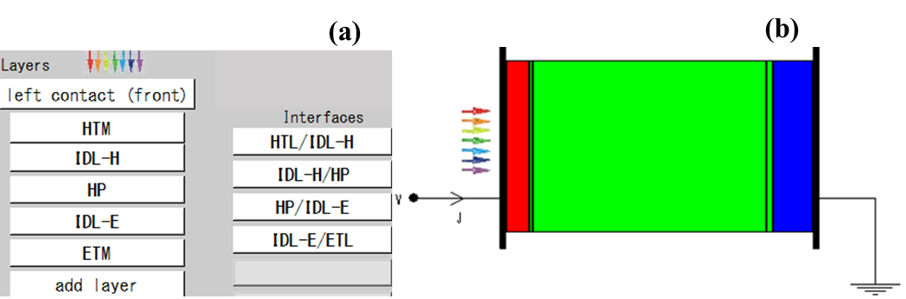
Figure S6. Schematic diagram device simulation: (a) PSC layer definition and (b) layer structure for SCAPS simulation.

Table S3. Summary of simulation parameters of PSCs for SCAPS simulation adopted from earlier reports.^{4,5,10} The device layers were defined considering our earlier reports and similar kinds of solar cells. Here, HP: halide perovskite; HTL: hole transport layer; ETL: electron transport layer; IDL: interface defect layer; ISD- interface surface defect. Defect types: N- Neutral defect; D- Donor (+/0); A- Aceptor (0/-); Amm- Amphoteric (+/0, 0/-).
Material layer /properties | HTL | IDL-H | HP |  | IDL-E | ETL
x(µm) | 0.035 | 0.015 | 0.350 |  | 0.010 | 0.060
E_{g} (eV) | 3.2 | 1.56 | 1.56 |  | 1.56 | 3.2
χ(eV) | 2.45 | 3.9 | 3.9 |  | 3.9 | 4.0
Ԑ_{r} | 3 | 22 | 22 |  | 22 | 3
Nc (cm⁻³) | 2.2×10¹⁸ | 2.2×10¹⁸ | 2.2×10¹⁸ |  | 2.2×10¹⁸ | 2.2×10¹⁸
Nv (cm⁻³) | 1.8×10¹⁹ | 1.8×10¹⁹ | 1.8×10¹⁹ |  | 1.8×10¹⁹ | 1.8×10¹⁹
v_{n} (cms⁻¹) | 1×10⁷ | 1×10⁷ | 1×10⁷ |  | 1×10⁷ | 1×10⁷
v_{h} (cms⁻¹) | 1 ×10⁷ | 1 ×10⁷ | 1×10⁷ |  | 1×10⁷ | 1×10⁷
μ_{n//}μ_{h} (cm²V⁻¹s⁻¹) | 5×10⁻⁴/5×10⁻⁴ | 2/2 | 4/4 |  | 2/2 | 5×10⁻⁴/5×10⁻⁴
N_{d}(cm⁻³) | - | 1×10¹⁴ | 1×10¹⁴ |  | 1×10¹⁴ | 5×10¹⁸
N_{a}(cm⁻³) | 1×10¹⁹ | 1×10¹⁴ | 1×10¹⁴ |  | 1×10¹⁴ | -
N_{t} (cm⁻³) | 1×10¹⁸ | 1×10¹⁴-1×10¹⁵ | 1×10¹⁴ - 8×10¹⁵ |  | 1×10¹⁴-1×10¹⁵ | 1×10¹⁸
CC of e/h (cm²) | 5×10⁻¹⁴/5×10⁻¹⁴ | 5×10⁻¹⁴/5×10⁻¹⁴ | 2×10⁻¹⁴/2×10⁻¹⁴ |  | 5×10⁻¹⁴/5×10⁻¹⁴ | 5×10⁻¹⁴/5×10⁻¹⁴
E_{t} (eV)/distribution | 0.5/ Gau | 0.4/ Gau | (0.3-0.7)/ Gau |  | 0.4/ Gau | 0.5/ Gau
Defect Type | N | N/A | N/D/A/Am |  | N/D | N
ISD | HTM/IDL-H | IDL-H/HP |  | IDL-H/HP |  | IDL-E/ETL
CC (cm²)  E_{t} (eV)- N/D/A  Nt (cm⁻²) | 10⁻¹⁰-10⁻²⁸  0.6-0.8  10¹⁰ -10¹⁶ | 10⁻¹⁰-10⁻²⁸  0.6-0.8  10¹⁰ -10¹⁶ |  | 10⁻¹⁰-10⁻²⁸  0.6-0.8  10¹⁰ -10¹⁶ |  | 10⁻¹⁰-10⁻²⁸  0.6-0.8  10¹⁰ -10¹⁶

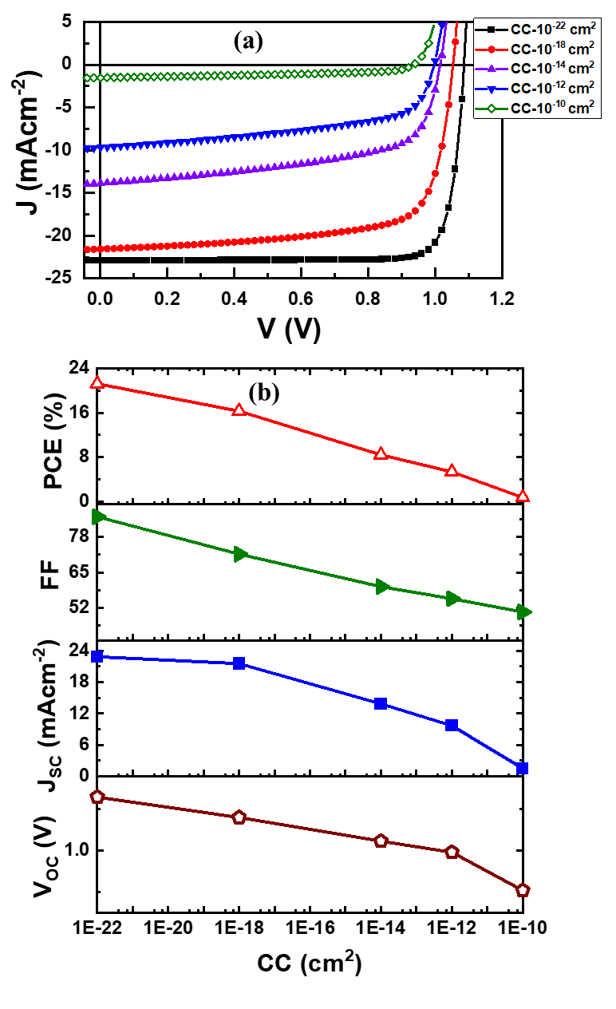
Figure S7. Device simulation results. Effect of capture crosssection of electron or hole (CC ~ 10⁻²² t0 10⁻¹⁰ cm²) in ISD layer. Plots of (a) J-V characteristics and (b) device parameters. These results indicate that a higher CC value for defects is detrimental to device performance.

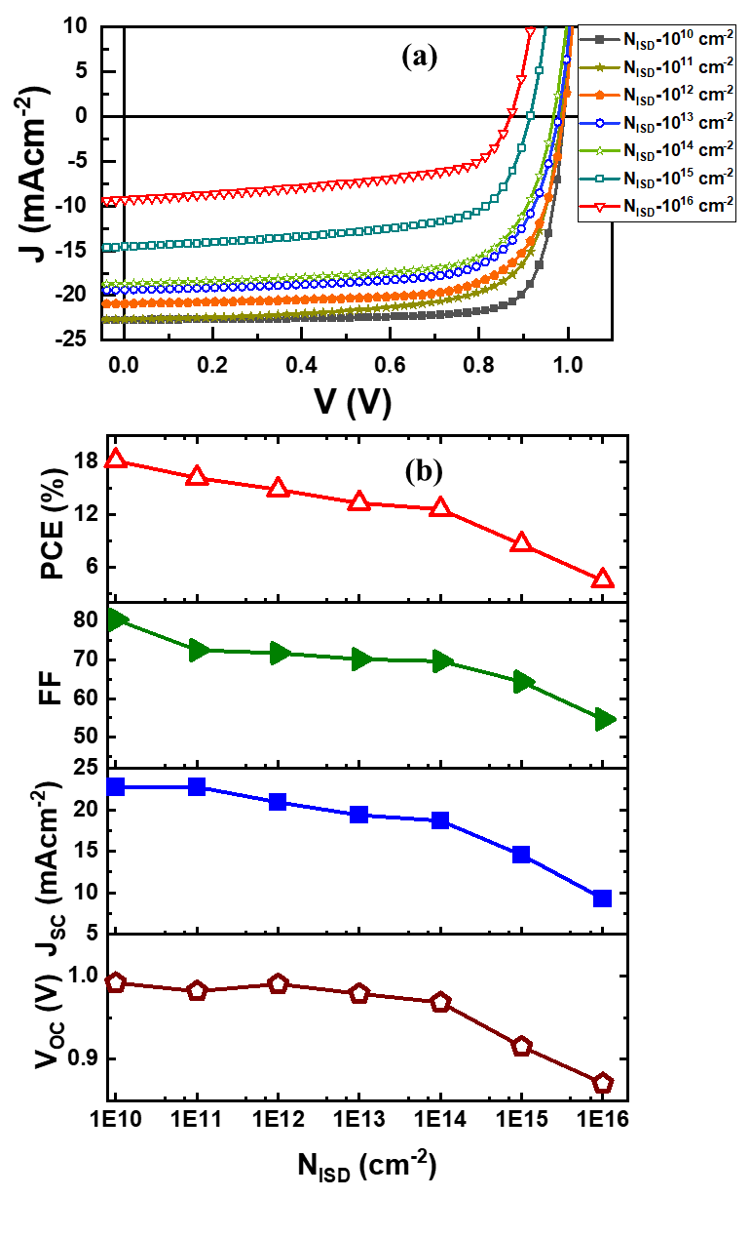
Figure S8. Effect of interface surface defect density (N_{ISD} ~ 10⁻²² t0 10⁻¹⁰ cm²) in ISD layer. Plots of (a) J-V characteristics and (b) device parameters. These results indicate that the performance of PSC lowers significantly as the N_{ISD} profile is comparable to the carrier density of the perovskite bulk layer. There is a correlation between the increase of surface defect density and device performance and connected to device deterioration.

Table S4. Summary of device parameters of PSCs corresponding to simulated J-V characteristics as depicted in Figure 5b.
ISD defect nature/  Parameter | N-defect | A defect- HTL  D defect- ETL | A defect- HTL  A defect- ETL | D defect- HTL  D defect- ETL
V_{OC} (V) | 0.9930 | 0.9928 | 1.0514 | 1.0514
J_{SC} (mA/cm²) | 22.79 | 22.79 | 0.0002 | 0.0002
FF | 80.662 | 80.642 | 51.863 | 51.863
PCE (%) | 18.252 | 18.244 | 0.0001 | 0.0001

Table S5. Summary of device parameters of PSCs corresponding to simulated J-V characteristics as depicted in Figure 5c,d.
 |  | Figure 5c |  |  |  | Figure 5d
Simulation  properties | CC (cm²) | 10⁻²⁸ | 10⁻²⁸ | 10⁻²⁸ |  | 10⁻²⁸ | 10⁻²⁰ | 10⁻¹⁶ | 10⁻¹⁶
Simulation  properties | N_{ISD} (cm⁻²) | 10¹² | 10¹⁴ | 10¹⁶ |  | 10¹² | 10¹² | 10¹² | 10¹³
Device parameters | V_{OC} (V) | 0.993 | 1.009 | 1.021 |  | 0.9930 | 0.9930 | 0.9929 | 0.9859
Device parameters | J_{SC} (mA/cm²) | 22.79 | 10.01 | 2.59 |  | 22.79 | 22.79 | 22.79 | 22.07
Device parameters | FF | 80.659 | 55.725 | 45.418 |  | 80.659 | 80.659 | 80.653 | 22.711
Device parameters | PCE (%) | 18.25 | 5.63 | 1.20 |  | 18.25 | 18.25 | 18.25 | 4.94

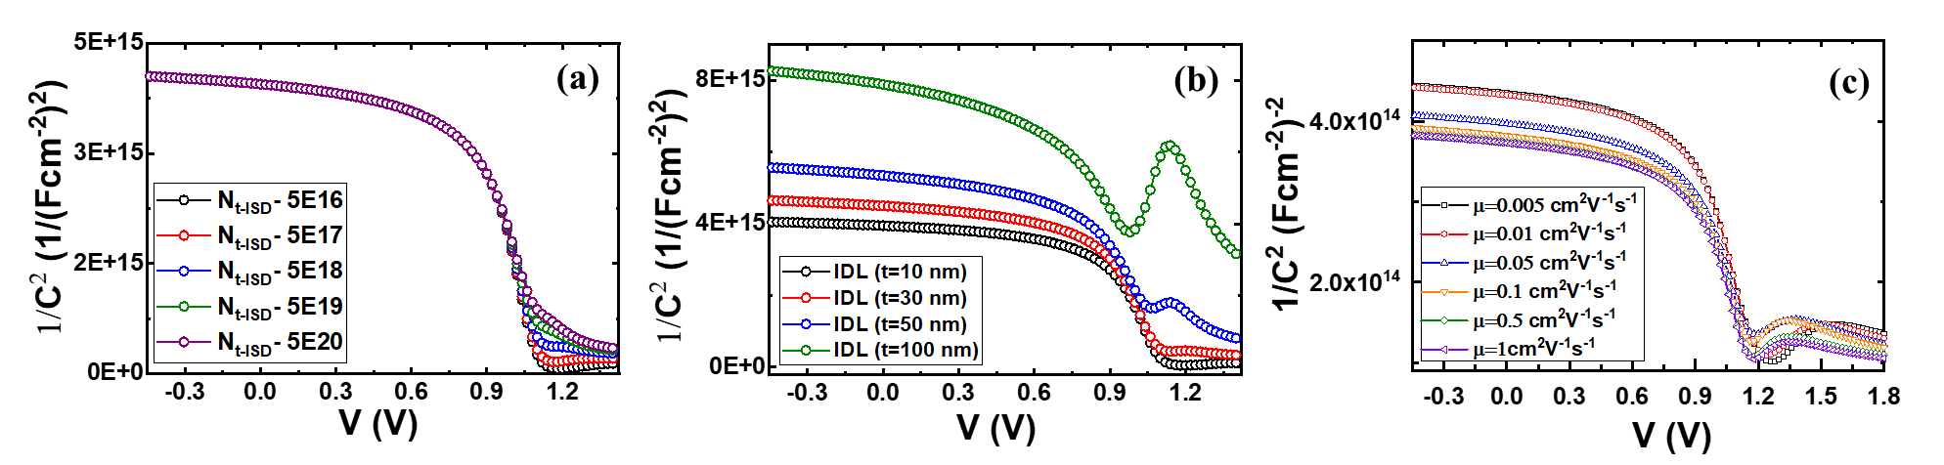

Figure S9. Simulation results of M-S curves. (a) M-S plots with varying ISD defect density (N_{t-ISD} ~ 5E16 to 5E20 cm⁻³; IDL thickness (t-IDL= 20 nm) and N_{i}- bulk~ 5E14 cm⁻³). (b) M-S plots with varying IDL-thickness 10 ~100 nm with simultaneous varying N_{t-ISD} ~ 5E16 ~5E19 cm⁻³). (c) M-S plots with varying conductivity (mobility) of IDL with varying IDL (10-20 nm).

Reference:
1. Yanagida, M. et al. Surface modification of sputtered NiOx hole transport layer for CH3NH3PbI3perovskite solar cells. Jpn J Appl Phys 62, SK1054 (2023).
2. Khadka, D. B., Shirai, Y., Yanagida, M. & Miyano, K. Insights into Accelerated Degradation of Perovskite Solar Cells under Continuous Illumination Driven by Thermal Stress and Interfacial Junction. ACS Appl Energy Mater 4, 11121–11132 (2021).
3. Khadka, D. B., Shirai, Y., Yanagida, M. & Miyano, K. Investigation of Degradation Kinetics of Perovskite Solar Cells by Accelerated Aging. in 2022 IEEE 49th Photovoltaics Specialists Conference (PVSC) 0001–0003 (IEEE, 2022). doi:10.1109/PVSC48317.2022.9938939.
4. Khadka, D. B., Shirai, Y., Yanagida, M., Masuda, T. & Miyano, K. Enhancement in efficiency and optoelectronic quality of perovskite thin films annealed in MACl vapor. Sustain Energy Fuels 1, 755–766 (2017).
5. Khadka, D. B., Shirai, Y., Yanagida, M., Ryan, J. W. & Miyano, K. Exploring the effects of interfacial carrier transport layers on device performance and optoelectronic properties of planar perovskite solar cells. J Mater Chem C Mater 5, 8819–8827 (2017).
6. Khadka, D. B., Shirai, Y., Yanagida, M. & Miyano, K. Unraveling the Impacts Induced by Organic and Inorganic Hole Transport Layers in Inverted Halide Perovskite Solar Cells. ACS Appl Mater Interfaces 11, 7055–7065 (2019).
7. Yanagida, M., Shimomoto, L., Shirai, Y. & Miyano, K. Effect of Carrier Transport in NiO on the Photovoltaic Properties of Lead Iodide Perovskite Solar Cells. Electrochemistry 85, 231–235 (2017).
8. ’Blood, P. & ’Orton, J. W. The Electrical Characterization of Semiconductors: Majority Carriers and Electron States. vol. 2 (Academic Press, London, 1992).
9. Look, D. C. Chapter 2 The Electrical and Photoelectronic Properties of Semi-Insulating GaAs. in 75–170 (1983). doi:10.1016/S0080-8784(08)60275-6.
10. Khadka, D. B., Shirai, Y., Yanagida, M. & Miyano, K. Degradation of encapsulated perovskite solar cells driven by deep trap states and interfacial deterioration. J Mater Chem C Mater 6, 162–170 (2018).

