Site-selective Creation of Blue Emitters in Hexagonal Boron Nitride
Haidong Liang^{1,2,} ‡,*, Yuan Chen^{2,} ‡, Leyi Loh^{3, ‡}, Nicholas Lin Quan Cheng², Dmitrii Litvinov^{3,4}, Chengyuan Yang^{1,2}, Yifeng Chen^{2,5}, Zhepeng Zhang², Kenji Watanabe⁷, Takashi Taniguchi⁸, Maciej Koperski^{3,4}, Su Ying Quek^{2,3,5}, Michel Bosman³, Goki Eda^{2,5,6, *}, Andrew Anthony Bettiol^{1,2,*}

¹ Centre for Ion Beam Applications (CIBA), Department of Physics, National University of Singapore, Singapore 117542, Singapore
² Department of Physics, National University of Singapore, Singapore 117551, Singapore
³Department of Materials Science and Engineering, National University of Singapore, 117575, Singapore
⁴ Institute for Functional Intelligent Materials, National University of Singapore, Singapore, 117544, Singapore
⁵Centre for Advanced 2D Materials, National University of Singapore, 117542, Singapore
⁶Department of Chemistry, National University of Singapore, 117543, Singapore
⁷Research Centre for Functional Materials, National Institute for Materials Science, Tsukuba 305-0044, Japan
⁸International Centre for Materials Nanoarchitectonics, National Institute for Materials Science, Tsukuba 305-0044, Japan

ABSTRACT
Hexagonal boron nitride (hBN) has been of great interest due to its ability to host several bright quantum emitters at room temperature. However, the identification of the observed emitters remains challenging due to spectral variability as well as the lack of atomic defect structure information. In this work, we demonstrate the site-selective creation of blue emitters in exfoliated hBN flakes with high energy ion irradiation. With the correlation analysis of cryogenic and temperature dependent photoluminescence (PL) spectroscopy, we observe two zero phonon lines (ZPLs) at ~432.8 nm and 454.3 nm. Photoluminescence excitation (PLE) measurements further confirm emission origins of the two prominent lines. Scanning transmission electron microscopy (STEM) reveals that the dominant defect structures present in ion irradiated samples are vacancy-type (V_{x}) and adatom(intercalant)-type (A_{x}). Together with first principles GW-BSE (Bethe-Salpeter equation) calculations, we deduce that the observed blue emissions are likely due to boron intercalants (B_{int}). Our results not only discover a group of blue emissions in hBN, but also provide insights into the physical origin of the emissions with local atomic structures in hBN.
KEYWORDS: hBN, blue emitters, site-selective, high energy ion irradiation, atomic structures, intercalants

INTRODUCTION
Since the discovery of single photon emission in WSe₂ and hBN^{1,2}, there has been a significant surge in research interest aimed at harnessing quantum technologies using atomically thin van der Waals materials^{3–7}. In particular, hBN has emerged as an intriguing candidate due to its ability to host a rich library of optically active emitters, some of which are operational at room temperature. Notably, one prevalent group of emitters identified within exfoliated and powdered hBN are the visible emitters, which cover a broad range of spectrum ranging from 520 nm to 850 nm ^{1,3,16–25,8,26–31,9–15}. However, these emitters are often randomly distributed in the sample and suffer from spectral variability. This presents a substantial limitation when considering their suitability for applications in photonic integrations. Consequently, extensive research is currently focused on the deterministic creation of bright emitters. For example, chemical vapour epitaxial grown hBN has been shown to lead to a narrow band spectral distribution around a central wavelength of 585 nm.^{9,32} Techniques such as focused ion beam exposure,^{29,33} strain engineering,³⁴ and femtosecond laser irradiation³⁵ have been employed to locally generate quantum emitters with wavelengths ranging between 550 and 650 nm. Recently, a family of quantum emitters, namely the “blue emitter”, featuring a zero phonon line (ZPL) at ~436 nm^{36,42–44}, have been reported by several groups. These emitters can be generated on-demand through electron beam irradiation, offering exceptional spatial resolution.
Despite the exciting possibilities that they can hold, the precise atomic structure of these quantum emitters within hBN remained elusive³⁷. While carbon doping is predominately associated with quantum emitters in the range of 580-630 nm^{25,38–42}, there is also emerging evidence which suggests that they might arise from donor-acceptor pairs within hBN⁴³. The absence of direct evidence to establish a correlation between the atomic structure and these emitters persists as a considerable challenge.
In this work, we demonstrate the fabrication of site-selective blue emitters with high energy ion irradiation in hBN. The emission peaks are carefully examined and analysed, which confirms that there are two ZPLs at around 433 nm and 454 nm which represent two different types of emitters. The capability to create uniform emitters over a large area using high energy ion beam enables us to conduct systematic scanning transmission electron microscopy (STEM) STEM to elucidate their structural origin. The combination of the systematic PL analysis of the site-selective emitters and the STEM statistical analysis, alongside first-principles GW-BSE (Bethe-Salpeter equation) calculations, provides insights into the atomic origins of these blue emitters.
RESULTS AND DISCUSSION
Creation of the blue emitters in hBN
High-energy ion irradiation on hBN transfers sufficient kinetic energy to displace boron or nitrogen atoms, creating vacancies in the lattice. One prominent example is the negatively charged boron vacancy ($V_{B}^{-}$), a well-known color center in hBN that can work as a quantum sensor.^{44,45} While creating such vacancies, the knocked-out atoms may remain near the vacancy site and form an intercalant (such as A_{Xi}) in between the layers, or they can diffuse across the crystal lattice and be absorbed in a pristine atomic column to form an adatom (such as A_{Xo}) outside of the irradiated area, where ‘X’ denotes either a B or an N atom. A schematic illustration demonstrating various possible defects created via such processes is shown in Figure 1a. After ion irradiation, different color centers can be observed in hBN. Specifically, the PL emission peaks at wavelengths of ~432 nm, 460 nm, 492 nm and 528 nm can be observed in the ion irradiated hBN when excited by a 405 nm laser at room temperature, as shown in Figure 1d. In this work, we primarily focus on the emissions in the blue range, specifically wavelengths between 400 nm and 500 nm. Figure 1c shows an hBN flake, irradiated by 1.6 MeV He⁺ ions in squares and points with different fluences. All the irradiated squares and points exhibit identical blue emissions at room temperature but with varied intensities. The squares marked as SQ1 to SQ5 in Figure 1c are created with fluences of 3E16, 1E16, 3E15, 1E15 and 3E14 respectively (the fluences are with unit of $ions/{cm}^{2}$, for example, $3E16=3×{10}^{16} ions/{cm}^{2}$ ), the points are irradiated with a focused ion beam with different dwell times (details can be found in the SI, Figure S1). Room-temperature confocal PL maps, shown in Figure 1c, demonstrate that the strongest blue emission occurs at SQ3 with an irradiation fluence of 3E15. The PL spectra at the center of each square are shown in Figure 1d.
To perform a detailed optical analysis, the sample is cooled to 4K. As the temperature decreases, the intensity of the blue emissions increases (Figure S2), and the ~432 nm peak becomes sharp, while the 460 nm and 490 nm peaks split into two sharp peaks for each (Figure 2a, b). At 4K, we can observe five sharp peaks centred at ~ 433 nm, 454 nm, 462 nm, 488 nm and 495 nm as shown in Figure 2b. A key distinction between ZPL and PSB lies in the linewidth of their emission peaks, with PSBs typically exhibiting broader linewidth due to stronger electron-phonon coupling.⁹ With decreasing beam fluence, the linewidth of all peaks generally decreases, with the 433 and 454 nm peaks exhibiting notably sharper linewidths at the lowest fluence. To further validate this observation, we plotted the full width at half maximum (FWHM) of all peaks under varying beam fluence (Figure 2c). The FWHMs of the 433 and 454 peaks consistently exhibit the smallest FWHMs and are at least twice narrower as those of the other peaks across all fluences, suggesting that these two peaks are potential ZPLs. Furthermore, low temperature PL mapping clearly reveals the different distributions of the 433 nm peak and 454 nm peak and the correlations of all the five peaks, as shown in Figure 2d. The emissions at 433, 462 and 495 nm share an identical spatial distribution profile, with highest intensity observed at SQ4 (1E15 fluence). In contrast, the emissions at 454 and 488 nm share similar distribution profile, with the strongest emission observed at SQ3 (3E15 fluence). These spatial correlations suggest that the 462 and 495 nm emissions are likely PSBs of the 433 nm ZPL, while the 488 nm emission is the PSB of the 454 nm ZPL. Herein after, we refer the emission at ~ 433 nm as B1 and the one at ~ 454 nm as B2. We notice that B1 and B2 show negligible energy shift at different irradiation areas with different irradiation fluences (Figure S3), suggesting their high consistency. Besides, based on the spatial correlations, we also notice that there are additional PSBs of B1 and B2 distributed beyond 500 nm wavelength, as shown in Fig. S4, at ~534 nm as a third distinct PSB for B1 and ~526 nm as a second PSB for B2.
To further substantiate our assignment, we performed photoluminescence excitation spectroscopy (PLE) to study the photophysical properties of the individual peaks. Figure 3a, b shows the experimental PLE data with different excitation wavelength range. From the colour plot, two distinct resonances were observed at ~ 453.5 nm and 432 nm. Figure 3c shows the PL intensity as a function of excitation wavelength for different emissions. Notably, the emissions at 462 and 495 nm exhibit similar PLE profile, with a strong resonance observed at 432 nm, coinciding with the B1 emission. This resonance behaviour is indicative of PSB, which arise from the interaction between excitonic transitions and phonons. The observed resonance at B1 transitions (432 nm) suggests that excitation at this wavelength efficiently promotes the system to an excited state, leading to the subsequent emission of PSBs. This behaviour supports the interpretation that the 462 and 495 nm emissions are PSBs of B1. On the other hand, B2 does not exhibit resonance at 432 nm, suggesting that it is not directly related to B1. This implies that B2 likely has a different emission origin, possible associated with other defects. Emission at 488 nm resonate more strongly at 453 nm, which aligns with B2 transition, further distinguishing it from B1. These findings suggest that the two emission features B1 and B2, likely stem from two distinct structural origins.
Table 1. Comparison of different emitters in this work and literatures.
Parameters  Emitters | ZPL (nm) | PSBs (nm) | Debye–Waller factor | Huang-Rhys factor | Source
B1 | 433 | 462, 495, 534 | 0.14 | 1.95 (4K) | This work
B2 | 454 | 488, 526 | 0.24 | 1.43 (4K) | This work
E-beam generated blue emitter | 435.7 | 460.7, 465.9 | 0.4 | 0.92 (5K) | Ref. ³⁶
B center | 436 | 462, 491 | ~0.4 | ~0.92 (70K) | Ref. ⁴⁶

The 433 nm emitter exhibits similar emission energy to the previously reported blue emission at ~436 nm which is attributed to carbon-related defects^{36,46–48}. However, the 433 nm emitter in our study displays significantly stronger PSB (i.e., the 462 nm and 495 nm peaks) emissions compared to the reported blue emission. The electron-phonon coupling strength can be determined by Debye-Waller and Huang-Rhys factors,^{40,42} which are calculated and listed in Table 1. For B1 and B2, the Debye-Waller and Huang-Rhys factors are different at different irradiation areas with different fluences. We are using an average value of Debye-Waller factor in Table 1, and the calculated Huang-Rhys factor accordingly. The detailed Debye-Waller and Huang-Rhys factors of B1 and B2 are shown in Table S1 in the SI. The different electron-phonon coupling strengths may be because of different strains introduced in different irradiation methods. Except the electron-phonon coupling strength differences, the energy gap between the PSBs and ZPL of B1 is similar with previous reported blue emissions at ~180 meV.
The origin of the blue emitters in hBN at the atomic scale
In previous studies, direct physical evidence of the origin of the SPEs has been difficult to obtain due to the inability to precisely locate the SPE positions within a sample. For focused ion beam irradiation, we can create point emissions and uniform regions of blue emission over large areas which are easy to locate in the scanning transmission electron microscope (STEM). This enables us to correlate the emission profile with the physical origin at the atomic scale.
To characterize the materials, STEM was used to examine the defect structures present within the ion beam irradiated hBN samples. This allows for possible defect candidates which give rise to the observed emissions. Figure 4a shows a large-area high-angle annular dark field-scanning transmission electron microscope (HAADF-STEM) image of a 500 keV He⁺(3E15) irradiated hBN multilayer. The bright and dark atomic columns represent N and B, respectively. Different types of defect structures are seen to be present in the sample, such as vacancy-type defects (V_{X}) and adatom- (intercalant-)type defects (A_{X}) characterized by dimmer and brighter regions in the HAADF-STEM image, respectively. V(A)_{X} denotes vacancy (additional atom) at a specific lattice site X which comprises either an isolated atom (e.g., B, N), atom pairs (e.g., BN, B2N2) or a cluster of atoms (i.e., BxNy where x, y >2). V_{X} represents atomic vacancies or vacancy clusters. They are characterized by lower contrast than the surrounding pristine lattice. On the other hand, defects denoted by A_{X} exhibit a brighter contrast than the surroundings. They can be attributed to additional atoms passivating a specific lattice site (X) in the outermost layer (i.e., adatoms) or in between the hBN layers (i.e., intercalants). Regardless of the various defects present, the sample still retains its crystallinity after He⁺ irradiation evident from the hexagonally arranged diffraction spots derived from the fast Fourier transformation (FFT) of the corresponding STEM image (inset of Figure 4a).
We estimate the statistical distributions of various defect types and densities in our sample from multiple areas imaged across the sample which amount to a total area of ~660 nm² (Figure 4b, S10). V_{X} are unequivocally higher in both density and diversity than A_{X}. Among the different types of V_{X}, V_{B} exhibits the highest density of ~ 3 x10¹² cm⁻² and constitutes the most common defect structure in our sample similar to a previous report on pristine hBN⁴⁹ followed by V_{N} at ~ 1 x 10¹² cm⁻² and finally other vacancy pairs and clusters with densities of the orders of 10¹¹ cm⁻². In contrast to V_{X}, A_{X} only has 3 types of defects, namely A_{B}, A_{N} and A_{BN}, with A_{B} appears at densities of the orders of 10¹² cm⁻² whilst A_{BN} and A_{N} at densities of the orders of 10¹¹ cm⁻². The 6 most common defect structures found in our samples with their corresponding atomic arrangements are listed in Figure 4c. From our imaging, it is apparent that B sites are more prone to both vacancy formation and atom absorption relative to N sites. Relative to pristine hBN⁴⁹, the defects in our irradiated samples are much more complex, such as BxNy which comprise at least five conjugated atoms; furthermore, adatom-(intercalant-)type defects which are not observed in pristine hBN, are instead commonly observed in irradiated samples.
Although so many different types of defects can be observed in the irradiated hBN, spectroscopic features observed in the PL mapping results provide clues about the origin of the blue emitters. Firstly, different ions with variad energies were applied to irradiated hBN samples on different substrates, all providing similar blue emissions as shown in Figure S6, which suggests that the blue emissions do not originate from impurities. Secondly, intercalated atoms are more prone to diffusion than vacancies, which is consistent with the PL mapping experiments monitoring the energy of blue emitters and $V_{B}^{-}$ defect (as shown in Figure 1 and more details in Figure S8).
First principles GW-BSE (Bethe-Salpeter equation) calculations
To unravel the identities of these blue SPEs in hBN under ion beam irradiation, we have employed state-of-the-art first principles GW-BSE (Bethe-Salpeter equation) calculations.⁵⁰ Several boron and nitrogen vacancies (‘V_{B} + H’ (2.5 eV), V_{B2} (2.9 eV),⁵¹ V_{N} (2.7 eV),⁵² $V_{N}^{-}$ (2.8 eV)⁵³) are predicted to emit at wavelengths close to the blue emissions observed in this work. However, as discussed earlier, we mainly suspect that the blue emissions observed are from the intercalants or interstitials. Nitrogen interstitials are calculated to be responsible for the blue emissions, which could be the origin of the blue emissions here.⁵⁴
In our work, we also discovered another possible origin for the blue emissions in the form of most abundant boron intercalants (B_{int}). Figure 5a shows the quasiparticle energy levels of B_{int} in multilayer hBN. Our calculations show that B_{int} has a spin doublet ground state configuration, with several defect levels lying well within the band gap of hBN for both spin components. Figure 5b shows the calculated optical transition spectra for B_{int}, which reflects a variety of sub-band gap intra-defect transitions well below the 5.6 eV optical band gap of pristine multilayer hBN.⁴⁵ For B_{int}, we observe prominent optical absorption peaks at ~2.4, 2.5 and 2.6 eV, and minor peaks at ~2.8 and 2.9 eV. The 2.8 eV transition is likely the candidate for B2 emission, and the 2.9 eV transition is likely the candidate for B1 emission.
CONCLUSIONS
In summary, we have demonstrated the fabrication of site-selective blue emitters in hBN with high energy ion irradiation. We have determined that there are two ZPLs centered around 433 nm (B1) and 454 nm (B2) with spatial correlation analysis, temperature dependent study and PLE measurement. While B1 is energetically similar to the previously reported blue emission at ~436 nm^{36,46}, their physical origins may differ. Notably, these emitters exhibit consistent emission wavelengths across the irradiated area with a small inhomogeneous broadening of less than 0.1 nm. Our STEM analysis has unveiled that vacancy and adatom defects are the most frequently observed atomic structures in irradiated samples. The observation that blue emissions can extend beyond the irradiation region suggests they may originate from adatoms generated by knock-on damage in the irradiation zone, which subsequently diffuse to pristine regions of the crystal. Our first-principles GW-BSE calculations suggest that boron intercalants might be the source of the emissions at 433 nm and 454 nm. It is noteworthy that refining the irradiation conditions to attain a single SPE per irradiation site is an important goal that warrants additional efforts in the future. We believe our systematic study is an important step toward understanding the structures of quantum emitters in hBN crystals.
EXPERIMENTAL SECTION
Sample preparation. Exfoliated hBN: The bulk hBN crystals, provided by K.W. and T.T., were mechanically exfoliated onto Ozone treated substrates. The double-sided polished STO wafers (orientation: 100) were bought from SurfaceNet GmbH.
Ion irradiation. A SingletronTM accelerator was used to generate proton or He⁺ ion beams from a hydrogen or helium source bottle and high terminal voltage (100keV – 1.6MeV). The high energy proton or He⁺ was selected by controlling a 90-degree magnetic field. The beam was focused with a quadrupole lens set to a spot size about 50 nm × 50 nm, and scanned with a pattern of squares or points. The irradiation fluence was controlled by the beam current and irradiation dwell time at each pixel.
Optical characterization. Room temperature PL: A home-built confocal scanning fluorescence microscope was used to acquire PL images, spectra. A 405 nm CW laser was used for excitation. A 100X objective lens (Olympus, numerical aperture (NA) of 0.95) was used for focusing the excitation laser and collecting the fluorescence. The fluorescence spectrum was obtained by Andor SR-500 spectrometer with a spectral resolution of 0.7 nm.
Low-temperature measurements. Low-temperature PL mapping was taken in microscopic (1 μm spot size) backscattering geometry with 405 nm laser excitation at temperature of 4 K. The sample was cooled down via thermal contact with a cold plate. The sample was mounted on x-y-z piezo scanners that allowed for a spatially resolved PL experiment. The signal was collected through an in-situ objective with a numerical aperture of 0.82. The PL signal from the sample was dispersed by a 0.75 m spectrometer with either 300 g/mm or 150 g/mm grating, and detected a by liquid-nitrogen-cooled charge-coupled device camera.
Temperature dependent measurement was performed using laser confocal system (Andor Solis spectrometer equipped with iDus Si CCD) with a 405 CW laser source inside an ST-500 Janis cryostat. For PLE measurement, a frequency tunable Fianium supercontinuum laser (NKT Photonics) was used as the excitation source, with a fixed power of 10 µW.
STEM Sample Preparation and Imaging. The hBN flakes were transferred onto ozone treated 1µm hole Si₃N₄ supported TEM grid (Ted Pella) using dry viscoelastic stamping method.⁵⁵ The homemade polydimethylsiloxane (PDMS) film was made by mixing PDMS elastomer with the curing agent at 10:1 volumetric ratio in a petri dish, then subsequently baked at 70 ºC for 8 hours. The PDMS stamp was assembled by cutting cured PMDS into small pieces and adhered to a glass slide. The bulk hBN crystals were then mechanically exfoliated onto the ozone treated PDMS stamp. The thickness of hBN was determined from the optical microscope contrast (Olympus BX51). The transferred hBN flake was then subjected to proton beam irradiation at a fluence of 3 x 10¹⁵ ion/cm². HAADF-STEM images of the treated samples were acquired with an aberration-corrected STEM (JEOL JEM-ARM200F) equipped with a cold-field emission gun operating at 80kV acceleration voltage with a convergence angle of 31 mrad.
First principles calculations. We compute the defect levels from first principles using the many-body perturbation theory within the GW approximation, and predict the GW-BSE optical absorption spectra of the defects using periodic boundary conditions with a plane wave basis set. The GW-BSE calculations in this work are carried out using the BerkeleyGW software package,⁵⁶ with the DFT mean-field starting point wavefunctions computed using the plane-wave pseudopotential code, Quantum-ESPRESSO.⁵⁷ We used PBE-optimized norm-conserving Vanderbilt (ONCV) pseudopotentials⁵⁸ with a kinetic-energy cutoff of 60 Ry. We used orthorhombic 6 × 4√3 × 2 supercells of hBN (96 atoms per layer in the pristine case) to construct the studied defect model. One-shot G₀W₀ calculations were carried out by first constructing the polarizability matrix with a cutoff of 10 Ry and 2000 bands. The quasiparticle energy corrections were then computed using the Hybertsen-Louie generalized plasmon pole (GPP) model,⁵⁹ and the static remainder method was employed to accelerate convergence with respect to the number of bands.⁶⁰ Using 3000 bands to evaluate the polarizability matrix and the quasiparticle energy corrections changes the quasiparticle energy gaps between in-gap defect states by up to ~0.05 eV as compared to when 2000 bands are used. The BSE kernel was constructed within the Tamm−Dancoff approximation using a k-grid of 3 × 3 × 4 and interpolated to a 6 × 6 × 8 k-grid. The BSE Hamiltonian was then solved by direct diagonalization, including bands with energies at least 0.3 eV beyond those of the VBM and CBM edges.
ASSOCIATED CONTENT
A preprint version of this study is available at Research Square: Liang, H.; Chen, Y.; Loh, L.; etc. Blue Quantum Emitters in hexagonal Boron Nitride. April 5, 2023. https://doi.org/10.21203/rs.3.rs-2606377/v1
Supporting Information
The supporting information includes: more details of irradiation conditions of Fig. 1; temperature dependent results and analysis; statistical analysis of the two ZPL wavelengths; detailed parameters of B1 and B2 with different irradiation fluences; full spectrum with fitting of all the ZPLs and PSBs; thickness of the samples; PL spectra of hBN flakes on different irradiation conditions; stability of the blue emitters; different distribution of the blue emitters and $V_{B}^{-}$; schematic of the ion irradiation on hBN with different fluences; more HAADF-STEM images.
AUTHOR INFORMATION
Corresponding Authors
Haidong Liang - Centre for Ion Beam Applications (CIBA), Department of Physics, National University of Singapore, Singapore 117542, Singapore; Department of Physics, National University of Singapore, Singapore 117551, Singapore; orcid.org/0000-0002-5437-066X; Email: haidong@nus.edu.sg
Goki Eda - Department of Physics, National University of Singapore, Singapore 117551, Singapore; Centre for Advanced 2D Materials, National University of Singapore, 117542, Singapore; Department of Chemistry, National University of Singapore, 117543, Singapore; orcid.org/0000-0002-1575-8020; Email: g.eda@nus.edu.sg
Andrew Anthony Bettiol - Centre for Ion Beam Applications (CIBA), Department of Physics, National University of Singapore, Singapore 117542, Singapore; Department of Physics, National University of Singapore, Singapore 117551, Singapore; orcid.org/0000-0001-5242-3644; Email: a.bettiol@nus.edu.sg
Authors
Yuan Chen - Department of Physics, National University of Singapore, Singapore 117551, Singapore
Leyi Loh - Department of Materials Science and Engineering, National University of Singapore, 117575, Singapore
Nicholas Lin Quan Cheng - Department of Physics, National University of Singapore, Singapore 117551, Singapore
Dmitrii Litvinov - Department of Materials Science and Engineering, National University of Singapore, 117575, Singapore; Institute for Functional Intelligent Materials, National University of Singapore, Singapore, 117544, Singapore
Chengyuan Yang - Centre for Ion Beam Applications (CIBA), Department of Physics, National University of Singapore, Singapore 117542, Singapore; Department of Physics, National University of Singapore, Singapore 117551, Singapore
Yifeng Chen - Department of Physics, National University of Singapore, Singapore 117551, Singapore; Centre for Advanced 2D Materials, National University of Singapore, 117542, Singapore
Zhepeng Zhang - Department of Physics, National University of Singapore, Singapore 117551, Singapore
Kenji Watanabe - Research Centre for Functional Materials, National Institute for Materials Science, Tsukuba 305-0044, Japan
Takashi Taniguchi - International Centre for Materials Nanoarchitectonics, National Institute for Materials Science, Tsukuba 305-0044, Japan
Maciej Koperski - Department of Materials Science and Engineering, National University of Singapore, 117575, Singapore; Institute for Functional Intelligent Materials, National University of Singapore, Singapore, 117544, Singapore
Su Ying Quek - Department of Physics, National University of Singapore, Singapore 117551, Singapore; Department of Materials Science and Engineering, National University of Singapore, 117575, Singapore; Centre for Advanced 2D Materials, National University of Singapore, 117542, Singapore
Michel Bosman - Department of Materials Science and Engineering, National University of Singapore, 117575, Singapore

Author Contributions
H.L. and A.B. conceived the idea for the work and designed the experiments. H.L. performed the ion irradiations, H.L. and C.Y. performed the room temperature optical characterizations under the supervision of A.B.; Y.C. and Z.Z. prepared the hBN samples under the supervision of G.E.; Y.C. and H.L. performed the low temperature PLE and temperature dependent measurements; D. L. performed the low temperature PL mapping under the supervision of M.K.; L.L. performed the STEM imaging and analyses under the supervision of M.B.; Y.F.C. and N.L.Q.C. conducted the DFT and GW-BSE calculations under the supervision of S.Y.Q.. K.W. and T.T. supplied the bulk hBN crystals; H.L, Y.C., C.Y., L.L., N.L.Q.C and A.B. wrote the manuscript with discussions and input from all the other authors. ‡These authors contributed equally to this work.
Notes
The authors declare no competing financial interest.
ACKNOWLEDGMENTS
The authors acknowledge financial support from Ministry of Education, Singapore, Tier 2 Grant MOE-T2EP50221-0009, AcRF Tier 3 Grant MOE2018-T3-1-005 and the Singapore National Research Foundation for funding the research under medium-sized centre programme. Y.C., N.L.Q.C. and S.Y.Q. acknowledge computational resources at the CA2DM cluster. The computational work for this article was partially performed on resources of the National Supercomputing Centre (NSCC), Singapore (https://www.nscc.sg). This project was supported by the Ministry of Education (Singapore) through the Research Centre of Excellence program (grant EDUN C‐33‐18‐279‐V12, I‐FIM). This research is supported by the Ministry of Education, Singapore, under its Academic Research Fund Tier 2 (MOE-T2EP50122-0012). This material is based upon work supported by the Air Force Office of Scientific Research and the Office of Naval Research Global under award number FA8655-21-1-7026.

REFERENCES
(1) Tran, T. T.; Bray, K.; Ford, M. J.; Toth, M.; Aharonovich, I. Quantum Emission from Hexagonal Boron Nitride Monolayers. Nat. Nanotechnol. 2016, 11 (1), 37–41. https://doi.org/10.1038/nnano.2015.242.
(2) He, Y. M.; Clark, G.; Schaibley, J. R.; He, Y.; Chen, M. C.; Wei, Y. J.; Ding, X.; Zhang, Q.; Yao, W.; Xu, X.; Lu, C. Y.; Pan, J. W. Single Quantum Emitters in Monolayer Semiconductors. Nat. Nanotechnol. 2015, 10 (6), 497–502. https://doi.org/10.1038/nnano.2015.75.
(3) Sajid, A.; Ford, M. J.; Reimers, J. R. Single-Photon Emitters in Hexagonal Boron Nitride: A Review of Progress. Reports Prog. Phys. 2020, 83 (4), 1–43. https://doi.org/10.1088/1361-6633/ab6310.
(4) Chejanovsky, N. Quantum Emitters in Low Dimensional van Der Waals Systems. 2019.
(5) Molaei, M. J.; Younas, M.; Rezakazemi, M. A Comprehensive Review on Recent Advances in Two-Dimensional (2D) Hexagonal Boron Nitride. ACS Appl. Electron. Mater. 2021. https://doi.org/10.1021/acsaelm.1c00720.
(6) Shaik, A. B. D. al jalali wal ikram; Palla, P. Optical Quantum Technologies with Hexagonal Boron Nitride Single Photon Sources. Sci. Rep. 2021, 11 (1), 1–27. https://doi.org/10.1038/s41598-021-90804-4.
(7) Caldwell, J. D.; Aharonovich, I.; Cassabois, G.; Edgar, J. H.; Gil, B.; Basov, D. N. Photonics with Hexagonal Boron Nitride. Nat. Rev. Mater. 2019, 4 (8), 552–567. https://doi.org/10.1038/s41578-019-0124-1.
(8) Hayee, F.; Yu, L.; Zhang, J. L.; Ciccarino, C. J.; Nguyen, M.; Marshall, A. F.; Aharonovich, I.; Vučković, J.; Narang, P.; Heinz, T. F.; Dionne, J. A. Revealing Multiple Classes of Stable Quantum Emitters in Hexagonal Boron Nitride with Correlated Optical and Electron Microscopy. Nat. Mater. 2020, 19 (5), 534–539. https://doi.org/10.1038/s41563-020-0616-9.
(9) Mendelson, N.; Chugh, D.; Reimers, J. R.; Cheng, T. S.; Gottscholl, A.; Long, H.; Mellor, C. J.; Zettl, A.; Dyakonov, V.; Beton, P. H.; Novikov, S. V.; Jagadish, C.; Tan, H. H.; Ford, M. J.; Toth, M.; Bradac, C.; Aharonovich, I. Identifying Carbon as the Source of Visible Single-Photon Emission from Hexagonal Boron Nitride. Nat. Mater. 2020, 20, 321–328. https://doi.org/10.1038/s41563-020-00850-y.
(10) Kianinia, M.; Bradac, C.; Sontheimer, B.; Wang, F.; Tran, T. T.; Nguyen, M.; Kim, S.; Xu, Z. Q.; Jin, D.; Schell, A. W.; Lobo, C. J.; Aharonovich, I.; Toth, M. All-Optical Control and Super-Resolution Imaging of Quantum Emitters in Layered Materials. Nat. Commun. 2018, 9 (1). https://doi.org/10.1038/s41467-018-03290-0.
(11) Choi, S.; Tran, T. T.; Elbadawi, C.; Lobo, C.; Wang, X.; Juodkazis, S.; Seniutinas, G.; Toth, M.; Aharonovich, I. Engineering and Localization of Quantum Emitters in Large Hexagonal Boron Nitride Layers. ACS Appl. Mater. Interfaces 2016, 8 (43), 29642–29648. https://doi.org/10.1021/acsami.6b09875.
(12) Vogl, T.; Campbell, G.; Buchler, B. C.; Lu, Y.; Lam, P. K. Fabrication and Deterministic Transfer of High-Quality Quantum Emitters in Hexagonal Boron Nitride. ACS Photonics 2018, 5 (6), 2305–2312. https://doi.org/10.1021/acsphotonics.8b00127.
(13) Feldman, M. A.; Marvinney, C. E.; Puretzky, A. A.; Lawrie, B. J. Evidence of Photochromism in a Hexagonal Boron Nitride Single-Photon Emitter. Optica 2021, 8 (1), 1. https://doi.org/10.1364/optica.406184.
(14) Tran, T. T.; Kianinia, M.; Nguyen, M.; Kim, S.; Xu, Z. Q.; Kubanek, A.; Toth, M.; Aharonovich, I. Resonant Excitation of Quantum Emitters in Hexagonal Boron Nitride. ACS Photonics 2018, 5 (2), 295–300. https://doi.org/10.1021/acsphotonics.7b00977.
(15) Jungwirth, N. R.; Calderon, B.; Ji, Y.; Spencer, M. G.; Flatté, M. E.; Fuchs, G. D. Temperature Dependence of Wavelength Selectable Zero-Phonon Emission from Single Defects in Hexagonal Boron Nitride. Nano Lett. 2016, 16 (10), 6052–6057. https://doi.org/10.1021/acs.nanolett.6b01987.
(16) Jha, P. K.; Akbari, H.; Kim, Y.; Biswas, S.; Atwater, H. A. Nanoscale Axial Position and Orientation Measurement of Hexagonal Boron Nitride Quantum Emitters Using a Tunable Nanophotonic Environment. Nanotechnology 2022, 33 (1). https://doi.org/10.1088/1361-6528/ac2b71.
(17) Liu, H.; Mendelson, N.; Abidi, I. H.; Li, S.; Liu, Z.; Cai, Y.; Zhang, K.; You, J.; Tamtaji, M.; Wong, H.; Ding, Y.; Chen, G.; Aharonovich, I.; Luo, Z. Quantum Emitter Formation in Carbon-Doped Monolayer Hexagonal Boron Nitride. 2021.
(18) Nikolay, N.; Mendelson, N.; Özelci, E.; Sontheimer, B.; Böhm, F.; Kewes, G.; Toth, M.; Aharonovich, I.; Benson, O. Direct Measurement of Quantum Efficiency of Single-Photon Emitters in Hexagonal Boron Nitride. Optica 2019, 6 (8), 1084. https://doi.org/10.1364/optica.6.001084.
(19) Exarhos, A. L.; Hopper, D. A.; Patel, R. N.; Doherty, M. W.; Bassett, L. C. Magnetic-Field-Dependent Quantum Emission in Hexagonal Boron Nitride at Room Temperature. Nat. Commun. 2019, 10 (1), 1–8. https://doi.org/10.1038/s41467-018-08185-8.
(20) Chen, Y.; Westerhausen, M. T.; Li, C.; White, S.; Bradac, C.; Bendavid, A.; Toth, M.; Aharonovich, I.; Tran, T. T. Solvent-Exfoliated Hexagonal Boron Nitride Nanoflakes for Quantum Emitters. ACS Appl. Nano Mater. 2021. https://doi.org/10.1021/acsanm.1c01974.
(21) Grosso, G.; Moon, H.; Lienhard, B.; Ali, S.; Efetov, D. K.; Furchi, M. M.; Jarillo-Herrero, P.; Ford, M. J.; Aharonovich, I.; Englund, D. Tunable and High-Purity Room Temperature Single-Photon Emission from Atomic Defects in Hexagonal Boron Nitride. Nat. Commun. 2017, 8 (1), 1–8. https://doi.org/10.1038/s41467-017-00810-2.
(22) Stewart, J. C.; Fan, Y.; Danial, J. S. H.; Goetz, A.; Prasad, A. S.; Burton, O. J.; Alexander-Webber, J. A.; Lee, S. F.; Skoff, S. M.; Babenko, V.; Hofmann, S. Quantum Emitter Localization in Layer-Engineered Hexagonal Boron Nitride. ACS Nano 2021, 15 (8), 13591–13603. https://doi.org/10.1021/acsnano.1c04467.
(23) Li, C.; Mendelson, N.; Ritika, R.; Chen, Y.; Xu, Z. Q.; Toth, M.; Aharonovich, I. Scalable and Deterministic Fabrication of Quantum Emitter Arrays from Hexagonal Boron Nitride. Nano Lett. 2021, 21 (8), 3626–3632. https://doi.org/10.1021/acs.nanolett.1c00685.
(24) Stern, H. L.; Gu, Q.; Jarman, J.; Eizagirre Barker, S.; Mendelson, N.; Chugh, D.; Schott, S.; Tan, H. H.; Sirringhaus, H.; Aharonovich, I.; Atatüre, M. Room-Temperature Optically Detected Magnetic Resonance of Single Defects in Hexagonal Boron Nitride. Nat. Commun. 2022, 13 (1), 1–9. https://doi.org/10.1038/s41467-022-28169-z.
(25) Exarhos, A. L.; Hopper, D. A.; Grote, R. R.; Alkauskas, A.; Bassett, L. C. Optical Signatures of Quantum Emitters in Suspended Hexagonal Boron Nitride. ACS Nano 2017, 11 (3), 3328–3336. https://doi.org/10.1021/acsnano.7b00665.
(26) Xu, X.; Martin, Z. O.; Sychev, D.; Lagutchev, A. S.; Chen, Y. P.; Taniguchi, T.; Watanabe, K.; Shalaev, V. M.; Boltasseva, A. Creating Quantum Emitters in Hexagonal Boron Nitride Deterministically on Chip-Compatible Substrates. Nano Lett. 2021, 21 (19), 8182–8189. https://doi.org/10.1021/acs.nanolett.1c02640.
(27) Noh, G.; Choi, D.; Kim, J. H.; Im, D. G.; Kim, Y. H.; Seo, H.; Lee, J. Stark Tuning of Single-Photon Emitters in Hexagonal Boron Nitride. Nano Lett. 2018, 18 (8), 4710–4715. https://doi.org/10.1021/acs.nanolett.8b01030.
(28) Mendelson, N.; Xu, Z. Q.; Tran, T. T.; Kianinia, M.; Scott, J.; Bradac, C.; Aharonovich, I.; Toth, M. Engineering and Tuning of Quantum Emitters in Few-Layer Hexagonal Boron Nitride. ACS Nano 2019, 13 (3), 3132–3140. https://doi.org/10.1021/acsnano.8b08511.
(29) Ziegler, J.; Klaiss, R.; Blaikie, A.; Miller, D.; Horowitz, V. R.; Alemán, B. J. Deterministic Quantum Emitter Formation in Hexagonal Boron Nitride via Controlled Edge Creation. Nano Lett. 2019, 19 (3), 2121–2127. https://doi.org/10.1021/acs.nanolett.9b00357.
(30) Li, X.; Shepard, G. D.; Cupo, A.; Camporeale, N.; Shayan, K.; Luo, Y.; Meunier, V.; Strauf, S. Nonmagnetic Quantum Emitters in Boron Nitride with Ultranarrow and Sideband-Free Emission Spectra. ACS Nano 2017, 11 (7), 6652–6660. https://doi.org/10.1021/acsnano.7b00638.
(31) Elshaari, A. W.; Skalli, A.; Gyger, S.; Nurizzo, M.; Schweickert, L.; Esmaeil Zadeh, I.; Svedendahl, M.; Steinhauer, S.; Zwiller, V. Deterministic Integration of HBN Emitter in Silicon Nitride Photonic Waveguide. Adv. Quantum Technol. 2021, 4 (6), 1–9. https://doi.org/10.1002/qute.202100032.
(32) Stern, H. L.; Wang, R.; Fan, Y.; Mizuta, R.; Stewart, J. C.; Needham, L. M.; Roberts, T. D.; Wai, R.; Ginsberg, N. S.; Klenerman, D.; Hofmann, S.; Lee, S. F. Spectrally Resolved Photodynamics of Individual Emitters in Large-Area Monolayers of Hexagonal Boron Nitride. ACS Nano 2019, 13 (4), 4538–4547. https://doi.org/10.1021/acsnano.9b00274.
(33) Klaiss, R.; Ziegler, J.; Miller, D.; Zappitelli, K.; Watanabe, K.; Taniguchi, T.; Alemán, B. Uncovering the Morphological Effects of High-Energy Ga+ Focused Ion Beam Milling on HBN Single-Photon Emitter Fabrication. J. Chem. Phys. 2022, 157 (7). https://doi.org/10.1063/5.0097581.
(34) Proscia, N. V.; Shotan, Z.; Jayakumar, H.; Reddy, P.; Dollar, M.; Alkauskas, A.; Doherty, M.; Meriles, C. A.; Menon, V. M. Near-Deterministic Activation of Room Temperature Quantum Emitters in Hexagonal Boron Nitride. Optica 2018, 5 (1128–1134). https://doi.org/10.1364/optica.5.001128.
(35) Gan, L.; Zhang, D.; Zhang, R.; Zhang, Q.; Sun, H.; Li, Y.; Ning, C. Large-Scale, High-Yield Laser Fabrication of Bright and Pure Single-Photon Emitters at Room Temperature in Hexagonal Boron Nitride. ACS Nano 2022, 16 (9), 14254–14261. https://doi.org/10.1021/acsnano.2c04386.
(36) Fournier, C.; Plaud, A.; Roux, S.; Pierret, A.; Rosticher, M.; Watanabe, K.; Taniguchi, T.; Buil, S.; Quélin, X.; Barjon, J.; Hermier, J. P.; Delteil, A. Position-Controlled Quantum Emitters with Reproducible Emission Wavelength in Hexagonal Boron Nitride. Nat. Commun. 2021, 12 (1), 1–6. https://doi.org/10.1038/s41467-021-24019-6.
(37) Igor Aharonovich,* Jean-Philippe Tetienne, and M. T. Quantum Emitters in Hexagonal Boron Nitride. Nano Lett. 2022, 5 (9). https://doi.org/10.1002/qute.202200009.
(38) Grzeszczyk, M.; Vaklinova, K.; Watanabe, K.; Taniguchi, T.; Novoselov, K. S.; Koperski, M. Electroluminescence from Pure Resonant States in HBN-Based Vertical Tunneling Junctions. Light Sci. Appl. 2024, 13 (1), 155. https://doi.org/10.1038/s41377-024-01491-5.
(39) Qiu, Z.; Vaklinova, K.; Huang, P.; Grzeszczyk, M.; Watanabe, K.; Taniguchi, T.; Novoselov, K. S.; Lu, J.; Koperski, M. Atomic and Electronic Structure of Defects in HBN: Enhancing Single-Defect Functionalities. ACS Nano 2024, 18 (35), 24035–24043. https://doi.org/10.1021/acsnano.4c03640.
(40) Badrtdinov, D. I.; Rodriguez‐Fernandez, C.; Grzeszczyk, M.; Qiu, Z.; Vaklinova, K.; Huang, P.; Hampel, A.; Watanabe, K.; Taniguchi, T.; Jiong, L.; Potemski, M.; Dreyer, C. E.; Koperski, M.; Rösner, M. Dielectric Environment Sensitivity of Carbon Centers in Hexagonal Boron Nitride. Small 2023, 19 (41). https://doi.org/10.1002/smll.202300144.
(41) Huang, P.; Grzeszczyk, M.; Vaklinova, K.; Watanabe, K.; Taniguchi, T.; Novoselov, K. S.; Koperski, M. Carbon and Vacancy Centers in Hexagonal Boron Nitride. Phys. Rev. B 2022, 106 (1), 014107. https://doi.org/10.1103/PhysRevB.106.014107.
(42) Koperski, M.; Vaclavkova, D.; Watanabe, K.; Taniguchi, T.; Novoselov, K. S.; Potemski, M. Midgap Radiative Centers in Carbon-Enriched Hexagonal Boron Nitride. Proc. Natl. Acad. Sci. 2020, 117 (24), 13214–13219. https://doi.org/10.1073/pnas.2003895117.
(43) Tan, Q.; Lai, J. M.; Liu, X. L.; Guo, D.; Xue, Y.; Dou, X.; Sun, B. Q.; Deng, H. X.; Tan, P. H.; Aharonovich, I.; Gao, W.; Zhang, J. Donor-Acceptor Pair Quantum Emitters in Hexagonal Boron Nitride. Nano Lett. 2022, 22 (3), 1331–1337. https://doi.org/10.1021/acs.nanolett.1c04647.
(44) Gottscholl, A.; Kianinia, M.; Soltamov, V.; Orlinskii, S.; Mamin, G.; Bradac, C.; Kasper, C.; Krambrock, K.; Sperlich, A.; Toth, M.; Aharonovich, I.; Dyakonov, V. Initialization and Read-out of Intrinsic Spin Defects in a van Der Waals Crystal at Room Temperature. Nat. Mater. 2020, 19 (5), 540–545. https://doi.org/10.1038/s41563-020-0619-6.
(45) Liang, H.; Chen, Y.; Yang, C.; Watanabe, K.; Taniguchi, T.; Eda, G.; Bettiol, A. A. High Sensitivity Spin Defects in HBN Created by High-Energy He Beam Irradiation. Adv. Opt. Mater. 2022, 2201941, 1–7. https://doi.org/10.1002/adom.202201941.
(46) Gale, A.; Li, C.; Chen, Y.; Watanabe, K.; Taniguchi, T.; Aharonovich, I.; Toth, M. Site-Specific Fabrication of Blue Quantum Emitters in Hexagonal Boron Nitride. ACS Photonics 2022, 9 (6), 2170–2177. https://doi.org/10.1021/acsphotonics.2c00631.
(47) Horder, J.; White, S. J. U.; Gale, A.; Li, C.; Watanabe, K.; Taniguchi, T.; Kianinia, M.; Aharonovich, I.; Toth, M. Coherence Properties of Electron-Beam-Activated Emitters in Hexagonal Boron Nitride under Resonant Excitation. Phys. Rev. Appl. 2022, 18 (6), 1. https://doi.org/10.1103/PhysRevApplied.18.064021.
(48) Ivan Zhigulin , Jake Horder , Viktor Ivády, Simon J.U. White, Angus Gale, Chi Li, Charlene J. Lobo, Milos Toth, Igor Aharonovich, and M. K. Stark Effect of Blue Quantum Emitters in Hexagonal Boron Nitride. Phys. Rev. Appl. 2023, 3 (1), 015002. https://doi.org/10.1103/PhysRevApplied.19.044011.
(49) Wang, Q.; Zhang, Q.; Zhao, X.; Luo, X.; Wong, C. P. Y.; Wang, J.; Wan, D.; Venkatesan, T.; Pennycook, S. J.; Loh, K. P.; Eda, G.; Wee, A. T. S. Photoluminescence Upconversion by Defects in Hexagonal Boron Nitride. Nano Lett. 2018, 18 (11), 6898–6905. https://doi.org/10.1021/acs.nanolett.8b02804.
(50) Wu, A.; Badrtdinov, D. I.; Lee, W.; Rösner, M.; Dreyer, C. E.; Koperski, M. Ab Initio Methods Applied to Carbon-Containing Defects in Hexagonal Boron Nitride. Mater. Today Sustain. 2024, 28, 100988. https://doi.org/10.1016/j.mtsust.2024.100988.
(51) Chen, Y.; Quek, S. Y. Photophysical Characteristics of Boron Vacancy-Derived Defect Centers in Hexagonal Boron Nitride. J. Phys. Chem. C 2021, 125 (39), 21791–21802. https://doi.org/10.1021/acs.jpcc.1c07729.
(52) Attaccalite, C.; Bockstedte, M.; Marini, A.; Rubio, A.; Wirtz, L. Coupling of Excitons and Defect States in Boron-Nitride Nanostructures. Phys. Rev. B - Condens. Matter Mater. Phys. 2011, 83 (14), 1–7. https://doi.org/10.1103/PhysRevB.83.144115.
(53) Sajid, A.; Thygesen, K. S.; Reimers, J. R.; Ford, M. J. Edge Effects on Optically Detected Magnetic Resonance of Vacancy Defects in Hexagonal Boron Nitride. Commun. Phys. 2020, 3 (1), 1–8. https://doi.org/10.1038/s42005-020-00416-z.
(54) Ganyecz, Á.; Babar, R.; Benedek, Z.; Aharonovich, I.; Barcza, G.; Ivády, V. First-Principles Theory of the Nitrogen Interstitial in HBN: A Plausible Model for the Blue Emitter. Nanoscale 2024, 16 (8), 4125–4139. https://doi.org/10.1039/d3nr05811e.
(55) Castellanos-Gomez, A.; Buscema, M.; Molenaar, R.; Singh, V.; Janssen, L.; Van Der Zant, H. S. J.; Steele, G. A. Deterministic Transfer of Two-Dimensional Materials by All-Dry Viscoelastic Stamping. 2D Mater. 2014, 1 (1). https://doi.org/10.1088/2053-1583/1/1/011002.
(56) Deslippe, J.; Samsonidze, G.; Strubbe, D. A.; Jain, M.; Cohen, M. L.; Louie, S. G. BerkeleyGW: A Massively Parallel Computer Package for the Calculation of the Quasiparticle and Optical Properties of Materials and Nanostructures. Comput. Phys. Commun. 2012, 183 (6), 1269–1289. https://doi.org/10.1016/j.cpc.2011.12.006.
(57) Giannozzi, P.; Baroni, S.; Bonini, N.; Calandra, M.; Car, R.; Cavazzoni, C.; Ceresoli, D.; Chiarotti, G. L.; Cococcioni, M.; Dabo, I.; Dal Corso, A.; De Gironcoli, S.; Fabris, S.; Fratesi, G.; Gebauer, R.; Gerstmann, U.; Gougoussis, C.; Kokalj, A.; Lazzeri, M.; Martin-Samos, L.; Marzari, N.; Mauri, F.; Mazzarello, R.; Paolini, S.; Pasquarello, A.; Paulatto, L.; Sbraccia, C.; Scandolo, S.; Sclauzero, G.; Seitsonen, A. P.; Smogunov, A.; Umari, P.; Wentzcovitch, R. M. QUANTUM ESPRESSO: A Modular and Open-Source Software Project for Quantum Simulations of Materials. J. Phys. Condens. Matter 2009, 21 (39). https://doi.org/10.1088/0953-8984/21/39/395502.
(58) Schlipf, M.; Gygi, F. Optimization Algorithm for the Generation of ONCV Pseudopotentials. Comput. Phys. Commun. 2015, 196, 36–44. https://doi.org/10.1016/j.cpc.2015.05.011.
(59) Hybertsen, M. S.; Louie, S. G. Electron Correlation in Semiconductors and Insulators: Band Gaps and Quasiparticle Energies. Phys. Rev. B 1986, 34 (8), 5390–5413. https://doi.org/10.1103/PhysRevB.34.5390.
(60) Deslippe, J.; Samsonidze, G.; Jain, M.; Cohen, M. L.; Louie, S. G. Coulomb-Hole Summations and Energies for GW Calculations with Limited Number of Empty Orbitals: A Modified Static Remainder Approach. Phys. Rev. B - Condens. Matter Mater. Phys. 2013, 87 (16), 1–6. https://doi.org/10.1103/PhysRevB.87.165124.

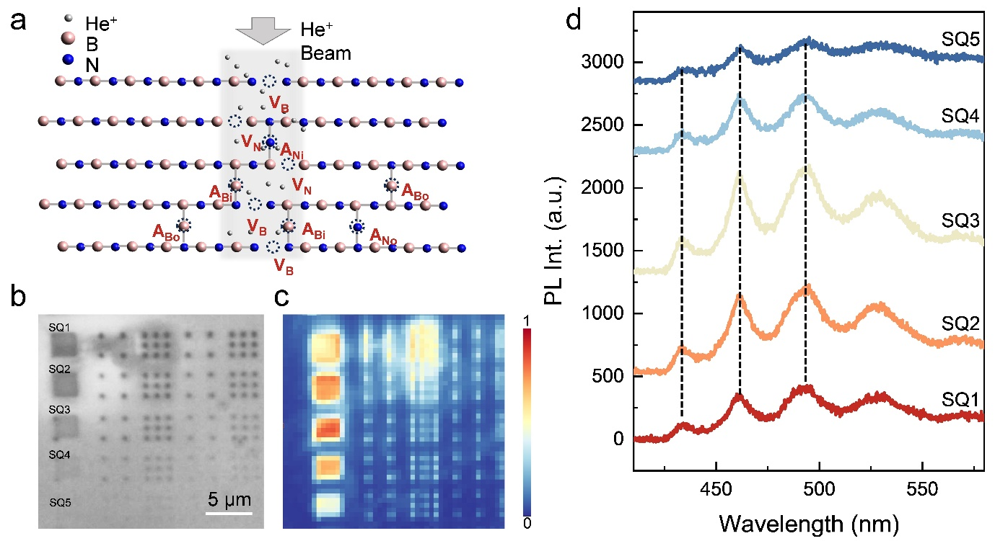
Figure 1. The creation of the blue emitters. (a) Schematic of the He⁺ irradiation on a hBN flake, creating different types of vacancies and adatoms within and out of the irradiation region. (b) Optical microscope of a hBN flake irradiated by He⁺ in sqaures and points, the squares are marked with SQ1-SQ5, are with fluences of 3E16, 1E16, 3E15, 1E15 and 3E14 respectively. (c) PL mapping results at room temperature capturing wavelength range 400-500 nm. (d) PL spectra of the irradiated hBN at room temperature at different areas with different fluences of irradiation.

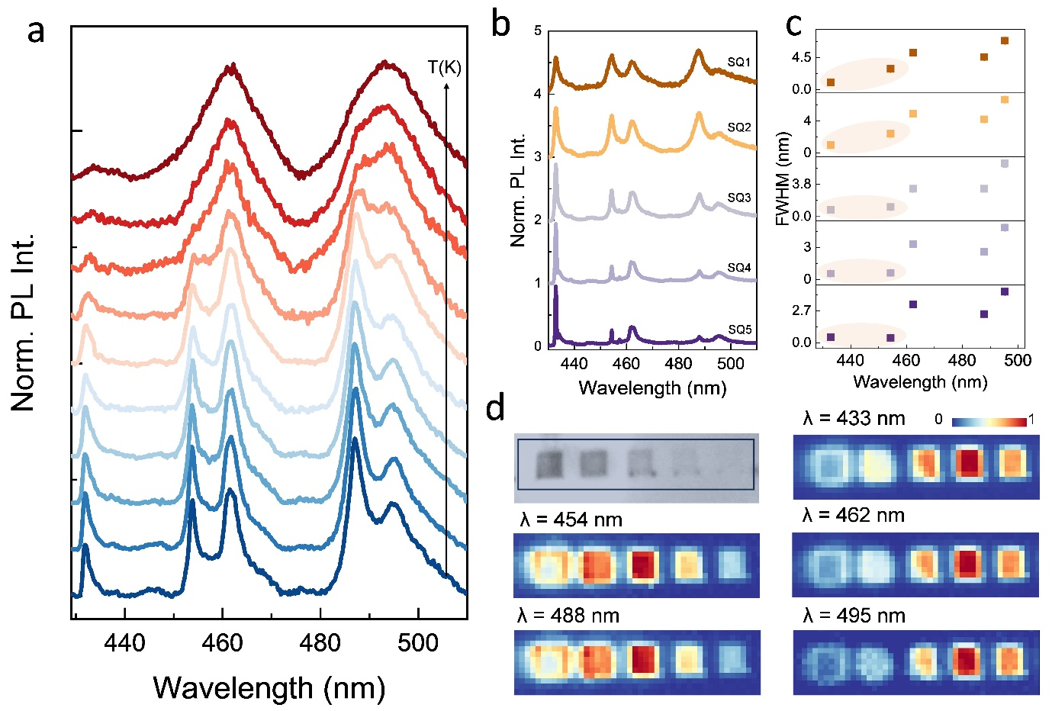
Figure 2. Temperature dependence and spatial correlation. (a) Temperature dependent PL spectra of the irradiated hBN. (b) PL spetra of the irradiated hBN at 4K (c) Full width at half maximum (FWHM) of the five peaks observed in the spectra in (b). (d) A spatial correlation of the emission peaks observed in (b) integrated over different energies.
Figure 3. PLE measurements. (a, b) PLE mapping of the emission peaks, with excitation wavelengths (a) from 437 nm to 455 nm, (b) from 427 nm to 437 nm. (c) PLE spectra of different emission peaks. (d) PL spectra of the emission peaks corresponding to (c). 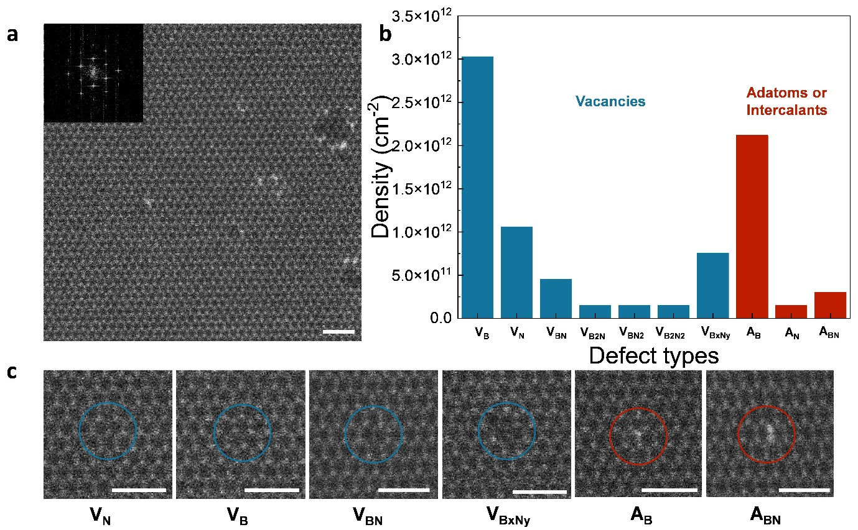
Figure 4. Structural characterization of helium irradiated hBN multilayer. (a) Large-area HAADF-STEM image of helium irradiated hBN multilayer with different defects. Inset denotes the FFT of the same area. (b) Statistical distribution of various vacancy-type and adatom-(intercalant-)type defects in helium irradiated hBN multilayer deduced from multiple HAADF-STEM datasets. (c) HAADF-STEM of the 6 most common defect structures found in helium irradiated hBN multilayer. Scale bar is 1 nm.
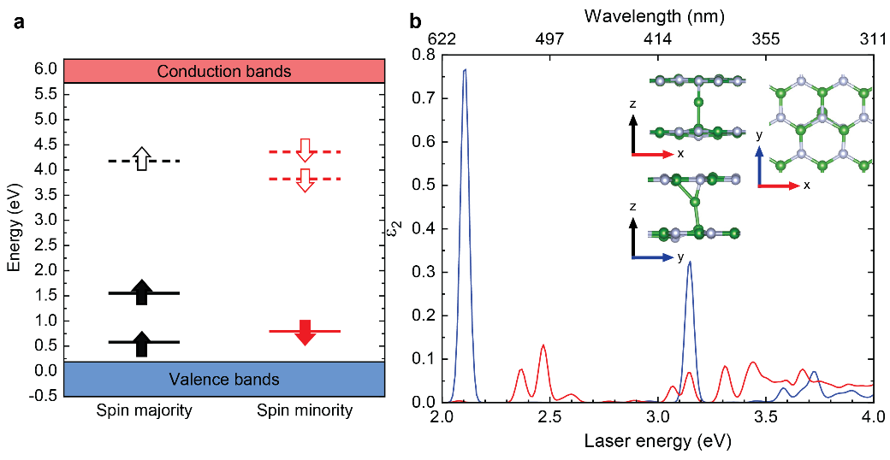
Fig. 5. Calculated quasiparticle energy levels and optical absorption spectra. (a) GW quasiparticle defect levels for B_{int}. The blue (red) area corresponds to the valence (conduction) bands. The black (red) lines and arrows correspond to spin majority (spin minority). The filled (empty) arrows and lines (dashed lines) denote occupied (unoccupied) defect states. (b) BSE optical absorption spectra of B_{int}. Blue lines denote spectra polarized along the x axis, while red lines denote spectra polarized along the y axis. The inset figures show the geometry of B_{int} from the top and side views. Green atoms denote B atoms; grey atoms denote N atoms.

Table of content

