Long-range modulation of skyrmion population by local current injection

Sneha Yadav^{1, 2}, Satoshi Sugimoto², Sandip Chatterjee¹, Kazuhito Tsukagoshi³ and Shinya Kasai²
¹Department of Physics, Indian Institute of Technology (BHU), Varanasi 221005, India
²Research Center for Magnetic and Spintronic Materials, National Institute for Materials Science, 1-2-1 Sengen, Tsukuba 305-0047, Japan
³International Center for Materials Nanoarchitectonics (WPI-MANA), National Institute for Materials Science, 1-1 Namiki, Tsukuba, Ibaraki, 305-0044, Japan

ABSTRACT
The thin-film magnetic skyrmion is designed to interact with each other as nonlinear response, enabling collective magnetic morphology at the nonequilibrium state. We here explore the alternative nonlinear morphology of multiple skyrmions induced by the orthogonal two-current injections for the Pt/Co/Ir multilayer platforms. The global currents induce polarity-dependent driving and accumulation of skyrmions across the whole area of a Hall bar device. Once another local current is injected from a μm width ports, dozens of skyrmions follow their polarity manners of the local injection, resulting in total modulations of skyrmion population governed by a pair of two-current polarities. Such massive morphology tuning at the nonlinear region indicates resemblances with a skyrmion Hall effect, where current-induced accumulation and depletion create the nonequilibrium distributions of skyrmions toward Hall deflections. Our findings propose an alternative controlling method of skyrmion population through threshold-like responses.
*Corresponding author: Shinya.Kasai@nims.go.jp

Magnetic skyrmions¹ are nanoscale chiral spin textures characterized by topological protection, and their properties of controllable downsizing and high current-driven mobility make them attractive for spintronic^{2,3}, memory⁴, and neuromorphic computing applications^{5,6}. Observations of such topological textures have been reported typically at non-centrosymmetric crystals that lack inversion symmetry⁷ and/or the magnetic thin film heterostructures under the finite Dzyaloshinskii Moriya interaction (DMI)⁸. For the latter thin film heterostructure platforms, particularly heavy metal/ferromagnet/heavy metal (HM/FM/HM) multilayers, competition between the DMI and the perpendicular magnetic anisotropy (PMA) leads to stabilizations and manipulations of skyrmions even at room temperature^{9–11}. Stabilizations of room-temperature skyrmions have been established for various multilayer platforms so far, including [Ir/Co/Pt]_{n} multilayers, where skyrmion density can be tuned by Co thickness and in-plane magnetic fields¹², and Pt/Co/Os/Pt heterostructures, which exhibit current-driven motion and measurable skyrmion Hall effect¹³. In ultrathin Pt/Co/MgO trilayers, Néel skyrmions show drive-dependent Hall angles¹⁴. Furthermore, subsequent recent studies have also paved ways to ferrimagnetic thin films, including Pt/CoGd ¹⁵, Pt/Fe_{1-x}Tb_{x}/Ta ¹⁶, and Pt/Co/Tb ¹⁷, where fast and efficient current manipulations are enabled by suppressing inherited Hall motions.
Beyond these studies of stabilizations and linear responses, increasing attention has recently focused on nonlinear skyrmion dynamics, such as threshold currents for motion or nucleation, deformation of spin textures, and nonreciprocal transport^{18,19,20}. From an applications perspective, these nonlinear dynamics are not merely limitations but provide new classes of opportunities. Threshold-like responses can be harnessed for energy-efficient switching in memory devices, where information is written only when a critical current is exceeded²⁰. Nonreciprocal transport and deformation under drive can be used to implement diode-like behaviour ²¹ and tunable signal processing²². In neuromorphic and reservoir computing^{23–25} schemes, the intrinsic nonlinearities of skyrmion motion and interaction offer a natural substrate for nonlinear transformation of input signals, enabling pattern recognition^{5,23}.
The nonlinear responses often accompany additional interactions between individual skyrmions during depinning/distortion processes, or inhomogeneous current distributions. Among them, spin-wave mediated skyrmion-skyrmion interactions potentially induce abnormally collective skyrmion dynamics. Koshibae et al. have predicted current-induced driving under such nonlinear interaction resulted in a new class of collective accumulations along the skyrmion Hall direction, addressing skyrmion accumulation, by theoretical and numerical approaches²⁶. Sugimoto et al. have subsequently demonstrated direct imaging of corresponding collective dynamics at nonequilibrium steady states for ultrathin Pt/Co/Ir trilayers²⁷. A framework for interpreting these nonequilibrium states lies beyond the reach of common micromagnetic analysis, and a new class of phenomenological chemical potential has been introduced in which the skyrmion Hall effect produces accumulation and depletion across pseudo-chemical potential gradients. Such a potential-based framework feasibly leads to distinctive scales from other types of skyrmion morphologies, dozens of μm-scale modulation of magnetic texture, although further investigations have barely been reported so far.
In this work, we explored such nonlinear collective dynamics and developed an alternative approach for selectively controlling skyrmion distributions using current applications along the two orthogonal directions. The first global current caused the nonequilibrium accumulation with a polarity-dependent asymmetry toward a Hall direction. Once the second local current from the orthogonal Hall ports hits a threshold value, these two currents trigger dozens of μ-scale accumulations, distinctively followed only by combinations of two-current polarities. Subsequently, a selective localization of skyrmion distributions, regarded as controlling “skyrmion population”, can be achieved only by switching the current directions in threshold manners.
Pt/Co/Ir heterostructures were sputtered onto thermally oxidized Silicon substrates by combinations of the DC and RF magnetron sputtering at room temperature. 3 nm-Ta and 5 nm-Pt layers were prepared as buffers to obtain highly oriented (111) texture prior to Co and Ir sputtering under a moving shutter drive, which enabled sub-nm scale thickness gradient of Co and Ir on a single substrate. After 3 nm-Pt layer capping, all samples were patterned into 20 µm-width wires with 5 µm-width symmetric Hall electrodes using maskless lithography. The magnetic morphologies were investigated using two types of magneto-optical Kerr effect (MOKE) facilities; the scanning MOKE magnetometer with a laser-based system first captured overall pictures of all switching behaviours by tracking hysteresis loops, then the detailed morphologies were selectively investigated only at skyrmionic conditions by direct imaging provided by the MOKE microscope. The skyrmion number statistics were evaluated using a typical particle analysis on bitmap image data, where the domain size $A$ and circularity $C=4πA/P^{2}$ ($P$ denotes the perimeter) were calculated from monotone PNG image then filtered as skyrmions, stripe domains, or distorted domains. Eventual particle analyses under current applications were performed on a series of devices at different Co and Ir thickness as ${0.3 nm≤t}_{Co}≤0.45 nm$ and ${ 0.02 nm≤t}_{Ir}≤0.11 nm$ with 2-3 process repetitions. The control numerical calculations were carried out by using the open-source micromagnetic code (see detailed conditions in the Supplementary Note 1).
Figure 1(a) indicates a schematic of the whole stack of sample structures. Atomic-scale thickness modulations of both the Co and Ir layers enable ultrafine tuning of the PMA and DMI of these heterostructures. A Kerr hysteresis loop under the room-temperature skyrmion-stabilized condition is shown in Fig. 1(b). The skyrmionics domain morphologies were successfully captured as deformations between skyrmion bubbles and stripe domains with varying the perpendicular magnetic field. As common features appeared in helical domain morphologies, the formation of stripe domains in Fig. 1(c) occurred at the smaller magnetic field of -3.2Oe, then stripe domains deformed into sub-μm scale skyrmion bubbles by increasing the field amplitude to -7.2Oe in Fig.1(d). Note that such stabilization condition settles at the sub-nm Co thickness t_{Co} < 0.5 nm, where enhanced pinning and surface inhomogeneity help to reach the current-induced nonlinear responses²⁸.
Figure 2(a) shows a schematic of our Hall bar structure, which consists of two local injection ports. The main wire is sectionized into four different regions, and the number of skyrmion densities at each region is designed to be controlled by combinations of the global current (j₁) or the local current (j₂). The skyrmion bubbles confined at sub-nm thickness FM indicate nonequilibrium thermodynamics under continuous current application. Such a nonequilibrium steady state also accompanies a distinctively long-range spatial modulation along the Hall directions, regarded as nonequilibrium skyrmion accumulations/depletions. Our micromagnetic simulations have given insights of these collective nonlinear responses, where skyrmions in impurity system are driven with lower velocities $v$ ($ο\left(v\right)=1\sim 10 m/s$ at $ο\left(j_{1,2}\right)={10}^{11}$A/$m^{2}$) under the spin wave propagation from impurity sites and/or by skyrmion distortions (Fig. S1(c) and (d) in the Supplementary Note 1). The individual skyrmion has then indicated a finite attractive force correlated by spin wave, resulting in the nonuniform segregations by prevailing against original repulsive interaction in the linear systems (Fig. S1(a) in the Supplementary Note 1).
Although the quantitative formulation of these complicated collective dynamics has lied beyond the reach of this study, the entire picture of the skyrmion morphologies could be discussed by introducing a phenomenological chemical potential model²⁷. The global and local current injections could be regarded to act to alter the phenomenological potential landscape, physically corresponding to changing the correlated skyrmion density distributions, i.e., spatial modulation of the entire magnetic energy. Since skyrmion Hall effect appears strongly on these correlated skyrmion systems, the magnetic energy modulation follows the skyrmion Hall manner. As a result, this phenomenological potential tuning indicates the skyrmion Hall manner also, simplified as potential landscape modulations orthogonal to current directions. Comprehensive skyrmion morphologies are discussed using this phenomenological role from single current injection results in Figs. 2(b-e). Firstly, positive global current j₁ > 0 leads to skyrmion accumulation in the bottom part of the wire (regions 3 and 4) whilst reversing the polarity of j₁ shifted the accumulation to the top part (regions 1 and 2) accompanied by depletion on the opposite side, consistent with the skyrmion Hall effect as observed in Figs.2(b) and (c). Second, the sketches of nonlocal potential landscape are supported by results with local current injections in Fig. 2(d) and (e), where positive j₂ >0 leads to accumulation in regions 1 and 4, whereas negative j₂ < 0 leads to the opposite accumulation in regions 2 and 3, respectively. Supposed skyrmions would follow only by the current-induced driving and nucleation process at the μm notch design^{28–31} , such local injections would bring about skyrmion accumulation only in the vicinity of injection ports, whilst there would exist a small number of skyrmions at the left and right edge parts due to the lack of driving torque. However, experimental skyrmions are distributed uniformly in regions 1(2) and 4(3) for positive j₂ >0 (negative j₂ < 0). Such global modulations have been commonly observed for collective skyrmion dynamics platform feasibly attributed to the synergetic effect of (i) the cascade-type spin wave propagations between continuously supplied skyrmions and (ii) finite thermal gradient induced by Joule heating. The corresponding micromagnetic simulations propose the individual steps of a global skyrmion accumulation by the local current injection in the Supplementary Note 2. Overall, these results indicate sketch of potential modulation is phenomenologically applicable to the overall distributions of skyrmions.
Based on phenomenological discussions of such chemical potential modulation, further control of skyrmion distribution is inspired by a combination of two-current injections $j_{1}(=±3.1 x {10}^{10} A/m^{2})$ and $j_{2}(=±7.5 x {10}^{10} A/m^{2})$ as demonstrated in Figs. 2(f)∼(i). Corresponding current amplitudes are set enough below to neglect both the current-induced Joule heating and magnetic field effects on counting skyrmion numbers (see details in the Supplementary Note 3). Under a pair of positive current application $\left(j_{1},j_{2}\right)=(+,+)$, skyrmions locally accumulate at region 4, accompanied by a gradual decrease of skyrmion density from region 1, 3 to 2 as shown in Fig. 2(f). This distinctive result indicates that the superposition manner of chemical potential gradient is phenomenologically assumed by following the manner of co-application of skyrmion Hall effect, in which region 4 is the exact region where skyrmion Hall directions of $j_{1}$ and $j_{2}$ coincide. The region of such selective skyrmion localization, named as skyrmion population, can be allocated by all possible combinations of two current polarities, at region 3 for $\left(j_{1},j_{2}\right)=(+,-)$ as shown in Fig. 2(g), at region 1 for $\left(j_{1},j_{2}\right)=(-,+)$ as shown in Fig. 2(h), and at region 2 for $\left(j_{1},j_{2}\right)=(-,-)$ as shown in Fig. 2(i), respectively. These results are apparent demonstrations of how skyrmion distribution can be localized selectively only by two current combinations as an alternative manipulation protocol of massive skyrmion distributions.
The more systematic results of these two-current injections are summarized in Table 1. All data point were obtained from the devices with Co and Ir thicknesses with $t_{Co}=0.41 nm$and $t_{Ir}=0.06 nm$ as a series of representative results for discussing this relative population hierarchy, since the skyrmion density is quite sensitive to sub-nm Co thickness variations. In the 3rd column of Table 1, the correlations of skyrmion population at each region are derived based on the chemical potential model, assuming global $j_{1}$ leads global potential gradient against local modulation by $j_{2}$. The corresponding experimental results are indicated in the 4th column for different $\left(j_{1},j_{2}\right)$ combinations, respectively. The small variation in total skyrmion numbers at $\left(j_{1},j_{2}\right)=(0,+)$ and $(0,-)$ is attributed from finite PMA variation along Co-thickness gradient, designed parallel to global current direction. On the other hand, there exists a negligible difference between $\left(j_{1},j_{2}\right)=(+,0)$ and $(-,0)$ in which current-induced Hall direction is set parallel to Ir-thickness gradient. Besides, between single current injection and two-current injections, the total number of skyrmions indicates notable increments combined with the skyrmion nucleation process at Hall edges. We phenomenologically observe qualitative analogies at skyrmion distributions with the previous potential model in these nonconservative topological charge processes. In the case of two-current injections, the whole orders of skyrmion population are consistently distributed in the following manner: the highest populations appear at coincident directions of skyrmion accumulations by j₁ and j₂, and the 2nd highest ones lie in accumulation of $j_{2}$ but depletion of $j_{1}$. The 3rd populations subsequently appear at accumulation of $j_{1}$ with depletion of $j_{2}$, and the minimum populations are observed coincident with depletion directions, indicating that local $j_{2}$ phenomenologically plays a more dominant role in population rather than global $j_{1}$. Consequently, skyrmion generation occurs preferentially in regions toward accumulations, corresponding to sites of higher effective skyrmion density shown in the bottom 4 lines in Table 1.
Next, the higher current dependencies of such skyrmion populations are investigated as functions $\left(j_{1},j_{2}\right)$ in Fig. 3 to obtain further insights into these nonequilibrium and nonlinear responses. Firstly, for global current dependencies in Fig. 3(a) under a constant local $j_{2}={7.5×10}^{10}A/m^{2}$, skyrmion population follows skyrmion Hall manner from below${5.0×10}^{10}A/m^{2}$ where the highest number of skyrmions accumulated in region 4 and lowest skyrmion accumulated in region 2. Beyond the value of ${5.0×10}^{10}A/m^{2}$, a relative increase of population in region 3 is prominent, combined with a gradual increase of total number of skyrmions. Such enhancement of $j_{1}$-leading accumulation is a straightforward response under larger $j_{1}$, with modulating balances between global and local contributions. Secondly, for local current dependencies in Fig. 3(b), skyrmion population shows massive modulation for the higher current region. Starting from an almost linear gradient of population between 4 regions below ${5.0×10}^{10}A/m^{2}$, the total number of skyrmions is linearly increased with $j_{2}$ and almost doubled above $15.0×{10}^{10}A/m^{2}$ since the $j_{2}$ amplitude links to the nucleation process at the Hall edges. In parallel, populations in regions 1 and 4 monotonically increase despite suppression of those in regions 2 and 3. At the higher current amplitude with the order of 10¹¹ A/m², the overall population approaches a single local current $j_{2}$ injection results in the 3rd line of Table 1. Such deviation from the previous selective population is feasibly attributed to the oversupply of additional skyrmions from nucleation edges, where excess numbers of skyrmions stack in region 3 after filling region 4, and the original skyrmion Hall manner induced by two currents would deviate from eventual skyrmion distributions. These results clearly indicate that a finite amplitude of the local current below excess nucleation around $j_{2}<{10}^{11}A/m^{2}$ is adequate to enable the selective population control of skyrmions through skyrmion Hall manners.
Finally, the detailed current dependencies at a lower limit for the skyrmion population give more insights into how such distinctive response is triggered by the current application. Figures 4 indicate MOKE images captured at different global current (i) $j_{1}=1.9×{10}^{10}A/m^{2}$ and (ii) $j_{1}=4.4×{10}^{10}A/m^{2}$ under constant local current $j_{2}=5.0×{10}^{10}A/m^{2}$, and (iii) zero current remanent ( $j_{1}=j_{2}=0 A/m^{2}$). Even though the applied current in (i) is too weak to induce a conventional global accumulation, expected at regions 3 and 4 in this configuration, the clear skyrmion population appears localized at region 4 in (ii) without passing any intermediate accumulations. This abrupt change indicates that skyrmion population is not a mere overlap of phenomenological potential modulations induced by independent currents, but more like ruled by a certain threshold nature once current-induced entire dynamics hit the nonlinear conditions. These types of response are also natural within the framework of skyrmion with impurities in our assumptions, where enhanced pinning allows the total magnetic energy at spin wave mediated relocalization, i.e., skyrmion population state here, allocate lower than that under the continuous skyrmion driving accompanied with subsequent nucleation and/or annihilation processes. In other words, these results indicate simple descriptions of skyrmion response with increasing current application (depinning, displacement with scattering, steady driving along skyrmion Hall direction, and nonlinear deformation in ascending order) are no longer applicable to these correlated skyrmion systems. Also, this sudden population redistribution beyond a critical current resembles a generic activation process in nonequilibrium systems. From a conceptual standpoint, this threshold behaviour bears phenomenological similarity to integrate-and-fire dynamics discussed in neuromorphic contexts, although concrete demonstrations of learning and construction of multi-element interconnection remain a subject for future study.
In conclusion, an alternative nonequilibrium magnetic morphology with a selective skyrmion population was explored using the orthogonal two-current drive approach in its nonlinear regime. A local current injection at a μm port controls collective magnetic textures with minimal external stimuli, enabling tunability of the selective skyrmion population. Precise confinement of the current-induced perturbations enables a clear correlation between local excitation and nonlocal skyrmion redistribution, thereby localizing the design toward combined Hall deflection. The observed threshold-dependent population response reflects a nonlinear activation process in a driven skyrmion ensemble. These results may nevertheless offer a platform for exploring threshold-driven information-processing concepts in magnetic textures.

S.Y. sincerely acknowledges the Ministry of Education, India, for providing financial support through the Prime Minister Research Fellowship (PMRF) grant (Ref. No. IITBHU/ACD/PMRF/2022-23/4003). This work was partially supported by the Japan Society for the Promotion of Science (JSPS) KAKENHI grant nos. JP24K00952, and JP25K01298, Japan.

AUTHOR DECLARATIONS
Conflicts of Interest
The authors have no conflicts to disclose.
Authors contributions
Sneha Yadav: Formal analysis (equal); Investigation (lead); Methodology (equal); Validation (lead); Writing - original draft (equal). Satoshi Sugimoto: Conceptualization (equal); Funding acquisition (equal); Project administration (supporting); Formal analysis (supporting); Methodology (supporting); Supervision (supporting); Writing - original draft (equal). Sandip Chatterjee: Conceptualization (supporting); Project administration (equal); Supervision (equal). Kazuhito Tsukagoshi: Methodology (supporting); Resources (supporting). Shinya Kasai: Conceptualization (equal); Funding acquisition (equal); Project administration (equal); Methodology (equal); Supervision (equal); Writing - original draft (supporting).

DATA AVAILABILITY
The data that support the ﬁndings of this study are available from the corresponding author upon reasonable request.

FIGURE CAPTIONS

FIG. 1. (a) The multilayer film stack of Si/SiO₂/Ta(3 nm)/Pt(5 nm)/Co(0.3-0.7 nm)/Ir(0-0.2 nm)/Pt(3 nm), where Co and Ir have a wedge structure whose directions were perpendicular to each other. (b) Kerr hysteresis loop under the skyrmion stabilization condition at the Co thickness of 0.41 nm. Magneto-optical Kerr effect imaging of (c) stripe domains at -3.2 Oe and (d) skyrmion bubbles at -7.2 Oe.

FIG. 2. (a) The Hall bar design for injections of global (j₁) and local (j₂) currents. Dimensions of wires were 80 µm x 20 µm, and the 2 Hall ports have 5 µm in their widths, sectionized to four regions 1~4. Magneto-optical Kerr effect images under (b),(c) global current injections $j_{1}=±3.1×{10}^{10} A/m^{2}$, (d),(e) local current injections $j_{2}=±7.5×{10}^{10} A/m^{2}$, and (f)-(i) co-applications $\left(\left|j_{1}\right|,\left|j_{2}\right|\right)=(3.1×{10}^{10} A/m^{2}, 7.5×{10}^{10} A/m^{2})$. Red and black arrows indicate the global and local current directions, respectively. The yellow enclosures highlighted skyrmion accumulated regions from 1~4.

FIG. 3. The number of skyrmions as functions of (a) the global current $j_{1}$ at constant local current $j_{2}=7.5×{10}^{10}A/m^{2}$ and (b) the local current $j_{2}$ at constant global current $j_{1}=1.9×{10}^{10}A/m^{2}.$ The black, red, blue, and purple symbols indicate skyrmion counts at regions 1, 2, 3, and 4, respectively.

FIG. 4. Magneto-optical Kerr effect images captured at different global current at (i) $j_{1}=1.9×{10}^{10}A/m^{2}$ and (ii) $j_{1}=4.4×{10}^{10}A/m^{2}$ under constant local current $j_{2}=5.0×{10}^{10}A/m^{2}$ , (iii) zero current remanent at $j_{1}=$ $j_{2}=$ 0.0 $A/m^{2}$.

TABLES
TABLE 1. Nonequilibrium skyrmion distributions at four different regions of wires at all combinations of the global and local current polarities at $\left(\left|j_{1}\right|,\left|j_{2}\right|\right)=(3.1×{10}^{10} A/m^{2}, 7.5×{10}^{10} A/m^{2})$. Column 1 and column 2 label combinations of global and local current polarities, column 3 presents the region of skyrmion accumulations derived from the skyrmion Hall manner, and column 4 indicates experimental skyrmion distribution in each region of the wire. The 1st and 2nd population regions are highlighted by orange and yellow colours. The devices with Co thickness $t_{Co}=0.41 nm$and Ir one $t_{Ir}=0.06 nm$ are adapted as a series of representative results for discussing this relative population hierarchy.

Fig. 1 Sneha et al.

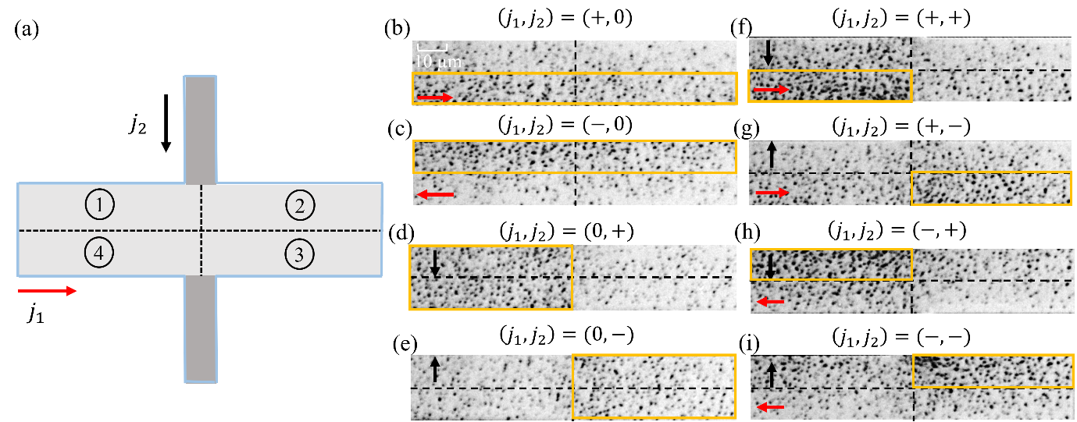
Fig. 2 Sneha et al.

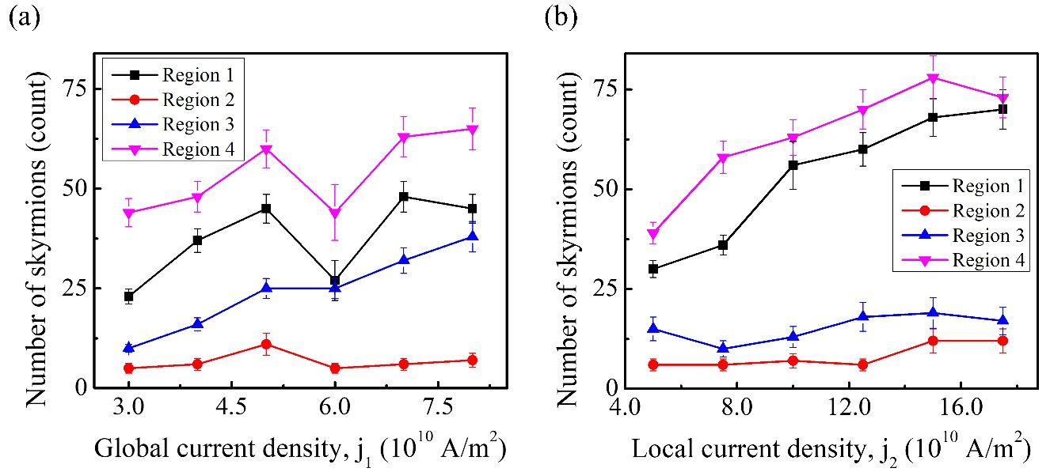
Fig. 3 Sneha et al.

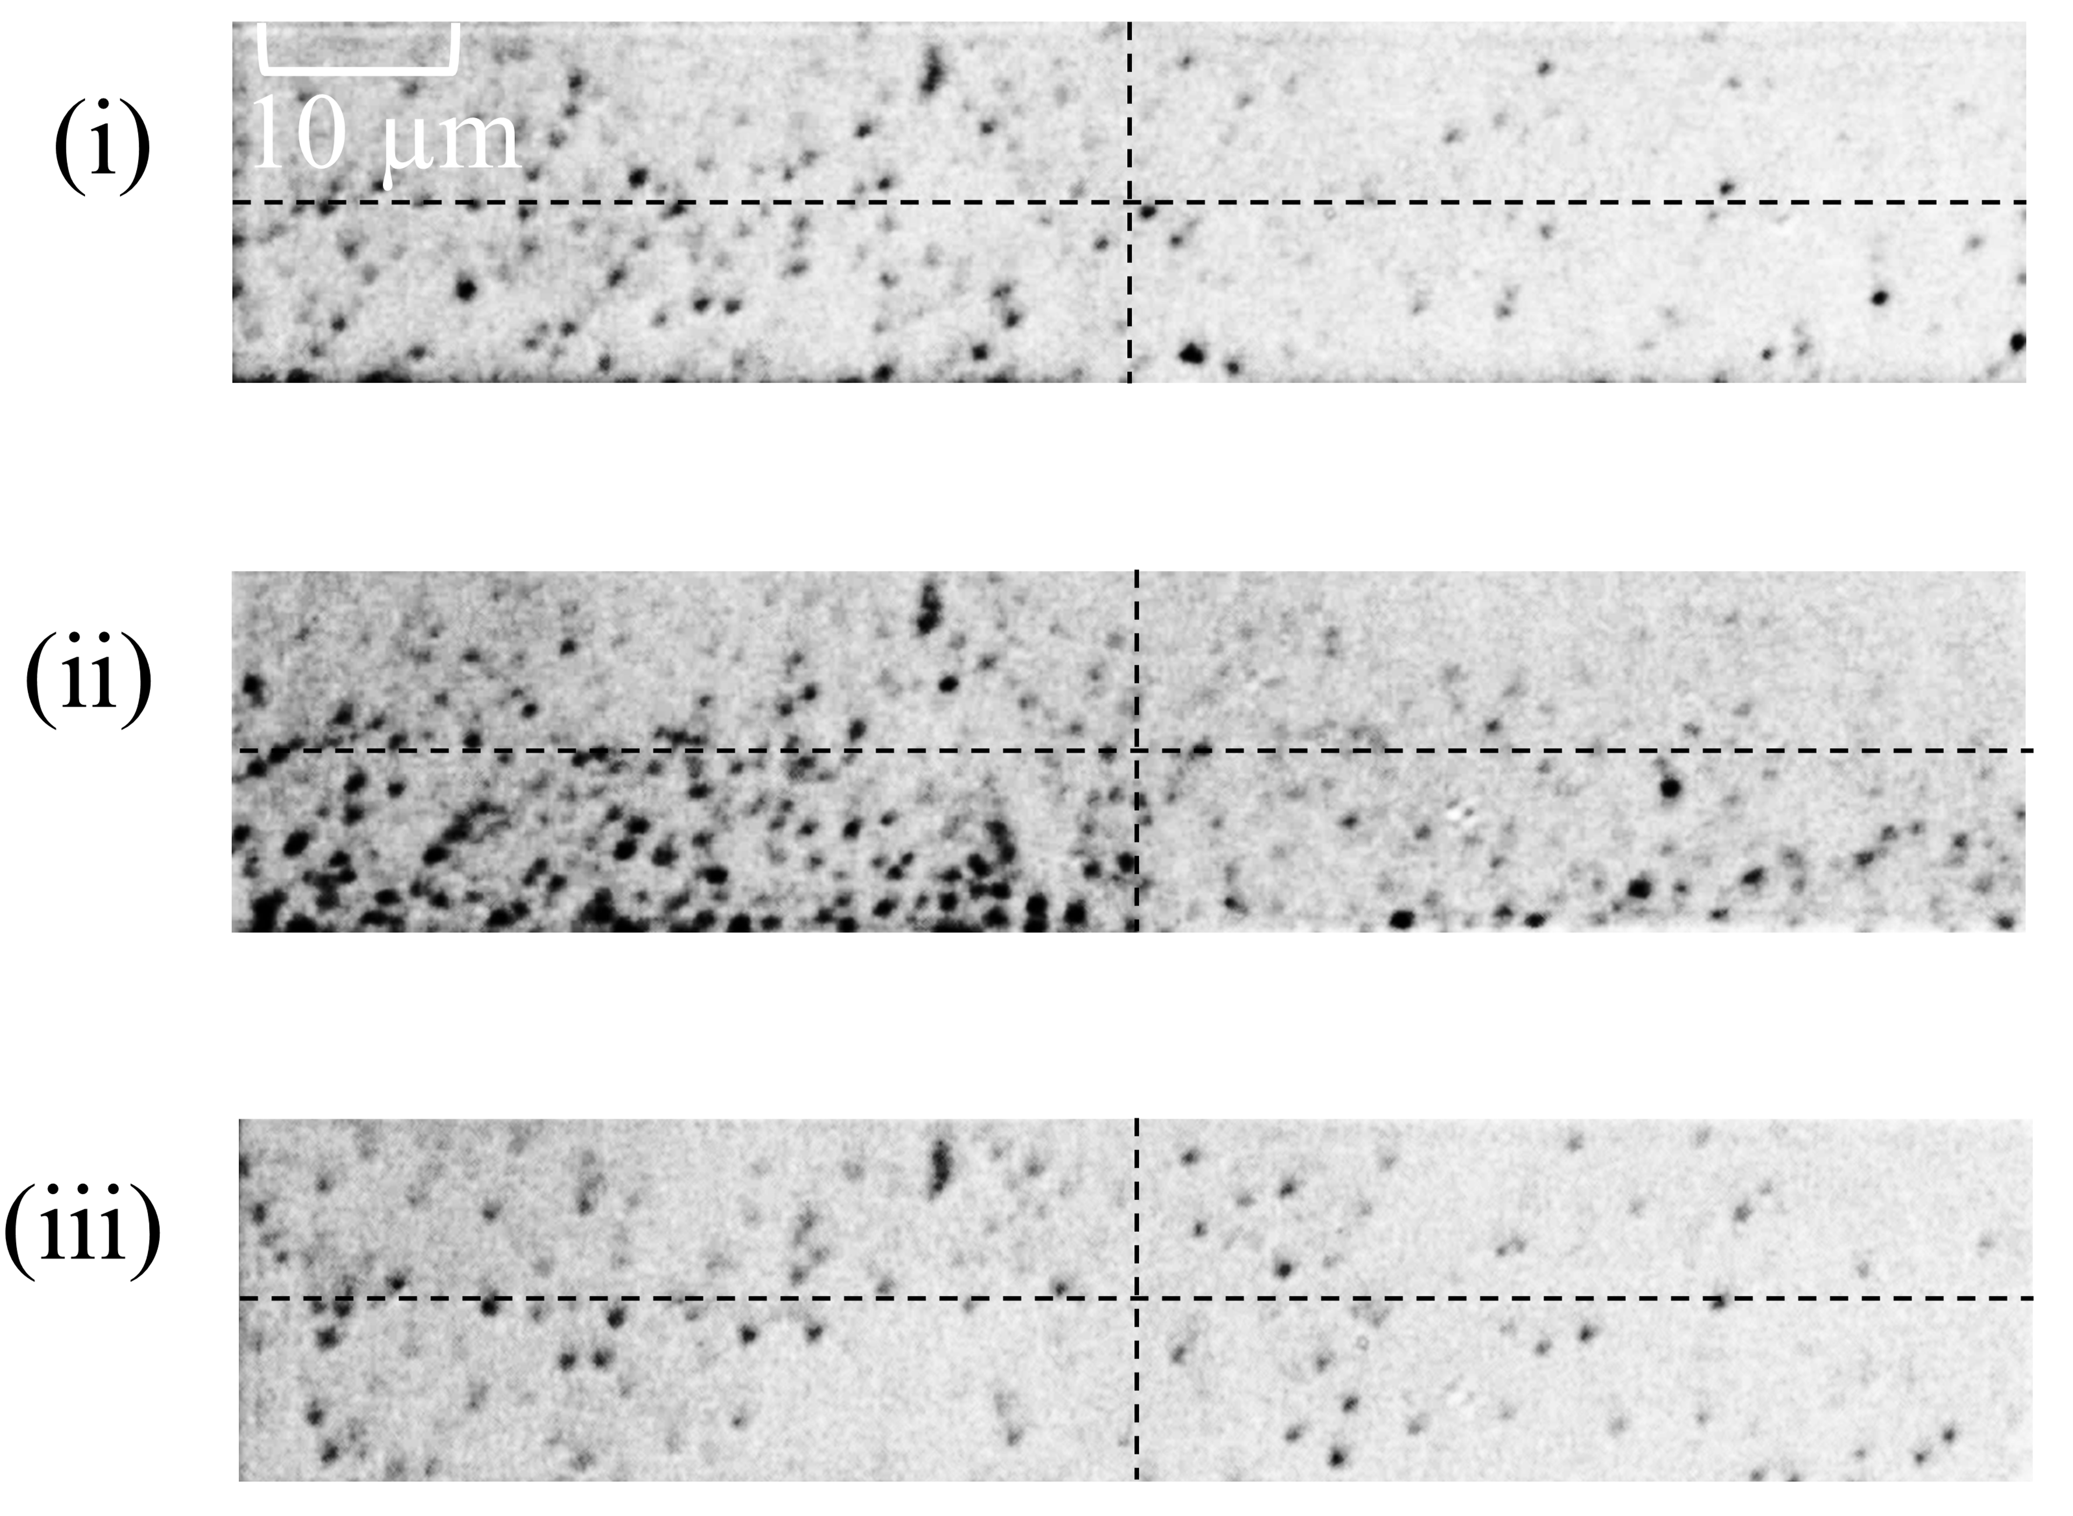
Fig. 4 Sneha et al.

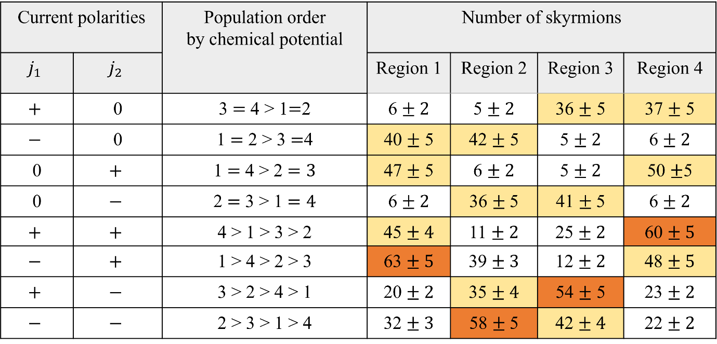

Table. 1 Sneha et al

REFERENCES
¹ A. Fert, N. Reyren, and V. Cros, “Magnetic skyrmions: Advances in physics and potential applications,” Nat. Rev. Mater. 2, 17031 (2017).
² X. Zhang, Y. Zhou, K.M. Song, T.E. Park, J. Xia, M. Ezawa, X. Liu, W. Zhao, G. Zhao, and S. Woo, “Skyrmion-electronics: Writing, deleting, reading and processing magnetic skyrmions toward spintronic applications,” J. Phys., Condens. Matter 32, 143001 (2020).
³ R. Wiesendanger, “Nanoscale magnetic skyrmions in metallic films and multilayers: A new twist for spintronics,” Nat. Rev. Mater. 1, 16044 (2016).
⁴ D. Prychynenko, M. Sitte, K. Litzius, B. Krüger, G. Bourianoff, M. Kläui, J. Sinova, and K. Everschor-Sitte, “Magnetic Skyrmion as a Nonlinear Resistive Element: A Potential Building Block for Reservoir Computing,” Phys. Rev. Appl. 9, 014034 (2018).
⁵ T. Yokouchi, S. Sugimoto, B. Rana, S. Seki, N. Ogawa, Y. Shiomi, S. Kasai, and Y. Otani, “Pattern Recognition with Neuromorphic Computing Using Magnetic Field-Induced Dynamics of Skyrmions,” Sci. Adv. 8, eabq5652 (2022).
⁶ A.H. Lone, X. Zou, D. Das, X. Fong, G. Setti, and H. Fariborzi, “Anomalous hall and skyrmion topological hall resistivity in magnetic heterostructures for the neuromorphic computing applications,” Npj Spintronics 2, 3 (2024).
⁷ S. Mühlbauer, B. Binz, F. Jonietz, C. Pfleiderer, A. Rosch, A. Neubauer, R. Georgii, and P. Böni, “Skyrmion Lattice in a Chiral Magnet,” Science 323, 915 (2009).
⁸ W. Jiang, G. Chen, K. Liu, J. Zang, S.G.E. te Velthuis, and A. Hoffmann, “Skyrmions in magnetic multilayers,” Phys. Rep. 704, 1 (2017).
⁹ A. Fert, V. Cros, and J. Sampaio, “Skyrmions on the track,” Nat. Nanotechnol. 8, 152 (2013).
¹⁰ S. Woo, K. Litzius, B. Krüger, M.Y. Im, L. Caretta, K. Richter, M. Mann, A. Krone, R.M. Reeve, M. Weigand, P. Agrawal, I. Lemesh, M.A. Mawass, P. Fischer, M. Kläui, and G.S.D. Beach, “Observation of room-temperature magnetic skyrmions and their current-driven dynamics in ultrathin metallic ferromagnets,” Nat. Mater. 15, 501 (2016).
¹¹ C. Moreau-Luchaire, C. Moutafis, N. Reyren, J. Sampaio, C.A.F. Vaz, N. Van Horne, K. Bouzehouane, K. Garcia, C. Deranlot, P. Warnicke, P. Wohlhüter, J.M. George, M. Weigand, J. Raabe, V. Cros, and A. Fert, “Additive interfacial chiral interaction in multilayers for stabilization of small individual skyrmions at room temperature,” Nat. Nanotechnol. 11, 444 (2016).
¹² A. Soumyanarayanan, M. Raju, A.L.G. Oyarce, A.K.C. Tan, M.Y. Im, A.P. Petrovic, P. Ho, K.H. Khoo, M. Tran, C.K. Gan, F. Ernult, and C. Panagopoulos, “Tunable room-temperature magnetic skyrmions in Ir/Fe/Co/Pt multilayers,” Nat. Mater. 16, 898 (2017).
¹³ R. Tolley, S.A. Montoya, and E.E. Fullerton, “Room-temperature observation and current control of skyrmions in Pt/Co/Os/Pt thin films,” Phys. Rev. Mater. 2, 044404 (2018).
¹⁴ K. Litzius, I. Lemesh, B. Krüger, P. Bassirian, L. Caretta, K. Richter, F. Büttner, K. Sato, O.A. Tretiakov, J. Förster, R.M. Reeve, M. Weigand, I. Bykova, H. Stoll, G. Schütz, G.S.D. Beach, and M. Klaüi, “Skyrmion Hall effect revealed by direct time-resolved X-ray microscopy,” Nat. Phys. 13, 170 (2017).
¹⁵ Y. Quessab, J.-W. Xu, E. Cogulu, S. Finizio, J. Raabe, and A. D. Kent, “Zero-Field Nucleation and Fast Motion of Skyrmions Induced by Nanosecond Current Pulses in a Ferrimagnetic Thin Film,” Nano. Lett. 22, 6091 (2022).
¹⁶ T. Xu, Y. Zhang, Z. Wang, H. Bai, C. Song, J. Liu, Y. Yan, S.-G. Je, A. T. N’Diaye, M.-Y. Im, R. Yu, Z. Chen, and W. Jiang, “Systematic Control of Ferrimagnetic Skyrmions via Composition Modulation in Pt/Fe_{1– x}Tb_{x} /Ta Multilayers,” ACS nano 17, 7920 (2023).
¹⁷ S. Mallick, Y. Sassi, N. F. Prestes, S. Krishnia, F. Gallego, L. M. V. Arche, S. Collin, K. Bouzehouane, A. Thiaville, R. E. Dunin-Borkowski, V. Jeudy, A. Fert, N. Reyren, and V. Cros, “Driving skyrmions in flow regime in synthetic ferrimagnets,” Nat. Commun. 15, 8472 (2024).
¹⁸ W. Jiang, X. Zhang, G. Yu, W. Zhang, X. Wang, M. Benjamin Jungfleisch, J.E. Pearson, X. Cheng, O. Heinonen, K.L. Wang, Y. Zhou, A. Hoffmann, and S.G.E. Te Velthuis, “Direct observation of the skyrmion Hall effect,” Nat. Phys. 13, 162 (2017).
¹⁹ T. Schulz, R. Ritz, A. Bauer, M. Halder, M. Wagner, C. Franz, C. Pfleiderer, K. Everschor, M. Garst, and A. Rosch, “Emergent electrodynamics of skyrmions in a chiral magnet,” Nat. Phys. 8, 301 (2012).
²⁰ B. Ojha, S. Mallick, S. Kumar Panigrahy, M. Sharma, A. Thiaville, S. Rohart, and S. Bedanta, “Driving Skyrmions with Low Threshold Current Density in Pt/CoFeB Thin Film,” Phys. Scr. 98, 035819 (2023).
²¹ T. Yokouchi, S. Hoshino, N. Kanazawa, A. Kikkawa, D. Morikawa, K. Shibata, T.-H. Arima, Y. Taguchi, F. Kagawa, N. Nagaosa, and Y. Tokura, “Current-Induced Dynamics of Skyrmion Strings,” Sci. Adv. 4, eaat1115 (2018).
²² D. Prychynenko, M. Sitte, K. Litzius, B. Krüger, G. Bourianoff, M. Kläui, J. Sinova, and K. Everschor-Sitte, “Magnetic Skyrmion as a Nonlinear Resistive Element: A Potential Building Block for Reservoir Computing,” Phys. Rev. Appl. 9, 014034 (2018).
²³ Y. Huang, W. Kang, X. Zhang, Y. Zhou, and W. Zhao, “Magnetic skyrmion-based synaptic devices,” Nanotechnology 28, 08LT02 (2017).
²⁴ G. Bourianoff, D. Pinna, M. Sitte, and K. Everschor-Sitte, “Potential implementation of reservoir computing models based on magnetic skyrmions,” AIP Adv. 8, 055602 (2018).
²⁵ D. Pinna, G. Bourianoff, and K. Everschor-Sitte, “Reservoir Computing with Random Skyrmion Textures,” Phys. Rev. Appl. 14, 054020 (2020).
²⁶ W. Koshibae, and N. Nagaosa, “Theory of current-driven skyrmions in disordered magnets,” Sci. Rep. 8, 6328 (2018).
²⁷ S. Sugimoto, W. Koshibae, S. Kasai, N. Ogawa, Y. Takahashi, N. Nagaosa, and Y. Tokura, “Nonlocal accumulation, chemical potential, and Hall effect of skyrmions in Pt/Co/Ir heterostructure,” Sci. Rep. 10, 1009 (2020).
²⁸ J. Iwasaki, M. Mochizuki, and N. Nagaosa, “Current-induced skyrmion dynamics in constricted geometries,” Nat. Nanotechnol. 8, 742 (2013).
²⁹ F. Büttner, I. Lemesh, M. Schneider, B. Pfau, C.M. Günther, P. Hessing, J. Geilhufe, L. Caretta, D. Engel, B. Krüger, J. Viefhaus, S. Eisebitt, and G.S.D. Beach, “Field-free deterministic ultrafast creation of magnetic skyrmions by spin-orbit torques,” Nat. Nanotechnol. 12, 1040 (2017).
³⁰ W. Wang, D. Song, W. Wei, P. Nan, S. Zhang, B. Ge, M. Tian, J. Zang, and H. Du, Electrical manipulation of skyrmions in a chiral magnet,” Nat. Commun. 13, 1593 (2022).
³¹ X.Z. Yu, D. Morikawa, K. Nakajima, K. Shibata, N. Kanazawa, T. Arima, N. Nagaosa, and Y. Tokura, “Motion Tracking of 80-Nm-Size Skyrmions upon Directional Current Injections,” Sci. Adv. 6, eaaz9744 (2020).

