Particle Arrangements and Optical Changes Induced by Water-swelling of Melanin-like Polydopamine Layers

Taku Watanabe^{§1}, Yui Maejima^{§1}, Yuki Ueda², Ryuhei Motokawa*², Ai Takabatake³, Shin-ichi Takeda⁴, Hiroshi Fudouzi⁵, Keiki Kishikawa⁶, and Michinari Kohri*⁶

¹ Department of Applied Chemistry and Biotechnology, Graduate School of Science and Engineering, Chiba University, 1-33 Yayoi-cho, Inage-ku, Chiba 263-8522, Japan
² Materials Sciences Research Center, Japan Atomic Energy Agency, 2-4 Shirakata, Tokai-mura, Naka-gun, Ibaraki 319-1195, Japan
³ MS Scientific Co. Ltd., 4-11-3, Kuramae, Taito-ku, Tokyo, 111-0051, Japan
⁴ Takeda Colloid Techno-Consulting Co., Ltd., 16–23, Toyotsu-cho, Suita, Osaka, 564-0051, Japan
⁵ National Institute for Materials Science, 1-2-1 Sengen, Tsukuba-Shi, Ibaraki 305-0047, Japan
⁶ Department of Applied Chemistry and Biotechnology, Graduate School of Engineering, Chiba University, 1-33 Yayoi-cho, Inage-ku, Chiba 263-8522, Japan

Author Contributions
§T. W. and Y. M. contributed equally.

Corresponding Authors
*E-mail: motokawa.ryuhei@jaea.go.jp (R. M.); kohri@faculty.chiba-u.jp (M. K.)

Abstract

The assembly structures of colloidal particles coated with a melanin-like polydopamine (PDA) layer create vivid structural colors. While it is known that the thickness of the PDA layer influences particle arrangement and optical properties, the underlying mechanism has remained controversial. Here, we demonstrate that the water-swelling characteristics of PDA are a crucial factor governing the dispersion and aggregation of these particles in solution. Detailed comparisons between dry and wet conditions revealed that the PDA layer readily absorbs water molecules, which leads to significant swelling in the thicker layers. The swelling of the PDA layers determined whether the particles remained dispersed or partially aggregated in the water, ultimately controlling the particle arrangement in the dried state once the water evaporated. These findings provide insights into the self-assembling of colloidal particles and offer a strategy for tuning the periodic particle order. This feature is pivotal for various applications in optical and sensing technologies.

Keywords: structural color; melanin; polydopamine; colloidal crystal; amorphous structure

Introduction
The periodic structures formed by the self-assembly of molecules and particles are extremely important for the functionalization of materials, and their functionality depends on the size of the structure. ¹⁻⁵ Periodic structures composed of colloidal particles of uniform submicron size are known as colloidal crystals, and they reflect visible light to produce structural color. ^{6, 7} Opal, which was identified by Sanders as an assembly of monodisperse silica particles, is an example of a colloidal crystal in nature. ⁸ The arrangement of the particles in opal acts as a diffraction grating, diffracting visible light. ⁹ Colloidal crystals exhibit an iridescent color due to the repeated combination of diffraction-causing structures. Thanks to advances in bottom-up nanotechnology, it is now possible to artificially create high-quality colloidal crystal structures, and research is being conducted. White light incident on a colloidal crystal is selectively reflected at a specific wavelength by Bragg diffraction. The reflected peak can be visually recognized as a structural color in the visible wavelength range. The peak wavelength of Bragg diffraction is expressed by eq 1 combined with Snell's law: ⁹

mλ = 2d$\sqrt{(n^{2}-\sin^{2}{θ})}$ (1)

where m is the diffraction order, λ is the wavelength of light, d is the interparticle distance, n is the effective refractive index of the colloidal crystal, and θ is the auxiliary angle of the incident light (for vertical incident: θ = 0). As observed from eq 1, the hue of the structural color produced by colloidal particles largely depends on the size and refractive index of the particles, and the previous focus of material development was on these parameters. ¹⁰⁻¹³
In addition to the above two parameters, the following two parameters have attracted great interest from the viewpoint of controlling the angle dependence and saturation of structural colors. The first is the assembled structure of colloidal particles, which greatly affects the angle dependence of the structural color (Figure 1a). ^{14, 15} Colloidal crystal structures with periodic structures formed over long distances produce highly reflective iridescent structural colors that change with the viewing angle due to Bragg diffraction, and much research has been performed in this area (vide supra). Additionally, recent studies have shown that deliberately disturbing the particle arrangement to build an amorphous colloidal array result in a viewing angle-independent color and a noniridescent structural color. ^{14, 15} The radial distribution function of the randomly assembled structure of colloidal particles is nearly constant over long distances and has clear peaks only over short distances, exhibiting a short-range ordered structure. ¹⁶ The photonic pseudogap of the isotropic short-range ordered structure is direction-independent. Therefore, coherent light scattering, which scatters evenly in all directions, creates a noniridescent structural color. Since the required characteristics differ depending on the application, a technique for arbitrarily controlling the angle dependence of the structural color is important. ^{17, 18} The second is the blackness of the colloidal particles, which is related to the saturation of the structural color. While submicron-sized periodic microstructures should be present to obtain structural color, they usually appear white because they simultaneously cause multiple light scattering. Doping the colloidal particle array with a black substance that absorbs excess light suppresses light scattering and generates a highly visible structural color. ^{19, 20} Carbon black,^{21, 22} graphene,²³⁻²⁵ iron oxide nanoparticles,^{26, 27} polypyrrole,²⁸ black metal osmium,²⁹ silver nanoparticles,³⁰ copper oxide nanoparticles,³¹ and carbonized particles³²⁻³⁴ are useful as black substances. The saturation and visibility of structural colors were improved by absorbing scattered light due to the absorption characteristics of the black substances in the visible range. It has also been reported that the intensity of scattered light was selectively suppressed by utilizing the light absorption capacity of gold nanoparticles in a specific wavelength region due to the plasmon resonance frequency. ⁷
Research on structural color materials, which contain melanin in their microstructure and replicate the structural coloration mechanisms found in living organisms, has advanced rapidly over the past decade. ³⁵⁻³⁸ Among these, the structural color materials we reported in 2016, ³⁹ which consist of melanin particles, i.e., PS@PDA core-shell particles with polystyrene (PS) as the core and melanin-mimetic polydopamine (PDA) ^{40, 41} as the shell, used in many studies due to the scalability of the particle design and the ease of synthesis. ⁴² Many researches are focused on particle shape, ^{43, 44} core and shell composition, ⁴⁵⁻⁴⁷ the effects of additives, ⁴⁸⁻⁵² PDA particles doping, ⁵³⁻⁵⁵ and functionalization through the creation of higher-order structures. ⁵⁶⁻⁵⁹ Recently, reports have emerged regarding optimizing PDA shell thickness using simulations ⁶⁰ and enhancing structural coloration through binary assembled systems of particles with and without PDA shells. ^{61, 62} An important characteristic is that the ordering of the particle array varies with the thickness of the PDA shell: particles having a thin PDA shell layer (< ca. 5 nm) form a colloidal crystal structure with an iridescent structural color and a thick PDA shell layer (> ca. 10 nm) form an amorphous structure with a noniridescent structural color. ³⁹ This unique future has been explained by the roughness seen on the surface of the thick PDA shell. ^{39, 63} However, these insights were based solely on observations of the surface of dry particles. Therefore, despite its importance, the effect of differences in the thickness of the PDA shell on the particle assembly structure remains unknown.
In this study, we report that the difference in the arrangement structure of PS@PDA particles in the dry state after water evaporation is due to the swelling behavior of PDA in water. PS(X)@PDA(Y) core-shell particles with different PDA shell thicknesses were created by changing the amount of DA monomer in a water solvent with dispersed PS particles: X and Y represent the diameter of the PS core particles and the thickness of the PDA shell layer (nm), respectively, as measured in a dry state (Figure 1b). Structural color materials were obtained by dropping a particle dispersion onto a substrate and evaporating the water. We focused on the gradual increase in particle concentration during water evaporation and evaluated the characteristics of structural color in the evaporation process using microspectroscopic reflectance measurements. The properties of the dispersions with varying particle concentrations were investigated using small-angle neutron scattering (SANS) and viscosity measurements, and the swelling behavior of each particle was evaluated using time-domain nuclear magnetic resonance (TD-NMR) measurements. The findings obtained here reveal that the swelling of the PDA shell layer modulates aqueous particle aggregation—thereby determining the ordering of the particle arrangement in the dry state, and we provide a comprehensive elucidation of the underlying mechanism governing particles with varied PDA shell thicknesses.

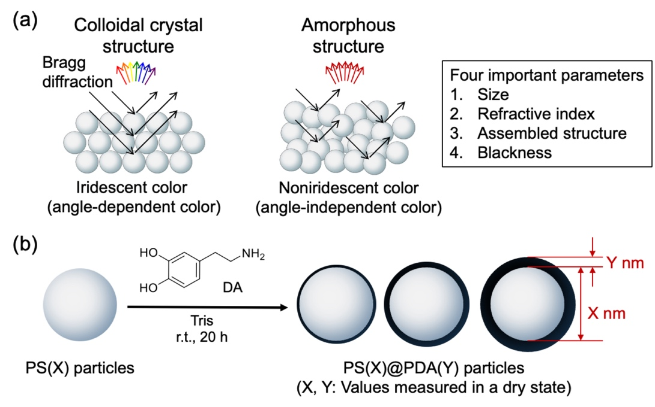
Figure 1. (a) Structural color characteristics obtained from colloidal crystals and amorphous colloidal arrays. (b) Schematic diagram of preparing PS@PDA particles with different PDA shell thicknesses by changing the DA feed ratio relative to the PS core particle amount.

Experimental
Materials
Dopamine hydrochloride (DA) and deuterium oxide (D₂O) were obtained from Sigma-Aldrich Japan Co., LLC. (Tokyo, Japan). Tris(hydroxymethyl)aminomethane (Tris) was obtained from Kanto Chemical Co., Inc. (Tokyo, Japan). A Millipore Simplicity UV system provided deionized water with an 18.2 MΩ·cm resistance. All other chemicals and solvents were of reagent grade and were used as received. PS particles were prepared according to the previous paper. ⁶⁴

Preparation of the PS@PDA core-shell particles
PS@PDA core-shell particles were prepared as described in a previous paper. ³⁹ Briefly, DA (0.36–12 g, 1.9–63 mmol) and Tris (14.5 g, 120 mmol) were added to an aqueous dispersion (1.2 L) of PS particles (2.4–6.0 g) and stirred at room temperature. After 20 h, the resulting samples were purified repeatedly by centrifugation (12000 rpm, 30 min), forming PS@PDA core-shell particles. The synthesized products are designated PS(X)@PDA(Y) core-shell particles (X: diameter of PS core particles, Y: thickness of PDA shell layer). The average particle diameter (D_{dry}) and coefficient of variation (CV) were determined from 50 particles observed in TEM images. The PDA shell layer thickness of the samples was calculated using the following eq 2:

$PDA shell thickess={(D}_{dry} of PS@PDA particles-D_{dry} of PS particles)×\frac{1}{2}$ (2)

Measurements
The diameters and zeta potentials of particles were measured by dynamic light scattering (Zetasizer Nano ZS; Malvern Panalytical). The zeta potentials of samples were in a 5 mM NaCl solution at a particle concentration of 0.01 wt % and at an applied voltage of 149 V. Transmission electron microscopy (TEM) micrographs were obtained using a transmission electron microscope (H-7650; HITACHI). Scanning electron microscope (SEM) images of the samples were obtained using an SEM (JSM-6510A; JEOL) and a field emission (FE)-SEM (JSM-6500F; JEOL). Photographs of the samples were taken with a digital camera (OM-D E-M10; Olympus). Optical micrographs of the samples were obtained with a handmade optical microscope unit, which was equipped with a lens unit (M Plan Apo; Mitsutoyo), a light source unit (HOYA-SCHOTT HL150 Cold light; FA-TSUKUMO), and a display unit (LCD-700VH; CENTURY). The light that enters the fiber is introduced into a UV-near-IR spectrometer (Ocean Optics, USB-2000, Dunedin). X-ray photoelectron spectroscopy (XPS) measurements were acquired using a spectroscopic instrument (JPS-9030; JEOL). TD-NMR measurements were performed with a low-field NMR system (MagnoMeter XRS; Mageleka). Viscosity measurements were carried out using a tuning fork viscometer (SV-1A; A&D).

SANS measurements
SANS measurements were performed using a SANS-J diffractometer installed at Japan Research Reactor-3 (JRR-3), Japan Atomic Energy Agency (JAEA), Tokai, Japan. ^{65, 66} The incident neutron beam was monochromatized using a velocity selector with a wavelength, λ, of 0.65 nm and a wavelength distribution, Δλ/λ, of 0.15. The incident beam size was defined using a 20 × 20 mm aperture 10 m upstream of the samples and a 15 mm diameter aperture at the sample position. Two-dimensional position-sensitive detectors (650 mm × 680 mm), which were composed of 95 ³He tube detectors 8 mm in diameter, were used to detect scattered neutrons from the sample. Three sample-to-detector distances were set as 4 m and 10 m, covering a q region of 0.025 nm⁻¹ < q < 0.5 nm⁻¹. Here, q = 4πsin θ/λ is the magnitude of the scattering vector, where 2θ is the scattering angle. The two-dimensional scattering data recorded on the detectors were corrected by detector geometry and counting efficiency, and then azimuthal averaging was applied to obtain the scattering intensity distribution as a function of q. Instrumental background and air scattering were subtracted as well as the corresponding empty cell scattering for each scattering curve. Absolute intensity units (cm⁻¹) were obtained using an Al plate as a standard reference. The corrected scattering intensity distribution was designated as I(q) hereafter. Additionally, I(q) in the q range of 0.006 nm⁻¹ < q < 0.04 nm⁻¹, corresponding to a q region of ultra-small-angle neutron scattering (USANS), was measured by using a set of neutron lenses and a position-sensitive photomultiplier. ⁶⁷ The USANS intensity was converted to the absolute intensity unit by scaling the data to the SANS data obtained at 0.025 nm⁻¹ < q < 0.5 nm⁻¹, which was already calibrated as described above. Particles, i.e., PS(215)@PDA(2.5) and PS(215)@PDA(11), were filled in a quartz cell of 1.0 mm thickness with D₂O solutions, having a concentration of 5–30 wt%. Note that D₂O was used as a solvent for SANS to obtain a sufficient scattering contrast between the polymer particles and solvent. All measurements were conducted at 20 °C.

Results and discussion
The PS@PDA particles were prepared through DA polymerization in the presence of PS particles measuring 240 nm in diameter. The size of the particles in their dry state (D_{dry}), as determined by TEM, is summarized in Table 1 and Figure S1. The D_{dry} of the PS@PDA particles increased as the addition ratio of DA monomer to PS core particles during polymerization increased. The thickness of the PDA shell in the dry state was controlled within a range of 1.5 to 15 nm. Figure 2a presents photographs of the pellet samples created from PS(240) and PS(240)@PDA(Y) particles. While the PS(240) pellet samples displayed a milky white color with iridescent hues, the PS(240)@PDA(Y) pellets exhibited a distinct appearance, showing vivid structural colors. The arrangement of particles on the pellet surfaces varied depending on the thickness of the PDA layer (Figure 2b). SEM images of the surfaces of PS(240) and PS(240)@PDA(Y) (Y = 1.5–6) pellets revealed the formation of highly ordered colloidal crystal structures. In contrast, the surface of the PS(240)@PDA(Y) (Y = 8–15) pellets displayed an amorphous structure with reduced particle arrangement order. The ordering of the particle arrangement was evaluated in more detail from the Voronoi diagrams of the SEM image (Figure 2c) ⁴⁸. In the Voronoi diagrams for PS(240) and PS(240)@PDA(Y) (Y = 1.5–6), hexagonal white polygons were mainly obtained, which indicates that the particles are densely packed. On the other hand, in the case of PS(240)@PDA(Y) (Y=8–15), the proportion of white polygons decreased, and polygons of various colors were randomly arranged, visualizing the strong disturbance of the particle arrangement. The insets in Figure 2b show FE-SEM images of individual particle surfaces. While smooth surfaces were observed in PS(240) and PS(240)@PDA(Y) (Y = 1.5–6) particles with a colloidal crystal structure, rough surfaces were formed in PS(240)@PDA(Y) (Y = 8–15) particles with an amorphous structure. The roughness of these PDA shell layers is discussed later.

Table 1. Characteristics of the Created Particles
Sample name | DA monomer feed ratio (g / 1 g of PS core particles) | D_{dry} (nm)ª | CV (%)ª | PDA shell thickness (nm)^{b} | D_{h} (nm)^{c} | PDI^{c} | Zeta potential (mV)
PS(240) | – | 240 | 2.41 | 0 | 252 | 0.005 | 40.2
PS(240)@PDA(1.5) | 0.15 | 243 | 1.49 | 1.5 | 256 | 0.003 | –54.1
PS(240)@PDA(3.5) | 0.25 | 247 | 1.32 | 3.5 | 264 | 0.002 | –51.3
PS(240)@PDA(6) | 0.5 | 252 | 1.71 | 6 | 282 | 0.015 | –51.7
PS(240)@PDA(8) | 0.75 | 256 | 1.39 | 8 | 307 | 0.006 | –44.2
PS(240)@PDA(12.5) | 1 | 265 | 1.50 | 12.5 | 371 | 0.049 | –41.4
PS(240)@PDA(15) | 1.5 | 270 | 3.14 | 15 | 376 | 0.065 | –45.6
PS(215) | – | 215 | 1.68 | 0 | 220 | 0.009 | 53.6
PS(215)@PDA(2.5) | 0.3 | 220 | 1.32 | 2.5 | 228 | 0.003 | –49.1
PS(215)@PDA(4.5) | 0.5 | 224 | 2.48 | 4.5 | 235 | 0.002 | –56.4
PS(215)@PDA(8.5) | 0.75 | 232 | 1.48 | 8.5 | 252 | 0.006 | –54.6
PS(215)@PDA(11) | 1 | 237 | 2.06 | 11 | 284 | 0.040 | –50.0
PS(215)@PDA(12.5) | 1.25 | 240 | 1.61 | 12.5 | 299 | 0.032 | –54.1
ª Determined from TEM images of 50 particles. ^{b} Calculated by eq 2. ^{c} Measured by DLS in water.

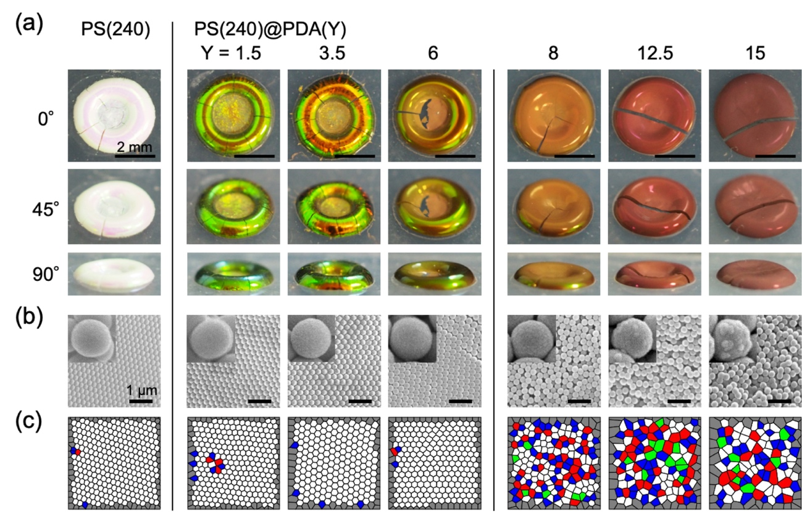
Figure 2. (a) Photographs for the pellet samples prepared from PS(240) and PS(240)@PDA(Y) particles taken from different angles. The numbers in the diagram indicate the angles observed. The PS@PDA particle water dispersions (10 wt%, 20 µL) were poured onto a silicone rubber plate. The droplets were then dried overnight at room temperature to prepare structural color pellets. (b) SEM images for the surface of the pellet samples in (a). The inset shows an enlarged image of the surface of a single particle as measured by FE-SEM. (c) Voronoi diagrams created from the SEM images in (b). Red: five-sided polygon, white: hexagonal polygon, blue: seven-sided polygon, and green: others. The Voronoi cells on the boundary of the analyzed square region (dark gray) are not included in this analysis.

Figure S2 shows the reflectance spectra of the pellets. The reflectance of the PS(240) and PS(240)@PDA(Y) (Y = 1.5–6) pellets, which formed colloidal crystals, was high at approximately 40–60%. For the PS(240)@PDA(Y) (Y = 8–15) pellets, which exhibited an amorphous structure, the reflectance significantly decreased due to the loss of the ordered structure. In all cases, the maximum reflection wavelength red-shifted as the PDA shell thickness increased due to an increase in particle size. Photographs of the pellets created from various angles also showed characteristic differences due to the thickness of the PDA shells. The thin PDA shell produced angle-dependent colors, whereas the thick PDA shell produced angle-independent colors (Figure 2a). These results were consistent with a previous report. ³⁹ To verify the universality of property changes caused by variations in the thickness of the PDA shell, we conducted a similar experiment using PS particles with a diameter of 215 nm as the core (Table 1, Figure S3). As shown in Figure S4, we obtained pellets with colloidal crystals from PS(215) and PS(215)@PDA(Y) (Y = 2.5–4.5) particles that had thin shells. In contrast, pellets made from PS(215)@PDA(Y) (Y = 8.5–12.5) particles with thick shells formed amorphous structures.
In this experiment, structural color pellets were created by dropping a water dispersion of particles onto a substrate; the concentration of particles gradually increased as the water evaporated. We thus assessed the dispersibility and dispersion stability of the obtained particles in a dilute aqueous solution (particle concentration: 0.01 wt%) using DLS measurements. Figure S5a shows that the DLS charts for all the particles immediately after ultrasonic irradiation were unimodal. After allowing the dispersions to sit for 2 hours, unimodal peak distributions were maintained, and the particles did not aggregate (Figure S5b). These results show that the particles obtained demonstrate high dispersibility and dispersion stability in dilute aqueous solutions, regardless of the PDA shell thickness. The hydrodynamic diameter (D_{h}) of the particles measured in water is presented in Table 1. The D_{h} values of PS(240) and PS(215) core particles increased slightly compared to the D_{dry} values. In the PS(240)@PDA(Y) and PS(215)@PDA(Y) particles, the D_{h} values were noticeably larger than the D_{dry} values as the PDA shell thickness increased, suggesting that the PDA layer may have swelled in water. ^{68, 69} The zeta potentials of the prepared PS@PDA core-shell particles were high, at approximately –50 mV, regardless of the PDA shell thicknesses, contributing to the suppression of particle aggregation through electrostatic repulsion.
We observed the structural color that appears on the surface of a water droplet during evaporation, using PS(215)@PDA(2.5) particles that form a colloidal crystal structure, as well as PS(215)@PDA(8.5) particles that create an amorphous structure. In both cases, the structural color was observed to begin near the contact point between the droplet and the glass substrate (Figures 3a and 3b). A microscopic reflectance spectrophotometer assessed the time-dependent changes in the reflectance properties of the area where the structural color was noted. During the drying process of the PS(215)@PDA(2.5) dispersion, a broad reflection peak appeared at approximately 580 nm. As the water evaporated, the peak sharpened and blue-shifted, indicating the formation of an ordering particle array structure within the water (Figure 3c). A blue shift of the reflection peak was also noted for the PS(215)@PDA(8.5) particles (Figure 3d). However, the reflection intensity significantly decreased, suggesting that the ordering of the particle arrangement structure was lower. These results highlight the importance of the particle arrangement ordering in the dispersion solution during the particle concentration process through solvent evaporation.

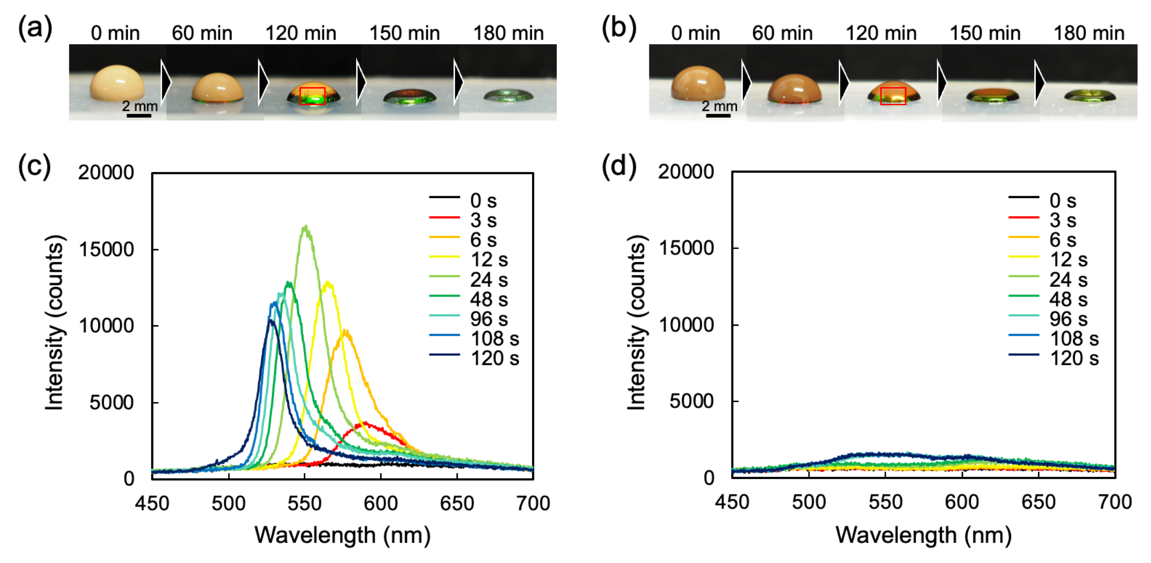
Figure 3. Photographs of the process of forming a pellet sample by evaporation of water from a droplet of (a) PS(215)@PDA(2.5) and (b) PS(215)@PDA(8.5) particle dispersion, which was obtained by dropping the dispersion on a substrate. Time variation of the reflectance spectrum of structural color appearing in water droplets prepared from (c) PS(215)@PDA(2.5) and (b) PS(215)@PDA(8.5) particle dispersion. The areas enclosed by the red squares in (a) and (b) were measured respectively.

SANS measurements were performed to investigate the state of the particle arrangements in the dispersion with the particle concentrations varying from 5 to 30 wt%. Figure 4 shows the SANS profiles obtained for PS(215)@PDA(2.5) and PS(215)@PDA(11) particles as a function of the particle concentrations. In Figure 4a, SANS intensities below 10 wt% for q < 0.02 nm⁻¹ hardly changed, while those for q > 0.4 nm⁻¹ showed a power-law scattering, I(q) ~ q^{−d}. For the samples examined here, the exponent, d, is close to 4 (i.e., the Porod law ⁷⁰). This behavior may result from sharp interfaces of the particles. A scattering maximum around q ≈ 0.03 nm⁻¹ (indicated by arrows in Figure 4a) appeared at 20 wt% particles, and the intensity increased with the particle concentration. The scattering peak originates from interparticle interference, and the average distance between the particles, L, can be roughly evaluated as 255 nm based on the q position of the scattering maximum, q_{m}, because of L ≈ 2π/q_{m}. In Figure 4b, as compared to the system for PS(215)@PDA(2.5) particles, clear differences in the SANS profiles were observed for q < 0.4 nm⁻¹, whereas the data are similar for q > 0.4 nm⁻¹. The scattering peaks were not clearer than those in Figure 4a, even at the high concentration, and the scattering intensity at q < 0.4 nm⁻¹ gradually increased with decreasing q. These facts indicate that PS(215)@PDA(11) particles are partially aggregated in D₂O and that some are dispersed without aggregation. In Figure 4b, it is noteworthy that SANS profiles for q > 0.3 nm⁻¹ do not exhibit the power-law scattering with an exponent of d = 4. This observation suggests that the interface of the PS(215)@PDA(11) particles is not as sharp as that of the PS(215)@PDA(2.5) particles, probably due to the scattering contributions resulting from the partial swelling of the PDA shell by water.

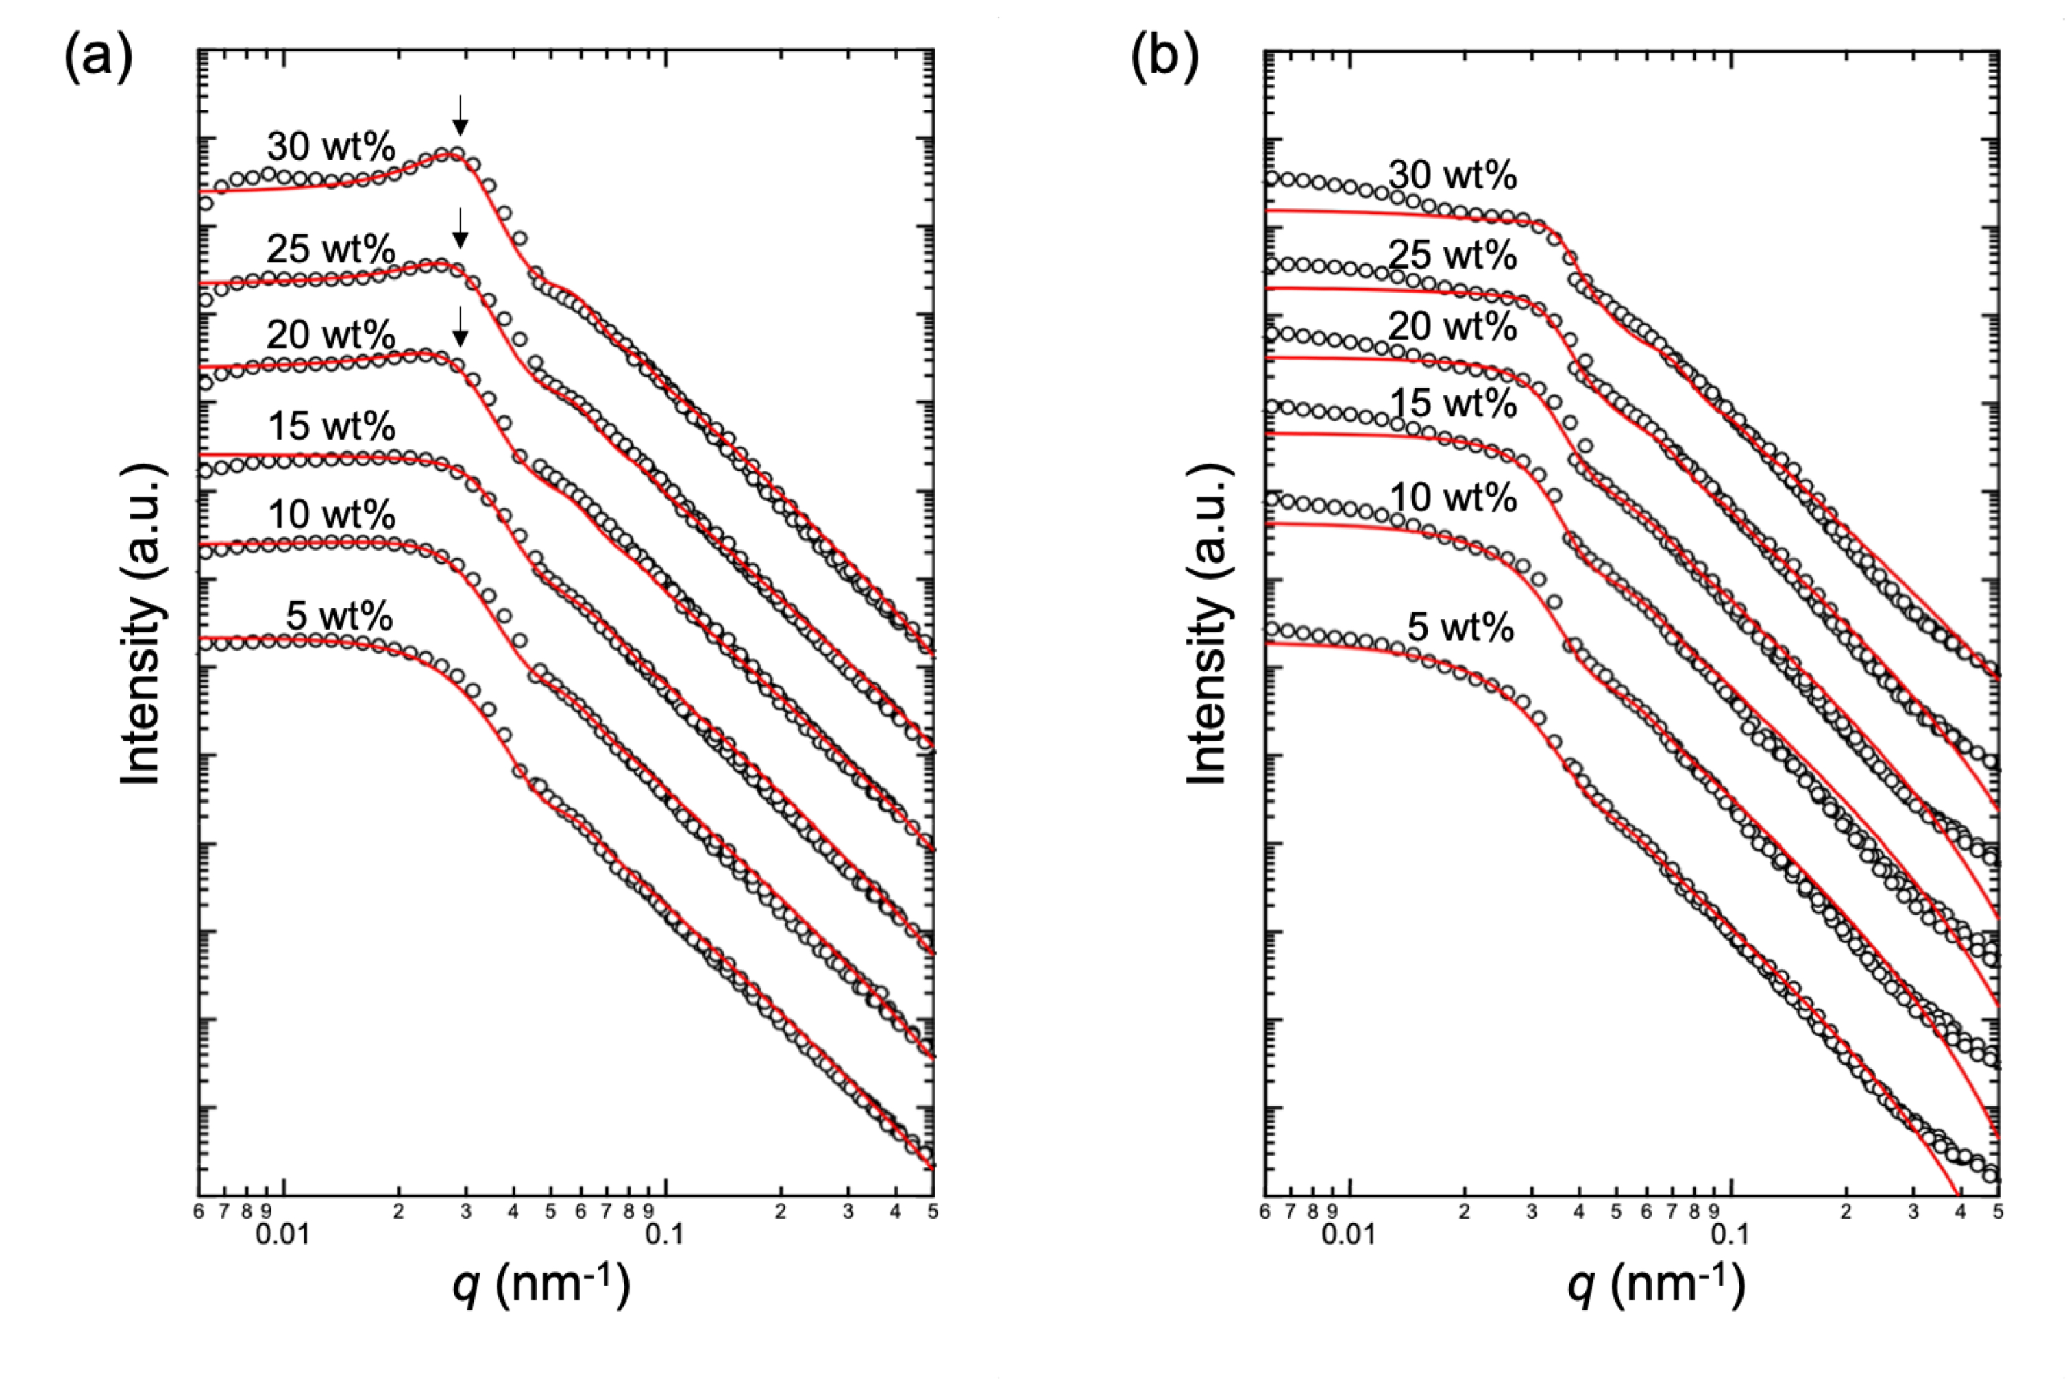
Figure 4. Double-logarithmic plots of the SANS profiles for D₂O dispersion of (a) PS(215)@PDA(2.5) and (b) PS(215)@PDA(11) particles (particle concentration: 5–30 wt%). SANS profiles are vertically shifted to avoid overlap by an offset constant of every one order magnitude.

We carried out a numerical analysis of the SANS profiles to characterize the dispersion and aggregation behavior of the particles. The scattering function of the particles, I_{particles}(q), which is given by the product of the particle form factor, P(q), and its structure factor, S(q), was calculated using the following eq 3: ⁷¹

$I_{particles}\left(q\right)=ϕV{∆B}^{2}P\left(q\right)S(q)$ (3)

where φ and V are the volume fraction of the volume of the particles, respectively. ΔB is the difference in scattering length density between the particles and D₂O. For P(q), we employed a theoretical scattering function for the spherical model, ⁷¹ which can be characterized by two structural parameters, i.e., the average radius of the particles and its polydispersity, corresponding to R and σ (standard deviation in Gaussian distribution), respectively. For S(q), originating from the interference among the particles, we employed the hard-sphere model given by the Percus-Yevick formalism. ^{67, 72} In this model, we replace the particles with an equivalent hard-sphere of radius R_{HS}, which has an excluded volume given by the sphere of radius R_{HS} and the φ (= 4πnR_{HS}³/3). n is the number of particles per unit volume in solution. Three parameters, R, σ, and R_{HS}, were refined to give the best fit to the data and reproduce the experimental SANS profiles. Table S1 lists the evaluated parameters. The black solid lines in Figure 4 show the best-fit theoretical scattering curves obtained using eq 3, which exhibit good agreement with the experimental data only in Figure 4a. However, in Figure 4b, the lines do not agree with the experimentally obtained SANS profiles for q < 0.02 nm⁻¹. This discrepancy arises because the model employed does not account for particle aggregation and, therefore, fails to reproduce the scattering behavior associated with the aggregation of PS(215)@PDA(11) particles, as discussed above.
The origin of the aggregation characteristics of PS@PDA particles at high particle concentrations was investigated from the viewpoint of chemical and physical factors. XPS measurements were utilized to assess whether the chemical composition of the particle surface varied based on the thickness of the PDA shell. The XPS spectra of PS(240)@PDA(Y) particles (Y=1.5, 15) in the C1s and N1s regions are illustrated in Figure S6; the spectra across the three regions align with previously reported PDA spectra, indicating that variations in shell thickness do not influence PDA chemical composition. ^{73, 74} Figure 5a presents the viscosity of water dispersions with varying concentrations of PS(240)@PDA(Y) particles (Y=1.5, 15) measured using a tuning fork viscometer. The viscosity of the dispersion system gradually increased with higher particle concentrations. For particle concentrations of 5–15 wt%, the viscosity of systems remained nearly constant across different PDA shell thicknesses. Interestingly, viscosity significantly increased for concentrations exceeding 20 wt% as the thickness of the PDA shell layer increased. The viscosity of the particle dispersion systems was monitored over time. While no change in viscosity over time was observed for both particles at low particle concentrations (5 wt%) (Figure 5b), the behavior differed depending on the particle used at high particle concentrations (25 wt%) (Figure 5c). The viscosity of the PS(240)@PDA(1.5) particle dispersions remained constant regardless of the time elapsed since the start of measurement. On the other hand, in the PS(240)@PDA(15) particle dispersion, a clear increase in viscosity was observed over time, indicating that particle aggregation was promoted in the solution. ⁷⁵

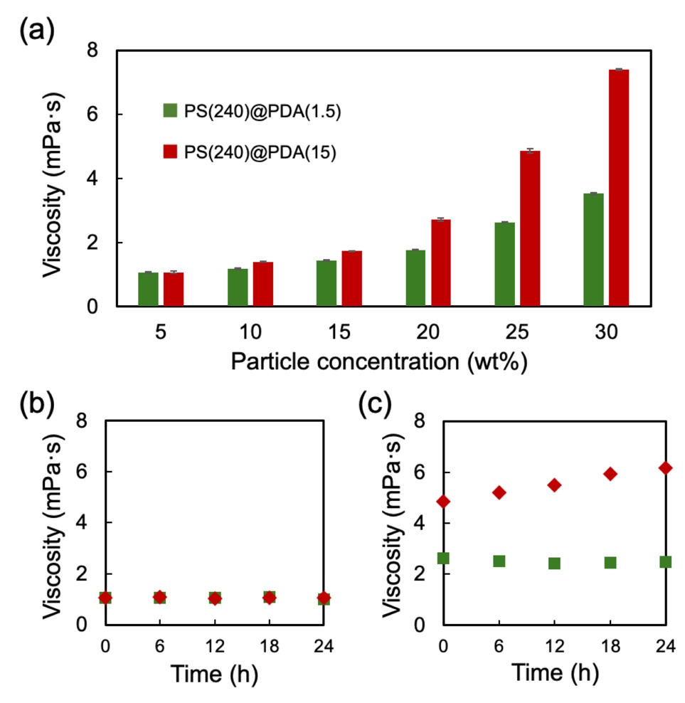
Figure 5. (a) The viscosity of water dispersions of PS(240)@PDA(Y) particles (Y=1.5, 15) at different particle concentrations. Time variation in the viscosity of the water dispersion of PS(240)@PDA(Y) particles (Y=1.5, 15) at a particle concentration of (b) 5 wt% and (c) 25 wt%. Green square: PS(240)@PDA(1.5) and Red diamond: PS(240)@PDA(15).

As mentioned above, as the thickness of the PDA layer increased, D_{h} in water increased compared to D_{dry}. The swelling rate (α) was calculated using the following eq 4: ^{76, 77}

$α=\frac{{D_{h}}^{3}}{{D_{dry}}^{3}}$ (4)

Figure 6a illustrates the α values plotted against the PDA thickness for PS(240)@PDA(Y) particles. The α values steadily increased with the amount of PDA coating. Notably, a significant rise was observed for PS(240)@PDA(Y) (Y = 8–15) particles. To investigate the factors contributing to the change in the α value, the proton spin-spin relaxation time (T₂) of the aqueous solution containing dispersed particles was measured using TD-NMR. The relaxation number R_{no}, which indicates the wettability of the particle surface, is a dimensionless parameter expressed by the following eq 5: ⁷⁸⁻⁸⁰

$R_{no}=\frac{T_{2w}}{T_{2s}}-1$ (5)

where T_{2s} and T_{2w} denote the spin-spin relaxation times of protons in the suspension and its dispersing solvent (here, water), respectively. Water in contact with or adsorbed onto the particle surface responds differently to changes in the magnetic field than bulk water in a free state. The T₂ values of water trapped on the particle surface are lower than those of bulk water. Consequently, the R_{no} value increases as the wettability of the particle surface improves. ⁷⁸⁻⁸⁰ Figure 6b shows the R_{no} values for PS(240)@PDA (Y) particles (particle concentration: 5 wt%) with varying PDA shell thicknesses. The gradual increase in R_{no} values with a thicker PDA shell suggests that water is penetrating the PDA layer. Notably, the slope of the plots for particles with a thicker PDA layer rises significantly compared to those with a thinner layer. This trend aligns with the change in the slope of α values, indicating that as the PDA shell thickness increases, more water becomes adsorbed and trapped in the shell layer, causing the volume to swell. This likely happens because PDA, a three-dimensional polymer that is physically and chemically cross-linked, can retain water inside it like a gel. ^{81, 82} Further research is needed to understand the gel-like properties of PDA, and we are currently addressing this issue.

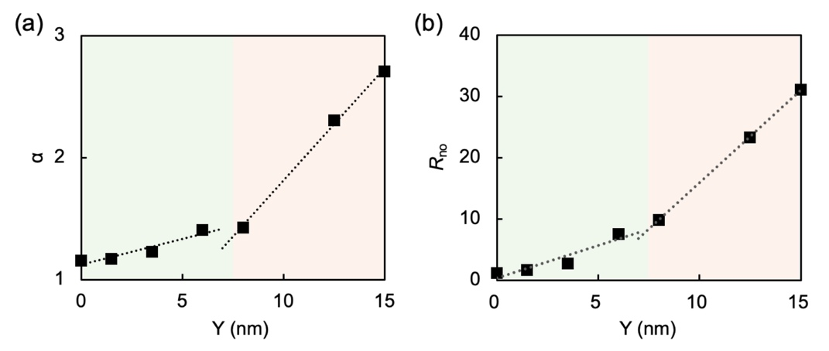
Figure 6. (a) α and (b) R_{no} values plotted against the PDA thickness (Y) for PS(240)@PDA(Y) particles. α values were calculated by eq 4. The green and orange areas in the diagram indicate the regions where colloidal crystal and amorphous structures are formed, respectively.

Figure 7 shows why the α and R_{no} values differ depending on the DA concentration when adjusting the PS@PDA particles. The PS@PDA particles were synthesized by polymerizing DA in water containing dispersed PS particles. The PDA oligomers that formed in the aqueous phase became insoluble, leading to the formation of small aggregates. ⁸³ These aggregates deposited and grew on the particle surface, creating a thin PDA shell layer. Due to the rapid polymerization of DA, small aggregates grow and coalesce to form PDA spherical aggregates when the concentration of DA in the water is high. This is evident from the following control experiment. Polymerization was carried out for 20 hours with a low DA concentration (0.5 mg/mL) and a high DA concentration (2.0 mg/mL) without adding PS particles. While a clear, light brown dispersion was obtained under low DA concentration, a dark brown, less transparent dispersion was obtained when the DA concentration was high (Figure S7a). The insoluble parts of the sample were separated by centrifugation and were observed under TEM measurements. At low DA concentration, no significant product was observed, resulting in the formation of only small aggregates. In contrast, at high DA concentration, the formation of PDA spherical aggregates of approximately 50–300 nm was observed, ^{84, 85} which is not inconsistent with the size of the PDA nodules depicted in the insets of Figure 2b (Figure S7b). The generated PDA spherical aggregates were adsorbed randomly onto the particle surface coated with a thin PDA layer, forming PS@PDA particles with a rough surface and thick shell.

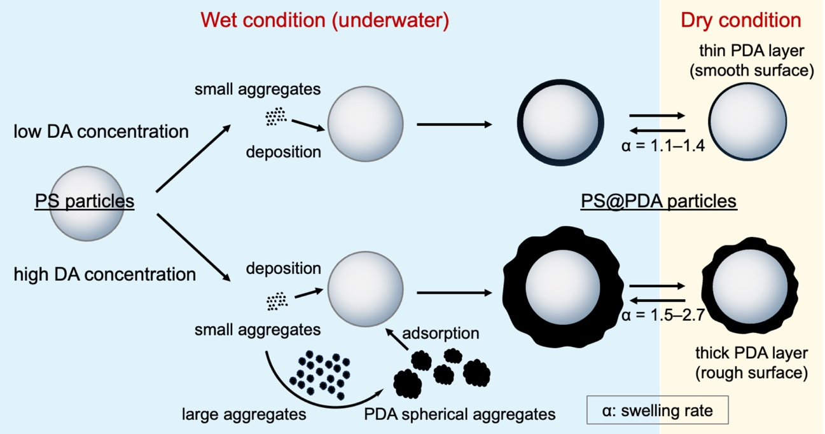
Figure 7. A schematic diagram showing the formation of differences in the surface roughness of PDA shells.

The proposed mechanism of particle assembly behavior is illustrated in Figure 8. Generally, as particle concentration increases and the distance between particles decreases during water evaporation, the strength of the attractive force between the particles becomes greater than that of the repulsive force. ^{86, 87} When the PDA shell layer is thin, the high zeta potential helps maintain the distance between particles in the dispersion, allowing the solvent to evaporate as is and forming a colloidal crystal structure. Particles with a thick PDA layer also exhibit a high zeta potential, and under low particle concentration conditions, the particle dispersion state is well maintained. However, under high concentration conditions, the thick PDA layer swells significantly in water, increasing the likelihood of contact between the hydration layers on adjacent particle surfaces. The presence of PDA nodules on the particle surface increases the specific surface area, and the swollen, highly fluid PDA layer probably penetrates into each other when the particles come into contact with each other. ⁸⁸⁻⁹⁰ Thus, local particle aggregation occurs at high particle concentrations. This partial aggregation also increases the viscosity of the system. The local aggregation state is maintained even during solvent evaporation, leading to the formation of amorphous structures in the dried state. It was found that the swelling characteristics of the PDA shell layer on the surface of each particle significantly affect the particle assembly structures and structural color properties in the dried state.

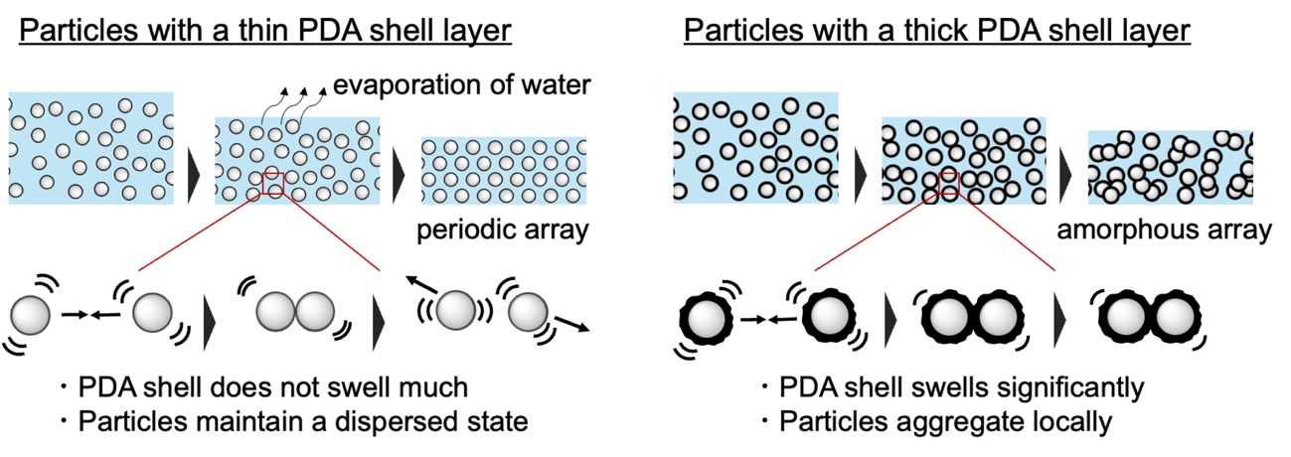
Figure 8. Proposed mechanism for the different particle assembly behavior due to the difference in PDA thickness.

4. Conclusion
By focusing on the behavior of PS@PDA particles in water, we clarified how variations in the thickness of the PDA shell influence the particle assembly structure. Particles with a thin PDA shell and minimal swelling, which have a smooth surface, remained dispersed in water regardless of particle concentration. In this state, the solvent evaporated, and a densely packed colloidal crystal structure was finally formed in the dried state, exhibiting vivid angle-dependent structural color. In contrast, PS@PDA particles prepared with a high concentration of DA showed significant surface roughness. Coupled with the adsorption of PDA spherical aggregates formed by DA polymerization in the solution phase, a thick PDA layer with many PDA nodules was formed on the particle surface. Importantly, the thick PDA layer showed a clear swelling behavior in water, with a swelling ratio reaching a maximum of 2.7. At low particle concentrations, the particles remained well dispersed in the water. At high concentrations, the substantial swelling of the PDA layer enhanced contact opportunities between particles, increasing the likelihood of interpenetration of PDA layers and resulting in local particle aggregation. After the solvent evaporated, an amorphous structure reflecting the aggregation state in water formed, exhibiting angle-independent structural coloration. The swelling of the PDA shell layer affected the dispersion and aggregation properties of particles in the water, as well as their particle assembly structures and structural color properties in the subsequent drying state. Research has also been carried out on structural color materials using core-shell particles using other monomers similar to DA, and the findings of this research will probably also apply to colloidal particles with other polymers on their surfaces. ^{28, 91-93} Furthermore, the functional control based on the ordering of colloidal particle arrays can be applied not only to structural coloration but also to a wide range of applications, including plasmon properties and light transmissivity.

ASSOCIATED CONTENT

Supporting Information

The Supporting Information is available free of charge on the ACS Publications website at DOI: XXXXXX.

Additional experimental and characterization details, including SANS Profiles, TEM images, reflection spectra, SEM images, Voronoi diagrams, DLS charts, and XPS spectra of the particles created (PDF).

AUTHOR INFORMATION

Corresponding Author
Ryuhei Motokawa – Materials Sciences Research Center, Japan Atomic Energy Agency, 2-4 Shirakata, Tokai-mura, Naka-gun, Ibaraki 319-1195, Japan
https://orcid.org/0000-0001-5010-0112; E-mail: motokawa.ryuhei@jaea.go.jp
Michinari Kohri – Department of Applied Chemistry and Biotechnology, Graduate School of Engineering, Chiba University, 1-33 Yayoi-cho, Inage-ku, Chiba, 263-8522, Japan
https://orcid.org/0000-0003-1118-5568; E-mail: kohri@faculty.chiba-u.jp

Author
Taku Watanabe – Department of Applied Chemistry and Biotechnology, Graduate School of Science and Engineering, Chiba University, 1-33 Yayoi-cho, Inage-ku, Chiba, 263-8522, Japan
Yui Maejima – Department of Applied Chemistry and Biotechnology, Graduate School of Science and Engineering, Chiba University, 1-33 Yayoi-cho, Inage-ku, Chiba, 263-8522, Japan
Yuki Ueda – Materials Sciences Research Center, Japan Atomic Energy Agency, 2-4 Shirakata, Tokai-mura, Naka-gun, Ibaraki 319-1195, Japan
https://orcid.org/0000-0001-8426-4537
Ai Takabatake – MS Scientific Co. Ltd., 4-11-3, Kuramae, Taito-ku, Tokyo, 111-0051, Japan
Shin-ichi Takeda – Takeda Colloid Techno-Consulting Co., Ltd., 16-23, Toyotsu-cho, Suita, Osaka, 564-0051, Japan
Hiroshi Fudouzi – National Institute for Materials Science, 1-2-1, Sengen, Tsukuba-Shi, Ibaraki, 305-0047, Japan
https://orcid.org/0000-0003-1442-4667
Keiki Kishikawa – Department of Applied Chemistry and Biotechnology, Graduate School of Engineering, Chiba University, 1-33 Yayoi-cho, Inage-ku, Chiba, 263-8522, Japan
https://orcid.org/0000-0002-7539-568X

Author Contributions
§T. W. and Y. M. contributed equally.

Notes

The authors declare no competing financial interests.

ACKNOWLEDGMENTS
M. K. acknowledges the support of the Japan Society for the Promotion of Science (JSPS) KAKENHI Grant in Aid for Scientific Research (B) (No. JP23H02018) and the Transformative Research Areas “Materials Science of Meso-Hierarchy” (No. JP24H01697). This work was supported by the National Institute for Materials Science (NIMS) Joint Hub Program (2024-042). SANS measurements were performed at SANS-J of the Research Reactor JRR-3, JAE (proposal No. 2024A-A30). The authors thank T. Harada (Chiba University), C. Tsuda (NIMS), and K. Terui (NIMS) for their support during the experiments.

REFERENCES
(1) Whitesides, G. M.; Mathias, J. P.; Seto, C. T. Molecular self-assembly and nanochemistry: a chemical strategy for the synthesis of nanostructures. Science 1991, 254 (5036), 1312-1319. DOI: 10.1126/science.1962191 From NLM Medline.
(2) Lee, S.; Bluemle, M. J.; Bates, F. S. Discovery of a Frank-Kasper sigma phase in sphere-forming block copolymer melts. Science 2010, 330 (6002), 349-353. DOI: 10.1126/science.1195552 From NLM PubMed-not-MEDLINE.
(3) Huang, F.; Anslyn, E. V. Introduction: Supramolecular Chemistry. Chem Rev 2015, 115 (15), 6999-7000. DOI: 10.1021/acs.chemrev.5b00352 From NLM PubMed-not-MEDLINE.
(4) Kato, R.; Mikami, T.; Kato, T. 2D Photonic Colloidal Liquid Crystals Composed of Self-Assembled Rod-Shaped Particles. Advanced Materials 2024, 36 (38). DOI: 10.1002/adma.202404396.
(5) Komiyama, N.; Ohkubo, T.; Maeda, Y.; Saeki, Y.; Ichikuni, N.; Masu, H.; Kanoh, H.; Ohara, K.; Takahashi, R.; Wadati, H.; et al. Magnetic Supramolecular Spherical Arrays: Direct Formation of Micellar Cubic Mesophase by Lanthanide Metallomesogens with 7-Coordination Geometry. Adv Sci 2024, 11 (20). DOI: 10.1002/advs.202309226.
(6) Kinoshita, S.; Yoshioka, S.; Miyazaki, J. Physics of structural colors. Reports on Progress in Physics 2008, 71 (7). DOI: 10.1088/0034-4885/71/7/076401.
(7) Vogel, N.; Utech, S.; England, G. T.; Shirman, T.; Phillips, K. R.; Koay, N.; Burgess, I. B.; Kolle, M.; Weitz, D. A.; Aizenberg, J. Color from hierarchy: Diverse optical properties of micron-sized spherical colloidal assemblies. P Natl Acad Sci USA 2015, 112 (35), 10845-10850. DOI: 10.1073/pnas.1506272112.
(8) JONES, J.; SANDERS, J.; SEGNIT, E. Structure of Opal. Nature 1964, 204, 990–991.
(9) Xia, Y. N.; Gates, B.; Yin, Y. D.; Lu, Y. Monodispersed colloidal spheres: Old materials with new applications. Advanced Materials 2000, 12 (10), 693-713. DOI: Doi 10.1002/(Sici)1521-4095(200005)12:10<693::Aid-Adma693>3.3.Co;2-A.
(10) Yamanaka, J.; Murai, M.; Iwayama, Y.; Yonese, M. S.; Ito, K.; Sawada, T. One-directional crystal growth in charged colloidal silica dispersions driven by diffusion of base. Journal of the American Chemical Society 2004, 126 (23), 7156-7157. DOI: 10.1021/ja049164w.
(11) Jiang, P.; Ostojic, G. N.; Narat, R.; Mittleman, D. M.; Colvin, V. L. The fabrication and bandgap engineering of photonic multilayers. Advanced Materials 2001, 13 (6), 389-393. DOI: Doi 10.1002/1521-4095(200103)13:6<389::Aid-Adma389>3.0.Co;2-L.
(12) Yoshinaga, K.; Fujiwara, K.; Mouri, E.; Ishii, M.; Nakamura, H. Stepwise controlled immobilization of colloidal crystals formed by polymer-grafted silica particles. Langmuir 2005, 21 (10), 4471-4477. DOI: 10.1021/la0467786.
(13) Tran, G. T. H.; Koike, M.; Uchikoshi, T.; Fudouzi, H. Rapid Growth of Colloidal Crystal Films from the Concentrated Aqueous Ethanol Suspension. Langmuir 2020, 36 (36), 10683-10689. DOI: 10.1021/acs.langmuir.0c01048.
(14) Harun-Ur-Rashid, M.; Bin Imran, A.; Seki, T.; Ishi, M.; Nakamura, H.; Takeoka, Y. Angle-Independent Structural Color in Colloidal Amorphous Arrays. Chemphyschem 2010, 11 (3), 579-583. DOI: 10.1002/cphc.200900869.
(15) Liew, S. F.; Forster, J.; Noh, H.; Schreck, C. F.; Saranathan, V.; Lu, X.; Yang, L.; Prum, R. O.; O'Hern, C. S.; Dufresne, E. R.; et al. Short-range order and near-field effects on optical scattering and structural coloration. Opt Express 2011, 19 (9), 8208-8217. DOI: 10.1364/Oe.19.008208.
(16) Takeoka, Y.; Honda, M.; Seki, T.; Ishii, M.; Nakamura, H. Structural Colored Liquid Membrane without Angle Dependence. Acs Appl Mater Inter 2009, 1 (5), 982-986. DOI: 10.1021/am900074v.
(17) Ai, Y. W.; Jiang, Y. N.; He, J. L.; Ohtsuka, Y.; Sakai, M.; Seki, T.; Yamanaka, T.; Tarutani, N.; Katagiri, K.; Takeoka, Y. Influence of Sodium Ions and Carbon Black on the Formation and Structural Color of Photonic Balls by Silica Particles. Langmuir 2024, 40 (38), 20045-20056. DOI: 10.1021/acs.langmuir.4c02283.
(18) Yamanaka, T.; Tarutani, N.; Katagiri, K.; Inumaru, K.; Takeoka, Y. Influences of Heat Treatment, Particle Arrangement, and Binder Addition on the Mechanical Robustness of Structurally Colored Coatings Formed with Monodisperse SiO
Spheres. Adv Eng Mater 2024, 26 (14). DOI: 10.1002/adem.202400814.
(19) Forster, J. D.; Noh, H.; Liew, S. F.; Saranathan, V.; Schreck, C. F.; Yang, L.; Park, J. G.; Prum, R. O.; Mochrie, S. G. J.; O'Hern, C. S.; et al. Biomimetic Isotropic Nanostructures for Structural Coloration. Advanced Materials 2010, 22 (26-27), 2939-+. DOI: 10.1002/adma.200903693.
(20) Takeoka, Y.; Yoshioka, S.; Takano, A.; Arai, S.; Nueangnoraj, K.; Nishihara, H.; Teshima, M.; Ohtsuka, Y.; Seki, T. Production of Colored Pigments with Amorphous Arrays of Black and White Colloidal Particles. Angew Chem Int Edit 2013, 52 (28), 7261-7265. DOI: 10.1002/anie.201301321.
(21) Cong, H. L.; Yu, B.; Wang, S. P.; Qi, L. M.; Wang, J. L.; Ma, Y. R. Preparation of iridescent colloidal crystal coatings with variable structural colors. Opt Express 2013, 21 (15), 17831-17838. DOI: 10.1364/Oe.21.017831.
(22) Shen, Z. H.; Shi, L.; You, B.; Wu, L. M.; Zhao, D. Y. Large-scale fabrication of three-dimensional ordered polymer films with strong structure colors and robust mechanical properties. J Mater Chem 2012, 22 (16), 8069-8075. DOI: 10.1039/c2jm30546a.
(23) Zhang, Y. X.; Han, P.; Zhou, H. Y.; Wu, N.; Wei, Y.; Yao, X.; Zhou, J. M.; Song, Y. L. Highly Brilliant Noniridescent Structural Colors Enabled by Graphene Nanosheets Containing Graphene Quantum Dots. Advanced Functional Materials 2018, 28 (29). DOI: ARTN 1802585
10.1002/adfm.201802585.
(24) Fu, F. F.; Chen, Z. Y.; Wang, H.; Liu, C. H.; Liu, Y. X.; Zhao, Y. J. Graphene hybrid colloidal crystal arrays with photo-controllable structural colors. Nanoscale 2019, 11 (22), 10846-10851. DOI: 10.1039/c9nr03250a.
(25) Song, L. J.; Chen, X. F.; Xie, Y. H.; Zhong, L.; Zhang, X. Y.; Cheng, Z. D. Non-iridescent, crack-free, conductive structural colors enhanced by flexible nanosheets of reduced graphene oxide. Dyes and Pigments 2019, 164, 222-226. DOI: 10.1016/j.dyepig.2019.01.037.
(26) He, L.; Wang, M. S.; Ge, J. P.; Yin, Y. D. Magnetic Assembly Route to Colloidal Responsive Photonic Nanostructures. Accounts Chem Res 2012, 45 (9), 1431-1440. DOI: 10.1021/ar200276t.
(27) Yang, D. P.; Luo, W. J.; Huang, Y. D.; Huang, S. M. Facile Synthesis of Monodispersed SiO2@Fe3O4 Core-Shell Colloids for Printing and Three-Dimensional Coating with Noniridescent Structural Colors. Acs Omega 2019, 4 (1), 528-534. DOI: 10.1021/acsomega.8b02987.
(28) Yang, X. M.; Ge, D. T.; Wu, G. X.; Liao, Z. W.; Yang, S. Production of Structural Colors with High Contrast and Wide Viewing Angles from Assemblies of Polypyrrole Black Coated Polystyrene Nanoparticles. Acs Appl Mater Inter 2016, 8 (25), 16289-16295. DOI: 10.1021/acsami.6b03739.
(29) Yabu, H.; Nakanishi, T.; Hirai, Y.; Shimomura, M. Black thin layers generate strong structural colors: a biomimetic approach for creating one-dimensional (1D) photonic crystals. J Mater Chem 2011, 21 (39), 15154-15156. DOI: 10.1039/c1jm13094c.
(30) Lai, C. F.; Wang, Y. C. Colloidal Photonic Crystals Containing Silver Nanoparticles with Tunable Structural Colors. Crystals 2016, 6 (5). DOI: ARTN 61
10.3390/cryst6050061.
(31) Lai, C. F.; Wang, Y. C.; Wu, C. L.; Zeng, J. Y.; Lin, C. F. Preparation of a colloidal photonic crystal containing CuO nanoparticles with tunable structural colors. Rsc Advances 2015, 5 (127), 105200-105205. DOI: 10.1039/c5ra21035f.
(32) Yamada, Y.; Ishii, M.; Nakamura, T.; Yano, K. Artificial Black Opal Fabricated from Nanoporous Carbon Spheres. Langmuir 2010, 26 (12), 10044-10049. DOI: 10.1021/la1001732.
(33) Kim, C.; Jung, K.; Yu, J. W.; Park, S.; Kim, S. H.; Lee, W. B.; Hwang, H.; Manoharan, V. N.; Moon, J. H. Controlled Assembly of Icosahedral Colloidal Clusters for Structural Coloration. Chemistry of Materials 2020, 32 (22), 9704-9712. DOI: 10.1021/acs.chemmater.0c03391.
(34) Nakamae, K.; Hano, N.; Ihara, H.; Takafuji, M. Thermally stable high-contrast iridescent structural colours from silica colloidal crystals doped with monodisperse spherical black carbon particles as maverick. Mater Adv 2021. DOI: 10.1039/d1ma00523e.
(35) Kohri, M.; Nannichi, Y.; Taniguchi, T.; Kishikawa, K. Biomimetic non-iridescent structural color materials from polydopamine black particles that mimic melanin granules. J Mater Chem C 2015, 3 (4), 720-724. DOI: 10.1039/c4tc02383h.
(36) Xiao, M.; Li, Y. W.; Allen, M. C.; Deheyn, D. D.; Yue, X. J.; Zhao, J. Z.; Gianneschi, N. C.; Shawkey, M. D.; Dhinojwala, A. Bio-Inspired Structural Colors Produced via Self-Assembly of Synthetic Melanin Nanoparticles. Acs Nano 2015, 9 (5), 5454-5460. DOI: 10.1021/acsnano.5b01298.
(37) Kohri, M. Progress in polydopamine-based melanin mimetic materials for structural color generation. Sci Technol Adv Mat 2020, 21 (1), 833-848. DOI: 10.1080/14686996.2020.1852057.
(38) Xiao, M.; Shawkey, M. D.; Dhinojwala, A. Bioinspired Melanin-Based Optically Active Materials. Adv Opt Mater 2020, 8 (19). DOI: ARTN 2000932
10.1002/adom.202000932.
(39) Kawamura, A.; Kohri, M.; Morimoto, G.; Nannichi, Y.; Taniguchi, T.; Kishikawa, K. Full-Color Biomimetic Photonic Materials with Iridescent and Non-Iridescent Structural Colors. Sci Rep-Uk 2016, 6. DOI: ARTN 33984
10.1038/srep33984.
(40) Lee, H.; Dellatore, S. M.; Miller, W. M.; Messersmith, P. B. Mussel-inspired surface chemistry for multifunctional coatings. Science 2007, 318 (5849), 426-430. DOI: 10.1126/science.1147241.
(41) d'Ischia, M.; Napolitano, A.; Ball, V.; Chen, C. T.; Buehler, M. J. Polydopamine and Eumelanin: From Structure-Property Relationships to a Unified Tailoring Strategy. Accounts Chem Res 2014, 47 (12), 3541-3550. DOI: 10.1021/ar500273y.
(42) Kohri, M. Artificial melanin particles: new building blocks for biomimetic structural coloration. Polym J 2019, 51 (11), 1127-1135. DOI: 10.1038/s41428-019-0231-2.
(43) Yi, B.; Shen, H. F. Liquid-immune structural colors with angle-independence inspired from hollow melanosomes. Chem Commun 2017, 53 (66), 9234-9237. DOI: 10.1039/c7cc04154c.
(44) Kohri, M.; Tamai, Y.; Kawamura, A.; Jido, K.; Yamamoto, M.; Taniguchi, T.; Kishikawa, K.; Fujii, S.; Teramoto, N.; Ishii, H.; et al. Ellipsoidal Artificial Melanin Particles as Building Blocks for Biomimetic Structural Coloration. Langmuir 2019, 35 (16), 5574-5580. DOI: 10.1021/acs.langmuir.9b00400.
(45) Xiao, M.; Hu, Z. Y.; Wang, Z.; Li, Y. W.; Tormo, A. D.; Le Thomas, N.; Wang, B.; Gianneschi, N. C.; Shawkey, M. D.; Dhinojwala, A. Bioinspired bright noniridescent photonic melanin supraballs. Sci Adv 2017, 3 (9). DOI: ARTN e1701151
10.1126/sciadv.1701151.
(46) Liu, P. M.; Sheng, T.; Xie, Z. Y.; Chen, J. L.; Gu, Z. Z. Robust, Highly Visible, and Facile Bioconjugation Colloidal Crystal Beads for Bioassay. Acs Appl Mater Inter 2018, 10 (35), 29378-29384. DOI: 10.1021/acsami.8b11472.
(47) Liu, P. M.; Chang, W. Y.; Ju, L. S.; Chu, L. L.; Xie, Z. Y.; Chen, J. L.; Yang, J. J. Bioinspired Noniridescent Structural Color with Hidden Patterns for Anticounterfeiting. Acs Applied Nano Materials 2019, 2 (9), 5752-5760. DOI: 10.1021/acsanm.9b01218.
(48) Kawamura, A.; Kohri, M.; Yoshioka, S.; Taniguchi, T.; Kishikawa, K. Structural Color Tuning: Mixing Melanin-Like Particles with Different Diameters to Create Neutral Colors. Langmuir 2017, 33 (15), 3824-3830. DOI: 10.1021/acs.langmuir.7b00707.
(49) Shen, H.; Liang, Q.; Song, L.; Chen, G.; Pei, Y.; Wu, L.; Zhang, X. Facile fabrication of mechanically stable non-iridescent structural color coatings. Journal of Materials Science 2019, 55 (6), 2353-2364. DOI: 10.1007/s10853-019-04118-y.
(50) Wang, X. H.; Li, Y. C.; Zhou, L.; Chai, L. Q.; Fan, Q. G.; Shao, J. Z. Structural colouration of textiles with high colour contrast based on melanin-like nanospheres. Dyes and Pigments 2019, 169, 36-44. DOI: 10.1016/j.dyepig.2019.05.006.
(51) Zhu, X. W.; Wei, T. C.; Mia, M. S.; Xing, T. L.; Chen, G. Q. Preparation of PS@PDA amorphous photonic structural colored fabric with vivid color and robust mechanical properties based on rapid polymerization of dopamine. Colloid Surface A 2021, 622. DOI: ARTN 126651
10.1016/j.colsurfa.2021.126651.
(52) Urase, M.; Maejima, Y.; Watanabe, T.; Kishikawa, K.; Fudouzi, H.; Kohri, M. Crack-Free Structural Color Materials Prepared without Disrupting the Particle Arrangement by Controlling the Internal Stress Relaxation and Interactions of the Melanin Particles. Langmuir 2023, 39 (25), 8725-8736. DOI: 10.1021/acs.langmuir.3c00720 From NLM PubMed-not-MEDLINE.
(53) Lee, G. H.; Han, S. H.; Kim, J. B.; Kim, J. H.; Lee, J. M.; Kim, S. H. Colloidal Photonic Inks for Mechanochromic Films and Patterns with Structural Colors of High Saturation. Chemistry of Materials 2019, 31 (19), 8154-8162. DOI: 10.1021/acs.chemmater.9b02938.
(54) Iwasaki, T.; Harada, S.; Okoshi, T.; Moriya, M.; Kojima, T.; Kishikawa, K.; Kohri, M. Effect of the Polydopamine Composite Method on Structural Coloration: Comparison of Binary and Unary Assembly of Colloidal Particles. Langmuir 2020, 36 (40), 11880-11887. DOI: 10.1021/acs.langmuir.0c01904.
(55) Echeverri, M.; Patil, A.; Hu, Z.; Shawkey, M. D.; Gianneschi, N. C.; Dhinojwala, A. Printing a Wide Gamut of Saturated Structural Colors Using Binary Mixtures, With Applications in Anticounterfeiting. Acs Appl Mater Inter 2020, 12 (17), 19882-19889. DOI: 10.1021/acsami.0c01449.
(56) Kohri, M.; Yanagimoto, K.; Kawamura, A.; Hamada, K.; Imai, Y.; Watanabe, T.; Ono, T.; Taniguchi, T.; Kishikawa, K. Polydopamine-Based 3D Colloidal Photonic Materials: Structural Color Balls and Fibers from Melanin-Like Particles with Polydopamine Shell Layers. Acs Appl Mater Inter 2018, 10 (9), 7640-7648. DOI: 10.1021/acsami.7b03453.
(57) Lee, G. H.; Han, S. H.; Kim, J. B.; Kim, D. J.; Lee, S.; Hamonangan, W. M.; Lee, J. M.; Kim, S. H. Elastic Photonic Microbeads as Building Blocks for Mechanochromic Materials. Acs Applied Polymer Materials 2020, 2 (2), 706-714. DOI: 10.1021/acsapm.9b01036.
(58) Wang, Y.; Yu, Y. R.; Guo, J. H.; Zhang, Z. H.; Zhang, X. X.; Zhao, Y. J. Bio-Inspired Stretchable, Adhesive, and Conductive Structural Color Film for Visually Flexible Electronics. Advanced Functional Materials 2020, 30 (32). DOI: ARTN 2000151
10.1002/adfm.202000151.
(59) Jiang, Y. N.; Shirai, A.; Kohri, M.; Ohnuki, R.; Yoshioka, S.; Yamamoto, T.; Takeoka, Y. Brilliant and Angular-Independent Photonic Balls Using High-Refractive-Index Inorganic-Polymer Hybrid Materials. Adv Opt Mater 2025. DOI: 10.1002/adom.202402863.
(60) Singla, S.; Yang, Z. P.; Patil, A.; Guo, H.; Vanthournout, B.; Htut, K. Z.; Shawkey, M. D.; Tsige, M.; Dhinojwala, A. Influence of Core Type and Shell Thickness on Avian-Inspired Structural Colors Produced from Melanin Nanoparticle Assemblies. Acs Appl Mater Inter 2023, 15 (38), 45229-45238. DOI: 10.1021/acsami.3c08152.
(61) Bittner, C.; Bleyer, G.; Nees, N.; Carneiro, M.; Pflug, L.; Stingl, M.; Vogel, N. Optimizing Color Saturation in Colloidal Photonic Crystals by Control of Absorber Amount and Distribution. Adv Mater Interfaces 2024, 11 (12). DOI: 10.1002/admi.202300986.
(62) Bleyer, G.; Nees, N.; Prohaska, F.; Pflug, L.; Stingl, M.; Vogel, N. Predictive Design to Determine Optimal Absorber Placement in Colloidal Photonic Crystals. Adv Opt Mater 2025. DOI: 10.1002/adom.202403279.
(63) Yi, B.; Shen, H. F. Structurally colored films with superhydrophobicity and wide viewing angles based on bumpy melanin-like particles. Appl Surf Sci 2018, 427, 1129-1136. DOI: 10.1016/j.apsusc.2017.09.091.
(64) Taniguchi, T.; Murakami, F.; Kasuya, M.; Kojima, T.; Kohri, M.; Saito, K.; Nakahira, T. Preparation of titania hollow particles with independently controlled void size and shell thickness by catalytic templating core-shell polymer particles. Colloid Polym Sci 2013, 291 (1), 215-222. DOI: 10.1007/s00396-012-2658-2.
(65) Kumada, T.; Motokawa, R.; Oba, Y.; Nakagawa, H.; Sekine, Y.; Micheau, C.; Ueda, Y.; Sugita, T.; Birumachi, A.; Sasaki, M.; et al. Upgrade of the small-angle neutron scattering diffractometer SANS-J at JRR-3. J Appl Crystallogr 2023, 56, 1776-1783. DOI: 10.1107/S1600576723009731.
(66) Kumada, T.; Motokawa, R.; Iwase, H. Low-background ultrahigh-purity aluminium window for small-angle neutron scattering using monochromatic cold neutrons. J Appl Crystallogr 2024, 57, 728-733. DOI: 10.1107/S160057672400373x.
(67) Motokawa, R.; Taniguchi, T.; Sasaki, Y.; Enomoto, Y.; Murakami, F.; Kasuya, M.; Kohri, M.; Nakahira, T. Small-Angle Neutron Scattering Study on Specific Polymerization Loci Induced by Copolymerization of Polymerizable Surfactant and Styrene during Miniemulsion Polymerization. Macromolecules 2012, 45 (23), 9435-9444. DOI: 10.1021/ma301776b.
(68) Xiao, M.; Li, Y. W.; Zhao, J. Z.; Wang, Z.; Gao, M.; Gianneschi, N. C.; Dhinojwala, A.; Shawkey, M. D. Stimuli-Responsive Structurally Colored Films from Bioinspired Synthetic Melanin Nanoparticles. Chemistry of Materials 2016, 28 (15), 5516-5521. DOI: 10.1021/acs.chemmater.6b02127.
(69) Li, T. K.; Zhao, T. T.; Tian, X. M.; Yuan, L.; Xue, X. Y.; Wang, Z. G.; Yin, L. Q.; Zhang, J. H. A high-performance humidity sensor based on alkalized MXenes and poly(dopamine) for touchless sensing and respiration monitoring. J Mater Chem C 2022, 10 (6), 2281-2289. DOI: 10.1039/d1tc05171g.
(70) Ruland, W. Small-angle scattering of two-phase systems: determination and significance of systematic deviations from Porod's law. J. Appl. Cryst. 1971, 4, 70-73. DOI: doi.org/10.1107/S0021889871006265.
(71) Higgins, J. S. B., H. C. Polymers and Neutron Scattering; Oxford University Press, 1994.
(72) Percus, J. K. Y., G. Analysis of Classical Statistical Mechanics by Means of Collective Coordinates. J. Phys. Rev. 1958, 110, 1-13.
(73) Zangmeister, R. A.; Morris, T. A.; Tarlov, M. J. Characterization of Polydopamine Thin Films Deposited at Short Times by Autoxidation of Dopamine. Langmuir 2013, 29 (27), 8619-8628. DOI: 10.1021/la400587j.
(74) Hemmatpour, H.; De Luca, O.; Crestani, D.; Stuart, M. C. A.; Lasorsa, A.; van der Wel, P. C. A.; Loos, K.; Giousis, T.; Haddadi-Asl, V.; Rudolf, P. New insights in polydopamine formation via surface adsorption. Nat Commun 2023, 14 (1). DOI: ARTN 664
10.1038/s41467-023-36303-8.
(75) Pereira, L.; Vasseur, J.; Wadsworth, F. B.; Trixler, F.; Dingwell, D. B. Interparticle and Brownian forces controlling particle aggregation and rheology of silicate melts containing platinum-group element particles. Sci Rep-Uk 2022, 12 (1). DOI: ARTN 9226
10.1038/s41598-022-12948-1.
(76) Takizawa, M.; Sazuka, Y.; Horigome, K.; Sakurai, Y.; Matsui, S.; Minato, H.; Kureha, T.; Suzuki, D. Self-Organization of Soft Hydrogel Microspheres during the Evaporation of Aqueous Droplets. Langmuir 2018, 34 (15), 4515-4525. DOI: 10.1021/acs.langmuir.8b00230.
(77) Yamamoto, M.; Ando, K.; Inoue, M.; Kanoh, H.; Yamagami, M.; Wakiya, T.; Iida, E.; Taniguchi, T.; Kishikawa, K.; Kohri, M. Poly-β-Ketoester Particles as a Versatile Scaffold for Lanthanide-Doped Colorless Magnetic Materials. Acs Applied Polymer Materials 2020, 2 (6), 2170-2178. DOI: 10.1021/acsapm.0c00149.
(78) Nelson, A.; Jack, K. S.; Cosgrove, T.; Kozak, D. NMR solvent relaxation in studies of multicomponent polymer adsorption. Langmuir 2002, 18 (7), 2750-2755. DOI: 10.1021/la0156863.
(79) Cattoz, B.; Cosgrove, T.; Crossman, M.; Prescott, S. W. Surfactant-Mediated Desorption of Polymer from the Nanoparticle Interface. Langmuir 2012, 28 (5), 2485-2492. DOI: 10.1021/la204512d.
(80) Maejima, Y.; Tomizawa, M.; Takabatake, A.; Takeda, S.; Fudouzi, H.; Kishikawa, K.; Kohri, M. Michael Addition Reaction-Assisted Surface Modification of Melanin Particles for Water-Repellent Structural Color Coating. Macromol React Eng 2025, 19 (1). DOI: 10.1002/mren.202400040.
(81) Hong, S.; Na, Y. S.; Choi, S.; Song, I. T.; Kim, W. Y.; Lee, H. Non-Covalent Self-Assembly and Covalent Polymerization Co-Contribute to Polydopamine Formation. Advanced Functional Materials 2012, 22 (22), 4711-4717. DOI: 10.1002/adfm.201201156.
(82) Liebscher, J.; Mrowczynski, R.; Scheidt, H. A.; Filip, C.; Hadade, N. D.; Turcu, R.; Bende, A.; Beck, S. Structure of Polydopamine: A Never-Ending Story? Langmuir 2013, 29 (33), 10539-10548. DOI: 10.1021/la4020288.
(83) Solano, F. Melanin and Melanin-Related Polymers as Materials with Biomedical and Biotechnological Applications-Cuttlefish Ink and Mussel Foot Proteins as Inspired Biomolecules. Int J Mol Sci 2017, 18 (7). DOI: ARTN 1561
10.3390/ijms18071561.
(84) Farnad, N.; Farhadi, K.; Voelcker, N. H. Polydopamine Nanoparticles as a New and Highly Selective Biosorbent for the Removal of Copper (II) Ions from Aqueous Solutions. Water Air Soil Poll 2012, 223 (6), 3535-3544. DOI: 10.1007/s11270-012-1131-7.
(85) Ho, C. C.; Ding, S. J. The pH-controlled nanoparticles size of polydopamine for anti-cancer drug delivery. J Mater Sci-Mater M 2013, 24 (10), 2381-2390. DOI: 10.1007/s10856-013-4994-2.
(86) Mampallil, D. Some Physics Inside Drying Droplets. Resonance 2014, 19 (2), 121-132.
(87) Pu, C.; Liu, F. Y.; Wang, S. H. Liquid Force and Rupture Distance between Two Particles. Adv Mater Sci Eng 2021, 2021. DOI: Artn 3542686
10.1155/2021/3542686.
(88) Conley, G. M.; Aebischer, P.; Nöjd, S.; Schurtenberger, P.; Scheffold, F. Jamming and overpacking fuzzy microgels: Deformation, interpenetration, and compression. Sci Adv 2017, 3 (10). DOI: ARTN e1700969
10.1126/sciadv.1700969.
(89) Nakaishi, A.; Minami, S.; Oura, S.; Watanabe, T.; Suzuki, D.; Urayama, K. Elastic and Flow Properties of Densely Packed Binary Microgel Mixtures with Size and Stiffness Disparities. Macromolecules 2018, 51 (23), 9901-9914. DOI: 10.1021/acs.macromol.8b01625.
(90) Kureha, T.; Minato, H.; Suzuki, D.; Urayama, K.; Shibayama, M. Concentration dependence of the dynamics of microgel suspensions investigated by dynamic light scattering. Soft Matter 2019, 15 (27), 5390-5399. DOI: 10.1039/c9sm01030k.
(91) Iwasaki, T.; Tamai, Y.; Yamamoto, M.; Taniguchi, T.; Kishikawa, K.; Kohri, M. Melanin Precursor Influence on Structural Colors from Artificial Melanin Particles: PolyDOPA, Polydopamine, and Polynorepinephrine. Langmuir 2018, 34 (39), 11814-11821. DOI: 10.1021/acs.langmuir.8b02444.
(92) Sakai, M.; Seki, T.; Takeoka, Y. Colorful Photonic Pigments Prepared by Using Safe Black and White Materials. Acs Sustain Chem Eng 2019, 7 (17), 14933-14940. DOI: 10.1021/acssuschemeng.9b03165.
(93) Wei, T. C.; Zhu, X. W.; Hou, X. N.; Li, Y. J.; Dong, A. Q.; Jiang, X. Y.; Huang, Y.; Dong, X.; Wang, X. R.; Chen, G. Q.; et al. Preparation of biomimetic non-iridescent structural color based on polystyrene-polycaffeic acid core-shell nanospheres. Rsc Advances 2022, 12 (6), 3602-3610. DOI: 10.1039/d1ra08691j.

Table of Contents
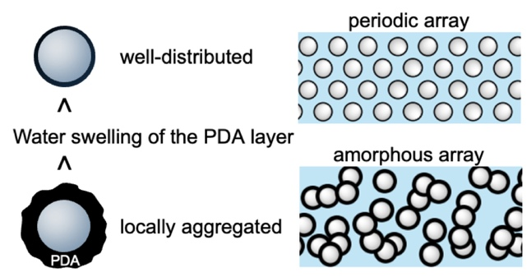

Supporting Information

Particle Arrangements and Optical Changes Induced by Water-swelling of Melanin-like Polydopamine Layers

Taku Watanabe^{§1}, Yui Maejima^{§1}, Yuki Ueda², Ryuhei Motokawa*², Ai Takabatake³, Shin-ichi Takeda⁴, Hiroshi Fudouzi⁵, Keiki Kishikawa⁶, and Michinari Kohri*⁶

¹ Department of Applied Chemistry and Biotechnology, Graduate School of Science and Engineering, Chiba University, 1-33 Yayoi-cho, Inage-ku, Chiba 263-8522, Japan
² Materials Sciences Research Center, Japan Atomic Energy Agency, 2-4 Shirakata, Tokai-mura, Naka-gun, Ibaraki 319-1195, Japan
³ MS Scientific Co. Ltd., 4-11-3, Kuramae, Taito-ku, Tokyo, 111-0051, Japan
⁴ Takeda Colloid Techno-Consulting Co., Ltd., 16–23, Toyotsu-cho, Suita, Osaka, 564-0051, Japan
⁵ National Institute for Materials Science, 1-2-1 Sengen, Tsukuba-Shi, Ibaraki 305-0047, Japan
⁶ Department of Applied Chemistry and Biotechnology, Graduate School of Engineering, Chiba University, 1-33 Yayoi-cho, Inage-ku, Chiba 263-8522, Japan

Author Contributions
§T. W. and Y. M. contributed equally.

Corresponding Authors
*E-mail: motokawa.ryuhei@jaea.go.jp (R. M.); kohri@faculty.chiba-u.jp (M. K.)

Number of pages: 5
Number of tables: 1
Number of figures: 7

Table S1. Summary of Characteristic Parameters Determined by the Model Analysis of SANS Profiles for PS(215)@PDA(2.5) and PS(215)@PDA(11)
Particle conc. (wt%) | 5 | 10 | 15 | 20 | 25 | 30
PS(215)@PDA(2.5)
R (nm) | 104 | 113 | 113 | 113 | 113 | 113
σ (nm) | 17 | 21 | 22 | 22 | 22 | 22
R_{HS} (nm) | 110 | 103 | 103 | 108 | 105 | 103
PS(215)@PDA(11)
R (nm) | 116 | 116 | 118 | 120 | 123 | 124
σ (nm) | 20 | 21 | 20 | 21 | 23 | 23
R_{HS} (nm) | 95 | 95 | 94 | 93 | 93 | 90

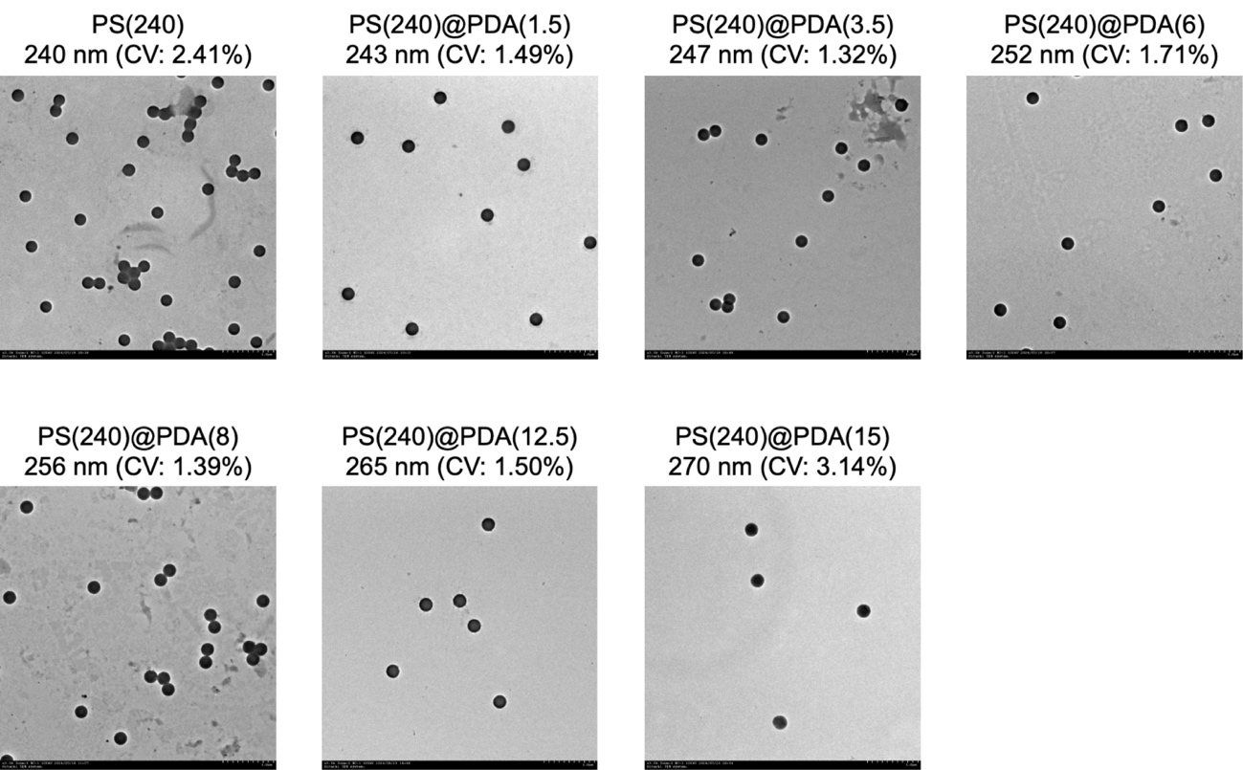
Figure S1. TEM images for the PS(240) and PS(240)@PDA(Y) (Y = 1.5–15) particles.

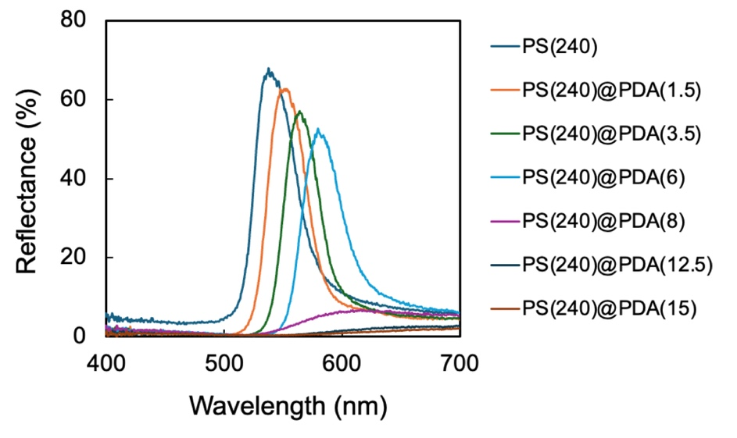
Figure S2. Reflectance spectra for the PS(240) and PS(240)@PDA(Y) (Y = 1.5–15) pellets.

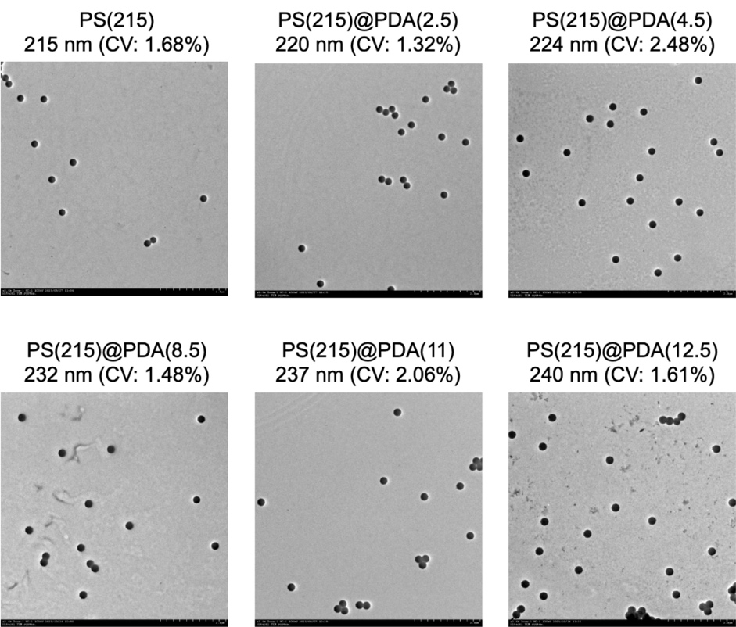
Figure S3. TEM images for the PS(215) and PS(215)@PDA(Y) (Y = 2.5–12.5) particles.

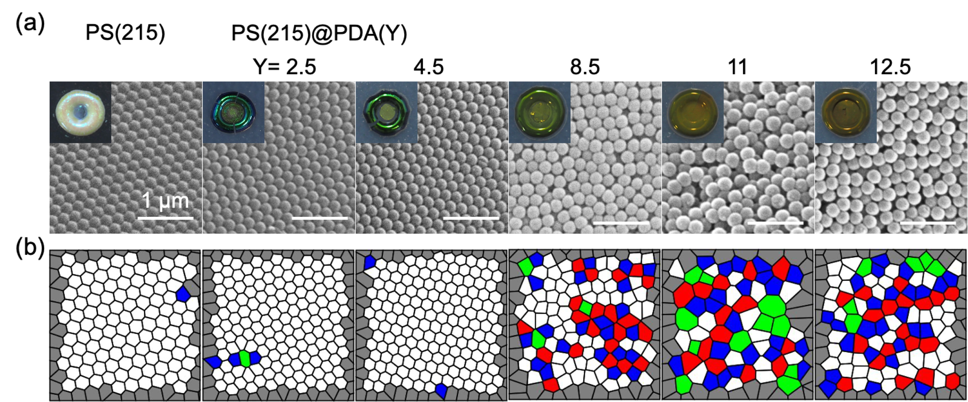
Figure S4. (a) SEM images for the surface of the pellet samples prepared from PS(215) and PS(215)@PDA(Y) particles. The inset shows photographs of the pellet samples. (b) Voronoi diagrams created from the SEM images in (a). Red: five-sided polygon, white: hexagonal polygon, blue: seven-sided polygon, and green: others. The Voronoi cells on the boundary of the analyzed square region (dark gray) are not included in this analysis.

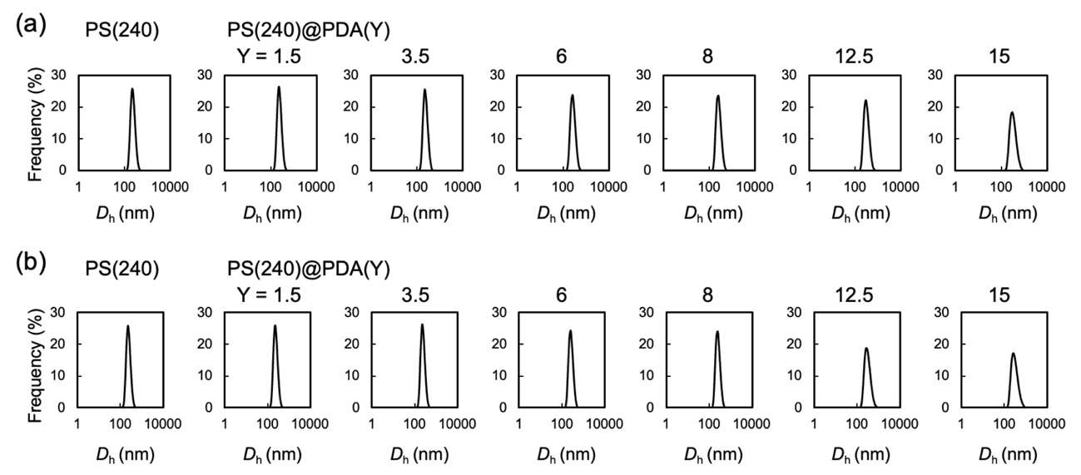
Figure S5. DLS charts of (a) immediately after preparation and (b) after standing for 2 hours of the water dispersion of PS(240) and PS(240)@PDA(Y) particles (particle concentration: 0.01 wt%)

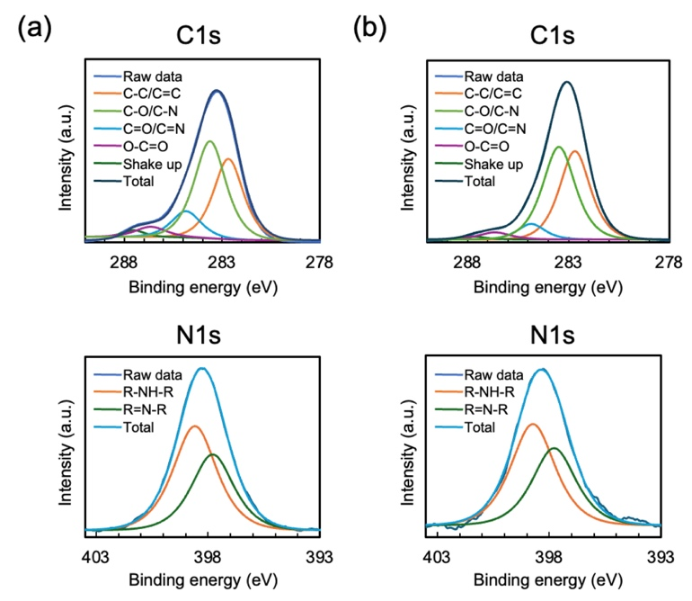
Figure S6. XPS spectra of (a) PS(240)@PDA(1.5) and (b) PS(240)@PDA(15) particles in the C1s and N1s regions.

Figure S7. (a) Photographs of samples after DA polymerization without PS particles. (b) TEM image of the insoluble part obtained under high DA concentration conditions.

