High-temperature strengthening effect of Pt grain-boundary framework on the bending strength behavior of monolithic boron carbide

High-temperature strength of boron carbide with Pt grain-boundary framework in situ synthesized during spark plasma sintering

O. Vasylkiv^{1,*}, D. Demirskyi^{2,*}, H. Borodianska¹, A. Kuncser³, and P. Badica^{3,*}

¹National Institute for Materials Science, 1-2-1 Sengen, Tsukuba, Ibaraki 305-0047, Japan
²WPI-Advanced Institute for Materials Research (WPI-AIMR), Tohoku University, 2-1-1 Katahira, Aoba-ku, Sendai, 980-8577 Japan
³National Institute of Materials Physics, street Atomistilor 405A, 077125 Magurele, Ilfov, Romania

*Corresponding authors:
Oleg Vasylkiv, oleg.vasylkiv@nims.go.jp /phone +81-(0)80-4144-4747
Dmytro Demirskyi, demirskyi.dmytro.e2@tohoku.ac.jp /phone +81-(0)70-2010-6281
Petre Badica, badica2003@yahoo.com /phone: +40-(0)21-3690185

Submitted to Ceramics International, Elsevier
High-temperature strengthening effect of Pt grain-boundary framework on the bending strength behavior of monolithic boron carbide

High-temperature strength of boron carbide with Pt grain-boundary framework in situ synthesized during spark plasma sintering

O. Vasylkiv^{1,*}, D. Demirskyi^{2,*}, H. Borodianska¹, A. Kuncser³, and P. Badica^{3,*}

¹National Institute for Materials Science, 1-2-1 Sengen, Tsukuba, Ibaraki 305-0047, Japan
²WPI-Advanced Institute for Materials Research (WPI-AIMR), Tohoku University, 2-1-1 Katahira, Aoba-ku, Sendai, 980-8577 Japan
³National Institute of Materials Physics, street Atomistilor 405A, 077125 Magurele, Ilfov, Romania

Abstract
Grain boundaries, twins, and defects are considered to influence the thermomechanical behaviour of any covalent ceramic, as a result, monolithic B₄C samples show different shapes and present theoretical models fail to fit them in the entire temperature range. To overcome these issues we fabricated a novel high-density boron carbide and evaluated its high-temperature bending strength. As-obtained ceramic is composed of boron carbide grains and a fine grain-boundary metal Pt framework. The material shows a decrease of strength, which is due to a non-linear increase in the volume expansion coefficient of B₄C. Recovery in strength above 1000 °C is contributed by twins presence. Twins are multiple and parallel. Asymmetric twins were found and the mismatch angles were around 73 °, but also atypical angles as low as 66 ° were observed. Twins rearrangements are the pieces of evidence for a novel ‘micro’ mechanism of high-temperature stress accommodation for boron carbide bulks.

Keywords: boron carbide; Pt framework; modified grain boundaries; spark plasma sintering; bending strength; asymmetric twins.

- Introduction
Boron carbide, B₄C, is a light weight ceramic (2.51 g/cm³) with a strong covalent nature. This provides excellent mechanical characteristics [1, 2] such as high hardness (40 GPa), bending strength (up to 900 MPa), and elastic modulus (460 GPa). Another consequence is its high melting temperature which is making difficult and expensive synthesis of boron carbide. However, synthesis of boron carbide does not require high processing pressures as in the case of cubic boron nitride or diamond. The high melting temperature enables use of boron carbide as a high temperature material for nuclear, aerospace, and engineering applications.
A number of parameters may influence mechanical behavior of B4C ceramics, including the presence of impurities and porosity [1], carbon deficiency [2], grain size or size of defect responsible for fracture [3], etc. All these can be viewed as microscopic or macroscopic factors, as internal fine defects such as dislocations, twins-defects among the most recognized at the crystalline level [4]. Because of the natural difference in scale between these two groups only selected mechanical properties were found to be depended on both factors. For instance in [5] it was underlined that twin defects can be inherited from the initial powders and be preserved during consolidation, whereas in some cases the twin concentration can be viewed as a reciprocal function of the grain size. Thus finer raw particles would have higher twin concentration. In this respect hardness of the boron carbide bulks can be explained at the crystalline level.
Other mechanical properties, such as bending strength can be also related or discussed with microscopic or crystalline defects [6]. Nevertheless, among covalent compounds of B, B₆O or B₄C it was reported [7] that at room temperatures the grain size would be a controlling factor, assuming a pore-free bulk ceramics. Because of the wide application of boron carbide as armour ceramic, it is believed [4] that high-temperature or dynamic properties [8] can be predominantly controlled on various levels.
Currently available literature data for bending strength σ versus temperature, T, usually up to 1600 °C. We gathered the information in Fig. 1 [X3–X11]. One can observe that the shapes of the σ(T) curves are different. Some curves show a minimum around 800–1200 °C, others decrease and become constant above 1000 °C, and there are curves constant or increasing with temperature. Keep in mind that in majority of works presented in Figure 1 different raw powders or specimen preparation methods were used. In this regard, even specimens with close grain size distribution may have different defect structure at crystalline level. The present study can be viewed as preliminary investigation of bending strength of boron carbide, which attempts to analyse temperature behaviour of bending strength from different structural aspects [4].
The boron carbide, as a typical ceramic, consists of grains and grain boundaries and their ratio varies depending on the grain size and distribution. Grains often show twins and defects associated in some cases with boron carbide stoichiometry variation. Precipitates of impurity phases are also found at triple points or along grain boundaries. All these details define the macroscopic integral properties such as bending strength. It is emphasized that the interaction between these system components is not clearly understood [12] and usually experiments are performed so that the influence of a single component is assessed. This type of approach can be misleading since to explain the differences in the shape of the bending strength curves several explanations can be given. Described elements are influenced by processing and different techniques and technologies are available for fabrication of B₄C ceramic [1]. Each of them induces specific features in the material which will define the material response under temperature and mechanical load.
In this work, to address the issue of different shapes for boron carbide ceramic of the bending strength with temperature up to 1600 °C and to provide a better understanding of the material’s behaviour, we obtained by reactive spark plasma sintering (SPS) at 1900 °C a boron carbide with a specially designed microstructure. The main idea was to eliminate inheritance of twinning defects [5] in the bulk specimen. To do so, the boron carbide sample was fabricated by reactive sintering from a mixture of boron powder and carbon nanotubes. Raw materials in the present study were decorated with nanoparticles of metallic Pt that was precipitated from a solution of K₂PtCl₄. The primary reasons for selecting these raw materials and the technological route were:
(i) This is a convenient way to introduce in a uniform manner a low amount of a metal (∼ 1 vol. %) such as Pt;
(ii) Commercial powders of boron carbide are usually obtained by metallothermic methods [1]. Use of a metal or of a different kind of addition with a low melting point mixed with boron and carbon powders is a convenient and popular approach to decrease synthesis temperature of the ceramic, but it has the drawback that the resulting material is impurified in a non-controlled manner with elements of the addition. The so-called pristine bulk boron carbide presented in literature and sintered from commercial powders, usually contains impurities which influence mechanical properties [3]. The material we considered for tackling the problem of different σ(T) curves shapes should consist of clean boron carbide grains without unwanted or accidental impurities, but with modified in a controlled manner grain boundaries. In the as-processed material, nanosized Pt locates at triple points and along the B₄C grain boundaries forming a 3D metal framework. It is important to emphasize that platinum does not react with B₄C, it melts during processing since the SPS temperature of 1900 °C is above its melting point of 1768 °C, and it shows good wetting properties as inferred from the formation of a fine mesh-like metal framework. The Pt metal-framework is the ductile element of the diluted B₄C-based composite and is expected to act as a stress relaxation matrix during boron carbide phase formation in the monolith or during subsequent heating for hot bending. We note that the volume coefficient of expansion for B₄C with T-increase, changes nonlinearly and has a maximum at around 1000 °C [13]. Around the same temperature, the bending strength shows for B₄C–Pt sample a minimum in the σ(T) curve (Fig. 1a) and for other different samples bending strength decreases in the same temperature range;
(iii) Platinum serves as a marker and indicator of the in-situ boron carbide grains formation and growth during SPS: the thickness of platinum mesh strings (2–10 nm) is comparable or few times larger than the boron carbide grain boundary thickness (2 nm) and, hence, the Pt presence at the grain boundaries of boron carbide can be easily revealed.
Furthermore, the growth process of boron carbide is considered asymmetric [14] in diffusion kinetics of boron and carbon. The result is formation of growth defects. Indeed, in our material many parallel growth twins in the boron carbide grains were observed. In turn, the defects influence in a complex manner the high-temperature bending strength [6];
(iv) During the bending tests in Ar up to 1600 °C, Pt does not suffer any transformation. The amount of Pt is low.
Results suggest that the B₄C–Pt as-proposed material can be considered a model boron carbide to study the nature of bending strength curves shape with temperature, σ(T). In defining the shape of σ(T) an important role plays the influence of the thermal coefficient with temperature of B₄C and the thermomechanical response at different temperatures of the microstructure. The microstructure contributes through the grain boundaries modified by the presence of the impurities or additives and through the twins. The effect of temperature and mechanical load should be investigated for low/intermediate temperature (<1000–1200 °C) and high temperature (1000–1600 °C) regions. In-situ observation of twins by TEM in the B₄C–Pt sample after bending at 1000 °C, at temperatures up to 800 °C has shown that they are stable without any transformations. The room temperature microscopy on the material after bending test at low temperatures revealed no changes in the boron carbide microstructure, while for high temperatures region, twins show a process of rearrangement, which was not reported previously. Furthermore, asymmetric multiple parallel twins were found. The mismatch angles are around 73 ° as reported in literature, but there are also twins with angles as low as 66 °. After bending at high temperatures more twins with a large width were detected.

2. Experimental
Raw materials were commercial powders of amorphous boron (99%, Chim Reactiv co. Ltd., Ukraine) and carbon nanotubes (CNT) produced by Wako Pure Chemical Industries, Ltd., Osaka, Japan. Potassium tetrachloroplatinate (K₂PtCl₄, reagent-grade, Wako Pure Chemical Industries Ltd.) was dissolved in ethanol. A magnetic stirrer (500 rpm) is used. A mixture of amorphous boron powder and CNT in ethanol with the molar ratio 4:1 is introduced in the solution and Pt is precipitated on the powder mixture at 60–80 °C. The colour of solution changes from yellow to black. Once the colour is stabilized, precipitation reaction is over. Liquid is removed and powder is washed with ethanol. Full experimental scheme can be visualized in Fig. 2. After drying, a mixture of nanoparticles of Pt on CNT and B can be seen in Fig. 3. The average size of the Pt nanoparticles is about 3 nm (Fig. 3 a). Pt nanoparticles are on the surface of B and of CNT. Remarkable is that, as revealed by TEM tomography images (insets to Fig. 3a), Pt nanoparticles are also located inside the CNTs.
Processing by SPS technique was conducted on a ‘Dr. Sinter’ apparatus (Sumitomo, Japan). Sintering process was performed in Ar gas with a flow rate of 2 l·min⁻¹. A graphite die with an inner diameter of 25 mm was used. Samples (6 g) were wrapped into Ta-foil (Sigma-Aldrich Chemie, 0.025 mm thick, 99.9+% metal basis, melting temperature 3017 °C) to avoid carbon intake from the graphite die system. SPS heating was performed at 1900 °C for 1 min. Two intermediate steps at 700 °C and 1250 °C for 8 and 5 min of dwell time, respectively, were introduced for stabilization. The maximum uniaxial pressure applied on the sample during SPS was 70 MPa. One can see from Fig. 2 that synthesis of the boron carbide was completed below 1750 °C, followed by a rapid shrinkage responsible for consolidation of the specimen.
The density of the samples was determined by the Archimedes method using ethanol as immersion medium following ASTM B 963–08. For the theoretical density of B₄C of 2.52 g/cm³, the relative density of the samples was in the range of 97–98 % showing a good reproducibility of the processing process.
X-ray diffraction (XRD) was measured with D8 Advance (Bruker, Germany) diffractometer (Cu_{Kα} radiation). XRD spectra indicate on the occurrence of boron carbide. Secondary phases were not observed.
The microstructure and fractured surfaces after the f test were observed by scanning electron microscopy (SEM/EDS, Hitachi SU 8000, Hitachi S-5500, Tescan Lyra 3, and Zeiss EVO 50) and by transmission electron microscopy (JEM 2100 TEM). The TEM microscope is equipped with ASTAR crystallographic analysis equipment which was successfully used for identification of the crystal twins in the B₄C grains through detailed orientation mapping. Experiments of in-situ TEM visualization during heating at temperatures up to 800 °C were performed using a JEOL double tilt heating holder. The TEM JEOL 2100 instrument has also polar pieces dedicated for tomography measurements. Acquisition of the images and reconstruction of the 3D volume from the tilt series is performed using JEOL proprietary and open-source software (tomo3d, IMOD, Fiji).
Hardness was determined using a MMT-7 Vickers hardness tester (Matsuzawa SEIKI Co., Ltd., Japan) for a load of 9.8 N applied for a dwell time of 15 s on the polished surface of the sample (ASTM C 1327–15). The average Vickers hardness of the samples was 33 GPa.
The three-point bending strength was determined using bars of 2 mm × 2.5 mm × 20 mm cut from the sintered specimen by using electric discharge machining. The lateral surfaces were ground and polished using diamond paste. The bending strength tests were conducted from room temperature up to 1600 °C in argon using a Shimadzu AG-X plus system (Shimadzu, Japan). The loading speed was 0.5 mm min⁻¹. Six samples were tested at each temperature, and the measurement accuracy was taken as the standard deviation of the bending strength (± 18-34 MPa). For the high-temperature bending strength tests, the following heating schedule was used: from room temperature to 200 °C in 10 min and from 200 °C to the testing temperature at a rate of 18 C min⁻¹. For stabilization, a dwell time of 5 min was employed before the bending test at the testing temperature. After testing, cooling from the testing temperature to room temperature was performed at a rate of 20 °C min⁻¹.

3. Results and Discussion

Figure 4 provides typical fracture surface of the SPSed sample of monolithic boron carbide added with Pt (denoted B₄C–Pt). Surface is relatively flat, typical for the brittle B₄C ceramic. The average grain size of B₄C is about 3 μm, but sometimes larger ones up to 10-15 μm are also observed (Fig. 4g). At higher magnifications one can observe the presence of small grains usually with round edges of about 100-500 nm located at triple points or at the grain boundaries between the B₄C grains. Rounded shape of these grains indicate on their melting during SPS processing, as anticipated in Introduction.
Pt was found by TEM investigations (Fig. 5) to be also along the grain boundaries between the boron carbide grains. It forms a fine mesh-like framework: EDS line profile analysis and maps show that Pt is present as a metal. The formation of a continuous layer along the grain boundaries of boron carbide grains with a thickness of about 5–10 nm indicates on good wetting of these grains by Pt. However, the layer is not always continuous (Fig. 6) although, as revealed by SAED pattern, the observed nanoparticles of 2–8 nm are of Pt metal, either.
The microscopy analysis by TEM indicates formation of a diluted composite in which the boron carbide grains are embedded into a fine metal framework, partially continuous, that modifies the grain boundaries between the ceramic grains. During fracture analysis of specimens after bending tests at different temperatures, fine Pt grains were also found (see for instance Fig 4 (j). Due to the difference in resolution and foreseeing [XX] a different contribution of microstructure at micro and atomic resolutions, grain boundaries and twin boundaries are discussed in literature as the key elements of microstructure able to control hardness and toughness of hard ceramic materials, including of strong covalent solids such as boron carbide in this work.
Grain boundaries are supposed to have less coherent interfaces than for twins, and, hence, they are the ‘soft’ elements of a polycrystalline monolithic material. In our case, grain boundaries are modified by the Pt presence. The Pt-metal framework is ductile and ensures a flexible matrix for sliding of the boron carbide grains. It should be underlined that the overall magnitude of this effect on the macroscopic strength values cannot be verified within a present study, as testing of B4C with various mesh metal framework with different strength behavior is required.
Nevertheless, in the present case of the boron carbide with Pt grains it is suggested to keep in min the following. Platinum has a cubic fcc structure and undergoes no structural changes up to high temperatures [15], while thermal expansion is isotropic, uniform vs. temperature, and it has a linear thermal expansion coefficient of 9.1 × 10 ⁻⁶ K⁻¹ at room temperature [15] and ∼13.5 × 10 ⁻⁶ K⁻¹ at 1600 °C estimated based on the data from ref. [16]. A relatively low bending strength for the B₄C-Pt sample is expected. Indeed, e.g. at room temperature, the bending strength is about 400 MPa while for many other reported samples presented in Fig. 1, the bending strength is in the range of 600 MPa (Fig. 1).
At intermediate temperatures of 800–1200 °C the B₄C–Pt sample shows a deep minimum in the bending strength. Two factors can contribute. One is the internal micro stress due to thermal expansion of B₄C: the volume thermal expansion coefficient of B₄C is not linear versus temperature (Fig. 1b) and increases up to a maximum value at about 1000 °C [13]. The second one is that the Pt-metal framework becomes more ductile with temperature: the hot tensile strength of pure Pt decreases with temperature according to ref. [15].
At high temperatures, above 1000 °C, the volume thermal expansion coefficient of B₄C decreases and bending strength of the composite partially recovers. The recovery process, although impressive, it is partial. Another reason is that with the increase in temperature Pt continues to enhance its ductility promoting softening of the composite. Nevertheless, at temperatures above 500 °C, Pt shows a process of recrystallization [15]. Observation of the Pt nano precipitates at grain boundaries in Fig. 6 is the possible evidence for recrystallization. Recrystallization of Pt slows down the decrease of the hot tensile strength with temperature of pure Pt. Therefore, a slower enhancement of Pt-ductility with temperature can also impact material response under the bending load at high temperatures, promoting the recovery of the bending strength.
As already mentioned, the magnitude of Pt contribution to this recovery process is unknown, but should be carefully considered in the upcoming studies, as introduction of the metal framework structure can be viewed as a possible tool for tailoring HT strength behaviour. Thus, one may consider consider that the behaviour of Pt and of the volume thermal expansion coefficient of B₄C with temperature cannot fully explain the recovery process.
Until now, we performed our analysis considering that material undergoes no changes and it is composed of Pt-modified grain boundaries and boron carbide grains which suffer no transformation due to high temperature and/or bending load. To continue our analysis, we shall pay attention to twins in the B₄C grains. In literature there are reports providing arguments in favor of twins as strengthening elements [17–21] while others suggest that twinning interfaces serve as preferred cleavage planes softening the material depending on its stoichiometry and crystal structure features as well as depending on mechanical loading details [14, 22]. In Fig. 7 the TEM results are for the monolithic B₄C–Pt after bending test at 1000 °C (Fig. 7 a–d) and at 1600 °C (Fig. 7 e–g).
The B₄C specimens for TEM observation of the twins were prepared on a 400 mesh Cu-grid with holey C membrane as a support. The nanobeam diffraction (NBD) spot deflected via deflection coils is controlled by NanoMEGAS DigiSTAR precession unit and allows a fine probing (few nm order) of a precisely defined sample area. From each probed point a diffraction pattern is obtained on the focus screen of the microscope and recorded by an external camera. The diffraction series spatially correlated with a corresponding image is processed with a proprietary suite of programs. The aim of the processing is to generate theoretical diffraction patterns of the candidate crystal phase/phases, to fit the theoretical data on the experimental data and to show the results in terms of crystal phase and/or orientation. In order to get information about a potential twin structure, in the fitting process only the B₄C crystal orientation has been considered. The standard crystal structure of B₄C was taken according to trigonal crystal system, space group number 166 (crystallography information file No. 4124697). The quality of the results has been checked by the index parameter (the quality of fitting) and by the orientation reliability parameter (which provides a measure of the uncertainty between the two highest quality values of the index orientations). Both parameters were controlled within reasonable limits for extraction of reliable results. The presence of the twins was assumed based on the bright-field TEM image in Fig. 7 a and d and also on the SEM images from Fig. 8 c–e: images show different contrast with formation of ‘stripes’ within the B₄C grains. The orientation maps from Fig. 7b, e and f obtained through the processing with the NanoMEGAS software suite indicate that the (hkl) orientation of each ‘stripe’ is the same, i.e. it is (-2-1-1), but there is a rotation (mismatch) with a certain angle around the c-axis between the neighbouring ‘stripes’ coloured with different colours for easy visualization. The mismatch angle is in most cases around 73 ° (Fig. 6 b, c, twin denoted I2) and this is in good agreement with literature data [14, 18]. The twinning plane is of the (100)–type. Interesting is that the mismatch angle in some cases (Fig. 7 b, c, twin I1) can take significantly lower values, around 66 °. To authors best knowledge, such twins were not reported and they were present in hot bent specimens (≥ 1000 °C). Further investigations are necessary to assess the mechanism and conditions for their formation and the structural details and model.
Our experiment clearly reveals twins within B₄C grains. Twins can take different mismatch angles. The twins with a mismatch angle around 73 °, symmetric or asymmetric [14] are considered the result of kinetic effects and atomic diffusivity at high temperatures where the growth twins are formed. Formation of multiple parallel twins, their anisotropic growth and thickening was observed also for other materials such as BeO-doped MgAl₂O₄ spinel [23]. It was emphasized that the presence of the liquid phase and its enhancement due to the addition of beryllium promotes non-equilibrium growth conditions leading to exaggerated growth and twinning of the grains. In the case of B₄C–Pt, if Pt is assimilated with a flux, the growth scenario proposed for MgAl₂O₄ can be considered, although further investigations are needed. On the other hand, very different mismatch angles of the twins in the B₄C–Pt sample, may promote the idea that twins with a mismatch angle of 66 ° are not growth twins and they are the consequence of the bending load application. It appears that the ratio between twins with angles of 73 ° and 66 ° is a subject of statistical scattering and the amount of the later likely increases for higher bending temperatures. At present, it is not possible to conclude on the effects of temperature and of the bending load at different temperatures on twins as more studies on boron carbide and compounds with B₄C-like structure are needed.
In Fig. 8 (a) and (b) are the TEM images taken at room temperature and at 800 °C on the B₄C–Pt sample after bending at 1000 °C: the twins’ geometry in the hot bent samples is stable with temperature. The result points on a relatively low effect of temperature below 1000 °C on the twins in the bent sample up to intermediate temperatures. If we assume, as noted before, that twins are stronger elements than Pt-modified ductile grain boundaries and twins are stable, up to intermediate temperatures the bending strength will be mainly controlled by the grain boundaries and the variation of the volume thermal expansion coefficient of B₄C. Thus, the already presented scenario of bending strength decrease is valid. Results are also in agreement with conclusions of Abzianidze et al. [11]. In a pristine B₄C i.e. in a boron carbide without metal-modified ductile grain boundaries, a brittle fracture region was defined below 1000 °C. The consequence is a very small change in the fracture strength with temperature, and this is much different than the significant decrease in σ(T) observed for the B₄C–Pt sample. Authors consider that in the brittle region, the fracture is due to expansion of the pre-existing defects, mainly cracks and pores. Twins are not taken into account. While, apparently this would be the case also for our B₄C–Pt material, asymmetric twins (e.g. with mismatch angles of 73 ° and 66 °), according to [14] may contribute the bending strength, softening the material. However, in our B₄C–Pt sample the main fracturing mechanism is found to be intragranular, even at the high temperature of bending of 1600 °C (Fig. 4) and cleavage on the twin boundaries was not observed, suggesting that twins are strengthening elements rather than softening ones in our material.
At high temperatures above 1000 °C, transformation of twins under bending load is possible. Evidences are in Fig 8 d, e. The monolithic B₄C–Pt sample after bending at 1200 °C (Fig. 8 d) shows the presence of curved twins. Tkachenko et al. [5] observed by SEM the surface of B₄C-Al-Al₂O₃ samples fractured in bending experiments performed at different temperatures. Based on the appearance of the intersecting twins and on the observation of their boundaries bending, they concluded on the formation of new twins, different than the growth ones. We also mention that Ruh et al. [24] have noticed that the presence of h-BN controls and actually suppresses the amount of growth twins in boron carbide and, thus, influences the room temperature bending strength. Unfortunately, Ruh et al. did not perform bending measurements at different temperatures to compare with results by Tkachenko et al. We shall also note that the two B₄C materials reported by Tkachenko et al. and Ruh et al. are very different: in the first case the material contains only hard components (B₄C and Al₂O₃ precipitates), while in the second one h-BN is soft. Tkachenko et al. [5] also suggested that not only twin boundaries, but also precipitates arrest cleavage cracks and improve strength. The comparative analysis of the two B₄C materials and properties indicate that microstructural details are essential for material response under bending load with temperature. Results presented in Fig. 1 strongly support this idea. Namely, in our previous works [5, 6], we observed that processing by SPS in Ar or N₂ atmospheres with formation in the second case of B-C-N-O – modified the grain boundaries [25] and depending also on the B₄C raw powder influences hot bending strength (Fig. 1, curves denoted Vasylkiv [3, 4]). An increase in the bending strength σ values at temperatures above 1000 °C is possible (Fig. 1b,c) and, in some cases, the attained values are higher than those measured at room temperature [3, 4, 11]. A careful look reveals that in our B₄C–Pt sample after bending test at 1600 °C are present nanoparticles of boron carbide. The presence of these grains can be explained by Oswald ripening in which large boron carbide grains grow at the expense of smaller neighbours. The nano grains (as indicated by Tkachenko et al.) can promote recovery of the bending strength from low values at intermediate temperatures to high ones at high temperatures in the B₄C–Pt sample.
Abzianidze et al. [11] explained enhancement of bending strength above 1000 °C based on the development of the microductility towards a maximum at the temperature of the brittle-ductile transition. This was considered the result of thermally activated relaxation of the local peak stresses near the structural defects. Further increase in temperature (>1600 °C) causes progression of macroductility and a monotonic decrease in strength occurs (Fig. 1c). The mechanisms of micro and macro ductility were not elaborated. A possible hint is perhaps provided by the following particularity of the B₄C–Pt ceramics. The width of common twins is about 150–250 nm as revealed by TEM and SEM images. There are also small-width twins of 10–20 nm, the so-called nanotwins (Fig. 7e, f, 8 a). They were observed in our sample after bending at all test temperatures. Remarkable is that there are also large-width twins of 1μm or more (Figs. 7e, f, and 8e). The incidence of large-width twins is apparently higher in the sample observed after the bending measurement at 1600 °C, but a statistical analysis is required to confirm the trend. This suggests a rearrangement of the twins at high temperatures of 1600 °C and under bending load. We speculate that large-width twins are not growth twins as in the BeO-doped MgAl₂O₄ spinel [23]. Therefore, we propose that the change in the symmetry of twins (width and mismatch angle) at elevated temperatures (1000–1600 °C) and under load may serve as an additional, previously unreported mechanism of micro ductility which leads to strength increase and strength recovery in our particular B₄C-Pt sample (Fig. 1a). The rearrangement/evolution of the twins under temperature and mechanical load can be relevant also for other covalent solids with similar crystal structure to B₄C, but, at present, the information is lacking.
The presence of twins, their amount and behaviour are the evidences of material’s response and accommodation to stresses. Stresses depend on thermal and/or mechanical conditions. As addressed, to predict and assess the integral-type bending properties with temperature of boron carbide monolithic materials, one has to consider twins, grain boundaries that are Pt-modified in our material, precipitates, defects, as well as the thermal expansion features with temperature. Situation is complex and understanding the thermomechanical behaviour of a specific B₄C material should be treated on a case by case basis. Despite this, theoretical models were developed to predict the temperature-dependent fracture strength [6, 26–28] and some of them [28] are claimed to be applicable to different ceramics. When theoretical models were used on B₄C, it was recognized that, in some cases, the theoretical values of the bending strength at certain intermediate or high temperatures may depart from the experimental values so that the shape of the bending strength σ(T) curve cannot be entirely reproduced. This situation was identified for B₄C at temperatures above 1000 °C when tested for bending in air atmosphere [9, 10]. Namely, the calculated values overestimate the experimental ones. High temperature oxidation of B₄C was claimed the reason for the encountered discrepancy. For our B₄C–Pt sample, the σ(T) curve shows a strong drop in the values of σ at intermediate temperatures (Fig. 1a) and this is apparently in agreement with results from refs. [9, 10]. Nevertheless, our material was tested for bending in the inert atmosphere of Ar and oxidation of B₄C was not observed in TEM investigations (Fig. 5). Moreover, in Fig. 1, the σ(T) curves, as already mentioned, display a variety of different shapes depending on materials structural and microstructural features. An issue of much interest not approached by the theoretical models is the recovery of σ(T) at high temperatures (1000–1600 °C) and achievement of higher values of σ (Fig. 1 b,c) than at room temperature. In conclusion, theoretical models in the case of B₄C materials show limitations and has to be refined. From a practical viewpoint, theoretical predictions assessment of the bending strength at intermediate and high temperatures of B₄C materials has to be carefully performed.

4. Conclusions

A diluted composite composed of B₄C grains embedded into a fine Pt-metal mesh-like framework was obtained by SPS. The proposed new microstructure of a ceramic with modified grain boundaries by a metal can find applications in high temperature, oxidation-resistive, corrosion-resistant and other applications. Search of new composites with similar microstructures deserves attention.

The material shows a peculiar shape of the bending strength vs. temperature with a deep minimum at around 800–1000 °C. This is the consequence of the specifics of the microstructure and its response to temperature and mechanical bending load. The drop at intermediate temperatures (∼ 1000 °C) and strong recovery in the bending strength at high temperatures (1600 °C) are not predicted by theoretical models reported in literature. Specific features of the B₄C–Pt material obtained in this work recommend it as a model material to study the mechanisms responsible for the control of the σ(T) curves shapes and to refine in the future the σ(T) theoretical models.

The shape of the bending strength curve with temperature is compared with data from literature and it is discussed versus the behaviour of grain boundaries, twins, nano precipitates and variation of the volume expansion coefficient with temperature.

Evidence of twin rearrangement at high temperatures and under bending load are presented. Twins with an unusual mismatch angle of ∼66 ° were observed in the sample after bending at high temperatures (1000–1600 °C). Modifications in the twins’ width and mismatch angle under temperature and mechanical load, as well as their possible influence on the bending strength are discussed, but more research is required.

Acknowledgements
PB acknowledges MEC-UEFISCDI project POC 37_697 no. 28/01.09.2016 REBMAT, Romania.
DD was supported by World Premier International Research Center Initiative (WPI), MEXT, Japan.

References
[1] F. Thevenot, Boron carbide – A comprehensive review, J. Eur. Ceram. Soc. 6 (1990) 205–225.
[2] V. Domnich, S. Reynaud, R. A. Haber; M. Chowalla, Boron Carbide: Structure, Properties, and Stability under Stress, J. Am. Ceram. Soc. 94 (2011) 3605–3628.
[3] O. Vasylkiv, D. Demirskyi, H. Borodianska, Y. Sakka and P. Badica, High temperature flexural strength in monolithic boron carbide ceramic obtained from two different raw powders by Spark Plasma Sintering, J. Ceram. Soc. Japan 124 (2016) 587–592.
[4] O. Vasylkiv, D. Demirskyi, P. Badica, T. Nishimura, A.I.Y. Tok, Y. Sakka, H. Borodianska, Room and high temperature flexural failure of spark plasma sintered boron carbide, Ceram. Int. 42 (2016) 7001–7013.
[5] Yu.G. Tkachenko, D.Z. Yurchenko, V.K. Sul’zhenko, G.S. Oleinik, V.M. Vereshchaka, Temperature effect on bending strength of hot-pressed boron carbide materials, Powder Metall. Metall. Ceram. 46 (2007) 60–68.
[6] G. De With, High temperature fracture of boron carbide: experiments and simple theoretical models, J. Mater. Sci. 19 (1984) 457–466.
[7] N. Tamari, H. Kobayashi, T. Tanaka, I. Kondoh, S. Kose, Mechanical properties of B4C-SiC whisker composite ceramics, J. Ceram. Soc. Jpn. 98 (1990) 1159–1163.
[8] K. Hirota, Y. Nakayama, M. Kato, S. Nakane, T. Nishimura, The study on carbon nanofiber (CNF)-dispersed B₄C composites, Int. J. Appl. Ceram. Technol. 6 (2009) 607–616.
[9] G.A. Gogotsi, Ya.L. Groushevsky, O.B. Dashevskaya, Yu.G. Gogotsi, V.A. Lavrenko, Complex investigation of hot-pressed boron carbide, J. Less Common Met. 117 (1986) 225–230.
[10] X.M. Cheng, R.J. He, Z.I. Qua, A.G. Ai, D.N. Fang, High-temperature flexural strength of B₄C-ZrB₂ ceramic at 1000-1600°C in air, Ceram. Int. 41 (2015) 14574–14578.
[11] T.G. Abzianidze, A.M. Eristavi, S.O. Shalamberidze, Strength and creep in boron carbide (B₄C) and aluminum dodecaboride (α-AlB₁₂), J. Solid State Chem. 154 (2000) 191–193.
[12] E. De Guire, “Atoms to armor”-Army invests in basic research to design new materials, Am. Ceram. Soc. Bull. 92 (2013) 26–31.
[13] G.V. Tsagareishvili, T.G. Nakashidze, J.Sh. Jobava, G.P. Lomidze, D.E. Khulelidze, D.Sh. Tsagareishvili, O.A. Tsagareishvili, Thermal expansion of boron and boron carbide, J. Less Common Met. 117 (1986) 159–161.
[14] T. Fujita, P. Guan, K.M. Reddy, A. Hirata, J. Guo, M. Chen, Asymmetric twins in rhombohedral boron carbide, Appl. Phys. Lett. 104 (2014) 021907.
[15] A.S. Darling, Some properties and applications of the platinum-group metals, Int. Metallurgical Rev. 18 (1973) 91–122.
[16] B. Fischer, A. Behrends, D. Freund, High temperature mechanical properties of the platinum group metals, Platinum Met. Rev. 43 (1993) 18–28.
[17] Q. An, K.M. Reddy, H. Dong, M.-W. Chen, A. R. Oganov, W.A. Goddard III, Nanotwinned boron suboxide (B₆O): new ground state of B₆O, Nano Lett. 16 (2016) 4236–4242.
[18] Q. An, W.A. Goddard III, K.Y. Xie, G. Sim, K.J. Hemker, T. Munhollon, M.F. Toksoy, R.A. Haber, Superstrength through nanotwinning, Nano Lett. 16 (2016) 7573–7579.
[19] Z. Zhao, B. Xu, Y. Tian, Recent advances in superhard materials, Annu. Rev. Mater. Res. 46 (2016) 4.1–4.24.
[20] T. Zhu, J. Li, Utra-strength materials, Prog. Mater. Sci. 55 (2010) 710–757.
[21] C. Kunka, Q. An, N. Rudawski, G. Subhash, J. Zheng, V. Halls, J. Singh, Nanotwinning and amorphisazation of boron oxide, Acta Mater. 147 (2018) 195–202.
[22] Q. An, W.A. Goddard III, Nanotwins soften boron-rich boron carbide (B13C2), Appl. Phys. Lett. 105 (2017) 111902.
[23] S. Drev, A. Recnik, N. Daneu, Twinning and epitaxial growth of taaffeite-type modulated structures in BeO-doped MgAl₂O₄, Cryst. Eng. Comm. 15 (2013) 2640–2647.
[24] R. Ruh, M. Kearns, A. Zangvil, Y. Xu, Phase and property studies of boron carbide – boron nitride composites, J. Am. Ceram. Soc. 75 (1992) 864–872.
[25] O. Vasylkiv, H. Borodianska, P. Badica, S. Grasso, Y. Sakka, A. Tok, L.T. Su, M. Bosman, J. Ma, High hardness B_{a}C_{b}-(B_{x}O_{y}/BN) composites with 3D mesh-like fine grain-boundary structure by reactive spark plasma sintering, J. Nanosci. Nanotechnol. 12 (2012) 959–965.
[26] W. Li, F. Yang, D. Fang, The temperature-dependent fracture strength model for ultra-high temperature ceramics, Acta Mech. Sin. 26 (2010) 235–239.
[27] R. Wang, W. Li, D. Li, D. Fang, A new temperature-dependent fracture strength model for the ZrB₂-SiC composites, J. Eur. Ceram. Soc. 35 (2015) 2957–2962.
[28] Y. Deng, W. Li, J. Shao, X. Zhang, H. Kou, P. Geng, X. Zhang, Y. Li, J. Ma, A novel theoretical model to predict the temperature-dependent fracture strength of ceramic materials, J. Eur. Ceram. Soc. 37 (2017) 5071–5077.
Figure Captions (old)
Fig. 1. Bending strength σ as a function of temperature T determined for the investigated material (B₄C–Pt) obtained by SPS in this work and for other B₄C-based ones reported in literature [3–11]: (a) Curves of σ(T) show a decreasing tendency at low or intermediate temperatures; (b,c) Curves of σ(T) present a constant behaviour at low and intermediate temperatures and/or an increase at high temperatures (see also data for the sample B₄C–Pt from this work presented in (a)). Bending tests are made in Ar atmosphere except for samples from ref. [9, 10] measured in air atmosphere. The volume coefficient of thermal expansion α_{V} of B₄C from literature [13] is also presented in (c).
Fig. 2. TEM (a)–(c) images and EDS maps (d)–(f) for B, C and Pt on the (B+CNT+K₂PtO₄) mixture used as the raw material for B₄C synthesis by reactive SPS. Inset to (a) shows through TEM-tomography images that metal particles are inside and on the outer surface of the CNT.
Fig. 3. Fractured as-prepared boron carbide sample by SPS: SEM images in secondary electrons (SE) (a, b) and backscattering (BSD) regimes (c) showing a general view at low magnification (a) and details of small particles at high magnification (b, c). Small bright particles in BSD image (c) contain the heavy element Pt.
Fig. 4. TEM/EDS showing Pt at triple points (a) and (b) and along the boundaries ((c)–(e)). Sample was fabricated by SPS and heated for bending test at 1600 °C.
Fig. 5. TEM and SAED images showing Pt precipitates at grain boundaries of B₄C.
Fig. 6. The B₄C–Pt sample after bending test at 1000 °C: (a) TEM image on a boron carbide grain with presumed twins; (b) orientation map identifying and demonstrating the presence of typical twins; (c) mismatch angle along the white line in (b), crossing the twins; (d) twin model. The B₄C–Pt sample after bending test at 1600 °C: (e) TEM image on a boron carbide grain with large twins; (f) orientation map on the grains from (e) showing twins with a large width of about 1μm; (g) orientation map showing narrow twins around 20 nm in width.
Fig. 7. TEM images of the B₄C–Pt sample after bending test at 1000 °C (a) and during reheating the sample from (a) at 800 °C in the TEM microscope (b); SEM images showing twins in the B₄C–Pt sample after bending test at room temperature (c), at 1200 °C (d) and at 1600 °C (e). Circle in (d) indicates on a grain with curved twins and arrows in (e) point on large-width twins (≥ 1 μm).
Fig. 8. SEM images on the fractured surface after bending test at 1600 °C: (a) general view, (b) twinned grains of B₄C, (c) and (d) small grains of B₄C.

Figures and captions

Fig. 1. Bending strength σ as a function of temperature T determined for the investigated material (B₄C–Pt) obtained by SPS in this work and for other B₄C-based ones reported in literature [3-11]: (a) Curves of σ(T) show a decreasing tendency at low or intermediate temperatures; (b,c) Curves of σ(T) present a constant behaviour at low and intermediate temperatures and/or an increase at high temperatures (see also data for the sample B₄C–Pt from this work presented in (a)). Bending tests are made in Ar atmosphere except for samples from ref. [9, 10] measured in air atmosphere. The volume coefficient of thermal expansion α_{V} of B₄C from literature [13] is also presented in (c).
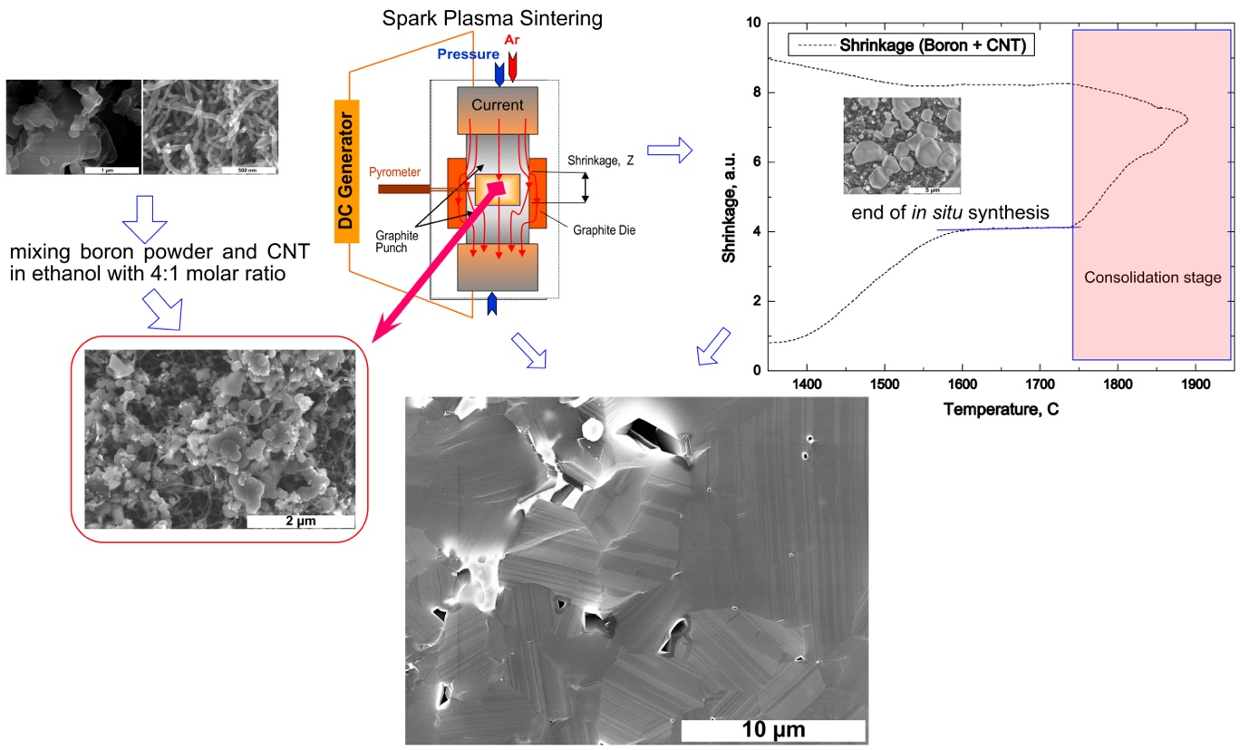
Fig. 2. Schematic presentation of in situ synthesis of the boron carbide used in the present study, which allows one to obtain stochiometric B4C bulks.

Fig. 3. TEM (a)–(c) images and EDS maps (d)–(f) for B, C and Pt on the (B+CNT+K₂PtO₄) mixture used as the raw material for B₄C synthesis by reactive SPS. Inset to (a) shows through TEM-tomography images that metal particles are inside and on the outer surface of the CNT.

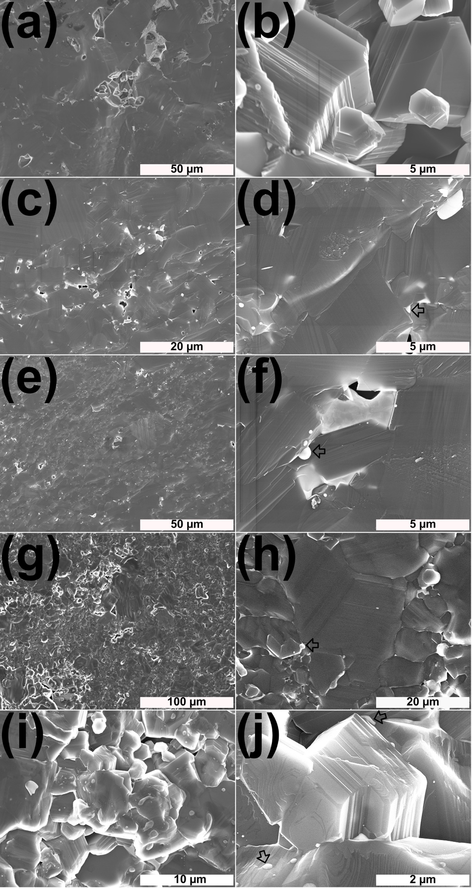
Fig. 4. Fractured as-prepared boron carbide sample by SPS: SEM images in secondary electrons (SE). (a, b) fracture at room temperature, (b, c) at 800 °C, (d,e) at 1000 °C and (g–j) at 1600 °C. Pt grains are white in color, most noticeably in (f) and (j) are marked with open arrows.

Fig. 5. TEM/EDS showing Pt at triple points (a) and (b) and along the boundaries ((c)–(e)). Sample was fabricated by SPS and heated for bending test at 1600 °C.
Fig. 6. TEM and SAED images showing Pt precipitates at grain boundaries of B₄C.

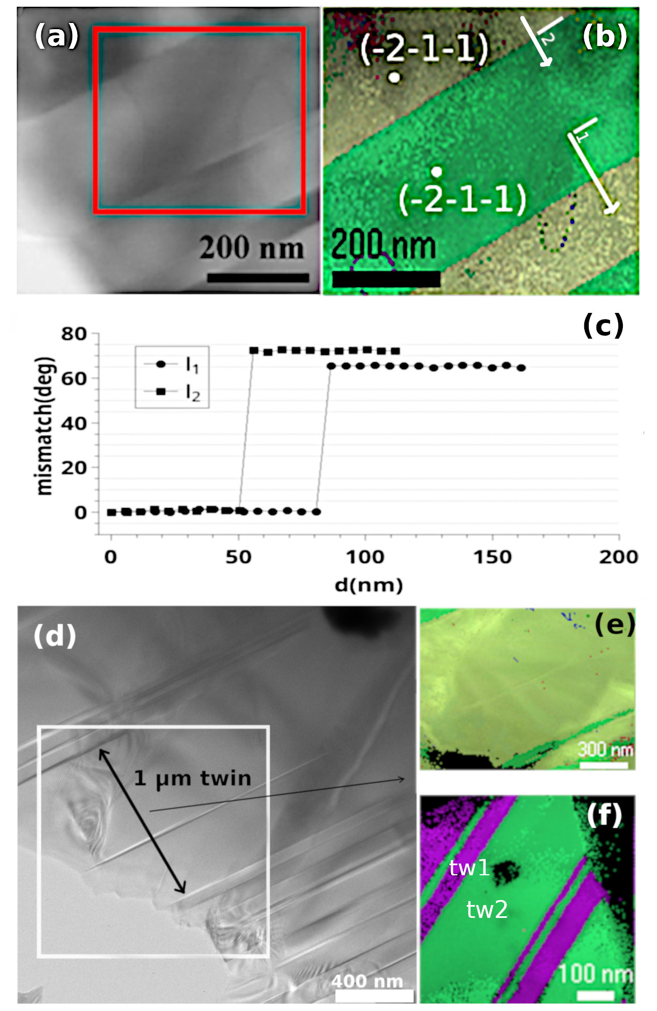

Fig. 7. The B₄C-Pt sample after bending test at 1000 °C: (a) TEM image on a boron carbide grain with presumed twins; (b) orientation map identifying and demonstrating the presence of typical twins; (c) mismatch angle along the white line in (b), crossing the twins; (d) twin model. The B₄C–Pt sample after bending test at 1600 °C: (e) TEM image on a boron carbide grain with large twins; (f) orientation map on the grains from (e) showing twins with a large width of about 1μm; (g) orientation map showing narrow twins around 20 nm in width.

Fig. 8. TEM images of the B₄C–Pt sample after bending test at 1000 °C (a) and during reheating the sample from (a) at 800 °C in the TEM microscope (b); SEM images showing twins in the B₄C–Pt sample after bending test at room temperature (c), at 1200 °C (d) and at 1600 °C (e). Circle in (d) indicates on a grain with curved twins and arrows in (e) point on large-width twins (≥ 1 μm).

