Microstructure and coercivity of Al-diffused Sm(Fe,Co,B)₁₂ film
H. Sepehri-Amin^{1,*}, N. Kulesh¹, Y. Mori², T. Ohkubo¹, K. Hono¹, and T. Shima²
¹⁾ National Institute for Materials Science, 1-2-1 Sengen, Tukuba, Ibaraki 305-0047, Japan
²⁾Tohoku Gakuin University, 3-1, Shimizu-kohji, Sendai 984-8588, Japan

Fe-rich SmFe₁₂-based compounds are considered as potential next generation permanent magnets due to their excellent intrinsic magnetic properties. However, their reported coercivities remain low, only ~12% of the magnetic anisotropy field of the SmFe₁₂-based compound. In this work, we successfully increased the coercivity of B-doped Sm(Fe_{0.8}Co_{0.2})₁₂-based thin films from 1.1 T to 1.8 T by diffusion of Al into the grain boundaries. Detailed microstructural characterization using scanning transmission electron microscopy (STEM) and atom probe tomography (APT) revealed that the high coercivity is due to the segregation of Al into ~4 nm thin B-rich amorphous intergranular phase, resulting in a reduction of its magnetization. This compositional modification of the intergranular phase can prevent the nucleation of reversed magnetic domains in the triple junctions and increase the pinning force of the grain boundary region against the magnetic domain wall motion. Based on detailed microstructural observations, the mechanism of coercivity enhancement is discussed.

Keywords: Sm(Fe_{0.8}Co_{0.2})₁₂; magnetic thin films; coercivity; microstructure
* Corresponding author.
Email address: h.sepehriamin@nims.go.jp (H. Sepehri-Amin).
Permanent magnets play an important role in achieving carbon neutrality through their applications in green energy conversion and transportation. Currently, Nd-Fe-B based magnets are the main material of choice for these applications because they have the largest maximum energy product among all types of permanent magnets at room temperature [1-4]. However, the increasing demands on the Nd-Fe-B magnets have raised the importance on the rare-earth use divergence and the minimization of their contents, which are important for the materials sustainability points of view. In this regard, the research interest on the SmFe₁₂ based compound with ThMn₁₂ type crystal structure has been revived [5-8]. These compounds have lower total rare earth content than Nd₂Fe₁₄B compounds. In addition, they exhibit superior intrinsic magnetic properties than the Nd₂Fe₁₄B phase at room temperature and elevated temperatures [8]. For example, a saturation magnetization of 1.78 T has been reported for Sm(Fe_{0.8}Co_{0.2})₁₂ with a large magnetic anisotropy field of 12 T [8]. The saturation magnetization can even be increased to 1.90 T for (Sm_{0.74}Zr_{0.26})(Fe_{0.8}Co_{0.2})₁₂ compounds [9]. These excellent intrinsic magnetic properties show that the materials have a great potential to be considered as the next generation rare-earth lean permanent magnets.
A major challenge for practical applications of SmFe₁₂-based compounds is how to transfer their excellent intrinsic magnetic properties to the extrinsic ones. SmFe₁₂ compounds are not stable in bulk form, and the addition of stabilizing elements such as Ti, V, Zr, etc. is required to realize a ThMn₁₂-type crystal structure [5-7]. Although the addition of these elements results in a reduction of the saturation magnetization, minimizing the addition of stabilizing elements or partially substituting Co for Fe are known as the solutions to have a sufficiently large saturation magnetization at room temperature [9-10]. However, a problem is that the reported coercivity in the SmFe₁₂ based magnets is far below the magnetic anisotropy field of the SmFe₁₂ based matrix phase [11]. There have been recent successes in developing high coercivity SmFe₁₂-based magnets in powder or bulk forms via tuning the alloy composition, grain size reduction, and optimization of secondary phases or intergranular phase (IGP) [12-22]. Zhang et al. have successfully realized 1.0 T coercivity in anisotropic bulk Sm(Fe,V,Ti)₁₂-based sintered magnets and reported that grain size reduction and IGP modification are necessary to further increase the coercivity [21]. Srinithi et al. reported an enhancement of the coercivity to 1.4 T in an anisotropic Sm(Fe,Ti,V,Al,Cu)₁₂-based sintered magnets by compositional modification of the IGP to an Sm-Cu rich phase [22]. Srinithi et al. discussed the reason the enhancement of coercivity is due to formation of Fe-lean intergranular phase with a content of below 20 %. However, it is still an open question why the obtained coercivity is still only ~12% of the magnetic anisotropy field of the matrix phase and whether a larger coercivity can be realized.
In order to demonstrate the highest possible coercivity, efforts have been made to find an optimal microstructure in SmFe₁₂-based system using the magnetic thin films, where the grain size reduction and intergranular phase modification, as well as oxygen content control, can be tuned more easily than in bulk materials [23-27]. Sepehri-Amin et al. showed that by doping Sm(Fe_{0.8}Co_{0.2})Fe₁₂ magnetic thin films with boron, anisotropic nano-sized Sm(Fe_{0.8}Co_{0.2})Fe₁₂ grains can be developed which are surrounded by a B-rich amorphous IGP, resulting in a large coercivity of 1.2 T [24]. Bolyachkin et al. showed that diffusion of Si into this microstructure can slightly increase the coercivity to 1.32 T [26]. Micromagnetic simulations showed that further modification of the IGP composition is necessary to increase the coercivity. Recently, Mori et al. demonstrated that the coercivity can be further increased to over 1.5 T by diffusion of Al element from the cap layer into Sm(Fe_{0.8}Co_{0.2})₁₂B_{0.5} thin film [27]. However, the question remains as to how Al diffusion into Sm(Fe_{0.8}Co_{0.2})₁₂B_{0.5} thin film leads to such a large coercivity. Note that although the (Fe,B)-rich intergranular phase has not yet been observed in the bulk materials, in this study we have investigated the microstructure and coercivity correlation of Al diffused Sm(Fe_{0.8}Co_{0.2})₁₂B_{0.5} thin film to shed a light on how modification of the grain size and intergranular phase in the SmFe₁₂-based system can overcome the large deviation of coercivity and magnetic anisotropy field of matrix 1:12 grains.
Magnetic thin films were prepared using a magnetron sputtering system with a base pressure below 4.0×10⁻⁷ Pa. B-free and B-doped Sm(Fe_{0.8}Co_{0.2})₁₂B_{0.5} films with a thickness of 100 nm were deposited on MgO (100) single crystal substrate at 400 °C. 20 nm thin V underlayer was used to grow the film with ThMn₁₂ type crystal structure. For Al diffusion, an optimized 35 nm thin Al top layer was deposited on 1:12 layer at 450 ºC followed by 10 nm thin V capping layer deposition. The whole film was optimally annealed at 400 ºC for 4 h. The magnetization curves of the SmFe₁₂-based thin films, at room and elevated temperatures, were measured using a superconducting quantum interference Vibrating Sample Magnetometer (SQUID-VSM) with a maximum applied magnetic field of 7 T. The microstructure of the samples was investigated by transmission electron microscopy (TEM) using an FEI Titan G2 80-200 STEM with probe aberration corrector and equipped with energy dispersive X-ray spectroscopy (EDS). Atom probe tomography (APT) was performed using a laser-assisted local electrode atom probe (LEAP5000XS). The specimens for TEM and APT were prepared with a focused ion beam (FEI Helios G4-UX) dual beam system using the lift-out method.
Figure 1: (a) Magnetization curves obtained from Sm(Fe_{0.8}Co_{0.2})₁₂, Sm(Fe_{0.8}Co_{0.2})₁₂B_{0.5}, and Al diffusion processed Sm(Fe_{0.8}Co_{0.2})₁₂B_{0.5} films. (b) temperature dependence of coercivity obtained form B-doped (green) and Al diffusion processed (blue) Sm(Fe_{0.8}Co_{0.2})₁₂B_{0.5} films.
Figure 1 shows normalized magnetization curves of Sm(Fe_{0.8}Co_{0.2})₁₂, Sm(Fe_{0.8}Co_{0.2})₁₂B_{0.5} and Al diffusion processed Sm(Fe_{0.8}Co_{0.2})₁₂B_{0.5} films. The grown Sm(Fe_{0.8}Co_{0.2})₁₂ film shows a very small coercivity of 0.14 T, while the coercivity increases to 1.1 T after boron doping. The coercivity is enhanced to the record value of 1.8 T by Al diffusion process. Note that the magnetization curves in which no demagnetizing factor correction was applied show a start of the magnetization reversal process from the first quadrant, indicating the existence of the soft magnetic phase, which acts as an easy nucleation of reversed magnetic domains. The temperature dependence of coercivity for the B-doped (green) as well as Al-diffusion processed Sm(Fe_{0.8}Co_{0.2})₁₂B_{0.5} films (blue) are shown in Fig. 1(b). As a reference, the magnetization curves with the absolute value of the saturation magnetization of the thin films are shown in the supplementary file (Fig. S1). The temperature coefficients of coercivity were calculated, $β(T)=[H\left(T\right)-H(RT)]/[H(RT)∙∆T]$, at the temperature range of 300-500 K. Note that due to the sample preparation of magnetic thin films to be placed on oven stick for high temperature measurements, there are some unavoidable damages at the side of samples resulting in a small reduction of coercivity. However, the calculated β_{Hc} shows that the temperature coefficient of coercivity is improved from -0.27 %/K to -0.18 %/K after Al diffusion process$β(T)=[H\left(T\right)-H(RT)]/[H(RT)∙∆T]$.
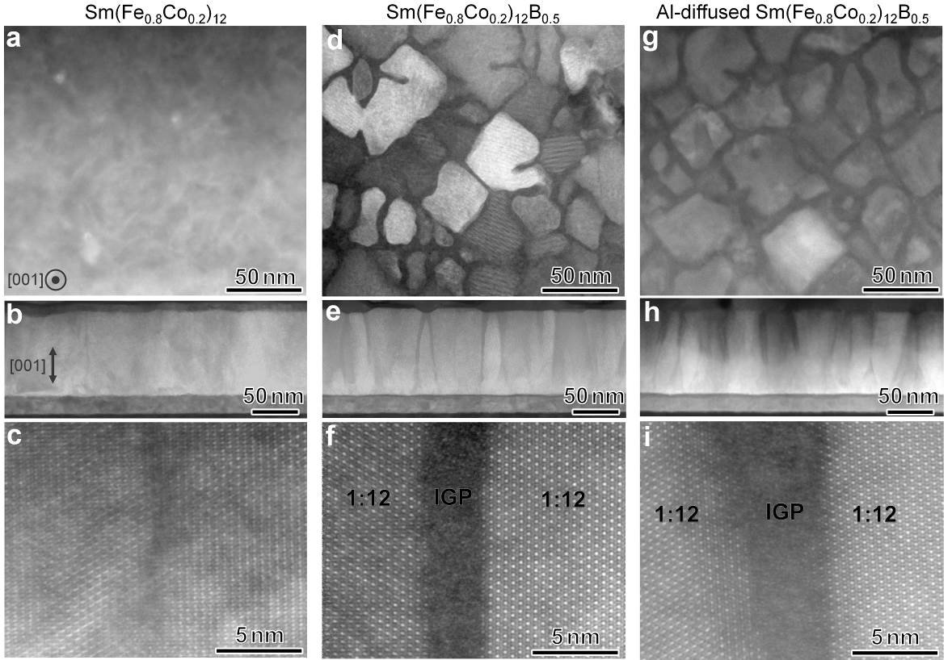
Figure 2: High angle annular dark field (HAADF)-STEM images obtained from plane and cross-sectional views of (a-c) Sm(Fe_{0.8}Co_{0.2})₁₂ and (d-f) Sm(Fe_{0.8}Co_{0.2})₁₂B_{0.5}, and (g-i) Al diffusion processed Sm(Fe_{0.8}Co_{0.2})₁₂B_{0.5} films, respectively.
Figure 2 shows high angle annular dark field (HAADF) scanning transmission electron microscopy (STEM) images obtained from plane and cross-sectional views of B-free, B-doped, and Al diffusion processed Sm(Fe_{0.8}Co_{0.2})₁₂B_{0.5} films. In the B-free sample, only low angle grain boundaries separate the epitaxially grown Sm(Fe_{0.8}Co_{0.2})₁₂ phase. Note that the projection of atoms in the high-resolution HAADF-STEM image shown in Fig. 2c suggests that the crystal structure is disturbed at the low angle grain boundaries of the B-free sample. This may lead to a change in the local intrinsic magnetic properties, especially the magnetic anisotropy field, at the grain surfaces. In the case of B-doped Sm(Fe_{0.8}Co_{0.2})₁₂B_{0.5} film, nano-sized Sm(Fe_{0.8}Co_{0.2})₁₂ grains are observed surrounded by a thin amorphous IGP with a sharp and defect free IGP/1:12 interface. A similar microstructure is observed in the Al diffusion processed Sm(Fe_{0.8}Co_{0.2})₁₂B_{0.5} film. Cross-sectional HAADF-STEM images show that the IGP near the top of the columnar grown grains appears to be thicker than the IGP near the V-underlayer in the B-doped film. This tendency is more pronounced in the Al diffusion processed Sm(Fe_{0.8}Co_{0.2})₁₂B_{0.5} film.

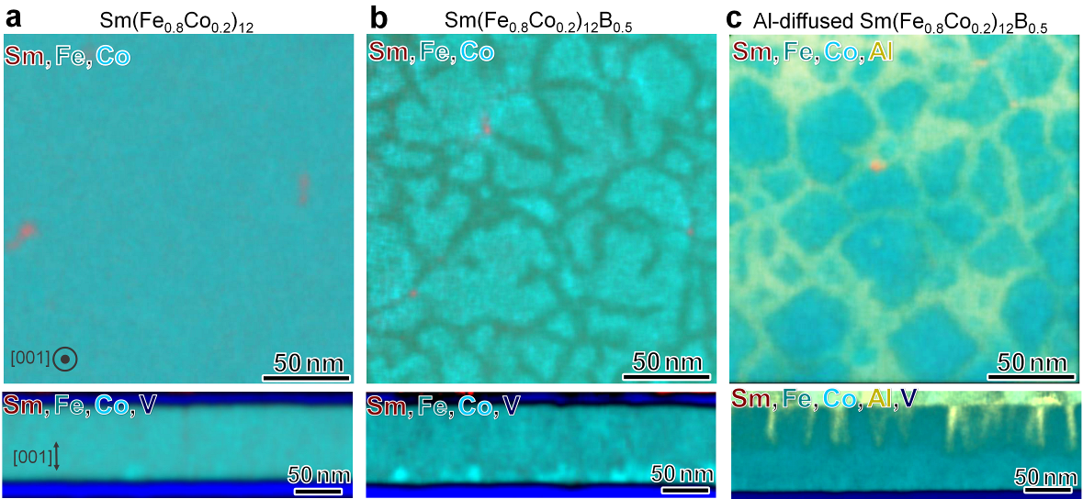
Figure 3: STEM-EDS maps of constituent elements obtained from plane and cross-sectional views of (a) Sm(Fe_{0.8}Co_{0.2})₁₂, (b) Sm(Fe_{0.8}Co_{0.2})₁₂B_{0.5} , and (c) Al diffusion processed Sm(Fe_{0.8}Co_{0.2})₁₂B_{0.5} films, respectively.

STEM-EDS maps of Sm, Fe, Co, V and Al obtained from B-free, B-doped and Al diffusion processed Sm(Fe_{0.8}Co_{0.2})₁₂B_{0.5} films are shown in Fig. 3. In the B-free samples, there are no significant compositional variations except for the presence of some Sm-rich triple junctions. Depletion of Co from the IGP is observed in the planar view STEM-EDS map of the B-doped sample. Diffusion of Al into the B-doped sample results in segregation of Al in the intergranular regions as observed in the planar view STEM-EDS map of the Al diffusion processed samples (Fig. 3c). The cross-sectional STEM-EDS map of the Al diffusion processed sample shows that the Al penetration depth is ~50 nm from the top surface of the film, which is mainly segregated in the thick intergranular region. Another observation from the cross-sectional STEM-EDS maps is the reduced areal fraction of (Fe, Co)-rich secondary phase in the 1:12 layer at the interface with the V-underlayer of the Al diffusion processed sample with respect to that of the B-doped sample.
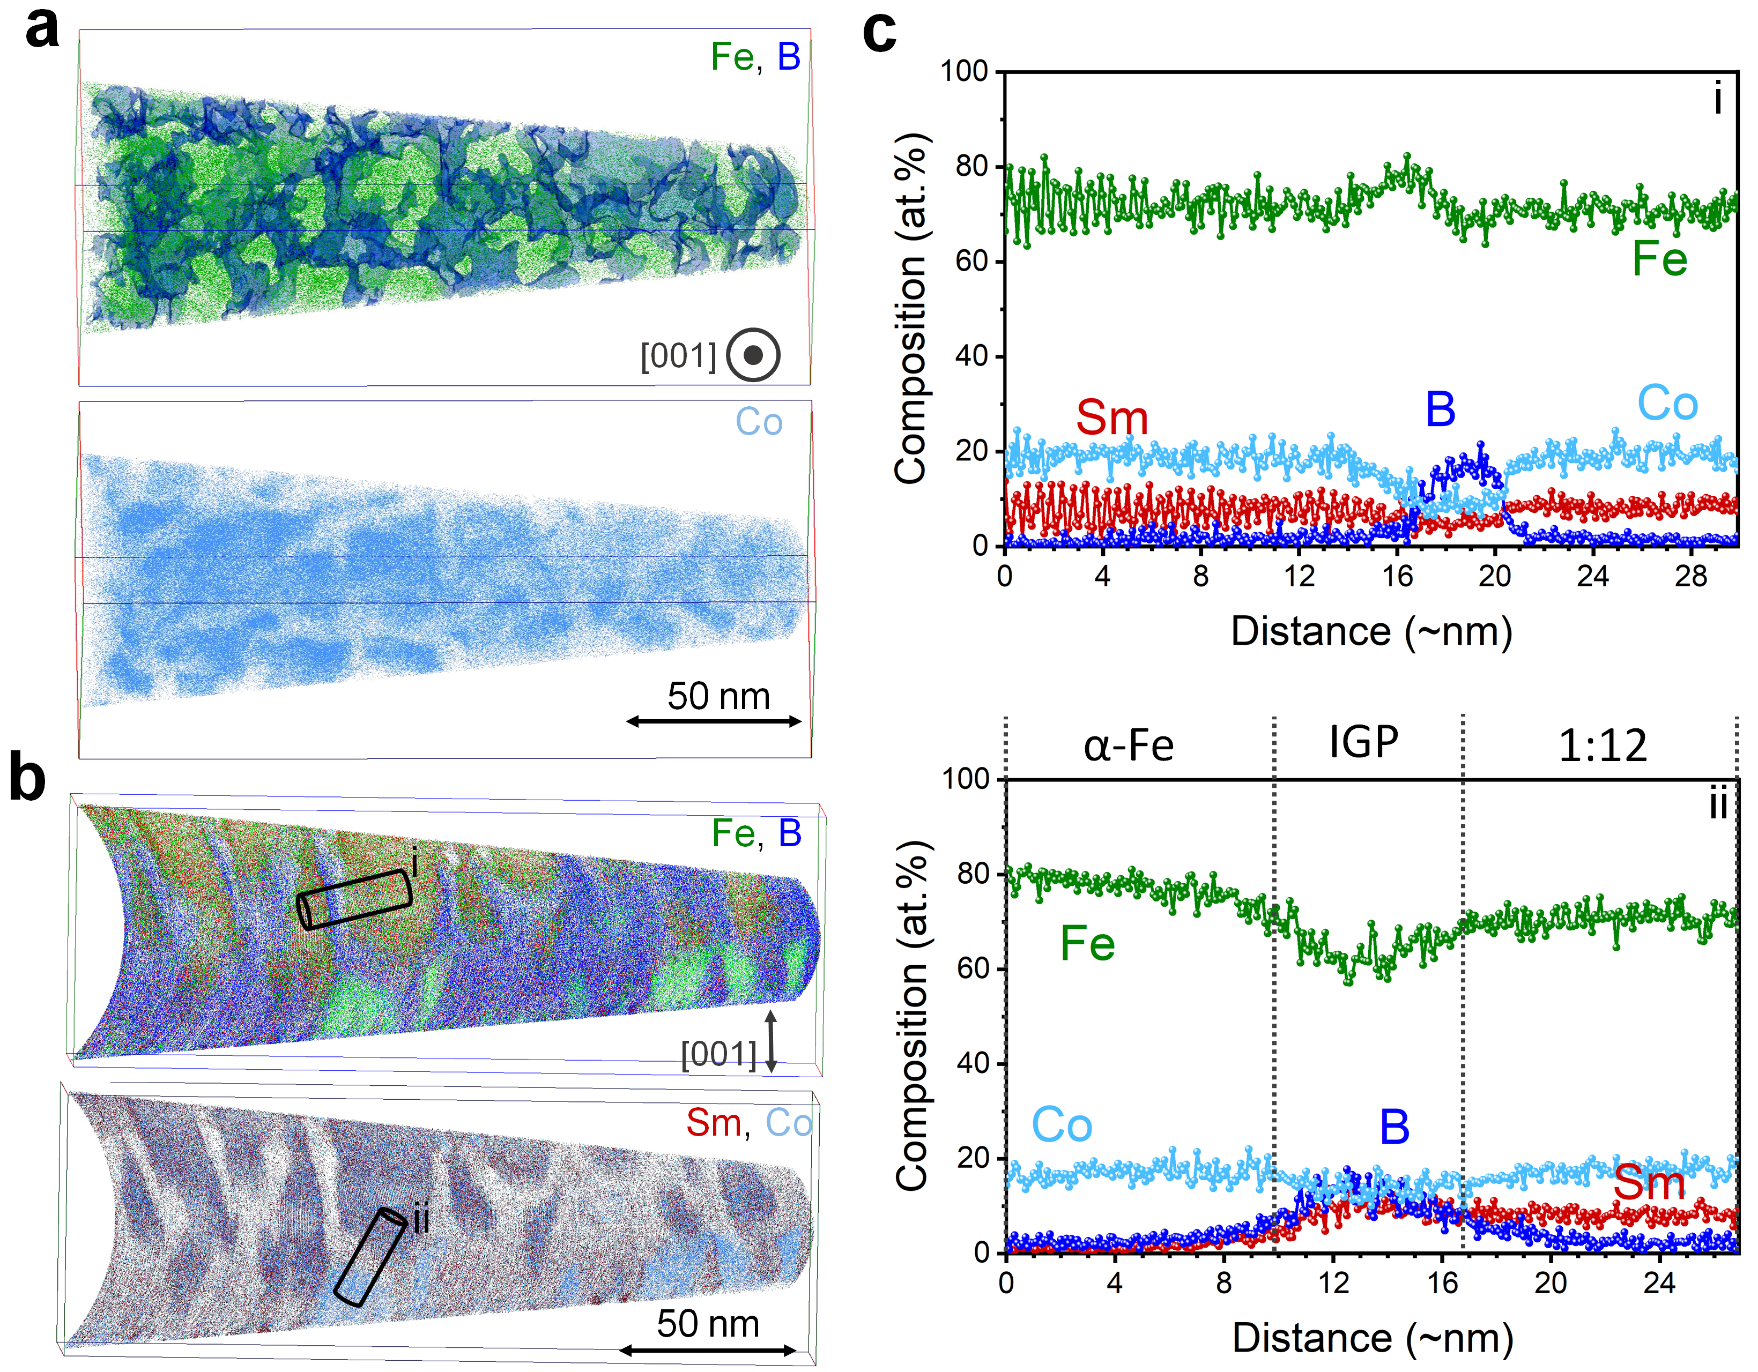
Figure 4: (a) 3D atom maps of Fe, B, and Co and (b) Fe, B, Sm, and Co obtained from the 100 nm thick Sm(Fe_{0.8}Co_{0.2})₁₂B_{0.5} film. Note that the viewing direction is out-of-plane in (a) and in-plane in (b). (c) Composition profiles of the constituent elements calculated from selected boxes i and ii, respectively.
The atom probe tomography results obtained from the Sm(Fe_{0.8}Co_{0.2})₁₂B_{0.5} film are shown in figure 4. The probing direction in the APT results is along the film plane. Thus, we were able to observe the distribution of elements in both parallel and perpendicular to the film growth. 3D atom maps of Fe and Co and isosurface of B-rich IGP with B content of above 8 at. % are shown in Fig. 4 (b) where the c-axis is out-of-plane. Granular 1:12 grains enveloped with B-rich IGP are observed. Fig. 4(b) shows 3D atom maps of Fe, B, Sm and Co where c-axis of grains is in the vertical direction in the image. From these maps, columnar 1:12 grains, B-rich and Co-depleted IGP, and (Fe, Co)-rich secondary phases are observed. Composition line profiles of the constituent elements obtained from selected volumes (i) and (ii) drawn perpendicular to an IGP and an (Fe, Co)-rich secondary phase respectively, are shown in Fig. 4 (c). Note that based on the APT result, the B-rich IGP have a composition of Sm_{5.3}Fe_{69.7}Co_{8.2}B_{16.8} at.%, where the Co content is half that of the matrix phase, while the Fe content is not much different from the matrix grains.
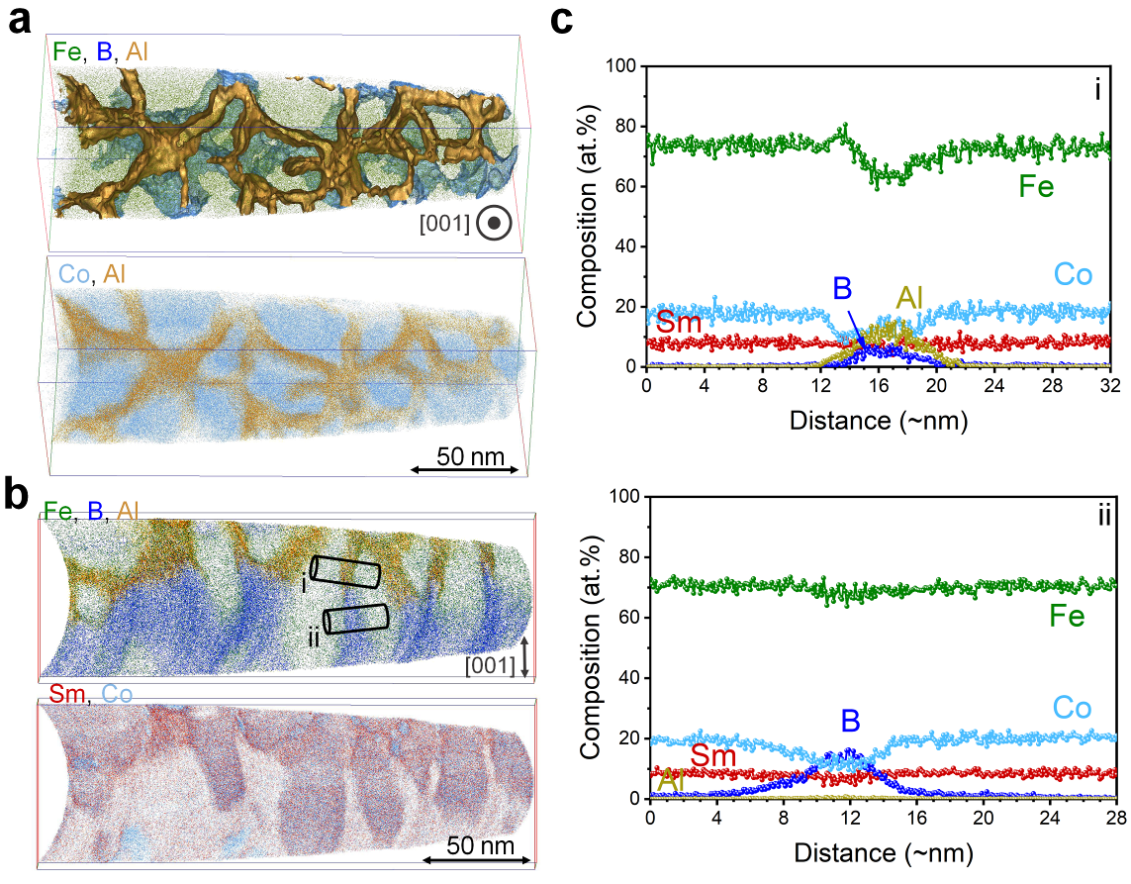
Figure 5: (a) 3D atom maps of Fe, B, Al, and Co and (b) Fe, B, Al, Sm, and Co obtained from the 100 nm thick Al diffusion processed Sm(Fe_{0.8}Co_{0.2})₁₂B_{0.5} film. Note that the viewing direction is out-of-plane in (a) and in-plane in (b). (c) Composition profiles of the constituent elements calculated from selected boxes i and ii, respectively.

The atom probe tomography results obtained from the Al diffusion processed Sm(Fe_{0.8}Co_{0.2})₁₂B_{0.5} film are shown in Fig. 5. Two different viewing directions, c-axis out-of-plane and c-axis in-plane, are shown in Fig. 5 (a, b), respectively. Isosurfaces of boron with more than 8 at. % (in blue) and aluminum with more than 10 at. % (in yellow) are shown in Fig. 5(a) together with 3D map of Fe. From the top view, granular 1:12 grains can be enveloped by (B, Al)-rich IGP. The side view APT result shows that the Al partially diffuses into the B-rich IGP, in agreement with what was observed in the STEM-EDS results (Fig. 3(c)). Based on these results, the Al diffusion processed sample contains two types of intergranular phases; (Al, B)-rich IGP and B-rich IGP. Fig. 5(c) shows the composition line profiles of the constituent elements obtained over these two IGPs; marked in Fig. 5(b). The (B, Al)-rich IGP shows a composition of Sm_{6.9}Fe_{62.6}Co_{11.0}B_{6.4}Al_{13.1} at. % and the B-rich IGP have a composition of Sm_{7.2}Fe_{68.3}Co_{11.1}B_{13.4} at. %.
TEM image-based micromagnetic simulations by Bolyachkin et al. showed that the formation of thick amorphous B-rich triple junctions is still a weak link in the coercivity of Sm(Fe,Co,B)₁₂ magnetic thin films [26]. This is due to the nucleation of reversed magnetic domains at these triple junctions where a high Fe content is present. Diffusion of Al into triple junctions and thin IGPs, leads to a change in their composition by reducing their Fe content. As shown in Fig. 5, the B-rich intergranular phase has a comparable Fe content to the matrix phase, while in the (B, Al)-rich region, the Fe content is slightly reduced with respect to the 1:12 matrix phase. Enrichment of Al in (Fe, B)-rich IGP results in reduction of magnetization [28.29]. This can result in an increase in coercivity as well as thermal stability of coercivity in the Al diffusion processed Sm(Fe_{0.8}Co_{0.2})₁₂B_{0.5} film. The composition modification of the intergranular phase and reduction of its magnetization may be beneficial to increase the nucleation field of magnetization reversals in these regions. However, the presence of ferromagnetic B-rich IGP in the region where Al diffusion has not taken place can still act as nucleation sites for the magnetization reversal process. Nevertheless, the lower magnetization of the (B, Al)-rich intergranular phase can lead to a stronger pinning force of the IGP against the magnetic domain wall motion and hence to a higher coercivity in the Al diffusion processed sample. Hindering the formation of ferromagnetic (Fe, Co)-rich secondary phase at the interface of 1:12 films with V underlayer is another microstructural origin for the enhancement of coercivity in the Al diffusion processed sample. Note that there was no Al diffusion into the 1:12 phase, and therefore there is no change in the intrinsic magnetic properties of the 1:12 matrix grains due to Al diffusion. Although Al diffusion process was not through the full depth of the IGP, this work clearly demonstrates that the compositional modification of the intergranular phase and the elimination of secondary soft magnetic phases are the major steps that should be considered to increase the coercivity of 1:12 magnets closer to their theoretical limit, which is the magnetic anisotropy field of 1:12 grains with ThMn₁₂-type crystal structure. This can be realized by conducting fundamental research on the phase equilibrium of Sm-(Fe, Co)-M system (M is a stabilizing element such as Ti, V, Zr, etc...) to extend the optimization of the alloy composition not only to optimize the intrinsic magnetic properties but also to realize the desired microstructure, secondary phases, and intergranular phase beneficial for the coercivity in the SmFe₁₂ based systems [30-32].
In summary, the coercivity of B-doped Sm(Fe_{0.8}Co_{0.2})₁₂-based thin films was enhanced from 1.1 T to 1.8 T by a low-temperature Al diffusion process. No Al was found inside the Sm(Fe_{0.8}Co_{0.2})₁₂ grains, while Al was only diffused into a thin amorphous intergranular phase. This may be due to the faster diffusion of Al into amorphous (Fe, B)-rich IGP than that of Sm(Fe_{0.8}Co_{0.2})₁₂ grains at the low diffusion process temperature of ~400-450ºC. However, the diffusion of Al did not occur through the entire thickness of the film. The formation of (B, Al)-rich IGP results in the reduction of its magnetization. These microstructural observations suggest that the large coercivity is realized by hindering the easy nucleation of reverse magnetic domains at the (B,Al)-rich triple junctions as well as enhancing the pinning strength of the IGP against the magnetic domain wall motion. This study demonstrates that the elimination of secondary soft magnetic phases and further composition modifications of the intergranular phases can increase the coercivity of SmFe₁₂ based systems closer to their magnetic anisotropy field.
This work was in-part supported by JSPS KAKENHI Grant Number JP23H01674, and MEXT Program: Data Creation and Utilization-Type Material Research and Development Project (Digital Transformation Initiative Center for Magnetic Materials) Grant Number JPMXP1122715503.

References:
[1] K. Hono, H. Sepehri-Amin, Prospect for HRE-free high coercivity Nd-Fe-B permanent magnets, Scripta Mater. 151 (2018) 6-13.
[2] H. Sepehri-Amin, S. Hirosawa, K. Hono, Advances in Nd-Fe-B based permanent magnets, Handbook of Magnetic Materials, 27 (2018) 269-372.
[3] O. Gutfleisch, M. A. Willard, E. Brück, C. H. Chen, S. G. Sankar, J. P. Liu, Magnetic materials and devices for the 21st century : stronger, lighter, and more energy efficient, Adv. Mater. 23 (2011) 821-842.
[4] M. Sagawa, S. Fujimura, N. Togawa, H. Yamamoto, Y. Matsuura, New material for permanent magnets on a base of Nd and Fe, J. Appl. Phys. 55 (1984) 2083-2087.
[5] K. Ohashi, T. Yokoyama, R. Osugi, Y. Tawara, The magnetic and structural properties of R-Ti-Fe ternary compounds, IEEE Trans. Magn. 23 (1987) 3101-3103.
[6] K.H.J. Buschow, D.B. de Mooij, M. Brouha, H.H. Smit, R.C. Thiel, Magnetic properties of ternary Fe-rich rare earth intermetallic compounds, IEEE Trans. Magn. 24 (1988) 1611-1616.
[7] A. Müller, Magnetic material R,Fe,Mo,(Co) with ThMn₁₂ structure, J. Appl. Phys. 64 (1988) 249-251.
[8] Y. Hirayama, Y.K. Takahashi, S. Hirosawa, K. Hono, Intrinsic hard magnetic properties of Sm(Fe_{1-x}Co_{x})₁₂ compound with the ThMn₁₂ structure, Scripta Mater. 138 (2017) 62-65.
[9] P. Tozman, H. Sepehri-Amin, Y.K. Takahashi, S. Hirosawa, K. Hono, Intrinsic magnetic properties of Sm(Fe_{1-x}Co_{x})₁₁Ti and Zr-substituted Sm_{1-y}Zr_{y}(Fe_{0.8}Co_{0.2})_{11.5}Ti_{0.5} compounds with ThMn₁₂ structure toward the development of permanent magnets, Acta Mater. 153 (2018) 354-363.
[10] P. Tozman, Y. K. Takahashi, H. Sepehri-Amin, D. Ogawa, S. Hirosawa, K. Hono, The effect of Zr substitution on saturation magnetization in (Sm_{1-x}Zr_{x})(Fe_{0.8}Co_{0.2})₁₂ compound with the ThMn₁₂ structure, Acta Mater. 178 (2019) 114-121.
[11] P. Tozman, H. Sepehri-Amin, K. Hono, Prospects for the development of SmFe12-based permanent magnets with a ThMn₁₂-type phase, Scripta Mater. 194 (2021) 113686_1-7.
[12] I. Dirba, H. Sepehri-Amin, T. Ohkubo, K. Hono, Development of ultra-fine grain sized SmFe₁₂-based powders using hydrogenation disproportionation desorption recombination process, Acta Mater., 165 (2019), 373-380.
[13] I. Dirba, J. Li, H. Sepehri-Amin, T. Ohkubo, T. Schrefl, K. Hono, Anisotropic, single-crystalline SmFe₁₂-based microparticles with high roundness fabricated by jet-milling, J. All. Comp. 804 (2019) 155-162.
[14] I. Dirba, Y. Harashima, H. Sepehri-Amin, T. Ohkubo, T. Miyake, S. Hirosawa, K. Hono, Thermal decomposition of ThMn₁₂-type phase and its optimum stabilizing elements in SmFe₁₂-based alloys, J. All. Comp. 813 (2020) 152224_1-7.
[15]A.M. Schönhöbel, R. Madugundo, A.M. Gabay,J.M.Barandiaran, G.C. Hadjipanayis, Nanocrystalline Sm-based 1:12 magnets, Acta Materialia, 200 (2020) 652-658.
[16]D.Palanisamy, S. Ener, M. Maccari, L. Schäfer, K.P. Skokov, O. Gutfleisch, D. Raabe, B. Gault, Grain boundary segregation, phase formation, and their influence on the coercivity of rapidly solidified SmFe₁₁Ti hard magnetic alloys, Phys. Rev. Mater. 4 (2020) 054404_1-9.
[17] A. M. Gabay, C. Han, C. Ni, G. C. Hadjipanayis, Effect of alloying with Sc, Nb and Zr on reduction-diffusion synthesis of magnetically hard Sm(Fe,Co,Ti)₁₂-based monocrystalline powders, J. Magn. Magn. Mater. 541 (2022) 168550_1-8.
[18] A. M. Gabay, G. C. Hadjipanayis, Recent developments in RFe₁₂-type compounds for permanent magnets, Scripta Mater. 154 (2018) 284-288.
[19] J. S. Zhang, X. Tang, H. Sepehri-Amin, A. K. Srinithi, T. Ohkubo, K. Hono, Origin of coercivity in an anisotropic Sm (Fe,Ti,V)₁₂-based sintered magnet, Acta Mater. 217 (2021) 117161_1-10.
[20] K. Otsuka, M. Kamata, T. Nomura, H. Iida, H. Nakamura, Coercivities of Sm-Fe-M sintered magnets with ThMn₁₂-type structure (M=Ti,V), Mater. Trans., 62 (6) (2021), pp. 887-891.
[21] J. S. Zhang, X. Tang, A. Bolyachkin, A. K. Srinithi, T. Ohkubo, H. Sepehri-Amin, K. Hono, Microstructure and extrinsic magnetic properties of anisotropic Sm(Fe,Ti,V)₁₂-based sintered magnets, Acta Mater. 238 (2022) 118228_1-10.
[22] A. K. Srinithi, X. Tang, H. Sepehri-Amin, J. S. Zhang, T. Ohkubo, K. Hono, High-coercivity SmFe₁₂-based anisotropic sintered magnets by Cu addition, Acta Mater. 256 (2023) 119111_1-10.
[23]D. Ogawa, X.D. Xu, Y.K. Takahashi, T. Ohkubo, S. Hirosawa, K. Hono, Emergence of coercivity in Sm(Fe_{0.8}Co_{0.2})₁₂ thin films via eutectic alloy grain boundary infiltration, Scripta Mater. 164 (2019) 140-144,
[24] H. Sepehri-Amin, Y. Tamazawa, M. Kambayashi, G. Saito, Y. K. Takahashi, D. Ogawa, T. Ohkubo, S. Hirosawa, M. Doi, T. Shima, K. Hono, Achievement of high coercivity in Sm (Fe_{0.8}Co_{0.2})₁₂ anisotropic magnetic thin film by boron doping, Acta Mater. 194 (2020) 337-342.
[25] M. Kambayashi, H. Kato, Y. Mori, M. Doi, T. Shima, Structure and magnetic properties of Sm(Fe_{0.8}Co_{0.2})₁₂ thin films by adding light elements, J. Magn. Soc. Japan, 45 (2021) 66-69.
[26] A. Bolyachkin, H. Sepehri-Amin, M. Kambayashi, Y. Mori, T. Ohkubo, Y. K. Takahashi, T. Shima, K. Hono, Coercivity engineering in Sm(Fe_{0.8}Co_{0.2})₁₂B_{0.5} thin films by Si grain boundary diffusion, Acta Mater. 227 (2022) 117716_1-8.
[27] Y. Mori, S. Hatanaka, M. Kambayashi, S. Nakatsuka, K. Hirayama, T. Shima, Increase in coercivity of Sm(Fe-Co)-B thin films due to diffusion of Al element from cap layer, J. Magn. Soc. Japan, 47 (2023) 103-107.
[28] D. M. Rodriguez, F. Plazaola, J. S. Garitaonandia, J. A. Jimenez, E. Apinaniz, Influence of volume and Fe local environment on magnetic properties of Fe-rich Fe-Al alloys, Intermetallics 24 (2012) 38-49.
[29] Y. N. Chen, D. R. Huang, Y. D. Chuang, Effects of Al and Ga additions on the magnetic properties of Fe-B alloy, IEEE Trans. Magn. 19 (1983) 1919-1921.
[30] P. Tozman, H. Sepehri-Amin, T. Abe, K. Hono, Y. K. Takahashi, Exploring secondary phases in the Sm–Fe–V system beneficial for coercivity, Acta Mater. 258 (2023) 119197_1-7.
[31] A. M. Gabay, C. Han, C. Ni, G. C. Hadjipanayis, Phase equilibria in iron-rich Sm–Fe–Ti and Sm–(Fe, Co)–Ti alloys at 1100–1200°C, J. All. Comp. 965 (2023) 171444_1-12.
[32] A. M. Gabay, C. Han, C. Ni, G. C. Hadjipanayis, Re-investigation of high-temperature phase equilibria in Fe-rich Sm–Fe–Ti alloys, J. All. Comp. 947 (2023) 169520_1-8.

