Surface-modified BaTiO₃ as functional filler in poly(ethylene oxide)-based solid polymer electrolyte for lithium-metal battery
Shuyu Dongª, Yiyi Zhengª, Qiaohui Duanª, Yu Zhaoª, Tian Tanª, Yu Zhouª, Tian Raoª, Hanbing Yan^{b}, Weiqian Guo^{b}, Denis Y. W. Yu^{c}*

ªSchool of Energy and Environment, City University of Hong Kong, 83 Tat Chee Avenue, Kowloon, Hong Kong, China
^{b}Tsinghua Shenzhen International Graduate School, Tsinghua University, Shenzhen 518055, China
^{c}Research Center for Energy and Environmental Materials (GREEN), National Institute for Materials Science, Namiki 1-1, Tsukuba, Ibaraki 305-0044, Japan

Abstract
Poly(ethylene oxide) (PEO)-based polymer electrolyte is regarded as a promising candidate for solid-state lithium metal batteries due to its unique lithium conduction mechanism compared to inorganic solid-state electrolyte. However, the development of this electrolyte is hindered by its low ionic conductivity and poor mechanical strength. In this study, we enhance the mechanical stability and ionic conductivity of PEO-based polymer electrolyte by incorporating barium titanate nanoparticles coated with 3-(triethoxysilyl) propionitrile (BTO@TESPN) as solid fillers. With 10 wt% of BTO@TESPN, ionic conductivity and critical current density at 60 °C is improved to 5.67 × 10⁻⁴ S cm⁻² and 1.6 mA cm⁻², respectively, compared to 2.69 × 10⁻⁴ S cm⁻² and 1.0 mA cm⁻² without the filler. Furthermore, the symmetric cell with Li utilizing this electrolyte demonstrates stable cycling at a rate of 0.1 mA cm⁻² for a minimum duration of 1000 h. Additionally, the lithium iron phosphate (LiFePO₄)-Li battery exhibits excellent stability up to 700 cycles at 60 °C at a current rate of 0.5 C while maintaining a capacity retention of up to 93.0%. This research presents an innovative approach towards enhancing PEO-based solid polymer electrolytes, by regulating the interface between the filler and the polymer matrix.

Keywords: Solid polymer electrolyte; poly(ethylene oxide); barium titanate; surface coating; lithium-metal battery

Introduction
Lithium metal is considered an optimal choice as the anode material of future lithium-ion batteries because it has a low redox potential of -3.04 V vs. SHE with a high theoretical specific capacity of 3860 mAh g⁻¹.^{[1–3]} Nevertheless, using a lithium metal anode in conventional liquid electrolyte systems can result in various problems such as reduced Coulombic efficiency, unstable solid-electrolyte interphase (SEI), and safety concerns regarding the formation of lithium dendrites.^{[4,5]} Solid-state electrolytes have been extensively studied as they can potentially overcome the safety issues of lithium metal batteries.^{[6–8]} Among them, solid polymer electrolytes (SPEs) with poly(ethylene oxide) (PEO) are widely recognized as a viable solution due to their minimal interfacial resistance, excellent stability towards lithium metal ions, and superior ionic conductivity.^{[9]}
PEO-based SPEs is typically made with a lithium salt in a polymer matrix. The ethylene oxide (EO) groups in the polymer chain can interact with dissociated lithium ions from the salt, facilitating their transport through the chain segments.^{[10]} In addition to these fundamental components, fillers are often incorporated to enhance the mechanical properties of the SPE and improve its ionic conductivity. Traditional inorganic fillers such as Al₂O₃,^{[11–13]} TiO₂^{[14–16]} and SiO₂^{[17–19]} were claimed to increase the mobility of lithium ions which enhances ionic conductivity due to the decrease of the crystallinity of PEO. Li-ion conducting inorganic fillers such as lithium lanthanum zirconium oxide (LLZO),^{[20,21]} lithium lanthanum zirconium tantalum oxide (LLZTO)^{[22,23]} and lithium lanthanum titanium oxide (LLTO)^{[24,25]} can also increase the ionic conductivity of the electrolyte by direct lithium-ion transport. However, their complex manufacturing process hinders widespread commercial applications. Furthermore, small molecular additives such as metal-organic frameworks (MOFs),^{[26,27]} succinonitrile (SN),^{[28–30]} gC₃N₄,^{[31]}, FeF₃,^{[32]} CuF₂,^{[33]} AlF₃,^{[34]} CeF₃,^{[35]} and SbF₃^{[36]} have been reported to improve the ionic conductivity of the PEO-based SPEs by strengthening the interaction between the additives and the ether oxygen on the polymer chain which reduces the crystallinity of PEO. Some soluble ions further participate in the SEI formation.
Barium titanate (BTO) — a distinctive ferroelectric material with the capability of self-polarization in an electric field — has been reported as a filler in PEO-based SPEs.^{[37,38]} The high dielectric constant and ferroelectric properties of BTO can enhance lithium-ion transport kinetics. However, the cycle stability of the SPE is poor probably due to poor connectivity between the BTO filler and the PEO matrix. To improve the compatibility and lithium transfer performance of the SPE, we propose to modify the BTO surface with a self-assembled monolayers (SAM) of 3-(triethoxysilyl) propionitrile (TESPN) in this study because the -CN functional group on TESPN can reduce the mobility of anions in lithium salts and can further increase the lithium transference number.^{[39]} The resultant SPE, designated as BTO@TESPN@PEO, demonstrates remarkable properties including an enhanced ionic conductivity of 5.67 × 10⁻⁴ S cm⁻² at 60°C, which is 2 times that of PEO without the filler. The BTO@TESPN@PEO electrolyte is able to increase the stability and critical current density of Li-Li symmetric cells, suggesting that it can reduce Li dendrite formation. In addition, LiFePO₄-Li cells with BTO@TESPN@PEO can maintain stable cycling over 700 cycles compared to 350 cycles with only PEO.

Experimental
Surface modification of BTO
TESPN-coated BTO was made by a SAM process (Figure S1). BTO (nanopowder < 100 nm, Sigma-Aldrich) was first treated by ultra-violet light (wavelengths: 254 and 185 nm; 350 W) for 20 mins at 60 ℃ to increase the surface hydroxyl functional groups. Then, 0.5 g BTO and 50 μL TESPN were put into a stainless-steel box inside the glovebox. The box was vacuumed in the antechamber of the glovebox before annealing at 150 ℃ for 8 h in a temperature chamber. The modified BTO nanoparticles were collected after cooling down to room temperature.

SPE preparation
The SPE was prepared using a solution casting method. Before making the solution, all components were dried at 55 °C under vacuum overnight. To make the BTO@TESPN@PEO membrane, 0.24 g lithium bis(trifluoromethane sulfonic)imide (LiTFSI, ShanShan), 0.8 g poly(ethylene oxide) (PEO, Mw: 600,000 g mol⁻¹, Sigma-Aldrich) and 0.08 g BTO@TESPN were first dissolved in 10 mL acetonitrile (ACN , HPLC, RCI). The EO/Li⁺ mole ratio is 20:1 while the amount of BTO is 10 wt% that of PEO. To form a homogeneous solution, the solution was magnetically stirred at 60 ℃ for 12 h. The obtained solution was poured into a silicone mold, followed by evaporating the solvent at 65 ℃ for 8 h in air. The membranes (thickness ~100 μm) were separated from the mold after cooling to room temperature, and were continuously dried at 55 °C for one day under vacuum. Then the membranes were transferred to an Ar-filled glovebox, punched into 19 mm diameter disks, and stored in Ar atmosphere before cell assembly. BTO@PEO and PEO SPEs were also made by the same method as that of BTO@TESPN@PEO, except without the TESPN coating and without BTO, respectively.

Characterizations of the coated BTO and SPE
Field emission scanning electron microscopy (FE-SEM, Zeiss SIGMA 500, 5 kV) with energy-dispersive X-ray spectroscopy (EDS) was conducted to observe the morphology of the SPE and cycled Li metal anode surface. X-ray diffractometry (XRD, (PANalytical X’Pert3 Powder) was performed on the BTO and BTO@TESPN powders and SPE membrane using Cu Kα radiation (λ=1.5418 Å). Thermogravimetric analysis (TGA, TA SDT650) tests of the BTO and BTO@TESPN were conducted from 25 to 800 °C with at 5 °C min⁻¹ in N₂ atmosphere. The Fourier transform infrared (FTIR) spectra of the BTO and BTO@TESPN particles were measured with a PerkinElmer instrument with 1 cm⁻¹ resolution and 20 scans between 400 and 4000 cm⁻¹. Melting points of the SPEs were measured with a differential scanning calorimeter (SHIMADZU, DSC-60A plus). The samples were tested with a heating rate of 5 °C min⁻¹ between -60 °C and 100 °C under argon. The tensile strength of the SPE was evaluated with METEK (LS1) at room temperature with an elongation rate of 5 mm min⁻¹. The X-ray photoelectron spectroscopy (XPS, PHI 5000 VersaProbe II spec-trometer) was performed using a monochromatic Al Kα X-ray source. The Li metal anode after cycling with a capacity limit of 1 mAh cm⁻² at 0.05 mA cm⁻² for 10 times were extracted to study the interfacial chemistry between the Li metal and SPE. Depth profiling of the SEI on Li metal was further conducted by XPS through Ar ion etching, and the thickness was estimated from a reference SiO₂. To investigate the interface between the BTO@TESPN@PEO and Li, time-of-flight secondary ion mass spectrometry (TOF-SIMS) using Bi as the main ion source (30 keV) and Ar as the sputtering source with a sputter rate of 0.3 nm s⁻¹ for SiO₂ was conducted with a Nano TOF 2 instrument (ULVAC- PHI, Japan). The samples were slightly air-exposed while transferring between an Ar-filled container to the instrument.

Fabrication and tests of CR2032 coin cells
The LiFePO₄ cathode was made by mixing LiFePO₄ (ShanShan), carbon black (Super P), and polyvinylidene fluoride (PVdF 5130, Arkema Kynar) in N-methyl-2-pyrrolidone (NMP) with a ratio of 8:1:1 by weight. The slurry was coated onto an aluminum foil and then dried at 80 °C for 2 h to remove the solvent. The electrodes were then cut into discs with 12 mm diameter. After calendaring, the electrodes typically have a density of 1.5 g cm⁻³ with 2.0 mg cm⁻² active mass. Before putting into an Ar-filled glovebox with less than 1ppm O₂ and H₂O content, the electrodes were dried at 110°C for 12 h in vacuum.
LiFePO₄-Li batteries were assembled in the glovebox using the LiFePO₄ electrodes as cathodes, SPE as separator and lithium metal as anode into a CR2032 coin cell. Li-Li symmetric cells with SPE as the separator were also assembled in the Ar-filled glovebox . All cells were aged at 60 ℃ for 12 h before electrochemical tests. The LiFePO₄-Li cells were operated at 0.1 C (1 C = 170 mA g⁻¹) for 5 cycles before rate and long-term cycling between 2.5 and 4.0 V (versus Li/Li⁺) at 60 °C.

Electrochemical measurements
Electrochemical impedance spectroscopy (EIS) was used to measure the ionic conductivity (σ) of the as-prepared SPEs with stainless steel (SS) blocking electrodes inside a 2032 coin cell using a potentiostat (BioLogic VMP3) between 0.1 MHz and 1 Hz and a voltage amplitude of 50 mV. The tested cells were held for at least 1 h at each test temperature (from 30 to 60 °C) before measurement. Ionic conductivity (σ) was calculated according to Eq. 1:
$$σ =\frac{L}{R×S}$$ | (1)
where S is the area of the stainless steel electrodes, L is the thickness of the SPE membrane and R is the resistance obtained from the x-intercept by curve fitting the Nyquist plot of the EIS measurement with a semi-circle.
Direct current polarization was conducted using Li|SPE|Li cells to determine the lithium-ion transference number (t_{Li}⁺) of the SPEs at 60 °C. Specifically, the initial resistances (R₀) of the cells were first measured by EIS. Then, a potential (ΔV) of 10 mV was applied and the initial (I₀) and steady state (I_{ss}) currents were recorded. Afterwards, the steady state resistance (R_{ss}) is further recorded by EIS. The corresponding results of t_{Li}⁺ were calculated according to Eq. 2:
$$t_{L_{i}}^{+}=\frac{I^{ss}\left(ΔV-I^{0}R_{i}^{0}\right)}{I^{o}\left(ΔV-I^{ss}R_{i}^{ss}\right)}$$ | (2)

Linear sweep voltammetry (LSV) tests with a scan rate of 0.1 mV s⁻¹ to 6 V (vs. Li/Li⁺) at 60 °C were conducted on Li|SPE|SS cells to study the electrochemical stability of the SPE. The decomposition potential of the SPE is defined as the potential when the measured current exceeds 1 μA. The Tafel test was carried out using Li|SPE|Li cells at 60 °C from -0.25 to 0.25 V with a scan rate of 1 mV s⁻¹. The exchange current density is the corresponding current where the two linearly fitted lines from the log |i| vs. V data at ±50 mV from the trough intersect.

Results and discussions
Characterizations of BTO@TESPN
TESPN ((C₂H₅O)₃SiCH₂CH₂CN) is a silane coupling agent with a nitrile (-CN) functional group that can increase the adhesion between inorganic and polymeric materials. Here, we use it to coat BTO nanoparticles to improve the mechanical strength and stability of the SPE composite. Figure 1a and 1b present the SEM images of BTO and BTO@TESPN, respectively, revealing that the particle size for both is approximately 50 nm. There is minimal change in the dimensions and morphology of the BTO nanoparticles after surface coating. EDS analysis of BTO@TESPN indicates a uniform dispersion of Si, C, and N elements on the nanoparticle surfaces (Figure 1b).
Figure 1c illustrates the TGA curves of pristine BTO nanoparticles compared to BTO@TESPN. While BTO shows a small weight drop of about 3.3% after annealing to 800 °C, probably due to decomposition of BaCO₃ on the surface, BTO@TESPN shows a larger weight drop due to the decomposition of TESPN. From the difference in weight loss, we can estimate the amount of TESPN to be at least 1.1 wt%, assuming that the amount of BaCO₃ remained unchanged during the coating process.
FTIR of the BTO@TESPN powders was conducted to verify the presence of TESPN on the surface. As shown in Figure 1d, the emergence of bands at 1132 and 1059 cm⁻¹ signifies the formation of Si-O-BTO and Si-O-Si bonds respectively,^{[37,40]} resulting from the condensation between silanol groups and hydroxyl groups present in BTO as well as other silanol entities. Variations in surface composition are evidenced from the C 1s XPS spectra (Figures 1e and 1f) where an additional peak around ~292.6 eV indicates the C-N component on the surface of the BTO@TESPN particles.^{[41]} XPS profile of Si 2p also shows a peak near 102.5 eV corresponding to silicon on the surface of the BTO@TESPN (Figure 1g).^{[42]} Collectively, these characterizations demonstrate that the BTO nanoparticles has a layer of TESPN coated on their surface. The XRD profiles of BTO and BTO@TESPN are shown in Figure 1h, showing peaks corresponding to BTO (JCPDS No. 01-089-1428). The TESPN coating does not affect the crystallinity of BTO.
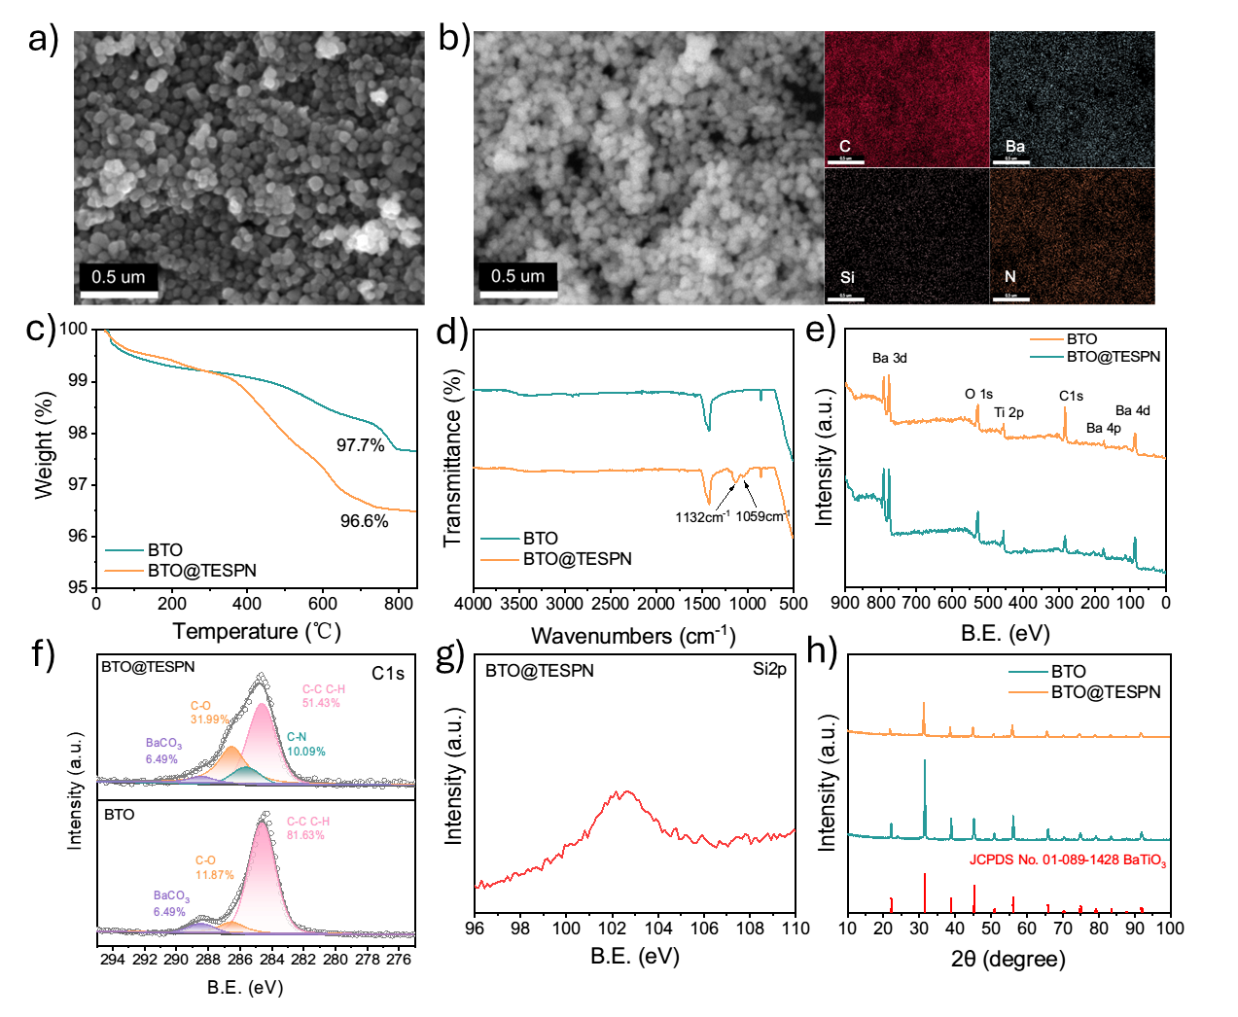
Figure 1. a) SEM image of BTO nanoparticles and b) SEM and EDS images of BTO@TESPN nanoparticles (scale bars are 0.5 μm); c) TGA curves of BTO and BTO@TESPN in N₂ atmosphere; d) FTIR spectra of BTO and BTO@TESPN; e) full XPS spectra of BTO and BTO@TESPN; f) C 1s profiles of BTO and BTO@TESPN and g) Si 2p profile of BTO@TESPN; h) XRD profiles of BTO and BTO@TESPN.

Physical/electrochemical properties of SPE
A solution casting method was employed to prepare three types of PEO-based SPE without filler, with BTO and with TESPN-coated BTO, namely PEO, BTO@PEO, and BTO@TESPN@PEO. Their appearances are shown in Figure S2. The typical thickness of the SPEs is 100 μm. SEM images in Figure 2a, 2b, and 2c show the surface morphology of the SPEs. Because the BTO powder has poor interfacial compatibility with the PEO matrix in the solution, small voids are formed during the evaporation process, resulting in a nonuniform surface for BTO@PEO (Figure 2b). In contrast, PEO and BTO@TESPN@PEO both exhibit a smooth surface with fewer potholes (Figure 2a and 2c, respectively).

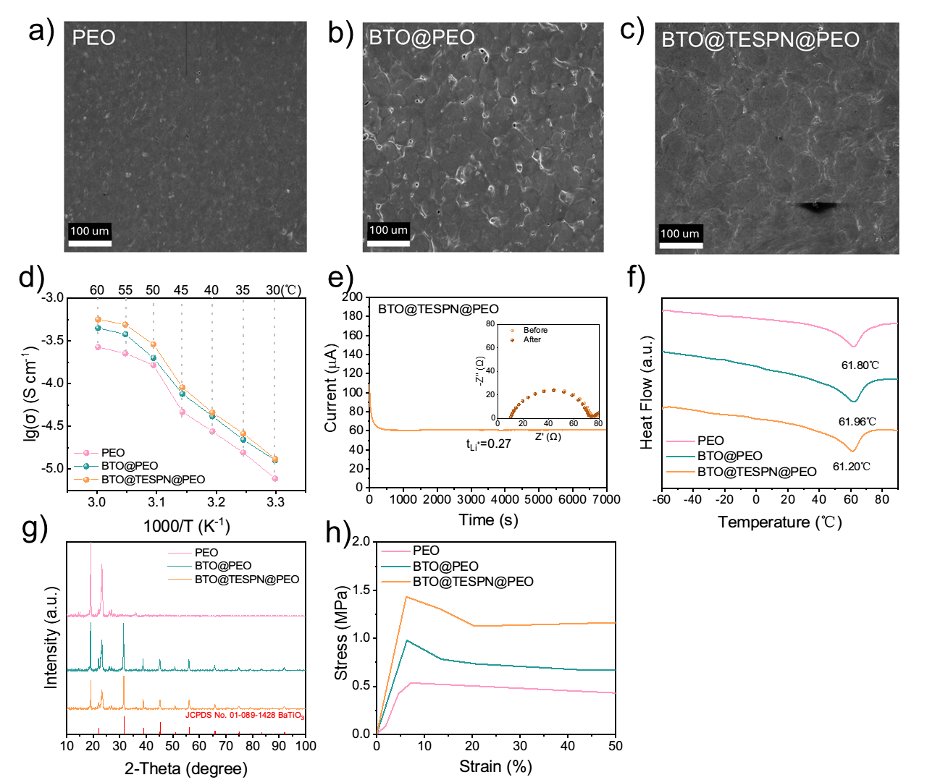
Figure 2. SEM images of a) PEO, b) BTO@PEO and c) BTO@TESPN@PEO; d) Arrhenius plots of ionic conductivity; e) transference number of BTO@TESPN@PEO SPE; f) DSC profiles, g) XRD patterns and h) stress-strain curves of PEO, BTO@PEO, and BTO@TESPN@PEO SPEs.

EIS tests were conducted with Li-Li symmetric cells to measure the ionic conductivity of these three SPEs (Figure S3). The addition of BTO nanoparticles enhances both high-temperature and low-temperature ionic conductivity in PEO-based SPEs. Notably, at 60 ℃, the ionic conductivity of PEO, BTO@TESPN and BTO@TESPN@PEO is 2.69 × 10⁻⁴, 4.49 × 10⁻⁴ and 5.67 × 10⁻⁴ S cm⁻¹, respectively, indicating that BTO filler can improve ionic conductivity of PEO, while TESPN functional groups further facilitate Li⁺ transfer within the SPE matrix. The transference number of SPEs was evaluated by symmetric Li-Li cells. The cells were first cycled at 60 °C with a capacity limit of 0.1 mAh cm⁻² at 0.1 mA cm⁻² for 3 cycles to roughen the lithium surface. As depicted in Figure 2e, the transference number of BTO@TESPN@PEO is calculated as 0.27±0.02, while that of PEO and BTO@PEO were 0.17±0.01 and 0.16±0.01, respectively (Figure S4). The increased transference number of BTO@TESPN@PEO further verifies that the addition of BTO and TESPN is able to enhance Li transport.
Figure S5 shows the LSV profiles of the SPEs. With the addition of BTO nanoparticles, the voltage window of SPEs is increased from 4.2 to 4.5 V. Though, the incorporation of TESPN (BTO@TESPN@PEO) decreases the upper stability voltage back to about 4.2 V due to the lower oxidation voltage of TESPN. DSC curves of the SPEs in Figure 2f shows an endothermic peak around 61-62 ℃ corresponding to the melting point of PEO. The difference in the DSC peak is small, suggesting that the BTO and BTO@TESPN fillers do not significantly change the melting point of the SPE. Though, characteristic peaks attributed to crystalline PEO at angles of approximately 19.0° and 23.1° are weakened upon incorporation of both BTO and BTO@TESPN nanoparticles into PEO matrix (Figure 2g).^{[32,43]}
BTO and TESPN improve the mechanical strength of the PEO SPE. The stress-strain curves of the SPEs in Figure 2h shows that the tensile modulus of BTO@TESPN reaches the highest value of 23.2 MPa amongst the three SPEs while PEO only shows a tensile modulus of 7.5 MPa. In addition, BTO and BTO@TESPN fillers increase the yield stress of the SPEs.

Effect of SPE on Li metal
The LSV curves of the Li-Li symmetric cells with a scan rate of 1 mV s⁻¹ between -0.25 V and 0.25 V are shown in Figure S6 and the results are summarized into a Tafel plot with log |i| vs. voltage of the cell in Figure 3a. The exchange current density of BTO@TESPN@PEO electrolytes is 1.68 × 10⁻¹ mA cm⁻², which is 1.5 times higher than that of BTO@PEO electrolytes (1.22 × 10⁻¹ mA cm⁻²) and three times higher than that of pure PEO electrolytes (4.53 × 10⁻² mA cm⁻²) (Figure S7). These results indicate enhanced Li⁺ transport kinetics at the Li-polymer interface for BTO@TESPN@PEO electrolytes.

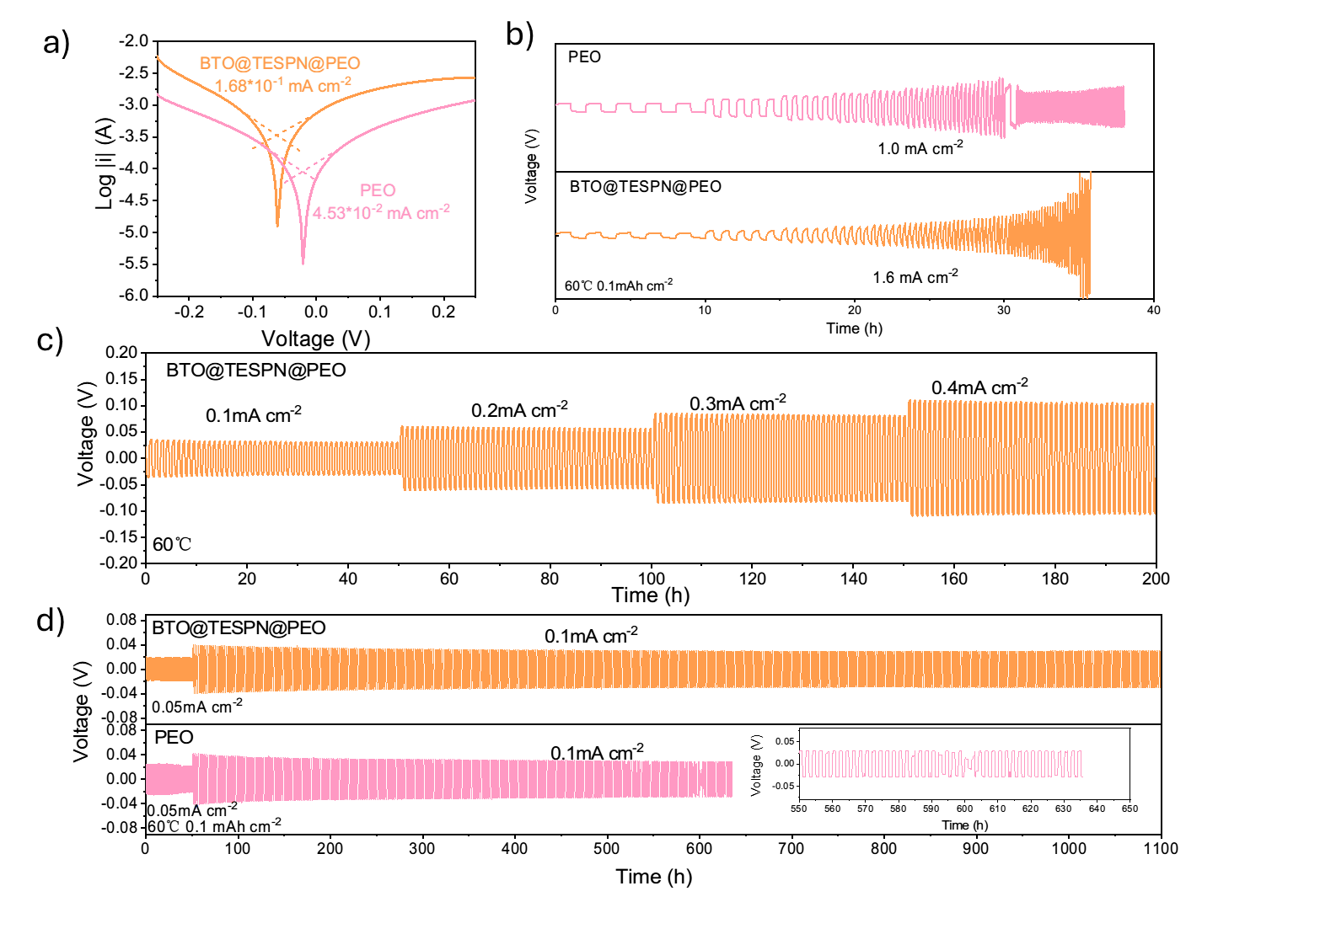
Figure 3. Li-Li symmetric cell performance at 60 ℃. a) Tafel curves and exchange current density from LSV tests between -0.25 V and 0.25 V; b) critical current density of symmetric cells with PEO and BTO@TESPN@PEO electrolytes at different current rates with 0.1 mAh cm⁻² capacity limit; c) galvanostatic cycle test of Li-Li symmetric cell with BTO@TESPN@PEO from 0.1 to 0.4 mA cm⁻² with half hour charge/half hour discharge; d) galvanostatic cycle tests of Li-Li symmetric cells with PEO and BTO@TESPN@PEO SPEs with 0.1 mA cm⁻².

The SPEs were also tested for 5 cycles each with increasing current rate from 0.1 mA cm⁻² with a capacity limit of 0.1 mAh cm⁻² until the cell short-circuits (Figure 3b). The maximum achievable current (critical current density) of BTO@TESPN@PEO is 1.6 mA cm⁻² which is higher than that for PEO (1.0 mA cm⁻²) and BTO@PEO (1.1 mA cm⁻²) (Figure S8), suggesting that BTO@TESPN@PEO may suppress Li dendrite formation. Additionally, symmetric cells with BTO@TESPN@PEO display stable charge-discharge profiles even at a high current rate of 0.4 mA cm⁻² (Figure 3c) in comparison with cells with PEO and BTO@PEO (Figure S9). Moreover, the cell employing BTO@TESPN@PEO also exhibits superior cycle stability when compared to those utilizing only pure PEO and BTO@PEO. As illustrated in Figure 3d, the cell incorporating BTO@TESPN@PEO can be operated successfully for over 1000 h with a capacity limit of 0.1 mAh cm⁻² at a current rate of 0.1 mA cm⁻², whereas the cell with pure PEO and BTO@PEO short-circuited after only about 500-600 h (Figure S10). Thus, BTO@TESPN not only enhances the mechanical strength of the electrolyte, but also contributes to establishing a stable interface between the electrolytes and the lithium metal anode.

Interfacial chemistry between SPE and Li
SEM images of Li metal after cycling with PEO and BTO@TESPN@PEO electrolytes are shown in Figure S11. The surface of the Li metal with BTO@TESPN@PEO is smoother than that with PEO, which indicates better reversibility of the lithium stripping and deposition process. High-resolution XPS was employed to study the SEI composition on the lithium metal. Li|SPE|Li cells were cycled 10 times with a capacity limit of 0.1 mAh cm⁻² at 0.1 mA cm⁻² and then the SPEs were removed from the Li surface in an Ar-filled glovebox. The Li electrodes were then loaded into the XPS chamber through an air-tight transfer unit to avoid air exposure. Figure 4a-f illustrates the C 1s, O 1s, and F 1s profiles of the Li anode after cycling with BTO@TESPN@PEO and PEO electrolytes with 0 s, 60 s and 120 s sputtering. The sputter rate is estimated to be 7 nm min⁻¹. For Li anode with BTO@TESPN@PEO, in the C 1s spectra (Figure 4a), various carbon species including C-C/C-H (~284.8 eV), C-O-C (~286.5 eV), and C=O (~289.6 eV) were detected with all sputtering times. The presence of peaks at 289.6 eV (C=O) in the C 1s spectra confirms the formation of Li₂CO₃, while those around 285 eV and 286.5 eV originate from different hydrocarbon species within the SEI layer.^{[44]} With prolonged sputtering time, there is an increase in Li₂CO₃ content accompanied by a decrease in hydrocarbon species within SEI layer, which indicates more Li₂CO₃ are formed on the lithium metal surface than the PEO SPEs (Figure 4d). For O 1s (Figure 4b), the peak at ~531.4 eV further confirm the existence of Li₂CO₃ within the SEI layer. Compared to the O 1s spectra of Li metal with PEO (Figure 4e), Li₂O (~528.5 eV) is detected on the surface, which is beneficial for inhibiting the growth of dendrite.^{[45,46]} For the F1s spectra, the peaks at ~688.1 eV and ~684.7 eV correspond to the C-F bonds and LiF species, respectively. Since the only source of fluorine in the battery is the LiTFSI salt, the XPS results suggest that there is more decomposition of TFSI⁻ into LiF on the Li metal with BTO@TESPN@PEO SPE (Figure 4c) compared to that with PEO electrolyte (Figure 4f).^{[5]}
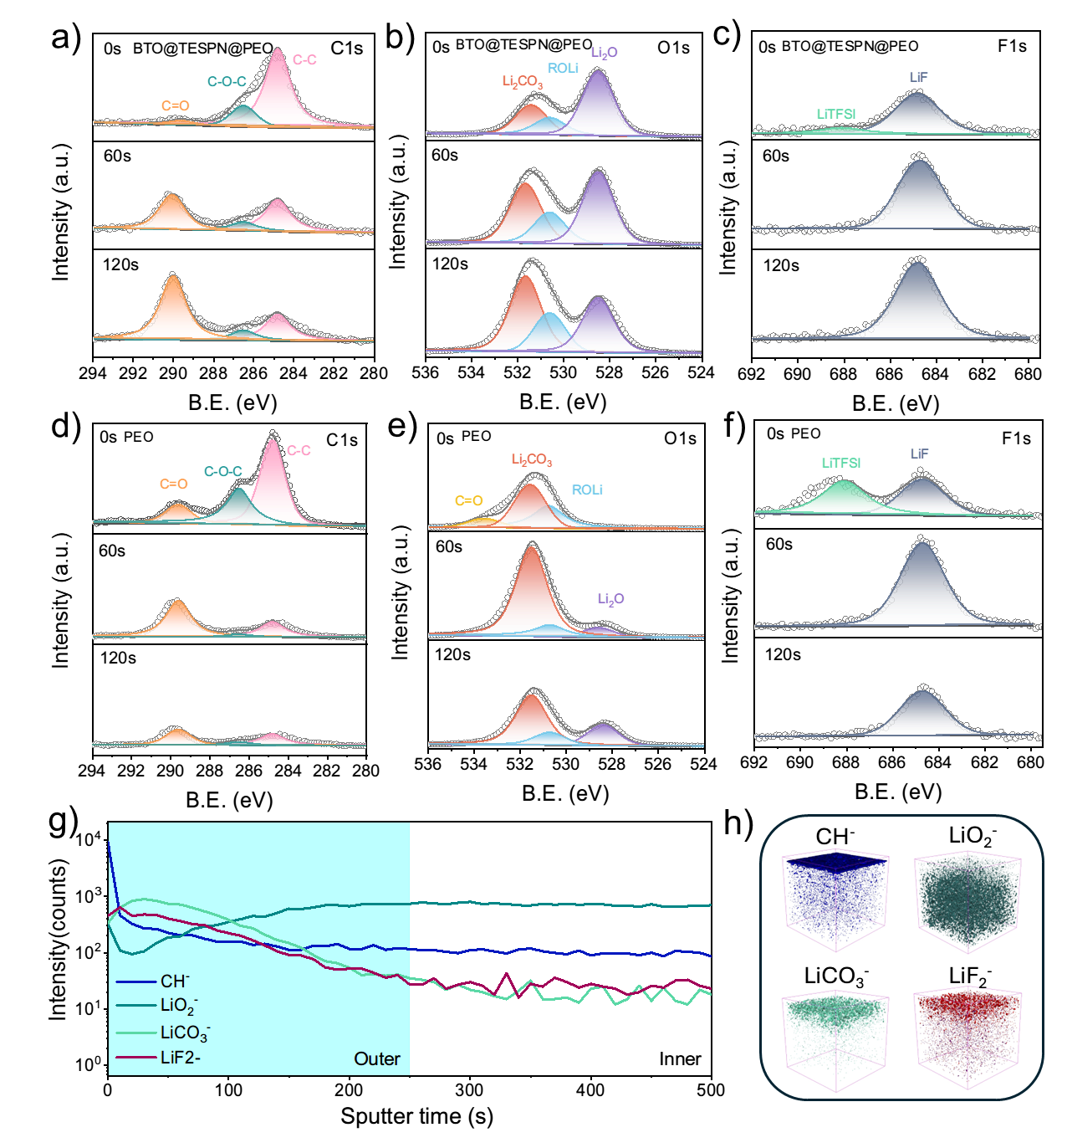
Figure. 4. High-resolution XPS results of the Li anode after cycling with BTO@TESPN@PEO and PEO electrolytes with 0 s, 60 s and 120 s sputtering – a) and d) C 1s; b) and e) O 1s; c) and f) F 1s. with sputtering rate in 7 nm min⁻¹, respectively. d) TOF-SIMS depth profiles and distribution of chemical species on the Li surface with e) corresponding 3D reconstructions of sputtered volume of various species on the Li surface after cycling (Li surface on the top).

The TOF-SIMS depth profiles provide a comprehensive analysis of the distribution of chemical components within the SEI layer on the cycled lithium metal with BTO@TESPN@PEO (Figure 4g). A corresponding 3D reconstruction of the sputtered species is shown in Figure 4h. Notably, there is a high intensity of CH⁻ (representing organic components) in the topmost layer of the SEI, most likely from reaction with PEO. Additionally, the surface layer is rich in LiF₂⁻ (representing LiF) and LiCO₃⁻ (representing Li₂CO₃), while there is higher intensity of intensity of LiO₂⁻ (representing Li₂O) in the bulk, forming a distinct second layer within the SEI structure. These findings are consistent with the XPS results.

All-solid-state lithium-metal batteries performance
All-solid-state batteries were assembled with a LiFePO₄ cathode to evaluate the electrochemical properties of the SPEs at 60℃. As depicted in Figure 5a, the cell containing BTO@TESPN@PEO exhibits capacities of 156.2, 159.2, 153.2, 123.9 and 100.3 mAh g⁻¹ at current rates of 0.2 C, 0.5 C, 1 C, 1.5 C and 2 C, respectively, higher than the cells with BTO@PEO and PEO electrolytes. The corresponding charge-discharge curves at different current rates are shown in Figure 5b to 5d. The higher capacity is attributed to the increase in ionic conductivity and also the reduced interfacial resistance between electrode and electrolyte with the incorporation of BTO@TESPN nanoparticles. Meanwhile, the cell using BTO@TESPN@PEO electrolyte also demonstrates excellent long-term cycle stability with 93.0% capacity retention after 700 cycles at 0.5 C (Figure 5e). The charge-discharge curves of the LiFePO₄/Li cells at different cycles are shown in Figure 5f-5h. The curves for the cell with BTO@TESPN@PEO (Figure 5h) overlap for 300 cycles and more, indicating there is no change to the electrode. This is attributed to a stable SEI that prevents the increase in interfacial resistance with charge-discharge. In comparison, the cell (Figure 5g) with BTO@PEO shows a drop in capacity with minimal change in voltage polarization. This suggests that capacity degradation is mainly contributed by a loss in active material. On the other hand, the cell (Figure 5f) with only PEO shows a drop in capacity with an increase in voltage polarization, which suggests an increase in resistance with cycling. In summary, BTO@TESPN@PEO demonstrates high ionic conductivity and excellent interfacial compatibility, thus enhancing both rate performance and long-term cycling stability of lithium metal batteries. Compared to the cell performances of PEO-based SPEs with other types of fillers (Table S1), BTO@TESPN@PEO shows long cycle stability and high capacity retention even when the Li⁺:EO ratio is as small as 1:20.
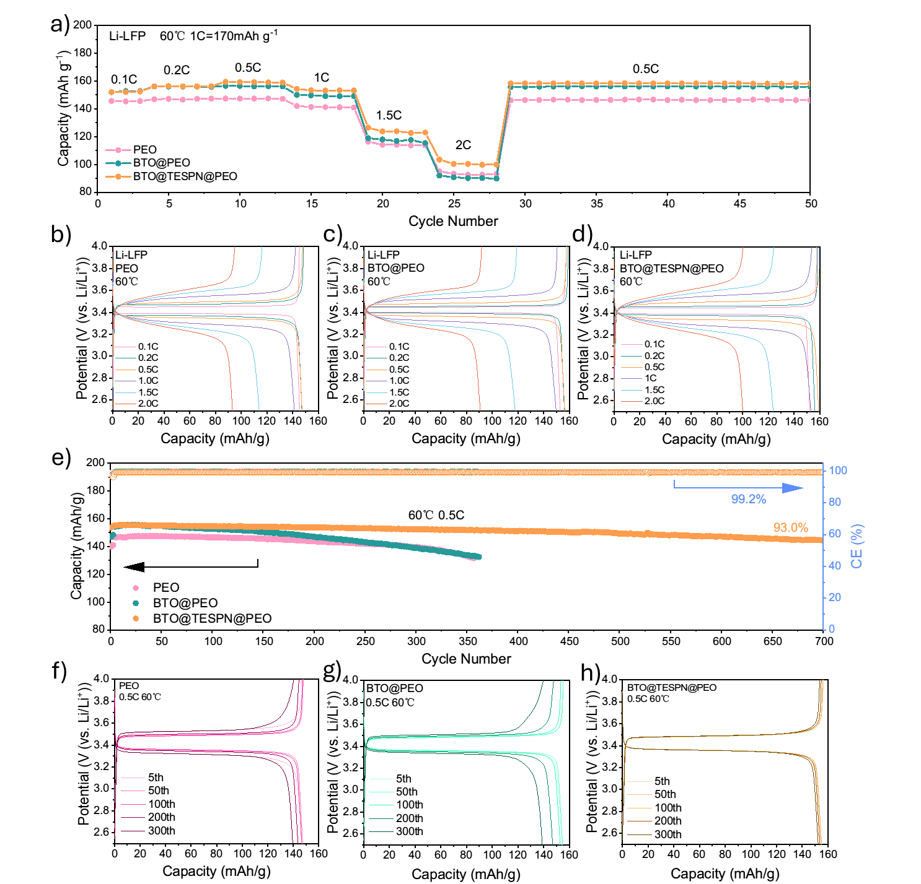
Figure 5. Electrochemical performances of all-solid-state lithium-metal batteries with LiFePO₄ cathode and PEO, BTO@PEO and BTO@TESPN@PEO electrolytes at 60 °C. a) Rate performance with various SPEs for charging and discharging at increasing current rates; b-d) charge and discharge profiles of LiFePO₄| SPE |Li cell with PEO, BTO@PEO and BTO@TESPN@PEO at different current densities; e) long-term cycle performance of cells with various SPEs at 0.5 C. Charge and discharge profiles at different cycle number of LiFePO₄| SPE |Li cells: f) PEO, g) BTO@PEO and h) BTO@TESPN@PEO.

Conclusions
BTO nanoparticle filler can improve the mechanical properties and ionic conductivity of the PEO-based SPE, but the capacity of the corresponding lithium metal battery decreases with cycling due to poor compatibility between the BTO filler and the PEO matrix. In this study, we successfully introduced a TESPN self-assembled monolayer on the surface of the BTO nanoparticles, which improves the linkage with the PEO matrix, enabling better cycle stability of the LiFePO₄-Li cell with minimal increase in voltage polarization upon cycling. Analysis of the lithium metal surface after cycling also reveals that the SPE can induce a stable SEI layer on the lithium comprising outer organic and inner inorganic components.

Contributions: Denis Y. W. Yu and Shuyu Dong conceived and designed this work. Shuyu Dong performed the experiments and wrote the manuscript. Yiyi Zheng, Qiaohui Duan, Yu Zhao, Tian Tan, Yu Zhou, Tian Rao, Hanbing Yan and Weiqian Guo discussed the results and participated in the preparation of the paper.

Acknowledgement: This work was partially supported by the National Institute for Materials Science, Japan.

References
[1] S. Jiao, J. Zheng, Q. Li, X. Li, M. H. Engelhard, R. Cao, J.-G. Zhang, W. Xu, Joule 2018, 2, 110.
[2] J.-M. Kim, M. H. Engelhard, B. Lu, Y. Xu, S. Tan, B. E. Matthews, S. Tripathi, X. Cao, C. Niu, E. Hu, S.-M. Bak, C. Wang, Y. S. Meng, J.-G. Zhang, W. Xu, Adv. Funct. Mater. 2022, 32, 2207172.
[3] F. He, W. Tang, X. Zhang, L. Deng, J. Luo, Adv. Mater. 2021, 33, 2105329.
[4] A. Naboulsi, R. Chometon, F. Ribot, G. Nguyen, O. Fichet, C. Laberty-Robert, ACS Appl. Mater. Interfaces 2024, 16, 13869.
[5] S. Wang, Q. Sun, Q. Zhang, C. Li, C. Xu, Y. Ma, X. Shi, H. Zhang, D. Song, L. Zhang, Adv. Energy Mater. 2023, 13, 2204036.
[6] K. Yoon, S. Lee, K. Oh, K. Kang, Adv. Mater. 2022, 34, 2104666.
[7] Toward High‐Energy‐Density Lithium Metal Batteries: Opportunities and Challenges for Solid Organic Electrolytes - Wang - 2020 - Advanced Materials - Wiley Online Library, .
[8] L. Porcarelli, A. S. Shaplov, F. Bella, J. R. Nair, D. Mecerreyes, C. Gerbaldi, ACS Energy Lett. 2016, 1, 678.
[9] G. Xi, M. Xiao, S. Wang, D. Han, Y. Li, Y. Meng, Adv. Funct. Mater. 2021, 31, 2007598.
[10] W. H. Meyer, Adv. Mater. 1998, 10, 439.
[11] T. K.-J. Köster, L. van Wüllen, Solid State Ion. 2010, 181, 489.
[12] C. C. Tambelli, A. C. Bloise, A. V. Rosário, E. C. Pereira, C. J. Magon, J. P. Donoso, Electrochimica Acta 2002, 47, 1677.
[13] H. Liu, C. Liu, Y. Zhou, Y. Zhang, W. Deng, G. Zou, H. Hou, X. Ji, Energy Storage Mater. 2024, 71, 103575.
[14] K. Vignarooban, M. A. K. L. Dissanayake, I. Albinsson, B.-E. Mellander, Solid State Ion. 2014, 266, 25.
[15] F. Colombo, S. Bonizzoni, C. Ferrara, R. Simonutti, M. Mauri, M. Falco, C. Gerbaldi, P. Mustarelli, R. Ruffo, J. Electrochem. Soc. 2020, 167, 070535.
[16] I. Gurevitch, R. Buonsanti, A. A. Teran, B. Gludovatz, R. O. Ritchie, J. Cabana, N. P. Balsara, J. Electrochem. Soc. 2013, 160, A1611.
[17] J. Cui, Z. Zhou, M. Jia, X. Chen, C. Shi, N. Zhao, X. Guo, Polymers 2020, 12, 1324.
[18] P. P. Chu, M. J. Reddy, H. M. Kao, Solid State Ion. 2003, 156, 141.
[19] C. Capiglia, P. Mustarelli, E. Quartarone, C. Tomasi, A. Magistris, Solid State Ion. 1999, 118, 73.
[20] F. Chen, D. Yang, W. Zha, B. Zhu, Y. Zhang, J. Li, Y. Gu, Q. Shen, L. Zhang, D. R. Sadoway, Electrochimica Acta 2017, 258, 1106.
[21] J. Li, K. Zhu, Z. Yao, G. Qian, J. Zhang, K. Yan, J. Wang, Ionics 2020, 26, 1101.
[22] D. Guan, Y. Huang, M. He, G. Hu, Z. Peng, Y. Cao, K. Du, Ionics 2021, 27, 4127.
[23] T. Duan, H. Cheng, Y. Liu, Q. Sun, W. Nie, X. Lu, P. Dong, M.-K. Song, Energy Storage Mater. 2024, 65, 103091.
[24] C. R. Milian Pila, E. P. Cappe, N. D. S. Mohallem, O. L. Alves, M. A. Aguilar Frutis, N. Sánchez-Ramírez, R. M. Torresi, H. León Ramírez, Y. M. Laffita, Solid State Sci. 2019, 88, 41.
[25] L. Zhu, P. Zhu, Q. Fang, M. Jing, X. Shen, L. Yang, Electrochimica Acta 2018, 292, 718.
[26] X. Wu, K. Chen, Z. Yao, J. Hu, M. Huang, J. Meng, S. Ma, T. Wu, Y. Cui, C. Li, J. Power Sources 2021, 501, 229946.
[27] X. Wu, Y. Zheng, W. Li, Y. Liu, Y. Zhang, Y. Li, C. Li, Energy Storage Mater. 2021, 41, 436.
[28] S. Xu, Z. Sun, C. Sun, F. Li, K. Chen, Z. Zhang, G. Hou, H.-M. Cheng, F. Li, Adv. Funct. Mater. 2020, 30, 2007172.
[29] L.-Z. Fan, J. Maier, Electrochem. Commun. 2006, 8, 1753.
[30] C. Wang, T. Yang, W. Zhang, H. Huang, Y. Gan, Y. Xia, X. He, J. Zhang, J. Mater. Chem. A 2022, 10, 3400.
[31] J. Hu, K. Chen, Z. Yao, C. Li, Sci. Bull. 2021, 66, 694.
[32] W. Guo, Q. Liu, K. Wu, X. Hu, X. Liu, X. Cheng, C. Han, Y. He, F. Kang, B. Li, Energy Storage Mater. 2023, 63, 103006.
[33] Y. Wei, T.-H. Liu, W. Zhou, H. Cheng, X. Liu, J. Kong, Y. Shen, H. Xu, Y. Huang, Adv. Energy Mater. 2023, 13, 2203547.
[34] J. Hu, C. Lai, K. Chen, Q. Wu, Y. Gu, C. Wu, C. Li, Nat. Commun. 2022, 13, 7914.
[35] M. Lei, X. Wu, Y. Liu, K. Chen, J. Hu, C. Li, Nano Res. 2023, 16, 8469.
[36] H. Sun, J. Cheng, S. Kang, W. Gao, R. Xu, T. Yuan, L. Cui, ACS Appl. Energy Mater. 2023, 6, 12206.
[37] S.-H. Choi, I.-D. Kim, J.-M. Hong, K.-H. Park, S.-G. Oh, Mater. Lett. 2007, 61, 2478.
[38] Y. L. Yap, A. H. You, L. L. Teo, H. Hanapei, Int. J. Electrochem. Sci. 2013, 8, 2154.
[39] H. Hua, X. Yang, P. Zhang, J. Zhao, J. Phys. Chem. C 2023, 127, 17324.
[40] T. T. M. Phan, N. C. Chu, V. B. Luu, H. Nguyen Xuan, D. T. Pham, I. Martin, P. Carrière, J. Sci. Adv. Mater. Devices 2016, 1, 90.
[41] C. Miot, E. Husson, C. Proust, R. Erre, J. P. Coutures, J. Eur. Ceram. Soc. 1998, 18, 339.
[42] P. M. Dietrich, S. Glamsch, C. Ehlert, A. Lippitz, N. Kulak, W. E. S. Unger, Appl. Surf. Sci. 2016, 363, 406.
[43] Z. Yang, Z. Sun, C. Liu, Y. Li, G. Zhou, S. Zuo, J. Wang, W. Wu, J. Power Sources 2021, 484, 229287.
[44] Z. Zhang, YingHuang, G. Zhang, L. Chao, Energy Storage Mater. 2021, 41, 631.
[45] J. Zhang, S. Li, X. Wang, S. Mao, J. Guo, Z. Shen, J. Mao, Q. Wu, K. Shen, H. Cheng, Y. Tan, Y. Lu, Adv. Energy Mater. 2024, 14, 2302587.
[46] Y. Li, Y. Li, A. Pei, K. Yan, Y. Sun, C.-L. Wu, L.-M. Joubert, R. Chin, A. L. Koh, Y. Yu, J. Perrino, B. Butz, S. Chu, Y. Cui, Science 2017, 358, 506.

