Revealing the Enhancement of Li Plating/Stripping Efficiency in the TEGDME-based Low-concentration Electrolytes for Anode-free Lithium Metal Batteries

Yushen Wang ^{a,b} and Hidenori Noguchi ^{a,b}*
ªGraduate School of Chemical Sciences and Engineering, Hokkaido University, Sapporo 060-8628, Japan
^{b}Center for Green Research on Energy and Environmental Materials, National Institute for Materials Science (NIMS), Tsukuba 305-0044, Japan

Supporting Information

Materials
Copper foil (φ16 mm, τ = 0.2 mm, ≥99.96%) was purchased from Takeuchi Metal Foil & Powder Co., Ltd., and was rinsed with concentrated acetic (denoted as c-HAc, Wako Pure Chemical Industries) for 10 min and thoroughly dried by Ar flow prior to all measurements.¹ The pre-treated Cu foil was assembled with Li ribbon (Sigma Aldrich, 99%) in order to construct the Li||Cu cell. Lithium-battery-grade LiTFSI (99.9%) and TEGDME (>98%) were purchased from Kishida Chemical Co., Ltd. LiTFSI was completely dissolved in TEGDME to make homogeneous solutions with different concentrations in an Ar-filled glovebox (H₂O < 0.5 ppm, O₂ < 0.2 ppm). As an additive, LiNO₃ (>99.95%, Kanto Chemical Co., Inc.) was added into the LiTFSI-TEGDME solutions to reach a concentration of 0.1 M. The water content in these electrolytes was all less than 30 ppm by Karl-Fischer titration (model: CA-21, Mitsubishi Chemical Analytech Co., Ltd.).
Experimental Methods
The cycling voltammetry (CV) measurements were conducted using the HZ-7000 system (Hokuto Denko Corporation) in the glovebox. A PTFE-made three-electrode cell was used, with the Cu foil as working electrode and Li ribbon as counter and reference electrode. The measurement conditions include a fixed scanning rate of 10 mV/s, a lower potential limit of -0.5 V or 0.2 V, and an upper potential limit of 3.2 V or 2.2 V vs. Li/Li⁺. The Coulombic efficiency of Li plating/stripping was calculated by Equation (1):
$CE= \frac{Q (stripping)}{Q (plating)}×100\%$ (1)
where Q(stripping) and Q(plating) represent the charges consumed during Li stripping and in Li plating, respectively, obtained by integrating the corresponding peak areas in current density vs. time curves.
The QCM (quartz crystal microbalance) measurement was carried out using the QCA-922 system (Seiko EG&G Co., Ltd.) during the CV scanning. The mass change on the working electrode surface was converted from the recorded frequency change using the Sauerbrey equation (Equation (2)):²
$∆f=-\frac{2f_{0}^{2}}{A\sqrt{{ρ_{q}μ}_{q }}}∆m$ (2)
where f₀ and Δf are the fundamental resonant frequency and the change in frequency (Hz) respectively, Δm is the mass change (μg), A is the active electrode area deposited on the crystal (cm²), ρ_{q} is the density of quartz (2.648 g/cm³), and μ_{q} is the shear modulus of quartz (2.947 × 10¹¹ g/cm·s²). The f₀ and A values for the Cu quartz electrode used in this study are 9.04 MHz and 0.196 cm², respectively. Therefore, Δm on the crystal surface can be determined for a given Δf during a QCM experiment. In the present study, a customized three-electrode electrochemical cell made of a PTFE bottom and a glass chamber was used. An AT-cut quartz crystal deposited by Cu thin film was used as working electrode, and Li ribbon was used as counter and reference electrode. The Cu quartz electrode was rinsed with c-HAc for 10 min and thoroughly dried by argon flow prior to the experiment. The QCM cell was kept for 30 min before each measurement to stabilize the open circuit potential (OCP), Δm, and ΔR. During the CV scanning, the values of Δm and ΔR were simultaneously recorded.
However, it should be noted that, the deviation could occur when applying above Sauerbrey equation to study an electrolyte/electrode interface, in which the influence of density and viscosity of electrolyte due to the contact with electrode surface should be considered.^{3,4} Under such circumstances, the measured Δf is expressed by Equation (3):
$∆f=∆f_{m}+∆f_{ηρ}$ (3)
Where Δf_{m} is due to the actual deposited product, and Δf_{ηρ} is due to electrolyte contact which is obtained from Equation (4):³
$∆f_{ηρ}={-f}_{0}^{3/2}\sqrt{\frac{ρ_{L}η_{L}}{π{ρ_{q}μ}_{q }}}$ (4)
where ρ_{L} and η_{L} are the density and viscosity of the electrolyte, which are subject to change during measurement. In the meantime, ΔR is also dependent on ρ_{L} and η_{L} (Equation (5)):
$∆R=\frac{A\sqrt{2πf_{0}ρ_{L}η_{L}}}{k^{2}}$ (5)
where k is called electromechanical coupling factor, which is a specific value for each electrolyte.⁴ By combining Equation (4) and (5), one can get the following equation (Equation (6)):
$∆f_{ηρ}=-\frac{f_{0}∆Rk^{2}}{Aπ\sqrt{2{ρ_{q}μ}_{q }}}$ (6)
in which the initial R and f_{ηρ} values can be confirmed as soon as the electrode is immersed in the electrolyte, while the latter is the difference between the resonant frequencies before and after immersing electrolyte, respectively. Then k can be determined according to Equation (6), and thereafter, the real-time Δf_{ηρ} during measurement can be obtained with the recorded ΔR. In this study, the measured Δf was converted into Δf_{m} for calculating the real mass change.
The X-ray photoelectron spectroscopy (XPS) depth profile was investigated with the VersaProbe II X-ray Photoelectron Spectrometer (ULVAC-PHI, Inc.) under ultra-high-vacuum condition using monochromatic Al Kα (1486.6 eV) as the X-ray source. The samples were prepared by disassembling Li||Cu cells after 50 Li plating/stripping cycles in each electrolyte, and were loaded in a portable transfer vessel without exposure to air before moving to the XPS spectrometer. The surface of sample was sputtered by Ar⁺ bombardment with a parameter of 2 keV & 20 mA. The F 1s peak at 685.2 eV was used as a reference.
The in situ SERS (surface-enhanced Raman spectroscopy) spectra was recorded with a confocal microscope spectrometer (RamanTouch-VIS-NIR) in a super-dry room (water contents < 0.1 ppm, Shinryo Corp.). A homemade three-electrode cell was used, and the roughened Cu foil was prepared by “cathodic deposition” method,⁵ and was used as the working electrode, The counter electrode and the reference electrode were Li metal. The 785 nm laser was focused on the Cu surface through a 10× long working distance lens with an exposure time of 10 s. The grating was 300 grooves mm⁻¹. During the first cycle, the spectra were recorded during the negative scanning from OCP to -0.5 V and then positive scanning to 2.2 V at 10 mV/s, followed by a positive scanning from 2.2 V to 3.2 V at 1 mV/s so as to carefully check the OSS process. From the second cycle, the spectra were recorded during the CV scanning between 3.2 V and -0.5 V at 10 mV/s. The working electrode potential was kept constant for 3 min before each SERS measurement.
Scanning electron microscope (SEM) measurement was conducted in the super-dry room using VE-8800 (Keyence) for the observation of the surface morphologies of SEI layers.

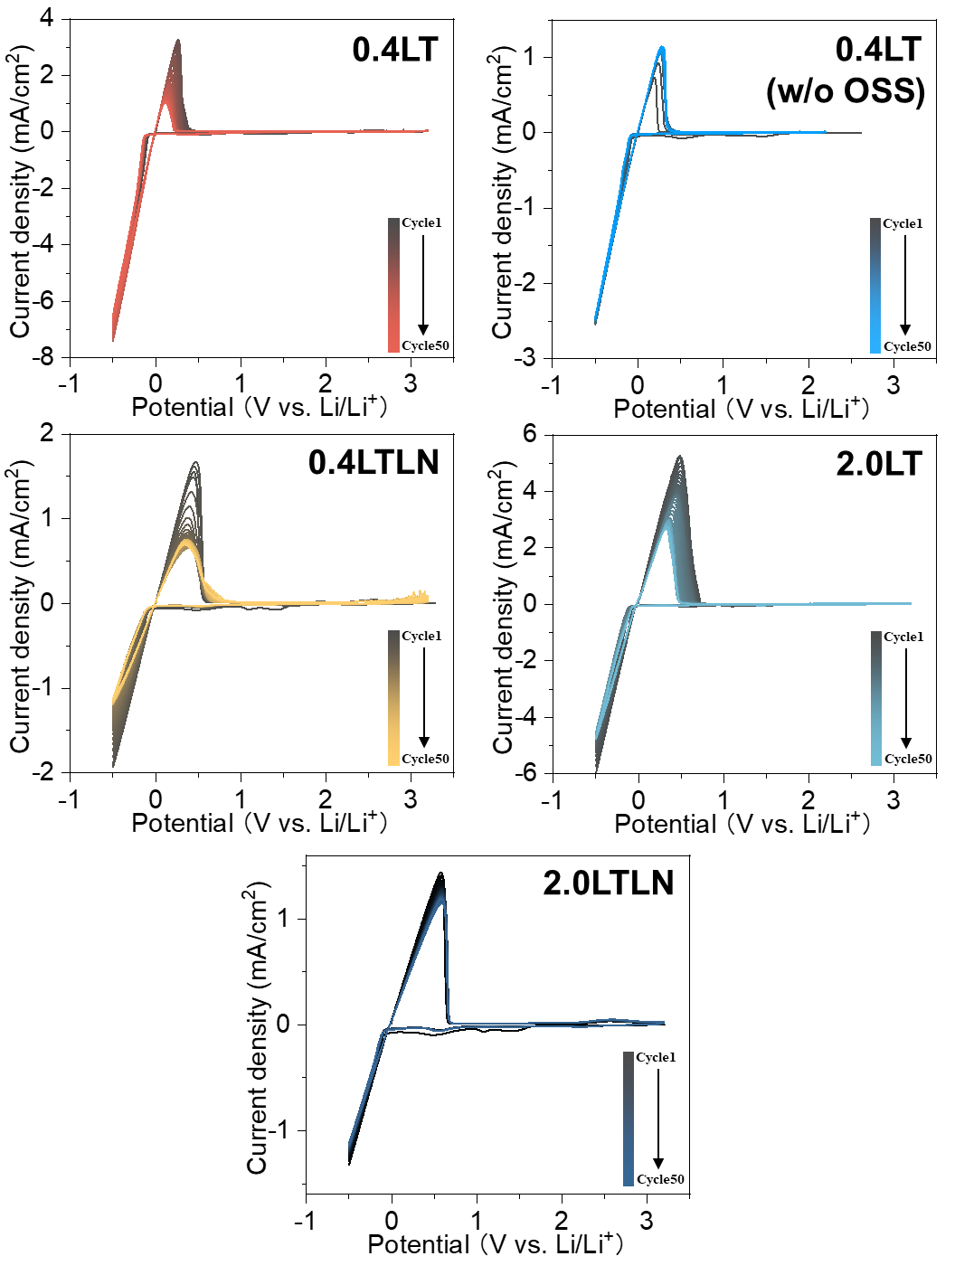

Figure S1. 50-cycle CV curves measured in 0.4LT, 0.4LT w/o OSS, 0.4LTLN, 2.0LT and 2.0LTLN. Potential range: -0.5 ~ 3.2 V vs. Li/Li⁺. Scan rate: 10 mV/s.

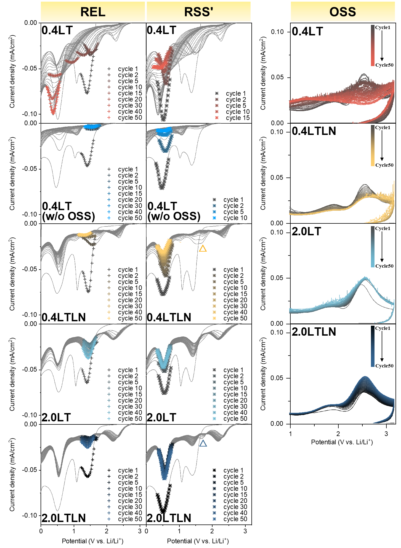

Figure S2. Cycling-dependent variation of peak REL, RSS' and OSS measured in 0.4LT, 0.4LT w/o OSS, 0.4LTLN, 2.0LT and 2.0LTLN. Scan rate: 10 mV/s. Peak REL and RSS' at selected cycles were marked by cross and asterisk symbols, respectively, for a better understanding of peak variation.

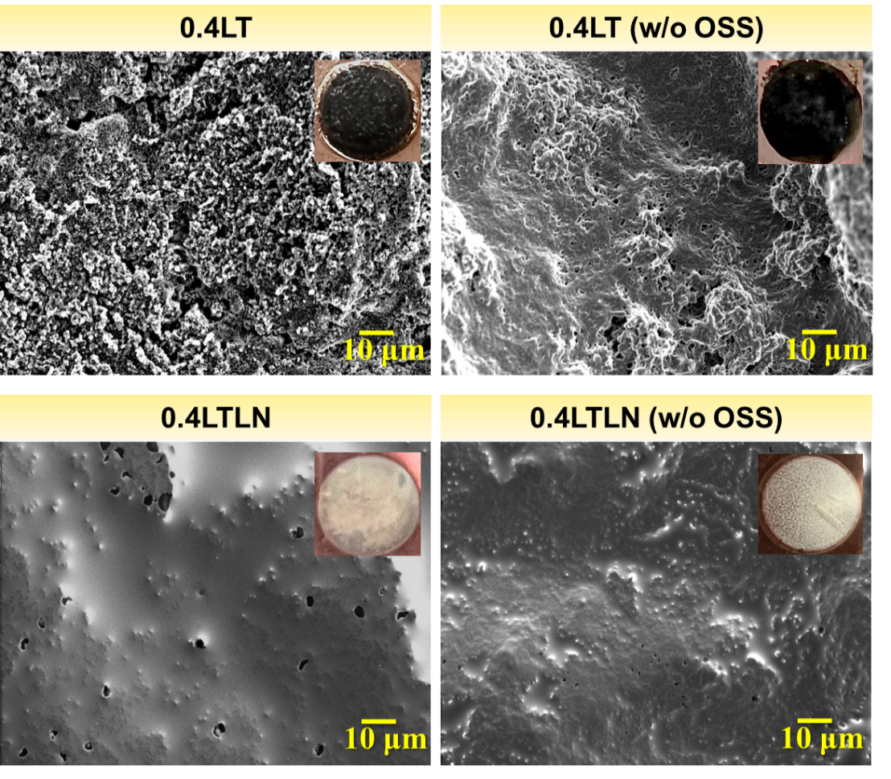

Figure S3. SEM morphologies and corresponding optical images of electrode surface in 0.4LT with and w/o OSS, and 0.4LTLN with and w/o OSS after 50 cycles.

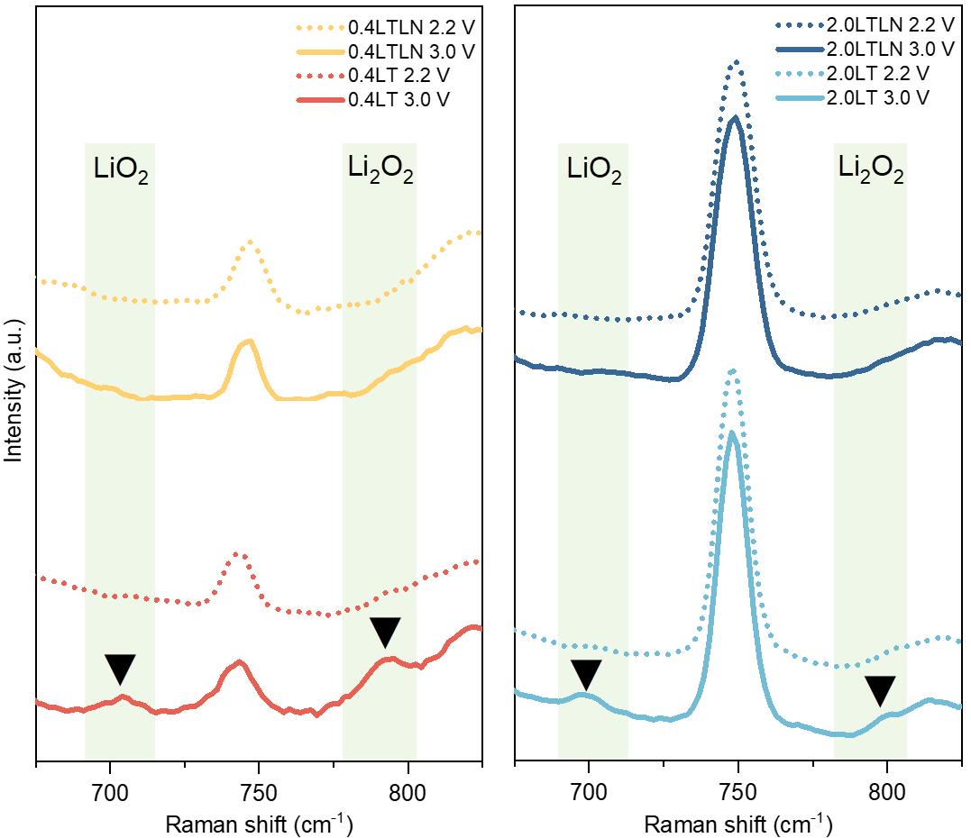

Figure S4. In situ SERS spectra recorded before (2.2 V) and after (3.0 V) reaction OSS during the first cycle in 0.4LT, 0.4LTLN, 2.0LT and 2.0LTLN.

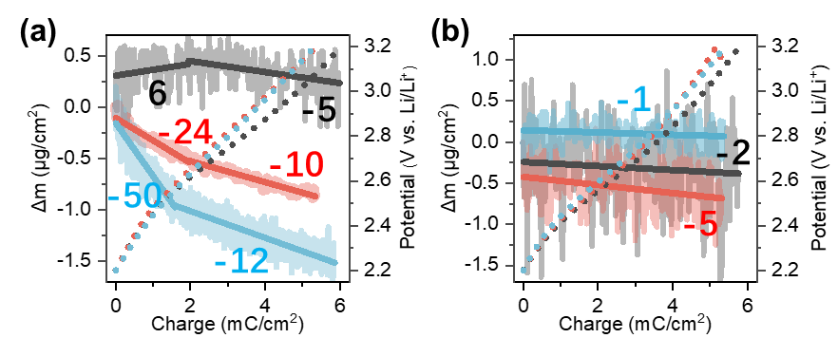

Figure S5. The calculated MPE values from the Δm-charge curves (solid bold line), and the potential-charge curves (dotted line) during the reaction OSS measured in (a) 0.4LT and (b) 0.4LTLN. Totally 3 samples (represented by 3 colors) were tested for each electrolyte. The positive and negative MPE indicate the increase and decrease of mass, respectively.

Table S1. The ratio of Li₂O oxidation charges over total charges
Initial MPE | Subsequent MPE | Ratio of Li₂O oxidation charges*
6 | -5 | 85%
-24 | -10 | 83%
-50 | -12 | 87%
* The calculation process:
- The ratio of the charge consumed by Li₂O oxidation over the total charges can be set as X.
- Since the MPE of Li₂O oxidation to Li₂O₂ is -7, assuming that the change of MPE was mostly due to Li₂O oxidation, we can obtain the following equation: A(1-X)-7X=B, where A and B represent the initial MPE and the subsequent MPE, respectively.
- The above equation can be changed to: X=(A-B)/(A+7), then X can be obtained.

Figure S6. Enlarged view of the second-cycle CV curves measured in the 0.1 M LiNO₃-TEGDME electrolyte under 3 different potential ranges. The redox a/(a', a'', a''') indicates the LiNO₃-related reactions, where the oxidative reaction a occurs within the OSS region; The redox b/(b', b'') indicates the SEI-related reactions.

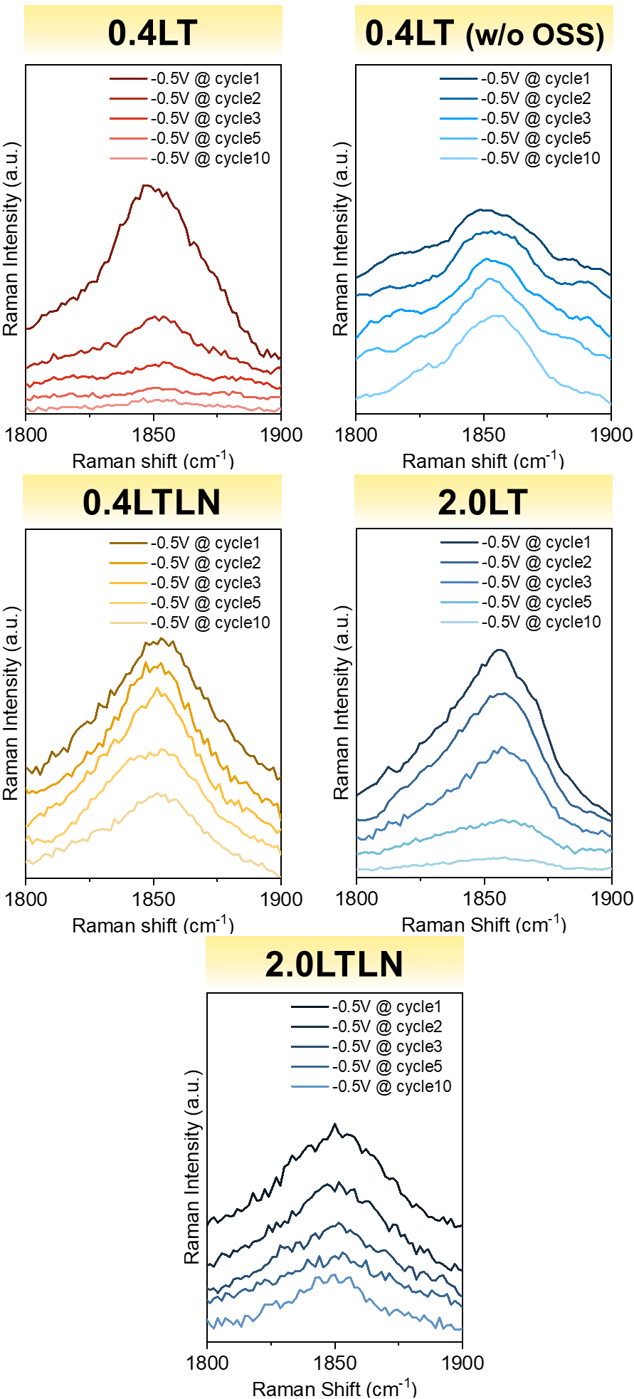

Figure S7. Potential-dependent SERS intensity of v(C≡C) band in 0.4LT, 0.4LT w/o OSS, 0.4LTLN, 2.0LT and 2.0LTLN. The SERS spectra were recorded at -0.5 V during cycle 1, 2, 3, 5 and 10.

REFERENCES
(1) Chavez, K. L.; Hess, D. W. A Novel Method of Etching Copper Oxide Using Acetic Acid. J. Electrochem. Soc. 2001, 148 (11), G640.
(2) Sauerbrey, G. Verwendung von Schwingquarzen Zur Wägung Dünner Schichten Und Zur Mikrowägung. Z. Für Phys. 1959, 155, 206–222.
(3) Kanazawa, K. K.; Gordon, J. G. Frequency of a Quartz Microbalance in Contact with Liquid. Anal. Chem. 1985, 57 (8), 1770–1771.
(4) Muramatsu, H.; Tamiya, E.; Karube, I. Computation of Equivalent Circuit Parameters of Quartz Crystals in Contact with Liquids and Study of Liquid Properties. Anal. Chem. 1988, 60 (19), 2142–2146.
(5) Kudelski, A.; Janik-Czachor, M.; Bukowska, J.; Dolata, M.; Szummer, A. Surface-Enhanced Raman Scattering (SERS) on Copper Electrodeposited under Nonequilibrium Conditions. J. Mol. Struct. 1999, 482, 245–248.

