Prediction of nanocomposite properties and process optimization using persistent homology and machine learning

Fumihiko Uesugi^{a,}*, Yu Wen^{a,b}, Ayako Hashimoto^{a,b,}, Masashi Ishii^{c}

ª National Institute for Materials Science, 1-2-1 Sengen, Tsukuba, Ibaraki 305-0047, Japan
^{b} University of Tsukuba, 1-2-1 Sengen, Tsukuba, Ibaraki 305-0047, Japan
^{c} National Institute for Materials Science, 1-1 Namiki, Tsukuba, Ibaraki 305-0044, Japan
*Corresponding author: Fumihiko Uesugi
National Institute for Materials Science, 1-2-1 Sengen, Tsukuba, Ibaraki 305-0044, Japan
Tel: +81-29-859-2685; Email: UESUGI.Fumihiko@nims.go.jp

Abstract
Physical property prediction and synthesis process optimization are key targets in material informatics. In this study, we propose a machine learning approach that utilizes ridge regression to predict the oxygen permeability at fuel cell electrode surfaces and determine the optimal process temperature. These predictions are based on a persistence diagram derived from tomographic images captured using transmission electron microscopy (TEM). Through machine learning analysis of the complex structures present in the Pt/CeO₂ nanocomposites, we discovered that l₂ regularization considering diverse structural elements is more appropriate than l₁ regularization (sparse modeling). Notably, our model successfully captured the activation energy of oxygen permeability, a phenomenon that could not be solely explained by the geometric feature of the Betti numbers, as demonstrated in a previous study. The correspondence between the ridge regression coefficient and persistence diagram revealed the formation process of the local and three-dimensional structures of CeO₂ and their contributions to pre-exponential factor and activation energies. This analysis facilitated the determination of the annealing temperature required to achieve the optimal structure and accurately predict the physical properties.
Keywords:
Persistent homology, Ridge regression, Electron tomography, Oxygen permeability, Activation energy, Annealing temperature

1. Introduction
Recently, in the field of material development, studies have focused on nanocomposites because of a key feature—they exhibit properties different from those of macroscopic composites [1–7]. Among nanocomposites, electrode materials combining catalytic metals and ion-conducting oxides hold considerable potential for enhancing fuel cell performance. Although the composite structures of oxides and catalyst metals have been investigated in atomic and chemical studies, the relationship between nanostructures and their functionality has remained relatively unexplored. Pt and CeO₂ (Pt/CeO₂) nanocomposites are promising candidates for high-performance fuel cells. At the cathode of a fuel cell, water is evolved through the chemical reaction between atmospheric oxygen and hydrogen ions and electrons from the anode. The catalytic layer of the cathode, composed of the Pt/CeO₂ nanocomposite, contains microscopic pores that facilitate the passage of oxygen molecules, thereby accelerating the reaction. Thus, oxygen permeation within the nanocomposite is essential for optimal fuel cell operation. It is readily understandable that the topological structure formed within Pt/CeO₂, most intuitively the three-dimensional (3D) connectivity of the ion-conductive CeO₂ phase, plays a pivotal role in determining oxygen permeability, which is a performance indicator for fuel cells. Actually, the 3D connection channels are known to be highly dependent on the formation temperature of the nanocomposite, and their optimization needs to be established based on the nanoscale-feature extraction methods [8,9]. In a previous study [8], some of the authors successfully realized various structures of Pt/CeO₂ nanocomposites, such as fiber-like and lamellar structures, by controlling the annealing temperature. Despite these complex topological changes, the oxygen permeability follows the Arrhenius equation for annealing. The pre-exponential factor in this equation serves as a metric for oxygen ion conductivity, whereas the activation energy acts as a metric for ion transport. We characterized the structures using the Betti numbers, which is an invariant in topological space determined from the scanning transmission electron microscopy (STEM) images [8]. Notably, the pre-exponential factor of oxygen permeability was found to be proportional to the Betti numbers. However, the activation energy could not linearly regress on the Betti number, suggesting a structural feature that could not be expressed by the Betti numbers. More details on the feature extraction by the Betti numbers and the complete images for the analysis used with this study can be found in reference [8]. This paper is an extended work to extract more descriptors from the images used in the previous paper and develop a more comprehensive physical model of the catalytic activity.
Therefore, we hypothesized that a structural feature in the 3D geometric information could represent the activation energy. To test this hypothesis, the 3D structures of the samples prepared at various temperatures were acquired using STEM. To obtain this structural feature, we used persistent homology, which is a useful method for quantifying irregular structures [10–15]. In this study, persistent homology was applied to tomographic data, and features were extracted from the resulting persistence diagrams to quantify the 3D structure of Pt/CeO₂. The extraction of geometric features from image data has been reported for several materials [16–20]. Herein, we examined its applicability to the development of practical materials, including synthesis process optimization. Machine learning of the persistence diagrams obtained from 3D STEM tomography was performed to ridge-regress the pre-exponential factor and activation energies of oxygen permeability from the Pt/CeO₂ structure and establish the structural determinants of the properties as ridge-regression coefficient maps. Notably, this regression can separately identify the structures that contribute negatively and positively to these properties. Moreover, this mapping is an effective tool for the selective fabrication of structures required for high-performance catalysts.

2. Methods

2.1 Data preparation: Pre-exponential factor, activation energy, and STEM tomography data
Ionic conductivity σ' is obtained by impedance measurement. The relationship between σ' and temperature is expressed by the classical Arrhenius relationship, as follows [9]:
$\ln\left(σ^{'}T\right)=\ln{σ_{0}}-\frac{E}{kT}$
where k is the Boltzmann constant, T is the absolute temperature, E is the activation energy, and σ₀ is the temperature-independent pre-exponential coefficient. Three sets of the pre-exponential factors and activation energies for oxygen permeability of Pt/CeO₂ nanocomposites synthesized at annealing temperature of 500, 700, and 800 ℃ were used from the previous study[8], which were obtained using AC impedance spectroscopy[9]. The images were acquired using STEM by tilting from −60° to +60° in increments of 2°. The images were transformed to binary images and processed to construct a 3D tomography data using a tomography reconstruction software [21]. In the reconstructed tomography data, the Pt regions were rendered as transparent, and only the CeO₂ regions were visualized. The size of the reconstructed data was 150 nm × 150 nm × 15 nm (700 pixels × 700 pixels × 70 pixels). Figure 1 shows the reconstructed tomography images of the three annealing temperatures used in this analysis. It will be seen that there is a distinctive shape for each temperature. The goal of this work is to quantitatively represent these differences and use them as explanatory variables for actual properties.
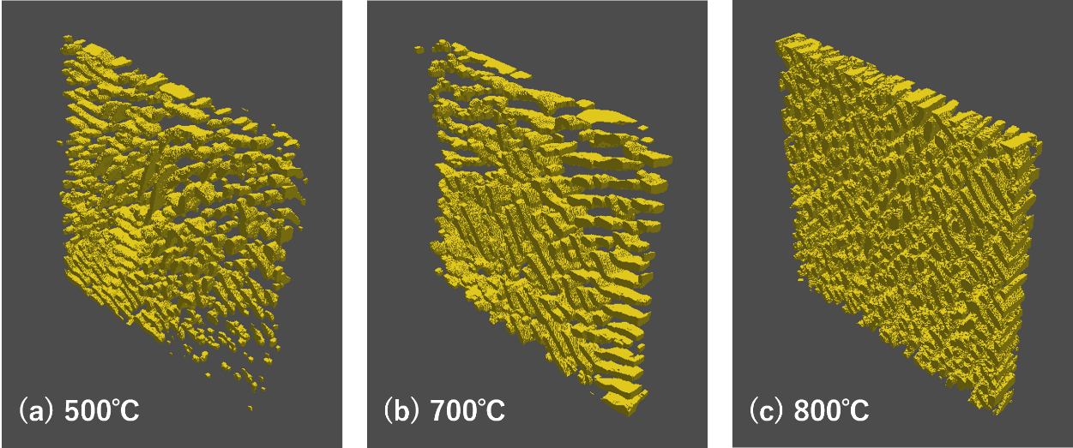
Figure 1 Reconstructed tomographic images of the Pt/CeO₂ nanocomposites synthesized at different annealing temperatures of (a) 500, (b) 700, and (c) 800 °C. The yellow regions represent the CeO₂ domains.

2.2 Machine learning of persistence diagram
To ensure an adequate amount of data for modeling, the tomographic data measured at each of the aforementioned temperatures were divided into 25 (5×5) segments. This number of divisions is considered to be somewhat arbitrary. Here, we have confirmed that all 25 segments are similar to the image. Specifically, the CeO₂ and Pt components are approximately equal. Persistent homology analysis for binarized images was performed on the segmented tomography data using the Python library reported by Obayashi et al. [22]. The distance between birth and death (birth–death distance) in the persistence diagram was defined as the Manhattan distance [16]. We used the sub-level set filtration of the 3D images that yielded favorable results in feature extraction of the amorphous images [20]. Under this definition, a birth–death distance of 0 indicates topological features on the surface, whereas a negative value indicates features within CeO₂. Positive values represent distant structures such as neighboring CeO₂. Figure 2 illustrates an example of persistence diagrams results using the 25 divisions of tomographic reconstruction data at 500 ℃. The most significant explanatory variables were determined from these 25 datasets to identify the structural determinants of the target properties.

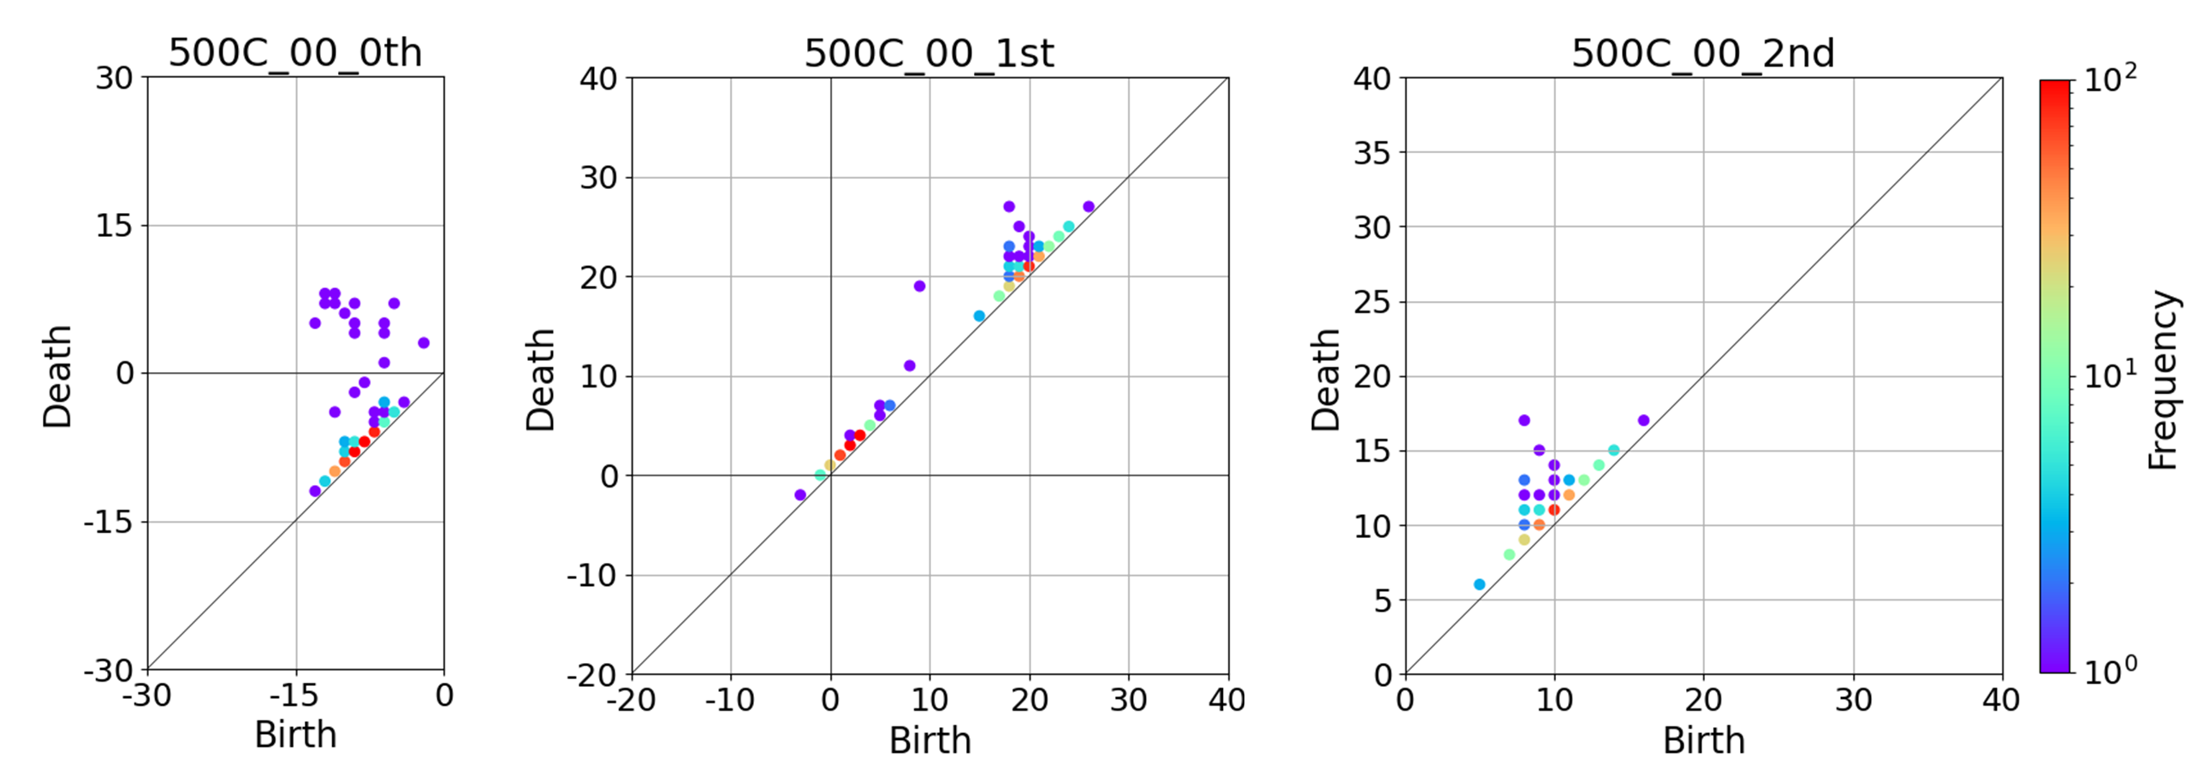
Figure 2. Persistence diagrams produced using tomographic reconstruction data of Pt/CeO₂ synthesized at annealing temperature of at 500 ℃.

Although there are several methods for vectorization [23–30], the 0th-, 1st-, and 2nd-order persistence diagrams obtained from the tomography data were vectorized using the persistent images [16] at the present study. Several references can be useful in obtaining the physical meaning and applications of persistence diagrams in each dimension [17–19, 31]. The original method of this study is to normalize and combine the homological features obtained from the vectorized 0th- to 2nd-order persistence diagrams. They were applied to ridge regression [32] to predict the pre-exponential factor and activation energy. In particular, linear regression with regularization allowed to identify terms that contribute positively or negatively to the predicted pre-exponential factor and activation energy based on their coefficients. The results were back-transformed to map the positive and negative contributions to the persistence diagram, enabling a comprehensive understanding of the structural determinants of the birth–death diagram. Figure 3 presents a conceptual flow diagram outlining the procedure for predicting oxygen permeability and identifying its structural determinants.

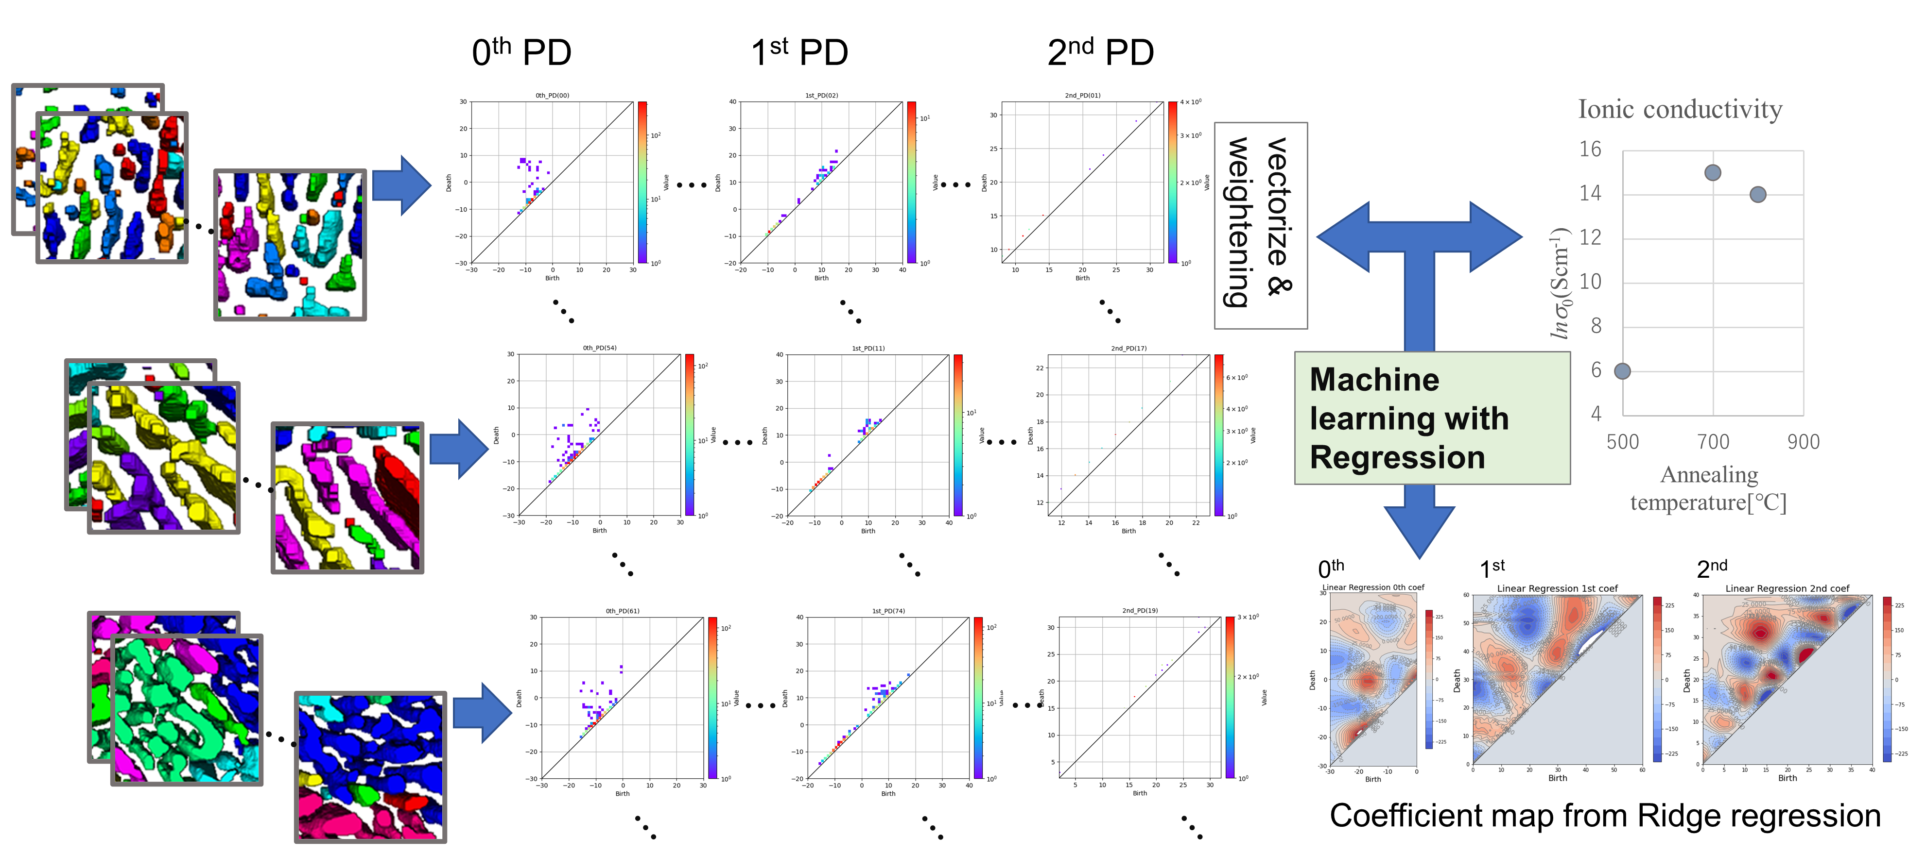
Figure 3. Conceptual flow diagram for the prediction of oxygen permeability and identification of its structural determinants.

3. Results and discussion

3.1 Modeling of oxygen permeability
In the ridge regression of the oxygen transmission coefficient using the persistence diagram, the regularization parameter α in Equation (1) must first be optimized, where α is the contribution of the regularization term in the ridge regression. If α is not chosen appropriately, model overfitting or a large error can be generated. Although the larger dimensional vector of the topological features from the persistence diagram is expected to contain sufficient information to regress only two target variables, namely the pre-exponential factor and activation energy, the excess information can lead to overfitting. Thus, α is optimized as follows:
$${\left\|y-Xβ\right\|}_{2}^{2}+α{\left\|β\right\|}_{2}^{2}, (1)$$
where y is the target variable, X is the descriptor, and ${\left\|β\right\|}_{2}$ is, for example, the l₂ norm of β. In ridge regression, β is determined to minimize Equation (1). To optimize α, the machine learning error in the training data were compared with the error in the test data. The error is defined in Equation (2) as
$$Error=\frac{1}{n}\sum_{i=1}^{n}{\frac{\left|σ_{predict}-σ_{label}\right|}{σ_{label}}} (2)$$
Figure 4 plots the errors with training data and test data versus α for the activation energy. The error with training data (blue circles) decreases as α decreases and achieves a minimum value when α is zero. Although the error with the test data (orange circles) decreases with decreasing α to 0.01, it increases for α < 0.005, suggesting that an l₂ regularization of α = 0.005 leads to the best regression model. An analysis revealed similar results for the pre-exponential factor. Considering these results, we adopted an α value of 0.005 for the following discussion. l₁ regularization (LASSO) is often employed to prevent overfitting, yielding satisfactory results in sparse systems. However, in the present system, LASSO regression did not yield a satisfactory prediction model. This suggests that Pt/CeO₂ is not a sparse system and that a wide range of structural factors contributes to oxygen permeability. Moreover, this observation might explain why the Betti numbers alone are not sufficient as a structural descriptor for explaining oxygen permeability.

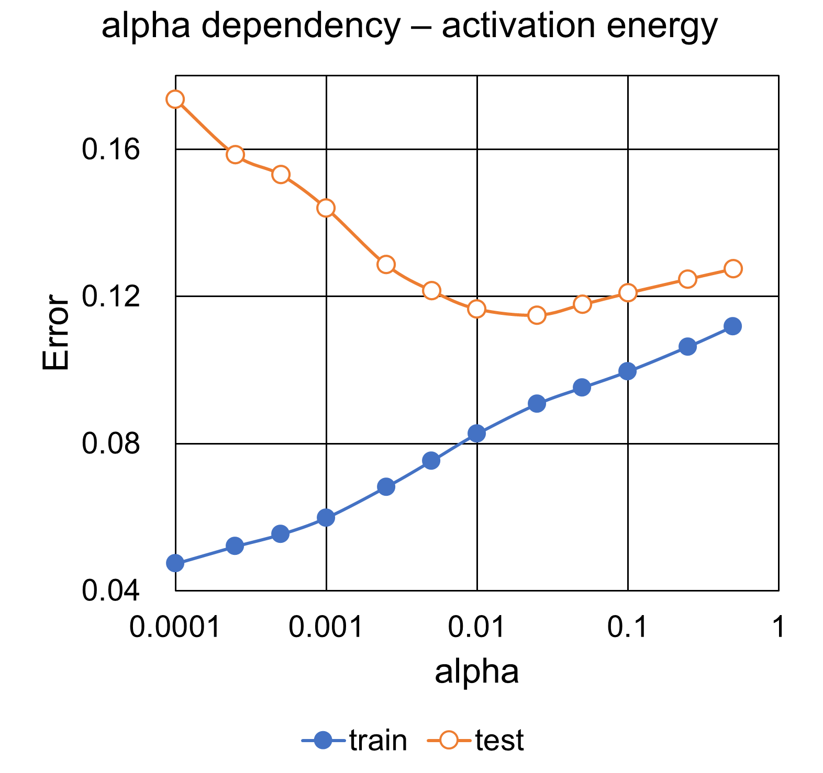
Figure 4. The dependency of the regularization term. Errors with training data (blue circles) and test data (orange circles) versus regularization parameter, α.

Figure 5 visualizes the temperature dependence of the experimental (a) pre-exponential factor for oxygen permeability and (b) activation energy (blue circles), along with their predicted (open circles) and average (orange circles) values using the ridge regression model optimized in Figure 4. The experimental results demonstrate that both the pre-exponential factor and activation energy reach maximum values at 700 ℃, indicating different limiting factors in the lower and higher temperature regions. Moreover, the ridge regression model suggests that the geometric features effectively reproduce the experimental results, implying that the limiting factors in the low- and high-temperature regions can be explained by different geometric factors. In the following section, the determined geometric limiting factors are presented.

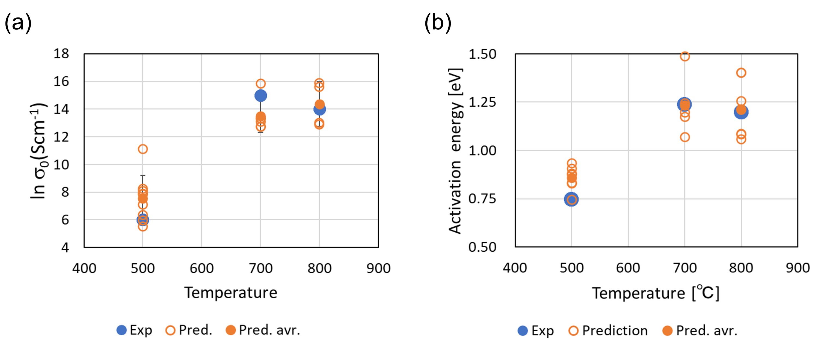
Figure 5. Comparison between the experimentally obtained (a) pre-exponential factor and (b) activation energy of oxygen permeability and their predictions using the ridge regression model.

3.2 Identification of limiting factors of oxygen permeability
Figure 6 presents contour plots of the ridge regression coefficient β in Equation (1) for the (a) pre-exponential factor and (b) activation energy on the 0th, 1st, and 2nd order persistence diagrams, where the red and blue regions denote positive and negative coefficients, respectively. Although their distributions are complex, both the pre-exponential factor and activation energy exhibit similar trends.

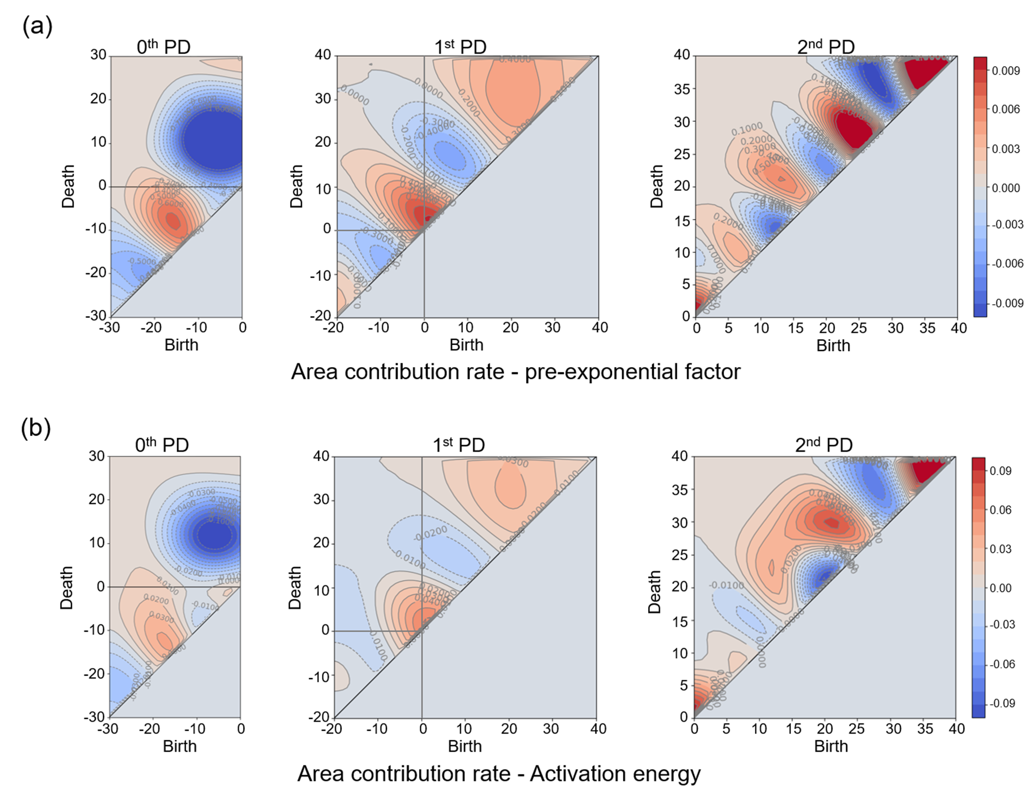
Figure 6. Contour plots of the ridge regression coefficient β for (a) pre-exponential factor and (b) activation energy on the persistence diagram. The left, center, and right columns illustrate the persistence diagrams of the 0th, 1st, and 2nd orders, respectively.

The β contour map of the 0th order persistence diagram is restricted to the 2nd and 3rd quadrants according to the persistent homology principle. In particular, a positive β area (red area) is present only in the 3rd quadrant, where both birth and death are negative. The birth and death in this quadrant are confined to the interior of CeO₂ and can be attributed to the topological features in the formation process of CeO₂ one-dimensional (1D) structures. The second quadrant, with positive death, provides the topology between the neighboring CeO₂ 1D structures. As shown in this figure, it can be seen that the negative region is larger and stronger over a wider range in the pre-exponential factor than in the activation energy. The pre-exponential factor depends on the topological properties, indicating that increasing the distance between elements greatly impedes oxygen transport. On the other hand, since the activation energy mainly depends on the local crystallinity [8], it can be seen that the positive and negative changes are more gradual overall than the pre-exponential factor. The experimentally obtained negative β (blue area) indicates the negative contribution of the distant CeO₂ 1D structures to the regression model. These observations suggest that the formation of the CeO₂ 1D structure is one of the processes limiting the pre-exponential factor and activation energy.
The β contour map of the 2nd order persistence diagram is limited to the 1st and 4th quadrants based on the persistent homology principle. The 2nd order persistence diagram shows the topological features of the 3D structure of CeO₂. As shown in Figure 6, positive and negative β coefficients are intermingled, making their analysis challenging. However, the features are concentrated along the diagonal of the persistence diagram, and complex 3D structures of various sizes are created, repeating birth and death with extremely short lifetimes in the filtration of persistent homology. These structures suggest a 3D overgrowth of the Pt/CeO₂ nanocomposite, indicating that its complexity represents another limiting factor for the pre-exponential factor and activation energy.
Based on the positive and negative β distributions shown in Figure 6, we analyzed where the birth–death pairs in persistence diagrams of each temperature data plotted on the β distribution. Figure 7 counts which of the positive and negative regions of the β coefficient the live/dead pairs obtained from the 0th, 1st, and 2nd persistence diagrams of the 25 tomograms used in this analysis are located. Since there were 25 persistence diagrams per temperature, all birth-death pairs in the 75 persistence diagrams were reviewed for their contribution to β. The difference between contributions to positive and negative β is denoted by the black solid line. Furthermore, these numbers of birth–death pairs are color-coded for each of the 0th, 1st, and 2nd orders and are summarized in a bar graph.
In Figure 7, the black solid line denotes the average values of -9.8 for 500 ℃, 141.4 for 700 ℃, and 116.2 for 800 ℃. Despite the dispersion of the 25 topological images obtained, the highest average value corresponds to 700 ℃, which qualitatively aligns with the temperature dependence of the experimental results of the pre-exponential factor and activation energy (Figure 5). This finding indicates that topological features determine oxygen permeability. The limiting processes at each temperature are discussed as follows:
- At 500 ℃, the local formation of the CeO₂ 1D structure characterized by the 1st order persistence diagram is considered a positive factor. However, its sparse distribution serves as the main negative factor, resulting in a lower contribution to the pre-exponential factor and activation energy. Consequently, we conclude that the annealing temperature is insufficient for the structuring of Pt/CeO₂ nanocomposites, consistent with the XRD results of our previous paper [8], and that the formation of CeO₂ is the limiting process for oxygen permeability at this temperature.
- At 700 ℃, the formation of the CeO₂ 1D structure, characterized by the 0th order persistence diagram, is the main contributor to the positive β. Additionally, its sparse distribution observed at 500 ℃ is improved, resulting in a higher contribution to the pre-exponential factor and activation energies. Therefore, since a temperature sufficient for the formation of CeO₂ could be achieved, a straight CeO₂ feed-through structure for oxygen was formed along the thermal gradient of the sample, resulting in the construction of a favorable pathway for oxygen permeation.
- At 800 ℃, the formation of the CeO₂ 1D structure, which exhibits a positive contribution to the 0th order persistence diagram, is significant and the negative interaction with the neighboring CeO₂ 1D structure is also significant. Unlike the anisotropic formation at 700 ℃, the CeO₂ structures are isotropically formed at this temperature and are considered to form 3D topological structures. As shown in Figure 6, the 2nd order persistence diagram exhibits overgrowth of the Pt/CeO₂ nanocomposite. Figure 7 shows a strong negative contribution from the 2nd order persistence diagram, indicating that overgrowth is a limiting process at this temperature. Particularly, CeO₂, which possesses a straight oxygen feed-through structure at 700 ℃, is presumed to adopt a branched structure at this temperature, thereby reducing oxygen permeability.

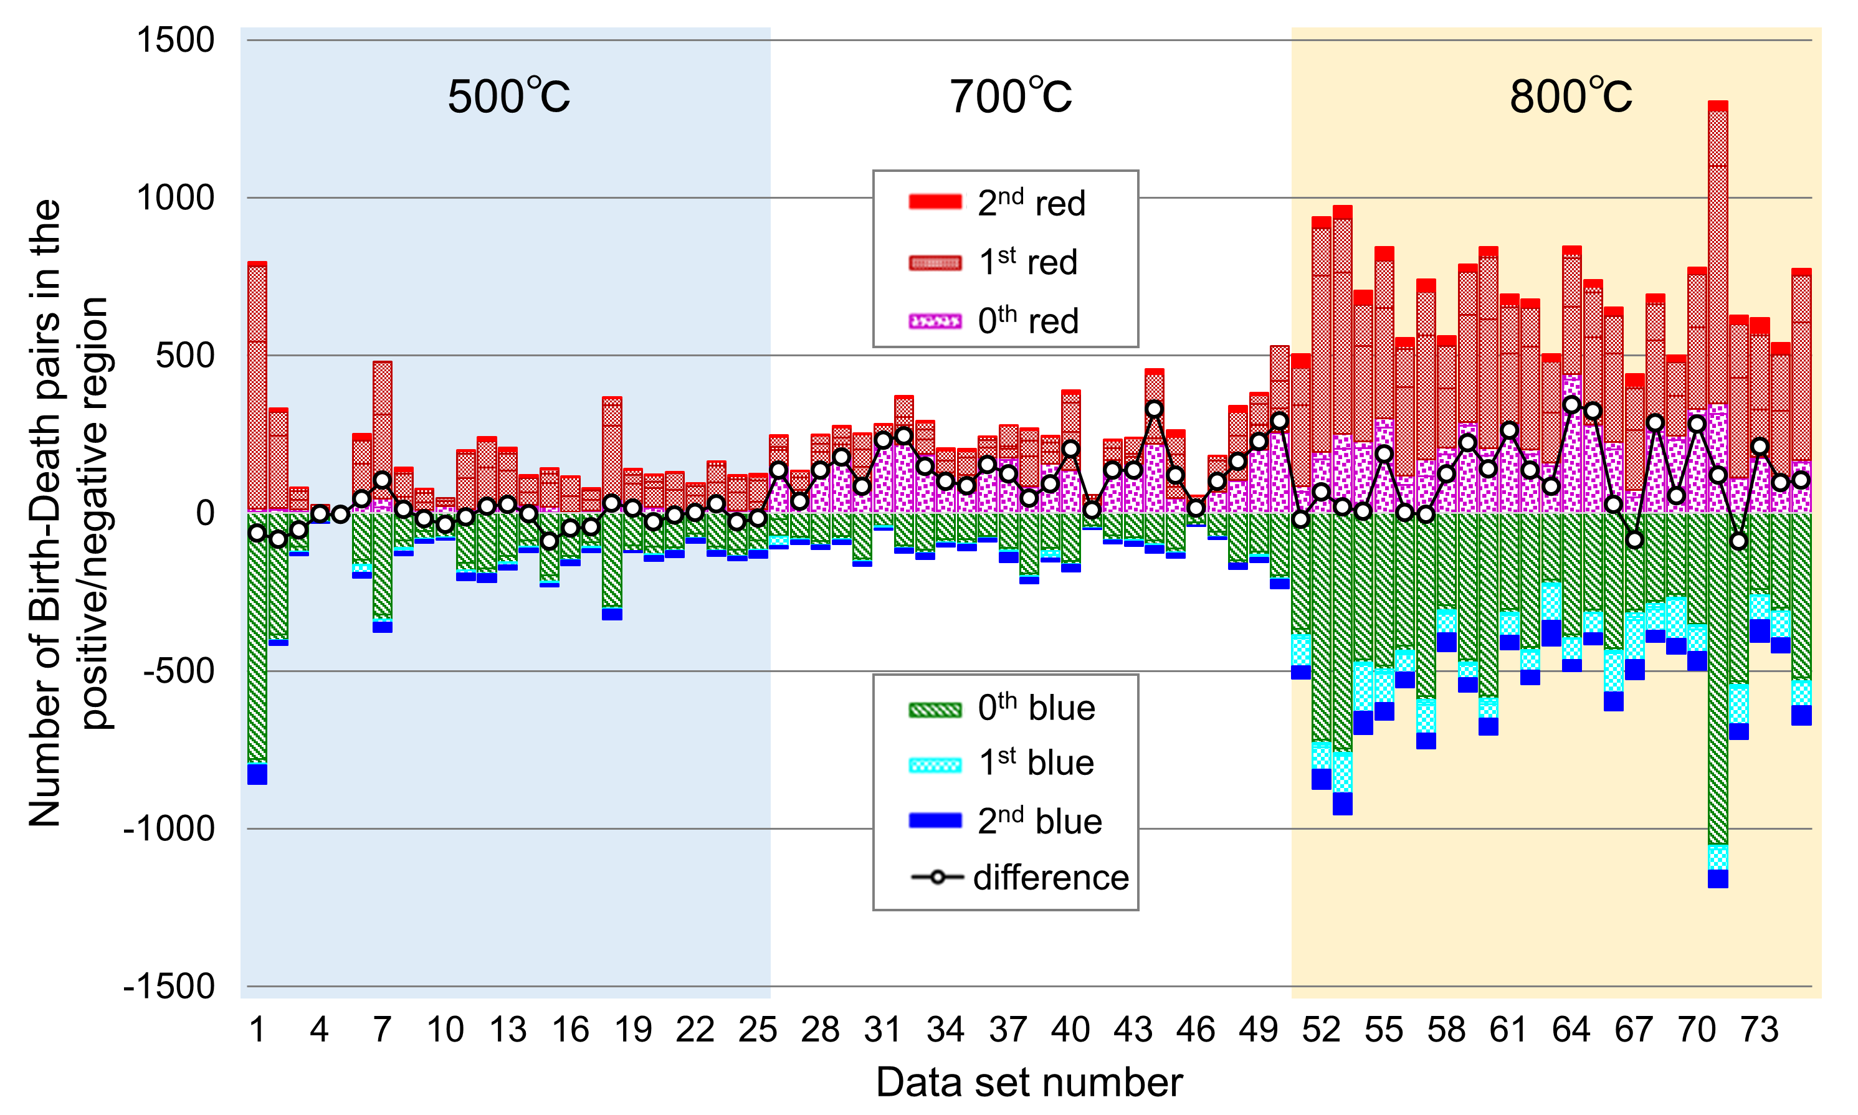
Figure 7. Contribution numbers to positive and negative β of birth–death pairs obtained from persistence diagram of tomographic images.

4. Concluding remarks
In our previous study, some of the authors attempted to predict the pre-exponential factor and activation energy of oxygen permeability using a topological invariant, namely the Betti numbers, which focused on analyzing the "holes" for shape analysis of Pt/CeO₂ nanocomposite. Although a correlation with the pre-exponential factor was determined, clear correlation with the activation energy was not observed. The analysis proposed in this study, employing persistent homology, is based on the underlying assumption that more complex geometric structures are determinants of oxygen permeability. Through ridge regression analysis of the tomography data, we were able to create a model that accurately predicted both the pre-exponential factor and activation energy. Analysis of the ridge regression coefficients revealed the optimal formation temperature of Pt/CeO₂ nanocomposites based on geometrical considerations. At temperatures below the optimum, the formation of CeO₂ emerged as the limiting process, whereas at higher temperatures, the transition in the growth mode of CeO₂ from linear to 3D structures became the limiting process.
Parameters based on 3D structures, such as oxygen permeability, can be reasonably elucidated from two-dimensional information, such as STEM images; however, these parameters can be better expressed using features extracted using persistent homology from the tomography data, which has 3D information. In each β contour map, positive and negative β coefficients are mixed because the pre-exponential factor and activation energy represent the distance between the elements expressed by the 0th-order persistence diagram, roughness of the surface expressed by the 1st-order persistence diagram, and configuration and phase between the elements expressed by the 2nd-order persistence diagram, using all coefficients. In a previous work, some of the authors clarified that the activation energy depends on the degree of crystallinity. With the tomography data, it is not possible to confirm the degree of the crystallinity observed by enlarging the vicinity of the interface. However, considering that the surface structure is the result of local crystallinity during CeO₂ formation, the persistence diagram indirectly captures crystallinity. The ability to evaluate the activation energy using the persistence diagram suggests that crystallinity can be estimated through the topological structure of macroscopic surface. Moreover, it can be said that persistent homology is a valuable tool capable of simplifying and quantifying characteristics that are difficult to express differently, such as length and size, enabling their classification and regression. In the future, it is likely to be used in the analysis of materials with irregular structures that were previously subject to human subjectivity, making quantification challenging.
Although this work demonstrated the usefulness of persistent homology in material processes, whether this method is the best or not still needs to be examined. It should be noted that there are other algorithms [23–25]to, for example, feature extraction and clustering by Silhouette. Furthermore, clustering/dimensional reduction, such as t-sne or gradient-boosted trees (GBT), could be used for the analysis of the extracted features. However, the hyperparameters found in perplexity of t-sne can lead to arbitrariness in the analysis, and the loss function dependence in the GBT leaves unknowns in its application to materials science in general. The success of the regression by ridge rather than LASSO in this study indicates the contribution of a wide range of structural factors, and the integrated use of these under appropriate regularization is likely to have produced favorable results.

Author contributions
F.U. designed and carried out the analytical concept of this work, and wrote the original draft. Y.W. carried out the experiments and prepared the experimental data of the pre-exponential factor, activation energy, and 3D tomography data. A.H. supervised the experiment. M.I. reviewed and revised the manuscript and supervised the analysis. All authors participated in the discussion of the research.

Acknowledgements
We thank to H. Abe (NIMS) for assisting in the composite synthesis.

Funding
This work is partially supported by the JST FOREST Program [grant number JPMJFR213U to A.H.].

Competing interests
The authors have no competing interest to report.

Data availability
The datasets generated during this study are available from the corresponding author upon reasonable request.

ORCID
Fumihiko Uesugi https://orcid.org/0000-0003-3346-4218
Yu Wen https://orcid.org/0000-0001-7809-5941
Ayako Hashimoto https://orcid.org/0000-0002-1985-7667
Masashi Ishii https://orcid.org/0000-0003-0357-2832

References
[1] R.A. Vaia, H. Daniel Wagner, Framework for nanocomposites, 2004.
[2] Seong-Min Choi, Hideo Awaji, Nanocomposites—a new material design concept, Sci Technol Adv Mater 6 (2005) 2–10.
[3] S.M. Yang, S. Lee, J. Jian, W. Zhang, P. Lu, Q. Jia, H. Wang, T. Won Noh, S. V. Kalinin, J.L. MacManus-Driscoll, Strongly enhanced oxygen ion transport through samarium-doped CeO2 nanopillars in nanocomposite films, Nat Commun 6 (2015). https://doi.org/10.1038/ncomms9588.
[4] C. Ray, T. Pal, Recent advances of metal-metal oxide nanocomposites and their tailored nanostructures in numerous catalytic applications, J Mater Chem A Mater 5 (2017) 9465–9487. https://doi.org/10.1039/c7ta02116j.
[5] S. Komarneni, Feature article. Nanocomposites, J Mater Chem 2 (1992) 1219. https://doi.org/10.1039/jm9920201219.
[6] T.J. Pennycook, M.J. Beck, K. Varga, M. Varela, S.J. Pennycook, S.T. Pantelides, Origin of colossal ionic conductivity in oxide multilayers: Interface induced sublattice disorder, Phys Rev Lett 104 (2010). https://doi.org/10.1103/PhysRevLett.104.115901.
[7] A.R. Puigdollers, P. Schlexer, S. Tosoni, G. Pacchioni, Increasing oxide reducibility: The role of metal/oxide interfaces in the formation of oxygen vacancies, ACS Catal 7 (2017) 6493–6513. https://doi.org/10.1021/acscatal.7b01913.
[8] Y. Wen, H. Abe, A. Hirata, A. Hashimoto, Correlation between the Charge-Transport Properties and the 3D-Phase Connectivities in Patterned Pt/CeO2 Nanostructured Composites: Implications for Solid-Oxide Fuel Cells, ACS Appl Nano Mater 4 (2021) 13602–13611. https://doi.org/10.1021/acsanm.1c03036.
[9] Y. Wen, A. Hashimoto, A.S.B.M. Najib, A. Hirata, H. Abe, Topological trends in ionic transport through metal-oxide composites, Appl Phys Lett 118 (2021) 054102. https://doi.org/10.1063/5.0033439.
[10] H. Edelsbrunner, D. Letscher, A. Zomorodian, Topological persistence and simplification, Discrete Comput Geom 28 (2002) 511–533. https://doi.org/10.1007/s00454-002-2885-2.
[11] A. Zomorodian, G. Carlsson, Computing persistent homology, Proceedings of the Annual Symposium on Computational Geometry 274 (2004) 347–356. https://doi.org/10.1145/997817.997870.
[12] Y. Pritchard, A. Sharma, C. Clarkin, H. Ogden, S. Mahajan, R.J. Sánchez-García, Persistent homology analysis distinguishes pathological bone microstructure in non-linear microscopy images, Sci Rep 13 (2023) 2522. https://doi.org/10.1038/s41598-023-28985-3.
[13] Z. Meng, D.V. Anand, Y. Lu, J. Wu, K. Xia, Weighted persistent homology for biomolecular data analysis, Sci Rep 10 (2020) 2079. https://doi.org/10.1038/s41598-019-55660-3.
[14] K. Xia, G.-W. Wei, Persistent homology analysis of protein structure, flexibility, and folding, Int J Numer Method Biomed Eng 30 (2014) 814–844. https://doi.org/https://doi.org/10.1002/cnm.2655.
[15] O. Ippei, N. Takenobu, H. Yasuaki, Persistent Homology Analysis for Materials Research and Persistent Homology Software: HomCloud, J Physical Soc Japan 91 (2022) 91013. https://doi.org/10.7566/JPSJ.91.091013.
[16] I. Obayashi, Y. Hiraoka, M. Kimura, Persistence diagrams with linear machine learning models, J Appl Comput Topol 1 (2018) 421–449. https://doi.org/10.1007/s41468-018-0013-5.
[17] Y. Hiraoka, T. Nakamura, A. Hirata, E.G. Escolar, K. Matsue, Y. Nishiura, Hierarchical structures of amorphous solids characterized by persistent homology, Proc Natl Acad Sci U S A 113 (2016) 7035–7040. https://doi.org/10.1073/pnas.1520877113.
[18] Y. ONODERA, S. KOHARA, S. TAHARA, A. MASUNO, H. INOUE, M. SHIGA, A. HIRATA, K. TSUCHIYA, Y. HIRAOKA, I. OBAYASHI, K. OHARA, A. MIZUNO, O. SAKATA, Understanding diffraction patterns of glassy, liquid and amorphous materials via persistent homology analyses, Journal of the Ceramic Society of Japan 127 (2019) 853–863. https://doi.org/10.2109/jcersj2.19143.
[19] S.S. Sørensen, T. Du, C.A.N. Biscio, L. Fajstrup, M.M. Smedskjaer, Persistent homology: A tool to understand medium-range order glass structure, Journal of Non-Crystalline Solids: X 16 (2022). https://doi.org/10.1016/j.nocx.2022.100123.
[20] F. Uesugi, M. Ishii, Classification for transmission electron microscope images from different amorphous states using persistent homology, Microscopy 71 (2022) 161–168. https://doi.org/10.1093/jmicro/dfac008.
[21] Thermo Fisher Scientific, Avizo, (n.d.). http://www.avizo3d.com/ (accessed June 21, 2023).
[22] Ippei Obayashi, Tomohide Wada, Tian Tunhua, Jun Miyanaga, Y. Hiraoka, HomCloud, (n.d.). https://homcloud.dev/index.en.html.
[23] B. Zieliński, M. Lipiński, M. Juda, M. Zeppelzauer, P. Dłotko, Persistence codebooks for topological data analysis, Artif Intell Rev 54 (2021) 1969–2009. https://doi.org/10.1007/s10462-020-09897-4.
[24] S. Kališnik, Tropical Coordinates on the Space of Persistence Barcodes, Foundations of Computational Mathematics 19 (2019) 101–129. https://doi.org/10.1007/s10208-018-9379-y.
[25] F. Chazal, B.T. Fasy, F. Lecci, A. Rinaldo, L. Wasserman, Stochastic Convergence of Persistence Landscapes and Silhouettes, in: Proceedings of the Thirtieth Annual Symposium on Computational Geometry, Association for Computing Machinery, New York, NY, USA, 2014: pp. 474–483. https://doi.org/10.1145/2582112.2582128.
[26] Y. Imoto, Y. Hiraoka, V-Mapper: topological data analysis for high-dimensional data with velocity, Nonlinear Theory and Its Applications, IEICE 14 (2023) 92–105. https://doi.org/10.1587/nolta.14.92.
[27] G. Singh, F. Memoli, G. Carlsson, Topological Methods for the Analysis of High Dimensional Data Sets and 3D Object Recognition, in: Symposium on Point - Based Graphics, The Eurographics Association;, Postfach 8043, 38621 Goslar, Germany, n.d.: pp. 91–100. https://doi.org/10.2312/SPBG/SPBG07/091-100.
[28] J.M. Carr, D. Mazauric, F. Cazals, D.J. Wales, Energy landscapes and persistent minima, J Chem Phys 144 (2016) 054109. https://doi.org/10.1063/1.4941052.
[29] D. Wales, Energy Landscapes: Applications to Clusters, Biomolecules and Glasses, Cambridge University Press, Cambridge, 2004. https://doi.org/DOI: 10.1017/CBO9780511721724.
[30] O.M. Becker, M. Karplus, The topology of multidimensional potential energy surfaces: Theory and application to peptide structure and kinetics, J Chem Phys 106 (1997) 1495–1517. https://doi.org/10.1063/1.473299.
[31] Y. Singh, C.M. Farrelly, Q.A. Hathaway, T. Leiner, J. Jagtap, G.E. Carlsson, B.J. Erickson, Topological data analysis in medical imaging: current state of the art, Insights Imaging 14 (2023) 58. https://doi.org/10.1186/s13244-023-01413-w.
[32] G. Varoquaux, L. Buitinck, G. Louppe, O. Grisel, F. Pedregosa, A. Mueller, Scikit-learn, GetMobile: Mobile Computing and Communications 19 (2015) 29–33. https://doi.org/10.1145/2786984.2786995.

[1] R.A. Vaia, H. Daniel Wagner, Framework for nanocomposites, 2004.
[2] Seong-Min Choi, Hideo Awaji, Nanocomposites—a new material design concept, Sci Technol Adv Mater 6 (2005) 2–10.
[3] S.M. Yang, S. Lee, J. Jian, W. Zhang, P. Lu, Q. Jia, H. Wang, T. Won Noh, S. V. Kalinin, J.L. MacManus-Driscoll, Strongly enhanced oxygen ion transport through samarium-doped CeO2 nanopillars in nanocomposite films, Nat Commun 6 (2015). https://doi.org/10.1038/ncomms9588.
[4] C. Ray, T. Pal, Recent advances of metal-metal oxide nanocomposites and their tailored nanostructures in numerous catalytic applications, J Mater Chem A Mater 5 (2017) 9465–9487. https://doi.org/10.1039/c7ta02116j.
[5] S. Komarneni, Feature article. Nanocomposites, J Mater Chem 2 (1992) 1219. https://doi.org/10.1039/jm9920201219.
[6] T.J. Pennycook, M.J. Beck, K. Varga, M. Varela, S.J. Pennycook, S.T. Pantelides, Origin of colossal ionic conductivity in oxide multilayers: Interface induced sublattice disorder, Phys Rev Lett 104 (2010). https://doi.org/10.1103/PhysRevLett.104.115901.
[7] A.R. Puigdollers, P. Schlexer, S. Tosoni, G. Pacchioni, Increasing oxide reducibility: The role of metal/oxide interfaces in the formation of oxygen vacancies, ACS Catal 7 (2017) 6493–6513. https://doi.org/10.1021/acscatal.7b01913.
[8] Y. Wen, H. Abe, A. Hirata, A. Hashimoto, Correlation between the Charge-Transport Properties and the 3D-Phase Connectivities in Patterned Pt/CeO2 Nanostructured Composites: Implications for Solid-Oxide Fuel Cells, ACS Appl Nano Mater 4 (2021) 13602–13611. https://doi.org/10.1021/acsanm.1c03036.
[9] Y. Wen, A. Hashimoto, A.S.B.M. Najib, A. Hirata, H. Abe, Topological trends in ionic transport through metal-oxide composites, Appl Phys Lett 118 (2021) 054102. https://doi.org/10.1063/5.0033439.
[10] H. Edelsbrunner, D. Letscher, A. Zomorodian, Topological persistence and simplification, Discrete Comput Geom 28 (2002) 511–533. https://doi.org/10.1007/s00454-002-2885-2.
[11] A. Zomorodian, G. Carlsson, Computing persistent homology, Proceedings of the Annual Symposium on Computational Geometry 274 (2004) 347–356. https://doi.org/10.1145/997817.997870.
[12] Y. Pritchard, A. Sharma, C. Clarkin, H. Ogden, S. Mahajan, R.J. Sánchez-García, Persistent homology analysis distinguishes pathological bone microstructure in non-linear microscopy images, Sci Rep 13 (2023) 2522. https://doi.org/10.1038/s41598-023-28985-3.
[13] Z. Meng, D.V. Anand, Y. Lu, J. Wu, K. Xia, Weighted persistent homology for biomolecular data analysis, Sci Rep 10 (2020) 2079. https://doi.org/10.1038/s41598-019-55660-3.
[14] K. Xia, G.-W. Wei, Persistent homology analysis of protein structure, flexibility, and folding, Int J Numer Method Biomed Eng 30 (2014) 814–844. https://doi.org/https://doi.org/10.1002/cnm.2655.
[15] O. Ippei, N. Takenobu, H. Yasuaki, Persistent Homology Analysis for Materials Research and Persistent Homology Software: HomCloud, J Physical Soc Japan 91 (2022) 91013. https://doi.org/10.7566/JPSJ.91.091013.
[16] I. Obayashi, Y. Hiraoka, M. Kimura, Persistence diagrams with linear machine learning models, J Appl Comput Topol 1 (2018) 421–449. https://doi.org/10.1007/s41468-018-0013-5.
[17] Y. Hiraoka, T. Nakamura, A. Hirata, E.G. Escolar, K. Matsue, Y. Nishiura, Hierarchical structures of amorphous solids characterized by persistent homology, Proc Natl Acad Sci U S A 113 (2016) 7035–7040. https://doi.org/10.1073/pnas.1520877113.
[18] Y. ONODERA, S. KOHARA, S. TAHARA, A. MASUNO, H. INOUE, M. SHIGA, A. HIRATA, K. TSUCHIYA, Y. HIRAOKA, I. OBAYASHI, K. OHARA, A. MIZUNO, O. SAKATA, Understanding diffraction patterns of glassy, liquid and amorphous materials via persistent homology analyses, Journal of the Ceramic Society of Japan 127 (2019) 853–863. https://doi.org/10.2109/jcersj2.19143.
[19] S.S. Sørensen, T. Du, C.A.N. Biscio, L. Fajstrup, M.M. Smedskjaer, Persistent homology: A tool to understand medium-range order glass structure, Journal of Non-Crystalline Solids: X 16 (2022). https://doi.org/10.1016/j.nocx.2022.100123.
[20] F. Uesugi, M. Ishii, Classification for transmission electron microscope images from different amorphous states using persistent homology, Microscopy 71 (2022) 161–168. https://doi.org/10.1093/jmicro/dfac008.
[21] Thermo Fisher Scientific, Avizo, (n.d.). http://www.avizo3d.com/ (accessed June 21, 2023).
[22] Ippei Obayashi, Tomohide Wada, Tian Tunhua, Jun Miyanaga, Y. Hiraoka, HomCloud, (n.d.). https://homcloud.dev/index.en.html.
[23] B. Zieliński, M. Lipiński, M. Juda, M. Zeppelzauer, P. Dłotko, Persistence codebooks for topological data analysis, Artif Intell Rev 54 (2021) 1969–2009. https://doi.org/10.1007/s10462-020-09897-4.
[24] S. Kališnik, Tropical Coordinates on the Space of Persistence Barcodes, Foundations of Computational Mathematics 19 (2019) 101–129. https://doi.org/10.1007/s10208-018-9379-y.
[25] F. Chazal, B.T. Fasy, F. Lecci, A. Rinaldo, L. Wasserman, Stochastic Convergence of Persistence Landscapes and Silhouettes, in: Proceedings of the Thirtieth Annual Symposium on Computational Geometry, Association for Computing Machinery, New York, NY, USA, 2014: pp. 474–483. https://doi.org/10.1145/2582112.2582128.
[26] Y. Imoto, Y. Hiraoka, V-Mapper: topological data analysis for high-dimensional data with velocity, Nonlinear Theory and Its Applications, IEICE 14 (2023) 92–105. https://doi.org/10.1587/nolta.14.92.
[27] G. Singh, F. Memoli, G. Carlsson, Topological Methods for the Analysis of High Dimensional Data Sets and 3D Object Recognition, in: Symposium on Point - Based Graphics, The Eurographics Association;, Postfach 8043, 38621 Goslar, Germany, n.d.: pp. 91–100. https://doi.org/10.2312/SPBG/SPBG07/091-100.
[28] J.M. Carr, D. Mazauric, F. Cazals, D.J. Wales, Energy landscapes and persistent minima, J Chem Phys 144 (2016) 054109. https://doi.org/10.1063/1.4941052.
[29] D. Wales, Energy Landscapes: Applications to Clusters, Biomolecules and Glasses, Cambridge University Press, Cambridge, 2004. https://doi.org/DOI: 10.1017/CBO9780511721724.
[30] O.M. Becker, M. Karplus, The topology of multidimensional potential energy surfaces: Theory and application to peptide structure and kinetics, J Chem Phys 106 (1997) 1495–1517. https://doi.org/10.1063/1.473299.
[31] Y. Singh, C.M. Farrelly, Q.A. Hathaway, T. Leiner, J. Jagtap, G.E. Carlsson, B.J. Erickson, Topological data analysis in medical imaging: current state of the art, Insights Imaging 14 (2023) 58. https://doi.org/10.1186/s13244-023-01413-w.
[32] G. Varoquaux, L. Buitinck, G. Louppe, O. Grisel, F. Pedregosa, A. Mueller, Scikit-learn, GetMobile: Mobile Computing and Communications 19 (2015) 29–33. https://doi.org/10.1145/2786984.2786995.

