Leveraging molecular interactions to develop a generalized design framework for co-amorphous drug-drug mixtures exhibiting elevated glass transition temperatures

Dani Lakshman Yarlagadda¹, Kohsaku Kawakami^{2,3**}, Satyavrata Samavedi^{1,2*}

¹Department of Chemical Engineering, Indian Institute of Technology Hyderabad
IITH Main Road, Near NH 65, Kandi, Sangareddy, Telangana 502285, India
²National Institute for Materials Science, Research Center for Macromolecules and Biomaterials,
1-1 Namiki, Tsukuba, Ibaraki 305-0044, Japan
³University of Tsukuba, Graduate School of Science and Technology, 1-1-1 Tennodai, Tsukuba, Ibaraki 305-8577, Japan

Contact authors:
*samavedi@che.iith.ac.in
**kawakami.kohsaku@nims.go.jp
Abstract
Co-amorphous mixtures (CAMs) prepared with two drugs have the potential to enhance the oral absorption of poorly soluble drugs and achieve combination therapy. From a practical standpoint, improving the glass transition temperature (T_{g}) of CAMs is desirable as it enhances stability and extends shelf-life during storage. Towards the eventual goal of developing highly stable CAMs, this study establishes a generalized framework that systematically relates elevated T_{g} values of CAMs to intermolecular interactions based on specific functional groups. CAMs were prepared via quench-cooling using various combinations of Indomethacin, Ketoprofen, Flurbiprofen, Flufenamic acid, Aripiprazole, Bifonazole and Clotrimazole. CAMs prepared with drugs containing the COOH group exhibited significant positive deviations from T_{g} values predicted by the Gordon-Taylor equation (i.e., ideal mixing behavior). COOH-associated hydrogen bonding was determined to be a key factor for T_{g} elevation, with synergistic contributions from π-π interactions and halogen bonding. In CAMs exhibiting the largest T_{g} deviations, contributions from ionic bonding were crucial and were likely favored by differences in the pKa values of the constituent drugs. Continuity in T_{g} as a function of varying molar ratios indicated that stoichiometric pairing had a relatively minor contribution, while a decrease in the width of the glass transition suggested the enhancement of molecular cooperativity as a possible mechanism for CAM stabilization. In contrast, non-COOH hydrogen bonding, π-π interactions and halogen bonding on their own did not result in any meaningful T_{g} deviations from theoretical predictions. Systematic correlations between T_{g} deviations and molecular interactions reported in this study can lead to generalized design rules for the development of stable CAMs.
Keywords: Co-amorphous mixture, Glass transition temperature, Gordon-Taylor equation, Molecular interaction, Amorphous drug stability, Molecular cooperativity
1. Introduction
A common approach to overcome the issue of low bioavailability for poorly soluble drugs is to prepare them in their amorphous form ¹. However, the amorphous state is thermodynamically unstable, quickly reverting to the less soluble crystalline form. While the molecular mobility and crystallization tendency of amorphous drugs can be lowered using polymeric excipients through the formation of amorphous solid dispersions ²⁻⁴, this approach often results in increased formulation volumes that can hinder manufacturing and patient compliance ⁵. Moreover, the polymeric excipients themselves do not typically exhibit specific therapeutic effects. In contrast, co-amorphous mixtures (CAMs) that use low molecular weight co-formers can stabilize amorphous drugs ⁶ without a significant increase in the overall volume. Further, CAMs prepared using drug-drug combinations can be used in combination therapy, whereby the two drugs can exert synergistic effects through coordinated release ⁷⁻⁸.
Broadly, two types of CAMs have been proposed in the field of pharmaceutical science. One type derives its origins from the work of Rades and co-workers focusing on stoichiometric paring among drugs for improving stability ⁹⁻¹¹. However, in recent years, CAMs have been used more broadly to refer to mixtures of multiple amorphous drugs, wherein stoichiometry is not necessary. In general, the presence of non-covalent interactions between CAM components can significantly influence several thermodynamic and kinetic parameters that are critical for stability. For example, CAMs can form salts in the amorphous state and can be stabilized by ionic bonding ¹²⁻¹³. Likewise, hydrogen bonding often enhances the stability of CAMs ¹⁴, although drugs such as Ritonavir and Indomethacin can maintain stable co-amorphous states even in the absence of intermolecular interactions ¹⁵. Recently, the role of halogen bonding has been implicated in amorphous solid dispersions ¹⁶, as also the co-existence of hydrogen and halogen bonds ¹⁷. Given the diverse types of bonds that can possibly exist in CAMs, a deeper understanding of drug-drug interactions can aid the development of design strategies for stable CAMs in specific applications.
An important property determining the stability of amorphous drugs is the glass transition temperature (T_{g}), which marks the transition from a rigid, glassy state to a viscous, super-cooled liquid-like state. Enchancing the T_{g} is important for improving the physical stability of amorphous materials in storage, as molecular mobility and crystallization tendency increase in the super-cooled state ¹⁸. The T_{g} of amorphous drugs can be increased by the addition of anti-plasticization agents ¹⁹ or via co-amorphization of two drugs ²⁰. CAM T_{g} values can be theoretically predicted using mixing rules that assume ideal behavior and the absence of molecular interactions ². However, interactions between drug and co-former or drug and drug can result in large positive deviations from theoretical predictions ²¹. The purpose of this study is to establish a generalized design framework for drug-drug CAMs by correlating significant positive T_{g} deviations (ΔT_{g}) with intermolecular interactions between drugs based on specific functional groups.
Previous studies have reported the importance of intermolecular interactions such as hydrogen bonding and ionic bonding in the context of T_{g} elevation in CAMs. For example, Alleso et al. reported hydrogen bonding between the N–H group of the imidazole ring of cimetidine with the carboxylic acid group of naproxen leading to positive T_{g} deviations ⁹, while Jensen et al. reported positive T_{g} deviations associated with ionic interactions between naproxen and arginine leading to possible salt formation ²². Although such studies have investigated stability and intrinsic dissolution profiles, their focus has primarily been specific drug-drug or drug-co-former combinations. To the best of our knowledge, generalized correlations between T_{g} deviations and intermolecular interactions across drug molecules have not been reported for CAMs. Specifically, the presence of specific functional groups in drugs leading to an elevation in CAM T_{g} has not been systematically studied. Such investigations are important because they can lead to the development of generalized design rules for CAMs exhibiting high stability.
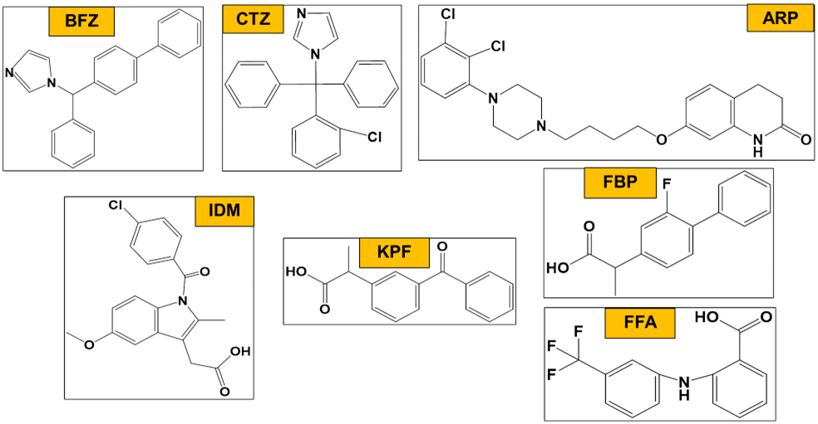
In this study, seven different drugs – Bifonazole (BFZ), Clotrimazole (CTZ), Aripiprazole (ARP), Indomethacin (IDM), Ketoprofen (KPF), Flurbiprofen (FBP) and Flufenamic Acid (FFA) (Figure 1) – were employed to prepare CAMs at 1:1 molar ratio. Drugs were chosen based on the presence of the COOH group in IDM, KPF, FBP and FFA, which can participate in hydrogen bonding. In contrast, BFZ, CTZ and ARP did not possess the COOH group but differed in the number of chlorine atoms, which can potentially participate in halogen bonding. The drugs also differed in their pKa values, thus exhibiting potential for ionic bonding across specific combinations. The effect of molecular interactions in promoting T_{g} deviations was investigated by analyzing CAMs across systematically varying molar ratios. Potential bond formation in CAMs was verified using infrared spectroscopy, with specific reference to co-existent interactions. Generalized correlations between T_{g} deviations and interactions were established by demonstrating similar phenomenology for CAMs prepared with drugs containing similar functional groups.
Figure 1: Chemical structures of the drugs used in this study.
2. Materials and Methods
2.1. Materials
ARP, BFZ, FBP and KPF were purchased from Tokyo Chemical Industry (Tokyo, Japan). CTZ and IDM were procured from FUJIFILM Wako Pure Chemical Corporation (Osaka, Japan), while FFA was purchased from Merck (Darmstadt, Germany). All drugs were stored as per supplier instructions and used as received.
2.2. Preparation of drug-drug CAMs
All CAMs were prepared by quench-cooling of physical drug mixtures using differential scanning calorimetry (DSC). The instrument (Q2000, TA Instruments, New Castle, USA) was equipped with a refrigerated cooling system and was operated under constant nitrogen flow of 50 mL/min. Individual drugs were weighed and mixed on a motor and pestle (Cole-Parmer Instrument Company, Vernon Hills, USA) to result in homogeneous physical mixtures. Uniformly mixed samples weighing 2.50-3.75 mg were crimped within Tzero® aluminum pans, loaded into the DSC instrument and heated at 10 ºC/min until complete melting. Following an isothermal hold for 0.5 min, the samples were rapidly cooled at 20 ºC/min, followed by another isothermal hold for 5 min ²³. The temperature ranges used for the melt-quench cycles for the different CAMs are presented in Supporting Information Table S1. All CAMs thus prepared were heated again at 10 ºC/min to determine the onset glass transition temperature (T_{g}). Changes in specific heat capacities were also determined for each glass transition.
In this study, IDM-based COOH CAMs (i.e., BFZ-IDM, CTZ-IDM, ARP-IDM), KPF-based COOH CAMs (i.e., BFZ-KPF, CTZ-KPF, ARP-KPF), FBP-based COOH CAMs (i.e., BFZ-FBP, CTZ-FBP, ARP-FBP) and FFA-based COOH CAMs (i.e., BFZ-FFA, CTZ-FFA, ARP-FFA) were prepared at 1:1 molar ratio using the aforementioned melt-quench method. In all cases, the respective individual amorphous drug samples were independently prepared in a similar manner. Additionally, BFZ-IDM, CTZ-IDM, ARP-IDM, ARP-KPF, ARP-FBP and ARP-FFA CAMs were investigated at systematically varying molar ratios from 1:9 to 9:1. Finally, drugs lacking the COOH group were separately used for the preparation of ARP-CTZ, ARP-BFZ and BFZ-CTZ CAMs. In all cases, the T_{g} values of CAMs or individual amorphous drugs were determined from the second heating cycle in the DSC runs.
2.3. Determination of theoretical glass transition temperature (Tg)
The theoretical glass transition temperature values (T_{g}^{GT}) of CAMs were predicted using the Gordon-Taylor (G-T) equation which assumes ideal volume additivity of components at T_{g} and no specific interactions between the components ². Changes in specific heat capacities at T_{g} (directly obtained from DSC measurements) were used as inputs to the equation, as reported previously ²⁴⁻²⁵. The equation used in the present study is given by: ²⁵⁻²⁶
$${T_{g}}^{GT}=\frac{\left[w_{1} T_{g1}+{K w}_{2}T_{g2}\right]}{\left[w_{1}+{K w}_{2}\right]}$$
where w represents the weight fraction of drug, T_{g} represents the experimental glass transition temperature of the individual drugs, K is given by $\frac{{ΔC}_{p2}}{{ΔC}_{p1}}$ , ∆C_{p} represents the change in specific heat capacity associated with the respective glass transition, and the subscripts 1 and 2 represent the two drug components in the CAM. For all CAMs, onset T_{g} was used for evaluation because of its implications for molecular mobility; in contrast, the middle point T_{g} is influenced by the width of the glass transition region and is associated with molecular cooperativity ²⁷. For each CAM, deviations from the corresponding theoretical predictions were determined as ΔT_{g} = T_{g} - T_{g}^{GT}.

2.4. X-ray diffraction (XRD)
To confirm the creation of the amorphous phase, CAMs were analyzed using XRD. Briefly, CAMs were gently transferred from the DSC pans to an XRD sample holder immediately following melt-quench preparation. During this transfer step, care was taken to avoid any mechanical stress because this could potentially result in the formation of crystal due to the generation of nucleation sites ²⁸⁻²⁹. Spectra were obtained using an X-ray diffractometer (Rigaku Corporation, Tokyo Japan) with Cu Kα radiation, operated at 40 kV and 40 mA. Each spectrum was obtained over a 2θ range of 5º to 35º with a 0.02º step size and scan rate of 1º/min.
2.5. Attenuated total reflectance Fourier transform infrared spectroscopy (ATR-FTIR)
CAMs and individual amorphous drug samples were analyzed using ATR-FTIR (Bruker Optik GmbH, Germany) to evaluate the existence of intermolecular interactions. All spectra were acquired in the 500–3500 cm⁻¹ range at a resolution of 2 cm⁻¹ for a total of 256 scans, and baseline-corrected using OPUS 7.5 spectroscopy software (Bruker Optik GmbH, Germany).
2.6. Data presentation and statistical analysis
The peak melting temperatures of individual drugs obtained from the first heating cycle are reported as mean ± standard deviation for a minimum of three independent replicates per drug. Experimentally obtained onset T_{g} values for 1:1 CAMs and individual amorphous drugs are also presented as mean ± standard deviation for a minimum of three independent replicates per sample. The difference between T_{g} and T_{g}^{GT} values for each CAM was analyzed using a two-tailed independent-samples student’s t-test suitable for comparison of means across two unpaired samples, wherein a p-value less than 0.05 was considered statistically significant. ATR-FTIR spectra were generally acquired twice to confirm reproducibility of trends, with representative spectra presented.
3. Results
3.1. Properties of individual drugs
Drug | Drug class  ª | Molecular weight (g/mol) | H-Bond Donors | H-Bond Acceptors | pKa  ³⁰⁻³⁶ | Melting Temperature T_{m} (ºC) ^{b} | Glass Transition Temperature T_{g} (ºC) ^{c}
Bifonazole (BFZ) | 3 | 310.40 | 0 | 1 | 6.29 | 149.8 ± 0.2 | 14.1 ± 0.3
Clotrimazole (CTZ) | 3 | 344.84 | 0 | 1 | 6.12 | 144.7 ± 0.1 | 26.2 ± 0.1
Aripiprazole (ARP) | 2 | 448.39 | 1 | 4 | 7.46 | 148.8 ± 0.1 | 30.5 ± 0.4
Indomethacin (IDM) | 3 | 357.79 | 1 | 4 | 4.0 | 161.1 ± 0.1 | 43.0 ± 0.5
Ketoprofen (KPF) | 3 | 254.29 | 1 | 3 | 4.4 | 95.6 ± 0.1 | -5.9 ± 0.4
Flurbiprofen (FBP) | 2 | 244.26 | 1 | 3 | 4.5 | 116.5 ± 0.1 | -8.4 ± 0.6
Flufenamic acid (FFA) | 2 | 281.23 | 2 | 6 | 3.9 | 134.4 ± 0.3 | 9.0 ± 0.2
Table 1: Important properties of the drugs used in this study.
ª Based on experimentally observed crystallization behavior in the DSC runs, according to the classification system proposed by Baird et al. ³⁷
^{b} Obtained experimentally as the peak value from the first heating cycle in DSC
^{c} Obtained experimentally as the onset value from the second heating cycle in DSC

Properties of individual drugs namely, molecular weight, number of hydrogen bond donors/acceptors and pKa values are listed in Table 1. Experimentally obtained peak melting temperature (T_{m}), onset glass transition temperature (T_{g}) and drug class (based on crystallization behavior noted during the melt-quench-melt cycle in DSC ³⁷) are also presented in Table 1. Among all the individual drugs, IDM exhibited the highest T_{g} (43.0 ºC) followed by ARP, CTZ, BFZ, FFA, KPF and FBP (-8.4 ºC). While BFZ, CTZ, IDM and KPF did not show crystallization either during the cooling or the second heating cycle, ARP, FBP and FFA exhibited cold-crystallization after the glass transition event in the second heating cycle.

3.2. IDM-based COOH CAMs
In the first set of experiments, IDM-based COOH CAMs were prepared and analyzed.
3.2.1. Preparation and analysis of 1:1 CAMs using DSC and XRD
IDM-based COOH CAMs were prepared using 1:1 molar ratios of IDM with BFZ, CTZ or ARP, for which representative thermograms from the second heating cycle are presented in Supporting Information Figure S1. All these CAMs exhibited T_{g} values higher than those of the constituent amorphous drugs and showed significant positive deviations from theoretically predicted T_{g}^{GT} values (Figure 2). ARP-IDM exhibited the largest deviation (ΔT_{g} =17.8 ± 0.4 °C, p < 0.0001), followed by BFZ-IDM (ΔT_{g} = 15.2 ± 0.4 °C, p < 0.0001) and CTZ-IDM (ΔT_{g} = 14.5 ± 0.4 °C, p < 0.0001). XRD analysis of all IDM-based COOH CAMs revealed a diffuse halo pattern, confirming the amorphous phase (Supporting Information, Figure S2).
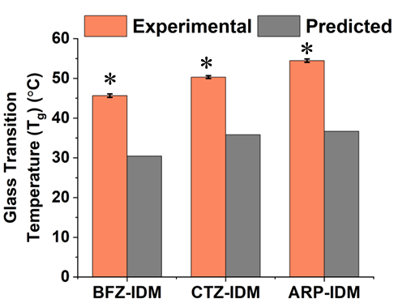
Figure 2: Experimental (T_{g}) and predicted (T_{g}^{GT}) glass transition temperatures of IDM-based COOH CAMs prepared with BFZ, CTZ or ARP at 1:1 molar ratio. An asterisk (*) symbol indicates statistically significant difference against the corresponding predicted T_{g} value (p < 0.05).

3.2.2. Analysis of 1:1 CAMS using ATR-FTIR spectroscopy
ATR-FTIR spectroscopy was conducted to examine potential interactions between drugs in the IDM-based COOH CAMs. Individual amorphous drugs were separately analyzed, whose peak assignments are presented in Table 2. Specific spectral regions for IDM-based COOH CAMs are presented in Figures 3, 4 and 5, wherein the spectra for individual amorphous drugs are also included to enable direct comparison. In all the spectra, only the characteristic peaks or peaks corresponding to functional groups that participated in interactions are marked. Additional peaks for the individual drugs and CAMs are presented and assigned in Supporting Information Table S2.
Table 2: Peak assignments for individual amorphous drugs obtained from ATR-FTIR spectroscopy
Drug (amorphous) | Peak Positions | Peak Assignments
BFZ | 725 cm⁻¹  1599 cm⁻¹  3028 cm⁻¹ | C-H bending of aromatic ring  C=N stretching vibrations  Aromatic C-H stretching vibrations
CTZ | 700 cm⁻¹  745 cm⁻¹  1591 cm⁻¹  3057 cm⁻¹ | C-H bending of aromatic ring  C-Cl stretching vibrations  C=N stretching vibrations  Aromatic C-H stretching
ARP | 776 cm⁻¹  1266 cm⁻¹  1673 cm⁻¹  3200 cm⁻¹ | C-Cl stretching vibrations  Aromatic C-O stretching  C=O stretching vibrations  N-H stretching of cyclic secondary amide
IDM | 749 cm⁻¹  1590 cm⁻¹  1676 cm⁻¹  1708 cm⁻¹  1736 cm⁻¹  3087 cm⁻¹ | C-Cl stretching vibrations  C=C of aromatic ring stretching  Benzoyl carbonyl C=O stretching  Carboxylic acid C=O stretching (dimer)  Carboxylic acid C=O stretching  Carboxylic acid O-H stretching
KPF | 784 cm⁻¹  1654 cm⁻¹  1703 cm⁻¹  1736 cm⁻¹  2938 cm⁻¹ | Out of plane C-H bending vibrations  Carboxylic acid C=O stretching (dimer)  Ketone C=O stretching  Carboxylic acid C=O stretching  Carboxylic acid O-H stretching
FBP | 764 cm⁻¹  1215 cm⁻¹  1694 cm⁻¹  2933 cm⁻¹ | Out of plane C-H bending vibrations  C-F stretching vibrations  Carboxylic acid C=O stretching  Carboxylic acid O-H stretching
FFA | 694 cm⁻¹  742 cm⁻¹  786 cm⁻¹  1326 cm⁻¹  1659 cm⁻¹  3335 cm⁻¹ | C-F stretching vibrations  C-F stretching vibrations  Out of plane C-H deformation  C=C stretching vibrations  Carboxylic acid C=O stretching  N-H stretching of secondary amide
Figure 3: ATR-FTIR spectrum of BFZ-IDM COOH CAM prepared at 1:1 molar ratio, depicted along with the spectra of amorphous BFZ and amorphous IDM controls.

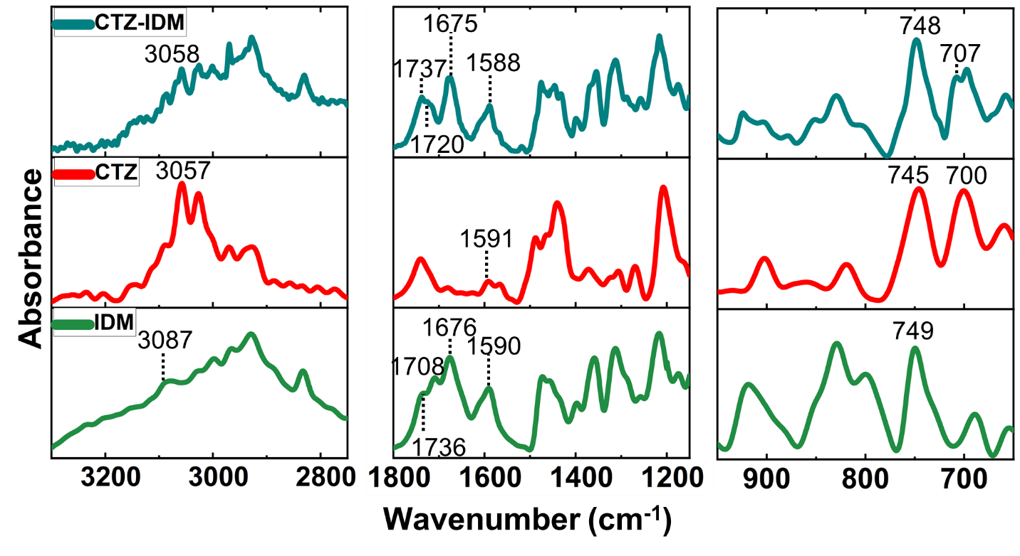
Compared to the individual amorphous drug spectra, attenuation of peaks was observed in the spectra of BFZ-IDM CAMs (Figure 3). Here, IDM's benzoyl C=O stretching shifted from 1676 to 1674 cm⁻¹ and carboxylic acid C=O stretching shifted from 1708 to 1720 cm⁻¹ and from 1736 to 1732 cm⁻¹. The out of plane C-H bending of BFZ’s aromatic ring shifted from 725 to 728 cm⁻¹, unlike the peak at 694 cm⁻¹. Further, BFZ’s aromatic C-H stretch vibrations shifted from 3028 to 3026 cm⁻¹ and C-H deformation shifted from 1480 cm⁻¹ to 1481 cm⁻¹ in the BFZ-IDM CAM (Supporting Information Table S2). Likewise, IDM's C-O stretching and C=C stretching of aromatic ring shifted from 1215 cm⁻¹ and 1472 cm⁻¹ to 1222 cm⁻¹ and 1470 cm⁻¹, respectively (Supporting Information Table S2). Finally, the C=C stretching vibrations of IDM’s aromatic ring shifted and merged with C=N stretching of BFZ at 1588 cm⁻¹ in the BFZ-IDM CAM.
Figure 4: ATR-FTIR spectrum of CTZ-IDM COOH CAM prepared at 1:1 molar ratio, depicted along with the spectra of amorphous CTZ and amorphous IDM controls.

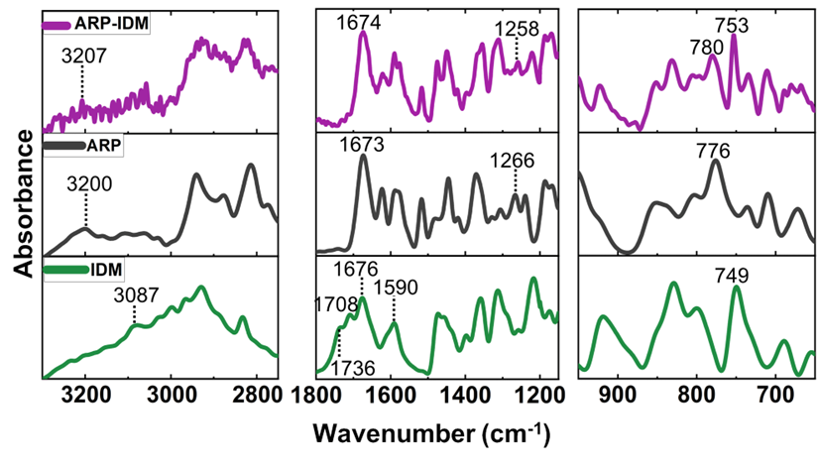
Attenuation of peaks was also observed in the spectra of CTZ-IDM CAMs compared to their respective individual amorphous drug spectra (Figure 4). Peak shifts in the CTZ-IDM CAMs included C-Cl stretch of CTZ and IDM appearing at 748 cm⁻¹, out of plane C-H bending of CTZ’s aromatic ring shifting from 700 to 707 cm⁻¹, IDM's benzoyl C=O stretching shifting from 1676 to 1675 cm⁻¹, IDM’s C-O stretching shifting from 1215 cm⁻¹ to 1216 cm⁻¹ and IDM’s C=C stretching in the aromatic ring shifting from 1472 cm⁻¹ to 1475 cm⁻¹. Importantly, the carboxylic acid C=O stretching of IDM shifted from 1708 to 1720 cm⁻¹ and from 1736 to 1737 cm⁻¹. Additionally, the C=C stretching in the aromatic ring of CTZ shifted from 1440 cm⁻¹ to 1445 cm⁻¹, while the aromatic C-H stretching in CTZ did not show any shift (Supporting Information Table S2). Finally, the C=N stretching vibrations of CTZ shifted from 1591 to 1588 cm⁻¹, while the aromatic C-H stretching of CTZ shifted from 3057 to 3058 cm⁻¹ in the CTZ-IDM CAM.
Figure 5: ATR-FTIR spectrum of ARP-IDM COOH CAM prepared at 1:1 molar ratio, depicted along with the spectra of amorphous ARP and amorphous IDM controls.

In the ARP-IDM CAMs, the transition from amorphous to co-amorphous environment was reflected in the diminution of peaks, as well as significant changes to the carboxylic acid region of IDM (Figure 5). Specifically, the carbonyl region of ARP broadened and merged with the carbonyl region of IDM at around 1674 cm⁻¹. Further, the carboxylic acid C=O stretching peaks for IDM at 1708 and 1736 cm⁻¹ were significantly diminished and almost disappeared in the ARP-IDM CAM. The CH₂ stretching and N-H stretch of cyclic secondary amide in ARP shifted from 2813 to 2819 cm⁻¹ and 3200 to 3207 cm⁻¹, respectively (Supporting Information Table S2). Finally, the C-Cl stretching vibrations of both IDM and ARP shifted from 749 cm⁻¹, 709 cm⁻¹ and 776 cm⁻¹ to 753 cm⁻¹, 710 cm⁻¹ and 780 cm⁻¹, respectively, in the ARP-IDM CAM.
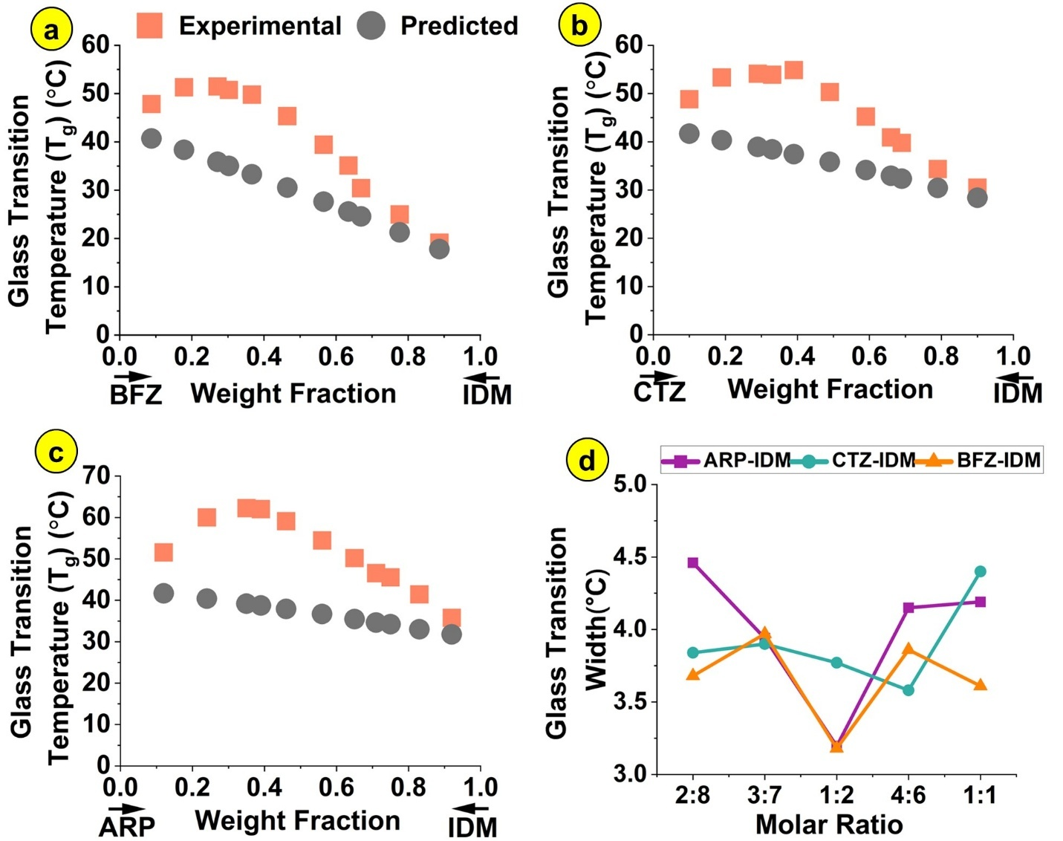
3.2.3. Analysis of T_{g} deviations for systematically varying molar ratios

Figure 6: Experimental (T_{g}) and predicted (T_{g}^{GT}) glass transition temperatures of (a) BFZ-IDM, (b) CTZ-IDM and (c) ARP-IDM COOH CAMs prepared at systematically varying molar ratios. The bottom X-axes in panels a-c depict drug weight fractions for ease of interpretation. (d) Width of the glass transition region for IDM-based COOH CAMs prepared at different molar ratios, which correspond to weight fractions of BFZ, CTZ or ARP ranging from ~0.2 to ~0.6.

In all the IDM-based COOH CAMs, positive T_{g} deviations were observed at all molar ratios (Figure 6a,b,c), with deviations being significantly higher at higher IDM weight fractions. The highest deviations were observed for ARP-IDM (ΔT_{g} = 23.3 °C) at 1:2 molar ratio, followed by CTZ-IDM (ΔT_{g} = 17.4 °C) at 4:6 molar ratio and BFZ-IDM (ΔT_{g} = 16.5 °C) at 4:6 molar ratio. The T_{g} width (i.e., the difference between onset and endpoint T_{g} values for a given transition) for different CAMs was analyzed over the range of compositions where the largest T_{g} deviations were observed. The molar ratio that exhibited the largest T_{g} deviation almost agreed with the ratio that resulted in the smallest T_{g} width (Figure 6d).

3.3. Extension of the analysis to other COOH CAMs
To extend the phenomenology of the trends observed in the IDM-based COOH CAMs, deviations in glass transition temperatures (ΔT_{g}) were also investigated for other 1:1 CAMs prepared with COOH containing drugs, namely KPF, FBP or FFA.
3.3.1. Preparation and analysis using DSC and XRD
Like the IDM-based COOH CAMs, all the CAMs prepared with KPF, FBP or FFA exhibited positive deviations as compared to their respective T_{g}^{GT} values (Figure 7). Among the KPF-based CAMs, the highest deviation was observed for ARP-KPF (ΔT_{g} = 17.1 ± 0.5 °C, p<0.0001) followed by CTZ-KPF (ΔT_{g} = 16.7 ± 0.2 °C, p<0.0001) and BFZ-KPF (ΔT_{g} = 15.6 ± 0.5 °C, p<0.0001). These deviations were comparable for FBP-based CAMs, with the highest deviation observed for ARP-FBP (ΔT_{g} = 18.8 ± 0.6 °C, p<0.0001), followed by CTZ-FBP (ΔT_{g} = 17.0 ± 0.3 °C, p<0.0001) and BFZ-FBP (ΔT_{g} = 15.4 ± 0.2 °C, p<0.0001). Among all the 1:1 molar ratio COOH CAMs tested in this study, ARP-FFA displayed the largest deviation (ΔT_{g} = 22.4 ± 0.3 °C, p<0.0001). However, CTZ-FFA (ΔT_{g} = 14.8 ± 0.4 °C, p<0.0001) and BFZ-FFA (ΔT_{g} = 10.7 ± 0.5 °C, p<0.0001) exhibited relatively less deviations. Representative diffraction spectra for COOH CAMs exhibiting the largest deviations (i.e., ARP-KPF, ARP-FBP and ARP-FFA) revealed a halo pattern (Supporting Information Figure S3), consistent with the amorphous phase.

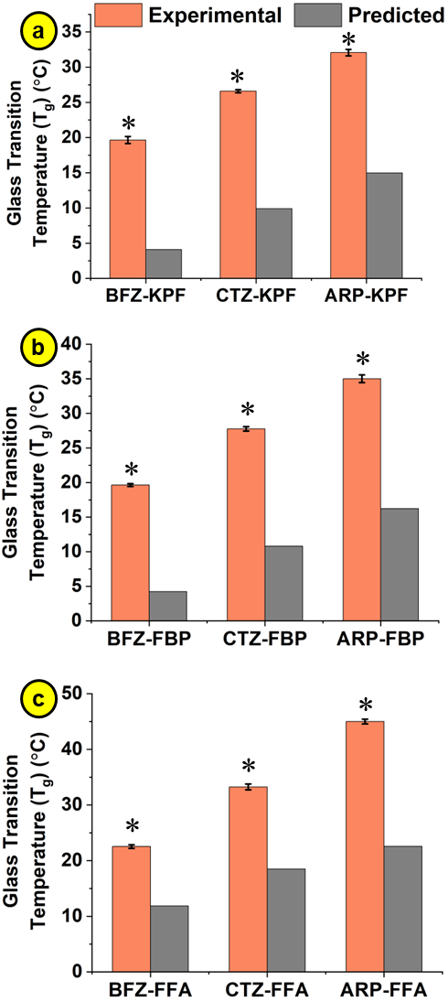
Figure 7: Experimental (T_{g}) and predicted (T_{g}^{GT}) glass transition temperatures of (a) KPF-based, (b) FBP-based and (c) FFA-based COOH CAMs prepared with ARP, CTZ or BFZ at 1:1 molar ratio. An asterisk (*) symbol indicates statistically significant difference against the corresponding predicted T_{g} value (p < 0.05).

3.3.2. Analysis of 1:1 CAMS using ATR-FTIR spectroscopy
Based on the T_{g} deviations being the maximum for ARP-KPF, ARP-FBP and ARP-FFA CAMs, these samples were further analyzed using ATR-FTIR spectroscopy. In the ARP-KPF CAMs (Supporting Information Figure S4), the carboxylic acid C=O stretching in KPF shifted from 1736 to 1727 cm⁻¹, while the ketone C=O stretching band at 1703 cm⁻¹ was not observed. Likewise, ARP’s C=O stretching peak shifted from 1673 to 1677 cm⁻¹, C-Cl stretching peak shifted from 776 to 778 cm⁻¹ and N-H stretching of the cyclic secondary amide shifted from 3200 to 3203 cm⁻¹ in the ARP-KPF CAMs. In ARP-FBP CAMs (Supporting Information Figure S5), the C-Cl stretching peak of ARP shifted from 776 to 779 cm⁻¹, while the C=O stretching band at 1673 cm⁻¹ shifted to 1676 cm⁻¹ and presented as a broad peak. The carboxylic acid C=O stretching of FBP at 1694 cm⁻¹ was significantly diminished and appeared to have merged with ARP’s peak at 1676 cm⁻¹. Likewise, the N-H stretching vibrations of the cyclic secondary amide in ARP shifted from 3200 to 3193 cm⁻¹ in the ARP-FBP CAMs. The transition to a co-amorphous environment was also reflected in the diminution of peaks in the spectra of ARP-FFA CAMs compared to their respective individual amorphous drug spectra (Supporting Information Figure S6). Here, peak shifts included FFA’s C=C stretching shifting from 1326 to 1329 cm⁻¹ and ARP’s N-H stretching of the cyclic secondary amide shifting from 3200 to 3202 cm⁻¹. The N-H stretching of FFA’s secondary amide at 3335 cm⁻¹ was significantly diminished in the CAMs, while the carboxylic acid C=O stretching band of FFA at 1659 cm⁻¹ was not observed in the CAM but appeared merged with the carbonyl region of ARP at 1675 cm⁻¹. Finally, the C-Cl stretching of ARP shifted from 776 to 781 cm⁻¹.

3.3.3. Analysis of T_{g} deviations for systematically varying molar ratios

Figure 8: Experimental (T_{g}) and predicted (T_{g}^{GT}) glass transition temperatures of a) ARP-KPF, b) ARP-FBP and c) ARP-FFA COOH CAMs prepared at systematically varying molar ratios. The bottom X-axes in panels a-c depict drug weight fractions for ease of interpretation. (d) Width of the glass transition region for COOH CAMs prepared at different molar ratios, which correspond to weight fraction of ARP ranging from ~0.2 to ~0.7.

For ARP-KPF, ARP-FBP and ARP-FFA, T_{g} deviations from predicted T_{g}^{GT} values were further analyzed at different molar ratios. Positive deviations were observed at all molar ratios (Figure 8), wherein deviations were generally larger at higher KPF or FBP or FFA weight fractions. The highest deviations were observed at 2:8 molar ratio for ARP-KPF (ΔT_{g} = 25.4 °C), 1:2 molar ratio for ARP-FBP (ΔT_{g} = 23.5 °C) and 1:1 molar ratio for ARP-FFA (ΔT_{g} = 22.4 °C). Concomitant visualization of the T_{g} width indicated a decreasing trend approaching 1:1 molar ratio for all CAMs (Figure 8d).
3.4. Analysis of non-COOH CAMs
To confirm the role of the COOH group in promoting significant deviations in T_{g} values, 1:1 CAMs were prepared with combinations of drugs lacking the COOH group viz., ARP, CTZ and BFZ (Figure 9a). The creation of the amorphous phase for all three non-COOH CAMs was confirmed using XRD (Supporting Information Figure S7). ARP-CTZ (ΔT_{g} = 0.1 ± 0.3 °C, p = 0.71) and ARP-BFZ (ΔT_{g} = 0.1 ± 0.2 °C, p = 0.25) did not exhibit statistically significant deviations from theoretically predicted T_{g}^{GT} values. Although the T_{g} of BFZ-CTZ showed a statistically significant difference compared to T_{g}^{GT} (ΔT_{g} = 0.8 ± 0.2 °C, p = 0.0009), this difference was not scientifically significant. Importantly, all three non-COOH CAMs exhibited no meaningful deviations from theoretical predictions at any of the tested molar ratios (Figure 9b,c,d). Further, the width of the T_{g} region for these non-COOH CAMs did not appear to show any specific trends as a function of molar ratio (data not shown). ATR-FTIR spectra for non-COOH CAMs are presented in Supporting Information Figures S8, S9 and S10. In the BFZ-CTZ CAMs, the C-Cl stretching bands of CTZ shifted from 745 to 748 cm⁻¹, the out of plane C-H bending of the CTZ aromatic ring shifted from 700 to 695 cm⁻¹ and the aromatic C-H stretching of BFZ and CTZ shifted from 3028 cm⁻¹ and 3057 cm⁻¹ to 3024 cm⁻¹ and 3056 cm⁻¹, respectively (Supporting Information Figure S8). In the ARP-CTZ CAMs, the C-Cl stretching of CTZ and ARP shifted from 745 and 776 to 748 cm⁻¹ and 779 cm⁻¹, respectively (Supporting Information Figure S9). While the carbonyl stretching band of ARP broadened and shifted from 1673 to 1678 cm⁻¹, the aromatic C-H stretching vibrations of CTZ shifted from 3057 to 3060 cm⁻¹ and the N-H stretching of ARP’s cyclic secondary amide shifted from 3200 to 3195 cm⁻¹. In the ARP-BFZ CAMs, the C-H bending of BFZ’s aromatic ring exhibited a shift from 725 to 728 cm⁻¹, and the carbonyl region of ARP broadened and shifted from 1673 to 1674 cm⁻¹ (Supporting Information Figure S10). Further, the aromatic C-H stretching vibrations of BFZ shifted from 3028 to 3026 cm⁻¹ and the N-H stretching of the cyclic secondary amide in ARP shifted from 3200 to 3195 cm⁻¹.
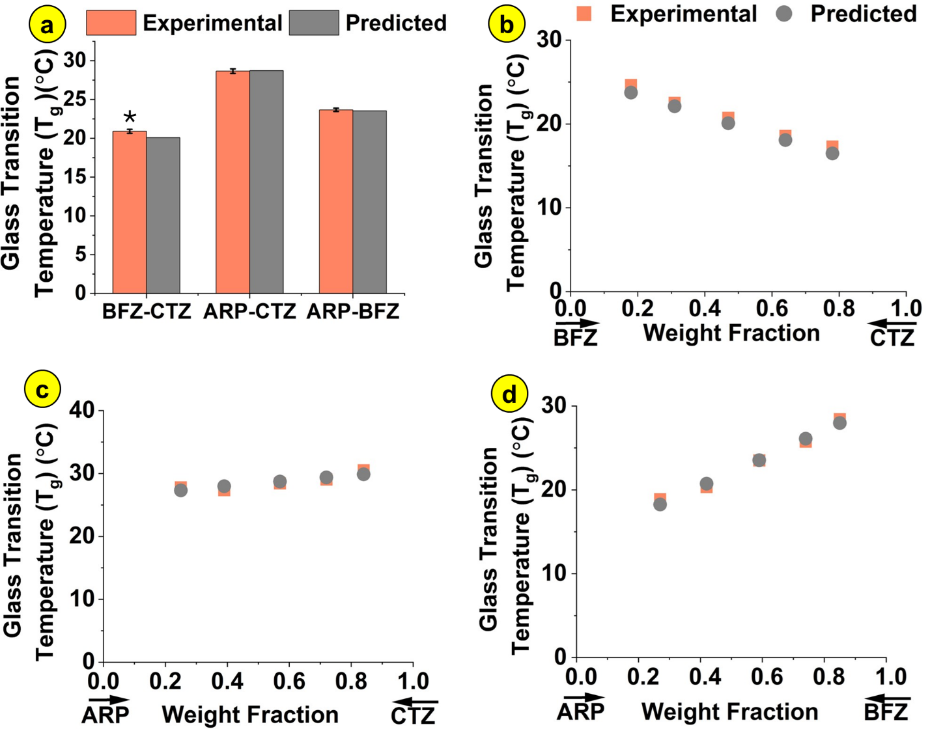
Figure 9: a) Experimental (T_{g}) and predicted (T_{g}^{GT}) glass transition temperatures of non-COOH CAMs prepared with BFZ, CTZ and ARP at 1:1 molar ratio. An asterisk (*) symbol indicates statistically significant difference against the corresponding predicted T_{g} value (p < 0.05). Experimental (T_{g}) and predicted (T_{g}^{GT}) glass transition temperatures of (b) BFZ-CTZ, (c) ARP-CTZ and (d) ARP-BFZ non-COOH CAMs prepared at systematically varying molar ratios. X-axes in panels b-d depict drug weight fractions for ease of interpretation.
4. Discussion
4.1. Preparation of CAMs
Several different preparation methods are available for CAMs such as spray drying ³⁸, hot melt extrusion ³⁹, quench-cooling ⁴⁰ and co-precipitation ⁴¹. In the present study, DSC was used to prepare CAMs following the well-established melt-quench method ⁴². Complete melting was ensured by heating 10 °C above the melting point of the higher melting drug, while the amorphous phase was stabilized by cooling to 20 °C below the expected T_{g} value. All the drugs used in this study belonged to either class 2 or 3 based on the crystallization tendency of undercooled melts ³⁷, and thus did not crystallize in the quenching cycle. The range of temperatures for the heating and cooling cycles (Supporting Information Table S1) were appropriately determined based on the thermal properties of specific drug combinations. For each drug, absence of thermal degradation over the tested temperature range was confirmed a priori using thermogravimetry analysis.
4.2. Analysis of T_{g} deviations in COOH CAMs prepared at 1:1 molar ratio
The thermal properties of 1:1 molar ratio COOH CAMs were analyzed using DSC. All the IDM-based COOH CAMs exhibited a single glass transition event in the second heating cycle, indicating a homogeneous amorphous phase. Cold-crystallization behavior was observed in the amorphous ARP control but was suppressed in 1:1 CAMs as confirmed by the absence of an exothermic peak in the second heating cycle (Supporting Information Figure S1). Previous studies have reported similar results for the inhibition of curcumin nucleation by chlorogenic acid due to hydrogen bonding ⁴³, and inhibition of ofloxacin crystallization in ofloxacin-tryptophan CAMs due to hydrogen bonding and π-π stacking ⁴⁴. In yet another study, hindered molecular mobility within CAMs was shown to inhibit the crystallization of ezetimib-indapamid, although neat amorphous ezetimib exhibited crystallization ⁴⁵.
For ideally mixed binary components, the T_{g} is expected to lie between the T_{g} values of the respective components weighted by their respective fractions ⁴⁶. This theoretical prediction of CAM T_{g} under the ideal mixing assumption is based on mixing rules given by the G-T equation ². A positive deviation may be attributed to the presence of strong intermolecular interactions between the two components ⁴⁷, wherein CAMs possessing high T_{g} values tend to show higher stability in the amorphous solid state ⁴⁸. All the 1:1 IDM-based COOH CAMs exhibited significant deviations from T_{g}^{GT} predictions (Figure 2), with IDM-ARP exhibiting the highest deviation. The ΔT_{g} trends observed for IDM-based COOH CAMs were also observed in CAMs prepared with KPF, FBP or FFA possessing the COOH group (Figure 7). Importantly, the T_{g} values of all COOH CAMs were higher than the higher T_{g} drug in each sample, which has been reported before for drugs possessing strong hydrogen bonding groups such as the carboxylic acid ⁴⁹. This elevation in the T_{g} of COOH CAMs can potentially be translated for formulation design to help improve the physical stability⁵⁰, reduce the recrystallization tendency ⁵¹ and enhance the kinetic stability⁵² during storage of CAMs.
4.3. Intermolecular interactions in COOH CAMs
The spectra of amorphous individual drugs exhibited peaks (Table 2) in accordance with previous reports in the literature ⁵³⁻⁵⁹. IDM-based COOH CAMs prepared at 1:1 molar ratio were first investigated as a representative class from the COOH CAMs. The interactions in BFZ-IDM CAMs (Figure 3) included a shift for the C=O stretching bands in IDM and the C-H deformation in BFZ, implying hydrogen bond formation. A similar interaction has been previously reported for the NH and COOH groups for co-amorphous systems of Naproxen-Cimetidine ⁹ and Cimetidine-Diflunisal ¹². Further, shifts in the out-of-plane C-H bending of the aromatic ring and aromatic C-H stretching vibrations of BFZ, as well as shifts in the C=C stretching of the aromatic ring in IDM suggested π-π interactions between the BFZ and IDM in the present study. In the case of CTZ-IDM CAMs (Figure 4), the shift of carbonyl bands in IDM indicated halogen bond formation between C=O of IDM and C-Cl of CTZ, which has been recently suggested in amorphous solid dispersions prepared with CTZ ¹⁶. The shift in the C=N region of CTZ indicated the formation of a hydrogen bond between the imidazole ring of CTZ and the OH of IDM. As with BFZ-IDM, shifts in the out-of-plane C-H bending, C=C stretching vibrations in aromatic rings and aromatic C-H stretching in CTZ, as well as shifts in the C=C stretching in the aromatic ring of IDM may be attributed to π-π interactions between CTZ and IDM.
In ARP-IDM CAMs (Figure 5), shifts in C-Cl stretching bands of both ARP and IDM indicated possible halogen bonds between C-Cl of ARP and C=O of IDM, as well as C-Cl of IDM and C=O of ARP. Significant peak shifts observed in the regions of N-H stretch of ARP implied hydrogen bonding. Importantly, the C=O stretching bands of the free carboxylic acid and acid dimer in amorphous IDM at 1736 cm⁻¹ and 1708 cm⁻¹, respectively, almost disappeared in the ARP-IDM CAMs, indicating ionic bond formation^{12-13, 60}, and disruption of IDM acid dimer through hydrogen bonding ⁶¹. These trends were also observed with other COOH CAMs prepared with ARP namely, ARP-KPF, ARP-FBP and ARP-FFA (Supporting Information Figure S4, Figure S5, Figure S6). In these COOH CAMs, significant peak shift in KPF’s C=O stretching, the absence of KPF’s ketone C=O stretching peak, significant diminution and broadening/merging of FBP’s C=O stretching peak and significant broadening/merging of FFA’s C=O stretching band indicated ionic bond formation. Importantly, ΔpKa values of ~3 or higher between drugs in the ARP-IDM, ARP-KPF, ARP-FBP and ARP-FFA CAMs would have favored ionic interactions ^{49, 62}, resulting in some of the highest T_{g} deviations across all 1:1 CAMs prepared in this study. Finally, shifts associated with ARP’s C=O stretching and ARP’s N-H stretching vibrations in the COOH CAMs indicated hydrogen bonding, while shifts in ARP’s C-Cl stretch suggested halogen bonding.
Previous studies have reported high T_{g} deviations arising from extensive intermolecular interactions between IDM and arginine in CAMs due to amorphous salt formation ⁴⁷. Similar deviations have also been observed by the addition of a salt co-former, enabling a ternary co-amorphous system of carbamazepine, citric acid, and l-arginine to complete salt formation ⁶³. Likewise, higher elevation in T_{g} has been reported for the sodium form of IDM compared to its free acid form due to strong ionic interactions ⁶⁴. In the current study, the T_{g} deviations for COOH CAMs may be explained primarily based on ionic bonds (including differences in pKa values) and COOH-associated hydrogen bonding with supporting contributions from π-π interactions and halogen bonding. Indeed, a similar positive deviation was reported by Huang et al. for valsartan CAMs in combination with histidine, wherein hydrogen bonding between valsartan's carboxylic acid and histidine amino groups, as well as ionic bonding due to salt formation between valsartan’s carboxylic acid and guanidyl vibrations of arginine, was confirmed by FTIR ⁶⁰. Taken together, the results from the current study reveal the effects of ionic, hydrogen, π-π and halogen bonds on the trends observed in ΔT_{g} values across CAMs.
4.4. Non-stoichiometric molar ratios in COOH CAMs and the role of molecular cooperativity
To understand the effect of COOH-containing drugs at non-stoichiometric molar ratios, systematically varying ratios from 1:9 to 9:1 were prepared and ΔT_{g} trends were visualized. All the COOH CAMs showed significant deviations over the entire range of molar ratios (Figure 6a,b,c and Figure 8a,b,c). Continuity in T_{g} as a function of the mixing ratios indicated that stoichiometric pairing had only a minor contribution towards CAM stabilization. For many of the COOH CAMs, the largest T_{g} deviations were often noted at non-stoichiometric molar ratios. Previous studies have reported similar trends for ΔT_{g} across systematically varied molar ratios. For example, Wu et al. reported the highest T_{g} deviation for carvedilol CAMs prepared with organic acids at non-stoichiometric ratios (1.5:1, 2:1) ⁶⁵, while Di et al. observed the highest deviation at 30% drug for carvedilol–tryptophan CAMs due to intensive hydrogen bonds ⁶⁶. The mechanism behind the largest deviations at non-stoichiometric ratios noted in the present study could be multi-faceted: extensive interactions between the components ⁴⁷, salt formation ⁶³, steric hindrance ⁶⁷ and the anti-plasticization effect. Although drugs such as IDM are known to form dimers by forming two hydrogen bonds using the carboxylic group ⁶⁸, an increase in ΔT_{g} with the addition of other drug molecules indicated stronger interactions than accounted for by COOH-associated hydrogen bond paring alone. Notably, a decrease in the width of the T_{g} region was observed for ARP-IDM, CTZ-IDM, ARP-FBP and ARP-FFA at non-stoichiometric molar ratios at which the highest T_{g} deviations were also seen. As a decreased width of the glass transition region originates from an increase in the characteristic length of the cooperatively rearranging region ²⁷, the trends in the present study indicate the formation of effective molecular networking structure via diverse molecular interactions ⁶⁹. Together, these results suggest increased molecular cooperativity as an important mechanism for CAM stabilization.
4.5. Analysis of CAMs lacking the COOH group
In the present study, CAMs prepared with drugs lacking the COOH group showed no meaningful deviations from T_{g}^{GT} predictions for all molar ratios that were tested (Figure 9). However, the absence of T_{g} deviations does not preclude the absence of intermolecular interactions ¹⁰. Indeed, intermolecular interactions were observed in these CAMs despite the absence of positive T_{g} deviations. In the BFZ-CTZ and ARP-CTZ CAMs, shifts in the C-Cl stretch regions of CTZ and ARP suggested the formation of halogen bonds. Likewise, significant shifts in the out-of-plane C-H bending of CTZ aromatic ring and aromatic C-H stretching vibrations of BFZ and CTZ indicated π-π interactions in BFZ-CTZ CAMs. Importantly, shifts in the N-H stretching region of ARP suggested possible non-COOH hydrogen bonding in ARP-CTZ and ARP-BFZ. These results are supported by a previous study by Chen et al., who reported an insignificant deviation in T_{g} for Nifedipine-epigallocatechin-3-gallate CAMs at 1:2 (0.19 °C) and 1:3 (0.12 °C) molar ratios, where hydrogen bonding was observed between the NH of Nifedipine and the OH of epigallocatechin-3-gallate ⁷⁰.
4.6. Generalized correlations for ΔT_{g} trends and molecular interactions
Table 3: Deviations in glass transition temperatures for 1:1 CAMs and possible interactions
 | FFA | FBP | IDM | KPF | CTZ | BFZ
ARP | 22.4 ± 0.3 | 18.8 ± 0.6 | 17.8 ± 0.4 | 17.1 ± 0.5 | 0.1 ± 0.3 | 0.1 ± 0.2
CTZ | 14.8 ± 0.4 | 17.0 ± 0.3 | 14.5 ± 0.4 | 16.7 ± 0.2 | - | 0.8 ± 0.3
BFZ | 10.7 ± 0.5 | 15.4 ± 0.2 | 15.2 ± 0.4 | 15.6 ± 0.5 | 0.8 ± 0.3 | -

Possible interactions
Orange cells: Ionic bond, COOH-associated hydrogen bond, π-π interactions, halogen bond
Blue cells: COOH-associated hydrogen bond, π-π interactions, possible halogen bond
Green cells: Non-COOH hydrogen bond, π-π interactions, possible halogen bond

To develop a generalized design framework for T_{g} deviations and intermolecular interactions, all the 15 different CAMs tested in this study were ordered based on the ΔT_{g} values and categorized into three different groups based on the proposed nature of interactions (Table 3). The first type of intermolecular interactions included ionic bonds, COOH-associated hydrogen bonds, π-π interactions and halogen bonds. This group included 1:1 CAMs that showed the largest T_{g} deviations, namely ARP-FFA, ARP-FBP, ARP-IDM and ARP-KPF. In these CAMs, the co-existence of π-π interactions and halogen bonds could have exerted synergistic effects to further enhance T_{g} elevation. The second category of interactions included COOH-associated hydrogen bonds and π-π interactions, with or without halogen bonds. The overall ΔT_{g} values were lower in this category as compared to the first category, which may be attributed to the lower strength of the COOH-associated hydrogen bonds as compared to ionic bonds associated with salt formation ⁷¹. The third category of interactions included non-COOH hydrogen bonds and π-π interactions, with or without halogen bonds, which included BFZ- CTZ, ARP-BFZ and ARP-CTZ CAMs. The T_{g} values in this last group showed no significant deviations from theoretically predicted T_{g}^{GT} values. These results are in accordance with the weak nature of the hydrogen bonds formed in such CAMs ⁷⁰. These results also suggest that π-π interactions or halogen bonds on their own may not be sufficient to cause large shifts in T_{g} values. In summary, the results from this study establish that T_{g} elevation can be directly influenced by the type, strength and diversity of interactions between mixtures of two drugs in the amorphous state. These results further demonstrate that simple rules based on H-bond donors/acceptors that do not account for specific interactions may not be suitable for CAM design as drugs possessing similar H-bond donors/acceptors (Table 1) do not necessarily show similar T_{g} elevation trends.
Although a limited number of CAM combinations were tested at several molar ratios in the present study, a larger set of CAMs with diverse functional groups and pKa values (beyond those explored herein) may be investigated in the future by employing design-of-experiments approaches (e.g., screening designs). Such a strategy would enable the development of universal guidelines for drug-drug CAMs exhibiting elevated T_{g} values. Further, drug combinations investigated in this study were not chosen based on pharmacological relevance or for specific clinical applications because the goal was to understand the relationship between glass transition elevation and molecular interactions in amorphous drug mixtures. Although CAMs prepared using anti-fungal drugs and NSAIDs (e.g., CTZ-IDM, BFZ-KFP) may potentially be used to overcome fungal resistance and improve anti-fungal efficacy ⁷²⁻⁷³, the generalized correlations between drug-drug interactions and T_{g} deviations reported in Table 3 have larger implications for CAM design. More specifically, they can be used to inform the choice of drugs and the type of functional groups required to promote the stability of CAMs in desired pharmaceutical applications. Finally, the stability and solubility advantages conferred by T_{g} elevation will need to be investigated in the future because CAM stability is known to depend on factors other than T_{g} alone (e.g., molecular mobility, anti-plasticization effect, molar ratios) ⁷⁴.

5. Conclusions
In this study, CAMs with varying molar ratios were prepared using IDM, FFA, FBP, or KPF with ARP, CTZ or BFZ. Deviations in T_{g} values from theoretical predictions were systematically analyzed. While the T_{g} values of all non-COOH CAMs were in accordance with predicted values under the assumption of ideal mixing, all the IDM-based, KPF-based, FBP-based and FFA-based COOH CAMs exhibited significant positive deviations at all molar ratios. The highest T_{g} deviations were noted for CAMs that involved ionic bonds (ΔpKa value of ~3 or higher), COOH-associated hydrogen bonds and synergistic contributions from π-π interactions and halogen bonds. COOH-associated hydrogen bonds, along with π-π interactions, also resulted in significant T_{g} deviations, albeit to a lesser extent. Non-COOH hydrogen bonds, halogen bonds and π-π interactions on their own did not result in significant T_{g} elevation. Diversity in interaction modes appeared to increase T_{g} values due to higher molecular cooperativity as indicated by a decrease in T_{g} width. Overall, this study offers a generalized framework to correlate T_{g} deviations with intermolecular interactions, thus laying the foundation for the design of stable CAMs.

Supporting Information
Table S1: DSC temperature limits for melt-quench cycles; Table S2: Additional FTIR peaks and assignments; Figures S1: Representative DSC thermograms of IDM-based COOH CAMs; Figure S2: X-ray diffractograms of IDM-based COOH CAMs; Figure S3: X-ray diffractograms of other COOH CAMs; Figure S4: ATR-FTIR spectrum of 1:1 ARP-KPF CAM; Figure S5: ATR-FTIR spectrum of 1:1 ARP-FBP CAM; Figure S6: ATR-FTIR spectrum of 1:1 ARP-FFA CAM; Figure S7: X-ray diffractograms of IDM-based non-COOH CAMs; Figure S8: ATR-FTIR spectrum of 1:1 BFZ-CTZ CAM; Figure S9: ATR-FTIR spectrum of 1:1 ARP-CTZ CAM; Figure S10: ATR-FTIR spectrum of 1:1 ARP-BFZ CAM

Acknowledgments
SS thanks the IITH-NIMS joint center for supporting a long-term collaborative visit to NIMS, Japan.

Declaration of interests: The authors declare no competing interests.
5. References
1. Kawakami, K., Modification of physicochemical characteristics of active pharmaceutical ingredients and application of supersaturatable dosage forms for improving bioavailability of poorly absorbed drugs. Advanced drug delivery reviews 2012, 64 (6), 480-495.
2. Baird, J. A.; Taylor, L. S., Evaluation of amorphous solid dispersion properties using thermal analysis techniques. Advanced drug delivery reviews 2012, 64 (5), 396-421.
3. Pugliese, A.; Tobyn, M.; Hawarden, L. E.; Abraham, A.; Blanc, F., New Development in Understanding Drug–Polymer Interactions in Pharmaceutical Amorphous Solid Dispersions from Solid-State Nuclear Magnetic Resonance. Molecular Pharmaceutics 2022, 19 (11), 3685-3699.
4. Kawakami, K., Crystallization tendency of pharmaceutical glasses: relevance to compound properties, impact of formulation process, and implications for design of amorphous solid dispersions. Pharmaceutics 2019, 11 (5), 202.
5. Bhujbal, S. V.; Mitra, B.; Jain, U.; Gong, Y.; Agrawal, A.; Karki, S.; Taylor, L. S.; Kumar, S.; Zhou, Q. T., Pharmaceutical amorphous solid dispersion: A review of manufacturing strategies. Acta Pharmaceutica Sinica B 2021, 11 (8), 2505-2536.
6. Liu, J.; Grohganz, H.; Löbmann, K.; Rades, T.; Hempel, N.-J., Co-amorphous drug formulations in numbers: Recent advances in co-amorphous drug formulations with focus on co-formability, molar ratio, preparation methods, physical stability, in vitro and in vivo performance, and new formulation strategies. Pharmaceutics 2021, 13 (3), 389.
7. Chen, X.; Li, D.; Zhang, H.; Duan, Y.; Huang, Y., Co-amorphous systems of sinomenine with nonsteroidal anti-inflammatory drugs: A strategy for solubility improvement, sustained release, and drug combination therapy against rheumatoid arthritis. International journal of pharmaceutics 2021, 606, 120894.
8. Cruz-Angeles, J.; Videa, M.; Martínez, L. M., Highly soluble glimepiride and irbesartan co-amorphous formulation with potential application in combination therapy. AAPS PharmSciTech 2019, 20, 1-12.
9. Allesø, M.; Chieng, N.; Rehder, S.; Rantanen, J.; Rades, T.; Aaltonen, J., Enhanced dissolution rate and synchronized release of drugs in binary systems through formulation: Amorphous naproxen–cimetidine mixtures prepared by mechanical activation. Journal of Controlled Release 2009, 136 (1), 45-53.
10. Löbmann, K.; Laitinen, R.; Grohganz, H.; Gordon, K. C.; Strachan, C.; Rades, T., Coamorphous drug systems: enhanced physical stability and dissolution rate of indomethacin and naproxen. Molecular pharmaceutics 2011, 8 (5), 1919-1928.
11. Gniado, K.; Löbmann, K.; Rades, T.; Erxleben, A., The influence of co-formers on the dissolution rates of co-amorphous sulfamerazine/excipient systems. International journal of pharmaceutics 2016, 504 (1-2), 20-26.
12. Yamamura, S.; Gotoh, H.; Sakamoto, Y.; Momose, Y., Physicochemical properties of amorphous salt of cimetidine and diflunisal system. International journal of pharmaceutics 2002, 241 (2), 213-221.
13. Deng, Y.; Deng, W.; Huang, W.; Zheng, Z.; Zhang, R.; Liu, S.; Jiang, Y., Norfloxacin co-amorphous salt systems: Effects of molecular descriptors on the formation and physical stability of co-amorphous systems. Chemical Engineering Science 2022, 253, 117549.
14. Allu, S.; Suresh, K.; Bolla, G.; Mannava, M. C.; Nangia, A., Role of hydrogen bonding in cocrystals and coamorphous solids: indapamide as a case study. CrystEngComm 2019, 21 (13), 2043-2048.
15. Dengale, S. J.; Ranjan, O. P.; Hussen, S. S.; Krishna, B.; Musmade, P. B.; Shenoy, G. G.; Bhat, K., Preparation and characterization of co-amorphous Ritonavir–Indomethacin systems by solvent evaporation technique: Improved dissolution behavior and physical stability without evidence of intermolecular interactions. European journal of pharmaceutical sciences 2014, 62, 57-64.
16. Que, C.; Qi, Q.; Zemlyanov, D. Y.; Mo, H.; Deac, A.; Zeller, M.; Indulkar, A. S.; Gao, Y.; Zhang, G. G.; Taylor, L. S., Evidence for halogen bonding in amorphous solid dispersions. Crystal Growth & Design 2020, 20 (5), 3224-3235.
17. Bookwala, M.; Buckner, I. S.; Wildfong, P. L., Implications of coexistent halogen and hydrogen bonds in amorphous solid dispersions on drug solubility, miscibility, and mobility. Molecular Pharmaceutics 2022, 19 (11), 3959-3972.
18. Alhalaweh, A.; Alzghoul, A.; Mahlin, D.; Bergström, C. A., Physical stability of drugs after storage above and below the glass transition temperature: Relationship to glass-forming ability. International journal of pharmaceutics 2015, 495 (1), 312-317.
19. Ueda, H.; Hirakawa, Y.; Miyano, T.; Imono, M.; Tse, J. Y.; Uchiyama, H.; Tozuka, Y.; Kadota, K., Design of a stable coamorphous system using lactose as an antiplasticizing agent for diphenhydramine hydrochloride with a low glass transition temperature. Molecular Pharmaceutics 2022, 19 (4), 1209-1218.
20. Lodagekar, A.; Chavan, R. B.; Mannava, M. C.; Yadav, B.; Chella, N.; Nangia, A. K.; Shastri, N. R., Co amorphous valsartan nifedipine system: Preparation, characterization, in vitro and in vivo evaluation. European Journal of Pharmaceutical Sciences 2019, 139, 105048.
21. Fung, M. H.; DeVault, M.; Kuwata, K. T.; Suryanarayanan, R., Drug-excipient interactions: effect on molecular mobility and physical stability of ketoconazole–organic acid coamorphous systems. Molecular pharmaceutics 2018, 15 (3), 1052-1061.
22. Jensen, K. T.; Löbmann, K.; Rades, T.; Grohganz, H., Improving co-amorphous drug formulations by the addition of the highly water soluble amino acid, proline. Pharmaceutics 2014, 6 (3), 416-435.
23. Xu, X.; Grohganz, H.; Rades, T., Influence of water on amorphous lidocaine. Molecular Pharmaceutics 2022, 19 (9), 3199-3205.
24. Pezzoli, R.; Lyons, J. G.; Gately, N.; Higginbotham, C. L., Investigation of miscibility estimation methods between indomethacin and poly (vinylpyrrolidone-co-vinyl acetate). International journal of pharmaceutics 2018, 549 (1-2), 50-57.
25. Yarlagadda, D. L.; Anand, V. S. K.; Nair, A. R.; Sree, K. N.; Dengale, S. J.; Bhat, K., Considerations for the selection of co-formers in the preparation of co-amorphous formulations. International journal of pharmaceutics 2021, 602, 120649.
26. Newman, A.; Zografi, G., Commentary: Considerations in the measurement of glass transition temperatures of pharmaceutical amorphous solids. Aaps Pharmscitech 2020, 21, 1-13.
27. Donth, E., The size of cooperatively rearranging regions at the glass transition. Journal of Non-Crystalline Solids 1982, 53 (3), 325-330.
28. Bhugra, C.; Shmeis, R.; Pikal, M. J., Role of mechanical stress in crystallization and relaxation behavior of amorphous indomethacin. Journal of pharmaceutical sciences 2008, 97 (10), 4446-4458.
29. Blaabjerg, L. I.; Lindenberg, E.; Löbmann, K.; Grohganz, H.; Rades, T., Glass forming ability of amorphous drugs investigated by continuous cooling and isothermal transformation. Molecular pharmaceutics 2016, 13 (9), 3318-3325.
30. Suñer-Carbó, J.; Calpena-Campmany, A.; Halbaut-Bellowa, L.; Clares-Naveros, B.; Rodriguez-Lagunas, M. J.; Barbolini, E.; Zamarbide-Losada, J.; Boix-Montañés, A., Biopharmaceutical development of a bifonazole multiple emulsion for enhanced epidermal delivery. Pharmaceutics 2019, 11 (2), 66.
31. Usach, I.; Martínez-Álvarez, P.; Peris, J.-E., Topical delivery systems containing clotrimazole for the management of candidiasis: Effect of different excipients and enhanced antifungal activity of nanovesicles. International journal of pharmaceutics 2023, 644, 123287.
32. Zhou, Q.; Tan, Z.; Yang, D.; Tu, J.; Wang, Y.; Zhang, Y.; Liu, Y.; Gan, G., Improving the solubility of aripiprazole by multicomponent crystallization. Crystals 2021, 11 (4), 343.
33. Shete, S.; Reddy, S. C.; Lakshman, Y. D.; Vullendula, S. K. A.; Mehta, C. H.; Nayak, U. Y.; Dengale, S., Implications of phase solubility/miscibility and drug-rich phase formation on the performance of co-amorphous materials: The case of Darunavir co-amorphous materials with Ritonavir and Indomethacin as co-formers. International journal of pharmaceutics 2021, 608, 121119.
34. Abou-Taleb, H. A.; Shoman, M. E.; Makram, T. S.; Abdel-Aleem, J. A.; Abdelkader, H., Exploration of the safety and solubilization, dissolution, analgesic effects of common basic excipients on the NSAID drug ketoprofen. Pharmaceutics 2023, 15 (2), 713.
35. Domanska, U.; Pobudkowska, A.; Pelczarska, A.; Gierycz, P., p K a and Solubility of Drugs in Water, Ethanol, and 1-Octanol. The Journal of Physical Chemistry B 2009, 113 (26), 8941-8947.
36. Manallack, D. T., The p K a distribution of drugs: application to drug discovery. Perspectives in medicinal chemistry 2007, 1, 1177391X0700100003.
37. Baird, J. A.; Van Eerdenbrugh, B.; Taylor, L. S., A classification system to assess the crystallization tendency of organic molecules from undercooled melts. Journal of pharmaceutical sciences 2010, 99 (9), 3787-3806.
38. Jensen, K. T.; Blaabjerg, L. I.; Lenz, E.; Bohr, A.; Grohganz, H.; Kleinebudde, P.; Rades, T.; Löbmann, K., Preparation and characterization of spray-dried co-amorphous drug–amino acid salts. Journal of Pharmacy and Pharmacology 2016, 68 (5), 615-624.
39. Partheniadis, I.; Nikolakakis, I., Development and characterization of co-amorphous griseofulvin/L-leucin by modified solvent processing hot-melt extrusion. International journal of pharmaceutics 2024, 652, 123824.
40. Fael, H.; Demirel, A. L., Indomethacin co-amorphous drug-drug systems with improved solubility, supersaturation, dissolution rate and physical stability. International journal of pharmaceutics 2021, 600, 120448.
41. Lim, A. W.; Löbmann, K.; Grohganz, H.; Rades, T.; Chieng, N., Investigation of physical properties and stability of indomethacin–cimetidine and naproxen–cimetidine co-amorphous systems prepared by quench cooling, coprecipitation and ball milling. Journal of Pharmacy and Pharmacology 2016, 68 (1), 36-45.
42. Kawakami, K.; Harada, T.; Miura, K.; Yoshihashi, Y.; Yonemochi, E.; Terada, K.; Moriyama, H., Relationship between crystallization tendencies during cooling from melt and isothermal storage: toward a general understanding of physical stability of pharmaceutical glasses. Molecular pharmaceutics 2014, 11 (6), 1835-1843.
43. Han, J.; Wei, Y.; Li, L.; Song, Y.; Pang, Z.; Qian, S.; Zhang, J.; Gao, Y.; Heng, W., Gelation elimination and crystallization inhibition by co-amorphous strategy for amorphous curcumin. Journal of pharmaceutical sciences 2023, 112 (1), 182-194.
44. Zhu, S.; Gao, H.; Babu, S.; Garad, S., Co-amorphous formation of high-dose zwitterionic compounds with amino acids to improve solubility and enable parenteral delivery. Molecular pharmaceutics 2018, 15 (1), 97-107.
45. Knapik, J.; Wojnarowska, Z.; Grzybowska, K.; Jurkiewicz, K.; Tajber, L.; Paluch, M., Molecular dynamics and physical stability of coamorphous ezetimib and indapamide mixtures. Molecular pharmaceutics 2015, 12 (10), 3610-3619.
46. Yarlagadda, D. L.; Anand, V. S. K.; Nair, A. R.; Dengale, S. J.; Pandiyan, S.; Mehta, C. H.; Manandhar, S.; Nayak, U. Y.; Bhat, K., A computational-based approach to fabricate Ceritinib co-amorphous system using a novel co-former Rutin for bioavailability enhancement. European Journal of Pharmaceutics and Biopharmaceutics 2023, 190, 220-230.
47. Jensen, K. T.; Larsen, F. H.; Löbmann, K.; Rades, T.; Grohganz, H., Influence of variation in molar ratio on co-amorphous drug-amino acid systems. European Journal of Pharmaceutics and Biopharmaceutics 2016, 107, 32-39.
48. Ueda, H.; Muranushi, N.; Sakuma, S.; Ida, Y.; Endoh, T.; Kadota, K.; Tozuka, Y., A strategy for co-former selection to design stable co-amorphous formations based on physicochemical properties of non-steroidal inflammatory drugs. Pharmaceutical research 2016, 33, 1018-1029.
49. Zhang, M.; Xiong, X.; Suo, Z.; Hou, Q.; Gan, N.; Tang, P.; Ding, X.; Li, H., Co-amorphous palbociclib–organic acid systems with increased dissolution rate, enhanced physical stability and equivalent biosafety. RSC advances 2019, 9 (7), 3946-3955.
50. Kissi, E. O.; Kasten, G.; Löbmann, K.; Rades, T.; Grohganz, H., The role of glass transition temperatures in coamorphous drug–amino acid formulations. Molecular Pharmaceutics 2018, 15 (9), 4247-4256.
51. Hiew, T. N.; Taylor, L. S., Combining drug salt formation with amorphous solid dispersions–a double edged sword. Journal of Controlled Release 2022, 352, 47-60.
52. Červinka, C.; Fulem, M., Structure and glass transition temperature of amorphous dispersions of model pharmaceuticals with nucleobases from molecular dynamics. Pharmaceutics 2021, 13 (8), 1253.
53. Lin, S.-Y.; Lin, H.-L.; Chi, Y.-T.; Huang, Y.-T.; Kao, C.-Y.; Hsieh, W.-H., Thermoanalytical and Fourier transform infrared spectral curve-fitting techniques used to investigate the amorphous indomethacin formation and its physical stability in Indomethacin-Soluplus® solid dispersions. International journal of pharmaceutics 2015, 496 (2), 457-465.
54. Jaworska-Krych, D.; Gosecka, M.; Gosecki, M.; Urbaniak, M.; Dzitko, K.; Ciesielska, A.; Wielgus, E.; Kadlubowski, S.; Kozanecki, M., Enhanced Solubility and Bioavailability of Clotrimazole in Aqueous Solutions with Hydrophobized Hyperbranched Polyglycidol for Improved Antifungal Activity. ACS applied materials & interfaces 2024, 16 (15), 18434-18448.
55. Hamideh, A.; Rahman, Z.; Dharani, S.; Khuroo, T.; Mohamed, E. M.; Nutan, M. T.; Reddy, I. K.; Khan, M. A., Preparation and characterization of dicarboxylic acids salt of aripiprazole with enhanced physicochemical properties. Pharmaceutical development and technology 2021, 26 (4), 455-463.
56. Shah, D. S.; Gurram, S.; Gadlawar, V. N.; Jha, D. K.; Kamble, S. P.; Amin, P. D., Co-amorphous system of Bifonazole for improved in-vitro permeation and antifungal activity. JCIS Open 2024, 14, 100108.
57. Choi, S.-H.; Kim, S.-Y.; Ryoo, J. J.; Park, J. Y.; Lee, K.-P., FT-Raman and FT-IR spectra of the non-steroidal anti-inflammatory drug ketoprofen included in cyclodextrins. Analytical Sciences/Supplements 2002, 17 (0), i785-i788.
58. Aminu, N.; Chan, S.-Y.; Mumuni, M. A.; Umar, N. M.; Tanko, N.; Zauro, S. A.; Aminu, A.; Toh, S.-M., Physicochemical compatibility studies of triclosan and flurbiprofen with excipients of pharmaceutical formulation using binary, ternary, and multi-combination approach. Future Journal of Pharmaceutical Sciences 2021, 7, 1-16.
59. Pang, Y.; Buanz, A.; Gaisford, S.; Magdysyuk, O. V.; Williams, G. R., Monitoring polymorphic phase transitions in flufenamic acid amorphous solid dispersions using hyphenated X-ray diffraction–differential scanning calorimetry. Molecular Pharmaceutics 2022, 19 (5), 1477-1487.
60. Huang, Y.; Zhang, Q.; Wang, J.-R.; Lin, K.-L.; Mei, X., Amino acids as co-amorphous excipients for tackling the poor aqueous solubility of valsartan. Pharmaceutical development and technology 2017, 22 (1), 69-76.
61. Ueda, H.; Aikawa, S.; Kashima, Y.; Kikuchi, J.; Ida, Y.; Tanino, T.; Kadota, K.; Tozuka, Y., Anti-plasticizing effect of amorphous indomethacin induced by specific intermolecular interactions with PVA copolymer. Journal of pharmaceutical sciences 2014, 103 (9), 2829-2838.
62. Hatanaka, Y.; Uchiyama, H.; Kaneko, S.; Ueda, K.; Higashi, K.; Moribe, K.; Furukawa, S.; Takase, M.; Yamanaka, S.; Kadota, K., Designing a novel coamorphous salt formulation of telmisartan with amlodipine to enhance permeability and oral absorption. Molecular Pharmaceutics 2023, 20 (8), 4071-4085.
63. Ueda, H.; Wu, W.; Löbmann, K.; Grohganz, H.; Müllertz, A.; Rades, T., Application of a salt coformer in a co-amorphous drug system dramatically enhances the glass transition temperature: A case study of the ternary system carbamazepine, citric acid, and l-arginine. Molecular Pharmaceutics 2018, 15 (5), 2036-2044.
64. Tong, P.; Zografi, G., Solid-state characteristics of amorphous sodium indomethacin relative to its free acid. Pharmaceutical research 1999, 16, 1186-1192.
65. Wu, W.; Ueda, H.; Löbmann, K.; Rades, T.; Grohganz, H., Organic acids as co-formers for co-amorphous systems–Influence of variation in molar ratio on the physicochemical properties of the co-amorphous systems. European Journal of Pharmaceutics and Biopharmaceutics 2018, 131, 25-32.
66. Di, R.; Liu, J.; Grohganz, H.; Rades, T., A multivariate approach for the determination of the optimal mixing ratio of the non-strong interacting co-amorphous system carvedilol-tryptophan. Molecules 2021, 26 (4), 801.
67. Lodagekar, A.; Chavan, R. B.; Chella, N.; Shastri, N. R., Role of valsartan as an antiplasticizer in development of therapeutically viable drug–drug coamorphous system. Crystal growth & design 2018, 18 (4), 1944-1950.
68. Gupta, M. K.; Vanwert, A.; Bogner, R. H., Formation of physically stable amorphous drugs by milling with Neusilin. Journal of pharmaceutical sciences 2003, 92 (3), 536-551.
69. Kawakami, K., Dynamics of ribavirin glass in the sub-T g temperature region. The Journal of Physical Chemistry B 2011, 115 (39), 11375-11381.
70. Chen, J.; Li, H.; Li, X.; Yuan, D.; Cheng, H.; Ke, Y.; Cheng, J.; Wang, Z.; Chen, J.; Li, J., Co-amorphous systems using epigallocatechin-3-gallate as a co-former: Stability, in vitro dissolution, in vivo bioavailability and underlying molecular mechanisms. European Journal of Pharmaceutics and Biopharmaceutics 2022, 178, 82-93.
71. Ekawa, B.; Diogo, H. P.; Castro, R. A.; Caires, F. J.; Eusébio, M. E. S., Coamorphous Systems of Valsartan: Thermal Analysis Contribution to Evaluate Intermolecular Interactions Effects on the Structural Relaxation. Molecules 2023, 28 (17), 6240.
72. Brilhante, R. S. N.; Brasil, J. A.; Oliveira, J. S. d.; Pereira, V. S.; Pereira-Neto, W. d. A.; Sidrim, J. J. C.; Rocha, M. F. G., Diclofenac exhibits synergism with azoles against planktonic cells and biofilms of Candida tropicalis. Biofouling 2020, 36 (5), 528-536.
73. Rocha, L. F. d.; Pippi, B.; Fuentefria, A. M.; Mezzari, A., Synergistic effect of ibuprofen with itraconazole and fluconazole against Cryptococcus neoformans. Brazilian Journal of Pharmaceutical Sciences 2020, 56, e18599.
74. Shi, Q.; Moinuddin, S. M.; Cai, T., Advances in coamorphous drug delivery systems. Acta pharmaceutica sinica B 2019, 9 (1), 19-35.

Table of contents graphic
