Robust aortic media adhesion using hydrophobically-modified Alaska pollock gelatin-based adhesive for aortic dissections

Temmei Ito^{1, 2}, Ryo Mizuta^{1, 2}, Shima Ito^{1,2}, Tetsushi Taguchi^{1, 2}*

¹Graduate School of Pure and Applied Sciences, University of Tsukuba, 1-1-1 Tennodai, Tsukuba, Ibaraki 305-8577, Japan
²Biomaterials Field, Research Center for Macromolecules and Biomaterials, National Institute for Materials Science, 1-1 Namiki, Tsukuba, Ibaraki 305-0044, Japan

* Author to whom correspondence should be addressed.
Tel: +81-29-60-4498
Fax: +81-29-851-4714
E-mail: taguchi.tetsushi@nims.go.jp
Abstract
Type-A aortic dissection is an acute injury involving the delamination of the aorta at the parts of the aortic media. Aldehyde crosslinker-containing glues have been used to adhere the media of the dissected aorta before joining an artificial graft. These glues effectively adhere to the aortic media; however, they show low biocompatibility due to the release of aldehyde compounds. In this study, we report innovative adhesives based on hydrophobically-modified Alaska pollock gelatin (hm-ApGltn) with different alkyl or cholesteryl groups that adhere to the media of the dissected aorta by combining hm-ApGltns with a biocompatible crosslinker, pentaerythritol poly(ethylene glycol) ether tetrasuccinimidyl glutarate (4S-PEG). The modification of alkyl or cholesteryl (Chol) groups contributed to enhanced adhesion strength between porcine aortic media. The adhesion strength increased with increasing modification ratios of alkyl groups from propanoyl to dodecanoyl groups and then decreased at a modification ratio of ~20 mol%. Porcine aortic media adhered using 7.5Chol-ApGltn adhesive showed stretchability even when expanded and shrunk vertically by 25% at least five times. Hm-ApGltn adhesives subcutaneously injected into the backs of mice showed no severe inflammation and were degraded during the implantation period. These results indicated that hm-ApGltn adhesives have potential applications in type-A aortic dissection.
Introduction
Acute aortic dissection is a serious vascular disease that causes delamination of the intima from most of the media layer extending from the outer adventitious layer along the aorta. Acute aortic dissections are classified into two types according to the Stanford classification system introduced in 1970¹: Type-A aortic dissection involves intimal tears and propagation of the dissection between the medial and intimal layers of the ascending aorta², while type-B is a dissection of the thoracic aorta below the left subclavian artery. Endovascular stent graft implantation has been employed in the treatment of type-B aortic dissection³. For type-A aortic dissections, artificial graft placement is performed after removal of the dissected aorta. Before joining the artificial graft with the original aorta by suture, glues are used to bond the false lumen of the dissected aorta⁴. These glues effectively bond to the false lumen in a moist environment; however, they contain aldehyde compounds, such as formaldehyde or glutaraldehyde, to crosslink gelatin or bovine serum albumin molecules. Due to their release of unreacted aldehyde compounds during biodegradation, cured glues show low biocompatibility⁵⁻⁷. Consequently, other types of adhesives such as cyanoacrylate⁸, fibrin⁹ and poly(ethylene glycol)¹⁰ have been used in surgical operations. Several other approaches have been developed to adhere soft tissues using adhesive hydrogels based on bio-inspired polymers¹¹⁻¹⁵, genetically-engineered polypeptides¹⁶, polysaccharides¹⁷⁻²⁰, and (meth)acrylate polymers^{21,22}; however, their applications in cardiovascular surgery, especially for type-A aortic dissection, are limited by their poor mechanical properties, adhesion strength, and biocompatibility.
We previously developed innovative tissue adhesive materials based on hydrophobically-modified Alaska pollock gelatins (hm-ApGltn)²³⁻²⁵. ApGltn has a low sol-gel transition temperature (<13.8 °C) due to its low imino acid content (<150 units per 1000 residues)²⁶, which negates the necessity for preheating. By combining hm-ApGltn with the water-soluble crosslinker pentaerythritol poly(ethylene glycol) ether tetrasuccinimidyl glutarate (4S-PEG), we successfully sealed tissue defects formed on the surface of lungs^{27,28}, large intestine^{29,30}, and blood vessels³¹. We confirmed that the increased adhesion/sealing strength on the surface of these soft tissues was due to the increased binding constant of hm-ApGltn with extracellular matrix proteins, such as fibronectin, and the anchoring of hm-ApGltn molecules to the phospholipid cell membrane²⁷. For sealing outside of the aorta using hm-ApGltn-based adhesives, the adherent needs to bind with the aortic adventitia, the main components of which are collagen and fibroblasts³². However, the adhesion properties of the aortic media, mainly consisting of elastin and smooth muscle cells³² require further investigation in the design of tissue adhesives using hm-ApGltn for type-A aortic dissection.
In this study, we synthesized hm-ApGltns with various alkyl chains or cholesteryl groups to design tissue adhesives for type-A aortic dissection. Combining hm-ApGltns with 4S-PEG, we evaluated the effects of varying physico-chemical parameters on adhesion strength along with tissue reactions related to subcutaneous injections with the resulting adhesives.

Materials and Methods
2.1 Materials
ApGltn (Mw = 150,000) was kindly donated by Nitta Gelatin (Osaka, Japan). Propionyl, hexanoyl, lauroyl, and stearoyl chlorides were purchased from Sigma-Aldrich (St. Louis, MO, USA). Triethylamine (TEA), sodium dodecyl sulfate (SDS), dehydrated dimethylsulfoxide (DMSO), ethanol, ethyl acetate, 2,4,6-trinitrobenzenesulfonic acid (TNBS), hydrochloric acid, and 10% formalin neutral buffer solution were purchased from Wako Pure Chemical Industries Ltd. (Osaka, Japan). 4S-PEG (SUNBRIGHT PTE-100GS, MW = 10,000) was purchased from NOF (Tokyo, Japan). Porcine aorta tissue was purchased from Funakoshi (Tokyo, Japan). Saline was purchased from Otsuka Pharmaceutical Co., Ltd. (Tokyo, Japan). All chemicals were used without further purification.

2.2 Synthesis and characterization of hm-ApGltn
Hydrophobically-modified Alaska pollock gelatins (hm-ApGltns) were prepared by the reaction of fatty acid chloride or cholesteryl chloroformate with the primary amine of ApGltn. Briefly, a mixture of ApGltn (30 g) in DMSO (495 mL) and TEA (5 mL) was stirred at 37 °C for 2 h. Cholesteryl group modified-ApGltn (Chol-ApGltn) was prepared by adding cholesteryl chloroformate powder at 80 °C. Propionyl, hexanoyl, lauroyl, and stearoyl group modified-ApGltns were prepared by the addition of various fatty acid chloride DMSO solutions at 37 °C. The mixture was stirred in an N₂ atmosphere overnight. The resulting hm-ApGltn was precipitated by adding three volumes of cold ethanol to remove unreacted fatty acid chlorides or cholesteryl chloroformate. The resulting solid was dried at 25 °C to obtain a white cake. The degree of substitution was evaluated by determining the number of free amino groups before and after modification using the TNBS method. Briefly, 0.1 mL of 0.05% hm-ApGltn, 0.1 mL of 4% NaHCO₃, and 0.1 mL of 0.1% TNBS were placed in a 48-well plate and incubated at 37 °C for 2 h. After the addition of 0.1 mL 1 N HCl, individual mixtures were measured spectrophotometrically using a microplate reader (GENios A-5082; Tecan Japan, Kanagawa, Japan). Modification of the hydrophobic groups into the amino groups of ApGltn was also confirmed by Fourier-transform infrared spectroscopy (FT-IR, FTIR-8400S, Shimadzu, Kyoto, Japan).

2.3 Measurement of adhesion strength
We determined the adhesion strength of the hm-ApGltn adhesives using aortic media prepared from porcine aorta as adherends. Briefly, porcine aortic media were cut into two disks of 5 mm and 5 cm in diameter, respectively. The first medium (5 mm in diameter) was adhered to a probe with cyanoacrylate glue, and the other medium (5 cm in diameter) was fixed using an acrylic plate (Fig. 2). 100 μL of hm-ApGltn adhesives with various hydrophobic groups were placed directly onto the porcine aortic media. The volume ratio between hm-ApGltn solution and 4S-PEG solution was fixed at 1/1 (v/v). To optimize the tissue adhesion conditions, Org-ApGltn and 4S-PEG concentrations were varied from 20 to 60 w/v% and 5 to 13 mM, respectively. Molar ratio of In addition, the pH and compressive stress were varied from 6 to 8 and 0.5 to 10 g/mm². To compare hm-ApGltn adhesives with different modification ratios of hydrophobic groups, the hm-ApGltn and 4S-PEG concentrations were fixed at 40 w/v% and 11 mM, respectively. The adhesion strength was measured using a texture analyzer (TA-XT2i, Stable Micro Systems, Godalming, UK; n = 3) with the following standard conditions: 300 s contact time, 0.5 g/mm² (49kPa) applied force, and 1 mm/s tracking speed. After the adhesion strength measurement, each sample was fixed with a 10% formalin neutral buffer solution, followed by hematoxylin and eosin (HE) staining. The cross-sections of the stained samples were observed using an optical microscope (BX51, Olympus, Tokyo, Japan). An aldehyde-based glue (GRF glue®, Senko Medical Instrument, Tokyo, Japan) was used as a commercial adhesive.

2.4 Mechanical strength of hm-ApGltn adhesive hydrogels
The mechanical strength of the cured hm-ApGltn adhesive (gel) was measured using texture analyzer (TA-XT2i, Stable Micro Systems, Godalming, UK) (n = 5). Rheological properties of the hm-ApGltn/4S-PEG gel were measured after mixing using a rheometer (Physica MCR301, Anton Paar GmBH, Graz, Austria) equipped with a parallel-plate geometry (diameter: 25 mm) and a solvent trap. The hm-ApGltn and 4S-PEG concentration was fixed at 40 w/v% and 11 mM, respectively. Testing was performed under unconstrained compression at room temperature. The strain was then set within the upper end of the linear range for each gel.

2.5 Subcutaneous implantation of hm-ApGltn adhesives
All animal experiments were performed with approval from the Animal Care and Use Committee of the National Institute for Materials Science. The tissue reactions and biodegradation behavior of the hm-ApGltn adhesives were evaluated by subcutaneous injection into the backs of 8-week-old ICR mice (Charles River Laboratories, Yokohama, Japan). Initially, hm-ApGltn (40 wt%, 0.1 M PBS (pH 8)) and 4S-PEG solutions (11 mM, 0.1 M PBS (pH 8)) were mixed at 1/1(v/v) to prepare the adhesive, of which 50 µL was injected using 18 G needle. After various periods, the tissue at the injection site was collected and fixed in 10% formalin neutral buffer solution. We then stained the samples with HE and conducted a histological evaluation by optical microscopy (BX51, Olympus).

2.6 Statistical analysis
All data are shown as mean ± standard deviation calculated from 3 independent experiments. Statistical analysis was performed using GraphPad Prism v.8.0 (GraphPad Software, La Jolla, CA, USA). Statistical significance tested by Tukey’s multiple comparison test (n = 3): *p < 0.05, **p < 0.01, ***p < 0.001, ****p<0.0001.
Results and Discussion
3.1 Synthesis and characterization of hm-ApGltns and hm-ApGltn/4S-PEG adhesive hydrogels
Hm-ApGltns with different alkyl (C3, C6, C12, and C18) or Chol groups and different modification ratios were successfully synthesized by nucleophilic substitution of the amino group in ApGltn with fatty acid chlorides (hydrocarbon chain: C3-C18) or cholesteryl chloroformate (Fig.1a). From the FT-IR measurements, typical peaks of methyl stretching (2,879 cm⁻¹), methylene stretching (2,935 cm⁻¹), and secondary amine stretching (3,276 cm⁻¹) were observed for the alkyl group-modified ApGltns. The modification ratios of C3-, C6-, C12-, C18-, and Chol-ApGltns were determined using the TNBS method. The modification ratios of the hydrophobic groups could be controlled by changing the initial concentration of the hydrophobic fatty acid chloride or cholesteryl chloroformate (Table S1). Using 4S-PEG as a crosslinker (Fig.1b), we also compared the storage modulus (G’) of the hm-ApGltn/4S-PEG cured adhesives (gels) with different alkyl or Chol groups and different modification ratios (Fig. S1). Compared with the Org-ApGltn/4S-PEG adhesive hydrogel, G’ decreased with an increase in the modification ratio when hm-ApGltns with short alkyl chain lengths (C3 or C6) were used. However, an increased G’ was observed in the hm-ApGltn/4S-PEG adhesive hydrogels with long alkyl chains (C12 or C18), which was due to the formation of physical crosslinks by the alkyl groups, especially the long alkyl chains, in addition to chemical crosslinking by 4S-PEG. In contrast, the G’ of the Chol-ApGltn/4S-PEG adhesive hydrogels increased up to a modification ratio of 7.5 mol%, and then decreased. The reason for this phenomenon is unclear; however, one possibility is that the heterogeneity of the Chol-ApGltn/4S-PEG adhesive hydrogel (12Chol) structure was greater than that of the Org-ApGltn/4S-PEG adhesive hydrogel owing to the high cohesive property of the Chol groups. In situ crosslinking of hm-ApGltns using 4S-PEG will show the adhesion property (Fig.1c), so we next measured adhesion strength using Org- or hm-ApGltns with different conditions.
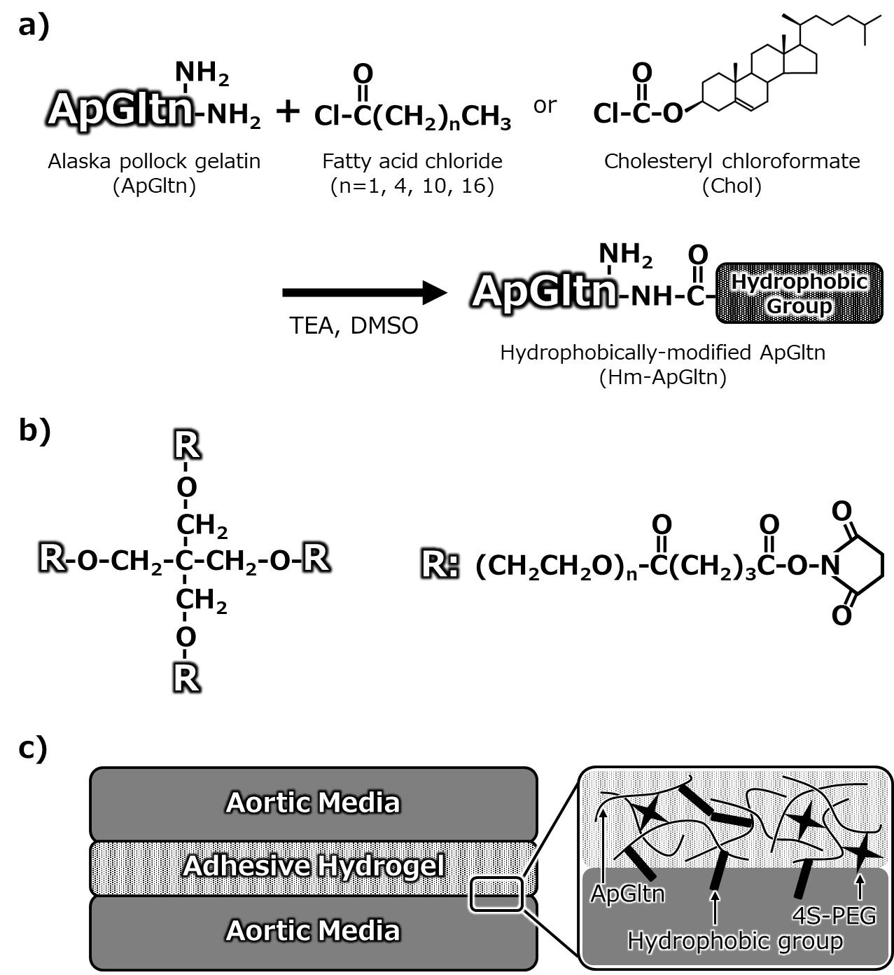
Figure 1. Synthesis and chemical structure of the hydrophobically modified Alaska pollock gelatin (hm-ApGltn) tissue adhesive components. a) Modification of ApGltn with different fatty acid chlorides or cholesteryl chloroformate. b) Chemical structure of pentaerythritol poly(ethylene glycol) ether tetrasuccinimidyl glutarate (4S-PEG). c) Adhesion of aortic media using hm-ApGltn/4S-PEG adhesive hydrogel.

3.2 Measurement of adhesion strength
The adhesion strength of the hm-ApGltn adhesive was measured using a fresh porcine aortic medium (Fig. 2). To optimize the adhesion conditions, we evaluated the effects of physicochemical factors on adhesion strength in Org-ApGltn. The adhesion strength increased with increasing 4S-PEG concentrations up to 11 mM, after which it decreased (Fig. 3a). At a 4S-PEG concentration of 13 mM, the molar ratio of the amino groups of Org-ApGltn (20wt%): active ester groups of 4S-PEG was 1/1 (mol/mol). However, the resulting Org-ApGltn/4S-PEG gel was opaque. This phenomenon is due to the fact that 4S-PEGinduced the dehydration of Org-ApGltn. Based on these results, we selected 11 mM 4S-PEG for subsequent experiments. We evaluated the effect of pH on adhesion strength using 0.1 M PBS with different pHs. Adhesion strength clearly increased with an increase in the pH of the 0.1 M PBS (Fig. 3b). Amide formation between amino groups and active ester groups is promoted in an alkaline environment due to the deprotonation of amino groups at high pH. Therefore, the increased adhesion strength was due to the high crosslinking density of the Org-ApGltn/4S-PEG gel at pH 8. We found that adhesion strength varied greatly between 20 and 60% Org-ApGltn concentration (Fig. 3c), indicating that the appropriate concentration of Org-ApGltn was lower than 60%. We further evaluated the effect of compressive stress on adhesion strength, and found that adhesion strength increased to 5 g/mm² (49kPa) and then became constant (Fig. 3d). Based on this result, we employed a compressive stress of 5 g/mm² to further evaluate the adhesion strength of the hm-ApGltn adhesives.
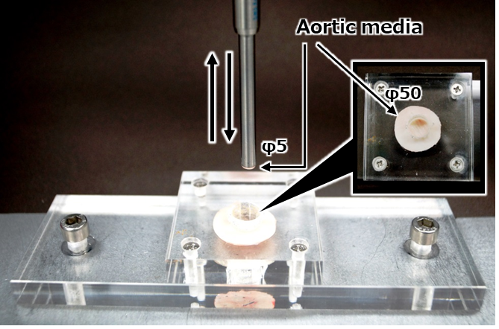
Figure 2. Procedure for adhesion strength measurements in aortic media.
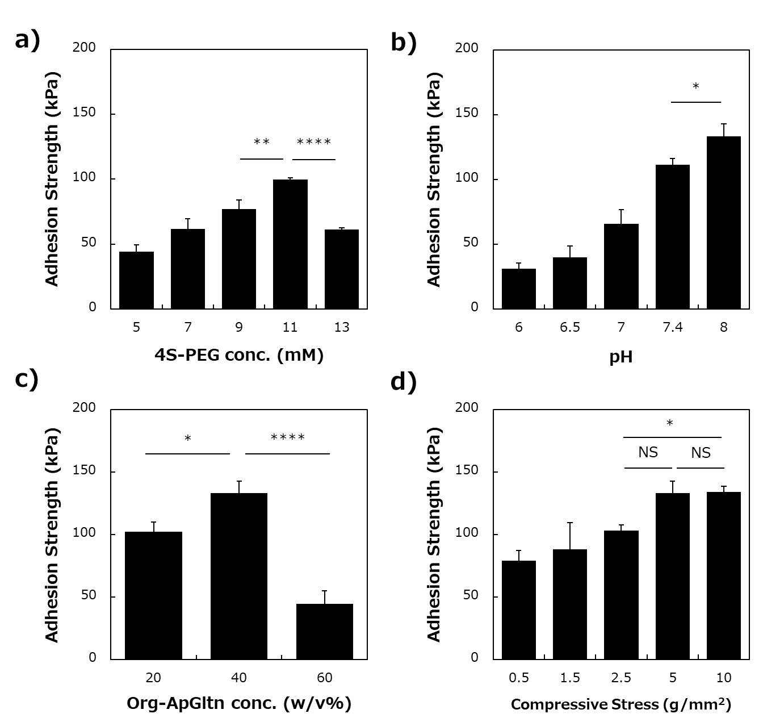
Figure 3. Effect of physico-chemical factors on adhesion strength of Org-ApGltn adhesives. a) Effect of 4S-PEG concentration, b) pH, c) Org-ApGltn concentration, and d) compressive stress on adhesion strength. Data are presented as the mean ± SD of three samples. *p<0.05, **p<0.01, ****p<0.0001; NS, not significant.
Fig. 4 shows the adhesion strength of hm-ApGltn adhesives after application to fresh porcine aortic media. The hydrophobic groups employed were different alkyl groups (C3, C6, C12, and C18) or a Chol group at different modification ratios. Adhesion strength was enhanced by modifying all the hydrophobic groups in Org-ApGltn (Fig. 4a). The 9.6C18-ApGltn adhesive showed the highest adhesion strength among the adhesives and had a 16-fold higher adhesion strength than the commercial aldehyde-based glue. Adhesion strength increased with an increasing modification ratio when the alkyl chains were C3, C6, or C12. Interestingly, the adhesion strength increased up to a modification ratio of approximately 10 mol% and then decreased when C18- or Chol-ApGltn adhesives were used. The decreased adhesion strength of C18- or Chol-ApGltn adhesives with high modification ratios (19C18 and 12Chol) was due to the increased aggregation or assembly of C18 or Chol groups in cured adhesives (gels), and that C18 or Chol groups in ApGltn could not effectively interpenetrate the surface of porcine aortic media. Fig. 4b shows the effect of alkyl chain length on the adhesion strength of alkyl group-modified ApGltn adhesives with modification ratios of ~20 mol%. Adhesion strength clearly increased with increasing alkyl chain length up to C12 and then decreased. Although further experiments are needed, we believe that this indicates that the aggregation/assembly of the C18 group potentially decreases adhesion strength.
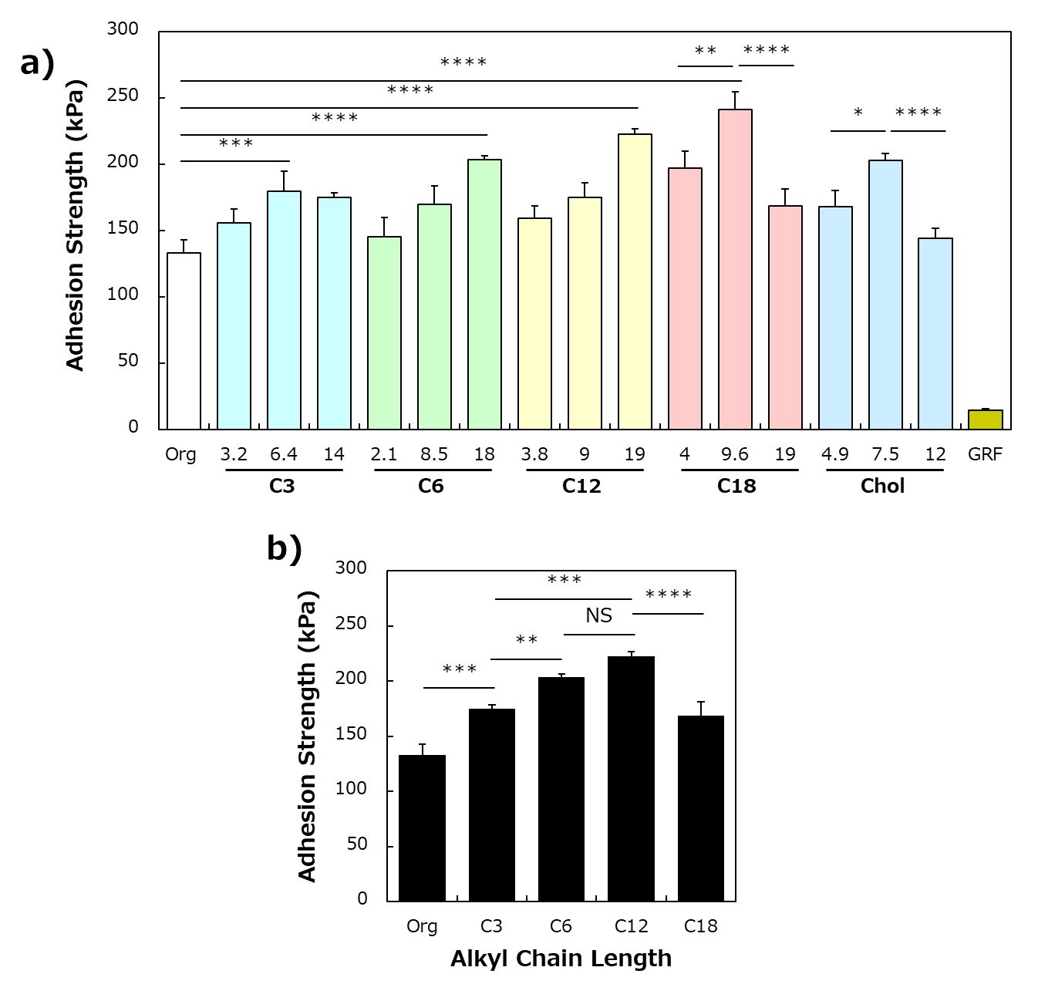
Figure 4. Adhesion strength of hm-ApGltn adhesives applied on fresh porcine aortic media. a) Adhesion strength of hm-ApGltn adhesives with various modification ratios. b) Effect of alkyl chain length on adhesion strength. Modification ratios of alkyl chain length were ~20 mol%. (C3: 14 mol%, C6: 18mol%, C12: 19 mol%, C18: 19 mol%). Data are presented as the mean ± SD of three samples. *p<0.05, **p<0.01, ***p<0.001, ****p<0.0001; NS, not significant.
We investigated the mechanisms of adhesion by hm-ApGltn adhesives by histological observations of the porcine aortic media. A residual adhesive layer was observed on porcine aortic media with most adhesives, except 12Chol and commercial aldehyde-based glue. Compared with the Org-ApGltn adhesive, a thick adhesive layer occurred on aortic media applied with long-alkyl-chain hm-ApGltn adhesives, such as C12 and C18. This indicates that the modification of the hydrophobic groups effectively enhanced the interfacial strength between the cured adhesives and the aortic media. In other words, cohesive fracturing occurred when applying hm-ApGltn. In particular, the thickness of the residual 9.6C18-ApGltn adhesive was significantly greater than that of the other adhesives, which correlated well with adhesion strength. In contrast, no residual 12Chol-ApGltn adhesive layer was observed, indicating that this adhesive peeled away from the surface of the aortic media, despite the high modification ratio of Chol in the ApGltn molecule. The decreased adhesion strength of the 12Chol-ApGltn adhesive was related to the inter/intramolecular aggregation or assembly of 12Chol-ApGltn molecules, which weakened their interpenetration into the surface of the aortic media (Figs. 4a, 5 and S2).
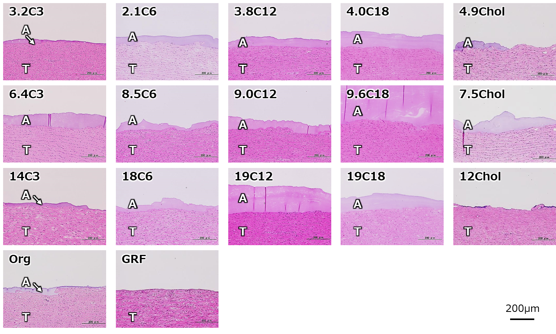
Figure 5. Histology of porcine aortic media after adhesion strength measurement using hm-ApGltn adhesives. Org-ApGltn and GRG glue® were used as control adhesives. A, adhesive; T, tissue.

To support this hypothesis, we evaluated the mechanical properties of the cured Chol-ApGltn adhesive gels using tensile tests (Fig. 6a). Tensile strength decreased at low Chol contents of 4.9 and 7.5 mol%, whereas it increased with Org-ApGltn adhesive hydrogels at a Chol content of 12 mol% (Fig. 6b), indicating that, despite having a lower adhesion strength, the bulk strength of the 12Chol-ApGltn adhesive hydrogel was higher than that of the 7.5Chol-ApGltn adhesive hydrogel. The adhesion strength of the Chol-ApGltn adhesive was mainly governed by the interfacial strength between the cured Chol-ApGltn and the porcine aortic media (Figs. 4a, 5, and 6b). We next evaluated the stretchability of two porcine aortic media adhered with the 7.5Chol-ApGltn adhesive (Fig. 6c). Stretchability was defined as whether or not the adhered aortic media tissues were not detached by stretching and shrinking them by 25%. The adhered porcine aortic media showed excellent stretchability when expanded by 25% and returned to their original state after shrinking 25%, without peeling. We repeated this test at least five times and found that the 7.5Chol-ApGltn adhesive showed good followability to shape changes. For type-A aortic dissection, the false lumen of the dissected aorta, i.e., the aortic media, was adhered with glue to join the artificial graft with the original aorta using sutures. Based on the results in Figs. 4, 5, and 6, hm-ApGltn adhesives, especially the 9.6C18- and 7.5Chol-ApGltn adhesives, have potential applications in type-A aortic dissection.
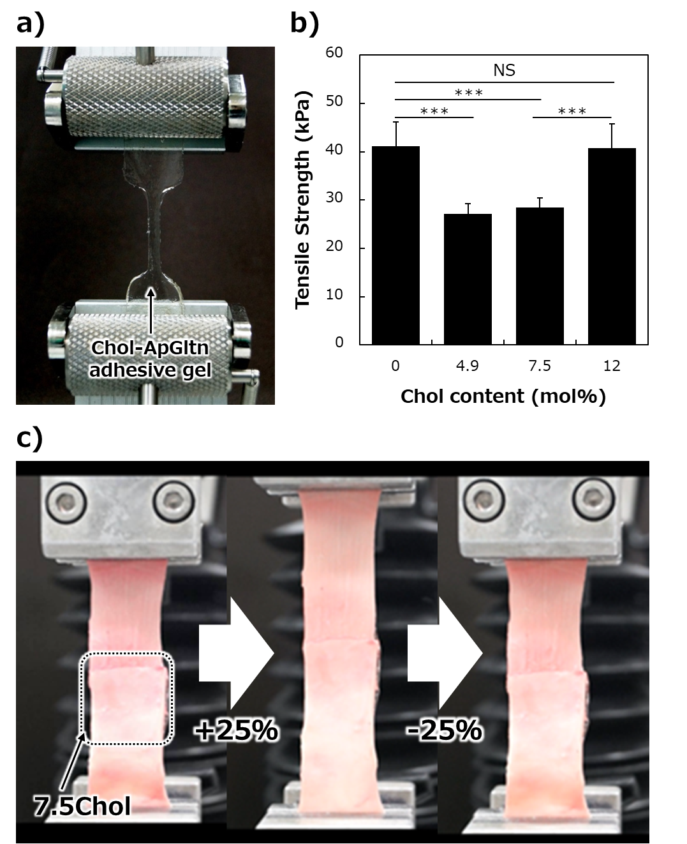
Figure 6. Mechanical properties of Chol-ApGltn adhesives. a) Tensile strength measurement of cured Chol-ApGltn adhesives gels. b) Effect of Chol modification ratios in Chol-ApGltn adhesive hydrogels on tensile strength. c) Stretchability of porcine aortic media adhered with 7.5Chol-ApGltn adhesive. Data are presented as the mean ± SD of five samples. ***p < 0.001; NS, not significant.

We finally evaluated tissue reactions and biodegradation behavior after injection of tissue adhesives into the backs of mice. We selected the 19C12- and 7.5Chol-ApGltn adhesives based on their higher adhesion strengths (compared to that of the Org-ApGltn adhesive, Fig. 4). The Org-ApGltn adhesive and commercial aldehyde-based glue were injected as controls. The Org-ApGltn adhesives gradually degraded over time, and most of the cured adhesives degraded within 4 weeks post-injection (Fig. 7a). Similarly, most of the 19C12-ApGltn adhesive degraded within 4 weeks post-injection, without any inflammatory reactions such as encapsulation or calcification. The 7.5Chol-ApGltn adhesive degraded with time, but remained intact even 4 weeks post-injection, which was likely due to the additional physical crosslinking of the Chol groups with covalent 4S-PEG. The commercial aldehyde-based glue also remained after 4 weeks post-injection; however, severe inflammation was observed compared to the 19C12- and 7.5Chol-adhesives at 2 weeks post-injection. Fig. 7b shows magnified images of the tissue-adhesive interface at 1 week post-injection. Some cells infiltrated the cured Org-, 19C12-, and 7.5Chol-ApGltn adhesives. Because ApGltn has specific amino acid sequences that are degraded by matrix metalloproteinases or promote cell adhesion/infiltration^{33,34}, the Org-, 19C12-, and 7.5Chol-ApGltn adhesives were subsequently degraded. In contrast, no cell infiltration was observed in the cured commercial aldehyde-based glue. Based on these results, the 19C12- and 7.5Chol-ApGltn adhesives showed excellent biocompatibility and were enzymatically degradable without severe inflammation.

a)
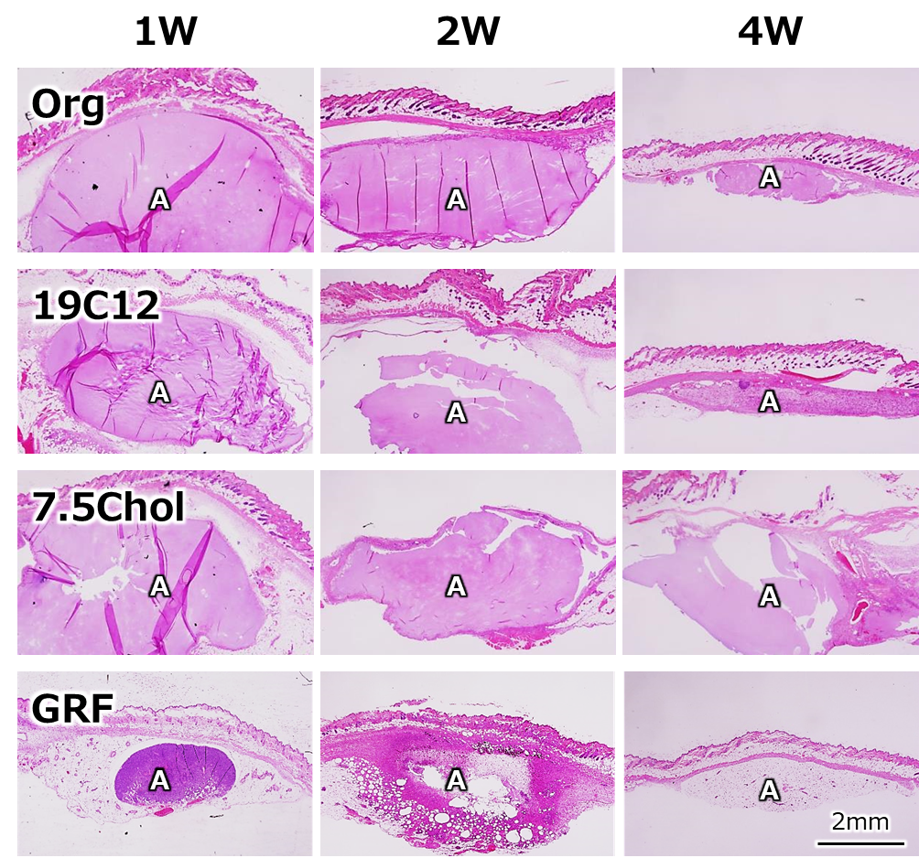
b)
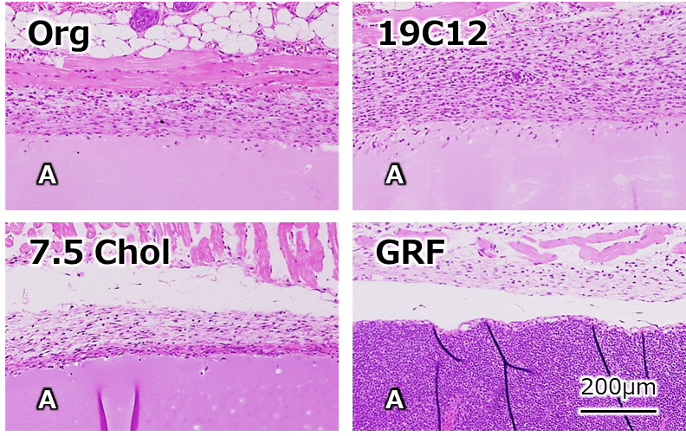
Figure 7. Tissue reaction to subcutaneous injection of hm-ApGltn adhesives at 1, 2, and 4 weeks. A, adhesive. a) Histological changes over time. b) Magnified images of tissues 1 week post injection.

Conclusion
We evaluated the adhesion performance of hm-ApGltn synthesized with the biocompatible crosslinker 4S-PEG and different modification ratios of alkyl or Chol groups in porcine aortic media. 4S-PEG concentration and pH as well as the modification of the alkyl or Chol groups had a strong association with adhesion strength. Adhesion strength increased with increasing modification ratios of the alkyl groups from C3 to C12, however, decreased at ~20 mol%. Porcine aortic media adhered using 7.5Chol-ApGltn adhesive showed stretchability with 25% vertical stretching and shrinking. hm-ApGltn adhesives subcutaneously injected into the backs of mice showed no severe inflammation and were degraded during the implantation period. These results indicate that the hm-ApGltn adhesives, especially the 9.6C18- and 7.5Chol-ApGltn adhesives, have potential for application in type-A aortic dissections.

Author contributions
Temmei Ito: Investigation, writing original draft and visualization. Ryo Mizuta: Investigation, writing original draft and visualization. Tetsushi Taguchi: Writing, review and editing, funding acquisition, project administration and supervision.

Acknowledgements
We acknowledge Ms. M. Katano of the Polymeric Biomaterials Group at National Institute for Materials Science (NIMS) for their technical support. This research was partially supported by the Japan Society for the Promotion of Science (JSPS) KAKENHI (Grant no. 23H01718) and the Uehara Memorial Foundation.

Conflict of interest statement
The authors declare no conflict of interest.

Data availability statement
The data that support the findings of this study are available from the corresponding author upon reasonable request.

References
1. DeBakey ME, McCollum CH, Crawford ES, Morris GC, Jr., Howell J, Noon GP, Lawrie G. Dissection and dissecting aneurysms of the aorta: twenty-year follow-up of five hundred twenty-seven patients treated surgically. Surgery 1982;92(6):1118-34.
2. Gudbjartsson T, Ahlsson A, Geirsson A, Gunn J, Hjortdal V, Jeppsson A, Mennander A, Zindovic I, Olsson C. Acute type A aortic dissection - a review. Scand Cardiovasc J 2020;54(1):1-13.
3. Wang J, Li Y, Li Y, Ren Z, Chen P, Qian X, Wang S, Wang J. Endovascular Stent-Graft Placement in Patients with Stanford Type B Aortic Dissection in China: A Systematic Review. Ann Vasc Surg 2016;36:298-309.
4. Suzuki R, Kurazumi H, Nawata R, Yokoyama T, Tsubone S, Matsuno Y, Shirasawa B, Mikamo A, Hamano K. Intimal-protected adventitial inversion technique accelerates the obliteration of a patent false lumen. J Card Surg 2022;37(9):2600-2606.
5. Furst W, Banerjee A. Release of glutaraldehyde from an albumin-glutaraldehyde tissue adhesive causes significant in vitro and in vivo toxicity. Ann Thorac Surg 2005;79(5):1522-8; discussion 1529.
6. Dagenais F. To glue or not to glue in type A dissection repair? J Thorac Cardiovasc Surg 2019;157(4):e119-e120.
7. Slezak P, Klang A, Ferguson J, Monforte X, Schmidt P, Bauder B, Url A, Osuchowski M, Redl H, Spazierer D and others. Tissue reactions to polyethylene glycol and glutaraldehyde-based surgical sealants in a rabbit aorta model. J Biomater Appl 2020;34(9):1330-1340.
8. Vauthier C, Dubernet C, Fattal E, Pinto-Alphandary H, Couvreur P. Poly(alkylcyanoacrylates) as biodegradable materials for biomedical applications. Advanced Drug Delivery Reviews 2003;55(4):519-548.
9. Spotnitz WD. Fibrin Sealant: Past, Present, and Future: A Brief Review. World Journal of Surgery 2010;34(4):632-634.
10. Tan C, Utley M, Paschalides C, Pilling J, Robb JD, Harrison-Phipps KM, Lang-Lazdunski L, Treasure T. A prospective randomized controlled study to assess the effectiveness of CoSeal (R) to seal air leaks in lung surgery. European Journal of Cardio-Thoracic Surgery 2011;40(2):304-308.
11. Wei C, Shi W, Zhao C, Yang S, Zheng J, Zhong J, Zhao T, Kong S, Gong X, Liu M. Superwetting Injectable Hydrogel with Ultrastrong and Fast Tissue Adhesion for Minimally Invasive Hemostasis. Adv Healthc Mater 2023;12(3):e2201799.
12. Wang G, Meng X, Wang P, Wang X, Liu G, Wang DA, Fan C. A catechol bioadhesive for rapid hemostasis and healing of traumatic internal organs and major arteries. Biomaterials 2022;291:121908.
13. Li Q, Song W, Li JH, Ma CY, Zhao XX, Jiao JL, Mrowczynski O, Webb BS, Rizk EB, Lu D and others. Bioinspired super-strong aqueous synthetic tissue adhesives. Matter 2022;5(3):933-956.
14. Huang Y, Fan C, Liu Y, Yang L, Hu W, Liu S, Wang T, Shu Z, Li B, Xing M and others. Nature-Derived Okra Gel as Strong Hemostatic Bioadhesive in Human Blood, Liver, and Heart Trauma of Rabbits and Dogs. Adv Healthc Mater 2022;11(18):e2200939.
15. Fujita M, Policastro GM, Burdick A, Lam HT, Ungerleider JL, Braden RL, Huang D, Osborn KG, Omens JH, Madani MM and others. Preventing post-surgical cardiac adhesions with a catechol-functionalized oxime hydrogel. Nat Commun 2021;12(1):3764.
16. Ma C, Sun J, Li B, Feng Y, Sun Y, Xiang L, Wu B, Xiao L, Liu B, Petrovskii VS and others. Ultra-strong bio-glue from genetically engineered polypeptides. Nat Commun 2021;12(1):3613.
17. Yang ZX, He YL, Ma YC, Li L, Wang YP. A Reversible Adhesive Hydrogel Tape. Advanced Functional Materials 2022.
18. Hu Y, Jia Y, Wang S, Ma Y, Huang G, Ding T, Feng D, Genin GM, Wei Z, Xu F. An ECM-Mimicking, Injectable, Viscoelastic Hydrogel for Treatment of Brain Lesions. Adv Healthc Mater 2023;12(1):e2201594.
19. Zhou L, Dai C, Fan L, Jiang YH, Liu C, Zhou ZN, Guan PF, Tian Y, Xing J, Li XJ and others. Injectable Self-Healing Natural Biopolymer-Based Hydrogel Adhesive with Thermoresponsive Reversible Adhesion for Minimally Invasive Surgery. Advanced Functional Materials 2021;31(14).
20. Munoz Taboada G, Dosta P, Edelman ER, Artzi N. Sprayable Hydrogel for Instant Sealing of Vascular Anastomosis. Adv Mater 2022;34(43):e2203087.
21. Bian SQ, Hao LZ, Qiu X, Wu J, Chang H, Kuang GM, Zhang S, Hu XH, Dai YK, Zhou ZY and others. An Injectable Rapid-Adhesion and Anti-Swelling Adhesive Hydrogel for Hemostasis and Wound Sealing. Advanced Functional Materials 2022;32(46).
22. Anthis AHC, Hu XQ, Matter MT, Neuer AL, Wei KC, Schlegel AA, Starsich FHL, Herrmann IK. Chemically Stable, Strongly Adhesive Sealant Patch for Intestinal Anastomotic Leakage Prevention. Advanced Functional Materials 2021;31(16).
23. Nishiguchi A, Kurihara Y, Taguchi T. Underwater-adhesive microparticle dressing composed of hydrophobically-modified Alaska pollock gelatin for gastrointestinal tract wound healing. Acta Biomaterialia 2019;99:387-396.
24. Mizuno Y, Mizuta R, Hashizume M, Taguchi T. Enhanced sealing strength of a hydrophobically-modified Alaska pollock gelatin-based sealant. Biomaterials Science 2017;5(5):982-989.
25. Taguchi T, Mizuta R, Ito T, Yoshizawa K, Kajiyama M. Robust sealing of blood vessels with cholesteryl group-modified, Alaska pollock-derived gelatin-based biodegradable sealant under wet conditions. Journal of Biomedical Nanotechnology 2016;12(1):128-134.
26. Karim AA, Bhat R. Fish gelatin: properties, challenges, and prospects as an alternative to mammalian gelatins. Food Hydrocolloids 2009;23(3):563-576.
27. Mizuta R, Taguchi T. Enhanced Sealing by Hydrophobic modification of Alaska pollock-derived gelatin-based surgical sealants for the treatment of pulmonary air leaks. Macromolecular Bioscience 2017;17(4):1600349.
28. Yanagihara T, Maki N, Wijesinghe AI, Sato S, Saeki Y, Kitazawa S, Yamaoka M, Kobayashi N, Kikuchi S, Goto Y and others. Efficacy of Alaska Pollock Gelatin Sealant for Pulmonary Air Leakage in Porcine Models. Annals of Thoracic Surgery 2022;113(5):1641-1647.
29. Mizuta R, Mizuno Y, Chen X, Kurihara Y, Taguchi T. Evaluation of an octyl group-modified Alaska pollock gelatin-based surgical sealant for prevention of postoperative adhesion. Acta Biomater 2021;121:328-338.
30. Mizuno Y, Watanabe S, Taguchi T. Tissue-sealing and anti-adhesion properties of an in situ hydrogel of hydrophobically-modified Alaska pollock-derived gelatin. Int J Biol Macromol 2020;163:2365-2373.
31. Mizuta R, Ito T, Taguchi T. Effect of alkyl chain length on the interfacial strength of surgical sealants composed of hydrophobically-modified Alaska-pollock-derived gelatins and poly(ethylene)glycol-based four-armed crosslinker. Colloids and Surfaces B-Biointerfaces 2016;146:212-220.
32. Matsumoto T, Sugita S, Yaguchi T. Biomechanics of Blood Vessels: Structure, Mechanics, and Adaptation. Advances in Metallic Biomaterials; 2015. p 71-98.
33. Loffek S, Schilling O, Franzke CW. Biological role of matrix metalloproteinases: a critical balance. European Respiratory Journal 2011;38(1):191-208.
34. Kim JH, Lee SJ. A BIOMIMETIC STRATEGY TO DESIGN BIOMATERIALS FOR IN SITU TISSUE REGENERATION; 2016. 185-201 p.

