Supplemental Material

Edge dependence of the Josephson current in the quantum Hall regime

Seong Jang¹, Geon-Hyoung Park¹, Kenji Watanabe², Takashi Taniguchi³ and Gil-Ho Lee^{1,*}

¹ Department of Physics, Pohang University of Science and Technology, Pohang, 37673, Republic of Korea,
² Research Center for Functional Materials, National Institute for Materials Science, Tsukuba, 305-0047, Japan
³ International Center for Materials Nanoarchitectonics, National Institute for Materials Science, Tsukuba, 305-0047, Japan

S1. Device information for graphene Josephson junction devices
Device | Width (μm) | Length (μm) | Note
NEGJJ-01 | 1.16 | 0.3 | Native edge
NEGJJ-02 | 1.67 | 0.3 | Native edge
EFGJJ-01 | N/A | 0.3 | Edge-free
EEGJJ-01 | 0.9 | 0.3 | Etched from EFGJJ-01
EEGJJ-02 | 0.63 | 0.3 | Etched from NEGJJ-01
EEGJJ-03 | 0.7 | 0.3 | Etched from NEGJJ-02
GGDEGJJ-01 | 0.28 | 0.2 | Graphite gate defined
GGDEGJJ-02 | 0.35 | 0.3 | Graphite gate defined
GGDEGJJ-03 | 0.43 | 0.35 | Graphite gate defined

Table S1. Details of graphene Josephson junction devices, including device names, edge configurations, and dimensions. For graphite gate-defined Josephson junctions, the width refers to the width of the local graphite gate located beneath the graphene.

S2. Electrical measurement
Resistance measurements (R_{I=0nA}, R_{I=10nA} and R_{T=1K}) are performed using a lock-in amplifier with an excitation current of 100 pA at 7.777 Hz. The differential resistance, dV/dI, is obtained from I–V characteristics measured by sweeping the DC bias current using a Yokogawa 7651 voltage source connected in series with a high-value resistor (1 MΩ or 100 MΩ). The voltage across the junction is amplified by an Itacho voltage preamplifier and recorded using a Keithley 2000 multimeter. The device, thermally anchored to the mixing chamber of a dilution refrigerator, is connected to the room-temperature instrumentation through a filtering chain consisting of RC and π filters at room temperature, Thermocoax cables, and an additional set of RC and π filters at the mixing chamber stage. This configuration is designed to suppress electromagnetic interference and prevent unwanted heating of the electrons.

S3. Verification of supercurrent in the QH regime
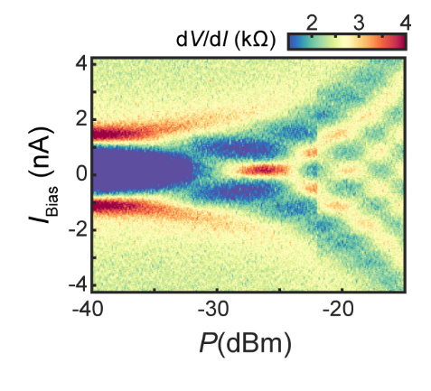
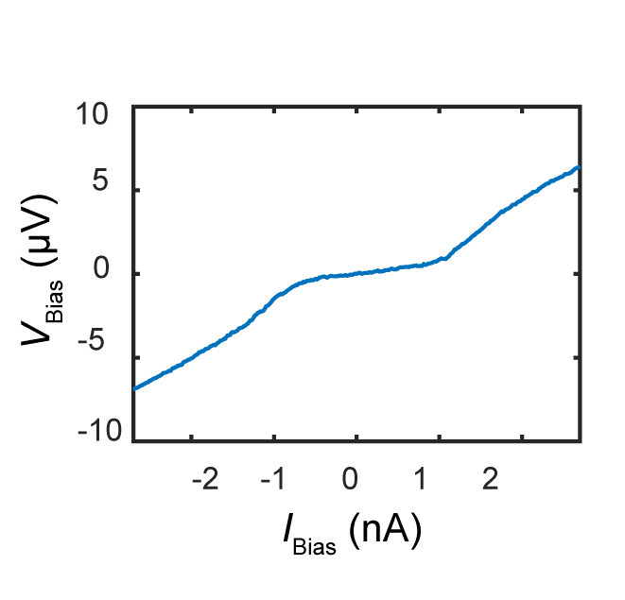
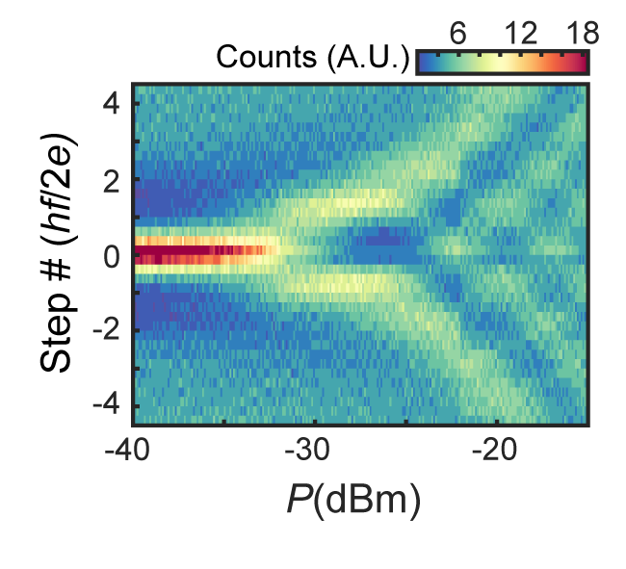
FIG. S1. (a) I-V curve in the quantum Hall regime at a magnetic field of B = 1.7545 T and a filling factor of ν = 9.5 (b) Differential resistance (dV/dI) as a function of bias current (I_{Bias}) and applied microwave power(P), measured at a fixed microwave frequency of f = 0.765 GHz, backgate voltage of V_{BG} = 7.8 V, and magnetic field of B = 1.75 T. (c) Shapiro steps as a function of P and normalized voltage.
(a)
(b)
(c)
Despite the use of multi-stage filters on all electrical lines, electrons in the graphene can still be easily heated by minimal external disturbances, as the graphene Josephson junction (GJJ) remains thermally isolated due to the negligible thermal conductivity of the superconducting electrodes. In the quantum Hall regime, the critical current is exceptionally small, making the phase particle prone to escape. As a result, a finite differential resistance persists even at zero bias current, as illustrated in FIG. S1(a). To further validate the presence of Josephson coupling in the QH regime, we measured the junction’s response to microwave irradiation, as shown in FIG. S1(b). The emergence of Shapiro steps confirms the development of integer voltage steps, which are multiples of hf/2e (FIG. S1(c))

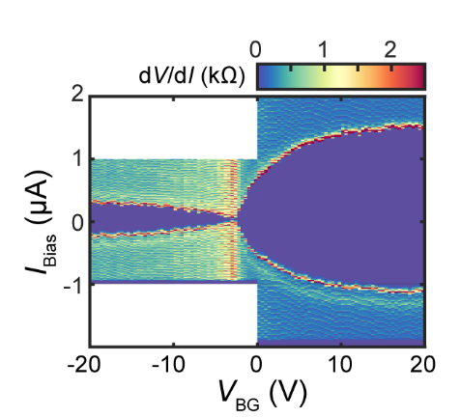
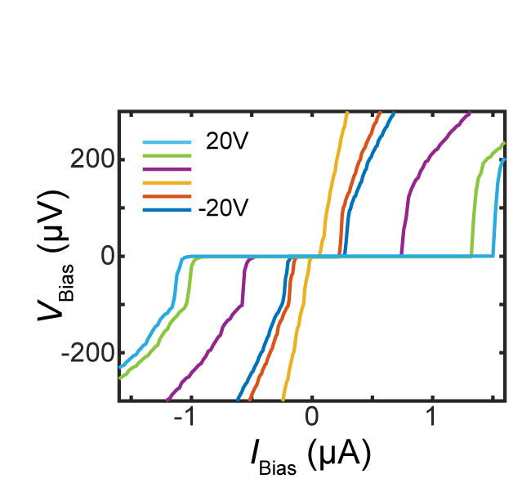
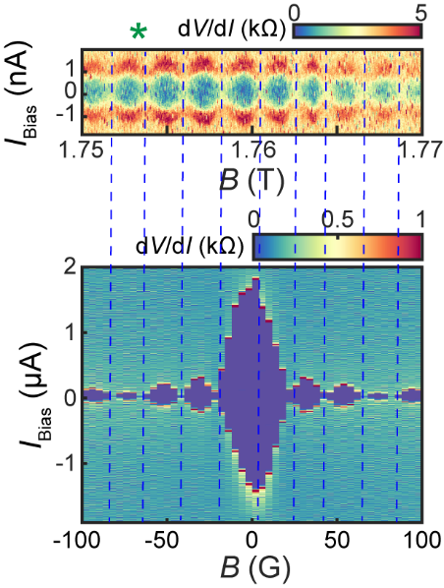
S4. Josephson junction characterization at low magnetic field
(a)
(b)
(c)

FIG. S2. (a) Current–voltage (I–V) characteristics of the NE GJJ-01 device measured at various backgate voltages. (b) Differential resistance as a function of bias current and backgate voltage, extracted from the corresponding I–V curves. (c) Upper: Magnetic field interference pattern of NE GJJ-01 measured at ν = 9.5. Fraunhofer pattern of NE GJJ-01 measured at V_{BG} = 20 V. Vertical blue dashed lines indicate the similar interference period observed in both cases.

The Josephson devices were characterized under near-zero magnetic field conditions. The I–V characteristics exhibit a sharp transition from the zero-resistance state to a finite-voltage state as the bias current increases. The dependence of the critical current on the gate voltage confirms that the Josephson coupling is mediated by the conduction channel in graphene. Furthermore, the observed Fraunhofer pattern provides additional evidence of supercurrent flow through the junction. Notably, the magnetic field interference period is nearly identical to that observed in the quantum Hall regime.

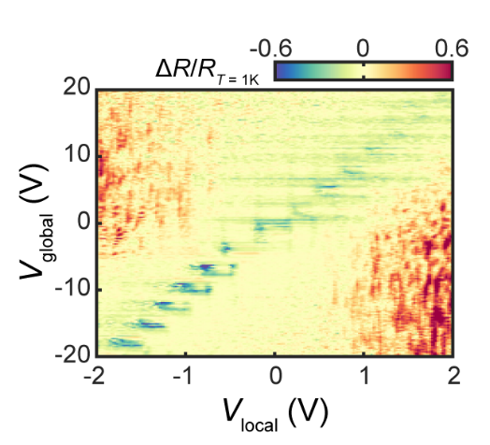
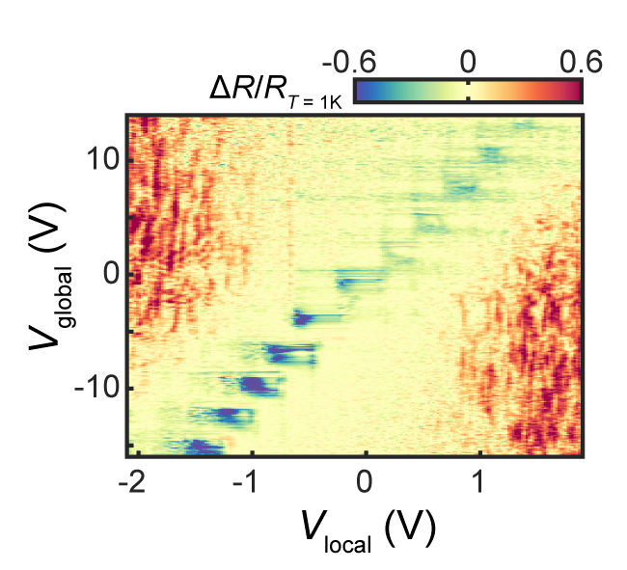
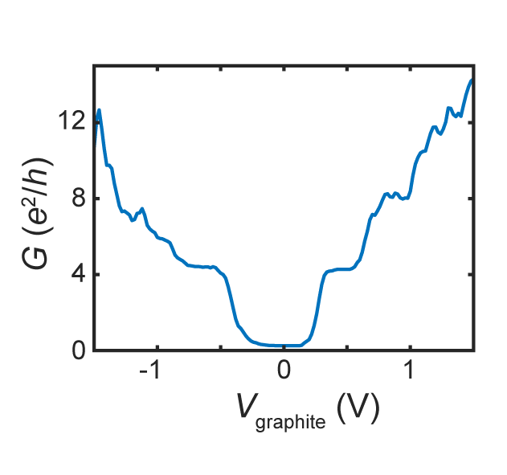
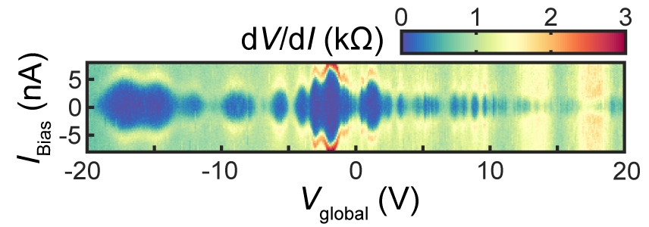
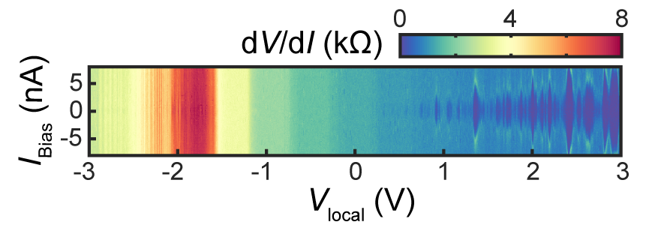
S5. Additional data for graphite gate-defined edge GJJs
(e)
(d)
(b)
(a)
(c)

FIG. S3. (a) Conductance obtained as a function of the gate voltage applied to the graphite gate (V_{local}) while the global silicon gate voltage V_{global} = 0 V. (b) differential resistance (dV/dI) as a function of applied bias current (I_{Bias}) and V_{local} while V_{global} = -20 V. (c) differential resistance (dV/dI) as a function of applied bias current (I_{Bias}) and V_{global} while V_{local} = -3 V. (d)(e) Normalized resistance difference as a function of local graphite gate voltage (V_{local}) and global silicon gate voltage (V_{global}) for (d) GGDEGJJ-02 and (e) GGDEGJJ-03, measured with an excitation current of 1 nA at a magnetic field of B = 2 T.
Graphite gate-defined edge graphene Josephson junctions (GGDE-GJJs) were fabricated on hBN/graphene/hBN stacks, incorporating a narrow graphite strip as a local back gate. This architecture enables independent control of the local filling factor ν_{l} in the graphene region above the graphite gate, while the global filling factor ν_{g}​ is separately tuned via the silicon back gate. Although the graphite gate introduces a step in the graphene topography, the graphene layer remains continuous, and the longitudinal conductance vanishes when ν_{l} = ν_{g} ​, as shown in FIG. S3(a). This enables gate-controlled switching of the edge state that mediates the Josephson coupling between the superconducting electrodes.
The Josephson current pockets are more sensitive to the local graphite gate voltage (FIG. S3(b)) than to the global silicon back gate voltage (FIG. S3(c)), indicating that Andreev bound states (ABS) predominantly form in the locally gated region of graphene. To verify reproducibility, we performed the same measurements shown in FIGs. 5(c) and 5(d) on two additional GGDE-GJJ devices (GGDEGJJ-02 and GGDEGJJ-03). Both devices exhibited behavior consistent with that in FIG. 5: Josephson current is absent in Configuration 1 but appears in Configurations 2 and 3. Furthermore, the vertically striped pattern of the JC pockets confirms that ABS are confined within the locally gated graphene region above the graphite gate.

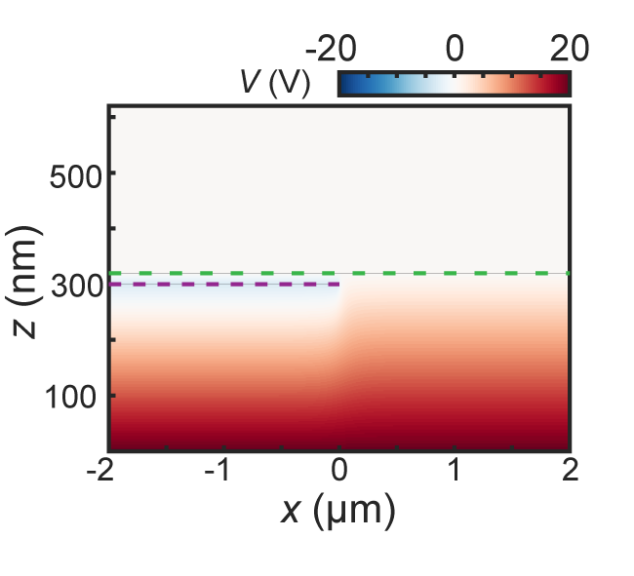
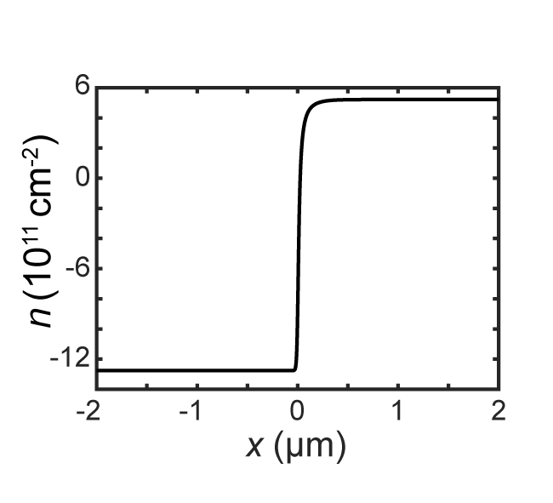
FIG. S4. (a) Finite element method simulation of the electrostatic potential. The SiO₂ thickness is 300 nm, and the bottom hBN thickness is 20 nm. A voltage of +20 V is applied to the Si substrate, and −3 V to the graphite gate. The green dashed line indicates the position of the graphene layer, and the purple dashed line indicates the graphite gate. (b) Spatial profile of the charge carrier concentration in the graphene layer.
(a)
(b)
S6. Finite element method simulation on charge concentration near the edge of graphite gate
To investigate why the upstream mode appears only in the region locally gated by graphite, we carried out a finite element method (FEM) simulation of the charge concentration in graphene near the edge of the graphite gate. Because the graphite gate is positioned much closer to the graphene than the silicon back gate, its electrostatic influence is more localized. Consequently, the charge concentration on the graphite-gated side exhibits a much sharper transition at the gate edge, whereas the variation on the silicon-gated side is significantly more gradual, as illustrated in FIG. S4. Reference 28 proposed that such abrupt charge gradients near the edge can give rise to non-monotonic spatial band dispersion, which in turn can host upstream modes.

