Stepwise Topochemical Linkage of Zirconium Oxo Clusters to Yield Black Zirconia Nanocrystals
Satoshi Tominaka¹*, Kazutaka Sonobe¹, Yoshitaka Matsushita², and Akihiko Machida³
¹Center for Basic Research on Materials (CBRM), National Institute for Materials Science (NIMS), 1-1 Namiki, Tsukuba, Ibaraki 305-0044, Japan
²National Institute for Materials Science (NIMS), 1-1 Namiki, Tsukuba, Ibaraki 305-0044, Japan
³Synchrotron Radiation Research Center, National Institutes for Quantum Science and Technology (QST), 1-1-1 Kouto, Sayo, Hyogo 679-5148, Japan

KEYWORDS Zirconium oxo clusters, Black zirconia, Topochemical reaction, Pair distribution function, Crystallographic analysis

ABSTRACT:
Elucidating the thermal transformation pathways of molecular precursors, such as the dimeric zirconium oxo cluster investigated herein, is crucial for the rational design of functional zirconia nanomaterials with tailored properties. This study primarily employed synchrotron X-ray pair distribution function (PDF) analysis of ex situ annealed samples, complemented by SCXRD, TGA, FTIR, and EPR spectroscopy, to track the detailed stepwise structural evolution from the molecular precursor to the final oxide. Key results demonstrate a sequential transformation: initial desolvation (100°C) largely preserves the local dimer structure; further heating (220°C) after removal of eight acetate equivalents forms a unique condensed dimeric intermediate; and finally, complete acetate decomposition by 480°C leads to crystallization into black, nanocrystalline tetragonal ZrO₂. We interpret these transformations as a topochemical-like process where core Zr₆ structural motifs are remarkably preserved, and specific oxygen-retaining acetate decomposition mechanisms create an intrinsically oxygen-excess framework that stabilizes the oxygen-centered radicals (g ≈ 2.001) detected by EPR in the final black zirconia. Ultimately, this work reveals a controlled pathway from a well-defined molecular cluster to defect-engineered black zirconia nanocrystals, highlighting how precursor architecture and specific decomposition routes govern the material's structural evolution and ultimate defect chemistry.

- INTRODUCTION
Traditional synthesis of solid-state materials has long relied on annealing processes. These classical high-temperature methods involve mixing atomic or ionic precursors to produce thermodynamically stable phases. Essentially, atoms or ions, driven by thermal energy, rearrange into the most stable configuration. This process is governed by thermodynamics, with researchers often guided by phase diagrams to achieve desired materials. While effective for producing bulk materials in their thermodynamically favored forms, this approach can limit access to metastable phases or intricate nanostructures. In contrast, modern synthetic techniques, such as solvothermal/hydrothermal reactions, allow access to materials at lower temperatures, often through pathways that are not fully understood. The mechanisms underlying these reactions are gradually being uncovered with the aid of advanced in situ methods like X-ray diffractometry and total scattering analyses.^{1–4} For example, layered titanium oxide crystals can be formed through hydrothermal reactions where nuclei, generated from the hydrolysis of a precursor in alkaline solution, aggregate anisotropically.³ This process highlights the role of heterogeneous aggregation in directing the formation of specific crystal structures, even when they might not be the most thermodynamically stable.
This exemplifies the principles of bottom-up synthesis, where the controlled assembly of nanoscale building blocks, such as nanoparticles, nanosheets, and molecular clusters, can lead to unique material architectures and properties unattainable through conventional means. For instance, nanosheets have been layered to create artificial heterostructures in designing and constructing materials with tailored functionalities.⁵ Clusters have been aggregated to form hierarchical structures with properties distinct from those of the pristine clusters.^{6–9} By carefully controlling the assembly of these pre-formed units in heterogeneous processes, bottom-up synthesis aims to preserve their structural integrity and achieve precise hierarchical organization, often yielding metastable phases. These unique metastable structures, with their long-range order distinct from the original building units, differ from the oriented attachment of nanocrystals where the crystal structure of the building units is largely conserved.¹⁰
The key to successfully forming these metastable phases lies in controlling the aggregation and chemical transformation of the building units—namely, forming chemical bonds between them—while preventing uncontrolled atom mixing that results in thermodynamically stable bulk materials.^{11,12} The structural changes upon aggregation and subsequent transformation need to be understood at an atomic level, because the properties of materials are governed by their atomic arrangements and symmetries, even in low-dimensional or disordered structures.¹³¹⁴ Such materials often lack sufficient crystallinity for conventional diffractometry, making pair distribution function (PDF) analysis,^{15–17} which can uniquely probe atomic configurations in amorphous, nanocrystalline, and cluster-based materials,^{12,18,19 3} crucial for uncovering the details of these structural changes. This allows for a deeper understanding of the underlying mechanisms and the resulting material properties.
The material of interest in this work is zirconium oxide (ZrO₂), which, with its d⁰ electron configuration, is prized for its stability and typically low reactivity in a variety of applications. Stoichiometric zirconia is well-known to crystallize in several polymorphic forms, principally monoclinic (stable at room temperature for bulk material), tetragonal (stable at elevated temperatures or in nanocrystals), and cubic (stable at very high temperatures). These phases are all derived from the fluorite (CaF₂) crystal structure type, in which zirconium is typically eight-coordinated by oxygen, and oxygen is tetrahedrally coordinated by zirconium. While the ideal cubic symmetry of these coordination polyhedra is maintained in the cubic phase, distortions lead to the lower symmetries of the tetragonal and monoclinic structures, though the fundamental fluorite-based network connectivity is largely preserved.
Owing to these stable crystallographic arrangements and its d⁰ electron configuration, stoichiometric zirconia generally exhibits high chemical inertness and limited electronic or catalytic activity. However, it has become increasingly evident that these characteristics can be dramatically altered, and significant electronic and catalytic functionalities can be unlocked by introducing defects, strain, or nanostructuring. Indeed, recent research has demonstrated that zirconium oxides can be transformed into active catalysts, potentially rivaling noble metal catalysts in applications such as fuel cells.^{20,21} This aligns with theoretical studies predicting the high catalytic potential of group-4 metal oxides.²² Activating zirconium oxides, often through the synthesis of "black zirconia", ^{23,24} by inducing atomic distortions, oxygen vacancies, or other defects, ²¹ ²⁵ can lead to reactive zirconium compounds with modified electronic states.^{26–28} However, controlling and understanding the structural changes and the nature of the active sites during these transformations remains a significant challenge, highlighting the need for synthetic strategies starting from well-defined molecular building blocks.
In this study, we leverage such a molecular building block approach by investigating the detailed thermal transformation of a structurally well-characterized, acetate-bridged dimeric zirconium oxo cluster into nanocrystalline black zirconia. We aim to elucidate how the intrinsic architecture of this precursor, particularly its robust Zr6 core units, directs a stepwise structural evolution through unique intermediate phases towards the final crystalline oxide. By combining thermogravimetric analysis (TGA), ex situ synchrotron X-ray pair distribution function (PDF) analysis, Fourier-transform infrared spectroscopy (FTIR), and Electron Paramagnetic Resonance (EPR) spectroscopy, we trace these transformations at an atomic level. A central focus is to unravel the specific ligand decomposition chemistry and its profound impact on the stoichiometry and defect structure of the resulting zirconia. This work demonstrates a bottom-up strategy where the controlled thermal processing of a defined metal oxo cluster facilitates a topochemical-like linkage of preserved building blocks to yield defect-engineered zirconia nanocrystals.

- EXPERIMENTAL METHODS
2.1 Materials: Zirconium(IV) propoxide (70 wt% solution in 1-propanol) was sourced from Tokyo Chemical Industry Co., Ltd. (Tokyo, Japan). Acetic acid (reagent grade) was purchased from Fujifilm Wako Pure Chemical Corporation (Osaka, Japan). All reagents were used as received without further purification.
2.2 Synthesis of Crude Zirconium Oxo Cluster: In a typical synthesis, 2.0 mL of the zirconium(IV) propoxide solution was added to 3.1 mL of acetic acid. The resulting mixture was allowed to stand at ambient temperature for 72 hours, during which a white solid precipitated. The supernatant liquid was decanted, and the remaining solid was isolated by centrifugation at 400 rpm for 2 hours. The collected crude product was dried in a vacuum oven at 50°C.
2.3 Recrystallization: Purification of the crude product was achieved by recrystallization. The powder was dissolved in pure acetic acid by heating to 200°C using a Biotage Initiator+ microwave reactor system. Subsequent slow cooling of the solution afforded the purified zirconium oxo cluster as a crystalline powder.
2.4 Thermal Decomposition: Zirconium oxide samples were prepared via thermal decomposition (pyrolysis) of the purified zirconium oxo cluster. The powder was heated to target temperatures of 100, 180, 220, 340, 480, and 580°C under a continuous flow of nitrogen gas in a tube furnace.
2.5 Elemental analysis: The zirconium-to-hafnium (Zr:Hf) atomic ratio in the zirconium(IV) propoxide starting material was determined by inductively coupled plasma optical emission spectrometry (ICP-OES) using an Agilent 5800 instrument. Sample preparation was performed as follows: Approximately 3 mg and 10 mg portions of the zirconium(IV) propoxide solution were weighed into separate quartz beakers. To each beaker, 5 mL of sulfuric acid (H₂SO₄, 1:1 v/v aqueous solution) was added, and the mixtures were heated on a hot plate until dense white fumes of SO₃ evolved, indicating digestion of the organic components. After cooling to room temperature, 1 mL of hydrofluoric acid (HF, concentrated) was added to each beaker to ensure complete dissolution. The resulting clear solutions were quantitatively transferred into 100 mL polypropylene volumetric flasks. Manganese (Mn), introduced via a standard solution to achieve a final concentration of 1 mg/L in the analyzed solution, was added to each flask as an internal standard. The flasks were then filled to the mark with ultrapure water. Emission intensities were measured using an axial plasma viewing configuration. The intensities of the Zr emission wavelength (343.823 nm) and Hf emission wavelength (264.141 nm) lines were monitored and quantified relative to the Mn internal standard emission at 257.610 nm. The analysis yielded a composition of Zr: 98.7 at% and Hf: 1.25 at%.
2.6 Single-Crystal X-ray Diffraction (SCXRD): The crystal structure of the zirconium oxo cluster, obtained via recrystallization from acetic acid, was determined by single-crystal X-ray diffraction (SCXRD). Data were collected at 100 K on a Rigaku XtaLAB AFC10 diffractometer (RCD3) equipped with a Varimax confocal mirror optic and a HyPix hybrid pixel array detector, using Mo K_{α} radiation (λ=0.71073 Å) from a rotating-anode X-ray source. Data collection, integration, scaling, and cell refinement were performed using the CrysAlisPro software package (v1.171.43.125a, Rigaku Oxford Diffraction). Absorption correction was performed using the multi-scan method implemented in CrysAlisPro (SCALE3 ABSPACK algorithm). The primary structure was solved using SHELXT ²⁹ and refined by full-matrix least-squares on F² using SHELXL, ³⁰ operated within the Olex2 graphical interface (ver. 1.5).³¹ All non-hydrogen atoms were refined anisotropically. Hydrogen atoms were placed in geometrically calculated positions and refined using a riding model. Structural visualization was performed using VESTA.³² The determined structure confirmed the presence of acetate ligands coordinated to the zirconium oxo core.
2.7 Thermal analysis: Thermogravimetric-differential thermal analysis (TG-DTA) was utilized for two primary purposes: characterizing the thermal decomposition of the precursor and evaluating the oxygen deficiency of the final products. First, the thermal decomposition behavior of the as-synthesized zirconium oxo cluster was investigated to understand the desorption process of ligands (e.g., acetic acid). This analysis was performed using a Shimadzu DTG-60 analyzer (Kyoto, Japan). The sample was heated from room temperature to 1000°C at a rate of 10 °C min⁻¹ under a nitrogen (N₂) gas flow (100 mL min⁻¹) using an alumina sample pan. The resulting TG-DTA curves are shown in Figure S3.
Second, the extent of oxygen deficiency (oxygen vacancy concentration) in the black zirconia samples, prepared by pyrolysis at 480°C and 580°C, was estimated from their re-oxidation behavior in air. These samples were analyzed using the same TG-DTA instrument (Shimadzu DTG-60) under a flow of dry air (100 mL min⁻¹) with a heating rate of 10 °C min⁻¹, utilizing an alumina pan. The oxygen vacancy ratio was calculated based on the maximum weight gain observed during heating, which corresponds to the uptake of oxygen required to form stoichiometric ZrO₂.
2.8 Infrared spectroscopy: Fourier-transform infrared (FTIR) spectra of the as-synthesized zirconium oxo clusters were recorded using a Bruker ALPHA II spectrometer (Bruker, Germany) equipped with an attenuated total reflection (ATR) accessory featuring a diamond crystal. Spectra were typically collected over the range of 4000–400 cm⁻¹.
2.9 Electron Paramagnetic Resonance (EPR): Electron Paramagnetic Resonance (EPR) measurements were performed on the black zirconia samples using a JEOL JES-FA100 EPR spectrometer (JEOL Ltd., Akishima, Tokyo, Japan) operating at X-band frequency (~9.17 GHz). Approximately 70 mg of each powder sample was loaded into a standard quartz EPR tube (5 mm outer diameter). Measurements were typically conducted at room temperature. Standard spectrometer settings included: microwave power of 0.998 mW, modulation frequency of 100 kHz, and modulation amplitude of 0.5 mT. The center field was 326.763 mT, the sweep width was 2.5 mT, and the sweep time was 240 s.
2.10 Synchrotron X-ray Total Scattering Data Collection: Synchrotron X-ray total scattering data for the calcined zirconia powders were collected at the BL22XU beamline of the SPring-8 synchrotron radiation facility (Hyogo, Japan). Data were collected in transmission mode using a Debye-Scherrer geometry equipped with a PerkinElmer XRD1621 large-area flat-panel detector. The incident X-ray beam was monochromatized to 68.444 keV (λ = 0.18114 Å) using a Si(111) double-crystal monochromator. The precise wavelength and sample-to-detector distance were calibrated using a National Institute of Standards and Technology Standard Reference Material (NIST SRM) 674b CeO₂ standard. The acquired two-dimensional (2D) diffraction images were azimuthally integrated into one-dimensional (1D) patterns (Intensity vs. scattering angle 2θ) using the PIXIA software within the Orochi data analysis package. ³ For the measurements, the powder samples were loaded and sealed into polyimide capillaries (Cole-Parmer, ϕ = 1.1 mm outer diameter). Typical exposure time was 600 sec. In order to obtain Debye-rings with a homogeneous intensity distribution, the capillary was oscillated by 90 degrees during measurements.
2.11 Data Processing for Pair Distribution Function Analysis: The acquired 2D diffraction images were azimuthally integrated into 1D patterns (Intensity vs. 2θ) using the PIXIA software within the Orochi data analysis package. ³ To obtain the scattering intensity related solely to the sample, contributions from the polyimide capillary and air scattering were subtracted. Subsequent corrections for experimental effects (e.g., background, absorption, polarization efficiency) and Compton scattering were applied. The corrected intensity data were then normalized to obtain the total scattering structure function, S(Q). The reduced pair distribution function, G(r), was obtained by the sine Fourier transform of the reduced structure function F(Q) = Q S(Q)⁻¹ over the scattering vector range Q = 1.0–22.0 Å⁻¹:
$$G\left(r\right)=\frac{2}{π}\int_{Q_{min}}^{Q_{max}}{F\left(Q\right)sin\left(Qr\right)dQ}$$
2.12 Structural Modeling: Structural modeling of the experimental pair distribution function (G(r)) data for samples annealed at 100°C, 220°C, and 580°C was performed to elucidate the structural evolution upon thermal treatment. All refinements were carried out using the DiffPy-CMI library,³³ within the srfit framework, employing the Levenberg-Marquardt algorithm (via SciPy's optimize.leastsq function) to minimize the weighted squared difference between the observed and calculated G(r) over a fitting range of r=0.8–12.0 Å. Common refined parameters for all models included an overall scale factor and instrumental resolution parameters (Q_{damp}​ and Q_{broad}​). The treatment of isotropic atomic displacement parameters (ADPs ​) was handled differently depending on the model's crystallinity, as detailed below. Hydrogen atoms were excluded from all structural models. Crucially, for the intermediate samples (100°C and 220°C), refinements using conventional nanocrystalline models of ZrO₂ phases were attempted first, but these failed to reproduce the characteristic relative intensity ratios of the PDF peaks, thus confirming the necessity of the precursor-based modeling approach detailed below.
For the sample annealed at 100°C, the starting model was constructed from the desolvated dimer core structure determined by SCXRD (Figure 1). This dimer unit was placed within a large, fictitious unit cell (15×15×25 Å³) and treated as nonperiodic. The refinement was then performed imposing monoclinic P2/m space group symmetry (No. 10). Atomic coordinates for Zr, O, and carboxyl C atoms were refined under these symmetry constraints, with additional restraints limiting atomic displacements from the initial positions to a maximum of ±0.2A˚ along each Cartesian axis. To ensure a stable and physically meaningful refinement, the ADPs for the heavy Zr atoms were refined, while those for the lighter C and O atoms were fixed to small, positive values. This approach allows the static disorder to be modeled primarily by the refinement of atomic coordinates. The model composition is [Zr₆​O₈​(C₂​O₂​)₁₀}​₂​(μ-C₂​O₂​)₄​].
For the sample annealed at 220°C, the structural model was derived from the refined 100°C structure. To account for the mass loss observed by TGA and to achieve optimal agreement with the PDF data, a total of eight C₂O₂ groups (presumably acetate-derived) per original dimer unit were computationally removed from the 100°C model via two specific mechanisms: (1) the four C₂O₂ ligands originally bridging the two Zr₆ units were replaced by single oxygen (μ-oxo) bridges (schematically, Zr-(O-C₂O)-Zr becomes Zr-O-Zr), and (2) four terminal C₂O₂ ligands were removed in pairs, where each pair, originally coordinated to a common Zr atom, was removed leaving one of their oxygen atoms coordinated to that same Zr atom. This yields a model with the overall composition [Zr₆​O₉​(C₂​O₂​)₈}_{​2}​(μ-O)₄​]. The refinement of this modified structure was again performed under P2/m symmetry constraints, optimizing the symmetry-constrained atomic coordinates (with tighter displacement restraints of ±0.08A˚ along each axis) and the element-specific isotropic ADPs (Biso​).
The choice of the P2/m space group for modeling these intermediate cluster-based structures (100°C and 220°C) was guided by considering the approximate point group symmetry of the dimer core (C_{2h}​, which is a subgroup of P2/m) and the symmetry elements of the final crystalline phases (e.g., tetragonal ZrO₂), under the hypothesis that a relatively high degree of symmetry is maintained or adopted during the initial thermal transformation stages before full crystallization.
For the sample annealed at 580°C, which exhibits significant crystallinity, a periodic model based on the tetragonal structure of zirconia (P4₂​/nmc, No. 137) was used. The refinement rigorously imposed the P4₂​/nmc space group symmetry using the constrainAsSpaceGroup functionality within srfit. Refined parameters included the symmetry-constrained lattice parameters, atomic coordinates, and element-specific isotropic ADPs (B_{iso}​ for Zr and O). Additionally, a parameter δ2​ accounting for correlated atomic motion was refined. The refinement model utilized only Zr atoms on the cation site, as the small amount of Hf detected by ICP-OES (1.25 at%) was deemed negligible for the purposes of this structural refinement.
- RESULTS AND DISCUSSION
3.1 Structural analysis of the zirconium oxo cluster. The crystal structure of the zirconium oxo cluster, synthesized from zirconium n-propoxide and acetic acid, was determined by single-crystal X-ray diffraction (SCXRD) analysis performed at 100 K. This low temperature was employed to mitigate crystal degradation caused by the evaporation of co-crystallized solvent molecules (identified as six acetic acid and four water molecules per formula unit in the crystal lattice). Thermal analysis indicated that solvent loss commences near room temperature and continues up to approximately 130°C (see TG-DTA, Figure 2a). The crystal adopts a triclinic lattice belonging to the space group $P\overline{1}$ (No. 2) with the following unit cell parameters at 100 K: a = 12.6440(2) Å, b = 16.6337(3)Å, c = 17.2297(3) Å, α = 100.160(2)°, β = 110.127(2)°, γ = 105.212(2)°, V = 3137.73(11)Å³, Z = 2. Crystallographic data for the structure reported in this paper have been deposited with the Cambridge Crystallographic Data Centre (CCDC) under deposition number CCDC 2449981.
The SCXRD analysis revealed a dimeric structure where two distinct Zr₆ oxo cluster units are bridged by acetate ligands (Figure 1). This acetate-bridged dimer arrangement is consistent with previously reported zirconium oxo cluster structures.³⁴ Each Zr₆ core unit is composed of six zirconium cations and eight oxygen atoms acting as μ₃-bridges (either O²⁻ or OH⁻). Additionally, nine acetate ligands are coordinated to the Zr cations within each unit, while four acetate ligands serve as bridges (μ-acetates) connecting the two Zr₆ units. Based on the structural refinement and considering charge neutrality requirements for the Zr(IV) cations, the composition of the desolvated dimer core is determined to be {Zr₆O₄(OH)₄(ac)₁₀}₂(μ-ac)₄ (ac: acetate).
This dimeric cluster possesses C_{2h}​ point group symmetry, indicating that the two {Zr₆O₄(OH)₄(ac)₁₀} units are related by an inversion center located midway between them. Analysis of the local coordination environment shows that each zirconium atom is eight-coordinated (forming a ZrO₈​ polyhedron). Following the notation proposed in reference,³⁵ the connectivity between adjacent polyhedra within a single Zr₆ core can be described as C₀​E₄​F₀​, signifying that each ZrO₈​ polyhedron shares four edges (E₄​) but no corners (C₀​) or faces (F₀​) with neighboring ZrO_{x}​ polyhedra within the cluster core.

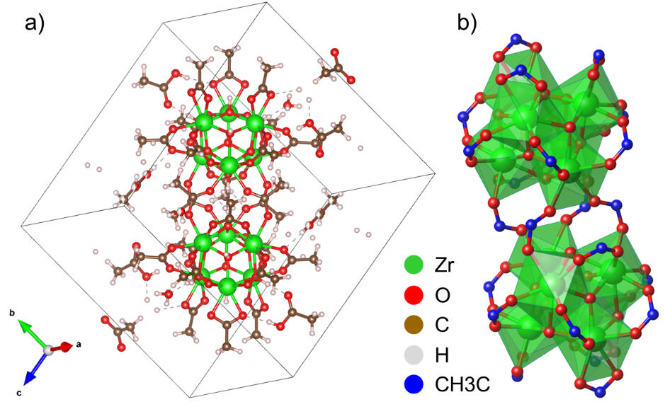
Figure 1. Crystal structure of the zirconium oxo cluster precursor determined by SCXRD at 100 K. (a) Unit cell view showing the packing of the dimeric cluster units along with co-crystallized solvent molecules (acetic acid and water). (b) Polyhedral representation of the {Zr₆​O₄​(OH)₄​(ac)₁₀​}₂​(μ-ac)₄​ dimer unit, highlighting the edge-sharing connectivity of the ZrO₈​ polyhedra within each Zr₆ core and the acetate bridging between cores. Solvent molecules are omitted for clarity.

3.2 Overview of thermal decomposition of the zirconium oxo cluster. To gain an overview of the thermal decomposition pathway and subsequent structural evolution of the zirconium oxo cluster precursor under inert conditions, thermogravimetric analysis (TGA) was performed under a nitrogen atmosphere (Figure 2a). The TGA curve exhibits distinct stepwise weight losses occurring primarily below 480°C. Following the initial loss of ~3.5 wt% below 130°C, attributed to the evaporation of co-crystallized solvent molecules, a second significant weight loss of approximately 13.7% is observed between ~130°C and ~220°C. This is followed by a third distinct weight loss step of approximately 23.3% between ~220°C and ~480°C. Crucially, complementary Fourier-transform infrared (FTIR) spectroscopy analysis indicated the complete disappearance of acetate vibrational modes in the sample heated to 480°C (Figure S1). This confirms that all original acetate ligands derived from the precursor are removed or decomposed by this temperature. Considering the total number of acetate ligands in the initial dimer structure and the FTIR results, the second (13.7%) and third (23.3%) weight loss steps are interpreted as corresponding to the sequential removal or decomposition of 8 and 16 acetate ligand equivalents, respectively. Subsequently, even after the removal of all acetate signatures, a gradual, continuous weight loss (> 2 wt%) is observed extending from ~550°C up to 1000°C (the limit of the measurement), indicating further subtle mass changes at higher temperatures, possibly related to the removal of residual decomposition products (like carbon) or further structural reorganization.
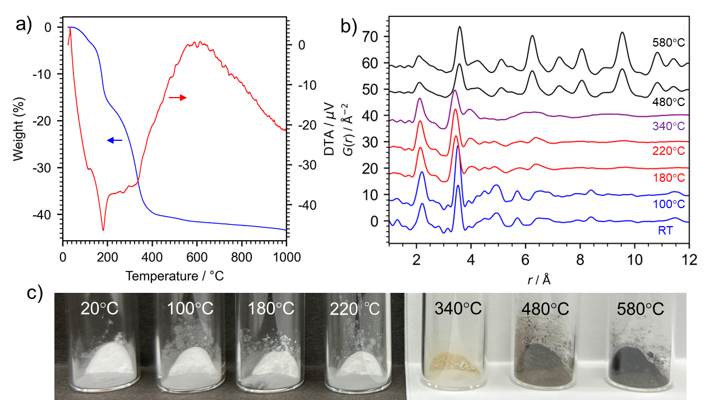
Figure 2. Overview of temperature dependence of zirconium oxo clusters. (a) Thermogravimetric analysis. (b) Pair distribution functions. (c) Photographs of zirconium compounds annealed at different temperatures.

The complex thermal decomposition pathway suggested by TGA necessitates a closer examination of the accompanying structural transformations using X-ray pair distribution function (PDF) analysis. The experimental PDFs, obtained from samples annealed at various temperatures and measured ex situ (Figure 2b), reveal a clear evolution in atomic arrangements. Up to 100°C, the PDF profile remains very similar to that of the as-synthesized precursor (RT sample), indicating that the fundamental local structure of the dimer core is largely preserved during the initial desolvation process. However, upon heating into the temperature range of the second TGA weight loss step (~130–220°C), the PDF profiles of samples annealed at 180°C and 220°C change significantly compared to the lower temperature data, signaling a distinct structural transformation. Proceeding to 340°C, within the third TGA weight loss stage (~220–480°C), the PDF profile qualitatively resembles those observed at 180/220°C, but the features become broader and less distinct, suggesting an increase in structural disorder or heterogeneity. Notably, the sample annealed at 340°C exhibits a yellow color (Figure 2c). Finally, for samples annealed at 480°C and 580°C, temperatures corresponding to the end of the main decomposition stages, the PDFs show the emergence of sharper peaks extending to higher r values, characteristic of the development of long-range crystalline order. Consistent with the TGA indicating incomplete decomposition, these crystalline products are notably black (Figure 2c), distinct from typical white ZrO₂. This overview highlights a multi-stage transformation proceeding through distinct, structurally different regimes – an initial stable dimer, intermediate disordered phases, and finally, formation of a non-stoichiometric crystalline product – underscoring the need for detailed structural modeling presented next.
3.3 Structural analysis of oxo clusters annealed at 100°C (step 1). Focusing now on the detailed structure of the sample annealed at 100°C, the PDF data (Figure 2b) indicated that while long-range crystalline order was lost upon desolvation compared to the pristine solvated crystal (as also seen in the total scattering data, Figure S2), the persistence of distinct peaks corresponding to intra-cluster distances suggested the local structure of the dimer core remained largely intact. To verify this preservation quantitatively, we performed detailed real-space refinement against the experimental G(r) data using the methodology detailed in the Structural Modeling section. In brief, the structural model consisted of the desolvated dimer core (derived from SCXRD) placed computationally within a large unit cell and refined using the DiffPy-CMI library under periodic boundary conditions imposing P2/m space group symmetry.
The choice of the P2/m space group for this non-crystalline, cluster-based model warrants explanation, as the modeling philosophy differs fundamentally from that of a standard crystallographic refinement. For materials lacking long-range order, the goal of PDF modeling is to find the simplest and most symmetric model that is consistent with the experimental data. While a low-symmetry model with more free parameters could be forced to achieve a better mathematical fit, our approach was to apply the highest plausible symmetry to create the most constrained and parsimonious model, thereby avoiding physically meaningless solutions. The P2/m space group (monoclinic, No. 10) was selected because it incorporates both the underlying C2h​ point group of the ideal dimer and the apparent mirror symmetry of the desolvated core (when excluding hydrogen atoms). The fact that this highly constrained, high-symmetry model successfully reproduces the experimental data (Figure 3a) is a powerful finding. It demonstrates that the local structure is consistent with the preservation of a highly symmetric dimer core, without needing to invoke complex, asymmetric distortions.
As demonstrated by the excellent agreement between the calculated and experimental G(r) shown in Figure 3a, this modeling approach successfully captured the atomic structure of the 100°C annealed sample over the fitted range (r = 0.8–12.0 Å). The refinement primarily involved optimizing the symmetry-constrained atomic coordinates (within ±0.2 Å positional restraints) and element-specific isotropic ADPs (B_{iso}​). This successful refinement confirms that the fundamental dimeric core structure, corresponding to the composition [Zr₆​O₈​(C₂​O₂​)₁₀}_{​2}​(μ-C₂​O_{2​})₄​] (which corresponds to {Zr₆​O₄​(OH)₄​(ac)₁₀​}₂​(μ-ac)₄​ with hydrogen atoms), is indeed well-preserved locally after annealing at 100°C, despite the loss of long-range periodicity. The refined parameters mainly account for slight structural relaxations induced by desolvation and thermal displacements reflecting the room temperature measurement condition. A minor, broad, and featureless residual is observed in the fit (Figure 3a), which can be attributed to weak scattering contributions not accounted for in the single-dimer model, such as correlations from any trace, disordered residual solvent molecules, and correlations between adjacent, imperfectly packed dimer units. The structural evolution at this stage is therefore governed by a clear hierarchy of bond energies: the thermal energy at 100°C disrupts the weak intermolecular forces responsible for crystal packing via desolvation, causing a loss of long-range order. This same energy, however, is insufficient to cleave the stronger coordination bonds of the acetate ligands, leaving the molecular integrity of the dimer core intact.

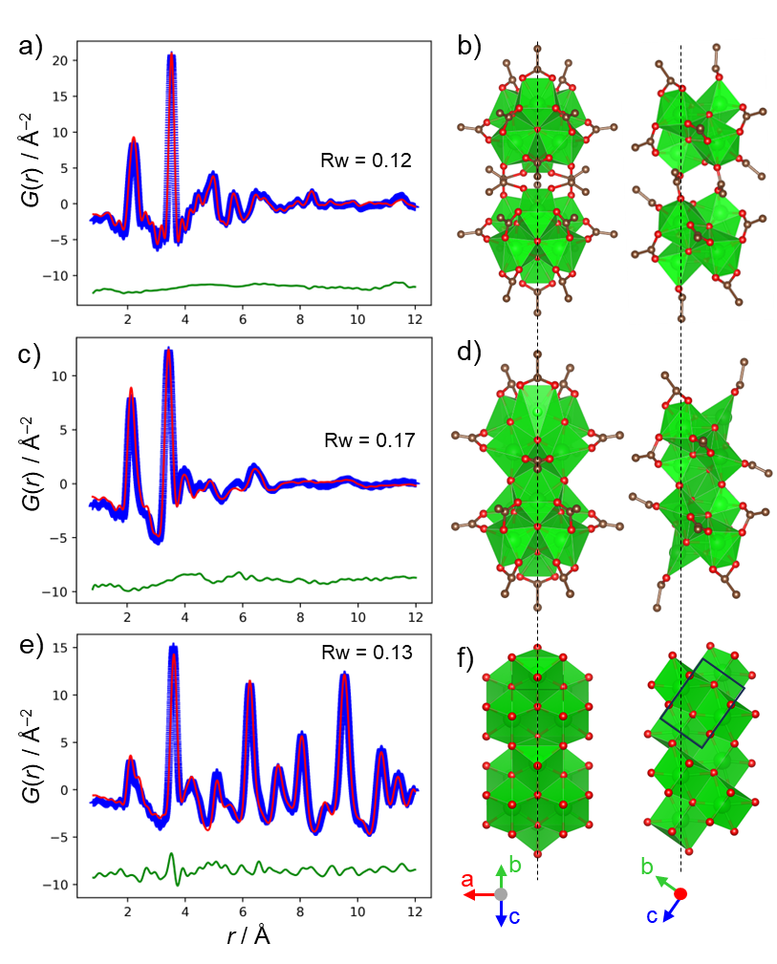
Figure 3. Structural evolution from the zirconium oxo cluster precursor to crystalline zirconia upon annealing, determined by Pair Distribution Function (PDF) analysis. (a, c, e) Experimental PDF data (G(r), blue symbols) for samples annealed at 100°C (a), 220°C (c), and 580°C (e), respectively. Overlaid are the best-fit calculated PDF profiles (red lines) obtained from real-space refinements using the structural models shown in (b), (d), and (f). The different curves are shown below each fit (green lines, offset for clarity). (b, d, f) Structural models corresponding to the refined structures at each temperature: (b) The acetate-bridged dimer core model derived from SCXRD and refined against the 100°C data using P2/m symmetry within a large unit cell. (d) The condensed dimer model refined against the 220°C data. This model was also refined under P2/m symmetry. (f) The tetragonal (P4₂​/nmc) ZrO₂ crystal structure model refined against the 580°C data. The black solid lines indicate the unit cell boundary. Vertical dotted lines in (b), (d), and (f) indicate selected, corresponding Zr atomic positions across the three structures, highlighting their remarkably conserved locations throughout the transformation.

3.4 Structural analysis of oxo clusters annealed at 220°C (step 2). Before delving into the detailed modeling of the intermediate structure formed upon annealing at 220°C, a crucial observation regarding the stability of the local structure emerges from comparing the PDF data across different temperatures (Figure 2b). Despite the significant changes in the overall PDF profiles reflecting the loss of long-range order and alterations in inter-cluster connectivity, the features at short radial distances (r ≲ 3.8 Å) remain remarkably consistent. Specifically, the prominent first peak around r ≈ 3.5Å, which corresponds to the shortest Zr-Zr distances within the Zr₆ core units bridged by μ3​-oxo/hydroxo groups, is clearly observed not only in the 100°C and 220°C annealed samples but also persists as a characteristic feature even in the crystalline tetragonal ZrO₂ phase formed at 580°C. This striking conservation of the short-range structure strongly indicates that the fundamental Zr₆ polyhedral arrangement acts as a highly stable and persistent building motif throughout the thermal decomposition process, guiding the transformation pathway from the molecular precursor towards the crystalline oxide.
Focusing now on the second major thermal event, the weight loss of 13.7 wt% observed between ~130°C and 220°C (Figure 2a) corresponds to the removal of eight acetate ligand equivalents per initial dimer, as inferred from the total acetate count and the FTIR results indicating complete removal by 480°C. As noted in the overview, annealing at 220°C results in significant changes in the PDF profile compared to the 100°C sample, particularly the emergence of a distinct peak around r ≈ 4 Å. This indicates a change in the inter-cluster arrangement or connectivity while preserving the Zr₆ core units, consistent with the removal of bridging/terminal ligands.
To identify the specific structure formed after the removal of these eight acetate equivalents, a systematic screening of candidate structures was performed. Multiple chemically plausible models were generated by computationally removing eight acetate-derived (C₂O₂) groups from the refined 100°C structure in various combinations, guided by the TGA results. Each candidate was tested against the experimental PDF data, and the model that provided the optimal agreement is presented here. A reasonably good fit to the experimental G(r) data was achieved (Figure 3d) with a condensed dimer model refined under the constraints of a hypothesized P2/m space group symmetry to ensure a stable and physically meaningful refinement for this non-crystalline intermediate. A reasonably good fit to the experimental G(r) data was achieved (Figure 3d) with a condensed dimer model derived directly from the refinement, corresponding to the composition [{Zr₆​O₈​(C₂​O₂​)₈}_{​2}​(μ-O)₄​] (or [{Zr₆​O₄​(OH)₄​(ac)₈​}₂​(μ-O)₄​] considering protonation). This experimentally-derived structure results from two specific modifications to the 100°C model: the replacement of the four bridging acetate ligands with μ-oxo bridges, and the removal of four specific terminal acetate ligands. This model is also consistent with the TGA results; the observed weight loss (13.7 wt%) is well-matched by a calculated value of 14.2 wt% based on the departure of four acetic acid molecules and the decomposition of four bridging acetates into volatile fragments (such as CH₃​CO⋅ radicals) ^{36,37} which leave their oxygen atoms behind. Furthermore, the distinct PDF signature of this intermediate, particularly the ~4 Å peak, distinguishes it from other known condensed zirconium oxo clusters, such as that formed by low-temperature hydrolysis, ³⁸ highlighting the unique nature of the structure captured in this thermal treatment stage.
The principle governing this specific transformation appears to be that of least structural rearrangement, dictated by the hierarchy of stabilities under these specific reaction conditions. The Zr₆ core unit, while known to be susceptible to hydrolysis, is remarkably robust under these thermal, non-aqueous conditions. Therefore, at ~220°C, the available thermal energy is far below that required to break the strong Zr-O bonds of this core framework. Transformations are thus limited to pathways involving the lower-energy modification of coordination bonds. The observed reaction adheres to this principle: the Zr₆ building blocks are preserved, albeit with minor polyhedral distortion, and the process follows a kinetically favorable route. This involves the simple departure of neutral acetic acid molecules and a condensation reaction at the bridging positions, which efficiently forms new, stable Zr-O-Zr linkages between the intact cluster cores. This pathway, which preserves the integrity of the core building blocks, explains the selective formation of this unique condensed dimer as a key intermediate.
3.5 Structural analysis of oxo clusters annealed at 480°C (step 3). The third major stage of weight loss observed in the TGA occurs between approximately 220°C and 480°C, with an observed mass loss of 23.3% (Figure 2a). This step corresponds to the removal of the remaining 16 acetate ligand equivalents per initial dimer unit, a process confirmed to be complete by 480°C via FTIR analysis (Figure S1). A simple decomposition of the intermediate material to stoichiometric ZrO₂ would theoretically result in a weight loss of 30.2%; the significantly lower observed value strongly implies that a substantial number of oxygen atoms from the acetate ligands are retained within the solid framework during this stage. Indeed, the experimental weight loss of 23.3% shows good agreement with a calculated value of 26.4 wt% based on a plausible decomposition pathway where the 16 acetate groups decompose to form eight molecules of volatile acetic anhydride ((CH₃​CO)₂​O),^{36,37} thereby leaving eight oxygen atoms behind. This transformation yields a final stoichiometry of [{Zr₆​O₈​(OH)₄}₂​(μ-O)₄​], which simplifies to Zr₃​O₅​(OH)₂​.
The structural changes during this stage were tracked by PDF analysis. The PDF profile of the sample annealed midway through this step, at 340°C, qualitatively resembles that of the condensed dimer formed at 220°C, albeit with broader, less distinct features (Figure 2b). This similarity provides crucial evidence that the fundamental Zr₆-based condensed dimer framework is preserved even as the remaining ligands are gradually removed. Subsequently, as ligand removal nears completion, a clear transition from a disordered to a crystalline state is observed for the samples annealed at 480°C and 580°C. This crystallization is definitively evidenced by the appearance of sharp Bragg peaks in the total scattering data (Figure S2). Consequently, the corresponding PDF profiles (Figure 2b) exhibit sharp, well-defined peaks extending to high r values, which represent the long-range atomic correlations characteristic of the tetragonal ZrO₂ crystalline lattice.
3.6 Overall structural evolution: a kinetically governed, topochemical transformation. The series of PDF refinements provides a comprehensive, atomistic picture of the overall structural evolution. A remarkable and unifying feature of this entire transformation, visualized by comparing the structural models in Figure 3, is the significant conservation of the relative zirconium atom positions within the core Zr₆ motifs. This persistence is the key to understanding the governing "evolvement rule" of this process.
The transformation is governed by kinetics under conditions where the available thermal energy is insufficient to cause large-scale atomic diffusion. The reaction therefore proceeds via a pathway of least structural rearrangement, dictated by the hierarchy of stabilities under these specific thermal, non-aqueous conditions. The Zr₆ core unit is exceptionally robust in this environment, making its internal bond cleavage energetically prohibitive. The transformation is thus constrained to the lower-energy pathway of modifying the linkages between these persistent building blocks.
This principle explains the entire evolution from a discrete molecule to a nanocrystal. The process, where the precursor's molecular architecture is preserved and templates the final structure, is the essence of the observed topochemical transformation. The evolution proceeds clearly from the initial acetate-bridged dimer (Figure 3b), through a condensed intermediate linked by new μ-oxo bridges (Figure 3d), and ultimately to the extended network of the final tetragonal crystalline lattice (Figure 3f). This stepwise linkage of preserved building blocks provides a clear structural narrative for the formation of the final product.
3.7 Defect stoichiometry and the origin of black coloration. The final, gradual weight loss observed in the TGA trace above ~550°C (Figure 2a) indicates that subtle chemical changes occur during the final stages of crystallization, even after the complete removal of all acetate ligands. The analysis of the preceding decomposition steps strongly suggests that the material formed by ~480°C is inherently oxygen-rich relative to its metal content. We therefore propose that the resulting black zirconia is not a conventional oxygen-deficient phase (ZrO_{2−x}​), but rather a metal-deficient phase, more accurately described as Zr_{1−x}​O₂​. This model provides a coherent explanation for the persistent black coloration (Figure 2c). The final weight loss above 550°C suggests that this initially formed Zr_{1−x}​O₂​ phase still contains some thermally unstable species. A plausible hypothesis, consistent with the charge balance requirements of an oxygen-excess framework, is the retention of a small amount of hydrogen species (e.g., as hydroxyl groups), whose slow removal could account for this final weight loss.
A potential alternative origin for the black coloration could be the formation of residual carbon. However, several lines of evidence contradict this hypothesis. FTIR analysis confirms the complete removal of all acetate signatures by 480°C, while the coloration begins at temperatures as low as 340°C. Most importantly, thermogravimetric analysis of the 480°C and 580°C samples in an air atmosphere (Figure S3) exhibits thermal behavior inconsistent with the combustion of carbon. The process shows an initial endothermic weight gain, not the highly exothermic weight loss expected for combustion. Therefore, the collective evidence strongly suggests that the color is predominantly of an intrinsic, electronic origin tied to the material's unique defect chemistry, rather than being due to carbon impurities.
3.8 EPR spectroscopic evidence for interfacial oxygen-centered radicals. To probe the electronic origin of the black color, Electron Paramagnetic Resonance (EPR) spectroscopy was performed. Consistent with their coloration, EPR signals were clearly observed for samples annealed at 340°C and above (Figure 4). The signal exhibits a nearly isotropic g-factor of approximately 2.001, which is close to the free-electron value. This value immediately rules out Zr³⁺ centers (g = 1.9060–1.9589) as the primary paramagnetic species. ³⁹ Furthermore, the highly symmetric nature of this signal is inconsistent with conventional F-type centers (electrons at oxygen vacancies), which are expected to produce distinctly anisotropic signals in the low-symmetry zirconia lattice. ³⁹ This strongly indicates that the paramagnetic centers in our black zirconia have a different origin than the defects commonly associated with reduced, oxygen-deficient zirconia.
The unique EPR signature is, however, perfectly consistent with our proposed oxygen-excess (Zr_{1−x}​O₂​) framework. The observed g-factor is characteristic of oxygen-centered radicals, such as O⁻ or O₂⁻ species, which are the expected paramagnetic defects in an oxygen-rich, p-type-like oxide.³⁹ The presence of such reactive electronic defects is further corroborated by the material's unique thermal behavior in air (Figure S3). The observed endothermic weight gain noted earlier is indicative of an activated chemisorption of molecular oxygen, a process consistent with the interaction of O₂ with the specific radical sites generated in our oxygen-excess framework.^{39,40} The formation of this oxygen-excess state is a direct consequence of the unique topochemical transformation established earlier, where the oxygen-retaining decomposition of acetate ligands around the persistent Zr₆ building blocks creates an intrinsically metal-deficient environment.
This model, which posits that the radicals are located at defective interfaces, is strongly supported by both literature precedent and our own analyses. A very similar, highly symmetric EPR signal (g ≈ 2.002) has been previously reported in polycrystalline zirconia and attributed to paramagnetic centers at extended defects, such as grain boundaries. ³⁹ This "interface hypothesis" is directly corroborated by our PDF refinement of the 580°C sample. The analysis shows that the crystalline domains themselves are nominally stoichiometric (with atomic occupancies fixed at 1.0, Figure S4), which implies that the significant non-stoichiometry—and thus the associated radicals—must be concentrated at the disordered interfaces. This provides a comprehensive picture: the topochemical linkage of the Zr₆ building blocks creates a nanocrystalline material where the interfaces are inherently metal-deficient (oxygen-excess), providing ideal sites for the stabilization of the observed oxygen-centered radicals.

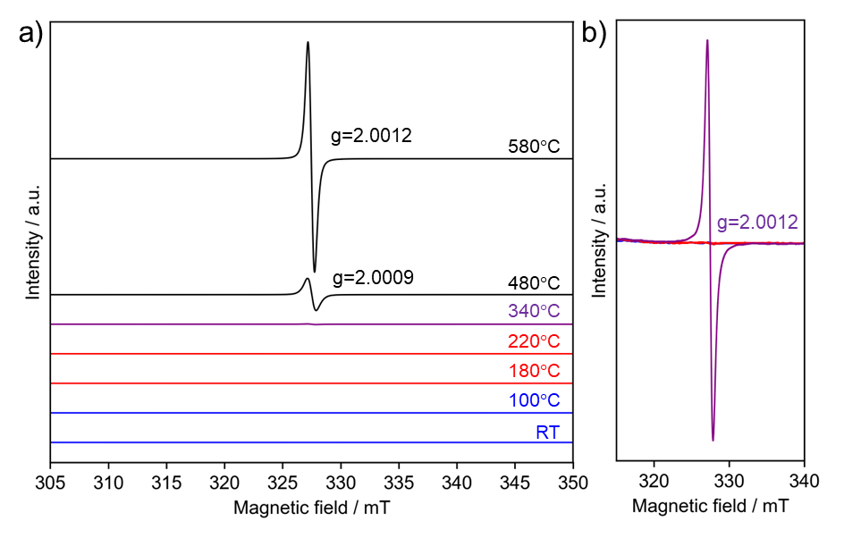
Figure 4. Electron Paramagnetic Resonance (EPR) spectra of materials derived from the zirconium oxo cluster precursor after annealing at various temperatures, illustrating the emergence of paramagnetic centers. All EPR signals were normalized by sample weight, and the spectra are vertically offset for clarity. (a) Overview of EPR spectra for samples annealed across the full temperature range studied (RT, 100, 180, 220, 340, 480, and 580°C). (b) Detailed view of EPR spectra for samples annealed at temperatures up to 340°C (RT, 100, 180, 220, and 340°C), i.e., below the onset of significant crystallization. The inset values indicate the experimentally determined g-values for the observed signals in this temperature range.

3.9 A unified model for the final black zirconia. The collective results from PDF, TGA, and EPR analyses converge to provide a comprehensive picture of the final black zirconia product as a defective, nanocrystalline material with a unique, oxygen-excess nature.
First, its nanocrystalline character is definitively established by the PDF data of the 580°C annealed sample. The experimental G(r) shows a finite structural coherence length, with correlations vanishing around 80 Å (8 nm) (Figure S4a). A quantitative estimation using a spherical particle model yielded a consistent particle diameter of 85 Å. The atomic arrangement within these nanocrystalline domains is well-ordered and accurately modeled by the stoichiometric tetragonal ZrO₂ phase (Figure S4b, R_{w} = 0.13), as confirmed by the excellent PDF fit at short-to-medium distances where atomic occupancies were fixed at unity. It is noted that the divergence of this ideal crystal model from the experimental data at higher r (Figure S4c) is a consequence of not only this intrinsic nanocrystallinity but also other structural complexities, such as particle size distribution and inter-domain strain, that are not fully captured by the simplified model.
However, the material's black color and strong EPR signal (Figure 4) clearly indicate a high density of defects that are not captured by this ideal, stoichiometric crystal model of the domains. This leads to a crucial conclusion: since the crystalline domains themselves are locally stoichiometric, the overall non-stoichiometry and the associated paramagnetic defects must be concentrated at the disordered interfaces and grain boundaries.
This model provides a unified explanation for all observations. The specific, oxygen-retaining decomposition of the acetate ligands around the persistent Zr₆ building blocks creates an intrinsically oxygen-excess (or metal-deficient) framework. This non-stoichiometry is accommodated at the interfaces between the nanocrystalline domains that form via the topochemical linkage of these building blocks. The resulting oxygen-rich nature of these interfacial regions, in turn, stabilizes the oxygen-centered radicals observed by EPR. Finally, the slow, high-temperature weight loss seen in TGA (>550°C) can be attributed to the gradual removal of species from these interfaces (such as residual hydroxyls or excess oxygen), a process that facilitates further grain growth and the slow perfection of crystalline order. Thus, the unique properties of this black zirconia are intrinsically linked to the defective interfaces generated by the controlled, stepwise transformation of the molecular precursor.

4. CONCLUSION
This study has elucidated the complex thermal transformation pathway of a structurally defined zirconium oxo cluster precursor into nanocrystalline zirconia, revealing unique intermediate structures and a distinct defect chemistry in the final oxide. While initial desolvation and subsequent partial acetate removal (up to 220°C) lead to the formation of an intermediate condensed dimeric structure where the Zr₆ cores are preserved, the most significant insights emerge from the subsequent decomposition stages, crystallization process, and the nature of the resulting material.
The complete removal of all acetate ligands by 480°C, as confirmed by FTIR and quantified by TGA, initiates the crystallization into tetragonal (P4₂​/nmc) ZrO₂. A critical finding is the remarkable preservation of the relative zirconium atom positions within the core Zr₆ motifs throughout the entire transformation process, from the molecular precursor to the final crystalline oxide. This strongly suggests a decomposition and crystallization pathway significantly templated by the precursor's architecture, exhibiting characteristics of a topochemical reaction where the robust Zr₆ units act as persistent structural building blocks guiding the formation of the oxide lattice.
The resulting crystalline product deviates significantly from stoichiometric white ZrO₂. This is evidenced by its persistent black coloration (Figure 2c) and a final, subtle high-temperature weight loss observed in TGA above ~550°C (Figure 2a). We attribute these features to a complex, defect-rich structure that is a direct consequence of the specific decomposition pathway. The oxygen-retaining ligand removal creates an intrinsically oxygen-excess (or metal-deficient) framework, which in turn stabilizes the oxygen-centered radicals (g ≈ 2.001) detected by EPR spectroscopy. This provides a comprehensive model for the unique defect chemistry of the material.
In essence, this work demonstrates a controlled pathway from a well-defined molecular cluster to nanocrystalline black zirconia featuring an oxygen-excess framework and hosting oxygen-centered radicals. The transformation is characterized by the topochemical preservation of its Zr₆ building blocks, highlighting a unique route to defect-engineered zirconia. These insights into the molecular-level transformation and the resulting defect chemistry offer a promising avenue for designing and synthesizing tailored zirconia nanomaterials with specific functionalities by rationally selecting or designing the molecular architecture of the starting cluster precursors.

ASSOCIATED CONTENT
Supporting Information. The Supporting Information is available free of charge at xxxxx. FT-IR spectra, total scattering data, thermogravimetric analysis, additional PDF analysis, atomic positions obtained by PDF analyses.
AUTHOR INFORMATION
Corresponding Author
* Corresponding Author: TOMINAKA.Satoshi@nims.go.jp
Author Contributions
ST designed and lead the project. ST synthesized the materials and collected data excepting the following measurements. ST, KS, AM collected synchrotron total scattering data. ST derived PDFs and analyzed them with the help of KS. YM analyzed single-crystal diffractometry. The manuscript was written by ST with the help of drafting by KS. All authors have given approval to the final version of the manuscript.
Funding Sources
This study was supported in part by NEDO JPNP20003 and by the JSPS KAKENHI (Grant Number 22K14712).
ACKNOWLEDGEMENT
We thank Y. Yoshida (NIMS) for help with the experiments (synthesis and characterization). The synchrotron radiation experiments at BL22XU and BL08W at SPring-8 were performed with the approval of the Japan Synchrotron Radiation Research Institute (JASRI) (Proposal Nos. 2018A3788, 2019A3751, 2019B3751, 2021A1025, 2021B3751, and 2023B3751). A part of this work was supported by "Advanced Research Infrastructure for Materials and Nanotechnology in Japan (ARIM)" of the Ministry of Education, Culture, Sports, Science and Technology (MEXT). Proposal Number JPMXP1223NM5052 and JPMXP1224NM5071.
REFERENCE
(1) Mi, J. L.; Jensen, K. M. O.; Tyrsted, C.; Bremholm, M.; Iversen, B. B. In Situ Total X-Ray Scattering Study of the Formation Mechanism and Structural Defects in Anatase TiO2 Nanoparticles under Hydrothermal Conditions. CrystEngComm 2015, 17 (36), 6868–6877.
(2) Skjærvø, S. L.; Ong, G. K.; Grendal, O. G.; Wells, K. H.; van Beek, W.; Ohara, K.; Milliron, D. J.; Tominaka, S.; Grande, T.; Einarsrud, M.-A. Understanding the Hydrothermal Formation of NaNbO ₃ : Its Full Reaction Scheme and Kinetics. Inorg Chem 2021, 60 (11), 7632–7640. https://doi.org/10.1021/acs.inorgchem.0c02763.
(3) Tominaka, S.; Yamada, H.; Hiroi, S.; Kawaguchi, S. I.; Ohara, K. Lepidocrocite-Type Titanate Formation from Isostructural Prestructures under Hydrothermal Reactions: Observation by Synchrotron X-Ray Total Scattering Analyses. ACS Omega 2018, 3 (8), 8874–8881.
(4) Yamada, H.; Tominaka, S.; Ohara, K.; Liu, Z. D.; Okubo, T.; Wakihara, T. Structural Evolution of Amorphous Precursors toward Crystalline Zeolites Visualized by an in Situ X-Ray Pair Distribution Function Approach. Journal of Physical Chemistry C 2019, 123 (46), 28419–28426. https://doi.org/10.1021/acs.jpcc.9b07232.
(5) Osada, M.; Sasaki, T. Two-Dimensional Dielectric Nanosheets: Novel Nanoelectronics from Nanocrystal Building Blocks. Advanced Materials 2012, 24 (2), 210–228. https://doi.org/10.1002/adma.201103241.
(6) Xie, Y. L.; Fang, W. H.; Zhang, J. Aggregation of Titanium-Oxo Clusters. Aggregate 2024, 5 (3), 1–20. https://doi.org/10.1002/agt2.506.
(7) Van den Eynden, D.; Pokratath, R.; Mathew, J. P.; Goossens, E.; De Buysser, K.; De Roo, J. Fatty Acid Capped, Metal Oxo Clusters as the Smallest Conceivable Nanocrystal Prototypes. Chem Sci 2022, 14 (3), 573–585. https://doi.org/10.1039/d2sc05037d.
(8) Hennig, C.; Weiss, S.; Kraus, W.; Kretzschmar, J.; Scheinost, A. C. Solution Species and Crystal Structure of Zr(IV) Acetate. Inorg Chem 2017, 56 (5), 2473–2480. https://doi.org/10.1021/acs.inorgchem.6b01624.
(9) Spijksma, G. I.; Seisenbaeva, G. A.; Fischer, A.; Bouwmeester, H. J. M.; Blank, D. H. A.; Kessler, V. G. The Molecular Composition of Non-Modified and Acac-Modified Propoxide and Butoxide Precursors of Zirconium and Hafnium Dioxides. J Solgel Sci Technol 2009, 51 (1), 10–22. https://doi.org/10.1007/s10971-009-1988-0.
(10) Li, D.; Chen, Q.; Chun, J.; Fichthorn, K.; De Yoreo, J.; Zheng, H. Nanoparticle Assembly and Oriented Attachment: Correlating Controlling Factors to the Resulting Structures. Chem Rev 2023, 123 (6), 3127–3159. https://doi.org/10.1021/acs.chemrev.2c00700.
(11) Ortatatli; Knossalla, J.; Schüth, F.; Weidenthaler, C. Monitoring the Formation of PtNi Nanoalloys Supported on Hollow Graphitic Spheres Using: In Situ Pair Distribution Function Analysis. Physical Chemistry Chemical Physics 2018, 20 (13), 8466–8474. https://doi.org/10.1039/c7cp07840d.
(12) Kondrat, S. A.; Smith, P. J.; Wells, P. P.; Chater, P. A.; Carter, J. H.; Morgan, D. J.; Fiordaliso, E. M.; Wagner, J. B.; Davies, T. E.; Lu, L.; Bartley, J. K.; Taylor, S. H.; Spencer, M. S.; Kiely, C. J.; Kelly, G. J.; Park, C. W.; Rosseinsky, M. J.; Hutchings, G. J. Stable Amorphous Georgeite as a Precursor to a High-Activity Catalyst. Nature 2016, 531 (7592), 83–87. https://doi.org/10.1038/nature16935.
(13) Tominaka, S.; Karimata, I.; Matsuoka, T.; Sakamoto, M.; Nakajima, T.; Ohara, K.; Tachikawa, T. Dynamic Symmetry Conversion in Mixed-Halide Hybrid Perovskite upon Illumination. ACS Energy Lett 2021, 6 (11), 3858–3863. https://doi.org/10.1021/acsenergylett.1c01798.
(14) Tominaka, S.; Ishihara, A.; Nagai, T.; Ota, K. I. Noncrystalline Titanium Oxide Catalysts for Electrochemical Oxygen Reduction Reactions. ACS Omega 2017, 2 (8), 5209–5214. https://doi.org/10.1021/acsomega.7b00811.
(15) Egami, T.; Billinge, S. J. L. Underneath the Bragg Peaks. Materials Today 2003, 6 (6), 57. https://doi.org/10.1016/S1369-7021(03)00635-7.
(16) Keen, D. A. Total Scattering and the Pair Distribution Function in Crystallography. Crystallogr Rev 2020, 26 (3), 141–199. https://doi.org/10.1080/0889311X.2020.1797708.
(17) Terban, M. W.; Billinge, S. J. L. Structural Analysis of Molecular Materials Using the Pair Distribution Function. Chem Rev 2022, 122 (1), 1208–1272. https://doi.org/10.1021/acs.chemrev.1c00237.
(18) Michel, F. M.; Ehm, L.; Antao, S. M.; Lee, P. L.; Chupas, P. J.; Liu, G.; Strongin, D. R.; Schoonen, M. A. A.; Phillips, B. L.; Parise, J. B. The Structure of Ferrihydrite, a Nanocrystalline Material. Science (1979) 2007, 316 (5832), 1726–1729. https://doi.org/10.1126/science.1142525.
(19) Sonobe, K.; Tominaka, S.; Sugimoto, W. Symmetric Breakage-Induced Semimetallic State: Polymorphism in Ruthenate Nanosheets. J Am Chem Soc 2022, 144 (33), 15008–15012. https://doi.org/10.1021/jacs.2c05951.
(20) Ohgi, Y.; Ishihara, A.; Matsuzawa, K.; Mitsushima, S.; Ota, K. Zirconium Oxide-Based Compound as New Cathode Without Platinum Group Metals for PEFC. J Electrochem Soc 2010, 157 (6), B885–B891.
(21) Doi, S.; Ishihara, A.; Mitsushima, S.; Kamiya, N.; Ota, K. I. Zirconium-Based Compounds for Cathode of Polymer Electrolyte Fuel Cell. J Electrochem Soc 2007, 154 (3), B362–B369.
(22) Yamamoto, Y.; Kasamatsu, S.; Sugino, O. Scaling Relation of Oxygen Reduction Reaction Intermediates at Defective TiO2 Surfaces. Journal of Physical Chemistry C 2019, 123 (32), 19486–19492. https://doi.org/10.1021/acs.jpcc.9b03398.
(23) Sinhamahapatra, A.; Jeon, J. P.; Kang, J.; Han, B.; Yu, J. S. Oxygen-Deficient Zirconia (ZrO2-x): A New Material for Solar Light Absorption. Sci Rep 2016, 6 (May), 1–8. https://doi.org/10.1038/srep27218.
(24) Ding, Y.; Wang, Q. Preparation and Research of New Black Zirconia Ceramics. Sci Rep 2024, 14 (1), 1–9. https://doi.org/10.1038/s41598-024-53793-8.
(25) Liu, Y.; Ishihara, A.; Mitsushima, S.; Kamiya, N.; Ota, K. Zirconium Oxide for PEFC Cathodes. Electrochemical and Solid-State Letters 2005, 8 (8), A400. https://doi.org/10.1149/1.1943550.
(26) Chen, X.; Liu, L.; Yu, P. Y.; Mao, S. S. Increasing Solar Absorption for Photocatalysis with Black Hydrogenated Titanium Dioxide Nanocrystals. Science (1979) 2011, 331 (6018), 746–750. https://doi.org/10.1126/science.1200448.
(27) Naldoni, A.; Allieta, M.; Santangelo, S.; Marelli, M.; Fabbri, F.; Cappelli, S.; Bianchi, C. L.; Psaro, R.; Dal Santo, V. Effect of Nature and Location of Defects on Bandgap Narrowing in Black TiO 2 Nanoparticles. J Am Chem Soc 2012, 134 (18), 7600–7603. https://doi.org/10.1021/ja3012676.
(28) Ariga, H.; Taniike, T.; Morikawa, H.; Tada, M.; Min, B. K.; Watanabe, K.; Matsumoto, Y.; Ikeda, S.; Saiki, K.; Iwasawa, Y. Surface-Mediated Visible-Light Photo-Oxidation on Pure TiO 2 (001). J Am Chem Soc 2009, 131 (41), 14670–14672. https://doi.org/10.1021/ja9066805.
(29) Sheldrick, G. M. SHELXT – Integrated Space-Group and Crystal-Structure Determination. Acta Crystallogr A Found Adv 2015, 71 (1), 3–8. https://doi.org/10.1107/S2053273314026370.
(30) Sheldrick, G. M. Crystal Structure Refinement with SHELXL. Acta Crystallogr C Struct Chem 2015, 71 (1), 3–8. https://doi.org/10.1107/S2053229614024218.
(31) Dolomanov, O. V; Bourhis, L. J.; Gildea, R. J.; Howard, J. A. K.; Puschmann, H. OLEX2: A Complete Structure Solution, Refinement and Analysis Program. J Appl Crystallogr 2009, 42, 339–341. https://doi.org/Doi 10.1107/S0021889808042726.
(32) Momma, K.; Izumi, F. VESTA 3 for Three-Dimensional Visualization of Crystal , Volumetric and Morphology Data. 2011, 1272–1276. https://doi.org/10.1107/S0021889811038970.
(33) Juhás, P.; Farrow, C. L.; Yang, X.; Knox, K. R.; Billinge, S. J. L. Complex Modeling: A Strategy and Software Program for Combining Multiple Information Sources to Solve Ill Posed Structure and Nanostructure Inverse Problems. Acta Crystallogr A Found Adv 2015, 71, 562–568. https://doi.org/10.1107/S2053273315014473.
(34) Puchberger, M.; Kogler, F. R.; Jupa, M.; Gross, S.; Fric, H.; Kickelbick, G.; Schubert, U. Can the Clusters Zr 6 O 4 (OH) 4 (OOCR) 12 and [Zr 6 O 4 (OH) 4 (OOCR) 12 ] 2 Be Converted into Each Other? Eur J Inorg Chem 2006, 2006 (16), 3283–3293. https://doi.org/10.1002/ejic.200600348.
(35) Tominaka, S.; Henke, S.; Cheetham, A. K. Coordination Polymers of Alkali Metal Trithiocyanurates : Measurements Using Single Crystals †. 2013, 9400–9407. https://doi.org/10.1039/c3ce41150h.
(36) Tosoni, S.; Pacchioni, G. Acetic Acid Ketonization on Tetragonal Zirconia: Role of Surface Reduction. J Catal 2016, 344, 465–473. https://doi.org/10.1016/j.jcat.2016.10.002.
(37) Cai, Q.; Lopez-Ruiz, J. A.; Cooper, A. R.; Wang, J.; Albrecht, K. O.; Mei, D. Aqueous-Phase Acetic Acid Ketonization over Monoclinic Zirconia. ACS Catal 2018, 8 (1), 488–502. https://doi.org/10.1021/acscatal.7b03298.
(38) Declerck, K.; Savić, N. D.; Moussawi, M. A.; Seno, C.; Pokratath, R.; De Roo, J.; Parac-Vogt, T. N. Molecular Insights into Sequence-Specific Protein Hydrolysis by a Soluble Zirconium-Oxo Cluster Catalyst. J Am Chem Soc 2024, 146, 11400–11410. https://doi.org/10.1021/jacs.4c01324.
(39) Gionco, C.; Paganini, M. C.; Giamello, E.; Burgess, R.; Di Valentin, C.; Pacchioni, G. Paramagnetic Defects in Polycrystalline Zirconia: An EPR and DFT Study. Chemistry of Materials 2013, 25 (11), 2243–2253. https://doi.org/10.1021/cm400728j.
(40) Giamello, E.; Volante, M.; Fubini, B.; Geobaldo, F.; Morterra, C. An EPR Study on the Formation of the Superoxide Radical Ion on Monoclinic Zirconia. Mater Chem Phys 1991, 29 (1–4), 379–386. https://doi.org/10.1016/0254-0584(91)90032-P.

For Table of Contents Use Only
Stepwise Topochemical Linkage of Zirconium Oxo Clusters to Yield Black Zirconia Nanocrystals
Satoshi Tominaka, Kazutaka Sonobe, Yoshitaka Matsushita, and Akihiko Machida

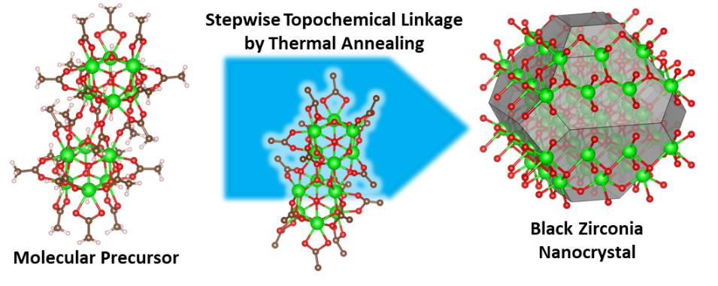
A structurally defined zirconium oxo cluster is shown to transform into a defect-rich black zirconia nanocrystal via a stepwise, topochemical pathway. X-ray pair distribution function (PDF) analysis reveals that the precursor's core Zr₆ building blocks are preserved during thermal annealing, guiding the formation of an oxygen-excess framework that hosts oxygen-centered radicals.

