Highlights
Study of radiation tolerance of Cu(In, Ga)Se₂ detector
K. Itabashi, S. Fujii, M. Imura, T. Isobe, M. Miyahara, J. Nishinaga, H. Oku- mura, M. Togawa
- Semiconductor detector’s performances degrade by radiation damage.
- A CIGS solar cell has an ability to recover from radiation damage though thermal annealing.
- The degradation of collected charge by ¹³²Xe⁵⁴⁺ irradiation is recovered by thermal annealing at 130 ◦C.
- The recovery characteristic of radiation damage in CIGS semiconductor is also beneficial for detectors.
- The recovery speed of proton irradiation damage in CIGS solar cells strongly depends on the annealing temperature.

Study of radiation tolerance of Cu(In, Ga)Se₂ detector
K. Itabashiª, S. Fujii^{b}, M. Imura^{c}, T. Isobe^{d}, M. Miyahara^{a,e}, J. Nishinaga^{f},
H. Okumura^{g}, M. Togawa^{a,e}
ªInternational Center for Quantum-ﬁeld Measurement Systems for Studies of the Universe and Particles (QUP,WPI), High Energy Accelerator Research Organization (KEK), Oho 1-1, Tsukuba, Ibaraki 305-0801, Japan.
^{b}The Graduate University for Advanced Studies, SOKENDAI, Kanagawa, Japan. ^{c}Research Center for Electronic and Optical Materials, National Institute for Materials Science (NIMS), Tsukuba, Ibaraki 305-0044, Japan.
^{d}Institute of Physical and Chemical Research (RIKEN), Wako, Sitama, 351-098, Japan. ^{e}Institute of Particle and Nuclear Studies, High Energy Accelerator Research Organization (KEK), Tsukuba, Ibaraki 305-0801, Japan.
^{f}Global Zero Emission Research Center, National Institute of Advanced Industrial Science and Technology (AIST), Tsukuba, Ibaraki 305-8568, Japan.
^{g}Faculty of Pure and Applied Sciences, University of Tsukuba, Tsukuba, Ibaraki 305-8573, Japan.

Abstract
A Cu(In, Ga)Se₂ (CIGS) semiconductor has been widely developed as a solar cell. It is known to have a radiation damage recovery mechanism brought about by a process of thermal annealing. We investigated the radiation dam- age recovery mechanism though two irradiation experiments at HIMAC and CYRIC. In the HIMAC experiment, a 2 µm-thick CIGS detector was irra- diated with a 400 MeV/u Xe ion (¹³²Xe⁺⁵⁴) beam, and the collected charge from Xe signal was observed. After Xe beam irradiation with a dose of
0.6 MGy, collected charge from the Xe beam was deteriorated to 51% of initial state. However, it recovered to 97% after 2 hours dark annealing at 130 ◦C. In the CYRIC experiment, 70 MeV protons with a fluence of
7.5×10¹⁵ MeV n_{eq}/cm² were irradiated to CIGS solar cells. After dark an- nealing at 130 ◦C for 1 hour, a short circuit current density (J_{SC}) recovered from 57% to 85% of the initial state. On the other hand, it took about 34 hours for the J_{SC} to recover from 50% to 85% at 90 ◦C. From these two irradiation experiments, it appeared that the radiation damage recovery mechanism is effective for the CIGS detector, the amount of recovery having a strong dependence on annealing temperature.

Preprint submitted to Elsevier September 3, 2024

Keywords: CIGS, Radiation-hard detector, Radiation-hard solar cell

Introduction
A Cu(In, Ga)Se₂ (CIGS) is an alloy semiconductor of CuInSe₂ and CuGaSe₂.
Since CIGS is a direct band gap semiconductor, it has a high light absorp- tion coefficient among solar cell materials and can absorb a broad spectrum of wavelengths, including in the infrared region. There has been significant activity in recent years in developing CIGS solar cells, and they attached a high energy conversion efficiency (η ∼ 20%), comparable to silicon solar cells [1]. Moreover, the CIGS solar cell is a promising candidate for space thin-film solar cells due to its light mass and high radiation tolerance [2]. In the previous experiment conducted at the Cyclotron and Radioisotope Cen- ter(CYRIC) in Tohoku University, we irradiated the 70 MeV proton beam with a fluence of 10¹⁶ MeV n_{eq}/cm² to CIGS solar cells [3]. The short- circuit current density (J_{SC}) and conversion efficiency were deteriorated, but gradually recovered through 95 ◦C dark annealing over an extended period. Therefore, a CIGS semiconductor has potential to be a detector with high ra- diation tolerance. To gain a more quantitative understanding of the recovery mechanism, we performed Xe ion and proton irradiation experiments: Heavy Ion Medical Accelerator in Chiba (HIMAC), and Cyclotron and Radioisotope Center (CYRIC).

¹³²Xe⁵⁴⁺ beam irradiation experiment at HIMAC
Radiation tolerance in CIGS detectors was studied using a 400 MeV/u Xe ion (¹³²Xe⁵⁴⁺) beam at HIMAC. Figure 1 (left) shows the integrated ADC value from Xe ion signal (collected charge). The collected charge from Xe ion signals continuously decreased to 50% of the initial state after Xe ion beam irradiation with 0.6 MGy. However, after 2 hours dark annealing at 130 ◦C, the collected charge recovered to 97% (Fig. 1, right). It was the first observation of radiation damage recovery in CIGS detectors, highlighting the potential for CIGS detectors with high radiation tolerance.

70 MeV proton irradiation experiment at CYRIC
In order to investigate the recovery mechanism of radiation damage, we irradiated CIGS solar cells, which have a thickness of 2 µm, with a 70 MeV

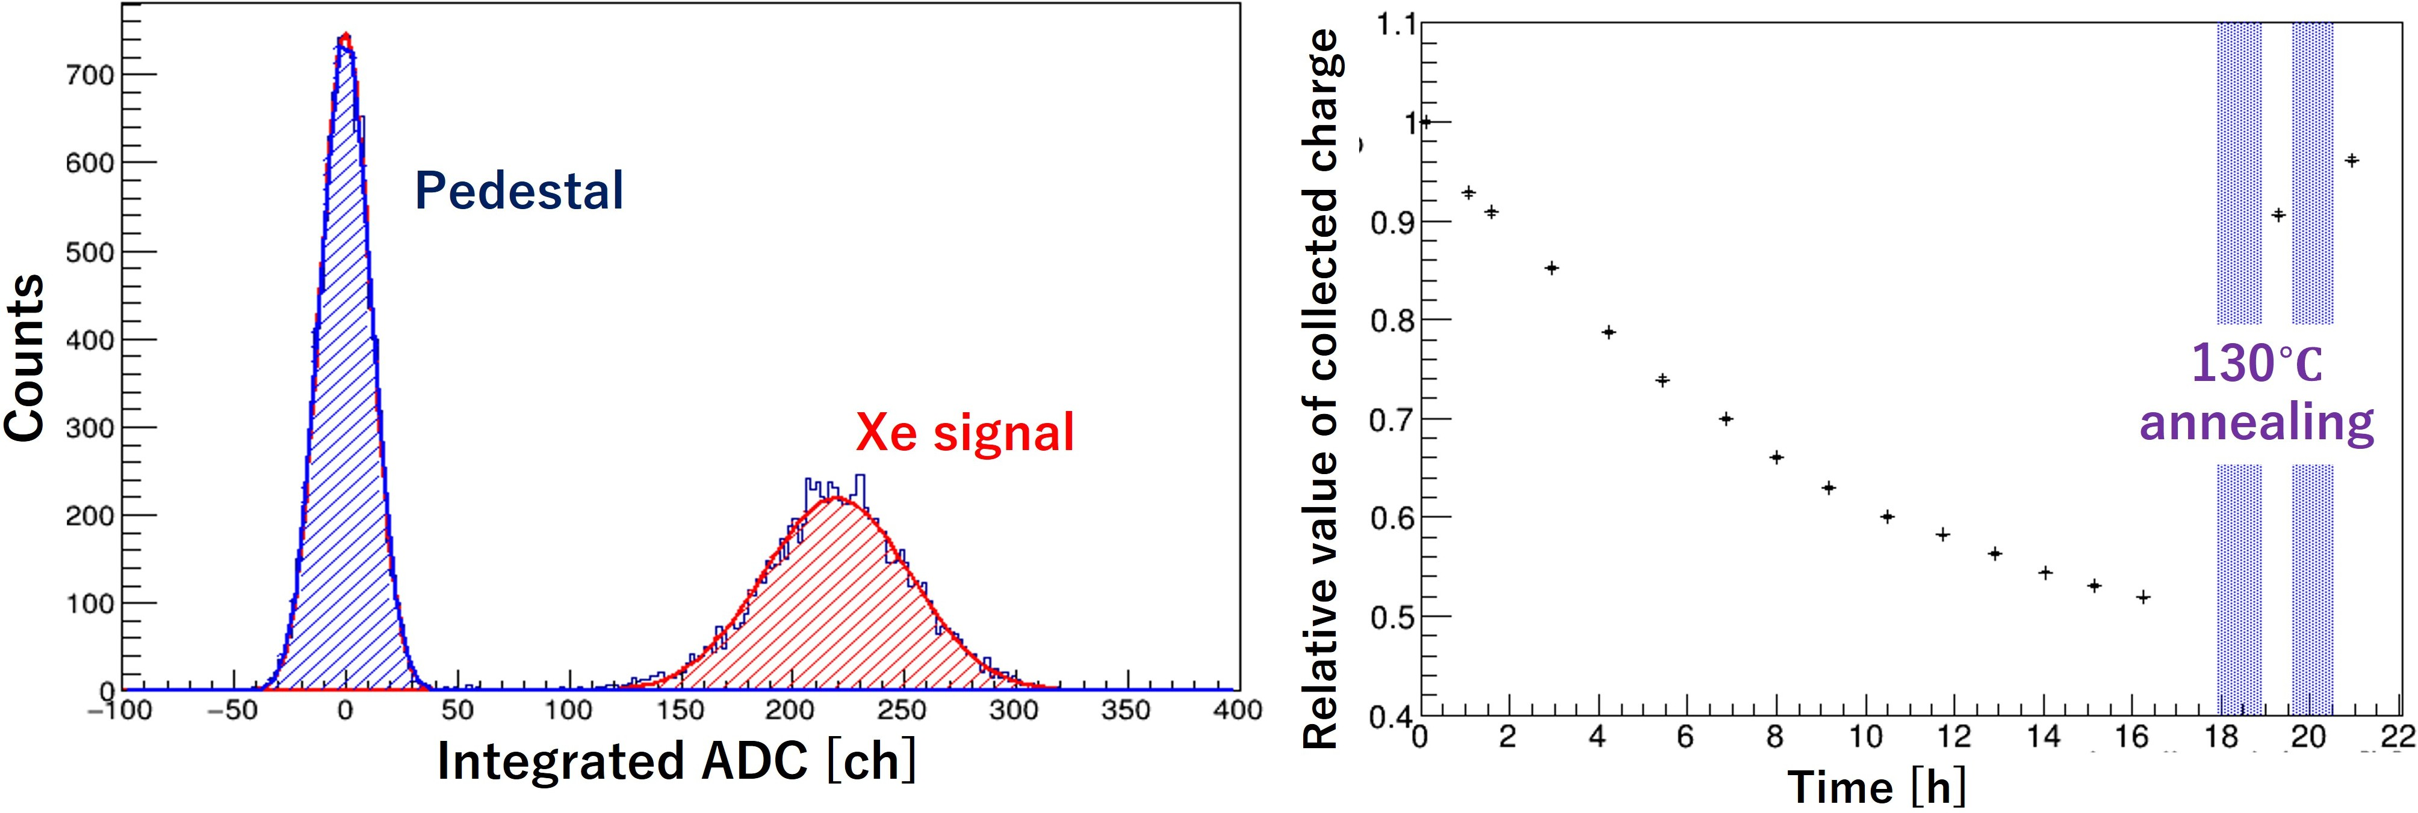
Figure 1: Left) Integrated ADC values from the Xe ion beam. Right) The Xe ion beam irradiation time dependence of the collected charge, and the collected charge recovery by dark annealing at 130 ◦C. The relative charge value continuously decreased during 16 hours period of ¹³²Xe⁵⁴⁺ irradiation. After two one-hour periods of dark annealing (blue hatched area), the relative charge value recovered to 97%.

proton beam at CYRIC. The annealing temperature dependence of the re- covery mechanism was evaluated through the current density-voltage (J-V) characteristic under irradiation with solar irradiation with an AM1.5 spec- trum with 100 mWcm⁻² at 25 ◦C. Figure 2 (left) shows the J-V curves. The J value decreased by radiation damage with a fluence of 7.5×10¹⁵ Me Vn_{eq}/cm² (blue line), but it recovered after dark annealing at 130 ◦C for 1.5 hours (yel- low line) and 2.5 hours (light blue line). Figure 2 (right) shows dark annealing cycles using proton irradiated solar cells heated under three different temper- ature conditions. The vertical axis represents a relative ratio of J_{SC}, which is the J value at 0 bias voltage, to that before irradiation. After a 90-minute period of annealing at 130 ◦C, the J_{SC} value reached saturation, the data exhibiting slight systematic fluctuations (Fig.2).
After 1 hour of dark annealing at 130 ◦C, the J_{SC} value recovered from
0.57 to 0.85, and then saturated at 0.87 for 90 minutes of dark annealing. Conversely, dark annealing at 90 ◦C required a longer period for J_{SC} to recover to 0.85 compared to dark annealing at 130 ◦C. This result is consistent with the recovery speed of collected charge measured in the HIMAC experiment at 130 ◦C (Fig. 1, right), and is expected to reflect similar trends in the CIGS detector.

Conclusion
The recovery mechanism of CIGS have been investigated though the pro- ton and Xe beam irradiation experiments. After proton and Xe irradiation, the performance of CIGS deteriorated due to radiation damage. However, we observed a recovery in the deteriorated performance by dark annealing

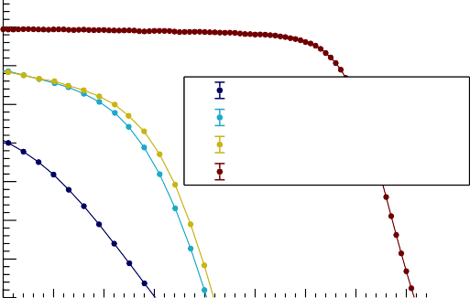
35
h
h
J [mA/cm2]
7.5×10¹⁵ MeV n /cm²
nq
130 °C annealing for 1.5
130 °C annealing for 2.5
Before Irradiation

30
25
20
15
10
5
00 0.1 0.2 0.3 0.4 0.5 0.6 0.7 0.8
Voltage [V]

0

0.
1
90 °C annealing
110 °C annealing
130 °C annealing
.9

8

7

6

5
Relative ratio of JSC

0.

0.

0.
0 200 400 600 800 1000 1200 1400 1600 1800 2000 2200
Annealing time [min]

Figure 2: Left) J-V curve with an AM1.5 spectrum at 100 mWcm⁻² at 25 ◦C. Right) Annealing time dependence of J_{SC} at 90, 110 and 130 ◦C.

at 130 ◦C for a short period. Through dark annealing of CIGS solar cells irradiated by the proton beam with the fluence of 7.5×10¹⁵ MeV n_{eq}/cm², we observed that the J_{SC} recovery has strong dependence on the annealing temperature.

Acknowledments
This work was supported by World Premier International Research Cen- ter Initiative (WPI), the Ministry of Education, Culture, Sports, Science and Technology (MEXT), Japan. This work was also supported by JSPS KAKENHI Grant No. 21K18635 and 23H01191 from MEXT, Japan and the Tsukuba Innovation Area (TIA). Part of the experiment was performed under the Research Project with Heavy Ions at NIRS-HIMAC, program No. 21H455.

References
- W. Liu et al., Solar Energy 233 337-344 (2022).
- M. Imaizumi et al., Prog. Phot. Res. Appl. 13 529-543 (2005).
- J. Nishinaga et al., J. Appl. Phys. 62 SK1014 (2023).

