Supporting Information:
On-Surface Synthesis of Polyene Linked Porphyrin Cooligomer
Kewei Sun^{1,2}, Atsushi Ishikawa³, Ryota Itaya⁴, Yuichiro Toichi⁴, Takuya Yamakado⁵, Atsuhiro Osuka⁵, Takayuki Tanaka⁵, Kazuyuki Sakamoto^{4,6}, Shigeki Kawai^{2,7}*

¹International Center for Young Scientists, National Institute for Materials Science, 1-2-1 Sengen, Tsukuba, Ibaraki 305-0047, Japan.
²Center for Basic Research on Materials, National Institute for Materials Science, 1-2-1 Sengen, Tsukuba, Ibaraki 305-0047, Japan.
³Department of Transdisciplinary Science and Engineering, School of Environment and Society, Tokyo Institute of Technology, 2-12-1 Ookayama, Meguro-ku, Tokyo, 152-8552, Japan.
⁴Department of Applied Physics, Osaka University, Osaka 565-0871, Japan.
⁵Graduate School of Science, Kyoto University, Kitashirakawa Oiwake-cho, Sakyo-ku, Kyoto 606-8502, Japan.
⁶Spintronics Research Network Division, Institute for Open and Transdisciplinary Research Initiatives, Osaka University, Osaka 565-0871, Japan
⁷Graduate School of Pure and Applied Sciences, University of Tsukuba, Tsukuba 305-8571, Japan.

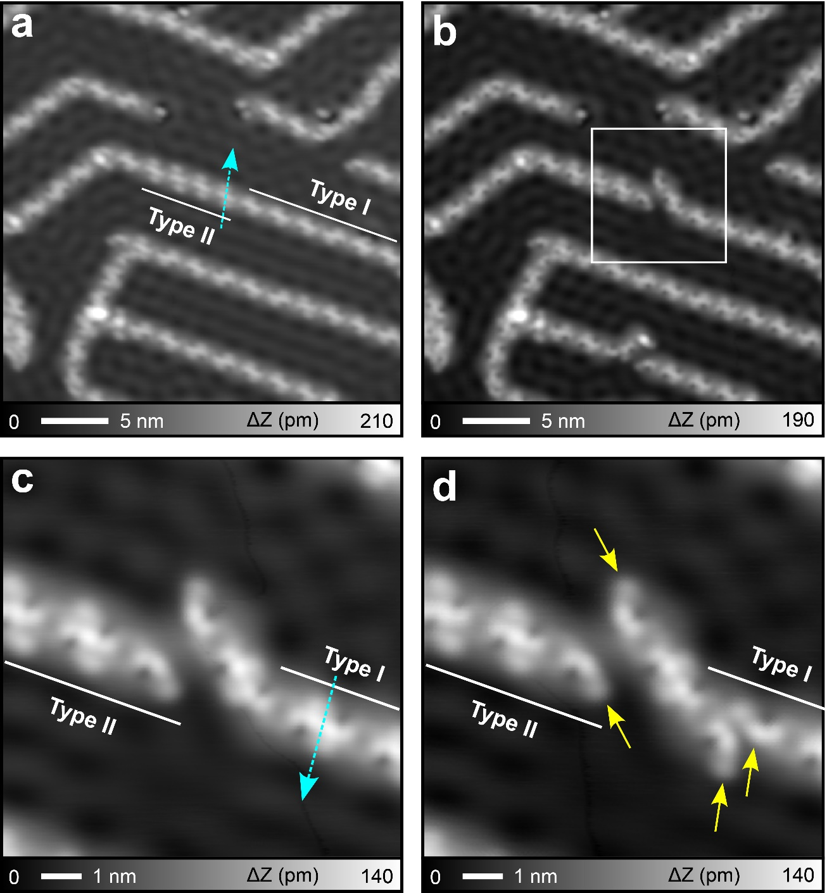
Figure S1. Tip manipulation. (a) Large-scale STM topography of self-assembled 1 on Cu(111). The arrow indicates the direction of the tip movement during manipulation process. (b) STM topography of the self-assembled 1 after tip manipulation. (c) Close-up view of the area indicated by square frame in (b). The arrow indicates next tip manipulation. (d) STM topography of the area (c) after tip manipulation. The arrows show the alkyl groups. Measurement parameters: Sample bias voltage V = 100 mV and tunneling current I = 100 pA in (a) (c) (d). V = 100 mV and I = 10 pA in (b).

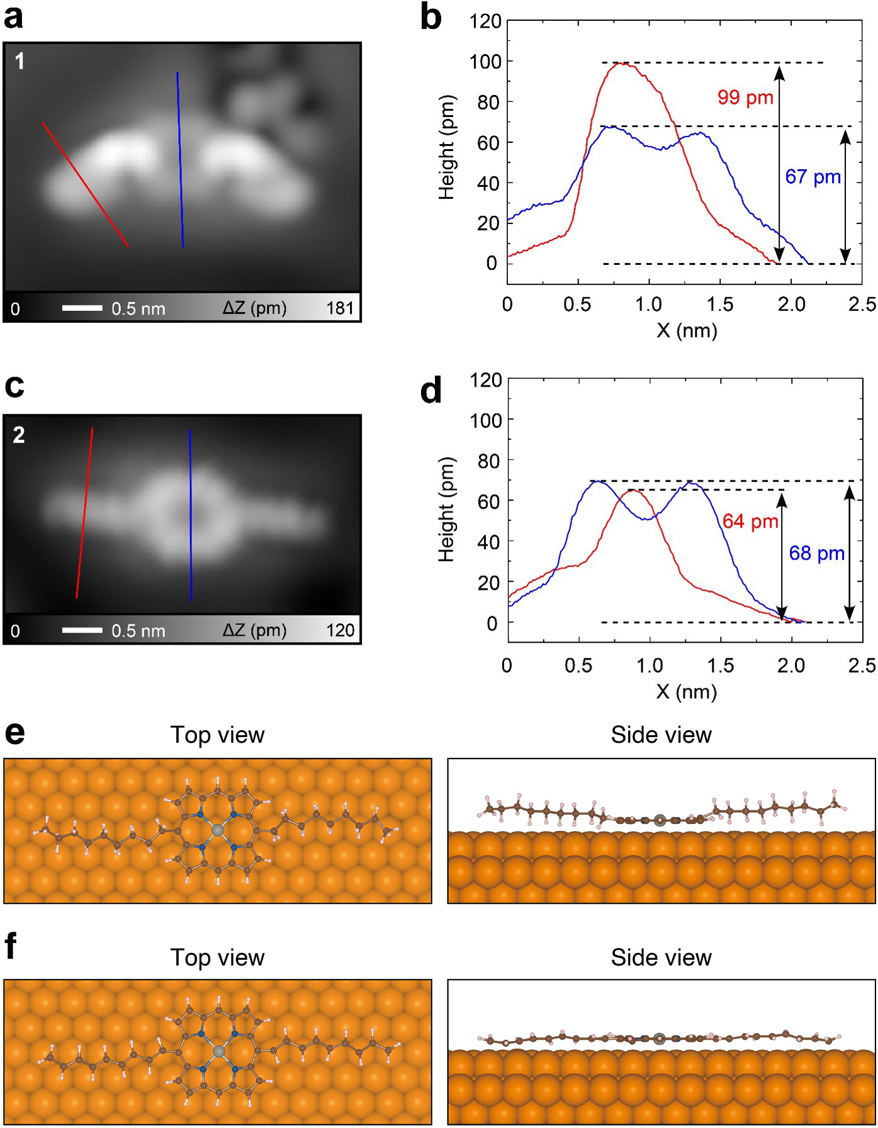
Figure S2. Experimental line profiles and DFT optimized structures. (a) Close-up STM topography of individual 1 on Cu(111). (b) Line profiles taken along red and blue lines in (a). (c) Close-up view of individual 2. (d) Line profiles taken along the red and blue lines in (c). (e) Top and side views of optimized 1 and (f) 2 on Cu(111). Measurement parameters: V = 200 mV and I = 5 pA in (a). V = 100 mV and I = 10 pA in (b).

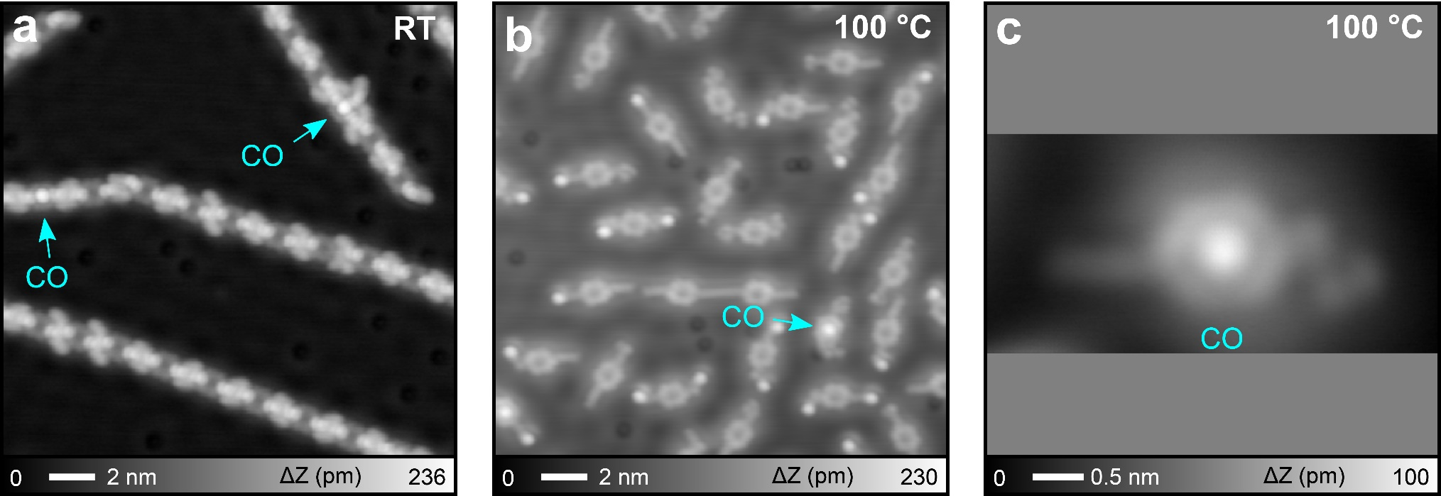
Figure S3. Adsorption of CO molecules on Zn-porphyrin core. (a) STM topography of as-deposited 1 on Cu(111) kept at room temperature, which is identical to Figure 1a of the main text. (b) STM topography of the Cu(111) surface after heating at 100 °C. (c) Close-up view of one molecule. The bright dots indicated by arrows correspond to CO molecules. Measurement parameters: V = 200 mV and I = 5 pA in (a) and (c). V = 200 mV and I = 10 pA in (b).

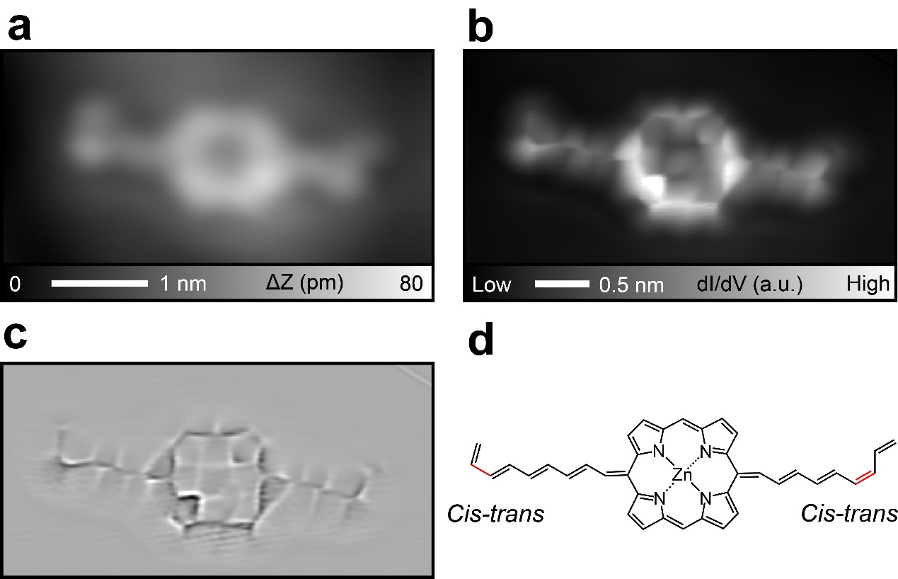
Figure S4. Cis isomer segment. (a) Close-up STM topography of a molecule with bent side groups, (b) the corresponding constant-height dI/dV mag, and (c) Laplace filtered image, as well as (d) the chemical structure model. Measurement parameters: V = 100 mV and I = 10 pA in (a).

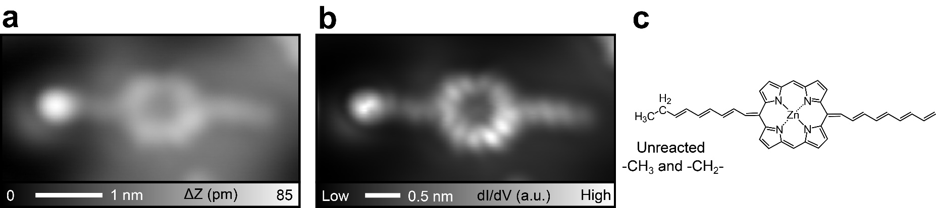
Figure S5. Incompletely reacted molecule. (a) Close-up STM topography of a single molecule with a bright dot, (b) the corresponding constant-height dI/dV map, and (c) the chemical structure model. Measurement parameters: V = 100 mV and I = 10 pA in (a).

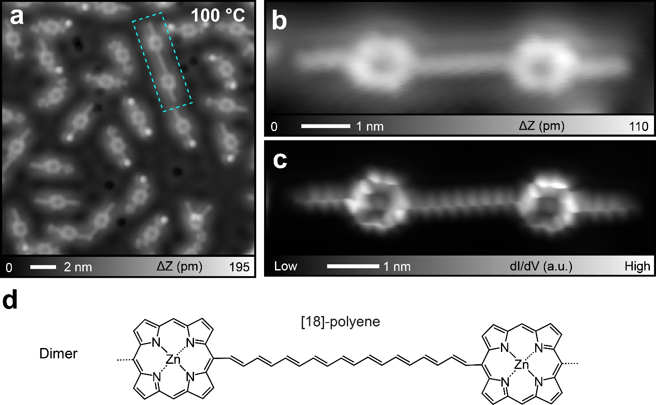
Figure S6. Dimer on Cu(111). (a) STM topography of Cu(111) after heating at 100 °C for 5 minutes. A rectangle indicates a straight dimer. (b) Close-up view of a straight dimer and (l) the corresponding constant height dI/dV map as well as (d) the chemical structure. Measurement parameters: V = 200 mV and I = 5 pA in (a), V = 200 mV and I = 10 pA in (b).

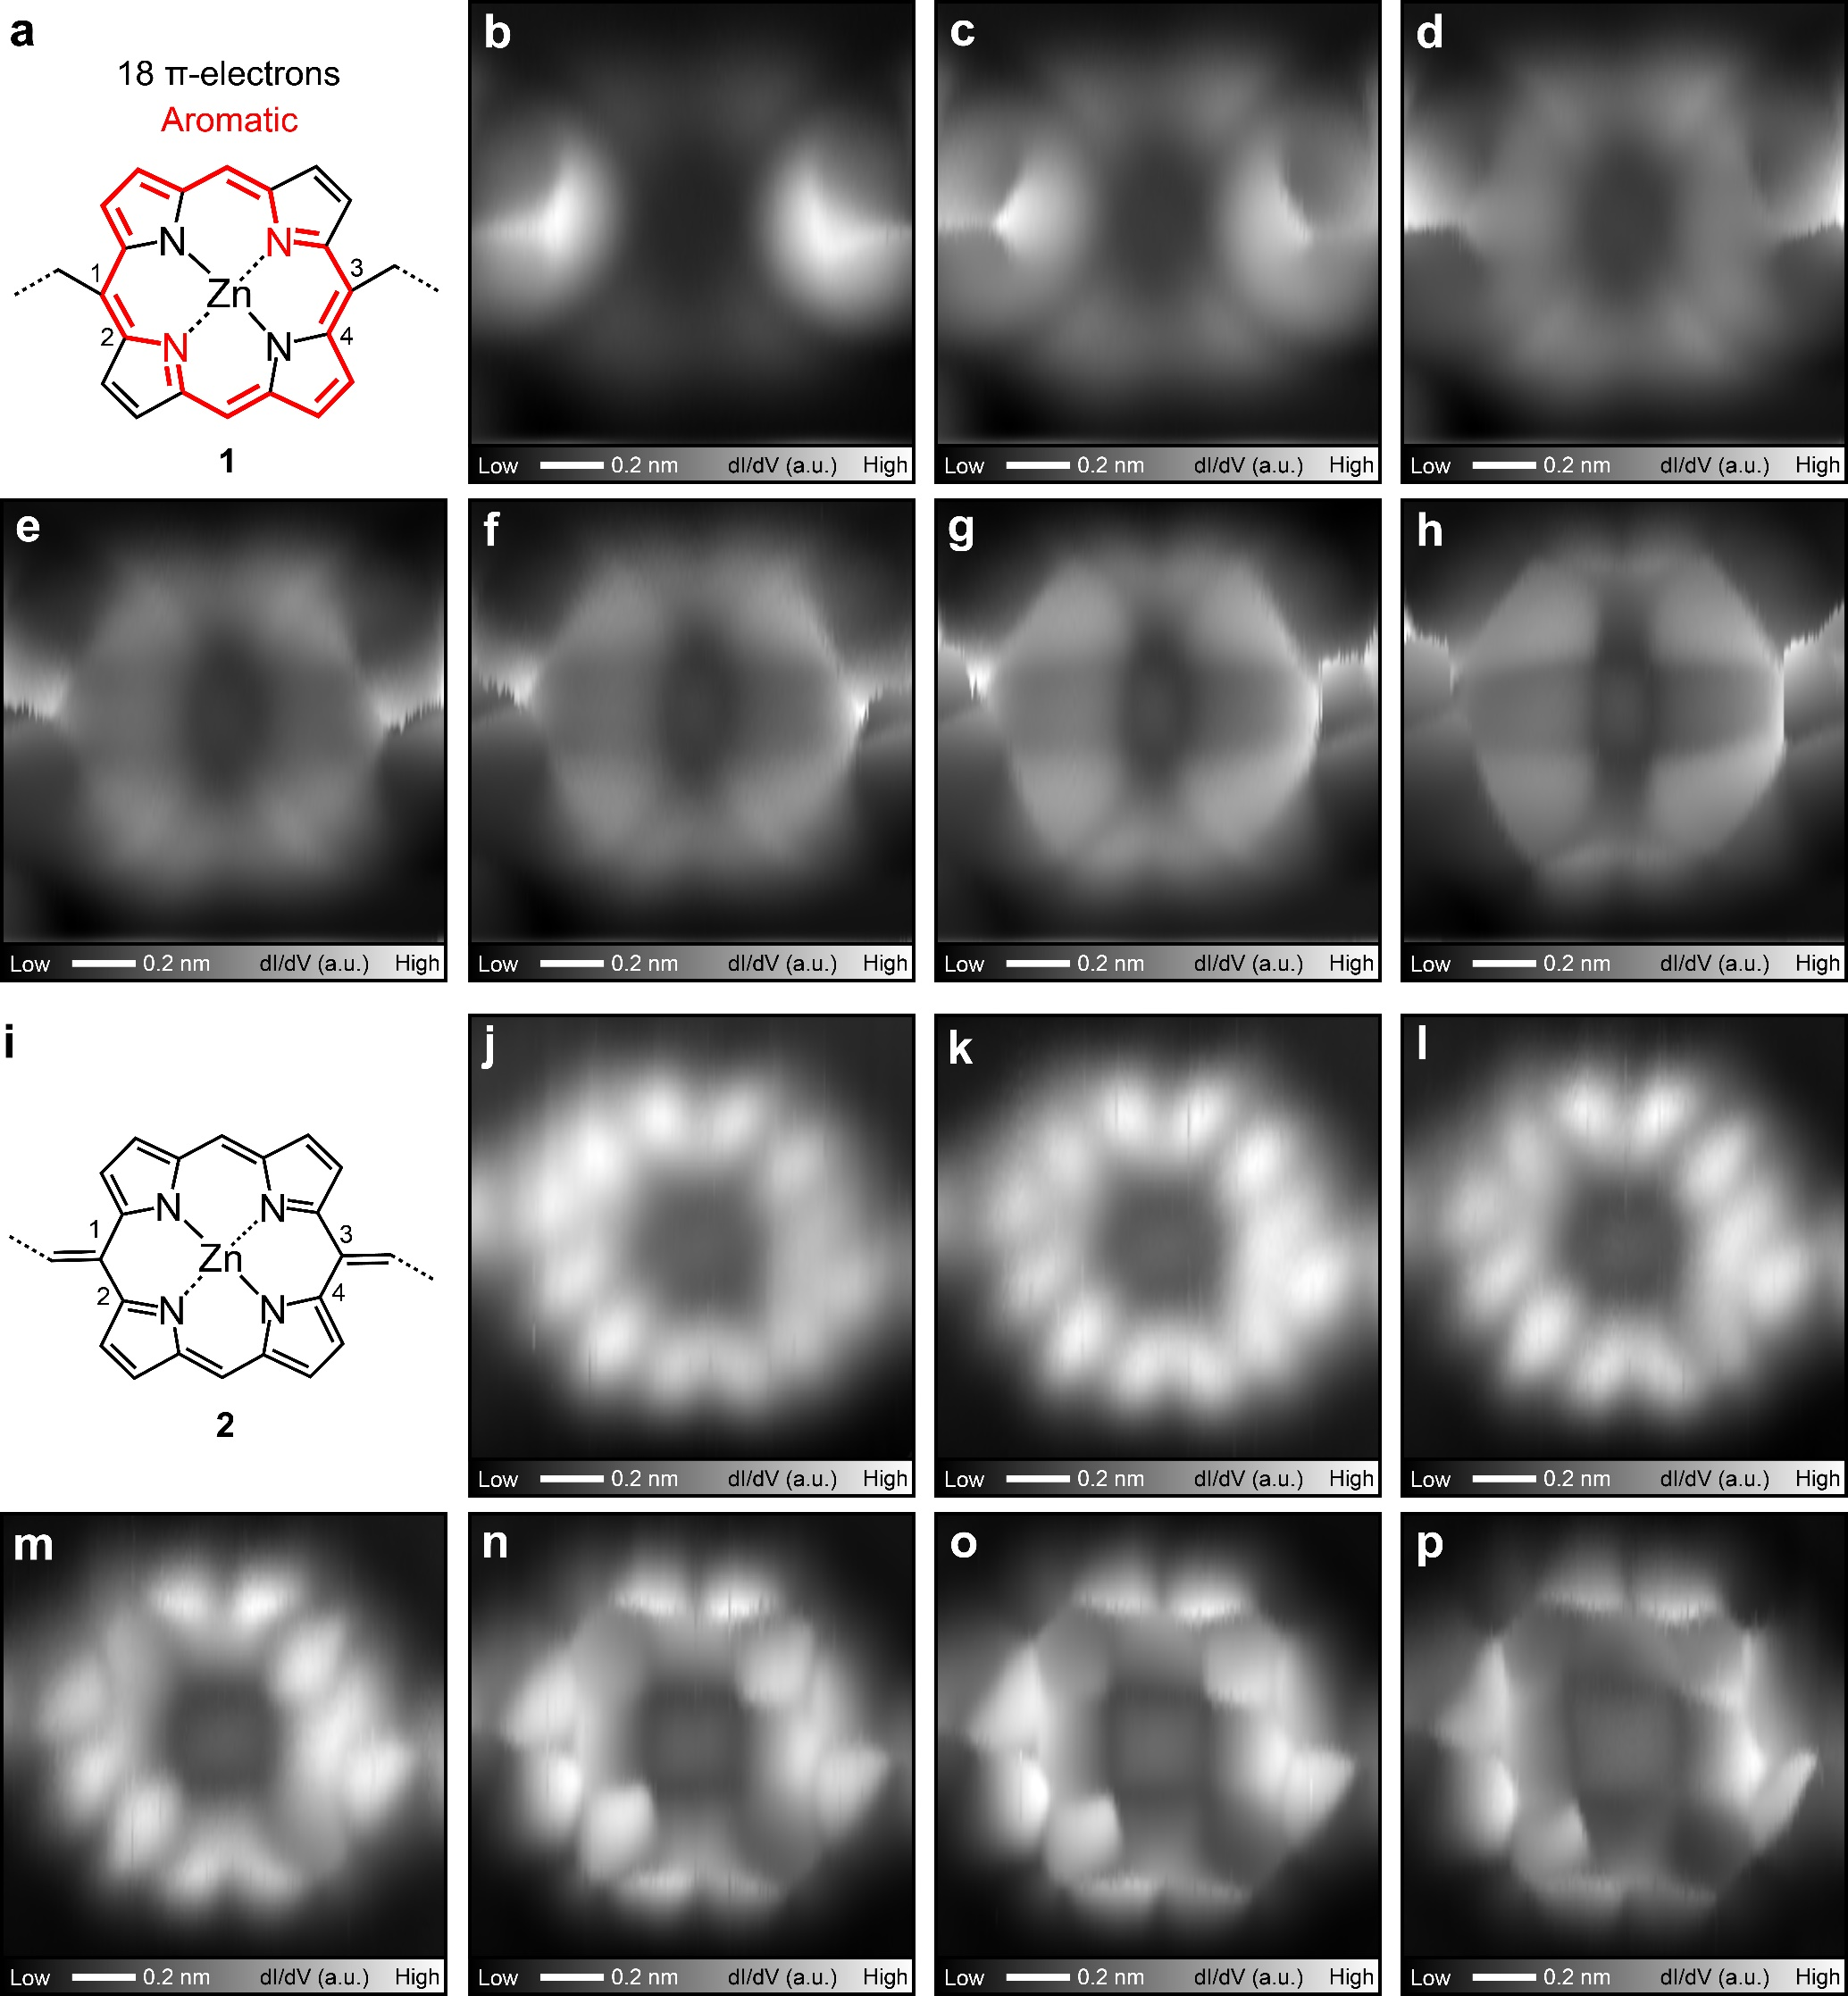
Figure S7. Contrasts of Zn-porphyrin cores before and after reactions. (a) Chemical structures of Zn-porphyrin core of 1. (b-h) A series of constant height dI/dV maps of Zn-porphyrin core of 1 taken with a CO tip at different tip-sample distances. (i) Chemical structures of Zn-porphyrin core of 2. (j-p) A series of constant height dI/dV maps of Zn-porphyrin core of 2 taken with a CO tip at different tip-sample distances.

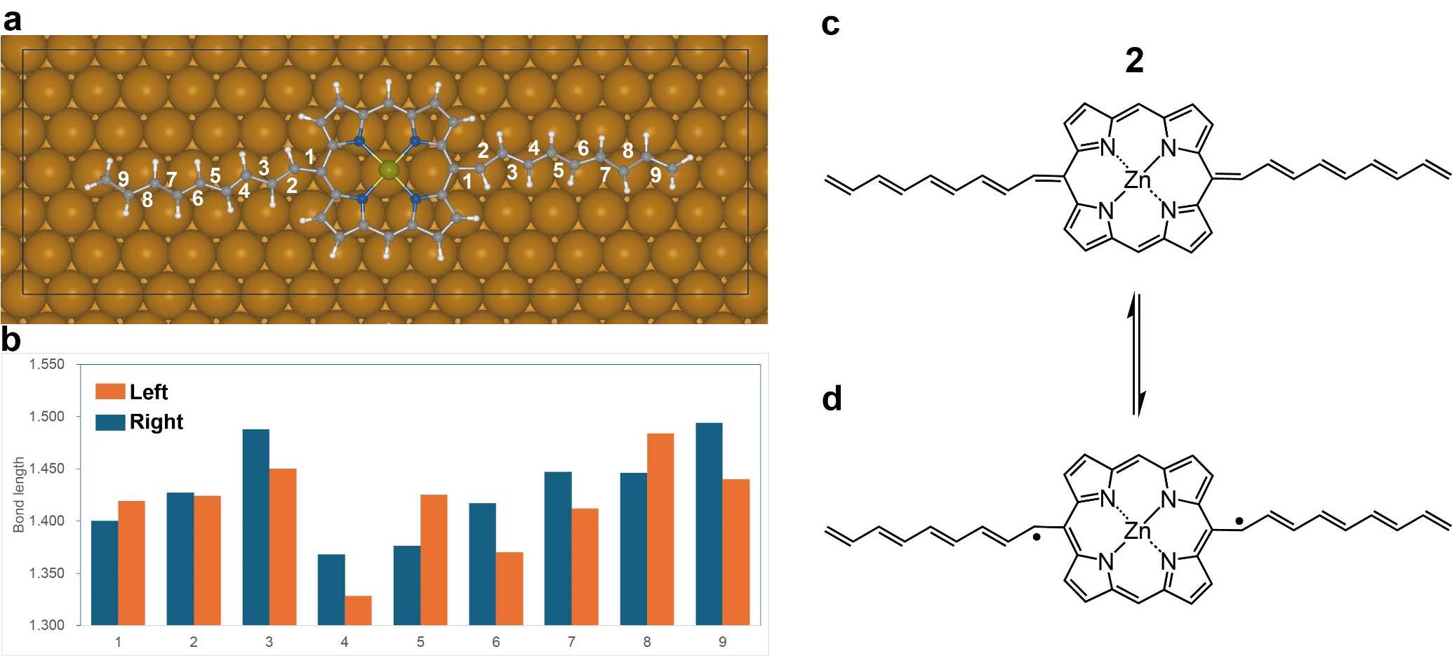
Figure S8. Calculated C-C bond lengths of the alkenyl groups of 2. (a) optimized 2 on Cu(111). (b) Calculated corresponding C-C bond lengths. (c) Closed-shell structure of 2. (d) Diradical structure of 2. The lengths of both bonds 1 and 2 are between single and double bonds, with bond orders approximately equal to 1.5. To explain the deviation from the double bond, we considered a resonating structure between quinoidal (c) and diradical porphyrin cores (d). The bond order close to 1.5 indicates that both structures almost equally contribute. Since the quinoidal character exists in the molecule, the aromaticity of the porphyrin core is reduced from that of 1 through the dehydrogenation of the nonyl group. Nevertheless, since the terminus of the alkene group has a CH₂ unit, it is reasonable to describe the quinoidal porphyrin core.

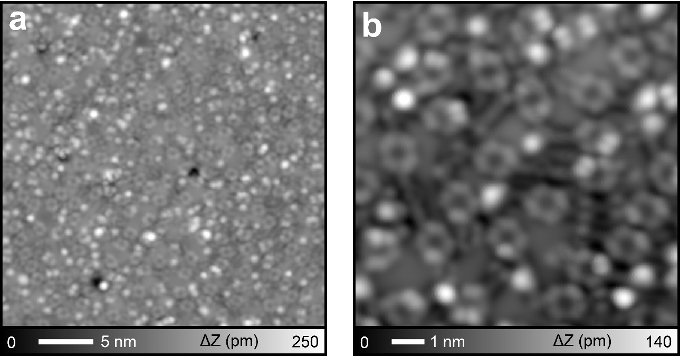
Figure S9. Disordered structures on Cu(111). (a) STM topography of Cu(111) with high coverage (~1ML) of 1 after annealing at 100 °C for 20 min and (b) close-up view. Molecules randomly fusing with each other to form disordered nanostructures. Measurement parameters: V = 5 mV and I = 100 pA in (a), V = 3 mV and I = 200 pA in (b).
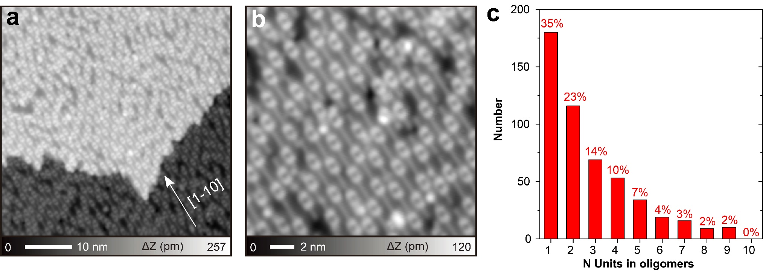
Figure S10. Statistical analysis of the product formed on Cu(110). (a) Large-scale STM topography of the Cu(110) surface with a high coverage of 1 after annealing at 180 °C for 30 min. (b) Corresponding zoom-in STM image. (c) Statistical analysis of the length distribution of products 3. Measurement parameters: V = 5 mV and I = 50 pA in (a). V = 10 mV and I = 500 pA in (b).

Figure S11. Calculated C-C bond lengths of the polyene chain between the Zn-porphyrin cores.

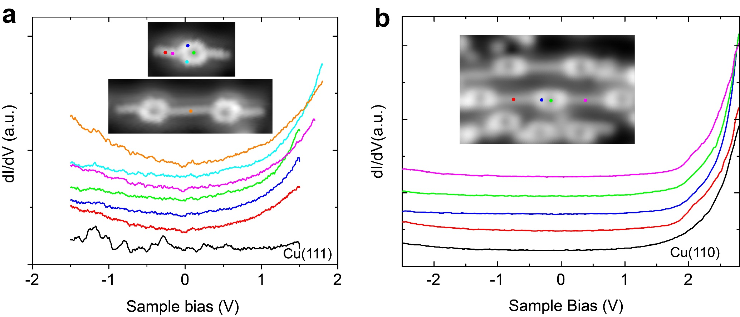
Figure S12. STS measurements. (a) dI/dV curves recorded above 2, a straight dimer and on the bare Cu(111) as reference. (b) dI/dV curves recorded above 3 and on the bare Cu(110) surface as a reference. Measurement parameters: V_{ac} = 10 mV, f = 510 Hz.

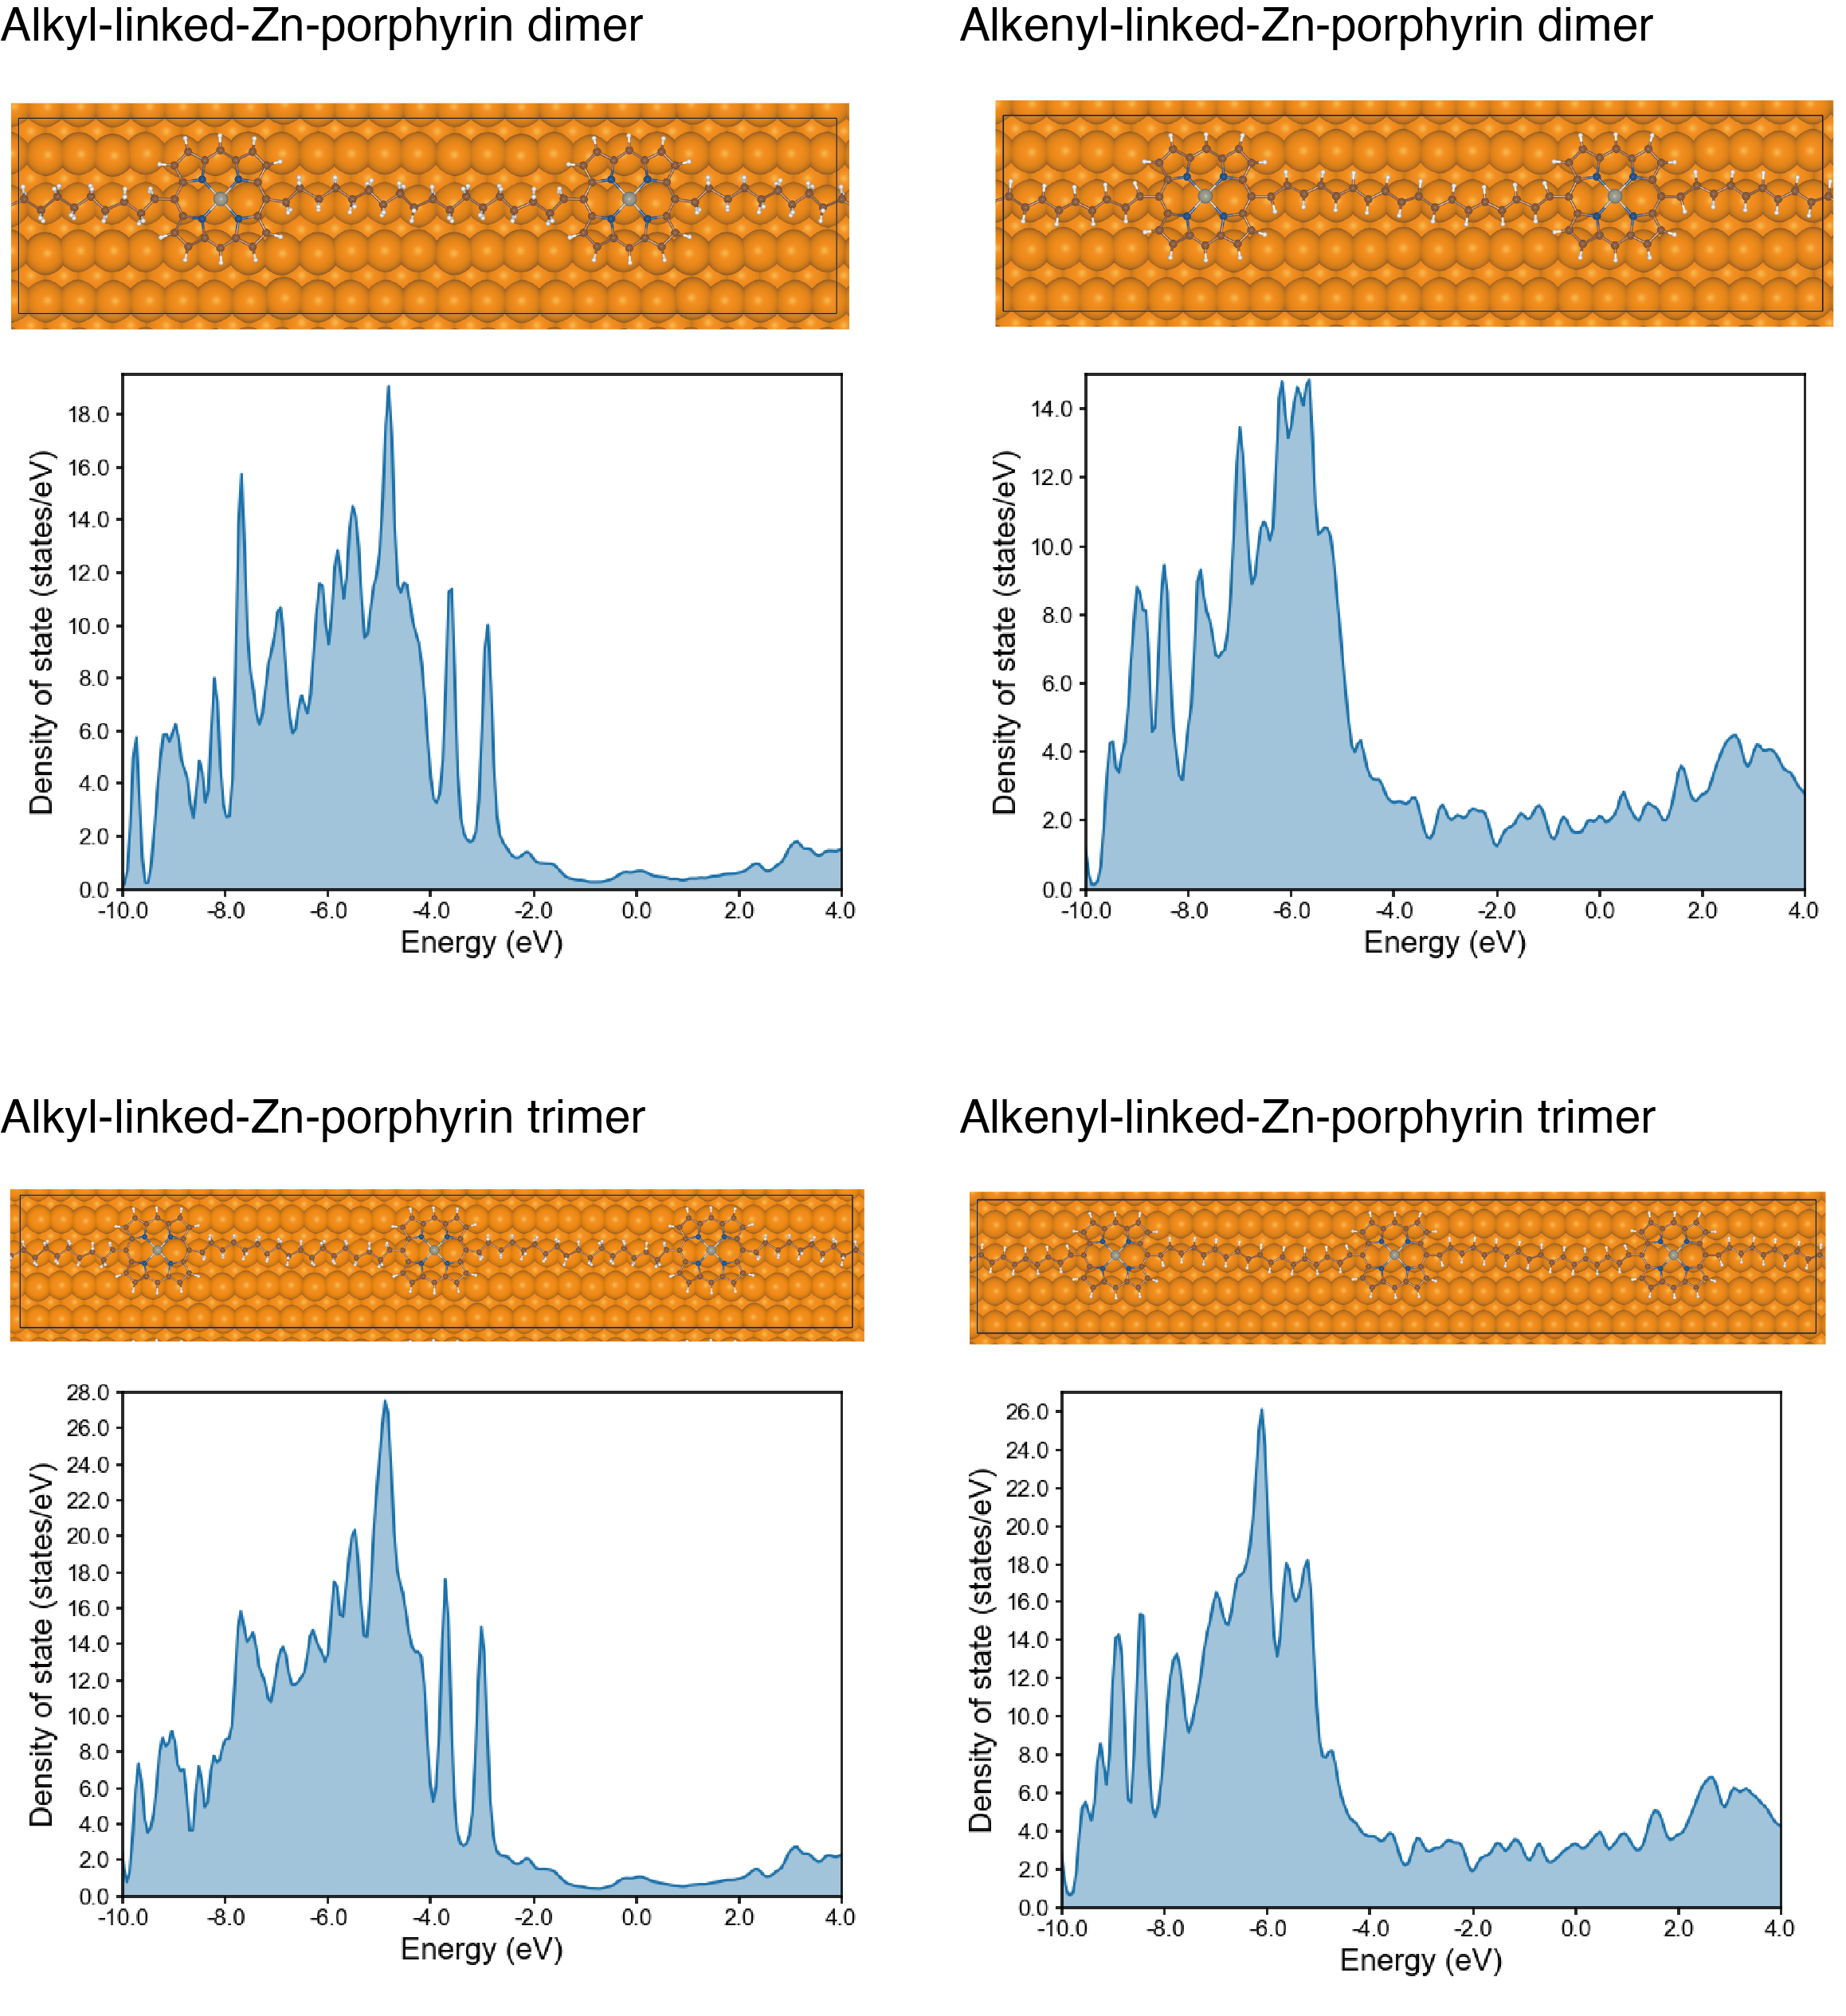
Figure S13. DFT-calculated localized density of states (LDOS) of dimer and trimers. Zn-porphyrin core linked by -C₉H₁₉ and -C₉H₁₀ are repeated, and dimer and trimer are formed and then adsorbed on Cu(110). The DOS calculations are done after the geometry optimization. The DOSs of alkyl and alkenyl chain carbon atoms are shown.

