Thermoelectric properties of single-phase n-type Bi₁₄Te₁₃S₈
Raphael Fortulan,#,† Sima Aminorroaya Yamini,∗†,‡¶ Azib Juri,† Illia Serhiienko,‡,§ and Takao Mori‡,§
#Department of Computer Science and Creative Technologies, UWE, Bristol, UK.
†Materials and Engineering Research Institute, Sheffield Hallam University, Sheffield S1
1WB, UK.
‡¶ Centre for Microscopy and Microanalysis, University of Queensland, St. Lucia, Qld, 4072, Australia.
‡International Center for Materials Nanoarchitectonics (WPI-MANA), National Institute
for Materials Science, Tsukuba 305-0044, Japan.
§Graduate School of Pure and Applied Science, University of Tsukuba, Tsukuba 305-8577, Japan
E-mail: s.aminorroaya@uq.edu.au

Abstract
Bismuth telluride (Bi₂Te₃) and its alloys are among the best thermoelectric materials at room temperature. Bi₁₄Te₁₃S₈, a material with a similar crystal structure, contains sulphur that can potentially improve thermoelectric performance through widening bandgap and reduced lattice thermal conductivity. This compound forms in sulphur added Bi₂Te₃ alloys. Here, polycrystalline iodine-doped Bi₁₄Te₁₃S₈ sample is investigated; an optimum iodine concentration of 1 at% resulted in the power factor of 3.5 mWm⁻² K⁻¹ at room temperature. Iodine doping reduced the lattice thermal conductivity for more than 30% by enhancing phonon scattering. An improved thermoelectric figure of merit zT of ∼0.29 at 520 K was obtained for 1-1.5 at% iodine doped Bi₁₄Te₁₃S₈. First-principles calculations indicate that Bi₁₄Te₁₃S₈ has a larger band gap compared to bismuth telluride, which allows for a reduction in the bipolar effect, however, a lower effective mass reduced the thermopower for a similar carrier concentration. This study demonstrates that tuned iodine doping can effectively optimise the thermoelectric performance of Bi₁₄Te₁₃S₈, highlighting its contribution in multiphase sulphur aloyed Bi₂Te₃-based materials.

Introduction
Thermoelectric Bi₂Te₃ and its alloys with sulphur have been the focus of extensive research^{2–7}; we have shown the alloying of Bi₂Te₃ with Bi₂S₃ introduces a secondary phase of Bi₁₄Te₁₃S₈ in the matrix of Bi₂Te₃¹, however, the thermoelectric properties of Bi₁₄Te₁₃S₈ have been not been intensely studied.⁸ Sulphur is a non-toxic and abundant, relative to tellurium and therefore, the thermoelectric properties of its compounds are of the interest of researchers.⁹
Previous works referred to Bi₁₄Te₁₃S₈ as Bi₂Te₂S and its electronic transport properties have been studied by several research groups.^{10–13} Bi₁₄Te₁₃S₈ has a layered rhombohedral crystal structure similar to Bi₂Te₃, with alternating layers of Bi-Te and Bi-S bonds along the c-axis, allowing for lower values of thermal conductivity.¹³ In this structure, some of Te atoms are replaced with lighter, more electronegative S atoms, widens the band gap compared to Bi₂Te₃, potentially allowing for a higher thermopower. The wider bandgap of Bi₁₄Te₁₃S₈ compared to Bi₂Te₃ allows for reduction of the bipolar effect which deteriorates the performance of this compound at temperatures higher than 400 K, ^{6,14,15} due to a reduction in thermopower. Several efforts have been made to suppress the effect of minority charges in Bi₂Te₃-based compounds by tuning the carrier concentration ^{16,17} and enlarging the bandgap. ^{18–20} However, the necessity for higher performance for temperatures over 500 K still persists.²¹
Similar to Bi₂S₃-based compounds, ^{22,23} high resistivity values present an obstacle for achieving higher values of figure-of-merit for Bi₁₄Te₁₃S₈, ¹³ creating a need to study the effects of carrier concentration tuning in this material.
In this work, we synthesise polycrystalline iodine doped Bi₁₄Te₁₃S₈ samples to investigate the effect of iodine on the electronic transport properties of this compound. The optimum concentration of iodine is determined to maximise the power factor through controlled changes in carrier concentration while suppressing harmful minority carrier conduction. Point defect scattering from the iodine dopants reduced the lattice thermal conductivity.

Experimental details

Synthesis
A set of Bi₂(Te_{1.857}S_{1.142})_{1–x}I_{x} (x = 0, 0.005, 0.01, 0.015, and 0.02) samples were synthesised by direct reaction of stoichiometric amounts of high purity Bi (99.999%, Alfa Aesar), Te (99.999%, Alfa Aesar) shots, dried S (99.99%, Alfa Aesar) powder, and BiI₃ (99.999%, Alfa Aesar Puratronic®) powder in vacuum sealed quartz tubes in an inert atmosphere glove box. The tubes were homogenised at 850◦C for 16 h, quenched in cold water, and annealed at 450◦C for 72 h. The obtained ingots were hand-ground into fine powders in an agate mortar and pestle inside an inert atmosphere glove box. The powders were then loaded into a graphite die and sintered under vacuum to produce 11 mm diameter rods using spark plasma sintering (Dr. Sinter-1080 SPS system, Fuji-SPS, Japan) at 400 ◦C and an axial pressure of 50 MPa for 5 min. The relative density of the sintered samples, calculated from the weight and dimensions of the rods, was ≥99% for all the samples.

Materials characterisation
Phase purity and crystal structure of the sintered samples were characterised by X-ray diffraction (XRD) using a PANalytical X’Pert PRO X-ray diffractometer with Cu-Kα1 radiation (λ = 1.54059 ˚A, 40 kV, 40 mA). Rietveld refinements were performed on the acquired diffraction patterns using the GSAS-II software.²⁴
The electronic transport properties of the sintered samples were investigated in the parallel direction to the sintering pressure by cutting ∼2 × 2 × 8 mm³ bars from the sintered rods, parallel to the sintering direction. The measurements were carried out from room temperature to 520 K under a helium atmosphere using a Linseis LSR-3 apparatus.
The thermal transport properties of the samples were investigated parallel to the sintering pressure by cutting out a disc with a diameter and thickness of approximately 10 mm and 1.5 mm, respectively, from the sintered rods. The thermal conductivities (κ) were calculated using the thermal diffusivity ($D$), specific heat capacity (c_{p}), and density ($d$) of the samples, κ = D · c_{p} · d. The thermal diffusivity was measured using a Netzsch LFA-467 Hyperflash® instrument. The specific heat capacity was measured using a PerkinElmer-DSC 8000 differential scanning calorimeter in compliance with the sapphire standard ASTM E1269-11(2018) test.²⁵
The disc-shaped samples were also used to measure carrier concentration and electronic mobility using the van der Pauw technique with an ECOPIA HMS 3000 Hall measurement system.

Electronic structure calculation
DFT calculations were employed to qualitatively study the electronic band structure of the pristine sample. The PBE and GGA exchange-correlation functionals were used.²⁶ Monkhorst-Pack procedure was used to generate 10 × 10 × 10 k-points for the Brillouin zone.²⁷ The plane wave/pseudopotential approach was employed, with a kinetic energy cut-off of 45 Ry for the wavefunctions and 360 Ry for the electron density. The crystal structure used was that of the Rietveld refined pristine sample.

Results and discussion

Structural and phase analysis

Figure 1 shows the XRD patterns of all samples analysed. The diffraction patterns confirm the existence of a single rhombohedral phase of Bi₁₄Te₁₃S₈ crystal belonging to the space group R$\bar{3}$ (PDF Card - 04-009-4602).
The lattice parameters for each sample were determined using Rietveld refinement of the XRD patterns (Table 1). As shown in Figure 2, the lattice parameters exhibit variation with the presence of the dopant, where a = b parameters show an overall decline, while the c parameter fluctuates with the dopant concentration. These changes in the lattice parameters can be attributed to the differences in ionic radii of S^{2–} (0.184 nm), Te^{2–} (0.221 nm), and I^{1–} (0.22 nm).²⁸ Similar behaviour was observed in iodine-doped Bi₂Te₃, albeit to a lesser extent due to the relatively similar radii of Te^{2–} and I^{1–}.^{29,30} Nevertheless, the obtained values are consistent with literature-reported values of a = b = 1.1269 nm and c = 1.1129 nm.³¹
It is worth noting that all samples exhibited a preferred orientation in the {006} lattice plane, as illustrated in Figure 3. This was also observed in samples of Bi₂Te_{2–x}S_{1–x}⁸ and it is likely due to the preferred crystal growth in the basal plane parallel to the ingot growth direction.³² This indicates that the samples show a large degree of anisotropy in the transport properties with a preferred orientation. Much like Bi₂T₃, Bi₁₄Te₁₃S₈ exhibits three covalently bonded quintuple layers of [Te⁽¹⁾/S⁽¹⁾ − Bi − S⁽²⁾ − Bi − Te⁽¹⁾/S⁽¹⁾] sheets stacked along the c-axis.^{33–35} These layers interact weakly through van der Waals interactions.³¹ Here, the superscripts (1) and (2) were used to distinguish the two types of atomic bonding, where (1) denotes a weak van der Waals attraction and (2) denotes a covalent bonding.³⁶ Note that this crystal structure has been erroneously referred to as “Bi₂Te₂S” in some works.^{12,37}. Pauling³¹ realised that the “Bi₂Te₂S” crystal structure was unlikely to be stable at this stoichiometry due to a substantial strain localised on the internal sulphur layer within the stacking sequence. This strain is due to the considerable difference in ionic radii between S and Te, which would result in a large size mismatch between the hexagonal, closely packed S and Te layers. To relieve this strain and stabilise the structure, formula of Bi₁₄Te₁₃S₈a was suggested in which S only occupies the ${Te}_{1}$ sites in the ${Bi}_{2}{Te}_{3}$ structure (39 and Cava, R. J.; Ji, H.; Fuccillo, M. K.; Gibson, Q. D.; Hor, Y. S., Crystal structure and chemistry of topological insulators. Journal of Materials Chemistry C 2013, 1 (19), 3176-3189).

Band structure analysis
The calculated electronic band structure of Bi₁₄Te₁₃S₈ using the refined lattice parameters for the original sample as described in Table 1 is shown in Figure 4. The band structure shows a direct bandgap semiconductor with the conduction band minimum and the valence band maximum centred around the Γ point in reciprocal space.

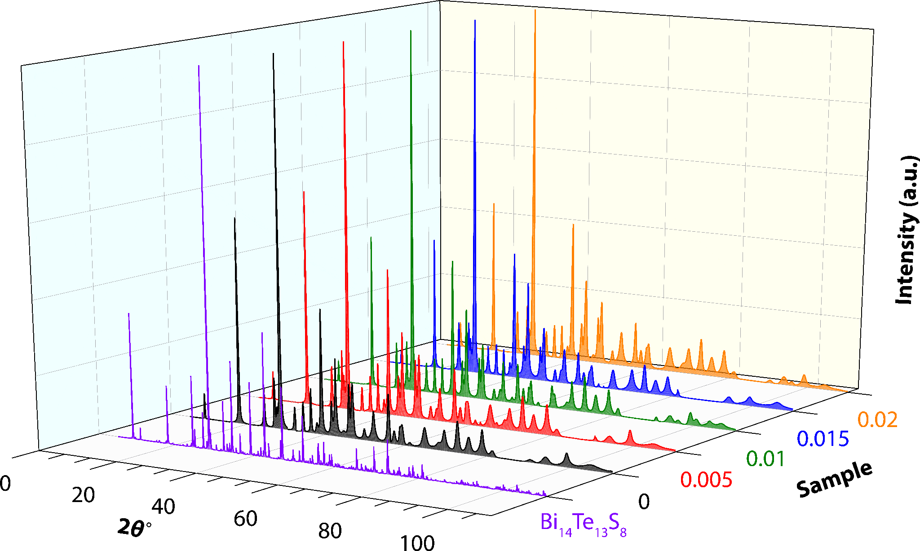
Figure 1: X-ray diffraction patterns of Bi₂(Te_{1.857}S_{1.142})_{1–x}I_{x} (x = 0, 0.005, 0.01, 0.015, and 0.02)

Table 1: Refined lattice parameters of Bi₂(Te_{1.857}S_{1.142})_{1–x}I_{x} (x = 0, 0.005, 0.01, 0.015, and
0.02)
x | a = b (nm) | c (nm)
0 | 1.121983(12) | 2.965397(29)
0.005 | 1.12174(12) | 2.96318(27)
0.01 | 1.12210(10) | 2.96279(26)
0.015 | 1.12140(9) | 2.96473(26)
0.02 | 1.12128(12) | 2.96494(31)

The obtained bandgap for Bi₁₄Te₁₃S₈ is about 0.14 eV. However, it is well known that traditional DFT calculations, such as PBE (used in this work), underestimate the value of the band gap ^{38–42} with the errors mainly due to: (1) self-interaction errors due to interactions of an electron with itself in the Coulomb repulsion term of the density functional;^{41,43} and (2) the Kohn-Sham eigenvalues, which stem from using the differences of the ground state energies of the Kohn-Sham system as the band gap.^{44,45}
Figure 2: Variation of lattice parameters a = b and c with the dopant concentration x.
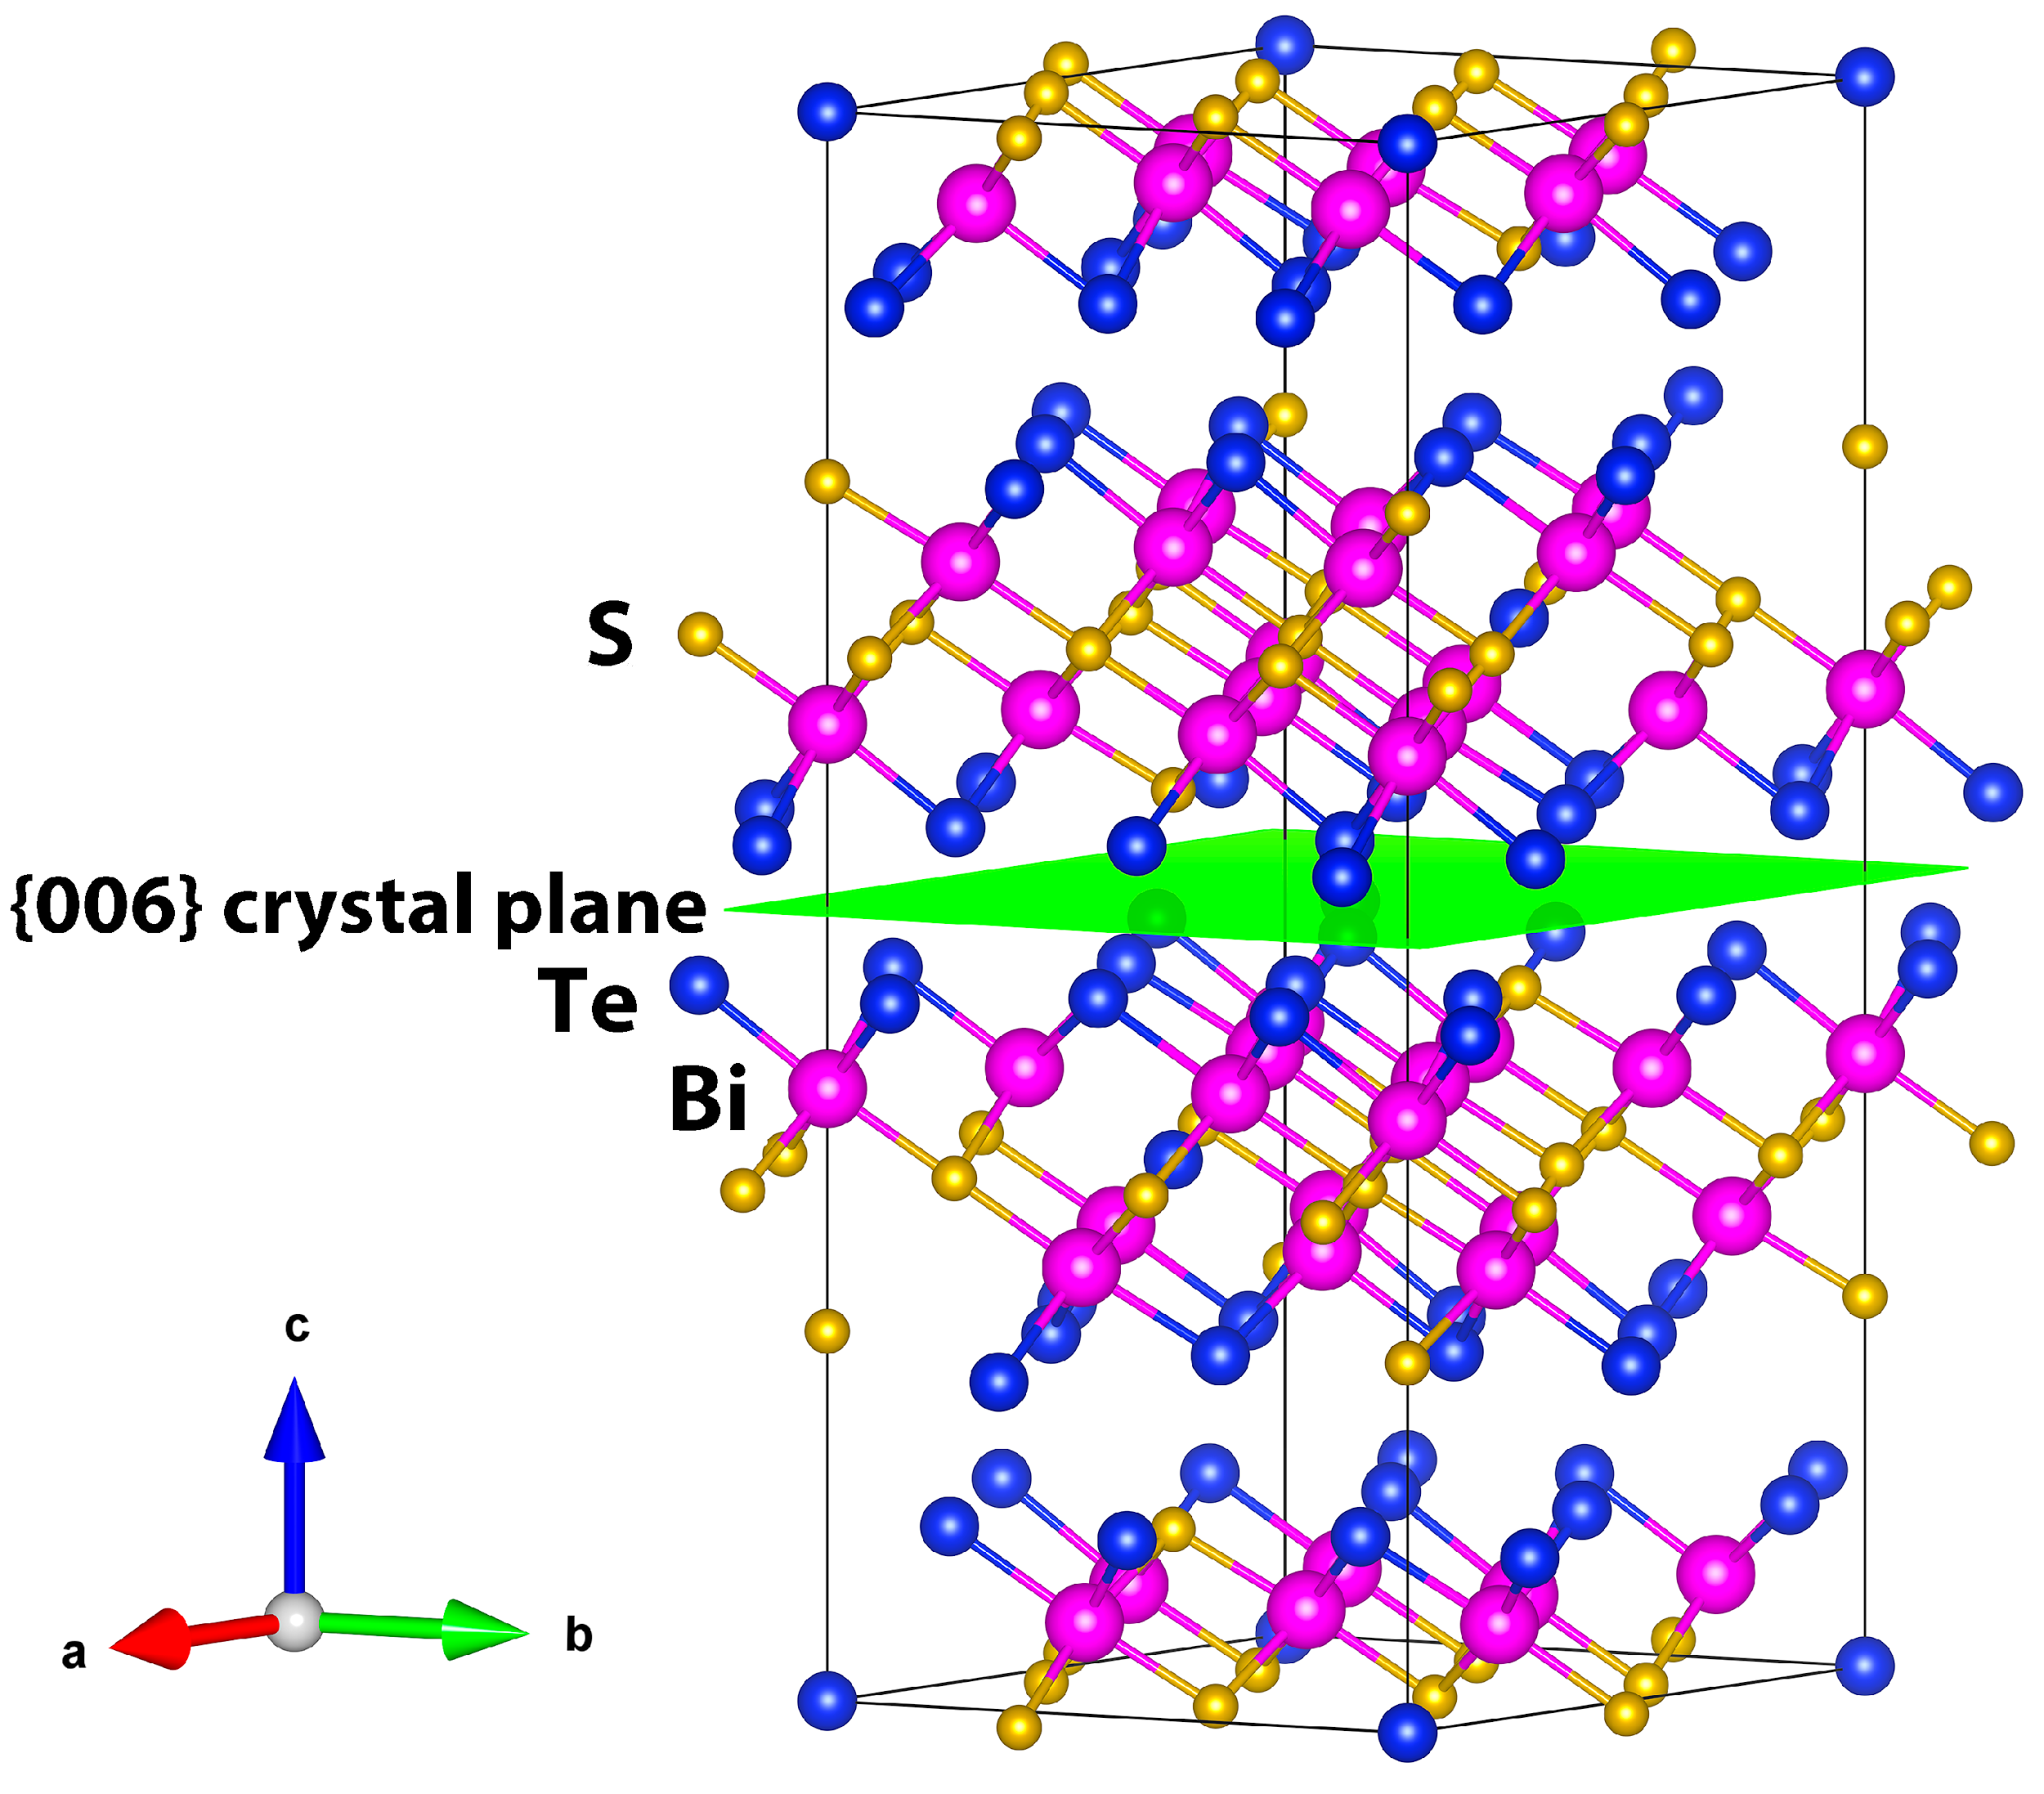
Figure 3: Crystal structure of Bi₁₄Te₁₃S₈ and {006} crystal plane.

The value calculated here is smaller than those presented in the Open Quantum Materials (∼0.5 eV),⁴⁶ JARVIS-DFT (∼0.36 eV),⁴⁷ and Materials Project (∼0.55 eV)⁴⁸ databases, and it also differs from previous works, calculating ∼0.9 eV,⁴⁹ of ∼0.34 eV³⁴ using PBE + spin-orbit coupling, and of ∼0.68 eV³⁴ using hybrid functionals + spin-orbit coupling. However, the overall trend points out that Bi₁₄Te₁₃S₈ is a narrow band semiconductor with a larger band gap compared to Bi₂Te₃, in agreement with the fact that the higher electronegativity of S (compared to Te) should reduce the valence band maximum of the material.³⁹

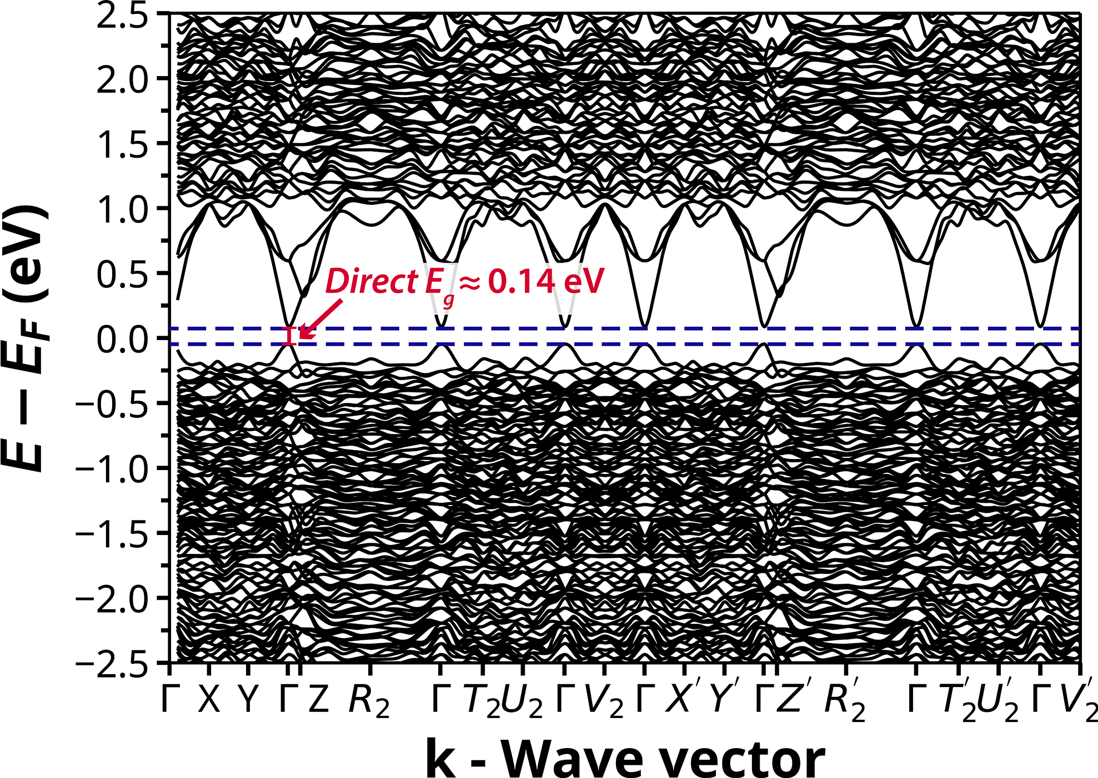
Figure 4: Band Structure of Bi₁₄Te₁₃S₈.

Transport properties analysis and figure of merit (zT)

The temperature dependent thermopower and electrical resistivity of all samples are shown in Figures 5(a) and (b). All samples show a negative value for the thermopower, indicating n-type semiconductor behaviour. At room temperature, the values of the thermopower vary between ∼−130 µV K⁻¹ for the undoped sample to ∼−44 µV K⁻¹ for the heavily doped sample with x = 0.02.
The electrical resistivity showed an inverse trend relative to the thermopower with the highest value of about 5.8 mΩ cm for the undoped sample and the lowest value of about 1.2 mΩ cm for the heavily doped sample with x = 0.02. All samples exhibited a metallic behaviour, with the electrical resistivity increasing with temperature. In particular, the thermopower and electrical resistivity showed similar values for the samples with x = 0.005, x = 0.01, and x = 0.015.
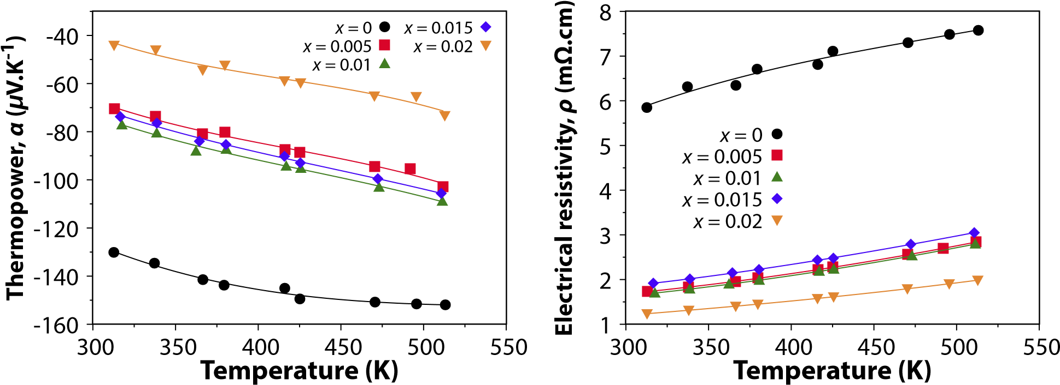
(a) (b)
Figure 5: Temperature dependence of the (a) thermopower and (b) electrical resistivity of Bi₂(Te_{1.857}S_{1.142})_{1–x}I_{x} (x = 0, 0.005, 0.01, 0.015, and 0.02) from 300 and 520 K.

The choice of iodine as a dopant in Bi₂Te₃ is typically effective, leading to noticeable changes in electrical resistivity due to controlled variations in carrier concentration,^{29,50–52} given to the similarity in radii of Te^{2–} and I^{1–}. However, in the case of Bi₂S₃ it was observed that iodine was not as successful as a dopant.⁵³
In this set of samples, both Te and S are present, and both have been accounted for substitution with I. Assuming that the changes are caused by the incorporation of I at the sites of both Te and S, the carrier concentration would be governed by the following defect chemistry reaction

$$\begin{aligned}Bi_{2}Te_{1.85-1.85\frac{x}{3}}S_{1.15-1.15\frac{x}{3}}→\left(1.85\frac{x}{3}I_{Te}^{∙}+1.85\frac{x}{3}e^{'}\right)+\left(1.15\frac{x}{3}I_{S}^{∙}+1.15\frac{x}{3}e^{'}\right).\#\left(1\right)\end{aligned}$$
Equation 1 predicts that the incorporation of high concentrations, x, of iodine will increase the carrier concentration in Bi₁₄Te₁₃S₈. To test this hypothesis, room temperature Hall effect measurements were conducted on samples with varying iodine doping concentrations. The results, summarised in Table 2, reveal that while carrier mobility (µ_{H}) decreases monotonically with increasing iodine concentration from a maximum of 75.24 cm² V⁻¹ s⁻¹ at x = 0 to a minimum of 22.29 cm² V⁻¹ s⁻¹ at x = 0.02, the dependence of carrier concentration on iodine doping is more complex. Specifically, the carrier concentration remains relatively constant for x = 0.005, 0.01, and 0.015 before increasing significantly at x = 0.02. These data suggest that iodine doping increases the carrier concentration only above a critical threshold between 0.015 < x < 0.02.

Table 2: Room-temperature Hall carrier concentration (n_{H}) and Hall mobility (µ_{H}) of Bi₂(Te_{1.857}S_{1.142})_{1–x}I_{x} (x = 0, 0.005, 0.01, 0.015, and 0.02)

x | n_{H} (× 10¹⁹ cm⁻³) | µ_{H} (cm² V⁻¹ s⁻¹)
0 | -1.41 | 75.24
0.005 | -5.3 | 68.50
0.01 | -5.47 | 68.22
0.015 | -5 | 64.68
0.02 | -22.9 | 22.29

The trends in electrical resistivity (see Figure 5(b)) further illustrate the effect of doping on the carrier concentration. The resistivity ρ shows a significant decrease from its maximum value for the undoped sample, maintaining similar values of ∼1.7 mΩ cm for 0.05 ≤ x ≤ 0.015 before dropping to its minimum at x = 0.02.
Similarly, given the inverse relationship between carrier concentration and thermopower α, the undoped sample has the largest thermopower magnitude due to its lowest carrier concentration, whereas the x = 0.02 sample has the smallest thermopower magnitude corresponding to its highest carrier density. Since the samples with x = 0.005, 0.01, and 0.015 have comparable carrier concentrations, they have shown similar thermopower values of −80 ∼ −70 µV K⁻¹. Overall, the transport data confirm the existence of a critical iodine doping range between 0.015 < x < 0.02.
At room temperature and with similar carrier concentrations, the thermopower value for Bi₂Te₃ (∼−238 µV K⁻¹ at n_{H} = 1 × 10¹⁹ cm⁻³) is larger than the one presented here, which indicates that this compound has a lower effective mass than Bi₂Te₃. However, thermopower value of Bi₂S₃ (∼−320 µV K⁻¹ at lower carrier concentrations of n_{H} = 0.45 × 10¹⁹ cm⁻³) suggests a similar effective mass for this sample and Bi₂S₃.
To understand the influence of the band structure on the thermopower, the single parabolic band model (SPB) was used to analyse the measured transport and carrier concentration data. The SPB model is described by the following set of equations

$$\begin{aligned}α=-\frac{k_{B}}{e}\left(\frac{2F_{1}\left(η\right)}{F_{0}\left(η\right)}-η\right)\#\left(2a\right)\end{aligned}$$
$$\begin{aligned}n = \frac{(2m^{*}k_{B}T)^{\frac{3}{2}}}{2π^{2}ℏ^{3}}F_{\frac{1}{2}}\left(η\right)\#\left(2b\right)\end{aligned}$$

where $e$ is the elementary charge, $k_{B}$ is the Boltzmann constant, $η=\frac{E_{F}}{k_{B}T}$ is the reduced Fermi level, $ℏ$ is the reduced Planck constant, $m^{*}$ is the density of states effective mass, and $F_{j}(η)$ is the Fermi-Dirac integral for an index $j$ and is defined as

$$\begin{aligned}F_{j}\left(η\right)= \int_{0}^{∞}{\frac{ε^{j}}{exp\left(ε-η\right)+1}}dε\#\left(3\right)\end{aligned}$$

where $ε=\frac{E}{k_{B}T}$ is the reduced energy.
The fitted density of states effective mass was found to be $m^{*} ≈ 0.65m_{0},$ where $m_{0}$ is the electron rest mass. The measured thermopower and carrier concentrations follow the trend predicted by the SPB model, as shown in the Pisarenko plot (Figure 6). Understandably, the relatively low effective mass of Bi₁₄Te₁₃S₈ compared to Bi₂T₃ ($m^{*} ≈ 1.06m_{0}$^{44,46}) can explain the low thermopower values observed even at lower carrier concentrations as predicted by Mott’s rule.
For comparison, data from pristine Bi₂Te₃ samples^{6,7,54} and Bi₂S₃ samples,^{22,55,56} and samples of similar composition to that used in this work of chlorine doped Bi₂Te_{1.93}S_{1.07–y}Cl_{y} and Bi₂Te_{1.83}S_{1.17}⁸ was added to the plot. As can be seen from the Pisarenko plot, Bi₁₄Te₁₃S₈ closely follows the band structure of both Bi₂S₃ and similar compositions of Bi₂Te_{1.93}S_{1.07–y}Cl_{y} and Bi2Te1.83S1.17.
Figure 7 shows the power factor (PF) values for all samples. Despite the reduced electrical resistivity, the reduced thermopower at higher doping concentrations resulted in similar,
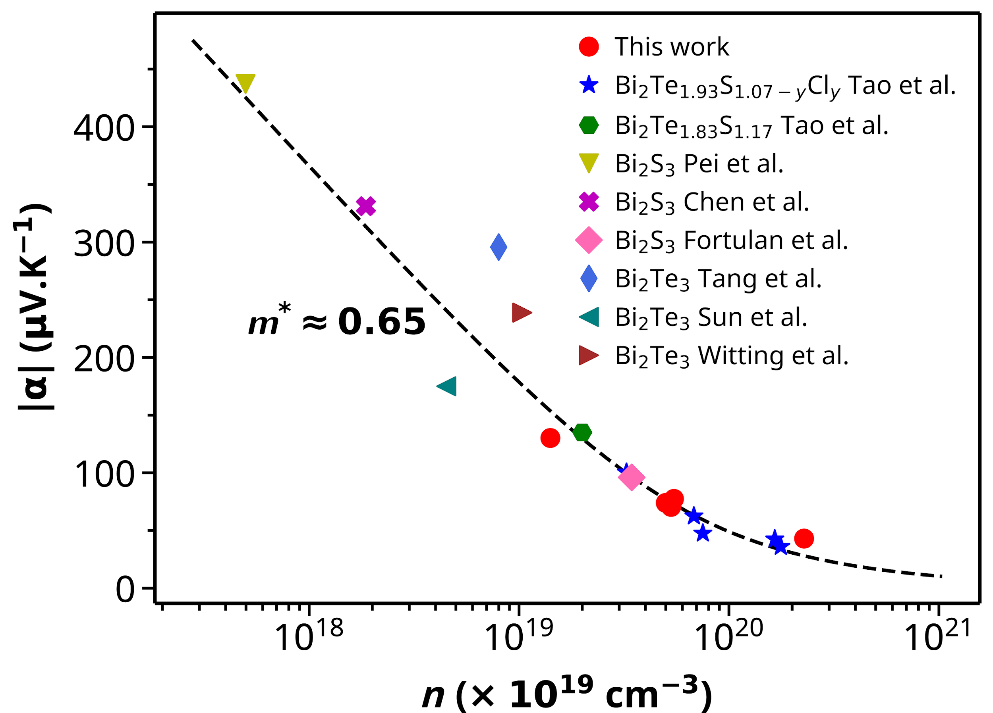
Figure 6: The Pisarenko plot (thermopower versus Hall carrier concentration) at room temperature of Bi₂(Te_{1.857}S_{1.142})_{1–x}I_{x}. The dashed line represents the calculated values from the SPB model using the fitted effective mass. Data from Bi₂Te₃,^{5,6,44} Bi₂S₃,^{5,45,47,48} Bi2Te1.93S1.07–yCly and Bi2Te1.83S1.177 are included for comparison.

modest power factor values of approximately 2.8 mW m⁻² K⁻¹ for the undoped, x = 0.005, and x = 0.015 samples. The heavily doped x = 0.02 sample exhibited the lowest power factor of ∼1.5 mW m⁻² K⁻¹, while x = 0.01 gave the maximum PF of ∼3.5 mW m⁻² K⁻¹.
To understand the heat transport mechanisms in this compound, the high temperature measurements of the specific heat capacity of pristine Bi₁₄Te₁₃S₈ were conducted and (Figure 8). At the temperature range of 300 ∼ 500 K, the specific heat capacity has values very close to those predicted by the Dulong-Petit law⁵⁷ with a linear trend (c_{p} = 0.16500(8) + 1.769(19) × 10⁻⁵T J g⁻¹ K⁻¹). At this temperature range, the specific heat capacity can be fitted using the Debye model,⁵⁸ which leads to a Debye temperature of $θ_{D}$ = 190.0(2.3) K and an average speed of sound of v = 2001(24) ms⁻¹. It is worth noting that due to the unavailability of lower temperature measurements for the specific heat capacity, these values can only be understood as approximations.
The thermal conductivity (κ) as a function of the temperature is shown Figure 9(a) and it increases with the presence of the dopant. The electronic contribution to thermal conductivity, i.e., the electronic thermal conductivity κ_{e}, was determined from the Wiedemann-Franz law⁵³ and shown in Figure 9(b). The Lorenz number was evaluated using the SPB model as follows

$$\begin{aligned}L = {\left(\frac{k_{B}}{e}\right)}^{2}\frac{3F_{0}(η)F_{2}(η)-4F_{1}(η)^{2}}{F_{0}(η)^{2}}.\#\left(4\right)\end{aligned}$$

As expected, with the increase in electrical conductivity with the dopant addition, the electronic thermal conductivity also increased for the doped samples. The lattice thermal conductivity was estimated from κ_{l} = κ − κ_{e} and plotted in Figure 8(c). With the presence of the dopant, the lattice thermal conductivity was reduced. This behaviour has been described by the effect of point defect due in literature ^{59–63}, causing scattering of phonons and, thus, reducing κ_{l}.
At room temperature, the maximum value of κ_{l} was observed for the undoped sample with

Figure 7: Temperature dependence of the power factor of Bi₂(Te_{1.857}S_{1.142})_{1–x}I_{x} (x = 0, 0.005, 0.01, 0.015, and 0.02) from 300 and 520 K.

∼0.69Wm⁻¹ K⁻¹ and a minimum of ∼0.47Wm⁻¹ K⁻¹ for the sample with x = 0.015 (Figure 8(c)). The values exhibited by this material are in the lower range of the ones observed for telluride compounds⁶⁴, as can be seen in the violin plot shown in Figure 8, the full list of references is presented in the SI.
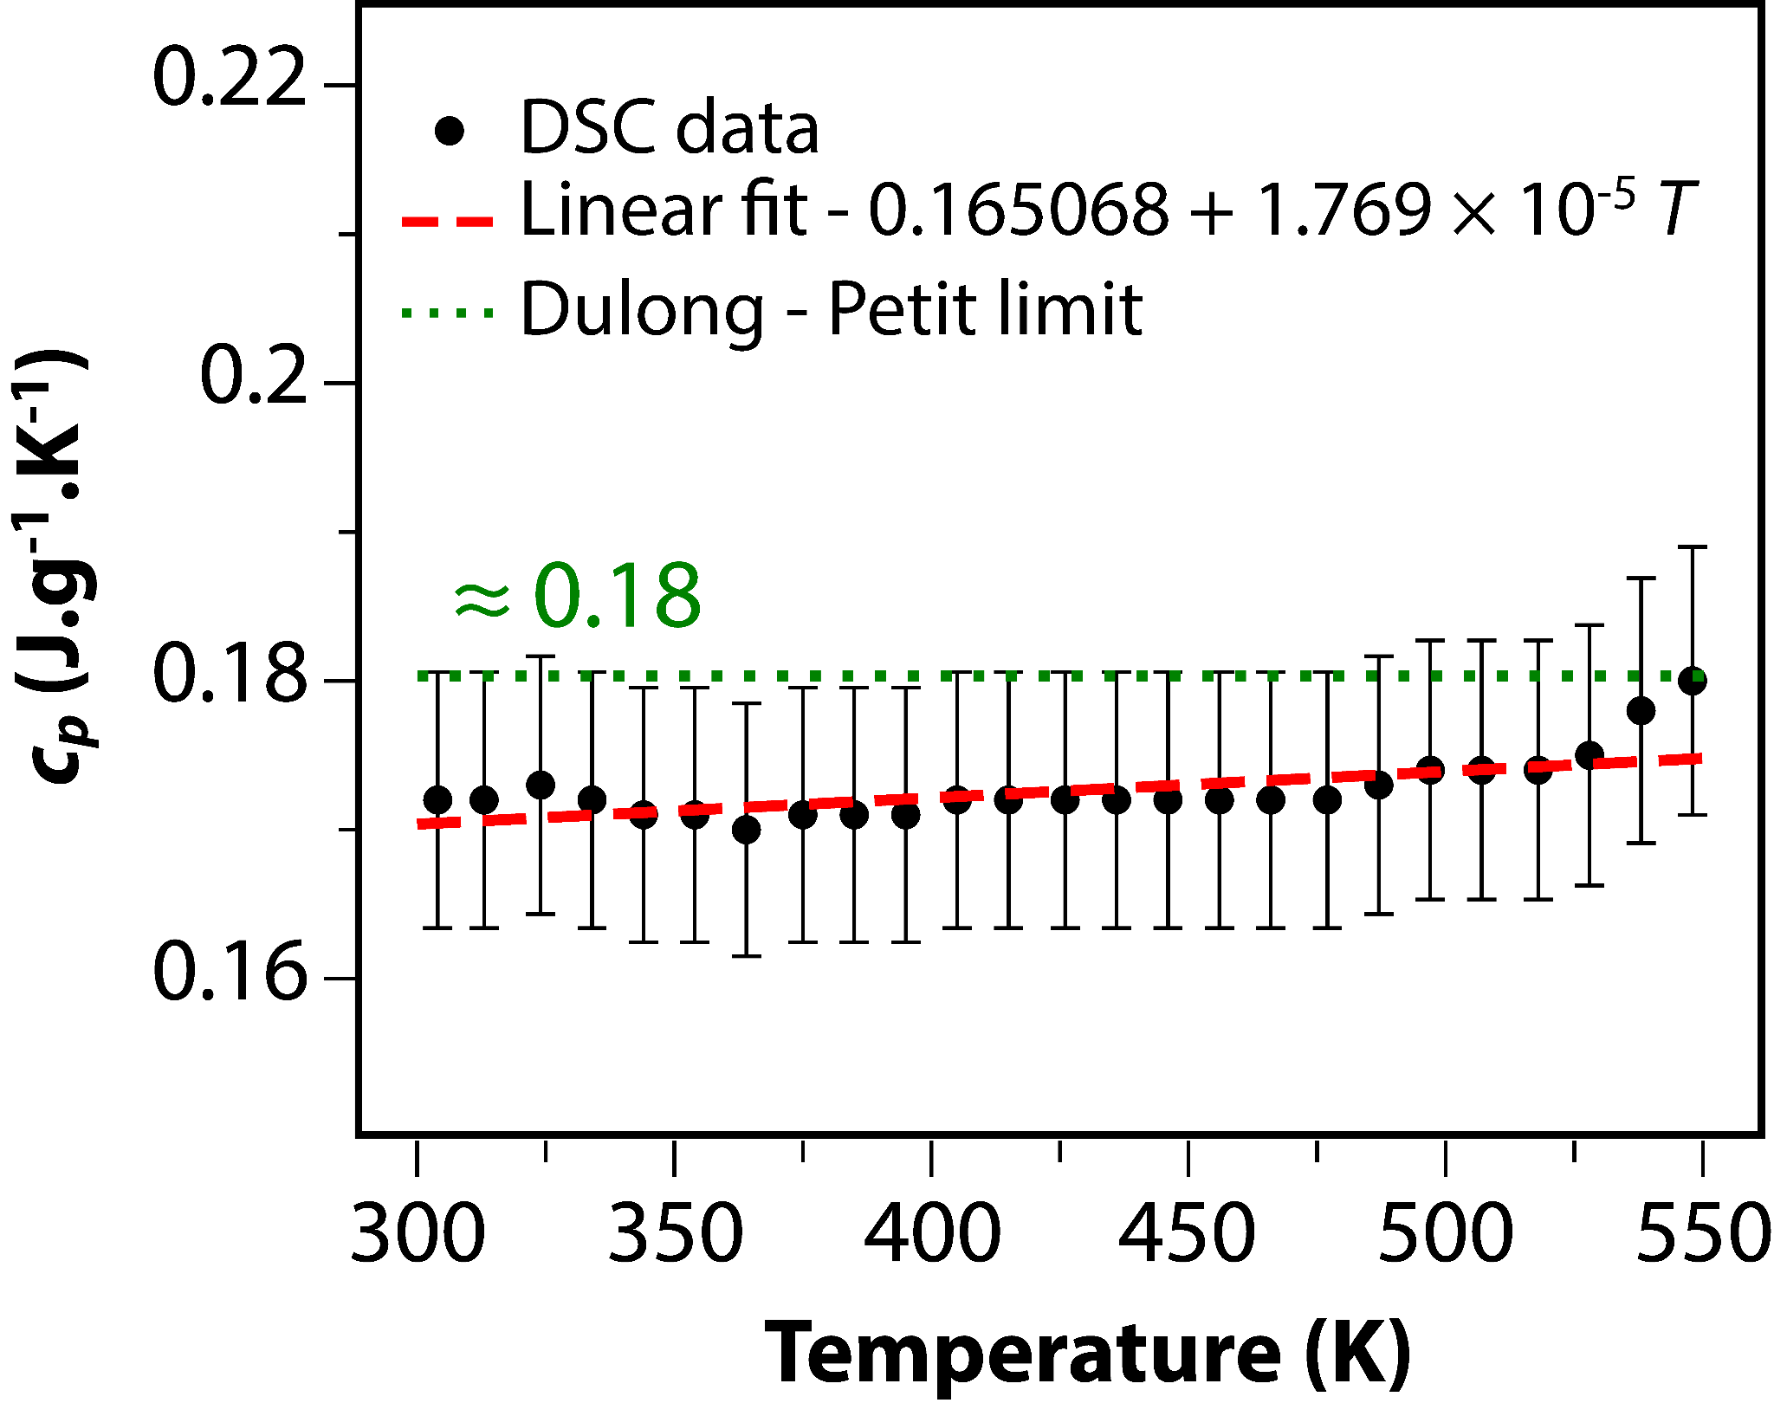
Figure 8: Temperature dependence of specific heat capacity of Bi₁₄Te₁₃S₈ from 300 to 550 K. The dotted green line represents the Dulong-Petit limit for the material and the dashed red line represents a linear fit of the data.

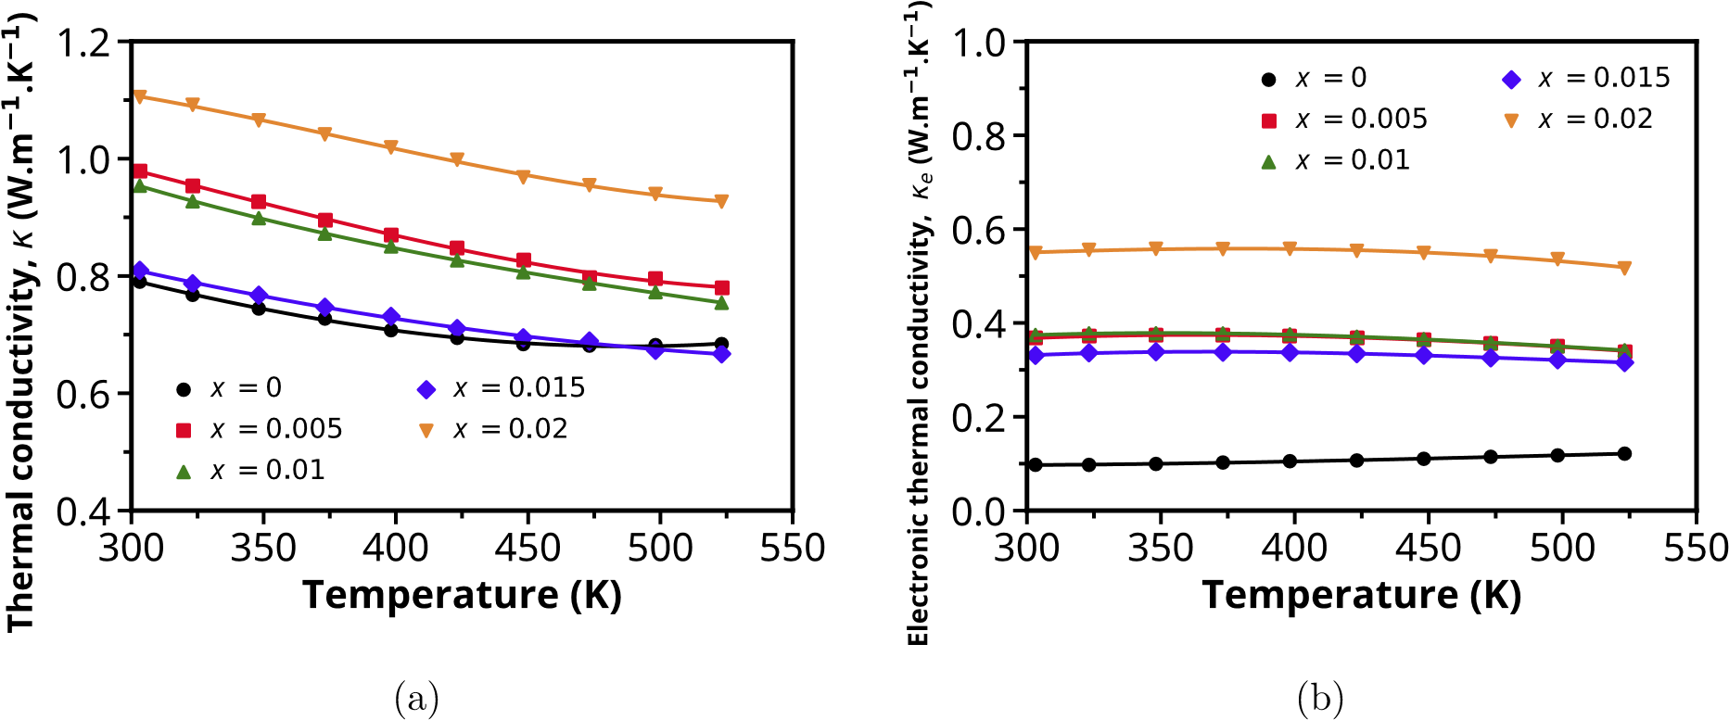
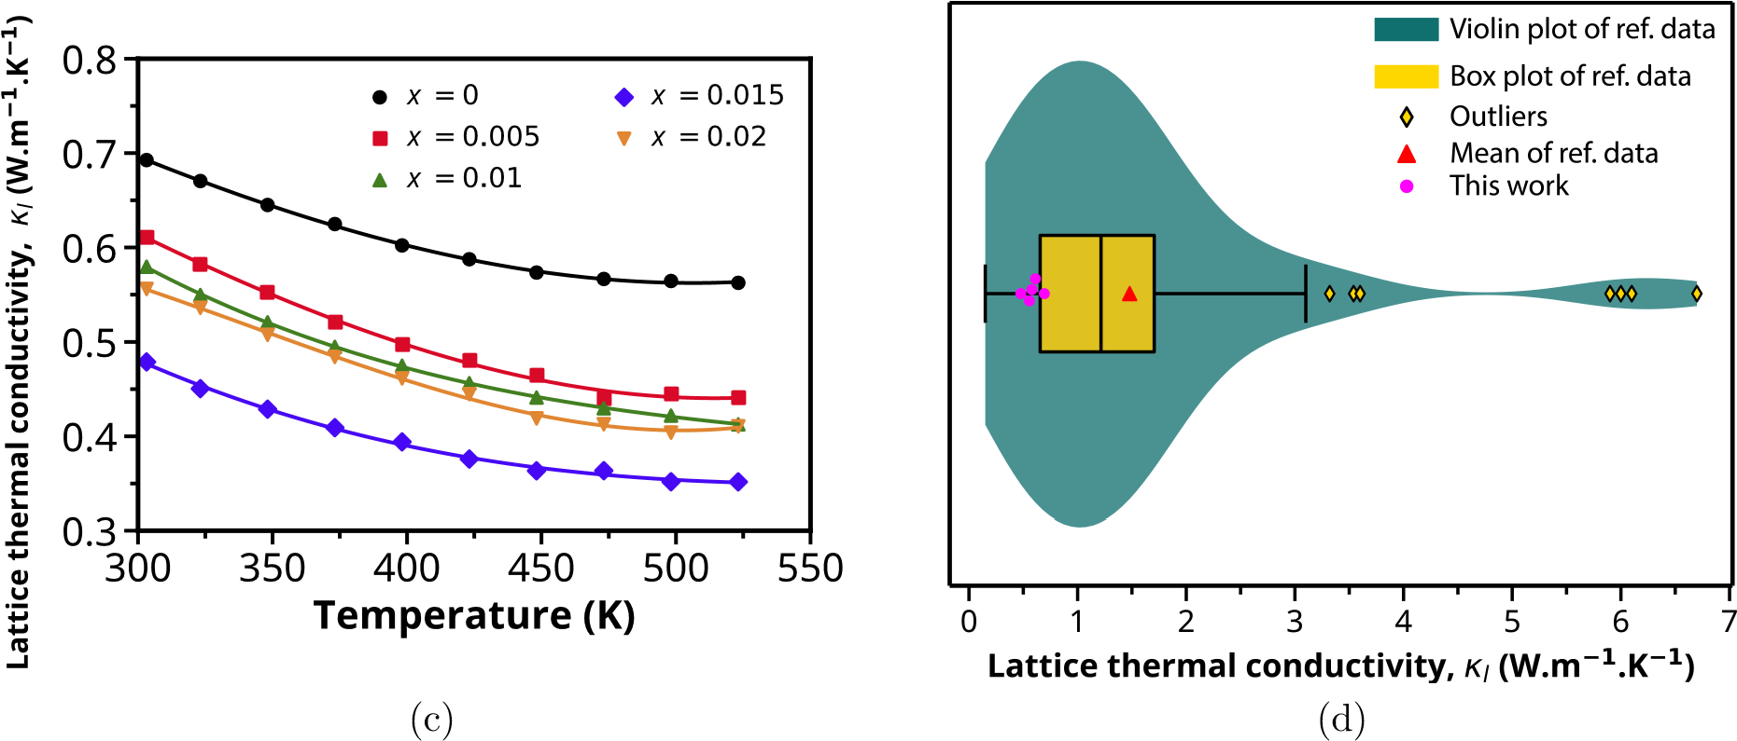
Figure 9: Temperature dependence of the (a) thermal conductivity, (b) electronic thermal conductivity, and (c) lattice thermal conductivity of Bi₂(Te_{1.857}S_{1.142})_{1–x}I_{x} (x = 0, 0.005, 0.01, 0.015, and 0.02) between 300 to 520 K; (d) violin plot of lattice thermal conductivity data of literature⁶⁵ compared with this work, all values are at room temperature.

Figure of merit (zT)
The figure of merit, zT, for the samples can be observed in Figure 9. The samples with x = 0.01 and 0.015 achieved a maximum value zT of ∼0.289 at 520 K. The presence of dopants resulted in a shift to the higher value of zT towards higher temperatures. The increase in the figure of merit was mainly due to the optimised power factor and a sharp reduction in the lattice thermal conductivity compared to the undoped sample.
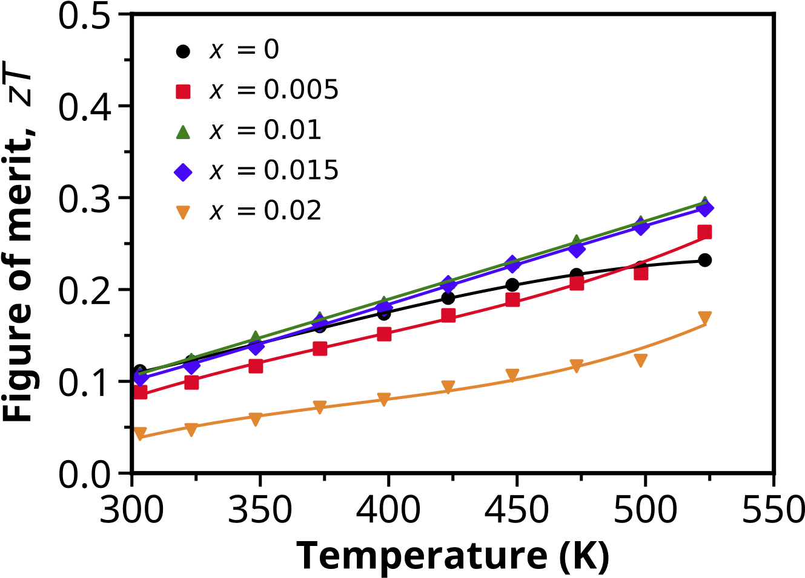
Figure 9: Figure of merit zT of Bi₂(Te_{1.857}S_{1.142})_{1–x}I_{x} (x = 0, 0.005, 0.01, 0.015, and 0.02) between 300 to 520 K.

Conclusions
This work presents an investigation of iodine doped Bi₁₄Te₁₃S₈for thermoelectric applications. The intrinsic properties of Bi₁₄Te₁₃S₈, including its layered crystal structure, larger bandgap, and intrinsically low thermal conductivity, make this compound a promising alternative to conventional Bi₂Te₃.
An optimised power factor around 3.5mWm⁻² K⁻¹ was achieved for a sample doped with 1% iodine. Further, the lattice thermal conductivity is reduced by over 30% with iodine addition due to increased phonon scattering from point defects. Samples doped with 1-1.5% iodine exhibit maximum zT values of ∼0.29 at 520 K, a noticeable improvement over undoped Bi₁₄Te₁₃S₈.
This study demonstrates that iodine doping can effectively tune the electrical and thermal properties of Bi₁₄Te₁₃S₈ to boost its thermoelectric performance. Our results highlight the contribution of Bi₁₄Te₁₃S₈ to the thermoelectric properties of multiphase materials.

Acknowledgement
The study has received partial funding from the European Union’s Horizon 2020 research and innovation program under the Marie Skłodowska-Curie Grant Agreement No. 801604. Takao Mori would like to thank JST Mirai Program Grant Number JPMJMI19A1.

References
1 S. Aminorroaya Yamini, R. Santos, R. Fortulan, A. A. Gazder, A. Malhotra, D. Vashaee, I. Serhiienko and T. Mori, ACS Appl. Mater. Interfaces, 2023, 15, 19220–19229.
2 C. M. Jaworski, V. Kulbachinskii and J. P. Heremans, Physical Review B, 2009, 80, 233201.
3 K. Ahmad, C. Wan, M. A. Al-Eshaikh and A. N. Kadachi, Appl Surf Sci, 2019, 474, 2–8.
4 P. Al-Alam, G. Pernot, M. Isaiev, D. Lacroix, M. De Vos, N. Stein, D. Osenberg and L. Philippe, Phys Rev B, 2019, 100, 115304.
5 S. Shigetomi and S. Mori, J. Phys. Soc. Jpn., 1956, 11, 915–919.
6 C. Tang, Z. Huang, J. Pei, B.-P. Zhang, P.-P. Shang, Z. Shan, Z. Zhang, H. Gu and K. Wen, RSC Adv., 2019, 9, 14422–14431.
7 Y. Sun, H. Qin, W. Wang, F. Guo, W. Cai and J. Sui, ACS Appl. Energy Mater., 2021, 4, 4986–4992.
8 Q. Tao, F. Meng, Z. Zhang, Y. Cao, Y. Tang, J. Zhao, X. Su, C. Uher and X. Tang, Materials Today Physics, 2021, 20, 100472.
9 Mineral commodity summaries 2022, 2022.
10 W. Liu, K. C. Lukas, K. McEnaney, S. Lee, Q. Zhang, C. P. Opeil, G. Chen and Z. Ren, Energy Environ. Sci., 2013, 6, 552–560.
11 B. Wang, X. Niu, Y. Ouyang, Q. Zhou and J. Wang, J. Phys. Chem. Lett., 2018, 9, 487–490.
12 D. C. Grauer, Y. S. Hor, A. J. Williams and R. J. Cava, Materials Research Bulletin, 2009, 44, 1926–1929.
13 S.-J. Joo, B. Ryu, J.-H. Son, J. E. Lee, B.-K. Min and B.-S. Kim, Journal of Alloys and Compounds, 2019, 783, 448–454.
14 M. U. Muzaffar, B. Zhu, Q. Yang, Y. Zhou, S. Zhang, Z. Zhang and J. He, Materials Today Physics, 2019, 9, 100130.
15 D. Hsieh, Y. Xia, D. Qian, L. Wray, F. Meier, J. H. Dil, J. Osterwalder, L. Patthey, A. V. Fedorov, H. Lin, A. Bansil, D. Grauer, Y. S. Hor, R. J. Cava and M. Z. Hasan, Phys. Rev. Lett., 2009, 103, 146401.
16 Z. Zhang, Y. Cao, Q. Tao, Y. Yan, X. Su and X. Tang, Journal of Solid State Chemistry, 2020, 292, 121722.
17 F. Hao, P. Qiu, Y. Tang, S. Bai, T. Xing, H.-S. Chu, Q. Zhang, P. Lu, T. Zhang, D. Ren, J. Chen, X. Shi and L. Chen, Energy & Environmental Science, 2016, 9, 3120–3127.
18 Z. Xu, H. Wu, T. Zhu, C. Fu, X. Liu, L. Hu, J. He, J. He and X. Zhao, NPG Asia Materials, 2016, 8, e302–e302.
19 F. Li, R. Zhai, Y. Wu, Z. Xu, X. Zhao and T. Zhu, Journal of Materiomics, 2018, 4, 208–214.
20 R. Zhai, Y. Wu, T.-J. Zhu and X.-B. Zhao, Crystal Growth & Design, 2018, 18, 4646–4652.
21 S. Wang, G. Tan, W. Xie, G. Zheng, H. Li, J. Yang and X. Tang, J. Mater. Chem., 2012, 22, 20943–20951.
22 R. Fortulan, S. Aminorroaya Yamini, C. Nwanebu, S. Li, T. Baba, M. J. Reece and T. Mori, ACS Appl. Energy Mater., , DOI:10.1021/acsaem.2c00295.
23 Z. H. Ge, B. P. Zhang, P. P. Shang and J. F. Li, J Mater Chem, 2011, 21, 9194–9200.
24 B. H. Toby and R. B. Von Dreele, J Appl Crystallogr, 2013, 46, 544–549.
25 E37 Committee, Test Method for Determining Specific Heat Capacity by Differential Scanning Calorimetry, ASTM International.
26 J. P. Perdew, K. Burke and M. Ernzerhof, Phys. Rev. Lett., 1996, 77, 3865–3868.
27 H. J. Monkhorst and J. D. Pack, Phys. Rev. B, 1976, 13, 5188–5192.
28 R. D. Shannon, Acta crystallographica section A: crystal physics, diffraction, theoretical and general crystallography, 1976, 32, 751–767.
29 F. Wu, W. Wang, X. Hu and M. Tang, Progress in Natural Science: Materials International, 2017, 27, 203–207.
30 J. H. Kim, S. Y. Back, J. H. Yun, H. S. Lee and J.-S. Rhyee, Materials, 2021, 14, 1564.
31 L. Pauling, American Mineralogist, 1975, 60, 994–997.
32 A. Tamtögl, D. Campi, M. Bremholm, E. M. J. Hedegaard, B. B. Iversen, M. Bianchi, P. Hofmann, N. Marzari, G. Benedek, J. Ellis and W. Allison, Nanoscale, 2018, 10, 14627–14636.
33 C. B. Satterthwaite and R. W. Ure, Physical Review, 1957, 108, 1164–1170.
34 Z. Rashid, A. S. Nissimagoudar and W. Li, Phys. Chem. Chem. Phys., 2019, 21, 5679–5688.
35 J. Nagao, M. Ferhat, E. Hatta and K. Mukasa, physica status solidi (b), 2000, 219, 347–349.
36 Y. Hosokawa, K. Tomita and M. Takashiri, Sci Rep, 2019, 9, 10790.
37 J. B. Byrnes, A. A. Gazder and S. A. Yamini, RSC Adv., 2018, 8, 7457–7464.
38 J. M. Crowley, J. Tahir-Kheli and W. A. Goddard, J. Phys. Chem. Lett., 2016, 7, 1198–1203.
39 P. Mori-Sánchez, A. J. Cohen and W. Yang, Phys. Rev. Lett., 2008, 100, 146401.
40 J. P. Perdew and M. Levy, Phys. Rev. Lett., 1983, 51, 1884–1887.
41 J. P. Perdew and A. Zunger, Phys. Rev. B, 1981, 23, 5048–5079.
42 L. J. Sham and M. Schlüter, Phys. Rev. Lett., 1983, 51, 1888–1891.
43 A. Pribram-Jones, D. A. Gross and K. Burke, Annu. Rev. Phys. Chem., 2015, 66, 283–304.
44 L. J. Sham and W. Kohn, Phys. Rev., 1966, 145, 561–567.
45 C. Fiolhais, F. Nogueira and M. A. L. Marques, A Primer in Density Functional Theory, Springer Science & Business Media, 2003.
46 Saal, J. E., Kirklin, S., Aykol, M., Meredig, B., and Wolverton, C., Bi14Te13S8, https://oqmd.org/materials/entry/101967, (accessed 1 August 2023).
47 National Institute of Standards and Technology (NIST), JVASP-29442_Bi14Te13S8, https://www.ctcms.nist.gov/~knc6/jsmol/JVASP-29442.html, (accessed 1 August 2023).
48 mp-557619, https://next-gen.materialsproject.org/materials/mp-557619/, (accessed 1 August 2023).
49 S. Lebègue, T. Björkman, M. Klintenberg, R. M. Nieminen and O. Eriksson, Phys. Rev. X, 2013, 3, 031002.
50 H. J. Goldsmid, Materials (Basel), 2014, 7, 2577–2592.
51 H. J. Goldsmid, Proc. Phys. Soc., 1958, 71, 633–646.
52 M.-K. Han, B.-G. Yu, Y. Jin and S.-J. Kim, Inorg. Chem. Front., 2017, 4, 881–888.
53 J. Yang, G. W. Liu, J. N. Yan, X. Z. Zhang, Z. Q. Shi and G. J. Qiao, J Alloy Compd, 2017, 728, 351–356.
54 I. T. Witting, T. C. Chasapis, F. Ricci, M. Peters, N. A. Heinz, G. Hautier and G. J. Snyder, Advanced Electronic Materials, , DOI:10.1002/aelm.201800904.
55 J. Pei, L.-J. Zhang, B.-P. Zhang, P.-P. Shang and Y.-C. Liu, J. Mater. Chem. C, 2017, 5, 12492–12499.
56 B. Chen, C. Uher, L. Iordanidis and M. G. Kanatzidis, Chem. Mater., 1997, 9, 1655–1658.
57 L. D. Landau and E. M. Lifshitz, Statistical Physics: Volume 5, Elsevier, 2013.
58 P. Attard, Thermodynamics and Statistical Mechanics: Equilibrium by Entropy Maximisation, Academic Press, 2002.
59 O. Zapata-Arteaga, A. Perevedentsev, S. Marina, J. Martin, J. S. Reparaz and M. Campoy-Quiles, ACS Energy Lett., 2020, 5, 2972–2978.
60 P. Zhang, W. Liao, Z. Zhu, M. Qin, Z. Zhang, D. Jin, Y. Liu, Z. Wang, Z. Lu and R. Xiong, Phys. Chem. Chem. Phys., 2023, 25, 15422–15432.
61 Y.-L. Pei, J. He, J.-F. Li, F. Li, Q. Liu, W. Pan, C. Barreteau, D. Berardan, N. Dragoe and L.-D. Zhao, NPG Asia Mater, 2013, 5, e47–e47.
62 M. Fava, N. H. Protik, C. Li, N. K. Ravichandran, J. Carrete, A. van Roekeghem, G. K. H. Madsen, N. Mingo and D. Broido, npj Comput Mater, 2021, 7, 1–7.
63 B. Dongre, J. Carrete, S. Wen, J. Ma, W. Li, N. Mingo and G. K. H. Madsen, J. Mater. Chem. A, 2020, 8, 1273–1278.
64 R. Freer, D. Ekren, T. Ghosh, K. Biswas, P. Qiu, S. Wan, L. Chen, S. Han, C. Fu, T. Zhu, A. K. M. A. Shawon, A. Zevalkink, K. Imasato, G. J. Snyder, M. Ozen, K. Saglik, U. Aydemir, R. Cardoso-Gil, E. Svanidze, R. Funahashi, A. V. Powell, S. Mukherjee, S. Tippireddy, P. Vaqueiro, F. Gascoin, T. Kyratsi, P. Sauerschnig and T. Mori, J. Phys. Energy, 2022, 4, 022002.
65 R. Freer, D. Ekren, T. Ghosh, K. Biswas, P. Qiu, S. Wan, L. Chen, S. Han, C. Fu, T. Zhu, A. K. M. A. Shawon, A. Zevalkink, K. Imasato, G. J. Snyder, M. Ozen, K. Saglik, U. Aydemir, R. Cardoso-Gil, E. Svanidze, R. Funahashi, A. V. Powell, S. Mukherjee, S. Tippireddy, P. Vaqueiro, F. Gascoin, T. Kyratsi, P. Sauerschnig and T. Mori, J. Phys. Energy, 2022, 4, 022002.

