Flexural Properties of an Organic Olefin-based Thermosetting Dicyclopentadiene Resin for Superconducting Magnet Impregnation

Xudong Wang, Akihiro Kikuchi, Masaki Takeuchi, Tatsushi Nakamoto, and Kiyosumi Tsuchiya

Abstract—An organic olefin-based thermosetting dicyclopentadiene (DCP) resin, C₁₀H₁₂, commercially available in Japan as TELENE® from RIMTEC Corporation, has a viscosity less than one tenth of that of the CTD-101K® epoxy resin. The TELENE® can tolerate larger strains than CTD-101K® and can have a higher heat capacity by mixing it with ceramic powder. Using the TELENE® as the impregnation resin is expected to reduce the number of quench training of Nb3Sn magnets. In this paper, the flexural properties of the pure and mixed TELENE® was measured before and after gamma-ray irradiation and compared to that of the CTD-101K®. Three powders of Gd₂O₃, Gd₂O₂S, and HoCu₂ were mixed with the pure TELENE®, respectively. The gamma-ray irradiation was performed using Cobalt-60 source at the Takasaki Advanced Radiation Research Institute, Japan, up to 25 MGy at room temperature. The pure TELENE® exhibits plastic deformation before irradiation and increases in strength up to 2 MGy irradiation. The flexural modulus of pure and mixed TELENE® increased continuously up to 25 MGy irradiation.

Index Terms—Impregnation resin, DCP, gamma-ray irradiation, flexural strength, flexural modulus.

I. INTRODUCTION
I
MPREGNATION material is a key specification for superconducting magnets. The radiation strength of impregnation materials is important to accelerator magnets because they are usually applied in an irradiated environment [1]. The limit for the Hi-Lumi LHC magnets is 25 MGy of proton radiation for the CTD-101K® epoxy resin, a traditional impregnation material. An organic olefin-based thermosetting dicyclopentadiene (DCP) resin, C₁₀H₁₂, commercially available in Japan as TELENE® from RIMTEC Corporation [2], has a viscosity less than one tenth of that of the CTD-101K® epoxy resin. The TELENE® was successful to prevent training in a Nb₃Sn undulator developed by ANL and FNAL [3]. The physical and mechanical properties of the TELENE® were also studied comparing with the CTD-101K® epoxy resin in the previous study. For organic materials like the TELENE®, the dependence of material response on the type of beam irradiation is very low, and the absorbed dose can be adequately used to qualify the radiation resistance [3, 4].
TABLE I
Specifications of Resin Samples

Samples | #1 | #2 | #3 | #4 | #5
Resins | TELENE® |  |  |  | CTD-101K®
Powder types | none | Gd₂O₃ | Gd₂O₂S | HoCu₂ | none
Powder wt% | none | 82 | 87 | 83 | none

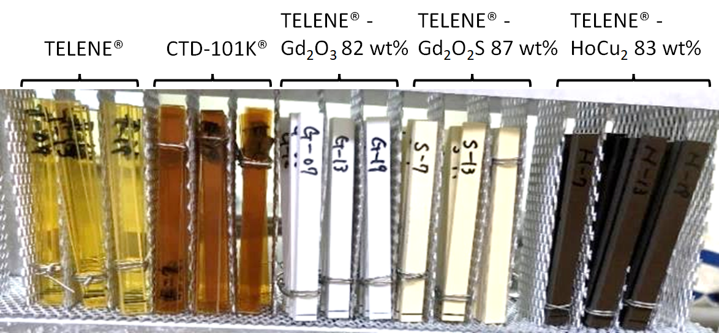
Fig. 1. Resin samples of the TELENE®, TELENE®-Gd₂O₃ 82 wt%, TELENE®-Gd₂O₂S 87 wt%, TELENE®-HoCu₂ 83 wt%, and CTD-101K®.
To comparatively evaluate the flexural characteristics of the TELENE® and the CTD-101K® epoxy before and after gamma-ray irradiation, the irradiation test and three-point bending test were performed at the Takasaki Advanced Radiation Research Institute and the High Energy Accelerator Research Organization, respectively. The gamma ray irradiation test was carried out up to 25 MGy using a Cobalt-60 source for a total of 180 days in three periods at dose rates ranging from 4 to 7 kGy/h. The flexural characteristics of the TELENE® mixed with Gd₂O₃, Gd₂O₂S, and HoCu₂ powders are also measured before and after gamma-ray irradiation. The results of flexural characteristics of those resins are presented in this paper.

II. Gamma-Ray Irradiation Test

A. Resin Samples
Resin samples #1-#5 of the TELENE®, three types of the mixed TELENE®, and the CTD-101K® were prepared for gamma-ray irradiation as listed in Table 1 and shown in Fig. 1, respectively. For the gamma-ray irradiation test and the three-point bending test, 36 samples of each resin were made with a length of 80 mm, a width of 8 mm, and a thickness of 4 mm. Three powders of Gd₂O₃, Gd₂O2_{S}, and HoCu₂ were mixed with the TELENE® using a planetary mixer, respectively. The three powders were expected to increase the heat capacity of the pure TELENE®. The TELENE® was mixed with a hardening agent or polymerization catalyst, which is a ruthenium complex, in a 2/100 ratio by weight. The curing time was controlled by the amount of phosphine derivative as retarder. The resin viscosity was controlled by the volume fraction and average size of the powder. The powder sizes of Gd₂O₃, Gd₂O₂S, and HoCu₂ are 0.7–1.2 µm, 10 µm, and less than 30 µm, respectively. The concentrations of the powders of Gd₂O₃, Gd₂O₂S, and HoCu₂ mixed with the TELENE® are 82 wt%, 87 wt%, and 83 wt%, respectively. The resin samples were placed in two tiers in an aluminum rack as shown in Fig. 2. Each resin was arranged in three rows on the top and bottom tier, with six samples in each row.
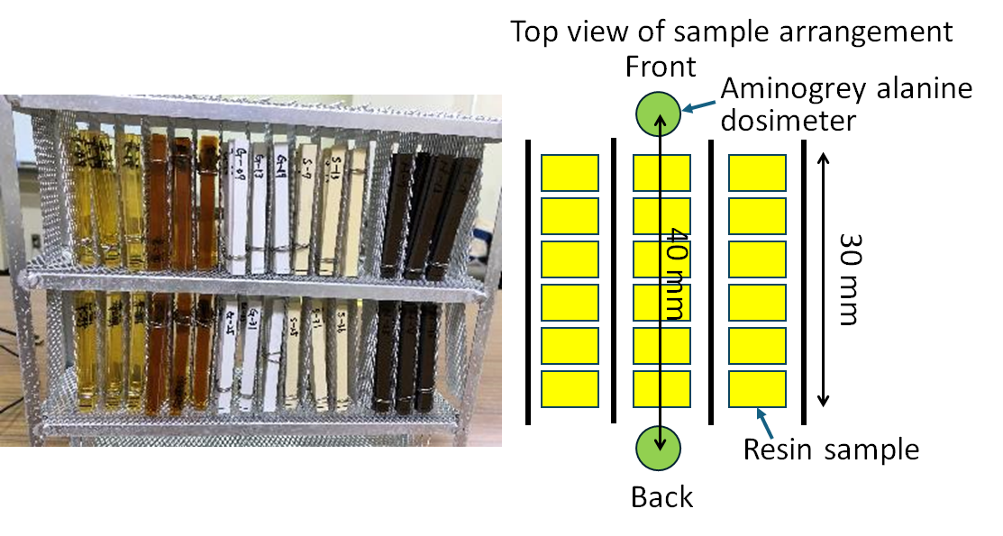
Fig. 2. Photograph of the arrangement of the resin samples in an aluminum rack and a schematic of the aminogrey alanine dosimeters for the gamma-ray irradiation in air atmosphere.

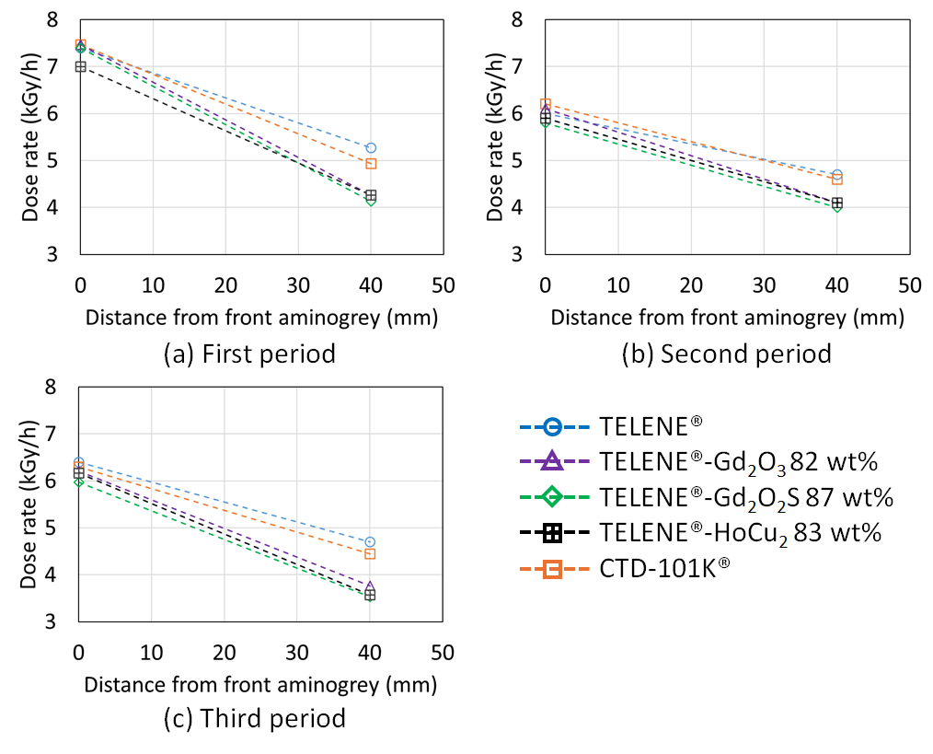
Fig. 3. Dose rate results measured three times before each of the three irradiation periods: (a) first period, (b) second period, and (c) third period.

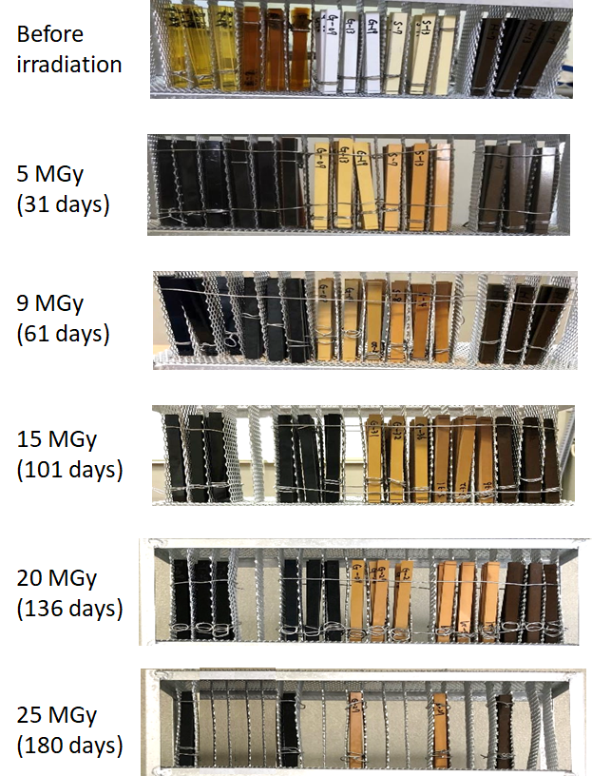
Fig. 4. Surface discoloration of each resin sample with increasing dose.

B. Dose Rate Measurement and Long-Term Irradiation
The gamma-ray irradiation was performed using cobalt-60 source at the Takasaki Advanced Radiation Research Institute, Japan, up to 25 MGy in air atmosphere at room temperature. The resin samples were subjected to the dose rate measurements for 60–90 minutes before the long-term irradiation to evaluate the total dose. Two aminogrey alanine dosimeters were attached on the front and back of each resin for the measurements as shown in Fig. 2. The long-term irradiation was carried out three times for a total of 180 days. The dose rate measurements were also performed three times before each of the three irradiation periods as shown in Fig. 3. The second and third irradiations had lower dose rates than the first because the aluminum rack was positioned slightly farther from the cobalt-60 source than in the first irradiation. There is a clear difference in dose rate reduction between the pure and mixed TELENE®. Due to the dose absorption by the powder, the dose rate on the back side of the mixed TELENE® is approximately 1 kGy/h lower than that of pure TELENE®. The absorbed dose was calculated as the product of the dose rate and the irradiation time for each sample using the results in Fig. 3. Fig. 4. shows the surface discoloration of each sample with increasing dose. The TELENE® and CTD-101K®, which were translucent before irradiation, turned black and were no longer transparent after irradiation with 5 MGy. The mixed TELENE® became darker as the dose increased.

III. Three-Point Bending Test

A. Experimental Setup
The three-point bending test was carried out at room temperature using a standard three-point bending device and an autograph of SHIMADZU AG-5000C, as shown in Fig. 5. The parameters of the test equipment follow ISO 178:2010-A1:2013. A load cell of 1 kgN was used to apply a force to the resin sample. The test speed of the load cell was 2 mm/min. The flexural stress (σ_{f}) and flexural strain (ε_{f}) are calculated from the measured force (F) and deflection (s) by (1, 2).
$σ_{f}=3FL/2wh^{2}.$ (1)
$ε_{f}=6sh/L^{2}$. (2)
The L, w, and h are the span between specimen supports of 64 mm, the sample width of 8 mm, and the sample thickness of 4 mm, respectively.

B. Flexural Stress vs. Flexural Strain
Fig. 6 shows the flexural stress vs. flexural strain curves of the resin samples #1–#5 before irradiation at room temperature. The TELENE® exhibits plastic deformation and accepts larger strains than CTD-101K® without breaking. On the other hand, the mixed TELENE® using Gd₂O₃ and Gd₂O₂S powders shows less ductility than the TELENE®. To confirm the powder concentration dependent ductility, two additional mixed TELENE® resins using the 21.5 wt% and 43 wt% Gd₂O₂S were also measured as shown in Fig. 7. These additional TELENE® mixed with low concentrations of the Gd₂O₂S powder give properties similar to those observed with the pure TELENE®. Therefore, the ductility of the mixed TELENE® can be controlled by optimizing the powder concentration. Every time the absorbed dose increased by 1–3 MGy from the start of irradiation, three samples of each resin were removed from the aluminum rack and subjected to a three-point bending test at room temperature. Fig. 8 shows the flexural stress vs. flexural strain curves of the resin samples #1–#5 at absorbed doses of 1.5 MGy, 5 MGy, and 25 MGy at room temperature. The pure TELENE® loses ductility and increases strength as the absorbed dose increases. The flexural stress vs. flexural strain curve of a mixed TELENE® with the HoCu₂ 82 wt% changed dramatically after the irradiation.
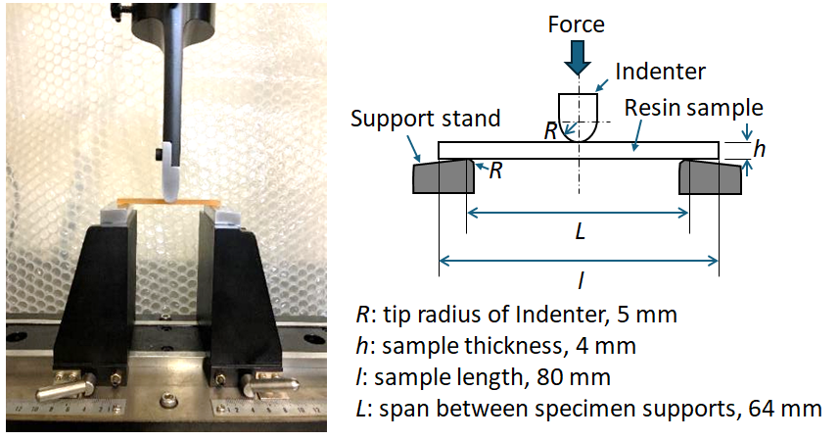
Fig. 5. Photographs and schematic of the three-point bending test.

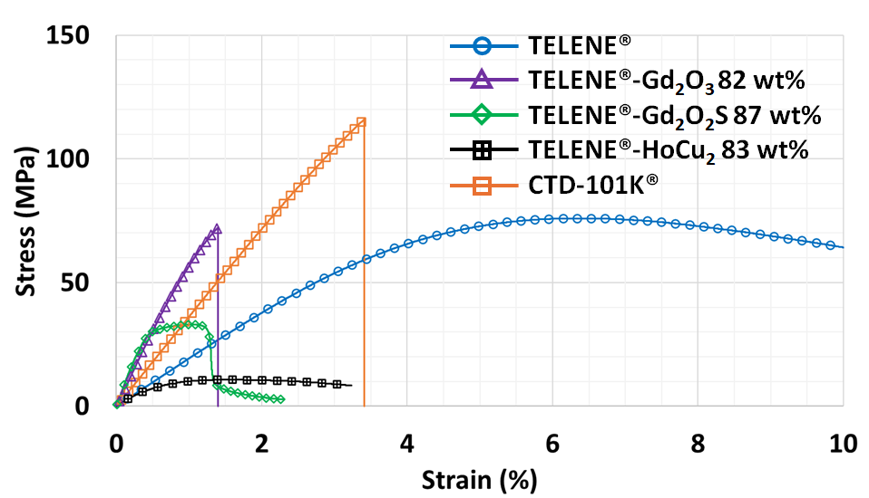
Fig. 6. Flexural stress vs. flexural strain curves of the resin samples #1-#5 before irradiation at room temperature.

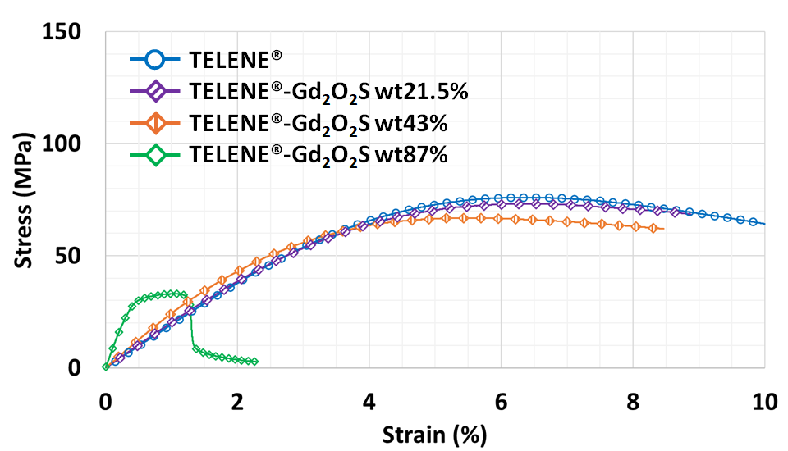
Fig. 7. Flexural stress vs. flexural strain curves of the different powder concentrations of the Gd₂O₂S mixed TELENE® before irradiation at room temperature.

C. Flexural Strength and Flexural Modulus
The flexural strength is the maximum flexural stress in the stress vs. strain curves. The flexural modulus was calculated from the stress vs. strain curve between 0.05% and 0.25% strain using (σ_{0.25}−σ_{0.05%})/(ε_{0.25%}−ε_{0.05%}). The flexural strength and normalized flexural strength of resin samples #1–#5 as a function of the absorbed dose are shown in Fig. 9. The flexural modulus and normalized flexural modulus of resin samples #1–#5 as a function of the absorbed dose are shown in Fig. 10. The normalized flexural strength and flexural modulus were determined by dividing the flexural strength and flexural modulus by their values before irradiation. The pure TELENE® shows lower flexural strength and flexural modulus than the CTD-101K®. Their flexural strength has a peak value around 2 MGy and then decreases with increasing dose. Above an absorbed dose of 15 MGy, the flexural strength of all resins remains approximately constant. Some samples show low flexural strength values, such as CTD-101K® at 19 MGy, but this is likely due to variability in the measurement data caused by air bubbles in the resin sample. The flexural modulus of the pure TELENE® is half that of CTD-101K® before irradiation, but it increases to approximately 85% of CTD-101K® at 25 MGy. Mixing TELENE® with the Gd₂O₃, Gd₂O₂S, and HoCu₂ powders increases the flexural strength and modulus after irradiation. In particular, mixing TELENE® with the Gd₂O₃ powder shows almost the same flexural strength as CTD-101K® when the absorbed dose exceeds 10 MGy. The flexural modulus of the mixed TELENE® increases with increasing absorbed dose, this property is similar to that of pure TELENE®. The flexural modulus of the CTD-101K® did not change with increasing absorbed dose.
Fig. 8. Flexural stress vs. flexural strain curves of the resin samples #1–#5 at absorbed doses of (a) 1.5 MGy, (b) 5 MGy, and (c) 25 MGy at room temperature.

IV. Conclusion
We carried out gamma-ray irradiation test and three-point bending test on the TELENE® resin and the CTD-101K® epoxy resin. The gamma-ray irradiation test was performed up to 25 MGy at room temperature and in the atmosphere for a total of 6 months. Before irradiation, the pure TELENE® shows plastic deformation and accepts larger strains than CTD-101K®. The flexural modulus of the TELENE® is increased by mixing it with the Gd₂O₃, Gd₂O₂S, and HoCu₂ powders, which can also increase the heat capacity of the TELENE®. After irradiation, pure TELENE® increases in flexural modulus and decreases in ductility as dose increases. Although the pure TELENE® shows lower flexural strength and flexural modulus than CTD-101k®, these properties can be improved by mixing with the Gd₂O₃, Gd₂O₂S, and HoCu₂ powders.
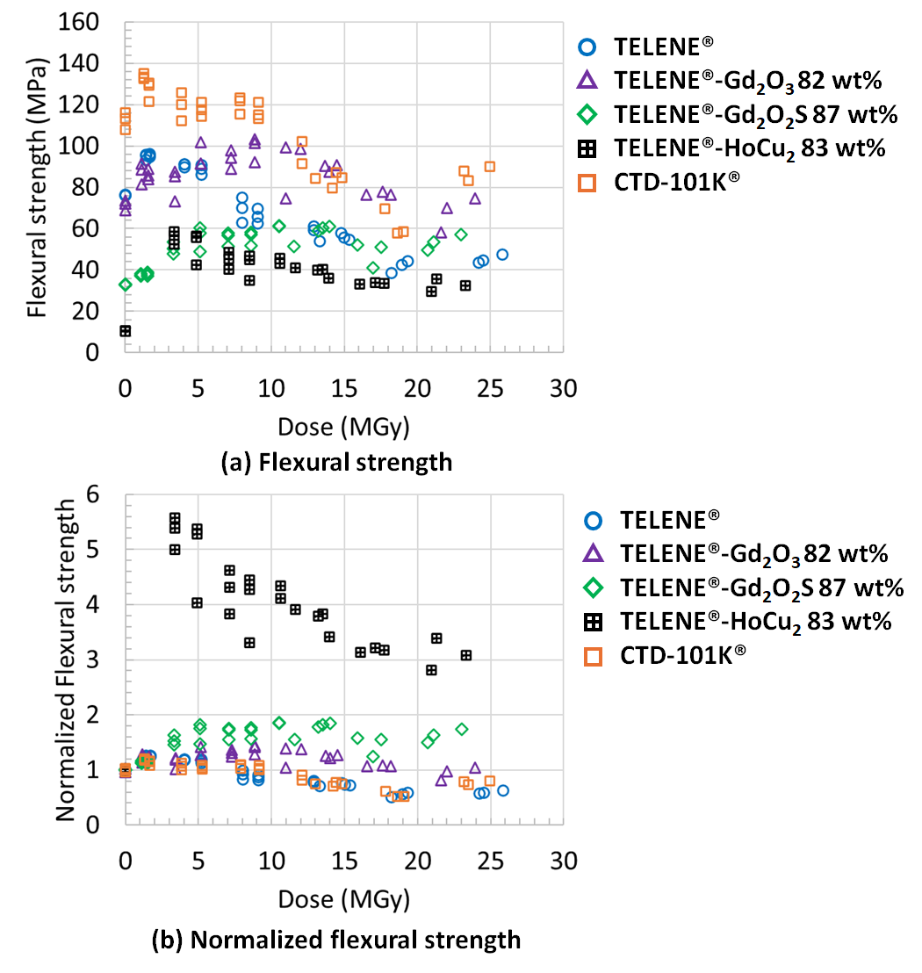
Fig. 9. Results of (a) flexural strength and (b) normalized flexural strength of resin samples #1–#5 as a function of the absorbed dose at room temperature.

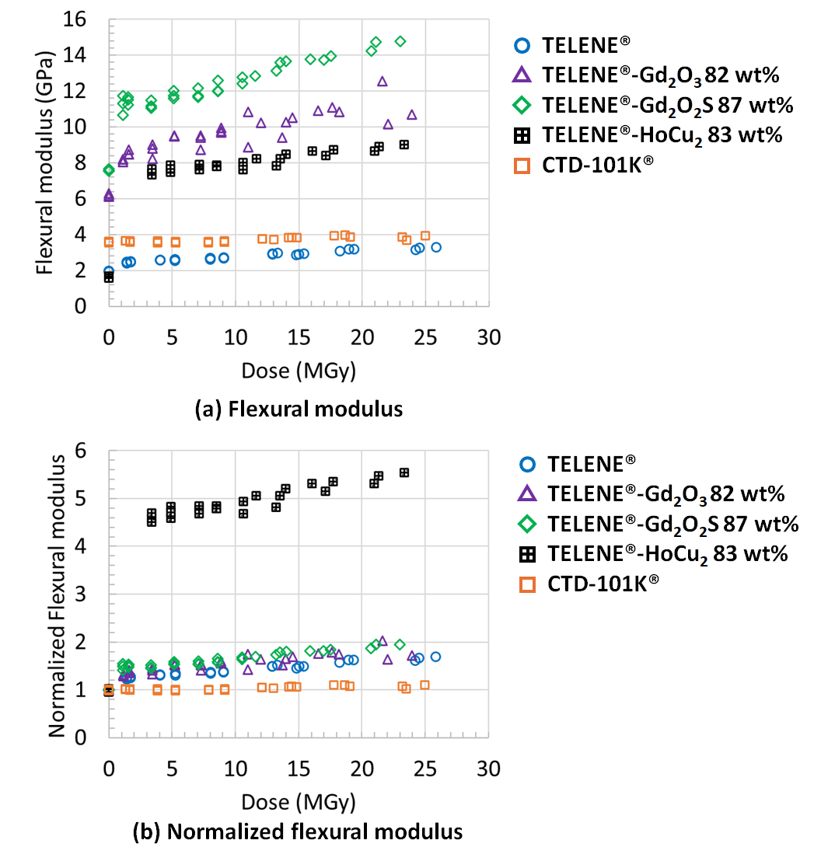
Fig. 10. Results of (a) flexural modulus and (b) normalized flexural modulus of resin samples #1–#5 as a function of the absorbed dose at room temperature.

Acknowledgment
The authors thank the staff of the KEK mechanical engineering center for fabricating the experimental tools and the staff of the Takasaki Advanced Radiation Research Institute for their technical support on conducting the irradiation test.
References
- A. Musso, T. Nakamoto, B. D. Grande, C. L. Borderas, D. F. da Sousa, M. Sugano, T. Ogitsu, and S. S. Tavares, “Characterization of the raidation resistance of glass fiber reinforced plastics for superconducting magnets,” IEEE Trans. Appl. Supercond. vol. 32, 2022, Art. no. 7700405, doi: 10.1109/TASC.2022.3157255.
- RIMTEC corporation (available at: www.rimtec.co.jp/en/ technology/behavior.html)
- Emanuela Barzi, Daniele Turrioni, Ibrahim Kesgin, Masaki Takeuchi, Wang Xudong, Tatsushi Nakamoto, and Akihiro Kikuchi, “A new ductile, tougher resin for impregnation of superconducting magnets,” Supercond. Sci. Technol., vol. 37, 2024, Art. no. 045008, doi: 10.1088/1361-6668/ad2c25.
- M. Miyamoto, N. Tomite, and Y. Ohki, “Comparison of gamma-ray resistance between dicyclopentadiene resin and epoxy resin,” IEEE Trans. Dielectr. Electr. Insul., vol. 23, 2016, 2270-2277, doi: 10.1109/TDEI.2016.7556503

This work was supported by the U.S.-Japan Science and Technology Cooperation Program in high energy physics operated by MEXT in Japan and DOE in the U.S. Xudong Wang, Tatsushi Nakamoto, and Kiyosumi Tsuchiya are with the High Energy Accelerator Research Organization (KEK), Tsukuba, Ibaraki 305-0801, Japan (e-mail: wanxdon@post.kek.jp). Akihiro Kikuchi is with the National Institute for Materials Science (NIMS), Tsukuba, Ibaraki 305-0028, Japan. Masaki Takeuchi is with the RIMTEC Corporation, Okayama 711-0934, Japan. Color versions of one or more of the figures in this article are available online at http://ieeexplore.ieee.org

