Machine Learning Approach for Evaluation of
Nanodefects and Magnetic Anisotropy in FePt Granular Films
E. Dengina, A. Bolyachkin, H. Sepehri-Amin*, and K. Hono
National Institute for Materials Science, 1-2-1 Sengen, Tsukuba 305-0047, Japan
*Corresponding author e-mail : h.sepehriamin@nims.go.jp

This paper reports a machine learning approach for evaluating micromagnetic and microstructural parameters from demagnetization curves of FePt granular films for heat-assisted magnetic recording (HAMR) media. We developed a neural network to predict parameters of magnetic anisotropy and volume fractions of defects such as [200] misoriented grains, {111} twined variants, and disordered grains. The neural network was trained on a synthetic dataset of out-of-plane demagnetization curves that were simulated using the micromagnetic model constructed from actual nanostructure of a FePt-X HAMR medium. Predicted nanodefects agreed well with those estimated by synchrotron X-ray diffraction, and the demagnetization curve simulated with the predicted parameters accurately reproduced the experimental one. This work paves the way for a high-throughput magnetometry-based characterization of FePt granular media for its structural optimization toward higher areal density of HAMR.

Keywords: FePt, machine learning, heat-assisted magnetic recording, neural network, micromagnetic simulation
*Corresponding author e-mail : h.sepehriamin@nims.go.jp
Machine learning (ML) is becoming an increasingly useful tool for industry, medicine, and science considering intensive data accumulation, growth of computational performance and the progress with algorithms [1-3]. In particular, machine learning has been successfully applied in research on magnetic materials in order to analyze complex relationships between their physical properties and to design new advanced compounds. The keystone of machine learning is a well-prepared dataset of samples. The dataset can be composed of experimental results mined through published papers and patents as reported in Ref. [4], where chemical compositions and details of synthesis of hard magnetic Sm-Fe-N alloys were collected and used to predict remanent magnetization and coercivity. Similar approach was realized in a study of Fe₂P-type magnetocaloric materials focused on tuning transition temperature by ML-assisted composition optimization [5]. However, collecting and curating extensive experimental datasets are usually costly and time-consuming. Joint efforts of researchers in formulating unified standards of publishing data and in developing global databases are needed to overcome such a bottleneck issue [6-9].
Datasets can be also enriched or fully composed of results obtained by computer simulations, i.e., density-functional theory calculations and micromagnetic modelling [10-16]. In the latter case, it can be a series of hysteresis loops simulated with the variation of magnetic and microstructural parameters. These parameters can be considered as features which are used to predict targets such as macroscopic hysteresis properties. Park et al. developed a synthetic micromagnetic model of nanocrystalline Nd-Fe-B permanent magnets and predicted coercivity and maximum magnetic energy product based on the microstructural features (average grain size, easy magnetization axes alignment etc.) [10]. Exl et al. used a similar approach to find Nd-Fe-B grains with low and high switching fields and revealed the most important microstructural parameters affecting the switching fields in a magnet [11]. Kulesh et al. addressed the prediction of coercivity and exchange bias field in the thin films with unidirectional magnetic anisotropy using ML on micromagnetic simulations [12]. A drawback of machine learning on synthetic datasets is that the validity of predictions for real samples can be debatable since a model usually contains some assumptions and limitations.
In this work we considered the inverse problem of evaluating micromagnetic and microstructural parameters based on a demagnetization curve for FePt nanogranular thin films. High-anisotropy FePt-X nanogranular films with L1₀ order are the media for heat-assisted magnetic recording (HAMR) [17-21]. In order to reach the future industrial goal for the storage areal density of 4 Tb/in², an accurate control of the nanostructure is required including grain size, nanodefects, crystallographic texture [21,22]. Recently, Bolyachkin et al. developed a micromagnetic model of FePt-X films and carried out the micromagnetic approximation of experimental hysteresis loops to estimate magnetic and microstructural parameters [23]. The approximation was accurate, but it was time-consuming due to incorporated grid-search method. Hence, here we applied machine learning to rapidly predict the parameters of magnetic anisotropy and volume fractions of {111} twinned variants, grains with in-plane c-axis ([200] misorientation) and disordered grains. These defects are the most detrimental to the coercivity and switching field distribution, or the signal to noise ratio for magnetic recording. For that the dataset of simulated demagnetization curves was collected with the variation of magnetic and microstructural parameters on the developed micromagnetic model well-replicating real FePt heat-assisted magnetic recording (HAMR) media.
Large finite element model of FePt granular films was constructed based on transmission electron microscopy (TEM) images following the method described in Ref. [23]. It has 250$×$250 nm² lateral size containing more than 1000 grains with mean size of 6.5 nm as shown in Fig. 1. The height of grains was varied with the mean of 7.4 nm and standard deviation (SD) of 0.6 nm. Uniaxial magnetic anisotropy was prescribed for each FePt grain. Nondefective grains had easy magnetization axes (EA) oriented in the out-of-plane direction (OOP; Z axis) with small inclinations which were randomized with SD of θ_{sd} (Fig. 1; zoomed inset). For some grains {111} twin planes were randomly introduced splitting them into variants of volumes $V_{001}^{(i)}$ and $V_{111}^{(i)}$. The parental variant ($V_{001}^{(i)}$) preserved OOP orientation of EA while the easy magnetization axis of another variant (EA_{tw}) was defined as the mirror reflection of EA in the {111} twin plane (Fig. 1; zoomed inset). The number of twinned grains was controlled by a parameter $V_{111}$ that is a volume fraction of twinned grains $V_{111}={\sum_{i}{V_{111}^{(i)}}}/{V_{tot}}$, where $V_{tot}$ is the total volume of grains. For some of the grains without twins, in-plane (IP) easy magnetization axes were introduced instead of OOP EAs, their orientations within XY-plane were random. Hereafter we refer to those grains as [200] misoriented ones, so their volume fraction is denoted by V₂₀₀. Magnetic anisotropy constant was distributed among grains with mean K_{m} and SD of K_{sd}. However, some undersized grains do not show L1₀ ordering due to the size effect [24] that results in zero magnetocrystalline anisotropy. The volume fraction of such disordered grains was denoted by V_{K=0}. Saturation magnetization M_{s} and exchange stiffness were set as 1.43 T and 10 pJ/m for all FePt grains, respectively [25]. Micromagnetic simulations were performed in Fastmag software [26] by solving Landau-Lifshitz-Gilbert equation.
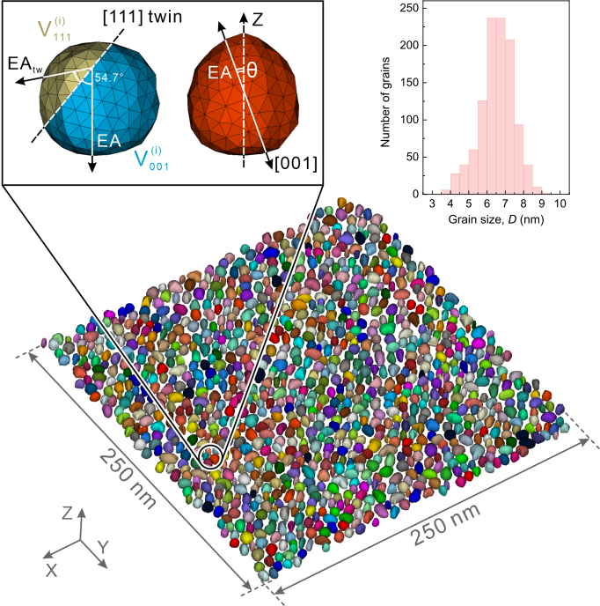
Figure 1. Micromagnetic model of FePt nanogranular media, grain size distribution and enlarged part of the model that demonstrates a grain with easy magnetization axis (EA) inclined by θ from out-of-plane direction (OOP; Z axis) and a defective grain with variants of different volumes $V_{001}^{(i)}$ and $V_{111}^{(i)}$ formed due to {111} twin.

We performed 760 micromagnetic simulations of OOP demagnetization curves M(H) within the fixed range of magnetic field from -10 to 10 T. Each simulation in the dataset had unique six parameters chosen randomly in the following limits: K_{m} ∈ [1.0, 4.2] MJ/m³, K_{sd}/K_{m} ∈ [0, 15] %, θ_{sd} ∈ [0, 10] deg., V₂₀₀ ∈ [0, 6] vol.%, V₁₁₁ ∈ [0, 10] vol.%, V_{K=0} ∈ [0, 15] vol.%. These parameters were considered as targets for ML. Two different approaches in formulating feature vectors were used depending on the target. For predicting K_{m}, feature vectors were defined as ordered lists of magnetizations [M_{i}] obtained by interpolation of the M(H) curves from -10 to 10 T with 100 uniform steps. This simple strategy was enough to get accurate predictions for mean magnetic anisotropy constant. For the rest of targets, feature vectors were prescribed in the similar way, but first M(H) curves were normalized on anisotropy field H_{a} = 2K_{m}/M_{s} and then they were interpolated within the range H/H_{a} ∈ [-1.4, 1.4] as it is shown schematically in Fig. 2(a). Such a normalization was done to focus training of ML models on the shape of demagnetization curves.
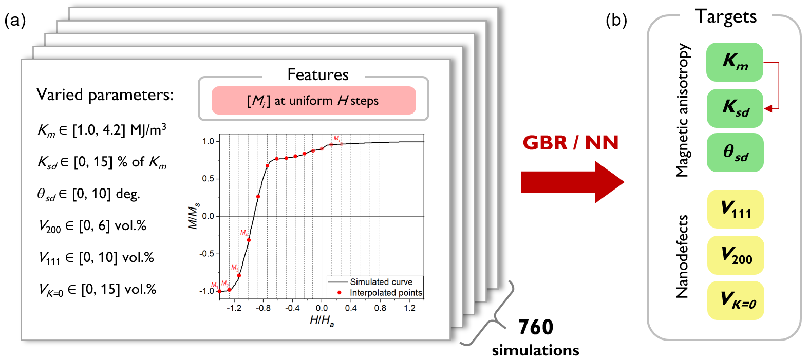
Figure 2. (a) Dataset of 760 simulations of OOP normalized demagnetization curves M(H) and its descriptors as list of magnetizations interpolated at fixed equidistant magnetic fields. (b) Set of target properties for prediction with machine learning: mean magnetic anisotropy constant K_{m}, its standard deviation K_{sd}, standard deviation of inclination angle θ_{sd}, volume fractions of {111} variants V₁₁₁, [200] misoriented grains V₂₀₀ and disordered ones V_{K=0}.

Machine learning was performed using Scikit-Learn Python library [27]. We considered two ML regression models: gradient boosting regression (GBR) based on decision trees and neural network (NN). All targets were predicted independently except K_{sd} for which K_{m} was used as an additional feature (Fig. 2(b)) since we were interested in estimating K_{sd} as the percentage of K_{m}. Three metrics were used to evaluate performance of the models: coefficient of determination (R²), mean absolute error (MAE) and 10% accuracy of allowable errors (10-AAE). 10-AAE is the fraction of samples for which predicted and observed target values deviate from each other by no more than 10%. Thus, 10-AAE = 1.0 means that all samples are within the 10% accuracy threshold while 10-AAE = 0.0 indicates vice versa. Cross validation was carried out by 10 random splitting of the dataset into 80% train set and 20% test one. Hyperparameters of the models were optimized using the grid search method. According to that, the optimum NN had 1 hidden layer containing 300 neurons with ‘relu’ activation function and L2 penalty parameter of 0.5. Let us note that the standard normalization was applied to the feature vectors in the case of NN. GBR had 200 boosting stages for decision trees which depth was limited to 3 and splitting condition for internal nodes started with 3 samples; learning rate was of 0.2.
High accuracy of predictions by NN and GBR is demonstrated in Table 1 with MAE and 10-AAE. Since NN had lower errors for most targets, it was used further as the main model for analysis and experimental validation. In more details predictive performance of NN is illustrated in Fig. 3, where for all targets deviations between actual and predicted values in train and test subsets are shown. Among the parameters describing magnetic anisotropy (Fig. 3(a-c)), the mean magnetic anisotropy constant was predicted precisely with MAE of 0.13 MJ/m³. As a reference, anisotropy constant of fully L1₀ ordered FePt is of 5.3 MJ/m³ [28]. It is remarkable that ML models picked up magnetizations in the vicinity to coercivities as the most relevant features to estimate K_{m}, as it can be seen in the inset of Fig. 3(a) which shows permutation feature importance for the NN. Let us remind that features were represented by magnetizations, so in the relative importance plot, the features are labeled by magnetic fields at which the magnetizations were extracted. This can be expected from the physical point of view considering high correlation between coercivity and magnetic anisotropy constant, e.g. Pearson correlation coefficient between coercivity and K_{m} was of 0.97 in our dataset. Accuracy of predictions for K_{sd} and θ_{sd} (Fig. 3(b,c)) was sufficient, i.e., corresponding MAEs were enough to resolve the parameters within the current industrial requirements [21,22]. Both K_{sd} and θ_{sd} deteriorate the shape of a hysteresis loop reducing its squareness as the parameters increase; however relationships between features and these targets established by ML models were less interpretable than for K_{m}. Among the volume fractions of the defects (Fig. 3(d-f)), the best results were obtained for predicting V_{K=0} (MAE = 0.17 vol. %). Grains with zero magnetocrystalline anisotropy constant are demagnetized at small magnetic fields that results in a distinct kink at a hysteresis loop near the remanence, and the larger V_{K=0}, the greater the kink. This was captured by ML models: magnetizations at small magnetic fields had the highest feature importance as shown in the inset of Fig. 3(f). The volume fractions of [200] misoriented grains and {111} variants, which are detrimental for the hysteresis loop squareness and a switching field distribution [23], were predicted accurately enough with MAEs of 0.35 vol. % and 0.47 vol. %, respectively.
Metric | MAE |  | 10-AAE
Model | NN | GBR | NN | GBR
K_{m} (MJ/m³) | 0.13 (0.01) | 0.10 (0.01) | 0.91 | 0.93
K_{sd} (% of K_{m}) | 0.83 (0.06) | 1.15 (0.06) | 0.57 | 0.41
$θ$_{sd} (deg.) | 0.31 (0.02) | 0.31 (0.02) | 0.73 | 0.71
V₂₀₀ (vol. %) | 0.35 (0.02) | 0.49 (0.02) | 0.44 | 0.33
V₁₁₁ (vol. %) | 0.47 (0.03) | 0.67 (0.05) | 0.59 | 0.43
V_{K=0} (vol. %) | 0.17 (0.02) | 0.31 (0.02) | 0.74 | 0.53
Table 1. Mean absolute errors (MAE) and 10% accuracy of allowable errors (10-AAE) for each target obtained with neural network (NN) and gradient boosting regression (GBR). Standard deviations for MAE are shown in brackets.
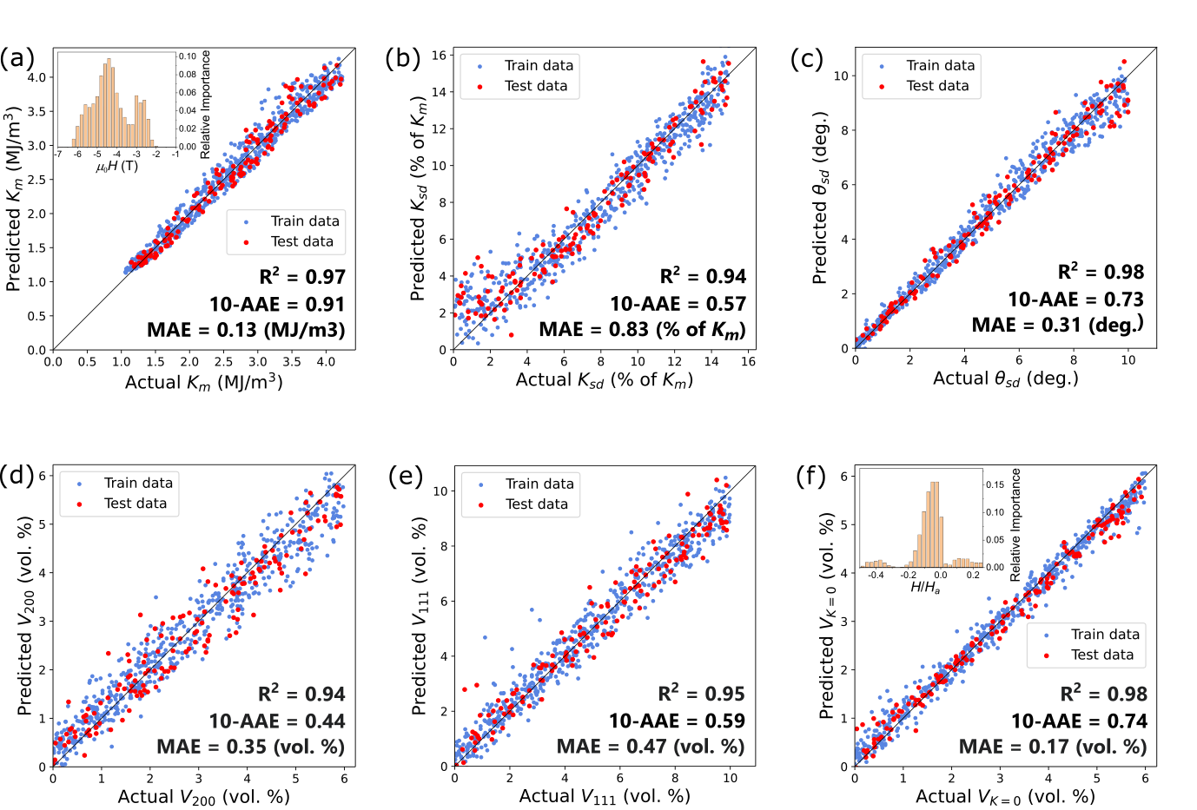
Figure 3. Comparison between actual parameters of the FePt nanogranular films and those predicted by NN based on OOP demagnetization curves. The parameters are: (a) mean magnetic anisotropy constant, (b) its standard deviation, (c) standard deviation of easy magnetization axis inclinations from the OOP direction, (d) volume fraction of grains with [200] misalignment, (e) volume fraction of {111} variants and (f) volume fraction of grains with K = 0. Black lines indicate perfect match between actual and predicted values. The insets in (a) and (f) show permutation feature importance plots obtained with NN where the features are labeled by magnetic fields.

Experimental validation of the trained NN was performed on FePt-X nanogranular thin film which deposition stack was (001)MgO(6 nm) / FePt-BN(1 nm) / FePt-(BN,C,SiO₂)(7 nm). Details about sputtering conditions and microstructural characterization can be found in Ref. [23]. Figure 4 shows (a) plane-view and (b) cross-sectional bright field (BF) TEM images of the FePt-X film. It can be seen that morphology of real grains was represented well by the developed micromagnetic model (Fig. 1). Mean grain size was of 6.2 nm with SD of 2.0 nm that was in compliance with the size implemented in the model. High angle annular dark field (HAADF) scanning TEM images demonstrate the presence of {111} twined grains (Fig. 4(c)) and [200] misoriented ones (Fig. 4(d)) in the FePt-X film.
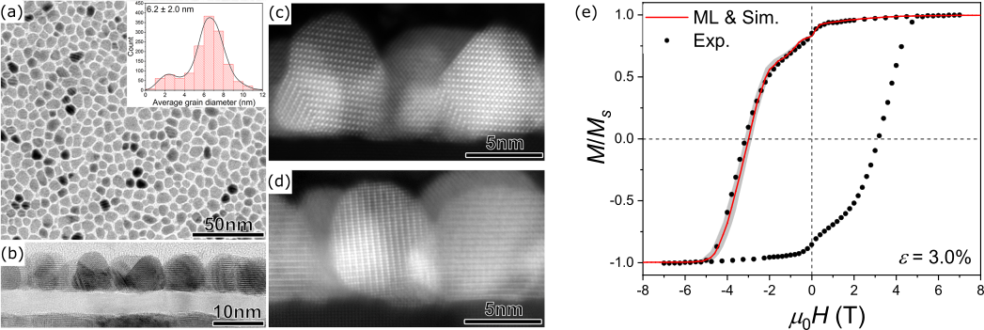
Figure 4. (a) Plane-view and (b) cross-sectional BF-TEM images of the FePt-X nanogranular thin film. The grain size distribution evaluated from the plane-view image is shown in the inset. (c,d) High resolution HAADF-STEM images obtained from the film. (e) Experimental out-of-plane hysteresis loop of the FePt-X film (black dots, replotted from [23]) and the simulated one with parameters predicted by NN (red line). The confidence interval for the simulated curve based on the mean absolute errors of predictions is shaded in gray.

Out-of-plane hysteresis loop of the film was measured using a superconducting quantum interference device equipped with a vibrating sample magnetometer (SQUID-VSM) with a maximum applied magnetic field of 7 T (Fig. 4(e); black dots). The demagnetization curve from positive to negative magnetic fields was selected and its high-field regions were linearly extrapolated up to 10 T. Thereafter, the M(H) curve was processed into the feature vector in the same way as simulated curves. The neural network was used to predict magnetic and microstructural parameters in the FePt-X film which yielded the following predictions: K_{m} = 2.27 MJ/m³, K_{sd}/K_{m} = 14.5 %, θ_{sd} = 5.4 deg., V₂₀₀ = 1.8 vol.%, V₁₁₁ = 10.3 vol.%, V_{K=0} = 4.5 vol.%. Note that K_{m} value was predicted first and used for H/H_{a} normalization required for predictions of the rest of parameters. Obtained V₁₁₁ and V₂₀₀ volume fractions are in good agreement with those estimated from synchrotron X-Ray diffraction (XRD) of the film [23]: V₁₁₁ = 13.7 vol.% and V₂₀₀ = 1.4 vol.%. The list of predicted parameters was used as an input for micromagnetic simulation of the demagnetization curve. Its comparison with the experimental result is shown in Fig. 4(e) taking into account the confidence interval (gray filled area). The confidence interval was estimated based on a set of demagnetization curves simulated with random variation of the predicted parameters within the corresponding MAEs. Also, accuracy of such a ML-assisted approximation can be evaluated using the following error function: $ε=\sqrt{\sum_{i}^{N}{{{\left(M_{exp}^{(i)}-M_{sim}^{(i)}\right)}^{2}}/{NM_{s}^{2}}}}$, where $M_{exp}^{(i)}$ and $M_{sim}^{(i)}$ are interpolated magnetizations of experimental and simulated M(H) curves and N = 100. The low error of $ε=3.0\%$ was achieved demonstrating the potential of our approach.
In summary, we developed the neural network that predicts target parameters of magnetocrystalline anisotropy and the volume fractions of {111} twined, [200] misoriented and disordered grains in a FePt-X granular medium. The neural network was trained on the dataset of simulated out-of-plane demagnetization curves using the TEM image based micromagnetic model that reproduced the main microstructural features of the media. We achieved low mean absolute errors of predicting all the targets and performed experimental validation of the neural network on the FePt-X nanogranular thin film. Predicted volume fractions V₁₁₁ and V₂₀₀ were in good agreement with those estimations by synchrotron XRD. Obtained list of parameters for the FePt-X film was used to simulate its demagnetization curve, which was in compliance with experimentally measured one. This study demonstrates the applicability of machine learning approach for evaluating the parameters in real FePt-X granular films through rapid ML-assisted magnetometry-based characterization. It can be implemented in nanostructural optimization of the FePt-X HAMR media towards industrial realization of improved areal density of data storage toward 4 Tb/in². For generalization of the approach, further extension of the dataset can be considered, e.g., the addition of in-plane demagnetization curves or the variation of structural parameters embedded in the model, such as grain size and morphology.
Authors acknowledge Western Digital members for discussion and allow to re-use of micrographs of part of the published work (Acta Mater. 227 (2022) 117744).

- M.I. Jordan, T.M. Mitchell, Science 349 (2015) 255–260.
- A.Y. Wang, R.J. Murdock, S.K. Kauwe, A.O. Oliynyk, A. Gurlo, J. Brgoch, K.A. Persson, T.D. Sparks, Chem. Mater. 2020 32 (2020) 4954–4965.
- J. Schmidt, M.R.G. Marques, S. Botti, M.A.L. Marques, Npj Comput. Mater. 5 (2019) 83.
- H. Hosokawa, E.L. Calvert, K. Shimojima, J. Magn. Magn. Mater. 526 (2021) 167651.
- J. Lai, A. Bolyachkin, N. Terada, S. Dieb, X. Tang, T. Ohkubo, H. Sepehri-Amin, K. Hono, Unpublished.
- Materials Genome Initiative. <https://www.nist.gov/mgi>, 2022 (accessed 02.02.22)
- M. Tanifuji, A. Matsuda, H. Yoshikawa, Proceedings – 8th International Congress on Advanced Applied Informatics (2019) 1021–1022.
- A. Zakutayev, N. Wunder, M. Schwarting, J. D. Perkins, R. White, K. Munch, W. Tumas, C. Phillips, High Throughput Experimental Materials Database, NREL Data Catalog, 2017. <https://doi.org/10.7799/1407128>.
- B. Blaiszik, L. Ward, M. Schwarting, J. Gaff, R. Chard, D. Pike, K. Chard, I. Foster, MRS Commun. 9 (2019) 1125–1133.
- H.-K. Park, J.-H. Lee, J. Lee, S.-K. Kim, Sci. Rep. 11 (2021) 3792.
- L. Exl, J. Fischbacher, A. Kovacs, H. Oezelt, M. Gusenbauer, K. Yokota, T. Shoji, G. Hrkac, T. Schrefl, J. Phys. Mater. 2 (2019) 014001.
- N. Kulesh, N. Permyakov, V. Zverev, A. Koshelev, A. Bolyachkin, V. Vas'kovskiy, IEEE Trans. Magn. 58 (2022) 7100105.
- M. Gusenbauer, H. Oezelt, J. Fischbacher, A. Kovacs, P. Zhao, T.G. Woodcock, T. Schrefl, Npj Comput. Mater. 6 (2020) 89.
- T. Long, N.M. Fortunato, I. Opahle, Y. Zhang, I. Samathrakis, C. Shen, O. Gutfleisch, H. Zhang, Npj Comput. Mater. 7 (2021) 66.
- B. Meredig, A. Agrawal, S. Kirklin, J.E. Saal, J.W. Doak, A. Thompson, K. Zhang, A. Choudhary, C. Wolverton, Phys. Rev. B 89 (2014) 094104.
- A. Seko, H. Hayashi, K. Nakayama, A. Takahashi, I. Tanaka, Phys. Rev. B 95 (2017) 144110.
- A. Perumal, Y. K. Takahashi, K. Hono, Appl. Phys. Express 1 (2008) 1013011–1013013.
- L. Zhang, Y. K. Takahashi, A. Perumal, K. Hono, J. Magn. Magn. Mater. 322 (2010) 2658–2664.
- L. Zhang, Y. K. Takahashi, K. Hono, B. C. Stipe, J.-Y. Juang, M. Grobis, IEEE Trans. Magn. 47 (2011) 6027541.
- D. Weller, G. Parker, O. Mosendz, A. Lyberatos, D. Mitin, N.Y. Safonova, M. Albrecht, J. Vac. Sci. Technol. B. 34 (2016) 060801.
- K. Hono, Y.K. Takahashi, G. Ju, J.U. Thiele, A. Ajan, X. Yang, R. Ruiz, L. Wan, MRS Bull. 43 (2018) 93–99.
- D. Weller, G. Parker, O. Mosendz, E. Champion, B. Stipe, X. Wang, T. Klemmer, G. Ju, A. Ajan, IEEE Trans. Magn. 50 (2014) 3100108.
- A. Bolyachkin, H. Sepehri-Amin, I. Suzuki, H. Tajiri, Y.K. Takahashi, K. Srinivasan, H. Ho, H. Yuan, T. Seki, A. Ajan, K. Hono, Acta Mater. 227 (2022) 117744.
- Y.K. Takahashi, T. Koyama, M. Ohnuma, T. Ohkubo, K. Hono, J. Appl. Phys. 95 (2004) 2690–2696.
- S. Wicht, V. Neu, L. Schultz, D. Weller, O. Mosendz, G. Parker, S. Pisana, B. Rellinghaus, J. Appl. Phys. 114 (2013) 063906.
- R. Chang, S. Li, M. V. Lubarda, B. Livshitz, V. Lomakin, J. Appl. Phys. 109 (2011) 07D358.
- F. Pedregosa, G. Varoquaux, A. Gramfort, V. Michel, B. Thirion, O. Grisel, M. Blondel, P. Prettenhofer, R. Weiss, V. Dubourg, J. Vanderplas, A. Passos, D. Cournapeau, M. Brucher, M. Perrot, E. Duchesnay, J. Mach. Learn. Res. 12 (2011) 2825–2830.
- J. Wang, H. Sepehri-Amin, Y.K. Takahashi, T. Ohkubo, K. Hono, Acta Mater. 177 (2019) 1–8.

