Supporting Information

Effect of Cr substitution for Mn on magnetic and transverse thermoelectric properties of isotropic Mn_{1-x}Cr_{x}AlGe magnets
Andres Martin-Cid^{1†}, Babu Madavali^{1†}, Fuyuki Ando¹, Nikita Kulesh¹, Ken-ichi Uchida^{1,2}, Hossein Sepehri-Amin^{1*}
¹National Institute for Materials Science, Tsukuba 305-0047, Japan
²Department of Advanced Materials Science, Graduate School of Frontier Sciences, The University of Tokyo, Kashiwa 277-8561, Japan

E-mail: *Corresponding author: h.sepehriamin@nims.go.jp
†These authors contributed equally to this work.

Figure S1. X-ray diffraction spectra for the different Mn_{1-x}Cr_{x}AlGe magnets, open red circles; the calculated spectra obtained by Rietveld refinement, black line; Rietveld refinement residuals, blue line; and the indexed reflections for the C38-MnAlGe structure, green vertical lines.

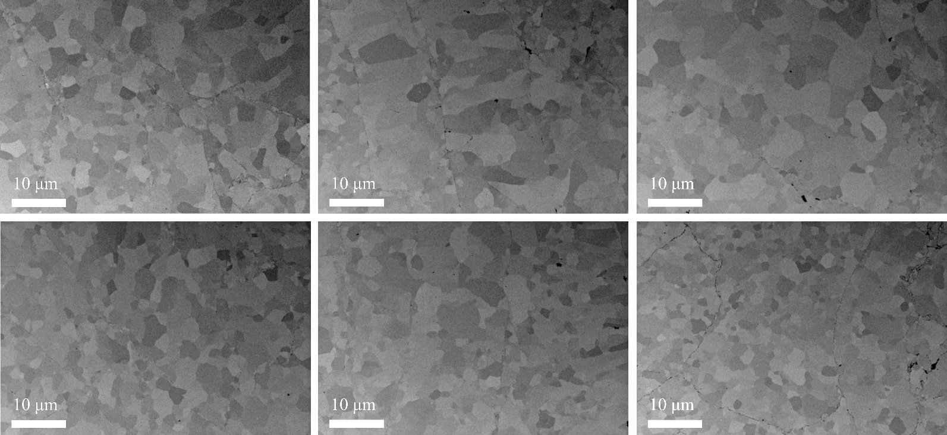
Figure S2. Backscattered Electrons (BSE)-SEM images for MnAlGe magnet.

Figure S3. Backscattered Electrons (BSE)-SEM images for Mn_{0.9}Cr_{0.1}AlGe magnet.

Figure S4. Backscattered Electrons (BSE)-SEM images for Mn_{0.8}Cr_{0.2}AlGe magnet.

Figure S5. Backscattered Electrons (BSE)-SEM images for Mn_{0.7}Cr_{0.3}AlGe magnet.

Figure S6. Backscattered Electrons (BSE)-SEM images for Mn_{0.6}Cr_{0.4}AlGe magnet.

Figure S7. Backscattered Electrons (BSE)-SEM images for Mn_{0.5}Cr_{0.5}AlGe magnet.

Figure S8. Grain size distribution for the Mn_{1-x}Cr_{x}AlGe magnets and the evolution of the mean grain size with Cr content. Each bin of the histograms represents 0.148 μm. Samples with x = 0 and 0.1 are fitted to a lognormal distribution. Samples with x = 0.2, 0.3, 0.4 and 0.5 are fitted to a generic gamma distribution.

Figure S9. Overlay maps showing spatial grain size distribution in samples with x = 0, 0.2 and 0.5. The distribution is relatively homogeneous for samples with x = 0 and 0.5, but inhomogeneous for x = 0.2. Grains are colorized by size (yellow indicates larger grains, dark magenta indicates smaller grains). Red circles highlight regions dominated by large grains, and yellow circles highlight regions dominated by fine.

Figure S10. BSE-SEM images and SEM-EDS elemental mapping of selected regions showing the composition homogeneity for all the samples.

Figure S11. Evolution with Cr content of the electronic contribution, κ_{e}, and phonon contribution, κ_{ph}, to the total thermal conductivity κ.

S12. Calculations of lock-in frequency dependence
To estimate the AEE signals in the steady-state condition, we evaluated the f dependence of AEE-induced temperature modulation by solving the one-dimensional heat diffusion equation in the frequency domain.
Specifically, in this model, the sample set as a thermally isolated ferromagnet in which only the length (L = 2 mm) along the AEE-driven heat-current density is considered. Because the sample is mounted to minimize heat leakage during LIT (thermally insulating support and high-emissivity coating), we impose adiabatic end conditions, i.e., zero net heat flow at both ends, which yields an analytical expression for the complex temperature modulation given by [21],
$$\begin{matrix} & Ae^{-iϕ}=\sqrt{\frac{i}{2πf C_{p}d κ}} \frac{cos⁡(-Lq)-1}{sin⁡(-Lq)} {\tilde{j}}_{q,AEE}, & & \text{(}\text{9}\text{)}\end{matrix}$$
where, $q=\sqrt{\frac{2πf C_{p}d}{iκ}}$
where d is the density, and ${\tilde{j}}_{q,AEE}$is the first-harmonic sinusoidal amplitude of the AEE-induced heat-current density.
Note that the frequency dependence in Eq. (9) is strongly constrained by thermal diffusion physics and by independently determined parameters ($C_{p}$, d, $κ$, and $L$). The calculated results are in good agreement with the experimental f dependence of the AEE signals as indicated in the Fig. 4(b) in the main text.

