Micromagnetic Simulations of Nd-Fe-B Hot-deformed Magnets
Subjected to Eutectic Grain Boundary Diffusion Process
Anton Bolyachkin^{1,2}, Ekaterina Dengina^{1,3}, Hossein Sepehri-Amin^{1,3},
Tadakatsu Ohkubo¹, and Kazuhiro Hono^{1,3}
¹Research Center for Magnetic and Spintronic Materials, NIMS, Tsukuba 305-0047, Japan
²International Center for Young Scientists, NIMS, Tsukuba 305-0047, Japan
³Graduate School of Science and Technology, University of Tsukuba, Tsukuba, 305-8573, Japan
The grain boundary diffusion process (GBDP) is one of the most efficient treatments for increasing the coercivity (H_{c}) of Nd-Fe-B magnets. However, this enhancement typically occurs at the expense of remanence (M_{r}). In this study, micromagnetic simulations were performed to quantify this tradeoff in hot-deformed Nd-Fe-B magnets subjected to the GBDP using a Nd-based eutectic alloy. The GBDP was imitated in a series of models with a gradually increasing volume fraction of the infiltrated Nd-rich nonmagnetic phase. This infiltration reduced the remanence and grain connectivity via the remaining thin magnetic intergranular phase (IGP), which in turn increased the coercivity. We distinguished between the roles of exchange and magnetostatic interactions in this coercivity enhancement. Furthermore, the simulated M_{r} vs. H_{c} curves defined realistic limits for coercivity that depended on the IGP magnetization, which was estimated to be 0.9 ± 0.1 T by reproducing experimental M_{r} vs. H_{c} data from the literature.
Keywords: permanent magnet, Nd-Fe-B, grain boundary diffusion process, micromagnetic simulation

Nanocrystalline anisotropic Nd-Fe-B permanent magnets have a prospect of achieving high coercivity with improved thermal stability and less or even no reliance on heavy rare earth elements [1-4]. These magnets are usually produced by the hot deformation of melt-spun ribbons [1,5]. This deformation results in platelet-shaped Nd₂Fe₁₄B grains with a typical width of 200–500 nm and aspect ratio of 3–5. The grains are compressed along the c-axis and closely packed, creating a c-axis crystallographic texture. An important microstructural feature is the intergranular phase (IGP) which is localized at the 1–4 nm thin interface between adjacent grains [6]. This IGP is typically amorphous and has a high content of Fe and Co, i.e., 50–70 at.% in total at the ab-interfaces [6-9]. Consequently, the thin IGP is considered magnetic, enabling undesirable exchange coupling between grains. This is one of the main factors hindering the coercivity, which should be higher considering the fine grain size of hot-deformed Nd-Fe-B magnets [2,4].
To suppress the detrimental role of thin magnetic IGP, a grain boundary diffusion process (GBDP) can be performed using a low-melting-point eutectic alloy, such as Nd-M [10-20], Pr-M [13,21,22], Nd-Dy-M [23], Nd-Tb-M [24], and others [3,25] (M = Cu, Al, Ga, Zn, Fe, and their combinations). A hot-deformed magnet is coated with such alloy and heat-treated at relatively low temperatures (600-700 °C) that do not remarkably coarsen the grains. During this process, the rare-earth-rich nonmagnetic phase diffuses into the magnet along the flake boundaries and into the flakes through triple junctions [14], resulting in better magnetic isolation of the grains. This significantly increases the coercivity (µ₀H_{c}) from 0.9–1.5 to 2.5–2.6 T at room temperature [10-20], but at the expense of reduced saturation magnetization and remanence (M_{r}). When a eutectic alloy contains Pr or heavy rare earth elements (HREE) such as Dy and Tb, the infiltration additionally results in a core-shell grain structure with enhanced magnetocrystalline anisotropy of shells, further improving the coercivity up to 3.0 T [1,13,21-25]. Hereafter, the GBDP refers to processing with a eutectic alloy unless otherwise specified.
Micromagnetic simulations have been extensively employed to explain the effect of the GBDP on the hysteretic properties of hot-deformed Nd-Fe-B magnets. In particular, the simulations have addressed the enhancement of coercivity [10], its improved thermal stability [21,24], details of the nucleation process, role of the core-shell structure along with its nonuniformity [21,24], influence of coarse grains near the surface of flakes [18,22], and effect of diffusion depth [16]. However, most micromagnetic models represent an idealistic scenario wherein the entire thin magnetic IGP becomes a thicker nonmagnetic phase after the GBDP. Figure 1a shows a high-angle annular dark-field scanning transmission electron microscopy (HAADF-STEM) image superimposed with an energy-dispersive X-ray spectroscopy (EDS) map of a hot-deformed Nd-Fe-B magnet after the GBDP using the eutectic Nd-Cu alloy. This is representative of the typical microstructure of such magnets. Two regions are highlighted at the boundaries of a grain: a region where the grain is covered by the Nd-rich phase depleted in Fe (Fig. 1b), and a region where the grain is still in contact with another one through the thin IGP with high Fe content (Fig. 1c), which is expected to be magnetic. Such adjacent grains, as in the latter case, can be seen in the scanning electron microscopy (SEM) images of many samples after the GBDP [10-15,17-19,21,23-25], so the magnetic isolation of grains is often incomplete [10,15]. To account for this microstructural feature, a new micromagnetic model is required in which both the rare-earth-rich nonmagnetic phase and thin magnetic IGP are introduced in a more realistic manner.
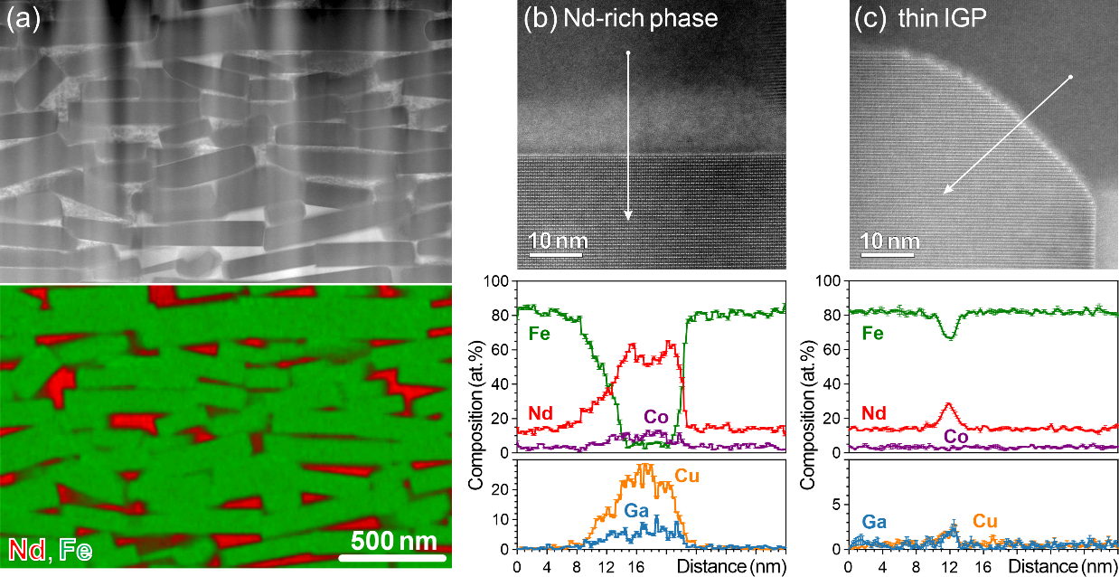
Figure 1. (a) Low-magnification HAADF-STEM image combined with STEM-EDS map of a hot-deformed Nd-Fe-B magnet after the GBDP using the eutectic Nd-Cu alloy. It shows the typical microstructure with incomplete grain isolation by the Nd-rich phase. This is highlighted in two regions with the (b) Nd-rich phase and (c) thin IGP, whose high-resolution HAADF-STEM images are shown along with composition line profiles extracted from corresponding STEM-EDS.
In this work, micromagnetic simulations were used to investigate how the incomplete magnetic isolation of grains affects the coercivity of hot-deformed Nd-Fe-B magnets processed via grain boundary diffusion with a Nd-based eutectic alloy. Microstructural transformations after the GBDP were imitated in a series of models wherein the volume fraction of the Nd-rich nonmagnetic phase was gradually increased, while the contacts between grains through the remaining thin IGP were reduced. This improved the coercivity, while the remanence deteriorated naturally. Accordingly, M_{r} vs. H_{c} trade-off curves of hot-deformed Nd-Fe-B magnets were simulated and analyzed to provide insights into the mechanism of coercivity enhancement as well as the magnetism of thin IGP.
We developed finite element models that mimicked hot-deformed Nd-Fe-B magnets subjected to the GBDP in several steps. First, the initial polycrystalline geometry was generated in the Neper package using Laguerre tessellation with a specified grain aspect ratio and default grain-growth morphology [26]. To introduce the intergranular phases, an approach proposed for tomography-based models was adapted [27]. Each initial polyhedral grain was represented as an axis-aligned bounding box after faceting by planes that defined the interfaces with adjacent grains (see Fig. 2a for the schematic). These cutting planes were fixed; hence, when the bounding box was scaled down with respect to its center, the transformed grain had less or no contact area with neighboring grains (Fig. 2b; the central grain was transformed accordingly, while its neighbors were left unchanged for simplicity). Then, the thin magnetic IGP was introduced at the grain interfaces (Fig. 2c) and the final geometry was regularized [27]. The Nd-rich nonmagnetic phase was constructed by subtracting the grains and thin IGP from the model volume.
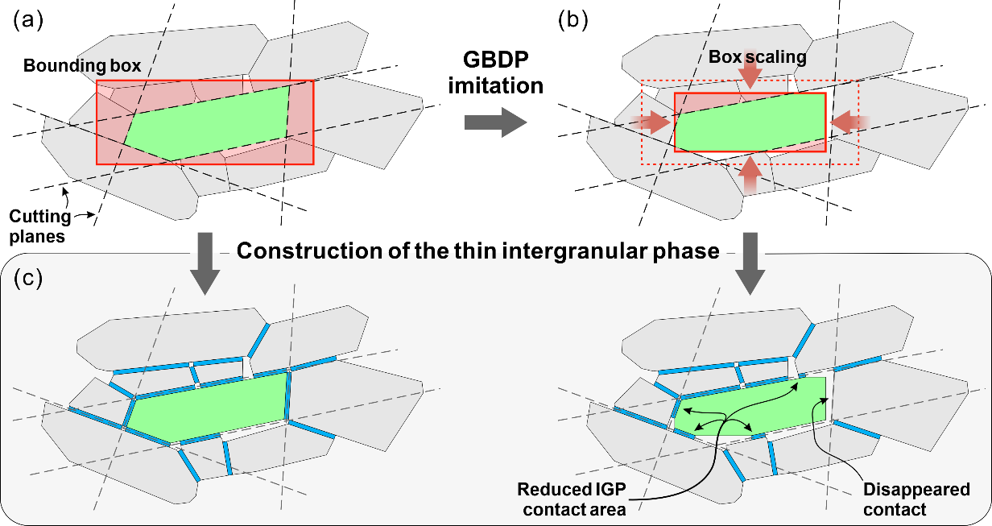
Figure 2. (a) Two-dimensional schematic of a grain created by faceting its bounding box with cutting planes. (b) Transformed grain after scaling down the bounding box under fixed cutting planes. Neighboring grains were kept unchanged for simplicity. (c) Construction of thin IGP following the algorithm from Ref. [27]. The transformed grain exhibited reduced IGP coverage that imitated the GBDP.
Following the described workflow, 11 models were created, in which the nonmagnetic Nd-rich phase was varied from 2 vol.% (no GBDP imitation) to 55 vol.% by tuning the scaling coefficient. Figure 3a shows the extreme models and an intermediate one, each with a sliced fragment to demonstrate the inner part. In the range of 2–55 vol.%, the areal coverage of grains with the nonmagnetic Nd-rich phase significantly changed from 13 to 96% (Fig. 3b). To compensate for the decrease in grain size due to reduced bounding boxes, the models were accordingly scaled up (Fig. 3a) to maintain the mean grain size (D) and aspect ratio (AR) at 175 ± 5 nm and 3.9 ± 0.2, respectively. Figure 3c shows similar distributions of D and AR for the models with the smallest and largest Nd-rich phase contents. Note that both D and AR are volumetric estimates obtained via arbitrarily aligned 3D bounding boxes defined for each grain after faceting (D = max(E) and AR = max(E)/min(E), where E is a list of box edges). Experimental D and AR from SEM images tend to be underestimated; for example, the model with 2 vol.% of the Nd-rich phase exhibited D_{2D} = 140 nm and AR_{2D} = 3.4 evaluated from 2D slices of the model by xy-planes (10–20% decrease with respect to the actual values). With this in mind, we compared the synthetic microstructures of the models with those of real hot-deformed Nd-Fe-B magnets subjected to the GBDP from Refs. [10-18]. The experimental AR varied within the range of 2.8–3.4 corresponding well to AR_{2D} in the models. In addition, the overall grain morphology of the models (Fig. 3a) was visually similar to that of SEM images [10-18]. However, the typical grain size of 230–330 nm was approximately twice as large as D_{2D} in the models even though we created the largest possible models with reasonable statistics (189–199 grains) given the memory limitation of our computational facilities. As final notes on the models, the thickness of the magnetic IGP was set to 3.5 nm; this phase and grain surfaces were discretized with a mesh size of 2.3 nm, which was allowed to gradually increase up to 5 nm toward the grain depth. The largest model comprised 189×10⁶ tetrahedral elements.
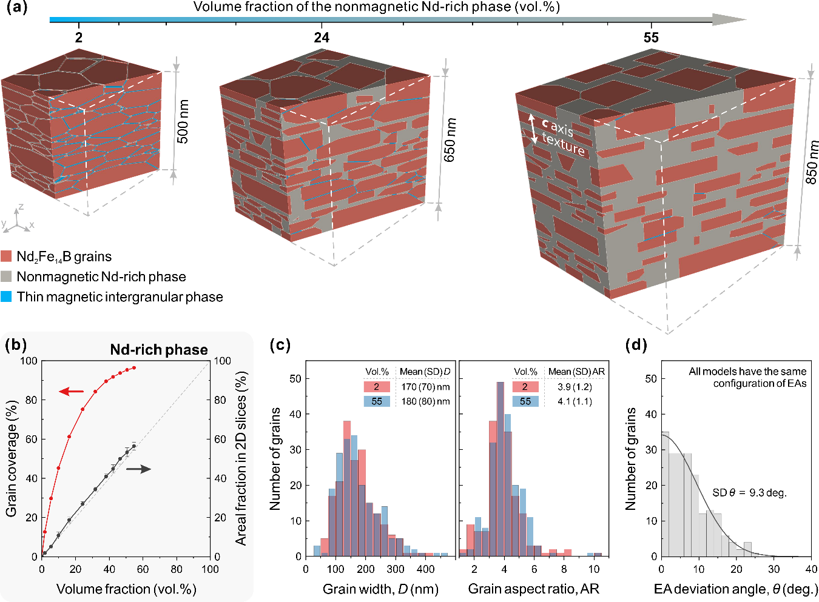
Figure 3. (a) Several micromagnetic models of hot-deformed Nd-Fe-B magnets wherein the Nd-rich nonmagnetic phase was varied from 2 to 55 vol.% upon grain boundary diffusion imitation. (b) Dependence of grain coverage by the Nd-rich phase on its volume fraction; a direct correspondence of the Nd-rich phase volume fraction to its areal fraction in 2D slices (as in SEM images) is also shown. (c) Distributions of grain width and aspect ratio for selected models. (d) Distribution of the angle between inclined easy magnetization axis (EA) and axis of crystallographic texture (z-axis).
Micromagnetic simulations were carried out on NVIDIA A100 GPUs using the “b4vex” code, which performs the free energy minimization [28]. Magnetic properties of the Nd₂Fe₁₄B phase were prescribed to the grains: saturation magnetization µ₀M_{s} = 1.61 T, uniaxial magnetic anisotropy constant K₁ = 4.36 MJ/m³, and exchange stiffness A = 8 pJ/m. The saturation magnetization of the thin IGP was varied in the range of 0–1.5 T, while its exchange stiffness was scaled as $A∝M_{s}^{2}$ [9,27] with respect to the Nd₂Fe₁₄B phase. The magnetic anisotropy of the thin IGP was neglected. All models had the same set of easy magnetization axes (EAs), and the inclination angles of EAs from the z-axis (c-axis texture) followed a normal distribution with a standard deviation (SD) of 9.3° (Fig. 3d). This distribution was considered a representative case according to the tomographic data in Ref. [27]. In addition, the model without GBDP imitation (2 vol.%) exhibited M_{r}/M_{s} = 0.93 at IGP µ₀M_{s} = 0.9 T, which is comparable to 0.94 for the hot-deformed magnet from Ref. [15].
The hysteresis loops of all models were simulated for different magnetizations of the thin IGP. Second quadrants of the loops are shown in Fig. 4 for some selected models with 6, 24, and 46 vol.% of the Nd-rich nonmagnetic phase. The obtained remanence vs. coercivity dependencies are summarized in Fig. 5a, which also includes relevant experimental data for hot-deformed Nd-Fe-B magnets after the Nd-based GBDP [10-18]; an alternative data representation of the coercivity vs. IGP magnetization is available in Supplementary Information (Fig. 1). Note that the simulation results were corrected by a -0.1 T shift along the coercivity axis to compensate for the twice smaller grain sizes in the models compared to those in the magnets from Refs. [10-18]. This correction was justified by a model with D = 370 nm and low vol.% of the Nd-rich phase; its coercivities at different IGP M_{s} were, on average, lower by 0.1 T than those of the corresponding model with D = 175 nm (Supplementary Fig. 2). Furthermore, the applied correction was in good agreement with the extrapolated experimental H_{c}(D) dependence from Ref. [29].
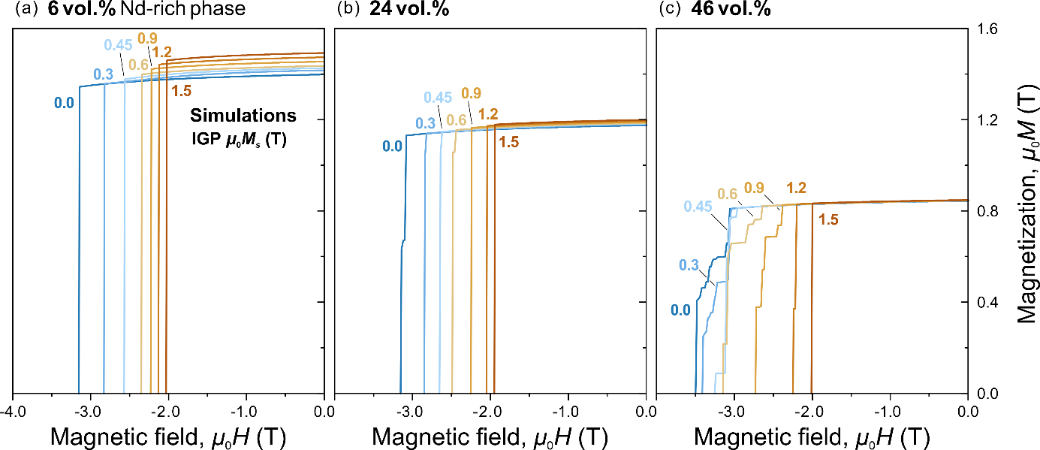
Figure 4. Simulated hysteresis loops of hot-deformed Nd-Fe-B magnets subjected to eutectic grain boundary diffusion up to (a) 6, (b) 24, and (c) 46 vol.% of the Nd-rich nonmagnetic phase. Only the second quadrant of the loops is shown. Simulations were performed for different magnetizations of the thin intergranular phase.
We first analyzed the case of exchange-decoupled grains (IGP µ₀M_{s} = 0 T) wherein the imitated GBDP only modified the magnetostatic interaction between grains. The coercivity exhibited a high value of 3.17 T and did not significantly change until the Nd-rich phase approached approximately 30 vol.%. Before this threshold, most of the grains retained connectivity through adjacent facets (Fig. 5b, i), thus still strongly interacting via the stray field. Therefore, a grain with the lowest nucleation field easily initiated a stray field-mediated cascade magnetization reversal. As a result, the coercivity was predominantly determined by the nucleation field of that grain (a so-called “weak link” [30]). This reversal could be suppressed after approximately 30 vol.% of the Nd-rich phase, when the net-like grain connectivity deteriorated enough to start splitting into grain clusters (Fig. 5b, ii-iv). This was accompanied by an almost linear increase in coercivity up to 3.75 T at 55 vol.% of the Nd-rich phase. One can interpret this within the Kronmüller theory of coercivity [31] as a decrease in the effective demagnetization factor, which has been experimentally observed in the ambient temperature range [9,32].
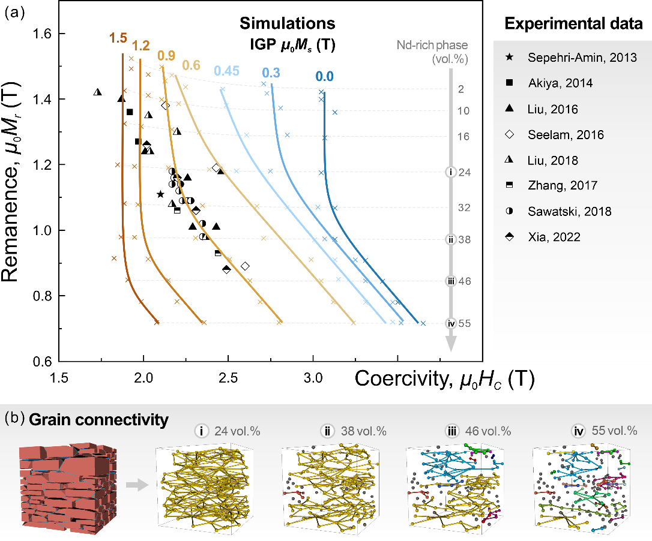
Figure 5. (a) Simulated remanence vs. coercivity of hot-deformed Nd-Fe-B magnets as the content of the Nd-rich nonmagnetic phase increased, imitating grain boundary diffusion by a Nd-based eutectic alloy. Simulations were performed for different magnetizations of the thin IGP. Solid lines are guides for the eye. Dashed lines indicate the volume fraction of the Nd-rich phase (for simulations only). Experimental data are taken from Refs. [10-18]. (b) Graph representation of grain connectivity. Grains are indicated by center-located nodes connected by edges if the corresponding grains have a contact through the thin IGP. Colors encode different clusters of adjacent grains, while isolated grains are gray.
Next, we considered the case of exchange-coupled grains, starting with the highest IGP magnetization of 1.5 T (Fig. 5). The coercivity dropped down to 1.98 T and remained the same up to about 46 vol.% of the Nd-rich nonmagnetic phase, at which the total area of the thin magnetic IGP and its grain coverage were reduced by more than an order of magnitude (see 2–46 vol.% range in Fig. 3b). Apparently, the thin IGP contributed in a local manner by decreasing the nucleation field of some “weak” grains (Supplementary Fig. 3). Even a small amount of such a highly magnetized phase near the grain edges is sufficient to significantly promote nucleation, and thus cascade magnetization reversal. Therefore, a higher content of the Nd-rich nonmagnetic phase is required to overcome the enhanced reversal and initiate an increase in coercivity.
In the aforementioned extreme cases of either strongly exchange-coupled or decoupled grains, the GBDP was inefficient in improving the coercivity in the low-infiltration range (< 30 vol.% of the Nd-rich phase). In this range, the grains were still well-connected, but their coverage by the thin IGP was significantly reduced. However, the situation was different for the intermediate cases when the IGP had moderate magnetization. In particular, the coercivity prominently increased at IGP µ₀M_{s} of 0.45–0.6 T (Fig. 5). Thus, coercivity is sensitive to grain coverage by the IGP when its magnetization takes values at which the nucleation field exhibited the maximum change (Supplementary Fig. 3). This implies that the GBDP is most beneficial for moderate IGP magnetization.
In the high-infiltration range, all M_{r} vs. H_{c} curves showed a linear trend with the same slope as that in the exchange-decoupled case (Fig. 5). Therefore, this increase in coercivity was solely controlled by the magnetostatic interaction. The exchange interaction just defined the intercept by affecting nucleation.
Finally, we compared our simulation results with experimental data from Refs. [10-18]. The M_{r} vs. H_{c} curve at IGP µ₀M_{s} = 0.9 T (A = 2.5 pJ/m) reproduced the experimental data well in the range of 24–46 vol.% of the Nd-rich phase (Fig. 5). This is the first estimation of the magnetization of thin IGP in hot-deformed Nd-Fe-B magnets. All previous studies on IGP magnetization were performed on sintered Nd-Fe-B magnets, yielding values in the range of 0.4–1.1 T [33-37]. Another conclusion is that IGP magnetization/composition in real magnets does not significantly change with the Nd-based GBDP, as assumed in simulations. Otherwise, the M_{r} vs. H_{c} data would show a smaller slope for highly infiltrated magnets. The discrepancies between experimental and simulated coercivities below 24 vol.% of the Nd-rich phase can be attributed to coarse and defective grains commonly present at the flake boundaries and magnet surface. When the GBDP is applied, the Nd-rich nonmagnetic phase first isolates these detrimental defects, which gradually improves the coercivity. Our models were considered as the internal parts of flakes, so such defective grains were not accounted.
In summary, we performed micromagnetic simulations of hot-deformed Nd-Fe-B magnets on models that imitated microstructural transformations after the grain boundary diffusion using a Nd-based eutectic alloy. The series of M_{r} vs. H_{c} trade-off curves were calculated for different magnetizations of the thin IGP. The IGP strongly affects the nucleation of magnetization reversal in the grains, so the infiltration reduces the grain coverage with this phase, suppressing its detrimental role. This is the main mechanism of coercivity enhancement until the Nd-rich nonmagnetic phase approaches the percolation threshold, when the net-like interconnected grains start splitting into clusters (≈ 30 vol.%). However, this mechanism is efficient only if the IGP has a moderate magnetization of 0.4–0.6 T. In real magnets, an additional contribution to coercivity enhancement comes from the magnetic isolation of defective grains at the magnet/flake surface. After the threshold, the linear increase in coercivity is mostly governed by the magnetostatic interaction. These results imply that the most promising way to improve the coercivity of hot-deformed Nd-Fe-B magnets while maintaining a reasonable remanence involves decreasing the IGP magnetization, whose current value was estimated to be 0.9 ± 0.1 T. This work also demonstrated the feasibility of high-remanent (μ₀M_{r} ~ 1.4 T) HREE-free Nd-Fe-B magnets with high coercivity (μ₀H_{c} > 3 T) if the nonmagnetic IGP can be achieved.
ACKNOWLEDGMENTS
This work was supported in part by the MEXT Program: Data Creation and Utilization-Type Material Research and Development Project (Digital Transformation Initiative Center for Magnetic Materials; JPMXP1122715503) and JSPS KAKENHI Grant Number JP23H01674. A. B. acknowledges the International Center for Young Scientists (ICYS) at NIMS for providing the ICYS fellowship.
REFERENCES
[1] K. Hioki, High performance hot-deformed Nd-Fe-B magnets, Sci. Technol. Adv. Mater. 22 (2021) 72–84.
[2] K. Hono, H. Sepehri-Amin, Strategy for high-coercivity Nd-Fe-B magnets, Scripta Mater. 67 (2012) 530–535.
[3] M. Zhao, N. Liu, X. Tang, R. Chen, J. Ju, W. Yin, Y. Du, A. Yan, X. Liu, J. Pan, Z. Xu., Recent progress of grain boundary diffusion process for hot-deformed Nd-Fe-B magnets, J. Rare Earths 41 (2023) 477–488.
[4] J. Li, H. Sepehri-Amin, T. Sasaki, T. Ohkubo, K. Hono, Most frequently asked questions about the coercivity of Nd-Fe-B permanent magnets, Sci. Technol. Adv. Mater. 22 (2021) 386–403.
[5] R.W. Lee, Hot-pressed neodymium-iron-boron magnets, Appl. Phys. Lett. 46 (1985) 790–791.
[6] J. Liu, H. Sepehri-Amin, T. Ohkubo, K. Hioki, A. Hattori, T. Schrefl, K. Hono, Effect of Nd content on the microstructure and coercivity of hot-deformed Nd-Fe-B permanent magnets, Acta Mater. 61 (2013) 5387–5399.
[7] Xin Tang, H. Sepehri-Amin, T. Ohkubo, K. Hioki, A. Hattori, K. Hono, Coercivities of hot-deformed magnets processed from amorphous and nanocrystalline precursors, Acta Mater. 123 (2017) 1–10
[8] Xin Tang, H. Sepehri-Amin, T. Ohkubo, K. Hono, Suppression of non-oriented grains in Nd-Fe-B hot-deformed magnets by Nb doping, Scripta Mater. 147 (2018) 108–113
[9] G.A. Zickler, J. Fidler, J. Bernardi, T. Schrefl, A. Asali, A combined TEM/STEM and micromagnetic study of the anisotropic nature of grain boundaries and coercivity in Nd-Fe-B magnets, Adv. Mater. Sci. Eng. 2017 (2020) 6412042.
[10] H. Sepehri-Amin, T. Ohkubo, S. Nagashima, M. Yano, T. Shoji, A. Kato, T. Schrefl, K. Hono, High-coercivity ultrafine-grained anisotropic Nd-Fe-B magnets processed by hot deformation and the Nd-Cu grain boundary diffusion process, Acta Mater. 61 (2013) 6622–6634.
[11] T. Akiya, J. Liu, H. Sepehri-Amin, T. Ohkubo, K. Hioki, A. Hattori, K. Hono, High-coercivity hot-deformed Nd-Fe-B permanent magnets processed by Nd-Cu eutectic diffusion under expansion constraint, Scripta Mater. 81 (2014) 48–51.
[12] L. Liu, H. Sepehri-Amin, T. Ohkubo, M. Yano, A. Kato, T. Shoji, K. Hono, Coercivity enhancement of hot-deformed Nd-Fe-B magnets by the eutectic grain boundary diffusion process, J. Alloys Compd. 666 (2016) 432–439.
[13] U.M.R. Seelam, L. Liu, T. Akiya, H. Sepehri-Amin, T. Ohkubo, N. Sakuma, M. Yano, A. Kato, K. Hono, Coercivity of the Nd-Fe-B hot-deformed magnets diffusion-processed with low melting temperature glass forming alloys, J. Magn. Magn. Mater. 412 (2016) 234–242.
[14] T. Zhang, F. Chen, Y. Zheng, H. Wen, L. Zhang, L. Zhou, Anisotropic behavior of grain boundary diffusion in hot-deformed Nd-Fe-B magnet, Scripta Mater. 129 (2017) 1–5.
[15] L. Liu, H. Sepehri-Amin, T.T. Sasaki, T. Ohkubo, M. Yano, N. Sakuma, A. Kato, T. Shoji, K. Hono, Coercivity enhancement of Nd-Fe-B hot-deformed magnets by the eutectic grain boundary diffusion process using Nd-Ga-Cu and Nd-Fe-Ga-Cu alloys, AIP Adv. 8 (2018) 056205.
[16] S. Sawatzki, T. Schneider, M. Yi, E. Bruder, S. Ener, M. Schönfeldt, K. Güth, B.-X. Xu, O. Gutfleisch, Anisotropic local hardening in hot-deformed Nd-Fe-B permanent magnets, Acta Mater. 147 (2018) 176–183.
[17] X. Xia, T. Zhang, M. Liu, L. Zhang, R. Chen, X. Tang, J. Ju, W. Yin, A. Yan, Improved (BH)_{max} and squareness in diffusion-processed hot-deformed Nd-Fe-B magnets by self-diffusion process under pressure, J. Alloys Compd. 896 (2022) 163051.
[18] M. Soderžnik, J. Li, L. Liu, H. Sepehri-Amin, T. Ohkubo, N. Sakuma, T. Shoji, A. Kato, T. Schrefl, K. Hono, Magnetization reversal process of anisotropic hot-deformed magnets observed by magneto-optical Kerr effect microscopy, J. Alloys Compd. 771 (2019) 51–59.
[19] X. Tang, J. Li, Y. Miyazaki, H. Sepehri-Amin, T. Ohkubo, T. Schrefl, K. Hono, Relationship between the thermal stability of coercivity and the aspect ratio of grains in Nd-Fe-B magnets: Experimental and numerical approaches, Acta Mater. 183 (2020) 408–417.
[20] J.-G. Yoo, H.-R. Cha, T.-H. Kim, D.-H. Kim, Y.-D. Kim, J.-G. Lee, Coercivity improvement in Nd-Cu infiltrated Nd-Fe-B hot-deformed magnets by controlling microstructure of initial HDDR powders, J. Mater. Res. Technol. 14 (2021) 340–347.
[21] H. Sepehri-Amin, L. Liu, T. Ohkubo, M. Yano, T. Shoji, A. Kato, T. Schrefl, K. Hono, Microstructure and temperature dependent of coercivity of hot-deformed Nd-Fe-B magnets diffusion processed with Pr-Cu alloy, Acta Mater. 99 (2015) 297–306.
[22] Z. Wang, J. Zhang, J. Wang, J. Ju, R. Chen, X. Tang, W. Yin, D. Lee, A. Yan, Coercivity improvement of hot-deformed Nd-Fe-B magnets by stress-induced Pr-Cu eutectic diffusion, Acta Mater. 156 (2018) 136–145.
[23] H. Sepehri-Amin, J. Liu, T. Ohkubo, K. Hioki, A. Hattori, K. Hono, Enhancement of coercivity of hot-deformed Nd-Fe-B anisotropic magnet by low-temperature grain boundary diffusion of Nd₆₀Dy₂₀Cu₂₀ eutectic alloy, Acta Mater. 69 (2013) 647–650.
[24] J. Li, L. Liu, H. Sepehri-Amin, Xin Tang, T. Ohkubo, N. Sakuma, T. Shoji, A. Kato, T. Schrefl, K. Hono, Coercivity and its thermal stability of Nd-Fe-B hot-deformed magnets enhanced by the eutectic grain boundary diffusion process, Acta Mater. 161 (2018) 171–181.
[25] T. Zhang, W. Xing, F. Chen, L. Zhang, R. Yu, Improvement of coercivity and its thermal stability of hot-deformed Nd-Fe-B magnets processed by Tb₇₀Cu₃₀ doping and subsequent Nd₈₅Cu₁₅ diffusion, Acta Mater. 220 (2021) 117296.
[26] R. Quey, P.R. Dawson, F. Barbe, Large-scale 3D random polycrystals for the finite element method: Generation, meshing and remeshing, Comput. Methods Appl. Mech. Eng. 200 (2011) 1729–1745.
[27] A. Bolyachkin, E. Dengina, N. Kulesh, X. Tang, H. Sepehri-Amin, T. Ohkubo, K. Hono, Tomography-based Digital Twin of Nd-Fe-B Permanent Magnets [Preprint, https://doi.org/10.21203/rs.3.rs-3281840/v1].
[28] J. Fischbacher, A. Kovacs, H. Oezelt, T. Schrefl, L. Exl, J. Fidler, D. Suess, N. Sakuma, M. Yano, A. Kato, T. Shoji, A. Manabe, Nonlinear conjugate gradient methods in micromagnetics, AIP Adv. 7 (2017) 045310.
[29] J. Liu, H. Sepehri-Amin, T. Ohkubo, K. Hioki, A. Hattori, T. Schrefl, K. Hono, Grain size dependence of coercivity of hot-deformed Nd-Fe-B anisotropic magnets, Acta Mater. 82 (2015) 336–343.
[30] J. Fischbacher, A. Kovacs, L. Exl, J. Kühnel, E. Mehofer, H. Sepehri-Amin, T. Ohkubo, K. Hono, T. Schrefl, Searching the weakest link: Demagnetizing fields and magnetization reversal in permanent magnets, Scripta Mater. 154 (2018) 253–258.
[31] H. Kronmüller, K.-D. Durst, M. Sagawa, Analysis of the magnetic hardening mechanism in RE-FeB permanent magnets, J. Magn. Magn. Mater. 74 (1988) 291–302.
[32] J. Li, Xin Tang, H. Sepehri-Amin, T. Ohkubo, K. Hioki, A. Hattori, K. Hono, On the temperature-dependent coercivities of anisotropic Nd-Fe-B magnet, Acta Mater. 199 (2020) 288–296.
[33] T. Nakamura, A. Yasui, Y. Kotani, T. Fukagawa, T. Nishiuchi, H. Iwai, T. Akiya, T. Ohkubo, Y. Gohda, K. Hono, S. Hirosawa, Direct observation of ferromagnetism in grain boundary phase of Nd-Fe-B sintered magnet using soft x-ray magnetic circular dichroism, Appl. Phys. Lett. 105 (2014) 202404.
[34] T. Kohashi, K. Motai, T. Nishiuchi, S. Hirosawa, Magnetism in grain-boundary phase of a NdFeB sintered magnet studied by spin-polarized scanning electron microscopy, Appl. Phys. Lett. 104 (2014) 232408.
[35] Y. Murakami, T. Tanigaki, T.T. Sasaki, Y. Takeno, H.S. Park, T. Matsuda, T. Ohkubo, K. Hono, D. Shindo, Magnetism of ultrathin intergranular boundary regions in Nd-Fe-B permanent magnets, Acta Mater. 71 (2014) 370–379.
[36] Y. Cho, T. Sasaki, K. Harada, A. Sato, T. Tamaoka, D. Shindo, T. Ohkubo, K. Hono, Y. Murakami, Magnetic flux density measurements from grain boundary phase in 0.1 at% Ga-doped Nd-Fe-B sintered magnet, Scripta Mater. 178 (2020) 533–538.
[37] Xin Tang, J. Li, H. Sepehri-Amin, A. Bolyachkin, A. Martin-Cid, S. Kobayashi, Y. Kotani, M. Suzuki, A. Terasawa, Y. Gohda, T. Ohkubo, T. Nakamura, K. Hono, Unveiling the origin of the large coercivity in (Nd, Dy)-Fe-B sintered magnets, NPG Asia Mater. 15 (2023) 50.

SUPPLEMENTARY INFORMATION
Micromagnetic Simulations of Hot-deformed Nd-Fe-B Magnets
after Grain Boundary Diffusion Process
Anton Bolyachkin^{1,2}, Ekaterina Dengina^{1,3}, Hossein Sepehri-Amin^{1,3}, and Kazuhiro Hono^{1,3}
¹Research Center for Magnetic and Spintronic Materials, NIMS, Tsukuba 305-0047, Japan
²International Center for Young Scientists, NIMS, Tsukuba 305-0047, Japan
³Graduate School of Science and Technology, University of Tsukuba, Tsukuba, 305-8573, Japan
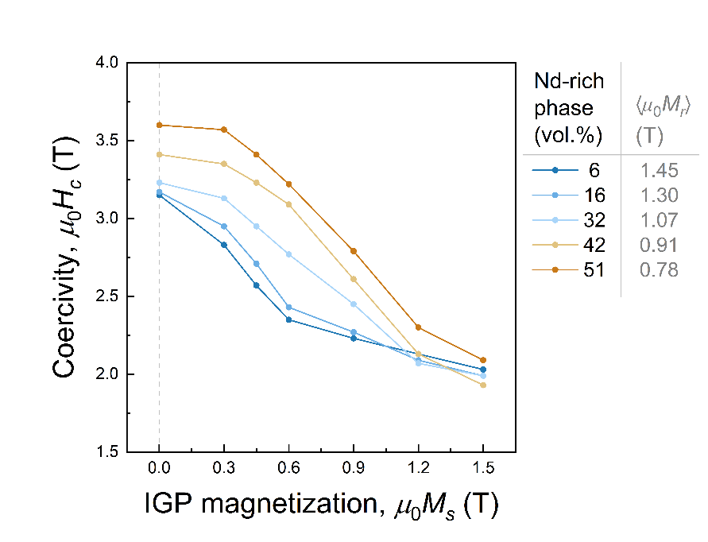
Supplementary Figure 1. Simulated dependencies of coercivity on magnetization of thin intergranular phase (IGP) for hot-deformed Nd-Fe-B magnets subjected to the eutectic grain boundary diffusion process up to different vol.% of the Nd-rich phase. The mean remanences $〈μ_{0}M_{r}〉$ are given for each model. The solid lines are guides for the eye.
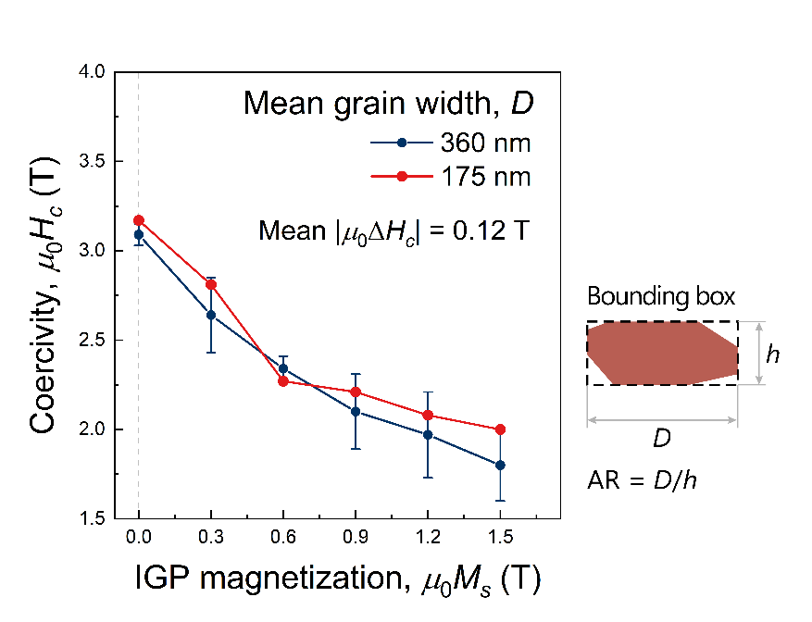
Supplementary Figure 2. Simulated dependencies of coercivity on magnetization of thin IGP for two models of hot-deformed Nd-Fe-B magnets with different grain widths (D) but same aspect ratio (AR). Both models had a similar low vol.% of the Nd-rich phase. The estimated mean coercivity difference was used to correct the simulation results, compensating for the grain size discrepancy between the models and real magnets from Refs. [10-18]. The solid lines are guides for the eye.
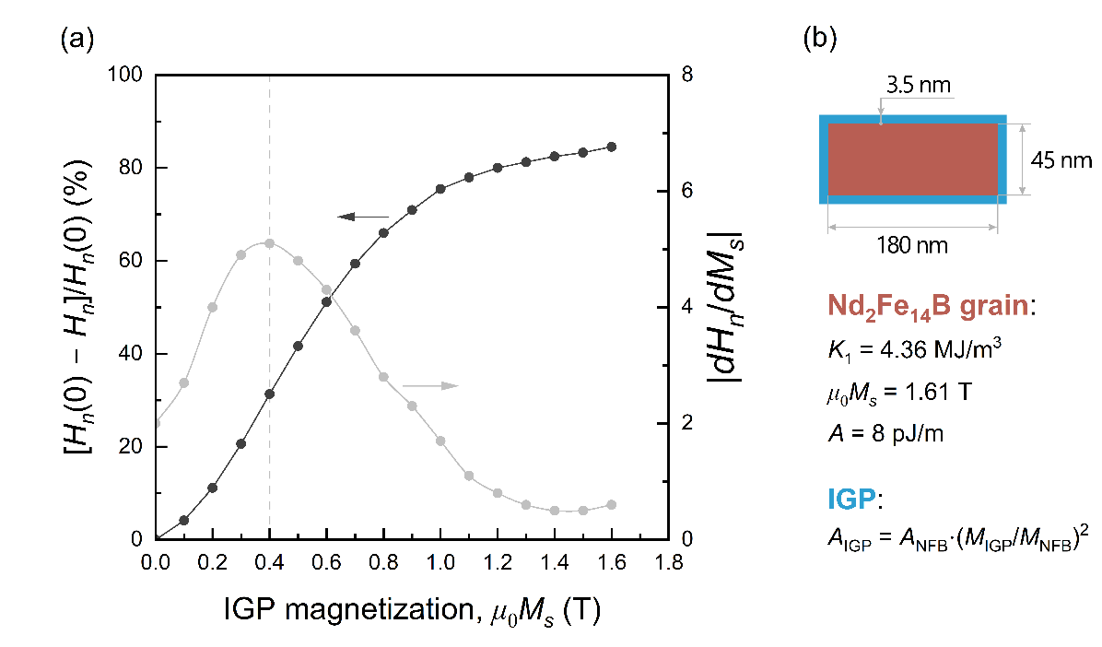
Supplementary Figure 3. (a) Decrease in nucleation field (H_{n}) vs. magnetization of thin IGP simulated for a toy model – an isolated platelet grain fully covered by IGP. (b) Geometry of toy model and used micromagnetic parameters. IGP exchange stiffness was assumed to scale as $A∝M_{s}^{2}$ with respect to that of the Nd₂Fe₁₄B phase.

