Gravimetric Analysis of Lithium-Air Batteries during Discharge/Charge Cycles
Akihiro Nomura*, Kimihiko Ito, Denis Y. W. Yu, and Yoshimi Kubo
Center for Green Research on Energy and Environmental Materials (GREEN),
National Institute for Materials Science, 1-1 Namiki, Tsukuba 305-0044, Japan
* Correspondence and requests for materials should be addressed to NOMURA.Akihiro@nims.go.jp

Abstract
Because the mass of lithium-air battery (LAB) changes due to oxygen reduction/evolution reactions (ORR/OER), weighing of the battery is an indispensable method for determining its actual energy density and analyzing the battery reactions. To this end, we have newly developed a weight monitoring system which can trace the semi-permanent weight change of air-batteries (~11 g including a holder) with a precision of 7.87 μg. The system reveals the weight decrease of LAB in each cycle before finally losing its capacity. The in-situ weighing during battery operation also provides first-hand evidence of double layer capacitance and electrolyte evaporation of LABs. Specifically, the e⁻/O₂ ratio during discharge is determined to be 1.954 ± 0.004 based on the weight increase of an LAB cell using tetraethylene glycol-based electrolyte at a current density of 100 μA cm⁻², confirming the slightly lower e⁻/O₂ ratio than the ideal two electron ORR. During charge, the initial weight decrease is 5.4% less than the 2e⁻/O₂ OER process, and the weight decreases sharply at the end of charge due to CO₂ evolution. The main rates of weight increase/decrease remain the same throughout the cycle life, but side reactions are accelerated with cycling, causing the deterioration of LABs.

Keywords
Lithium-air battery
Battery weight change
Oxygen reduction reaction
Oxygen evolution reaction
Electrolyte evaporation
Double layer capacity

Introduction
Lithium-air batteries (LABs) are expected to be the next-generation storage device with ultra-high energy density of 5-10 times higher than that of current lithium-ion batteries (LiBs) by using the Li-O₂ reaction with theoretical energy density of ~3,500 Wh kg⁻¹ [1]. LABs “inhale” oxygen during discharge with an oxygen reduction reaction (ORR), specifically, 2Li⁺ + 2e⁻ + O₂ → Li₂O₂. The oxygen is then “exhaled” from the cell on charging through the reversed oxygen evolution reaction (OER). As a results, the weight of LAB changes along with discharge and charge, with a theoretical electron-to-oxygen molar ratio of 2 (e⁻/O₂ = 2). While the gravimetric energy density of LAB depends on the weight of the cell, the actual change of cell mass during discharge and charge has rarely been measured. This is because in most studies, the LAB cells were only tested in a laboratory, where the cell weight change and actual energy density are not of research interest.
In the past few years, however, the use of light-weight battery materials has propelled the development of large-capacity LABs with a high energy density exceeding 500 Wh kg⁻¹ [2-4]. For example, thin carbon nanotube (CNT) sheet cathodes enable LABs with a discharge capacity of as high as 30 mAh cm⁻², which is more than 10 times higher than that of current LiBs [5, 6]. Lee et al. reported an LAB cell with an ultra-high specific energy density of 1,214 Wh kg⁻¹, in which a double-sided porous carbon cathode coated on a gas-diffusion layer (GDL) was surrounded by a folded Li foil anode [2]. In addition, Zhao et al. demonstrated a large capacity pouch-type LAB of 8.7 Ah with an energy density of 768 Wh kg⁻¹ [4]. At the same time, rate capability of LABs has also been improved with the incorporation of ORR/OER catalysts into the cathode [7-10], but this in turn compromise the actual energy/power densities of the cells by increasing the cathode weight. Instead, there is more evidence that oxygen permeation of the air-inhaling cathode (or air-electrode) has more effect on the rate performance of LABs [11-16]. Highly porous cathode with micrometer scale pores was demonstrated to attain homogenous cathode reaction throughout the cathode, enabling discharge current comparable to ~1C rate of existing LiBs [16]. Because the cell mass of these light-weight and large-capacity LABs varies significantly during battery operation, in-situ observation of the weight change can give better understanding of the battery reactions occurring in the cells.
In this study, a novel periodic zero-correction weight monitoring system was developed, which enables long-term monitoring of a LAB during discharge and charge with a precision of 7.67 μg. Since the system can automatically weigh the cell while keeping the same precision, it allows continuous study of the reactions in the battery for over a few weeks, which is not possible using common techniques of measuring O₂ consumption, such as differential electrochemical mass spectroscopy (DEMS), in which the measurement time is typically limited to ~10 h or less due to unreliable quantification of gas mass [17-20]. Our weighing system is synchronized with the battery tester and can record the cell weight change profile during discharge/charge, which provides clear evidence of discharge by electric double layer (DL) capacitance before ORR. The system also enables the measurement of electrolyte solvent evaporation from the open perforated holes in the LABs by detecting the small weight decrease while the cell is in the rest state. In addition, e⁻/O₂ ratio during ORR and OER can also be determined with high precision by studying the change in weight increase/decrease during the test while knowing the applied current.
The measurement system is then used to monitor the weight change of a LAB coin cell under oxygen environment using a tetraethylene glycol-based electrolyte at a current density of 100 μA cm⁻². During ORR and OER, the e⁻/O₂ ratio is determined to be 1.954 ± 0.004 and 2.107 ± 0.007, respectively, confirming the almost ideal 2e⁻/O₂ reactions but also inferring the presence of small amount of side reactions. The main weight changes from ORR and OER remain the same throughout the cycle life of the cell, though, weight loss which is attributed to electrolyte decomposition and CO₂ evolution at the end of charge became prominent with cycling, before the cell finally loses its capacity. The weight change of a stacked cell was also measured in this work. The gravimetric measurement of air-battery cells is a powerful technique for monitoring the battery reactions during the whole cycle life and gives important insights for developing long-life LABs.
Methods
Cell assembly. Batteries were assembled in a CR2032 coin cell with perforated stainless-steel cases (Hohsen Corp.) in a dry room with a supply-air dew point of <-90 ºC (< 0.1 ppm of H₂O) and an environmental dew point of approximately -60 to -50 ºC. The cell is comprised of layers of Li metal foil anode (φ16 mm, 2 cm² electrode area, 200 μm thick, Honjo Metal), glass microfiber filter separator (GF/A, Whatman®), porous carbon nanotube (CNT) sheet cathode (ZEONANO SG101®, 130 μm thick, 2.1 mg cm⁻²), and gas diffusion layer (GDL, 110 μm thick, TGP-H-030, Toray) facing the perforated side of the cell. An ether-based electrolyte, composed of 1 M lithium bis(trifluoromethanesulfonyl)imide (LiTFSI, Kishida Chemical Co., Ltd.) dissolved in anhydrous tetraethylene glycol dimethyl ether (tetraglyme, TEGDME, <10 ppm H₂O, Japan Advanced Chemicals) was prepared in an Ar-filled glovebox, and about 32-100 μl of it is added to the separator and cathode before the battery testing. Dummy cell with a stainless steel plate was also prepared with just the CNT sheet cathode and GDL in a CR2032 cell case to evaluate the electrolyte solvent evaporation rate. Li foil was not used as the anode in the evaporation tests so as to eliminate the possibility of hydrogen gas evolution by the reduction of the electrolyte or any impurities by the lithium metal.
Battery testing with gravimetric measurement. The galvanostatic discharge and charge profiles were recorded under pure oxygen environment using a battery discharge-charge machine (ECAD-1000, EC Frontier) with discharge and charge cutoff voltages of 2.0 V and 4.5 V, respectively. The actual applied currents at each current setting were calibrated by observing voltage drops between a shunt resistor (250 Ω ± 0.1%) using a voltage logger (midi LOGGER GL240, Graphtech Corp.) to remove the effect of leakage current of the battery tester, and the values are tabulated in Table S1. Along with the battery testing, cells were periodically weighed using a home-made high-precision weight measurement system equipped with a high precision weigh module (1 μg minimum readability, 21 g max load capacity, AD-4212B-23, A&D Co., Ltd.), in which the balance automatically weighs an air-battery cell while performing zero correction each time (as shown in Figure 1a and S1). Specifically, the system repeats the following steps once every minute to obtain a sequential weight signal: putting the cell under battery testing on the weighing pan; recording the cell weight, lifting up the cell from the pan, performing tare. The ambient temperature was also simultaneously recorded by a thermocouple logger in conjunction with the weighing in order to perform weighing value correction as discussed below, but briefly, by subtracting the weight difference caused by temperature sensitivity drift. The cell was wired through thin Au bonding wires (Nilaco Corp, φ30 μm) to the battery discharge-charge machine. The whole system is installed in an air-tight chamber (inner capacity of 5 L) with pure oxygen flow of 150 ml min⁻¹. Apart from the weighing, online differential electrochemical mass spectrometry (DEMS) measurement was performed for an LAB coin cell using a quadrupole mass spectrometer (JMS-Q1500, JEOL) with flowing He as the carrier gas to monitor the gas evolution during charge.

Result & Discussion
Gravimetric analysis of LAB coin cells
A stable and precise weight monitoring system is imperative for long-term gravimetric analysis of air-batteries. Figure 1 illustrates the home-made automated weighing system developed in this study (the photographs of the system is shown in Figure S1). The system repeatedly weighs the cell holder dish (~11 g) by a high precision electronic balance with zero correction each time to monitor the weight change of a battery cell mounted on the holder. The LAB coin cell with a total weigh of about 3 g includes ~100 mg of battery materials consisting of Li foil anode, CNT cathode, and electrolyte, and its weight change is typically less than 10 mg during the battery testing. Figure 2(top) shows the raw weight signal W_{raw} profile of the cell holder dish loaded with a blank coin cell case (total weight of 10,847 mg). Although the zero correction after each measurement ensures the weighing of the cell with the same precision as that of the balance used, the profile revealed that the W_{raw} is highly perturbed during the 150 h measurement time, with a standard deviation (SD) of 21 μg. This is due to the temperature sensitivity of the system, as the W_{raw} value is correlated with the recorded temperature (T profile, Figure 2(middle)). Since the measured weight is directly proportional to the ambient temperature, the weight of the cell can be calibrated with W = W_{raw} - (T – 25) × A, where W is the calibrated weight and A is a fixed coefficient for the temperature sensitivity of the system. Based on the raw data, the constant A is determined to be 0.03523 mg ºC⁻¹ for the system from the linear fitting of W_{raw} –W_{raw,ave} against (T – 25) (Figure S2), where W_{raw,ave} is the averaged value of W_{raw} for the 150 h weighing. Figure 2(bottom) shows the temperature-adjusted weight change profile ΔW (= W-W₀) of the blank cell, where W₀ is initial value of W, giving a flat profile with no weight change and a SD of 7.87 μg. The error bar of the measured weight is slightly larger than that of the balance based on the catalog (SD of 4 μg), which is attributed to the variation of the atmospheric pressure and/or the microscopic fluctuation derived from the thin leading wires. Nonetheless, the sufficiently flat ΔW profile demonstrates the reliability of the system for long-term weight monitoring, which can be used to track a few mg weight change of LAB cells.
For the experiments, 7 different LAB coin cells were mounted on the holder and discharged/charged with different conditions (Cells 1 to 7) as tabulated in Table 1. Figure 3 shows the ΔW, the time derivative of ΔW (dΔW/dt), and the voltage profiles of Cell 1 for the whole cycle life over 500 h, which was discharged and charged for 50 h at a current setting of 200 μA (current density of 100 μA cm⁻²) with 1 h rest in between steps, repeated three times before the cell reaching a cutoff voltage of 2.0 V during the 4th discharge. The ΔW profile is in accordance with battery operation, where an increase in cell weight is observed during discharge while it decreases during charge. The weight increase/decrease are resulted from oxygen reduction and evolution reactions, and the dΔW/dt profile shown in Figure 3(middle) reveals that the main weight increase/decrease rates during the discharge/charge are always constant, close to the red dotted lines representing a 2e⁻/O₂ process. After the 4th discharge-charge cycles, the cycle capacity decayed rapidly, and in the end, the cell lost up to ~8 mg of its weight which corresponds to about 25 wt% of its initial amount of the electrolyte. The main mass loss comes from the high weight decrease rates near the end of each charging process. In addition, the weight change profile can tell us more details about the processes occurring inside the battery, as discussed below.
Firstly, the weight change profile is synchronous to the battery reactions, which tells the response of the battery for each battery operation. Figure 4a shows the enlarged ΔW profiles of Cell 1 during the initial discharge process (between 0 and 0.5 h) and slightly before and after the rest process (between 49.5 and 51.5 h). The profile at the 49.5 - 51.5 h reveals that the weight change is highly synchronous with the charge-discharge processes, e.g. the weight increase stops when the discharge process ends (at 50 h) and the weight decrease starts when the charge process is initiated (at 51 h). Interestingly, during initial discharge (at 0 h), the weight change is delayed for about 0.25 h after the current is applied. That is, when discharge begins, the voltage of LAB is monotonically reduced by the accumulation of electrons on the cathode surface without weight change until ORR starts at 2.6~2.7 V. This is attributed to the double layer (DL) capacitance of the porous CNT sheet cathode. The capacitance for the test cell was calculated as 0.16 F, or 40 F/g per the CNT cathode weight, from the linear fitting of the voltage decay. LABs can discharge/charge by the capacitance of carbon cathodes, and the value of the capacitance has been reported to be proportional to the BET surface area of the cathode used [16]. In this case, the measured capacitance value for Cell1 (40 F/g) is close to the reported value, which supports that DL capacitance proceeds without oxygen reduction. To the best of our knowledge, this is the first report of DL capacitance directly detected in LABs. Note that the capacitance is only observed during the initial discharge, not during the initial charge (at 51 h), which is probably due to a significant reduction of the surface area of the cathode after Li₂O₂ deposition.
Besides, the weighing system can be used to determine the rate of electrolyte evaporation, which is a practical issue LABs face. The LAB coin cells in this study experience a small weight decrease even in the rest state, and the decrease rate is determined to be -5.72 ± 0.16 μg h⁻¹ for Cell 1 before the first discharge from the linear fitting of the ΔW profile (Figure 4b). This is due to the evaporation of the TEGDME electrolyte from the open perforated holes on a cathode case for air intake, which can be confirmed from the comparable weight loss of the Dummy Cell 1 (-5.64 μg h⁻¹, Figure S3) that has the same configuration and electrolyte as Cell 1 but without the Li metal anode. Actually, the evaporation rates, r_{evap}, somewhat vary in the range of 4.5-7.0 μg h⁻¹ even for the coin cells having the same amount of electrolyte (32 μL), and the rate tends to be higher with larger amount of electrolyte (Figure S4). This is probably due to a variation of electrolyte distribution inside the coin cell. We suspect that some of the electrolyte may have leached into the GDL with larger amount of electrolyte, thus increasing rate of electrolyte evaporation. The rate is also affected by the presence of salt. A cell with pure TEGDME solvent without LiTFSI salt (Dummy Cell 2) shows an evaporation rate of -8.50 μg h⁻¹ (Figure S3), higher than that with salt. Solvent evaporation is suppressed due to the decrease in vapor pressure by the dissolved LiTFSI salt following Raoult’s law. After long-term cycling of Cell 1 for over 480 h, the evaporation rate is reduced to -4.39 μg h⁻¹, which is attributed to the increase in salt concentration of the electrolyte after multiple discharge/charge cycles. Since LAB is a semi-open system where the electrolyte can evaporate during operation, the weighing system can be a useful tool for evaluating the rate of electrolyte evaporation in LAB under actual working conditions.
Further analysis of the weight change was conducted to elaborate the battery reactions during the discharge-charge operation. Figure 5 shows the enlarged dΔW/dt profile for the first discharge and charge cycle for Cell 1, where the electrolyte solvent evaporation rate, r_{evap} (= -5.72 μg h⁻¹), was deducted from the data to show the actual weight increase/decrease rates corresponding to oxygen reduction/evolution, assuming that the evaporation rate was constant during the cycle. The resulting profile reveals that the weight increase rate by ORR was slightly higher than the red dotted line of 2e⁻/O₂ process. The e⁻/O₂ ratio of the reaction can be calculated by dividing the applied current (i) by the rate of weight change (r) as obtained from the linear fitting of ΔW with time, specifically, (3.6 × i × M_{O2}) / (F × (r - r_{evap}) × 10³), where F is the Faraday constant (96485 C mol⁻¹) and M_{O2} is the molecular weight of O₂ (32.00 g mol⁻¹). For example, during first discharge for Cell 1, i =199.88 ± 0.28 μA (Table S1) and r = +116.38 ± 0.02 μg h⁻¹, giving an e⁻/O₂ ratio of 1.954 ± 0.004 when the applied current setting was 100 μA cm⁻². The precision of the measured e⁻/O₂ value for single measurement is the highest ever recorded so far, at least one order of magnitude higher than that determined by differential electrochemical mass spectroscopy (DEMS) technique from measuring oxygen consumption [17].
LAB cells (Cells 2 to 7) were further tested under different conditions (electrolyte amount, applied current and capacity limitation) and the corresponding data and ΔW profiles are shown in Figure S5. The e⁻/O₂ values of all coin cells were determined using the procedure above and were listed in Table 1. The data indicates that the e⁻/O₂ ratio is lower when the cell is tested at a lower discharge rate and asymptotically increase to a value of 2 (ideal) when the discharge rate is increased (Figure S6). Note that even though the e⁻/O₂ values can be determined precisely for each cell, a larger variation of about ±0.02 for the e⁻/O₂ ratio is observed across measurements, probably due to the uneven quality of each coin cell, such as electrolyte distribution and/or electrode materials loading in the cells, which causes non-uniformity in their battery reactions. The lower e⁻/O₂ value than the ideal 2 during discharge suggests there are other one-electron-based side reactions occurring alongside the main 2e⁻/O₂ reduction. For example, some researchers have reported the evidence of one-electron-reduction product of LiO₂ (Li⁺ + e⁻ + O₂ → LiO₂) in LAB [21-23]. The partial evolution of LiO₂ along with Li₂O₂ as discharge products can result in the e⁻/O₂ value less than 2. In addition, one-electron intermediate (O₂⁻) can cause hydrogen abstraction to decompose the glyme-based solvent [20, 24]. H₂O, CO₂, lithium formate, and lithium acetate are finally generated as by-products of the electrolyte decomposition through a four-electron reduction process. However, the e⁻/O₂ values slightly less than 2 observed here indicate that the four-electron process is negligible at least during discharge state.
Meanwhile, the weight decrease rate during charge is considerably lower than that during discharge. For Cell 1, the weight decrease rate during the first 7.5 h charging process (data from 0-15% of charging was selected to ensure that the weight loss is purely from O₂ evolution, as discussed below) is -119.14 ± 0.28 μg h⁻¹, which gives an e⁻/O₂ value of 2.107 ± 0.007. This corresponds to 5.4% less O₂ evolution than the ideal 2e⁻/O₂ process, which is opposite to the slightly larger amount of O₂ absorbed by the battery during the discharge process immediately before. The less O₂ evolution suggests that there are side reactions other than OER occurring in the battery right after the start of charging. After 30 h, a faster drop in weight is observed when the charge voltage is above 4.2 V due to the evolution of gasses other than O₂. To further quantify which gas (e.g. O₂, H₂O, CO₂, and CO) is evolved, the exhaust gas of the cell that is discharged/charged at 800 μA current setting (400 μA cm⁻² current density, the same condition with Cell 2) was connected to a DEMS, and the gas evolution profiles along with the dΔW/dt profile are shown in Figure 6. The total mass of the evolved gas correlates well with the dΔW/dt profile. The DEMS profiles reveal that pure O₂ was evolved only at the beginning of charge. After 1.5 h (15% of charging), small amounts of H₂O and CO are observed while the amount of O₂ evolution is slightly reduced, possibly due to the decomposition of the TEGDME electrolyte, as it is the only source of hydrogen in the system. Starting from 6 h (60% of charging), CO₂ evolution starts to dominant until around 10 h due to electrochemical decomposition of the electrolyte, leading to a significant weight decrease at the end of charge. These results indicate that the gravimetric system is able to continuously monitor the weight change of an air-battery for a long period of time, giving valuable information about battery reactions and other phenomena throughout its cycle life.

Gravimetric analysis of a 330 Wh kg⁻¹ LAB stacked cell
Apart from coin cells, the weight change of stacked cells can also be measured by the new weight measurement system. The gravimetric analysis of an LAB, comprised of a single stack of Li foil anode and CNT sheet cathode with a 2 × 2 cm² square dimension sandwiched by two glass plates held together by Cu tapes (the schematic configuration is shown in Figure 7a) was conducted. This configuration is tested because it is the basic unit of a multi-layered LAB module [25]. The cell “inhales” and “exhales” O₂ through the side of the gas diffusion layer (GDL) placed above the cathode, as there is no oxygen path from the face of the cell. LiNO₃ and LiBr as redox mediators (RMs) were added to the electrolyte to suppress Li dendrite formation and reduce charge overpotential [19, 26]. The weight of the cell unit was 126.1 mg excluding the two current collector plates, giving a specific energy density of 330 Wh kg⁻¹ at a fixed cycle capacity of 16 mAh and 2.6 V average discharge voltage. The weight decrease rate during the rest state before the battery testing was -6.51 μg h⁻¹, corresponding to the evaporation rate of the electrolyte. This evaporation rate is similar to those of the coin cells (Cell 1-7) despite that the effective electrode area of the stacked cell is doubled (4 cm²), implying that electrolyte evaporation is more affected by the ventilation pathway of the cells instead of electrode area.
To condition the stacked cell, it was discharged and charged with a small capacity of 0.27 mAh (1600 μA × 10 min) for 3 times before starting the 16 mAh (1600 μA × 10 h) discharge/charge cycles. Figure 7b shows the ΔW profile during the conditioning process. The first conditioning discharge increased the cell weight by 120 μg, corresponding to a capacity of 0.20 mAh assuming a 2e⁻/O₂ ORR reaction. As the total applied capacity is 0.27 mAh, the extra 0.07 mAh discharge most likely comes from DL capacitance of the CNT cathode sheet, which agrees well with the 40 F g⁻¹ capacitance as discussed above. However, no noticeable weight decrease was observed during the first conditioning charge of the stacked cell, which is different from that observed in the LAB coin cells (Cell 1-7). Giving that the small discharge reaction immediately before the charging probably did not affect the surface area of the CNT cathode, we expect 0.15 mAh out of the total 0.27 mAh recorded during charging comes from the DL capacitance considering each voltage step (from 3.00 V to 2.66 V for the first conditioning discharge, and from 2.84 V to 3.58 V for the first conditioning charge). The remaining 0.12 mAh comes from the oxidation of the Br⁻ RM near 3.5 V to Br₃⁻ (3Br⁻ → Br₃⁻ + 2e⁻). Br₃⁻ chemically oxidizes the Li₂O₂ discharge product getting itself back to Br⁻, which is the normal function of RM of Br⁻, enabling the Li₂O₂ decomposition without increasing charging voltage [27]. However, the produced Br₃⁻ can be diffused to the lithium metal anode to be reduced without inducing Li₂O₂ oxidation (shuttle effect), resulting in the no weight decrease even while in charging [19, 28, 29]. In addition, a previous report suggests that a part of Br₃⁻ could be accumulated inside the cell without Li₂O₂ oxidation, which also explains the no weight decrease during the charging [30]. The accumulated Br₃⁻ is reduced to Br⁻ in the subsequent discharge, which results in the short voltage shoulders of ~0.05 mAh near 3.3~3.4 V found in the 2nd and 3rd conditioning discharge. Because the cell shows a capacity of 0.15 mAh from DL capacitance during the 2nd conditioning, ORR is only proceeded with ~0.07 mAh during the 2nd and 3rd conditioning discharge, which resulted in ~40 μg cell weight increase in the 2nd and 3rd discharge.
After conditioning, the stacked cell was discharged and charged with a capacity limitation of 16 mAh, and the ΔW and dΔW/dt profiles are shown in Figure 7c. A weight increase of 9.6 mg was recorded during the 1st discharge, so the actual energy density of the battery is decreased from 330 Wh kg⁻¹ to 300 Wh kg⁻¹ with the reduced oxygen. The cell could be cycled for 5 times before its voltage reached the cut off value of 2.0 V at the 6th discharge. During the normal operation, the weight increase and decrease during discharge/charge correspond to e⁻/O₂ ratios of nearly 2 (specifically, 1.984 ± 0.007 during discharge and 2.133 ± 0.008 during the beginning of charge), which indicates that the stacked battery also undergoes the same reactions as the coin cells. Figure 7d shows the enlarged dΔW/dt profiles for the 1st, 3rd and 5th discharge/charge cycles, and the profiles reveal the evolution of side reactions irrelevant to the 2e⁻/O₂ ORR/OER. In particular, with cycling, the amount of weight decrease becomes smaller in the middle of the charging process, most likely due to shuttling of the RM. There is more and more weight loss due to CO₂ evolution near the end of charge upon cycling, indicating the acceleration of oxidative decomposition of the electrolyte and/or the cathode. In addition, the initial weight gain at the start of each discharge process is smaller than that corresponding to ORR, which indicates that there are more and more side products accumulated during the preceding charge process which are reduced here without generating Li₂O₂. These side reactions not related to the ideal 2e⁻/O₂ process cause continuous weight loss from the LAB every cycle, accelerating the deterioration of the battery. This result suggests that electrochemically stable and oxidative resistant battery materials and electrolyte are needed to improve the cycle performance of LABs, and the weight monitoring system constructed in this work will be an indispensable tool for future development of LABs.

Conclusions
A novel automatic weight monitoring system was developed in this work that can allow long-term monitoring of weight change of air-batteries with a standard deviation as low as 7.67 μg. The system was used to investigate battery reactions in LAB cells under battery testing during their entire cycle life. Because of the high precision of the system, it is able to monitor various processes in the battery such as electrolyte evaporation, double-layer capacitance and also detect small deviations in the battery reactions from the theoretical 2 e⁻/O₂ ORR/OER. In particular, there are side reactions that cause larger weight increase during discharge and smaller weight decrease during charge. In addition, a large weight loss is observed at the end of charge. Gas analysis indicates that this is due to CO₂ evolution from the cell, most likely due to electrolyte decomposition at a high applied voltage. Continuous loss of electrolyte and the accelerated side reactions are primary reasons for the degradation of the LAB with cycling. The new gravimetric analysis system will be a useful tool for future development of LABs.

CRediT authorship contribution statement
Akihiro Nomura: Conceptualization, Methodology, Validation, Investigation, Data curation, Writing – original draft, Writing – review & editing. Kimihiko Ito: Conceptualization, Data curation, Resources. Denis Y. W. Yu: Writing – review & editing. Yoshimi Kubo: Writing – review & editing, Supervision.

Declaration of competing interest
The authors declare that they have no known competing financial interests or personal relationships that could have appeared to influence the work reported in this paper.

Acknowledgements
This work was partially supported by JST ALCA-SPRING Grant Number JPMJAL1301, Japan. The authors are grateful to Battery Research Platform, National Institute for Materials Science (NIMS) for experimental facilities. The authors thank Emiko Mizuki for providing coin cells and Shin Kimura for providing the stack cell.

Appendix A. Supplementary data
Supplementary data to this article can be found online at https://

References
- W.J. Kwak, Rosy, D. Sharon, C. Xia, H. Kim, L.R. Johnson, P.G. Bruce, L.F. Nazar, Y.K. Sun, A.A. Frimer, M. Noked, S.A. Freunberger, D. Aurbach, Lithium-Oxygen Batteries and Related Systems: Potential, Status, and Future, Chem. Rev., 120 (2020) 6626-6683. https://doi.org/10.1021/acs.chemrev.9b00609.
- H.C. Lee, J.O. Park, M. Kim, H.J. Kwon, J.H. Kim, K.H. Choi, K. Kim, D. Im, High Energy Density LiO₂ Battery at Cell Scale with Folded Cell Structure, Joule, 3 (2019) 542-556. https://doi.org/10.1016/j.joule.2018.11.016.
- J.O. Park, M. Kim, J.H. Kim, K.H. Choi, H.C. Lee, W. Choi, S.B. Ma, D. Im, A 1000 Wh kg⁻¹ Li-Air battery: Cell design and performance, J. Power Sources, 419 (2019) 112-118. https://doi.org/10.1016/j.jpowsour.2019.02.057.
- S.Q. Zhao, L. Zhang, G.N. Zhang, H.B. Sun, J.Y. Yang, S.G. Lu, Failure analysis of pouch-type LiO₂ batteries with superior energy density, Journal of Energy Chemistry, 45 (2020) 74-82. https://doi.org/10.1016/j.jechem.2019.09.029.
- A. Nomura, K. Ito, Y. Kubo, CNT Sheet Air Electrode for the Development of Ultra-High Cell Capacity in Lithium-Air Batteries, Scientific reports, 7 (2017) 45596. https://doi.org/10.1038/srep45596.
- S.H. Park, Y.J. Cheon, Y.J. Lee, K.H. Shin, Y.Y. Hwang, Y.S. Jeong, Maximal Utilization of a High-Loading Cathode in LiO₂ Batteries: A Double Oxygen Supply System, ACS Appl. Mater. Interfaces, 11 (2019) 30872-30879. https://doi.org/10.1021/acsami.9b08970.
- [7] E. Yilmaz, C. Yogi, K. Yamanaka, T. Ohta, H.R. Byon, Promoting Formation of Noncrystalline Li₂O₂ in the LiO₂ Battery with RuO₂ Nanoparticles, Nano Lett., 13 (2013) 4679-4684. https://doi.org/10.1021/nl4020952.
- J.J. Xu, Z.L. Wang, D. Xu, F.Z. Meng, X.B. Zhang, 3D ordered macroporous LaFeO₃ as efficient electrocatalyst for LiO₂ batteries with enhanced rate capability and cyclic performance, Energy Environ. Sci., 7 (2014) 2213-2219. https://doi.org/10.1039/c3ee42934b.
- X. Xin, K. Ito, Y. Kubo, Electrochemical behavior of Ru nanoparticles as catalysts in aprotic LiO₂ batteries, Electrochim. Acta, 261 (2018) 323-329. https://doi.org/10.1016/j.electacta.2017.12.148.
- K.D. Cai, C.X. Dong, X.S. Lang, L. Li, Q.G. Zhang, Study on leaf-shaped cobalt-based metal-organic frameworks synthesized by solvothermal method as high discharge current density air cathode catalyst for lithium-oxygen batteries, Ionics, 26 (2020) 2673-2680. https://doi.org/10.1007/s11581-020-03501-z.
- A. Dutta, K. Ito, Y. Kubo, Establishing the criteria and strategies to achieve high power during discharge of a Li-air battery, J. Mater. Chem. A, 7 (2019) 23199-23207. https://doi.org/10.1039/c9ta07427a.
- S. Fujimoto, S. Uemura, N. Imanishi, S. Hirai, Oxygen concentration measurement in the porous cathode of a lithium-air battery using a fine optical fiber sensor, Mechanical Engineering Letters, 5 (2019) 19-00095-00019-00095. https://doi.org/10.1299/mel.19-00095.
- K. Ushijima, S. Iwamura, S.R. Mukai, Simple and Cost-Effective Method to Increase the Capacity of Carbon Nanotube Sheet Cathodes for Lithium-Air Batteries, ACS Appl. Energ. Mater., 3 (2020) 6915-6921. https://doi.org/10.1021/acsaem.0c00991.
- J. Li, F.Z. Yan, Z.P. Su, T.Y. Zhang, X.C. Zhang, H. Sun, Highly Efficient Li-Air Battery Using Linear Porosity Air Electrodes, J. Electrochem. Soc., 167 (2020). https://doi.org/10.1149/1945-7111/ab8b98.
- K. Hayat, L.F. Vega, A. AlHajaj, Modeling of Hierarchical Cathodes for Li-Air Batteries with Improved Discharge Capacity, J. Electrochem. Soc., 168 (2021). https://doi.org/10.1149/1945-7111/ac42ef.
- A. Nomura, E. Mizuki, K. Ito, Y. Kubo, T. Yamagishi, M. Uejima, Highly-porous Super-Growth carbon nanotube sheet cathode develops high-power Lithium-Air Batteries, Electrochim. Acta, 400 (2021). https://doi.org/10.1016/j.electacta.2021.139415.
- B.D. McCloskey, D.S. Bethune, R.M. Shelby, T. Mori, R. Scheffler, A. Speidel, M. Sherwood, A.C. Luntz, Limitations in Rechargeability of LiO₂ Batteries and Possible Origins, Journal of Physical Chemistry Letters, 3 (2012) 3043-3047. https://doi.org/10.1021/jz301359t.
- S. Das, J. Hojberg, K.B. Knudsen, R. Younesi, P. Johansson, P. Norby, T. Vegge, Instability of Ionic Liquid-Based Electrolytes in LiO₂ Batteries, J. Phys. Chem. C, 119 (2015) 18084-18090. https://doi.org/10.1021/acs.jpcc.5b04950.
- X. Xin, K. Ito, Y. Kubo, Highly Efficient Br⁻/NO₃⁻ Dual-Anion Electrolyte for Suppressing Charging Instabilities of LiO₂ Batteries, ACS Appl Mater Interfaces, 9 (2017) 25976-25984. https://doi.org/10.1021/acsami.7b05692.
- M. Ue, H. Asahina, S. Matsuda, K. Uosaki, Material balance in the O-2 electrode of LiO₂ cells with a porous carbon electrode and TEGDME-based electrolytes, Rsc Advances, 10 (2020) 42971-42982. https://doi.org/10.1039/d0ra07924c.
- U. Das, K.C. Lau, P.C. Redfern, L.A. Curtiss, Structure and Stability of Lithium Superoxide Clusters and Relevance to LiO₂ Batteries, Journal of Physical Chemistry Letters, 5 (2014) 813-819. https://doi.org/10.1021/jz500084e.
- J. Lu, Y.J. Lee, X.Y. Luo, K.C. Lau, M. Asadi, H.H. Wang, S. Brombosz, J.G. Wen, D.Y. Zhai, Z.H. Chen, D.J. Miller, Y.S. Jeong, J.B. Park, Z.Z. Fang, B. Kumar, A. Salehi-Khojin, Y.K. Sun, L.A. Curtiss, K. Amine, A lithium-oxygen battery based on lithium superoxide, Nature, 529 (2016) 377. https://doi.org/10.1038/nature16484.
- L.B. Chen, J. Yang, Z.X. Lu, P. Dai, X.H. Wu, Y.H. Hong, L.P. Xiao, L. Huang, H. Bai, S.G. Sun, A new type of sealed rechargeable lithium-lithium oxide battery based on reversible LiO₂/Li₂O₂ interconversion, J. Mater. Chem. A, 10 (2022) 16570-16577. https://doi.org/10.1039/d2ta03314c.
- S.A. Freunberger, Y.H. Chen, N.E. Drewett, L.J. Hardwick, F. Barde, P.G. Bruce, The Lithium-Oxygen Battery with Ether-Based Electrolytes, Angew. Chem.-Int. Edit., 50 (2011) 8609-8613. https://doi.org/10.1002/anie.201102357.
- Y. Kubo, K. Ito, Multicell Stack of Nonaqueous Lithium-Air Batteries, in: J.W. Fergus (Ed.) 17th International Meeting on Lithium Batteries, Electrochemical Soc Inc, Pennington, 2014, pp. 129-135.
- X. Xin, K. Ito, A. Dutta, Y. Kubo, Dendrite-Free Epitaxial Growth of Lithium Metal during Charging in LiO₂ Batteries, Angew. Chem. Int. Edit., 57 (2018) 13206-13210. https://doi.org/10.1002/anie.201808154.
- Z.J. Liang, Y.C. Lu, Critical Role of Redox Mediator in Suppressing Charging Instabilities of Lithium-Oxygen Batteries, J. Am. Chem. Soc., 138 (2016) 7574-7583. https://doi.org/10.1021/jacs.6b01821.
- Y. Hayashi, R. Honda, I. Moro, M. Fukunishi, H. Otsuka, Y. Kubo, T. Horiba, M. Saito, LiBr-coated Air Electrodes for Li-air Batteries, Electrochemistry, 89 (2021) 557-561. https://doi.org/10.5796/electrochemistry.21-00096.
- Y.F. Wang, L.N. Song, F. Li, Y. Wang, X.X. Wang, M.L. Li, L.C. Zou, J.J. Xu, Enabling shuttle-free of high concentration redox mediators by metal organic framework derivatives in lithium-oxygen batteries, J. Power Sources, 492 (2021). https://doi.org/10.1016/j.jpowsour.2021.229575.
- K. Ito, D. Matsumura, C. Song, Y. Kubo, Operando Br K-Edge Dispersive X-ray Absorption Fine Structure Analysis for Br⁻/ Redox Mediator for Li-Air Batteries, ACS Energy Letters, 7 (2022) 2024-2028. https://doi.org/10.1021/acsenergylett.2c00912.

Tables & Figures
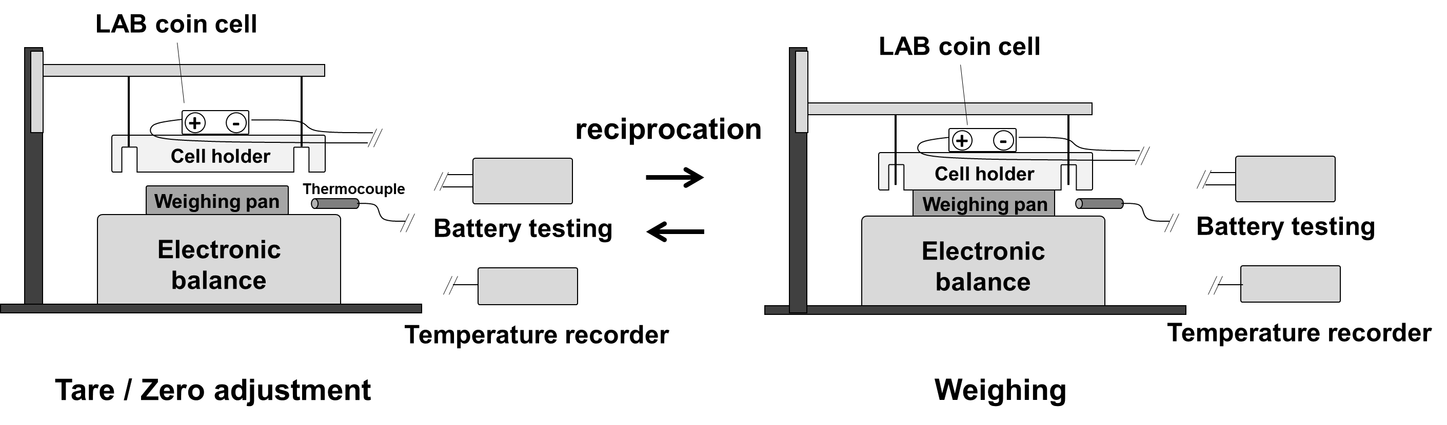
Figure 1. Schematic illustration of the automated weighing system for LAB cells under battery testing. The photographs of the system are shown in Figure S1.

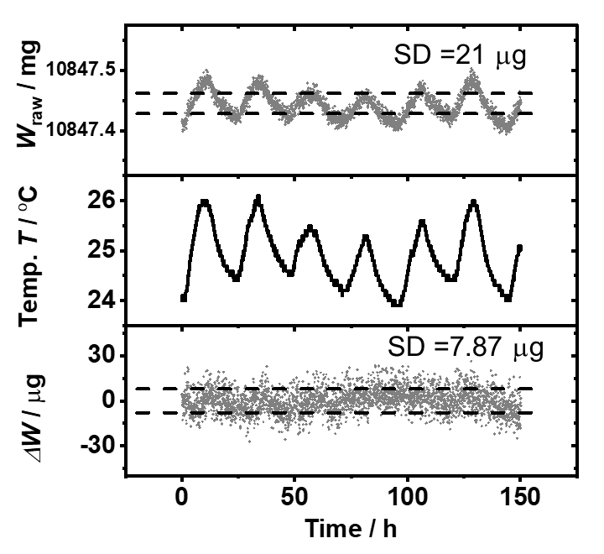
Figure 2. The profiles of raw weight signal (W_{raw}), temperature (T), and weight change (ΔW) of a holder loaded with a blank CR2032 coin cell as recorded by the weighing system developed in this study. The SD of W_{raw} was 21 μg during the 150 h weight monitoring. After temperature correction, the ΔW profile confirms no weight change of the holder with a SD of 7.87 μg. The dotted lines in the W_{raw} and ΔW profiles represent the range of the SD values.

Table 1. The discharge and charge conditions of the LAB coin cells investigated in this study.
Cell | Electrolyte amount  / μL | r_{evap} / μg h⁻¹ | Discharge |  |  |  | Charge
Cell | Electrolyte amount  / μL | r_{evap} / μg h⁻¹ | Current setting / μA | Duration / h | r / μg h⁻¹ | e⁻/O₂ | Current setting / μA | Duration / h | r / μg h⁻¹ | e⁻/O₂
Cell 1 | 32 | -5.69 | 200 | 50 | 116.38 | 1.954 ± 0.004 | 200 | 50 | -119.14 ± 0.28 | 2.107 ± 0.007
Cell 2 | 50 | -5.46 | 800 | 10 | 473.71 | 1.992 ± 0.003 | 800 | 10 | -458.00 ± 1.24 | 2.115 ± 0.007
Cell 3 | 100 | -6.68 | 200 | 40 | 113.95 | 1.978 ± 0.003 | 800 | 10 | -451.36 ± 2.05 | 2.151 ± 0.010
Cell 4 | 32 | -4.59 | 200 | 140 | 115.64 | 1.984 ± 0.003 | 200 | 95 | -115.84 ± 0.08 | 2.149 ± 0.004
Cell 5 | 32 | -6.98 | 800 | 10 | 469.74 | 2.002 ± 0.003 | - | - | - | -
Cell 6 | 32 | -5.63 | 800 | 10 | 471.16 | 2.002 ± 0.003 | - | - | - | -
Cell 7 | 80 | -8.74 | 100 | 10 | 54.03 | 1.901 ± 0.012 | - | - | - | -
Cell 7 | 80 | -8.74 | 200 | 10 | 112.09 | 1.975 ± 0.004 | - | - | - | -
Cell 7 | 80 | -8.74 | 400 | 10 | 232.28 | 1.975 ± 0.003 | - | - | - | -
Cell 7 | 80 | -8.74 | 800 | 5 | 472.65 | 1.983 ± 0.003 | - | - | - | -
DummyCell 1 | 32 | -5.64 | - | - | - | - | - | - | - | -
DummyCell 2 | 32 | -8.50 | - | - | - | - | - | - | - | -

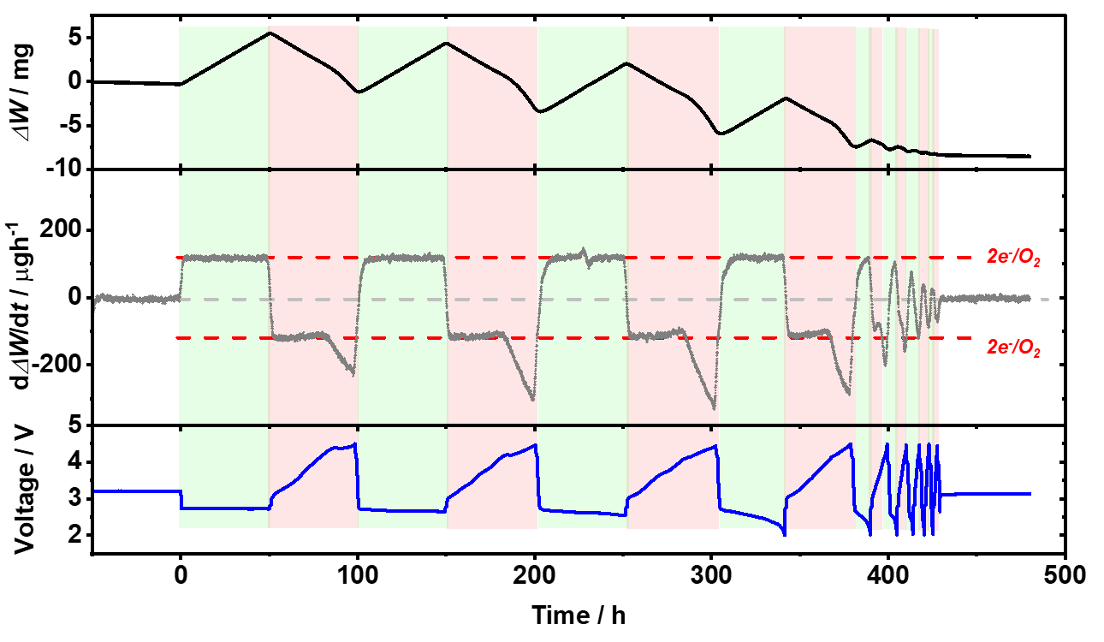
Figure 3. The ΔW and its time-derivative, dΔW/dt, profiles for Cell 1, along with the cell voltage at a current rate of 200 μA. The pale green and pink boxes in the figure show the regions of discharge and charge, respectively. The red dotted lines in the dΔW/dt profile show the weight increase/decrease rates by the 2e⁻/O₂ ORR/OER.

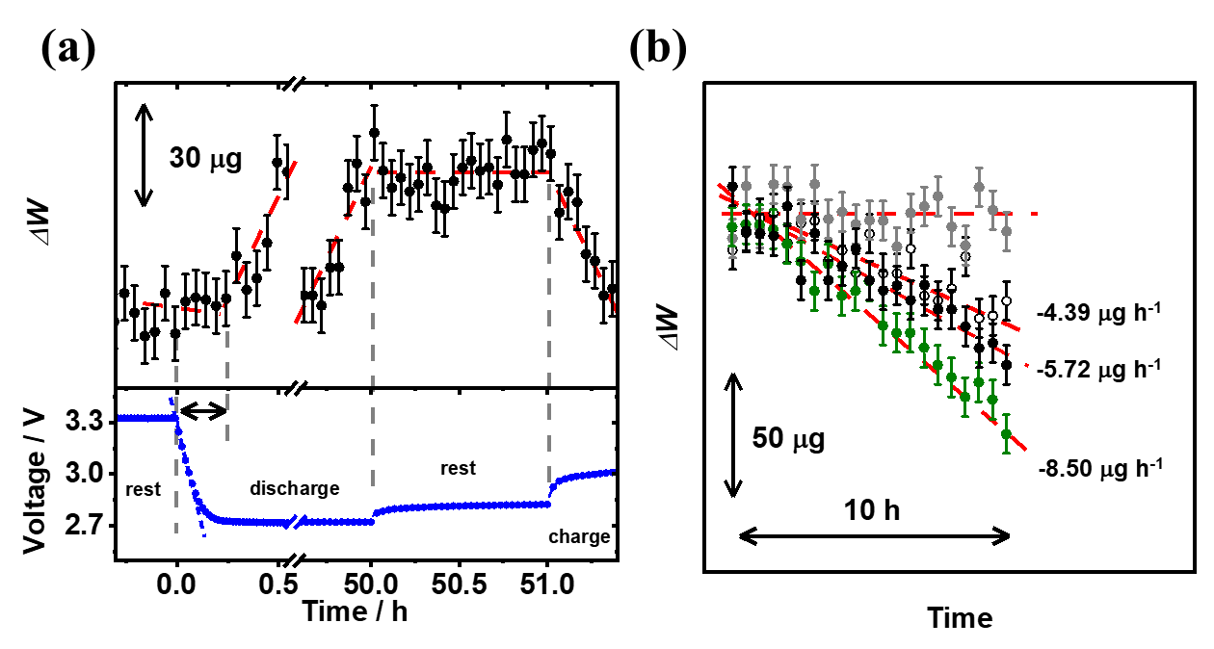
Figure 4. (a) The enlarged ΔW profiles (offset on the y-axis) of Cell 1 near the first discharge, and the time slightly before and after the 1 h rest at the end of first discharge at 50 h, along with their voltage profiles. The SD of ΔW (7.87 μg) is added as the black vertical lines in the figure. The blue dotted line in the voltage profile near the first discharge is the linear approximation for the voltage drop, and the slope of the line gives the capacitance of 0.16 F at the 200 μA discharge rate. The red dotted lines in the ΔW profiles are visual guide to the trend of the data. (b) The ΔW profile of Cell 1 during the rest states before the first discharge (●) and after the cycle test (>450 h, ○). The ΔW profiles of a blank cell holder without electrode and electrolyte (grey filled circle, ●) and Dummy Cell 2 with TEGDME electrolyte without salt (green filled circle, ●) are also included. The SD of ΔW (7.87 μg) is added as the vertical lines. The red dotted lines show the linear fit of each profile. For clarity the profiles are offset on both axes.

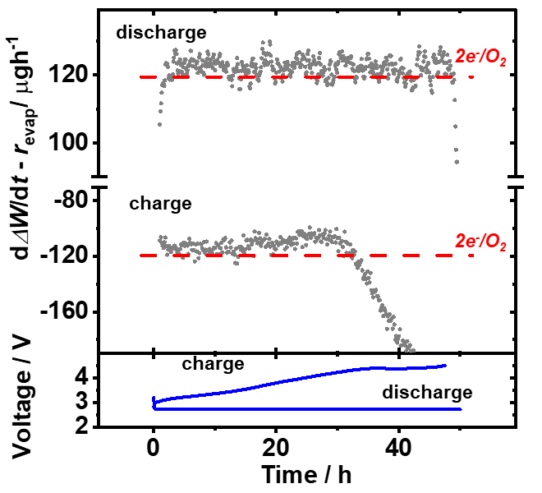
Figure 5. The enlarged dΔW/dt profile for the first discharge/charge of Cell 1. The rate of solvent evaporation r_{evap} was subtracted from dΔW/dt in the plot to show the net weight increase/decrease rate due to oxygen reaction. The red dotted lines in the figure show the theoretical weight increase/decrease rates corresponding to 2e⁻/O₂ ORR/OER.

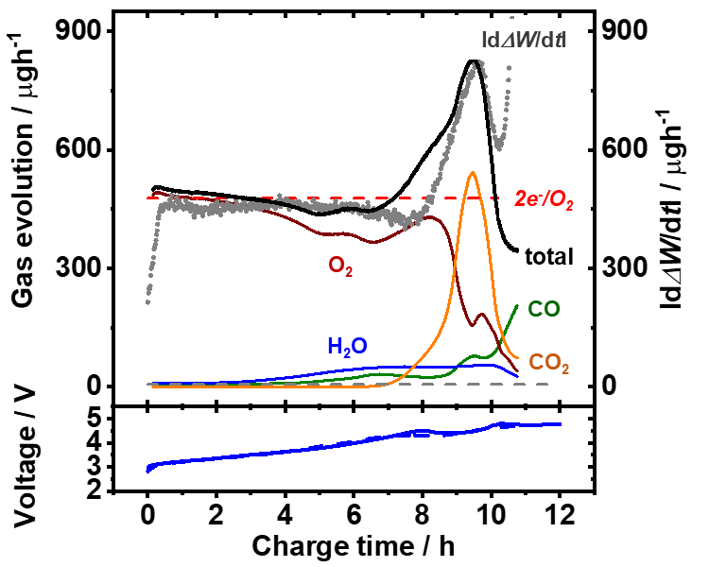
Figure 6. The gas evolution profiles of O₂, H₂O, CO₂, and CO of an LAB cell tested with the same discharge/charge condition as Cell 2 at a current rate of 800 μA. The absolute value of dΔW/dt profile of Cell 2 during charging was also plotted in gray filled circle. The red dotted line in the figure shows the weight decrease rate by the 2e⁻/O₂ OER. The voltage profiles of the cell for DEMS (solid blue line) and Cell 2 (dotted blue line) are shown at the bottom of the figure.

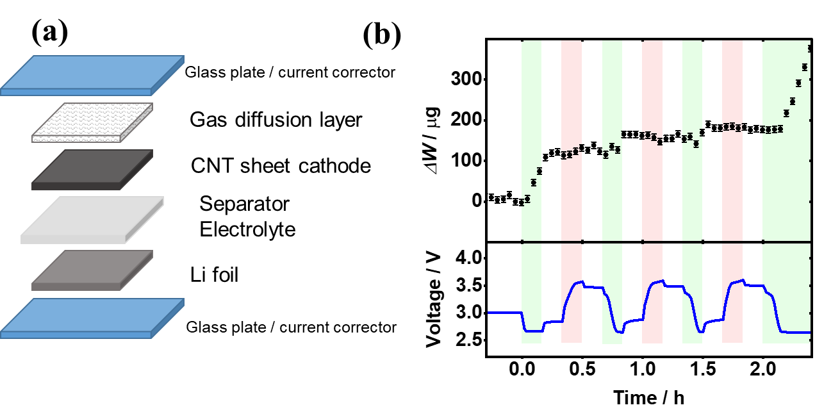
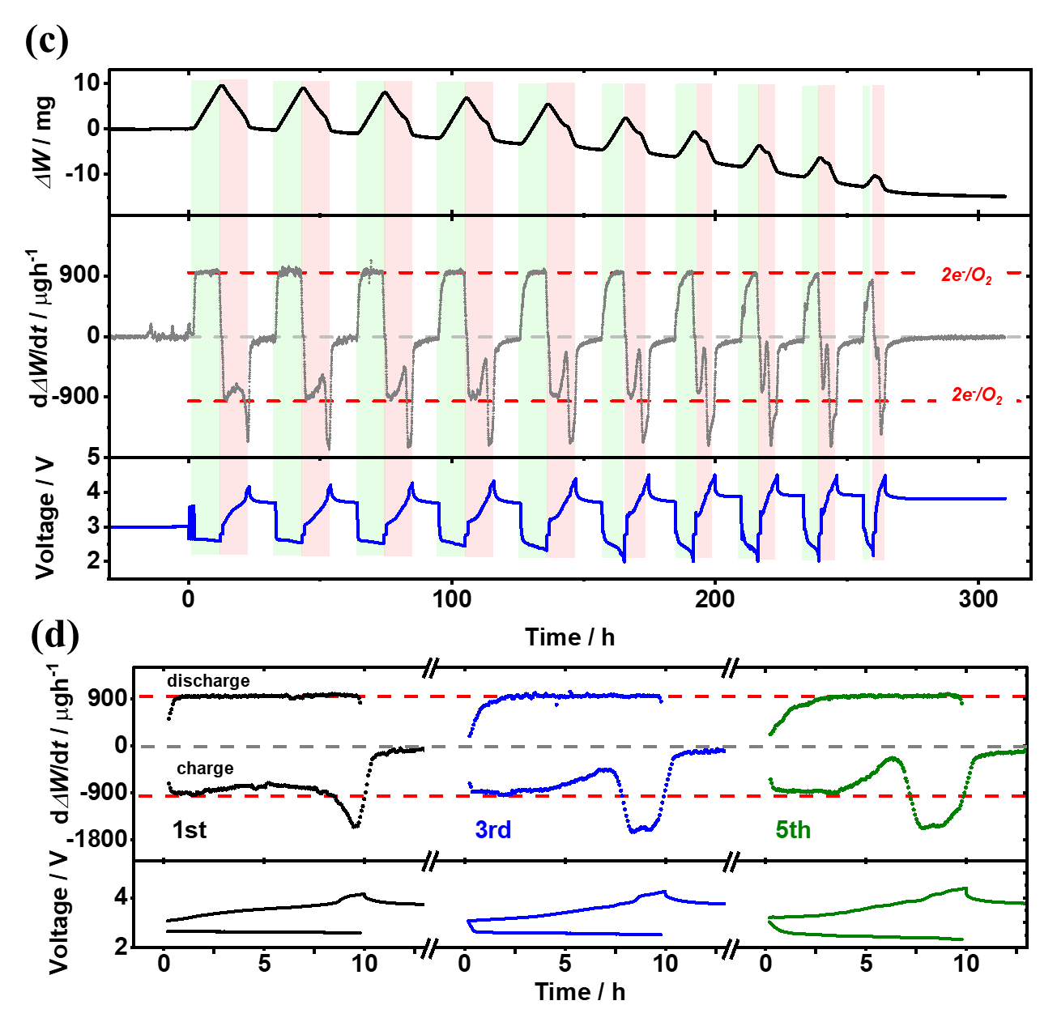
Figure 7. (a) The schematic illustration of a stacked LAB with 2 × 2 cm² square electrodes. 64 μL of LiTFSI/LiNO₃/LiBr = 0.5/0.5/0.2 M in TEGDME was used as the electrolyte. (b) The ΔW profile during the initial conditioning discharge/charge. The cell was repeatedly discharged and charged for 3 times at 1600 μA × 10 min before the actual discharge/charge step of 1600 μA × 10 h. (c) The ΔW and dΔW/dt profiles of the stacked cell for the whole cycle life. (d) The enlarged dΔW/dt profiles of the stacked cell for the 1st (black lines), 3rd (blue lines), and 5th (green lines) discharge/charge cycles. Note that the pale green and pink boxes show the regions of discharge and charge, respectively, and the red dotted lines in the dΔW/dt profile represent the weight increase/decrease rates corresponding to the 2e⁻/O₂ ORR/OER.

