Room temperature large magnetodielectric and magnetoimpedance in (NiMnFeAlZn)₃O₄ high entropy oxide

Alok Kumar Sahu,¹ Sananda Das,¹ Sanjay Tamang,¹ Y.K. Takahashi,² and Perumal Alagarsamy¹
¹Department of Physics, Indian Institute of Technology Guwahati, Guwahati - 781039, India.
²Research Center for Magnetic and Spintronic Materials, National Institute for Materials Science, Tsukuba, 305-0047 Japan.

ABSTRACT
Spinel-structured high entropy oxide (HEO) establishes a novel class of multifunctional materials, where intrinsic chemical disorder and multi-site tenancy enable a unique interplay between spin and charge dynamics. In this work, we report, for the first time, the interplay between magnetic field and dielectric and impedance behaviors in such a chemically complex HEO. For this purpose, a spinel-structured (NiMnFeAlZn)₃O₄ single-phase compound was synthesized via the solid-state method, its microstructure was analyzed at the atomic level, and its electronic, magnetic, dielectric, and impedance properties were systematically characterized. The detailed atomic-level microstructure and electronic properties analyses revealed a strong site presence by Zn²⁺ and Al³⁺ in tetrahedral and octahedral sublattices, respectively, while Ni, Mn, and Fe cations with mixed-valence state are distributed across both sublattices. Thermomagnetization studies and detailed analyses of magnetic data using the modified Arrott plot method and the modified Curie-Weiss law revealed a ferrimagnetic-to-paramagnetic phase transition around 217K. The dielectric and impedance studies showed a strong temperature- and frequency-dependent behavior, underscoring the intrinsic association between spin and charge dynamics. As a result, a notably large room-temperature magnetodielectric (MD) effect (10.3%) and magnetoimpedance (MZ) response (-13%) were observed at 2.2T. Comparative analysis of the square of normalized magnetization with normalized MD and MZ, along with the field-dependent thermomagnetization, not only confirmed that these enhanced functionalities stem from the field-induced magnetic ordering but also highlighted the importance of harnessing the couplings in these spinel-based HEOs for applications in next-generation electromagnetic, memory, sensing, and spintronic applications.

Keywords: High entropy oxide, Spinel, Site occupancy, Magnetodielectric, Magnetoimpedance

The idea of high entropy alloys has sparked the development of various high entropy materials, including high entropy oxides (HEOs), which are single-phase oxide materials comprising five or more multi-principal cations and offering tunable compositions. The unique structural characteristics, which are maintained by high configurational entropy and unconventional functional properties resulting from structural disorder in a complex chemical environment, have garnered considerable attention among researchers[1-4]. Notably, the coexistence of multi-principal cations in a highly disordered environment extends complex interactions between charge, spin, and lattice degrees of freedom, as well as the development of diverse crystal structures[5]. Consequently, they create a plethora of possibilities for a wide range of uses, which include adjustable magnetism ranging from antiferromagnetism, ferrimagnetism, and ferromagnetism[6-8], colossal to giant dielectric behavior[9], remarkable ionic conductivity[10,11], enhanced catalytic activity[12], excellent electrochemical performance[13], high thermal stability[14], etc. Among the different HEOs, the HEOs with the spinel structure exhibit functional properties[15-17] due to the existence of two different cationic sublattices, namely tetrahedral and octahedral sublattices. These sublattices not only contribute to enhanced configurational entropy due to the presence of multi-principal elements but also enable flexible cation distribution based on the selection of cations. As a result, it offers controllable electrical, dielectric, and magnetic properties, enriching HEOs with a spinel structure that is tremendously promising for new technological applications. For instance, Sahu et al.[18] showed how to design giant dielectric materials using the concept of tunable entropy oxides and compositions, while Johnstone et al.[19] reported a remarkable enhancement in the coercivity of 0.9T in (CrMnFeCoNi)_{3-x}Ga_{x}O₄. Although significant studies were focused on thermal, magnetic, dielectric, and impedance properties of spinel structured HEOs[20], the systematic analyses to explore (i) the interplay between applied magnetic fields and the dielectric and impedance responses and (ii) the underlying mechanisms controlling the magnetodielectric (MD) and magnetoimpedance (MZ) effects are not yet well comprehended, leaving a critical gap within this chemically complex spinel HEO family.
Hence, in this study, the correlation between the structural and functional landscape of spinel-structured (NiMnFeAlZn)₃O₄ HEO, prepared using the solid state synthesis method, is explored for the first time through systematic investigations of its structural, microstructural, electronic, magnetic, dielectric, and impedance properties. Such studies revealed a large MD (10.3%) and MZ (-13%). Interestingly, this study not only broadens the fundamental understanding of intrinsic couplings between magnetic and electric ordering but also highlights the importance of harnessing these couplings for suitable applications, including electromagnetic shielding, non-volatile memory devices, antennas, sensors, and energy-efficient spintronic systems.
The (NiMnFeAlZn)₃O₄ HEO was prepared through a typical solid-state synthesis technique. The commercially available powders of MnO, NiO, Fe₂O₃, ZnO, and Al₂O₃ (from Alfa Aesar and Sigma Aldrich) were taken as starting materials in equi-cationic ratio and hand ground for 3-hrs: (i) initially under dry conditions for 1.5-hrs and (ii) then dispersing in an acetone medium for an additional 1.5-hrs. The resulting mixture was eventually pressed into a 10-mm diameter disk-shaped pellet using a uniaxial hydraulic press with an optimized force of 4-Ton. Furthermore, the pellet was calcined at 1000°C for 12-hrs, followed by air quenching. The regrinding and recalcination process was repeated several times to achieve the desired phase. Finally, the comprehensive structural, microstructural, electronic, magnetic, dielectric, and impedance characterizations were carried out.
To analyze the crystal structure, confirm phase purity, and extract structural parameters, powder X-ray diffraction (P-XRD) measurements were performed at room temperature using a rotating anode X-ray diffractometer (Rigaku Smartlab, 9kW) with Cu-K_{α} radiation (λ=1.541Å). The P-XRD patterns were analyzed using Rietveld refinement through the FullProf software. The microstructure and atomic-level elemental mapping were performed using scanning transmission electron microscopy (S/TEM, ThermoFisher Scientific) and energy-dispersive X-ray spectroscopy (EDS) with a Spectra Ultra S/TEM. The specimen for S/TEM analysis was fabricated using a focused-ion-beam (FIB, Helios5UX, Thermo Fisher Scientific). Electronic properties, defect states, and cationic valence states were investigated using a PHI 5000 Versa Probe III type X-ray photoelectron spectroscopy (XPS) system. The scale of binding energy was calibrated using the C-1s peak at 284.8eV. The field-dependent magnetization was measured at room and low temperatures using a vibrating sample magnetometer (VSM, Lakeshore 7410, USA) and a VSM attached to a Dynacool-based physical property measurement system. The dielectric, magnetodielectric, impedance, and magnetoimpedance measurements were performed using an impedance analyzer (Hioki, Model:IM3570) with temperature and magnetic fields controlled by a temperature controller (Model:335) and electromagnet (Model:642) from Lakeshore, both operated through a homemade LabVIEW program.
Figure 1(a-b) illustrates the room temperature P-XRD pattern, the Rietveld refinement, and the generated crystal structure of (NiMnFeAlZn)₃O₄ HEO. The observed P-XRD peaks are consistent with the spinel structure, M₃O₄ ($Fd\overline{3}m$,227), confirming the formation of the spinel phase. The refined parameters R_{p}=13.3%, R_{wp}=5.98%, R_{exp}=5.04%, and $ζ^{2}$=1.41 confirm the reliability of the fit and the validity of the structural model. The refined lattice constant is 8.294(3)Å, and the refined crystal structure exhibits two sublattices: tetrahedral and octahedral. Figures 1(c-d) and 1(d1-d7) display the HAADF-STEM image, STEM EDS mapping, the individual elemental mapping, and the quantitative line-scan profiles across the grain boundaries. These results show no detectable cluster of any elements, strengthening the uniform distribution of elements down to the atomic scale. To study the site occupancy of elements in sublattices, the spinel structure along the [100]-zone axis generated using Vesta software is presented in Figure 1(e-g). This anticipated spinel structure is in close agreement with the HAADF-STEM image presented in Figure 1(h). Atom resolved elemental mapping shown in Figure 1(h1-h6) reveals that Mn, Ni, and Fe are distributed across both tetrahedral and octahedral sublattices, whereas Zn and Al are confined to tetrahedral and octahedral sites, respectively.
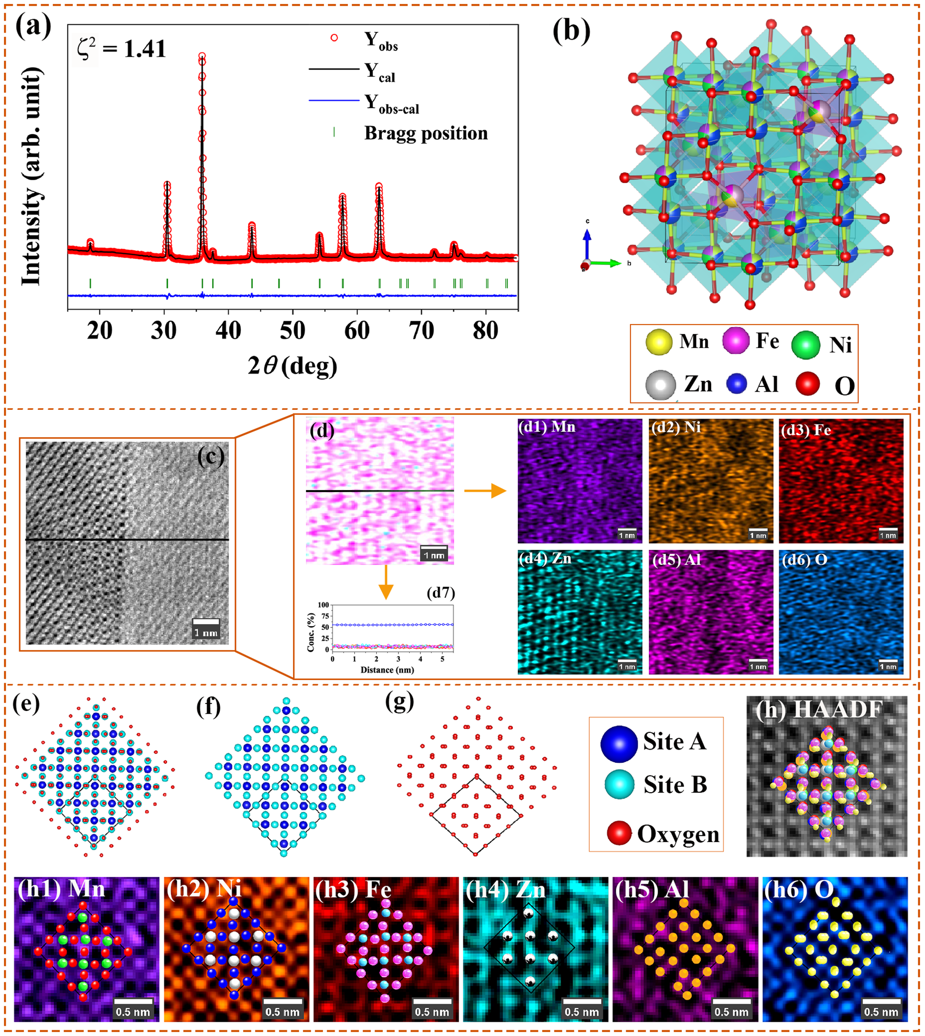
Figure 1: (a) Rietveld refinement of room temperature P-XRD pattern, (b) Crystal structure generated from the refinement and drawn using VESTA software, (c) HAADF-STEM images, (d,d1-d7) the quantitative line-scan profiles across grain boundaries, STEM EDS mappings of individual elements at atomic level, (e-g) simulated crystal structure and cations projected along [100]-zone axis, (h) HAADF-STEM image, and corresponding (h1-h6) elemental mapping along the [100]-zone axis for (NiMnFeAlZn)₃O₄ HEO.
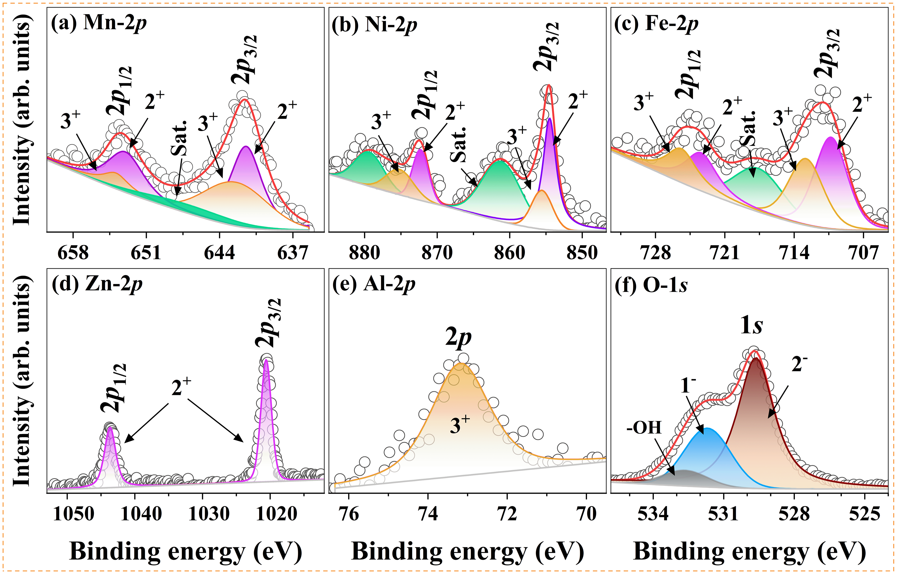
Figure 2: High-resolution XPS spectra for (NiMnFeAlZn)₃O₄ HEO: (a) Mn-2p, (b) Ni-2p, (c) Fe-2p, (d) Zn-2p, (e) Al-2p, and (f) O-1s.

To further elucidate the site occupancy of elements in the spinel structure, high-resolution XPS spectra of Mn, Ni, Fe, Zn, Al, and O at room temperature are obtained and presented in Figure 2. The binding energies of different elements extracted from Figure 2 are listed in Table S1. The presence of mixed valence states for Mn, Ni, and Fe, i.e., 2⁺/3⁺ states, and a single valence state for Zn(2⁺) and Al(3⁺)[21-22] is rational with the elemental mapping in STEM images. The strong site preferences of Zn²⁺ and Al³⁺ in tetrahedral and octahedral sublattices, respectively, force Ni, Mn, and Fe cations to alter their oxidation states, allowing them to occupy both tetrahedral and octahedral sublattices, thereby stabilizing the spinel structure in (NiMnFeAlZn)₃O₄. The configurational entropy of (NiMnFeAlZn)₃O₄ [23] is found to be ~1.6R, substantiating its classification as a HEO material.
Figure 3(a) illustrates thermomagnetization curves (M(T)) measured under zero-field-cooled (ZFC) and field-cooled (FC) conditions between 10K and 300K under the applied field of 0.022T. It is observed that (i) a bifurcation between ZFC and FC curves at low temperature below 160K and (ii) a magnetic transition from ferrimagnetic to paramagnetic phase above 215K. To study the nature of the magnetic phase transition, isothermal magnetization curves are obtained close to the transition temperature and analyzed using the modified Arrott plot (MAP) method (Figure S1). The detailed analyses of the extracted spontaneous magnetization and inverse susceptibility from the MAP method[24] (Figure S2) provide a phase transition temperature of 217.5K, along with the critical exponents 0.395 (β), 1.026 (γ), and 3.626 (δ). As listed in Table S2, γ is close to that of the mean-field model[24], while β and δ do not match with conventional models, but exhibit close agreement with Widom’s scaling relation[25]. Table S3 presents a summary of the magnetic phase transition temperatures of various HEOs. To gain further insight into the ferrimagnetic properties, the temperature-dependent inverse susceptibility data (Figure S3) are analyzed using the modified Curie-Weiss law[26,27]. The calculated effective paramagnetic moment, $μ_{eff}^{(exp.)}$ is found to be 6.09μ_{B}/f.u., nearly matching with the theoretical moment, $μ_{eff}^{(th.)}$ (=6.23μ_{B}/f.u.) (Table S4).

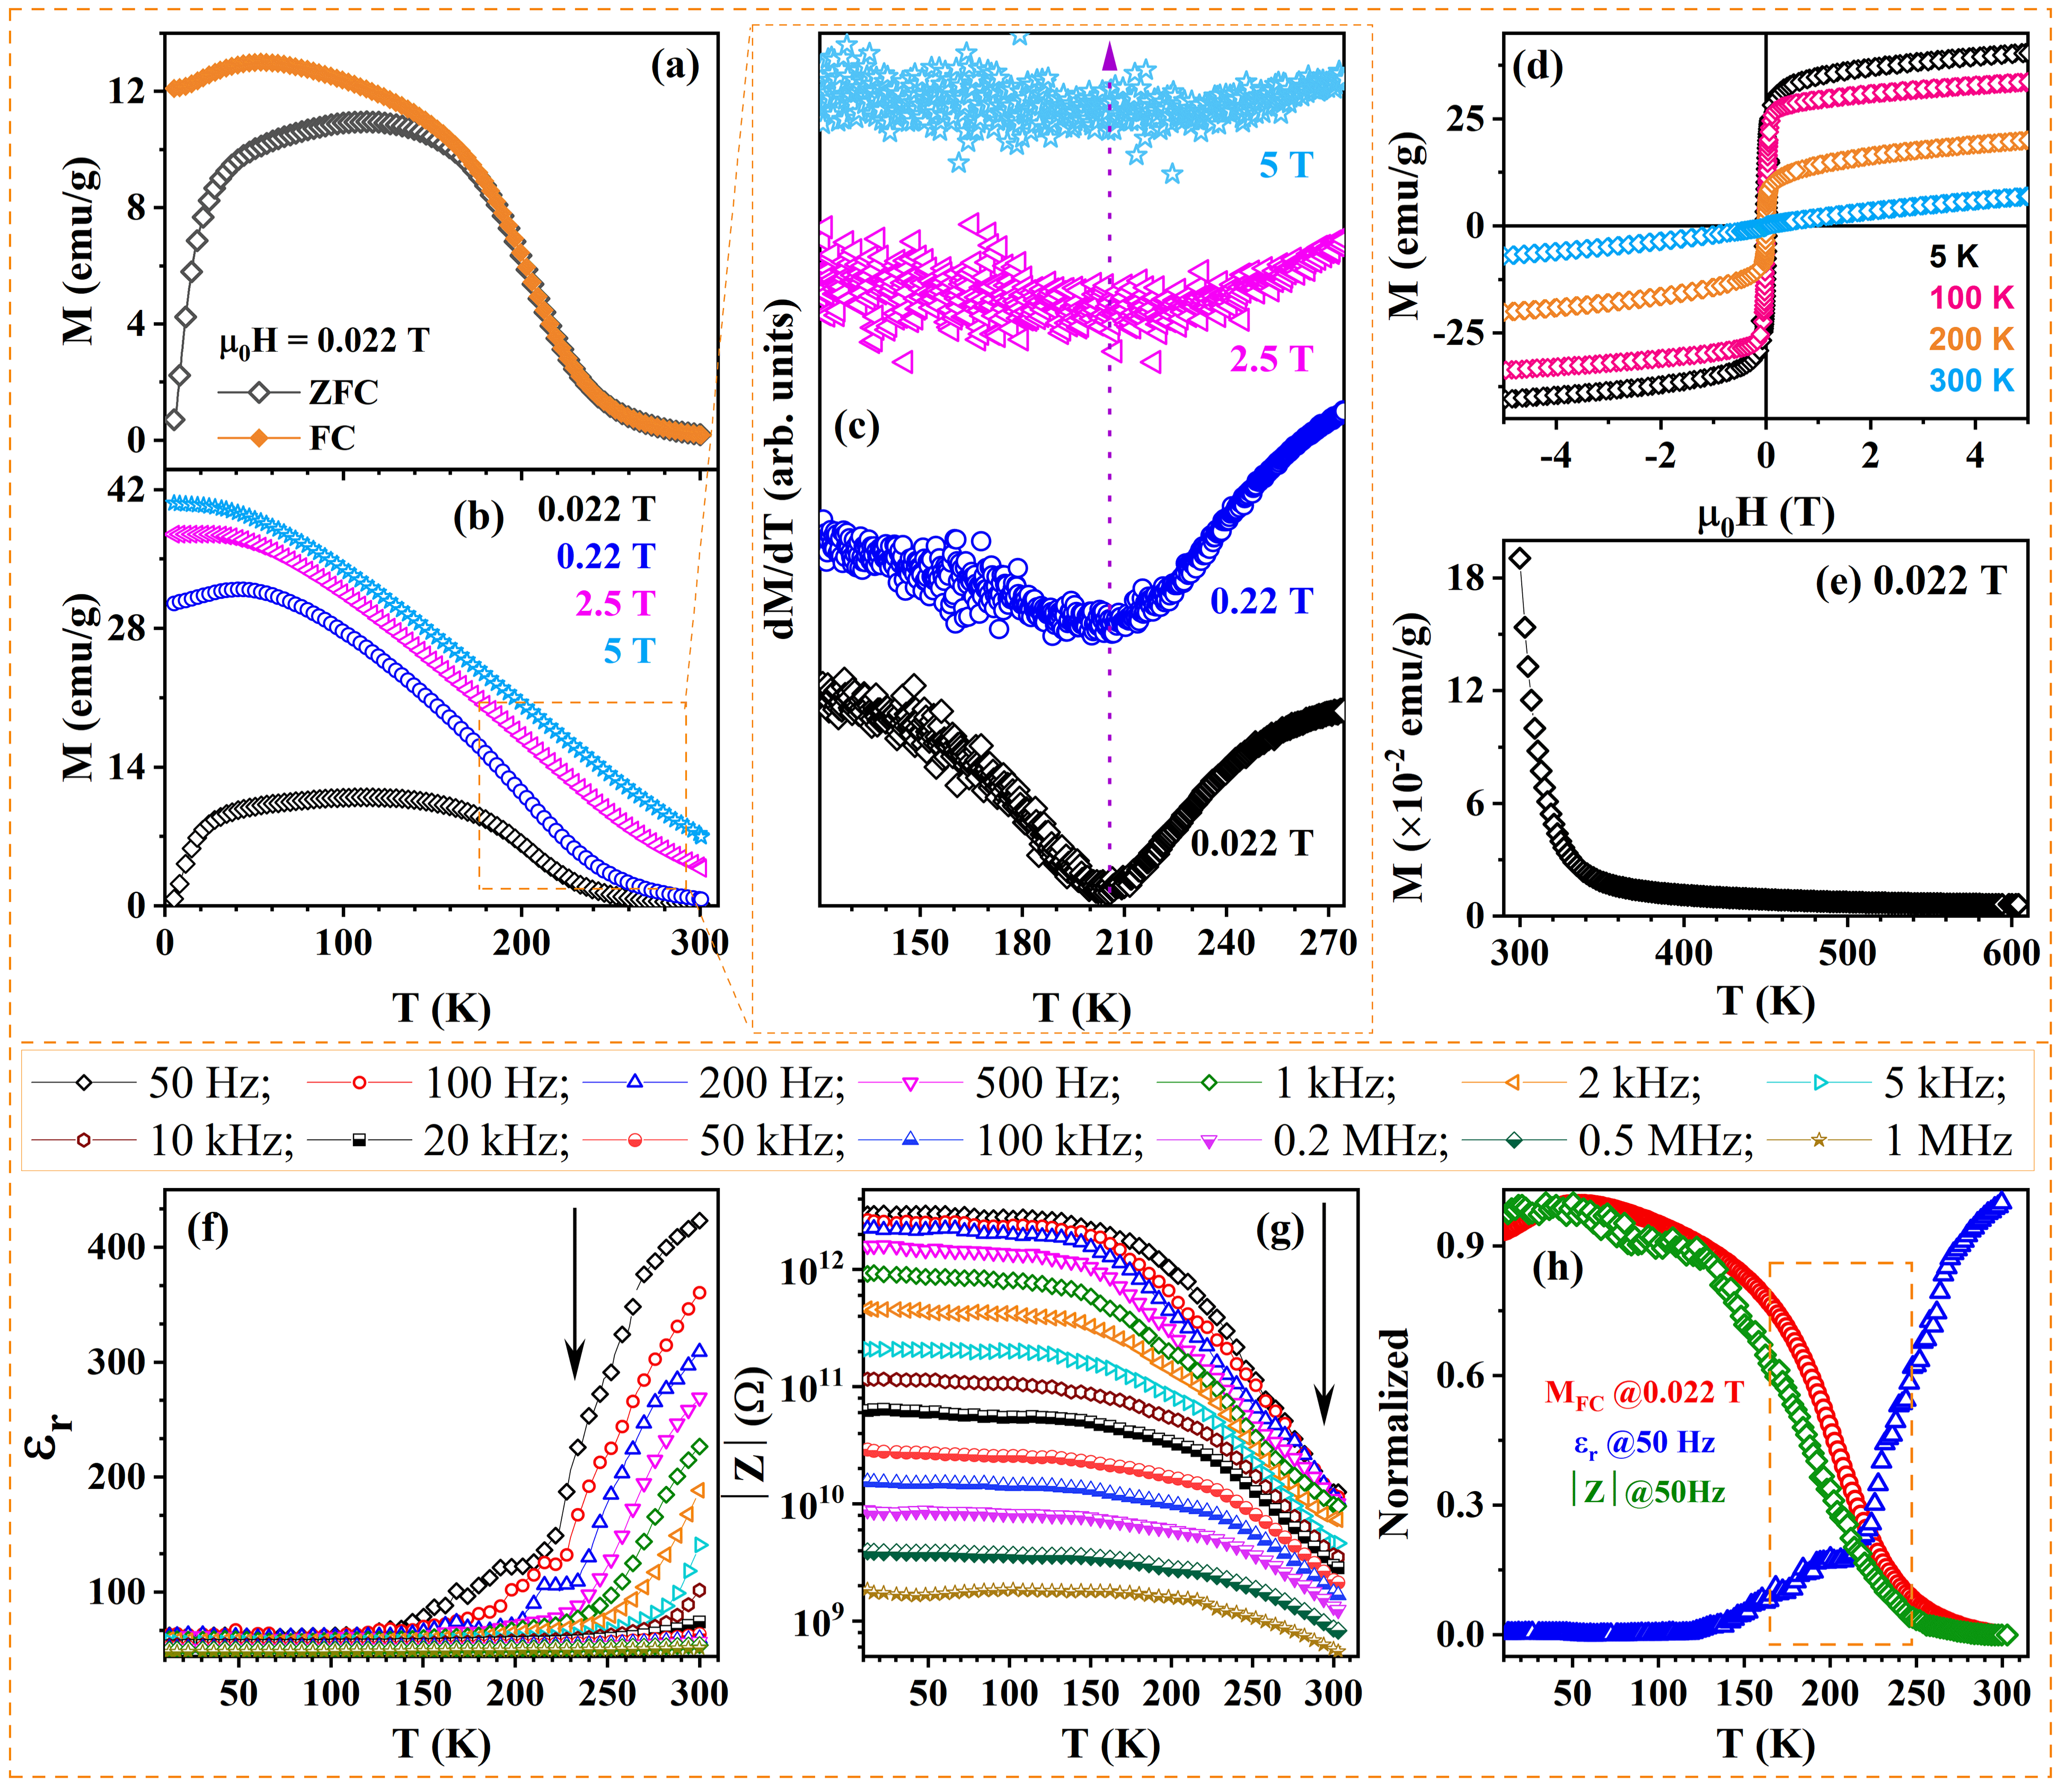
Figure 3: (a) Thermomagnetization curves (M(T)) measured under ZFC and FC conditions at 0.022T, (b) M(T) curves measured under different applied fields, (c) the corresponding thermal-derivative curves, (d) M(H) curves measured at different temperatures, (e) high-temperature M(T) curve measured at 0.022T, (f-g) $ε_{r}(T)$ and $\left|Z\right|(T)$ at different frequencies, and (h) comparative study of normalized M(T)@0.022T, $ε_{r}$ and $\left|Z\right|$ for (NiMnFeAlZn)₃O₄ HEO.

To study the effect of the applied magnetic field on the phase transition, ZFC curves are obtained at different magnetic fields and presented in Figure 3(b). As the applied field increases, there exists (i) a progressive suppression of spin fluctuations by the temperature, (ii) a broadening of the phase transition, and (iii) a nonlinear increase in magnetization with increasing applied field up to 5T, even at 300K (Figure S4), supporting the field-induced magnetic ordering. Figure 3(d) presents the magnetic hysteresis loops (M(H)) measured between 10K and 300K. A maximum magnetization (M_{S}) of 40.4emu/g is obtained at 5T, along with a coercivity (H_{C}) of 41.5mT at 5K. Both M_{S} and H_{C} decrease with increasing temperature. Additionally, the magnetization values extracted from the M(T) curves at 300K (Figure 3(b)) under different applied fields match the M(H) data at 300K (Figure S4), reinforcing the consistency of our observations.
It is well known that the overall magnetic properties of the spinel HEOs arise from the imbalance between the magnetic contributions of the tetrahedral and the octahedral sublattices, driven by the co-existence and competition between double-exchange and super-exchange interactions. Considering the preferred occupancy of Zn²⁺ in the tetrahedral sublattice and Al³⁺ in the octahedral sublattice, along with the nonuniform distribution of Ni, Mn, and Fe across both sublattices, the net magnetic moment is produced from the unequal moments of the two sublattices[28,29]. Furthermore, electron hopping between mixed-valence cations, including Ni²⁺-O-Ni³⁺, Mn²⁺-O-Mn³⁺, Fe²⁺-O-Fe³⁺, and Fe³⁺-O-Ni²⁺, among others, could facilitate double-exchange interactions, enhancing magnetic alignment and contributing to an increase in net magnetization. These interactions promote spin-dependent charge transfer, aligning neighboring magnetic moments and reinforcing ferromagnetic coupling within the lattice. On the other hand, various superexchange interactions among other cation pairs can also exist, depending on the specific electronic configurations and bond geometries[30-37]. To understand the possible contribution of various magnetic ions to the saturation magnetization, the isothermal magnetization curve at 5K (Figure S5) has been fit using the law of approach to saturation model[38] and the calculated experimental magnetic moment is found to be 1.68μ_{B}/f.u., which is good agreement with the theoretical moment for the spinel structure (1.72μ_{B}/f.u.). The high-temperature M(T) (Figure 3(e)) further confirms the gradual decrease of magnetization in the paramagnetic state. It is expected that the field-induced magnetic phase transition exerts a significant influence on the dielectric and impedance responses of the (NiMnFeAlZn)₃O₄ HEO[39,40].
Figure 3(f) shows the temperature-dependent dielectric (ε_{r}) for (NiMnFeAlZn)₃O₄ in the temperature range between 10K and 300K at different frequencies from 50Hz to 1MHz. The room temperature ε_{r} exhibits a strong dispersion, i.e., decreasing from ~ 430 at 50Hz to a nearly constant (~46) at high frequencies. This can be attributed to the contributions from multiple polarizations, such as space charge, dipolar, ionic, and electronic, which are active at low frequencies[41]. As the frequency increases, the dipolar and space charge contributions are progressively suppressed due to the inability of dipoles and space charges to respond to the rapidly oscillating electric field[42]. As a result, εᵣ decreases with increasing frequency. Furthermore, with decreasing temperature, εᵣ progressively diminishes due to a reduction in the thermal energy, suppressing electron hopping between mixed-valence cations (Mn²⁺/Ni²⁺/Fe²⁺↔Mn³⁺/Ni³⁺/Fe³⁺) and leading to a nearly frequency-independent zone at low temperature below 150K[43]. On the other hand, the sharp rise in ε_{r} at low frequencies and high temperatures indicates an increase in the hopping rate of charge carriers with increasing temperature, as well as an interfacial polarization contribution[44]. Figure S6 presents the temperature-dependent tanδ measured at various frequencies for (NiMnFeAlZn)₃O₄. The tanδ(T) exhibits characteristic relaxation peaks that shift toward higher temperatures with increasing frequency, a behavior characteristic of thermally activated dielectric relaxation[42,45,46], which is generally described by the Debye relaxation model[47]. The observed peak in tanδ is attributed to the strong interplay between the conduction mechanism and dielectric response. At low temperatures, electric dipoles tend to freeze easily through the relaxation process, leading to reduced polarization and minimal dielectric loss. As the temperature increases, enhanced dipole mobility and charge carrier hopping shift the relaxation process to higher frequencies, resulting in a peak when the hopping frequency matches the applied electric field. It has been observed that (i) below 150K, tanδ remains nearly zero across all frequencies, indicating negligible dielectric loss due to limited dipole reorientation or carrier hopping, and (ii) above 150K, tanδ gradually increases, particularly at lower frequencies, reflecting the growing influence of thermally activated relaxation mechanisms. Importantly, the relaxation peak coincides with the magnetic transition temperature identified from the M(T). This correlation suggests that the dielectric relaxation is influenced not only by thermal effects but also by magnetic ordering.
Figure 3(g) displays the temperature-dependent impedance (|Z|) response of (NiMnFeAlZn)₃O₄ at different frequencies (50Hz-1MHz). At 50Hz, |Z| exhibits a low-temperature plateau (~10¹²Ω) that decreases by two-to-three orders of magnitude as temperature increases, indicating thermally activated carrier hopping. This could be correlated with the magnetic ordering, where thermally activated electron hopping between mixed-valence cations (Mn²⁺/Ni²⁺/Fe²⁺ and Mn³⁺/Ni³⁺/Fe³⁺) modulates the ferrimagnetic to paramagnetic transition. Moreover, with increasing frequency, this transition shifts to higher temperatures and becomes less prominent. To probe the possible correlation between spin and charge degrees of freedom, the normalized M, εᵣ, and |Z| are plotted against temperature in Figure 3(h). All three responses exhibit a strong correlation around the transition temperature (~217.5K), indicating a significant association between spin and charge dynamics in the system. The charge response is strongly influenced by frequency and the applied magnetic field.
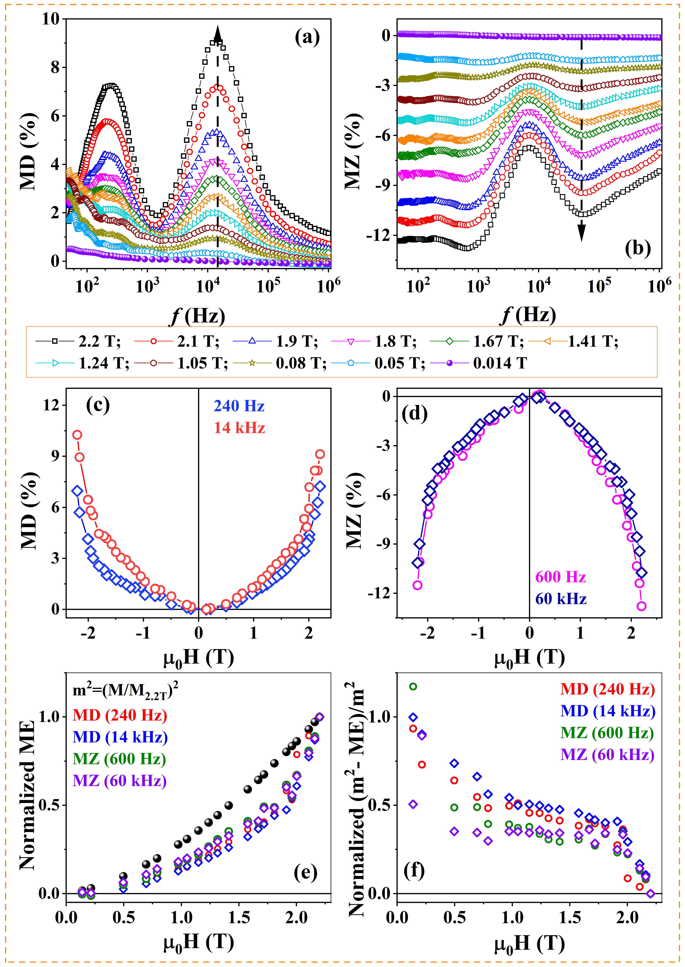
Figure 4: The frequency-dependent (a) MD and (b) MZ at various applied magnetic fields between 0.014 and 2.2T, (c-d) the field-dependent MD and MZ, (e-f) Comparison of m² with normalized MD and MZ and their difference as a function of applied magnetic field for (NiMnFeAlZn)₃O₄ HEO.

Figure 4(a-b) illustrates the room temperature frequency-dependent magnetodielectric (MD) and magnetoimpedance (MZ) responses of (NiMnFeAlZn)₃O₄ under different applied magnetic fields up to 2.2T. The MD and MZ effects are calculated using $MD(\%)=\left({(ε_{H}-ε_{0})}/{ε_{0}}\right)×100$ and $MZ(\%)=\left({({\left|Z\right|}_{H}-{\left|Z\right|}_{0})}/{{\left|Z\right|}_{0}}\right)×100$, where $ε_{0}$, ${\left|Z\right|}_{0}$ and $ε_{H}$, ${\left|Z\right|}_{H}$ are the dielectric and impedance responses without and with magnetic field, respectively and presented in Figure 4(c-d). It can be seen that two distinct peaks are evident in the MD response: one centered around 240Hz and another near 14kHz. The low-frequency peak at 240Hz is primarily attributed to intrinsic hopping dipoles, further amplified by interfacial Maxwell-Wagner polarization mechanisms[18,48]. In contrast, the high-frequency peak at 14kHz is dominated by intrinsic dipolar polarization, with interfacial effects becoming negligible. This duality of intrinsic and extrinsic polarization processes is strongly modulated by valence fluctuations, which not only drive spin–charge–lattice coupling but also generate mobile charge carriers that accumulate at grain boundaries, thereby enhancing Maxwell–Wagner-type interfacial polarization[49-51]. The MD magnitude at 240Hz reaches 7.2%. At the same time, the 14kHz peak exhibits a maximum MD of 10.3% at 2.2T. This pronounced MD effect likely originates from magnetic field-induced modifications in space charge dynamics and dipolar polarization processes, particularly near the characteristic relaxation frequency where charge carriers or dipoles exhibit strong coupling with the magnetic lattice. Additional contributing factors include field-induced lattice distortions, magnetoelectric coupling, spin-phonon interactions, and other field-sensitive mechanisms that collectively modulate the dielectric response[52]. Under low magnetic fields, partial spin alignment reduces the energy barrier for hopping conduction, facilitating charge transfer between mixed-valence cations (e.g., Fe²⁺/Fe³⁺, Mn²⁺/Mn³⁺, Ni²⁺/Ni³⁺), resulting in a single dominant relaxation process of diminished magnitude. As the magnetic field increases, progressive spin alignment further lowers the hopping barrier[53,54]. It enhances dipolar polarization through intensified charge transfer between mixed-valence ions, thereby giving rise to the emergence of two distinct peaks. Concurrently, asymmetric charge redistribution arising from electron hopping between mixed-valence cations strengthens spin-charge coupling, contributing to a robust intrinsic MD response. Hence, the observed MD behavior can be reasonably attributed to a synergistic interplay between intrinsic hopping and dipolar polarization mechanisms, with magnetoresistance (MR)-related effects potentially offering supplementary contributions. Beyond this frequency, the MD effect decreases progressively with increasing frequency and approaches saturation in the high-frequency regime (>10⁵Hz), as only the ionic and electronic polarization mechanisms remain active and are unaffected by the magnetic field. On the other hand, the frequency dependence of the MZ is negative across the entire frequency range, indicating reduced impedance under the applied magnetic fields. For frequencies <10²Hz, the MZ(%) is small but increases with increasing frequency, reaching -13% at 2.2T near ~600Hz and -10.7% near 60kHz, consistent with field-enhanced carrier hopping via mixed-valence cations. The origin of these features is analogous to that of the MD relaxations, where the low-frequency response arises from intrinsic hopping dipole polarization supported by interfacial polarization. In contrast, the high-frequency behavior is governed by intrinsic dipolar processes. Table S5 summarizes the list of similar oxide materials and their MD and MZ responses. Upon further increasing the frequency beyond 10⁵Hz, as with MD, the MZ diminishes towards zero, as interfacial and dipolar contributions are suppressed, leaving only intrinsic ionic/electronic processes.
For a comprehensive understanding of the spin-charge correlation, a comparative analysis of normalized magnetization, i.e., m²[=(M/M_{2.2T})²], MD, and MZ is analyzed simultaneously as a function of applied field up to 2.2T at room temperature (Figure 4(e-f)). In the low-field regime, both normalized MD and MZ deviate from m². As the applied magnetic field intensifies, the magnetic phase transition becomes broadened, resulting in an overlapping region where the induced ferrimagnetic and paramagnetic characteristics coexist. This progressive stabilization of the induced ferrimagnetism results in a gradual enhancement in MD(%) and MZ(%)[40]. At sufficiently high applied magnetic fields, the further enhancement in the ferrimagnetic ordering results in a sharp rise in MD(%) and MZ(%), which closely approaches m² dependence. These field-induced disorder and short- and long-range magnetic ordering are extremely vital in the HEO family. Furthermore, the inherent structural disorder and chemical complexity in these materials provide a unique platform for investigating the fundamental mechanisms that govern tunable magnetic and electrical functionalities, which are essential for advanced technological applications.
In conclusion, we have successfully synthesized the spinel-structured (NiMnFeAlZn)₃O₄ HEO single-phase compound ($Fd\overline{3}m$,227) via the solid-state method. The HAADF-STEM EDS mapping at the atomic level revealed the formation of single-phase HEO without any agglomeration or phase segregation. Further, the elements Mn, Ni, and Fe with mixed-valence states are distributed across both tetrahedral and octahedral sublattices, whereas Zn²⁺ and Al³⁺ are confined to tetrahedral and octahedral sites, respectively. The analysis of high-resolution XPS spectra further supported these observations. Temperature-dependent magnetic studies and detailed magnetic data analyses using the modified Arrott plot method and the modified Curie-Weiss law revealed a ferrimagnetic to paramagnetic phase transition around 217K and exhibited field-induced magnetic ordering. The frequency and temperature-dependent dielectric and impedance behaviors under different magnetic fields showed anomalies around 217K, highlighting the intrinsic correlation between spin and charge dynamics in the system. This yielded a large room-temperature magnetodielectric (MD) (~10.3%) and magnetoimpedance (MZ) (~-13%) responses. Furthermore, the comparative analysis of normalized m² with normalized MD and MZ revealed that the field-induced magnetic ordering is responsible for the high MD and MZ response at room temperature. These findings positioned spinel-based HEOs as a multifunctional material for next-generation electromagnetic, memory, sensing, and spintronics applications.

Supporting Information
Supporting information is provided in a separate file.

Acknowledgements
PA acknowledges the support of the research fund from the Science and Engineering Research Board, India, through the research grant [CRG/2022/002284]. The other supports from the Department of Science and Technology (DST), New Delhi [SR/ S2/ CMP-19/ 2006; SR/ FST/ PII-020/ 2009; SR/FST/PSII-037/2016], CSIR [03(1166)/10/EMR-II], and the Central Instrument Facility are also acknowledged for the current work. A part of this work was supported by the Electron Microscopy Unit, National Institute for Materials Science (NIMS).

Conflict of Interest
The authors declare that they have no conflict of interest.

Data Availability Statement
The data supporting this study’s findings are available within the article and its supplementary material. Any other data supporting this study's findings are available from the corresponding author upon reasonable request.

References
[1] C. M. Rost, E. Sachet, T. Borman, A. Moballegh, E. C. Dickey, D. Hou, J. L. Jones, S. Curtarolo, J.-P. Maria, “Entropy-stabilized oxides,” Nat. Commun. 6, 8485 (2015). https://doi.org/10.1038/ncomms9485
[2] N. Sharma, J. Link, I. Heinmaa, R. Stern, T. Chakrabarty, S. Marik, “Spin glass and complex magnetism in a high-entropy spinel oxide with five cations at both tetrahedral and octahedral sites,” Appl. Phys. Lett. 126, 051901 (2025). https://doi.org/10.1063/5.0242505
[3] J. Yan, A. Kumar, M. Chi, M. Brahlek, T.Z. Ward, M.A. McGuire, “Orbital degree of freedom in high entropy oxides,” Phys. Rev. Mater. 8, 024404 (2024). https://doi.org/10.1103/PhysRevMaterials.8.024404
[4] Z. Rák, J.P. Maria, D.W. Brenner, “Evidence for Jahn-Teller compression in the (Mg Co Ni Cu Zn)O entropy-stabilized oxide: A DFT study,” Mater. Lett. 217, 300 (2018). https://doi.org/10.1016/j.matlet.2018.01.111
[5] Y. Ma, Y. Ma, Q. Wang, S. Schweidler, M. Botros, T. Fu, H. Hahn, T. Brezesinski, B. Breitung, “High-entropy energy materials: Challenges and new opportunities”, Energy Environ. Sci. 14, 2883 (2021). https://doi.org/10.1039/d1ee00505g
[6] A. Mao, H.Z. Xiang, Z.G. Zhang, K. Kuramoto, H. Yu, S. Ran, “Solution combustion synthesis and magnetic property of rock-salt (Co_{0.2}Cu_{0.2}Mg_{0.2}Ni_{0.2}Zn_{0.2})O high-entropy oxide nanocrystalline powder,” J. Magn. Magn. Mater. 484, 245 (2019). https://doi.org/10.1016/j.jmmm.2019.04.023
[7] N.J. Usharani, A. Bhandarkar, S. Subramanian, S.S. Bhattacharya, “Antiferromagnetism in a nanocrystalline high entropy oxide (Co,Cu,Mg,Ni,Zn)O: Magnetic constituents and surface anisotropy leading to lattice distortion,” Acta Mater. 200, 526 (2020). https://doi.org/10.1016/j.actamat.2020.09.034
[8] B.L. Musicó, D. Gilbert, T.Z Ward, K. Page, E. George, J. Yan, D. Mandrus, V. Keppens, “The emergent field of high entropy oxides: Design, prospects, challenges, and opportunities for tailoring material properties,” APL Mater. 8, 040912 (2020). https://doi.org/10.1063/5.0003149
[9] D. Bérardan, S. Franger, D. Dragoe, A.K. Meena, N. Dragoe, “Colossal dielectric constant in high entropy oxides,” Phys. Status Solidi - Rapid Res. Lett. 10, 328 (2016). https://doi.org/10.1002/pssr.201600043
[10] D. Bérardan, S. Franger, A.K. Meena, N. Dragoe, “Room temperature lithium superionic conductivity in high entropy oxides,” J. Mater. Chem. A 4, 9536 (2016). https://doi.org/10.1039/c6ta03249d
[11] M. Gazda, T. Miruszewski, D. Jaworski, A. Mielewczyk-Gryń, W. Skubida, S. Wachowski, P. Winiarz, K. Dzierzgowski, M. Łapiński, I. Szpunar, E. Dzik, “Novel Class of Proton Conducting Materials - High Entropy Oxides,” ACS Mater. Lett. 2, 1315 (2020). https://doi.org/10.1021/acsmaterialslett.0c00257
[12] Y. Sun, S. Dai, “High-entropy materials for catalysis: A new frontier,” Sci. Adv. 7, 1 (2021). https://doi.org/10.1126/sciadv.abg1600
[13] H. Raza, S. Ullah, A. Akhtar, G.A. Gohar, I.T. Bello, A. Raza, A. Ahmed, “Enhancing lithium-sulfur battery performance through the integration of six-metal high entropy oxides,” Mater. Lett. 393, 138580 (2025). https://doi.org/10.1016/j.matlet.2025.138580
[14] Z.Y. Tan, Z.H. Xie, X. Wu, J.W. Guo, W. Zhu, “Spark plasma sintering of A₆B₂O₁₇ (A = Hf, Zr; B = Ta, Nb) high entropy ceramics,” Mater. Lett. 330, 2 (2023). https://doi.org/10.1016/j.matlet.2022.133381
[15] T. Warski, J. Kubacki, D. Łukowiec, R. Babilas, P. Włodarczyk, Ł. Hawełek, M. Polak, B. Jóźwik, M. Kowalczyk, A. K.-Burian, A. Radoń, “Magnetodielectric and low-frequency microwave absorption properties of entropy stabilised ferrites and 3D printed composites,” Compos B Eng 243, 110126 (2022). https://doi.org/10.1016/j.compositesb.2022.110126
[16] Z. Chen, B. Ma, C. Dang, J. Song, Y. Zhou, “High-Entropy Spinel Oxide Nanostructures as Stable Cathodes for Solid Oxide Fuel Cells,” Nano Lett. 25, 6421 (2025). https://doi.org/10.1021/acs.nanolett.4c06461
[17] S. Ghosh, L. Raman, S. Sridar, W. Li, “High-Entropy Engineering in Thermoelectric Materials: A Review,” Crystals 14, 432 (2024). https://doi.org/10.3390/cryst14050432
[18] A. Sahu, A.M. Padhan, R. Abinath, S. Pandey, P. Dobbidi, J. Kumar, Y.K. Takahashi and P. Alagarsamy, “Tunable Entropy Oxides: A Pathway to Design Giant Dielectric Materials for Energy Harvesting,” Adv. Funct. Mater. e18131 (2025). https://doi.org/10.1002/adfm.202518131
[19] G. H. J. Johnstone, M. U. González-Rivas, K. M. Taddei, R. Sutarto, G. A. Sawatzky, R. J. Green, M. Oudah, A. M. Hallas, “Entropy Engineering and Tunable Magnetic Order in the Spinel High-Entropy Oxide,” J. Am. Chem. Soc. 144, 20590 (2022). https://doi.org/10.1021/jacs.2c06768
[20] S. Sen, M. Palabathuni, K.M. Ryan, S. Singh, “High Entropy Oxides: Mapping the Landscape from Fundamentals to Future Vistas,” ACS Energy Lett. 9, 3694 (2024). https://doi.org/10.1021/acsenergylett.4c01129
[21] S. Fan, X. Li, M. Qin, J. Mu, L. Wang, G. Gan, X. Wang, A. Chen, “Rational Design of Peroxymonosulfate Activation and Photoinduced Catalysis Tandem Systems for Artificial Conversion of Solar Light to Chemical Energy,” ACS Omega 4, 4113 (2019). https://doi.org/10.1021/acsomega.8b03071
[22] M.Z. Khan, I.H. Gul, M.M. Baig, A.N. Khan, “Comprehensive study on structural, electrical, magnetic and photocatalytic degradation properties of Al³⁺ ions substituted nickel ferrites nanoparticles,” J. Alloys Compd., 848, 155795 (2020). https://doi.org/10.1016/j.jallcom.2020.155795
[23] O.F. Dippo, K.S. Vecchio, “A universal configurational entropy metric for high-entropy materials,” Scr. Mater. 201, 113974 (2021). https://doi.org/10.1016/j.scriptamat.2021.113974
[24] S.N. Kaul, “Static critical phenomena in ferromagnets with quenched disorder,” J. Magn. Magn. Mater., 53, 5 (1985). https://doi.org/10.1016/0304-8853(85)90128-3
[25] B. Widom, “Equation of State in the Neighborhood of the Critical Point,” J. Chem. Phys., 43, 3898 (1965). https://doi.org/10.1063/1.1696618
[26] B. Alzahrani, K. Amira, S. Hcini, M.M. Almoneef, M.H. Dhaou, A. Mallah, M.L. Bouazizi, J. Khelifi, “Synthesis and study of microstructural analysis, magneto-optical properties, magnetocaloric and critical behaviors for the Ni_{0.5}Fe_{0.5}Cr₂O₄ spinel chromite,” J. Mater. Sci.: Mater. Electron., 33, 11365 (2022). https://doi.org/10.1007/s10854-022-08109-9
[27] K.P. Patra, S. Ravi, “Effect of chromium in magnetic and dielectric properties of inverse spinel FeMn₂O₄,” Appl. Phys. A, 128, 289 (2022). https://doi.org/10.1007/s00339-022-05401-7
[28] G.F. Dionne, “Magnetic Oxides,” Springer US, Boston, MA, 2009. https://doi.org/10.1007/978-1-4419-0054-8
[29] R.J. Harrison, A. Putnis, “The Magnetic Properties and Crystal Chemistry of Oxide Spinel Solid Solutions,” Surv. Geophys., 19, 461 (1999). https://doi.org/https://doi.org/10.1023/A:1006535023784
[30] Y. Jiang, D. Xue, J. Niu, X. Shi, Y. Liu, C. Wang, W. Gao, S. Zhao, “Tuning Perpendicular Magnetic Anisotropy Compatible with Hybrid Improper Ferroelectricity via a Geometrical Route,” Phys. Rev. Lett., 135, 04680 (2025). https://doi.org/10.1103/q237-k8yg
[31] Y. Jiang, J. Niu, C. Wang, D. Xue, X. Shi, W. Gao, S. Zhao, “Experimental demonstration of tunable hybrid improper ferroelectricity in double-perovskite superlattice films,” Nat. Commun., 15, 5549 (2024). https://doi.org/10.1038/s41467-024-49707-x
[32] Y. Su, L. Zhen, R. Song, D. Wu, S. Zhao, Y. Bai, “Self-Powered Bi₆Ti₃Fe₂O₁₈@CuO Core−Shell Ferroelectric Photodetectors Realizing Encryption Communication,” J. Phys. Chem. Lett. 16, 10506 (2025). https://doi.org/10.1021/acs.jpclett.5c02432
[33] Y. Su, S. Zhao, Y. Bai, “Efficient magneto-tunable photocurrent in multiferroics,” Appl. Phys. Lett. 127, 122901 (2025). https://doi.org/10.1063/5.0276328
[34] V.L. Joseph Joly, P.A. Joy, S.K. Date, C. S. Gopinath, “Two ferromagnetic phases with different spin states of Mn and Ni in LaMn_{0.5}Ni_{0.5}O₃”, Phys. Rev., B 65, 184416 (2002). https://doi.org/10.1103/PhysRevB.65.184416
[35] P. Iyyappa Rajan, S. Mahalakshmi, S. Chandra, “Establishment of half-metallicity, ferrimagnetic ordering and double exchange interactions in Ni-doped BiFeO₃-A first-principles study”, Comput. Mater. Sci., 130, 84 (2017). http://dx.doi.org/10.1016/j.commatsci.2016.12.034
[36] A.A.A. Al-Mushki, A.A.A. Ahmed, A.M. Abdulwahab, S.A.S. Qaid, N.S. Alzayed, M. Shahabuddin, J.M.A. Abduljalil, F.A.A. Saad, “Effect of the molar ratio of (Ni²⁺ and Fe³⁺) on the magnetic, optical and antibacterial properties of ternary metal oxide CdO–NiO-Fe₂O₃ nanocomposites,” Sci. Rep., 13, 9021 (2023). https://doi.org/10.1038/s41598-023-36262-6
[37] S. Bhanuchandar, G. Vinothkumar, P. Arunkumar, M. Sribalaji, A. K. Keshri, K. Suresh Babu, “Electronic materials Unravelling the role of cationic Ni²⁺ vacancies and Ni³⁺ ions in non-stoichiometric NiO: breakdown of anti-ferromagnetic ordering and large exchange bias,” J. Mater. Sci., 58, 13136 (2023). https://doi.org/10.1007/s10853-023-08853-1
[38] H. Kronmüller, “General Micromagnetic Theory and Applications” In Materials Science and Technology, eds R.W. Cahn, P. Haasen, E.J. Kramer, (2025). https://doi.org/10.1002/9783527603978.mst0460
[39] R. Tackett, G. Lawes, “Magnetodielectric coupling in Mn₃O₄,” Phys. Rev. B 76, 024409 (2007). https://doi.org/10.1103/PhysRevB.76.024409
[40] A. K. Kundu, R. Ranjith, V. Pralong, V. Caignaert, B. Raveau, “Magneto-transport and magneto-dielectric effects in Bi-based perovskite manganites,” J. Mater. Chem. 18, 4280 (2008). https://doi.org/10.1039/B806134C
[41] C. Elissalde, J. Ravez, “Ferroelectric ceramics: defects and dielectric relaxations,” J. Mater. Chem. 11, 1957 (2001). https://doi.org/10.1039/b010117f
[42] S. Singh, A. Kaur, P. Kaur, L. Singh, “High-Temperature Dielectric Relaxation and Electric Conduction Mechanisms in a LaCoO₃-Modified Na_{0.5}Bi_{0.5}TiO₃ system,” ACS Omega, 8, 25623 (2023). https://doi.org/10.1021/acsomega.3c04490
[43] S. Anirban, R. Roy, R. Roy, R. Mondal, S. Nath, P. Chandra, “Unraveling the charge carriers conduction mechanism and dielectric properties of Sm₂CuMnO₆ double perovskite,” Mater. Sci. Semicond. Process, 190, 109313 (2025). https://doi.org/10.1016/j.mssp.2025.109313
[44] N. Nazir, M. Ikram, “Tuning of the structural, morphological, dielectric, and magnetoresistance properties of Gd₂NiMnO₆ double perovskite by Ca doping,” Physica B: Condens. Matter., 632, 413734 (2022). https://doi.org/10.1016/j.physb.2022.413734
[45] E. B. Orman, S. Altun, Z. Odabas, A. Altındal, A. R. Ozkaya, “Electrochemical, Electrocatalytic Dioxygen Reducing and Dielectric Relaxation Properties of Non-Peripheral Tetra-2,3-dihydro-1H-inden-5-yloxy Substituted Phthalocyanines,” J. Electrochem. Soc., 162, H825-H840 (2015) .http://dx.doi.org/10.1149/2.0061512jes
[46] L.Q. Yan, Z.H. Sun, L.H. He, J. Shen, J. Zhang, F.W. Wang, “Magnetodielectric effect and dielectric relaxation of spinel Cd_{0.7}Fe_{0.3}Cr₂S₄,” J. Appl. Phys. 103, 07E308 (2008). https://doi.org/10.1063/1.2838997
[47] S. Mandal, N. Sharma, S. Marik, T. Chakraborty, “Structural, microstructural, and dielectric properties of Al, Ga, and Cr based high-entropy spinel oxides. Solid State Commun.,” 404, 116069 (2025). https://doi.org/10.1016/j.ssc.2025.116069
[48] R. Jasrotia, P. Puri, V.P. Singh, R. Kumar, “Sol-gel synthesized Mg-Ag-Mn nanoferrites for Power Applications,” J. Sol-Gel Sci. and Technol., 97, 205-212 (2021). https://doi.org/10.1007/s10971-020-05428-3
[49] J. Parashar, V.K. Saxena, Jyoti, D. Bhatnagar, K.B. Sharma, “Dielectric behaviour of Zn substituted Cu nano-ferrites,” J. Magn. Magn. Mater., 394, 105 (2015). https://doi.org/10.1016/j.jmmm.2015.06.044
[50] M. Akhtar, M.S. Hasan, N. Amin, N.A. Morley, M. I. Arshad, “Tuning structural, electrical, dielectric and magnetic properties of Mg-Cu-Co ferrites via dysprosium (Dy³⁺) doping,” J. Rare Earths, 42, 137 (2024). https://doi.org/10.1016/j.jre.2023.01.021
[51] J. Lee, S.A. Trugman, C.D. Batista, C.L. Zhang, D. Talbayev, X.S. Xu, S.-W. Cheong, D.A. Yarotski, A.J. Taylor, R.P. Prasankumar, “Probing the Interplay between Quantum Charge Fluctuations and Magnetic Ordering in LuFe₂O₄,” Sci. Rep., 3, 2654 (2013). https://doi.org/10.1038/srep02654
[52] H. Shen, L. Shen, Z. Lin, M. Li, Y. Liu, “Enhanced magnetic properties and magnetodielectric effects in Bi₂Fe₄O₉/BaTiO₃ composite,” J. Alloys Compd., 924 166535 (2022). https://doi.org/10.1016/j.jallcom.2022.166535
[53] A.V. Shumilin, V.V. Kabanov, “Kinetic equations for hopping transport and spin relaxation in a random magnetic field,” Phys. Rev. B, 92, 1–15 (2015). https://doi.org/10.1103/PhysRevB.92.014206
[54] T. Sarkar, M.V. Kamalakar, A.K. Raychaudhuri, “Electrical transport properties of nanostructured ferromagnetic perovskite oxides La_{0.67}Ca_{0.33}MnO₃ and La_{0.5}Sr_{0.5}CoO₃ at low temperatures (5 K ≥ T ≥ 0.3 K) and high magnetic field,” New J. Phys., 14, 033026 (2012). https://doi.org/10.1088/1367-2630/14/3/033026

