Sorption Kinetic Parameters from Nanomechanical Sensing for Discrimination of 2-Nonenal from Saturated Aldehydes
Kosuke Minami,*,†,‡,∥ Yingcheng Zhou,†,§,∥ Gaku Imamura,†,# Kota Shiba,† and Genki Yoshikawa*,†,§
† Research Center for Macromolecules and Biomaterials, National Institute for Materials Science (NIMS), 1-1 Namiki, Tsukuba, Ibaraki 305-0044 Japan
‡ International Center for Young Scientists (ICYS), National Institute for Materials Science (NIMS), 1-1 Namiki, Tsukuba, Ibaraki 305-0044 Japan
§ Materials Science and Engineering, Graduate School of Pure and Applied Science, University of Tsukuba, 1-1-1 Tennodai, Tsukuba, Ibaraki 305-8571, Japan
# Graduate School of Information Science and Technology, Osaka University, 1-2 Yamadaoka, Suita, Osaka 565-0871 Japan
* Correspondence and requests for materials should be addressed to K.M. (MINAMI.Kosuke@nims.go.jp) and G.Y. (YOSHIKAWA.Genki@nims.go.jp)
∥ These authors contributed equally to this work.
Keywords: nanomechanical sensors; sorption kinetics, electronic nose; human body odor; aging marker; Membrane-type Surface stress Sensors (MSS)
ABSTRACT: Nanomechanical sensors have gained significant attention as a promising platform for artificial olfaction. Since sorption kinetic parameters that can be estimated from the sensing signals of nanomechanical sensors reflect the chemical and physicochemical interactions between odorant and receptor material, the parameters can be utilized for direct discrimination of each odorant. In this study, we demonstrated the discrimination of 20 vapors including hydrocarbons, alcohols, organic acids, ketones, and aldehydes, which are reported as human body odor components, using the parameters extracted in the analytical solution of nanomechanical sensors based on sorption kinetics with viscoelastic behaviors. By using one of the specific nanomechanical sensors—Membrane-type Surface stress Sensor (MSS)—as a sensing unit, we successfully discriminated trans-2-nonenal known as an aging marker from other saturated aldehydes along with quantifying their concentrations.

Human body odor plays a fundamental role in our daily life and our behaviors. Body odor results from gland secretions and environmental compounds with their metabolites produced by skin bacteria. Human body odor is influenced by food, living habitats and environment, use of cosmetics, emotions, genetics, gender, age, health status and diseases,^{1–11} thus presenting a fingerprint of individuals and their health conditions. Therefore, the detection of human body odor has attracted significant attention in a wide range of fields including food, cosmetic, environment and medicine. The body odors are composed of a miscellaneous mixture of numerous volatile organic compounds (VOCs), including hydrocarbons, alcohols, organic acids, ketones, and aldehydes.⁴⁻¹¹ Many researchers have identified the chemical compositions of body odors mostly by gas chromatography-mass spectrometry (GC-MS). Some characteristic markers have also been identified by GC-MS, e.g., 2-nonenal as an aging biomarker.⁵ Discrimination of individuals by GC-MS-based body odor analysis has also studied.¹² With increasing importance of body odor detection in various situations, it is important to develop mobile odor sensors, which do not require a bulky, expensive setup for laboratory use with the help of a trained operator.
Since first proposed by Persaud and Dodd in 1982,¹³ artificial olfaction, also known as an electronic nose has emerged as a powerful tool for odor sensing.¹⁴ Artificial olfaction is consisting of an array of chemical sensors.¹⁴ Various types of chemical sensor arrays have been developed for odor identification in the form of quartz crystal microbalance (QCM), field-effect transistors (FET), surface acoustic wave (SAW), metal oxide semiconductors (MOS), conducting polymers, and nanomechanical sensors.^{15–20} In contrast to the conventional chromatographic odor analysis, these chemical sensor arrays are capable of responding to a wider range of chemicals by measuring physicochemical interactions induced by the sorption of target analytes to receptor layer and discriminate each odor by a pattern recognition approach using the multidimensional dataset. This approach has been shown to discriminate various types of odors including human body odors and/or their components using QCM,^{21–23} MOS,²⁴ SAW,²⁵ and nanomechanical sensors.^{26–28} In addition to the pattern recognition-based chemical sensor approaches, recent advances in artificial intelligence and machine learning have led to further applications of artificial olfaction. For example, the specific target components can be quantified through machine learning, such as alcohols in liquors.^{29,30} To improve the accuracy of these analyses in combination with machine learning, however, large datasets are required.
In this study, we have demonstrated the discrimination of 20 vapors, which are reported as human body odor components, along with the quantification of their concentrations using a theoretical model of sensing responses. We used one of the nanomechanical sensors—Membrane-type Surface stress Sensor (MSS)^{20,31} because of its high sensitivity and robustness. Based on theoretical models of nanomechanical sensors in static mode operation,^{32,33} sorption kinetic parameters reflect the chemical and physicochemical interactions between the target gas analyte and the receptor material. Using the estimated parameters obtained from the curve fitting, we have established a method to identify a target analyte.^{34,35} The use of three different polymers as receptor materials for MSS achieved identification of 20 human body odor components with quantifying their concentrations. In addition, 2-nonenal, which is α,β-unsaturated aldehydes and known as an aging biomarker,³⁶ can be clearly discriminated from other saturated aldehydes. To compare this theoretical model-based analysis with a conventional approach, we also conducted a principal component analysis (PCA) based on features extracted empirically from sensing signals, demonstrating the robustness of the present analysis for extracting specific parameters. The present approach allows us to identify and quantify target analytes based not on an arbitrarily extracted features from the sensing signals but on the intrinsic physicochemical parameters determined by the sorption kinetics between the target analytes and receptor layers.
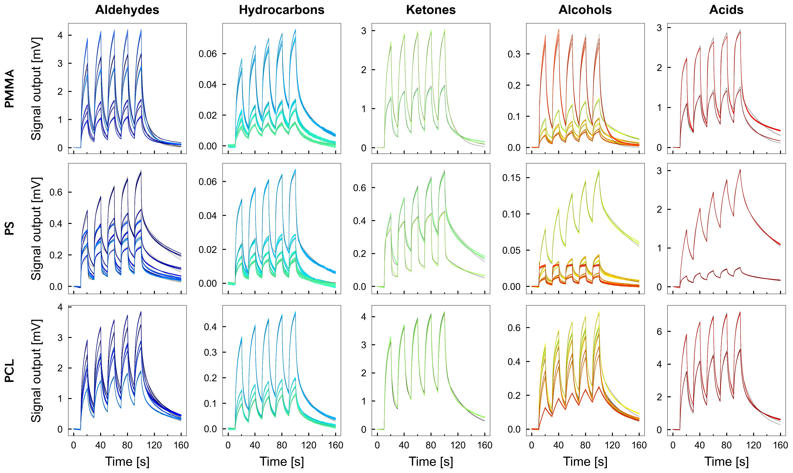
Figure 3. Typical signal responses of MSS to odorants. Signal responses of three different polymer-based MSS to odorants listed in Table 1 with the concentration of 30%.
EXPERIMENTAL SECTION
Materials. Poly(methyl methacrylate) (PMMA), polystyrene (PS), and polycaprolactone (PCL) used as receptor materials were purchased from Sigma-Aldrich Inc. N,N-Dimethylformamide (DMF) was purchased from Sigma-Aldrich Inc and used for preparation of coating layers. All liquid odorants listed in Table 1 were purchased from Sigma-Aldrich Inc., Tokyo Chemical Industry Co., Inc., Wako Pure Chemical Industry, Ltd., or Kanto Chemical Co., Inc.
Sensor preparation. The construction of the MSS chips and its working principle have been previously reported.^{31,37} Briefly, MSS consists of a silicon membrane suspended by four sensing beams, in which piezoresistors are embedded. The membrane is coated with a receptor material, which generates the surface stress caused by the sorption-induced expansion.
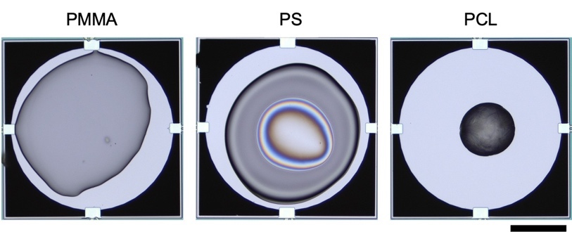 Figure 2. Optical microscope images of coating materials on MSS. A scale bar is 100 mm.
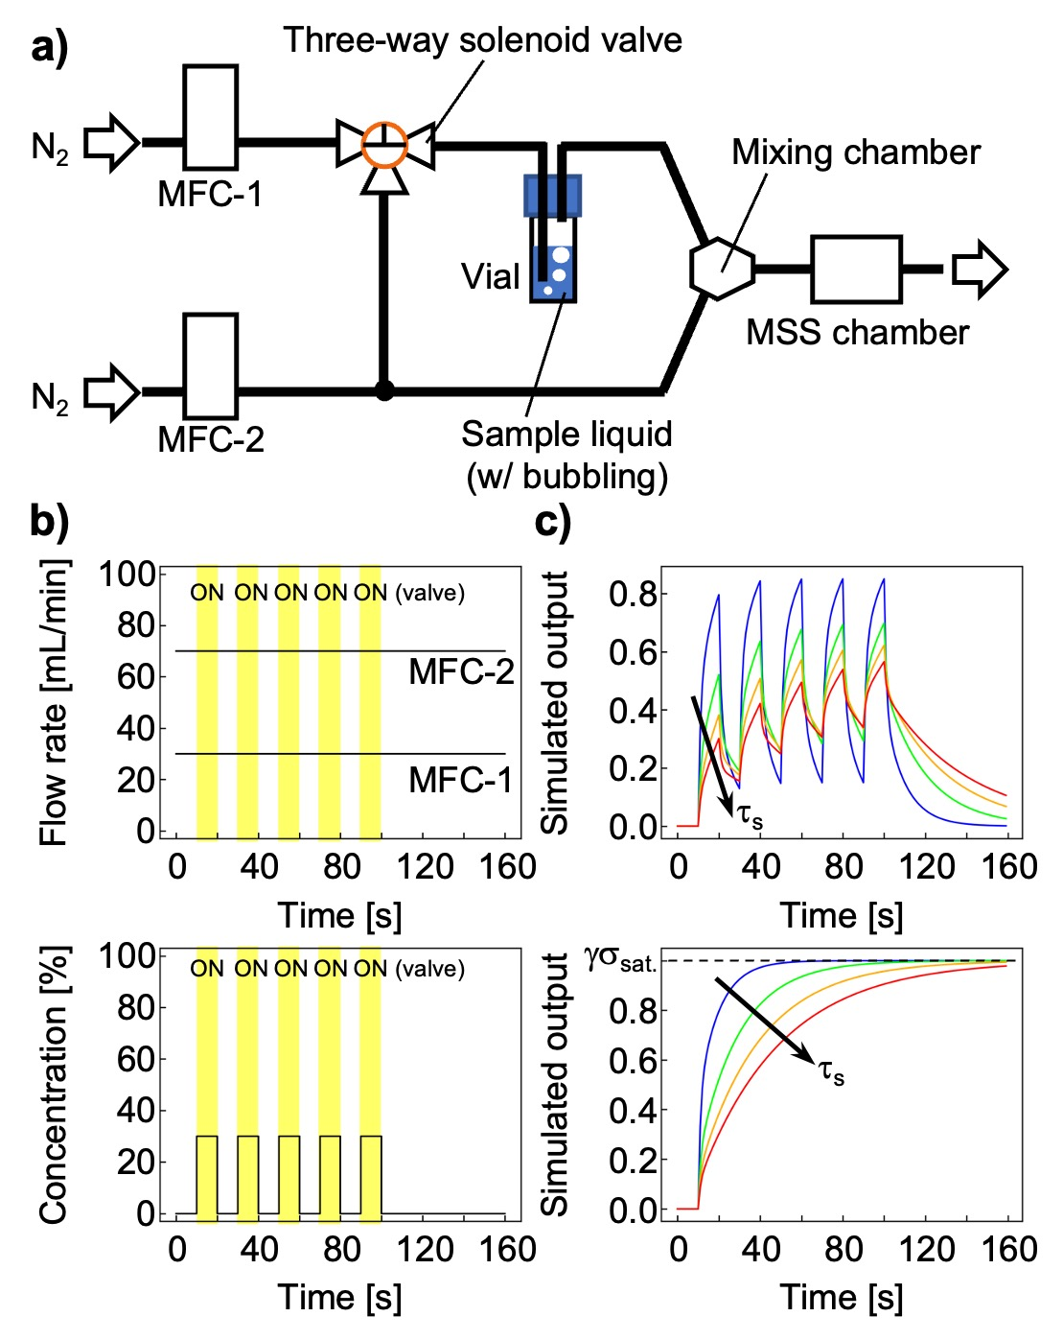Figure 1. Sensing system. a) Schematic illustration of sensing system. b) Gas flow rates of MFC-1 and MFC-2 (upper) and the corresponding concentration of P_{a}/P_{o} (bottom). Yellow-shaded areas are the solenoid valve turned on. c) The simulated signal output using Eq. (1). τ_{s} is varied with 10 (blue), 20 (green), 30 (orange), and 40 s (red), and other parameters are fixed; E_{U}/E_{R} = 5; τ_{r} = 1 [s]; γσ_{sat.} = 1; and t₀ = 10 [s]. Upper and bottom panels are five-cycle injection and single injection, respectively.
Materials were deposited directly onto the MSS membrane by inkjet spotting using an inkjet spotter (LaboJet-500SP, MICROJET Co. Ltd.) equipped with a nozzle (IJHBS-300, MICROJET Co. Ltd.). Each polymer was dissolved in DMF at the concentration of 1 mg/mL, and the resulting solutions were deposited onto each channel of the MSS. The injection speed and volume of a droplet were fixed at approx. 2 m/s and approx. 70 pL. The parameters allow the nozzle form single droplet in each shot and increase the reproducibility of the signal. The number of inkjet shots were 800, 400, and 300 shots for PMMA, PS, and PCL, respectively. The stage of the inkjet spotter was heated at 80°C to enhance the vaporization of DMF.
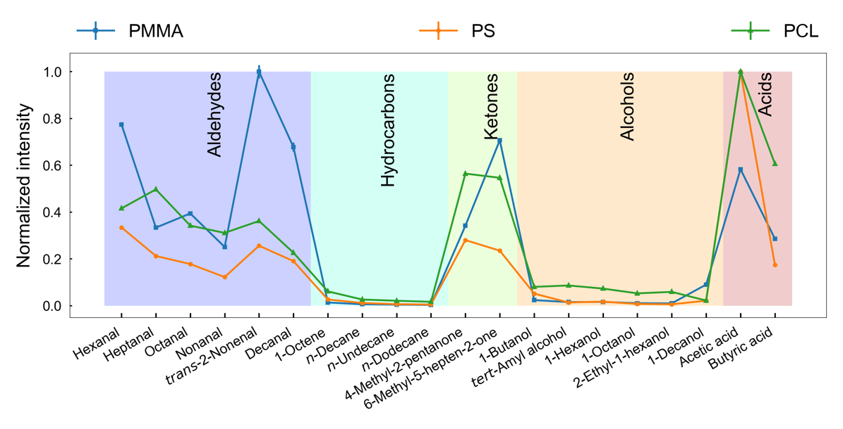
Figure 4. Trends of relative output voltages of the first injections for all 20 odorant vapors. Error bars are ± standard deviations (n = 3). The maximum intensity was set to 1.
Sensing system and procedure. The MSS chips were settled into a Teflon chamber and placed in an incubator with controlled temperature at 25.00 ± 0.02°C (Figure 1). The chamber was connected to a gas system consisting of two mass flow controllers (MFCs), a vial for a target sample liquid, a three-way solenoid valve, purge gas line, and a mixing chamber. In the injection process, the valve was switched to the line of MFC-1 and the vial, and carrier gas was bubbled to produce saturated vapor, which was then diluted to different concentration with purge gas by using MFC-2 (Figure 1b). In the purge process, the valve was switched to the line of MFC-1 and mixing chamber, and pure carrier gas from MFC-1 and MFC-2 directly purges the chamber. Pure nitrogen gas was used as carrier and purge gases (Figure 1b). The concentrations of the vapor were varied at P_{a}/P_{o} = 10%, 20%, 30% for aldehydes and 30% for other categories, where P_{a} and P_{o} stand for the partial vapor pressure and saturated vapor pressure of samples, respectively. Each odorant vapor was measured three times. Before measuring signal responses, pure nitrogen gas was introduced into the MSS chamber at least for 1 min. Subsequently, the injection/purge processes were measured for five cycles by switching the valve every 10 s, while maintaining total flow rate of 100 mL/min and constant flow rate for each MFC during the measurement of same concentration. The MSS measures electrically surface stress caused by gas sorption as a change in resistance of the piezoresistors embedded in the sensing beams (details are described in previous reports^{31,37}). Data were recorded with a bridge voltage of –1.0 V and a sampling rate of 100 Hz. The instrument control and data acquisition programs were designed using LabVIEW software (NI Corporation).
To measure signal responses under humidified conditions, another experiemntal setup was constructed (Figure S1a in the supplementary materials). A vial containing water was connected to the purge line and the relative humidity (RH) was controlled by using MFC-3. The relative humidity was varied at 20%, 40%, 60%, and 80%. The concentrations of sample vapors were varied at P_{a}/P_{o} = 10%, 15%, and 20% controlled by MFC-1. Total flow rate was fixed at 100 mL/min. The sequence of the flow rate of MFCs is shown in Figure S1b,c. Each odorant vapor was measured three times.
Identification of odorants. To identify each human body odor component, we used a method using sorption kinetic parameters that we established previously.³⁴ Sorption kinetic parameters were extracted from a signal response by curve-fitting using a theoretical model as follows:³³

$$σ\left(t\right)=\left\{\begin{matrix}0, & t<t_{0} \\ -σ_{\text{sat.}}+σ_{\text{sat.}}α\sum_{i=0}^{2(n-1)}{{\left(-1\right)}^{i}e^{-\frac{t-t_{i}}{τ_{s}}}}+σ_{\text{sat.}}\left(1-α\right)\sum_{i=0}^{2\left(n-1\right)}{{\left(-1\right)}^{i}e^{-\frac{t-t_{i}}{τ_{r}}}}, & t_{2(n-1)}≤t<t_{2n-1} \\ σ_{\text{sat.}}α\sum_{i=0}^{2n-1}{{\left(-1\right)}^{i}e^{-\frac{t-t_{i}}{τ_{s}}}}+σ_{\text{sat.}}\left(1-α\right)\sum_{i=0}^{2n-1}{{\left(-1\right)}^{i}e^{-\frac{t-t_{i}}{τ_{r}}}}, & t_{2n-1}≤t<t_{2n}\end{matrix}\right.,$$ | (1)

with
$$σ_{\text{sat.}}=\frac{1}{3}E_{R}K_{p}C_{g}v_{a},$$ | (2)
$$α=\frac{1}{τ_{s}}\left(\frac{E_{U}}{E_{R}}-\frac{τ_{s}}{τ_{r}}\right){\left(\frac{1}{τ_{s}}-\frac{1}{τ_{r}}\right)}^{-1},$$ | (3)
where E_{U}, E_{R}, and τ_{r} are the viscoelastic parameters derived from the simplest three-parameter solid model and denote the unrelaxed (instantaneous) modulus, the relaxed (asymptotic) modulus, and the time constant of stress relaxation, respectively; τ_{s} and K_{p} are the time constant of diffusion and the partition coefficient, respectively; C_{g} and ν_{a} are the concentration of gas species introduced in sensor element and the specific volume of target analyte, respectively.³⁸ The larger τ_{s} corresponds to the slower signal (Figure 1c). To extract the time constant of diffusion τ_{s} and saturated signal intensity γσ_{sat.} from signal responses (where γ is the proportional factor for signal response to convert the induced stress to the measured sensing signal),³³ we used least squares methods with trust region reflective algorithm using Python 3 with SciPy module. Details are described in previous report.³³
To compare the sorption kinetic parameter-based analysis with an empirical feature extraction, we performed PCA using two distinct feature sets: one is extracted from raw signal outputs, i.e., non-normalized; the other is extracted from normalized signal outputs. The feature extraction process of non-normalized signal has been detailed in previous report.²⁹ Briefly, four parameters were extracted as follows:
$$P_{1}=\frac{V\left(t_{1}\right)-V\left(t_{0}\right)}{t_{1}-t_{0}},$$ | (4)
$$P_{2}=\frac{V\left(t_{2}\right)-V\left(t_{1}\right)}{t_{2}-t_{1}} ,$$ | (5)
$$P_{3}=\frac{V\left(t_{3}\right)-V\left(t_{2}\right)}{t_{3}-t_{2}},$$ | (6)
$$P_{4}=V\left(t_{2}\right)-V\left(t_{0}\right),$$ | (7)
where V(t_{n}) represents the signal output at corresponding time t_{n}; t₀ represents the time when the injection starts. In this study, we chose t_{n} as follows: t₁ = t₀ + 1 [s], t₂ = t₀ + 10 [s], and t₃ = t₀ + 11 [s]. For the normalized feature set, three parameters were extracted as follows:
$$P_{1}^{'}={P_{1}}/{P_{4}},$$ | (8)
$$P_{2}^{'}={P_{2}}/{P_{4}},$$ | (9)
$$P_{3}^{'}={P_{3}}/{P_{4}}.$$ | (10)
The features of two PCA were extracted from the signal responses of three polymers of 5th injection-purge cycle measured by MSS.
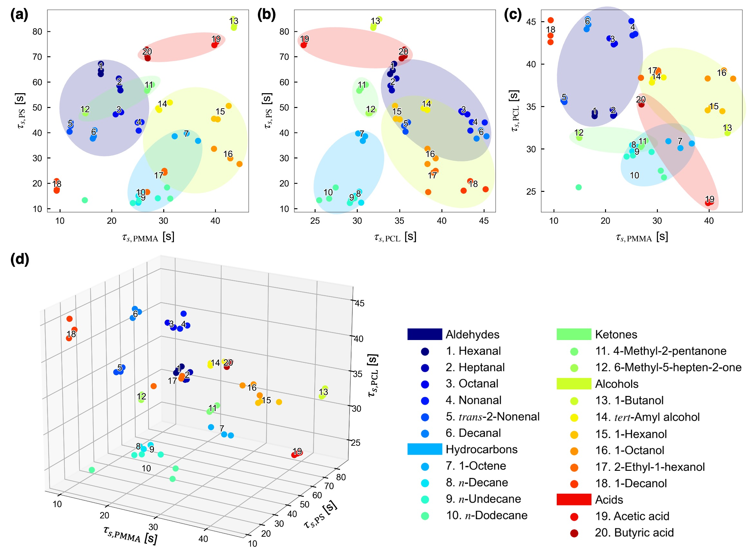
Figure 5. Plots of diffusion time constants τ_{s} obtained from two different polymers. a–c) Plots of τ_{s,PMMA} and τ_{s,PS} (a); τ_{s,PCL} and τ_{s,PS} (b); τ_{s,PMMA} and τ_{s,PCL} (c). d) Three-dimensional plots of τ_{s,PMMA}, τ_{s,PCL}, and τ_{s,PS}.
RESULTS AND DISCUSSION
Odorant sensing properties of polymers coated on MSS. To investigate the sensing performances of polymers for detection of odorants listed in Table 1, three different polymers were coated on each surface of the MSS membrane by the inkjet spotting. The polymers have different chemical properties, such as polar hydrophilic (PMMA), nonpolar hydrophobic (PS), and polar hydrophobic nature (PCL), which are expected to show a different chemical selectivity to each odorant. The sensor surface was covered with the coating layer as confirmed by an optical microscope (Figure 2).
The resulting MSS chip coated with these polymers was then exposed to 20 liquid odorant vapors, which are reported as chemical compositions in human body odor⁵ as listed in Table 1. Since the trends in odor intensity of the chemical sensors including MSS are relative to the vapor pressure of odorants,^{27,39} the concentration of the odorants in Table 1 was used in this study as relative vapor pressure, i.e., P_{a}/P_{o} (see also Experimental Section). Figure 3 shows a typical sensing signal of polymer coated MSS and all measured signal responses are found in Figures S2–S4 in Supplementary materials. Upon exposure to odorant vapor, output voltage increased since each receptor material absorbs the target gas molecules and then swells, resulting in deformation of the MSS membrane.³¹ The chemical selectivity in terms of signal intensity is summarized in Figure 4 (see also Figure S5). While several trends are observed for the series of linear chemicals, the branched and unsaturated species often show different trends (Figure S5), possibly reflecting differences in various affinities, such as hydrophilicity and aromatic π interactions. As each polymer shows different chemical selectivity, the combination of the present polymers should possess a sufficient discrimination capability.
Identification of odorants. To identify odorous molecules of human body odor, we applied the direct discrimination using physical parameter estimation, that is, sorption kinetic parameters obtained from the analytical model of nanomechanical sensing in Eq. (1).^{33–35} We performed curve-fitting to each signal response in Figure 3 and estimate the sorption kinetic parameter (i.e., τ_{s} and γσ_{sat.}) and viscoelastic parameters (i.e., E_{U}/E_{R} and τ_{r}). The parameters are summarized in Table 2. As shown in Figures S2–S4, the signal responses are well fit with the theoretical model in Eq. (1).
Among the estimated parameters, the diffusion time constant τ_{s} is informative for odorant identification because it reflects the sorption behavior of each odorant to the selected receptor.^{32,38} We demonstrate the identification of odorants by simply plotting two different diffusion time constants τ_{s} obtained from two of the three polymers as shown in Figure 5. As listed in Table 2, the trends of the diffusion time constant for each receptor material are different, reflecting their different chemical properties, such as hydrophilicity and polarity. Plots of each odorant listed Table 1 form well-separated clusters in two τ_{s} planes as well as three-dimensional τ_{s} space (Figure 5). Most categories form clusters by simply plotting two sorption kinetic parameters in Figure 5,³⁴ except 1-decanol, which is plotted far from other alcohols in Figure 5a,c. This is possibly due to the low vapor concentration of 1-decanol (around 1.5 part per million (ppm) calculated by Antoine equation⁴⁰), which resulted in the fast response derived from the surface adsorption-induced expansion.
Identification of 2-nonenal as an aging marker. Since 2-nonenal is known as an aging marker,⁵ 2-nonenal is one of the important detection targets. 2-Nonenal is α,β-unsaturated aldehydes, and hence the reactivity to the receptor materials used in this work should be different from other saturated aldehydes. Figure 6a–c shows the signal outputs to saturated nonanal and unsaturated 2-nonenal. As shown in Figure 6a, trans-2-nonenal responds to PMMA with approximately four times higher intensity than that of nonanal, possibly due to the different polarity of trans-2-nonenal and nonanal. PCL, on the other hand, does not show such clearly different responses because of its lower polarity than PMMA (Figure 6b). In terms of the diffusion time constant, trans-2-nonenal showed smaller τ_{s} for the polar polymers (Table 2). Compared to PMMA and PCL, PS is non-polar or less polar polymer, whereas its response to trans-2-nonenal is stronger than nonanal with respect to the intensity (i.e., γσ_{sat.} = 0.74 [mV] for trans-2-nonenal and γσ_{sat.} = 0.45 [mV] for nonanal; see also Table 2). It is probably because the delocalized π-electrons on the α,β-unsaturated aldehydes interact with the aromatic PS substituents. The diffusion time constants of trans-2-nonenal and nonanal for PS exhibit similar values, therefore, PS is not suitable for discriminating trans-2-nonenal and nonanal in the present approach as can be seen in Figure 6d,e. It should be noted that the use of two sorption kinetic parameters including PS allows us to clearly identify each aldehydes including different carbon numbers because of the different cross reactivity of the receptor materials (Figure 6d–f).
Importantly, the sensing signal amplitude-related parameter γσ_{sat.} is concentration dependent while the affinity-related parameter τ_{s} is theoretically independent of the concentration in Eq. (1). Therefore, the parameters obtained from Eq. (1) are expected to allow us to identify not only the gas species with different concentration but also their concentration without multivariate analyses. We further investigated the identification of aldehydes including trans-2-nonenal with varying concentrations of 10%, 20%, and 30% (Figure 7a,b; see also Figure S6). The fitting results are shown in Figure 7c,d. As can be seen in Figure 7e,f, the amplitude-related parameter γσ_{sat.} is linearly correlated with the concentrations (see also Figures S7–S9). Figure 7g shows the plots of τ_{s,PMMA} and τ_{s,PS}, which denote the diffusion time constants obtained from PMMA and PS, respectively. Each aldehyde, even with different concentrations, can be seen to plot well-separated clusters on the graph (Figure 7g). This result indicates that the present approach successfully identifies the odorant species as well as their concentrations.
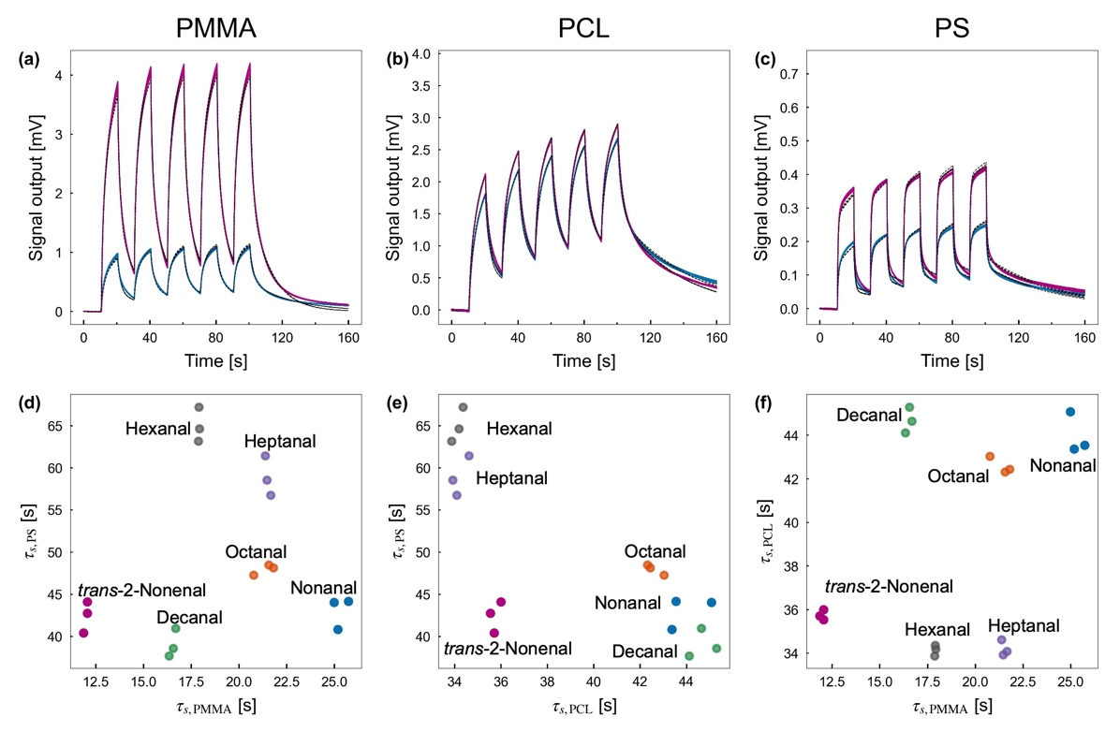
Figure 6. Discrimination of 2-nonenal from other aldehydes. a–c) the signal responses of PMMA (a), PCL (b), and PS (c) to 2-nonenal (pink) and nonanal (blue). Dashed lines are the results of curve fitting. d–f) Plots of τ_{s,PMMA} and τ_{s,PS} (d); τ_{s,PCL} and τ_{s,PS} (e); τ_{s,PMMA} and τ_{s,PCL} (f).
For comparison with the present approach, we also performed PCA using two different feature sets; one extracted from raw signal outputs and the other extracted from normalized signal output (detailed feature extraction can be found in Experimental Section). Latter features might be expected to reduce the effects of concentrations. Figure 7h,i shows the plots of the corresponding PCA results. As expected, using the features extracted from the raw signal outputs in Eqs. (4)–(7), a significant concentration dependency is observed for PC1 (75.6%) as well as PC2 (18.7%) (Figure 7h). By normalizing the signal outputs in Eqs. (8)–(10), the concentration dependency can be reduced as shown in Figure 7i; however, the discrimination performance is also decreased. It should be noted that the pattern recognition-based analysis (e.g., PCA) is not suitable to measure certain quantities such as concentration without applying machine learning approaches. These results clearly revealed that the present approach provides a powerful method to directly identify the odorants as well as to measure their concentrations.
Tolerance under humidified condition. Since the body odor contains water vapor, humidity interference is always a challenge in gas sensing.⁴¹ To investigate the humidity interference, we constructed an experimental setup for measuring signal responses in humidified environment (Figure S1). The MSS chip was exposed to nonanal and trans-2-nonenal at the concentration of 10–20% under 20–80%RH. The sensing signals to nonanal and trans-2-nonenal under different relative humidity are shown in Figure S10. Higher relative humidity results in higher baseline, while the sensing signals tend to be similar to those at 0%RH (see also Figures S11 and S12). This is because sensing signal of nanomechanical sensors in static mode operation is obtained from sorption-induced expansion,^{20,42} which is governed by sorption kinetics³² as long as the absorbed molecules including water does not exceed the capacity of receptor materials. It should be noted that the signal responses of PMMA to aldehydes fluctuated significantly under the humidified conditions because PMMA has hydrophilic nature and is sensitive to water.⁴³ This led to poor fitting results. Therefore, PCL and PS results will be discussed below.
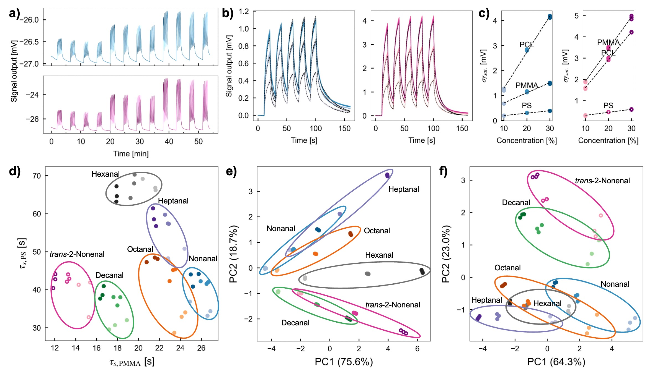
Figure 7. Discrimination of 2-nonenal from other aldehydes with quantification of their concentration. a) Signal responses of PMMA to nonanal (top) and trans-2-nonenal (bottom) with three different concentrations of 10%, 20%, and 30%. Other responses are shown in Figure S6. b) Fitting results of PMMA to nonanal (left) and PMMA to trans-2-nonenal (right). c) Plots of γσ_{sat.} of nonanal (left) and trans-2-nonenal (right) as a function of vapor concentration. Other aldehydes are shown in Figures S7–S9. d) Plots of τ_{s,PMMA} and τ_{s,PS} obtained from the aldehydes with three different concentrations of 10%, 20%, and 30%. Color gradients indicate the different concentration. e,f) PCA score plots of aldehydes using features extracted from the raw signal (e) and the normalized signal (f).
To investigate the influence of the humidity for discrimination, we performed curve-fitting to estimate τ_{s} and γσ_{sat.} with different relative humidity. The fitting results are shown in Figures S11 and S12. The diffusion time constant τ_{s} was plotted as a function of relative humidity in Figure 8a. As can be seen, τ_{s} is little influenced by the humidity interference. By applying the direct discrimination approach using sorption kinetic parameters, 2-nonenal can be distinguished from nonanal, even if the signals obtained under different humidity ranging from 0% to 80% (Figure 8b). Moreover, the amplitude-related parameter γσ_{sat.} is linearly correlated to the concentrations of 10%, 15%, and 20% in all relative humidity (Figures S13 and S14). This result suggests that the direct discrimination using sorption kinetic parameters has high tolerance to the humidity interference.
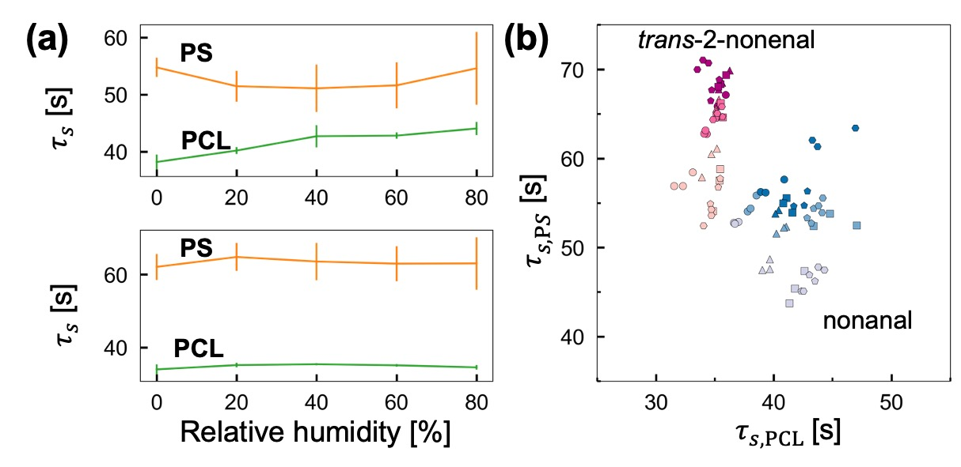
Figure 8. Discrimination of 2-nonenal from nonanal in humidified environment. a) Plots of τ_{s} of nonanal (top) and trans-2-nonenal (bottom) as a function of relative humidity. b) Plots of τ_{s,PCL} and τ_{s,PS} obtained from nonanal and trans-2-nonenal with three different concentrations of 10%, 15%, and 20% under four different relative humidity. Color gradients indicate the different concentration. Markers: circles, 0%RH; triangles, 20%RH; squares, 40%RH; pentagons, 60%RH; and hexagons, 80%RH.
CONCLUSION
We have demonstrated that an MSS array can identify and quantify 20 human body odor components by using sorption kinetic parameters estimated by a simple curve fitting. The sorption kinetic parameters in the theoretical model of the nanomechanical sensors in Eq. (1) can be utilized for both identifying and quantifying human body odor components; the diffusion time constant τ_{s} for identification and the intensity γσ_{sat.} for quantification. Since the sorption kinetic parameters τ_{s} and γσ_{sat.} used in this study contain chemical affinity and concentration-related term, respectively, this study provides the efficient method to identify and quantify odorants. In addition, we achieved the discrimination of 2-nonenal from nonanal even under various humidity, indicating the high tolerance of this approach to the humidity interference. Although actual body odor samples are composed of complex mixture of the components at various concentrations with other interfering gases, and thus require further development of sensing performance, this study demonstrates the basic potential towards the identification of body odors in terms of sorption kinetics.
ASSOCIATED CONTENT
Supporting Information
The Supporting Information is available free of charge on the ACS Publications website.
Experimental setup for measuring humidified conditions; all signal responses of PMMA, PS, and PCL to 20 vapors; signal responses of PMMA, PS, and PCL to 6 aldehydes with different concentrations; signal responses of PMMA, PS, and PCL to nonanal and trans-2-nonenal under humidified condition. (PDF)
AUTHOR INFORMATION
Corresponding Authors
Kosuke Minami – Research Center for Macromolecules and Biomaterials, National Institute for Materials Science (NIMS), 1-1 Namiki, Tsukuba, Ibaraki 305-0044 Japan; International Center for Young Scientists (ICYS), National Institute for Materials Science (NIMS), 1-1 Namiki, Tsukuba, Ibaraki 305-0044 Japan; https://orcid.org/0000-0003-4145-1118; Email: MINAMI.Kosuke@nims.go.jp
Genki Yoshikawa – Research Center for Macromolecules and Biomaterials, National Institute for Materials Science (NIMS), 1-1 Namiki, Tsukuba, Ibaraki 305-0044 Japan; Materials Science and Engineering, Graduate School of Pure and Applied Science, University of Tsukuba, 1-1-1 Tennodai, Tsukuba, Ibaraki 305-8571, Japan; https://orcid.org/0000-0002-9136-8964; Email: YOSHIKAWA.Genki@nims.go.jp
Authors
Yingzheng Zhou – Materials Science and Engineering, Graduate School of Pure and Applied Science, University of Tsukuba, 1-1-1 Tennodai, Tsukuba, Ibaraki 305-8571, Japan; Research Center for Macromolecules and Biomaterials, National Institute for Materials Science (NIMS), 1-1 Namiki, Tsukuba, Ibaraki 305-0044 Japan; https://orcid.org/0000-0002-6999-4897
Gaku Imamura – Research Center for Macromolecules and Biomaterials, National Institute for Materials Science (NIMS), 1-1 Namiki, Tsukuba, Ibaraki 305-0044 Japan; Graduate School of Information Science and Technology, Osaka University, 1-2 Yamadaoka, Suita, Osaka 565-0871 Japan; https://orcid.org/0000-0002-3130-7190
Kota Shiba – Research Center for Macromolecules and Biomaterials, National Institute for Materials Science (NIMS), 1-1 Namiki, Tsukuba, Ibaraki 305-0044 Japan; https://orcid.org/0000-0001-7775-0318
Author Contributions
K.M. and G.Y. conceived and designed the research; K.M. and Y.Z. performed experiments, validation, formal analysis, and investigation; K.M. and Y.Z. wrote an original draft and graphical artworks; G.I., K.S., and G.Y. reviewed and edited the manuscript. All authors have read and agreed to the published version of the manuscript.
∥ These authors contributed equally to this work.
Funding Sources
This study was financially supported by a Grant-in-Aid for Scientific Research (A), JSPS, MEXT, Japan (No. 18H04168); a Grant-in-Aid for Scientific Research (B), JSPS, MEXT, Japan (No. 21H01971); a Grant-in-Aid for Scientific Research (C), JSPS, MEXT, Japan (No. 22K05324); a Grant-in-Aid for Challenging Research (Pioneering), JSPS, MEXT, Japan (No. 20K20554); a Grant-in-Aid for Challenging Research (Exploratory), JSPS, MEXT, Japan (No. 21K18859); Fund for the Promotion of Joint International Research, International Collaborative Research, JSPS, MEXT, Japan (No. JP19KK0141); the Public/Private R&D Investment Strategic Expansion Program (PRISM), Cabinet Office, Japan; ICYS, NIMS; and Center for Functional Sensor & Actuator (CFSN), NIMS.
Notes
The authors declare no conflict of interest.
ACKNOWLEDGMENT
K.M. acknowledges the International Center for Young Scientists (ICYS) program, NIMS. Y.Z. thanks NIMS Junior program, NIMS.
REFERENCES
(1) Zeng, X. N.; Leyden, J. J.; Lawley, H. J.; Sawano, K.; Nohara, I.; Preti, G., Analysis of characteristic odors from human male axillae. J. Chem. Ecol. 1991, 17, 1469–1492. 10.1007/BF00983777
(2) Inaba, M.; Inaba, Y., Human Body Odor: etiology, treatment, and related factors. Springer-Verlag: New York, 1992. 10.1007/978-4-431-66908-1
(3) Yamazaki, S.; Hoshino, K.; Kusuhara, M., Odor Associated with Aging. Anti-Aging Med. 2010, 7, 60–65. 10.3793/jaam.7.60
(4) Kanda, F.; Yagi, E.; Fukuda, M.; Nakajima, K.; Ohta, T.; Nakata, O., Elucidation of chemical compounds responsible for foot malodour. Br. J. Dermatol. 1990, 122, 771–776. 10.1111/j.1365-2133.1990.tb06265.x
(5) Haze, S.; Gozu, Y.; Nakamura, S.; Kohno, Y.; Sawano, K.; Ohta, H.; Yamazaki, K., 2-Nonenal newly found in human body odor tends to increase with aging. J. Invest. Dermatol. 2001, 116, 520–544. 10.1046/j.0022-202x.2001.01287.x
(6) Murata, T.; Rahardjo, A.; Fujiyama, Y.; Yamaga, T.; Hanada, M.; Yaegaki, K.; Miyazaki, H., Development of a compact and simple gas chromatography for oral malodor measurement. J. Periodontol. 2006, 77, 1142-1147. 10.1902/jop.2006.050388
(7) Martinez-Lozano, P.; Fernandez de la Mora, J., Direct analysis of fatty acid vapors in breath by electrospray ionization and atmospheric pressure ionization-mass spectrometry. Anal. Chem. 2008, 80, 8210–8215. 10.1021/ac801185e
(8) Grice, E. A.; Kong, H. H.; Conlan, S.; Deming, C. B.; Davis, J.; Young, A. C.; Program, N. C. S.; Bouffard, G. G.; Blakesley, R. W.; Murray, P. R.; Green, E. D.; Turner, M. L.; Segre, J. A., Topographical and temporal diversity of the human skin microbiome. Science 2009, 324, 1190–1192. 10.1126/science.1171700
(9) Davis, C. E.; Bogan, M. J.; Sankaran, S.; Molina, M. A.; Loyola, B. R.; Zhao, W. X.; Benner, W. H.; Schivo, M.; Farquar, G. R.; Kenyon, N. J.; Frank, M., Analysis of Volatile and Non-Volatile Biomarkers in Human Breath Using Differential Mobility Spectrometry (DMS). IEEE Sens. J. 2010, 10, 114–122. 10.1109/Jsen.2009.2033562
(10) Wang, C. J.; Mbi, A.; Shepherd, M., A Study on Breath Acetone in Diabetic Patients Using a Cavity Ringdown Breath Analyzer: Exploring Correlations of Breath Acetone With Blood Glucose and Glycohemoglobin A1C. IEEE Sens. J. 2010, 10, 54–63. 10.1109/Jsen.2009.2035730
(11) Szulejko, J. E.; McCulloch, M.; Jackson, J.; McKee, D. L.; Walker, J. C.; Solouki, T., Evidence for Cancer Biomarkers in Exhaled Breath. IEEE Sens. J. 2010, 10, 185–210. 10.1109/Jsen.2009.2035669
(12) Jha, S. K.; Marina, N.; Liu, C.; Hayashi, K., Human body odor discrimination by GC-MS spectra data mining. Anal. Methods 2015, 7, 9549–9561. 10.1039/c5ay02457a
(13) Persaud, K.; Dodd, G., Analysis of discrimination mechanisms in the mammalian olfactory system using a model nose. Nature 1982, 299, 352–355. 10.1038/299352a0
(14) Manzini, I.; Schild, D.; Di Natale, C., Principles of odor coding in vertebrates and artificial chemosensory systems. Physiol. Rev. 2022, 102, 61–154. 10.1152/physrev.00036.2020
(15) Albert, K. J.; Lewis, N. S.; Schauer, C. L.; Sotzing, G. A.; Stitzel, S. E.; Vaid, T. P.; Walt, D. R., Cross-reactive chemical sensor arrays. Chem. Rev. 2000, 100, 2595–2626. 10.1021/cr980102w
(16) Bai, H.; Shi, G., Gas sensors based on conducting polymers. Sensors 2007, 7, 267–307. 10.3390/s7030267
(17) Lange, U.; Roznyatovskaya, N. V.; Mirsky, V. M., Conducting polymers in chemical sensors and arrays. Anal. Chim. Acta 2008, 614, 1–26. 10.1016/j.aca.2008.02.068
(18) Gutierrez, J.; Horrillo, M. C., Advances in artificial olfaction: sensors and applications. Talanta 2014, 124, 95–105. 10.1016/j.talanta.2014.02.016
(19) Lv, A.; Pan, Y.; Chi, L., Gas Sensors Based on Polymer Field-Effect Transistors. Sensors 2017, 17, 213. 10.3390/s17010213
(20) Minami, K.; Imamura, G.; Tamura, R.; Shiba, K.; Yoshikawa, G., Recent Advances in Nanomechanical Membrane-Type Surface Stress Sensors towards Artificial Olfaction. Biosensors 2022, 12, 762. 10.3390/bios12090762
(21) Di Natale, C.; Macagnano, A.; Paolesse, R.; Tarizzo, E.; Mantini, A.; D'Amico, A., Human skin odor analysis by means of an electronic nose. Sens. Actuators B: Chem. 2000, 65, 216–219. 10.1016/s0925-4005(99)00313-5
(22) Jha, S. K.; Hayashi, K., Polyacrylic acid polymer and aldehydes template molecule based MIPs coated QCM sensors for detection of pattern aldehydes in body odor. Sens. Actuators B: Chem. 2015, 206, 471–487. 10.1016/j.snb.2014.09.102
(23) Jha, S. K.; Liu, C.; Hayashi, K., Molecular imprinted polyacrylic acids based QCM sensor array for recognition of organic acids in body odor. Sens. Actuators B: Chem. 2014, 204, 74–87. 10.1016/j.snb.2014.07.098
(24) Wongchoosuk, C.; Lutz, M.; Kerdcharoen, T., Detection and classification of human body odor using an electronic nose. Sensors 2009, 9, 7234–7249. 10.3390/s90907234
(25) Jha, S. K.; Yadava, R. D. S., Designing Optimal Surface Acoustic Wave Electronic Nose for Body Odor Discrimination. Sens. Lett. 2011, 9, 1612–1622. 10.1166/sl.2011.1740
(26) Jha, S. K., Molecular Imprinted Polymers for Sensing of Volatile Organic Compounds in Human Body Odor. In Advanced Molecularly Imprinting Materials, 2016; pp 561–636.
(27) Minami, K.; Shiba, K.; Yoshikawa, G., Discrimination of structurally similar odorous molecules with various concentrations by using a nanomechanical sensor. Anal. Methods 2018, 10, 3720–3726. 10.1039/c8ay01224e
(28) Ngo, H. T.; Minami, K.; Imamura, G.; Shiba, K.; Yoshikawa, G., Effects of Center Metals in Porphines on Nanomechanical Gas Sensing. Sensors 2018, 18, 1640. 10.3390/s18051640
(29) Shiba, K.; Tamura, R.; Imamura, G.; Yoshikawa, G., Data-driven nanomechanical sensing: specific information extraction from a complex system. Sci. Rep. 2017, 7, 3661. 10.1038/s41598-017-03875-7
(30) Shiba, K.; Tamura, R.; Sugiyama, T.; Kameyama, Y.; Koda, K.; Sakon, E.; Minami, K.; Ngo, H. T.; Imamura, G.; Tsuda, K.; Yoshikawa, G., Functional Nanoparticles-Coated Nanomechanical Sensor Arrays for Machine Learning-Based Quantitative Odor Analysis. ACS Sens. 2018, 3, 1592–1600. 10.1021/acssensors.8b00450
(31) Yoshikawa, G.; Akiyama, T.; Gautsch, S.; Vettiger, P.; Rohrer, H., Nanomechanical membrane-type surface stress sensor. Nano Lett. 2011, 11, 1044–1048. 10.1021/nl103901a
(32) Wenzel, M. J.; Josse, F.; Heinrich, S. M.; Yaz, E.; Datskos, P. G., Sorption-induced static bending of microcantilevers coated with viscoelastic material. J. Appl. Phys. 2008, 103, 064913. 10.1063/1.2902500
(33) Minami, K.; Shiba, K.; Yoshikawa, G., Sorption-induced static mode nanomechanical sensing with viscoelastic receptor layers for multistep injection-purge cycles. J. Appl. Phys. 2021, 129, 124503. 10.1063/5.0039045
(34) Imamura, G.; Shiba, K.; Yoshikawa, G.; Washio, T., Analysis of nanomechanical sensing signals; physical parameter estimation for gas identification. AIP Adv. 2018, 8, 075007. 10.1063/1.5036686
(35) Minami, K.; Shiba, K.; Imamura, G.; Yoshikawa, G., Identification of gas species and their concentrations by using sorption kinetics of viscoelastic film. In 2022 IEEE International Symposium on Olfaction and Electronic Nose (ISOEN), IEEE: Aveiro, Portugal, 2022; pp 1–4.
(36) Gozu, Y.; Haze, S.; Nakamura, S.; Kohno, Y.; Fukui, H.; Kumano, Y.; Sawano, K.; Ohta, H.; Yamazaki, K., Development of Care-Products to Prevent Aged Body Odor. J. Soc. Cosmet. Chem. Jpn. 2000, 34, 379-386. 10.5107/sccj.34.379
(37) Yoshikawa, G.; Akiyama, T.; Loizeau, F.; Shiba, K.; Gautsch, S.; Nakayama, T.; Vettiger, P.; de Rooij, N. F.; Aono, M., Two dimensional array of piezoresistive nanomechanical Membrane-type Surface Stress Sensor (MSS) with improved sensitivity. Sensors 2012, 12, 15873–15887. 10.3390/s121115873
(38) Hu, Z.; Thundat, T.; Warmack, R. J., Investigation of adsorption and absorption-induced stresses using microcantilever sensors. J. Appl. Phys. 2001, 90, 427–431. 10.1063/1.1378333
(39) Doleman, B. J.; Severin, E. J.; Lewis, N. S., Trends in odor intensity for human and electronic noses: relative roles of odorant vapor pressure vs. molecularly specific odorant binding. Proc. Natl. Acad. Sci. U. S. A. 1998, 95, 5442–5447. 10.1073/pnas.95.10.5442
(40) Yaws, C. C., The Yaws Handbook of Vapor Pressure, Antoine Coefficients. 2 ed.; Springer: New York, 2015.
(41) Potyrailo, R. A., Multivariable Sensors for Ubiquitous Monitoring of Gases in the Era of Internet of Things and Industrial Internet. Chem. Rev. 2016, 116, 11877–11923. 10.1021/acs.chemrev.6b00187
(42) Ruz, J. J.; Malvar, O.; Gil-Santos, E.; Ramos, D.; Calleja, M.; Tamayo, J., A Review on Theory and Modelling of Nanomechanical Sensors for Biological Applications. Processes 2021, 9, 164. 10.3390/pr9010164
(43) Minami, K.; Kobayashi, H.; Matoba, M.; Kamiya, Y.; Maji, S.; Nemoto, T.; Tohno, M.; Nakakubo, R.; Yoshikawa, G., Measurement of Volatile Fatty Acids in Silage through Odors with Nanomechanical Sensors. Biosensors 2023, 13, 152. 10.3390/bios13020152

Table 1. List of chemicals in human body odor and their saturated vapor pressures.
Chemicals | P_{sat.} ¹  [mmHg] | C_{sat.} ²  [ppm] | Chemicals | P_{sat.} ¹  [mmHg] | C_{sat.} ²  [ppm]
Aldehydes |  |  | Ketones
Hexanal | 10.6 | 13900 | 4-Methyl-2-pentanone | 17.3 | 22800
Heptanal | 1.99 | 2620 | 6-Methyl-5-hepten-2-one | 2.55 | 3350
Octanal | 0.724 | 953 | Alcohols
Nonanal | 0.162 | 214 | 1-Butanol | 6.60 | 8680
trans-2-Nonenal | 0.215 | 283 | tert-Amyl alcohol | 3.12 | 4100
Decanal | 0.0763 | 100 | 1-Hexanol | 1.25 | 1650
Hydrocarbons |  |  | 1-Octanol | 0.105 | 138
1-Octene | 18.0 | 23700 | 2-Ethyl-1-hexanol | 0.232 | 305
n-Decane | 0.792 | 2100 | 1-Decanol | 0.0112 | 14.8
n-Undecane | 0.189 | 558 | Acids
n-Dodecane | 0.0625 | 196 | Acetic acid | 8.38 | 11000
 |  |  | Butyric acid | 1.01 | 1330
¹ Saturated vapor pressure (P_{sat.}) at 25 °C were estimated by using Antoine equation.⁴⁰
² Saturated vapor concentration (C_{sat.}) at 25 °C calculated from the saturated vapor pressure.

Table 2. The optimized sorption kinetic parameters and viscoelastic parameters in Eq. (1) for each odorant/polymer combination.
Chemicals | PMMA |  |  |  | PCL |  |  |  | PS
Chemicals | γσ_{sat.}  [mV] | τ_{s}  [s] | τ_{r}  [s] | E_{U}/E_{R} | γσ_{sat.}  [mV] | τ_{s}  [s] | τ_{r}  [s] | E_{U}/E_{R} | γσ_{sat.}  [mV] | τ_{s}  [s] | τ_{r}  [s] | E_{U}/E_{R}
Hexanal | 4.17 | 17.90 | 1.74 | 4.99 | 5.17 | 34.14 | 2.33 | 4.73 | 1.32 | 65.00 | 0.82 | 19.12
Heptanal | 1.94 | 21.50 | 1.67 | 5.85 | 5.36 | 34.21 | 1.74 | 7.68 | 0.81 | 58.91 | 0.69 | 25.67
Octanal | 2.20 | 21.38 | 1.84 | 5.99 | 4.37 | 42.60 | 2.06 | 6.75 | 0.56 | 47.96 | 0.64 | 25.79
Nonanal | 1.49 | 25.30 | 1.74 | 5.52 | 4.14 | 44.00 | 2.57 | 5.75 | 0.38 | 43.02 | 0.82 | 18.99
trans-2-Nonenal | 4.91 | 11.99 | 1.38 | 4.25 | 4.22 | 35.75 | 2.63 | 5.27 | 0.58 | 42.42 | 0.52 | 39.33
Decanal | 3.50 | 16.52 | 1.74 | 4.85 | 2.96 | 44.69 | 2.77 | 5.59 | 0.43 | 39.08 | 0.56 | 32.87
1-Octene | 0.10 | 34.42 | 1.62 | 7.89 | 0.61 | 30.55 | 1.57 | 8.16 | 0.09 | 38.37 | 1.06 | 15.56
n-Decane | 0.04 | 25.47 | 1.79 | 4.22 | 0.27 | 30.14 | 1.75 | 7.04 | 0.03 | 14.72 | 0.64 | 9.06
n-Undecane | 0.04 | 26.09 | 2.08 | 3.22 | 0.23 | 29.33 | 2.13 | 5.57 | 0.02 | 13.22 | 0.64 | 7.81
n-Dodecane | 0.02 | 25.58 | 6.86 | 2.30 | 0.19 | 26.53 | 2.64 | 3.83 | 0.02 | 15.24 | 0.80 | 7.40
4-Methyl-2-pentanone | 2.13 | 27.19 | 1.55 | 7.72 | 5.75 | 30.55 | 1.49 | 8.29 | 1.23 | 57.69 | 1.15 | 11.78
6-Methyl-5-hepten-2-one | 3.68 | 14.83 | 1.49 | 4.83 | 5.69 | 31.57 | 1.84 | 7.07 | 0.65 | 48.08 | 0.55 | 37.75
1-Butanol | 0.25 | 43.52 | 1.70 | 6.29 | 0.83 | 32.14 | 1.62 | 8.08 | 0.35 | 82.91 | 2.15 | 5.63
tert-Amyl alcohol | 0.11 | 29.78 | 1.90 | 6.17 | 1.00 | 38.18 | 1.82 | 7.55 | 0.06 | 50.18 | 1.23 | 11.19
1-Hexanol | 0.14 | 40.92 | 2.05 | 6.18 | 0.79 | 34.67 | 1.92 | 7.14 | 0.07 | 47.16 | 1.50 | 9.67
1-Octanol | 0.09 | 42.42 | 3.68 | 4.11 | 0.65 | 38.62 | 3.44 | 4.48 | 0.03 | 30.40 | 1.47 | 6.62
2-Ethyl-1-hexanol | 0.07 | 29.06 | 2.16 | 4.57 | 0.72 | 38.88 | 2.60 | 5.58 | 0.02 | 21.91 | 0.68 | 11.46
1-Decanol | 0.42 | 9.38 | 0.88 | 4.31 | 0.45 | 43.71 | 8.34 | 1.66 | 0.04 | 18.55 | 0.34 | 36.47
Acetic acid | 4.17 | 40.11 | 1.08 | 15.26 | 9.71 | 23.73 | 1.34 | 7.10 | 6.67 | 75.84 | 3.86 | 3.22
Butyric acid | 2.22 | 26.85 | 1.99 | 4.19 | 7.27 | 35.47 | 2.74 | 4.90 | 1.02 | 70.84 | 1.88 | 6.54

Table of Content
