Designing Wide-Spectrum-Responsive Cathode Catalysts with Abundant Active Sites for High-Performance Photo-Enabled Lithium-Oxygen Batteries via Band Engineering
Yanhui Gan^{a,#}, Min Yue^{a,#}, Yujia Niuª, Chengjie Wuª, Songtao Zhang^{d}, Mengtao Maª, Hao Gong^{*a}, Hairong Xue^{*b,c} and Renzhi Ma^{*e}
Aprotic lithium-oxygen batteries (LOBs) have been regarded as novel energy storage devices due to their excellent specific energy density, yet the large discharge/charge overpotentials remain a formidable obstacle to be overcome. Photo-assisted battery has been verified as one of the most effective approaches to reduce the overpotentials of LOBs. Herein, ZnO nanorod arrays were in-situ grown on carbon textile, followed by in-situ transformation to form Zn-HHTP@ZnO (HHTP, Hexahydroxytriphenylene) heterojunction photocatalysts. The porous structure and conjugated system of highly conductive Zn-HHTP provide efficient electron conduction pathways, compensating for the insufficient conductivity of ZnO. The nano-array structure enables multiple scattering and reflection of incident light within the array, enhancing photon utilization efficiency. The in-situ grown Zn-HHTP@ZnO heterojunction composite not only possesses abundant active catalytic sites but also exhibits a broad light absorption range. Consequently, the assembled LOBs with Zn-HHTP@ZnO cathode delivers a low charging potential of 3.20 V under illumination and an excellent energy efficiency of 93.4%, which is significantly higher than that of 78% under dark conditions. Therefore, this paper provides a deeper understanding of the mechanism of photoexcited charge carrier in LOBs and will facilitate further exploration of light-involved energy storage systems.
Instructions
With the increasing consumption of fossil fuels and the development of electric vehicles (EVs), there is an urgent need to develop low-cost, environmentally friendly, and efficient energy conversion systems. ^{[1-6]} Lithium-oxygen (Li-O₂) batteries stand out as leading candidates among storage batteries due to their remarkable theoretical energy density (3500 Wh kg⁻¹). ^{[7-8]} However, they are hindered by several unresolved technical challenges, including low round-trip efficiency, poor rate capability, and inferior cycle stability resulting from the sluggish kinetics of oxygen reduction (ORR) and evolution reactions (OER). ^{[9-12]} To achieve high reversibility in LOBs, effective bifunctional electrocatalysts have been widely reported to promote ORR and OER. Nevertheless, inherent issues such as the insulating nature of discharge products still lead to high charging overpotentials. The introduction of photo-assisted Li-O₂ batteries has proven to be an effective strategy for achieving high performance, featuring enhanced reaction kinetics and low energy barriers, ^{[13-15]} which largely depends on the development of semiconductor photoelectrodes. These photoelectrodes possess the capability to generate highly active electrons and holes by capturing photons. Considerable research efforts have been dedicated to the rational design of photoanode catalysts to expand the limited utilization of solar energy and suppress the recombination of photogenerated electron-hole pairs. ^{[16-17]}
Yu et al. ^{[18]} combined the mechanism of dye-sensitized batteries with LOBs and fabricated the original photo-assisted LOBs. In detail, the discharge products (Li₂O₂) are formed on the porous oxygen cathode, while the generated holes from another TiO₂ photoelectrode will oxidize the I-, which further reacts with Li₂O₂. After that, several semiconducting cathodes were applied for oxidation of Li₂O₂ to reduce the charging overpotential. The photo-generated charge carriers can not only enhance the oxidation reaction but also promote the reduction reaction. ^{[19]} Recently, Zhou et al. ^{[20]} reported that doping Ru into the interstitial sites of β-MnO₂ induces lattice expansion, introduces additional reaction sites, enhances light absorption, and accelerates redox reaction kinetics. The assembled photo-assisted LOBs achieve a cycle efficiency as high as 98.4%, excellent high-rate performance, and outstanding cycle stability exceeding 720 hours. Li et al. ^{[21]} developed a novel porphyrin-based metal-organic framework (MOF), which enables efficient dissociation of excited-state electron-hole pairs (excitons) through precise regulation of metal-oxygen clusters, thus promoting the generation of photogenerated charge carriers. This work not only significantly improves the charge-discharge efficiency of the battery but also
reduces the overall overpotential, achieving an energy conversion efficiency of up to 92.0%. Despite the current development of various photo-assisted Li-O₂ battery designs, issues such as limited light absorption capacity, low photon
utilization efficiency, and sluggish reaction kinetics still restrict the photoelectric conversion efficiency and battery performance. ^{[22-23]} The band structure is an intrinsic determinant of photocatalytic performance, and band engineering serves as the core technique for regulating the electronic structure of semiconductor materials, particularly the positions of the conduction band minimum, valence band maximum, and the band gap width. Band engineering can optimize photocatalytic behavior by regulating the band structure, making it an effective approach to address the aforementioned photocatalytic challenges in the design of photo-assisted Li-O₂ batteries. Although heterojunctions can be constructed via band engineering to enhance the light absorption of materials, Schottky barriers and ohmic resistances at traditional two-phase interfaces still hinder electron-hole diffusion.
Here, ZnO nanorod arrays were in-situ grown on carbon textile as shown in Fig. 1a, followed by in-situ transformation to form Zn-HHTP@ZnO heterojunction photocatalysts. Compared with conventional TiO₂, ZnO offers several notable advantages as a photocatalyst. Its slightly narrower bandgap and higher conduction band position endow ZnO with stronger reduction capability and broader light absorption. Moreover, the Zn–O bonds in ZnO possess greater covalent character and enhanced electron cloud overlap, facilitating efficient electron transport within the lattice. In contrast, TiO₂ exhibits more ionic Ti–O bonding, which leads to stronger electron confinement and increased lattice and defect scattering, thereby impeding charge migration. In addition, ZnO can be readily synthesized into diverse nanostructures and forms stable interfaces with other semiconductors, enabling the efficient construction of heterojunctions. However, ZnO can only absorb light in the ultraviolet region. As a narrow-bandgap semiconductor, Zn-HHTP is capable of absorbing photons within the visible light range. Through heteroepitaxial growth, it forms an intimate interfacial contact with ZnO nanorods, resulting in the in-situ construction of a well-coupled heterojunction. This heterojunction integrates the band structure characteristics of both ZnO and Zn-HHTP, allowing the Zn-HHTP@ZnO composite to achieve a band alignment that covers the entire ultraviolet–visible light region. Furthermore, the π–π transition characteristics of the HHTP ligand further broaden the absorption range toward longer-wavelength visible light. Consequently, combining ZnO with a narrow-bandgap semiconductor through rational band engineering enables the realization of full-spectrum light absorption in ZnO. The nano-array structure enables multiple scattering and reflection of incident light within the array, enhancing photon utilization efficiency. The porous structure and conjugated system of highly conductive Zn-HHTP provide efficient electron conduction pathways, compensating for the insufficient conductivity of ZnO. For one thing, upon light illumination, ultraviolet light excites ZnO semiconductors to generate electron-hole pairs, which rapidly migrate through the heterojunction surface to Zn-HHTP to participate in redox reactions. During discharge, numerous photoexcited electrons act as reaction sites to promote the reduction of O₂ to LiO₂, which eventually deposits as Li₂O₂. During charging, photogenerated holes in the valence band directly oxidize Li₂O₂ due to their high oxidizability, helping to reduce the oxidation potential of Li₂O₂ during charging. ^{[24]} The in-situ composite Zn-HHTP and ZnO have a tight interfacial layer; photo-carriers are generated on the surface, and photogenerated electrons in the conduction band can be rapidly transferred through the Zn-HHTP layer to the interface to participate in oxygen reduction reactions. Besides, the narrow band structure of Zn-HHTP ensures visible light absorption, endowing the Zn-HHTP@ZnO composite with a broad light absorption range and high photoelectric conversion efficiency. As a cocatalyst, Zn-HHTP has abundant catalytic sites, enabling faster redox reactions. The assembled battery demonstrates a high discharge potential of 3.00 V and a low charging potential of 3.20 V, with a narrow overpotential of only 200 mV and an energy efficiency as high as 93.4%.
Results and Discussion
The Zn-HHTP@ZnO nanoarray structure was constructed on a flexible carbon textile substrate via multiple liquid-phase deposition methods, as shown in Fig. 1a. First, the ZnO seed layer was pre-deposited on the carbon textile surface as a growth template. ^{[25-26]} The carbon textile was then vertically placed in a reaction kettle for hydrothermal reaction to induce the oriented growth of ZnO nanorods. ^{[27-30]} The structure was solidified by heat treatment to improve crystal stability. After that, the ZnO nanorods were partially dissolved in a weakly acidic solution and served as a sacrificial template, providing a Zn source for the direct growth of Zn-HHTP, thereby forming a well-arranged and structurally stable Zn-HHTP@ZnO composite. ^{[31]}
The morphology of the obtained Zn-HHTP@ZnO and ZnO samples was first observed by SEM and TEM. As exhibited in Fig. 1b-c and S1a the Zn-HHTP@ZnO nanorod arrays presented a closely ordered vertical growth morphology on the flexible carbon textile surface, with a distinct rounded morphology at the nanorod ends. In contrast, the original ZnO nanorods had a typical hexagonal prism structure, as shown in Fig. S1b-c. The morphological changes confirmed that ZnO nanorods are etched and effectively coated with Zn-HHTP. The HR-TEM image of Zn-HHTP@ZnO was given in Fig. 1d, where regular lattice fringes with a spacing of 1.8 nm, matching the (100) crystal plane spacing of Zn-HHTP, confirming the successful composite of Zn-HHTP on the surface of ZnO nanorods. ^{[31-32]} Further mapping image in Fig. 1e exhibits that C, O and Zn elements presented a uniform spatial distribution on the carbon textile substrate. Notably, the distribution areas of C and Zn elements were highly consistent in diameter, in Fig. 1f. This result proved that Zn-HHTP completely coated the surface of ZnO nanorods.
X-ray diffraction (XRD) analysis was conducted to elucidate the crystal structure of the synthesized materials. As depicted in Fig. 2a, the three characteristic diffraction peaks at 4.7°, 9.6° and 12.8° correspond to the (100), (200) and (210) crystal planes of Zn-HHTP crystal, ^{[24]} respectively. The position of the (100) crystal plane is consistent with the calculated result of the 1.8 nm interplanar spacing observed by TEM, confirming the existence of Zn-HHTP crystal. In addition, the diffraction peaks at 31.6° and 34.2° in the XRD pattern correspond to the (100) and (002) crystal planes of hexagonal wurtzite ZnO (PDF#36-1452), respectively. ^{[32-34]} This result not only confirms the existence of ZnO nanorod arrays, but also strongly proves the successful composite of Zn-HHTP crystals on the surface of ZnO nanorod arrays. The precise matching of diffraction peak positions and intensities indicates that both crystal phases in the composite material maintain good crystalline quality.

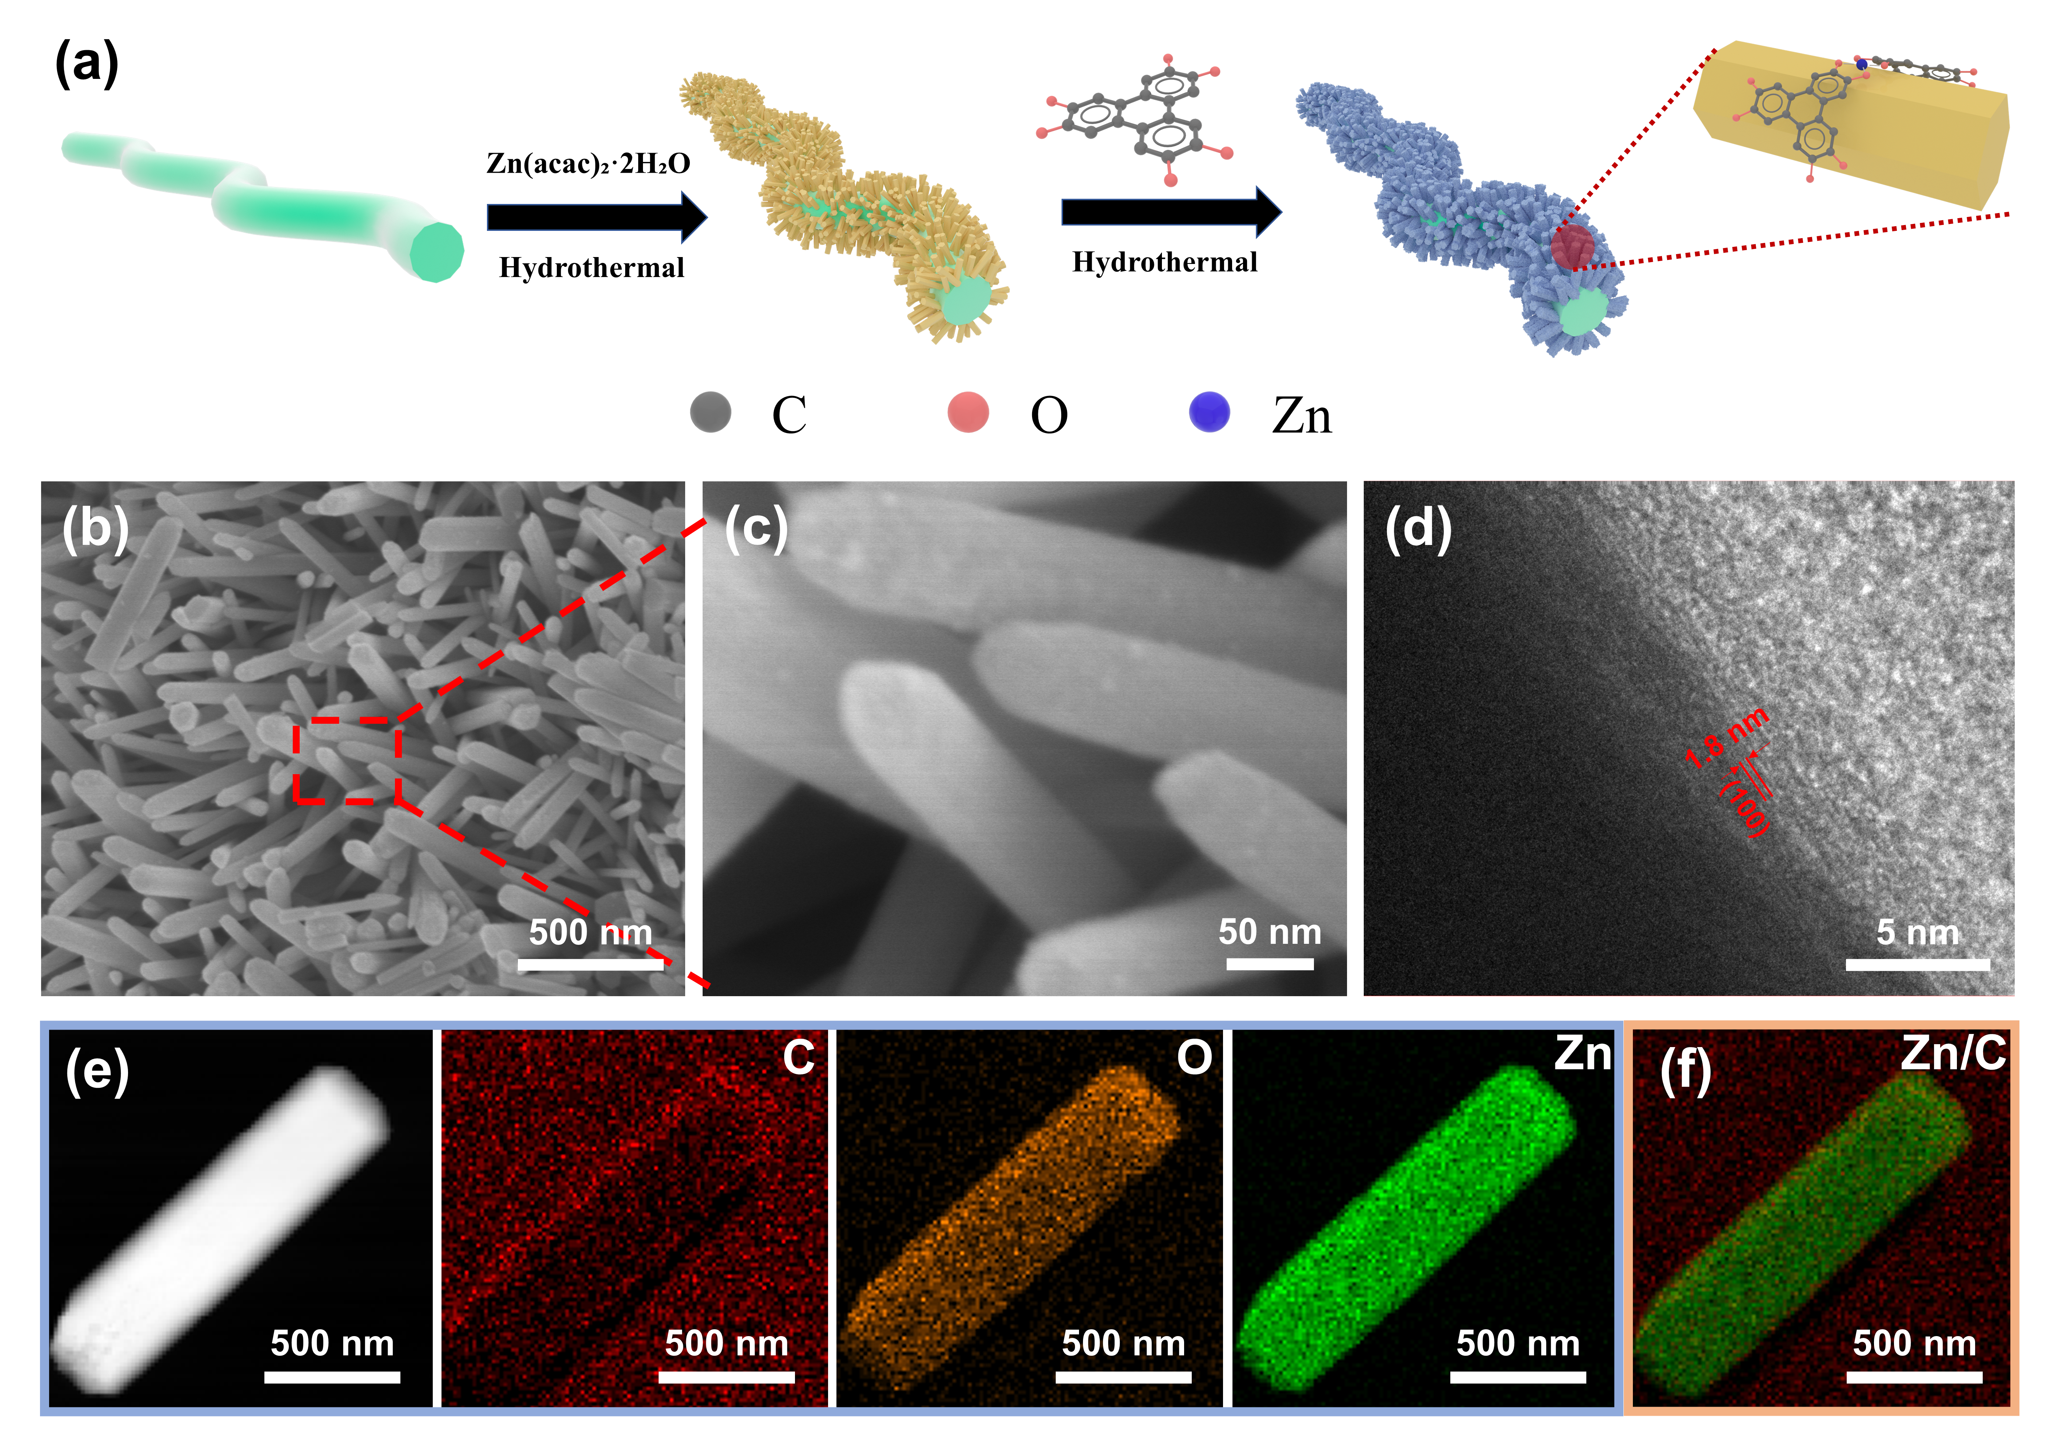
Fig. 1 (a) Synthesis schematic of Zn-HHTP@ZnO; (b-c) SEM images of Zn-HHTP@ZnO; (d) High-resolution transmission electron microscopy (TEM).; (e) TEM image of the Zn-HHTP@ZnO sample and the mapping results of C, O and Zn; (f) Schematic diagram of the mapping overlay of Zn and C.
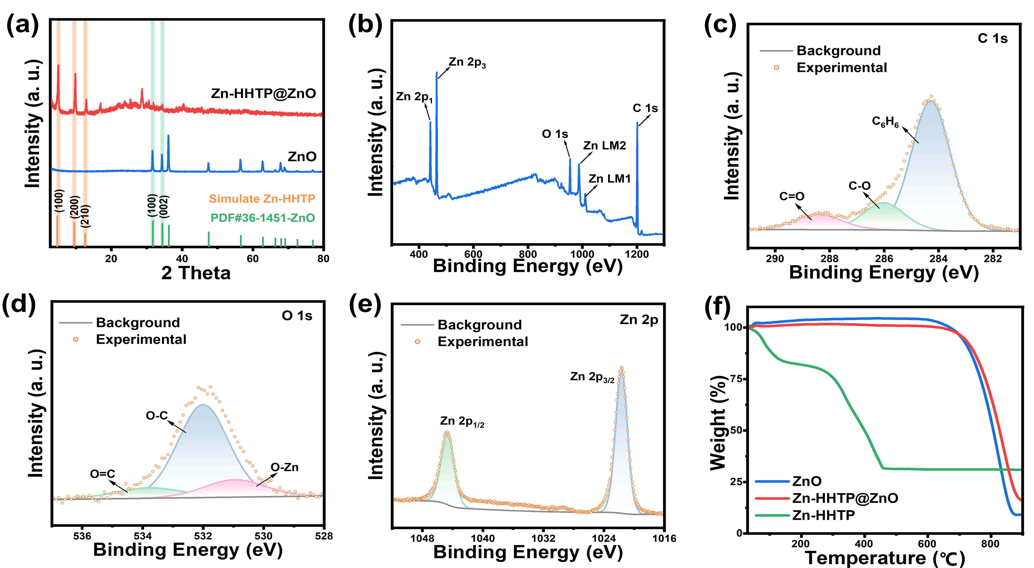
Fig. 2 (a) XRD pattern of Zn-HHTP@ZnO and ZnO; (b) XPS total spectrum of Zn-HHTP@ZnO; (c-e) C 1s, O 1s and Zn 2p spectrum of Zn-HHTP@ZnO; (f) TG graph of ZnO, Zn-HHTP@ZnO and Zn-HHTP.
X-ray diffraction (XRD) analysis was conducted to elucidate the crystal structure of the synthesized materials. As depicted in Fig. 2a, the three characteristic diffraction peaks at 4.7°, 9.6° and 12.8° correspond to the (100), (200) and (210) crystal planes of Zn-HHTP crystal, ^{[24]} respectively. The position of the (100) crystal plane is consistent with the calculated result of the 1.8 nm interplanar spacing observed by TEM, confirming the existence of Zn-HHTP crystal. In addition, the diffraction peaks at 31.6° and 34.2° in the XRD pattern correspond to the (100) and (002) crystal planes of hexagonal wurtzite ZnO (PDF#36-1452), respectively. ^{[32-34]} This result not only confirms the existence of ZnO nanowire arrays, but also strongly proves the successful composite of Zn-HHTP crystals on the surface of ZnO nanowire arrays. The precise matching of diffraction peak positions and intensities indicates that both crystal phases in the composite material maintain good crystalline quality.
X-ray photoelectron spectroscopy (XPS) analysis was carried out to explore the elemental chemical states of the Zn-HHTP@ZnO composite. As illustrated in Fig. 2b-c, the XPS survey spectrum reveals characteristic peaks exclusively for Zn, O and C indicating the compositional purity of the material. The C 1s spectrum exhibits three distinct valence states: the peak at 284.2 eV is assigned to quinone-type carbon (C=C) in the HHTP ligand, while the peaks at 285.9 eV and 288.3 eV correspond to C-O and C=O bonds, respectively. ^{[35]} In contrast, only the C-O and C=O bonds belonging to the carbon textile are observed in the C 1s spectrum of the ZnO sample (Fig.S2a), while the intensity of the C=O bond in the Zn-HHTP@ZnO sample increases significantly compared with that in the ZnO sample. In the O 1s spectrum (Fig. 2d), the peak at 530.8 eV originates from O-Zn bonds in ZnO, whereas the peaks at 532.0 eV and 533.8 eV are attributed to C-O and O=C bonds. In contrast, only the peak corresponding to the O-Zn bond is present in the ZnO sample (Fig. S2b). ^{[36]} The presence of the O=C bond provides direct evidence for the successful incorporation of Zn-HHTP. Finally, the Zn 2p spectrum (Fig. 2e) displays characteristic peaks at 1021.5 eV (Zn 2p3/2) and 1044.6 eV (Zn 2p1/2). This stable electronic configuration with fully occupied 3d orbitals facilitates the formation of robust coordination bonds with the HHTP ligand. ^{[37-38]} Thermogravimetric analysis (TGA) of Zn-HHTP@ZnO and ZnO is shown in Fig. 2f. Both the Zn-HHTP@ZnO with well-defined nanoarrays and pure ZnO exhibit exceptional thermal stability. Zn-HHTP completely decomposes into ZnO at around 450°C, while the weight loss after 600°C is attributed to the decomposition of the carbon textile. The reduced total weight loss rate of the Zn-HHTP@ZnO sample compared to pure ZnO indicates the successful loading of Zn-HHTP on the ZnO surface.

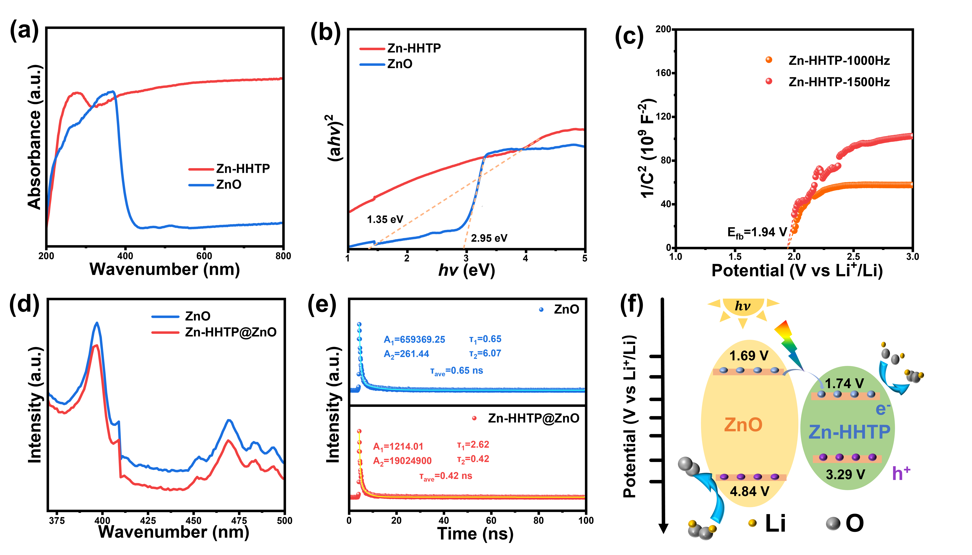
Fig. 3 (a-b) UV-vis spectra and corresponding Tauc Plot curves of Zn-HHTP and ZnO; (c) Mott-Schottky curves of Zn-HHTP@ZnO; (d-e) Photoluminescence (PL) spectra and time--resolved PL spectra of Zn-HHTP@ZnO and ZnO; (f) Schematic illustration of the band structure and photo-generated charge-transfer process.
The optical absorption properties were characterized by UV-vis spectroscopy. As shown in Fig. 3a-b, the Zn-HHTP composite exhibits a significantly broadened absorption range, with strong absorption in the ultraviolet region and an absorption edge extending into the near-infrared region (λ>800 nm). The band gaps of ZnO and Zn-HHTP were determined to be 2.95 eV and 1.35 eV, respectively, via linear extrapolation. Mott-Schottky measurements (Fig. 3c and S3) reveal that both ZnO and Zn-HHTP are n-type semiconductors with flat-band potentials of 1.89 V and 1.94 V, corresponding to conduction band positions of 1.69 V and 1.74 V, respectively. Combining the band gap parameters, the valence band (VB) positions of Zn-HHTP and ZnO were calculated as 3.29 V and 4.84 V, respectively.
The photogenerated carrier dynamics of the samples were analyzed using PL and TR-PL spectra. In Fig. 3d, the Zn-HHTP@ZnO composite exhibits a weaker PL signal compared to ZnO, indicating a lower ratio and fewer numbers of photogenerated electron-hole pair recombination. Meanwhile, as shown in Fig. 3e, the average lifetime of Zn-HHTP@ZnO (0.42 ns) is shorter than that of ZnO (0.65 ns). The improved electron-hole separation ability was mainly contributed to heterojunction as illustrated in Fig. 3f, where the photo-generated hole can directly transfer from CB of ZnO to that of Zn-HHTP avoiding recombination. The PL and TR-PL spectra collectively confirm that Zn-HHTP@ZnO exhibits better photocatalytic activity. This is beneficial for free electrons and holes to participate in redox reactions, improving their utilization efficiency and promoting the enhancement of photo-assisted electrochemical performance. Furthermore, combined with the transient photocurrent response tests in Fig 4, this indicates that after photogenerated carriers are produced under light irradiation, electrons in the Zn-HHTP@ZnO composite can be rapidly transferred through atomically grown Zn-HHTP to participate in the battery redox reactions, significantly suppressing electron-hole pair recombination.
The photocurrents of Zn-HHTP@ZnO and ZnO samples were further evaluated in a three-electrode system, where two pieces of metallic lithium served as the counter and reference electrodes. The Zn-HHTP@ZnO and ZnO samples were used as photoelectrodes, with 1 M LiTFSI/TEGDME as the electrolyte. Before the test, the cell was purged with pure O₂ for 30 min. The transient photoresponse currents of Zn-HHTP@ZnO and ZnO cathodes are shown in Figure 4a-b and S4a-b. During charging/discharging, Zn-HHTP@ZnO exhibits stable and stronger photocurrents than ZnO under full-spectrum light illumination, indicating higher charge separation efficiency. To systematically investigate the photoelectric response characteristics of photo-cathodes under different light illuminations, chopped light LSV and i-t tests were performed on Zn-HHTP@ZnO and ZnO cathodes under full-spectrum, as well as specific wavelength (UV and VIS) light irradiation. As shown in Figure 4c-d and S5, the current density of Zn-HHTP@ZnO during charging demonstrates full-spectrum catalytic enhancement, with significantly improved visible light absorption compared to ZnO.

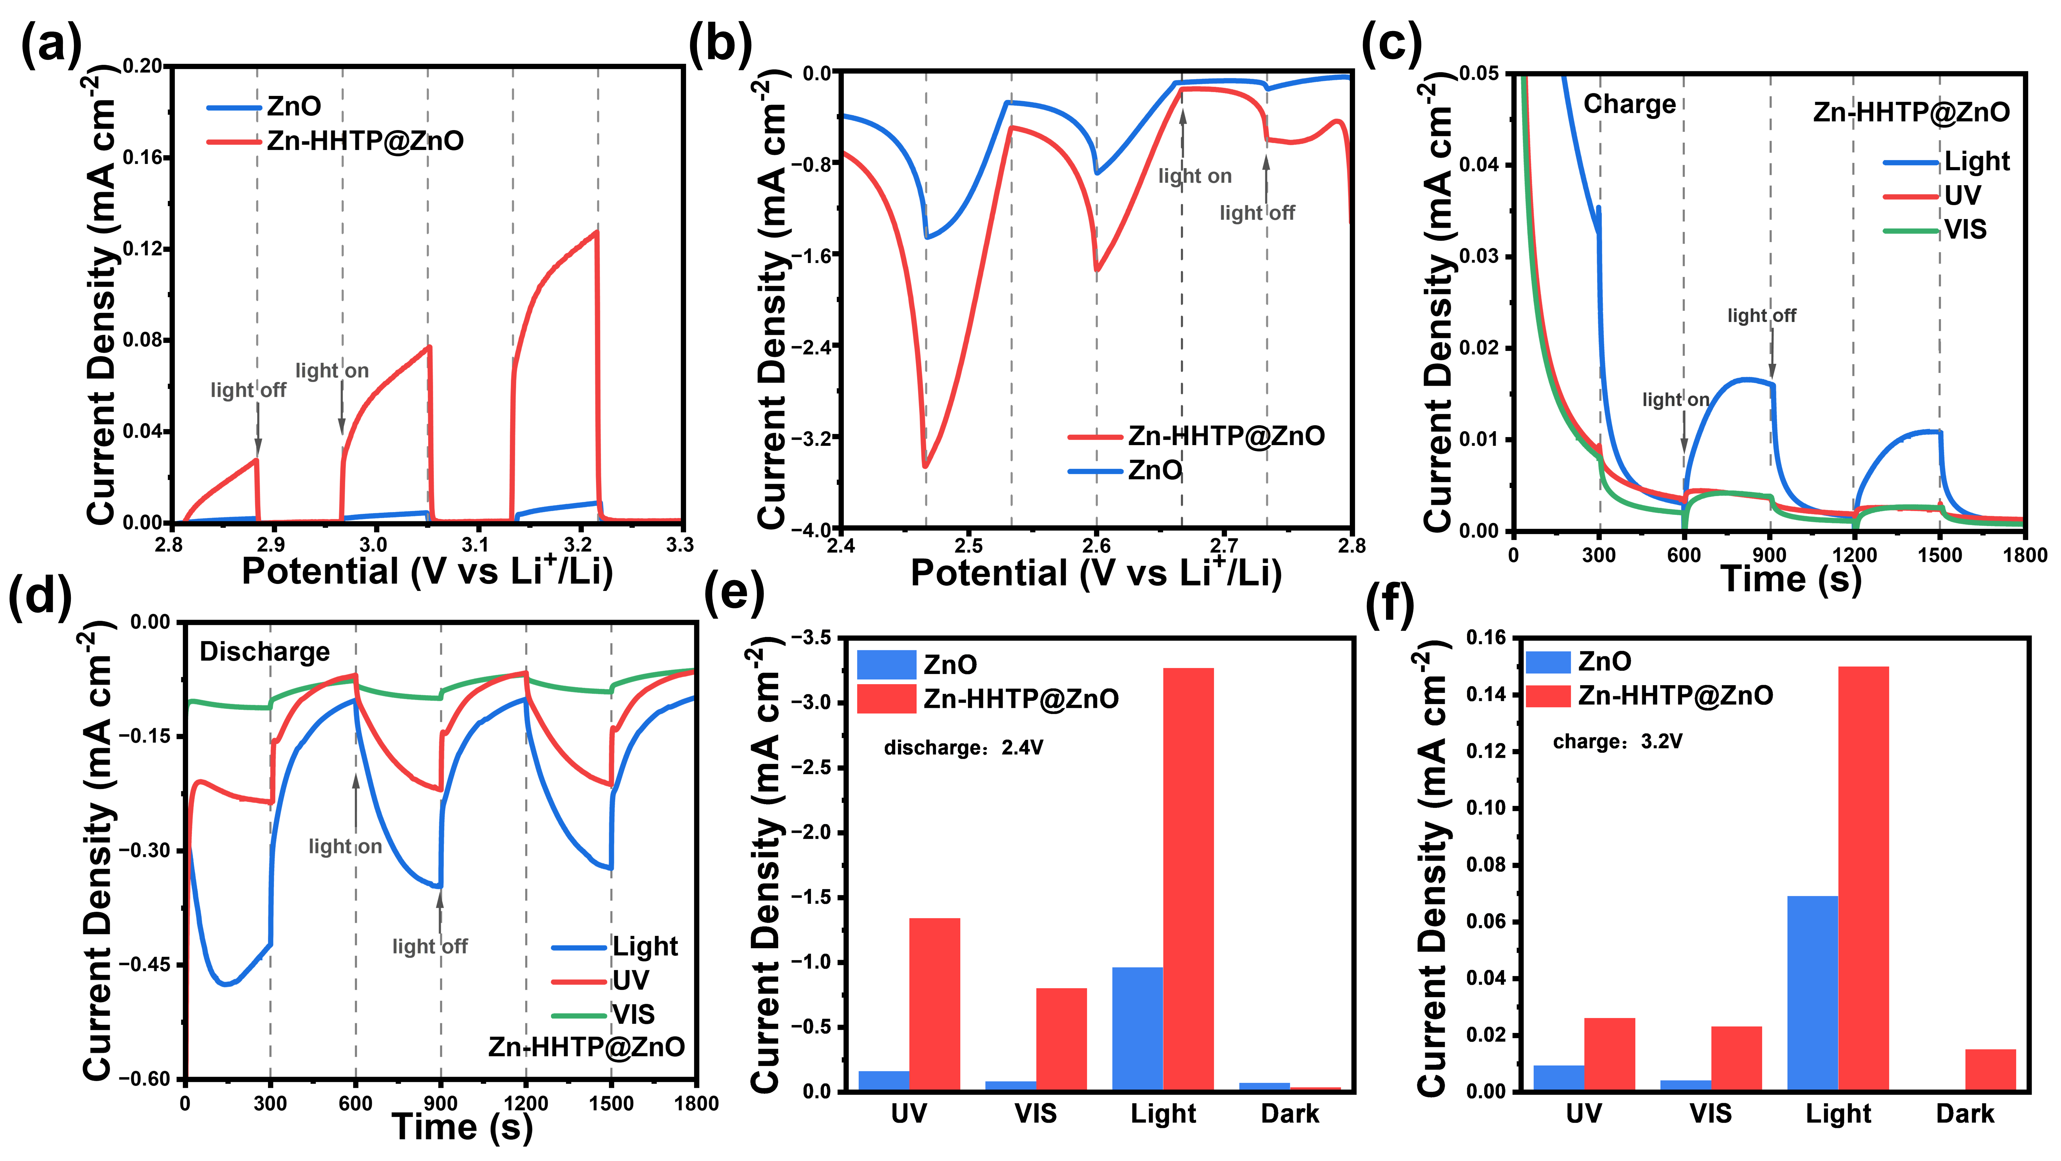
Fig. 4 Photoelectrochemical testing of Zn-HHTP@ZnO and ZnO cathodes: (a-b) LSV diagram under chopped light; (c-d) i–t curves under chopped light at 3.0 and 2.6 V with different spectra (UV, Vis and full spectrum); (e-f) The calculated discharge/charge photocurrent with different spectra.
To further understand the photocurrent characteristics of Zn-HHTP@ZnO and ZnO, LSV and i-t tests were conducted under different wavelength illuminations to investigate the maximum photocurrent density and the relationship between photocurrent and light bands. As shown in Fig. 4e-f and S6-8, both photo-cathodes exhibit the strongest current responses (3.27 mA cm⁻² for Zn-HHTP@ZnO and 0.96 mA cm⁻² for ZnO) under full-spectrum light illumination. Additionally, Zn-HHTP@ZnO generates current responses of 1.34 and 0.80 mA cm⁻² under UV and VIS light, respectively, far exceeding those of ZnO (0.16 and 0.08 mA cm⁻²) and consistent with the PL and TR-PL spectral results in Fig 3. Notably, the sum of responses in each band for both photo-cathodes is lower than the full-spectrum result, consistent with energy loss in photoelectric conversion. The results show that photocurrent response of ZnO is significantly lower than Zn-HHTP@ZnO, relying mainly on UV light excitation. In contrast, Zn-HHTP@ZnO demonstrates enhanced VIS light absorption, which outperforms that reported in previous related studies (Table S1), confirming that the heterostructure effectively improves carrier separation efficiency. This fully validates that the modification of conjugated Zn-HHTP not only broadens the light absorption range but also significantly enhances photocatalytic activity by optimizing interfacial charge transport.
The Zn-HHTP@ZnO sample was assembled into a non-aqueous LOBs and first cycled at a current density of 0.02 mA cm⁻² under different light conditions. As shown in Fig. 5a, the Zn-HHTP@ZnO sample provides a discharge plateau of 3.00 V and a charge plateau of 3.20 V under light illumination, yielding a narrow polarization voltage of 0.20 V and an excellent energy efficiency of 93.4%, superior than the previous reported photo-inspired LOBs (Table S2). This is attributed to special band engineering process, which enables full-spectrum absorption to improve light energy utilization efficiency. Meanwhile, Zn-HHTP tightly connected to ZnO that can rapidly transfer photogenerated carriers to the interface for reaction participation, thereby suppressing electron-hole pair recombination. Compared with ZnO, more electrons and holes are available for the redox reactions in Li-O₂ batteries, allowing the photo-assisted Li-O₂ battery with the Zn-HHTP@ZnO photocathode to exhibit lower charge-discharge overpotentials and higher energy efficiency. To confirm the positive effect of illumination, discharge/charge measurements of the Zn-HHTP@ZnO sample were further conducted in the dark, where the discharge potential was 2.81 V and the charge potential was as high as 3.60 V, leading to an undesirable energy efficiency of 78%. After illumination, the charge potential of the Li-O₂ battery decreased by 0.40 V, demonstrating that illumination significantly promotes the decomposition of Li₂O₂. The redox performance differences of the Zn-HHTP@ZnO cathode under light/dark states were further analyzed by CV tests. As shown in Fig. 5b, illumination not only increases the ORR onset potential but also significantly enhances the redox current response, all of which indicate that light energy input has an obvious enhancement effect on the electrode reaction. In addition, electrochemical impedance spectroscopy (EIS) was used to analyze the charge transfer characteristics. As shown in Fig. 5c, the arc in the Nyquist plot corresponds to the charge transport process at the electrode/electrolyte interface, and its diameter directly reflects the interfacial impedance value. Under illumination, the arc diameter sharply decreases from 404.54 Ω in the dark state to 10.98 Ω, and this order-of-magnitude difference fully proves that photoexcitation can effectively improve the interfacial charge transfer efficiency.

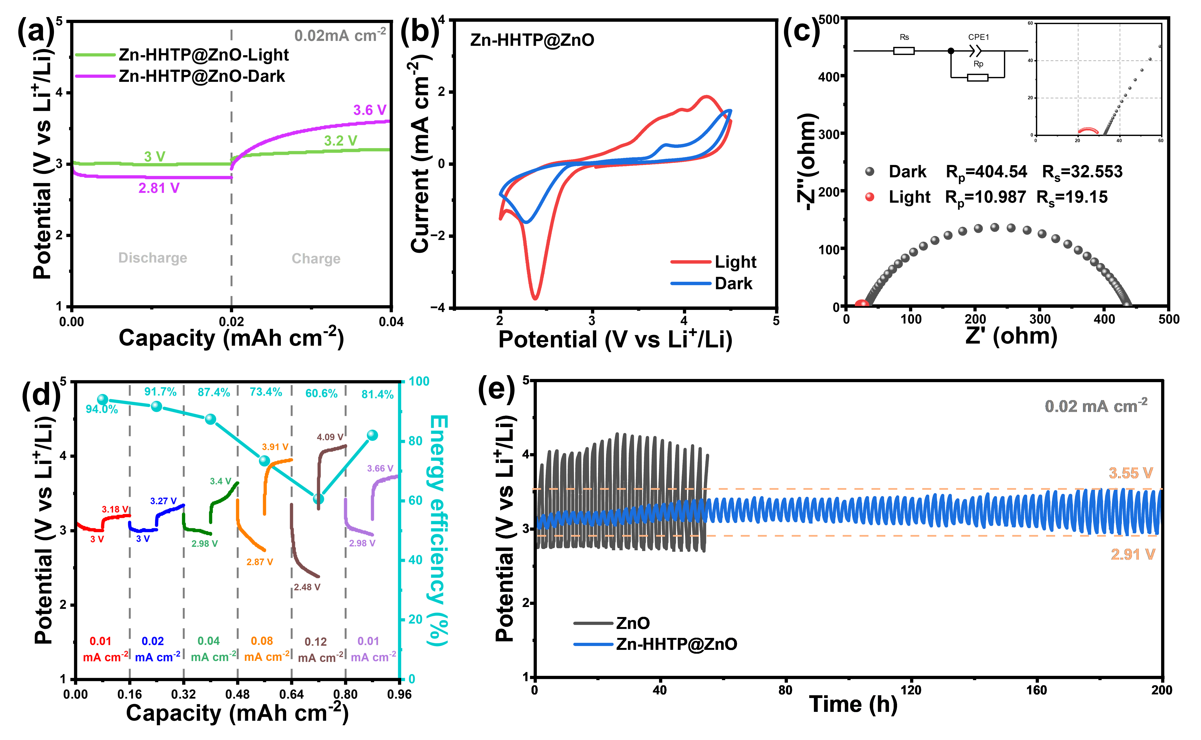
Fig. 5 Electrochemical performance test of Zn-HHTP@ZnO cathode in light/dark condition: (a) First discharge-charge curves of the battery at a current density of 0.02 mA cm⁻², with a capacity limit of 0.02 mAh cm⁻²; (b) Cyclic voltammetry curves with a scan rate of 0.5 mV s⁻¹; (c) EIS graph; (d) Charge-discharge curves of Zn-HHTP@ZnO cathode at different current densities; (e) Comparison of cycling performance of Zn-HHTP@ZnO cathode under light/dark conditions.
Fig. 5d presents the rate performance test of the Zn-HHTP@ZnO cathode under illumination, with a cut-off capacity of 0.08 mAh cm⁻² and current densities increasing from 0.01 to 0.12 mA cm⁻². The discharge potentials of the battery based on Zn-HHTP@ZnO cathode are 3.00, 3.00, 3.29, 2.87, and 2.48 V, with corresponding charge potentials of 3.18, 3.27, 3.4, 3.91, and 4.09 V. When the current density returns to 0.01 mA cm⁻², the discharge potential remains at 2.98 V with only slight decay, while the charge potential is 3.66 V, fully demonstrating the excellent rate retention capability of the electrode material. Further cycle tests (Fig. 5e) show that under illumination, the Li-O₂ battery with a Zn-HHTP@ZnO cathode exhibits an initial discharge potential of 3.00 V and charge potential of 3.20 V at a current density of 0.02 mA cm⁻². After 200 hours of cycling, the electrode maintains good electrochemical stability, with the discharge potential remaining at 2.91 V and the charge potential only increasing to 3.55 V. In contrast, the initial polarization voltage in the dark state is as high as 1.13 V (discharge 2.74 V/charge 3.87 V). In addition, the evaluation of long-term cycling and fast-charging performance is crucial for secondary batteries. ^{[39-40]} We conducted cycling performance tests at higher current densities (0.1 mA cm⁻²) to evaluate the cycling and fast-charging performance of the photo-assisted Li-O₂ battery with the Zn-HHTP@ZnO cathode (Fig. S9). At the high current densities of 0.1 mA cm⁻², it could stably cycle for 150 hours, with the first-cycle polarization voltages of 0.9 V. Notably, the Li-O₂ battery assembled with a Zn-HHTP@ZnO photo-cathode exhibits a charging voltage of only 3.7 V under such a high current density, which is much lower than the Li-O₂ battery assembled with solid electrocatalysts.^{[41-42]} Compared with traditional electrocatalysts, the developed Zn-HHTP@ZnO photo-cathode shows significant advantages, and its low polarization voltages under both small and large current densities confirm the high efficiency of the light-assisted catalytic system.
To confirm the mechanism and reversibility of the light-assisted battery reaction, systematic characterization of the electrode products after charging/discharging was conducted. The Zn-HHTP@ZnO cathode was subjected to charge-discharge treatments at different depths under illumination at a current density of 0.02 mA cm⁻². As shown in Fig. 6a-c, when discharged to 0.80 mAh cm⁻², the original nanorod structure on the electrode surface was partially covered by dense discharge products, but the nanorod morphology was still observable. Further discharging to 2 mAh cm⁻² completely covered the nanorods with discharge products, making the original structure invisible. After charging to the same depth of 2 mAh cm⁻², the discharge products decomposed, and the nanorod morphology became clearly distinguishable. Compared with the original electrode (Fig. S10), only a small amount of film-like products remained on the surface.^{[43-44]} Component analysis of the discharge products by XPS (Fig. 6d) revealed a characteristic binding energy of 55.4 eV in the Li 1s spectrum, which fully matches the standard spectrum of L_{i2}O₂, confirming that the discharge product is Li₂O₂. These characterization results not only confirm that the formation and decomposition processes of Li₂O₂ in the light-assisted system are consistent with those in traditional Li-O₂ battery systems but also reveal the morphological evolution law of products during charge-discharge processes.

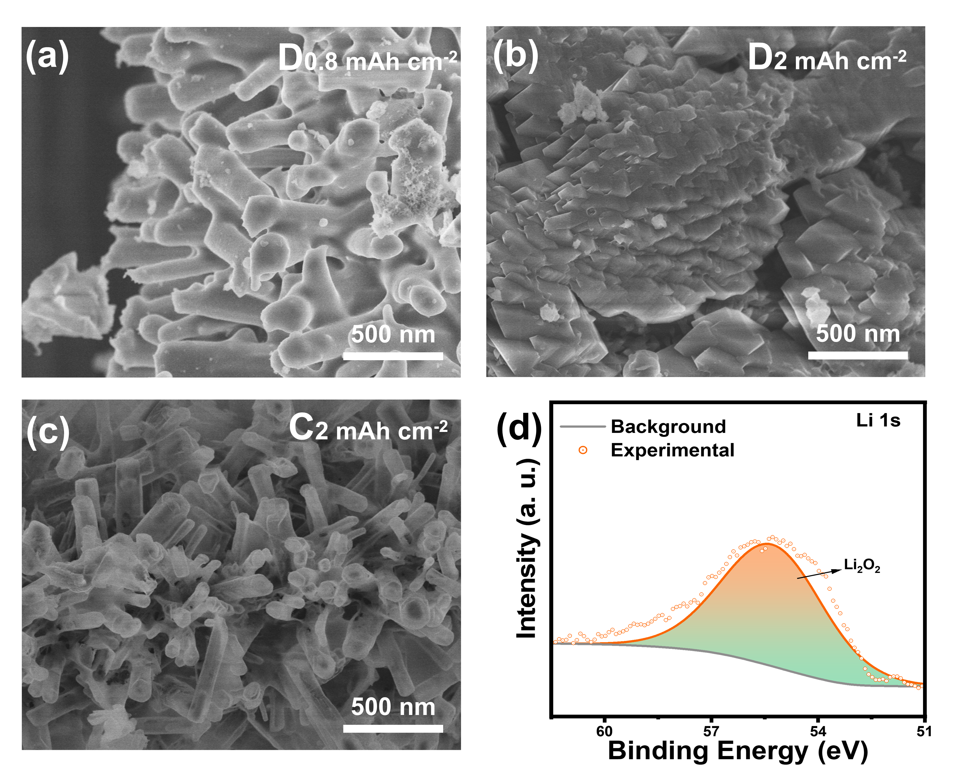
Fig. 6 (a-b) SEM images of Zn-HHTP electrodes at different discharge depths (0.8 mAh cm⁻² and 2 mAh cm⁻²); (c) SEM image of Zn-HHTP electrodes after charging to the depth of 2 mAh cm⁻² (d) Li 1s spectrum of the Zn-HHTP positive electrode discharged to 2 mAh cm⁻².
Conclusions
In this work, an in-situ synthesized photocatalyst with nanorod array structure and abundant active catalytic sites is proposed. Its broad spectral response enables efficient light harvesting, and the generated charge carriers promote both oxygen reduction reaction (ORR) and oxygen evolution reaction (OER). The nanorod-array structured Zn-HHTP@ZnO composite effectively suppresses the recombination rate of photogenerated electrons and holes. Under illumination, the assembled LOBs exhibit a high discharge potential of 3.00 V and a low charge potential of 3.20 V, with a narrow overpotential of only 200 mV and a high energy efficiency of 93.4%. Sufficient photogenerated electrons ensure low discharge overpotential and uniform nucleation of discharge products. This study provides new insights for developing innovative, high-performance light-involved energy storage devices.
Author contributions
All authors have given approval to the final version of this manuscript.
Conflicts of interest
There are no conflicts to declare.
Data availability
All data needed to support the conclusions in the paper are presented in the manuscript and/or the Electronic Supplementary Material. Additional data related to this paper may be requested from the corresponding author upon request.

Acknowledgements
The authors express their appreciations for the financial support from the National Science Foundations of China (22309084), Natural Science Foundation of Jiangsu Province (BK20210616), the China Postdoctoral Science Foundation (2023M731589), and a project funded by the Priority Academic Program Development of Jiangsu Higher Education Institutions (PAPD). H. R. Xue acknowledges supports from the project of Zhongyuan Critical Metals Laboratory (GJJSGFYQ202422) and Zhongyuan Youth Talent Cultivation Project for Scientific and Technological Innovation.
Notes and references
- H.-D. Lim, B. Lee, Y. Bae, H. Park, Y. Ko, H. Kim, J. Kim and K. Kang, Reaction chemistry in rechargeable Li-O₂ batteries, Chemical Society Reviews, 2017, 46, 2873-2888.
- Z.-L. Wang, D. Xu, J.-J. Xu and X.-B. Zhang, Oxygen electrocatalysts in metal-air batteries: from aqueous to nonaqueous electrolytes, Chem. Soc. Rev., 2014, 43, 7746-7786.
- D. Aurbach, B. D. McCloskey, L. F. Nazar and P. G. Bruce, Advances in understanding mechanisms underpinning lithium-air batteries, Nature Energy, 2016, 1，16128.
- X. Chi, M. Li, J. Di, P. Bai, L. Song, X. Wang, F. Li, S. Liang, J. Xu and J. Yu, A highly stable and flexible zeolite electrolyte solid-state Li-air battery, Nature, 2021, 592, 551-557.
- H. Wang, X. Wang, M. Li, L. Zheng, D. Guan, X. Huang, J. Xu and J. Yu, Porous Materials Applied in Nonaqueous Li-O₂ Batteries: Status and Perspectives, Advanced Materials, 2020, 32，2002559.
- X. Wu, G. Meng, W. Liu, T. Li, Q. Yang, X. Sun and J. Liu, Metal-organic framework-derived, Zn-doped porous carbon polyhedra with enhanced activity as bifunctional catalysts for rechargeable zinc-air batteries, Nano Research, 2018, 11, 163-173.
- Y. Wang, C. J. Zanelotti, X. Wang, R. Kerr, L. Jin, W. H. Kan, T. J. Dingemans, M. Forsyth and L. A. Madsen, Solid-state rigid-rod polymer composite electrolytes with nanocrystalline lithiumion pathways, Nature Materials, 2021, 20, 1255-1263.
- W.-J. Kwak, Rosy, D. Sharon, C. Xia, H. Kim, L. R. Johnson, P. G. Bruce, L. F. Nazar, Y.-K. Sun, A. A. Frimer, M. Noked, S. A. Freunberger and D. Aurbach, Lithium–Oxygen Batteries and Related Systems: Potential, Status, and Future, Chemical Reviews, 2020, 120, 6626-6683.
- D. Wang, X. Mu, P. He and H. Zhou, Materials for advanced Li-O₂ batteries: Explorations, challenges and prospects, Materials Today, 2019, 26, 87-99.
- H. Song, H. Deng, C. Li, N. Feng, P. He and H. Zhou, Advances in Lithium-Containing Anodes of Aprotic Li-O₂ Batteries: Challenges and Strategies for Improvements, Small Methods, 2017, 1，17100135.
- J. Lu, L. Li, J.-B. Park, Y.-K. Sun, F. Wu and K. Amine, Aprotic and Aqueous Li–O₂ Batteries, Chemical Reviews, 2014, 114, 5611-5640.
- Y. Ma, H. Qu, Z. Chi, X. Liu, Y. Yu, Z. Guo and L. Wang, The highly dispersed Co-based nanoparticles encapsulated into porous N-doping carbon polyhedral with the low content of Ru modification as a promising cathode catalyst for long-life Li-O₂ batteries, Nano Research, 2022, 15, 3204-3212.
- X. X. Wang, D. H. Guan, F. Li, M. L. Li, L. J. Zheng and J. J. Xu, Magnetic and Optical Field Multi-Assisted Li-O₂ Batteries with Ultrahigh Energy Efficiency and Cycle Stability, Advanced Materials, 2021, 34, 2104792.
- Z. Zhu, Y. Ni, Q. Lv, J. Geng, W. Xie, F. Li and J. Chen, Surface plasmon mediates the visible light-responsive lithium-oxygen battery with Au nanoparticles on defective carbon nitride, Proceedings of the National Academy of Sciences, 2021, 118 (17) e2024619118.
- Q. Lv, Z. Zhu, S. Zhao, L. Wang, Q. Zhao, F. Li, L. A. Archer and J. Chen, Semiconducting Metal-Organic Polymer Nanosheets for a Photoinvolved Li-O₂ Battery under Visible Light, Journal of the American Chemical Society, 2021, 143, 1941-1947.
- M. Li, X. Wang, F. Li, L. Zheng, J. Xu and J. Yu, A Bifunctional Photo-Assisted Li-O₂ Battery Based on a Hierarchical Heterostructured Cathode, Advanced Materials, 2020, 32, 1907098.
- D. H. Guan, X. X. Wang, M. L. Li, F. Li, L. J. Zheng, X. L. Huang and J. J. Xu, Light/Electricity Energy Conversion and Storage for a Hierarchical Porous In₂S₃@CNT/SS Cathode towards a Flexible Li-CO₂ Battery, Angewandte Chemie International Edition, 2020, 59, 19518-19524.
- M. Yu, X. Ren, L. Ma and Y. Wu, Integrating a redox-coupled dye-sensitized photoelectrode into a lithium-oxygen battery for photoassisted charging, Nature Communications, 2014, 5, 5111.
- H. Gong, T. Wang, K. Chang, P. Li, L. Liu, X. Yu, B. Gao, H. Xue, R. Ma, J. He and J. Ye, Revealing the illumination effect on the discharge products in high-performance Li-O₂ batteries with heterostructured photocatalysts, Carbon Energy, 2022, 4, 1169-1181.
- G. Wang, X. Hu, J. Wang, Y. Wang, Y. Dou, M. Guo, Q. Zhang, J. Han, Z. Xie and Z. Zhou, Toward Practical Photo-Assisted Li-O₂ Batteries: a Four-Electron Pathway Enabled by Ru-Doped β-MnO₂, Advanced Materials, 2025, DOI: 10.1002/adma.202507891.
- B. Wen, Y. Huang, Z. Jiang, Y. Wang, W. Hua, S. Indris and F. Li, Exciton Dissociation into Charge Carriers in Porphyrinic Metal-Organic Frameworks for Light-Assisted Li-O₂ Batteries, Advanced Materials, 2024, 36, 2405440.
- R. Cao, Y. Cui, G. Huang, W. Liu, J. Liu and X. Zhang, Designing a photo-assisted Co-C₃N₄ cathode for high performance Li-O₂ batteries, Nano Research, 2023, 16, 8405-8410.
- H. Xue, H. Gong, Y. Yamauchi, T. Sasaki and R. Ma, Photo-enhanced rechargeable high-energy-density metal batteries for solar energy conversion and storage, Nano Research Energy, 2022, 1, 9120007.
- E Z. Zhu, X. Shi, G. Fan, F. Li and J. Chen, Photo-energy Conversion and Storage in an Aprotic Li-O₂ Battery, Angewandte Chemie International Edition, 2019, 58, 19021-19026.
- T. Slimani Tlemcani, C. Justeau, K. Nadaud, G. Poulin-Vittrant and D. Alquier, Deposition Time and Annealing Effects of ZnO Seed Layer on Enhancing Vertical Alignment of Piezoelectric ZnO Nanowires, Chemosensors, 2019, 7, 7.
- H. J. Jung, S. Lee, Y. Yu, S. M. Hong, H. C. Choi and M. Y. Choi, Low-temperature hydrothermal growth of ZnO nanorods on sol–gel prepared ZnO seed layers: Optimal growth conditions, Thin Solid Films, 2012, 524, 144-150.
- M. A. F. b. N. Asmadi, A. A. M. Ralib, N. B. Saidin and A. N. Nordin, Optimization of hydrothermally grown ZnO nanorods on flexible fabric using finite element simulation and single precursor for wearable nanogenerator, Journal of Materials Science: Materials in Electronics, 2024, 35, 2244.
- A. A. M. Raub, R. Bahru, S. N. A. M. Nashruddin and J. Yunas, A review on vertical aligned zinc oxide nanorods: Synthesis methods, properties, and applications, Journal of Nanoparticle Research, 2024, 26, 186.
- A. Y. Al-She'irey, A. Balouch, E. R. Mawarnis, L. Roza, M. Y. A. Rahman, Abdullah and A. M. Mahar, Effect of ZnO seed layer annealing temperature on the growth of ZnO nanorods and its catalytic application, Optical Materials, 2022, 131, 112652.
- K. Liu, M. Zhang, X. Du, A. Zhou, B. Hui, Y. Xia and K. Zhang, Zinc-catecholete frameworks biomimetically grown on marine polysaccharide microfibers for soft electronic platform, Nano Research, 2023, 16, 1296-1303.
- Y. Jin, T. Zhang, N. Pan, S. Wang, B. Zhang, X. Zhu, Y. Hao, X. Wang, L. Song and M. Zhang, Surface functionalization of carbon cloth with conductive Ni/Fe-MOFs for highly efficient oxygen evolution, Surfaces and Interfaces, 2022, 33, 102294.
- N. Ekthammathat, T. Thongtem, A. Phuruangrat and S. Thongtem, Growth of hexagonal prism ZnO nanorods on Zn
substrates by hydrothermal method and their photoluminescence, Ceramics International, 2013, 39, S501-
S505.
- L. Tang, X.-B. Bao, H. Zhou and A.-H. Yuan, Synthesis and characterization of ZnO nanorods by a simple single-source hydrothermal method, Physica E: Low-dimensional Systems and Nanostructures, 2008, 40, 924-928.
- A. Rana, R. Malik, M. Rana, D. Kaushik, S. P. Khanna, R. Srivastava and C. K. Suman, Studies of optoelectrical properties of Mn-doped ZnO nanostructure for supercapacitor and photodetector applications, Journal of Alloys and Compounds, 2024, 997, 174931.
- X. Chen, Y. Chen, L. Zhang, Z. Liu, E. Qiu, Q. Liu, M. D. Regulacio, C. Lin and D.-P. Yang, Hydrophilic ZnO/C nanocomposites with superior adsorption, photocatalytic, and photo-enhanced antibacterial properties for synergistic water purification, Journal of Colloid and Interface Science, 2023, 648, 535-550.
- G. P. Singh and M. K. Roy, Structural and optical study of high concentrate Co-doped ZnO nanostructures, Materials Today: Proceedings, 2021, 46, 5852-5856.
- A. Latif, L. Arab, A. Amri, H. Arab, N. Sengouga and T. Tibermacine, Effect of Ga doping on the structural, optical, and electrical properties of ZnO nanopowders elaborated by sol-gel method, Materials Research Bulletin, 2024, 178, 112886.
- Y. Jin, X. Yuan, L. Ou, J. Wu, J. Hu, K. Xue and X. Xiong, In situ fast self-assembled preparation of dandelion-like Cu(OH)₂@Cu₃(HHTP)₂ with core-shell heterostructure arrays for electrochemical sensing of formaldehyde in food samples, Food Chemistry, 2024, 447, 139013.
- J. Mun, T. Song, M. S. Park and J. H. Kim, Paving the Way for Next-Generation All-Solid-State Batteries: Dry Electrode Technology, Advanced Materials, 2025, 37,2506123.
- J. H. Suh, S. A. Han, S. Y. Yang, J. W. Lee, Y. Shimada, S. M. Lee, J. W. Lee, M. S. Park and J. H. Kim, Toward Fast-Charging and Dendritic-Free Li Growth on Natural Graphite Through Intercalation/Conversion on MoS2 Nanosheets, Advanced Materials, 2025, 37,2414117.
- Y. Yang, X. Hu, G. Wang, J. Han, Q. Zhang, W. Liu, Z. Xie and Z. Zhou, Two Better Than One: Enhanced Photo‐Assisted Li‐O2 Batteries with Bimetallic Fe‐UiO‐66 Metal‐Organic Framework Photocathodes, Advanced Functional Materials, 2024, 34.
- Y. Tao, X. Fan, X. Yu, K. Gong, Y. Xia, H. Gong, H. Chen, X. Huang, A. Zhang, T. Wang and J. He, Metal–Organic Framework with Dual Excitation Pathways as Efficient Bifunctional Catalyst for Photo‐assisted Li–O2 Batteries, Small, 2024, 20.
- J. M. Garcia-Lastra, J. D. Bass and K. S. Thygesen, Communication: Strong excitonic and vibronic effects determine the optical properties of Li₂O₂, The Journal of Chemical Physics, 2011, 135.
- M. Wang, J. Chen, Z. Tian, W. Dai, B. Cui, X. Cui, D. Wang, Y. Xiao, X. Lian, C. Jiang, H. Yang, Y. Wang, Z. Sun, Y. Ding, Y.-Y. Sun, J. Zhang and W. Chen, Facet-controlled bifunctional WO3photocathodes for high-performance photo-assisted Li–O₂ batteries, Energy & Environmental Science, 2023, 16, 523-534.

