Supporting Information:
On-Surface Synthesis of Multiple Cu Atom-Bridged Organometallic Oligomers
Kewei Sun^{1,5}, Kazuma Sugawara², Andrey Lyalin^{3,4}*, Yusuke Ishigaki², Kohei Uosaki⁴, Oscar Custance¹, Tetsuya Taketsugu^{2,3}, Takanori Suzuki²*, Shigeki Kawai^{1,6}*

¹Research Center for Advanced Measurement and Characterization, National Institute for Materials Science, 1-2-1 Sengen, Tsukuba, Ibaraki 305-0047, Japan.
²Department of Chemistry, Faculty of Science, Hokkaido University, Sapporo, Hokkaido 060-0810, Japan.
³Institute for Chemical Reaction Design and Discovery (WPI-ICReDD) Hokkaido University, Sapporo 001-0021, Japan.
⁴Global Research Center for Environment and Energy based on Nanomaterials Science, National Institute for Materials Science, 1-1 Namiki, Tsukuba, Ibaraki 305-0044, Japan.
⁵International Center for Young Scientists, National Institute for Materials Science, 1-2-1 Sengen, Tsukuba, Ibaraki 305-0044, Japan.
⁶Graduate School of Pure and Applied Sciences, University of Tsukuba, Tsukuba 305-8571, Japan.

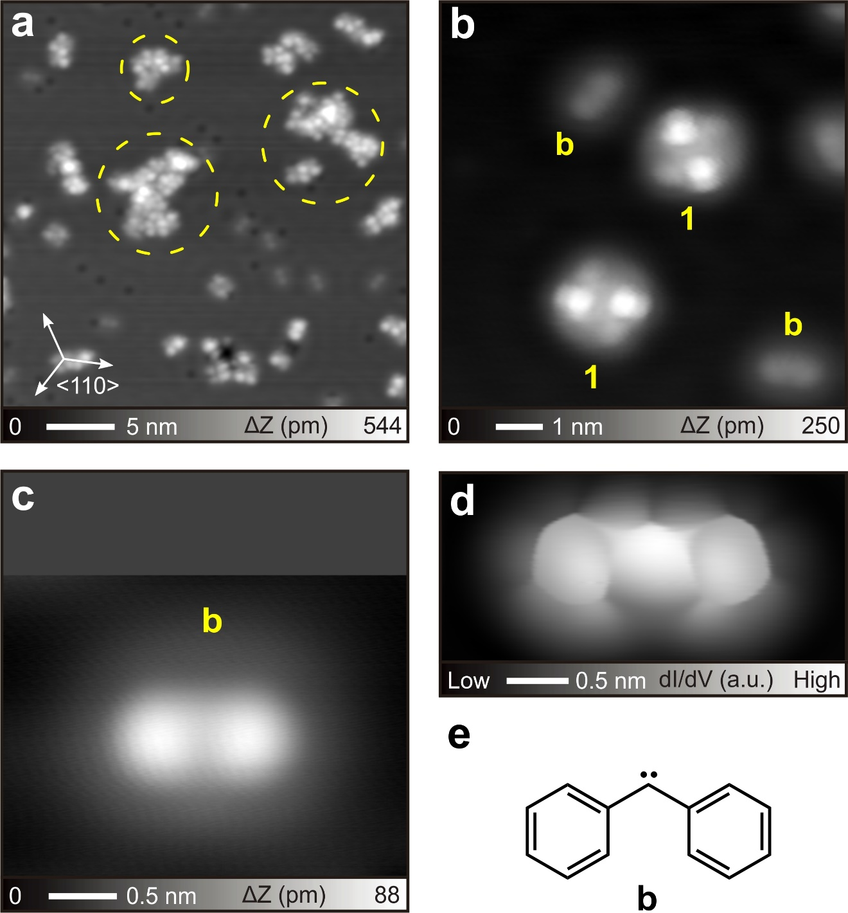
Figure S1. As-deposited 1 on Cu(111). (a) STM topography of as-deposited 1 on Cu(111) at room temperature. The yellow dashed circles show the disordered structure after assembly and fusion of molecular fragments. Besides these, some small molecules can be observed. (b) A close-up view of several small molecules on Cu(111). Precursor 1 and small fragment b can be observed. The apparent feature of 1 on Cu(111) is the same of that on Au(111).¹ (c) A close-up of one b, and the corresponding constant dI/dV image (d). (e) The chemical structure of b. As the fragment of precursor 1, b may be derived from the cleavage of C-C bonds of evaporated 1 after attached to Cu(111) surface with the kinetic energy. Measurement parameters: V = 200 mV and I = 5 pA in (a). V = 200 mV and I = 20 pA in (b). V = 200 mV and I = 10 pA in (c).

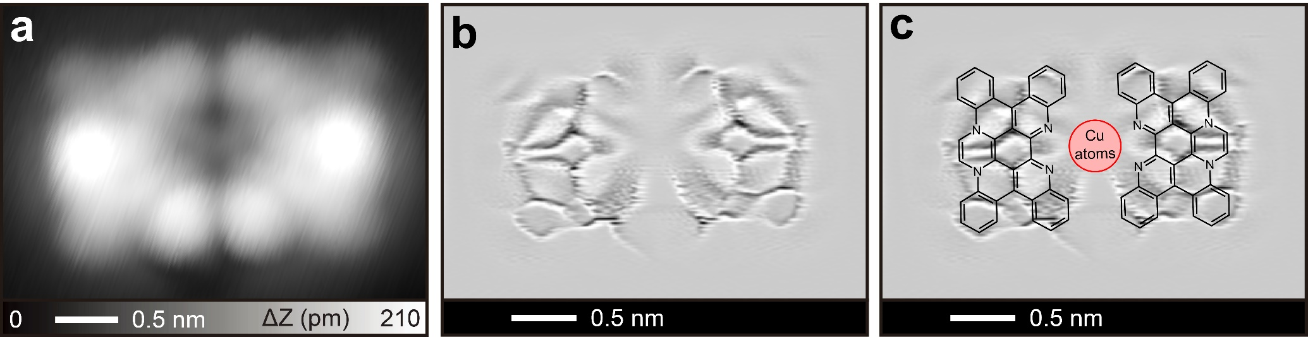
Figure S2. STM characterization on dimer of 3. (a) A closeup view of a dimer. (b) The corresponding Laplace filtered image in Figure 1b, and (c) chemical structures superimposed image. At least three Cu adatoms are in the center of this dimer. Measurement parameters: V = 50 mV and I = 50 pA.

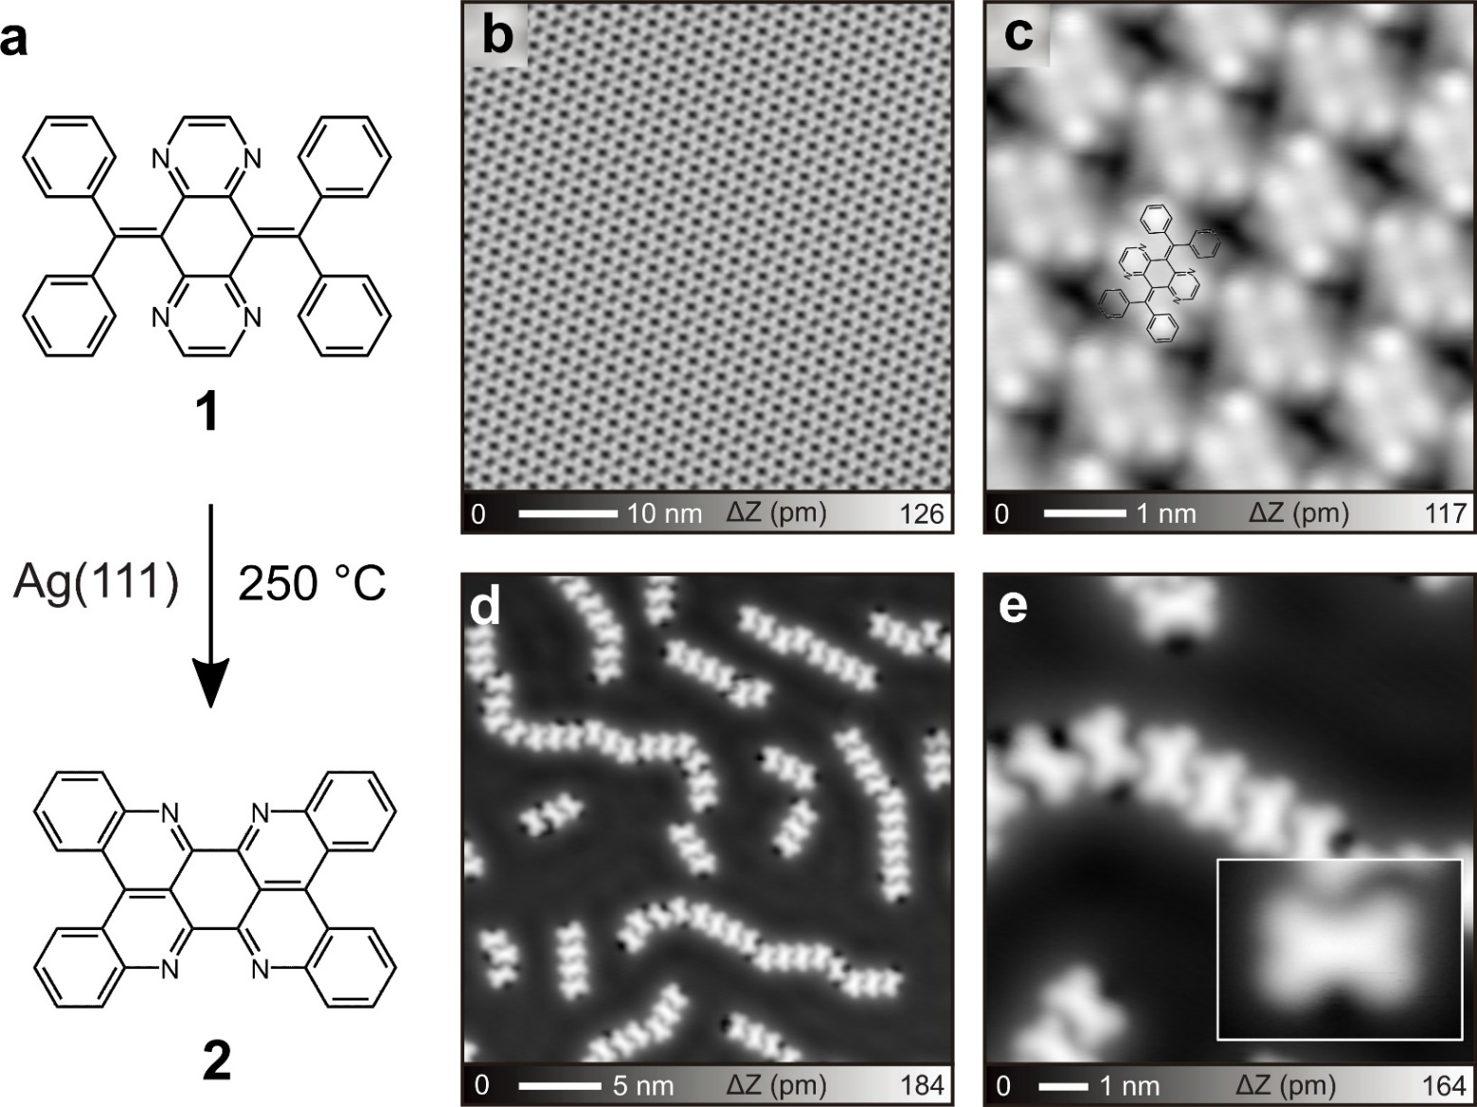
Figure S3. On-surface reaction of molecule 1 on Ag(111). (a) Scheme of reaction of molecule 1 on Ag(111), similar with that on Au(111). Large (b) and close-up (c) STM topographies of as-deposited 1 on Ag(111). (d) and (e) STM topographies of 2 on Ag(111) after heating at 250 °C. Insert exhibits a detailed image of single product 2. The reaction yield was almost 100 %. Measurement parameters: V = 200 mV and I = 10 pA in (b), V = 20 mV and I = 20 pA in (c), V = 200 mV and I = 5 pA in (d) and (e).

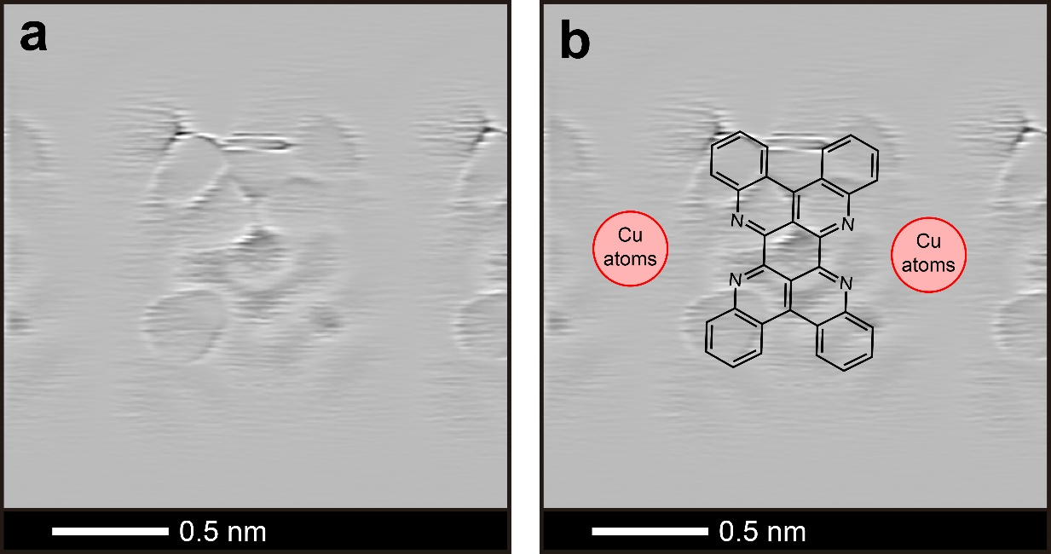
Figure S4. Laplace filtered image of 4. (a) The corresponding Laplace filtered image in Figure 1d, and (c) chemical structures superimposed image.

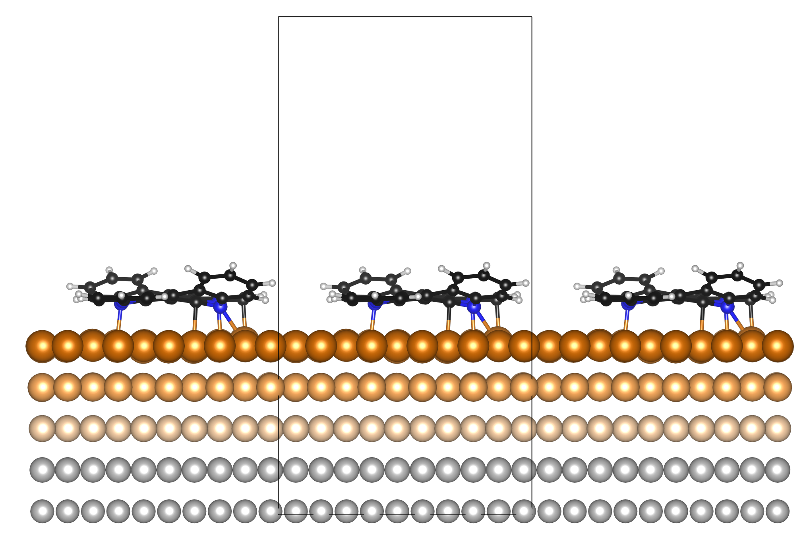
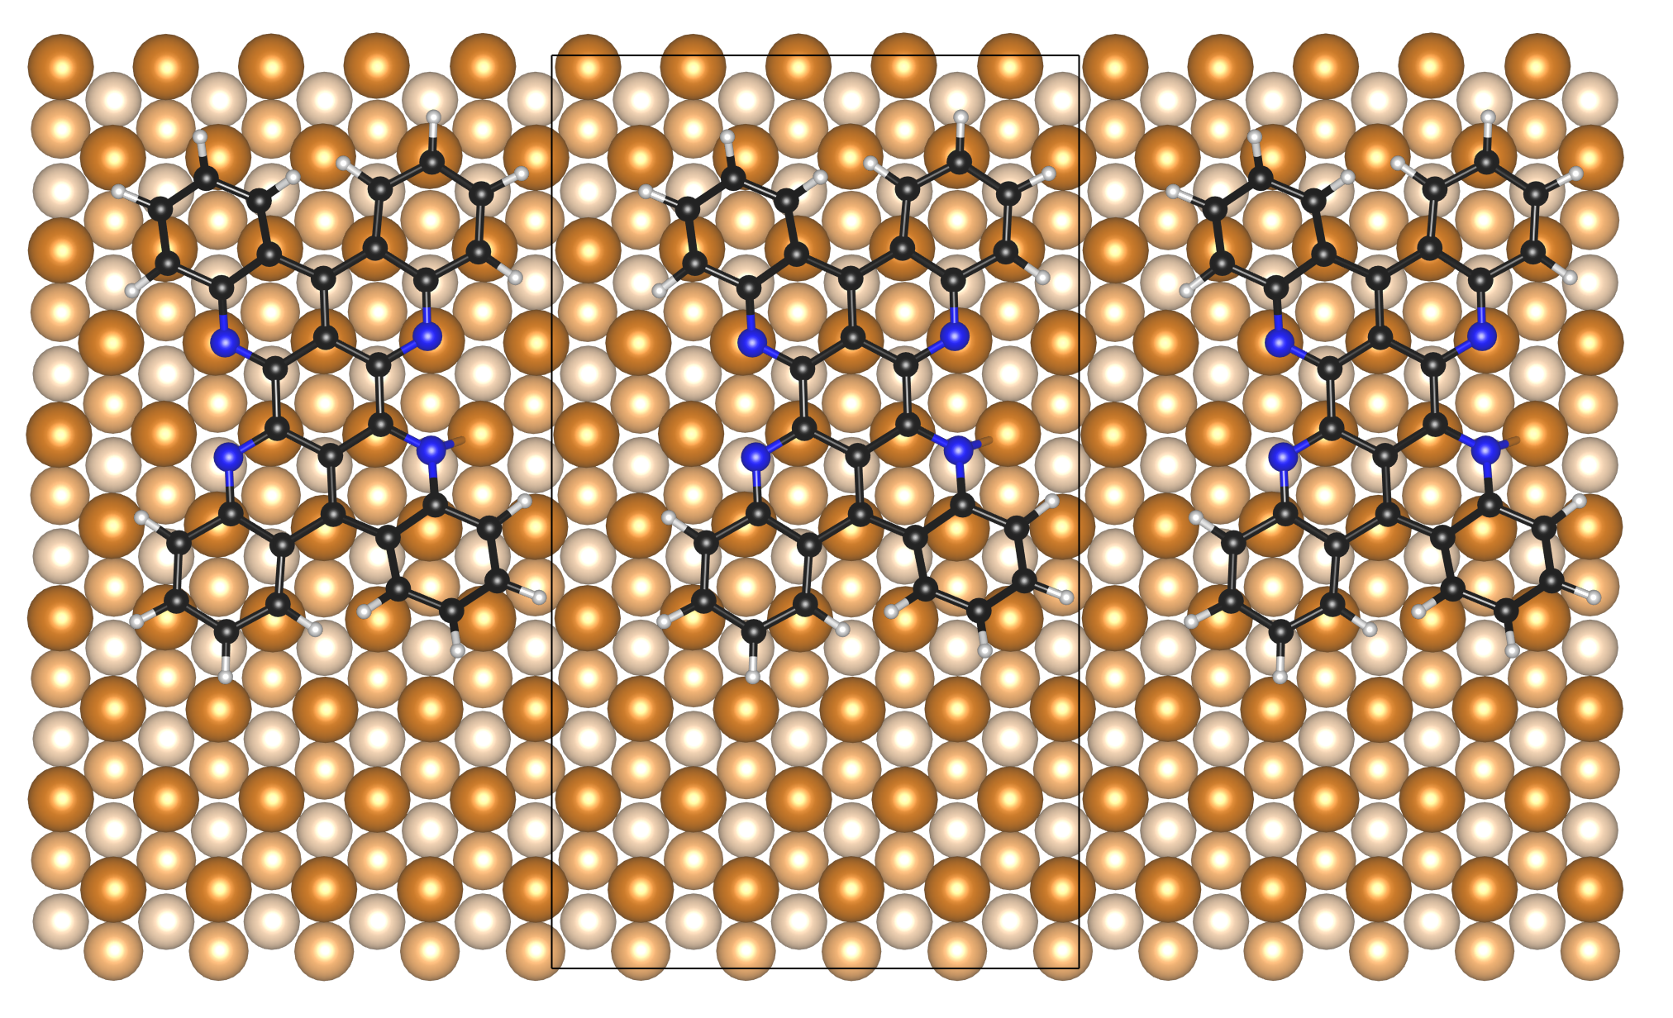

Figure S5. Optimized structures of pristine 2 on Cu(111). Side and top views of the 2 optimized on the 5×5$\sqrt{3}$ Cu(111) surface. Cu atoms in the top, second, and third surface layers are shown in brown, light brown, and peach colors, respectively. Cu atoms in the fourth and fifth layers are shown in grey. C, N and H atoms in 2 are shown in black, blue and light grey colors, respectively. The unit cell is shown with black lines.

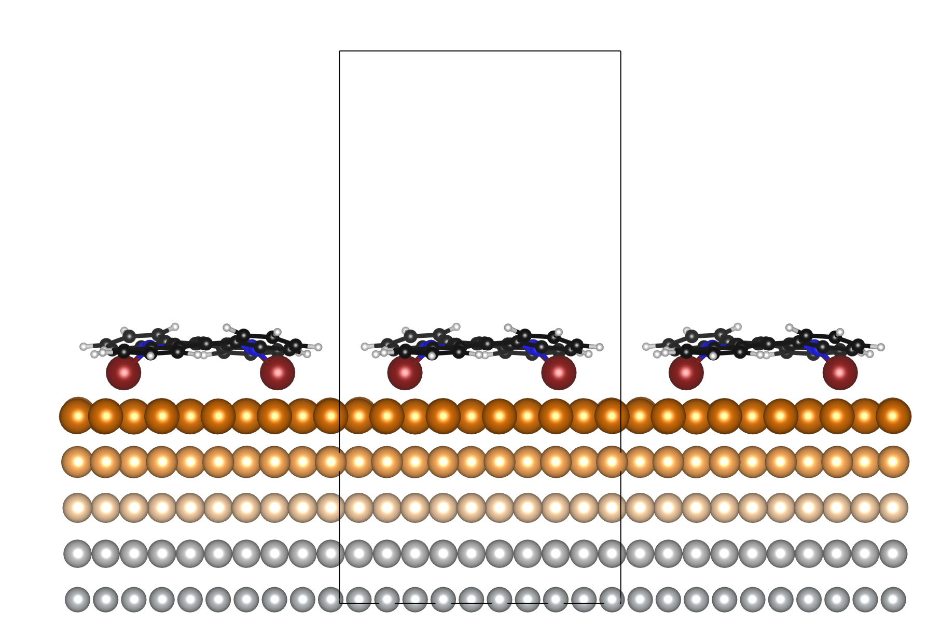
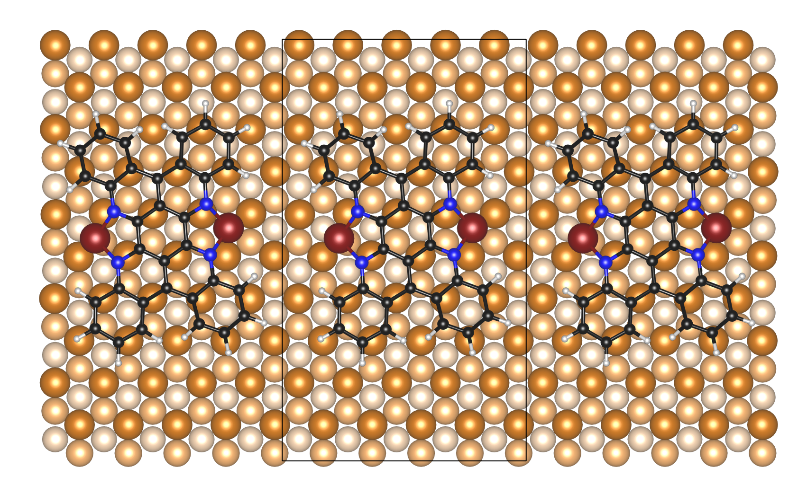

Figure S6. Optimized structures of 2 linked with two Cu Adatoms on Cu(111). Side and top views of the Cu-terminated 2 optimized on the 5×5$\sqrt{3}$ Cu(111) surface. Cu adatoms are shown in dark brown color. Cu atoms in the top, second, and third surface layers are shown in brown, light brown, and peach colors, respectively. Cu atoms in the fourth and fifth layers are shown in grey. C, N and H atoms in 2 are shown in black, blue and light grey colors, respectively. The unit cell is shown with black lines.
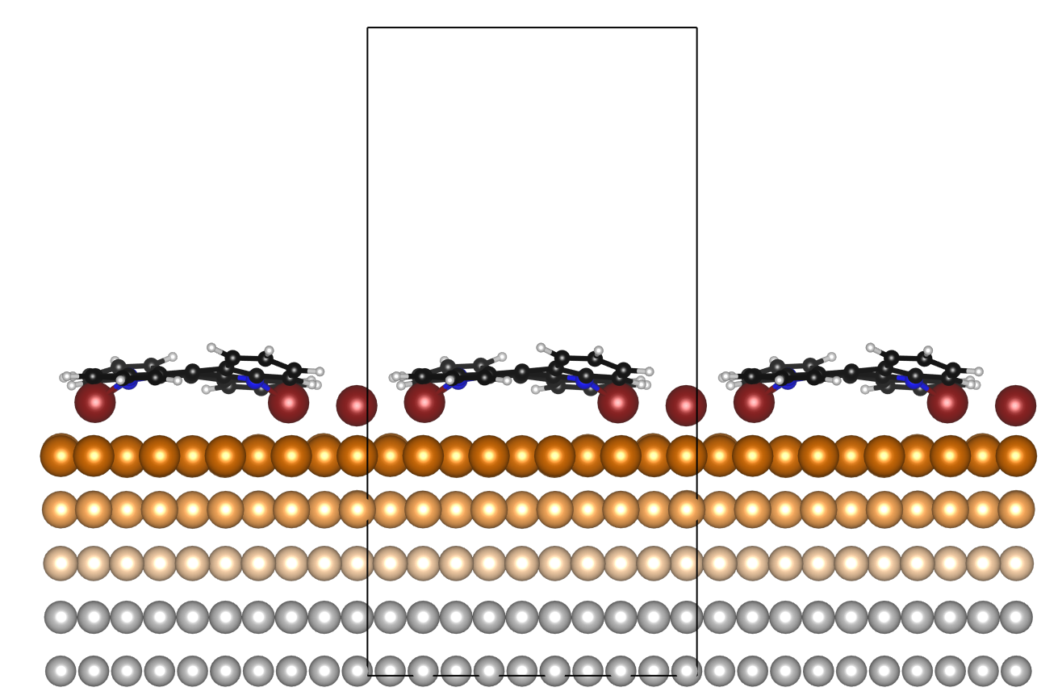

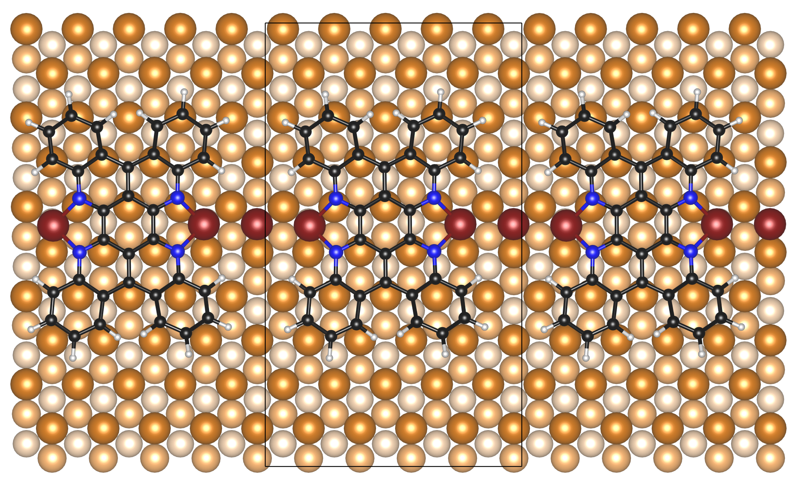

Figure S7. Optimized structures of 2 linked with three Cu Adatoms on Cu(111).

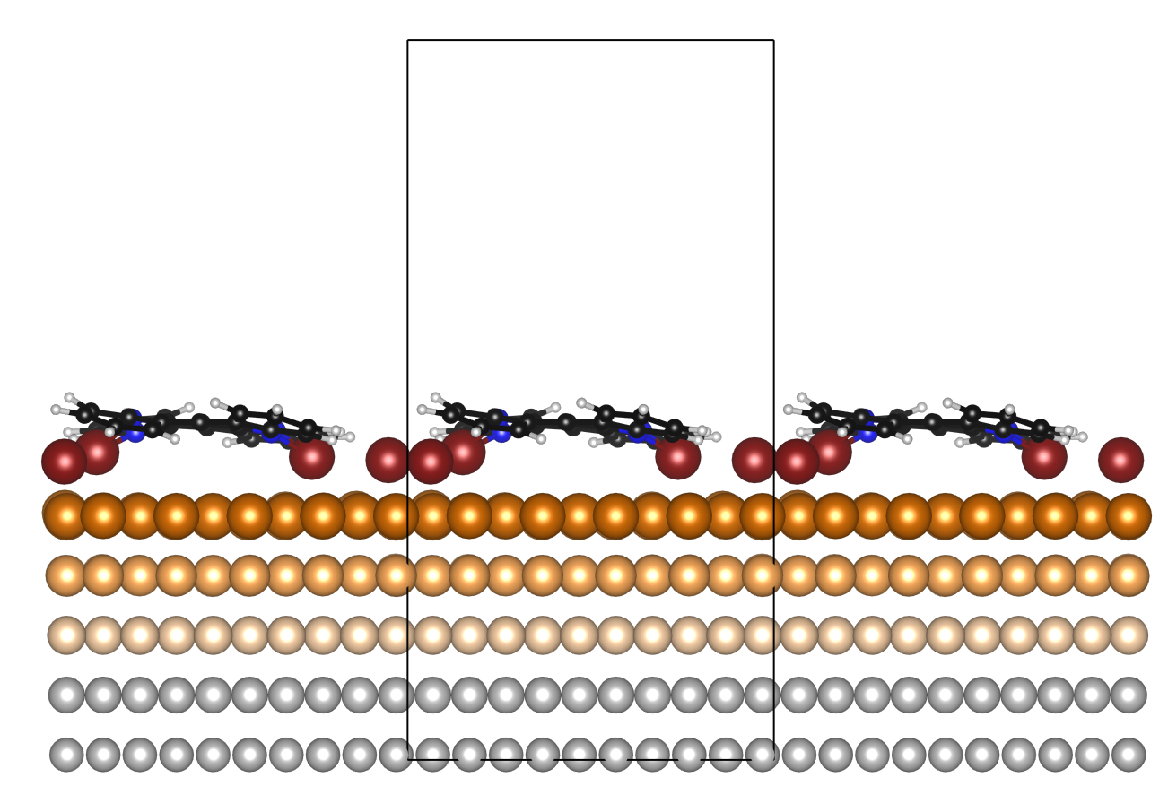
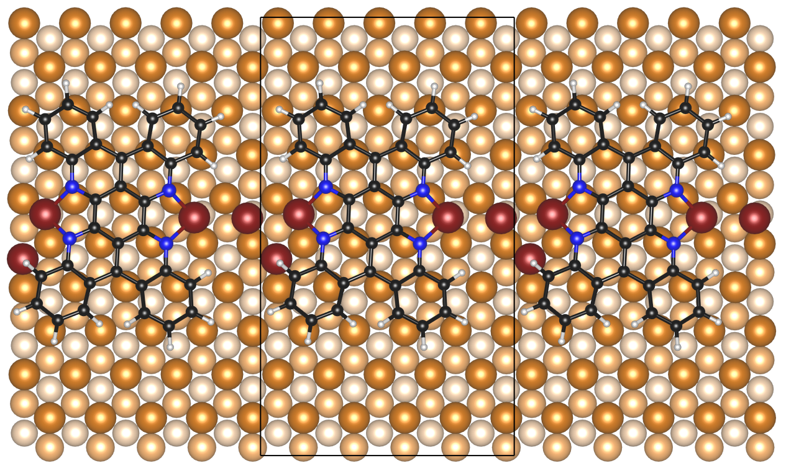

Figure S8. Optimized structures of 2 linked with four Cu Adatoms on Cu(111).
Interestingly, we found that the one longitudinal side of the oligomer always appeared brighter than the other side in the STM topography (Figure S9a). The orientation of the asymmetric contrast is constant for each three orientations as the darker longitudinal sides are indicated by lines and arrows with three different colors (red, blue, and yellow). Thus, the c₃ rotational symmetry appeared on the Cu(111) surface. The difference of the apparent corrugation heights between the longitudinal sides was about 50 pm (Figure S9b). This rotational symmetric feature is quite unique in the molecular assembly formed on the three-fold symmetric surface. We assigned this phenomenon to selective adsorption sites for oligomers. If the Cu adatoms adsorbed on hcp hollow sites, the C₆ rotational symmetry would have appeared since the adsorption site of the unit has a mirror symmetry. However, in this oligomer, the coordination center adsorbs at the fcc site rather than the hcp site (Figure S9c).^{2,3} Consequently, the upper and lower parts of the units locate the different atomic sites of the Cu(111) surface, leading to the C₃ rotational symmetry.

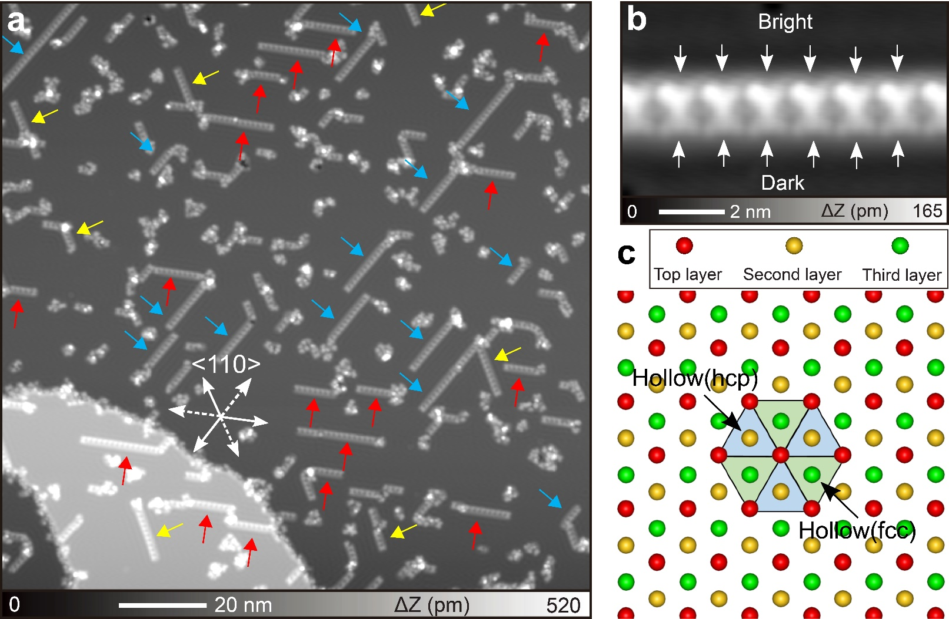
Figure S9. STM characterization on rotational symmetry of 4 on Cu(111). (a) Large-scale STM topography and (b) the close-up view. The darker longitudinal sides in the oligomer are indicated by lines and arrows. (c) Ball model of the Cu(111) surface. Measurement parameters: V = 200 mV and I = 10 pA in (a). V = 200 mV and I = 5 pA in (b).

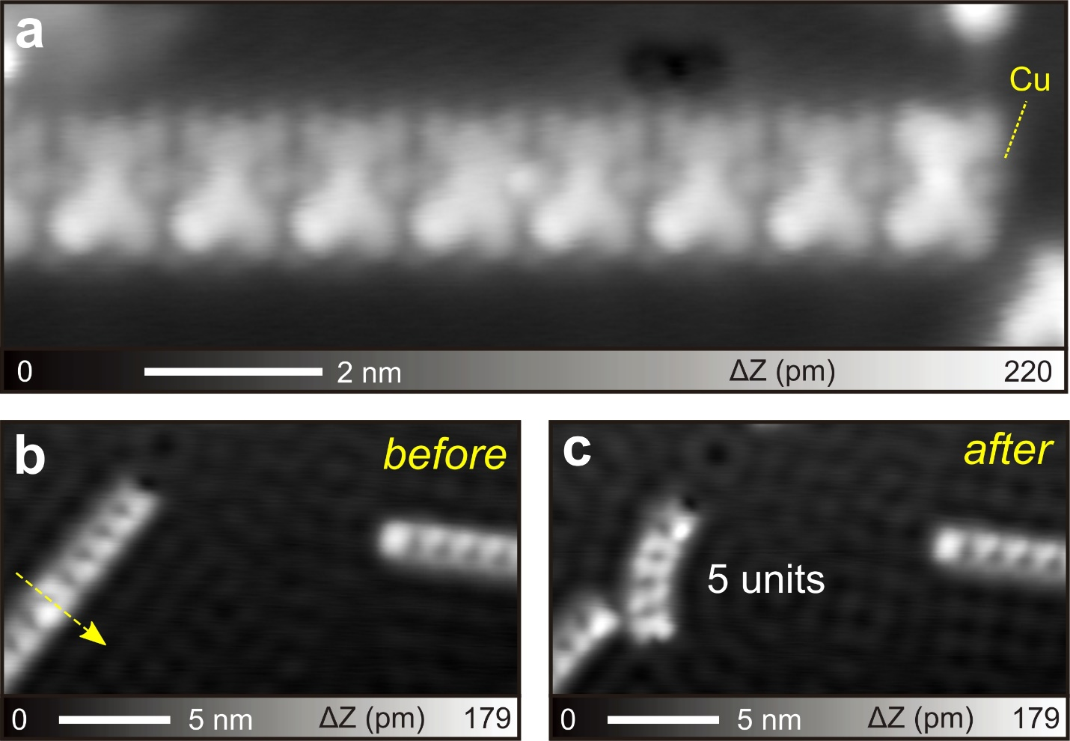
Figure S10. Cutting the organometallic compound by the STM tip. (a) High-resolution STM topography of an organometallic chain 4, terminated by a Cu adatom that can be observed. STM images of tip-induced cleavage of the organometallic chains: before (b) and after (c). Measurement parameters: V = 200 mV and I = 4 pA in (a). V = 10 mV and I = 10 pA in (b) and (c).

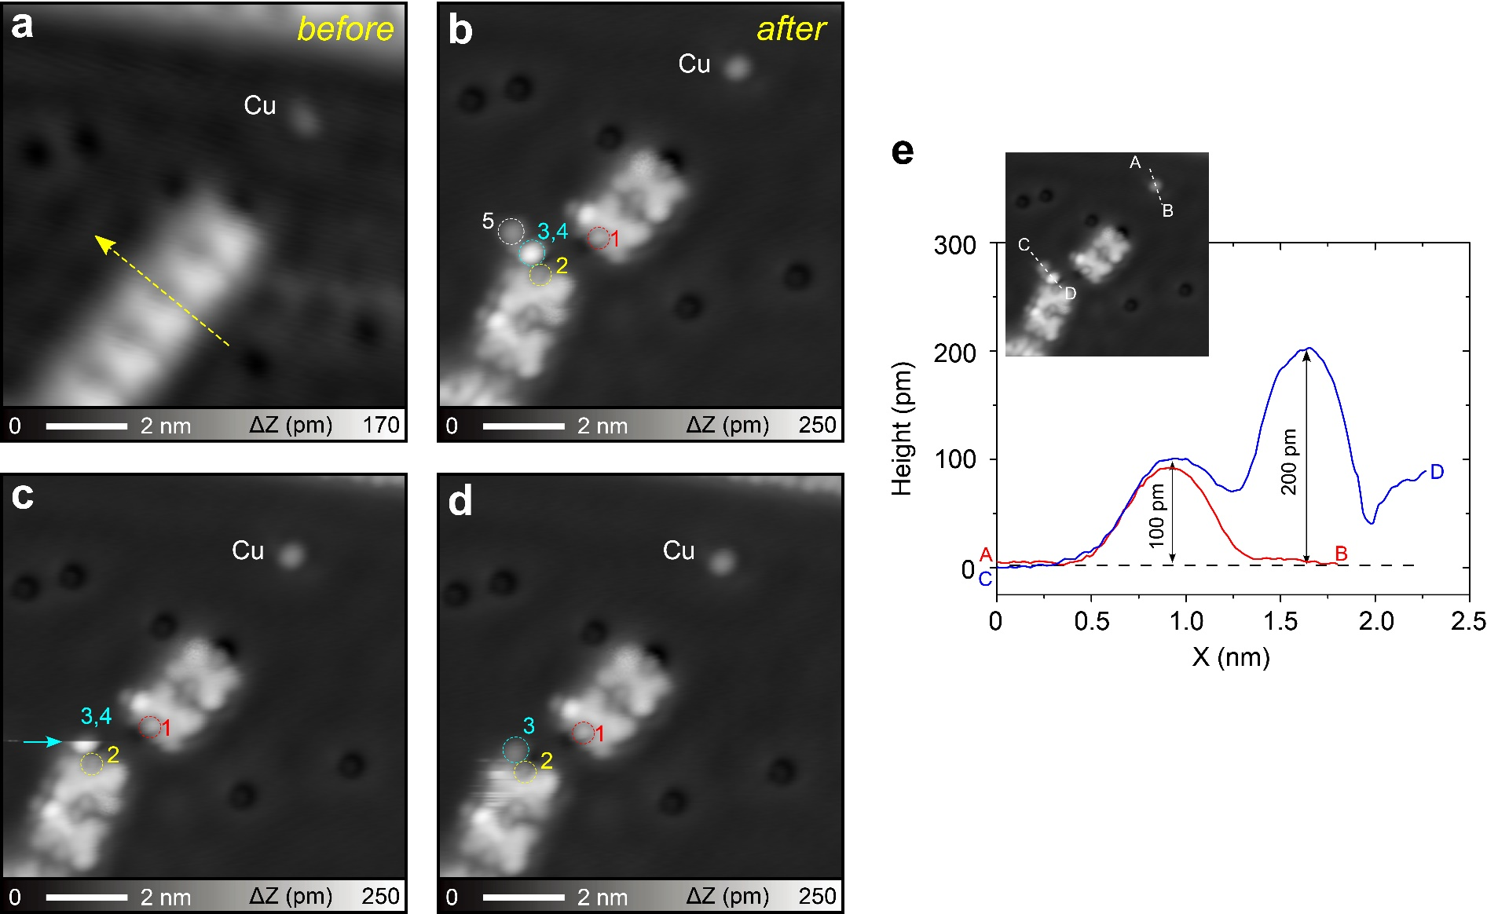
Figure S11. Number of Cu adatoms between the units. STM images of tip-induced cleavage of the organometallic chains 4: before (a) and after (b). (c)(d) Subsequent STM images of the same position in (b). (e) Line profiles taken along the dashed lines in the upper image (identical with (b)). Total five Cu adatoms can be identified in (b): Cu 1 and 2 are at the edge of the broken segments (indicated by red and yellow circles, respectively), Cu 3 and 4 are the bright dot indicated by light blue circle, Cu 5 is the normal dot indicated by white circle. The apparent height of bright dot (Cu 3 plus Cu 4) is about 200 pm, which is twice that of a normal dot (Cu 5). On the other hand, Cu 4 and 5 were removed during the tip scanning (indicated by the arrow in (c)). Measurement parameters: V = 100 mV and I = 100 pA in (a), V = 200 mV and I = 5 pA in (b-d).

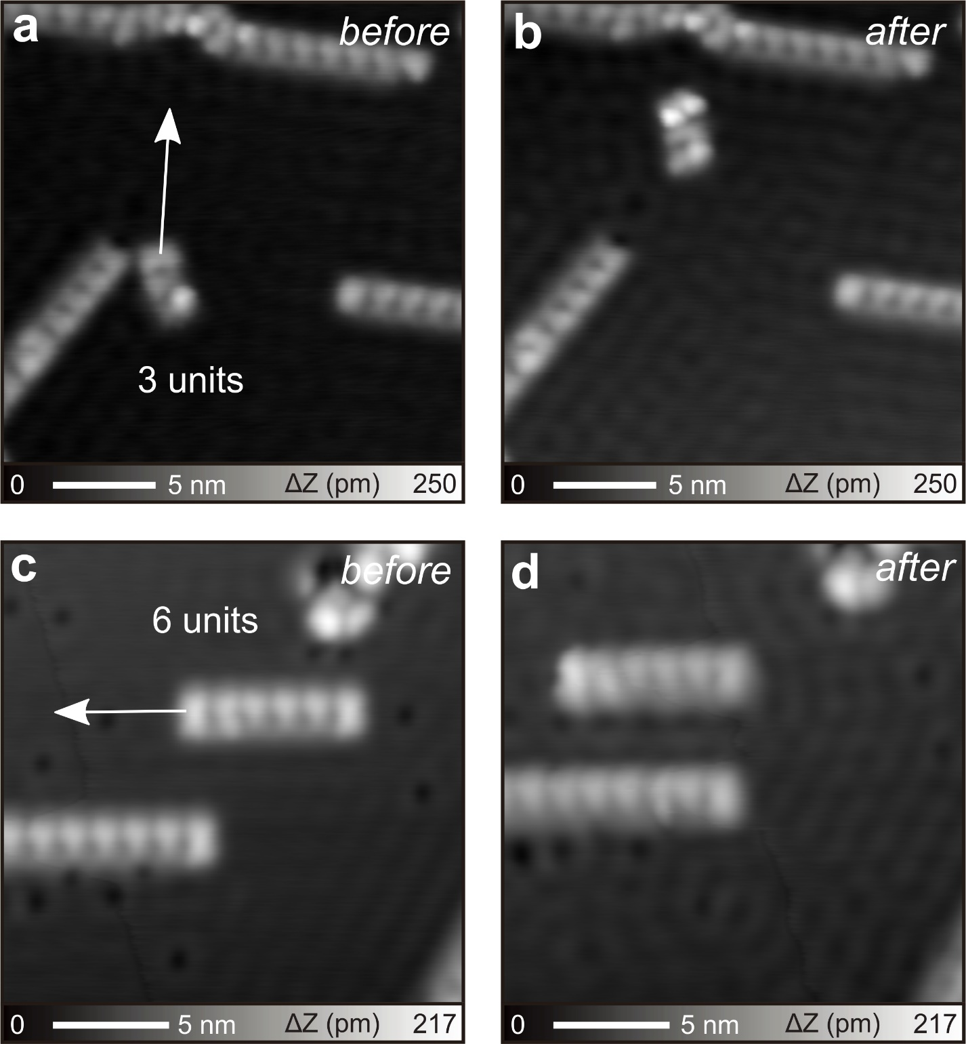
Figure S12. Tip-induced lateral manipulation. STM images of one 3-unit chain 4 on surface before (a) and after (b) tip manipulation. STM images of the 6-unit long chain 4 before (c) and after (d) tip manipulation. Red arrows show the moving direction. Measurement parameters: V = 10 mV and I = 10 pA in (a) and (b). V = 100 mV and I = 30 pA in (c). V = 10 mV and I = 100 pA in (d).

References
- Sun, K.; Sugawara, K.; Lyalin, A.; Ishigaki, Y.; Uosaki, K.; Taketsugu, T.; Suzuki, T.; Kawai, S. Heterocyclic Ring-Opening of Nanographene on Au(111). Angew. Chem. Int. Ed. 2021, 60, 9427–9432.
- Ohmann, R.; Levita, G.; Vitali, L.; De Vita, A.; Kern, K. Influence of Subsurface Layers on the Adsorption of Large Organic Molecules on Close-Packed Metal Surfaces. ACS Nano 2011, 5, 1360–1365.
- Zhong, Q.; Ebeling, D.; Tschakert, J.; Gao, Y.; Bao, D.; Du, S.; Li, C.; Chi, L.; Schirmeisen, A. Symmetry Breakdown of 4,4″-Diamino-p-Terphenyl on a Cu(111) Surface by Lattice Mismatch. Nat. Commun. 2018, 9, 3277.

