Development of Oral pH-Sensitive Redox Nanotherapeutics for Gastric Ulcer Therapy
Minh-Dat Quoc Tang^{1,2}, Nhi Bao Tran^{1,2}, Thu-Ha Thi Nguyen^{1,2}, Khanh-Uyen Hoang Nguyen^{2,3} Nhu-Thuy Trinh^{1,2}, Toi Van Vo^{1,2}, Makoto Kobayashi⁴, Toru Yoshitomi⁵, Yukio Nagasaki^{6,7,8,9,10*}, Long Binh Vong^{1,2*}
¹School of Biomedical Engineering, International University, Ho Chi Minh 700000, Vietnam
²Vietnam National University Ho Chi Minh City (VNU-HCM), Ho Chi Minh 700000, Vietnam
³Falcuty of Biology and Biotechnology, University of Science Ho Chi Minh 700000, Vietnam
⁴Institute of Medicine, University of Tsukuba, Tsukuba, Ibaraki 305-8575, Japan
⁵Research Center for Macromolecules and Biomaterials, National Institute for Materials Science, 1-1 Namiki, Tsukuba, Ibaraki, 305-0044, Japan
⁶Department of Materials Science, Faculty of Pure and Applied Sciences, University of Tsukuba, Tennoudai 1-1-1, Tsukuba, Ibaraki 305-8573, Japan
⁷Master's School of Medical Sciences, Graduate School of Comprehensive Human Sciences, University of Tsukuba, Tennoudai 1-1-1, Tsukuba, Ibaraki 305-8573, Japan
⁸Center for Research in Radiation and Earth System Science (CRiES), University of Tsukuba, Tennoudai 1-1-1, Tsukuba, Ibaraki 305-8573, Japan
⁹Department of Chemistry, Graduate School of Science, The University of Tokyo, Hongo 7-3-1, Bunkyo-ku, Tokyo 113-8654, Japan
¹⁰High-value Biomaterials Research and Commercialization Center (HBRCC), National Taipei University of Technology, Taipei 10608, Taiwan
*Corresponding author: Long Binh Vong, School of Biomedical Engineering, International University, Ho Chi Minh 700000, Vietnam. E-mail address: vblong@hcmiu.edu.vn
Phone: +84 2837 244 270 Fax: +84 2837 244 271
*Corresponding author: Yukio Nagasaki, Department of Materials Science, Graduate School of Pure and Applied Sciences, University of Tsukuba, 1-1-1 Tennoudai, Tsukuba, Ibaraki 305-8573, Japan. E-mail address: happyhusband@nagalabo.jp
Phone: +81 29-853-5749 Fax: +81 29-853-5749
Conflicts of Interest
The University of Tsukuba has a patent for the material developed in this study, licensed to CrestecBio.
ABSTRACT
Gastric ulcer is a common gastrointestinal disorder worldwide. Although its pathogenesis is unclear, the overproduction of reactive oxygen species (ROS), which results in an oxidative imbalance, has been reported as a central driving mechanism. Within the scope of this investigation, we developed two different self-assembling redox nanoparticles (RNPs) with ROS-scavenging features for the oral treatment of gastric ulcers. One of them, referred to as RNP^{N}, disintegrates in response to acidic pH, whereas the other, denoted as RNP^{O}, remains intact regardless of pH variations. Both types of RNPs showed different free radical scavenging activities in vitro. Protonation of the amino linkages in the side chains of RNP^{N} caused the micelle structure to collapse and the nitroxide radicals encapsulated in the core were exposed to the outside, resulting in a significant increase in antioxidant capacity as the pH decreases. In contrast, RNP^{O} maintained its spherical structure and consistent antioxidant reactivity irrespective of pH changes. The in vivo gastric retention of orally administered RNP^{N} was significantly improved compared to that of RNP^{O} which might be explained by the increased exposure of cationic protonating segments in RNP^{N} on the negatively charged gastric mucosal surface. Owing to its improved gastric retention and enhanced ROS scavenging capacity under acidic pH conditions, RNP^{N} exhibited superior protective effects against oxidative stress induced by aspirin in a gastric ulcer mouse model compared to RNP^{O}. In addition, neither RNP^{N} nor RNP^{O} resulted in severe lethal effects or significant changes in the morphology of zebrafish embryos, indicating their biosafety. Our results suggest that the oral administration of RNPs has a high therapeutic potential for gastric ulcer treatment.
Keywords: ROS, redox nanoparticles, pH-sensitive, oral delivery, aspirin, gastric ulcer.
1. INTRODUCTION
Gastric ulcers are a prevalent gastrointestinal pathology with global implications for morbidity and mortality. Furthermore, the protracted and consistent administration of low-dose aspirin, a non-steroidal anti-inflammatory drug (NSAID) used as an antiplatelet agent to mitigate the risk of myocardial and cerebral infarctions, concurrently elevates the likelihood of complications arising from gastric ulceration. Although its specific pathophysiological origin is not fully understood, the oxidative imbalance resulted from excessive reactive oxygen species (ROS) and inflammation have been defined as primary directive elements [1]. One of the crucial roles of ROS is to serve as signaling molecules in vivo; however, excessive production of ROS disrupts the regular redox balance and triggers lipid and protein peroxidation as well as DNA lesions [2,3]. These effects collectively contribute to the damage to the gastric epithelium, resulting in cell death and irreversible injury to the gastric mucosa.
Although several therapeutic treatments for gastric ulcers have been developed, numerous adverse effects have been reported [4]. Moreover, these drugs are not always effective because of their systemic distribution, which results in undesirable adverse effects on the entire body. For instance, idiosyncratic liver injury has been reported in some cases after administration of H₂-receptor antagonist drugs, such as ebrotidine and cimetidine [5,6]. Although the causes of the damage are still unclear, effects on the functions of the hemoprotein cytochrome P450 might be a possible mechanism for the adverse effects of these drugs. Therefore, various drug delivery nanoplatforms have been explored to control the pharmacokinetics of these low-molecular-weight drugs and reduce their undesired dispersion by targeting specific factors at the gastric site, including a low pH environment and gastric mucoadhesion [7–9]. However, these nanocarriers generally encapsulate drugs through physical interactions, which have been reported to lead to premature leakage before reaching the target site, thereby reducing therapeutic efficiency rather than preventing adverse effect [10].
To address the current limitations of drug delivery systems, we developed a solution using pharmacologically active polymer micelles. These micelles are composed of a functionalized block copolymer consisting of a hydrophilic and biocompatible poly(ethylene glycol) (PEG) segment and a hydrophobic poly(methylstyrene) segment. Within this structure, we covalently installed a 2,2,6,6-tetramethylpiperidine-1-oxyl (TEMPO) moiety, which served as a side chain for each methylstyrene repeating unit in the hydrophobic segment. Although an unpaired electron in the TEMPO moiety is recognized as stable and avoids coupling reactions between the TEMPO moieties, it reacts rapidly with various types of ROS, making it one of the most potent antioxidants [11,12]. The TEMPO moiety was incorporated into two distinct linkages, as shown in Fig. 1A. The first was an ether linkage that remained unresponsive to pH changes, denoted as PEG-b-PMOT. The second was an amine linkage that became protonated under low pH conditions, referred to as PEG-b-PMNT. Consequently, polymer micelles comprising PEG-b-PMNT, abbreviated as (RNP^{N}), disintegrated under low pH conditions because of the reduced core aggregation force resulting from the protonation of the PMNT segment. Owing to its spherical core-shell structure measuring tens of nanometers, RNP^{O} exhibited exceptional accumulation in the intestinal mucosa, regardless of pH variation, leading to an extended retention period. The exceptional dispersion stability of RNP^{O} prevented coagulation under the challenging conditions of the gastrointestinal tract. This contributes to its high accumulation in the intestinal mucosa. It was confirmed that orally administered RNP^{O} was highly effective in mouse models of colitis by neutralizing intestinal ROS [13,14]. In contrast, RNP^{N} disintegrated under acidic conditions, including the gastric environment. Consequently, we can expect gastroprotection by RNP^{N} due to the improvement in gastric retention caused by the increased ion interactions between cationic RNP^{N} and the negatively charged epithelial surface, as well as the increased exposure of the TEMPO moieties resulting from the disintegration of RNP^{N} under gastric pH conditions to effectively neutralize gastric ROS. In this study, we examined the gastric transit time of RNPs via oral administration and their protective effects in an aspirin-induced mouse model of gastric ulcer. The results indicate that both RNPs showed different free radical scavenging activities. In addition, RNP^{N} demonstrated increased antioxidant capacity under gastric pH and extended retention, resulting in more effective protection of the inflamed stomach than RNP^{O}. Finally, RNP^{N} did not show significant toxicity or abnormal morphology in zebrafish embryos during the 120 h exposure period.
2. MATERIALS AND METHOD
2.1. Preparation and characterization of RNPs
The pH-responsive redox nanoparticle (RNP^{N}) and pH-unresponsive redox nanoparticle (RNP^{O}) were prepared using the dialysis method with two types of self-assembly redox block copolymers, namely PEG-b-poly[4-(2,2,6,6-tetramethylpiperidine-1-oxyl)aminomethylstyrene] (PEG-b-PMNT) and PEG-b-poly[4-(2,2,6,6-tetramethylpiperidine-1-oxyl)oxymethylstyrene] (PEG-b-PMOT), as reported in a previous study [15]. Briefly, 15 mg of PEG-b-PMNT or PEG-b-PMOT were dissolved in 1 mL of methanol or dimethylformamide (DMF; Sigma-Aldrich, US). The mixture was stirred at 25 ± 2 °C for 1 h and then placed into a semi-permeable membrane tube (MWCO 3.5 kDa; Spectrum Laboratories Inc., Japan), followed by dialysis against distilled water for 1 d to remove organic solvents. Control NPs (CNP) without side chains containing the TEMPO moieties were prepared from PEG-b-poly(methylstyrene) (PEG-b-PCMS) copolymers. The size distribution of the NPs was evaluated using dynamic light scattering (DLS; Malvern Instruments, UK).
2.2. pH-responsive disintegration of RNPs
Phosphate buffer (10 mM) was prepared at various pH levels (7.4, 5.5, and 2.0) to represent the pH levels of the physiological environment and the stomach. RNP^{N} and RNP^{O} were mixed (1:2, v/v) in the prepared phosphate buffer. The pH-responsive disintegration of RNPs was determined by monitoring the relative light scattering intensity after 30 min of incubation at 25 ± 2 °C measured by the DLS system.
2.3. Hydroxyl free radical-scavenging activity of RNPs
Hydroxyl free radicals were generated by the Fenton reaction between the Fe²⁺ and H₂O₂ solution. Safranin-O is then targeted by hydroxyl radicals, causing it to fade. Briefly, RNPs, safranin-O (0.36 mg/mL), and FeSO₄ (2 mM) solutions were added to 96-well plates, before H₂O₂ (5% w/v) solution was added. The solution was then placed in the darkened condition at 60 ºC for 0.5 h, followed by evaluating the absorbance at 492 nm by a 96-microplate reader (Thermo Fisher Scientific, US). The hydroxyl scavenging of RNPs was calculated using the following formula:
$$Scavenging (\%)=\frac{{\text{A}}_{S}-A_{\text{B}}}{{\text{A}}_{\text{C}}-A_{\text{B}}}×100\%$$
where A_{S} is the absorbance of the sample, A_{B} is the absorbance of the background correction (no samples), and A_{C} is the absorbance of the control (no samples and H₂O₂ solution).
2.4. 2,2-Azinobis(3-ethylbenzothiazoline-6-sulfonate) (ABTS) free radical-scavenging capacity of RNPs
The scavenging capacity of RNPs was also determined using ABTS free radicals (BioBasic, US). The ABTS reagent was prepared via an overnight reaction between the ABTS solution (7 mM) and K₂S₂O₈ solution (2.4 mM) in the darkened condition at 25 ± 2 °C. RNPs were supplied with the ABTS reagent at a ratio of 1:4 (v/v), then incubated in the darkened condition at 25 ± 2 °C for 0.5 h, followed by evaluating the absorbance at 734 nm. The ABTS free radical-scavenging activity of RNPs was calculated using the following formula:
$$Scavenging (\%)=\frac{{\text{A}}_{C}-A_{\text{S}}}{{\text{A}}_{\text{C}}}×100\%$$
where A_{C} is the absorbance of the control and A_{S} is the absorbance of the sample.
2.5. 2,2-Diphenyl-1-picrylhydrazyl (DPPH) free radical-scavenging activity of RNPs
The antioxidant capacity of RNPs was evaluated using DPPH free radicals (TCI, Japan). Different concentrations of RNPs and DPPH reagent (40 µg/mL) were mixed at a ratio of 1:4 (v/v), then incubated in the darkened condition at 25 ± 2 °C for 0.5 h, followed by evaluating the absorbance at 517 nm. The DPPH scavenging activity of RNPs was calculated using a formula similar to that used in the ABTS assay.
2.6. Cytotoxicity of RNPs in vitro
Murine macrophage cells (RAW 264.7 from ATCC, US) were cultured in Dulbecco’s Modified Eagle’s Medium (DMEM; Sigma-Aldrich, US) supplied with 1% antibiotic mixture (penicillin, streptomycin, and neomycin; Invitrogen, US) and 10% fetal bovine serum (FBS; Sigma-Aldrich, US), followed by incubating at 37 °C and 5% CO₂. A total of 10⁴ cells were added to each well of a 96-well plate and incubated overnight. Different concentrations RNPs (8, 16, 31, 63, and 125 µg/mL, corresponding to 12, 24, 46.5, 94.5, and 187.5 µmol of TEMPO, respectively) were added and continuously incubated for 1 d. The medium was then replaced with 3-(4,5-dimethylthiazol-2-yl)-2,5-diphenyltetrazolium bromide (MTT; Roche Diagnostics, Japan) solution, followed by incubation for 4 h. Dimethyl sulfoxide was added, and the absorbance was measured at 540 nm.
2.7. Protective effects of RNPs in vitro
H₂O₂ can damage cells by directly oxidizing biomolecules or acting as a signaling molecule to stimulate different intracellular pathways, resulting in cell death [16]. Therefore, the in vitro ROS-scavenging activity of RNPs was determined by measuring the RAW 264.7 cell viability under oxidative stress induced by H₂O₂. Briefly, the cells were seeded on 96-well microtiter plates with a density of 10⁴ cells per well and then placed for overnight. After that, RNPs were added, and continuously incubated for 60 min. H₂O₂ solution (final concentration of 150 µM) was then added and incubated for 1 d. Similar steps were repeated to measure the cytotoxicity of RNPs on RAW264.7 cells.
2.8. Determination of nitric oxide (NO) level n lipopolysaccharide (LPS)-induced activation RAW 264.7 cells
Although the complex role of nitric oxide (NO) in gastric inflammation is debated, excessive NO production by inducible NO synthase (iNOS) in neutrophils and macrophages has been reported to cause gastric oxidative damage [17,18]. LPS (Sigma Aldrich, US) is known to activate macrophages, resulting in increased expression of iNOS and NO generation. Briefly, the macrophage cells were added to 24-well plates with a density of 10⁵ cells per well and placed for overnight. Next, different concentrations of RNPs were added, followed by incubation for 1 h. Then, each well was supplied with LPS solution (1 µg/mL) and further placed for 24 h. Finally, 50 µL of the medium was mixed with Griess reagent (Sigma Aldrich, US) at a ratio of 1:1 and the absorbance was evaluated at 540 nm. The NO levels were determined using a standard curve prepared using NaNO₂.
2.9. Animals
ICR male mice (7 to 8-week-old, weight from 32 to 35 g), supplied from Charles River Inc. (Japan), were kept under standard conditions with ad libitum access to food, controlled temperature (23.5 ± 2.5 °C), lighting (14 h/10 h light-dark cycles), and humidity (52.5 ± 12.5%). Part of the experiments were performed using mice supplied by the Stem Cell Institute (Vietnam). The mice were housed in animal facilities at the International University, Vietnam National University, Ho Chi Minh City, Vietnam. All animal experiments were performed in accordance with the animal protocol approved by the Animal Experiment Committee of the University of Tsukuba (approval number #20-392) and the University of Science, Vietnam National University, Ho Chi Minh City (approval number #209/KHTN-ACUCUS).
The zebrafish embryos and larvae (wild-type strain AB, University of Tsukuba) were acquired through natural reproduction and nurtured in E3 medium (0.33 mM CaCl₂, 0.33 mM MgSO₄, 5 mM NaCl, and 0.17 mM KCl, pH around 6.8) supplied with 0.1 mg/L of methylene blue. The rooms were kept under 14 h/10 h light-dark cycles and controlled temperature (28 ± 1 °C).
2.10. The gastric retention time of RNPs
¹²⁵I-labeled RNPs were generated by reacting RNPs and Na[¹²⁵I] with a chloramine-T reagent catalyst, as reported previously [13]. Briefly, the mice were fasted for 24 h before the experiments. Mice were orally administered 10 mg ¹²⁵I-labeled RNPs (20 mg/mL). At predetermined time intervals, the mice were sacrificed to harvest their stomachs, and radioactivity was detected using a gamma counter (ARC380, Aloka, Japan). The percentage gastric retention of ¹²⁵I-labeled RNPs at different time points was calculated based on the initial dose.
2.11. Induction and evaluation of gastric ulcer mouse model
ICR mice were fasted for 24 h prior to the experiment to increase gastric acid levels and make them more susceptible to aspirin-induced gastric damage. Fifteen mice were randomly assigned to five groups. Group 1 (control) received water, whereas group 2 received a single dose of aspirin (350 mg/kg body weight) suspended in water by oral administration to serve as the aspirin-induced ulcer group. Groups 3, 4, and 5 were treated with a single oral dose of CNP, RNP^{N}, or RNP^{O} (120 mg/kg body weight) 0.5 h before administration of aspirin. Two hours after aspirin administration, all mice were sacrificed for stomach harvesting. Digital images of the stomach were obtained for gross pathological evaluation. The stomachs were halved longitudinally for histological assessment and measurement of lipid peroxidation.
2.12. Histological analysis
The stomachs were cut in half, washed with saline, then stored in 10% formalin, and covered by paraffin. The gastric sections (5 μm thick) were then stained with hematoxylin-eosin (H&E). Histological assessment of the gastric ulcers was performed using an inverted microscope (Nikon, Japan).
2.13. Lipid peroxidation
Malondialdehyde (MDA), the final product of lipid oxidation, was detected through its reaction with thiobarbituric acid (TBA; Sigma-Aldrich, US) to generate the MDA-(TBA)₂ complex, with absorbance at 532 nm corresponding to the oxidized lipid level of the samples. Briefly, the gastric tissues were homogenized in phosphate-buffered saline (PBS), and then centrifugated at 6000 rpm at 4 ºC for 0.25 h. The mixture of stomach homogenate, 10% (w/v) trichloroacetic acid, and 0.8% (w/v) TBA was heated for 60 min at 100 °C, before cooling to 25 ± 2 °C for 10 min. The solution was then supplemented with an n-butanol:pyridine mixture (1:1, v/v), and centrifugated at 10,000 rpm for 5 min to obtain the supernatant, which was read at an absorbance of 532 nm. The level of lipid peroxidation was evaluated using a standard curve prepared using tetramethoxypropane (TMP; Wako, Japan).
2.14. Toxicity evaluation in zebrafish
Thirty larvae (five days post-fertilization) were placed in a 6 cm dish supplied with E3 medium and different predetermined concentrations of CNP or RNP^{N}. The survival rate of the zebrafish was evaluated under a light microscope at half-day intervals during the 5-d experimental period. The experiments were repeated three times for statistical analysis.
2.15. Statistical analysis
Data were expressed as the mean ± standard deviation (SD) or standard error of the mean (SEM). Statistical analysis was conducted using Student’s t-test and one-way analysis of variance. Differences between groups were considered statistically significant at p < 0.05.
3. RESULTS AND DISCUSSION
3.1. Characterization of RNPs
Both RNP^{N} and RNP^{O} were prepared by dialysis of the corresponding polymers in DMF or methanol against water to form self-assembling polymer micelles (Fig. 1A). The DLS measurement showed that both RNP^{N} and RNP^{O} were approximately 40–50 nm with a narrow size distribution (PdI ≤ 0.25) (Fig. 1B). As shown in Fig. 1C, the light scattering intensity of the RNP^{N} solution decreased under acidic conditions and did not change at physiological pH. This phenomenon could be explained by protonated amino linkages inside the core of the NPs under acidic conditions, which decreased their hydrophobic core coagulation force and disintegrated the micelle structures. In contrast, the light scattering intensity of RNP^{O} prepared using PEG-b-PMOT with ether linkages was stable regardless of pH.
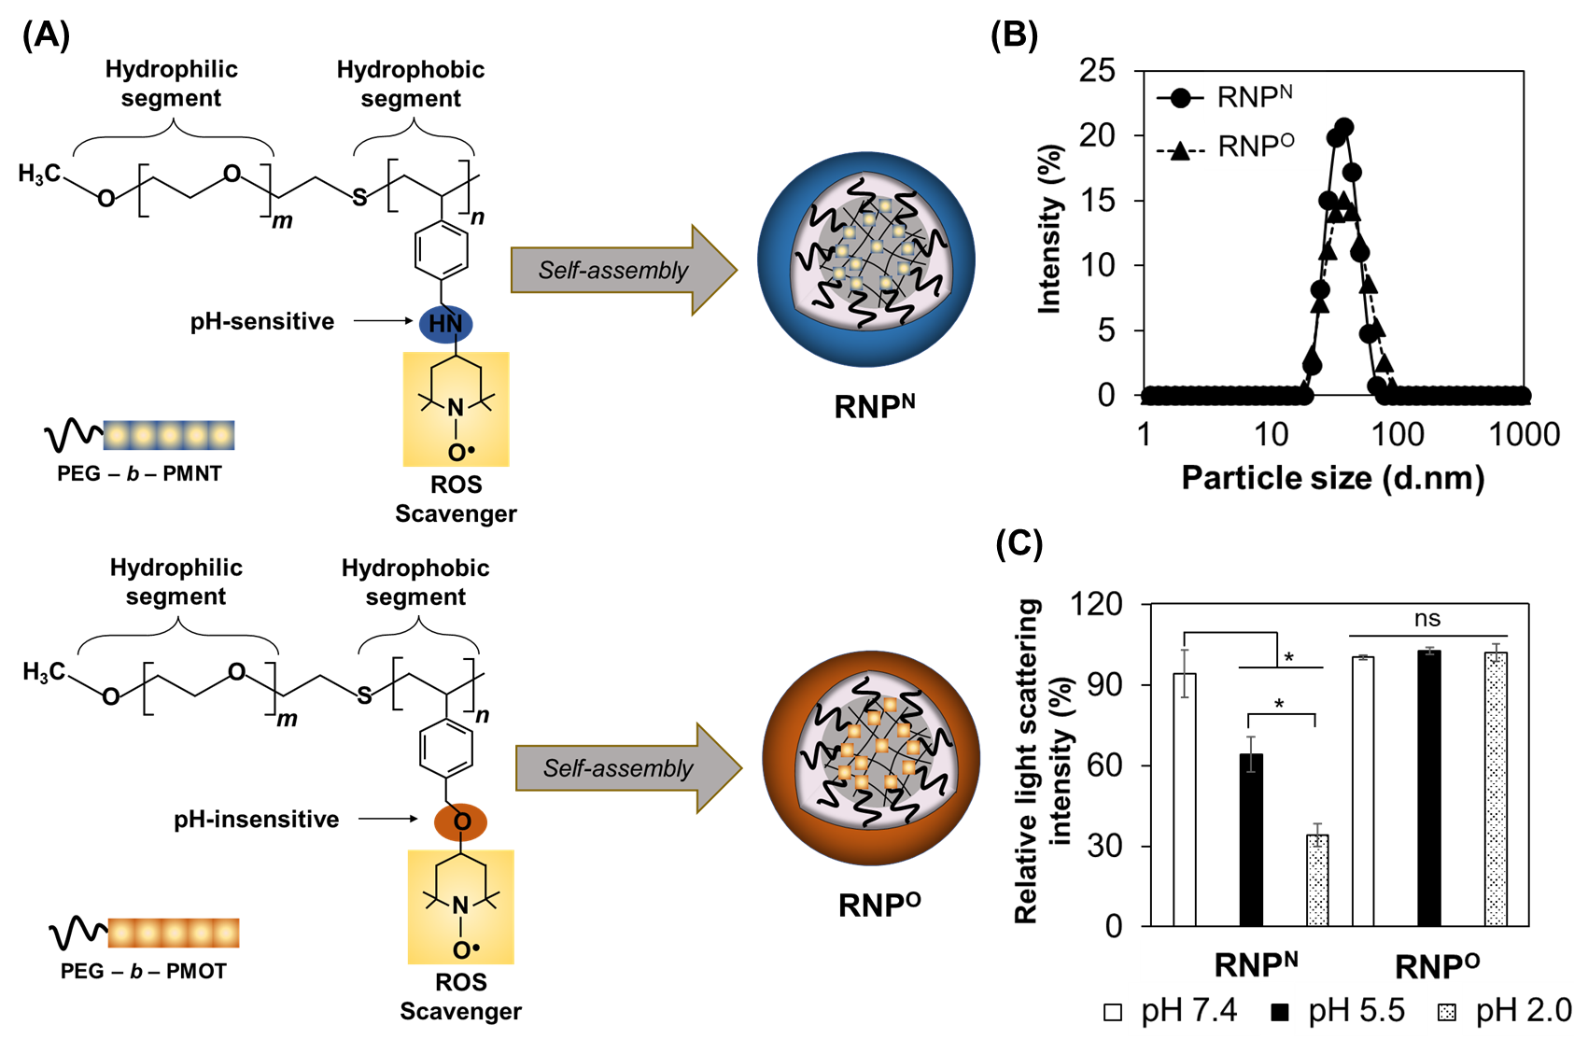
Figure 1: Characterization of RNPs. (A) Schematic illustrations of RNPs prepared using dialysis from two different types of block copolymers. (B) Size distribution of RNPs measured via DLS. (C) The relative light scattering intensity of RNPs after 30 min of incubation under different pH buffers was evaluated via DLS. The data are expressed as the mean ± SD. n = 3; *p < 0.05; ns = non-significant.

3.2. ROS scavenging activities of RNPs
The overproduction of ROS induces oxidative injury, which plays a crucial role in gastric ulcers. Therefore, the scavenging activity of RNPs against different radical species, such as hydroxyl, ABTS, and DPPH free radicals, was examined. Fig. 2A shows the scavenging activity of RNPs against hydroxyl radicals. With increasing concentrations of RNPs, the hydroxide radical levels decreased, indicating that RNPs effectively scavenged hydroxyl radicals as antioxidants. Moreover, both RNP^{N} and RNP^{O} showed ABTS and DPPH free radical scavenging activities in a tendency of enhancing concentrations (Fig. 2B, C). It is worth mentioning that these RNPs are self-assembled structures under neutral conditions. An important aspect to highlight is that they possess a substantial antioxidant capacity even when the TEMPO moieties are situated within the core of the micelle. Moreover, RNPs with the TEMPO moieties that can scavenge various radical species are expected to effectively reduce their oxidative damage to cells and tissues [19–21]. However, in acidic media, the reactivity of RNP^{N} was greater than that observed under neutral conditions (Fig. 2D and Fig. S1). This suggests that the disintegration of the micelles might enhance the reactivity of TEMPO, possibly because of its exposure from the core to the exterior. These results were similar to those of a previous report on the pH-responsive disintegration of RNP^{N} during superoxide scavenging [22]. In contrast, the DPPH scavenging activity of RNP^{O} did not change with pH (Fig. 2D).
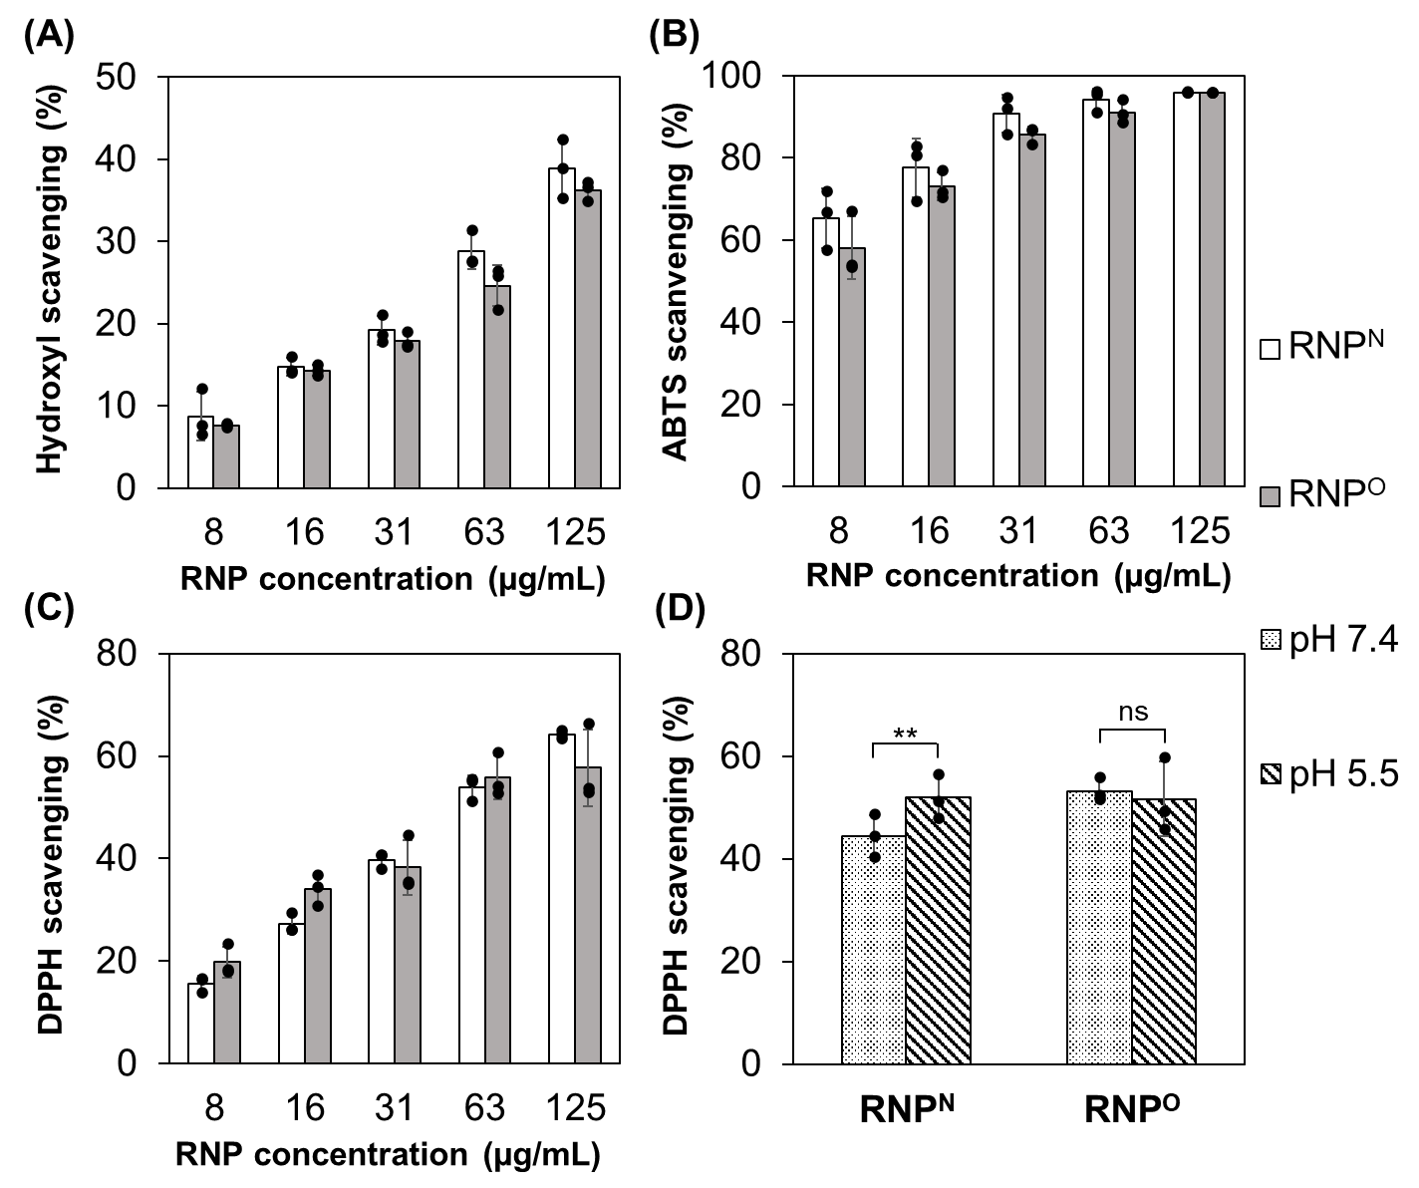
Figure 2: The scavenging activity of RNPs against different free radicals. (A) Hydroxyl free radicals scavenging activity. (B) ABTS free radicals scavenging activity. (C) DPPH free radicals scavenging activity. (D) The pH influences on DPPH scavenging activity of RNPs. The RNPs solutions were adjusted to pH 7.4 and 5.5 and incubated for 1 h followed by measurement of the radical scavenging activity by reacting with the DPPH reagent. The data are expressed as the mean ± SD. n = 3; **p < 0.01; ns, non-significant.

3.3. Protective effects of RNPs on RAW 264.7 murine macrophage cells
Before examining the in vitro antioxidant capacity of RNPs, their cytotoxicity was examined in RAW 264.7 cells. Fig. 3A shows the cell viability after 1 d of exposure with different concentrations of RNPs. Interestingly, the cell viability gradually increased with increasing the RNP concentration. It has been reported that conventional cell culture systems induce strong oxidative stress in incubated cells [23,24]. RNPs possessed the antioxidant activity to suppress oxidative stress, therefore, an increase in viability of the RAW 264.7 cells was observed (Fig. 3A). To further assess the antioxidant capabilities of RNPs, we cultured macrophages in the presence of H₂O₂, a well-documented agent known to trigger apoptosis in RAW 264.7, through oxidative damage [25,26], and investigated the protective effects of RNPs. The results show that H₂O₂ (150 µM) decreased cell viability by approximately 40% after 24 h of incubation (Fig. 3B). However, pretreatment with RNPs significantly improved cell viability in a concentration-dependent manner, demonstrating antioxidant capacity against ROS in vitro. It has been reported that LPS-activated macrophages can induce morphological transformation and elevate the levels of both NO and numerous ROS, leading to irreversible oxidative damage to cells [27–30]. Hence, we examined the effect of RNP on NO production induced by LPS-activated RAW 264.7 cells. As shown in Fig. 3C, the NO level in cells activated by LPS was significantly higher than that in untreated cells. Conversely, RNPs treatment resulted in a concentration-dependent reduction in NO levels, suggesting its role in scavenging ROS and influencing NO levels in vitro. In addition, the protective effects of RNPs were also confirmed by the suppression of LPS-induced RAW 264.7 activation via morphology observations confirming the maintenance of the cellular size and suppression of the formation of lamellipodia and filopodia in macrophage cells (Fig. S2).
Figure 3: Protective effects of RNPs in RAW 264.7 murine macrophage cells. (A) Cell viability of RAW 264.7 cells exposed to predetermined concentrations of RNPs and then measured using an MTT assay, n = 6-8. (B) Protective effects of RNPs on RAW 264.7 cell viability under oxidative stress caused by H₂O₂. After pre-incubation with different concentrations of RNPs for 1 h, the cells were exposed to H₂O₂ (150 µM) and placed for 1 d. The H₂O₂ oxidative damage level representing the decrease in cell viability was then measured using an MTT assay, n = 4. (C) The NO level of LPS-induced activation of RAW 264.7 macrophage cells exposed to predetermined concentrations of RNPs. After pre-incubation with different concentrations of RNPs for 60 min, the cells were supplied with LPS (1 µg/mL) and further placed for 24 h. Then, the extracellular NO level was examined using the Griess reagent. The data are expressed as the mean ± SD. n = 4; *p < 0.05; ***p < 0.001.

3.4. Retention of orally administered RNPs in the stomach
In this study, the gastric retention time of RNPs was investigated using radiolabeling. The concentration of NPs in the stomach generally decreases several hours after oral administration owing to the short gastric transit time [31], indicating the challenge of retention time for gastric treatment. Fig. 4A shows the gastric transit time of RNPs and a significantly higher retention of RNP^{N} than of RNP^{O} in the stomach 2 h after oral administration. This was thought to be due to the collapse of RNP^{N} in the gastric pH and its enhanced interaction with the negatively charged gastric wall. Even more surprisingly, approximately 5% of the administered dose of RNP^{N} was retained in the stomach after 12 h, while a negligible amount of orally administered RNP^{O} could be detected after the same time (Fig. 4A). As shown in Fig. 4B, the area under the curve (AUC) of RNP^{N} in the stomach over 24 h was significantly higher than that of RNP^{O}, suggesting higher accumulation and retention of RNP^{N} in the stomach over time after oral administration.
Figure 4: Gastric transit time of RNPs. (A) The ¹²⁵I-labeled RNP concentration at predetermined times in the stomach was detected using a gamma counter. (B) The area under the curve (AUC) values of RNPs in the stomach. The data are expressed as the mean ± SEM. n = 5; *p < 0.05; **p < 0.01, ***p < 0.001.
3.5. Protective effects of RNPs against aspirin-induced gastric ulcers in mice
The protective effect of RNPs against gastric injury induced by aspirin administration in mice was investigated (Fig. 5A). It has been reported that the excessive ROS is related to the pathogenesis of gastric ulcers resulted from aspirin and other non-steroidal anti-inflammatory drugs (NSAIDs) [32]. ROS can be generated directly from the accumulation of NSAIDs in the gastric epithelium and are also produced as a response of infiltrated neutrophils in inflamed tissues [33]. Thus, reducing excessive ROS levels is considered a potential therapeutic strategy for stomach inflammation. There are several approaches for treating gastric inflammation using antioxidants. For example, diosmin, an antioxidant and anti-inflammatory compound, provides effective gastroprotection against ethanol [34]. However, its low solubility, which leads to short gastric retention and no detection 2-h post oral administration [35], may negatively affect the clinical use of diosmin. Low-molecular-weight antioxidants have several other disadvantages, such as spreading throughout the body, which causes unwanted adverse effects and dysfunction of the intracellular redox balance. The use of self-assembled antioxidant nanoparticles can prevent the spread of antioxidants throughout the body and prevent intracellular redox dysfunction. In addition, because RNPs, particularly RNP^{N}, have prolonged retention in the stomach and high antioxidant capacity under acidic gastric conditions as described above, they are expected to have a positive effect on aspirin-induced gastric ulcers. Fig. 5B shows gastric images of aspirin-induced stomachs treated with RNPs. The control group showed normal gastric morphology while the stomachs of the aspirin- and CNP-treated groups (non-antioxidant control nanoparticles) swelled and bled, which is a common symptom of inflammation (Fig. 5B). By contrast, the histology of stomach in both RNP-treated groups were similar to that in the healthy control group. As shown by histological assessment (Fig. 5C), the aspirin- and CNP-treated groups also displayed erosion of the mucosal layer, extensive submucosal edema, and inflammatory cell infiltration. However, both RNP-treated groups showed protection of gastric architecture, with mild erosion, submucosal extension, and leukocyte infiltration. In particular, the RNP^{N}-treated group displayed fewer symptoms of gastric inflammation than the RNP^{O} group, indicating its superior anti-inflammatory effectiveness. To verify the aforementioned visual observations, we also assessed the levels of MDA, a lipid peroxidation product. The aspirin-treated group exhibited a significant rise in MDA levels, indicating that pronounced oxidative stress was induced by aspirin. MDA levels were not reduced in the CNP-treated group (Fig. 5D). In contrast, both RNP-treated indicate lower MDA levels in comparison with those of the CNP- and aspirin-treated groups. Notably, the MDA levels in the RNP^{N} group were similar to those in the control group. Although both RNPs showed gastric protective effects, RNP^{N} was more effective in gastroprotection both in terms of histology and inhibited levels of lipid peroxidation. This result could be explained by the greater gastric retention and increased antioxidant capacity because ofthe exposure of TEMPO moieties of RNP^{N} from the core to the exterior under the gastric pH.
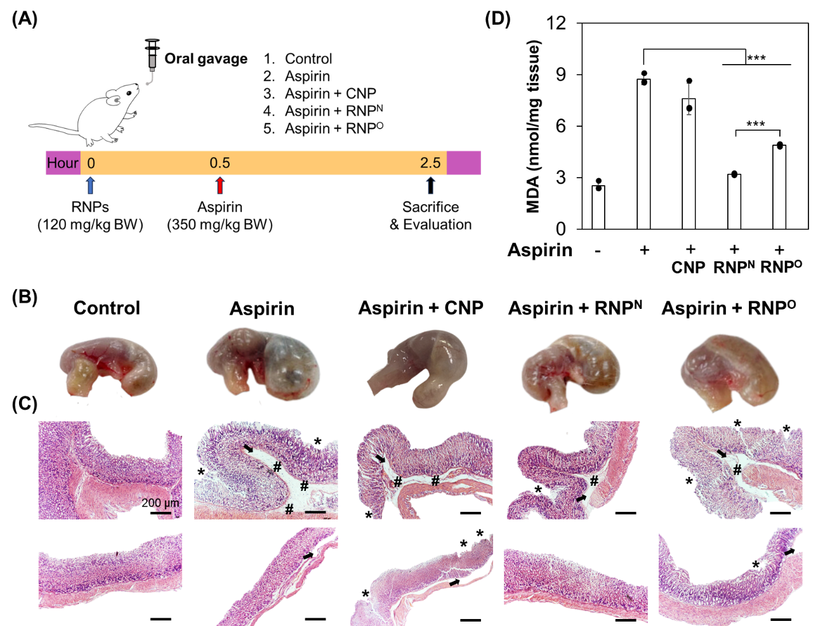
Figure 5: Protective effects of RNPs against gastric ulcers induced by aspirin in mice. (A) The experimental design. (B) Images of the stomachs. (C) The histology of gastric fold and mucosa stained by H&E. Notice the erosion of the mucosal layer (asterisks), the extensive submucosal edema (black arrow), and the inflammatory cell infiltration (hashtag). Scale bars 200 µm. (D) The lipid peroxidation after treatment with RNPs was quantified via the measurement of MDA. Data were expressed as the mean ± SD. n = 3; ***p < 0.001.
3.6. Toxicity of RNP^{N} to zebrafish embryos
Zebrafish is a well-known model for evaluating NP toxicity [36,37]. For example, Zhu et al. reported that morphological changes and death of zebrafish embryos were not observed during 4 days of exposure to ginkgolide B encapsulated polymeric NPs [38]. Therefore, the toxicity of RNP^{N} and CNP was evaluated by counting the number of surviving zebrafish embryos after 5 d of exposure. At low concentrations (2 and 6.7 mg/mL), neither RNP^{N} nor CNP exhibited noticeable toxicity in the zebrafish embryos, as confirmed by the absence of mortality (Fig. S3). However, treatment with a higher concentration of CNP (20 mg/mL) resulted in an increase in embryo mortality, corresponding to the incubation time (Fig. 6A). Moreover, abnormal zebrafish morphologies were recorded after 3 d of CNP exposure (Fig. 6B). These results are similar to those of previous reports on oxidative damage related to polystyrene NP toxicity on zebrafish [39,40]. In contrast, RNP^{N} showed negligible toxicity, with over 90% of embryo survival even after 5 days of incubation, owing to its high antioxidant capacity. In addition, no abnormal morphologies were observed in the zebrafish embryos after treatment with RNP^{N}, suggesting its biosafety profile. It should be noted that in our previous report, RNP^{O} did not cause death or change the morphology of zebrafish embryos at the same concentrations, whereas low-molecular-weight TEMPO exhibited significant toxicity [41], indicating that not only antioxidant capacity but also core–shell nanostructures with PEG on the surface layer could reduce the toxicity of RNPs. This result clearly indicated that the addition of TEMPO to the polymer backbone of RNP^{N} and RNP^{O} significantly decreased the toxicity of conventional polymeric NPs.
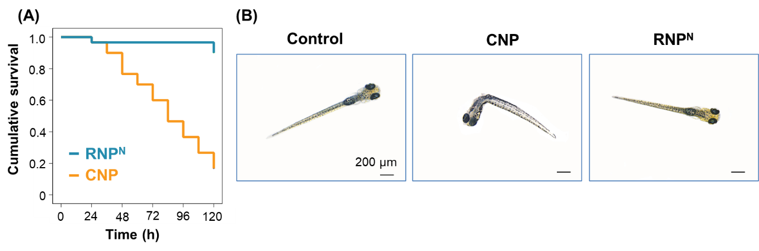
Figure 6: Toxicity of RNP^{N} and CNP on zebrafish embryos. (A) The survival rate after a 5-d treatment was assessed by counting surviving zebrafish. The data are presented as Kaplan-Meier plots and were analyzed with a log-rank test (3 independent experiments). (B) The morphologies after 72 h post-incubation with CNP and RNP^{N} (20 mg/mL) were observed using a light microscope. Scale bars 200 µm.
4. CONCLUSION
In this study, we successfully developed two types of nanocarriers possessing ROS scavenging activity, including pH-responsive RNP^{N} and pH-unresponsive RNP^{O}. Both RNPs exhibited high free radical-scavenging activity in vitro. Because RNP^{N} disintegrates in an acidic stomach environment, orally administered RNP^{N} exhibits longer retention in the stomach owing to the interaction of positively protonated amino groups of RNP^{N} with negatively charged gastric mucosal epithelium surfaces, resulting in a higher antioxidant capacity. Although both RNP^{N} and RNP^{O} showed a potential gastro-protective effect in mice with aspirin-induced gastric ulcer, orally administered RNP^{N} exhibited superior efficacy compared to RNP^{O} owing to the extended retention and increased exposure of TEMPO moieties in the stomach to effectively reduce local oxidative stress. In addition, the RNPs showed extremely low toxicity to murine macrophages and zebrafish embryos. Taken together, RNPs, particularly RNP^{N}, may be considered a potential oral nanotherapeutic for the treatment of gastric ulcers.

ACKNOWLEDGMENTS
This work was supported by the Vietnam National University, Ho Chi Minh City (VNU-HCM), under grant number NCM2020-28-01. This study was also supported by a Grant-in-Aid for Specially Promoted Research (19H05458) from the Ministry of Education, Culture, Sports, Science, and Technology (MEXT), Japan.

REFERENCES
[1] K. Koc et al., “Gastroprotective effects of oleuropein and thymol on indomethacin-induced gastric ulcer in Sprague-Dawley rats,” Drug and Chemical Toxicology, vol. 43, no. 5, pp. 441–453, 2020.
[2] G. Pihan, C. Regillo, and S. Szabo, “Free radicals and lipid peroxidation in ethanol-or aspirin-induced gastric mucosal injury,” Digestive diseases and sciences, vol. 32, pp. 1395–1401, 1987.
[3] I. Schraufstätter, P. A. Hyslop, J. H. Jackson, and C. G. Cochrane, “Oxidant-induced DNA damage of target cells.,” The Journal of clinical investigation, vol. 82, no. 3, pp. 1040–1050, 1988.
[4] S. Chanda, Y. Baravalia, and M. Kaneria, “Protective effect of Polyalthia longifolia var. pendula leaves on ethanol and ethanol/HCl induced ulcer in rats and its antimicrobial potency,” Asian Pacific journal of tropical medicine, vol. 4, no. 9, pp. 673–679, 2011.
[5] R. J. Andrade et al., “Acute liver injury associated with the use of ebrotidine, a new H2-receptor antagonist,” Journal of hepatology, vol. 31, no. 4, pp. 641–646, 1999.
[6] L. A. García Rodríguez, M.-A. Wallander, and B. H. C. Stricker, “The risk of acute liver injury associated with cimetidine and other acid‐suppressing anti‐ulcer drugs,” British journal of clinical pharmacology, vol. 43, no. 2, pp. 183–188, 1997.
[7] S. K. Pramanik et al., “Stimuli-responsive nanocapsules for the spatiotemporal release of melatonin: protection against gastric inflammation,” ACS Applied Bio Materials, vol. 2, no. 12, pp. 5218–5226, 2019.
[8] H. M. Anter, I. I. Abu Hashim, W. Awadin, and M. M. Meshali, “Novel chitosan oligosaccharide-based nanoparticles for gastric mucosal administration of the phytochemical ‘apocynin,’” International Journal of Nanomedicine, pp. 4911–4929, 2019.
[9] Y.-H. Lin, C.-H. Chang, Y.-S. Wu, Y.-M. Hsu, S.-F. Chiou, and Y.-J. Chen, “Development of pH-responsive chitosan/heparin nanoparticles for stomach-specific anti-Helicobacter pylori therapy,” Biomaterials, vol. 30, no. 19, pp. 3332–3342, 2009.
[10] Z. Xie et al., “A novel polymer–paclitaxel conjugate based on amphiphilic triblock copolymer,” Journal of Controlled Release, vol. 117, no. 2, pp. 210–216, 2007.
[11] M. Lewandowski and K. Gwozdzinski, “Nitroxides as antioxidants and anticancer drugs,” International Journal of Molecular Sciences, vol. 18, no. 11, p. 2490, 2017.
[12] B. P. Soule et al., “The chemistry and biology of nitroxide compounds,” Free Radical Biology and Medicine, vol. 42, no. 11, pp. 1632–1650, 2007.
[13] L. B. Vong, T. Tomita, T. Yoshitomi, H. Matsui, and Y. Nagasaki, “An orally administered redox nanoparticle that accumulates in the colonic mucosa and reduces colitis in mice,” Gastroenterology, vol. 143, no. 4, pp. 1027-1036. e3, 2012.
[14] L. B. Vong, J. Mo, B. Abrahamsson, and Y. Nagasaki, “Specific accumulation of orally administered redox nanotherapeutics in the inflamed colon reducing inflammation with dose–response efficacy,” Journal of Controlled Release, vol. 210, pp. 19–25, 2015.
[15] L. B. Vong and Y. Nagasaki, “Combination treatment of murine colon cancer with doxorubicin and redox nanoparticles,” Molecular pharmaceutics, vol. 13, no. 2, pp. 449–455, 2016.
[16] K. M. Holmström and T. Finkel, “Cellular mechanisms and physiological consequences of redox-dependent signalling,” Nature reviews Molecular cell biology, vol. 15, no. 6, pp. 411–421, 2014.
[17] C. H. Cho, “Current roles of nitric oxide in gastrointestinal disorders,” Journal of Physiology-Paris, vol. 95, no. 1–6, pp. 253–256, 2001.
[18] J. L. Wallace and M. J. Miller, “Nitric oxide in mucosal defense: a little goes a long way,” Gastroenterology, vol. 119, no. 2, pp. 512–520, 2000.
[19] B. M. Ali, M. Boothapandi, and A. S. Nasar, “Nitric oxide, DPPH and hydrogen peroxide radical scavenging activity of TEMPO terminated polyurethane dendrimers: Data supporting antioxidant activity of radical dendrimers,” Data in brief, vol. 28, p. 104972, 2020.
[20] Y. Nagasaki, “Nitroxide radicals and nanoparticles: a partnership for nanomedicine radical delivery,” Therapeutic delivery, vol. 3, no. 2, pp. 165–179, 2012.
[21] H. Yu et al., “The antioxidant mechanism of nitroxide TEMPO: scavenging with glutathionyl radicals,” RSC Advances, vol. 5, no. 78, pp. 63655–63661, 2015.
[22] T. Yoshitomi, A. Hirayama, and Y. Nagasaki, “The ROS scavenging and renal protective effects of pH-responsive nitroxide radical-containing nanoparticles,” Biomaterials, vol. 32, no. 31, pp. 8021–8028, 2011.
[23] B. Halliwell, “Cell culture, oxidative stress, and antioxidants: avoiding pitfalls,” Biomedical journal, vol. 37, no. 3, p. 99, 2014.
[24] B. Halliwell, “Oxidative stress in cell culture: an under-appreciated problem?,” FEBS letters, vol. 540, no. 1–3, pp. 3–6, 2003.
[25] J.-M. Chow, S.-C. Shen, S. K. Huan, H.-Y. Lin, and Y.-C. Chen, “Quercetin, but not rutin and quercitrin, prevention of H2O2-induced apoptosis via anti-oxidant activity and heme oxygenase 1 gene expression in macrophages,” Biochemical pharmacology, vol. 69, no. 12, pp. 1839–1851, 2005.
[26] X. Zhang et al., “Heme oxygenase-1 induction by methylene blue protects RAW264. 7 cells from hydrogen peroxide-induced injury,” Biochemical Pharmacology, vol. 148, pp. 265–277, 2018.
[27] Z. Zhai et al., “Free radical-operated proteotoxic stress in macrophages primed with lipopolysaccharide,” Free Radical Biology and Medicine, vol. 53, no. 1, pp. 172–181, 2012.
[28] K. Niikura et al., “Gold nanoparticles as a vaccine platform: influence of size and shape on immunological responses in vitro and in vivo,” ACS nano, vol. 7, no. 5, pp. 3926–3938, 2013.
[29] Y.-D. Lee et al., “Dye/peroxalate aggregated nanoparticles with enhanced and tunable chemiluminescence for biomedical imaging of hydrogen peroxide,” ACS nano, vol. 6, no. 8, pp. 6759–6766, 2012.
[30] B.-P. Huang, C.-H. Lin, Y.-C. Chen, and S.-H. Kao, “Anti‑inflammatory effects of Perilla frutescens leaf extract on lipopolysaccharide‑stimulated RAW264. 7 cells,” Molecular medicine reports, vol. 10, no. 2, pp. 1077–1083, 2014.
[31] D. Li et al., “Influence of particle geometry on gastrointestinal transit and absorption following oral administration,” ACS applied materials & interfaces, vol. 9, no. 49, pp. 42492–42502, 2017.
[32] M. Jainu, K. V. Mohan, and C. S. Devi, “Protective effect of Cissus quadrangularis on neutrophil mediated tissue injury induced by aspirin in rats,” Journal of ethnopharmacology, vol. 104, no. 3, pp. 302–305, 2006.
[33] C. Musumba, D. M. Pritchard, and M. Pirmohamed, “cellular and molecular mechanisms of NSAID‐induced peptic ulcers,” Alimentary pharmacology & therapeutics, vol. 30, no. 6, pp. 517–531, 2009.
[34] H. H. Arab, S. A. Salama, H. A. Omar, E.-S. A. Arafa, and I. A. Maghrabi, “Diosmin protects against ethanol-induced gastric injury in rats: novel anti-ulcer actions,” PloS one, vol. 10, no. 3, p. e0122417, 2015.
[35] W. E. Abd El Hady, E. A. Mohamed, O. A. E.-A. Soliman, and H. M. El-Sabbagh, “In vitro–in vivo evaluation of chitosan-PLGA nanoparticles for potentiated gastric retention and anti-ulcer activity of diosmin,” International journal of nanomedicine, pp. 7191–7213, 2019.
[36] X. Zhu, L. Zhu, Z. Duan, R. Qi, Y. Li, and Y. Lang, “Comparative toxicity of several metal oxide nanoparticle aqueous suspensions to Zebrafish (Danio rerio) early developmental stage,” Journal of Environmental Science and Health, Part A, vol. 43, no. 3, pp. 278–284, 2008.
[37] V. E. Fako and D. Y. Furgeson, “Zebrafish as a correlative and predictive model for assessing biomaterial nanotoxicity,” Advanced drug delivery reviews, vol. 61, no. 6, pp. 478–486, 2009.
[38] Y. Zhao et al., “Polymeric nanoparticles-based brain delivery with improved therapeutic efficacy of ginkgolide B in Parkinson’s disease,” International journal of nanomedicine, pp. 10453–10467, 2020.
[39] M. Feng et al., “Polystyrene nanoplastic exposure induces developmental toxicity by activating the oxidative stress response and base excision repair pathway in zebrafish (Danio rerio),” ACS omega, vol. 7, no. 36, pp. 32153–32163, 2022.
[40] Q. Hu, H. Wang, C. He, Y. Jin, and Z. Fu, “Polystyrene nanoparticles trigger the activation of p38 MAPK and apoptosis via inducing oxidative stress in zebrafish and macrophage cells,” Environmental Pollution, vol. 269, p. 116075, 2021.
[41] L. B. Vong and Y. Nagasaki, “Development of redox nanomedicine for gastrointestinal complications via oral administration route,” in Advances in Bioinspired and Biomedical Materials Volume 2, ACS Publications, 2017, pp. 47–67.

