Fracture and property relationships in the double diboride ceramic composites via spark plasma sintering of TiB₂ and NbB₂
D. Demirskyi (a,b)†, I. Solodkyi (a), T. Nishimura (c), and O. Vasylkiv (a)†.
(a) Research Center for Functional Materials, National Institute for Materials Science, 1-2-1 Sengen, Tsukuba, Ibaraki 305-0047, Japan
(b) WPI-Advanced Institute for Materials Research (WPI-AIMR), Tohoku University, 2-1-1 Katahira, Aoba-ku, Sendai, 980-8577 Japan
(c) Research Center for Structural Materials, National Institute for Materials Science, 1-2-1 Sengen, Tsukuba, Ibaraki, 305-0047, Japan

Abstract
Bulk titanium diboride – niobium diboride ceramic composites were consolidated by spark plasma sintering (SPS) at 1950 °C. SPS resulted in dense specimens with a density exceeding 98% of the theoretical density and a multimodal grain size ranging from 1 to 10 µm. During the SPS consolidation, pressure was applied and released at 1950 °C and 1250 °C, respectively. This allowed obtaining a two phase composite consisting of TiB₂ and NbB₂ without formation of intermediate solid solution between phases. For these ceramics composites we evaluated flexural strength and fracture toughness and room and elevated temperatures. Although the room temperature strength of thus produced bulks was between 300 and 330 MPa, at 1200 °C or 1600 °C an increase in strength up to 400 MPa was observed, which was accompanied by the appearance of the pillar-shape subgrains of NbB₂. Although microstructural evidence for ongoing plastic deformation of TiB₂ grains was observed, composites had elastic loading – stress curves at 1600 °C. At 1800 °C TiB₂–NbB₂ composites fractured in the plastic manner and strength was ranged from 300 to 450 MPa. Possible explanation of this unusual behavior was attempted.
Keywords: titanium diboride; niobium dirobide; flexural strength; elevated temperature strength; composite.

1. Introduction
Engineering of material systems capable of functioning at higher temperatures has increased the industrial importance of refractory. Recently, transition metal diborides of IVB and VB groups such as TiB₂, TaB₂, ZrB₂ etc., widely known as ultra-high temperature ceramics (UHTC), have attracted significant attention in the scientific community due to their ability to retain the required level of mechanical properties at temperatures exceeding 1600 °C [1–6]. The adequate level of oxidation resistance of ceramics based on transition metal diborides makes these UHTCs suitable materials for components of hypersonic aerospace vehicles, thermal protection system and armour, etc. [4–6]. Among all the UHTCs, ZrB₂, and TiB₂ based materials have received wider attention in last two decades, both as ceramics monoliths, as well as composites with various covalent solids such as B₄C [7–9] or SiC [10–12]. Because of the amount of research conducted on zirconium diboride, this ceramic often serves as a benchmark for other UHTCs. Due to the ‘ultra-high’ in UHTC name, these ceramics require consolidation at high temperatures. Therefore consolidation at temperatures above 1900 °C may lead to grain growth [13–18]. In addition, Baumgratner and Steiger have found that monolithic titanium diboride undergoes spontaneous microcracking once the grains size reaches a critical value [17]. Thus, the development of crack-free monolithic diborides with low porosity at elevated sintering temperature remains a challenge.
As a quest for higher elevated performance and understanding of the processes behind elevated temperature behavior of UHTC continues, hence it is logical that studies concerning other less well studied diborides such as NbB₂ are emerging [19–22]. Previous studies on the monocrystalline niobium diboride showed that high hardness can be retained up to 1100 °C [19]. Study [20] in particular, showed that flexural strength of the bulk niobium diboride was unexpectedly high at 1600–1800 °C compared to ZrB₂ bulks [24–26].
Another example would be a ZrB₂–27 vol.% TaB₂ ceramic composite produced by spark plasma sintering at 2300 °C. It was reported that despite high consolidation temperature, the resulting composite was free of macroscopic cracks. The ZrB₂–TaB₂ composite only showed plastic behavior at 1800 °C, a finding that is atypical for ZrB₂-based ceramics [27]. Hence, double diboride ceramic composites (DDCC) may also lead to improvement of ceramic performance at elevated temperatures.
In this respect, a study of two different attractive diborides from group IV and V seems to unavoidable. For such study we selected titanium diboride and niobium diborides, since these ceramics have a similar coefficients of thermal expansions (CTE) [28], both have similar Poisson ratios and elastic modulus [29,30]. Abovementioned anomalies with flexural strength in [20] and [27] thus will be further verified. Hence in this study we want to benefit from abnormal plastic behavior of bulk niobium diboride at elevated temperatures and restrict grain growth by addition of a secondary diboride phase.
In the present case in order to obtain DDCC, the TiB₂ and NbB₂ were combined at mixing stage. Efforts are made to prevent formation of solid solution between NbB₂ and TiB₂ introduced to the system during spark plasma consolidation at 1950 °C. Thus present investigation will examine the role of the TiB₂ to NbB₂ phase ratio (i.e., 1:1, 2:1 and 1:2 in mass) on the elevated temperature strength of these composites. Within the framework of the present study, volumetric ratio between component is selected thus in two occasions TiB₂ serves as a matrix, and in the case of 1:2 mass ratio, NbB₂ serves as the matrix (~56 vol.%). Thus TiB₂ plays three roles: (i) acts as a sintering aid to promote densification without triggering extensive grain growth and (ii) as a matrix (or a secondary phase) to minimize the thermal stresses formed inside bulk ceramics during consolidation, and hence to avoid the reduction in strength at 800–1200 °C [26]; and (iii) allows to lower specific density of the composites. SEM and XRD techniques have been extensively used for microstructural and phase characterization of dense NbB₂–TiB₂ ceramic composites.

2. Materials and Methods
Commercially available TiB₂ (average powder particle size 0.7–2.2 µm) and NbB₂ (average powder particle size 1.0–2.4 µm), powders(Wako Pure Chemicals, Osaka, Japan) were used as the starting materials. Three powder mixtures with different mass ratio between TiB₂ and NbB₂ phases were used in this study: #97 2:1, #98 1:1 and #99 1:2 (TiB₂ to NbB₂). Powder mixtures were prepared by wet-chemical mixing in alcohol with low-temperature drying(at ~ 100 °C) to remove moisture. The resultant powder was screened using a 60-mesh screen.
The homogenized powder was loaded into a graphite die with an inner diameter of 60 mm and subjected to SPS. The outer surface of the die was wrapped in 5-mm-thick graphite felt to homogenize the temperature distribution and reduce heat loss by radiation. The mold system containing the powder mixture was placed in an SPS furnace (HP D125; FCT Systeme GmbH, Rauenstein, Germany).
Initially, a pressure of 20 kN was applied to ensure sufficient electrical contact between the powder tablet and the graphite die, which was then increased to 40 kN at 800 °C. A dwell time of 1 minute at 800 °C was used to increase the pressure. Then we increased the temperature at a rate of 115 °C/min up to a sintering temperature of 1950 °C with a dwell time of 10 minutes. Subsequently, each specimen was gradually cooled to 600 °C at a rate of 100 °C/min and then naturally to room temperature in the furnace. The sintering process was performed in argon gas
with a flow rate of 2 L/min.
After initial increase in pressure to 40 kN at 800 °C, the pressure remained unchanged until temperature has reached 1950 °C. At this temperature, the pressure was increased up to 80±1 kN within 1 minute. The pressure was then released during cooling below 1250 °C to the level of 16±1 kN. This pressure peculiar loading procedure is similar to that used in [27], and was applied to prevent formation of (Ti,Nb)B₂ solid solution during the SPS consolidation.
The sintered specimens were ground with diamond disks with a particle size of up to 0.5 µm. Then, the density of the samples was measured by the Archimedes method using ethanol as a medium in accordance with ASTM B 963–08.
The three-point flexural strength was determined using rectangular blocks (2×2.5×26 mm) cut from specimens with a diameter of 60 mm by electric discharge machining. Their lateral surfaces were ground and polished using diamond pastes to a 0.5 µm finish. The flexural strengths were measured by a Shimadzu AG-X plus (Shimadzu, Kyoto, Japan) mechanical strength testing equipment described in depth previously [31]. A span of 16 mm was used.
Measurements were performed using with a loading speed of 0.5 mm/min. Four to six samples were tested at each temperature, and the standard deviation was taken as the measurement accuracy. In the case of the 1800 °C tests, where majority of specimens had a typical plastic strain-stress curve, flexural strength was determined calculated using a fracture stress, not a maximum stress.
As a reference, a single specimen with dimensions of 3×4×30 mm was tested at every temperature.
Before the flexural strength tests at elevated temperatures, we used the reference bars made from the material with known flexural strength behavior – the commercially available boron carbide (Bocadur, CeramTec GmbH, Plochingen, Germany), and the testing was performed only if the reference bars did not show any significant deviation from the mean values.
For the high-temperature flexural strength tests, the following heating schedule was used: from room temperature to 200 °C in 10 minutes and from 200 °C to the testing temperature at a rate of 18°C/min. A dwell time of 5 minutes was employed before the flexural test at the testing temperature. For the tests at 1800 °C, specimens were gradually cooled and heated up to the test temperature with rate of 12 °C/min from 1570 °C. During these heating and cooling procedures the specimen was kept 20 mm bellow the hot-zone used for the tests. For the tests conducted bellow 1600 °C the specimen was lowered in 5 minutes for exchange without any dwell at the temperature of the test. After testing at temperature bellow or equal to 1600 °C, cooling from the testing temperature to room temperature was performed at a rate of 20 °C/min.
We evaluated the elastic modulus (Ef) for the tests at room temperature from the linear portion of the load–displacement curve using the procedure described in ASTM E111–04.
The fracture toughness of composites was evaluated using specimens testing in bending which contained a single edge through-thickness notch in accordance with ASTM C1421–10. Eight tests were conducted at room temperature and four specimens were tested at each of the same elevated temperatures used for flexure testing. Loading rate of 0.05 and 0.5 mm/min were used. Heating and cooling schedules were identical to those used for flexural tests. Tests at elevated temperatures were performed in argon gas.
Microstructural observations and analyses were carried out on the fractured surfaces using scanning electron microscopy (SEM, SU 8000; Hitachi, Tokyo, Japan) in secondary electrons (SE), while for the back-scattered electrons (BSE) a TM3000 (Hitachi, Tokyo, Japan) microscope was used.
X-ray diffraction (XRD) analysis (Ultima IV; Rigaku, Tokyo, Japan) was performed on polished surfaces of bars before flexural tests, in order to identify the crystalline phases using CuKa radiation.

3. Results and discussion

3.1. Microstructure and phase composition of composites after high temperature SPS

The final density of the ceramics composites are (#97) 5.67 g/cm³, (#98) 5.23 g/cm³ and (#99) 6.02 g/cm³, corresponding to relative densities of above 98% (see Table 1). The only crystalline phases are TiB₂ and NbB₂. From X-ray diffraction analyses (Fig. 1), traces of solid solution between TiB₂ and NbB₂ were not identified. Peak at lower two-theta values were joined together, also a peak intensity in these peak pairs was different for different compositions. The peaks at higher two-theta values corresponding to the (112) plane were more clearly separated. Noticeably, for the TiB₂:NbB₂ 1:1 composition (#97) peaks for both phases had similar ratio between heights of the peaks. Quantity analysis performed by MDI Jade suggested that mass ratio for the SPSed specimens, and for randomly selected bars before flexural strength tests were close to the initial values before sintering: #97 42:58, #98 72:38 and #99 40:60.

In addition, examination of the microstructure for the polished ceramics suggested some local phase segregation, in the case of the #99 specimen this has led to the formation of the relatively large NbB₂ clusters with the size of 30–40 µm. Examination of the polished surfaces also revealed the large number of voids, suggestive different hardness of individual phases. Vickers hardness of grains under a 9.8 N load was 22.3±1.6 GPa for TiB₂ and 19.8±0.4 GPa for NbB₂ respectively, which is consistent with hardness measurements of the individual ceramics bulks [14,23,30]. Furthermore, it should be noted that NbC carbide, possess one of the highest abrasive ability among transition metal carbides of group IV and V [32,33]. Hence, it is thought that NbB₂ may have similar properties compared to TiB₂, since specimen with highest TiB₂ content had higher number of the voids after polishing.

The microstructure of a fracture surface of the composites reveals the presence of fine porosity with size of bellow 0.5 µm and that the intra-granular fracture mode is dominant (Fig. 2).

3.2. Mechanical properties of the TiB₂–NbB₂ composites

The values of the measured properties are summarized in Table 1 [17,20,24,27,34–36]. The value of Young’s modulus measured on sample #98 is slightly higher than for the other composites evaluated in the present study. It is well documented that monolithic TiB₂ should have Young’s modulus around 565 GPa [1], while the data for bulk NbB₂ range between 539 to 550 GPa [20–23]. Hence it is thought that phase distribution, grain size and porosity lower the estimated elastic modulus in the present study.

Temperature dependence of the fracture toughness measurements, obtained by flexural strength reveals a maximum in toughness at 1200 °C for composite #98. In addition at this temperature a local maximum in flexural strength (442±21 MPa) was observed. Other composites show a gradual decrease in toughness with increase in temperature. Importantly, fracture toughness of DDCCs at 1800 °C was slightly below 4 MPa m^{1/2}.

The number of studies concerning temperature dependence of flexural strength or fracture toughness of bulk metal borides or boride-carbide composites is scare (see Table 1). Following analysis omits the numerous reports on ceramic composites of ZrB₂ or HfB₂ with SiC. Since, silicon carbide is a covalent solid, hence temperature dependence of elastic, CTE and strength behavior is quite different from that of metal diborides [37].

Study [36] on ZrB₂–ZrC composite showed gradual decrease of fracture toughness and flexural strength up to 1600 °C, followed by a slight increase at 1800 °C. Similar trend was also reported in [38] for HfC–HfB₂ composites, and was mainly attributed to relaxation of stresses and effect of grain-boundary sliding. Grain-boundary sliding would inhibit the crack propagation of a crack nucleated within a grain and, in addition, would retard the nucleation of crack at any flaws in the grain boundaries. In [24,25], the increase in toughness have been attributed to stress relief ahead of the crack tip by plastic flaw. Similar conclusion was drawn by Rhodes for the strength increase during his studies of ZrB₂ at elevated temperatures [26].

Thus the main trend that should be observed is that decrease in fracture toughness with increase in temperature. This not only affects toughness, but the Young’s modulus as well [24]. Furthermore, decrease in toughness and elastic moduli can be explained by changes in microstructure that occur during testing or stress state of material during the testing. In general, improvement or decrease in toughness in two-phase ceramic composites is known to be a result of mismatch in CTE [37]. Importantly, in the present study two phases TiB₂ and NbB₂ have similar CTE’s in the wide temperature range between 25 and 1900 °C, and more crucially bellow 1200 °C (see Supplementary I). At room temperature widely accepted values of CTE are 5.6 and 6.3x10⁻⁶, for TiB₂ and NbB₂, respectively.

Therefore, an assessment of the accumulated stresses using Taya's model [37] and data in [28–30,39], and temperature gradient of 1800 °C, showed that residual stresses on the TiB₂ matrix σm (1:1 composite) and NbB₂ inclusions σi are −255 MPa and 398 MPa, respectively. A negative value of the residual stress at matrix indicates compression, while a positive value of the residual stress at reinforcement suggests tension. In this case, where the temperature gradient is 1200 °C or 1400 °C [40], values of 115 MPa and –173 MPa can be estimated. Mind, that at higher temperatures the CTE of TiB₂ is fairly larger than that of NbB₂ (i.e., 9 and 8.2 x10⁻⁶, respectively), but they come to equilibrium at the range of 600–800 °K (see Supplementary I), thus the sign of stresses at matrix and inclusions are reversed. Importantly, the absolute value of stresses induced on the diborides have same magnitude of below 500 MPa. This suggests that, unlike the SiC–ZrB₂ system, thermal stresses accumulated during cooling might not lead to increase in toughness at elevated temperatures.

Judging from the fractographic analysis (see section 3.3), the fracture toughness increase for composite #99 at 1200 °C, to some point can be explained by the existence of the wide range of grain sizes in the composite, and finer grains will be more easily subjected to the creep influence even at the relatively low temperature, and their natural higher plasticity since the same mechanism, presumably, observed in [41] should also affect strength (see Figs. 3, 4).

Typical loading diagrams presented in Fig. 3 suggest that at 1800 °C, specimen #98 experienced plastic deformation and associated elevated temperature creep. Interestingly, at 1800 °C strength for the TiB₂–NbB₂ ceramics was increasing with growth of amount of NbB₂ phase, with maximum observed for 1:1 composition. This may corelated with abnormal flexural behavior of NbB₂ observed in [20]. Study [20] suggested that flexural strength of niobium diboride remains unchanged until 1600 °C, which can be attributed to the number of factors such as specific value of the grain size (6.2±1.3 µm), SPS as a consolidation method and peculiar balance in the Me–Me bonding found previously for the Nb-based compounds [20,42].

In the present study, a change in composition for studied ceramic composites caused a different distribution of phases after SPS. This also affected grain sizes of TiB₂ and NbB₂ grains (see Fig. 2), hence both positive and negative effect of the grain size on the flexural strength at elevated temperatures were anticipated.

In general, Figure 4 suggests that flexural strength of the TiB₂–NbB₂ DDCCs followed the same trend as that reported in [20] for bulk NbB₂ (red open squares in Fig. 4). The composite #97, which had highest TiB₂ content showed a lowest flexural strength at 1800 °C. This suggests that this composite follows the trend previously reported in [24–26] for bulk ZrB₂. Surprisingly, the absolute value of the flexural strength observed was somehow higher than that reported for bulk TiB₂ or ZrB₂ in [34,24]. This can be attributed to specific measurement conditions such as a length of a span, size of specimens and lastly loading rate [43]. Some attempts were made to correlate flexural strength and the loading rate at 1800 °C for #98 composite. It was found that flexural strength value (i.e., the stress of fracture, not the maximum value of the stress of the s-shaped loading curve) was not affected by applying loading rate of 0.05, 0.5 and 5 mm/min, and data were within a standard deviation collected for 0.5 mm/min specimens.

It is worthy to underline that data for ZrB₂ [24] and ZrB₂–ZrC [36] at elevated temperatures were obtained using different cross-heads speeds. Study [20], used 0.5 mm/min crosshead speed, in [26] crosshead speed was not mentioned. Because studies of NbB₂ or NbC are quite limited to this day, we will attempt to provide a short discussion for the difference in trends for the flexural strength at the elevated temperatures observed in Fig. 4.

Study of Ordan’yan on flexural strength of bulk NbB₂, NbC and their composites [44] might provide an additional insight on difference in trends observed for Zr-based and Nb-based compounds. Figure 5 presented such attempt, here for clarity data on NbB₂–NbC composites are not shown, but the general trend observed in [44] is that composite with 30–50 wt.% NbC had highest strength among composites investigated in [44], and their values were close to bulk NbB₂. As noted above, data of [36] for ZrB₂–ZrC ceramics show gradual decrease to 1600 °C, while ZrB₂ bulk usually experience a minimum in strength below this temperature (Fig. 4). Nb-based compounds follow two different trends: (i) bulk NbC has a gradual decrease up to 2000 °K which is followed by increase in strength at 2400 °K; (ii) bulk NbB₂ has a rapid decrease in strength up to 1400 °K, followed by a twofold increase in strength at 2400 °K. In [35] this behavior was attributed to activation of plastic deformation, but a closer look at data for bulk NbB₂ in [20] (see Fig. 4), suggests that the same trend is being observed for the elevated temperatures.

In addition, while comparing critical resolved stress for single crystal of TiC, ZrC and NbC Williams [45] had found that temperature dependence of these compounds had a similar shape, but among these carbides NbC had the highest values of resistance to deformation. It is worthy to underline that niobium carbide had higher carbon deficiency than other specimens used in [45], hence this may also add more complexity in the analysis of the results. Nevertheless, it was argued that niobium carbide had highest hardness and was interpreted in [45] as a higher lattice resistance to dislocation motion, due to a different level of the Peierls stress.

Thus it is quite likely that on the macroscopic scale a different temperatures of activation of plastic deformation, and a general balance between micro- and macro-plasticity [41,46] is responsible for the unusual behavior of NbB₂-based composites at elevated temperatures. Plasticity on the macroscopic scale can be associated with increased atom mobility at elevated temperatures. Atoms become mobile within their lattice at temperatures approximately around half of their melting point (~0.5 Tmelt), which is often referred as Tamman temperature [47]. For the niobium diboride the 0.5 Tmelt is 1388 °C, while for the niobium metal 0.5 Tmelt is 1098 °C. In the former case, data on strength in [44] are in good with Tamman’s temperature for niobium diborides, as increase in strength can be seen in Fig. 5. Other factors such as grain size, porosity, presence of secondary phases also need to be considered.

Thus another observation can be made from Fig. 4 is that although the data for #98 and #99 composites follow the same trend observed for NbB₂, but average values of the composite were lower than that observed for bulk NbB₂. Hence despite decrease in bulk density associated with addition of the titanium diboride, flexural strength at elevated temperatures of composites #98 and #99 decreases. This decrease can be undoubtfully attributed to the effect of microstructural characteristics of ceramic composites during flexure [48], which is described in section 3.3.

3.3. Microstructure analysis of TiB₂–NbB₂ DDCCs after elevated temperature bending tests
Figures 6–8 illustrate typical structures observed after the flexural tests at 1200–1800 °C, and were usually taken from the middle section of the bars after the flexural test.
Some unusual fracture characteristics were observed for the ceramic composite #97 (Fig. 5). Firstly, the trans-granular fracture was dominant for all specimens observed after the flexural strength tests at elevated temperatures. Nevertheless, even at 1200 °C we observed a number of finer grains that were cracked in inter-granular manner, especially those that were adjunct to the 5–8 µm titanium diboride grains. Some voids resultant from the phase removal or due to fine spherical pores were seldomly observed. Nevertheless, at 1600 °C, the number of grain pull-outs site increased significantly, and predominantly grains that were occupying the triple grain junctions were missing. This caused the illusion that the observed composite was somehow porous. Because decrease in strength and toughness was observed it was thought that some number of these voids were the direct consequence of the micro-void formation and related mechanisms.
In contrast, at 1800 °C the size of the voids has increased, suggesting that grains of a larger size were missing thus causing the confusion that the composite was somehow denser than that observed at 1600 °C. In addition in secondary electrons it was not possible to distinguish two phases. Thus it was decided to use a lower detector for SE in SU 8000, which in addition to providing additional topographic information, allow distinction between phases with different atomic number (similar to BSE mode). As result, the grains with the heavier element (i.e., Nb) will be lighter in colour.
One can see the difference between Fig. 6 e and g (the lover SE filter was applied for the latter): Fig. 6 (g) reveals additional relief features, suggesting rough surface of fracture. Some distinctive grains of NbB₂ and TiB₂ were marked in Fig. 6 (g), and the dashed area taken is secondary electrons is shown in Fig. 6 (f). This fractography reveals few important features: (i) the grain pull-out site located the upper left of the figure is mainly surrounded by the TiB₂ grains, (ii) right below this area one can find the fine subgrains of NbB₂ grain with void between subgrains of the size of 200 nm and (iii) appearance of the line structures at the TiB₂ grains (marked with arrow in Fig. 6 (f)). These observations suggest that, TiB₂ and NbB₂ contribute differently to the fracture process at 1800 °C. Namely, appearance of subgrains and voids after tests at elevated temperatures [49], suggest that NbB₂ undergoes plastic deformation. Hence, a mechanism of stress relief before the crack tip is more applicable in this case. In the case of the TiB₂, flexural strength of monolithic titanium diboride is known to be quite low in this temperature range. With the exception being observed only in [50], where strength of titanium diboride with grain size of 50 µm was shown to be almost independent of temperatures and was at the level of 200 MPa for 25–1800 °C region. Thus further in-depth studies on the grain size dependence of the elevated flexural strength of transition metal diborides will be needed to advance our understanding in this field.
Appearance of striations on the TiB₂ grain is unclear at this point (marked with arrows in Fig. 6), but we suggest that this is due to the niobium diboride grain sliding during fracture. Similar planes showed up on the channels leaved by the tantalum diboride fibrils torn from the boron carbide matrix at 2000 °C in [31], which may be considered as an evidence of simultaneous plastic deformation of matrix and fibrils. Comparable situation was also observed for ZrB₂–LaB₆ system at 1400 °C [51], and it worthy to note that in both case these observations were accompanied by the increase in flexural strength at elevated temperatures. But judging by the findings for composites #98 and #99 (Figs. 7 and 8) a more elaborate explanation may be required, and the traces of tearing-out process or grain sliding may be an intermediate stage in a complex fracture process.
For the specimen #98, (Fig. 7), two main observations may be made. Firstly, this composite has grains with large variety of sizes, thus it means that the roughly composite consist of large sized up to 10 µm grains of TiB₂, which always fracture in the trans-granular mater, and the coexistence of relatively fine 1–2 µm TiB₂ grains in the matrix consisting of almost equal volume ratio of titanium diboride and niobium diboride grains with mean 4–6 µm size.
Secondly, one may observe the appearance of subgrains which fracture in a different manner when compared to Fig. 6 (g, i). Here these subgrains have a needle-like shape, that has a remarkable similarity to a fracture of the eutectic B₄C–NbB₂ or B₄C–TaB₂ ceramic composites [31, 52–54], where the metal diboride fibrils stick out of boron carbide matrix during macroscopic plastic deformation of metal diborides at elevated temperatures. In this sense, the coexistence of needle-shaped subgrains and voids between those subgrains suggests that plastic deformation is main driving force in fracture of these areas.
Furthermore, it worth noticing, that some of these needle-shaped grains appeared at 1200 °C, hence this maybe also considered as an explanation of the flexural strength maximum for the composite #98 at this particular temperature. Preliminary observations at temperatures of 1000 °C and 900 °C, reveal that these features were not observed and fracture was similar to that for room temperature. Hence, it appears that the mechanism of local micro/macro plastic deformation can be triggered above 1200 °C (~0.42 Tmelt for TiB₂), and this is also similar that reported in [9]. Study [9] argues that TiB₂ grains were constrained in the in situ formed boron carbide ‘cage’ formed during SPS. Some noticeable grain softening of diboride grains was observed at 1400 °C, and more importantly the number of ‘softened’ grains increased with temperature.
One cannot exclude the possibility that these subgrains were formed as consequence of the solid solution reaction between diboride phases, since such process may result in some grain refinement. In this study, EDX (or XRD) did not provide a conclusive evidence of the solid-solution formation, but the coexistence of such phase in the form of thin grain-boundary phase cannot be overruled at this point, since the consolidation was performed at temperature as high as 1950 °C. One of the main goals of this study was to have a two-phase ceramic composite without solid solution between them. Our preliminary results indicate that significant decrease in flexural strength (as low as 200 MPa) at 1800 °C if the monolithic (Ti_{0.5}Nb_{0.5})B₂ ceramic was consolidated by SPS (see supplementary II). Thus within this study we applied a complex loading schedule in order to prevent formation of solid solution between diborides.
Another observation that was highlighted from Figures 7 and 8 that fine sided TiB₂ grains were not pulled-out from the NbB₂ matrix (marked as white arrows in Figs. 7 and 8), this may also contribute to increase in strength, as the crack has an additional obstacle to pass through, hence energy consumption for the fracture process.
In the case of composite #99 (Fig. 8) observations suggest that a similar fracture was observed at 1200 °C and 1600 °C, and the occurrence of the needle-shaped grains was higher at the 1200 °C than in the case of the specimen #98. In particular, Figure 8 (b) suggests that a primary ~5 µm grain was decomposed to a number of subgrains during flexure. This mechanism seems to be active for all temperature range up to 1800 °C, where needle-shaped inclusions are still present, but they are somehow more smooth, possible due to effect of surface-diffusion. Nevertheless, one can see that at 1800 °C (Fig. 8 (e), quasi-inter-granular and trans-granular fractures were observed for TiB₂ (compare with Fig. 6 (g)) and fracture surface of titanium diboride grains in the latter case was free from markings and is rather flat. Although, some inter-grain pores or voids were observed.
These findings underline the complexity associated with design of DDCC. Nevertheless it is believed that other mixtures of diborides with different CTE’s seem to be crucial to understand the individual contribution of the discussed parameters for possible increase of composites performance such as thermal expansion mismatch, grain-size distribution, phase distribution and, perhaps crucially, activation microscopic/macroscopic plastic deformation at elevated temperatures. Thus performing compressive tests at elevated temperatures or creep test on these unique composite might provide an additional insight. Hence we identify such studies as a priority for the further research.

4. Conclusions
Spark plasma sintering of the TiB₂–NbB₂ ceramics at 1950 °C enabled consolidation of dense and high-strength ceramics composites. These two-phase double diboride ceramic composites possessed density lower to the bulk zirconium diboride. TiB₂ and NbB₂ phases possess similar thermal expansion coefficients, thus bulk composites did not show any of the decrease in strength below 1200 °C that is usually associated with stress relaxation upon reheating during flexural tests. Importantly, at 1600 °C the TiB₂–NbB₂ composites fractured in an elastic manner, and possessed flexural strength between 350–400 MPa, much higher than that of monolithic titanium diboride. Mass ratio between diboride phases in composite, local distribution of phases and multimodal grain size distribution allowed composite have toughness between 3.5 and 4 MPa m^{1/2} at a wide range of temperatures. Fractographic analysis of composites suggested that ceramics with high NbB₂ content had a peculiar subgrain formation, which is similar to that usually observed for metal diboride fibrils in the B₄C–MeB₂ eutectic ceramics. Although the composites fractured in the plastic manner at 1800 °C, flexural strength of ceramics composites with starting ratio between TiB₂ and NbB₂ 1:1 and 1:2, showed flexural strength 400–420 MPa just below the values recently reported for the monolithic niobium diboride (470 MPa). Thus it is anticipated that addition of niobium diroride might help improving high-temperature flexural performance of other transition metal diboride bulks.

Acknowledgments
DD is grateful to Dr. Eric Neuman for providing a final data set for his studies on bulk ZrB₂ [24], [25].

References
[1] R.G. Munro, Material properties of titanium diboride, J. Res. Natl. Inst. Stand. Technol. 105 (2000) 709–720.
[2] W.G. Fahrenholtz, G.E. Hilmas, I.G. Talmy, J.A. Zaykoski, Refractory Diborides of Zirconium and Hafnium, J. Am. Ceram. Soc. 90 [5] (2007) 1347–1364.
[3] G.-J. Zhang, D.-W. Ni, J. Zou, H.-T. Liu, W.-W. Wu, J.-H. Liu, T.S. Suzuki, Y. Sakka, Inherent anisotropy in transition metal diborides and microstructure/property tailoring in ultra-high temperature ceramics – A review, J. Eur. Ceram. Soc. 38 [2] (2018) 371–389.
[4] M.M. Opeka, I.G. Talmy, and J.A. Zaykoski, Oxidation-based materials selection for 2000°C + hypersonic aerosurfaces: Theoretical considerations and historical experience, J. Mater. Sci. 39 (2004) 5887–5904.
[5] F.Peng, R.F. Speyer, Oxidation resistance of fully dense ZrB2 with SiC, TaB2, and TaSi2 additives, J. Am. Ceram. Soc. 91 (2008) 1489–1494.
[6] T. H. Squire and J. Marschall, Material property requirements for analysis and design of
UHTC components in hypersonic applications, J. Eur. Ceram. Soc. 30 (2010) 2239–2251.
[7] V. Skorokhod Jr., V.D. Krstic, High strength-high toughness B4C-TiB2 composites, J. Mater. Sci. Lett. 19 (2000) 237–239.
[8] L.S. Sigl, H.J. Kleebe, Microcracking in B4C-TiB2 composites, J. Am. Ceram. Soc. 78 (1995) 2374–2380.
[9] D. Demirskyi, H. Borodianska, Y. Sakka, O. Vasylkiv, Ultra-high elevated temperature strength of TiB2-based ceramics consolidated by spark plasma sintering, J. Eur. Ceram. Soc. 37 (2017) 393–397.
[10] E.W. Neuman, G.E. Hilmas, W.G. Fahrenholtz, Elevated temperature strength enhancement of ZrB2–30 vol% SiC Ceramics by postsintering thermal annealing, J. Am. Ceram. Soc. 99 (2016) 962–970.
[11] E.W. Neuman, G.E. Hilmas, W.G. Fahrenholtz, Mechanical behaviour of zirconium diboride–silicon carbide–boron carbide ceramics up to 2200°C, J. Eur. Ceram. Soc. 35 (2015) 463–476.
[12] W.-M. Guo, J. Vleugels, G.-J. Zhang, P.-L. Wang, and O. Van der Biest, Effect of heating rate on densification, microstructure and strength of spark plasma sintered ZrB2-based ceramics, Scripta Mater. 62 (2010) 802–805.
[13] J.M. Lonergan, W.G. Fahrenholtz, G.E. Hilmas, Sintering Mechanisms and Kinetics for Reaction Hot‐Pressed ZrB2, J. Am. Ceram. Soc. 98 (2015) 2344–2351.
[14] D. Demirskyi, J. Cheng, D. Agrawal, A. Ragulya, Densification and grain growth during microwave sintering of titanium diboride, Scripta Mater. 69 [8] (2013) 610–613.
[15] D. Demirskyi, O. Vasylkiv, Consolidation and grain growth of tantalum diboride during spark plasma sintering, Ceram. Int. 42 (2016) 16396–16400.
[16] S. Leo, C. Tallon, G.V. Franks, D. Green, Pressureless Sintering of ZrB2 Prepared by Colloidal Processing: Particle Packing, Sintering Conditions, and Additives, J. Am. Ceram. Soc. 99 (2016) 3883–3892.
[17] H.R. Baumgartner, R.A. Steiger, Sintering and properties of titanium diboride made from powder synthesized in a plasma-arc heater, J. Am. Ceram. Soc. 67 (1984) 207–212.
[18] H.J. Brown-Shaklee, W.G. Fahrenholtz, G.E. Hilmas, Densification behavior and microstructure evolution of hot-pressed HfB2, J. Am. Ceram. Soc. 94 (2011) 49–58.
[19] K. Nakano, K. Nakamura, T. Okubo, High temperature hardness and slip system of NbB2 and TaB2 single crystals, J. Less.-Common Met. 84 (1982) 79–85.
[20] D. Demirskyi, I. Solodkyi, T. Nishimura, Y. Sakka, O. Vasylkiv, High-temperature strength and plastic deformation behavior of niobium diboride consolidated by spark plasma sintering, J. Am. Ceram. Soc. 100 (2017) 5295–5305.
[21] T.N. Maity, K. Biswas, B. Basu, Critical role of ZrO2 on densification and microstructure development in spark plasma sintered NbB2, Acta Mater. 152 (2018) 215–228.
[22] O Balci, D. Agaogullari, F. Muhaffel, M. L. Ovecoglu, H. Cimenoglu and I. Duman, Effect of sintering techniques on the microstructure and mechanical properties of niobium borides, J. Eur. Ceram. Soc. 36 (2016) 3113–3123
[23] K. Sairam, J. K. Sonber, T.S.R.C. Murthy, C. Subramanian, R. K. Fotedar, and R.C. Hubli, Reaction spark plasma sintering of niobium diboride, Int. J. Refract. Met. Hard Mater. 43 (2014) 259–262.
[24] E.W. Neuman, G.E. Hilmas, W.G. Fahrenholtz, Strength of zirconium diboride to 2300°C, J. Am. Ceram. Soc. 96 (2013) 47–50.
[25] Neuman, Eric W., "Elevated temperature mechanical properties of zirconium diboride based ceramics" (2014). Doctoral Dissertations. 2164 (http://scholarsmine.mst.edu/doctoral_dissertations/2164).
[26] Rhodes WH, Clougherty EV, Kalish D. Research and development of refractory oxidation-resistant diborides Part II, Volume IV: mechanical properties [Technical report AFML-TR-68-190, Part II, Volume IV]. Wright-Patterson Air Force Base, OH: Air Force Materials Laboratory, Air Force Systems Command; 1970.
[27] D. Demirskyi, O. Vasylkiv, Flexural strength behavior of a ZrB2–TaB2 composite consolidated by non-reactive spark plasma sintering at 2300 C, Int. J. Refract. Met. Hard Mater. 66 (2017) 31–35.
[28] S. Touloukian, R.K. Kirby, E.R. Taylor, T.Y.R. Lee, Thermal Expansion – Nonmetallic
Solids, 13, IFI/Plenum, New York, NY, 1977.
[29] R. Andrievsky, A. Lanin, G. Rimashevsky, Strength of Refractory Compounds, Metallurgia, Moscow, 1974 [in Russian].
[30] Kosolapova, T.Ya (ed.) Properties, Preparation and Application of High-Melting Compounds: Reference Book, Metallurgiya, Moscow, 1986 [in Russian].
[31] D. Demirskyi, O. Vasylkiv, Analysis of the high-temperature flexural strength behavior of B4C–TaB2 eutectic composites produced by in situ spark plasma sintering, Mater. Sci. Eng. A 697 (2017) 71–78.
[32] G.V. Samsonov, A.N. Stepanchuk, A.S. Pritulyak, V.Ya. Shlyuko, A.A. Adamovskii, Composition dependence of the abrasive properties of fused niobium carbide powder, Sov. Powder Metall. Met. Ceram. 14 [1] (1975) 72–74.
[33] M. Woydt, S. Huang J. Vleugels H. Mohrbacher E. Cannizza, Potentials of niobium carbide (NbC) as cutting tools and for wear protection, Int. J. Refract. Met. Hard Mater. 71 (2018) 380–387.
[34] D. Demirskyi, T. Nishimura, Y. Sakka, O. Vasylkiv, High-strength TiB2-TaC ceramic composites prepared using reactive spark plasma consolidation, Ceram. Int. 42 (2016) 1298–1306.
[35] J.J. Melendez-Martinez, A. Dominguez-Rodriguez, F. Monteverde, C. Melandri, G. de Portu, Characterisation and high temperature mechanical properties of zirconium boride-based materials, J. Eur. Ceram. Soc. 22 (2002) 2543–2549.
[36] E. Neuman, G.E. Hilmas, and W.G. Fahrenholtz, Ultra-high temperature mechanical properties of a zirconium diboride–zirconium carbide ceramic, J. Am. Ceram. Soc. 99 (2016) 597–603.
[37] M. Taya, S. Hayashi, A.S. Kobayashi, H.S. Yoon, Toughening of a Particulate-Reinforced Ceramic-Matrix Composite by Thermal Residual Stress, J. Am. Ceram. 73 (1990) 1382–1391.
[38] High temperature mechanical properties of polycrystalline hafnium carbide and hafnium carbide containing 13-volume-percent hafnium diboride. H.B. Probst, W.A. Sanders, NASA-TN-D-5008, Technical Report, 1969.
[39] G.V. Samsonov, L.Ya. Markovskii, A.F. Zhigach,M.G. Valyashko, Boron, its compounds
and alloys, Izd. Akad. Nauk UkrSSR, Kiev, 1960 [in Russian].
[40] J.Watts, G. Hilmas,W.G. Fahrenholtz, D. Brown, B. Clausen, Measurement of thermal residual stresses in ZrB2–SiC composites, J. Eur. Ceram. Soc. 31 (2011) 1811–1820.
[41] G.V. Samsonov, Strength and plasticity of refractory compounds, Inorg. Mater. (USSR) 9 (1973) 1680–1687.
[42] C. Hu, F. Li, L. He, et al., In situ reaction synthesis, electrical and thermal, and mechanical properties of Nb4AlC3, J. Am. Ceram. Soc. 91 (2008) 2258–2264.
[43] ASTM C1211-13. Standard test method for flexural strength of advanced ceramics at elevated temperatures. West Conshohocken, PA: ASTM International; 2013.
[44] S.S.Ordan'yan, E.K. Stepanenko, I.V.Sokolov, Strength of NbC-NbB2 sintered composites Izv. Vyssh. Uchebn. Zaved., Khim. Khim T. 27 [10] (1984) 1201–1203.
[45] W.S. Williams, Influence of Temperature, Strain Rate, Surface Condition, and Composition on the Plasticity of Transition‐Metal Carbide Crystals, J. Appl. Phys. 35 (1964) 1329–1338.
[46] D. Demirskyi, O. Vasylkiv, Mechanical properties of SiC–NbB2 eutectic composites by in situ spark plasma sintering, Ceram. Int. 42 (2016) 19372–19385.
[47] D.J.M. Bevan, J.P. Shelton, J.S. Anderson, 351. Properties of some simple oxides and spinels at high temperatures, J. Chem. Soc. (1948) 1729–1747.
[48] R.M. Spriggs, T. Vasilos, Effect of Grain Size on Transverse Bend Strength of Alumina and Magnesia, J. Am. Ceram. Soc. 46 [5] (1963) 224–228.
[49] D. Demirskyi, I. Solodkyi, Y. Sakka, O. Vasylkiv, High‐Temperature Strength of Boron Suboxide Ceramic Consolidated by Spark Plasma Sintering, J. Am. Ceram. Soc. 99 [8] (2016) 2769–2777.
[50] V. Mandorf and J. Hartwig. High Temperature Properties of Titanium Diboride. High Temperature Materials II (G. Ault, W. Barclay, and H. Munger, eds.). Interscience, New York, 1963, pp. 455–467.
[51] I. Bogomol, T. Nishimura, O. Vasylkiv, Y. Sakka, P. Loboda, The bending strength temperature dependence of the directionally solidified eutectic LaB6–ZrB2 composite, J. Alloy. Compd. 509 (2011) 6123–6129.
[52] V. Paderno, Y. Paderno, V. Filippov, A. Liashchenko, Directional Crystallization of B4C–NbB2 and B4C–MoB2 Eutectic Compositions, J. Solid State Chem. 177 [2] (2004) 523–528.
[53] D. Demirskyi, Y. Sakka, O. Vasylkiv, High-strength B4C–TaB2 eutectic composites obtained via in situ by spark plasma sintering, J. Am. Ceram. Soc. 99 (2016) 2436–2441.
[54] Yu.B. Paderno, V.N. Paderno, V.B. Filippov, Yu.V. Mil’man and A.N. Martynenko, Structure Features of the Eutectic Alloys of Borides with the d- and f- Transition Metals, Sov. Powder Metall. Met. Ceram. 31 [8] (1992) 700–706.

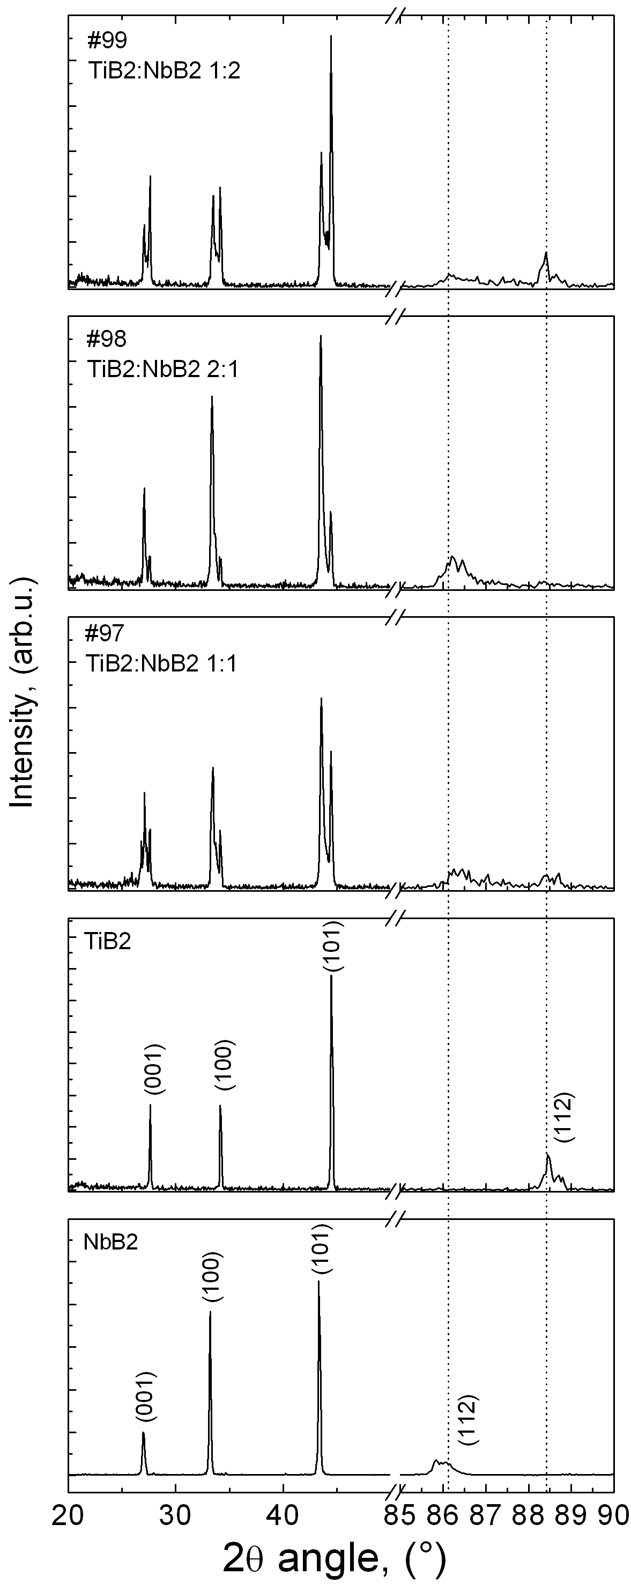
Fig. 1. XRD patterns for initial TiB₂ and NbB₂ powders and TiB₂–NbB₂ composites after spark plasma consolidation at 2000 °C for 10 min. TiB₂ (#35-0741) and NbB₂ (#35-0742) were detected as main phases by XRD. Ration between TiB₂ and NbB₂ on the XRD patterns correspond to initial mass ratio of phases before the SPS consolidation. Quantity analysis suggested the following TiB₂ to NbB₂ ratios after SPS: #97 42:58, #98 72:38 and #99 40:60.

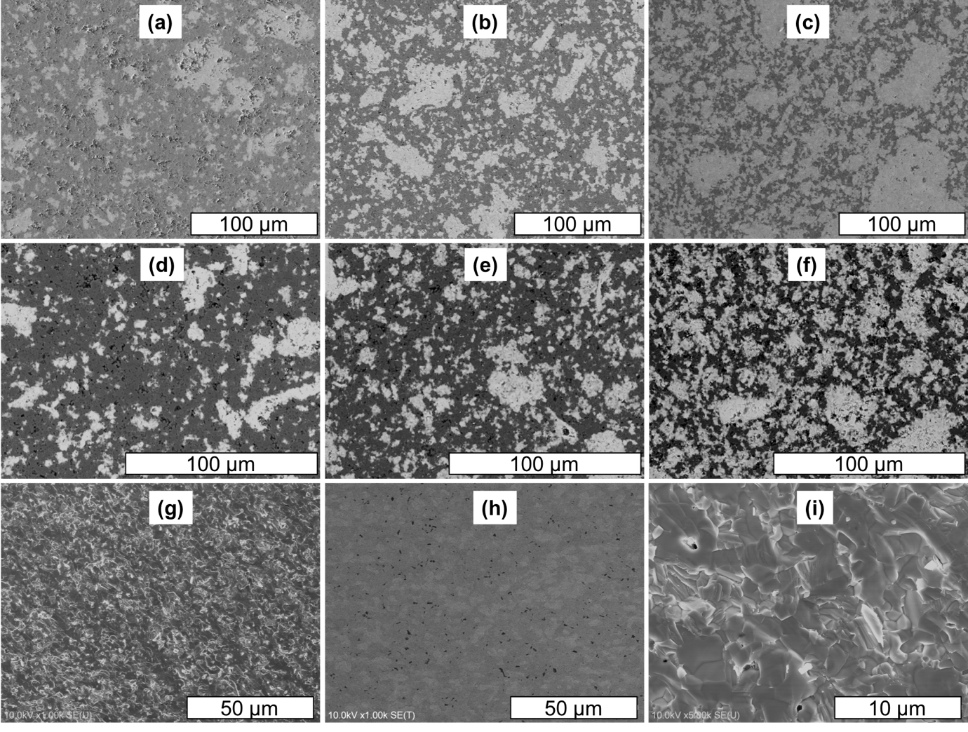
Fig. 2. SEM images of polished (a-f) and fractured surfaces of TiB₂–NbB₂ ceramics following flexural test at room temperature (g-i). (a,c) #97; (b,e,g-i) #98 and (c,f) – #99. (a-f) images were taken in BSE mode, (g-i) – secondary electrons, while (h) was acquired using high-angle BSE filter. Black areas in (h) indicate pores and grain pullouts.

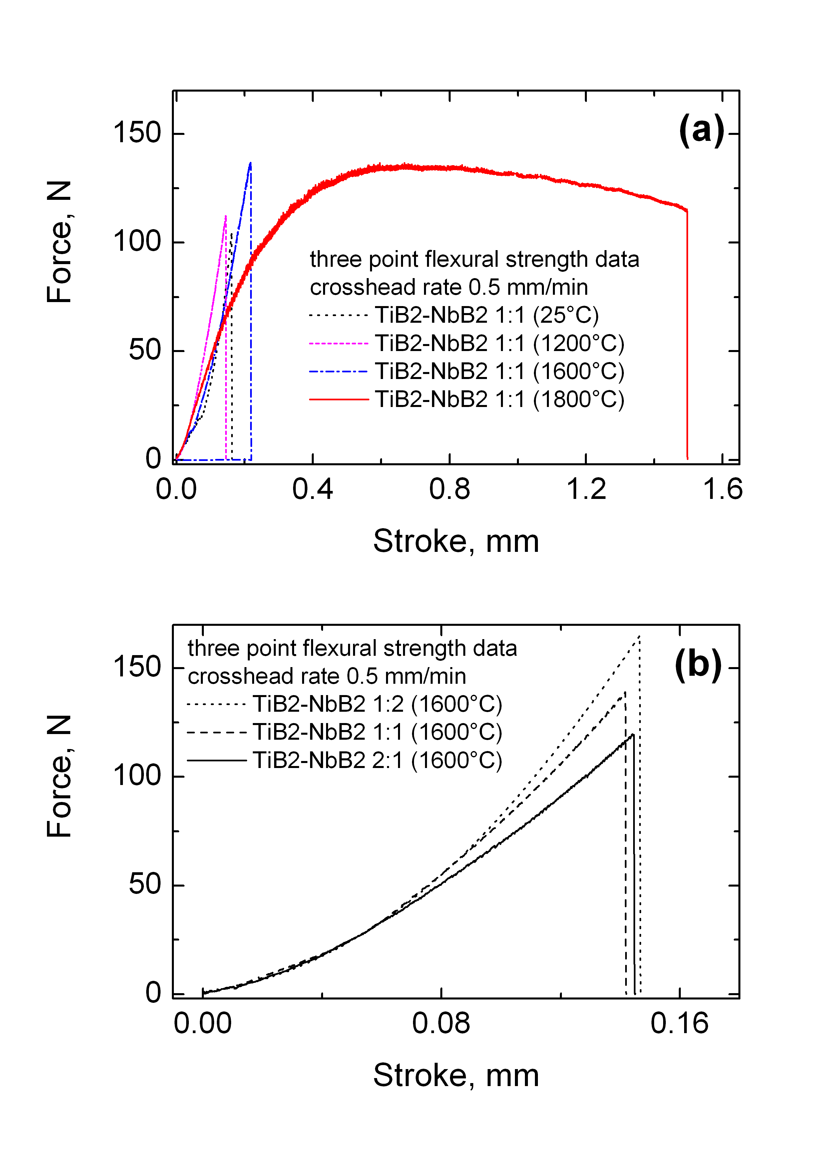
Fig. 3. Typical loading diagrams of the TiB₂–NbB₂ ceramic composites tested at room temperature and at elevated temperatures by the three-point flexural strength test.
(b) shows the effect of composition on the flexural strength at 1600 °C.

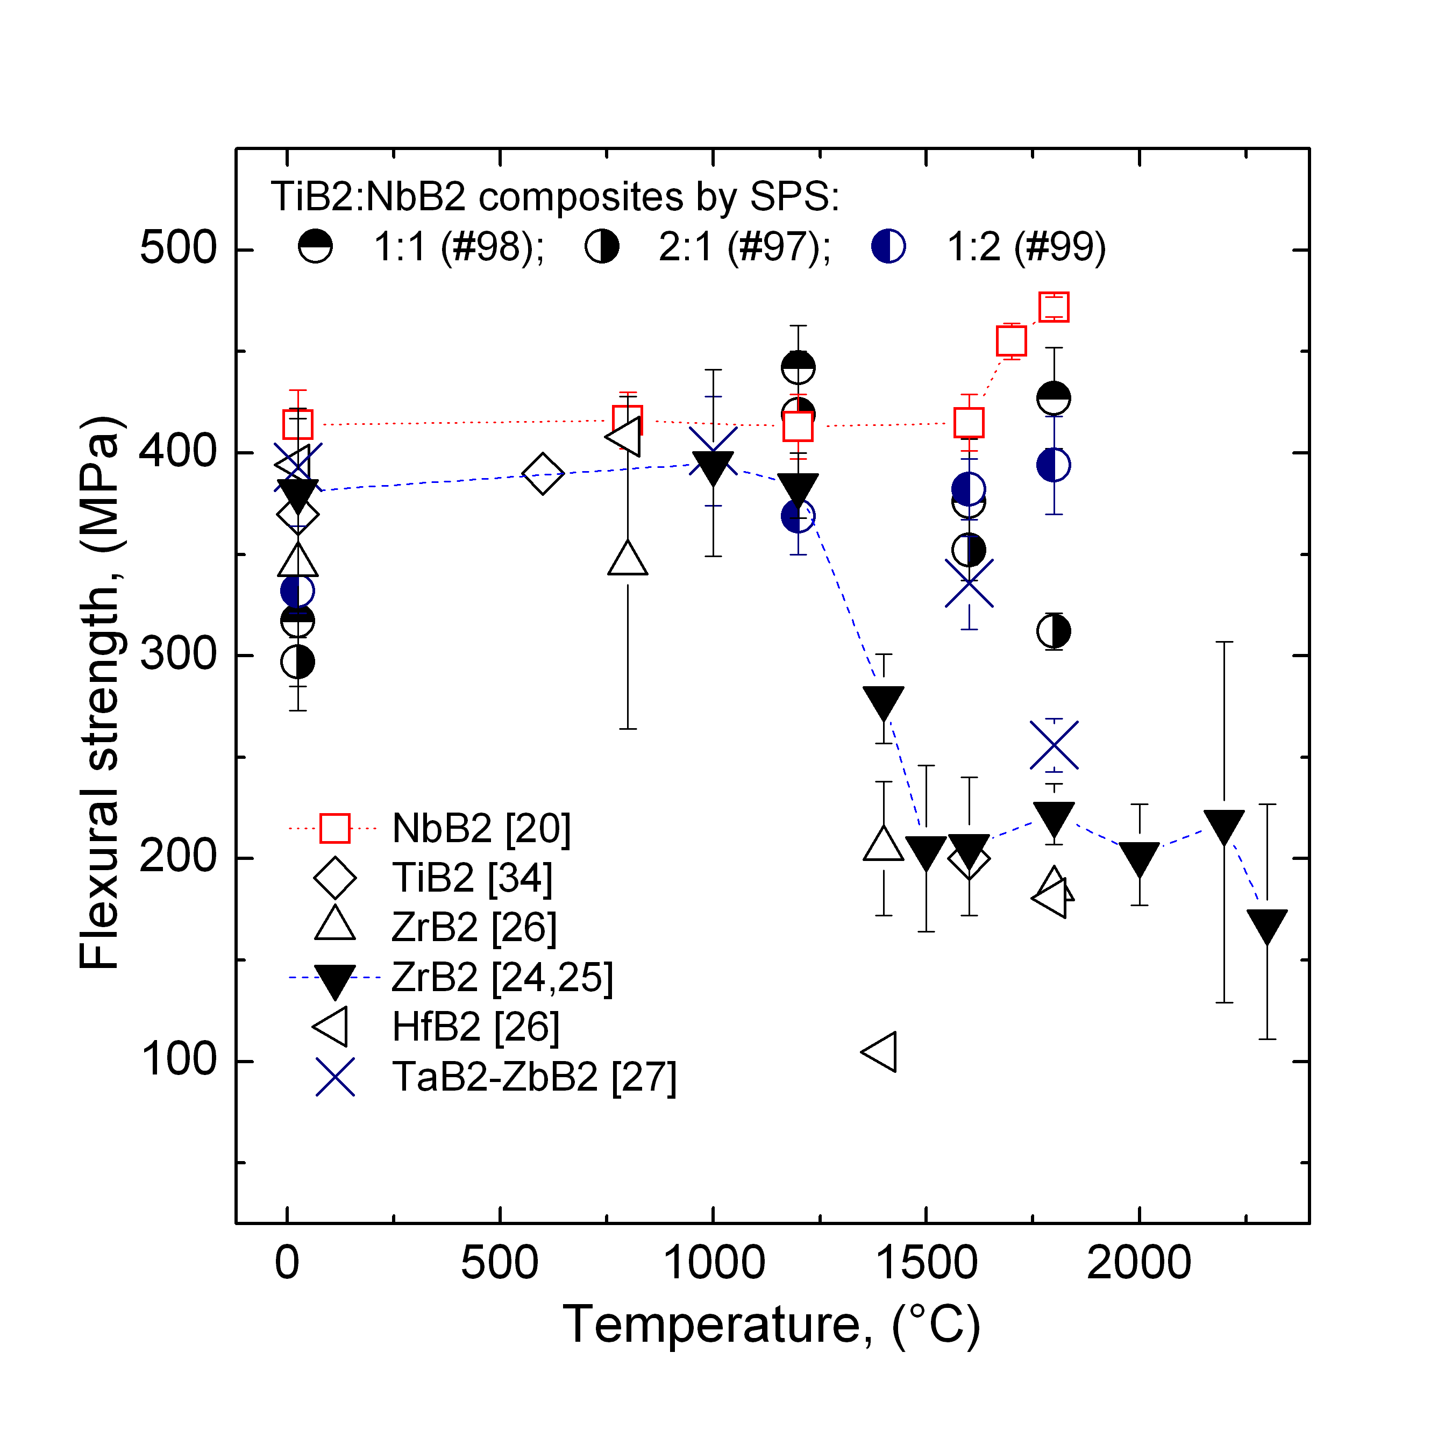
Fig. 4. Effect of temperature on the flexural strength of transition metal diborides and DDCCs. Argon was used during high-temperature flexural test for all data reported. The dashed and dotted line for ZrB₂ and NbB₂ ceramics indicate the general tendencies observed in previous studies [25 and 20]. Closed symbols indicate that the strength was measured using a four-point setup and the open symbols show the results of three-point flexural strength tests.
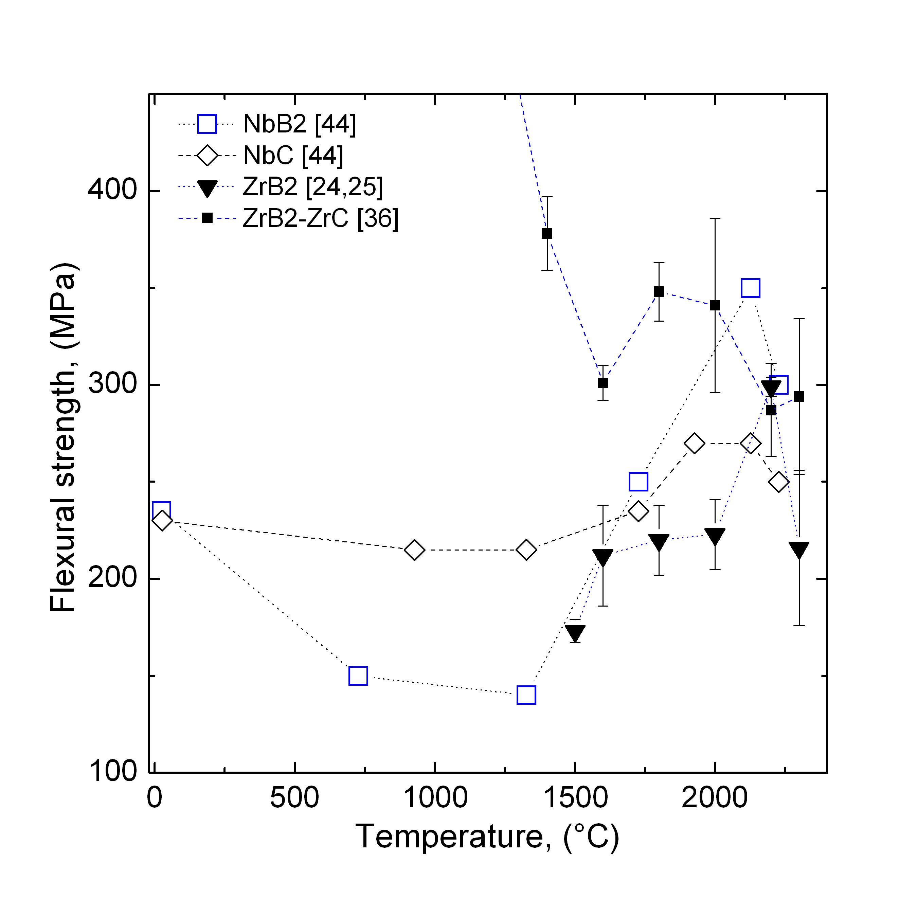
Fig. 5. Effect of temperature on the flexural strength of carbides and borides of zirconium and niobium. Mind that data of Nueman et al. for ZrB₂–ZrC is not shown for the lower temperature range in order to make data at high temperatures more visible. The dashed line for ZrB₂–ZrC data shows general trend observed in [36]. In the case of data ZrB₂ data in [24], only data for specimens tested in argon is shown. Data of Ordnan’yan et al. for NbB₂ and NbC was obtained in [44], where it was presented in in kelvins, the highest testing temperature was 2500 °K, hence, mind the unusual position of data points.

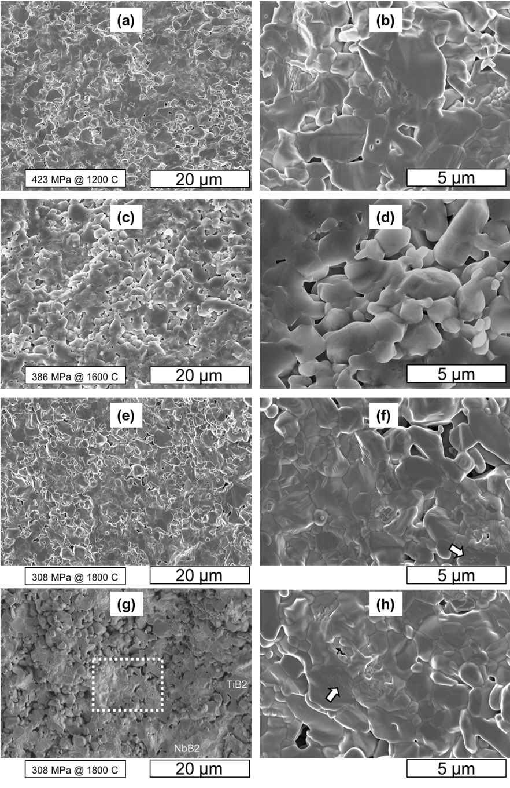
Fig. 6. SEM images of TiB₂:NbB₂ 2:1 (#97) ceramic composite after the three-point flexural strength test at different temperatures, the value of the flexural strength for observed sample is provided alongside with the flexural strength test temperature. The arrows indicate places of striations on the surface of titanium diboride grains. (f) shows the area marked by the dashed line in (g), while the (g) and (e) is the same area on the specimen taken in secondary electrons. Image (g) was acquired using lower detector of secondary electrons in SEM, thus one can distinguish TiB₂ and NbB₂ phases. Titanium diboride as a phase with an element with lower atomic number appears to be dark gray in (g), while niobium diboride grains have light gray color.

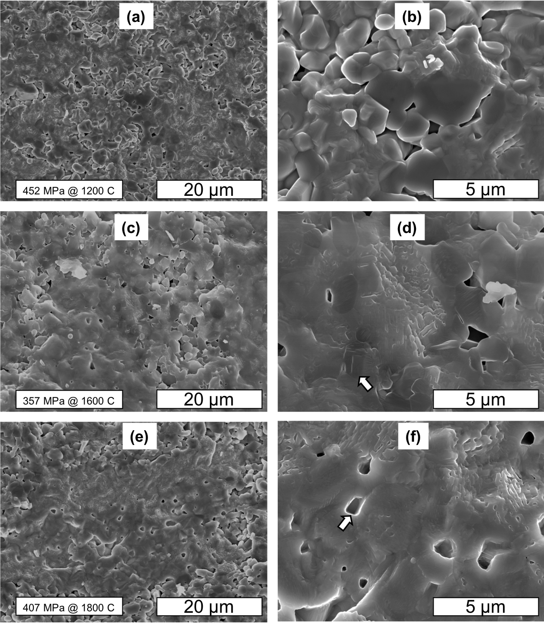
Fig. 7. SEM images of TiB₂:NbB₂ 1:1 (#98) ceramic composite after the three-point flexural strength test at different temperatures, the value of the flexural strength for observed sample is provided alongside with the flexural strength test temperature. Because of increased number of grain pull-outs, structure seems to have higher porosity. Furthermore, increased number of pull-out sites that should correspond to fine grain size (of TiB₂) with clearly symmetrical shape can be found at 1800 °C (see the arrow in (f)).

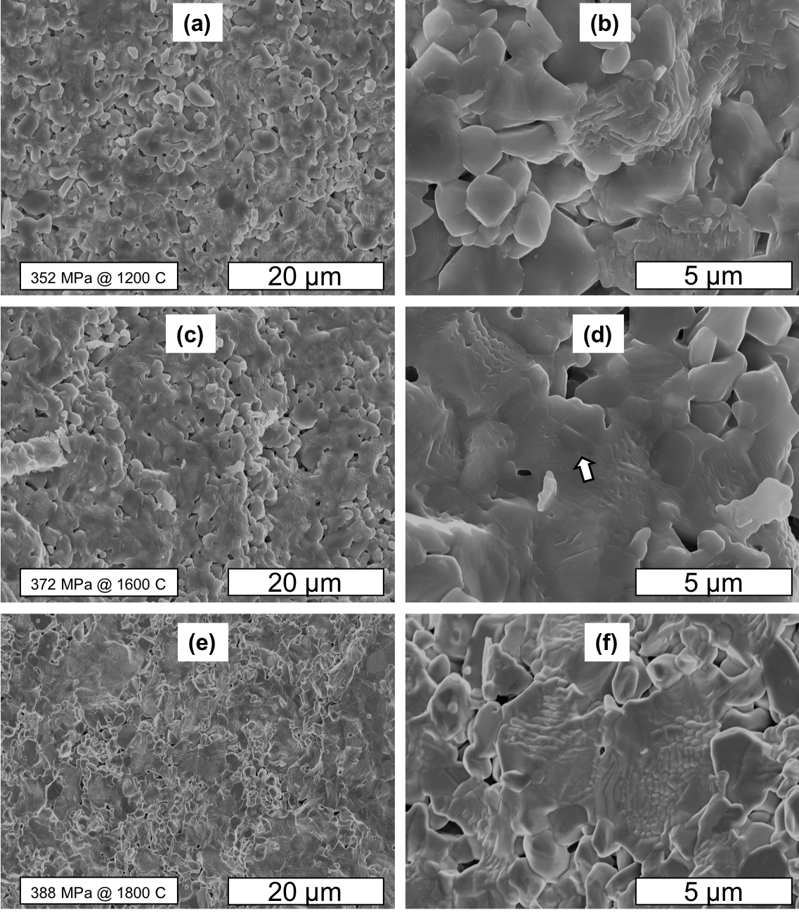
Fig. 8. SEM images of TiB₂:NbB₂ 1:2 (#99) ceramic composite after the three-point flexural strength test at different temperatures, the value of the flexural strength for observed sample is provided alongside with the flexural strength test temperature. Voids with rectangular symmetry can be clearly seen at images with higher magnification. Arrow in (d) indicates the TiB₂ grain with a grain size similar to that for the pull-out site in Fig. 7 (f). Mind the clear difference between fracture of TiB₂ and NbB₂ grains becomes clear at 1600 °C and 1800 °C, as the latter phase has clear terrace-like surface of the grains, suggestive the simultaneous effect of creep deformation at elevated temperature, and surface diffusion.

Table 1 Mechanical performance of TiB₂–NbB₂ ceramic composites
ID | Comp, wt.% | Fractional density, % | Grain size, µm | Flexural strength^{Y}, MPa |  |  |  | Fracture toughness, MPa m^{1/2} |  |  |  | Ef^{Z}, GPa
 |  |  |  | RT | 1200 | 1600 | 1800 | RT | 1200 | 1600 | 1800 | Ef^{Z}, GPa
#97 | TiB₂:NbB₂ 2:1 | 99.1 | 2–8 | 297  (12) | 419  (31) | 382  (15) | 312  (9) | 4.1  (0.6) | 3.9  (0.3) | 3.6  (0.4) | 3.5  (0.3) | 533±11
#98 | TiB₂:NbB₂ 1:1 | 98.3 | 2–6 | 317  (19) | 442  (21) | 376  (31) | 427  (25) | 3.1  (0.6) | 3.9  (0.3) | 3.6  (0.4) | 3.5  (0.3) | 539±14
#99 | TiB₂:NbB₂ 1:2 | 98.8 | 2–7 | 332  (11) | 369  (19) | 382  (15) | 394  (24) | 4.4  (0.2) | 4.6  (0.3) | 4.2  (0.3) | 3.8  (0.4) | 536±12
[27] | ZrB₂–44 TaB₂ | 99.2 | 4–8 | 393  (29) | - | 336  (23) | 256  (13) | - | - | - | - | -
[20] | NbB₂ | >98 | 6.2±1.3 | 414  (17) | 413  (16) | 415  (14) | 472  (5) | - | - | - | - | 542±13
[34] | TiB₂ | 96 | 6–12 | 370  (15) | - | 200  (7) | - | - | - | - | - | -
[17] | TiB₂ | 99.3 | <4 | 290 | 400  (25) |  | - | - | - | - | - | -
[24] | ZrB₂ | 99.4 | 19.4±13 | 381  (41) | 384  (16) | 206  (34) | 222  (89) | - | - | - | - | 542±17
[35] | ZrB₂ | 86.5 | <10 | 351  (31) | 312  (11)^{X} | - | - | 2.35  (0.15) | - | - | - | 346
[36] | ZrB₂–ZrC | >99.9 | 4.9±3 | 696  (82) | 525  (45) | 301  (9) | 348  (15) | 4.8  (0.5) | 4.6  (0.3) | 4.1  (0.4) | 4.5  (0.2) | 505±12
[34] | TiB₂–10TaC | >98 | 2–7 | 533  (13) | - | 480  (15) | - | - | - | - | - | -

Y – standart error in brackets
Z – evaluated at room temperature
X – tested in Air

