Syntheses of AlLB₁₄ (L=Li or Na) crystals using alkali fluorides and its properties

Takeshi Hagiwara, Kaoru Kouzu^{1,*}, Shigeru Okada, Akiko Nomura², Kunio Yubuta³, Toetsu Shishido², Akira Yoshikawa² and Takao Mori⁴

Faculty of Engineering, Kanagawa University, 3-27-1 Rokkakubashi, Kanagawa-ku, Yokohama 221-8686, Japan
¹Faculty of Science and Engineering, Kokushikan University, 4-28-1 Setagaya, Setagaya-ku, Tokyo 154-8515, Japan
²Institute for Materials Research, Tohoku University, 2-1-1 Katahira, Aoba-ku, Sendai, Miyagi 980-8577, Japan
³Faculty of Engineering, Kyushu University,744 Motooka, Nishi-ku, Fukuoka 819-0395, Japan
⁴Materials Nanoarchitechtonics Center, National Institute for Materials Science (NIMS), Namiki, Tsukuba, Ibaraki 305-0044, Japan

AlLB₁₄ (L=Li or Na or K) crystals were grown using LiF or NaF or KF and crystalline boron powders as the starting materials using high-temperature Al melt at soaking temperature 1573~1773 K for soaking time 5 h under an Ar atmosphere. A new compound AlNaB₁₄ and AlLiB₁₄ crystals were obtained from LiF or NaF and B powders, and the atomic ratios (n=B/L=2.0~4.0) of starting materials. AlKB₁₄ crystal was not obtained from KF and B powders as starting materials. The micro-Vickers hardness of AlLB₁₄ crystals is 24(±1) GPa for AlLiB₁₄ and 25(±1) GPa for AlNaB₁₄. The oxidation initiation temperature of AlLiB₁₄ was about 815 K, and the peak due to the exothermic reaction was about 960 K for AlLiB₁₄ and about 990 K for AlNaB₁₄. The final oxidation products were Li₂B₂O₄, Al₄B₂O₉, B₂O₃ and amorphous phases. The values for the electrical resistivity of the AlLB₁₄ compound were 2.4~157 Ω·cm.

*Present address: Faculty of Science and Engineering, Kokushikan University, 4-28-1 Setagaya, Setagaya-ku, Tokyo 154-8515, Japan.
*email: kouzu@kokushikan.ac.jp

1. Introduction
In the ternary Al-L-B (L=Li or Na) system, one type of ternary structure, namely AlLB₁₄ with AlMgB₁₄-type (orthorhombic; space group Imma) have been reported.^{1~3)} Higher borides containing the B₁₂ icosahedron unit have been studied because of their many interesting properties, including potential applications to thermoelectric materials and photodetectors.⁴⁾ In the case of higher borides, it may be difficult to synthesize from the alkali metal-B-Al system by arc-melting method. However, the ternary borides AlLB₁₄ have yet been fully studied well, and there is little information about the physical and chemical properties of AlLB₁₄. Crystal of the ternary boride AlLiB₁₄ is obtained by adding relatively large amount of Li metal.^{1,5,6)} But, owing to the high vapor pressure of Li at high temperature, optimum conditions for growing AlLiB₁₄ crystal are not established. Formerly we successfully prepared single crystals of the ternary borides AlLB₁₄ (L=Li or Na) from the high-temperature Al melt using Li₂B₄O₇ or Na₂B₄O₇ and boron powders as the raw materials.^{7~10)} Here, AlNaB₁₄ crystal is a new compound found by the authors earlier.^{8~10)} In addition, the magnetic susceptibility, microhardness, and oxidation resistance of ALiB₁₄ and AlNaB₁₄ were measured. The temperature dependence of the magnetic susceptibility was measured down to 2 K. The measured magnetic susceptibility of AlLB₁₄ was -4.4×10⁻⁷ emu/g for AlLiB₁₄ and -4.0×10⁻⁷ emu/g for AlNaB₁₄, which were the same value at room temperature,^{9,11)} and shows an increase at low temperatures indicative of the paramagnetic contribution, which we attribute to impurities.^{9,11)} In addition, the syntheses of AlLB₁₄ compounds from metal salts or oxides or metal carbonates and boron powders were reported using the same melt.^{11,12)} Authors found that AlLB₁₄ can be synthesized from alkali fluoride and boron element.
In this paper, we report the synthesis conditions for growing relatively large crystals of AlLB₁₄ (L=Li or Na or K) from LiF or NaF or KF and B powders as the starting materials using high-temperature Al melt. There are few reported examples for syntheses of AlLB₁₄ using alkali fluoride and boron in the same melt. The metal fluorides of LiF or NaF and KF were more suitable as the source of Li or Na or K elements than Li or Na or K metals that had high vapor pressure,¹³⁾ because of relatively good solubility in the Al melts at high temperature. The morphology and crystallographic data of the AlLB₁₄ (L=Li or Na) crystals obtained were determined. In addition, micro-Vickers hardness at room temperature, electrical resistivity and oxidation resistance by heating of the as-grown crystals were investigated. Furthermore, some properties of the AlLB₁₄ crystals obtained in this study were compared with the previously reported results. Fig. 1 shows the crystal structure of AlLB₁₄. The structure of AlLB₁₄ compound is made up of four B₁₂ icosahedron units and eight single boron atoms per unit cell. The L and Al atoms are accommodated in the largest and smaller holes outside the B₁₂ icosahedral units.⁸⁾

2. Experimental Details
2.1 Preparation of AlLB₁₄ crystals
The reagents used to prepare the AlLB₁₄ compounds were LiF or NaF or KF (purity 99~99.9%, Wako Pure Chemical Industries Ltd. Mitsuwa Pure Chemical Co. Japan), and crystalline boron (purity 99%, Mitsuwa Pure Chemical Co. Japan) powders and Al (purity 99.99%, Nippon Light Metal Co. Japan) metal buttons. The reagents and B were weighted at atomic ratios n=B/L=2.0~4.0. Al metal were added to each mixture at mass ratio 1:15~20. The quantity of alkaline fluorides in the starting material was fixed at 1.5 g throughout all experiments. The reaction equation (1) for obtaining AlLB₁₄ from alkaline fluorides and B powders were as follows.

3LF + (3n + 1)B → 3LB_{n} + BF₃ -------------(1)

The mixture was placed in a dense alumina crucible (Nikkato Co. SSA-H). The crucible was inserted in a vertical electric furnace with a SiC heater and then heated under an argon gas. The mixture was heated at a rate of 300 K·h⁻¹, raised to 1573~1773 K, kept for 5 h and then cooled to room temperature at a rate of 50 K·h⁻¹. The crystals were removed from the solidified melt by dissolving the matrix with dilute hydrochloric acid. The crystals obtained as described above were dried in a dryer. After drying, the resulting crystals were selected with a stereomicroscope.

2.2 X-ray and chemical analyses of AlLB₁₄ crystals
The crystal structure and lattice constants of the compounds were examined by the powder X-ray diffraction (XRD) (Rigaku, Ultima Ⅲ) with monochromatic CuKα radiation.¹⁴⁾ The values of lattice constants were used as the internal standard with high-purity Si (purity 99.99%, High-Purity Chemical Co.). The morphology, size, chemical composition and impurity content of the crystals were observed by a stereomicroscope, the scanning electron microscope (SEM), energy dispersive X-ray spectroscopy (EDX) (Horiba Co. EMAX-2770) and electron probe microanalysis (EPMA) (JEOL, JXA-8621MX).¹⁵⁾

2.3 Properties
2.3.1 Determination of micro-Vickers hardness, electrical resistivity, and oxidation resistivity heated in air
As-grown AlLB₁₄ crystals were measured using the micro-Vickers hardness in air. The hardness of the crystal was determined from the average value at room temperature with the load of 1.96 or 2.94 N and a load time of 15 s using about 8 to 12 positions on a well-developed face of each crystal. The values of electrical resistivity were measured by the direct-current four-probe technique at room temperature in air atmosphere. For hardness and electrical resistance measurement, the crystals were embedded in the resin, polished, and then measured. The electrical resistance was measured using KEITHLEY as the power supply and ESSTECH (ESS Tech Co.) as the small prober system. The crystals were powdered in an Al₂O₃ mortar and then heated to 1473 K in air using the differential thermal analyses and thermogravimetric (DTA-TG, Seiko Instrument) apparatus for oxidation resistance. After inserting the sample into the quartz cell, it was heated in air at a constant rate of 10 K·min⁻¹. The oxidation products were analyzed by powder XRD measurements.

3. Results and Discussion
3.1 Syntheses of AlLB₁₄ crystals
AlLB₁₄ crystals could be grown under the conditions using LiF or NaF or KF and boron powders as starting materials by high temperature Al metal. Here, AlLB₁₄ was performed based on experimental conditions obtained from L₂B₄O₇ (L=Li or Na) and B powders. AlLB₁₄ crystals could be grown under the conditions of the atomic ratios n=B/L=2.0~4.0 from LiF or NaF and B powders as starting materials (Table Ⅰ). However, while synthesis of AlKB₁₄ was attempted by utilizing KF and boron powders, AlKB₁₄ was not obtained in the Al-K-B system as shown in Fig. 2. In this case, mixed crystals of grayish black α-AlB₁₂ (tetragonal, space group P4₁2₁2 or P4₃2₁2)^{16,17)} and amber color β-AlB₁₂-type^{18,19)} were formed. It can be inferred that the cause of this is that potassium and boron atoms do not react in the high temperature Al melt. Alternatively, it can be inferred that the AlKB₁₄ phase was not formed because the K atom has a larger atomic radius (2.31 Å) or ionic radius (+1) Corresponding Number (CN) (6) 1.52 Å²⁰⁾ than the Li or Na atoms. The XRD patterns of AlLiB₁₄ and AlNaB₁₄ were shown in Fig. 3. From this, AlLB₁₄ phase and alumina were identified. Al₂O₃ phase is thought to be a contamination derived from the alumina crucible used for crystal synthesis and the alumina mortar used for XRD measurements. AlLB₁₄ crystals could be grown under the conditions of the atomic ratios n=B/L=2.0~4.0. AlLB₁₄ crystals having the typical crystal form are shown in Fig. 4. AlLiB₁₄ and AlNaB₁₄ crystals were obtained as plate-like shape with the pink-grey color. In addition, the lattice constant value of AlNaB₁₄ is related to the size of the atomic radius (for Li, 1.52 Å; for Na, 1.86 Å) or ionic radius (for Li, (+1) CN (6) 0.76 Å; for Na, (+1) CN (6) 1.02 Å^{13,20)} of the metal in the crystal structure, and it can be inferred that it is larger than that of AlLiB₁₄ and AlNaB₁₄.

3.2 Lattice constants and chemical analysis
Table Ⅱ shows the lattice constant values of AlLB₁₄. From this, it can be seen that the lattice constant of AlNaB₁₄ is slightly higher than that of AlLiB₁₄. As described in Section 3.1, it can be inferred that this is a difference in the size of metal atoms or metal ions contained in the AlLB₁₄ compound. In addition, the lattice constants of AlLB₁₄ are very similar to those reported synthesized from different starting materials; AlLiB₁₄ (for example, AlLiB₁₄ obtained from Li₂B₄O₇; a=5.847(1), b=10.354(1), c=8.143(1) Å, V=493.0(1) Å³,⁷⁾ AlLiB₁₄ obtained from metal Li; a=5.8469(9), b=10.3542(6), c=8.1429(8) Å, V=492.97(9) Å³,²⁾ and AlNaB₁₄ obtained from Na₂B₄O₇; a=5.844(1), b=10.465(1), c=8.231(1) Å, V=503.4(1) Å³.⁸⁾ Chemical analysis for the AlNaB₁₄ crystal corresponds to atomic ratio Al:L:B=1:1:14 (see Table Ⅲ). However, chemical analysis of AlLiB₁₄ has not been performed. The chemical analysis value of AlNaB₁₄ crystals seems to have fewer Na and Al atoms than the atomic ratio Al:Na:B=1:1:14 of stoichiometry ratio. The values of the chemical analysis of AlNaB₁₄ obtained from Na₂B₄O₇ and boron in Al metal reported earlier are consistent with the stoichiometric ratio of the atomic ratio Al:Na:B=1.00:0.95:14.⁸⁾ According to the results of this experiment, the chemical analysis value of AlNaB₁₄ crystal seems to have slightly fewer Na and Al atoms than the atomic ratio Al:Na:B=1:1:14 in the stoichiometric ratio. As a result, it can be inferred that the change in the composition ratio of the AlNaB₁₄ crystal is the difference of Na₂B₄O₇ or NaF in the starting materials.

3.3 Properties
3.3.1 Measurement of micro-hardness and oxidation resistance by heating in air
Table IV shows the micro-Vickers hardness values of AlLiB₁₄ and AlNaB₁₄ crystals together with the values of AlLB₁₄ reported by the authors. From them AlLiB₁₄ and AlNaB₁₄ are approximately the same hardness value. The values of the crystals are in comparatively good agreement with the values of these faces for AlLiB₁₄ and AlNaB₁₄ in the literature.^{2,7,9)} Higher borides containing B₁₂ icosahedron unit have been reported to have relatively high hardness. For instance, B₆O (Hv=34~38 GPa), B₄C (Hv=34.5~40 GPa), cBN (Hv=50~60 GPa),²¹⁾ and Al_{1.1}Be_{0.7}B₂₂, Al_{1.4}Mg_{0.45}B₂₂, Al_{x}Cu_{y}B₁₀₅ (x=2.8~3.3, y=2.9~1.0) and Al_{1.3}Cu_{1.1}B₂₅ (Hv=25.4(±0.5)~27.8(±1.7) GPa) crystals.^{22,23)} However, the authors report on the hardness of TmAlB₄ and YbAlB₄ with YCrB₄-type compounds and the novel solid solution Tm(Al,Mo)B₄ and Yb(Al,T)B₄ (T=Cr, Fe, Mn, Mo). These hardness values were 14.5(±1.4) GPa for TmAlB₄, 13.0(±1.5)~15.5(±2.4) GPa for Tm(Al_{x-1}Mo_{x})B₄ (x=0~0.01), 14.2(±1.4) GPa for YbAlB₄ and 13.0(±0.6)~16.8(±1.5) GPa for Yb(Al_{1-x}T_{x})B₄ (x=0~0.1; T=Fe, Cr, Mn).^{15,24~26)} It can be seen that the hardness of AlLB₁₄ crystals is higher than that of YCrB₄-type compounds. The crystal structure of YCrB₄-type is similar to that of AlB₂-type, but YCrB₄-type is layered in the c-plane direction by the 5-membered and 7-membered rings of boron atoms (the structure of AlB₂ is the 6-membered ring of boron atoms).⁴⁾ It can be inferred that this is due to the difference between these structures and the crystal structure of AlLB₁₄. AlLB₁₄ crystals have the same values in the hardness of higher borides that have B₁₂ icosahedral unit in the crystal.
The oxidation process of AlLiB₁₄ and AlNaB₁₄ crystals were studied at temperatures below 1473 K by DTA-TG analyses in air atmosphere. Oxidation of the AlLiB₁₄ crystals were starts at about 805 K (see Fig. 5). From the TG curve, the oxidation initiation temperature was about 815 K for AlLiB₁₄ and 814 K for AlNaB₁₄. The final oxidation products, as analyzed by powder XRD, were Li₂B₂O₄, Al₄B₂O₉, B₂O₃ and amorphous phases, and so the exothermic peaks (for AlLiB₁₄ about 960 K; for AlNaB₁₄ about 990 K) are attributed to oxidation products.

3.3.2 Electrical resistivity
The results for measured resistance (Ω) and the electrical resistivity values (Ω·cm) of AlLiB₁₄ and AlNaB₁₄ crystals are shown in Table Ⅴ. Comparing these results with the electrical resistivity of higher boride and metal borides, it is as follows: B₁₂P₂ (p-type) 5.2×10⁴ Ω·cm, B₁₂P₂ (p-type) 9.0×10⁴ Ω·cm;²⁷⁾ B₄C 1.0 Ω·cm;²⁸⁾ B₄C 0.1~10 Ω·cm;²⁹⁾ hBN 1.7×10¹³ Ω·cm, cBN 1×10¹⁶ Ω·cm, ScB₂ 13×10⁻⁶ Ω·cm, TiB₂ 5.7×10⁻⁶ Ω·cm, VB₂ 38×10⁻⁶ Ω·cm, YB₂ 39×10⁻⁶ Ω·cm, TaB₂ 14×10⁻⁶ Ω·cm;²⁹⁾ DyB₁₂ 25.56×10⁻⁶ Ω·cm, HoB₁₂ 13.18×10⁻⁶ Ω·cm, ErB₁₂ 12.40×10⁻⁶ Ω·cm, TmB₁₂ 14.04×10⁻⁶ Ω·cm, LuB₁₂ 11.5×10⁻⁶ Ω·cm;²⁹⁾ LuAlB₄ 86(±6)×10⁻⁶ Ω·cm, Lu₂AlB₆ 31(±3)×10⁻⁶ Ω·cm;³⁰⁾ PrRh_{4.8}B₂ 670×10⁻⁶ Ω·cm.³¹⁾ From this result, it can be understood that the electrical resistivity values of AlLB₁₄ crystals were relatively close to the value of B₄C with B₁₂ icosahedral units. Namely, the electrical resistivity of the AlLB₁₄ compounds were close to that of the semiconductor region, in contrast to the insulating RB₆₆ (R=rare earth) compounds which also have B₁₂ icosahedral units. AlLB₁₄ has a structure similar to that of NaBB₁₄ (NaB₁₅ orthorhombic, space group Cmcm),³¹⁾ and the basic structural units of the NaBB₁₄ structure are the B₁₂ icosahedron units and the boron atoms. In NaBB₁₄, free boron atoms are stored at the site corresponding to the Al site in AlNaB₁₄. Although this structure is close to the structure of AlLB₁₄, there are few reported examples of various physical properties due to the difficulty of synthesis. In addition, B₄C (rhombohedron, space group R-3m) is classified as β-rhombohedral boron,²¹⁾ but the structure of B₄C is located at the midpoint of the lattice point and the ridge of the B₁₂ icosahedral lattice, and there are two B₂₈ units on the diagonal of the rhombohedral lattice. There is a single boron atom between the two units. It was found that B₄C having such the structure has an electrical resistivity close to that of AlLB₁₄.

4. Conclusions
AlLB₁₄ (L=Li or Na or K) crystals were grown using LiF or NaF or KF and crystalline boron powders as the starting materials using a high-temperature Al melt at soaking temperature 1573~1773 K for soaking time 5 h in an Ar atmosphere. Mixtures of these materials in various atomic ratios (n=B/L=2.0~4.0). The results are as follows.
1) AlKB₁₄ crystal is not obtained from KF and B powders. In that case, α-AlB₁₂ and β-AlB₁₂-type crystals are obtained.
2) AlLiB₁₄ and a new compound AlNaB₁₄ crystals obtained have the plate-like shape. The lattice constant values of the obtained AlLB₁₄ compounds were in good agreement with the previously reported values of AlLB₁₄ obtained from L₂B₄O₇ or lithium metal and B powders as starting materials.
3) The results of micro-Vickers hardness measurements of as-grown AlLB₁₄ crystals are discussed. In particular, the hardness values of AlLiB₁₄ and AlNaB₁₄ were equivalent to the higher borides with B₁₂ icosahedral units of Al_{1.1}Be_{0.7}B₂₂, Al_{1.4}Mg_{0.45}B₂₂, Al_{1.3}Cu_{1.1}B₂₅ and Al_{x}Cu_{y}B₁₀₅ (x=2.8~3.3, y=2.9~1.0) crystals.
4) The oxidation resistance in air up to 1473 K of as-grown AlLiB₁₄ and AlNaB₁₄ crystals were investigated.
5) The electrical resistivity of the AlLB₁₄ compound are the values of 146~157 Ω·cm for AlLiB₁₄ and 2.4~57 Ω·cm for AlNaB₁₄. These values for the electrical resistivity of AlLB₁₄ are in the semiconductor region.

Acknowledgments
The authors are indebted to IMR in Tohoku University for their technical contributions and Ms. Yoko Imai of Kanagawa University for their help in the experiments.

1) I. Higashi, M. Kobayashi, Y. Takahashi, S. Okada and K. Hamano: J. Cryst. Growth 99 (1990) 998.
2) I. Higashi, M. Kobayashi, S. Okada, K. Hamano and T. Lundström: J. Cryst. Growth 128 (1993) 1113.
3) S. Okada, K. Kudou, T. Mori, T. Shishido, I. Higashi, N. Kamegashira, K. Nakajima and T. Lundström: Materials Science Forum 449-452 (2004) 365.
4) V. I. Matkovich (Ed.): Boron and Refractory Borides, Springer-Verlag, 1977, p.439.
5) I. Higashi and Y. Takahashi: J. Less-Common Met. 81 (1981) 133.
6) I. Higashi: J. Less-Common Met. 82 (1981) 317.
7) K. Kudou, S. Okada, T. Mori, K. Iizumi, T. Shishido, T. Tanaka, I. Higashi and K. Nakajima, P. Rogl, Y. B. Andersson and T. Lundström: Jpn. J. Appl. Phys. 41 (2002) L928.
8) S. Okada, T. Tanaka, A. Sato, T. Shishido, K. Kudou, K. Nakajima and T. Lundström: J. Alloys compd. 395 (2005) 231.
9) S. Okada, T. Mori, K. Kudou, T. Tanaka, T. Shishido and T. Lundström: J. Euro. Ceram. Soc. 26 (2006) 631.
10) S. Okada, K. Kudou, T. Shishido, K. Yubuta and T. Mori: J. Solid State Phenomena 170 (2011) 150.
11) S. Okada, T. Shishido, T. Mori, K. Iizumi, K. Kudou and K. Nakajima: J. Alloys Compd. 458 (2008) 297.
12) S. Okada, K. Kouzu, T. Yamasaki, T. Mori, K. Yubuta, A. Nomura, T. Shishido, A. Yoshikawa and P. Rogl: J. Flux Growth 13 No.1, (2018) 9 [in Japanese].
13) David R. Lide Editor-in-Chief, Howard T. Evans, Jr: CRC Handbook of Chemistry and Physics 1995-1996, 76th Edition, CRC press, New York, p.12-14.
14) K. Kouzu, S. Okada, K. Hagiwara, A. Nomura, T. Shishido, A. Yoshikawa, K. Yubuta, C. Bourgés and T. Mori: J. Jpn. Soc. Powder Powder Metallurgy 70 (2023) 461 [in Japanese].
15) K. Kouzu, T. Yamasaki, S. Okada, T. Mori, Q. Quo, K. Yubuta, A. Nomura, T. Shishido, A. Yoshikawa and P. Rogl: J. Jpn. Soc. Powder Powder Metallurgy 66 (2019) 525.
16) I. Higashi and T. Ito: J. Less-Common Met. 92 (1983) 239.
17) I. Higashi: J. Solid State Chem. 154 (2000) 168.
18) J. A. Kohn and D. W. Eckart: Anal. Chem. 32 (1960) 296.
19) S. Okada and T. Atoda: Yogyo Kyokai-shi 88 (1980) 547 [in Japanese].
20) K. Niwa el al.: The ceramic Society Japan, Handbook of Ceramics 2nd Edition, Gihodo Shuppan Co. (2002) p.683.
21) K. Takagi, R. Uno, K. Kimura, I. Higashi, T. Tanaka, T. Shishido, T. Mori, Y. Ishizawa, S. Okada et al.: Fundamentals and Application of Boron, Borides and Related Materials, CMC (2008) p.3.
22) S. Okada, T. Mori, T. Shishido, K. Iizumi, K. Kudou, K. Nakajima and P. Rogl: J. Alloys Compd. 442 (2007) 320.
23) S. Okada: J. Technical Association of Refractories, Japan 32 [4] 239 (2012) [in Japanese].
24) S. Okada, K. Kudou, Y. Yu, T. Lundström: Jpn. J. Appl. Phys. 33 No.5A (1994) 2663.
25) S. Okada, K. Kouzu, T. Yamasaki, T. Mori, Q. Guo, T. Shiashido, K. Yubuta, G. Rogl and P. Rogl: Solid State Phenomena 289 (2019) 65.
26) S. Okada, K. Kudou, Y. Yu and T. Lundström: Pro. 11th Int. Symposium on Boron, Borides and Related Compounds, Tsukuba 1993 JJAP Series 10, (1994) 136.
27) Y. Kumashiro, H. Yoshizawa and K. Shirai: Jpn. J. Appl. Phys. 10 (1994) 166.
28) G. V. Samsonov and I. M. Vinitskii: Handbook of Refractory Compounds, IFI/Plenum, New York, 1980, p. 233.
29) Y. Paderno, V. Filippov and N. S. Shitsevalova: Pro. 11th Int. Symp. Boron, Borides and Related Compounds, Tsukuba 1993 JJAP Series 10 (1994) 154.
30) S. Okada, Y. Yu, T. Lundström, K. Kudou and T. Tanaka: Jpn, J. Appl. Phys. 35 (1996) 4718.
31) S. Okada, T. Shishido, K. Kudou, I. Higashi, M. Ogawa, H. Horiuchi and T. Fukuda: J. Ceram. Soc. Japan 107 (1999) 184.
32) R. Naslain, A. Guette and P. Hagenmuller: J. Less-Common Met. 47 (1976) 1.

Table Ⅰ. Synthesis conditions of AlLB₁₄ compounds obtained from LF and B powders as starting materials at soaking temperature 1573~1773 K for soaking time 5 h.
 | B/L | Soaking temperature
Alkali fluorides | (atomic ratios) | (K) | Phases identified
LiF | 2.0, 4.0, 6.0 | 1573, 1673, 1773 | AlLiB₁₄
NaF | 2.0, 4.0, 6.0 | 1573, 1673, 1773 | AlNaB₁₄
KF | 2.0, 4.0, 6.0 | 1573, 1673, 1773 | α-AlB₁₂, β-AlB₁₂-type

Table Ⅱ. The results for lattice constants of AlLB₁₄ compounds.
Compounds | ― | Lattice constants (Å)
AlLB₁₄ | Alkali  fluorides | a | b | c | V (Å³)
AlLiB₁₄ | LiF | 5.850(1) | 10.359(1) | 8.145(1) | 493.6(1)
AlNaB₁₄ | NaF | 5.851(2) | 10.455(4) | 8.243(3) | 504.2(3)

Table Ⅲ. The results for chemical analysis of AlNaB₁₄.
Compound | Crystal | Chemical analysis  (mass%) |  |  | In total | Chemical  composition
Compound | Crystal | Al | Na | B | In total | Chemical  composition
AlNaB₁₄ | Plate | 5.55 | 4.96 | 89.49 | 100 | Al_{0.87}Na_{0.78}B₁₄

Table Ⅳ. The values for micro-Vickers hardness of AlLB₁₄ crystals.
Compounds | Micro-hardness values |  | Reference
AlLB₁₄ | metal salts or metal | (GPa) | Reference
AlLiB₁₄ | LiF | 24(±1) | this work
˶ | Li | 25(±1)~29(±1) | 2)
˶ | Li₂B₄O₇ | 20(±1)~29(±1) | 7)
AlNaB₁₄ | NaF | 25(±1) | this work
˶ | Na₂B₄O₇ | 23(±1)~28(±1) | 9)

Table Ⅴ. Results of resistance (Ω) and electrical resistivity (Ω·cm) of AlLiB₁₄ and AlNaB₁₄ crystals.
Compounds | resistance (Ω) | Electrical resistivity /ρ (Ω・cm)
AlLiB₁₄ | 64~594 | 146~157
AlNaB₁₄ | 17~399 | 2.4~57

Figure captions
Fig. 1 Crystal structure of AlLB₁₄ compound: a-plane perspective and three-dimensional perspective⁶⁾ view.
Large boron lump: B₁₂ icosahedron unit. large circle: L (Li or Na), middle circle: Al, small circle: B
Fig. 2 XRD patterns of AlLB₁₄ (L= Li or Na) obtained from LiF or NaF and B powders as starting materials and Mg_{0.78}Al_{0.75}B₁₄ (ICDD Card No.39-0459).
Fig. 3 Photographs for stereoscopic microscopy of AlLiB₁₄ (A) and AlNaB₁₄ (B) crystals obtained by LiF or NaF and B powders as the starting materials. (C) α-AlB₁₂ and (D) β-AlB₁₂-type crystals obtained from KF and B powders as the raw materials. Soaking temperature; 1673 K, Soaking time; 5 h
Fig. 4 DTA-TG analyses of (a) AlLiB₁₄ and (b) AlNaB₁₄ crystals heated in air. Sample was heated in air at a constant rate of 10 K·min⁻¹.

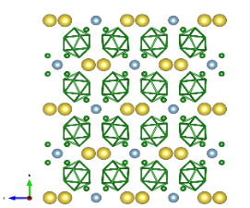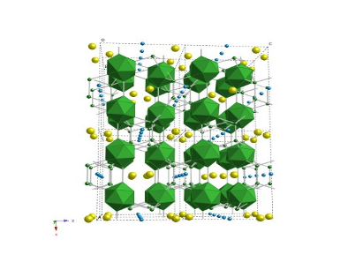
a-plane perspective three-dimensional perspective⁶⁾
Fig. 1 Crystal structure of AlLB₁₄ compound: a-plane perspective and three-dimensional perspective⁶⁾ view.
Large boron lump: B₁₂ icosahedron unit, large circle: L (Li or Na), middle circle: Al, small circle: B
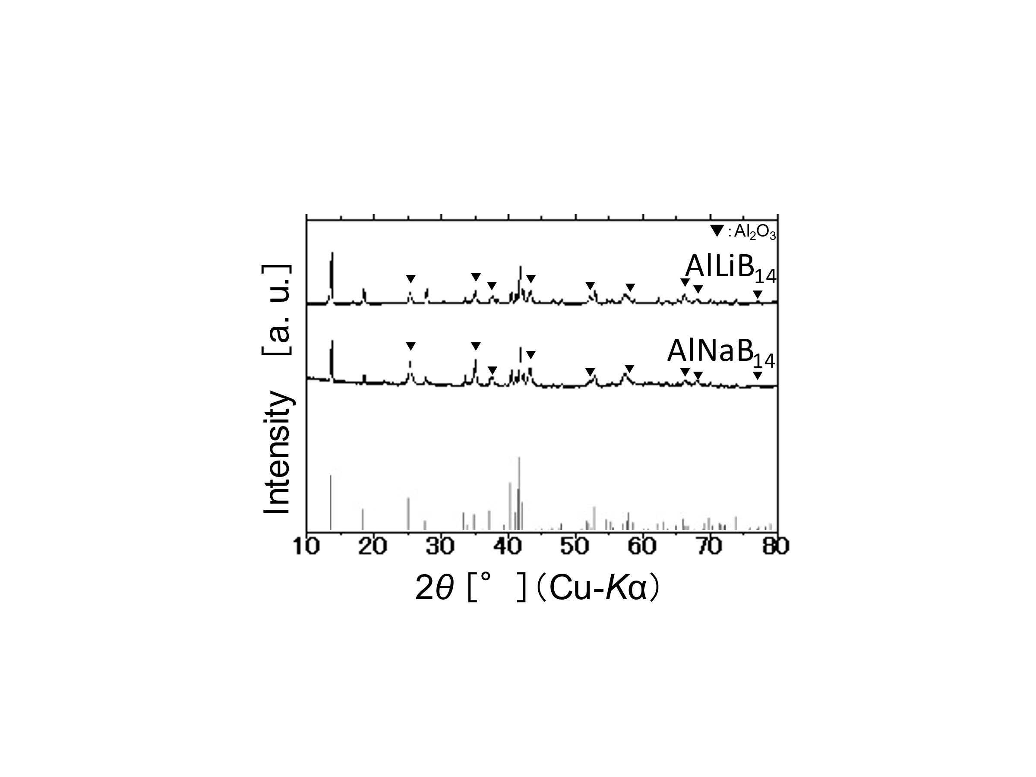
ICDD Card
No.39-0459
Fig. 2 XRD patterns of AlLB₁₄ (L= Li or Na) obtained from LiF or NaF and B powders as starting materials and Mg_{0.78}Al_{0.75}B₁₄ (ICDD Card No.39-0459).

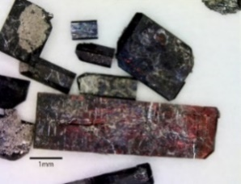
- AlLiB₁₄ crystals (B) AlNaB₁₄ crystals

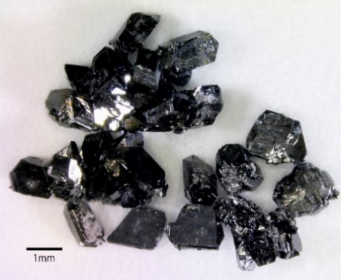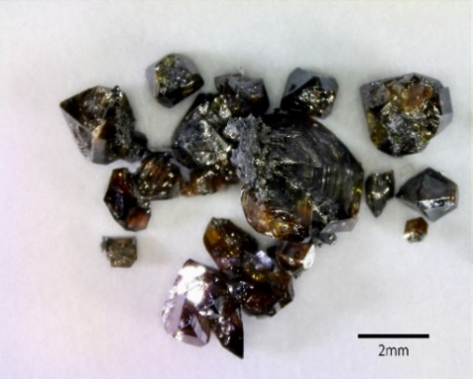
(C) α-AlB₁₂ crystals (D) β-AlB₁₂-type crystals

Fig. 3 Photographs for stereoscopic microscopy of AlLiB₁₄ (A) and AlNaB₁₄ (B) crystals obtained by LiF or NaF and B powders as the starting materials. (C) α-AlB₁₂ and (D) β-AlB₁₂-type crystals obtained from KF and B powders as the raw materials. Soaking temperature; 1673 K, Soaking time; 5 h

DTA curve
TG curve

- DTA-TG curve of AlLiB₁₄

TG curve
DTA curve
- DTA-TG curve of AlNaB₁₄
Fig. 4 DTA-TG analyses of (a) AlLiB₁₄ and (b) AlNaB₁₄ crystals heated in air.
Sample was heated in air at a constant rate of 10 K·min⁻¹.

