Influence of Selenophene Auxiliary Acceptor in Porphyrin Sensitizers for High Performance Dye Sensitized Solar Cells
Palivela Siva gangadhar†,‡, Silve Das Gupta,†,‡ Prakriti R. Bangal,*,‡,§ Towhid H. Chowdhury∥, Ashraful Islam,*∥ Lingamallu Giribabu*,†,‡
†Polymers & Functional Materials Division, CSIR-Indian Institute of Chemical Technology, Tarnaka, Hyderabad-500007, India.
‡Academy of Scientific and Innovative Research, Ghaziabad 201002, India
§Departmentof Analytical and Structural Chemistry, CSIR-Indian Institute of Chemical Technology, Hyderabad 50000, India.
∥Photovoltaic Materials Unit, National Institute for Materials Science, Sengen 1-2-1, Tsukuba, Ibaraki 305-0047, Japan.
Corresponding authors: giribabu@iict.res.in, Phone: +91-40-27191724, Fax: +91-40-27160921.
ISLAM.Ashraful@nims.go.jp, Phone: +81-298- 859 2129, FAX: +81-298- 859 2301.
Abstract
Porphyrin-based dyes are widely used as sensitizers for dye-sensitized solar cells (DSSCs), but their power conversion efficiencies (PCEs) are limited mainly due to charge recombination and aggregation tendency. Here, we report two D−π−A porphyrin-based sensitizers, LG 28 and LG 29, which comprise a 3-ethynylphenothiazine as an electron donor, meso-substituted porphyrin as a π-spacer, and selenophene and cyanoacrylic acid as an auxiliary acceptor and anchoring group, respectively. When compared to the LG5 dye, we have replaced the thiophene (LG5) unit with 2-phenylselenophene (LG 28) and 2-(selenophenye-2yl)thiophene (LG 29) auxiliary acceptors. Upon successful substitution with the selenophene unit, the molar extinction coefficient was increased without noticeable change in absorption maxima. Density functional theory studies suggest that the intramolecular interactions between donor phenothiazine and acceptor anchoring groups in both sensitizers play a pivotal role. Excited state properties are found to be quenched for the sensitizers upon the formation of self-assembled monolayers on nanocrystalline TiO2. Finally, we have evaluated the device performances of both sensitizers in DSSCs using I−/I3 − liquid redox electrolyte and device efficiency of 8.83 and 10.31% using LG 28 and LG 29-based sensitizers, respectively. To understand the observed photovoltaic trends, we have performed ultrafast transient absorption studies on bare LG 28 and LG 29 sensitizers in the presence of TiO2 in solution phase, respectively. The described results confirm multilevel electron injection from different higher excited singlet states of the LG 28 sensitizer to the TiO2 conduction band with an overall rate of electron injection of 3.84 × 1011 s−1, contrary to electron injection from the lowest excited state of the LG 29 sensitizer to the TiO2 conduction band with a two-order slower rate of electron injection with a higher device efficiency than that of LG 28, and it is attributed to onset incident-photon-to-currents efficiency, which extends to 900 nm in LG 29 dye.

Key Words: Porphyrin sensitizers, dye-sensitized solar cells, donor-π-acceptor, liquid redox couple, multiple electron injection, long-lived charge separated state.

Introduction
In the modern era, the growing consumption of fossil fuel energy sources associated with the fast development of industry and search for the low-cost alternative technologies have encouraged researchers.¹ In this concerne, sun light has been considered as the most feasible choice for a clean and renewable energy source.² Dye sensitised solar-cells (DSSCs) are a promising cost-effective and highly efficient photovoltaic-technology for utilising solar electricity among many photovoltaic technologies.^{3,4} In a DSSC, sensitizers play a significant task in light-harvesting and power conversion efficiency (PCE). Since Gratzel and co-workers reported in 1991, ruthenium dye based DSSCs showed a PCE of 7.1% and later has crossed with certified power conversion efficiency (PCE) of 12%.⁵⁻¹⁰ Regardless of their high PCE, the main difficulties of Ru(II) poly-pyridyl complexes are less feasible due to the less abundant nature of Ru in the earth's crust, and low absorption in the near-infrared(IR) region. Among a variety of sensitizers, tetrapyrrolic systems such as porphyrins are best alternatives to Ru(II) polypyridyl complexes based on their remarkable optoelectronic properties, facile structural alterations and thermal stability.^{11,12} The first porphyrin sensitizer used for the sensitization of nano-crystalline TiO₂ was the carboxy zinc porphyrin, in which anchoring carboxyl group at meso phenyl position was reported with an efficiency of 3.5%.¹³ The device efficiency was enhanced to 7.1%, when the anchoring group position changed from meso phenyl to β-pyrrole position of a zinc porphyrin.¹⁴ Further the device efficiency enhanced by structural alterations at the meso phenyl position of a porphyrin macrocycle by adopting donor-π-acceptor concept. In this concept, the donor is an organic molecule having absorption in UV region, porphyrin is a π-spacer having absorption in visible to near-IR region, and either thiophene acrylic acid or benzothiadiazole acrylic acid is an acceptor or anchoring group.¹⁵⁻²⁵ By adopting D-π-A concept, the absorption of porphyrin sensitizer has extended up to near-IR region. In addition, the introduction of alkoxy groups at ortho position of meso phenyl ring not only enhances the solubility of porphyrin sensitizer in common organic solvents but also diminishes the recombination of porphyrin with electrons present in TiO₂ conduction band. Gratzel and co-workers have reported a porphyrin sensitizer (SM315) having N,N’-diphenylamine as donor, porphyrin as π-spacer, benzothiadiazole (BTD) as an auxiliary acceptor and a carboxylic acid either as an acceptor or anchoring group reported a PCE of 13% using Co(II/III) redox couple.²⁴ Recently, Zou et al., have reported a series of porphyrins in which the dodecyloxy groups at meso phenyl ring replaced with two diethyleneglycol (DEG) chains and double straps having tetraphenylethylene substituted phenothiazine as donor and a phenyl carboxylic acid as an anchoring group (XW73) reported with PCE of 11% using I⁻/I₃⁻ as redox couple. Upon co-sensitization of XW73 with an organic dye XC3, the device efficiency further enhanced to 12.3%.¹⁷ Our group also reported a few porphyrin sensitizers using D-π-A concept with device efficiency >10% by iodide redox electrolytes.¹⁸⁻²³ The porphyrin sensitizer (LG5), which composed of a phenothiazine donor, 4-ethynyl thiophene as an ancillary acceptor and anchoring group is a cyanoacrylic acid reported a PCE of 10.20%.²² To further enhance the optical properties of LG5 sensitizer, we re-designed by introducing either thienothiophene (LG tT) or dithienothiophene (LG DtT) as auxiliary acceptors and reported PCE of 8.25%.¹⁹ It is known in literature that the induction of selenophene hetero cyclic ring as an ancillary acceptor in place of thiophene can enhance the molar extinction coefficient along with red shifted absorption and improves the device efficiency.^{26,27} In the present study, we re-designed LG5 sensitizer by replacing thiophene ancillary acceptor with either phenyl selenophene (LG28) or selenothiophene (LG29) and cyanoacrylic acid anchoring group in both the sensitizers (Chart 1). Both the sensitizers are characterized by various spectroscopic techniques and electrochemical methods. The newly designed sensitizers are tested in DSScs and the LG 29-dye based DSSCs showed highest PCE of 10.31% . .

Chart 1: Designed molecular structures of the porphyrin sensitizers (LG 28 and LG 29).

Experimental Details
Materials
The chemicals and reagents that were used in this work procured from Merck and Sigma-Aldrich and were used as such, without further purification. Analytical reagent (AR) grade solvents were used for synthesis and laboratory reagent (LR) grade solvents were used for purifications and column chromatography. All the reactions were carried out under nitrogen or argon atmosphere using dry and degassed solvents.

Synthesis
2,5-dibromoselenophene (3), 4-formylphenylboronic acid (4), and 5-formyl-2-thienylboronic acid (6) are procured from commercial sources and used as it is. [3-Ethynyl-10-octyl-10H-phenothiazine - 15-(Triisopropylsilyl)ethynyl-10,20-bis(2,6-dioctoxy phenyl)-porphyrinato] Zinc(II) (8) was synthesized as per literature methods.²²
Synthesis of 4-(5-bromoselenophen-2-yl)benzaldehyde (5): The compound is prepared by adopting Suzuki coupling reaction between 4-formylphenylboronic acid (3) with 2,5-dibromoselenophene (4). Compound 3 (500 mg, 1.736 mmol) was dissolved in 15mL of dry toluene and 5mL of THF under an inert atmosphere. To this compound 4 (260 mg, 1.736 mmol), Pd(dppf)₂Cl₂ (63 mg, 0.866 mmol) and Na₂CO₃ (367 mg, 3.50 mmol) was added, and the resultant reaction mixture was heated at 90 ºC for 3 hours. The reaction mixture was cooled to room temperature and exacted with ethyl acetate (100 mL). The organic phase was washed with saturated NaCl (20 mL), dried over anhydrous Na₂SO₄, and filtered. The filtrate was purified by silica gel column chromatography and the obtained compound 5 as a yellow solid. ¹H NMR (400 MHz, CDCl₃): δ 9.97 (s, 1H), 8.05 (d, J = 5.6 Hz, 1H), 7.84 (d, J = 8.0 Hz, 2H), 7.67 (d, J = 8.1 Hz, 2H), 7.59 (d, J = 7.3 Hz, 1H). ¹³C NMR (CDCl₃, 400 MHz):δ (ppm)= 191.48, 148.99, 142.06, 135.16, 132.42, 131.04, 130.51, 127.36, 126.57. ESI-MS (m/z) = 215.20 (calculated mass = 214.03, [M]⁺).

Synthesis of 5-(5-bromoselenophen-2-yl)thiophene-2-carbaldehyde (7): We have adopted similar procedure as for compound 5 but only difference is that we have taken 5-formyl-2-thienylboronic acid (6) and get title compound as solid in yellow colour. ¹H NMR (500 MHz, CDCl₃) δ 9.86 (s, 1H), 7.64 (d, J = 3.9 Hz, 1H), 7.23 (d, J = 5.8 Hz, 3H), 7.12 (d, J = 3.9 Hz, 1H). ¹³C NMR δ (ppm)= 182.50, 148.27, 142.02, 137.09, 134.33, 128.05, 124.88, 117.95. ESI-MS (m/z) = 338 (calculated mass = 320.06+NH₄⁺).

Synthesis of 3-(4-(5-bromoselenophen-2-yl)phenyl)-2-cyanoacrylic acid (1): This compound was synthesized by Knoevenagel condensation reaction. To compound 5 (100 mg, 0.318 mmol) add cyanoacetic acid (39 mg, 0.477 mmol) and a catalytic amount of piperidine (1mL) was dissolved in 3 mL of CH₃CN. The resultant reaction mixture was refluxed for 2 h. After being cooled to room temperature, the reaction mixture was washed with 0.1 M HCl and water and extracted with distilled water dried under vacuum distillation. ¹H NMR (400 MHz, DMSO) δ 8.22 (d, J = 4.5 Hz, 1H), 7.87 (d, J = 3.8 Hz, 4H), 7.79 (d, J = 3.8 Hz, 1H), 7.73 (d, J = 8.5 Hz, 3H), 7.39 (dd, J = 5.5, 3.8 Hz, 1H). ¹³C NMR δ (ppm)= 162.49, 149.73, 146.10, 133.07, 131.54, 130.50, 127.38, 126.56, 123.71, 114.60, 79.95. ESI-MS (m/z) = 380 (calculated mass = 380.89).

3-(5-(5-bromoselenophen-2-yl)thiophen-2-yl)-2-cyanoacrylic acid (2): We have adopted similar procedure as for compound 1 to prepare compound 2 and obtained solid in yellow in colour. ¹H NMR (400 MHz, DMSO) δ 8.40 (s, 1H), 7.87 (d, J = 29.8 Hz, 1H), 7.59 (d, J = 35.6 Hz, 2H), 7.41 (d, J = 9.0 Hz, 3H), 7.27 (d, J = 3.9 Hz, 2H).¹³C NMR δ (ppm)= 163.93, 154.41, 144.90, 139.61, 135.01, 130.41, 129.42, 128.34, 125.87, 117.30, 115.21, 69.88. ESI-MS (m/z) = 380 (calculated mass = 386.85).

Synthesis of LG 28: Compound 8 (250 mg, 0.192 mmol) was dissolved in a mixture of anhydrous THF (3 mL) and triethylamine (7 mL) under an inert atmosphere. To this, compound 1 (86 mg, 0.227 mmol), Pd₂(dba)₃ (17.3 mg, 0.019 mmol) and AsPh₃ (115 mg, 0.019 mmol) were added. The resultant reaction mixture was refluxed 8 hrs and cooled to room temperature. The solvent was removed and purified by silica gel column chromatography (CH₂Cl₂/ MeOH = 20:1, v/v), recrystallized from MeOH/ether to give the desired sensitizer LG28 (yield 55%) as a green solid. Anal.Calcd. For C₁₀₂H₁₁₄N₆O₆SSeZn % (1694.69): C, 72.21; H, 6.77; N, 4.95; Found: C, 73.65; H, 6.62; N, 5.35. MALDI-TOF: m/z [M-H] ⁺ calcd. For C₁₀₂H₁₁₄N₆O₆SSeZn % 1694.69; found, 1695.75. ¹H NMR (400 MHz, CDCl₃+ pyridine-d₅) = δ 8.47 (s, 3H), 7.50 (s, 3H), 7.36 (s, 7H), 6.90 (d, J = 12.4 Hz, 6H), 6.57 (s, 1H), 5.79 (s, 1H), 5.22 (dd, J = 23.1, 18.6 Hz, 5H), 3.97 (dd, J = 13.6, 6.5 Hz, 6H), 3.57 (dd, J = 21.9, 13.7 Hz, 4H), 2.18 (ddd, J = 30.5, 15.2, 7.7 Hz, 7H), 1.91 (dd, J = 16.9, 11.7 Hz, 13H), 1.32 (s, 20H), 0.80 – 0.65 (m, 35H). ¹³C NMR δ (ppm)= 160.01, 149.53, 149.25, 148.98, 135.49, 135.25, 125.35, 123.26, 123.01, 122.77, 105.16, 68.39, 34.23, 31.78, 31.61, 31.31, 30.25, 29.57, 29.28, 28.64, 28.56, 25.28, 22.09, 13.99, 13.82. FT–IR (neat, cm⁻¹): 3445, 2981, 2966, 2867, 2690, 2361, 1994, 1742, 1638, 1457, 1178, 1083, 918.

Synthesis of LG 29: We have adopted similar synthetic procedure as for compound LG28 but only difference is that we have taken compound 2 instead of compound 1. The desired LG29 compound obtained as green solid and recrystallized from MeOH/ether (yield 68%). Anal.Calcd. For C₁₀₀H₁₁₂N₆O₆S₂SeZn % (1700.65): C, 70.55; H, 6.63; N, 4.94; Found: C, 72.65; H, 6.62; N, 6.35. MALDI-TOF: m/z [M-H] ⁺ calcd. For C₁₀₀H₁₁₂N₆O₆S₂SeZn % 1700.65; found, 1701.81. ¹H NMR (500 MHz, CDCl₃+ pyridine-d₅) δ 9.67 – 9.43 (m, 3H), 8.82 (d, J = 13.9 Hz, 3H), 8.59 (s, 1H), 7.82 – 7.44 (m, 8H), 7.39 (s, 4H), 7.17 (s, 1H), 6.99 (s, 4H), 5.31 (d, J = 29.4 Hz, 2H), 3.77 (d, J = 53.5 Hz, 10H), 2.30 (d, J = 21.9 Hz, 1H), 2.19 (dd, J = 24.4, 16.9 Hz, 1H), 2.06 – 1.99 (m, 2H), 1.93 (s, 2H), 1.44 (dd, J = 9.3, 5.5 Hz, 4H), 1.26 (s, 20H), 1.00 – 0.82 (m, 15H), 0.79 – 0.37 (m, 30H).¹³C NMR δ (ppm)=158.62, 149.59, 149.32, 149.05, 135.56, 135.31, 135.06, 123.32, 123.07, 122.82, 104.65, 99.53, 68.33, 31.83, 31.36, 29.57, 28.67, 28.61, 25.23, 22.57, 22.28, 14.05, 13.87. FT–IR (neat, cm⁻¹): 3445, 2981, 2966, 2868, 2690, 2367, 2000, 1753, 1638, 1458, 1382, 1083, 919.

Methods
The details of instrumentation adopted for this study can be seen in supporting information.

Results and Discussion
The synthetic scheme of starting materials and both LG28 and LG29 sensitizers were presented in Scheme 1. To evaluate the effect of selenophene heterocyclic ring as an auxiliary acceptor moiety expecting towards the high efficiency than LG5, we synthesized LG28 and LG29 dyes having phenyl-selenophene and thieno-selenophene as auxiliary acceptors, respectively. Phenyl-selenophene acceptor 1 was obtained from commercially available 2,5-dibromoselenophene (3) by Suzuki coupling with 4-formylphenyl-boronic acid (4) and followed by Knoevenagel condensation with cyanoacetic acid. Similar procedure was performed for the transformation of thieno-selenophene acceptor (2) from 5-formyl, 2-thiophene boronic acid (6) to accomplish compound 7. Finally, both the desired sensitizers LG28 and LG29 were achieved by using Sonogashira coupling reaction between 8 with either 1 or 2, respectively. Both the sensitizers, all starting and intermediate compounds are highly soluble in common organic solvents and allowed to characterize by various spectroscopic techniques that include elemental analysis, ¹H NMR, ¹³C NMR, MALDI-TOF-MS, IR, UV−visible, and fluorescence spectroscopies as well as electrochemical methods. The elemental analysis of both LG28 and LG29 sensitizers are found to satisfactory (see experimental section). The MALDI-TOF spectrum of LG28 showed a peak at m/z = 1695.75 (C₁₀₂H₁₁₄N₆O₆SSeZn), and LG29 at m/z = 1701.81 (C₁₀₀H₁₁₂N₆O₆S₂SeZn), which was assigned to their matching molecular ion peaks. Further molecular integrity of these both sensitizers was confirmed by ¹H and ¹³C NMR spectroscopy (see supporting information Figure S1-S18).

Scheme1: Synthetic route for compounds (LG 28 and LG 29).

Optical Properties
Steady state and Time resolved spectroscopic studies
Figure 1a demonstrates the UV-Vis optical absorption spectra of both dyes LG 28 and LG 29 along with pristine LG 5 which were recorded at room temperature (r.t) in THF solvent. The corresponding absorption maxima (λ_{max}) and logarithmic molar extinction coefficient (log ε) values of LG 28 and LG 29 are summarized in Table 1. Both the sensitizers exhibit typical
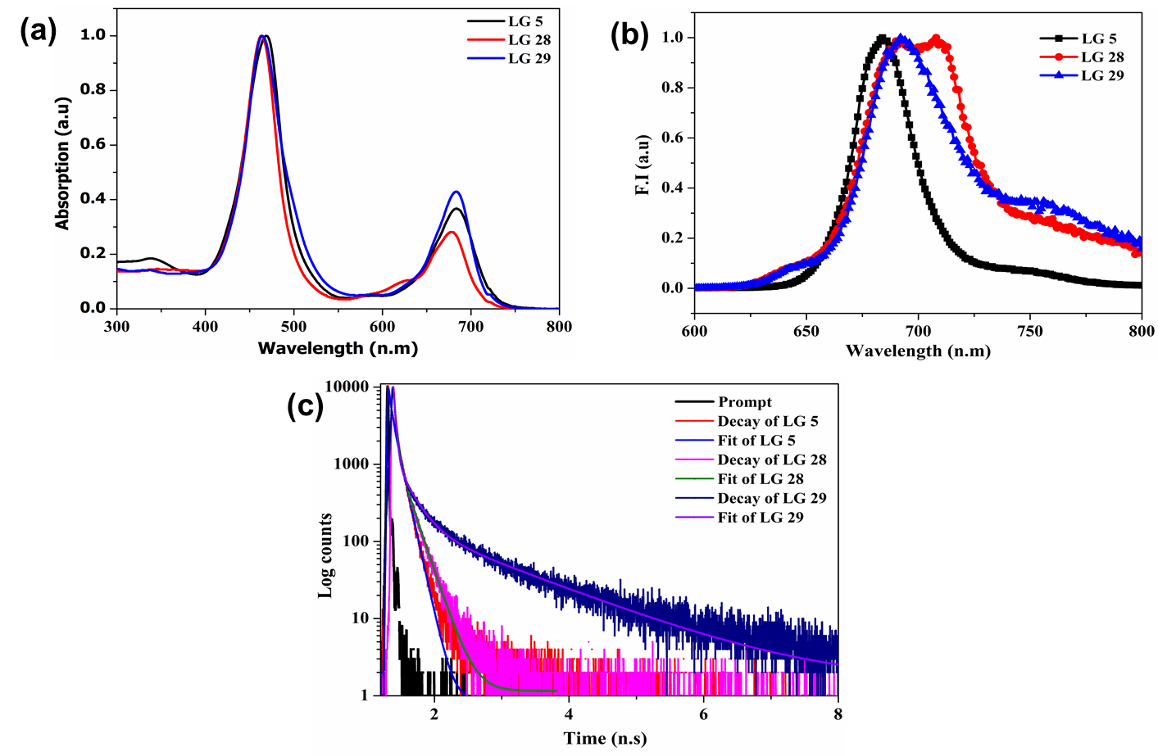
Figure 1: a) Absorption spectra in THF solvent. b) Emission spectra of the dye molecules in THF solvent, c) Singlet excited lifetime of the dye molecules.

intense Soret band at 450 nm region which arises due to the a_{1u}(π)/ e_{g}(π*) electronic transition and less intense Q band at 680 nm region which could be due to a_{2u}(π)/e_{g}(π*) electronic transition. From Figure 1a and Table 1, it suggests that the λ_{max} of both LG 28 and LG 29 sensitizers are not much shifted but their log ε values are enhanced, when compared to LG 5 sensitizers and that may reflect PCE of the device. Among selenophene sensitizers, the Q band absorption maxima of LG 29 sensitizer red-shifted by ~4 nm with enhanced molar extinction coefficient. TD-DFT calculations were adopted to analyse the theoretical absorption spectra and found that the simulated absorption spectra of LG 28 and LG 29 dyes closely match with the experimental absorption spectra (see supporting information Figure S19). Figure 1b demonstrated the emission spectra of both new sensitizers LG 28 and LG 29 measured in THF solvent along with LG 5 and the corresponding emission data are shown in Table 1. The tendencies in emission intensities of newly designed porphyrin sensitizers were red-shifted and it is related to the propensity of their Q-band UV-Vis absorption spectra. This phenomenon designates more effective electronic coupling by the incorporation of the selenophene between anchoring group and porphyrin moiety. Thus, the optical properties of both sensitizers suggest that the presence of selenophene heterocyclic ring as an auxiliary acceptor facilitates the extended π-conjugation in newly designed sensitizers that outcomes the ground and excited state electronic properties. The estimated singlet state band gap energies (E₀₋₀) (resulted from both excitation and emission spectra) of the two novel porphyrin sensitizers LG 28 and LG 29 were higher than that of the reference LG 5 ( ∼1.82 ± 0.02eV).²² The singlet excited state lifetime of both porphyrin sensitizers were measured by employing TCSPC method and unlike LG 5, they are distinctly multiexponential (Table 1) with longest component of 1.88 and 2.42 ns respectively, which are larger than the characteristic lifetime of LG 5 measured in THF solvent (Figure 1c). Note, in presence of TiO₂, fluorescence emission intensity of LG 28 and LG 29 is too quenched to record steady state emission spectra and singlet state lifetime by TCSPC method.

Table 1 Photophysical properties of porphyrin sensitizers.
 | Steady state spectroscopic parameters |  | Time resolved fluorescence studies
 |  |  | Fluorescence Upconversion studies |  |  | TCSPC
Dyes | Absorption λ_{max} nm  (log ɛ, M⁻¹cm⁻¹)ª | Emission  λ_{max}nm^{b},  (Ф)^{c} | 1st  Comp.  τ₁ps  (a₁%) | 2nd  Comp.  τ₂ ps  (a₂%) | 3rd Comp.  τ₃ ns  (a₃%) | τ,^{d}ns (A%) | E₀₋₀ (eV)^{e} | E_{1/2}(V)  vs. NHE^{f} | E_{oxd}  *(V)
LG5 | 467 (5.20)  687 (4.85) | 688  (0.27) | ---- | ---- | ---- | 1.64 ,(66)  1.75 (34) | 1.80 | 1.06 | -0.98
LG 28 | 464 (5.90)  678 (5.34) | 707  (0.26) | 5.9± 0.7  (-100) | 225±17  (84) | ≅1.9  (16) | 1.88 (60)  0.50 (40) | 1.84 | 1.06 | -1.02
LG 28+TiO₂ | 461  673 | ------ | 0.6 ±0.07  (-100) | 23±3  (50) | ≅0.5  (50) | ------ | ------ | ------ | ------
LG 29 | 464 (6.00)  683 (5.60) | 693  (0.27) | 0.6±0.03  (-100) | 95±5  (95) | ≅3.0  (5) | 2.42 (26)  0.20 (24)  0.40 (50) | 1.82 | 1.08 | -0.98
LG 29+TiO₂ | ------ | ------ | 0.2 ±0.03  (-100) | 75±5  (95) | ≅1.5  (5) | -------- | ------ | ------ | ------
ªSolvent: THF, error limits: λ_{max}, ±1 nm, ε± 10%. ^{b}Error limits: λ_{em}, ±1 nm. ^{c}Ф, ± 0.01%. ^{d}Error limits τ ≈ 10%. ^{e}E₀₋₀ was measured from spectral intersection between absorption and emission spectra’s, as depicted in Figure 1. ^{f}Solvent: THF, error limits: E_{OX} ± 0.03 V, 0.1 M TBAP. ^{g}E*_{OX} was calculated as E_{OX} − E₀₋₀.

Upconversion Studies
To explore detail relaxation dynamics of LG 28 and LG 29 in absence and presence of TiO₂ in sub-nanosecond time domain, we performed fluorescence upconversion studies of LG 28 and LG 29 in THF solvent. Figure 2 shows the decay profiles of fluorescence upconversion signals of LG 28 and LG 29 along with TiO₂ in THF solution upon 400 nm excitation. Both the sensitizers show three components time profile, one rise component and followed by two decay components. LG 28 shows rise component of 6 ps characteristic time with two decay components of 225 and 1880 ps lifetime. Whereas, LG 29 shows relatively shorter rise component of 0.6 ps with two decay components of 95 and 3000 ps respectively. Since both sensitizers are excited at the Soret band and fluorescence decays are measured at the peak of Q band emission and rise components are very close to reported lifetime of S₂ state of Zn-TPP ²⁸, they are assigned to the internal conversion time from S₂ state to S₁ state. The slower decay components are found to be very similar to the lifetime of relaxed singlet state of LG 28 (1.9 ns) and LG 29 (3.0 ns) measured by TCSPC. It must be noted that, the third or slower component was constraint of fit in three component fitting of fluorescence upconversion signal in 2.5 ns detection time window. The second decay component was recorded with 225 and 95 ps for LG 28 and LG 29 respectively. Existence of such component in parent Zn-TPP is not reported. Therefore, this intermediate component can be assigned to be conformationally unrelaxed S₁ state which appears due to substitution of phenothiazine and thiol/selenophene heterocyclic ring in meso 5 and 15 position of ZnTPP in LG 28 and LG 29 respectively and for brevity we assign this state as S₁* state. However, upon addition of TiO₂ in the THF solution of LG 28 and LG 29, self-assemble layer of respective sensitizer are formed and it is substantiated by systematic blue-shift of all major absorption peaks by 3-4 nm followed by nearly complete quenching of fluorescence

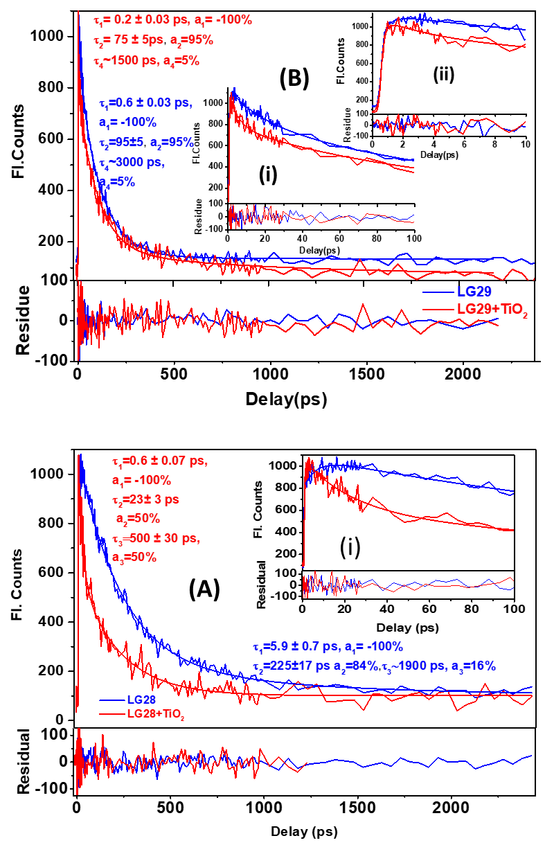
Figure 2. Fluorescence upconverted signal of (A) LG 28 (blue color) and LG 28+TiO_{2 ,}(B) LG 29 (blue color) and LG 29+TiO₂ monitored at the peak of S₁ emission upon 400 nm excitation in THF solution. Inset (i) in (A) and (i) and (ii) in (B) are enlarged view in 100 and 10 ps time domains. Scribbling lines are experimental data and smooth line is the multiexponential fit.
emission of these two sensitizers. To understand the nature of fluorescence quenching we performed fluorescence upconversion studies of LG 28 and LG 29 in presence of TiO₂. Comparative fluorescence upconversion signal time profiles are shown in Figure 2. The characteristic time constant for all three components for both the sensitizers quenched in respect to their corresponding characteristic time constants observed in absence of TiO₂. This quenching of time constants clearly suggests that it is a dynamic process which is related with the electron injection from sensitizers to TiO₂ conduction band. Note, for LG 28 extent of quenching is more pronounced from higher excited state whereas quenching of time constant observed to be prominent from relaxed S₁ state for LG 29. Therefore, electron ejection process from LG28 to TiO₂ competes with relaxation dynamics of higher excited state of LG 28 and electron ejection process from LG 29 to TiO₂ competes with relaxation dynamics of lower excited state. These observations lead to conclude that electron injection rate is higher in case of LG 28 over LG 29.

Electrochemical Properties
With a view to evaluate the HOMO-LUMO levels of newly designed selenophene auxiliary acceptor based porphyrin sensitizers, we have performed electrochemical properties of both sensitizers using cyclic voltammetry technique in THF solvent using 0.1 mM TBAP as a supporting electrolyte. Figure 3a demonstrates the oxidation reactions of both the sensitizers along with LG5 dye and respective redox data presented in Table 1. Both the sensitizers (LG 28 and LG 29) exhibit two reversible oxidations shown in Figure 3a and one quasi-reversible reduction processes presented in Figure 3b. The HOMO energy levels corresponding to the ground state oxidation potentials of the two sensitizers are 0.82 and 0.84 V (vs. SCE), respectively and which is situated below the redox potential of the iodide/tri-iodide redox couple (0.4 V vs. NHE). It indicates that dye regeneration is feasible in both the sensitizers. The respective LUMO (excited state oxidation potential) of both the porphyrin sensitizers was calculated by using the formula, (E*_{OX} = E_{OX} − E₀₋₀), and lie above the edge of TiO₂ conduction band (0.5 V vs. NHE). This suggests that the sufficient electron injection driving force from the excited states of dyes to the TiO₂ conduction band. The π-conjugation extension from LG5 to LG29 sensitizerdid not show much effect on the redox potentials. The energy level diagram of present sensitizers in comparison with LG5 sensitizer was demonstrated in Figure 3c and suggests that the electron injection and dye oxidation is feasible.
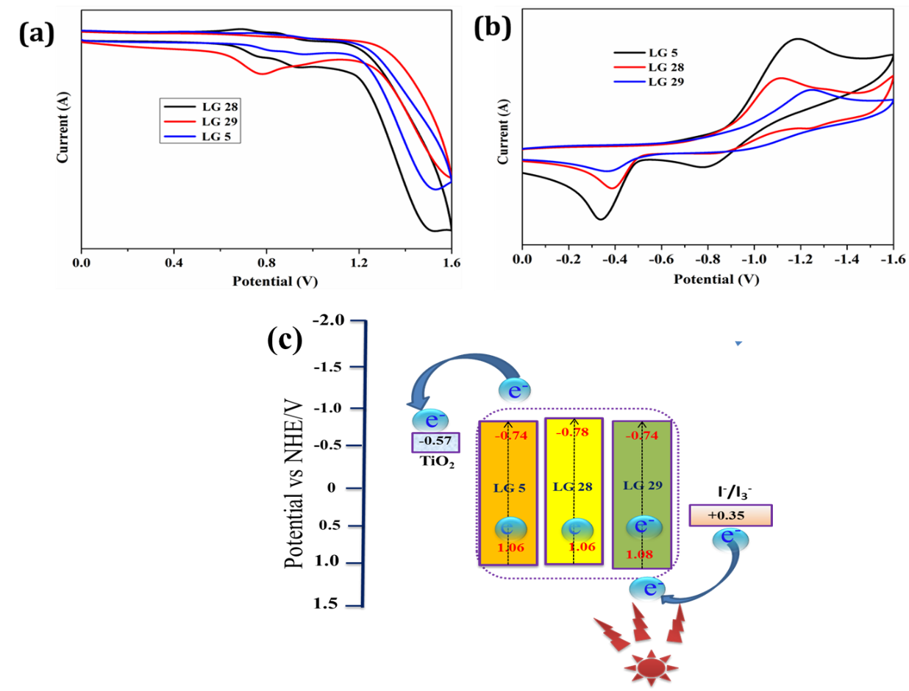
Figure 3: Cyclic voltammograms of LG 28 and LG 29 dyes in THF a. oxidation, b. reduction (scan rate: 100 mVs⁻¹); c. Energy-levels of LG 28, LG 29 porphyrins (comparison with previously reported LG5 dye), TiO₂ and electrolyte.
In a DSSC, the sensitizer gets oxidized when a photon absorbs the electron get excited and injects into TiO₂ conduction band on an ultra-rapid time scale. The redox species are highly reactive and it is very essential to understand the stability of these species in devices. The redox species of Ru(II) polypyridyl complexes are highly unstable due to the presence of labile –NCS ligands.²⁹ This is one of the reasons that searching alternative sensitizers have intensified for the last couple of decades. For this motivation, we have executed in-situ spectro-electrochemical studies of both newly synthesized sensitizers. Figure 4a exemplifies the in-situ spectral changes of LG 28 sensitizer at an applied oxidation potentialof +0.88 V vs. SCE. During the course of controlled potential oxidation, the intensity of Q band at 678 nm was reduced to a considerable blue shift and the development of new band at 562 nm was observed. In contrast, the intensity of Soret band also reduced with the formation of a new band at 453 nm. During this process, isosbestic points were clearly perceived at 446 nm, 547 nm, and 625 nm. This effect obviously indicates that the oxidation gave a single product and creating the porphyrin cation radical. While the oxidation was perceived to be alterable throughout the cyclic voltammetry, the produced porphyrin cation radical at +0.88 V cannot be completely convalesced to its neutral form when the applied oxidation potential altered to 0.15 V. This may be owed to the partial degradation of LG 28 during continuous time-scale of the spectro-electrochemical study, which is similar to LG5.²² Similar spectral changes were also observed for the LG 29 sensitizer (Figure 4b).
Figure 4: Oxidative OTTLE studies of LG 28 sensitizer in 0.3M TBAP/THF with an applied potential of +0.88V (vs. SCE/:KCl).
Quantum Mechanical Studies:
To comprehend the theoretical information such as optical, electronic, and structural properties of the novel sensitizers LG 28 and LG 29, DFT and TD-DFT calculations were executed with the Gaussian 09 software with the functional basis set of B3LYP/6-31G(d,p) method.³⁰⁻³² Figure 5a elucidates the optimized structures of LG 28 and LG 29 sensitizers in ground state; it comprises the donor phenothiazine and selenophene auxiliary acceptor groups separating the ethynyl bridged porphyrin macrocycle. With respect to the phenothiazine donor, the two dyes are displayed non planar bahaviour and it reduces the aggregation both in solvent as well as on the TiO₂ conduction surface. Figure 5b displays the electron density distribution of LG 28 and LG 29 dyes. The frontier molecular orbitals (FMOs) of sensitizers suggest that the HOMO is
Figure 5: The B3LYP/6-31G(d,p)-calculated a. optimized structures, b. frontier HOMOs and frontier LUMOs, and c. electrostatic maps of LG 28 and LG 29 dyes.

Table 2 Represents the calculated HOMO, LUMO, band gap energy values and dipole moment values in Debye units.
Dye | ªHOMO (H), | ªLUMO (L) | ªH-L gap | ^{b}μ
LG 5^{c} | -4.734 | -2.821 | 1.91 | 15.341
LG 28 | -4.607 | -2.733 | 1.88 | 12.081
LG 29 | -4.625 | -2.808 | 1.84 | 11.774
ªvalues in eV, ^{b}values in debye units. ^{C}Reference

present on the phenothiazine donor moiety and partially spread on both porphyrin as well as selenophene rings, while LUMO is delocalized over anchoring group and slightly distributed on porphyrin ring. This is suitable for capable charge separation between donor to anchoring group and the electrons in the excited state of sensitizer is effectively injected into TiO₂ conduction band via the cyanoacrylic acid anchoring group. The electron density of HOMO-1 exists both donor and porphyrin macrocycle while LUMO+1 is on porphyrin ring and auxiliary groups. In case of HOMO-2 and LUMO+2, the electron density present on porphyrin ring only. Hence, the calculated HOMO-LUMO band gap from theoretical calculations of LG 28 and LG 29 are 2.54 eV and 2.58 eV respectively, which might effect the DSSCs performances. Further, we have performed single-point TD-DFT studies of both porphyrin dyes by CPCM methodology with the CAMB3LYP functional with tetrahydrofuran as a solvent. The acquired values agree with the experimental values. The calculated vertical excitation energies for the singlet excited states together with the calculated oscillator strengths are listed in Table S1. The electrostatic potential (ESP) maps of both the sensitizers were demonstrated in Figure 5c in which the positive electrostatic potential was at the donor phenothiazine, while the negative potential was concentrated at the anchoring cyanoacrylic acid group. The theoretical values of the diploe moments of LG 28 and LG 29 dyes were estimated to be 12.081 and 11.774, respectively. The diploe moment did not have much effect on the shift of conduction band edge of TiO₂ in either of the two sensitizers.³³ The dihedral angle between phenyl group and anchoring cyanoacrylic acid was estimated to be 13.09° in LG 28 sensitizer while in case of LG 29 dye, the dihedral angle between thiophne auxiliary acceptor and anchoring cyanoacrylic acid was found to be 1.07°. This means that the sensitizer LG 28 slightly twisted while LG 29 sensitizer is planar at anchoring group allowed efficient charge injection into TiO₂ conduction band and it will affect on efficiency of the DSSCs.

Photovoltaic Performance
Due to the favorable optoelectronic properties of the LG 28 and LG 29 dyes, the photovoltaic properties i.e., IPCE and photocurrent-voltage (J-V) characteristics, were performed and compared to LG 5 sensitizer using 8 μm thick mesoporousTiO₂ films and an acetonitrile- based electrolyte composed of 0.6M 1,2-dimethyl-3-propylimidazolium iodide (DMPII), 0.05 MI₂, 0.1 M LiI, and 0.1 M 4-tert-buylpyridine (TBP). The detailed fabrication method was described in our earlier studies.²² The J-V curves of LG 28 and LG 29 sensitizers along with LG 5 are showed in Figure 6a. The respective photovoltaic parameters are summarized in Table 3. LG 29 based DSSC showed an open circuit voltage (V_{OC}) of 0.70 V, short circuit currentdensity (J_{SC}) of 20.50 mA cm⁻², fill factor (FF) of 71.7% leading to a PCE of 10.31%, whereas LG 28 based DSSC showed V_{OC} of 0.71, J_{SC} of 17.64 mA cm⁻², FF of 71% leading to a PCE of 8.83%. On the other hand, under similar test cell conditions, the sensitizer LG 5 displayed PCE of 10.20%. The IPCE spectra of both sensitizers showed two maxima at ~500 nm and ~700 nm attributed to the Soret band and Q-band absorption and similar spectral features were also observed for f LG 5 dye based DSSC. We observed an IPCE of 85% and 82% for LG 29 and LG 28 dyes, respectively under similar test cell conditions. On the other hand, we have observed an IPCE of 85% for LG 5 dye. The onset of IPCE extends up to 900 nm in case of LG 29 and LG 5 dyes whereas onset extends up to 850 nm only in LG 28 dye that may affect the PCE of the respective DSSC. From Figure 6b and Table 3 it can be seen that the high efficiency of LG 29 and LG 5 based DSSCs onset of IPCE extends up to 900 nm whereas for LG 28 based DSSCs, it extends up to 850 nm where more photons absorbed as a result J_{SC} over 20 mA cm⁻². In addition to this, the planar structure of LG 29 allowed to adsorb more dye compared to LG 28 due to low dihedral angle.
In addition, the influence of TBP concentration in liquid redox electrolyte on device efficiency was investigated. It is well known in the literature that as the concentration of TBP increases in the redox couple, the conduction band edge of TiO₂ shifts, increasing V_{OC}.³⁴ Figure S20 demonstrates the IPCE spectra of the sensitizers using 0.1, 0.3 and 0.5 M concentration of TBP and the resultant data is summarized in Table 3. From Table 3, it can be observed that the IPCE decreases in both sensitizers as the concentration of TBP increases. Similar negative effect of TBP is also observed in the J-V curves of both sensitizers (Figure S21) .V_{OC} increased marginally while J_{SC} decreased dramatically with increased TBP

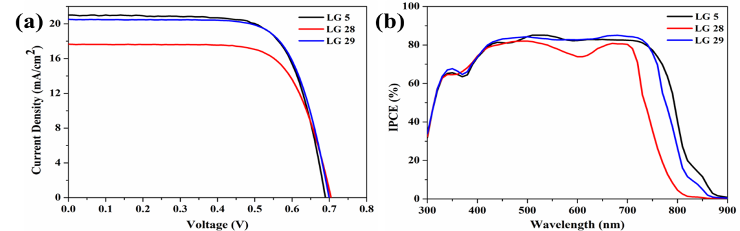
Figure 6: a. current–voltage curves and b. IPCE spectra of LG 5, LG 28 and LG 29 sensitizers based DSSCs. TBP concentration 0.1 M.

Table 3 Photovoltaic performance parameters of porphyrin sensitizers.
Sensitizer | TBP  (mM) | IPCE (%)ª | J_{SC} mA/cm^{2 a} | V_{OC}  (V) ª | FFª | η(%)
LG-5 | 0.10  0.30  0.50 | 85  76  57 | 21.01  18.49  13.17 | 0.685  0.714  0.722 | 0.709  0.718  0.725 | 10.20  9.48  6.89
LG 28 | 0.10  0.30  0.50 | 82  70  55 | 17.64  15.10  10.09 | 0.706  0.711  0.725 | 0.710  0.719  0.723 | 8.83  7.73  5.29
LG 29 | 0.10  0.30  0.50 | 85  75  62 | 20.50  17.51  14.31 | 0.701  0.716  0.727 | 0.717  0.715  0.729 | 10.31  8.96  7.58
ªError limits: J_{SC}±0.20 mA/cm², V_{OC} = ± 0.30 mV, FF = ±0.03.
concentrations from 0.1 M to 0.5 M in both sensitizers. As a result, the current porphyrin sensitizer's optimum TBP concentration is 0.1M.

Femtosecond transient absorption studies
To have better understanding about electron injection process and rate of electron injection from sensitizer to TiO_{2,} we have performed systematic femtosecond transient absorption studies for both LG 28 and LG 29 dyes in THF solution in absence and in presence of TiO₂ upon 400 nm excitation. Figure 7 shows the pictorial summary of transient absorption studies of LG 28 and LG 28+TiO₂ in THF solution which include ΔOD heat map, ΔOD time profiles (in 3.5 ns time window) at different probe wavelength and ΔOD wavelength profiles or transient absorption spectra at different selective delay times in 420-750 nm spectral window. For both the cases transient absorption spectra appear to be typical transient absorption spectra of tetra phenyl porphyrin (TPP) or ZnTPP.^{35,36} Apparently, not much difference is observed in overall aspects of transient spectra obtained for LG 28 and LG 28+TiO₂ solution except long lived spectra for LG 28 solution. However, careful observation revealed that in case of LG 28+ TiO₂ solutions, negative signals corresponding to ground state absorption become narrower than that observed in case of LG 28 only. This observation clearly suggests the disappearance of stimulated emission signal of LG 28+TiO₂ and it can be correlated to electron ejection from excited LG 28 to TiO₂. Due to electron injection from excited singlet state to TiO₂ conduction band population of triplet state is prohibited resulting shortening of spectral lifetime. It is worthy to mention here that transient absorption spectra pertaining lowest triplet and singlet states of TPP or ZnTPP are quite similar but triplet state of TPP/ZnTPP has very long lifetime of few microsecond and this cannot be accessed exactly in 3.5 ns time domain. However, time profiles of transient signals at different probe wavelengths for LG 28+TiO₂ are different over its LG 28 counterpart (Figure 7). A comparative analysis was attempted to fit time profiles of transient signals at different wavelengths for LG 28 and LG 28+TiO₂ cases which is shown in Figure S22. Three to four lifetimes are unambiguous, because three lifetimes were clearly seen in the fluorescence upconversion signal at 675 nm and an extra contribution of T₁→T_{n} transition in transient absorption cannot be excluded in nanosecond time domain. Note, porphyrin based sensitizer have wide range of ground state absorption starting from 400 nm to above 750 nm. Therefore, multiexponential fits of individual transient time profile permit only broad limits located on component amplitudes and lifetimes as transient absorption signals of porphyrin based sensitizers interplay of multiple signatures in detection wavelength window, such as ground state bleaching, stimulated emission, excited state absorption from singlet to singlet and triplet to triplet and absorption due to intermediate species if any. Therefore, we adopted global fitting of full transient data matrix based on singular value decomposition using R-TIMP package interfaced with Glotaran³⁷ with four components. This global analysis yields both evolutions associated difference spectra (EADS) and decay associated difference spectra (DADS) identifying the characteristic spectral signature of each state. Figure 8 (lower panel) shows the summary of global analysis of transient data for both LG 28 and LG 28+TiO₂ with EADSs, DADSs and population profile of EADSs and respective lifetime values are listed in Table 4. For LG 28, lifetimes of first three components are of very similar to that observed in fluorescence upconversion studies and 4th component which appears to be very long-lived (≥ nanosecond), which may either decay or rise with the 1.9 ns third component lifetime to another much longer-lived plateau and cannot be precisely estimated from 2-3 ns time window data. The EADS₁ corresponds to S₂ state of LG 28 which has lifetime of 6 ps, the EADS₂ indicates the intermediate S₁* state with lifetime around 255 ps, the EADS₃ represents the S₁ which has lifetime of 1.9 ns and finally EADS₄ signifies T₁ state which has lifetime greater than 10 ns and it cannot be estimated precisely from 3 ns time window data. In fact, triplet state lifetime of ZnTPP is reported to be in milli second order elsewhere.³⁷ However, all EADSs look nearly alike leaving little blue shift of negative signals corresponding to S₁ state ground state absorption and fluorescence emission at around 670 nm region but corresponding DADSs are much different for each other reflecting wavelength dependent growth and rise of subsequent EADSs. Figure 8 (upper panel) shows the global analysis results for LG 28+TiO₂ which is very much parallel in terms of number of components that observed for LG 28. In this case lifetime of the first three components decreases substantially whereas almost no change in fourth component which is long-lived. The lifetime of first EADS₁ is 2 ps , the lifetime of second (EADS₂) and third (EADS₃ ) quenched strongly and they reduce to 19 ps from 255 ps and 400 ps from 1.9 ns respectively in LG 28+TiO₂. Note, this decrease of lifetime in LG 28+TiO₂ case is associated to electron injection from each state LG 28 to TiO_{2.} Since electron injection competes with all radiative and nonradiative decays population of T₁ state is minimized. Therefore, fourth component in this case is predominately due to charge separated state and lifetime of this state is tend to be morethan 13 ns. It is worthy to mention here that exact estimation of the lifetime of this component is hard in 3 ns time window data but it provides the broad limit. Therefore, these results clearly suggest that upon self-assembled of LG 28 with TiO₂ efficient electron injection occurred from LG 28 to TiO₂ with overall rate of electron injection of 3.84 x 10¹¹ s⁻¹. Likewise, in LG 28 case, similar set of femtosecond transient experiments were performed with identical condition for LG 29 and LG 29+TiO₂ and they are pictorially summarized in Figure S23 and global analysis results are summarized in Figure S24 and the corresponding spectral parameters are summarized in Table 4. As shown in Table 4, no quenching of lifetime is observed for S₂ and S₁* states but it occurs only for S1 state. In presence of TiO₂ lifetime of S₁ state of LG 29 reduced to 378 ps from 2.34 ns. Similar kinds of results were observed in fluorescence upconversion studies. These results confirm that electron injection occurs only from S₁ state of LG 29 to TiO₂ and the rate of electron injection is found to be 2.22 x 10⁹s⁻¹ which is two order lower than that in LG 28.

Table 4. Spectroscopic parameters of LG 28, LG 28+TiO2, LG 29 and LG 29+TiO₂ in THF solution obtained from femtosecond transient absorption studies.
Sensitizer | EADS₁ /S₂  τ₁ ps, | EADS₂/ S₁*  τ₂ps | EADS₃/S₁  τ₃ps | EADS₄  τ₄ ns | Electron  injection rate/s⁻¹
LG28 | 6±1 | 255 ± 10 | 1900 ±50 | >10 (T₁) | -----
LG28+TiO₂ | 2 ± 1 | 19±3 | 400±10 | >13 (CS) | 3.84x10¹¹
LG29 | 6±1 | 142±5 | 2340±50 | >10 | ----------
LG29+TiO2 | 7±1 | 152±5 | 378±10 | >13 | 2.22x10⁹

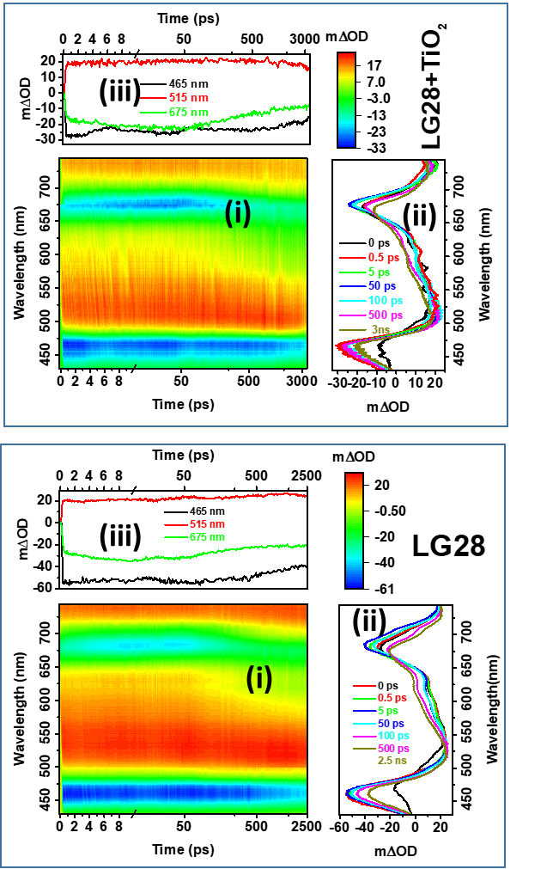
Figure 7. Pictorial summary of transient absorption spectra of LG28 (lower panel) and LG 28+TiO₂ (upper panel) upon 400 nm excitation in THF solution. (i) represents ΔOD heat map, (ii) represents transient absorption spectra at different delay time and (iii) represents transient time profiles at selective wavelengths. Time axis is in linear scale till 10 ps and in logarithmic scale thereafter.
Despite having multiple electron injection and better electron injection rate to TiO₂ conduction band in case of LG 28, but the device efficiency is low, when compared to LG 29 and
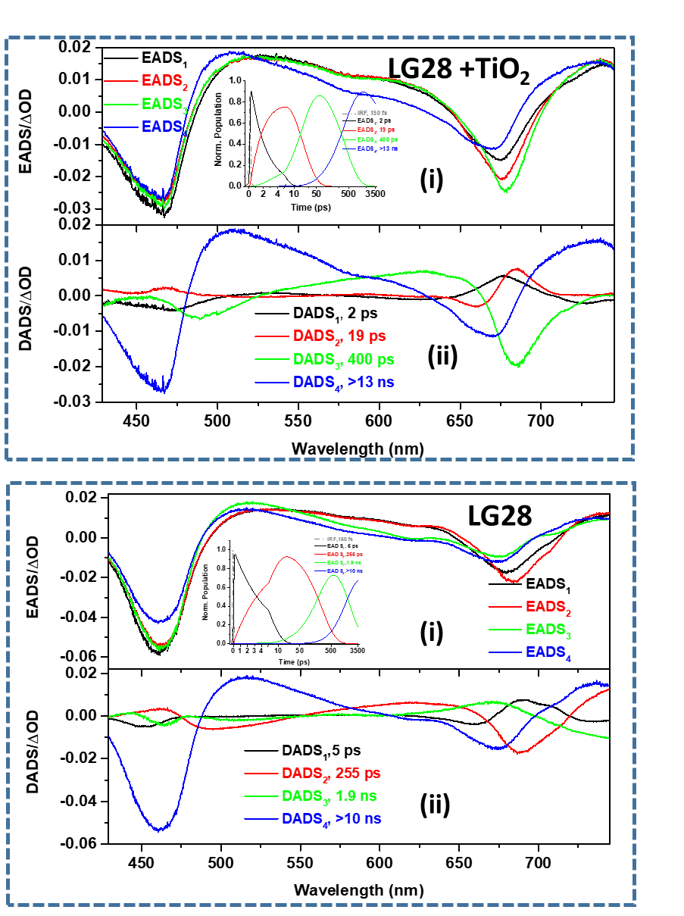
Figure 8. Pictorial summary of global analysis of transient data matrices obtained upon 400 nm excitation of LS28 (lower panel) and LG28+TiO₂ (upper panel) in THF solution. In both the panel (i) shows evolution associated different spectra (EADS) and inset of (i) represents population profiles of respective EADSs as a function of time for which time axis is in linear scale till 10 ps and logarithmic thereafter, (ii) shows the decay associated difference spectra for the respective time constants.
LG 5. Similarly, in case of LG 5 multiple electron injection from excited singlet state to TiO2 conduction band possible.³⁸ High efficiency of LG 29 and LG 5 probable due to the onset of IPCE extends up to 900 nm region where one can expect more photons harvest possible particularly in near-IR region of the spectra. From this study it is proved that in addition to multiple electron injection, broad IPCE spectra also required for better efficiency of the device and literature also suggests similar phenomena.^{38,39}
Finally, we studied thermal stability of new synthesized sensitizers by using thermogravimetric analysis. Figure S25 demonstrates the thermal behavior of LG 28 and LG 29, and it is suggested that both the sensitizers are stable up to 200 ºC. The initial weight loss (∼10%) occurs between 200ºC and 250ºC due to the elimination of anchoring group. Therefore, both the sensitizers are stable up to 200 ºC and have immense potential for roof top applications.

Conclusions
In conclusion, we have modified porphyrin LG 5 sensitizer by replacing thiophene auxiliary acceptor with either phenylselenophene (LG 28) and selenothiophene (LG 29) in a D-π-A concept. Both the new sensitizers are characterized by various spectroscopic techniques and electrochemical methods. The molar extinction coefficient of both sensitizers is enhanced, when compared to LG 5 sensitizer. The emission maxima of both sensitizers are red shifted and it was observed multiexponential decay in TCSPS studies with lifetime of ~2 ns. Optimized studies suggest that HOMO on donor and partially on porphyrin π-spacer and LUMO on anchoring group. The device studies suggest that the sensitizer having selenothiophene showed better efficiency, 10.31% than phenylselenophene (8.35%) auxiliary acceptor as well as LG 5 sensitizer. The change in photovoltaic performance of the respective DSSCs by varying auxiliary acceptor has been explained by adopting transient absorption studies and LG 28 sensitizer showed multiple electron injections from singlet state to TiO₂ conduction band with rate of 3.84 x 10¹¹ s⁻¹ whereas in case of LG 29 it found 2.22 x 10⁹s⁻¹.

Acknowledgements
This work was financially supported by the Council of Scientific and Industrial Research under the FTT programme (MLP-0092). PSG thanks to CSIR and SDG thanks to UGC for research fellowships. A.I acknowledges support from JSPS Kakenhi with grant no. 22H02190 and JST-Mirai Program grant no. JPMJMI21E6, Japan. We thank the Director CSIR-IICT for support (IICT/Pubs./2023/xxx).

References
- Santamouris, M.; Vasilakopoulou, K. Present and Future Energy Consumption of Buildings: Challenges and Opportunities Towards Decarbonization, e-Prime - Advances in Electrical Engineering Electronics and Energy, 2021, 1, 100002.
- Kabir, E.; Kumar, P.; Kumar, S.; Adelodun A. A.; Kim, K.-H. Solar energy: Potential and future prospects. Renewable and Sustainable Energy Reviews, 2018, 82, 894-900.
- Srivishnu, K. S.; Rajesh, M. N.; Prasanthkumar, S.; Giribabu, L. Photovoltaic s fo r indoor applications : Progress , challenges and perspectives. Solar Energy 2023, doi.org /10.1016/j.solener.2023.
- Hagfeldt, A.; Boschloo, G.; Sun, L.; Kloo, L.; Pettersson, H. Dye-Sensitized Solar Cells. Chem. Rev. 2010, 110, 6595-6663.
- O’regan, B.; Grätzel, M. A low-cost, high-efficiency solar cell based on dye-sensitized colloidal TiO₂ films. Nature, 1991, 353, 737-740.
- Tomar, N.; Agarwal, A.; Dhaka, V. J.; Surolia, P. K. Ruthenium complexes based dye sensitized solar cells: Fundamentals and research trends. Solar Energy 2020, 207, 59-76.
- Jella, T.; Srikanth, M.; Soujanya, Y.; Singh, S. P.; Giribabu, L.; Islam, A.; Han, L.; Gupta, R. K. Heteroleptic Ru(II) cyclometalated complexes derived from benzimidazole-phenyl carbine ligands for dye-sensitized solar cells: an experimental and theoretical approach. Mater. Chem. Front. 2017, 1, 947-957.
- Aghazada, S.; Gao, P.; Yella, A.; Marotta, G.; Moeh, T.; Teuschen, J.; De Angelis, F.; Grätzel, M.; Nazeeruddin, M. Ligand Engineering for the Efficient Dye-Sensitized Solar Cells with Ruthenium Sensitizers and Cobalt Electrolytes. Inorg. Chem. 2016, 55, 6653-6659.
- Han, L.; Islam, A.; Chen, H.; Chandrasekharam, M.; Chiranjeevi, B.; Zhang, S.; Yang X.; Yanagida, M. High-efficiency dye-sensitized solar cell with a novel co-adsorbent. Energy Environ. Sci., 2012, 5, 6057–6060.
- Nazeeruddin, M. K.; Pechy, P.; Renouard, T.; Zakeeruddin, S. M.; Humphry-Baker, R.; Comte, P.; Liska, P.; Cevery, L.; Costa, E.; Shklover, V.; Spiccia, L.; Deacon, G. B.; Bignozzi C. A.; Grätzel, M. Engineering of Efficient Panchromatic Sensitizers for Nanocrystalline TiO₂-Based Solar Cells. J. Am. Chem. Soc., 2001, 123, 1613–1624.
- Zhang, Y.; Higashino, T.; Imahori, H. Molecular Designs, Synthetic Strategies, and Properties for Porphyrins as Sensitizers in Dye-Sensitized Solar Cells. J. Mater. Chem. A 2023, 11, 12659-12680.
- Giribabu, L.; Kanaparthi, R. K. Are Porphyrins are Alternative to Ruthenium (II) Sensitizers for Dye-Sensitized Solar Cells? Current Sci., 2013, 104, 847-855.
- Kalyanasundaram, K.; Vlachopoulos, N.; Krishnan, V.; Monnier, A.; Grätzel, M. Sensitization of titanium dioxide in the visible light region using zinc porphyrins. J. Phys. Chem., 1987, 91 2342–2347.
- Campbell, W. M. et al., Highly efficient porphyrin sensitizers for dye-sensitized solar cells. J. Phys. Chem. C, 2007, 111, 11760–11762.
- Luo, J.; Lu, Q.; Li, Q.; Li, Z.; Wang, Y.; Wu, X.; Li, Ch.; Xie, Y. Efficient Solar Cells Based on Porphyrin and Concerted Companion Dyes Featuring Benzo 12-Crown-4 for Suppressing Charge Recombination and Enhancing Dye Loading. ACS Appl. Mater. Interface 2023, 15, 41569-41579.
- Zhou, H.; Ji, J. –M.; Lee, H. S.; Masud, Aftabuzzaman, M.; Lee, D. –N.; Kim. Ch. H. Kim, H. K. D-π-A Structured Porphyrin and Organic Dyes with Easily Synthesizable Donor Units for Low-Cost and Efficient Dye-Sensitized Solar Cells. ACS Appl. Mater. Interfaces 2023, 15, 39426-39434.
- Zou, J.; Tang, Y.; Baryshnikov, G.; Yang, Z.; Mao, R.; Feng, W.; Guan, J.; Li Ch.; Xie, Y. Porphyrins containing a tetraphenylethylene-substituted phenothiazine donor for fabricating efficient dye sensitized solar cells with high photovoltages. J. Mater. Chem. A, 2022, 10, 1320-1328.
- Koteshwar, D.; Prasanthkumar, S.; Singh, S. P.; Chowdhury, T. H.; Bedja, I.; Islam, A.; Giribabu, L. Effects of methoxy group(s) on D-p-A porphyrin based DSSCs: efficiency enhanced by co-sensitization. Mater. Chem. Front. 2022, 6, 580-592.
- Gangadhar, P. S.; Gonuguntla, S.; Madanaboina, S.; Islavath, N.; Pal U.; Giribabu, L. Unravelling the impact of thiophene auxiliary in new porphyrin sensitizers for high solar energy conversion. J. Photochem. and Photobiol. A: Chem., 2020, 392, 112408.
- Krishna, J. V. S.; Koteshwar, D.; Chowdhury, T. H.; Singh, S. P.; Bedja, I.; Islam, A.; Giribabu, L. Efficient near IR porphyrins containing a triphenylamine-substituted anthryl donating group for dye sensitized solar cells. J. Mate. Chem. C 2019, 7, 13594-13605.
- Krishna, J. V. S.; Krishna, N. V.; Chowdhury, T. H.; Singh, S.; Bedja, I.; Islam A.; Giribabu, L. Kinetics of dye regeneration in liquid electrolyte unveils efficiency of 10.5% in dye-sensitized solar cells. J. Mater. Chem. C, 2018, 6, 11444-11456.
- Krishna, N. V.; Krishna, J. V. S.; Singh. S. P.; Giribabu, L.; Han, L.; Bedja, I.; Gupta, R. K.; Islam, A. Donor-π−Acceptor Based Stable Porphyrin Sensitizers for Dye- Sensitized Solar Cells: Effect of π‑Conjugated Spacers. J. Phys. Chem. C 2017, 121, 6464-6477.
- Krishna, N. V. S.; Krishna, J. V. S.; Singh, S. P.; Giribabu, L.; Islam, A.; Bedja, I. Bulky Nature Phenanthroimidazole-Based Porphyrin Sensitizers for Dye-Sensitized Solar Cell Applications. J. Phys. Chem. C 2017, 121, 25691-25704.
- Mathew, S.; Yella, A.; Gao, P.; Humphry-Baker, R.; Curchod, B. F. E.; Ashari-Astani, N.; Tavernelli, I.; Rothlis-berger, U.; Nazeeruddin M. K.; Grätzel, M. Dye-sensitized solar cells with 13% efficiency achieved through the molecular engineering of porphyrin sensitizers, Nat. Chem., 2014, 6, 242–247.
- Kang, M. S.; Choi, I. T.; Kim, Y. W.; You, B. S.; Kang, S. H.; Hong, J. Y.; Ju, M. J.; Kim, H. K. Novel D–π–A structured Zn(II)–porphyrin dyes with bulky fluorenyl substituted electron donor moieties for dye-sensitized solar cells. J. Mater. Chem. A 2013, 1, 9848–9852.
- Tamba, S.; Fuji, R.; Mori, A.; Hara, K.; Koumura, N. Synthesis and Properties of Seleno-analog MK-organic Dye for Photovoltaic Cells Prepared by CH Functionalization Reactions of Selenophene Derivatives. Chem. Lett., 2011, 40, 922-924.
- Li, R.; Lv, X.; Shi, D.; Zhou, D.; Cheng, Y.; Zhang, G.; Wang, P. Dye-Sensitized Solar Cells Based on Organic Sensitizers with Different Conjugated Linkers: Furan, Bifuran, Thiophene, Bithiophene, Selenophene, and Biselenophene. J. Phys. Chem. C 2009, 113, 7469-7479.
- Mataga, N.; Shibata, Y.; Chosrowjan, H. Internal Conversion and Vibronic Relaxation from Higher Excited Electronic State ofPorphyrins: Femtosecond Fluorescence Dynamics Studies. J. Phys. Chem. B 2000, 104, 4001-4004.
- McCall, K. L.; Jennings, J. R.; Wang, H.; Morandeira, A.; Peter, L. M.; Durrant, J. R.; Yellowlees, L. J.; Woollins J. D.; ; Robertson, N. Novel ruthenium bipyridyl dyes with S-donor ligands and their application in dye-sensitized solar cells. J. Photochemistry and Photobiology A: Chem., 2009, 202, 196-204.
- Karthikeyan S.; Lee, J. Y. Zinc-Porphyrin Based Dyes for Dye-Sensitized Solar Cells. J. Phys. Chem. A, 2013, 117, 10973-10979.
- Wang, Z.; Day P. N.; Pachter, R. Density functional theory studies of mesomeso-alkynyl porphyrins. J. Chem.Phys., 1998, 108, 2504-2510.
- Chen, J.; Gao, Y.; Xu, Y.; Xu, F.; Zhang, Q.; Lu, X. Theoretical study of novel porphyrin D-π-A conjugated organic dye sensitizer in solar cells. Mater. Chem. Phys., 2019, 225, 417-425.
- Gangadhar, P. S.; Jagadeesh, A.; George, A. S.; Reddy, G.; Prasanthkumar, S.; Soman, S.; Giribabu, L. An investigation into the origin of variations in photovoltaic performance using D–D–π–A and D–A–π–A triphenylimidazole dyes with a copper electrolyte. Mol. Syst. Des. Eng. 2021, 6, 779-789.
- Huang, S. Y.; Schlichthörl, G.; Nozik, A. J.; Grätzel, M.; Frank, A. J. Charge Recombination in Dye-Sensitized Nanocrystalline TiO₂ Solar Cells. J. Phys. Chem. B 1997, 101, 2576−2582.
- Taniguchi, M.; Lindsey, J. S.; Bocian, D. F.; Holten D. Comprehensive review of photophysical parameters (ε, φ_{f}, τ_{s}) of tetraphenylporphyrin (H₂TPP) and zinc tetraphenylporphyrin (ZnTPP) – Critical benchmark molecules in photochemistry and photosynthesis. J. Photochem. Photobiol. C 2021, 46, 100401.
- Venkatesh, Y.; Venkatesan, M.; Ramakrishna, B.; Bangal, P. R. Ultrafast Time-Resolved Emission and Absorption Spectra ofmeso-Pyridyl Porphyrins upon Soret Band Excitation Studied byFluorescence Up-Conversion and Transient Absorption Spectroscopy. J. Phys. Chem. B 2016, 120, 9410-9421.
- Snellenburg, J. J.; Laptenok, S.; Seger, R.; Mullen, K. M.; van Stokkum, I. H. Glotaran: A Java-based graphical user interface for the R package TIMP. J. Stat. Softw. 2012, 49, 1–22.
- Biswas, Ch.; Gangadhar, P. S.; Giribabu, L.; Soma, S. V.; Raavi, S. S. K. Femtosecond excited-state dynamics and ultrafast nonlinear optical investigations of ethynylthiophene functionalized porphyrin. Opt. Mater. 2022, 127, 112232.
- Biswas, Ch.; Gangadhar, P. S.; Giribabu, L.; Chetti, P.; Banerjee, D.; Soma, V. R. Raavi, S. S. K. Ultrafast intramolecular charge transfer dynamics and nonlinear optical properties of phenothiazine-based push–pull zinc porphyrin. J. Photochem. Photobiol. A Chem: 2022, 433, 114141.

