Plastic anisotropy in yield stress of drawn pearlitic steels

Takumi Akada^{1,2}, Rintaro Ueji^{2,3}*, Masatoshi Mitsuhara⁴, Shigeto Yamasaki⁵, Masaki Tanaka⁵

¹ Sumitomo Electric Industries, Ltd. Itami, Hyogo 664-0016, Japan
² Graduate School of Engineering, Kyushu University, Fukuoka 819-0395 Japan
³ National Institute for Materials Science, Tsukuba, Ibaraki 305-0047, Japan
⁴ Department of Advanced Materials Science and Engineering, Kyushu University, Kasuga-shi, Fukuoka 816-8580, Japan
⁵ Department of Materials, Kyushu University, Fukuoka 819-0395, Japan

*Corresponding author.
e-mail address: ueji.rintaro@nims.go.jp

ABSTRACT
Plastic anisotropy in the yield stress of pearlitic steels evolved by drawing was studied. The tension and compression tests were performed in parallel and perpendicular directions to the drawing direction. The yield stress in the parallel tension and vertical compression tests increased with the increase in drawing strain. On the other hand, in the parallel compression, the yield stress decreased significantly at the small drawing strain and then increased at the larger strain. The difference between the yield stress at the tension and at the compression did not change largely after the start of the drawing. The observation of microstructure indicated no significant heterogeneity of the deformation microstructure and texture at the different locations in the radial direction of the drawn samples, meaning that the plastic anisotropy was brought by reasons other than the non-uniformity of the deformation condition. The measurement of the distribution of the local misorientation in ferrite suggested the large plastic deformation even at smaller strain by drawing. This result indicates that the residual stress in plastically deformed ferrite brings back stress, which can be the source of the plastic anisotropy.

key words: pearlite, yield stress, anisotropy, drawing, residual stress, Bauschinger effect

1. Introduction
Pearlite consisting of fine lamellar ferrite and cementite is the fundamental microstructures in various kinds of structural steels. Many researchers have reported variety of the mechanical properties of fully pearlitic steels, such as tensile strength [1,2], ductile fracture [3,4,5,6], impact toughness [7,8], twisting [9], fatigue [10,11,12], hydrogen embrittlement [13,14,15,16,17,18], flow stress at compression [19] and so on. The significant character among these properties is the highest tensile strength in steel when it is severely deformed by wire drawing [20,21]. The importance in engineering and the superior strength motivates the study on the microstructural development by wire drawing, as typified by the literatures by Embury & Fisher [22] and Langford et al. [23,24] In these studies, the relationship between drawing strain and tensile strength was discussed via microstructural change during the drawing. The strengthening by drawing has been reported followingly for the several steels [25,26, 27]. Additionally, advanced characterization of the drawn steels was conducted by atom-prove tomography [26,28] and clarified the dissolution of carbon by severe deformation. In recent years, Zang et al. [29,30,31,32] revealed more detailed microstructure, such as the change of cementite morphology, the dislocation structure with increasing drawing strain and its relation to the mechanical properties. Gondo et al. [33] reported the radial distribution of texture component and the possibility to optimize the ductility by the control of texture. Additionally, the further strengthening is explored. Li et al. [20] reported the fabrication of steel wire with tensile strength of 7 GPa. Furthermore, several researchers [14,15,17,18] reported that the elongated pearlitic steel shows preferable resistance against hydrogen embrittlement. These recent studies indicate the possibility of the more optimization of the mechanical properties of the pearlitic steel wire.

On the other hand, some applications of the drawn pearlitic steel require the second forming by bending or shaping the cross-section. At these second forming processes, usually both compressive and tensile stress states coexist simultaneously, or more multiaxial stress conditions is expected in a formed wire. The example of the secondly formed products are found in several mechanical parts such as snap rings and piston rings. The advanced design of these parts includes the adoption of the wire with non-circle cross-section, which can contribute both weight savings and the reduction of material waste. The wire with non-circle cross-section can be prepared by plastic processing, such as the flat rolling of the round wire. The precise planning of the second forming needs the deep understanding of plastic behavior at the different loading condition which can be representative by the plastic anisotropy.

The survey of the change in target mechanical properties by increasing of an applied plastic strain has been adopted occasionally as the strategy to study on the relationship between the mechanical properties and the plastic deformation [20, 22, 23, 24, 25, 26, 27, 29, 30, 31, 32, 33]. Especially, the recent studies conducted the multiscale characterization of the microstructure evolution with local crystallographic orientation by the electron back scattering diffraction (EBSD) and so on [29-33] and the atom prove tomography [20,28]. These studies contribute to understand the change of the microstructure in drawing. However, their target property has been limited to the uniaxial tensile properties. The study to clarify the change in both the microstructure and the plastic anisotropy by the drawing is difficult to find.

One of the most fundamental aspects of the plastic anisotropy is asymmetry of yield stress at uniaxial tensile or compressive loading. This asymmetry is well known as the Bauschinger effect, and this is the limited examples on which the study for the plastic anisotropy of the drawn pearlitic steels was conducted. Stobbs and Paetke [34] clarified that the existence of internal stress in the drawn wire (0.82wt%C-0.23%Si-0.86%Mn-Fe) with the investigation of Bauschinger effect. However, the discussion of their study is focused only on the mechanics aspect. Toribio et al. [35] reported the Bauschinger effect of both the as-heat treated and drawn pearlitic steels (drawing strain = 0 and 0.8). These two previous works [34,35] applied pre-straining for the measurement of Bauschinger effect and thus the plastic anisotropy only due to drawing has not been discussed. In addition, there are no reports that exhibits both experimental data of the plastic asymmetry and the microstructural observation. Therefore, this study is aimed to clarify the the plastic deformation behavior at different loading axis/polarity of the drawn pearlitic steels deformed to systematically varying the degree of drawing, accompanied with the microstructural observations.

2. Experimental procedure
Two types of steel wire rods, SWRH62A and SWRH82A, coded by the Japanese Industrial Standards, JIS (G 3506), were used. The chemical composition of each material is shown in Table 1. The significant difference of these chemical composition is found in their carbon contents. These steel wire rods with an initial diameter of 8 mm, 9 mm, 11 mm or 14 mm were heat treated to obtain pearlitic structure (patenting treatment) and drawn to a diameter of 8 mm at room temperature by multi pass. The reduction in diameter at each pass was approximately 20%. Their total drawing strain, ε, can be represented as 2ln (d₀/d_{n}) where d₀ and d_{n}(=8mm) are initial and final diameter [22]. In this work the samples were deformed to ε = 0.24 (d₀=9mm), 0.64 (d₀=11mm), and 1.12 (d₀=14mm).

The patented and drawn specimens were examined by both tensile and compressive tests in the direction parallel to the longitudinal direction of the wire (0° compression). The compression test was conduced in the vertical direction (90° compression) as well. The specimen geometry and direction of the load axis are shown schematically in Fig.1. At the tensile test, the as-patented or as-drawn rods without any shaping was tested at a constant deformation rate with an initial strain rate of 1.7 × 10⁻²/s. The samples cut in the shape of conventional dog-bone tensile specimen were examined at an initial strain rate of 1.0 × 10⁻¹ /s. The meaning of the comparison between the as drawn and the processed specimens is discussed later at the results section. For the 0° compression test, a cylindrical specimen with a diameter of 8 mm × a height of 12 mm was used, while for the 90° compression test, a cubic specimen with a side length of 5.5 mm was cut from a wire rod. The tensile test with loading in the vertical direction was not conducted because of the limitation of area in cross section necessary for cutting of a tensile specimen. In the compression test, a 0.2 mm thick mica plate coated with BN powder was placed between the compression specimen and anvils for lubrication. The Vickers hardness was measured at a load of 200 g.

Microstructural observation by scanning electron microscopy (SEM JEOL JSM-7000F) and crystal orientation measurement by EBSD (TSL-OIM data collection) were conducted. The observed surface was prepared by mechanical polishing and then electropolishing with a solution of 10 vol% perchloric acid + 90 vol% acetic acid. EBSD measurements were conducted at an acceleration voltage of 15 kV and a step size of 0.1 μm. Only bcc phase is adopted because the cementite plate was too small to be obtained clear EBSD pattern. The EBSD measurement was conducted both at the area near the surface and the center of the wire rods to examine the difference along the radial direction.

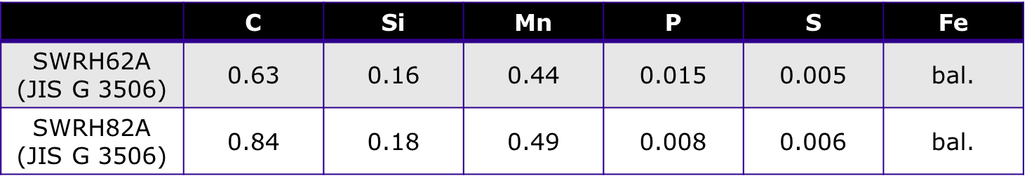
Table 1 Chemical compositions of the steels.

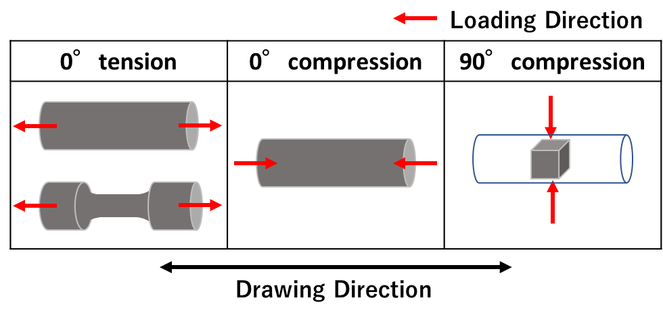
Figure 1 Shape of the test pieces and the loading directions.

3. Results
3.1 Microstructure
The microstructures of the as-patinated specimens are shown in Fig.2. The SWRH62A (a) includes about 5 area% of proeutectoid ferrite, while the SWRH82A (b) showed almost only pearlite microstructure. The average lamella spacing was 110 nm for the SWRH62A and 95 nm for SWRH82A. These differences are probably due to the lower carbon content of the SWRH62A. The diameter of the colonies, where the direction of lamellar elongation is almost the same, [36] were a few ten μm in both the specimens.

Figure 3 shows the results of the EBSD measurement of the SWRH62A (a-e) and the SWRH82A (f-j), as-patented of (a,f) and drawn to a strain of 0.24 (b,c,g,h) or 1.12 (d,e,i,j). These IPF maps show from the wire drawing direction. In the as-patented specimens (a,f), the size of nodules (or blocks), separated by high-angle grain boundaries [36], ranged from 30 to 50 μm. Within any nodule, there is gradual variation in orientation indicated by the color gradient. As for the textures, the {110} pole figures (a,f) indicate that the as-patinated specimens has no significant component of texture. These characters appear to be similar to what reported in the previous studies on the microstructure of pearlite [36].

Drawing develops the deformation microstructures as found in Fig.3(b-e, g-j). The pearlite nodule was elongated and their mean spacing, L, which was evaluated with the length of high-angle grain boundary per unit area, decreased with increasing of the drawing strain. To evaluate the development of deformation substructure, KAM (Kernel Average Misorientation) values, which represent the orientation difference between each EBSD measurement point and its second neighboring points, were calculated. In both samples, the KAM value increases as the drawing strain increases. This indicates the development of dislocation structure in the ferrite phase with increasing of the dislocation density. In the other hand, no significant differences in KAM values in the radial direction were observed.

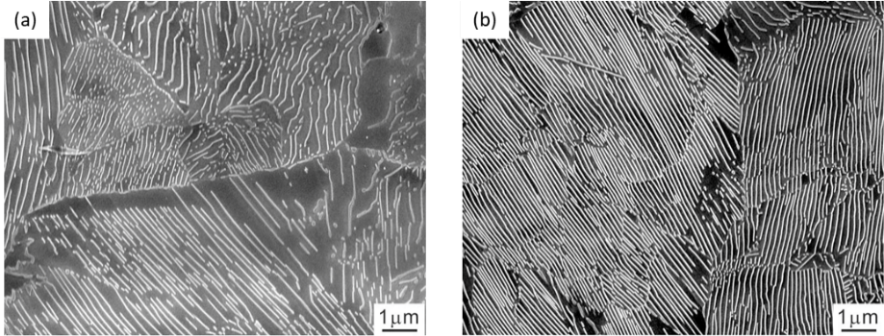

Figure 2 SEM images of the as-patented steels. (a) SWRH62A, (b) SWRH82A.

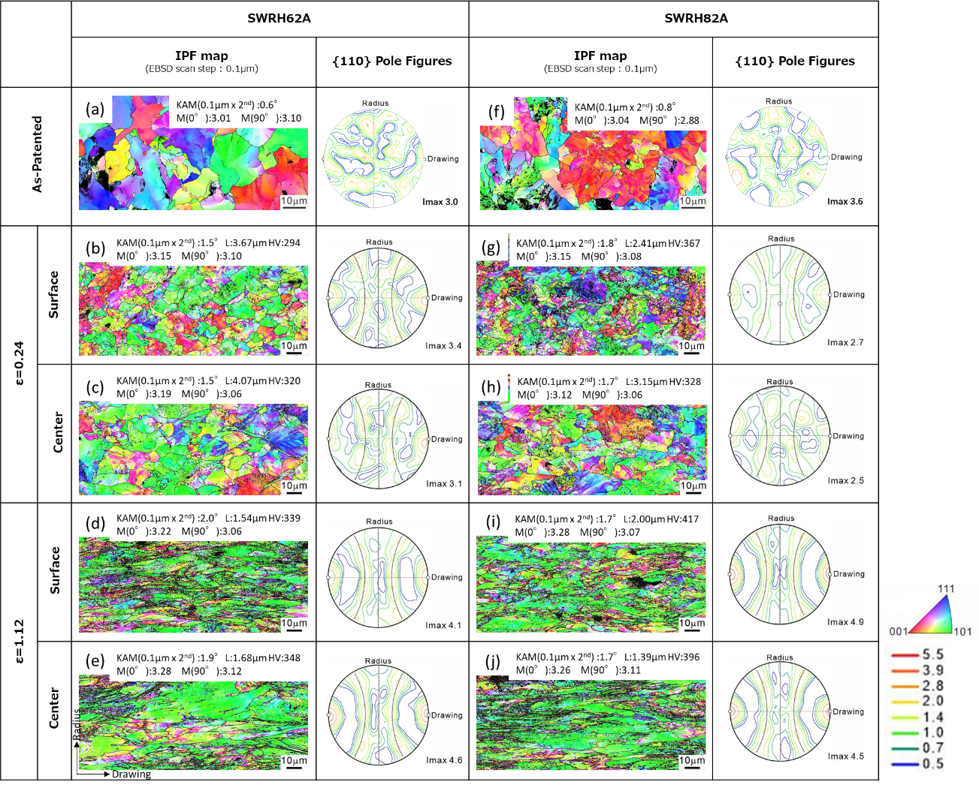
Figure 3 EBSD measurement results of the SWRH62A (a-e) and the SWH82A (f-j). As-patented samples (a,f) and those drawn to a strain (ε) of 0.25 (b,c,g,h) or 1.12 (d,e,i,j) were measured to obtain the orientation color maps (IPF map) and {110} pole figures. The measurements of the drawn samples were conducted at the central (center) and the near-surface (surface) areas in the radial direction. The black line on the color maps indicates the high angle boundary and the color represented the crystallographic orientation parallel to the drawing (or longitudinal) directions with the color-key triangle at the bottom-right of this figure. The dotted lines in the pole figures indicates the orientation of the <110> fiber texture. KAM value, the mean spacing of nodule boundary (L), Taylor factors in the longitudinal and the radial direction (M(0°), M(90°)) and the maximum intensity (Imax) are shown as well. Hv means the Vickers hardness at the corresponding areas.

Concerning of the texture in the drawn specimens, the fiber texture with the drawn orientation parallel to <110> fiber axis was evolved as found in the previous works in drawn metals [33,37]. The concentration of the <110> fiber axis increases with the increasing of the drawn strain. The average Taylor factor, M, is the other well-known factor to indicate texture. The Taylor factor at each EBSD measurement point was calculated for both 0° (longitudinal) and 90° (radial) directions as the loading axis of the tensile or the compressive tests, taking {110}<111> slip system of ferrite in account. M(0°) and M(90°) were evaluated as the average value of all the Taylor factors for 0° and 90° directions, respectively in each EBSD measurement area. The results are shown in the top-right side of each orientation color maps. All of the Taylor factors for the drawn samples indicates around 3 and M(0°) is 10% larger than M(90°). The similar tendency was also obtained when other possible slip systems ({112}<111>, {123}<111>) were assigned. M shows no change with the switching of the loading polarity (tension or compression). These differences in the texture, hardness and KAM value between at the surface and at the center of each sample, indicate the small difference in these character along the radial direction.

The microstructural changes by wire drawing are able to be presented more clearly by analyzing the local {110} pole figures of sole pearlite nodule. The local pole figures of the as-patented (a,d) and the drawn (b,c,e,f) samples are shown in Fig.4. The nodules indicated by blue color at the orientation color maps were selected to plot the {110} poles on the pole figure by blue points. Concerning of the as-patented specimens (a, d), the {110} poles distribute along several circles defined by corresponding rotation axes. These rotation axes appear independent from any mechanical direction such as the drawing direction. This significant distribution suggests that the orientation change in nodule is ruled by the rotation axes related to the mechanism of pearlitic transformation. This characteristic distributions in as-patented pearlite have been reported by previous works [38]. On the other hand, after the drawing (b, e,), the {110} pole distributes more randomly, and no dominant rotation axis appears. It is more difficult to find any simple rule at the drawing specimens than at the as-patented ones. The local misorientation in the plastically deformed metal is closely related to the formation of geometrically necessary (GN) dislocations [39]. It should be noted that the change in the crystallographic orientation at the nodule by the drawing indicates intense plastic deformation in ferrite.

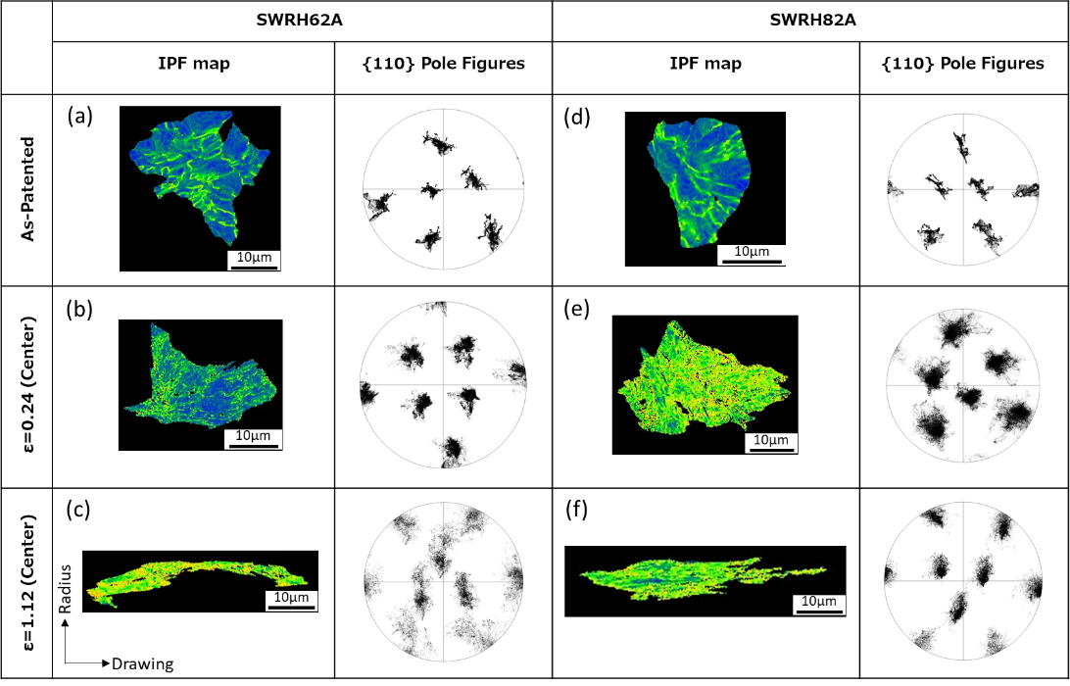
Figure 4 {110} pole figures of the selected nodule shown by blue colors in the highlighted color maps of the SWRH62 (a-c) and the SWRH82A (d-f) patented (a,d) and subsequently drawn to a strain of 0.24 (b,e) or 1.12 (c,f).

3.2 Anisotropy in yield stress
Figure 5 shows the stress-strain curves in the tensile direction of parallel to 0° of the as-patented samples and the specimens drawn to a strain (ε) of 1.12. Both the results with the processed specimen with dog-bone shape and the raw wire rod shape one were shown for comparison. In as-patented specimens of both the SWRH62A and the SWRH82A, the yield stress and tensile strength increase, and the elongation decreases by the drawing. This is the same trend as shown in the previous studies on drawn pearlite [29,31,32]. Although elongation differs depending on the shape of the tensile specimen, no evident effect on strength appears. These results appear consistent with the homogeneity of drawing deformation microstructure in the radial direction as shown in Fig.3, since the difference between the processed (dog-bone shaped) specimen and the as-drawn wire is the existence of the surface part in the drawn wire. When considered more precise condition, the initial strain rates were different (1.7×10⁻² and 1.0×10⁻¹/s) between the tests with these specimens. However, the strength does not show significant difference. This should be due to the small strain rate dependence of the strength of pearlitic steel at the examined strain rate [40,41]. The reduction of elongation of the test with the wire-rod specimen is probably due to the rougher surface condition of the wire rod than that of the processed specimens. It is noted that the target of this work is yield stress anisotropy, thus the difference in elongation brought by the change in the shape of test pieces has no issue to discuss the anisotropy.

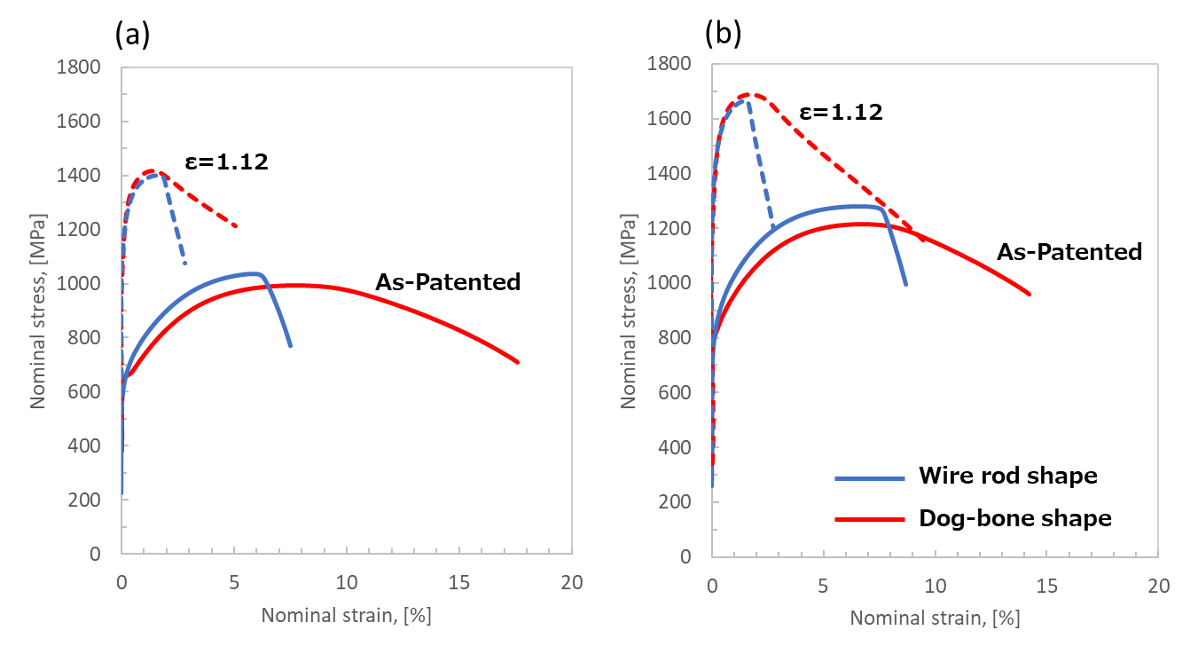
Figure 5 Tensile stress - strain curves of the SWRH62A (a) and the SWRH82A (b) patented and drawn to a strain of 1.12. The tensile test was conducted with two types of the specimen shape (as-wire, processed).

Figure 6 shows the compressive stress-strain curves for the as-patented specimens and the samples drawn to a strain of 0.24. The compression axis is set to 0° and 90° directions. Due to the microstructure doesn’t show the anisotropic character as shown in Fig.3, the plastic isotropy is well expected. Therefore, only the 0° compression results are shown for the as-patented specimen. All the curves show the continuous yielding without any stress dropping around the yield point. For both the SWRH62A and the SWRH82A steels, the flow stress in the 0° compression test decreases, while that in the 90° compression increases by the drawing. In other words, the anisotropy of yield stress was found clearly in the compressive deformation of the drawn specimens. The curves of the specimen drawn to a strain of 0.24 show the stress dropping after the yielding, due to the macroscopic kinking during the work hardening. This does not affect the yield stress comparison as mentioned below.

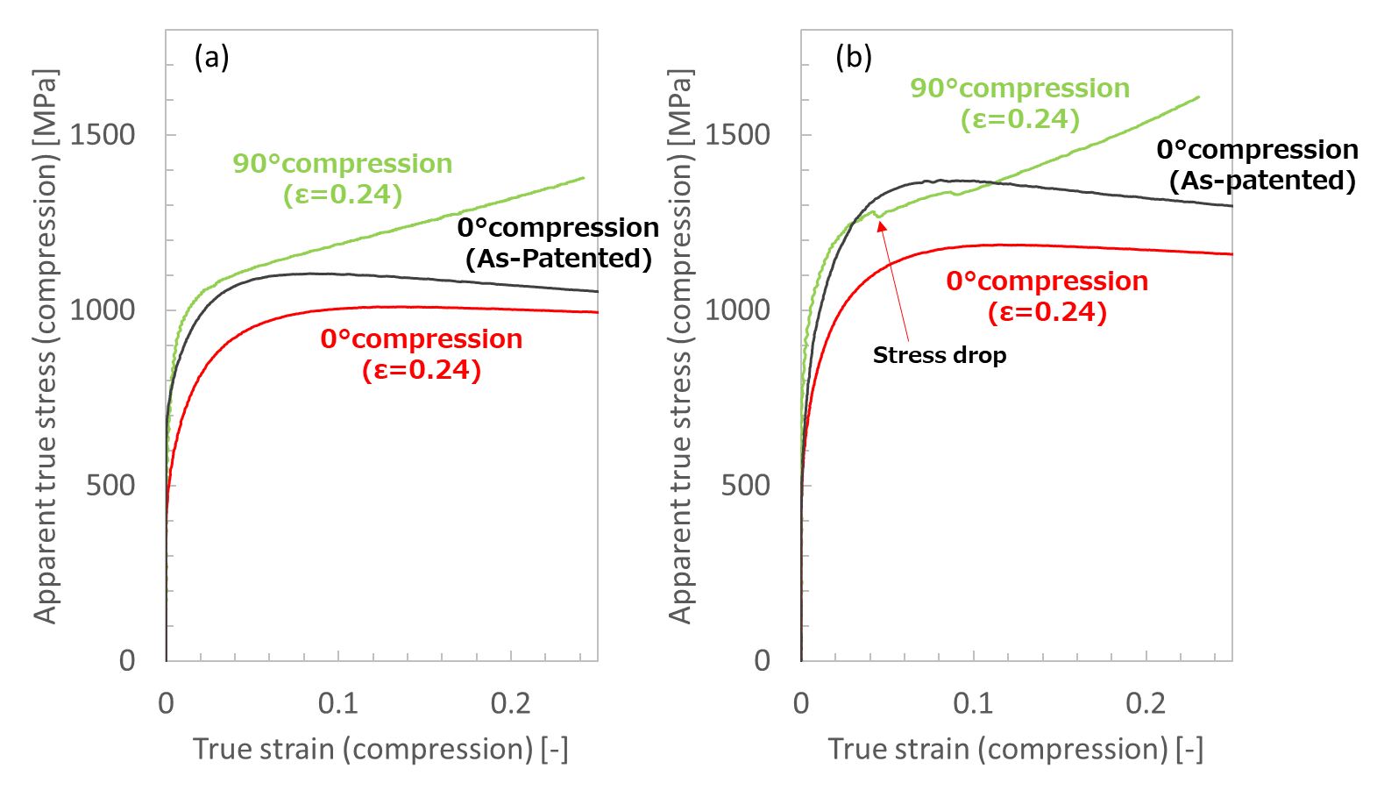
Figure 6 Compressive stress - strain curves of the SWRH62A (a) and the SWRH82A (b) patented and drawn to a strain of 0.24. The compressive test was conducted in two different loading directions. 0°means parallel to the longitudinal (drawing) direction. 90°means parallel to the radial direction.
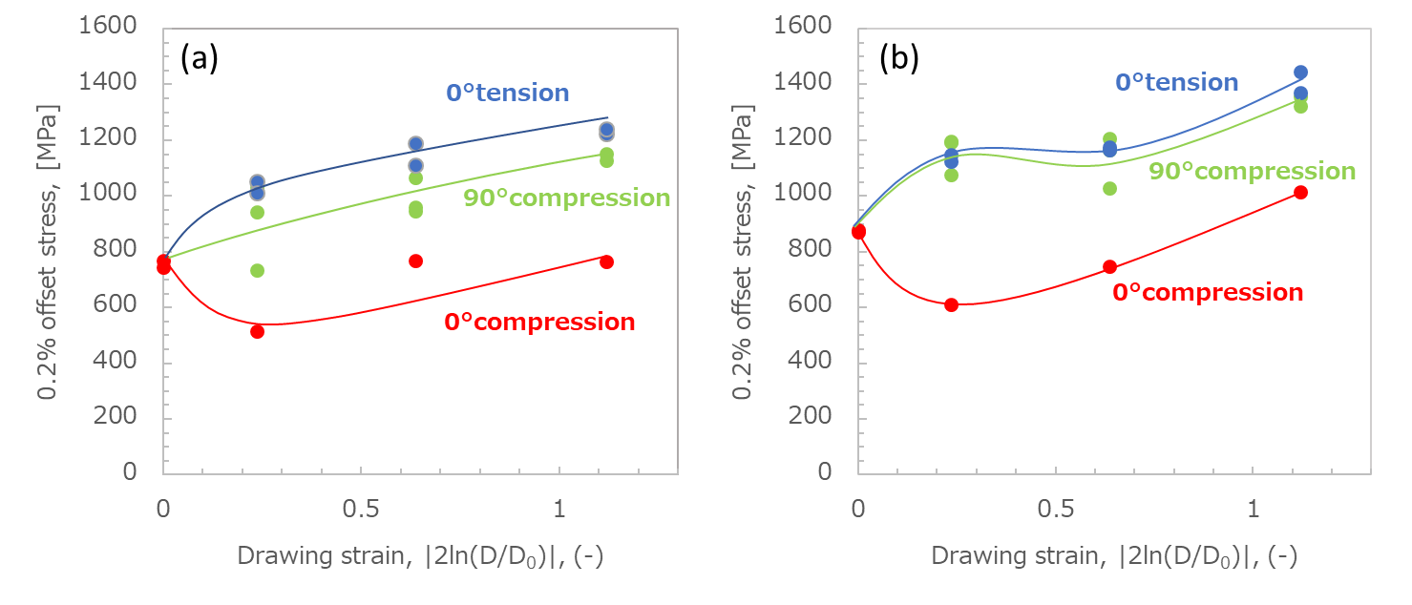

Figure 7 0.2% offset stress obtained by tensile and compressive tests of the SWRH62A (a) and the SWRH82A (b) as a function of a drawing strain.

Figure 7 shows the yield stress obtained in different direction of the SWRH62A (a) and the SWRH82A (b) specimens drawn to different strain. In both the steels, the yield stress increases with increasing of the drawing strain at the 0° tension and the 90° compression. On the other hand, at the 0° compression, the yield stress decreased by the drawing to relatively small strain (ε = 0.24) and then increased by the further drawing. This result indicates that the anisotropy in yield stress in the drawing direction appears by the drawing to a small strain. The relativity of these yield stresses,

0° compression < 90° compression < 0° tension

, keeps in all the drawn specimens. In addition, no significant difference in the anisotropy of yield stress was observed in both the steels. This implies that the small amount of proeutectoid ferrite (SWRH62A) has no contribution to the yield stress anisotropy. The evolution of anisotropy in yield stress by drawing (Fig.7) is one of the most important findings in this work because it has not been found in previous studies. The mechanism how to evolve the anisotropy is discussed in the next chapter.

4. Discussion
As clearly shown in Fig. 7, the drawn steel shows the significant anisotropy in yield stress even when the drawing strain is as small as ~0.2. The plastic anisotropy is important both for the scientific study on the mechanical properties, and for the development of engineering application of steel wire rods. Because the characteristic finding of this work should lie on the results of the 0° and 90° compressive yield stresses, the difference between the 0° tensile yield stress and the other stress is attempted to be explained separately as the following two issues:
(i) The 0° compressive yield stress is lower than the 0° tensile yield stress,
(ii) The 90° compressive yield stress is lower than the 0° tensile yield stress.
The formation mechanism of the yield stress anisotropy is discussed with the perspective of heterogeneous deformation of pearlite that is a lamellar structure composed of soft ferrite and hard cementite.

(i) 0° compression < 0° tension
One of the well-known examples of plastic anisotropy is the Bauschinger effect which appears in a metal pre-strained at tension followed by compression. In several studies of the Bauschinger effect, the tensile stress at the final state of the pre-straining showed larger than absolute value of yield stress at the following compression [34,35]. This anisotropy is explained with the concept of so-called back stress, σ_{BS}, brought by pre-straining [42,43]. It is notable that positive σ_{BS} indicates compressive. When σ_{BS} exists in a pre-strained specimen, the absolute value of the tensile and the compressive yield stresses, σ_{ten} and σ_{com} can be expressed by the following equations (1,2) [44]:

σ_{ten} = σ₀ + σ_{f} + σ_{BS} (1)
σ_{com} = σ₀ + σ_{f} - σ_{BS} (2)

σ₀ is the stress combines the lattice friction stress and the solid solution strengthening. σ_{f} is the contribution of the forest dislocations evolved by pre-straining. When σ_{BS} is compressive (σ_{BS} is positive), σ_{ten} > σ_{com} as found conventionally in the Bauschinger effect [42,43,44]. The absolute value of σ_{BS} equals half the difference between σ_{ten} and σ_{com}, as expressed by the following equation.

σ_{BS} = (σ_{ten} - σ_{com}) / 2 (3)

If σ_{BS} causes the plastic anisotropy in the present case as well, the compressive back stress should be formed in the ferrite where dislocation starts first [45]. Thus, the question is whether the drawing is able to bring the compressive σ_{BS} at ferrite or not.

Uniaxial deformation of a layered composite like pearlite is described representatively by the constant stress (Reuss) or constant strain (Voigt) models. These models were considered under the condition where the longitudinal direction of layers is perpendicular (Ruess) or parallel (Voigt) to the direction of loading. In the case of the constant stress model, the individual constituent layers are allowed to have different strains, and no elastic strain remains after unloading, even after yielding. At the constant strain model, plastic strain in the soft layer (ferrite) is larger than that in the hard layer (cementite) after the yielding due to the difference in these yielding stresses. Since these plastic strains remain after unloading, the soft layer (ferrite) is subjected to compressive residual stress, and the hard layer (cementite) to tensile residual stress to sustain the total force of the composite zero. The distribution of residual stress was indicated by the result of in situ neutron diffraction [46]. Consequently, the residual stress in ferrite can be considered as the reason for the yield stress anisotropy like the Bauschinger effect.

It should be noted that the difference in yield stresses is not the sole mechanism for the evolution of back stress, because this mechanism cannot explain the tendency that the back stress appears no large change by the further drawing as shown in Fig.7. One probable reason for this tendency should lie on the plastic deformation of cementite. Gadalinńska et al. [47] analyzed the stress dispersion between of ferrite and cementite during tensile test of pearlitic steels by neutron diffraction. They found the plastic deformation in cementite, indicating the change in the yield stresses of ferrite as well as cementite. In other others, the back stress is affected by not only the alinement of lamellar structure but also the change in the difference in yield stress. The tendency in Fig.7 can be explained by both the effects. However, further analyzing the plastic deformation behavior of cementite in drawn pearlitic steel is necessary to advance our understanding of plastic anisotropy.

(ii) 90° compression < 0° tension
It was also found in this study that the yield stress at 90° compression is slightly lower than the yield stress in 0° tension (Fig.7). If σ_{BS} can be regarded as the uniaxial stress condition in the drawing direction, it should be possible to estimate the yield stress at 90° compression. Of course, this assumption seems to be oversimplified condition. However, the comparison between the experimental results and the estimation can clarify what is necessary to understand the yield stress anisotropy, no matter whether these are matched or not. In the theory for the Bauschinger effect, σ_{BS} is evolved due to the existence of unrelaxed elastic shear strain, γ*, in the pre-straining direction [44]. In order to consider the contribution of γ* to the normal strain, ε* (θ) , in any direction, θ, can be estimated by the corresponding Taylor factor M(θ).

γ* = M(θ) ε* (θ) (4)

This equation is the definition of Taylor factor [48,49]. When the corresponding back stress (normal stress) in the direction, θ, act as the flow stress estimated by the Taylor factor with the CRSS, σ_{BS}(θ) is simply evaluated with the Young's modulus E:

σ_{BS}(θ) = E ε* (θ) (5)

These equations (4.5) provide not only the expression for the linking between the source of the back stress (γ*) and the contribution to macroscopic flow stress (σ_{BS}(θ)) but also the way to estimate the plastic anisotropy. Taylor factor has been commonly used to express a flow stress measured in a polycrystal in terms of critical shear stress with some assumptions [48, 49] and it can be obtained when the crystal orientation and load axis are known. This means that σ_{BS} parallel to any load axis can be estimated with γ*. Actually, there are several studies using Taylor factor to estimate the flow stress of ferritic steels. Araki et al.[50] discussed the grain size effect on the yield stress of ferritic steel. In Araki’s study, the shear stress evolved by pile-up dislocations was converted to the normal stress with the Taylor factor. Jiang et al. [51] modeled the work hardening of dual-phase steel with considering the increase of dislocation density by the dispersed hard-particles and estimated the change in flow stress with the Taylor factor. These papers imply the usefulness of Taylor factor even in ferritic steel. In this study, the estimation the contribution of γ* to the 90° compressive stress.

Since γ* is considered as constant, the equations (4) and (5) gives the following relations:

σ_{BS}(0°) M(0°) = σ_{BS}(90°) M(90°) (6)

σ_{BS}(0°) can be evaluated with the experimental data of the difference in yield stress between at the compression and at the tension in the drawing direction (Fig.7). M(0°) and M(90°) were also determined by the EBSD measurement as shown in Fig.3. With Eq. (6) and these experimental data, σ_{BS}(90°) at a drawing strain of 0.24 for the SWRH62A and SWRH82A are estimated as 273 MPa and 275 MPa (in compression), respectively. However, these values are too large to explain the relativity between the yield stress at the 90° compression and at the 0° tension. In other words, this estimation implies additional and independent back stress in tension in radial direction.

The failure of the above attempt is probably due to the multiaxial condition of the residual stress by the drawing. Tomoda et al. [52,53] reported the development of internal stresses caused by differences in nodule (block) orientation, suggesting that heterogeneous deformation due to the other microstructural factors than lamellar composite provides a multiaxial stress state. It is difficult to measure complete stress state in a drawn pearlite experimentally. However, at least, the heterogeneity at the yielding should be the main reason because the back stress evolves at the early stage of drawing, and it does not change largely (Fig.7). One of the possible applications of the finding in this work is the attempt to control the anisotropy by the change of local yield stress with alloying or the change of nodule size in order to change the back stress.

According to the effect of the alloying, the anisotropic stress condition may be enhanced via the increasing of the difference in yield stress between two phases. For example, the bearing of Cr brings the increasing in the hardness of cementite [54], followed by the change in back stress condition. Meanwhile, the constraining by cementite on ferrite provides the multiaxial stress condition where the yielding is controlled by the criteria with all of stress component like Mises’s or Tresca’s criteria. This means that the change in back stress may provide the change not only in the drawing direction as well as in the other directions via plastic constraining. The change of the multiaxial stress condition is able to change with crystallographic boundaries including the nodule boundaries. However, it is unclear whether these are related to the back stress for the Bauschinger effect. This means that the back stress related to the yield stress anisotropy has not been clarified yet because of the mixture of both macroscopic and microscale residual stress.

The anisotropy can be beneficial or harmful according to the applications. When the 0° compressive yield stress is small, the work force required the press along the longitudinal axis, such as bolt processing, can be reduced [55]. Large value of the 90° compressive yield stress results in more energy consumption during rolling of a drawn wire for second shaping. These variety means the significance of the knowledge about plastic anisotropy for the advanced application of drawing pearlitic steel.

5. Conclusion
The anisotropy in the yield stress of the two kinds of pearlitic steel, (0.63%C;SWRH62A and 0.84%C;SWRH82A) drawn to different strains (maximum 1.12) were examined. The drawn steels show the significant dependence of the yield stress on the loading direction and the polarity (tension or compression). The main findings are the followings.
1. No significant difference in mechanical properties and microstructure in the radial direction was found.
2. The tensile and compressive tests in the drawing direction (0°) and the compressive test in the radial direction (90°) clarifies the plastic anisotropy in yielding stress.
0° compression < 90° compression < 0° tension
This tendency keeps in any drawing strain examined in this work.
3. The main reason of the anisotropy is considered to be the effect of back stress (residual stress in microstructural scale) caused by the heterogeneity of yield stress in pearlite.

Acknowledgements
This study is based on the work partially supported by a Grant-in-Aid for Scientific Research (ID: 23H01732) through the Japan Society for the Promotion of Science (JSPS).

References
[1] H.K.D.H. Bhadeshia and A.R. Chintha, Critical assessment 41: the strength of undeformed pearlite, Mater. Sci. Technol., 38(2022), 1291-1299.
https://doi.org/10.1080/02670836.2022.2079295
[2] N. Nakada, N. Koga, Y. Tanaka, T. Tsuchiyama, S. Takaki and M. Ueda, Strengthening of Pearlitic Steel by Ferrite/Cementite Elastic Misfit Strain, ISIJ Int., 55(2015), 2036-2038.
http://dx.doi.org/10.2355/isijinternational.ISIJINT-2015-102
[3] D.A. Porter and K.E. Esterling, Dynamic study of the tensile deformation and fracture of pearlite, Acta metall., 26(1978), 1405-1422.
https://doi.org/10.1016/0001-6160(78)90156-6
[4] A.M. Elwazri, P. Wanjara and S. Yue, The effect of microstructural characteristics of pearlite on the mechanical properties of hypereutectoid steel, Mater. Sci. Eng. A, 404 (2005), 91-98.
https://doi.org/10.1016/j.msea.2005.05.051
[5] T. Teshima, M. Kosaka, K. Ushioda, N. Koga and N. Nakada, Local cementite cracking induced by heterogeneous plastic deformation in lamellar pearlite, Mater. Sci. Eng. A, 679(2017), 223-229.
https://doi.org/10.1016/j.msea.2016.10.018
[6] Y. Yajima, N. Koga and C. Watanabe, Influential factors on the deformability of colonies in pearlitic steel, Mater. Charact., 177(2021) 111197.
https://doi.org/10.1016/j.matchar.2021.111197
[7] J.M. Hyzak and I.M. Bernstein, The role of microstructure on the strength and toughness of fully pearlitic steels, Metall. Trans. A, 7A(1976), 1217-1224.
https://doi.org/10.1007/BF02656606
[8] K. Nakase and I.M. Bernstein, The effect of alloying elements and microstructure on the strength and fracture resistance of pearlitic steel, Metall. Trans. A, 19A(1988), 2819-2929.
https://doi.org/10.1007/BF02645816
[9] M. Tanaka, H. Saito, M. Yasumaru and K. Higashida, Nature of delamination cracks in pearlitic steels, Scr. Mater., 112(2016), 32-36.
http://dx.doi.org/10.1016/j.scriptamat.2015.09.004
[10] L.B. Godefroid, L.P. Moreira, T.C.G. Vilela, G.L. Faria, l.C. Candido and E.S. Pinto, Effect of chemical composition and microstructure on the fatigue crack growth resistance of pearlitic steels for railroad application, Int. J. Fatigue, 120(2019), 241-253.
https://doi.org/10.1016/j.ijfatigue.2018.10.016
[11] L.Á. de Oliveira Silva, G.A.C. Sartori, D. Bondarchuk, I.M.O.A. Costa, C. Mesplont and J.‑B. Vogt, Effect of interlamellar spacing on the low cycle fatigue behavior of a fully pearlitic steel, Metallography Microstructure and Analysis, 10(2021), 692-699.
https://doi.org/10.1007/s13632-021-00775-1
[12] S. Scherbring, B. Adams and J. Mola, Impact of interlamellar spacing and non-pearlitic features on mechanical properties and cyclic damage initiation in near-eutectoid pearlitic steels, Mater. Sci. Eng. A, 889(2024), 145846.
https://doi.org/10.1016/j.msea.2023.145846
[13] J. Toribio, A.M. Lancha and M. Elices, Macroscopic variables governing the microscopic fracture of pearlitic steels, Mater. Sci. Eng. A, 145(1991), 167-177.
https://doi.org/10.1016/0921-5093(91)90246-J
[14] J.S. Kim, Y.H. Lee, D.L. Lee, K.-T. Park and C.S. Lee, Microstructure influences on hydrogen delayed fracture of high strength steels, Mater. Sci. Eng. A, 505(2009), 105-110.
https://doi.org/10.1016/j.msea.2008.11.040
[15] T. Doshida and K. Takai, Dependence of hydrogen-induced lattice defects and hydrogen embrittlement of cold-drawn pearlitic steels on hydrogen trap state, temperature, strain rate and hydrogen content, Acta Mater., 79(2014), 93-107.
https://doi.org/10.1016/j.actamat.2014.07.008
[16] S.-H. Yu, S.-M. Lee, S. Lee, J.-H. Nam, J.-S. Lee, C.-M. Bae and Y.-K. Lee, Effects of lamellar structure on tensile properties and resistance to hydrogen embrittlement of pearlitic steel, Acta Mater., 172(2019), 92-101.
https://doi.org/10.1016/j.actamat.2019.04.040
[17] R. Ueji, Y. Kimura and T. Inoue, Preferable resistance against hydrogen embrittlement of pearlitic steel deformed by caliber rolling, ISIJ Int., 62(2022), 368-376.
https://doi.org/10.2355/isijinternational.ISIJINT-2021-429
[18] Z.H. Li, T.T. Sasaki, R. Ueji, Y. Kimura, A. Shibata, T. Okubo and K. Hono, Role of deformation on the hydrogen trapping in the pearlitic steel, Scr. Mater., 241(2024), 115859.
https://doi.org/10.1016/j.scriptamat.2023.115859
[19] R. Ueji, H. Somekawa, T. Inoue and T. Hara, Compression temperature to activate kinking in pearlitic steel, Mater. Sci. Eng. A, 857(2022), 144018.
https://doi.org/10.1016/j.msea.2022.144018
[20] Y. Li, D. Raabe, M. Herbig, P.P. Choi, S. Goto, A. Kostka and H. Yarita, Segregation stabilizes nanocrystalline bulk steel with near theoretical strength, Phys. Rev. Lett. 113 (2014) 106104
https://doi.org/10.1103/PhysRevLett.113.106104
[21] S. Yamasaki, The microstructure and mechanical properties of drawn and aged pearlitic steel wires, Mater. Sci. Technol. 34 (2018) 1–11.
https://doi.org/10.1080/02670836.2017.1407542.
[22] J.D. Embury and R.M. Fisher, The structure and properties of drawn pearlite, Acta Metall., 14(1966), 147-159.
https://doi.org/10.1016/0001-6160(66)90296-3
[23] G. Langford and M. Cohen, Microstructural analysis by high-voltage electron diffraction of severely drawn iron wires, Metall. Trans. 6A (1975) 901-910.
https://doi.org/10.1007/BF02672314
[24] G. Langford, Deformation of Pearlite, Metall. Trans. 8A (1977) 861-875.
https://doi.org/10.1007/BF02661567
[25] H.-C. Choi and K.-T. Park, The effect of carbon content on the Hall-Petch parameter in the cold drawn hypereutectoid steels, Scr. Mater., 34(1996), 857-862.
https://doi.org/10.1016/1359-6462(95)00607-9
[26] N. Guelton and M. François, Strain-induced dissolution of cementite in cold-drawn pearlitic steel wire, Metall. Mater. Trans. A, 51(2020), 1602-1613.
https://doi.org/10.1007/s11661-020-05640-4
[27] N. Guelton and M. François, Microstructure-properties relationship in cold-drawn pearlitic steel wires, Metall. Mater. Trans. A, 51(2020), 1543-1566.
https://doi.org/10.1007/s11661-019-05613-2
[28] K. Hono, M. Ohnuma, M. Murayama, S. Nishida, A. Yoshie and T. Takahashi, Cementite decomposition in heavily drawn pearlite steel wire, Scr. Mater., 44(2001), 977-983.
https://doi.org/10.1016/S1359-6462(00)00690-4
[29] X. Zhang, A. Godfrey, X. Huang, N. Hansen and Q. Li, Microstructure and strengthening mechanisms in cold-drawn pearlitic steel wire, Acta Mater., 59 (2011) 3422-3430.
https://doi.org/10.1016/j.actamat.2011.02.017
[30] X. Zhang, A. Godfrey, N. Hansen and X. Huang, Hierarcical structures in cold-drawn pearlitic steel wire, Acta Mater., 61(2013), 4898-4909.
https://doi.org/10.1016/j.actamat.2013.04.057
[31] X. Zhang, N. Hansen, A. Godfrey and X. Huang, Dislocation-based plasticity and strengthening mechanisms in sub-20 nm lamellar structures in pearlitic steel wire, Acta mater. 114 (2016) 176-183.
https://doi.org/10.1016/j.actamat.2016.04.040
[32] X. Zhang, N. Hansen, A. Godfrey and X. Huang, Structure and strength of sub-100nm lamellar structures in cold-drawn pearlitic steel wire, Mater. Sci. Technol., 34(2018), 794-808.
https://doi.org/10.1080/02670836.2018.1440155
[33] S. Gondo, R. Tanemura, R. Mitsui, S. Kajino, M. Asakawa, K. Takemoto, K. Tashima and S. Suzuki, Relationship between mesoscale structure and ductility of drawn high carbon steel wire, Mater. Sci. Eng. A, 800 (2021) 140283.
https://doi.org/10.1016/j.msea.2020.140283
[34] W.M. Stobbs and S. Paetke, The Bauschinger effect in cold drawn patented wire, Acta Metall. 33 (1985) 777-783.
https://doi.org/10.1016/0001-6160(85)90101-4
[35] J. Toribio, V. Kharin, F.-J. Ayaso, M. Lorenzo, B. González, J.-C. Matos and L. Aguado, Analysis of the Bauschinger effect in cold drawn pearlitic steels, Metals, 10 (2020) 114.
https://doi.org/10.3390/met10010114
[36] Y. Adachi, S. Morooka, K. Nakajima and Y. Sugimoto, Computer-aided three-dimensional visualization of twisted cementite lamellae in eutectoid steel, Acta Mater., 56(2008) 5995-6002.
https://doi.org/10.1016/j.actamat.2008.08.017
[37] M. Ettisc, M. Polanyi and K. Weissenberg, Über Faserstruktur bei Metallen, Z. Phys. 7 (1921) 181-184.
[38] N. Nakada, N. Koga, T. Tsuchiyama and S. Takaki, Crystallographic orientation rotation and internal stress in pearlite colony, Scr. Mater., 61 (2009) 133-136.
https://doi.org/10.1016/j.scriptamat.2009.03.028
[39] M. F. Ashby. The deformation of plasticity non-homogeneous materials, Phil. Mag. 21 (1970) 399-424.
https://doi.org/10.1080/14786437008238426
[40] A. Kanie, Y. Tomota, T. Suzuki, S. Torii, A. Moriai, N. Minakawa, Y. Morii and T. Kamiyama, A Neutron diffraction study on work-hardening mechanism for a pearlite steel, J. Soc. Mat. Sci. Jpn., 53 (2004) 772-775. (in Japanese)
[41] T. Nojima, Strain rate dependence of lower yield stress for plain carbon steels at high strain rates, J. Soc. Mat. Sci. Jpn., 35 (1985) 1118-1124. (in Japanese)
[42] C.J. Bayley, W.A.M. Brekelmans and M.G.D. Geers, A comparison of dislocation induced back stress formulations in strain gradient crystal plasticity, Int. J. Solids Struct., 43 (2006) 7268-7286.
https://doi.org/10.1016/j.ijsolstr.2006.05.011
[43] Y. Kaneko, N. Ishikawa, A. Vinogradov and K. Kitagawa, Hysteresis loop shape of a cyclically deformed copper tricrystal having two longitudinal grain boundaries, Scr. Mater., 38 (1998) 1609-1614.
https://doi.org/10.1016/S1359-6462(98)00100-6
[44] B.C. De Cooman and K. Findley, ‘Introduction to the mechanical behavior of steel’, Association for Iron & Steel Technology, (2017), p.399.
[45] M. Guziewski, S.P. Coleman and C.R. Weinberger, Atomistic investigation into interfacial effects on the plastic response and deformation mechanisms of the pearlitic microstructure, Acta Mater., 180(2019), 287-300.
https://doi.org/10.1016/j.actamat.2019.09.013
[46] Y. Wang, Y. Tomota, S. Hajyo, W. Gong and T. Ohmura, In-situ neutron diffraction during tension-compression cyclic deformation of a pearlitic steel, Mater. Sci. Eng. A, 676(2016), 522-530.
https://doi.org/10.1016/j.msea.2016.08.122
[47] E. Gadalinńska, A. Baczmański, C. Braham, G. Gonzalez, H. Sidhom, S. Wroński, T. Buslaps, K. Wierzbanowski, Stress localisation in lamellar cementite and ferrite during elastoplastic deformation of pearlitic steel studied using diffraction and modelling, Int. J. Plast., 127(2020) 102651.
https://doi.org/10.1016/j.ijplas.2019.102651
[48] W. F. Hosford, ‘The Mechanics of Crystals and Textured Polycrystals’, Oxford University Press, (1993), p.57.
[49] H. Mecking, U.F. Kocks and Ch. Hartig, Taylor factors in materials with many deformation mode, Scr. Mater., 35(1996) 465-471.
https://doi.org/10.1016/1359-6462(96)00137-6
[50] S. Araki, K. Mashima, T. Masumura, T. Tsuchiyama, S. Takaki and T. Ohmura, Effect of grain boundary segregation of carbon on critical grain boundary strength of ferritic steel, Scr. Mater., 169 (2019) 38-41.
https://doi.org/10.1016/j.scriptamat.2019.05.001
[51] Z. Jiang, Z. Guan and J. Lian, Effects of microstructural variables on the deformation behavior of dual-phase steel, Mater. Sci. Eng. A, 190 (1995) 55-64.
https://doi.org/10.1016/0921-5093(94)09594-M
[52] Y. Tomota, T. Suzuki, A. Kanie, Y. Shiota, M. Uno, A. Moriai, N. Minakawa and Y. Morii, In situ neutron diffraction of heavily drawn steel wires with ultra-high strength under tensile loading, Acta Mater., 53 (2005) 463-467.
https://doi.org/10.1016/j.actamat.2004.10.003
[53] Y. Tomota, P. Lukás, D. Neov, S. Harjo and Y.R. Abe, In situ neutron diffraction during tensile deformation of a ferrite-cementite steel, Acta Mater., 51 (2003) 805-817.
https://doi.org/10.1016/S1359-6454(02)00472-X
[54] M.Umemoto, Z.G.Liu, K.Masuyama and K.Tsuchiya: Scr. Mater., 45(2001), 391. https://doi.org/10.1016/S1359-6462(01)01016-8
[55] H. Kanisawa, T. Mori and T. Miki, Development of high strength wire rod with low flow stress for non-heat treated fasteners utilizing Bauschinger effect, J. Jpn. Inst. Met., 30 (1991) 557-559.
https://doi.org/10.2320/materia1962.30.557

Captions of Table & Figures

Table 1 Chemical compositions of the steels.
Figure 1 Shape of the test pieces and the loading directions.
Figure 2 SEM images of the as-patented steels. (a) SWRH62A, (b) SWRH82A.
Figure 3 EBSD measurement results of the SWRH62A (a-e) and the SWH82A (f-j). As-patented samples (a,f) and those drawn to a strain (ε) of 0.25 (b,c,g,h) or 1.12 (d,e,i,j) were measured to obtain the orientation color maps (IPF map) and {110} pole figures. The measurements of the drawn samples were conducted at the central (center) and the near-surface (surface) areas in the radial direction. The black line on the color maps indicates the high angle boundary and the color represented the crystallographic orientation parallel to the drawing (or longitudinal) directions with the color-key triangle at the bottom-right of this figure. The dotted lines in the pole figures indicates the orientation of the <110> fiber texture. KAM value, the mean spacing of nodule boundary (L), Taylor factors in the longitudinal and the radial direction (M(0°), M(90°)) and the maximum intensity (Imax) are shown as well. Hv means the Vickers hardness at the corresponding areas.
Figure 4 {110} pole figures of the selected nodule shown by blue colors in the highlighted color maps of the SWRH62 (a-c) and the SWRH82A (d-f) patented (a,d) and subsequently drawn to a strain of 0.24 (b,e) or 1.12 (c,f).
Figure 5 Tensile stress - strain curves of the SWRH62A (a) and the SWRH82A (b) patented and drawn to a strain of 1.12. The tensile test was conducted with two types of the specimen shape (as-wire, processed).
Figure 6 Compressive stress - strain curves of the SWRH62A (a) and the SWRH82A (b) patented and drawn to a strain of 0.24. The compressive test was conducted in two different loading directions. 0°means parallel to the longitudinal (drawing) direction. 90°means parallel to the radial direction.
Figure 7 0.2% offset stress obtained by tensile and compressive tests of the SWRH62A (a) and the SWRH82A (b) as a function of a drawing strain.

