Transmission electron microscopy image based micromagnetic simulations for optimizing nanostructure of FePt-X heat-assisted magnetic recording media
A. Bolyachkin¹, H. Sepehri-Amin^{1*}, I. Suzuki¹, H. Tajiri², Y.K. Takahashi¹,
K. Srinivasan³, H. Ho³, H. Yuan³, T. Seki³, A. Ajan³, and K. Hono¹
¹National Institute for Materials Science, 1-2-1 Sengen, Tsukuba 305-0047, Japan
²Japan Synchrotron Radiation Research Institute (JASRI), Sayo, 679-5198, Japan
³Magnetic Recording Media Division, Western Digital Corporation,
5601 Great Oaks Pkwy., San Jose, CA 95138, USA
The areal density of the heat-assisted magnetic recording (HAMR) technology has a potential to reach 4 Tb/in². However, the bimodal grain size distribution and structural defects that are unavoidable in actual FePt-X nanogranular media must be minimized for further reduction of a jitter noise. Here we report transmission electron microscopy (TEM) image based micromagnetic simulations of the FePt-X nanogranular media in order to elucidate the role of structural defects such as [200] misalignment and {111} twins on the magnetic properties. Micromagnetic approximation of experimental out-of-plane hysteresis loops allows to evaluate micromagnetic parameters and volume fractions of the defects in MgO(6 nm)/FePt-BN(1 nm)/FePt-(BN,C,SiO₂)(7 nm) granular thin films. Synchrotron XRD of the films validated that the structural defects can be accurately evaluated by the proposed approach. The developed TEM image based micromagnetic simulations can directly link nanostructure of the FePt-X media with magnetic properties, boosting not only the optimization of the HAMR media but also a design of magnetic nanomaterials in general.
Keywords: FePt, nanostructure, heat-assisted magnetic recording, micromagnetic simulation

1. Introduction
Hard disk drives (HDD) occupy the dominant niche of data storage in data centers since they have the best combination of low cost and high capacity. A rapid global expansion of digital data requires HDD with increased areal recording density. However, the areal density of conventional HDD has already reached its physical limit of about 1 Tb/in² arising from so-called “magnetic recording trilemma” [1], i.e., smaller nanograins are needed to increase the areal density → their magnetic anisotropy should be increased to maintain thermal stability in nanosized volumes → a higher magnetic field is required to switch such grains that is unachievable even with the state-of-the-art write head technology. An option to overcome this limit is heat-assisted magnetic recording (HAMR) which reduces substantially the switching field of grains by local laser heating [2-5]. Thus, current industrial goal for HAMR is the areal density of 4 Tb/in².
A keystone for realizing the high areal density is L1₀-ordered FePt-X nanogranular thin films where X stands for nonmagnetic segregant that separates FePt nanograins [2-5]. A tetragonal FePt phase (P4/mmm) with L1₀ order has the large uniaxial magnetocrystalline anisotropy of K_{u} > 5.0 MJ/m³ that preserves thermal stability of grains down to ~3 nm size. To achieve the goal of 4 Tb/in², the FePt-X media should satisfy the following requirements [3,4]: grain size of 4.3 nm with the standard deviation of 10–15%, center-to-center distance of 5.1 nm, and aspect ratio of 1.6. Besides, large degree of L1₀ order in nano-sized FePt grains and their good out-of-plane [001] crystallographic texture are needed [6].
A common way to refine FePt-X nanostructure is an optimization of deposition conditions such as Ar pressure, power, base pressure, growth rate, chosen underlayer [7-9], substrate temperature, segregant, its amount etc. A variety of options for segregant X were considered such as C [10-17], B [18], oxides (SiO_{x}, TiO_{x}, TaO_{x}) [19-21], nitrides (SiN_{x}, BN) [22,23], or their mixtures [9,24]. Promising results with small grain size of 4–6 nm were demonstrated for X = C [4,10,11]. However, a bimodal or broad distributions of the grain size remain a critical issue that needs to be eliminated in the FePt-X granular media [2,5,15,24]. Such distributions contribute significantly to transition position fluctuations (jitter) that cause the main media noise. When the grain size is reduced to ~6 nm, this problem becomes more serious because grains below 3 nm tend to be disordered to A2 phase [25]. This results in a prominent heterogeneity of the switching field of FePt grains [5,16]. Therefore, it is important to develop a method for suppressing a bimodal distribution of the grain size and minimizing its dispersion. Perumal et al. reported that the size distribution of FePt grains can be substantially reduced by using appropriate amount of C as a segregant on a MgO substrate [10]. Zhang et al. demonstrated the first HAMR recording on such FePt-C granular media [11]. Thereafter, many derivative FePt-(C,X) media have been considered. For example, Weller et al. reported that a mixture of C and BN as a segregant can partially suppress the bimodal grain size distribution [5]. Introduction of a nucleation layer also demonstrated an efficiency in increasing the areal number density of FePt grains [26].
In this study, we show that the introduction of a FePt-(BN+N₂) nucleation layer before the growth of a FePt-(BN,C,SiO₂) recording layer suppresses the bimodal grain size distribution in FePt HAMR media. In order to understand the deviation of the magnetization curves from the ideal rectangular one, a special focus is given on nanostructural defects like [200] misalignment of grains and variants appearing due to {111} twinning observed by high-resolution transmission electron microscopy (TEM). Based on TEM images, we constructed a micromagnetic model with misaligned and twined grains. Such a detailed model allows us to reveal the role of the defects in the macroscopic magnetic properties of FePt media and provides a pathway toward a direct micromagnetic approximation of experimental hysteresis loops with the evaluation of micromagnetic parameters and fractions of the defective volumes.

2. Methods
A FePt-X recording layer was deposited on the 1-nm-thick nucleation layer over a 6-nm-thick (001)-textured MgO underlayer using magnetron sputtering with a base pressure greater than 8.5 × 10⁻⁷ Pa. The FePt-X recording layer consisted of the stack of FePt-C/FePt-BN-C/FePt-BN-SiO₂ which total nominal thickness was of 7 nm. Four different nucleation layers were considered: FePt, FePt-16 vol.% BN, FePt-33 vol.% BN, and FePt-33 vol.% BN+N₂. The last nucleation layer was deposited in a N₂ + Ar gas atmosphere. For simplicity, hereafter vol.% is presented as % in the notations for the nucleation layers. The substrate temperature was maintained at 450 °C during the deposition of the nucleation layer while it was of about 600 °C during the deposition of the FePt-X recording layer. The trilayer structure of the recording layer was not preserved due to the elevated deposition temperature and related high layer intermixing. Therefore, the recording layer is referred as FePt-(BN,C,SiO₂) hereafter.
Magnetic properties of the films were measured using a superconducting quantum interference device equipped with a vibrating sample magnetometer (SQUID-VSM; Quantum Design) with a maximum applied magnetic field of 7 T. Microstructure of the films was investigated by scanning transmission electron microscopy (STEM) using a Titan G2 80-200 (FEI) with a probe aberration corrector. A lift-out method was used to prepare TEM specimens using a focused ion beam system Helios G4-UX DualBeam (FEI).
XRD patterns were measured by synchrotron X-rays with the energy of 8.0 keV using θ-2θ scanning setup at the beamline BL13XU of SPring-8 [26,27]. The L1₀ order parameter S was calculated from $S=\sqrt{{\left[I_{001}^{exp}∙I_{002}^{cal}\right]}/{\left[I_{001}^{cal}∙I_{002}^{exp}\right]}}$, where $I_{001}^{cal}$ and $I_{002}^{cal}$ denote the calculated peak intensities for ideal L1₀ order while $I_{001}^{exp}$ and $I_{002}^{exp}$ represent the corresponding experimental ones [29-32]. The $I_{001}^{cal}$ and $I_{001}^{cal}$ values were obtained considering the Lorentz–Polarization factor for the synchrotron setup and footprint correction [30]. The volume ratio of [111] misaligned grains with respect to [002] textured grains was evaluated from ${V_{111}}/{V_{002}}={\left[I_{111}^{exp}∙I_{002}^{cal}\right]}/{\left[I_{111}^{cal}∙I_{002}^{exp}\right]}$ since the proportionality $I∝V$ for textured media [29]. The total volume fraction of the [111] misaligned grains was given by $V_{111}{/V}_{tot}={\left[V_{111}{/V}_{002}\right]}/{\left[1+ V_{111}/V_{002}+V_{200}/V_{002}\right]}$.
The finite element micromagnetic models of granular media were developed based on TEM observations of the FePt-X films using Gmsh [33] and Trelis software. The model had an area of 250 × 250 nm² that contained 1088 FePt grains with an average grain size of 6.0 nm. The height of grains was 7.4 nm with a standard deviation of 0.6 nm. The saturation magnetization (μ₀M_{s}) and exchange stiffness (A) of the L1₀ ordered FePt nanograins were selected to be 1.43 T and 10 pJ/m, respectively [34]. The developed model was meshed with a size of 1.5 nm using a geometry adaptive approach, and the Landau–Lifshitz–Gilbert equation was solved at each node using Femme [35] and Fastmag [36] software.

3. Results and Discussion
3.1. Magnetic Properties
Figure 1 shows in-plane and out-of-plane magnetization curves of the 7-nm-thick FePt-(BN,C,SiO₂) films deposited on 1-nm-thick nucleation layers of (a) FePt, (b) FePt-16 vol.% BN, (c) FePt-33 vol.% BN, and (d) FePt-33 vol.% BN+N₂. The largest out-of-plane coercivity, μ₀H_{c}, of 3.47 T is obtained for the film with FePt nucleation layer while the in-plane coercivity is 0.17 T, which should be zero in the ideal case for HAMR. The addition of 16 vol.% BN as a segregant in the 1-nm-thick FePt nucleation layer results in a slight decrease in the out-of-plane coercivity to 3.14 T while the in-plane coercivity of 0.19 T remains comparable. The out-of-plane coercivity is further decreased to 2.15 T for the FePt-33% BN underlayer, and the in-plane coercivity is increased to 0.46 T, indicating the increase of the in-plane component in the media. An increase in the volume fraction of the BN segregant in the nucleation layer results in a poor switching field distribution of the FePt grains, as can be concluded from the slope of the out-of-plane magnetization curve in the second quadrant (Fig. 1c). The introduction of N₂ gas during the deposition of the FePt-33% BN nucleation layer recovers the out-of-plane coercivity to 3.0 T, improves the switching field distribution and reduces the in-plane coercivity to 0.26 T.
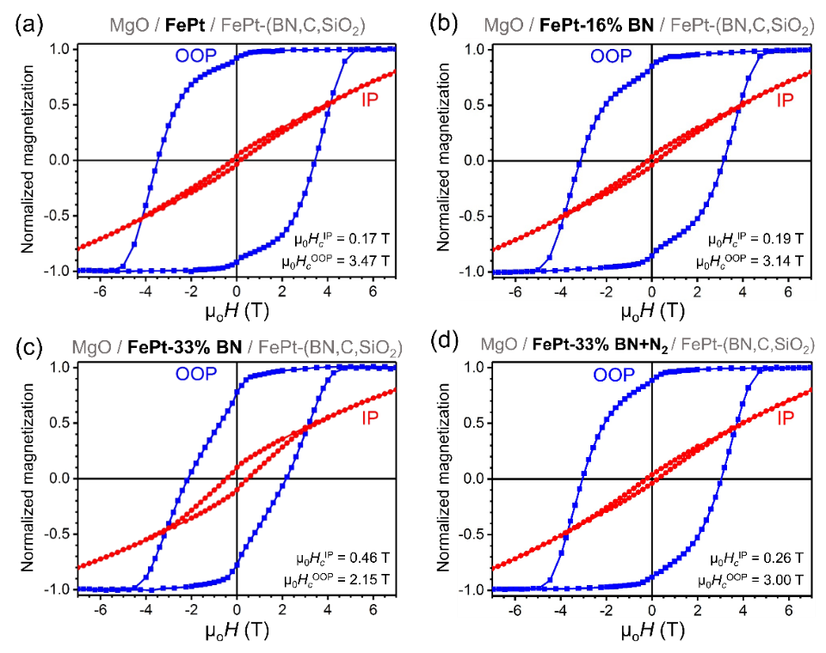
Figure 1. In-plane and out-of-plane magnetization curves obtained from the FePt films deposited on 1-nm-thick nucleation layers of (a) FePt, (b) FePt-16 vol.% BN, (c) FePt-33 vol.% BN, and (d) FePt-33 vol.% BN+N₂.
3.2. TEM Characterization
We observed the microstructure of the nucleation layers to understand the origins of described features of the magnetic properties of the FePt-(BN,C,SiO₂) recording layer deposited on the nucleation layers. Figure 2 shows the plane-view and cross-sectional high angle annular dark field scanning transmission electron microscopy (HAADF-STEM) images of the 1-nm-thick (a) FePt, (b) FePt-16% BN, (c) FePt- 33% BN, and (d) FePt-33% BN+N₂ nucleation layers. The size distribution of the FePt grains for each film is shown in the inset of the images. The FePt nucleation layer has the bimodal grain size distribution with a mean of 2.6 nm and a standard deviation (SD) of 0.6 nm. The cross-sectional HAADF-STEM image in Figure 2a shows that the FePt grains are mostly disordered, while alternating projections of Pt and Fe atoms on the (002) planes indicate the existence of L1₀-ordered domains within the grains. The mean grain size in the FePt-16% BN is reduced to 1.7 nm (SD = 0.3 nm). The cross-sectional HAADF-STEM image shows that FePt grains are crystalline with the A1 or L1₀ structure. The grain size in the FePt-33% BN nucleation layer is ~1.2 nm (SD = 0.3 nm), which is comparable to that of the FePt-33% BN+N₂ nucleation layer. No atomic contrast is observed in the FePt grains in the FePt-33% BN and FePt-33% BN+N₂ nucleation layers; this indicates that the grains have an amorphous structure. The addition of BN as a segregant eliminates the bimodal distribution of the FePt grains, as shown in Figure 2b-d. The calculated grain density in the 1-nm-thick FePt nucleation layer is 18.9×10¹² grains/in², which is increased to 44.1×10¹² grains/in² in the FePt-33% BN+N₂ nucleation layer.
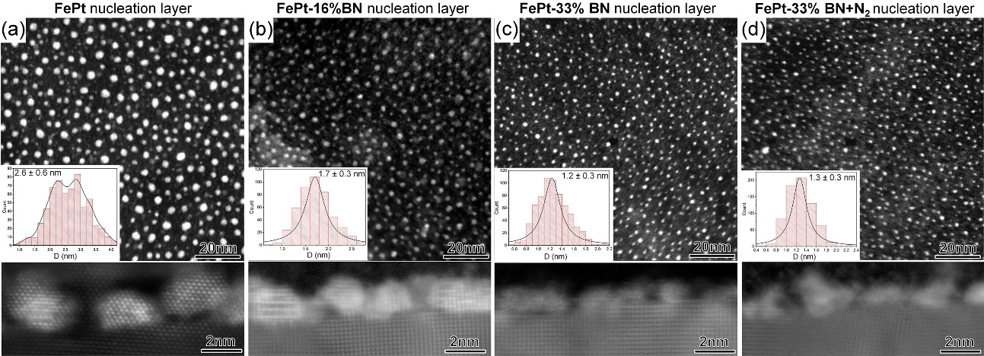
Figure 2. Plane-view and cross-sectional HAADF-STEM images obtained from the 1-nm-thick (a) FePt, (b) FePt-16 vol.% BN, (c) FePt-33 vol.% BN, and (d) FePt-33 vol.% BN+N₂ nucleation layers. The FePt grain size distributions in the nucleation layers are indicated in the insets of the plane-view HAADF-STEM images.
Figure 3a-d shows plane-view TEM and cross-sectional STEM images obtained from the FePt-(BN,C,SiO₂) films deposited on (a) FePt, (b) FePt-16% BN, (c) FePt-33% BN, and (d) FePt-33% BN+N₂ nucleation layers. The grain size histograms evaluated from the plane-view TEM images are shown in the inset figures. The average grain size in the FePt-(BN,C,SiO₂) film deposited on the FePt nucleation layer was 7.0 nm with SD = 2.4 nm. A bimodal distribution of the grain size is observed with a secondary grain size peak at 2.5 nm. The cross-sectional STEM images show that the average height of the FePt grains is 7.4 nm; the average grain size of the recording layer is decreased to 6.2 nm with a SD of 2.0 nm for the FePt-16% BN nucleation layer, and 6.5 nm with a SD of 2.3 nm for the FePt-33% BN with the bimodal distribution of the grain size at around 2 nm. The bimodal distribution of the FePt grain disappears with the introduction of N₂ during the deposition of the nucleation layer in the FePt-33% BN+N₂/FePt-(BN,C,SiO₂) film with an average grain size of 6.2 nm with a SD of 1.8 nm. Center-to-center pitch distances in films with the FePt, FePt-16% BN, and FePt-33% BN nucleation layers were comparable of 7.4 nm. It was reduced to 7.1 nm in the case of FePt-33% BN+N₂/FePt-(BN,C,SiO₂) film. No distinct differences were observed in the shape of the grains.
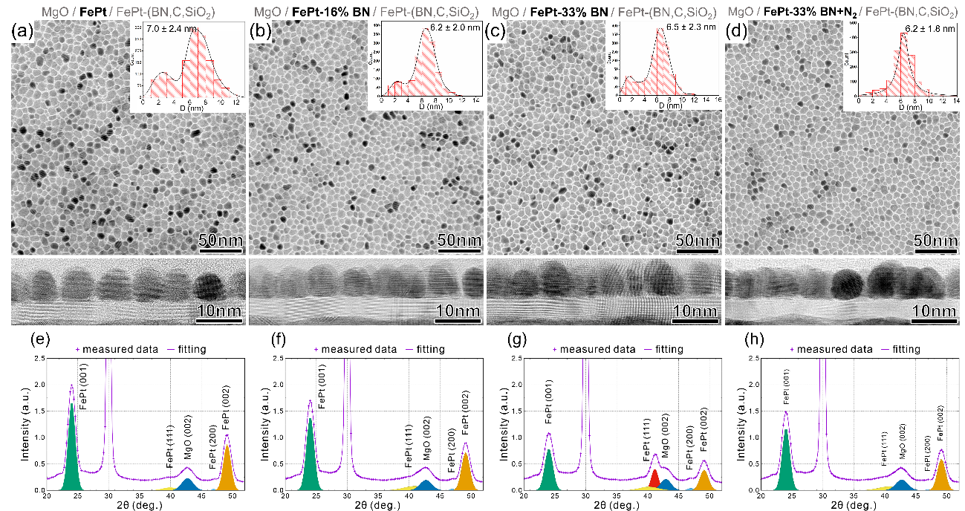
Figure 3. Plane-view bright field (BF)-TEM images, cross-sectional BF-STEM images and synchrotron XRD patterns of the FePt-(BN,C,SiO₂) films deposited on 1-nm-thick nucleation layers of (a) FePt, (b) FePt-16 vol.% BN, (c) FePt-33 vol.% BN, and (d) FePt-33 vol.% BN+N₂. The grain size distribution of the films obtained from plane-view BF-TEM images are shown in the inset. Peak decompositions of XRD patterns based on Gaussian fitting after background subtraction are illustrated in the graphs.

3.3. XRD Investigation
Figure 3e-h shows the synchrotron XRD patterns of FePt granular films and their peak decompositions based on the Gaussian fitting performed after a background subtraction. Although all films show a [001] texture, there are small (111) and (200) peaks for FePt. The lattice constants c and a, and the c/a ratio of the L1₀-FePt grains and order parameter S were evaluated from the XRD results and summarized in Table 1. The c/a ratios of the lattice constants of the FePt grains in all films are comparable in addition to the order parameter S.
${I_{111}^{exp}}/{I_{002}^{exp}}$ and ${I_{200}^{exp}}/{I_{002}^{exp}}$ ratios of the integrated XRD peak intensities and the volume fractions of the {111} and [200] misoriented FePt grains are listed in Table 1. The volume fraction of the {111} misoriented FePt grains in the FePt/FePt-(BN,C,SiO₂) film was 6.2%, whereas that of the [200] misoriented grains was only 1.2%. The addition of BN as a segregant in the nucleation layer increased the number of {111} misoriented grains. The FePt-16% BN/FePt-(BN,C,SiO₂) film shows 13.7 vol.% of {111} misoriented grains; the amount of [200] misoriented grains remains almost the same, at 1.4 vol.%. In the case of the FePt-33% BN/FePt-(BN,C,SiO₂) film, the volume fractions of the {111} and [200] misoriented grains increased to 16 and 5 vol.%, respectively. A prominent secondary peak appeared at 2θ = 41.2° between the (111) FePt peak (40.2°) and the (002) MgO peak (42.9°). A possible origin of this was related to the {111} misaligned grains distorted by a high concentration of BN. The addition of N₂ during the deposition of the nucleation layer in the FePt-33% BN+N₂/FePt-(BN,C,SiO₂) film reduced the volume fractions of {111} and [200] misoriented grains to 13.7 and 0.9 vol.%.
Table 1. Lattice parameters c and a, c/a ratio, ordering parameter S, XRD peak intensity ratios of ${I_{111}^{exp}}/{I_{002}^{exp}}$ and ${I_{200}^{exp}}/{I_{002}^{exp}}$, and calculated volume fractions of {111} and [200] misoriented grains obtained from synchrotron XRD results for FePt-(BN,C,SiO₂) films deposited on different nucleation layers.
Nucleation layer | $$c$$  [nm] | $$a$$  [nm] | $$\frac{c}{a}$$ | S | $$\frac{I_{111}^{exp}}{I_{002}^{exp}}$$ | $$\frac{V_{111}}{V_{tot}}$$ | $$\frac{I_{200}^{exp}}{I_{002}^{exp}}$$ | $$\frac{V_{200}}{V_{tot}}$$
FePt | 0.3727 | 0.3888 | 0.959 | 0.78 | 0.126 | 6.2% | 0.016 | 1.2%
FePt-16 vol.% BN | 0.3727 | 0.3890 | 0.958 | 0.78 | 0.301 | 13.7% | 0.020 | 1.4%
FePt-33 vol.% BN | 0.3728 | 0.3889 | 0.959 | 0.79 | 0.380 | 16% | 0.075 | 5%
FePt-33 vol.% BN+N₂ | 0.3726 | 0.3894 | 0.957 | 0.79 | 0.300 | 13.7% | 0.012 | 0.9%

3.4. Nanostructural Defects
Figure 4 shows the HAADF-STEM cross-sectional images of L1₀-FePt grains deposited on (a,b) FePt-16% BN, (c,d) FePt-33% BN, and (e,f) FePt-33% BN+N₂ nucleation layers. The bright imaging atoms correspond to the projections of Pt atoms and the grayly ones correspond to Fe atoms. The alternating projections of Pt and Fe atoms on (002) planes can be viewed in the L1₀-ordered FePt grains. Figure 4a shows a small (~2 nm) FePt grain with the disordered structure indicated by a dashed circle. Figure 4b displays a part of the grain volume that is misaligned with respect to the out-of-plane direction by ~54°. In the case of the FePt-33%BN/FePt-(BN,C,SiO₂) film, twins can be seen inside a L1₀-FePt grain as shown in Figure 5c. The twined variants can expand to a larger volume of some grains that results in the formation of their remarkable ~54° misalignment. A similar feature can be viewed in the case of the FePt-33% BN+N₂/FePt-(BN,C,SiO₂) film; the L1₀-FePt grains have misaligned variants in Figure 4e,f. The HAADF-STEM images show that this misalignment forms only in a part of the volume of a single grain. These TEM observations explain the obtained (111) peak of FePt grains in the XRD patterns. Although most L1₀-ordered FePt grains have a [001] axis oriented out-of-plane, some grains are 90° misaligned, i.e., their [001] axes are oriented in-plane of the film as it is demonstrated in Figure 4d. This observation manifests itself in the synchrotron XRD patterns by the formation of the (200) peak of the FePt grains.
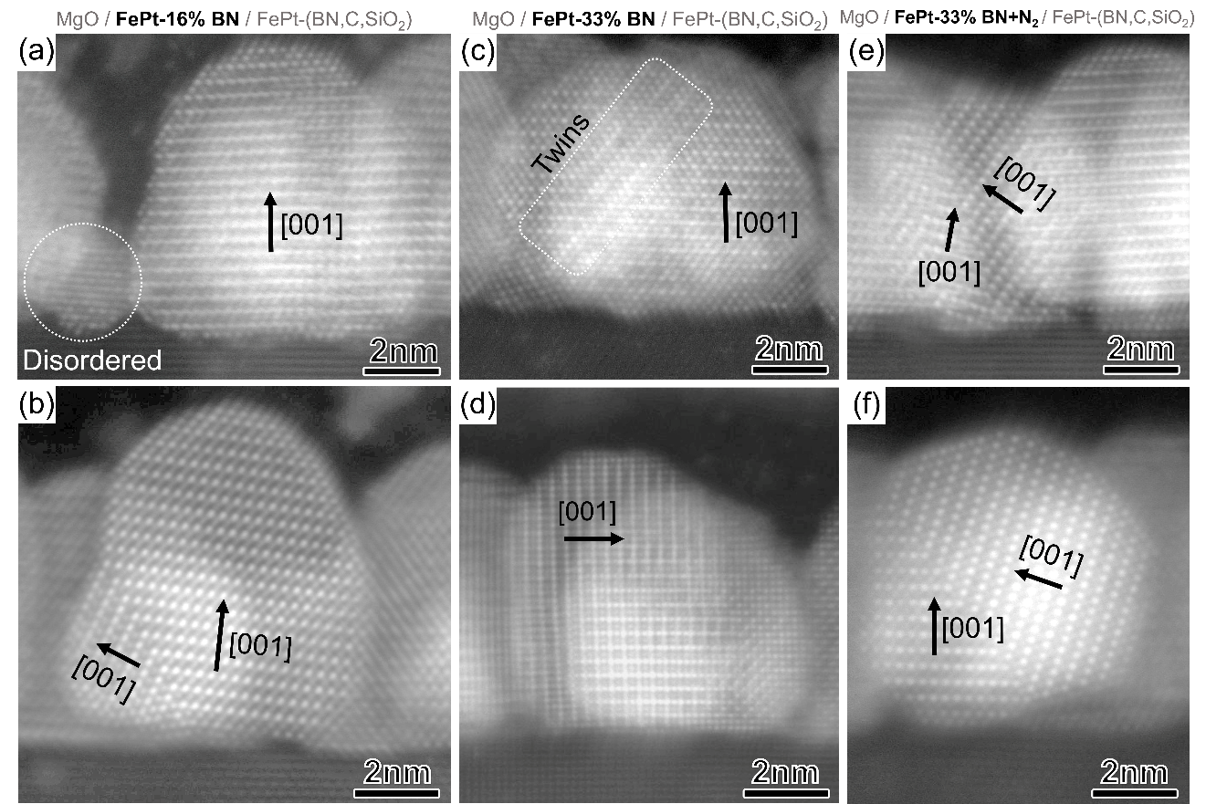
Figure 4. High resolution HAADF-STEM images obtained from L1₀-FePt grains deposited on nucleation layers of (a,b) FePt-16 vol.% BN, (c,d) FePt-33 vol.% BN, and (e,f) FePt-33 vol.% BN+N₂.
The addition of BN as a segregant in the nucleation layer resulted in a reduction of average grain size from 7 nm to ~6.2 nm in the FePt-(BN,C,SiO₂) recording layer. The use of N₂ in combination with BN suppresses the bimodal distribution of FePt grain size in the recording layer. However, the addition of BN increases the volume fraction of {111} misoriented FePt grains. This grain misalignment originates from the formation of crystallographic twins, and it has been reported that twinning occurs during the A1 → L1₀ ordering because of the distortion caused by the cubic to tetragonal phase transformation [37-40]. As shown in Figure 2, the nucleation layer becomes partially amorphous upon the addition of BN as a segregant. During the phase transition from the amorphous or A1 phase to the L1₀-ordered FePt, which is accompanied by twinning, {111} misaligned variants form (Figure S1, Supplementary material). The formation of amorphous FePt is attributed to the dissolution of boron, which is a glass-forming element for FePt [41,42]. Although the nucleation layers for the 33 vol.% addition of BN and BN+N₂ both are amorphous, the introduction of N₂ gas during the early growth of the film can minimize the dissolution of B into the FePt grains because the increased partial pressure of nitrogen induces the formation of BN as a segregant, which is confirmed by electron energy loss spectroscopy (EELS) results (Figure S2, Supplementary material). Twinning occurs when A1 transforms into L1₀ without variant selection; therefore, if FePt grains are crystalline from the nucleation stage, twinning is not expected on the MgO underlayer, because the compressive strain between FePt/MgO induces single variant growth for L1₀ ordering.

3.5. Micromagnetic Simulations for a Single FePt Grain
We address how the twined grains deteriorate the magnetic properties of the FePt-(BN,C,SiO₂) films, in particular the switching field distribution, using micromagnetic simulations. First, we consider a simplified model – an isolated spherical grain of FePt with a diameter of 7 nm. A {111} twin plane is introduced in the grain, as shown in Figure 5a, and its z-location is varied by passing the full range of volume fractions for the misaligned part (${V_{111}}/V$). Easy magnetization axis of the variant (EA_{tw}) was prescribed as mirror reflection of those of the grain (EA) from {111} plane. The obtained demagnetization curves for the out-of-plane direction (H || [001]) are shown in Figure 5b. The magnetic anisotropy constant was 2.44 MJ/m³. Out-of-plane M(H) curve changed remarkably with an increase in the misaligned volume fraction, i.e., coercivity, remanence and squareness decrease drastically. Let us note that reversal can occur with a kink in the demagnetization curve that is observed for ${V_{111}}/V=0.63$ in Figure 5b. The nonmonotonic dependence of coercivity on ${V_{111}}/V$ with a minimum at 0.72 is shown in the inset. In real FePt granular films, one can expect mostly the random formation of {111} twin planes, which results in a distribution of volume fractions for the misaligned parts of grains. Therefore, as the next step, we extended our investigation of the effect of twinned grains to a granular media.
Figure 5. (a) Schematic of a grain with easy magnetization axes for its misaligned part (EA_{tw}) attributed to the {111} twin plane and for the rest volume (EA). (b) Simulated out-of-plane demagnetization curves (H || [001]) of a spherical isolated grain with varied volume fraction of the {111} twinning variant. Dependence of coercivity on the volume fraction is indicated in the inset. (c) Top-view construction of a micromagnetic model based on TEM image (i): its binarization (ii) and segmentation with further processing into finite elements (iii). (d) Side-view on the model, where different colors indicate individual grains and their twined parts. Simulated out-of-plane and in-plane hysteresis loops of FePt granular media obtained for different volume fractions of (e) {111} and (f) [200] misalignment of grains. (g) Switching field distributions for the FePt media without any misaligned volumes and with 15 vol.% of either {111} or [200] misalignment.

3.6. Micromagnetic Simulations for FePt Granular Media
A multigrain model was developed based on the real microstructure of granular media. First, the most representative plane-view TEM image with an area of 250 × 250 nm² was chosen and binarized (Figure 5c; (i) and (ii) superimposed insets). Image segmentation was performed to extract the contours of individual grains that were then approximated by polygons (Figure 5c; (iii)). The smallest grains with an effective size $D_{eff}=\sqrt{{4A}/π}<3 nm$, where A denotes the area of a grain contour, were excluded from further processing to omit the problem of their meshing and the uncertainty of their real height. Second, cross-sectional HAADF-STEM images were used to digitize a set of profiles of grains and to perform their approximation using Bezier curves (Figure S3, Supplementary material). Also, these images allowed us to estimate the mean height of grains as 7.4 nm and its standard deviation (SD) of 0.6 nm. A slight randomization of the parameters of Bezier curves was implemented to imitate a variation in the profile shape of the grains. In the last step, these profiles were used as guiding lines for the curvilinear extrusion of the top-view contours of grains that provides their final 3D geometry (Figure S4, Supplementary material). The model created in this manner contained 1088 grains. A small part of the developed model is shown in Figure 5c(iii) and 5d from different viewpoints. Based on the microstructural investigations, we introduced small random inclinations of the [001] axes with respect to the OOP direction controlled by a standard deviation θ_{sd} and {111} twin planes for some grains. As shown in Figure 5a; both z-location of {111} twin plane and its azimuthal orientation prescribed by the normal N were random; one of the twined grains is marked in Figure 5d.
The results of micromagnetic simulations for the developed model of the FePt granular media are shown in Figure 5e-h. For these simulations, the mean magnetic anisotropy constant K_{m} was set to 2.44 MJ/m³ with a reduced standard deviation K_{sd} of 5%, and EAs were inclined with θ_{sd} = 5°. The listed parameters provided the simulated OOP coercivity and the shape of M(H) in the third quadrant similar to those in the experiments. Figure 5e demonstrates how the volume fraction of the {111} misalignment ($V_{111}$) affects the out-of-plane and in-plane hysteresis loops. The simulated M(H) in the second quadrant is very similar to the experimental measurements (Fig. 1). The switching field distribution degrades progressively with an increase in $V_{111}$, which is demonstrated in Figure 5h, where the switching field distributions are obtained straightforwardly as fields corresponding to ${dM}/{dH}$ maximum on the hysteresis loops of individual grains. An increase in the number of grains with reduced switching fields is observed. Since the existence of [200] misaligned grains is revealed by TEM and XRD, the effect of such misalignment on hysteresis loops is examined separately (Fig. 5f). In this case, the full volume of some grains had [200] misalignment with [001] (EA) oriented randomly within the plane. For the OOP hysteresis loops, the increase in the volume fraction of [200] misalignment ($V_{200}$) led to a remanence decrease with a maintained switching field distribution, and this implies the enhancement of the reversible magnetization reversal. The [200] misalignment increases the remanence and coercivity of the in-plane hysteresis loops, which results in a wider opening of the loops compared to the {111} misalignment. Therefore, increases in $V_{111}$ and $V_{200}$ both enhance the in-plane component of the magnetization in the FePt granular media, whereas the [200] misaligned grains have more adverse effects. Hence, the elimination of both $V_{111}$ and $V_{200}$ is necessary to minimize the in-plane component of magnetization, and this leads to an increase in the signal-to-noise ratio in the heat-assisted magnetic recording.

3.7. Micromagnetic Approximation of Hysteresis Loops
The developed realistic TEM-based model of FePt granular media enable us to conduct a direct micromagnetic approximation of the experimental hysteresis loops. For that one additional feature is added besides the previously described {111} twinning and [200] misaligned grains. For the smallest grains, a zero magnetic anisotropy constant is prescribed in the model, and the number of such grains is controlled by the volume fraction $V_{K=0}$. First, this considers the fact that in real FePt media, there are some small grains with size D < 3 nm that do not maintain L1₀ ordering, and therefore, their magnetic anisotropy is low [25]. These grains are clearly observed in Figure 3. The approximation of experimental M_{exp}(H) curves was realized using the grid search approach with the following parameters: mean magnetic anisotropy constant K_{m}, its reduced standard deviation K_{sd}, standard deviation θ_{sd} of the easy magnetization axis inclination angle from the out-of-plane orientation, volume fractions $V_{111}$, $V_{200}$, and $V_{K=0}$. For N points of M_{exp}(H), the minimum of the following function was considered:
$ε=\sqrt{\sum_{i}^{N}{\frac{{\left(M_{exp}^{(i)}-M_{sim}^{(i)}\right)}^{2}}{NM_{s}^{2}}},}$ (1)
where the magnetizations of the simulated curve M_{sim}(H) were interpolated to the experimental magnetic fields. Although the grid search is time consuming, it is robust and can reveal multiple local minima of ε. Figure 6 shows the experimental out-of-plane magnetization curves and their micromagnetic approximations for FePt-(BN,C,SiO₂) films deposited on the nucleation layer of (a) FePt, (b) FePt-16% BN, (c) FePt-33% BN, and (d) FePt-33% BN+N₂. An example of a grid search varying $V_{111}$ and $V_{K=0}$ with fixed rest parameters is shown in the inset of Figure 6a for the corresponding sample. A high accuracy of approximation was achieved with a magnetization discrepancy of 2–4% only. The evaluated magnetic and microstructural parameters are listed in Table 2. The mean magnetic anisotropy of the film with the FePt nucleation layer was found to be of 2.49 MJ/m³. Assuming the relation $K=K_{L10}S^{2}$ [43], the anisotropy constant 3.22 MJ/m³ can be expected with S = 0.78 obtained from the XRD. The reduction by 23% of the value provided by the micromagnetic approximation can be attributed to the thermal agitations of magnetization that decrease OOP coercivity. With an addition of BN as a segregant, K_{m} tends to decrease to 2.12 MJ/m³ for 33 vol.%. Given that the ordering parameter is comparable for all samples (Table 1), this reduction can be associated with the dissolution of B into FePt grains, as indicated by EELS. The usage of N₂ during the nucleation layer growth helps to recover the magnetic anisotropy to 2.23 MJ/m³. The standard deviations K_{sd} and θ_{sd} for films with a nucleation layer of FePt and FePt-16% BN were similar at 15% and 5°, respectively. With 33 vol.% of the BN, they increased to 20% and 10°, and then, with N₂, they were suppressed back to 15% and 5°. The evaluated volume fractions of the {111} misaligned grains were 8, 11, 20, and 12 vol.% for films with FePt, FePt-16% BN, FePt-33% BN, and FePt-33% BN+N₂ nucleation layers. These results are in good agreement with the XRD results (Table 1), which confirms the benefit of N₂ in suppressing the {111} misalignment of grains. However, in contrast to XRD data, only for the film with FePt-16% BN nucleation layer, the 2 vol. % of [200] misaligned grains was proposed by approximation. This film had the highest M(H) slope in the first quadrant. Thus, measurements up to a higher magnetic field are preferable for more reliable determination of $V_{200}$. The variation in the $V_{K=0}$ volume fraction among the films is remarkable. Micromagnetic simulations show that, with the addition of BN, $V_{K=0}$ increases from 4 vol.% to 9 vol.% when BN reaches 33 vol.%. The histograms in Figure 3 can provide the estimation of the volume fraction of grains with small size D < 3 nm using D³-weighted summation. They yield approximately 1 vol.% for all samples except the one with the FePt-33% BN+N₂ nucleation layer. Hence, the increase in $V_{K=0}$ indicates that the grain size threshold when L1₀ can be maintained was shifted toward larger values with the addition of BN and related dissolution of B into the FePt grains. The use of N₂ substantially decreased $V_{K=0}$ to 3 vol.%. Note that the volume fraction of grains is more relevant quantity for the analysis of magnetic properties than the simple fraction of grains based on diameters.
Table 2. Magnetic and microstructural parameters evaluated by micromagnetic approximation of hysteresis loops of FePt-(BN,C,SiO₂) films deposited on different nucleation layers. The parameters are mean magnetic anisotropy constant $K_{m}$, its reduced standard deviation $K_{sd},$ standard deviation $θ_{sd}$ of the easy magnetization axis inclination angle from the out-of-plane orientation, volume fractions of {111} and [200] misaligned grains $V_{111}$ and $V_{200}$ respectively, and volume fraction of small grains $V_{K=0}$ that have a zero magnetic anisotropy constant ($K_{m}=0$).
Nucleation layer | $$K_{m}$$  [MJ/m³] | $$K_{sd}$$[%] | $$θ_{sd}$$[deg.] | $$V_{111}$$[vol.%] | $$V_{200}$$[vol.%] | $$V_{K=0}$$[vol.%]
FePt | 2.49 | 15 | 5 | 8 | 0 | 4
FePt-16 vol.% BN | 2.33 | 15 | 5 | 11 | 2 | 5
FePt-33 vol.% BN | 2.12 | 20 | 10 | 20 | 0 | 9
FePt-33 vol.% BN+N₂ | 2.23 | 15 | 5 | 12 | 0 | 3

The kink on M_{sim}(H) near the remanence caused by grains with $K_{m}=0$ is especially remarkable in Figure 6c. In real FePt-X HAMR media, one can expect that small grains have a distribution of K_{m} correlated with the corresponding peak in the bimodal grain size distribution. Thus, the normal distribution $\left(0,K_{sd}^{(0)}\right)$ can be used as an option to further improve the approximation. However, in this work, we consider only the case of $K_{m}=0$ for simplicity. Finally, we emphasize the sensitivity of the micromagnetic approximation to volume fractions $V_{111}$, $V_{200}$, and $V_{K=0}$. With appropriate and accurate TEM-based micromagnetic models, their magnetometry-based estimation can be fast and reliable to accelerate the characterization of FePt granular films.
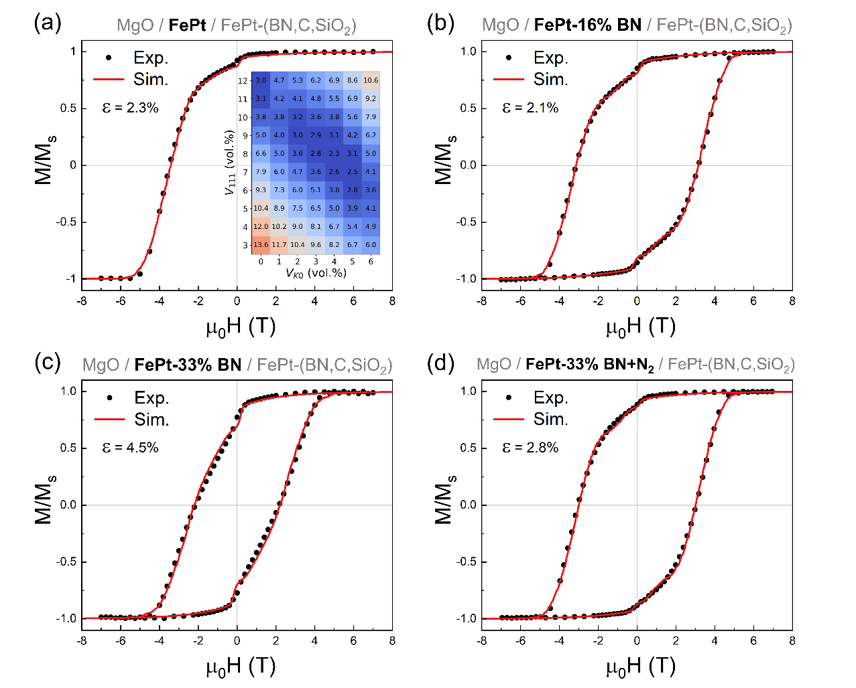
Figure 6. Experimental out-of-plane magnetization curves (dots) and their micromagnetic approximations (solid lines) for FePt films deposited on a 1-nm-thick nucleation layer of (a) FePt, (b) FePt-16 vol.% BN, (c) FePt-33 vol.% BN, and (d) FePt-33 vol.% BN+N₂. The discrepancy between the experimental and simulated M(H) curves is characterized by a mean squared deviation ε (Equation 1). A grid search for volume fractions $V_{111}$ and $V_{K=0}$ providing the minimal ε with fixed rest parameters is shown in the inset of (a).

4. Conclusion
This work has demonstrated a new TEM image based micromagnetic approach for structural optimization of FePt-X heat-assisted magnetic recording media. Its key concept is to construct a finite element model that replicates the nanostructure of granular media based on high-resolution transmission electron microscopy images. The approach enables the evaluation of micromagnetic parameters and the volume fractions of defects in FePt grains by the precise micromagnetic approximation of experimental hysteresis loops. This method was applied to MgO(6 nm)/FePt-BN(1 nm)/FePt-(BN,C,SiO₂)(7 nm) granular thin films, for which the micromagnetic approximation yielded the volume fractions of {111} twins and [200] misaligned grains, which are in excellent agreement with those determined by synchrotron XRD. The estimation and control of the {111} and [200] defects are critical for designing HAMR media due to their detrimental effect on the in-plane component and switching field distribution. Such a microstructure control is achieved by tuning the amount of BN segregant in the nucleation layer deposited in N₂ atmosphere that results in minimizing the volume fractions of the defects and the unimodal grain size distribution in the FePt-(BN,C,SiO₂) recording layer.
The demonstrated TEM image based micromagnetic modelling is an efficient method to evaluate structural defects in nanostructured magnetic materials, enabling high-throughput optimization of the FePt-X media for HAMR. Moreover, the proposed approach can be expanded to any other nanostructured magnetic systems.

Acknowledgements
This work was in-part supported by JSPS KAKENHI Grant Numbers JP19K05257 and JP18H03787.

References
[1] H.J. Richter, The transition from longitudinal to perpendicular recording, J. Phys. D: Appl. Phys. 40 (2007) R149–R177.
[2] D. Weller, O. Mosendz, G. Parker, S. Pisana, T.S. Santos, L1₀ FePtX-Y media for heat-assisted magnetic recording, Phys. Status Solidi A 210 (2013) 1245–1260.
[3] D. Weller, G. Parker, O. Mosendz, E. Champion, B. Stipe, X. Wang, T. Klemmer, G. Ju, A. Ajan, A HAMR media technology roadmap to an areal density of 4Tb/in², IEEE Trans. Magn. 50 (2014) 3100108.
[4] K. Hono, Y.K. Takahashi, G. Ju, J.U. Thiele, A. Ajan, X. Yang, R. Ruiz, L. Wan, Heat-assisted magnetic recording media materials, MRS Bull. 43 (2018) 93–99.
[5] D. Weller, G. Parker, O. Mosendz, A. Lyberatos, D. Mitin, N.Y. Safonova, M. Albrecht, FePt heat assisted magnetic recording media, J. Vac. Sci. Technol. B. 34 (2016) 060801.
[6] H. Sepehri-Amin, H. Iwama, G. Hrkac, K.T. Butler, T. Shima, K. Hono, Pt surface segregation in L1₀-FePt nano-grains, Scripta Mater. 135 (2017) 88–91.
[7] H. Sepehri-Amin, H. Iwama, T. Ohkubo, T. Shima, K. Hono, Microstructure and in-plane component of L1₀-FePt films deposited on MgO and MgAl₂O₄ substrates, Scripta Mater. 130 (2017) 247–251.
[8] I. Suzuki, S. Kubo, H. Sepehri-Amin, Y.K. Takahashi, Dependence of the growth mode in epitaxial FePt films on surface free energy, ACS Appl. Mater. Interfaces 13 (2021) 16620–16627.
[9] H. Sepehri-Amin, M. Nagano, T. Seki, H. Ho, D. Tripathy, S. Pirzada, K. Srinivasan, H. Yuan, P. Dorsey, A. Ajan, K. Hono, Microstructure and magnetic properties of FePt-(C, SiO₂) granular films deposited on MgO, MgTiO, and MgTiON underlayers, Scripta Mater. 157 (2018) 1–5.
[10] A. Perumal, Y.K. Takahashi, K. Hono, L1₀ FePt-C nanogranular perpendicular anisotropy films with narrow size distribution, Appl. Phys. Express. 1 (2008) 101301.
[11] L. Zhang, Y.K. Takahashi, A. Perumal, K. Hono, L1₀-ordered high coercivity (FePt)Ag–C granular thin films for perpendicular recording, J. Magn. Magn. Mater. 322 (2010) 2658–2664.
[12] B.C.S. Varaprasad, Y.K. Takahashi, J. Wang, T. Ina, T. Nakamura, W. Ueno, K. Nitta, T. Uruga, K. Hono, Mechanism of coercivity enhancement by Ag addition in FePt–C granular films for heat assisted magnetic recording media, Appl. Phys. Lett. 104 (2014) 222403.
[13] J. Wang, S. Hata, Y.K. Takahashi, H. Sepehri-Amin, B.C.S. Varaprasad, T. Shiroyama, T. Schrefl, K. Hono, Effect of MgO underlayer misorientation on the texture and magnetic property of FePt-C granular film, Acta Mater. 91 (2015) 41–49.
[14] H. Pandey, J. Wang, T. Shiroyama, B.C.S. Varaprasad, H. Sepehri-Amin, Y.K. Takahashi, A. Perumal, K. Hono, Structure optimization of FePt–C nanogranular films for heat-assisted magnetic recording media, IEEE Trans. Magn. 52 (2015) 1–8.
[15] O. Mosendz, S. Pisana, J.W. Reiner, B. Stipe, D. Weller, Ultra-high coercivity small-grain FePt media for thermally assisted recording, J. Appl. Phys. 111 (2012) 07B729.
[16] B. Zhou, B.S.D.C.S. Varaprasad, E. Zhang, D.E. Laughlin, J.G. Zhu, Microstructure analysis on size distribution during film growth in HAMR media, IEEE Trans. Magn. 54 (2018) 1–4.
[17] J. Wang, H. Sepehri-Amin, Y.K. Takahashi, T. Ohkubo, K. Hono, Magnetic in-plane components of FePt nanogranular film on polycrystalline MgO underlayer for heat-assisted magnetic recording media, Acta Mater. 177 (2019) 1–8.
[18] S.D. Granz, K. Barmak, M.H. Kryder, Granular L1₀ FePt: X (X = Ag, B, C, SiO_{x}, TaO_{x}) thin films for heat assisted magnetic recording, Eur. Phys. J. B. 86 (2013) 1–7.
[19] C.P. Luo, D.J. Sellmyer, Structural and magnetic properties of FePt:SiO₂ granular thin films, Appl. Phys. Lett. 75 (1999) 3162–3164.
[20] A.C. Sun, J.H. Hsu, P.C. Kuo, H.L. Huang, Microstructural and magnetic studies of L1₀ FePt–SiO₂ nano-composite thin film with columnar structure for perpendicular magnetic recording, J. Magn. Magn. Mater. 320 (2008) 3071–3074.
[21] Y.F. Ding, J.S. Chen, B.C. Lim, J.F. Hu, B. Liu, G. Ju, Granular L1₀ FePt:TiO₂ (001) nanocomposite thin films with 5 nm grains for high density magnetic recording, Appl. Phys. Lett. 93 (2008) 032506.
[22] J. A. Christodoulides, P. Farber, M. Dannl, H. Okumura, G.C. Hadjipanayis, V. Skumryev, A. Simopoulos, D. Weller, Magnetic, structural and microstructural properties of FePt/M (M = C, BN) granular films, IEEE Trans. Magn. 37 (2001) 1292–1294.
[23] M. Daniil, P. A. Farber, H. Okumura, G.C. Hadjipanayis, D. Weller, FePt/BN granular films for high-density recording media, J. Magn. Magn. Mater. 246 (2002) 297–302.
[24] B.C.S. Varaprasad, M. Chen, Y.K. Takahashi, K. Hono, L1₀-ordered FePt-based perpendicular magnetic recording media for heat-assisted magnetic recording, IEEE Trans. Magn. 49 (2013) 718–722.
[25] Y.K. Takahashi, T. Koyama, M. Ohnuma, T. Ohkubo, K. Hono, Size dependence of ordering in FePt nanoparticles, J. Appl. Phys. 95 (2004) 2690–2696.
[26] I. Suzuki, J. Wang, Y.K. Takahashi, K. Hono, Control of grain density in FePt-C granular thin films during initial growth, J. Magn. Magn. Mater. 500 (2020) 166418.
[27] O. Sakata, Y. Furukawa, S. Goto, T. Mochizuki, T. Uruga, K. Takeshita, H. Ohashi, T. Ohata, T. Matsushita, S. Takahashi, H. Tajiri, T. Ishikawa, M. Nakamura, M. Ito, K. Sumitani, T. Takahashi, T. Shimura, A. Saito, M. Takahasi, Beamline for surface and interface structures at SPring-8, Surf. Rev. Lett. 10 (2003) 543–547.
[28] H. Tajiri, H. Yamazaki, H. Ohashi, S. Goto, O. Sakata, T. Ishikawa, A middle energy-bandwidth X-ray monochromator for high-flux synchrotron diffraction: revisiting asymmetrically cut silicon crystals, J. Synchrotron Rad. 26 (2019) 750–755.
[29] B.D. Cullity, S.R. Stock, Elements of X-Ray diffraction, Prentice-Hall, New York, 2001.
[30] E. Yang, D.E. Laughlin, J.G. Zhu, Correction of order parameter calculations for FePt perpendicular thin films, IEEE Trans. Magn. 48 (2012) 7–12.
[31] T.W. Huang, T.H. Tu, Y.H. Huang, C.H. Lee, C.M. Lin, X-Ray scattering absorption spectroscopy study of the order-disorder transition of (FePt)_{1-x}Cu_{x} nanoparticles, IEEE Trans. Magn. 41 (2005) 941–943.
[32] S.D. Granz, M.H. Kryder, Granular L1₀ FePt (001) thin films for heat assisted magnetic recording, J. Magn. Magn. Mater. 324 (2012) 287–294.
[33] C. Geuzaine, J.F. Remacle, Gmsh: a 3‐D finite element mesh generator with built‐in pre‐ and post‐processing facilities, Int. J. Numerical Methods Eng. 79 (2009) 1309–1331.
[34] S. Wicht, V. Neu, L. Schultz, D. Weller, O. Mosendz, G. Parker, S. Pisana, B. Rellinghaus, Atomic resolution structure–property relation in highly anisotropic granular FePt–C films with near-Stoner-Wohlfarth behaviour, J. Appl. Phys. 114 (2013) 063906.
[35] T. Schrefl, J. Fidler, Micromagnetic simulation of magnetizability of nanocomposite Nd–Fe–B magnets, J. Appl. Phys. 83 (1998) 6262–6264.
[36] R. Chang, S. Li, M. V. Lubarda, B. Livshitz, V. Lomakin, FastMag: fast micromagnetic simulator for complex magnetic structures, J. Appl. Phys. 109 (2011) 07D358.
[37] I. Baele, G. Van Tendeloo, S. Amelinckx, Microtwinning in Ni-Mn resulting from the β-θ martensitic transformation, Acta Metall. 35 (1987) 401–412.
[38] Q.F. Xiao, E. Brück, Z.D. Zhang, F.R. De Boer, K.H.J. Buschow, Phase transformation and magnetic properties of bulk CoPt alloy, J. All. Comp. 364 (2004) 64–71.
[39] Y.U. Heo, H.C. Lee, The twin and twin system in FCT L1₀ θ-MnNi phase in an equiatomic Mn-Ni alloy, Mater. Trans. 48 (2007) 2546–2550.
[40] Z.R. Dai, S. Sun, Z.L. Wang, Phase transformation, coalescence, and twinning of monodisperse FePt nanocrystals, Nano Lett. 1 (2001) 443–447.
[41] A. Inoue, W. Zhang, Nanocrystalline Fe-Pt-B base hard magnets with high coercive force obtained from amorphous precursor, J. Appl. Phys. 97 (2005) 10H308.
[42] G.M. Choi, B.C. Min, K.H. Shin, L1₀ ordering of FePtB films on a thin MgO layer, Appl. Phys. Express 4 (2011) 023001.
[43] Y. Kota, A. Sakuma, Relationship between magnetocrystalline anisotropy and orbital magnetic moment in L1₀-type ordered and disordered alloys, J. Phys. Soc. Japan. 81 (2012) 084705.
Supplementary Materials
Transmission electron microscopy image based micromagnetic simulations for optimizing nanostructure of FePt-X heat-assisted magnetic recording media
Anton Bolyachkin, Hossein Sepehri-Amin*, Ippei Suzuki, Hiroo Tajiri, Yukiko Takahashi, Kumar Srinivasan, Hoan Ho, Hua Yuan, Tomoko Seki, Antony Ajan, and Kazuhiro Hono

Figure S1. Schematic of twin formation during L1₀ ordering from amorphous and/or disordered FePt grains.

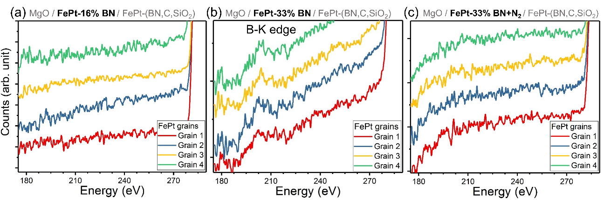
Figure S2. Electron energy loss spectra obtained from four different L1₀-FePt grains with a thickness of 8 nm deposited on different nucleation layers of a) FePt-16 vol.% BN, b) FePt-33 vol.% BN, and c) FePt-33 vol.% BN+N₂.

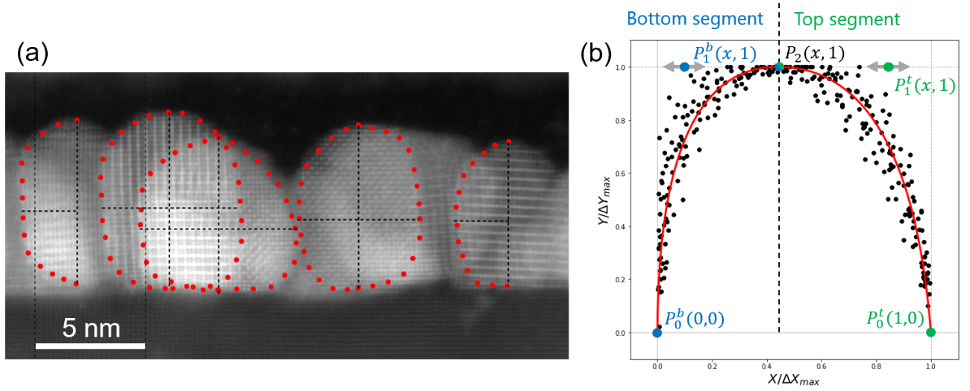
Figure S3. (a) High resolution cross-sectional HAADF-STEM image obtained from MgO/FePt-BN/FePt-(BN,C,SiO₂) granular thin film with digitization of grain profiles marked by red points. (b) Collected profiles of grains in normalized coordinates and their approximation by two quadratic Bezier curves which control points are noted.

A series of cross-sectional HAADF-STEM images obtained from MgO/FePt-BN/FePt-(BN,C,SiO₂) granular thin films were used to evaluate the shape of grains. First, profiles of individual grains were digitized, an example is shown in Figure S3a. For further processing only one-side segment of the grain profile was needed. Thus, some grains provided two profiles that were used independently, for others only one profile was digitized (Fig. S3a). This yielded in 22 profiles in total which are shown as the cloud of points in reduced coordinates in Figure 3Sb. Note that axes in the figure are rotated, so x-axis corresponds to the out-of-plane direction of the film. At the next step, the cloud of point was approximated with two quadratic Bezier curves, which can be described parametrically as:
$$B_{b,t}\left(t\right)=P_{1}^{b,t}+{\left(1-t\right)}^{2}\left(P_{0}^{b,t}-P_{1}^{b,t}\right)+t^{2}(P_{2}-P_{1}^{b,t})$$
where $P_{0,1,2}^{b,t}$ are control points of the Bezier curves and $0≤t≤1$. One Bezier curve was responsible for the bottom part of a grain, another – for the top one. $P_{0}^{b,t}$ points were fixed at (0,0) and (1,0) while $P_{1,2}^{b,t}$ had y coordinates fixed at 1. Thus, x coordinates of $P_{1,2}^{b,t}$points were used as parameters for approximation that was realized using gradient descent in combination with interpolation. Result of the approximation is shown with red line in Figure 3Sb. Finally, the parameters of approximated Bezier curves were slightly randomized for individual grains that resulted in individual profiles which variation replicated the spread of points in the cloud in Figure 3Sb. The variation of grain profiles can be seen in Figure 5d.
Bezier profiles were used in combination with top-view polygonal contours of grains to construct their final 3D volumes. Main steps of this process are realized in Gmesh as shown schematically in Figure S4.
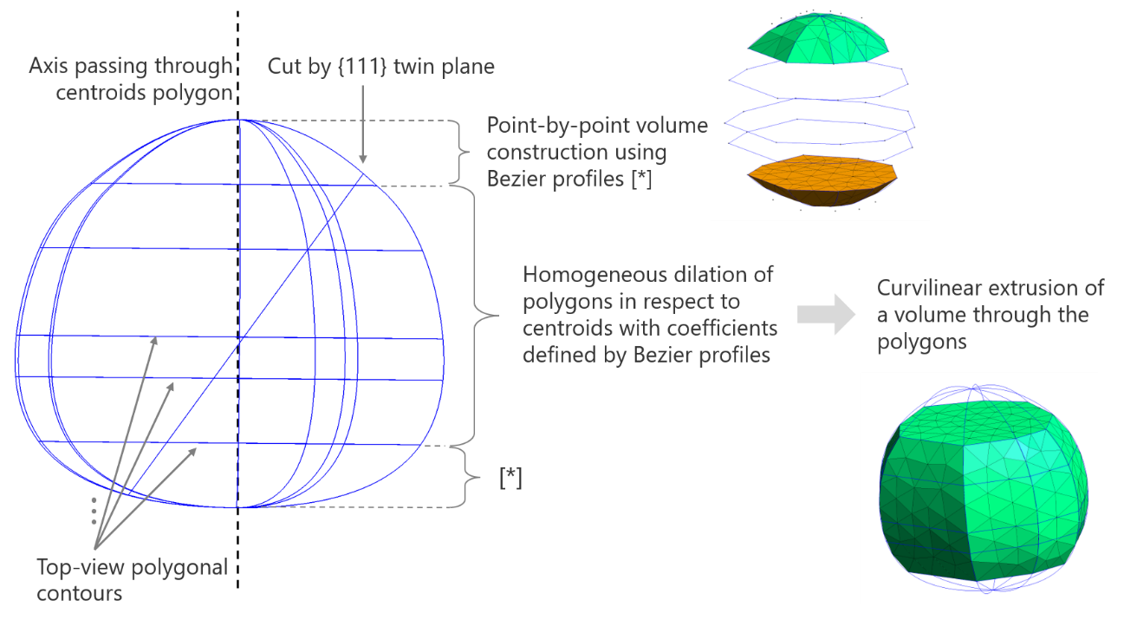
Figure S4. The procedure of constructing 3D volume for a grain described schematically.

