-Paper-

GREEN RUST-BASED CATALYSTS FOR AMMONIA BORANE DEHYDROGENATION.

Ezz-Elregal M. Ezz-Elregal^{a,b,c}, Makoto Oishi^{d}, Takuro Nagai^{d}, Yusuke Ide^{a,b,*}

ª Research Centre for Materials Nanoarchitectonics (WPI-MANA), National institute for Materials Science (NIMS), 1-1 Namiki, Tsukuba, Ibaraki, 305-0044, Japan.
^{b} Graduate School of Engineering Science, Yokohama National University, 79-5 Tokiwadai, Hodogaya-ku, Yokohama, 240-8501, Japan.
^{c} Chemistry Department, Faculty of Science, Ain Shams University, Abbassia, Cairo 11566, Egypt.
^{d} Research Network and Facility Services Division, National institute for Materials Science (NIMS), 1-1 Namiki, Tsukuba, Ibaraki, 305-0044, Japan.

*Corresponding author: Yusuke Ide, Graduate School of Engineering Science, Yokohama
National University, 79-5 Tokiwadai, Hodogaya-ku, Yokohama, 240-8501, Japan. e-mail: ide.yusuke@nims.go.jp

ABSTRACT
Green rust (GR), a Fe²⁺/Fe³⁺-layered double hydroxide (LDH), was thought to be extremely unstable toward oxidation and thus less well studied as catalysts and their supports than many other LDHs. Here, the modification of a [Fe²⁺-Fe³⁺] mixed valent iron hydroxide, that we term GR, with Cu species and application of the Cu-modified GR as the catalyst for the hydrolysis of ammonia borane (AB) was described. From spectroscopic and microscopic analyses, the Cu-modified GR was composed of plate-like GR particles decorated with Cu₂O clusters and nanoparticles on the particles’ surfaces and edges. The Cu-modified GR, synthesized via the modification of ball-milled GR with Cu₂O species, exhibited an excellent H₂ evolution rate and amount at room temperature under solar simulator irradiation that was faster and larger, respectively, than Pt nanoparticle-supported and Cu-modified TiO₂. Control catalytic tests without solar simulator irradiation and an action spectrum study suggested that the Cu-modified GR showed light-assisted catalysis toward AB hydrolysis thanks to Cu₂O modifiers.

Keywords: Green rust, Layered double hydroxide, Copper, Ammonia borane, Hydrogen storage material

INTRODUCTION

Layered double hydroxides (LDHs), first identified in 1842 by a geologist (C. Hochstetter, 1842), have recently attracted widespread interest in catalysts and their supports and precursors, mainly due to their rich versatility in compositions. LDHs consist of brucite-like layers incorporating divalent/trivalent metal cations and interlayer anions; the general formula is described as [M(II)_{1-x} M(III)_{x}(OH)₂]^{x+} [A^{n−}]_{x/n}·mH₂O, where M(II) (Ni²⁺, Co²⁺, Fe²⁺, Mn²⁺, Cu²⁺, Mg²⁺ etc) and M(III) (Fe³⁺, Co³⁺, Al³⁺, Mn³⁺, Cr³⁺, Ga³⁺ etc) are framework cations and Aⁿ⁻ (CO₃²⁻, NO₃⁻, Cl⁻ etc) and mH₂O are interlayer anions and water molecules, respectively (Miyata, 1983; Evans and Slade, 2005; Forano et al., 2006). This versatility of the compositions has enabled to tune the physicochemical characteristics useful for catalyst design (Evans and Slade, 2005; Forano et al., 2006; Cai et al., 2019).

A particularly interesting subclass of LDHs is Fe²⁺/Fe³⁺-LDH called green rust (GR). GR is rarely found in nature due to its instability toward oxidation. The synthetic GR is also immediately oxidized to stable phases like magnetite when exposed to air, which limits its broader applicability (Poincare et al., 2007; Feder et al., 2018). Thus, systematic studies exploring its catalytic potential remain limited. Nevertheless, GR, due to its Fe²⁺/Fe³⁺ properties, has been investigated as a catalyst for several reactions like Fenton-like reactions for the degradation of organic pollutants. For example, GR(Cl⁻ interlayer anion) showed a significantly higher catalytic activity in the degradation of phenol in water than GR(CO₃²⁻), GR(SO₄²⁻), and another [Fe²⁺-Fe³⁺] mixed valent iron compound, magnetite, attributed to its higher Fe²⁺/Fe³⁺ ratio of 3:1 (Hanna et al., 2010). GR has also been used to oxidize 2,4,6-trinitrotoluene in water, achieving a higher initial reaction rate (38%) than magnetite (24%) (Matta et al., 2008b). The catalytic efficiency of GR is largely due to its abundant Fe(II) content, which facilitates the generation of hydroxyl radicals (.OH) in the presence of H₂O₂. Despite these advantages, GR suffers from significant drawbacks in Fenton-like systems, including rapid oxidative degradation into ferric phases (e.g., ferrihydrite, lepidocrocite) when exposed to H₂O₂, limiting the reusability and shortening the catalytic lifetime (Matta et al., 2008b). Moreover, compared to magnetite, the use of GR in other reactions, like advanced oxidation processes, remains underexplored (Matta et al., 2008a, 2008b; Usman et al., 2018a).

Recently, we developed a [Fe²⁺-Fe³⁺] mixed valent iron compound with high stability toward oxidation in air, that we can term GR from comprehensive analyses (Tahawy et al., 2021; Zaki et al., 2023). Importantly, they showed the light-assisted catalysis toward the hydrolysis of ammonia borane (AB) to release H₂;

NH₃BH₃ + 2H₂O(l) → NH₄BO₂ + 3H₂ (g) (1)

AB is considered a highly promising hydrogen storage material due to its high hydrogen content (19.6 wt%), chemical stability, and composition of light, non-toxic elements (N, H, B) (Yan et al., 2008; Guo et al., 2015; Rej et al., 2016; Zhang et al., 2017; Tahawy et al., 2021; Guan et al., 2023). H₂ can be released from AB at room temperature via hydrolysis (equation 1) on solid catalysts, however, many catalysts investigated were based on precious and novel metals (Aijaz et al., 2012; Verma et al., 2015, 2017; Zhang et al., 2021; Zheng et al., 2021; Kang et al., 2023) . The light-assisted catalytic activity of our GR toward AB hydrolysis was, unfortunately, lower than that of Pt nanoparticle-supported TiO₂ (Zaki et al., 2023).

More recently, we have reported that the GR modified with Cu₂O clusters shows an excellent catalytic and light-assisted catalytic activity toward the hydrolysis of another important hydrogen storage material, sodium borohydride (SBH), that is significantly higher than existing precious or novel metal-based catalysts (Ezz-Elregal et al., 2025). We demonstrated, via experiments and calculations, that the Cu₂O modifiers served as not only the adsorption site for reactants (SBH and water) but cocatalysts to transfer light-excited electrons in the GR to SBH. These results motivated us to test the Cu₂O-modified GR as catalysts toward AB hydrolysis.

MATERIALS AND METHODS.

Synthesis of green rust samples

A [Fe²⁺-Fe³⁺] mixed valent iron compound that we termed GR (named GR hereafter) was prepared via a solvothermal method reported in our previous study (Zaki et al., 2023). 7.2 g of sodium acetate trihydrate (Wako Chemicals, 99%) was thoroughly dissolved in 100 mL of glycerol (Nacalai Tesque, 99%) at 80 °C in a 250 mL glass container. To this solution, 0.95 g of FeCl₃ and 1.4 g of FeCl₂ (Sigma-Aldrich, 99% and 98%, respectively) were added at a molar ratio FeCl₃:FeCl₂ of 35:65 and the mixture was stirred at 100 °C for 1 hour. The resulting brown suspension was then transferred into a 200 mL Teflon-lined stainless-steel autoclave and heated at 200 °C for 24 hours. After the reaction, the wet green solid was collected, rinsed twice with 140 mL of an ethanol-water mixture (1:1 v/v %), washed once with 100 mL of absolute ethanol, and dried at 80 °C for 24 hours. Ball-milled GR (bGR) was prepared by treating the as-synthesized GR with a planetary ball mill (PSL-450, Ito Seisakusho, Japan) equipped with a zirconia container (80 cm³ internal volume). 2.0 g of GR powder was milled with both 11 number of zirconia balls (10 mm diameter) and 28 number of zirconia balls (5 mm diameter) at a rotation speed of 400 rpm for 30 minutes.

Modification of GR samples with Cu species

The modification of GR or bGR with Cu species was conducted through a facile impregnation method according to our previous paper (Ezz-Elregal et al., 2025). CuCl₂∙2H₂O (Nacalai tesque, 99%) was dissolved in a mixed solvent (100 mL) composed of ethanol (99%) and hexane (96%) in a 3:17 volumetric ratio. 0.2 g of GR or bGR was subsequently added into the solution, and the resulting mixture was stirred at ambient conditions for 24 hours. The product was separated by centrifugation at 3500 rpm for 15 minutes, thoroughly washed with the same mixed solvent used in the impregnation process, and finally dried at 80°C for 20 hours. The amount of the copper salt added was adjusted to regulate the Cu loading on the GR support, with the target copper concentration per GR ranging from 0.2 to 2.0 wt%. The products using GR and bGR were named Cu-GR and Cu-bGR, respectively, and the actual Cu loading amounts determined by the inductively coupled plasma optical emission spectroscopy (ICP-OES) of the dissolved products were 0.50 wt% for each unless otherwise mentioned.

Characterizations

The ⁵⁷Fe Mössbauer spectra were recorded in conventional transmission geometry at the Nagoya Institute of technology in Japan. ICP-OES was performed on an Agilent 5800 instrument. The samples were dissolved in a mixture of H₂SO₄ and HNO₃. Ultraviolet-visible (UV-vis) spectra were recorded with a JASCO V-770 spectrophotometer with an integrated sphere (ISV-722). Scanning electron microscopy (SEM) images were taken using a HITACHI-SU-8230 microscope. High-angle annular dark field-scanning transmission electron microscopy (HAADF-STEM) and transmission electron microscopy (TEM) images were taken using a Thermo Fisher Scientific Talos F200X G2 transmission electron microscope. N₂ adsorption isotherms were performed using a Quantachrome Autosorb-1 instruments. Piror to the measurements, the samples were degassed under vacuum at 100 °C for 24 hours.

AB hydrolysis

15 mg of powder sample was mixed with 5 mL of Milli-Q water containing 20 vol% glycerol in a 34 mL Pyrex glass tube. The resulting mixture was purged with Ar gas for approximately 30 minutes to remove dissolved oxygen, after which the tube was firmly sealed with a rubber septum. Subsequently, 100 μL of aqueous solution containing AB (20 μmol, Sigma-Aldrich, 98%) was introduced into the mixture via syringe through the septum. The tube was then subjected to simulated solar light irradiation (San-Ei Electric, λ > 300 nm, 1000 Wm²⁻) at 25°C under continuous stirring. The headspace gas was collected using a gastight syringe and analyzed by a Shimadzu GC-2010 gas chromatography equipped with a barrier ionization detector. Control catalytic experiments were conducted under similar conditions without light irradiation.

Action spectrum study

Apparent quantum efficiency (AQE) measurements were conducted using a Ushio 500 W Xe lamp equipped with a Bunkoukeiki SM-25 monochromator. A Pyrex glass tube containing the above mixture was exposed to monochromatic light. The quantity of the incident light was determined using a Bunkoukeiki S1337-1010BQ silicon photodiode. AQE was calculated using the following formula:
AQE (%) = 2 x number of evolved H₂ molecules / number of incident photons x 100

RESULTS AND DISCUSSION

The formation of GR with both carbonate and lactate anions in the interlayer space was confirmed in our previous studies via comprehensive characterizations and calculations including XRD, FTIR, ⁵⁷Fe Mössbauer spectroscopy and DFT (Tahawy et al., 2021; Zaki et al., 2023). The modification of GR with Cu species was also conducted according to an impregnation method reported in our previous study (Ezz-Elregal et al., 2025). Figure 1 shows the ⁵⁷Fe Mössbauer spectra of GR and Cu-GR. The hyperfine parameters obtained from the deconvoluted spectra of both GR and Cu-GR (Table 1) are in good agreement with those reported for conventional GR (Usman et al., 2018b; Tahawy et al., 2021; Zaki et al., 2023) and deviated from those of other iron oxides/hydroxides like hematite, as well as other structurally analogous mixed-valent iron compounds including mössbauerite (Génin et al., 2018; Lyu et al., 2019) and iron glycerolate (Khonina et al., 2022). These results, in addition to XRD and FTIR results (Ezz-Elregal et al., 2025), indicate that the LDH structure of GR is preserved after the Cu modification.

UV-Vis spectroscopy was employed to examine the state of Cu species in Cu-GR. As shown in Figure 2, the diffuse reflectance UV-vis spectra of GR and Cu-GR reveal the absence of prominent absorption bands typically associated with Cu⁰ species; for example, no features corresponding to the localized surface plasmon resonance around 680 nm observed for Cu⁰ nanoparticles (3-40 nm) on titania nanosheets were detected (Sasaki et al., 2016). Alongside, no absorption bands characteristic of highly dispersed Cu²⁺ ions or CuO cluster typically observed at wavelengths both between 400-450 nm and longer than 650 nm were detected (Irie et al., 2009; Naya et al., 2011; Jin et al., 2013; Liao et al., 2017). However, the Cu-GR spectrum exhibited only weak absorption at wavelength longer than 400 nm, which is reported for TiO₂ doped with Cu⁺ ions (Jin et al., 2013; Tsai et al., 2013). These observations suggest that Cu-GR likely contains highly dispersed Cu⁺ ions or Cu₂O clusters.

To verify the location and kind of Cu species in Cu-GR, SEM, HAADF-STEM and TEM analyses were conducted. As shown in the SEM image, GR is composed of well-defined plate- and belt-like particles with lateral length of up to 2 μm (Figure 3A). On the other hand, although Cu-GR is also composed of the similar-size plate- and belt-like particles (Figure 3B), these particles have uneven particle’s surfaces and edges unlike those for GR. The HAADF-STEM image of Cu-GR confirmed that particles with a size down to 0.5 nm are deposited on the particle’s edge to form the uneven surfaces (Figure 3C). From the TEM image and the selected area fast Fourier transform (FFT) pattern (Figures 3 D and E), smaller particles on the particle’s edge of GR plates were revealed to have d spacing of 0.274 nm. This value is consistent with cubic Cu₂O according to literatures (Radi et al., 2010; Zhang et al., 2019; Fuku et al., 2020; Sudha et al., 2021; Xiong et al., 2021). Therefore, we can conclude that Cu-GR is composed of GR plates whose surface and edge are modified with Cu₂O clusters and nanoparticles.

Cu-GR was used as the catalyst for AB hydrolysis. Figure 4A shows the time-course H₂ evolution from water containing 20 µmol of AB on different materials under simulated solar light irradiation. All the Cu-modified GR samples showed faster and larger H₂ evolution rate and amount, respectively, than the pristine GR. Among all the Cu-modified GR samples with different Cu loadings, Cu-GR (0.50 wt%) gave the best H₂ evolution rate and amount. Considering that Cu-GR was reused without losing the original H₂ evolution rate and amount largely (Figure 4B), it could work as a catalyst and/or photocatalyst in AB hydrolysis. However, the maximum amount of the evolved H₂ even on Cu-GR was 45 µmol, which was smaller than that (60 µmol) evolved from 20 µmol of AB via quantitative hydrolysis (Equation 1).

In our previous study, Cu-bGR showed a higher activity toward SBH hydrolysis than Cu-GR, which was explained by the larger surface area (Figure 5) and co-existing of Cu 0 and +1 states in the Cu modifier (Ezz-Elregal et al., 2025). Thus, we used Cu-bGR for AB hydrolysis. As expected, almost quantitative hydrolysis of AB occurred on Cu-bGR (Figure 6). Importantly, Cu-bGR showed a H₂ evolution rate and amount faster and larger, respectively, than TiO₂ nanoparticles (P25) modified with Cu⁺/Cu²⁺ (Ezz-Elregal et al., 2025) and Pt nanoparticle-supported P25 (Ezz-Elregal et al., 2025).

We then investigated the mechanism behind the H₂ evolution on Cu-GR (and Cu-bGR) under solar simulator irradiation. Figure 7A compares the time-course H₂ evolution on Cu-GR with and without solar light irradiation. Interestingly, even without light, Cu-GR showed a significant H₂ evolution significantly better than GR, and the H₂ evolution rate and amount were enhanced by 15% with light. These results indicate that Cu-GR shows light-enhanced catalytic activity toward AB hydrolysis. The significant activity of Cu-GR without light irradiation is a merit for the practical uses. Further development of the GR-based catalyst, via the downsizing of Cu modifiers and use of other metal modifiers, is underway in our laboratory.

We further performed the action spectrum study in AB hydrolysis on Cu-GR. As illustrated in Figure 7B, the AQE values of Cu-GR matched its photoabsorption. Given that not only the Cu₂O modifier exhibits negligible photoabsorption as shown in the UV-vis spectrum (Figure 2) but the bare GR displays almost no enhancement in catalytic activity with light irradiation (Figure 7A), we can propose that the Cu modifier functions as an electron-transfer channel, facilitating the transfer of photo-excited electrons from the GR component to reactants like AB.

As shown in Figure 6, Cu-GR had an induction period (up to 5 min) in AB hydrolysis while Cu-bGR showed faster and larger H₂ evolution without an induction period than Cu-GR. Therefore, the reason for the higher H₂ evolution ability of Cu-bGR than Cu-GR is probably the larger surface area and the nature of the Cu modifier (including more metallic Cu having a higher electronic population near the Fermi energy than Cu⁺) to enable preferential activation of AB over H₂O adsorption that hinders interactions between AB and the Cu species (Peng et al., 2015; Fu et al., 2017).

CONCLUSIONS

GR, when ball-milled and then modified with Cu₂O clusters and/or nanoparticles, demonstrates light-assisted catalysis toward AB hydrolysis at room temperature under solar simulator irradiation. The H₂ evolution rate and amount was faster and larger, respectively, than that on Pt nanoparticle-supported TiO₂ and Cu-modified TiO₂ under the identical conditions. These results, considering the structural and compositional tunability of the GR, suggest that GR is a promising platform to design cost-effective and environmentally benign catalysts for many reactions including green H₂ production.

ACKNOWLEDGMENT
This work was supported by the World Premier International Research Center Initiative (WPI), MEXT, Japan. A part of this work was supported by ARIM of MEXT (JPMXP1223NM51). We also acknowledge JSPS KAKENHI (Grant-in-Aid for Scientific Research), Grant numbers of 25K01509.

REFERENCES
Aijaz, A., Karkamkar, A., Choi, Y.J., Tsumori, N., Rönnebro, E., Autrey, T., Shioyama, H., Xu, Q., 2012. Immobilizing highly catalytically active Pt nanoparticles inside the pores of metal-organic framework: A double solvents approach. J. Am. Chem. Soc. 134, 13926–13929. https://doi.org/10.1021/ja3043905
C. Hochstetter, 1842. Untersuchung uber .die Zusammenselzung einiger Mineralien. J. Für Prakt. Chemie 27, 375–378.
Cai, Z., Bu, X., Wang, P., Ho, J.C., Yang, J., Wang, X., 2019. Recent advances in layered double hydroxide electrocatalysts for the oxygen evolution reaction. J. Mater. Chem. A 7, 5069–5089. https://doi.org/10.1039/c8ta11273h
Evans, D.G., Slade, R.C.T., 2005. Structural aspects of layered double hydroxides. Struct. Bond. 119, 1–87. https://doi.org/10.1007/430_005
Ezz-Elregal, E.-E.M., Shinohara, K., El-hosainy, H., Miyakage, T., Toyao, T., Shimizu, K., Iwanade, A., Oishi, M., Nagai, T., Fukata, N., Tsushima, T., Yoshida, H., Oshikiri, M., Ide, Y., 2025. A Catalyst for Sodium Borohydride Dehydrogenation Based on a Mixed-Valent Iron Hydroxide Platform. ACS Catal. 15, 12269–12280. https://doi.org/10.1021/acscatal.5c01894
Feder, F., Trolard, F., Bourrié, G., Klingelhöfer, G., 2018. Quantitative estimation of fougerite green rust in soils and sediments by citrate—bicarbonate kinetic extractions. Soil Syst. 2, 1–13. https://doi.org/10.3390/soilsystems2040054
Forano, C., Hibino, T., Leroux, F., Taviot-Guého, C., 2006. Chapter 13.1 Layered Double Hydroxides. Dev. Clay Sci. 1, 1021–1095. https://doi.org/10.1016/S1572-4352(05)01039-1
Fu, Z.C., Xu, Y., Chan, S.L.F., Wang, W.W., Li, F., Liang, F., Chen, Y., Lin, Z.S., Fu, W.F., Che, C.M., 2017. Highly efficient hydrolysis of ammonia borane by anion (-OH, F-, Cl-)-tuned interactions between reactant molecules and CoP nanoparticles. Chem. Commun. 53, 705–708. https://doi.org/10.1039/c6cc08120g
Fuku, X., Modibedi, M., Mathe, M., 2020. Green synthesis of Cu/Cu₂O/CuO nanostructures and the analysis of their electrochemical properties. SN Appl. Sci. 2. https://doi.org/10.1007/s42452-020-2704-5
Génin, J.M.R., Christi, A., Garcia, Y., Ksenofontov, V., Mills, S., Ruby, C., Shcherbakova, E., 2018. Mössbauerite; polytypes in Tatkul Lake (Russia) marls and evidence in a Murray River reservoir (Australia). Hyperfine Interact. 239. https://doi.org/10.1007/s10751-018-1497-z
Guan, S., Liu, Y., Zhang, H., Shen, R., Wen, H., Kang, N., Zhou, J., Liu, B., Fan, Y., Jiang, J., Li, B., 2023. Recent Advances and Perspectives on Supported Catalysts for Heterogeneous Hydrogen Production from Ammonia Borane. Adv. Sci. 10, 1–49. https://doi.org/10.1002/advs.202300726
Guo, L., Cai, Y., Ge, J., Zhang, Y., Gong, L., Li, X., Wang, K., Ren, Q., Su, J., Chen, J., 2015. Multifunctional Au−Co@CN Nanocatalyst for Highly Efficient Hydrolysis of Ammonia Boran. ACS Catal. 5, 388–392.
Hanna, K., Kone, T., Ruby, C., 2010. Fenton-like oxidation and mineralization of phenol using synthetic Fe(II)-Fe(III) green rusts. Environ. Sci. Pollut. Res. 17, 124–134. https://doi.org/10.1007/s11356-009-0148-y
Irie, H., Kamiya, K., Shibanuma, T., Miura, S., Tryk, D.A., Yokoyama, T., Hashimoto, K., 2009. Visible Light-Sensitive Cu (II) -Grafted TiO₂ Photocatalysts: Activities and X-ray Absorption Fine Structure Analyses. J. Phys. Chem. C 113, 10761–10766.
Jin, Q., Fujishima, M., Iwaszuk, A., Nolan, M., Tada, H., 2013. Loading Effect in Copper (II) Oxide Cluster-Surface-Modified Titanium (IV) Oxide on Visible- and UV-Light Activities. J. Phys. Chem. C 117, 23848–23857.
Kang, N., Wei, X., Shen, R., Li, B., Cal, E.G., Moya, S., Salmon, L., Wang, C., Coy, E., Berlande, M., Pozzo, J.L., Astruc, D., 2023. Fast Au-Ni@ZIF-8-catalyzed ammonia borane hydrolysis boosted by dramatic volcano-type synergy and plasmonic acceleration. Appl. Catal. B Environ. 320, 121957. https://doi.org/10.1016/j.apcatb.2022.121957
Khonina, T.G., Nikitina, E.Y., Germov, A.Y., Goloborodsky, B.Y., Mikhalev, K.N., Bogdanova, E.A., Tishin, D.S., Demin, A.M., Krasnov, V.P., Chupakhin, O.N., Charushin, V.N., 2022. Individual iron(III) glycerolate: synthesis and characterisation. RSC Adv. 12, 4042–4046. https://doi.org/10.1039/d1ra08485b
Liao, Y. Te, Huang, Y.Y., Chen, H.M., Komaguchi, K., Hou, C.H., Henzie, J., Yamauchi, Y., Ide, Y., Wu, K.C.W., 2017. Mesoporous TiO₂ Embedded with a Uniform Distribution of CuO Exhibit Enhanced Charge Separation and Photocatalytic Efficiency. ACS Appl. Mater. Interfaces 9, 42425–42429. https://doi.org/10.1021/acsami.7b13912
Lyu, P., Ertl, M., Heard, C.J., Grajciar, L., Radha, A. V., Martin, T., Breu, J., Nachtigall, P., 2019. Structure Determination of the Oxygen Evolution Catalyst Mössbauerite. J. Phys. Chem. C 123, 25157–25165. https://doi.org/10.1021/acs.jpcc.9b06061
Matta, R., Hanna, K., Chiron, S., 2008a. Oxidation of phenol by green rust and hydrogen peroxide at neutral pH. Sep. Purif. Technol. 61, 442–446. https://doi.org/10.1016/j.seppur.2007.12.005
Matta, R., Hanna, K., Kone, T., Chiron, S., 2008b. Oxidation of 2,4,6-trinitrotoluene in the presence of different iron-bearing minerals at neutral pH. Chem. Eng. J. 144, 453–458. https://doi.org/10.1016/j.cej.2008.07.013
Miyata, S., 1983. Anion-exchange properties of hydrotalcite-like compounds. Clays Clay Miner. 31, 305–311.
Naya, S.I., Tanaka, M., Kimura, K., Tada, H., 2011. Visible-light-driven copper acetylacetonate decomposition by BiVO₄. Langmuir 27, 10334–10339. https://doi.org/10.1021/la2016935
Peng, C.Y., Kang, L., Cao, S., Chen, Y., Lin, Z.S., Fu, W.F., 2015. Nanostructured Ni₂P as a Robust Catalyst for the Hydrolytic Dehydrogenation of Ammonia-Borane. Angew. Chemie - Int. Ed. 54, 15725–15729. https://doi.org/10.1002/anie.201508113
Poincare, H., Nancy, À.I., Cnrs, U.M.R., Chimie, L. De, Rochelle, F.- La, 2007. FOUGERITE , A NEW MINERAL OF THE PYROAURITE-IOWAITE GROUP : DESCRIPTION AND CRYSTAL STRUCTURE. Clays Clay Miner. 55, 323–334. https://doi.org/10.1346/CCMN.2007.0550308
Radi, A., Pradhan, D., Sohn, Y., Leung, K.T., 2010. Nanoscale Shape and Size Control of Cubic, Cuboctahedral, and Octahedral Cu-Cu₂O Core-Shell Nanoparticles on Si(100) by One-Step, Templateless, Capping-Agent-Free Electrodeposition. ACS Nano 4, 1553–1560.
Rej, S., Hsia, C.F., Chen, T.Y., Lin, F.C., Huang, J.S., Huang, M.H., 2016. Facet-Dependent and Light-Assisted Efficient Hydrogen Evolution from Ammonia Borane Using Gold–Palladium Core–Shell Nanocatalysts. Angew. Chemie - Int. Ed. 55, 7222–7226. https://doi.org/10.1002/anie.201603021
Sasaki, K., Matsubara, K., Kawamura, S., Saito, K., Yagi, M., Norimatsu, W., Sasai, R., Yui, T., 2016. Synthesis of copper nanoparticles within the interlayer space of titania nanosheet transparent films. J. Mater. Chem. C 4, 1476–1481. https://doi.org/10.1039/c5tc03152d
Sudha, V., Murugadoss, G., Thangamuthu, R., 2021. Structural and morphological tuning of Cu-based metal oxide nanoparticles by a facile chemical method and highly electrochemical sensing of sulphite. Sci. Rep. 11, 1–12. https://doi.org/10.1038/s41598-021-82741-z
Tahawy, R., Doustkhah, E., Abdel-Aal, E.S.A., Esmat, M., Farghaly, F.E., El-Hosainy, H., Tsunoji, N., El-Hosiny, F.I., Yamauchi, Y., Assadi, M.H.N., Ide, Y., 2021. Exceptionally stable green rust, a mixed-valent iron-layered double hydroxide, as an efficient solar photocatalyst for H₂ production from ammonia borane. Appl. Catal. B Environ. 286, 119854. https://doi.org/10.1016/j.apcatb.2020.119854
Tsai, C.Y., Hsi, H.C., Kuo, T.H., Chang, Y.M., Liou, J.H., 2013. Preparation of Cu-doped TiO₂ photocatalyst with thermal plasma torch for low-concentration mercury removal. Aerosol Air Qual. Res. 13, 639–648. https://doi.org/10.4209/aaqr.2012.07.0196
Usman, M., Byrne, J.M., Chaudhary, A., Orsetti, S., Hanna, K., Ruby, C., Kappler, A., Haderlein, S.B., 2018a. Magnetite and Green Rust: Synthesis, Properties, and Environmental Applications of Mixed-Valent Iron Minerals. Chem. Rev. 118, 3251–3304. https://doi.org/10.1021/acs.chemrev.7b00224
Usman, M., Byrne, J.M., Chaudhary, A., Orsetti, S., Hanna, K., Ruby, C., Kappler, A., Haderlein, S.B., 2018b. Magnetite and Green Rust: Synthesis, Properties, and Environmental Applications of Mixed-Valent Iron Minerals. Chem. Rev. 118, 3251–3304. https://doi.org/10.1021/acs.chemrev.7b00224
Verma, P., Kuwahara, Y., Mori, K., Yamashita, H., 2017. Enhancement of Ag-based plasmonic photocatalysis in hydrogen production from ammonia borane by the assistance of single-site Ti-oxide moieties within a silica framework. Chem. - A Eur. J. 23, 3616–3622. https://doi.org/10.1002/chem.201604712
Verma, P., Kuwahara, Y., Mori, K., Yamashita, H., 2015. Synthesis and characterization of a Pd/Ag bimetallic nanocatalyst on SBA-15 mesoporous silica as a plasmonic catalyst. J. Mater. Chem. A 3, 18889–18897. https://doi.org/10.1039/c5ta04818d
Xiong, W., Gu, X.K., Zhang, Z., Chai, P., Zang, Y., Yu, Z., Li, D., Zhang, H., Liu, Z., Huang, W., 2021. Fine cubic Cu₂O nanocrystals as highly selective catalyst for propylene epoxidation with molecular oxygen. Nat. Commun. 12, 1–8. https://doi.org/10.1038/s41467-021-26257-0
Yan, J.M., Zhang, X.B., Han, S., Shioyama, H., Xu, Q., 2008. Iron-nanoparticle-catalyzed hydrolytic dehydrogenation of ammonia borane for chemical hydrogen storage. Angew. Chemie - Int. Ed. 47, 2287–2289. https://doi.org/10.1002/anie.200704943
Zaki, A.H., Tsunoji, N., Ide, Y., 2023. Controlled Synthesis of Oxidation-Insensitive Green Rust, a Mixed-Valent Iron Mineral, for Enhancing Solar Hydrogen Production via Hydrolysis of Ammonia Borane. ACS Sustain. Chem. Eng. 11, 2295–2302. https://doi.org/10.1021/acssuschemeng.2c05862
Zhang, H., Gu, X., Liu, P., Song, J., Cheng, J., Su, H., 2017. Highly efficient visible-light-driven catalytic hydrogen evolution from ammonia borane using non-precious metal nanoparticles supported by graphitic carbon nitride. J. Mater. Chem. A 5, 2288–2296. https://doi.org/10.1039/C6TA08987A
Zhang, L., Zhang, K., Wang, C., Liu, Y., Wu, X., Peng, Z., Cao, H., Li, B., Jiang, J., 2021. Advances and Prospects in Metal–Organic Frameworks as Key Nexus for Chemocatalytic Hydrogen Production. Small 17, 1–34. https://doi.org/10.1002/smll.202102201
Zhang, Z., Wu, H., Yu, Z., Song, R., Qian, K., Chen, X., Tian, J., Zhang, W., Huang, W., 2019. Site-Resolved Cu₂O Catalysis in the Oxidation of CO. Angew. Chemie - Int. Ed. 58, 4276–4280. https://doi.org/10.1002/anie.201814258
Zheng, F., Fan, Y., Chen, W., 2021. Homogeneous Distribution of Pt₁₆(C₄O₄SH₅)₂₆Clusters in ZIF-67 for Efficient Hydrogen Generation and Oxygen Reduction. ACS Appl. Mater. Interfaces 13, 38170–38178. https://doi.org/10.1021/acsami.1c05412

FIGURES AND TABLES

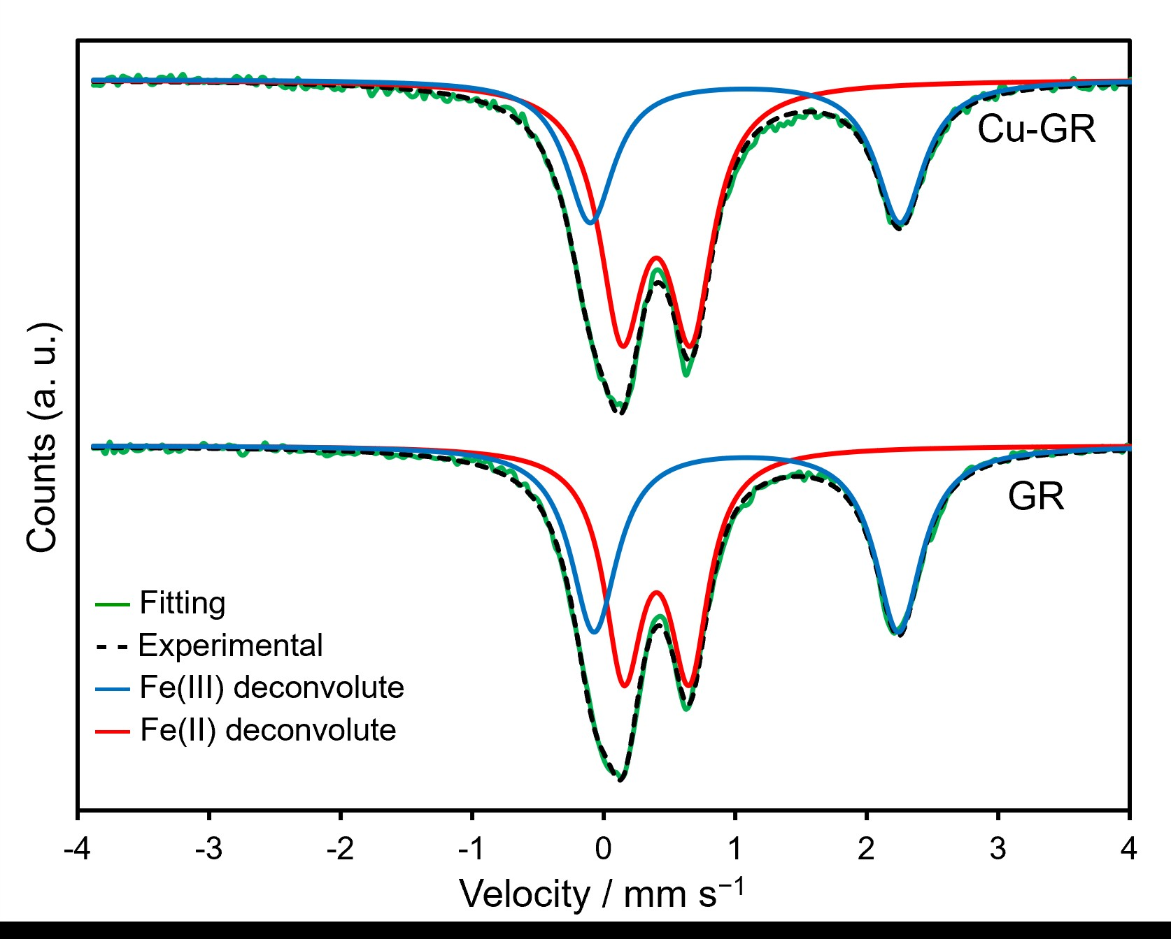

Figure 1. ⁵⁷Fe Mössbauer spectra of GR and Cu-GR.

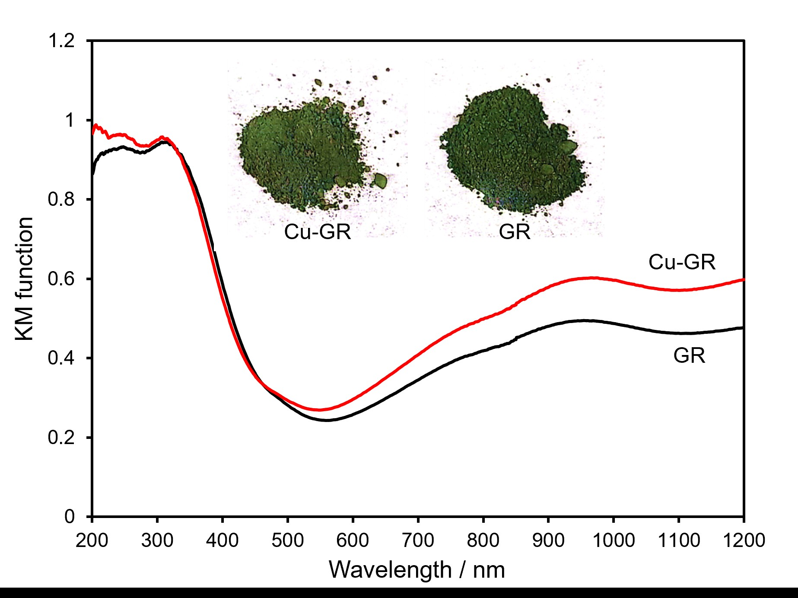
Figure 2. UV−vis spectra of GR and Cu-GR. The insets indicate the photographs of each powder.

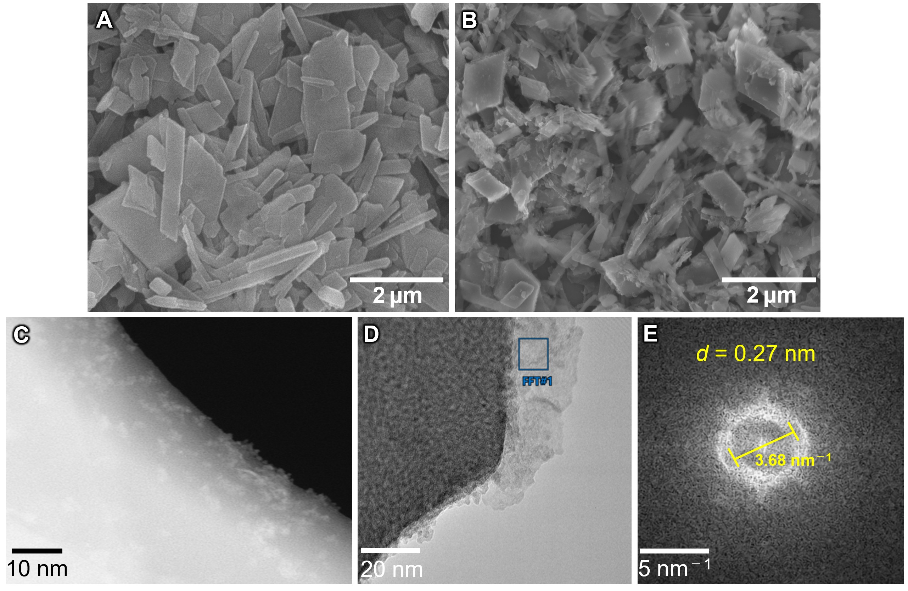
Figure. 3 SEM mages of (A) GR and (B) Cu-GR. (C) HAADF-STEM image of Cu-GR. (D) TEM and (E) selected area FFT image of Cu-GR.

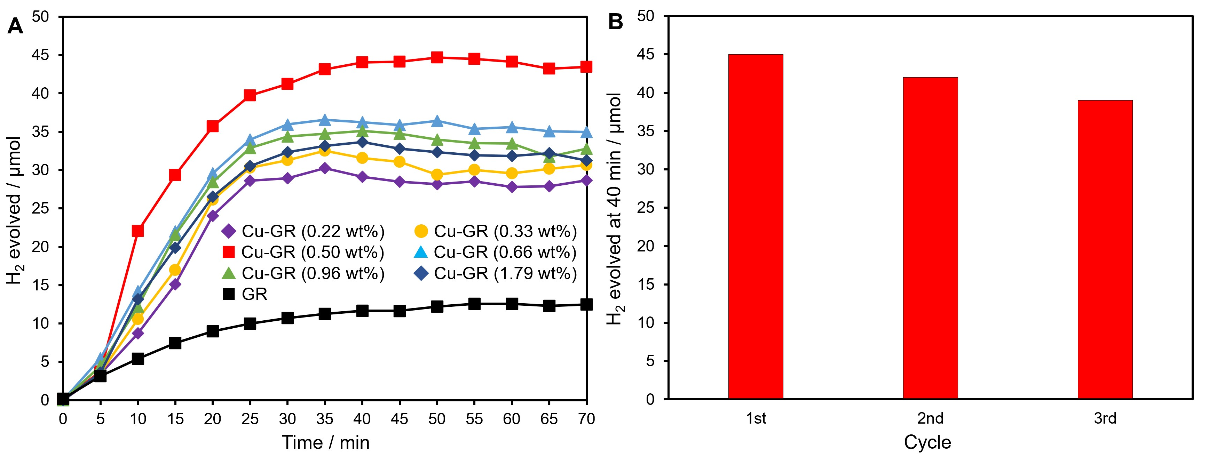
Figure 4. (A) Time course of H₂ evolution from water containing AB under solar simulator irradiation on GR and Cu modified-GR with different Cu amounts. (B) Reusability test of Cu-GR for AB hydrolysis under solar simulator irradiation.

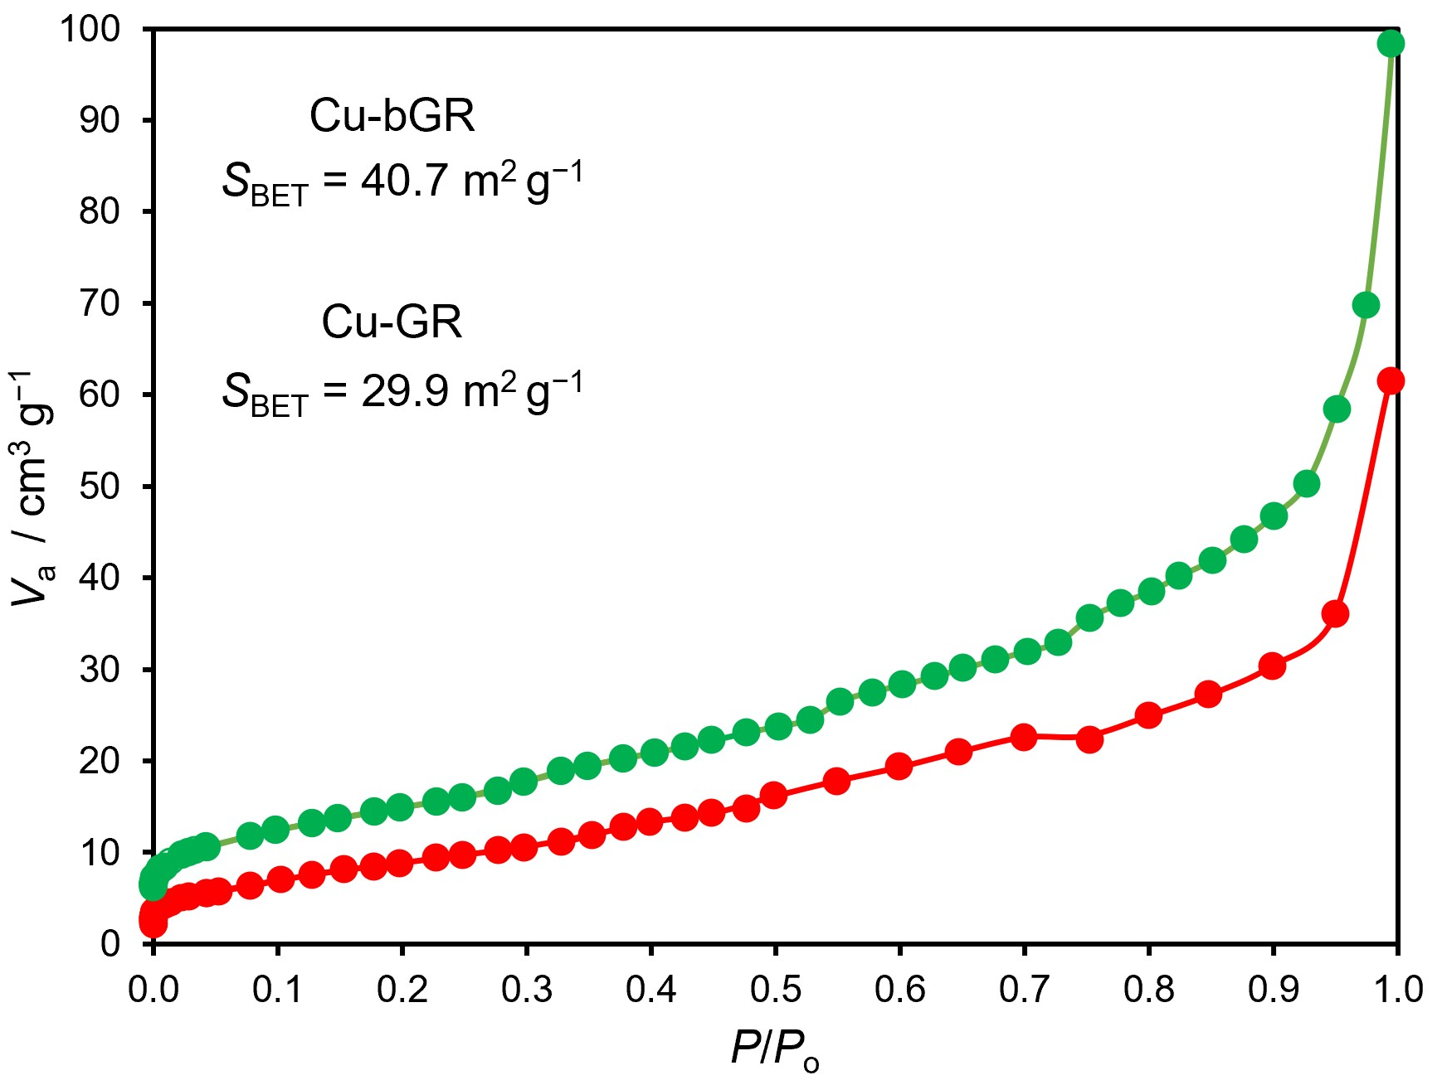
Figure 5. N₂ adsorption isotherms for Cu-GR and Cu-bGR.

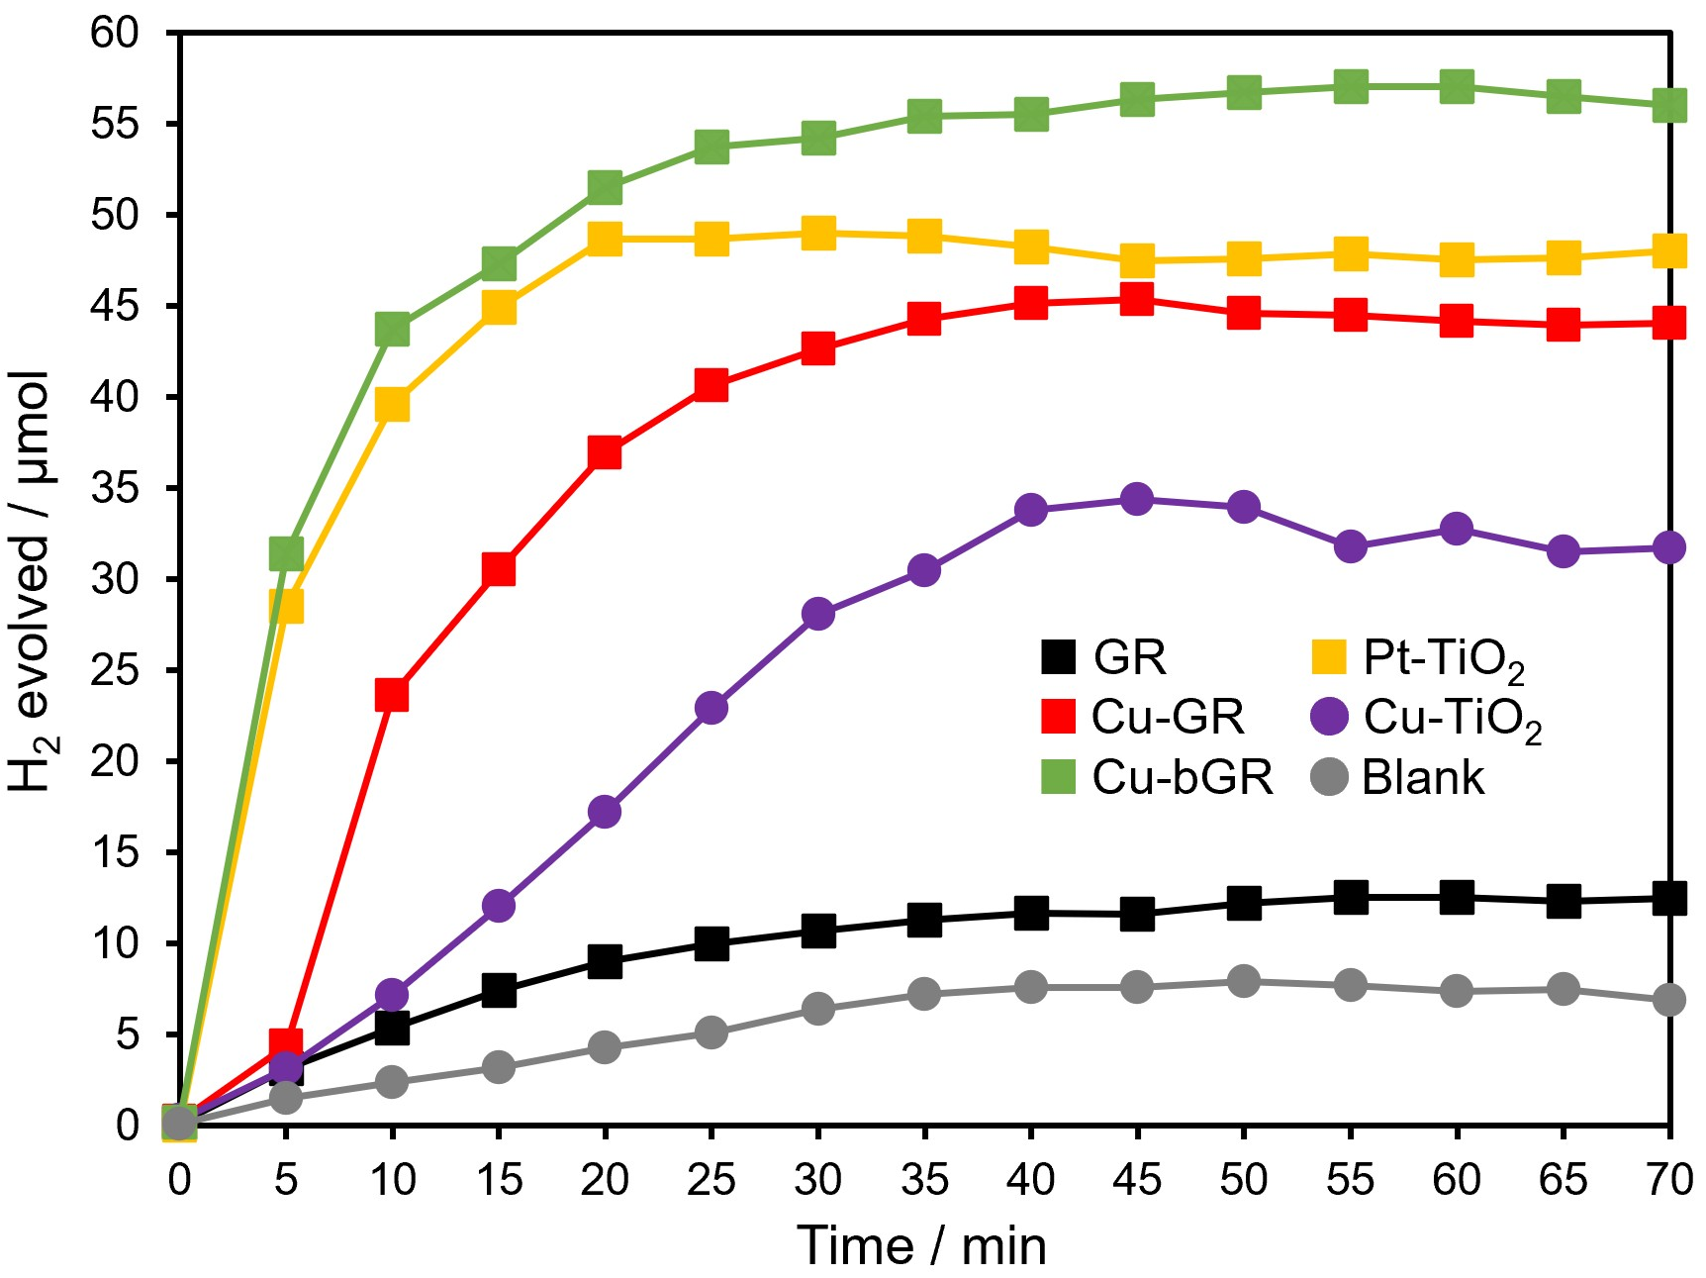
Figure 6. AB hydrolysis tests on different materials under solar simulator irradiation.

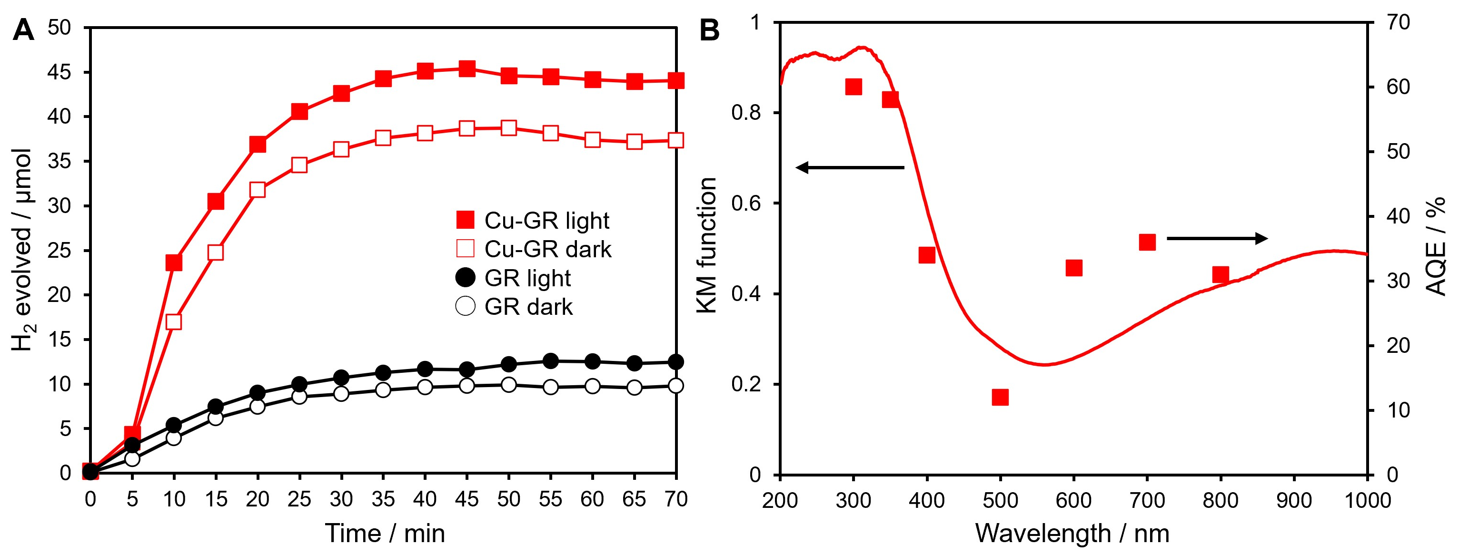
Figure 7. (A) Effect of solar light irradiation on AB hydrolysis on GR and Cu-GR. (B) Action spectrum of Cu-GR in AB hydrolysis under solar simulator irradiation.

Table 1. The hyperfine parameters obtained from Mössbauer spectra of GR and Cu-GR.
