Supplementary Materials

Effect of Co on twin formation and magnetic properties of Sm(Fe,Ti,V)₁₂ alloys
P. Tozman^{1*}, G. Hrkac², C. E. Patrick³, J. B. Staunton⁴, T. Saito¹, T. Sasaki¹, T. Ohkubo¹, H. Sepehri-Amin^{1*}
¹ National Institute for Materials Science, Tsukuba, Ibaraki 305-0047, Japan
²College of Engineering, Mathematics, and Physical Sciences, University of Exeter, Exeter, Devon, United Kingdom
³ Department of Materials, University of Oxford, Oxford OX1 3PH, United Kingdom
⁴ Department of Physics, University of Warwick, Coventry CV4 7AL, United Kingdom

* Corresponding authors: H. Sepehri-Amin (h.sepehriamin@nims.go.jp) and P. Tozman (pelin.tozman@tu-darmstadt.de)

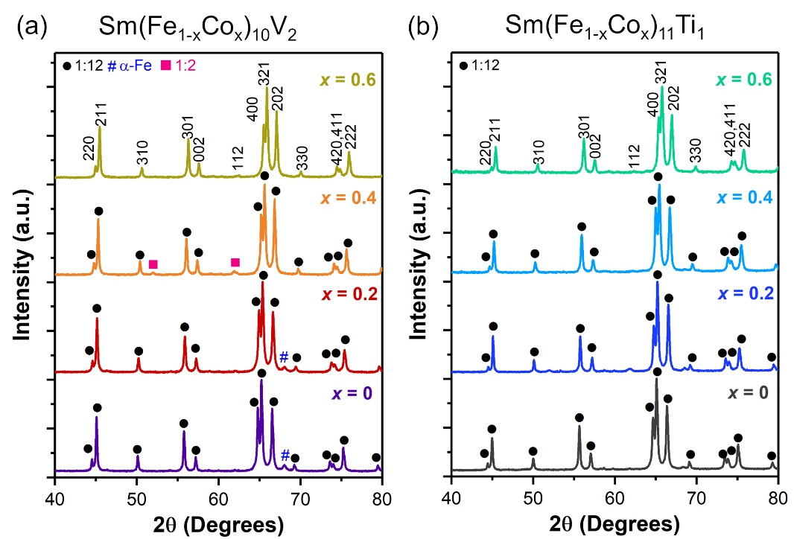
Fig. S1. The XRD patterns of (a) annealed Sm(Fe_{1-x}Co_{x})₁₀V₂ and (b) as-cast Sm(Fe_{1-x}Co_{x})₁₁Ti₁.

In Fig. S1, the XRD patterns of annealed Sm(Fe_{1-x}Co_{x})₁₀V₂ and as-cast Sm(Fe_{1-x}Co_{x})₁₁Ti₁ were obtained at 300 K. The as-cast Sm(Fe_{1-x}Co_{x})₁₁Ti₁ exhibit single phase. Sm(Fe_{1-x}Co_{x})₁₀V₂ exhibit trace amount of secondary α-Fe phase for x = 0 and 0.1 and SmFe₂ phase for x = 0.4.
In Fig. S2, XRD patterns of the as-cast and annealed SmFe₁₀V₂ are compared. In the as-cast ingot, an intense peak of α-Fe is observed, along with the SmFe₂ phase. Annealing at 1313 K for 2 days decreases substantially α-Fe content. However, in the case of Ti-containing alloys, the as-cast sample shows mainly 1:12 phase while annealing at the elevated temperature lead to the formation of Fe and (Fe,Co)₂Ti phases [1].
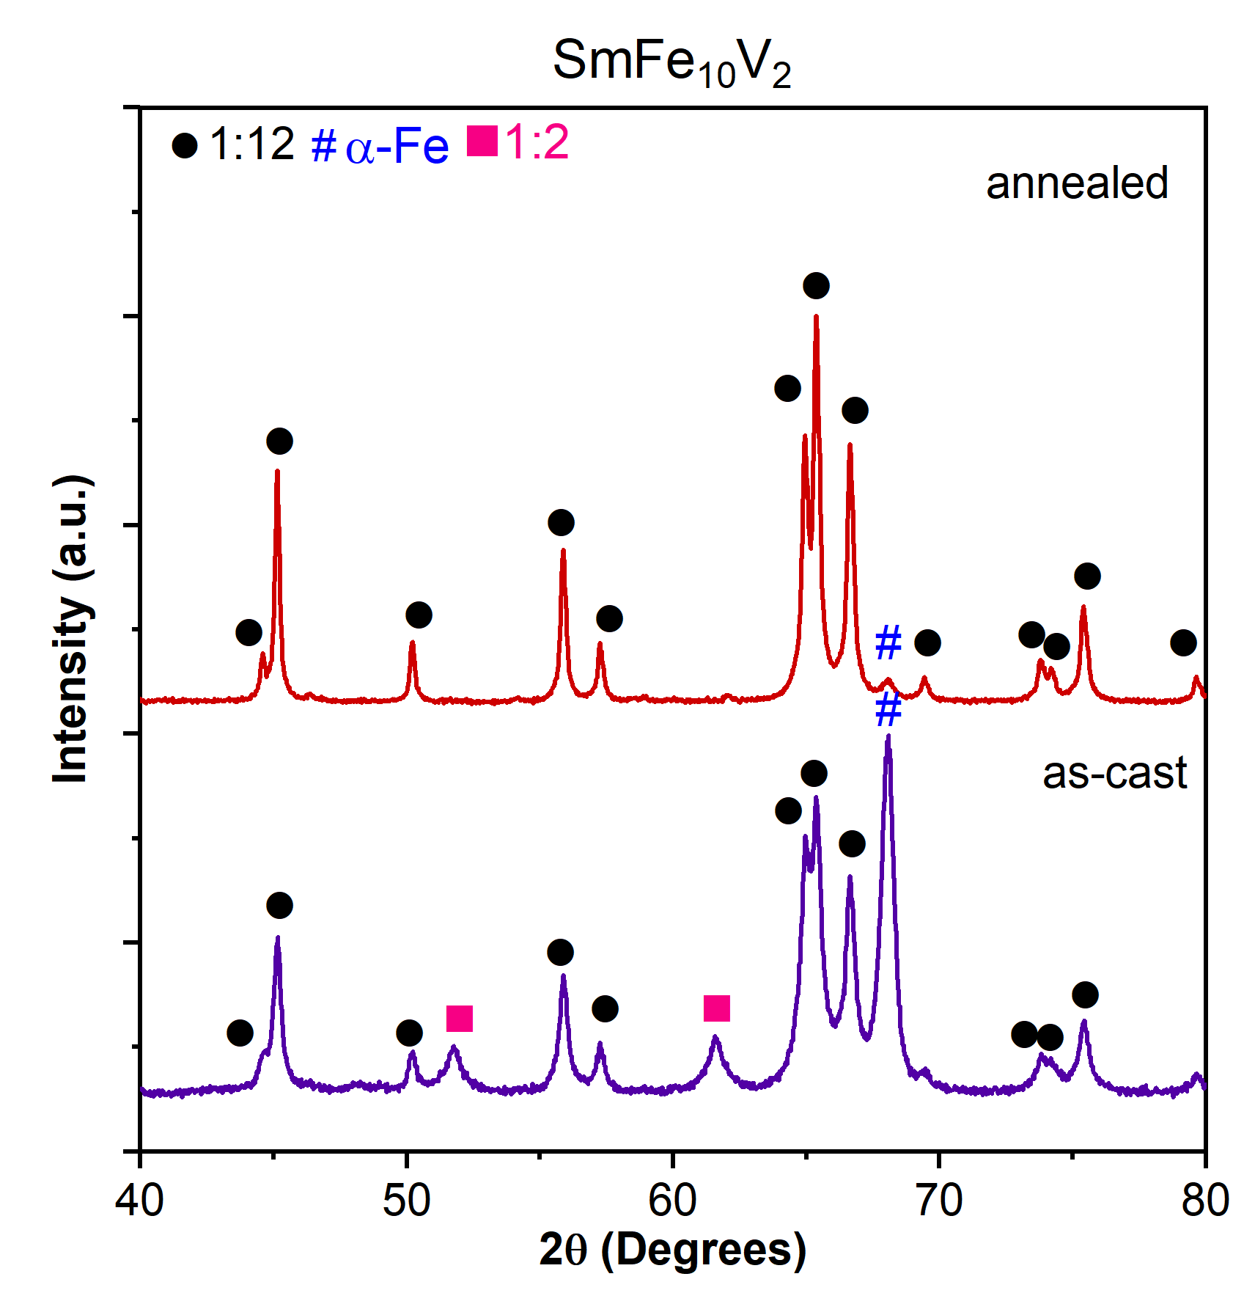
Fig. S2 The XRD patterns of as-cast and annealed SmFe₁₀V₂ ingot

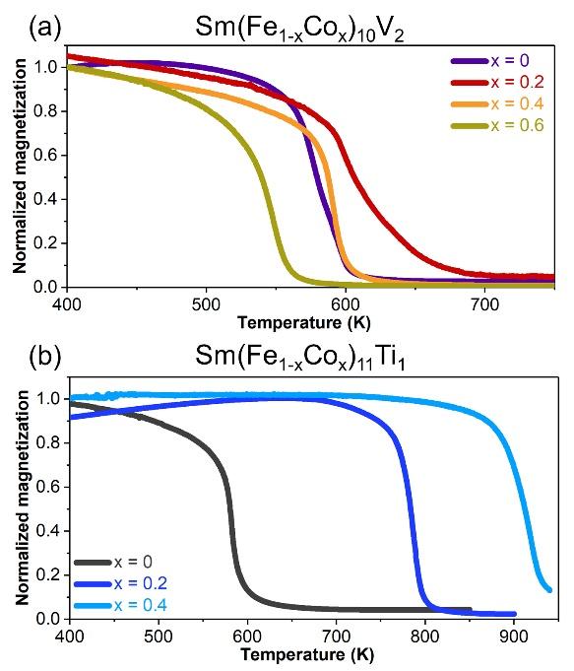
Fig. S3. The M-T measurement for (a) annealed Sm(Fe_{1-x}Co_{x})₁₀V₂ and (b) as-cast Sm(Fe_{1-x}Co_{x})₁₁Ti₁ measured under 500 Oe external magnetic field.
The thermomagnetic measurement (Fig. S3) indicates that all compounds have magnetically single phase. The Curie temperature T_{c} is determined from the intersection of the extrapolated baseline.

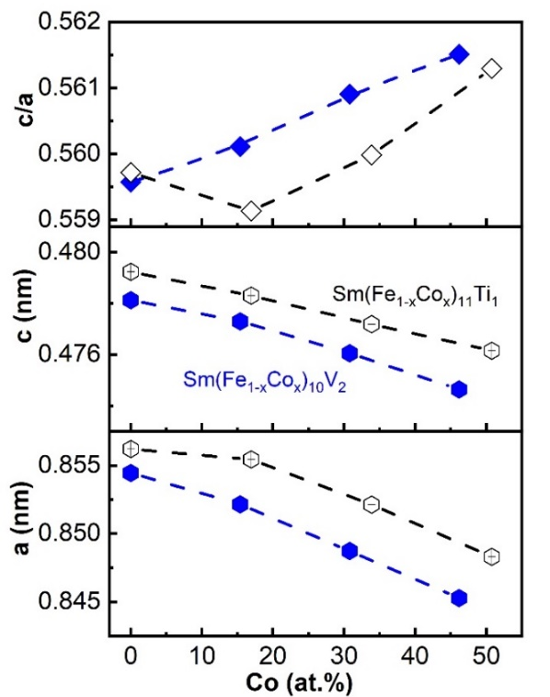
Fig. S4. The variation of the lattice parameter a, c and c/a ratio of ThMn₁₂ phase is illustrated for annealed Sm(Fe_{1-x}Co_{x})₁₀V₂ and as-cast Sm(Fe_{1-x}Co_{x})₁₁Ti₁.

The lattice parameters a, c and c/a ratio are deduced from the XRD patterns (Fig. S4). Co substitution leads to a decrement in c/a ratio Sm(Fe_{0.8}Co_{0.2})₁₁Ti₁ which indicates the most stable condition. Replacing Fe with Co decreases lattice parameters a and c for both compositions.

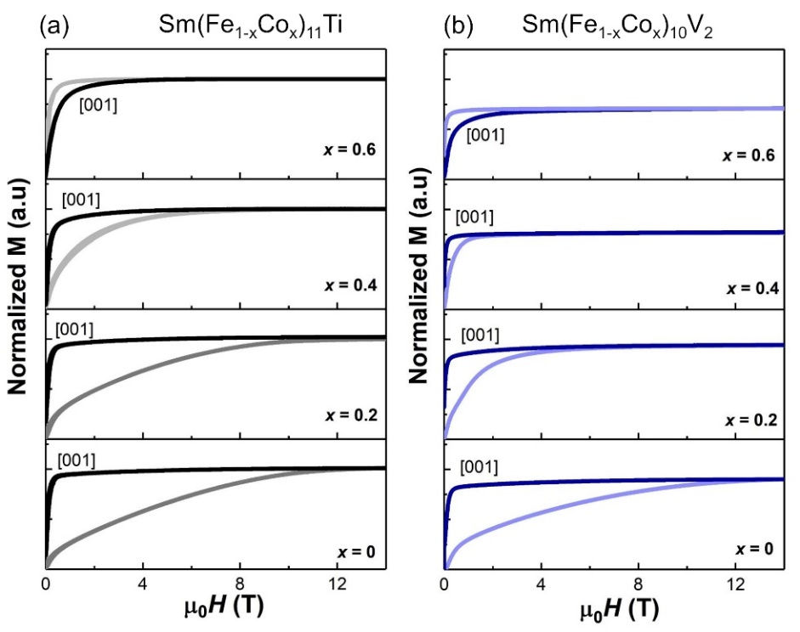
Fig. S4. M-H curves of magnetically oriented and as-cast Sm(Fe_{1-x}Co_{x})₁₁Ti₁ and (b) annealed Sm(Fe_{1-x}Co_{x})₁₀V₂ that are measured parallel and perpendicular to the applied field.

[1] P. Tozman, H. Sepehri-Amin, Y. K. Takahashi, S. Hirosawa, K. Hono, Intrinsic magnetic properties of Sm(Fe_{1-x}Co_{x})₁₁Ti and Zr-substituted Sm_{1-y}Zr_{y}(Fe_{0.8}Co_{0.2})_{11.5}Ti_{0.5} compounds with ThMn₁₂ structure toward the development of permanent magnets, Acta Mater. 153 (2018) 354-363.

