Received 00th January 20xx,
- National Institute for Materials Science, 1-1 Namiki, Tsukuba, Ibaraki, 305-0044 JAPAN. E-mail: ABE.Hideki@nims.go.jp
- Graduate School of Science and Technology, Saitama University, 255 Shimookubo,
Saitama 338-8570, Japan.
Accepted 00th January 20xx
DOI: 10.1039/x0xx00000x

Sub-50 nm pattering via Nanophase Separation of Alloy Thin Films for Hydrogen Gas Sensing
Sherjeel Mahmood Baig,^{a,b} Satoshi Ishii,ª Hideki Abe*^{a,b}
A novel patterning method achieves a two-dimensional nano-pattern of metal nanofibers by depositing a platinum-cerium alloy film on a silicon wafer and inducing phase separation in an oxygen-carbon monoxide atmosphere. The resulting nano-patterned thin film, Pt#CeO₂/Si, consisting of platinum and cerium oxide with an average pattern width of 50 nm, exhibits potential as a hydrogen sensor with sensitive electrical responses to hydrogen ad/desorption. This introduced patterning method addresses the challenge of wavelength limitations in traditional optical lithography, offering a scalable approach for sub-50 nm patterns crucial in advanced sensor and electronic applications.
Introduction
Figure 1. Schematic diagram illustrating the proposed nanopatterning method. A thin film of Pt-Ce alloy is deposited onto Si substrates through vacuum sputtering (left). Ce and Pt atoms in the Pt-Ce film are represented by red and green circles, respectively (middle). The Pt-Ce film undergoes treatment in an O₂-containing atmosphere, resulting in the formation of a nanonetwork composed of Pt and CeO₂, with an average width of 50 nm (right, where the maze-like red and green phases correspond to Pt and CeO₂, respectively.
Nano-patterned thin films play a pivotal role in optics, electronics, and sensing technologies, characterized by nanometre-wide metallic phases arranged in fibrous patterns on solid-state substrates like silicon (Si) wafers [1]. Those films exhibit diverse patterns, including stripes, lattices, and networks [2]. Specifically, network-patterned thin films functioning as sensors for various chemical species, capitalize on their high-density metal surfaces. Molecular ad/desorption on those surfaces can be detected at high sensitivity as changes in electrical resistance within the nano-patterned network. This functionality positions network-patterned thin films as effective sensors, holding promise for responding to various chemical stimuli across a range of applications [1, 3].
Efforts to enhance the performance of patterned thin films are actively focused on reducing patterning size. Lithography techniques, particularly those employing visible-light lasers, have been widely used to pattern metal thin films at the nanoscale, achieving patterns around 100 nm [4]. However, the challenge arises when attempting nano-patterning at sizes smaller than 50 nm, referred to as sub-50 nm patterning, as it encounters the limitations imposed by the wavelength of light [5, 6]. Although techniques like Electron Beam Lithography (EBL) and Focused Ion Beam Lithography (FIB) can achieve sub-50 nm patterning, their adoption is limited by low throughput due to intricate processes and the use of ultra-fine manufacturing equipment [7].
Herein, we report that thin films can be patterned at the nanoscale by taking advantage of the spontaneous nanophase separation of alloys [8-10]. Thin films of an alloy of platinum (Pt) and cerium (Ce), Pt-Ce, were deposited to Si substrates at a thickness of 50 nm by vacuum sputtering. The Pt-Ce alloy thin films were then subjected to a stream of a gas mixture of carbon monoxide (CO) and oxygen (O₂) at elevated temperatures to promote the selective oxidation of Ce (Fig. 1). As the result of the selective oxidation of the Pt-Ce film, a two-dimensional, fibrous nano-network of Pt and cerium dioxide, i.e., Pt#CeO₂/Si emerged, covering the Si surface (Fig. S1, S2). A set of gold-titanium (Au-Ti) terminals was finally deposited onto Pt#CeO₂/Si, maintaining a gap of 25 micrometers. Pt#CeO₂/Si exhibited a reversible change in two-terminal resistance when exposed to hydrogen (H₂) and O₂ atmospheres in sequence, due to the adsorption of different chemical species onto the Pt nano-network. The demonstrated chemo-electric function of Pt#CeO₂/Si positions it as a potential alternative to traditional palladium (Pd)-based H₂ sensors [11, 12], with an added advantage of reduced material costs (Pt cost: $28/g compared to Pd cost: $40/g).

Experimental
Figure 3. SEM images of the as-deposited Pt-Ce film (a) and the atmosphere-treated Pt-Ce film (b). EDX mapping images of the atmosphere-treated Pt-Ce film (c), where the red, cyan, green, and blue-colored images represent elemental mapping of Pt, Si, Ce, and O, respectively.
A spattering target of Pt₂Ce alloy was prepared by melting Pt and Ce metal ingots with an atomic ratio of Pt:Ce=2:1 using an arc torch in a pure Ar atmosphere (see Powder X-ray Diffractometry (pXRD) data in Fig. S3). Thin films of the Pt-Ce alloy, approximately 50±1 nm thick, were deposited onto a Si substrate (Si wafer: 380 μm thick) at room temperature through sputtering of the Pt₂Ce target with an (MB-501010) electron-beam evaporator (Fig. S4, S5). The as-deposited Pt-Ce film exhibited chemical stability in air at room temperature and/or in a pure argon (Ar) atmosphere up to 600 °C (Fig. S6). Subsequently, the Pt-Ce film underwent an atmosphere treatment in a stream of a mixture gas of CO, O₂, and Ar in a specific volumetric ratio of 2 ml min⁻¹, 1 ml min-¹, and 47 ml min⁻¹, respectively, at 600 °C for 1 hour).

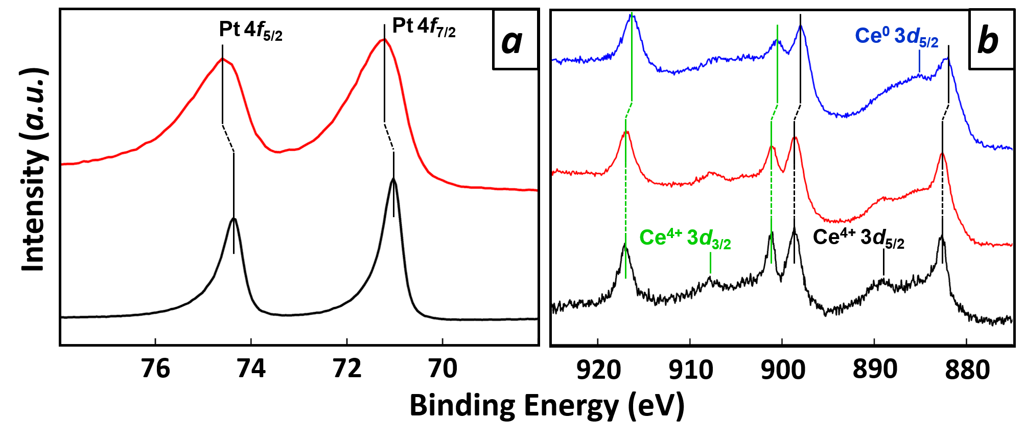
Results & Discussion
Figure 2. XPS spectra in the Pt 4f region (a) and the Ce 3d region (b) for the deposited films and the control. In (a), the black and red curves represent pure Pt and the atmosphere-treated film, respectively. In (b), the black, red, and blue curves correspond to CeO₂, the atmosphere-treated Pt-Ce film, and the as-deposited Pt-Ce film, respectively.
X-ray photoemission spectroscopy (XPS) was conducted to examine the chemical nature of the as-deposited and atmosphere-treated Pt-Ce films (Fig. 2). The peak positions for the 4f_{7/2}- and 4f_{5/2} emissions from the atmosphere-treated Pt-Ce film exhibited a 0.20 eV shift towards deeper binding energies with respect to the corresponding peaks from pure Pt (Fig. 2a) [13, 14]. This shift in the Pt 4f emission peaks suggests that Pt atoms are partially deprived of valence electrons by adjacent oxygen (O) atoms, which are more electrophilic than Pt. The XPS spectrum of the atmosphere-treated Pt-Ce film closely resembles that of the control material, CeO₂, in terms of peak positions and intensities (Fig. 2b). Based on the XPS analyses in the Pt- and Ce core regions, we conclude that the atmosphere-treated Pt-Ce film is a composite of Pt and CeO₂ phases, where the Pt phase maintains an atomistic contact with the CeO₂ phase through Pt-O bonds.
In the Ce 3d spectrum of the as-deposited Pt-Ce film, there is a recognized finite shift in peak positions towards binding energies 0.61 eV shallower than those for CeO₂ or the atmosphere-treated Pt-Ce film (Fig. 2b) [15]. This shift indicates that the Ce atoms in the as-deposited Pt-Ce film exist in a low valence state, as in metals. Note that a peak appears in the Ce 3d spectrum of the as-deposited film, attributed to the Ce⁰ atoms in alloys such as CePd₃ [16]. The low-valence Ce atoms in the as-deposited film undergo selective oxidation to CeO₂ by the atmosphere treatment, resulting in a phase separation forming of a composite of Pt and CeO₂ phases. This transformation is accompanied by the formation of Pt-O bonds, solidifying the interconnected structure of the Pt and CeO₂ phases in the film.
Scanning Electron Microscopy (SEM) shows the uniformity of the as-deposited Pt-Ce film (Fig. 3a). Energy-dispersive X-ray Spectroscopy (EDX) mapping confirmed a uniform distribution of Pt and Ce throughout the as-deposited film. The atomic ratio of Pt and Ce was determined as Pt/Ce = 1.95 ± 0.05, with no traces of other elements present (Fig. S7, S8, and Tab. S9). In contrast, nanophase separation became evident in the atmosphere-treated Pt-Ce film (Fig. 3b and 3c, see also Fig. S10 and S11 for more details on the nanophase separation). Fibrous Pt phases formed an interconnected network with a width of less than 40 nm, developing a two-dimensional nano-network of Pt metal. This metal nano-network allowed the Si substrate to be visible between adjacent Pt phases, resulting in a negative image of Pt distribution (Fig. 3c). Most Ce and O were concentrated over the Pt phase. The average atomic ratio of Pt and Ce, quantified with EDX, was Pt/Ce = 1.86 ± 0.05 (Fig. S12, and Tab. S13). Hereafter, this nano-pattern of Pt and CeO₂ that is spontaneously formed over the Si surface is denoted as Pt#CeO₂/Si.
Kelvin-force probe microscopy (KFPM) [17, 18] was employed to investigate the surface potential distribution of Pt#CeO₂/Si. A finely pointed platinum needle served as the KFPM probe. In Figure 4, warm-colored areas indicate low surface potential, while cold-colored areas signify high surface potential. The warm-colored areas are assigned to the surfaces of the Si substrate, while the cold-colored areas correspond to the Pt phase. The Pt nano-network of Pt#CeO₂/Si with low surface potential can act as an effective adsorption site for different molecules due to strong molecular dipole-surface dipole interactions. The Pt nano-network develops an interconnected electrical network throughout Pt#CeO₂/Si, adding a function as a sensitive electric probe for different gas species.
Figure 5. (a) Electric resistance of Pt#CeO₂/Si at different temperatures. (b) Schematic diagram of the hydrogen sensor setup featuring Pt#CeO₂/Si. Pt#CeO₂/Si with Au-Ti terminals was placed in a glass chamber with gas ports. Gold wires led the electric terminals to an external current source, monitoring inter-terminal voltage. (c) Electric resistance of Pt#CeO₂/Si at room temperature in various gas atmospheres, with figure annotations indicating the correspondence between gas type and resistance.
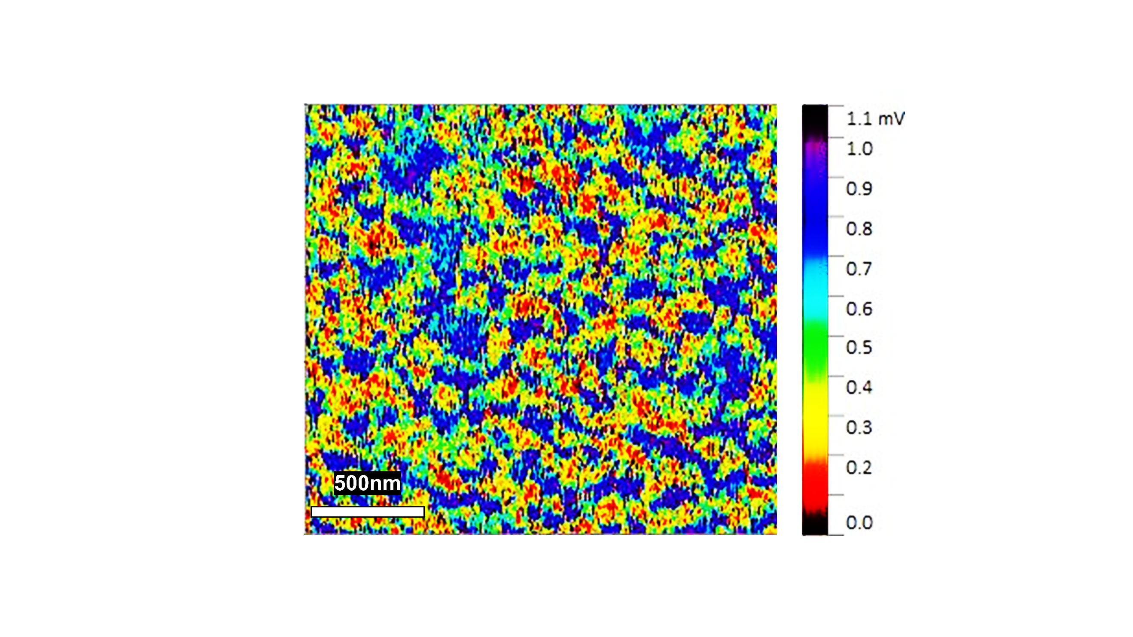
Finally, the Pt#CeO₂ film was utilized as a gas-sensing probe. Using the electron-beam evaporator (UEP-3000BS), a pair of gold-titanium (Au-Ti) terminals were deposited onto the film surface, maintaining a terminal gap of 25 μm (Fig. S14). The electrical resistance between these electrodes on Pt#CeO₂/Si was measured through the two-terminal method (Fig. S15). The electrical resistance of Pt#CeO₂/Si increased as the temperature decreased (Fig. 5a). The trend in temperature dependence of the electrical resistance shows that the Pt metal nano-network in Pt#CeO₂/Si was not entirely connected across the terminal gap, leading to semiconducting conduction rather than metallic conduction.
Figure 4. KPFM image of Pt#CeO₂/Si, where the contrast from cold to warm colors visualizes the surface potential of the sample relative to the Pt probe surface.

Pt#CeO₂/Si was then introduced into a glass chamber equipped with gas ports for inlet and outlet gases, as illustrated in the experimental setup scheme (Fig. 5b). Nitrogen (N₂) gas was initially purged into the chamber to clean the surface of Pt#CeO₂/Si before gas sensing tests. The electric resistance of Pt#CeO₂/Si was continuously monitored while hydrogen (H₂) and oxygen (O₂) were alternately injected into the sensing chamber for 5 minutes each (Tab. S16). During exposure to the H₂ gas atmosphere, the Pt surface of the Pt#CeO₂ film was adsorbed by molecular H₂, resulting in reduced electric resistance of the Pt nano-network due to inhibited electron scattering [19].
When the hydrogen (H₂) atmosphere was replaced by an O₂ atmosphere, molecular O₂ occupied the Pt surface, displacing the physisorbed H₂ molecules. The resistance of Pt#CeO₂/Si was restored to its initial value during the first O₂ purge (Fig. S17). This cyclic change in electrical resistance was consistently observed each time the H₂ and O₂ atmospheres were alternated [20, 21]. Importantly, the switching of atmospheres induced no irreversible change in resistance, underscoring the reversible nature of terminalized Pt#CeO₂/Si as a reliable probe for H₂ sensing.

Conclusion
In summary, our work leveraged the nanophase separation phenomenon in alloys to successfully fabricate thin metallic films with a network structure, achieving dimensions below 50 nm—a challenge with traditional optical lithography methods. By depositing a platinum (Pt) and cerium (Ce) alloy thin film onto a silicon (Si) substrate and subjecting it to an atmosphere containing oxygen (O₂) and carbon monoxide (CO) at elevated temperatures, selective oxidation of Ce to cerium dioxide (CeO₂) occurred, resulting in the emergence of a network-like Pt nano-pattern over the Si surface, denoted as Pt#CeO₂/Si. Those Pt nano-patterns were uniformly spaced approximately 50 nm apart. Pt#CeO₂/Si exhibited sensitive and repeatable responses in electrical resistance to the alternating cycles of O₂ and H₂ atmospheres, showcasing its potential as a probe in H₂ gas sensors. This innovative nano-patterning method reported in this work holds promise as a breakthrough for diverse applications, including catalysts, sensors, optical collectors, and integrated circuits. Its simplicity, avoiding the need for complex and expensive lithography equipment, enables the construction of uniform nanostructures over large areas.
Author Contributions
S. M. Baig synthesized, characterized, and developed the chemo-electric functionality of the materials. S. Ishii conducted microscopic characterizations with S. M. Baig. H. Abe designed and conducted the research and edited the manuscript.

Conflicts of interest
There are no conflicts to declare.
Acknowledgments
This work was supported by "Advanced Research Infrastructure for Materials and Nanotechnology in Japan (ARIM)" of the Ministry of Education, Culture, Sports, Science and Technology (MEXT)—proposal Number JPMXP1223NM5363.
References
[1] H. Yin et al., “Periodic nanostructures: preparation, properties and applications,” Chem Soc Rev, vol. 50, no. 11, pp. 6423–6482, 2021, doi: 10.1039/D0CS01146K.
[2] H.-N. Barad, H. Kwon, M. Alarcón-Correa, and P. Fischer, “Large Area Patterning of Nanoparticles and Nanostructures: Current Status and Future Prospects,” ACS Nano, vol. 15, no. 4, pp. 5861–5875, Apr. 2021, doi: 10.1021/acsnano.0c09999.
[3] T. Zhou and T. Zhang, “Recent Progress of Nanostructured Sensing Materials from 0D to 3D: Overview of Structure–Property‐Application Relationship for Gas Sensors,” Small Methods, vol. 5, no. 9, Sep. 2021, doi: 10.1002/smtd.202100515.
[4] M. Guo, Z. Qu, F. Min, Z. Li, Y. Qiao, and Y. Song, “Advanced unconventional techniques for sub‐100 nm nanopatterning,” InfoMat, vol. 4, no. 8, Aug. 2022, doi: 10.1002/inf2.12323.
[5] Y. Wu and Z. Xiao, “The Recent Progress of Lithography Machine and the State-of-art Facilities,” 2022.
[6] T. Ito and S. Okazaki, “Pushing the limits of lithography,” Nature, vol. 406, no. 6799, pp. 1027–1031, Aug. 2000, doi: 10.1038/35023233.
[7] I. Kostic, K. Vutova, A. Bencurova, A. Ritomsky, and R. Andok, “Limitations of variable shaped electron beam lithography for advanced research and semiconductor applications,” in 2017 40th International Spring Seminar on Electronics Technology (ISSE), IEEE, May 2017, pp. 1–6. doi: 10.1109/ISSE.2017.8000969.
[8] A. S. B. M. Najib et al., “Mesoporous Rh Emerging from Nanophase‐separated Rh‐Y Alloy,” Chem Asian J, vol. 14, no. 16, pp. 2802–2805, Aug. 2019, doi: 10.1002/asia.201900542.
[9] S. Shoji et al., “Topologically immobilized catalysis centre for long-term stable carbon dioxide reforming of methane,” Chem Sci, vol. 10, no. 13, pp. 3701–3705, 2019, doi: 10.1039/C8SC04965C.
[10] Y. Wen, H. Abe, K. Mitsuishi, and A. Hashimoto, “Tracking the emergence of epitaxial metal–oxide interfaces from precursor alloys,” Nanoscale, vol. 13, no. 45, pp. 18987–18995, 2021, doi: 10.1039/D1NR03492H.
[11] I. Darmadi, F. A. A. Nugroho, and C. Langhammer, “High-Performance Nanostructured Palladium-Based Hydrogen Sensors—Current Limitations and Strategies for Their Mitigation,” ACS Sens, vol. 5, no. 11, pp. 3306–3327, Nov. 2020, doi: 10.1021/acssensors.0c02019.
[12] K. Arora and N. K. Puri, “Chemiresistive sensing platform based on PdO-PANI/ITO heterostructure for room temperature hydrogen detection,” Mater Chem Phys, vol. 247, p. 122850, Jun. 2020, doi: 10.1016/j.matchemphys.2020.122850.
[13] C. J. Powell, “Recommended Auger parameters for 42 elemental solids,” J Electron Spectros Relat Phenomena, vol. 185, no. 1–2, pp. 1–3, Mar. 2012, doi: 10.1016/j.elspec.2011.12.001.
[14] P. Légaré et al., “On the interaction of O2 with Pt(111) and Pt(557) surfaces: core-level shift study using conventional and synchrotron radiation sources,” Surf Sci, vol. 198, no. 1–2, pp. 69–78, Jan. 1988, doi: 10.1016/0039-6028(88)90472-4.
[15] E. Paparazzo, G. M. Ingo, and N. Zacchetti, “X-ray induced reduction effects at CeO2 surfaces: An x-ray photoelectron spectroscopy study,” Journal of Vacuum Science & Technology A: Vacuum, Surfaces, and Films, vol. 9, no. 3, pp. 1416–1420, May 1991, doi: 10.1116/1.577638.
[16] J. C. Fuggle, M. Beyss, M. Campagna, F. Steglich, and F. Hulliger, “X-RAY PHOTOEMISSION FROM Ce CORE LEVELS OF CePd3, CeSe, CeAl2 AND CeCu2Si2,” 1980.
[17] W. Melitz, J. Shen, A. C. Kummel, and S. Lee, “Kelvin probe force microscopy and its application,” Surf Sci Rep, vol. 66, no. 1, pp. 1–27, Jan. 2011, doi: 10.1016/j.surfrep.2010.10.001.
[18] G. Cohen et al., “Reconstruction of surface potential from Kelvin probe force microscopy images,” Nanotechnology, vol. 24, no. 29, p. 295702, Jul. 2013, doi: 10.1088/0957-4484/24/29/295702.
[19] E. H. Sondheimer, “The mean free path of electrons in metals,” Adv Phys, vol. 1, no. 1, pp. 1–42, Jan. 1952, doi: 10.1080/00018735200101151.
[20] H. W. Yoo, S. Y. Cho, H. J. Jeon, and H. T. Jung, “Well-defined and high resolution pt Nanowire arrays for a high performance hydrogen sensor by a surface scattering phenomenon,” Anal Chem, vol. 87, no. 3, pp. 1480–1484, Feb. 2015, doi: 10.1021/ac504367w.
[21] N. Kilinc, “Palladium and platinum thin films for low-concentration resistive hydrogen sensor: a comparative study,” Journal of Materials Science: Materials in Electronics, vol. 32, no. 5, pp. 5567–5578, Mar. 2021, doi: 10.1007/s10854-021-05279-w.

