Ultra-high Resolution, Wide-range Thermometry Based on High-quality Factor Microscale Diamond Resonators

Wen Zhao¹, Guo Chen¹, Ruochen Lu², Tokuyuki Teraji¹, Satoshi Koizumi¹, Yasuo Koide¹, Masaya Toda³, Meiyong Liao^{1*}
¹Research Center for Electronics and Optical Materials, National Institute for Materials Science, Namiki 1-1, Tsukuba, Ibaraki 305-0044, Japan
²Department of Electrical and Computer Engineering, University of Texas at Austin, Texas, 78712, USA
³Graduate School of Engineering, Tohoku University, Sendai, Miyagi 9808579, Japan
Correspondence to: Meiyong Liao* (meiyong.liao@nims.go.jp)

Keywords: Diamond, MEMS, thermometry, Ultra-high resolution, low noise

Next-generation thermometry requires ultrahigh precision and microscale or nanoscale spatial resolution for bio-calorimetry, optoelectronic sensing, quantum science, energy storage and thermal management of electronic devies. Current thermometry approach based on capacitive, piezo-resistive and resonant mechanisms, suffers from various problems such as large volume, narrow temperature range, low resolution, and high noise level. Microelectromechanical system (MEMS) thermometry holds great potential as thermometry due to the small size, batch fabrication and easy of integration with integrated circuits. However, mainstream silicon MEMS thermometry struggles with the trade-off between sensitivity, temperature resolution, and thermal noise. In this work, we propose the utilization of high-quality factor single-crystal diamond MEMS cantilevers with multi-mode resonance to address these challenges. The resulting diamond MEMS thermometry exhibit unparalleled performance, with an ultra-high temperature resolution of 100 µK, a noise equivalent temperature of ~22 nK/Hz^{1/2}, and a wide-temperature range from 6.5K to 380K. This work highlights the versatility and transformative potential of the diamond MEMS resonator as an advanced platform for high-resolution temperature sensing.

1. Introduction
Microscale ultra-high resolution thermometry has become increasingly essential in system-on-chip (SoC) technology, facilitating precise temperature monitoring across diverse applications, such as bio-calorimetry[1, 2], optoelectronic sensing [3], quantum science[4], thermal management[5, 6], scanning thermal imaging probes[7] and energy generation and storage technologies[8, 9]. The most commonly used thermometers include resistance temperature detectors (RTDs) employing materials like platinum, nickle or copper [10], thermal couples [9], and semiconductor-based temperature sensors [11]. Thermalcouples and semiconductor-based thermometers typically exhibit low resolution (~0.1K). In response to the growing demand for ultra-high-precison microscale thermometry, various techniques have been developed. Using modulated electrical sensing technique, the temperature resolution of the platinum resistance thermometers has been improved to the range of 20~100 µK [10]. However, the thermal noise induced by electrical sensing imposes a fundamental limitation, with the noise floor reaching ~10 µK/Hz^{1/2}. Optical thermometry techniques, leveraging fluorescence [3] and optical resonators, have been extensivly explored to enhance both temperature and spatial resolution. Notably, nitrogen-vacancy centers in diamond enable nanoscale spatial resolution, yet their noise floor is contrained to ~mK/Hz^{1/2} [12]. Additionally, the recorded nanokelvin-resolution thermometer near room temperature has been demonstrated using suspended asymmetric Fabry-Perot resonators [13]. However, the limited temperature range of such techniques restricts their broader applicability. Microelectromechanical system (MEMS) thermometry have emerged as promising alternatives due to their microscale size, batch fabrication and integrated circuits. Current MEMS thermometers are predominantly based on capacitive, piezo-resistive, and resonant mechanisms[14]. However, each type of MEMS thermometer has inherent limitations. For example, MEMS capacitive thermometers [15-17] offer high accuracy but are susceptible to nonlinear pull-in instability, resulting in a low resolution of ~10 mK and a limited temperature sensing range of 203 K to 373 K. By employing a multi-layer stacked double-clamped structure, MEMS resonant thermometers have achieved an ultra-high resolution of 7.25 µK with a sensing range from 223K to 313 K[14]. Nevertheless, the multi-layer design introduces significant challenges, including restricted measurement temperature ranges due to differential thermal expansion of layers and increased fabrication complexity. As a result, the development of a thermometer that combines ultra-high resolution, microscale size, and a wide operational temperature range spanning from cryogenic temperatures (<10 K) to high temperatures (>373 K) remains an unlocked challenge.
Single-crystal diamond (SCD) exhibits exceptional mechanical and physical properties, such as the highest Young’s modulus, an ultra-wide bandgap energy, low mechanical loss, and absence of solid-state surface oxides. These characteristics make diamond an ideal material for MEMS sensors, offering unparalleled performance, stability, and reliability[18-21]. Leveraging these properties, diamond MEMS thermometry enables wide-range temperature sensing, from cryogenic temperature to high temperature over 1000 K, owing to its ultra-wide bandgap and insulating nature [22-24].
In MEMS resonant thermometry, a high thermal coefficient of frequency (TCF) is typically desirable to enhance temperature sensitivity [25]. However, diamond inherently has a relatively low TCF compared to other semiconductors. A common strategy to improve sensitivity is the use of multilayer stacked structures [14]. While this approach increases the TCF, it also degrades the quality (Q) factor of the resonator, thereby reducing the ultimate resolution. Although the low TCF of diamond MEMS reduces sensitivity for thermometry applications, it simultaneously minimizes thermal noise for thermal control, contributing to higher resolution. This highlights a fundamental trade-off between sensitivity and resolution in MEMS resonator-based thermometers, particularly when using diamond as the material platform.
To address the dilemma associated with SCD MEMS thermometry, we propose the development of an ultra-high Q factor exceeding 1 million, enabling high-resolution and low noise temperature sensing. By employing a multi-mode actuation approach, we significantly enhance the temperature sensitivity, from 8 Hz/K for the 1st resonance mode to 20 Hz/K for the 2nd resonance mode. The proposed SCD MEMS thermometry demonstrates unparalleled performance, achieving an ultra-low noise level of ~22 nK/Hz^{1/2}, a temperature resolution as low as 100 µK, and a wide operational temperature range spanning from below 10K to over 380 K. This work paves the way for broad applications in bio-calorimetry, electronic devices, energy systems, and quantum technologies that demand integrated and miniaturized sesning solutions.

2. Results and Discussion
2.1 High Crystal Quality Diamond Epilayer and Ultra-high Q Factor Cantilevers
To achieve high Q factor SCD MEMS cantielvers, we grew a homoepitaxial diamond epilayer with the highest crystal quality on the high-pressure high-temperature (HPHT) (100) type-Ib SCD substrate. The fabrication of SCD cantilevers was performed using the smart-cut method, which involves the high-energy ion implantation, photolithography, reactive ion etching, and structure release[24, 26]. To achieve Q factors over 1 million, the damaged layer at the bottom of the SCD cantilevers was efficiently removed in an oxygen ambient. The crystal quality of SCD epilayer was characterized using Raman spectroscopy, as shown in Figure 1. The Raman peak position (Figure 1a, 1b) and full-width at half-maxium (FWHM) (Figure 1c, 1e) of the diamond Raman signal were statistically analyzed in two dimensions across the epilayer. The FWHM of the diamond Raman peak centered at approximately 1332.27cm⁻¹ , was measured to be ~1.5cm⁻¹, which is the lowest reported value among the SCD wafers to date. The uniform distribution (Figure 1d) of the Raman peak discloses low strain in the SCD epilayer. Thus, the SCD epilayer in this work represents the higest crystal quality achieved so far. An optical image of typical SCD cantilevers with a length of 120 µm, a width of 12 µm, and a thickness around 2.2 µm is illustrated in Figure 1f.

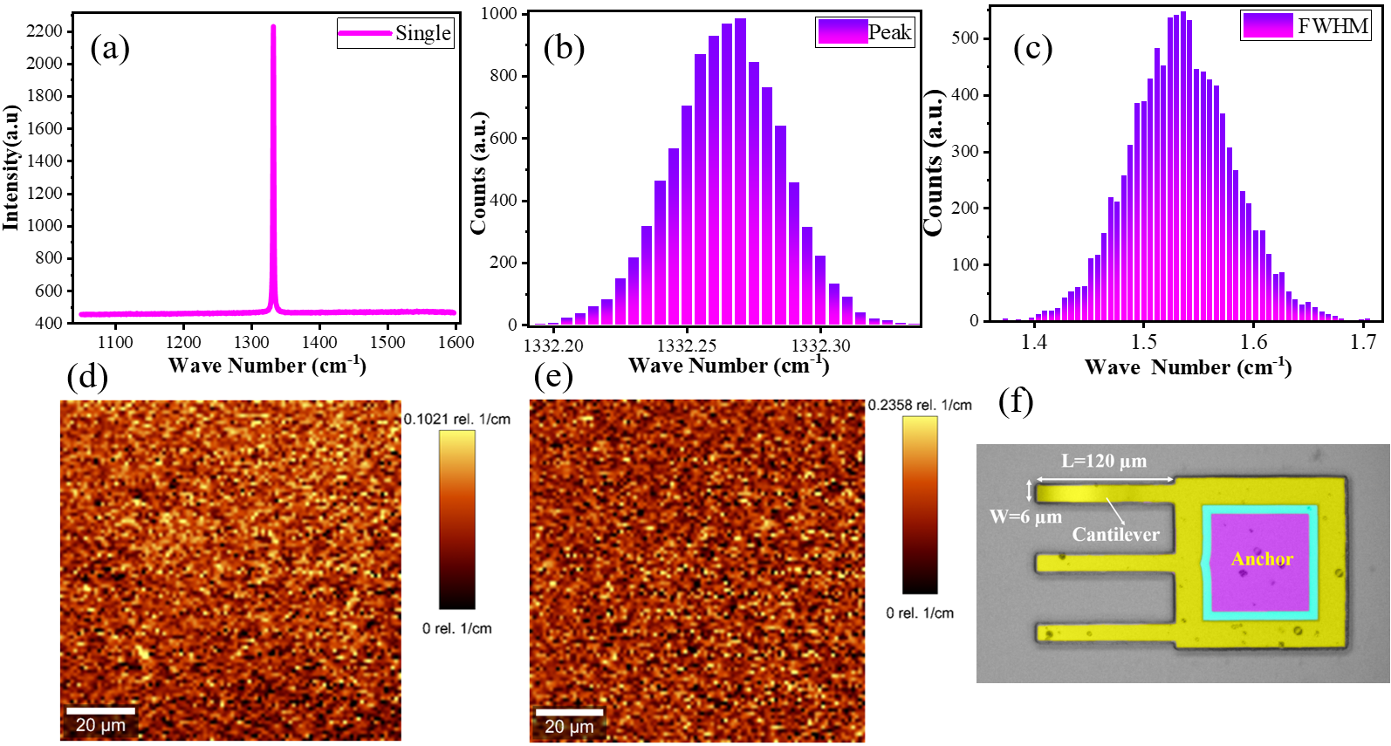
Figure 1. Overall material characterization of the high-quality diamond MEMS resonator (a) a typical Raman spectrum (should be replotted ), (b) Raman peak 2D mapping , (c) FWHM 2D distribution accross the SCD epilayer, (d) Raman peak 2D image, (e) FWHM 2D image, and (f) optical image of SCD cantilevers

2.2 Temperature Dependent Resonance Properties
The mechanical resonance properties of the SCD cantilevers were investigated in an ultra-high vacuum chamber with a pressure around 10⁻⁷ Pa. The vibrational velocity of the cantilevers was measured by a Laser Doppler Vibrometer (LDV) [27, 28]. A signal generator was used to actuate the cantilevers and the data was acquired using a lock-in amplifier. During the measurements, the temperature of the sample stage was varied from 6.5 K to 380 K. The detailed measurement setup is illustrated in Figure S1. We investigate the fundamental (1st mode) and the 2nd mode resonance frequencies. Figure 2a,b display the typical resonance frequency spectra of the 120 µm long SCD cantilever at the room temperature(T=300 K). Also, the resonance frequency response at higher (T=380K) and lower temperature (T=6.5K) are illustrated in Figure S2. The measured resonance frequencies align well with theoretical predictions based on the Euler-Bernoulli formula for a rectangular shape cantilever, expressed as
$f_{n}=k_{n}\frac{t}{L^{2}}\sqrt{\frac{E}{ρ}}$ (1)
where n (n = 1, 2, 3, n > 3 ∙∙∙) is the vibration mode number. k₁ = 0.162, k₂ = 1.012, and k₃ = 2.835,…. f_{n}, E, L, t, and ρ represent the resonance frequency, Young’s modulus, cantilever length, thickness, and mass density, respectively[29, 30]. The smart-cut method developed in our laboratory allows precise and well-controlled production of SCD cantilevers, as evidenced by the dependence of resonance frequency on the cantilever length (Figure S3). The Q factors were calculated using the band width method by performing Lorentzian fitting on the frequency spectra across a temperature range from 6.5 K to 380 K. To validate these measurements, the ring-down method is also employed to confirm the Q factors at each temperature. The Q factors were measured during both the heating and cooling process, as illustrated in Figure 2c, d for the 1st and 2nd resonance modes, respectively. The consistency between the Q factors obtained during heating and cooling, as well as the reproducibility of measurements on different days, rules out surface absorption as a significant contributor to the energy dissipation in the cantilever resonator. Notably, the overall Q-factors for the 1st mode resonance is over 400, 000 at room temperature while those for the 2nd mode are above 150, 000. At low temperature around 30 K, the Q factor approaches 1 million, demonstrating the exceptional mechanical performance of the SCD cantilevers. The temperature dependence of the Q-factor is primarily attributed to thermalelastic damping (TED), as discussed in detail in Supplementary Information (Figure S4). The temperature dependent resonance frequency for both the 1st and 2nd mode is shown in Figure 2e from 6.5 K to 380 K, from which the TCF was calculated (Figure 2f). It is noted that the TCF is as low as <-7ppm/K. Although this makes diamond insensitive to temperature, the thermal noise is expected to be greatly constrained. The low noise performance is a great merit for precise temperature controller.
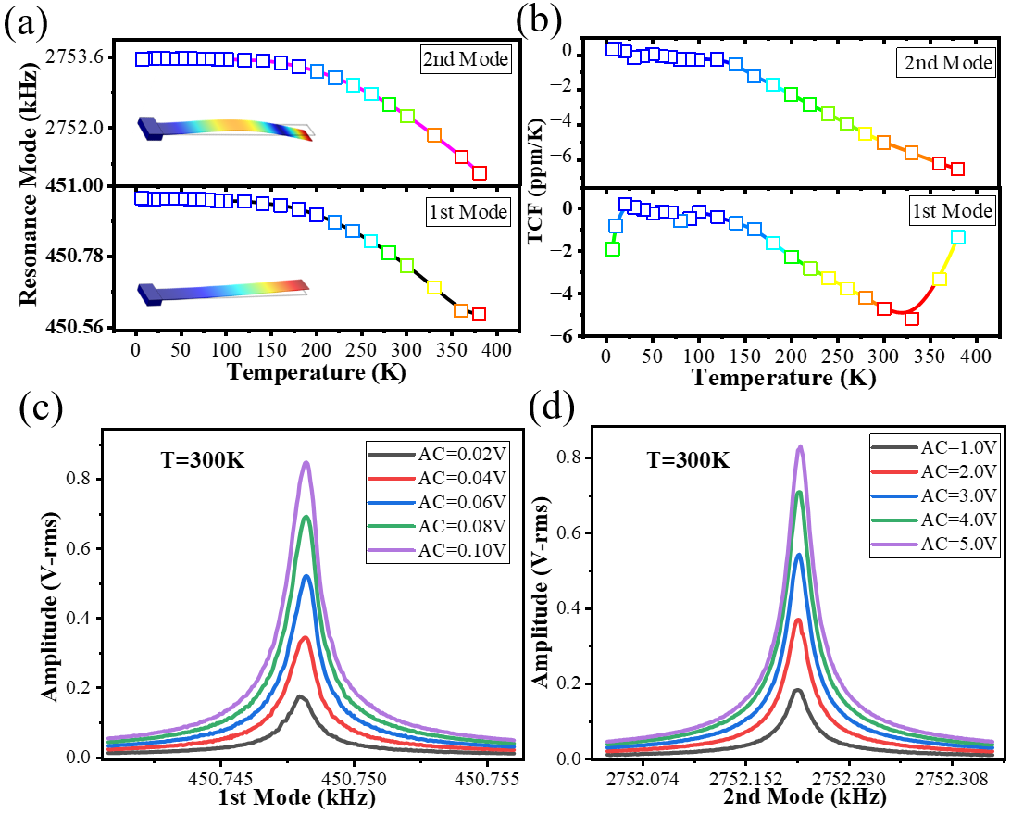
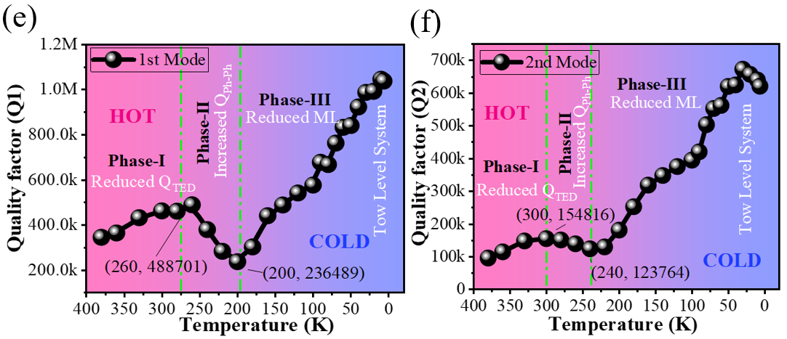
Figure 2 Resonance properties at different temperatures. Typical resonance spectra for the 1st (a) and 2nd (b) modes at 300 K, which is operated in the linear region. Q factor dependence on the temperature from 6.5 K to 380 K for the 1st (c) and 2nd (d) resonance modes (e) temperature dependent resonance frequency and (f) TCF at different temperatures. All the displacement measurements were performed by positioning the laser spot at the tip of the micro beam for maximum sensitivity[27].

2.3 Temperature Sensing Performance
By fully leveraging the high Q factor and low TCF of the SCD MEMS cantilever resonators, we achieved ultra-high resolution and low-noise thermometry. The underlying mechanism relies on the changes in the resonance frequency caused by the thermally induced variations in the Young’s modulus and the thermal expansion effect on the effective length together (See the movies in Supplementary Information ). These relationships can be expressed as:
E(T)=E₀ (1-α_{E}·ΔT) (2)
L(T)=L₀ (1+α_{L}·ΔT) (3)
where E₀ and L₀ are the original modulus and length at a reference temperature T₀, respectively, α_{E} and α_{L}, respectively, are temperature coefficient and expansion coefficient, ΔT represents temperature variation[31-33]. The resonant thermometer operates by tracking resonance frequency shifts as the temperature varies. While the frequency shift caused by thermal expansion of diamond is negligible, the dominant effect stems from temperature-induced variation in the elastic modulus. Owing to the high crystal quality and ultra-high Q factors of the SCD cantilever, the frequency shifts and temperature coefficient factor (TCF) can be predicted with exceptional precision (Figure 2).
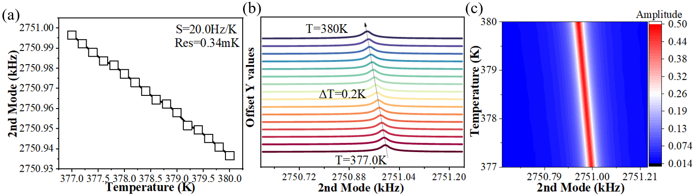
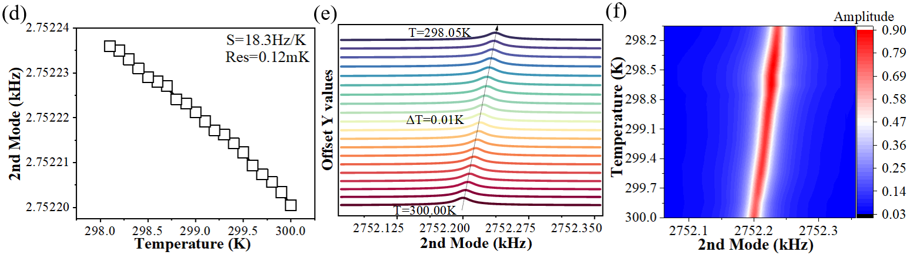
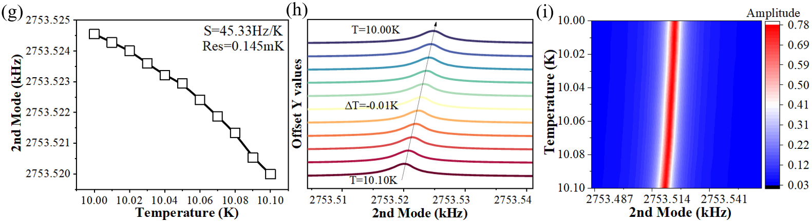

Figure 3 Precise temperarture sensing performance of a high-Q diamond cantilever resonator operating at the 2nd resonance mode at differernt tempreatures. Resonance frequency dependence on temperature (i), frequency spectra (ii), and image of resonance variation frequency and temperature (iii) at differerent temperatures. (a) near 380 K, (b) near 300 K, and (c) near 10 K . The image in (iii) The gradient color mapping also reflecting variations of the resonance frequency and Q factor with temperature
We measured the resonance frequency as a function of temperature variation within the linear region, initially focusing on the first resonance mode for temperature sensing (Figure S5). The resonance frequency decreases as the temperature increases. Around 10 K, the temperature senstivity is approximately 9.0 Hz/K ( Figure S5a), which reduces to around 2.0Hz/K at higher temperture of 380 K (Figure S5b,c). Desite the low sensitivity at the high temperature, the high Q-factor enables the detection of very small frequency changes, facilitating high resolution temperature sensing. At low temperature, such as 10 K, an actual temperature resolution of 0.01K is achieved (Figure S5b). As the tempersture rises above 30K , the resolution decreases (Figure S5 j,k,l), indicating a temperature-dependent degration in sensitivity.
Operation at the 2nd resonance mode significantly enhances both senstivity and temperature resolution (Figure 3). For example, at high temperatures near room temperature and high temperatures, i.e. 380K, the senstivity is improved to be ~20Hz/K (Figure 3a,b), which is ten times greater than that of the 1st mode (2 Hz/K). At low temperature such as 10 K (Figure 3c), the temperature sensitivity is improved to be ~45 Hz/K. The high Q factor and the increased temperature senstivity for the 2nd resonance mode enable precise temperature detection with a step resolution of 0.01K down to cryogenic temperatures (Figure 3a-ii). For temperature above 100 K, the resolution of 0.1 K is achieved, even at 380 K (Figure 3b,c-ii). It worth to mentioning that the temperature resolution of our temperture controller is 0.01K for the temperature below 100 K and 0.1 K for temperatures over 100 K. Therefore, for the 2nd mode resonance, the actuation temperature resolution is superior to those of the temperature control system. In Figure 3 a-iii, b-iii, and c(iii) we present the colored mapping curves of the temperature dependent resonance freqeuncy shift for the second mode. Althogh the overall frequency shift with temperature variation is not linear, a linear behavior can be obseved within a limited temperature range, as indicated by the color gradient on map. The bandwidth of the color gradient reflects to the Q-factor, which remains nealy constant in the linear domain, further highlighting minimal fluctuations and reinforcing the system’s robustness for high-resolution sensing. Additional color-maping comparision results for the first two modes can be tracked in Supplementary Information (Figure S6). Furthermore, the amplitude of the resonance stays relatively constant over a small temperature range, further validating the system's reliability without signal degradation (Figure S7). The SCD cantilever effectively detects temperature variation by tracking the resonance frequency changes with temperature. The real temperature mornitoring by the SCD cantilevers for different modes was conducted at different temperatures from 10 K to 380 K. Shown in Figure 4 is the typical temporal resonse to temperature change. One can see the distinguished resonance frequency shift with temperature. Note that the slow response time is limited by the temperature controller.
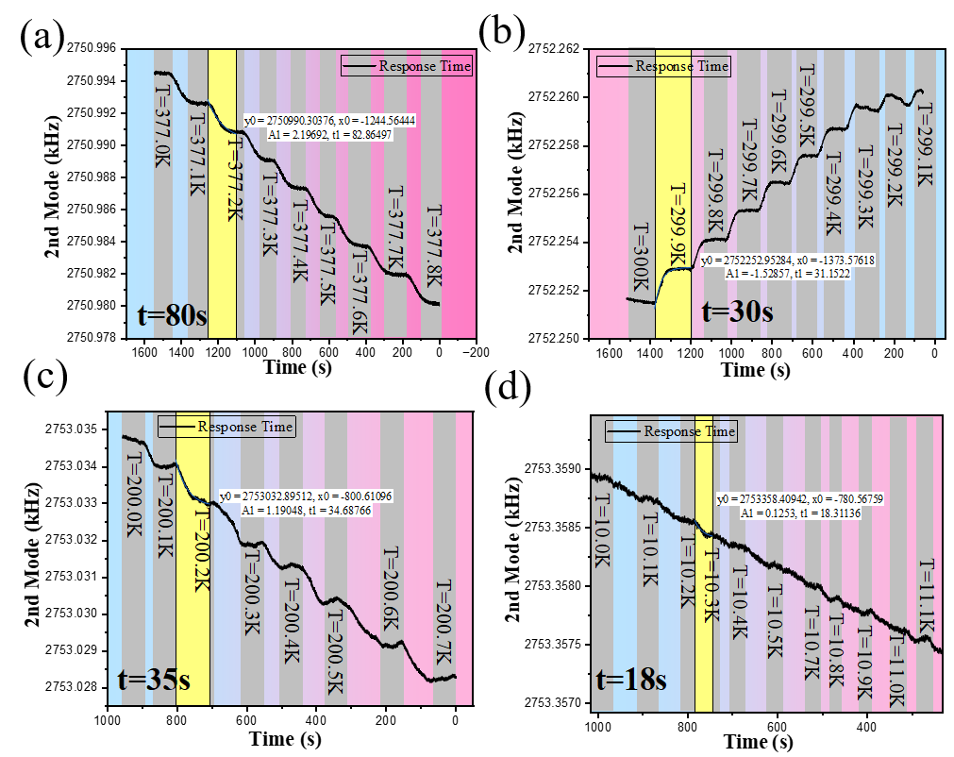
Figure 4 Temperature sensing performance in real time at different temperatures (a) high temperatures near 380 K, (b) near room temperature 300 K, (c) and (d) low temperatures near 200 K and 10 K, respectively.
To accurately evaluate the temperature resolution and thermal noise of the high-Q factor, we analyzed the frequency stability of the SCD cantilever with a sampling rate of 1799Sa/s, due to the limitation of our temperature controller . A phase lock loop (PLL) was also utilized to assess the frequency stability by tracking the frequency fluctuation over time. The frequency stability was analyzed based on the theory of Allan deviation [34, 35] with different bandwidths (BW) of 1 Hz, 50Hz, and 100 Hz. Figure 5a and 5b show the Allan deviation (BW=50Hz) at 30 K and 380 K of the 2nd resonance mode, respectively. At 30 K, the minimal Allan deviation at BW=50 Hz is around 7mHz, and it changes little as the the tempreature increases up to 100 K. Using the temperature sensitivity near a given temperature (Figure S7), the minimum detectable temperature is markedly improved to be approximately 0.1 mK for the 2nd mode. Interesingly, at high temperature near 380K, the Allan deviation does not change significantly at BW=50Hz. Due to the reduced sensitivity (~20Hz/K), the temperature resolution decreases to ~0.3 mK. We also investigated temperature resolution of the 1st resoance mode of the SCD cantilever. TAs shown in Figure S8, a temperature resolution from 2-5 mK was estimated for the temperatures from 10 K to 380K. The degradation in temperature resolution for the 1st mode is primarily due to the reduced temperature sensitivity. Therefore, the SCD cantilever demonstrates high-temperature sensitivity across both cryogenic and high-temperature range. Leveraging higher-order resonance modes significantly enhances the resolution and sensitivity of the SCD cantilever thermometer, making it highly effective for detecting minute temperature changes in precision sensing applications.
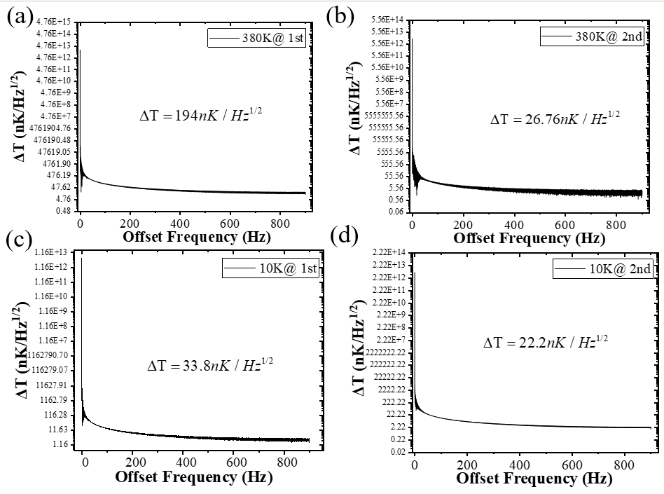
Figure 5 Allan deviation ( BW=50 Hz) at (a) 10 K and (b) 380 K for the 2nd resonance mode. Noise level at (c) 10 K and (d) 380 K for the 2nd resonance mode.

For resonant-type MEMS sensors, thermal noise limits the ultimate sensing performance. Figure 5c, d illustrates the noise performance for the 2nd modes at two distinct temperatures, 10 K and 380K, respectively. The 2nd mode demonstrates a significantly better sensitivity, with noise level of ~27 nK⸱Hz^{-1/2} at 380 K compared to the 1stresonance mode, which has a noise level of approximately ~ 194 nK⸱Hz^{-1/2} at the frequency of 50 Hz ​(Figure S9). At 10K, the noise level further improves to ~ 22 nK⸱Hz^{-1/2}. The low thermal noise level is primarily attributed to the low TCF of diamond, which is less than -7 ppm/K. While the low TCF results in reduced thermal sensitivity, high resonance modes offers an effective solution for high-precision thermometry. Specifically, the SCD cantilever can be used as thermometry in devices or applications requiring precise temperature control.
We compare the sensing performance of the-state-of-the-art thermometers, including the conventional thermocouples, thermistor, optical waveguides, advanced optical resonators, and quantum sensors, in terms of resolution, noise level, temperature range and size, listed in Table 1. The MEMS based-sensors made from different materials, such as silicon, GaAs, nano-diamond, and AlN is also shown. Most sensors operate at a single mode, with principles based on resistance, wavelength shifts, lattice strain or frequency shifts. Operational temperature ranges vary considerably: silicon-based devices are typically limited to room temperature or slightly lower, while GaAs and AlN sensors extend to broader ranges, including cryogenic temperatures. Nano-diamond sensors focus on narrower temperature ranges, emphasizing high precision in specific applications, but their temperature sensing range, resolution and noise limit are still constrained.
However, our work utilizes micro-diamond, a material known for its superior thermal conductivity and mechanical stability, which enables exceptional performance under extreme conditions. This material exhibits an impressive temperature range from 380K to 6.5K, effectively covering both high and cryogenic temperatures, making it highly versatile. Additionally, the proposed temperature sensor achieves sensitivities of 2 Hz/K in the 1st mode and 45 Hz/K in the 2nd mode, striking an optimal balance between high precision and a wide operational range. Furthermore, with a noise limit of 22 nK/Hz^{1/2} and a resolution of 100 µK, our device ranks among the most precise in the comparison, allowing for the detection of minute temperature variations.
The proposed sensor stands out due to its dual-mode operation, leveraging both the 1st and 2nd resonance modes. This dual-mode strategy enhances versatility by enabling the optimization of sensitivity, resolution, and response time based on specific application requirements. The combination of micro-diamond material, a high Q-factor and dual-mode operation positions the sensor as groundbreaking innovation in MEMS-based temperature sensing. It outperforms other existing solution in terms of versatility, precision, and applicability, particularly for high-resolution sensing in extreme environments.
Table1 illustrates the comparisons performance of different type of temperature sensors

Ref | Type MEMS |  | Material | Sensing mode | T-Range  (K) | Resolution | Noise Limit
[36] | Ring Resonator |  | Silicon | Wavelength | [180 300] | 31.3mK | NA
[37] | Bridge |  | Silicon | 1st 2nd | [309, 310] | NA | 234µK/Hz^{1/2}
[13] | Fabry-Perot Resonator |  | GaAs |  | [30, 306] | 100nK | 0.01µK/Hz^{1/2}
[38] | MEMS Resonator |  | Pt on Silicon | Resistance | [299, 386] | NA | NA
[39] | lattice strain changes |  | Nano-Diamond | 1st | [295, 305] | 1mK | 5mK/Hz^{1/2}
[40] |  | Nanoscale thermometry | Nano-Diamond |  | [297, 298] | 1.8mK | NA
[41] |  | Acoustic MEMS | AlN | S0 Mode | [248, 373] | NA | NA
[42] |  | Micro-Ring Resonator | Silicon | Wavelength | [10, 240] | NA | NA
[43] |  | MEMS-based programmable oscillator | Silicon | Frequecny ratio | [228, 378] | 20 µK | NA
[44] |  | Optical ring resonator | Silicon |  | [288, 306] | 1mK | 80 µK
This work |  | Mechanical Cantilever Resonator | Diamond | 1st 2nd | [380, 6.5] | 100uK | 22nK~40nK/Hz^{1/2}

5. Conclusion
In this work, we demonstrate a thermometer based diamond MEMS resonator that can achieve ultra-high-resolution and extensive range temperature sensing simultaneously. The proposed sensor operates in two distinct modes: Easy-use-Mode (1st mode) for straightforward operating and Ultra-high-Mode (2nd mode) to enhancing resolution across the wide sensing range. The obtained results reveal that, in higher order modes, sensitivity is enhanced up to 10 times compared to the Easy-Use-Mode. Remarkably, the sensor achieves a resolution a fine as 100 uK and noise floor of 22 nK/Hz^{1/2}, setting new benchmarks for temperature sensors globally. The ability to switch between modes provides significant flexibility, enabling the resonator to be optimized for diverse sensing requirements. This dual-mode capability highlights the system’s versatility, precision, and effectiveness as a state-of-the-art high-resolution temperature sensor.

Supporting Information
Supporting Information is available from the Wiley Online Library or from the author.

Acknowledgements
This work was supported by JSPS KAKENHI (No. Grant Number 24KF0085, 24H00287, 22K18957) and ARIM (JPMXP1223NM5297) sponsored by the Ministry of Education, Culture, Sports, and Technology (MEXT) of Japan.

Received: ((will be filled in by the editorial staff))
Revised: ((will be filled in by the editorial staff))
Published online: ((will be filled in by the editorial staff))

((For Reviews and Perspectives, please insert author biographies and photographs here for those authors who should be highlighted, max. 100 words each))

Author Photograph(s) ((40 mm broad, 50 mm high, color or grayscale))

[1] T. Muñoz‐Ortiz et al., "3D Optical Coherence Thermometry Using Polymeric Nanogels," Advanced Materials, vol. 35, no. 33, p. 2301819, 2023.
[2] S. Hong et al., "Sub-nanowatt microfluidic single-cell calorimetry," Nature communications, vol. 11, no. 1, p. 2982, 2020.
[3] C. D. Brites et al., "Spotlight on luminescence thermometry: basics, challenges, and cutting‐edge applications," Advanced Materials, vol. 35, no. 36, p. 2302749, 2023.
[4] J. Yin et al., "Diamond with Sp 2-Sp 3 composite phase for thermometry at Millikelvin temperatures," Nature Communications, vol. 15, no. 1, p. 3871, 2024.
[5] S. Liu et al., "Efficient Thermal Management with Selective Metamaterial Absorber for Boosting Photothermal CO2 Hydrogenation under Sunlight," Advanced Materials, p. 2311957, 2024.
[6] J. Liang et al., "Fabrication of GaN/diamond heterointerface and interfacial chemical bonding state for highly efficient device design," Advanced Materials, vol. 33, no. 43, p. 2104564, 2021.
[7] Y. Zhang, W. Zhu, F. Hui, M. Lanza, T. Borca‐Tasciuc, and M. Muñoz Rojo, "A review on principles and applications of scanning thermal microscopy (SThM)," Advanced functional materials, vol. 30, no. 18, p. 1900892, 2020.
[8] H. Zhao et al., "Hot hydrocarbon‐solvent slot‐die coating enables high‐efficiency organic solar cells with temperature‐dependent aggregation behavior," Advanced materials, vol. 32, no. 39, p. 2002302, 2020.
[9] G. Li et al., "Structure and performance evolution of perovskite solar cells under extreme temperatures," Advanced Energy Materials, vol. 12, no. 48, p. 2202887, 2022.
[10] S. Sadat, E. Meyhofer, and P. Reddy, "High resolution resistive thermometry for micro/nanoscale measurements," Review of Scientific Instruments, vol. 83, no. 8, 2012.
[11] D. McCammon, "Semiconductor thermistors," Cryogenic Particle Detection, pp. 35-62, 2005.
[12] P. Neumann, "Nanoscale temperature sensing using single defects in diamond," 2014.
[13] A. Reihani, E. Meyhofer, and P. Reddy, "Nanokelvin-resolution thermometry with a photonic microscale sensor at room temperature," Nature Photonics, vol. 16, no. 6, pp. 422-427, 2022.
[14] Z. Wang et al., "A 7.25 μK Ultra-High Resolution MEMS Resonant Thermometer," IEEE Sensors Journal, 2024.
[15] H.-Y. Ma, Q.-A. Huang, M. Qin, and T. Lu, "A micromachined silicon capacitive temperature sensor for wide temperature range applications," Journal of Micromechanics and Microengineering, vol. 20, no. 5, p. 055036, 2010.
[16] M. M. Othayq, N. Giganti, and M. Shavezipur, "Development of capacitive temperature sensors with high sensitivity using a multiuser polycrystalline silicon process," Microelectronic Engineering, vol. 226, p. 111287, 2020.
[17] S. Taniker, V. Costanza, P. Celli, and C. Daraio, "Capacitive temperature sensing via displacement amplification," IEEE Sensors Journal, vol. 22, no. 11, pp. 10388-10395, 2022.
[18] M. Liao, "Progress in semiconductor diamond photodetectors and MEMS sensors," Functional Diamond, vol. 1, no. 1, pp. 29-46, 2022.
[19] W. Zhao, S. Koizumi, and M. Liao, "P-channel MOSFETs on phosphorous-doped n-type diamond," IEEE Electron Device Letters, 2024.
[20] Z. Zhang, K. Gu, G. Chen, M. Imura, and M. Liao, "Electrical actuation of single-crystal diamond MEMS resonators at high temperatures," Functional Diamond, vol. 4, no. 1, p. 2346085, 2024/12/31 2024, doi: 10.1080/26941112.2024.2346085.
[21] R. Zulkharnay and P. W. May, "Applications of diamond films: a review," Functional Diamond, vol. 4, no. 1, p. 2410160, 2024/12/31 2024, doi: 10.1080/26941112.2024.2410160.
[22] H. Sun et al., "Effect of deep-defects excitation on mechanical energy dissipation of single-crystal diamond," Physical review letters, vol. 125, no. 20, p. 206802, 2020.
[23] C. E. Nebel, "CVD diamond: a review on options and reality," Functional Diamond, vol. 3, no. 1, p. 2201592, 2023.
[24] Z. Zhang et al., "On‐chip diamond MEMS magnetic sensing through multifunctionalized magnetostrictive thin film," Advanced Functional Materials, vol. 33, no. 27, p. 2300805, 2023.
[25] T. Kose, K. Azgin, and T. Akin, "Design and fabrication of a high performance resonant MEMS temperature sensor," Journal of Micromechanics and Microengineering, vol. 26, no. 4, p. 045012, 2016.
[26] M. Liao, S. Hishita, E. Watanabe, S. Koizumi, and Y. Koide, "Suspended single‐crystal diamond nanowires for high‐performance nanoelectromechanical switches," Advanced Materials, vol. 22, no. 47, pp. 5393-5397, 2010.
[27] W. Zhao, R. T. Rocha, N. Alcheikh, and M. I. Younis, "Dynamic response amplification of resonant microelectromechanical structures utilizing multi-mode excitation," Mechanical Systems and Signal Processing, vol. 196, p. 110347, 2023.
[28] W. Zhao, N. Alcheikh, F. Khan, U. Yaqoob, and M. I. Younis, "Simultaneous gas and magnetic sensing using a single heated micro-resonator," Sensors and Actuators A: Physical, vol. 344, p. 113688, 2022.
[29] W. Weaver Jr, S. P. Timoshenko, and D. H. Young, Vibration problems in engineering. John Wiley & Sons, 1991.
[30] H. A. Tilmans, M. Elwenspoek, and J. H. Fluitman, "Micro resonant force gauges," Sensors and Actuators A: Physical, vol. 30, no. 1-2, pp. 35-53, 1992.
[31] U. Gysin et al., "Temperature dependence of the force sensitivity of silicon cantilevers," Physical review B, vol. 69, no. 4, p. 045403, 2004.
[32] J. Wachtman Jr, W. Tefft, D. Lam Jr, and C. Apstein, "Exponential temperature dependence of Young's modulus for several oxides," Physical review, vol. 122, no. 6, p. 1754, 1961.
[33] R. Lifshitz and M. L. Roukes, "Thermoelastic damping in micro-and nanomechanical systems," Physical review B, vol. 61, no. 8, p. 5600, 2000.
[34] P. Sadeghi, A. Demir, L. G. Villanueva, H. Kähler, and S. Schmid, "Frequency fluctuations in nanomechanical silicon nitride string resonators," Physical Review B, vol. 102, no. 21, p. 214106, 2020.
[35] D. Antonio, D. H. Zanette, and D. López, "Frequency stabilization in nonlinear micromechanical oscillators," Nature communications, vol. 3, no. 1, p. 806, 2012.
[36] M. You, Z. Lin, X. Li, and J. Liu, "Chip-scale silicon ring resonators for cryogenic temperature sensing," Journal of Lightwave Technology, vol. 38, no. 20, pp. 5768-5773, 2020.
[37] C. Li et al., "On enhancing the sensitivity of resonant thermometers based on parametric modulation," Journal of Microelectromechanical Systems, vol. 30, no. 4, pp. 539-549, 2021.
[38] J. Wu et al., "Multifunctional and high-sensitive sensor capable of detecting humidity, temperature, and flow stimuli using an integrated microheater," ACS applied materials & interfaces, vol. 11, no. 46, pp. 43383-43392, 2019.
[39] P. Neumann et al., "High-precision nanoscale temperature sensing using single defects in diamond," Nano letters, vol. 13, no. 6, pp. 2738-2742, 2013.
[40] G. Kucsko et al., "Nanometre-scale thermometry in a living cell," Nature, vol. 500, no. 7460, pp. 54-58, 2013.
[41] H. Campanella, M. Narducci, S. Merugu, and N. Singh, "Dual MEMS resonator structure for temperature sensor applications," IEEE Transactions on Electron Devices, vol. 64, no. 8, pp. 3368-3376, 2017.
[42] X. Zhu, Z. Lin, X. Li, B. Yang, J. Liu, and M. You, "Wide-range and ultra-low temperature thermometer based on a silicon resonator," Optics Letters, vol. 49, no. 21, pp. 6101-6104, 2024.
[43] M. H. Roshan et al., "A MEMS-Assisted Temperature Sensor With 20-$\mu\text {K} $ Resolution, Conversion Rate of 200 S/s, and FOM of 0.04 pJK2," IEEE Journal of Solid-State Circuits, vol. 52, no. 1, pp. 185-197, 2016.
[44] H. Xu, M. Hafezi, J. Fan, J. Taylor, G. F. Strouse, and Z. Ahmed, "Ultra-sensitive chip-based photonic temperature sensor using ring resonator structures," Optics Express, vol. 22, no. 3, pp. 3098-3104, 2014.

