Focal Adhesion and Actin Orientation Regulated by Cellular Geometry Determine Stem Cell Differentiation via Mechanotransduction

Xinlong Wang,^{a,b} Yingjun Yang,^{a,b} Yongtao Wang,^{a,b} Chengyu Lu,^{a,b} Xiaohong Hu, ^{a,c} Naoki Kawazoe,ª Yingnan Yang ^{c} and Guoping Chen ^{a,b,*}
ªResearch Center for Macromolecules and Biomaterials, National Institute for Materials Science, 1-1 Namiki, Tsukuba, Ibaraki 305-0044, Japan.
^{b}Graduate School of Science and Technology, University of Tsukuba, 1-1-1 Tennodai, Tsukuba, Ibaraki 305-8571, Japan.
^{c}Graduate School of Life and Environmental Science, University of Tsukuba, 1-1-1 Tennodai, Tsukuba, Ibaraki 305-8571, Japan.
*Corresponding author: Prof. Guoping Chen, E-mail: Guoping.CHEN@nims.go.jp; Tel: 81- 29-860-4496, Fax: 81-29-860-4673

Keywords: micropattern, adhesion geometry, curvature degree, cytoskeleton force, mesenchymal stem cells, osteogenic differentiation

Abstract: Tuning cell adhesion geometry can affect cytoskeleton organization and the distribution of cytoskeleton forces, which play critical roles in controlling cell functions. To elucidate the geometrical relationship with cytoskeleton force distribution, it is necessary to control cell morphology. In this study, a series of dextral vortex micropatterns were prepared to precisely control cell morphology for investigating the influence of the curvature degree of adhesion curves on intracellular force distribution and stem cell differentiation at a sub-cellular level. Peripherial actin filaments of micropatterned cells were assembled along the adhesion curves and showed different orientations, filament thicknesses and densities. Focal adhesion and cytoskeleton force distribution were dependent on the curvature degree. Intracellular force distribution was also regulated by adhesion curves. The cytoskeleton and force distribution affected the osteogenic differentiation of mesenchymal stem cells through a YAP/TAZ-mediated mechanotransduction process. Thus, regulation of cell adhesion curvature, especially at cytoskeletal filament level, is critical for cell function manipulation.

1. Introduction
Mechanotransduction refers to the process that cells transmit intracellular force through the cytoskeleton in response to their surrounding microenvironment [1]. Intracellular force is generated through the interactions of motor proteins with the cytoskeleton structures [2]. During this process, focal adhesion (FA) sites that are tightly associated with the cytoskeleton serve as mechanosensors and transmitters [3, 4]. Depending on the adhesion environment, cells may develop diverse cytoskeleton structures and have different mechanical states [5]. In turn, the transmitted cytoskeleton force causes the deformation of the extracellular matrix (ECM) which regulates the cell morphogenesis [6, 7]. Cytoskeleton force has been reported to play critical roles in many cell behaviors such as migration, proliferation and differentiation [8]. Elucidation of the influence of cell adhesion environment on the cytoskeleton organization and force distribution is important to understand the interactions between biomaterials and cells which will make great contributions to the development of biomaterials for manipulation of cell functions.
Chirality is a widely observed intriguing biological phenomen happened ranging from the molecular to the tissue level. At the nano-scale, chiral molecules such as poly-_{L}(_{D})-lysine, N-isobutyryl-_{L}(_{D}) cysteine) and _{L}/_{D}-cysteine were reported to affect cell adhesion, as well as differentiation of various cell types [9-11]. At the macro-scale, left-right asymmetry is established during embryonic development which consequently affects tissue and organ formation, positioning, and functions [12-14]. At the intermediate micro-scale, cell, as the basic unit of most living creatures, was also reported to be able to distinguish between left and right on micro-engineered surfaces [15-17]. In addition, single cell chirality was observed on isotropic circular microislands which arose from the self-organization of actin filaments [18, 19]. More recently, in our group, we developed a series of micropatterns with various swirling stripe lines to regulate the chirality of cell focal adhesions (FAs) to investigate their influences on cytoskeleton development and gene transfection [20]. We disclosed that the left-/right-handed FAs did not significantly affect cell behaviors, but the swirling angles did, indicating that finely tuning the cell adhesive environment can effectively manipulate cell functions.
The cell adhesive environment includes complex topologies with diverse curvatures ranging from convex geometry to concave pattern [21]. Using micropatterned surfaces, the influence of curvature on cell behaviors including cell migration, stem cell differentiation and cancer cell reprogramming have been investigated at the multi-cell level [22-24]. These effects can be attributed to changes in the spatial distribution and local magnitude of traction stress, regulated by the local curvature of the cell [25]. More recently, at the molecular level, researchers identified various curvature-sensing peptides and proteins that regulate cell behaviors [26-28]. However, only a few studies have reported the single cell response to the variation of curvature degrees at the sub-cellular level. In vitro, the curvature of cell adhesion has been reported to affect the polarity and migration of cancer cells [29]. Theoretical modeling has also predicted that cell adhesion orientation would influence cell shape, which has been reported to impact many cell functions [30]. In vivo, tissue morphogenesis is primarily driven by intracellular forces, mainly produced through cytoskeleton assembly, intimately related to adhesion orientation [31]. Therefore, there is an urgent need to investigate the influence of cell adhesion orientation on stem cell fate determination at the sub-cellular level.
In our previous study, we reported that the swirling angle of FAs could affect cytoskeleton assembly that regulate cellular uptake and gene transfection at the single cell level [20]. However, the influence of chiral curvature degrees on cytoskeleton organization and cytoskeleton force distribution, especially their regulation in the consequent mechanotransduction process as well as on stem cell differentiation remains elusive. Therefore, in this study, we prepared a series of dextral micro-vortexes with different curvature degrees by UV lithography. We revealed that such kinds of micropatterned geometries can affect cell adhesion by regulating FA formation and their connection with the cytoskeleton structure. Consequently, the local and global distribution of intracellular force is regulated to determine stem cell fate through the YAP/TAZ-mediated mechanotransduction process that intimately related to stem cell fate determination. (Figure 1).

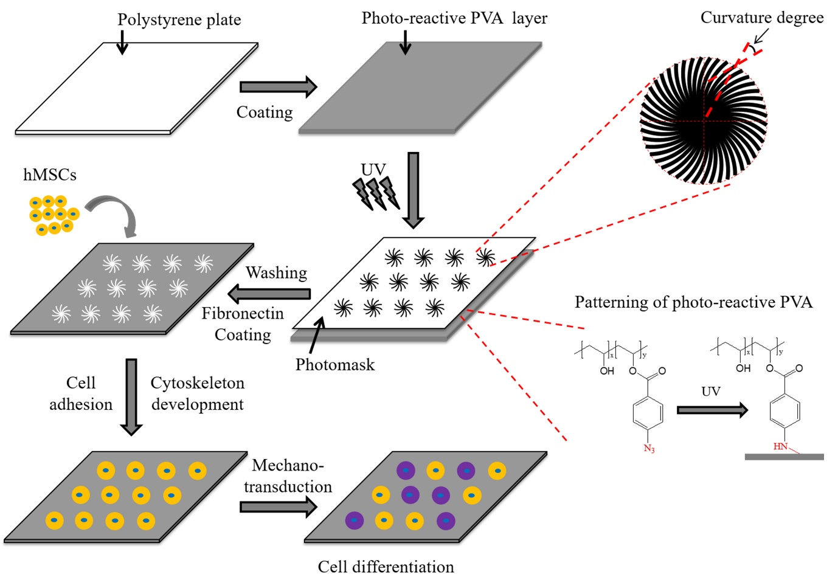
Figure 1. Schematic illustration of the study. Photo-reactive PVA micropatterned TCPS surfaces were prepared using UV lithography. The influence of curvature degree on cytoskeleton force distribution and stem cell differentiation was investigated.

2. Materials and Methods
2.1. Preparation of the micropatterns
The photo-reactive poly(vinyl alcohol) (PVA) micropatterned tissue culture polystyrene (TCPS) surfaces were prepared using UV lithography according to previous report [28]. Briefly, 200 μl 0.3 mg/ml photo-reactive PVA solution was dropped onto the TCPS plate (BD Falcon) within 1.5 × 1.5 cm² area and air-dried in the dark at room temperature. Then the plate was covered with a photomask and irradiated with UV light (Funa-UV-linker FS-1500) to immobilize the PVA onto the TCPS plate. After irradiation, the plate was washed with ultrasonic to completely remove any unreacted polymer. The micropatterns were sterilized by immersion in 70% ethanol followed by aseptic water washing. To enhance cell adhesion, the sterilized micropatterns were incubated with 20 μg/ml fibronectin (Sigma-Aldrich) in NaHCO₃ (pH = 8.4) solution for 1 h followed by exhaustive washing in NaHCO₃ and aseptic Milli-Q water. And then the micropatterns were directly used for cell culture.

2.2. Characterization of the micropatterns
Surface topography of the micropatterns was scanned with a MFP-3D-BIO atomic force microscope (Asylum Research). A commercially available cantilever (spring constant: 0.6 N/m; oscillation frequency: 18 kHz; DNP, Bruker) was used to measure the samples in Milli-Q water in a contact mode. The scan size was 80 × 80 μm². The size and depth of the micropattern were analyzed according to the section view of the scanning images. Three randomly selected micropatterns were measured to calculate the means and standard deviations. To confirm the adsorption of fibronectin, the coated micropatterns were incubated with mouse anti-fibronectin antibody (1:100, Santa Cruz Biotechnology, sc-59826) at 4 °C overnight. And then the micropatterns were washed and incubated with Alexa Fluor-488 labeled goat anti-mouse IgG antibody (1:800, Invitrogen, A-11001) at room temperature for 1 h. After washing, the fluorescence images were observed with an Olympus BX51 microscope with a DP-70 CCD camera (Olympus).

2.3. Cell culture
Human bone marrow derived mesenchymal stem cells (MSCs, passage 2) were purchased from Lonza Walersville, Inc. (PT-2501, Lot: 2F3478, 43 years old black male), and subcultured using MSCGM medium (MSCBM supplemented with 10% serum, 2% L-glutamine and 0.1% gentamicin sulfate amphotericin b, Lonza). The cells at passage 4 were used in this study. A glass ring (inner diameter 1.5 cm) was placed over each micropattern to prevent cell leaking during cell seeding process. A 3 mL aliquot of serum-free medium (DMEM supplemented with 4500 mg/L glucose, 584 mg/L glutamine, 100 μg/mL penicillin-streptomycin, 0.1 mM NEAA, 0.4 mM proline and 50 mg/L ascorbic acid) was added to each well of the plate, and 200 μL cell suspension solution (serum-free) was added within the glass ring (3000 cells/cm²). After 6 hours, the glass rings were taken out and the medium was changed to serum-containing medium for cytoskeleton development. After culture for 24 h, the samples were either fixed with 4% paraformaldehyde for immunofluorescence staining, or were directly used for mechanical measurement at a living state. To disrupt actin structure, 0.2 μg mL−1 cytochalasin D (Sigma) in growth medium was applied to cells after 6 h post-seeding. After incubation for another 18 h, cells were fixed for YAP/TAZ staining. The osteogenic induction of micropatterned cells was performed by culturing them in osteogenic induction medium after one-day cell attachment according to previously published method [32]. The osteogenic induction medium was changed every two days. After 3 days induction, parts of cells were fixed for YAP/TAZ staining and osteopontin (OPN) staining.

2.4. Immunofluorescence staining
For vinculin staining, cells were treated with 1% Triton X-100 and 0.02% Tween-20 for 30 min. And then the samples were incubated with mouse anti-vinculin antibodies (Abcam, ab129002, 1:100 in Can Get Signal solution, Toyobo Co., Ltd.) at 37 °C for 1.5 h followed by washing with 0.02% Tween-20 for three times. Finally, the samples were incubated with Alexa Fluor-488 labeled goat anti-mouse IgG antibody (Invitrogen, 1:800, A-11001) at 37 °C for 1 h. For actinin and F-actin staining, cells were permeabilized with 1% Triton X-100 and blocked with 1% BSA solution. The samples were then incubated with mouse anti-actinin antibody (Abcam, 1:100, ab68194) at 4 °C overnight followed by PBS washing. Finally, the samples were incubated with Alexa Fluor-488 labeled goat anti-mouse IgG antibody (Invitrogen, 1:800, A-11001) and Alexa Fluor-594 phalloidin (Invitrogen, 1:40, A12381) solution at room temperature for 1 h. The 4’,6-diamidino-2-phenylindole (DAPI, Vector Laboratories, Inc.) was used to stain nuclei. For YAP/TAZ staining, the cells were fixed, permeabilized and blocked followed by incubation with anti-YAP/TAZ primary antibody (Santa Cruz Biotechnology, 1:100, sc101199) at 37 °C for 1h. After being rinsed by PBS, the samples were incubated with Alexa Fluor-488 labeled goat anti-mouse IgG antibody (Invitrogen, 1:1000, A-11001) at room temperature for 1 h. For OPN staining, cells were incubated with OPN primary antibody (Abcam, 1:100, ab63856) followed by Alexa Fluor-488 labeled goat anti-rabbit IgG antibody (Invitrogen, 1:1000, A-11008). The stained samples were observed and recorded through a fluorescence microscope (Olympus, Japan).

2.5. Image analysis
The staining images of vinculin, F-actin and actinin were analyzed using a software ImageJ according to previous report [33]. Briefly, the fluorescence images were firstly converted to 16-bit images. The individual vinculin length was analyzed based on the converted images. The angle between FA-associated actin and linking actin was measured using ‘Angel tool’. To measure the fluorescence yield of actinin and OPN, the micropatterned cells were selected as regions of interest. Cell size (S) and integrated signal intensity (I) were measured. The mean fluorescence (M) of the unpatterned region was measured as the background. And then the total fluorescence yield (TF) of the actinin and OPN in a micropatterned cell was described as: TF = I – (S × M). The distribution of F-actin in micropatterned cells was evaluated according to the heatmap generated from staining images [34]. Nuclear morphological features were analyzed accoding to a previous report using an imageJ software [35]. More than 20 cells of 3 independent experiments were used for these analysis.
The YAP/TAZ localization in cells was analyzed through fluorescence images by using a software IamgeJ. The region at cytoplasm and nuclei part was selected to calculate the average fluorescence intensity in cytoplasm (AFI_{cytoplasm}) and nuclei (AFI_{nucleus}). The cells which YAP/TAZ was defined as the AFI_{nucleus} was two times higher than AFI_{cytoplasm} were defined as cells having nuclear localized YAP/TAZ. The other cells were defined as cells without nuclear localized YAP/TAZ. DAPI staining was used to count the total cell number in each sample and the percentage of hMSCs with nuclear localized YAP/TAZ to the total cell number was calculated. More than 300 cells from 3 independent experiments were analyzed.

2.6. Cell mechanics measured by AFM
Cytoskeleton force was evaluated based on cell stiffness measurement by using AFM nanoindentation according to previous report [36]. The micropatterned cells were cultured for 24 h and directly used for mechanical test under a living condition. A silicon nitride cantilever (Novascan) coated with reflective gold was used for force indentation. The cantilever has a silica glass ball with a diameter of 600 nm attached to the end as the probe. Using the thermal tuning method, the exact spring constant of the cantilever was measured. An optical microscope was used to visualize the micropatterned cells and the position of the cantilever. The measurement was performed within 1.5 hours to minimize cell death during the experiment. The force distance curves were collected in the periphery region of cells at an indentation rate of 4 μm/s with a trigger force of 2 nN to avoid any damage to the cell surface. The obtained force curves were fitted to Hertz’s contact model to calculate the Young’s modulus. Ten force curves were obtained from each cell. And more than 20 cells of 3 independent experiments were measured in each group. To analyze the force distribution, the histogram of the measured Young’s modulus was fitted using the Kernel density plot. The average Young’s modulus of the 20 cells was considered as the average force of the cells on the same type of micropattern.

2.7. Osteogenic differentiation and alkaline phosphatase staining
After the micropatterned MSCs were cultured in osteogenic induction medium for 2 weeks, the cells were rinsed by PBS and fixed by with 4% paraformaldehyde for 10 min. The fixed cells were rinsed by PBS and subsequently immersed in 56 mM 2-amino-2-methyl-1,3-propanediol (pH = 9.9, Sigma-Aldrich Co. LLC., USA) working solution containing 0.1 wt% naphthol AS-MX phosphate (Sigma-Aldrich Co. LLC., USA) and 0.1 wt% Fast Blue RR salt (Sigma-Aldrich Co. LLC., USA) at room temperature for 10 min. Optical images of the stained cells were obtained through an Olympus BX51 microscope with a DP-70 CCD camera (Olympus, Tokyo, Japan). The ALP staining density was analyzed by using a software ImageJ. The optical images were firstly processed with Color Deconvolution plugin of ImageJ to discriminate ALP positively stained and negatively stained cells. In the original optical images, color-specific vectors were assigned as purple and brown channels. The percentage of ALP positively stained cells to the total cell number was calculated (Figure S6). More than 300 cells from 3 independent experiments were used for the analysis. In addition, the ALP staining intensity of each positively stained cell was also analyzed. The ALP positively stained cells on the deconvoluted images were selected to calculate the mean gray value of cells (MGV_{cell}). On the other hand, the region on the micropatterns unoccupied with cells was selected as the background to calculate the MGV_{background}. The absolute value of the difference between MGV_{cell} and MGV_{background} was considered as the ALP staining intensity of single cell (Figure S7). More than 100 cells from 3 independent experiments were analyzed.

2.8. Statistical analysis
The data were presented as means ± standard deviations (SD) and violin plot. Statistical analysis was performed using a one-way analysis of variance (ANOVA) with Tukey’s post hoc test for multiple comparisons to confirm the significant differences among samples. Kyplot software (version 2.0 beta 15) was employed for these analyses. It was considered to be significantly different when p < 0.05.

3. Results
3.1. Cell morphology on dextral micro-vortexes
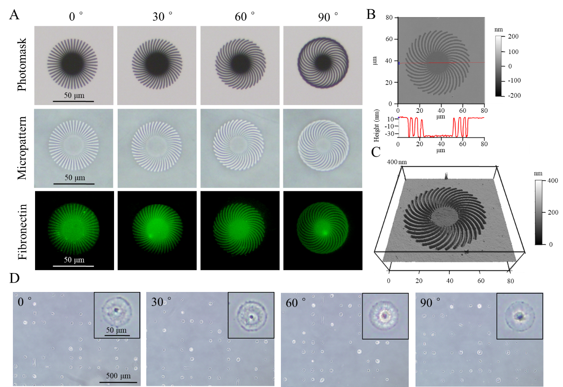
Figure 2. Characterization of the micropatterns. (A) Phase contrast micrographs of the photomasks and micropatterns with a curvature degree of 0°, 30°, 60° and 90°. The fluorescence images show the adsorbed fibronectin (green) on micropatterns. (B) Height and section and (C) 3D images of the micropattern with a curvature degree of 60°. (D) Cell attachment on the micropatterns. Insert images are typical cells with a high magnification.

The confirmation of micropattern formation was based on phase-contrast images (Figure 2A). Four distinct of micropatterns with curvature degrees of 0°, 30°, 60° and 90° were designed. For each type of the micropatterns, the length and number of the non-transparent curves were controlled to maintain a consistent cell adhesion area. These micropatterns faithfully replicated the geometry outlined in the designed photomasks. AFM scanning images of the micropatterns were acquired to analyze the dimension of the micropatterns (Figure 2B and C). The designed diameter of the micro-vortex was 60 μm and the width of the adhesion curves was 2 μm. Based on the section analysis, the measured diameters of the micro-vortexes were 60.12 ± 1.35 μm, 60.28 ± 0.54 μm, 60.52 ± 0.93 μm, and 60.65 ± 1.12 μm for micropatterns with curvature degrees of 0°, 30°, 60°, and 90°, respectively (Figure S1). Additionally, the width of the adhesion curves were 2.11 ± 0.09 μm, 2.06 ± 0.08 μm, 2.08 ± 0.15 μm, and 2.11 ± 0.17 μm for micropatterns with curvature degrees of 0°, 30°, 60°, and 90°, respectively. This suggests that the dimension of the micropatterns was effectively controlled using this preparation method. The average thickness of the PVA layer was 50.29 ± 0.78 nm. Fibronectin was applied to enhance cell adhesion, selectively adsorbing onto the TCPS surface due to the protein-resistant nature of the PVA layer [37]. There was no significant difference observed in the fibronectin-coated area among the different groups (Figure S2). Human bone marrow-derived mesenchymal stem cells (MSCs) were cultured on the micropatterns. After 6 h, the cells attached uniformly to the micropatterns, exhibiting a consistent round geometry across all designs (Figure 2D). This affirmed that fibronectin-coated micropatterns effectively regulated cell morphology, ensuring cells displayed identical size and shape while varying in adhesion geometries dictated by the micro-vortexes.

3.2. Focal adhesion formation and nuclear morphology are regulated by adhesive curvatures
The influence of curvature degree on cell adhesion was firstly evaluated by staining of vinculin, which is one of the major cytoplasmic domains associated with the FA [38]. Similar expression of immature FA at cell center was observed for all the 4 types of micropatterns according to the vinculin staining images (Figure 3A). In addition, at cell periphery region, the micropatterned cells (0°, 30° and 60°) formed clear FA that aligned along the adhesion micro-curves. However, on micropatterns with a 90° curvature, the majority of FAs aligned parallel to the radius, perpendicular to the designed adhesion pattern. Only a small portion of FAs displayed assembly along the adhesive curves, likely resulting from the fusion of perpendicularly assembled FAs. The observed connection of the edges of 90° micropatterns may facilitate the radial growth of FAs. The results indicated that the FA formation was dependent on the adhesion geometry.
Meanwhile, it was observed that the distance between each individual FA decreased with the increase of curvature degree at cell edge, attributed to the decrease of the non-adhesion area between the neighboring adhesion curves. The average length of individual periphery FA of cells on micropatterns with curvature degrees of 0°, 30°, 60° and 90° was 6.2 ± 1.1 μm, 5.3 ± 1.3 μm, 3.2 ± 0.9 μm and 5.5 ± 1.0 μm, respectively (Figure 3B). In general, the FA length decreased with an increase in curvature degree (except at 90°) indicating the adhesion curvature played a role in FA formation. Depending on the length, FA can be divided into three categories: focal complex (shorter than 1 μm in length), mature focal adhesion (in range of 1 to 5 μm) and super-mature adhesion (longer than 5 μm in length) [39, 40]. According to this criterion, all the micropatterned cells formed focal complexes at cell center, while assembled mature FAs at cell edge. Vinculin has been reported to be involved in force transmission process [4]. Especially the periphery vinculin assembly has important roles in regulation of cell adhesion strength [41]. Thus, the different orientation and length of individual FA should affect the cytoskeleton organization and cell mechanical state which in return regulate FA formation. Additionally, we assessed the influence of adhesive curvatures on nuclear morphology, as shown in Figure 3C and Figure S3. The nuclear project area and perimeter gradually decreased with an increase in curvature degrees from 0° to 60°, showing a significant difference between 0° and 60°. Meanwhile, the aspect ratio and roundness remained unchanged among the groups.

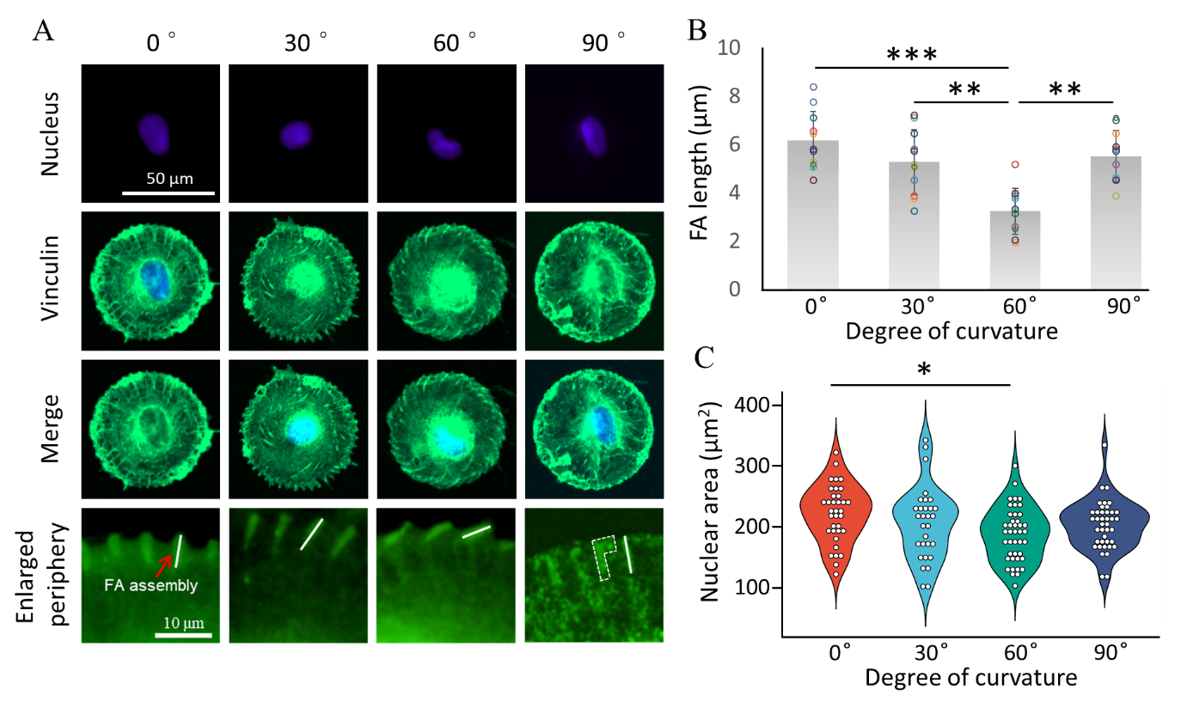
Figure 3. FA formation regulated by curvature degree of adhesive curves. (A) Typical vinculin (green) staining images of the micropatterned cells with a curvature degree of 0°, 30°, 60° and 90°. Nuclei (blue) were stained to show the single cells. Solid line indicates FA assembly and dashed line indicate fused FAs. (B) Average length of the individual FA of the micropatterned cells. Data are presented as mean ± SD, n>10 cells, N=3 biological replicates, **p < 0.01, ***p < 0.001. (C) Average nuclear size on various micropatterns (n>30 cells, N=3 biological replicates, *p < 0.05).

3.3. Cytoskeleton organization depends on adhesive curvatures
To investigate the influence of curvature degree on cytoskeleton organization, the actin filaments and their binding protein actinin were stained (Figure 4A). Actin filaments, as one of the major cytoskeleton components, have critical roles in mechanosensing and mechanotransduction process [42-44]. Previous studies have divided the actin filaments into several subtypes such as the dorsal stress fibers and transverse arcs [45, 46]. In this study, the F-actin filaments were observed to assemble in both radial and concentric directions of the micro-vortexes which corresponded to the dorsal fibers and transverse arcs, respectively. Specifically, the radially assembled dorsal actin filaments were divided into two parts including the ‘FA-associated actin’ and the ‘linking actin’. FA-associated actin referred to the actin assembled at the cell periphery region, directly connected to mature focal adhesions (FAs), aligning along the adhesion curves of the micro-vortexes. Meanwhile, linking actin filaments extended from the FA-associated actin and grew toward the cell center. The angle (Ɵ) between the FA-associated actin and linking actin was measured to investigate the cytoskeleton orientation regulated by the micro-vortexes (Figure 4B). The Ɵ value of the cells on micropatterns with a curvature degree of 0°, 30°, 60° and 90° was 173.7 ± 6.1°, 147.3 ± 13.3°, 120.9 ± 12.8° and 174.7 ± 5.4°, respectively. Since the edge of the micropatterns with a curvature degree of 90° was continuously adhesive, the FA-associated actin assembled toward cell center in the same direction as the linking actin filaments grew. Besides orientation, the assembly of F-actin filaments was also regulated by the adhesive curvatures. As shown in Figure 4C, the average thickness of actin filaments decreased with the increase of curvature degree. The filament density remained similar on micropatterns with a curvature degree of 0°, 30°, 60°, but significantly higher at 90° (Figure 4D). The changes in F-actin orientation and assembly indicated the cytoskeleton organization was regulated by the adhesion microenvironment.
Dorsal stress fibers move toward cell center and weave together with transverse arcs and ventral fibers forming a perinuclear actin mesh [47-49]. The perinuclear actin networks are directly connected to nuclear envelop through linkers of nucleoskeleton and cytoskeleton (LINC) complexes, and play critical roles in various cell behaviors [50, 51]. Herein, besides the various actin orientations at cell edge, we also observed distinct actin distribution especially at cell center (top layer) that is the perinuclear region of the micropatterned cells (Figure S4). Although no obvious actin cap was observed above nucleus, the area of actin cortex at cell center decreased from 0° to 60°, and then increased on 90° micropatterns. It indicates the adhesive orientiation can affect 3D organization of F-actin filaments. The heatmap generated from multiple F-actin staining images showed that the density of perinuclear actin network decreased with increase of curvature degree from 0° to 60°, and more concentric transverse arcs formed on the micropatterns with a curvature degree of 90° (Figure 4E). The peripheral F-actin heterogeneity decreased with the increase of curvature degrees. Adhesion geometries controlled by either micro- or nano-patterning strategies have been shown to affect cytoskeleton development via regulation of focal adhesion complexes formation [52, 53]. Therefore, we speculate that the distinct distribution of cytoskeleton structures in micropatterned cells might be attributed to the curvature degree regulated FA orientation and maturation.
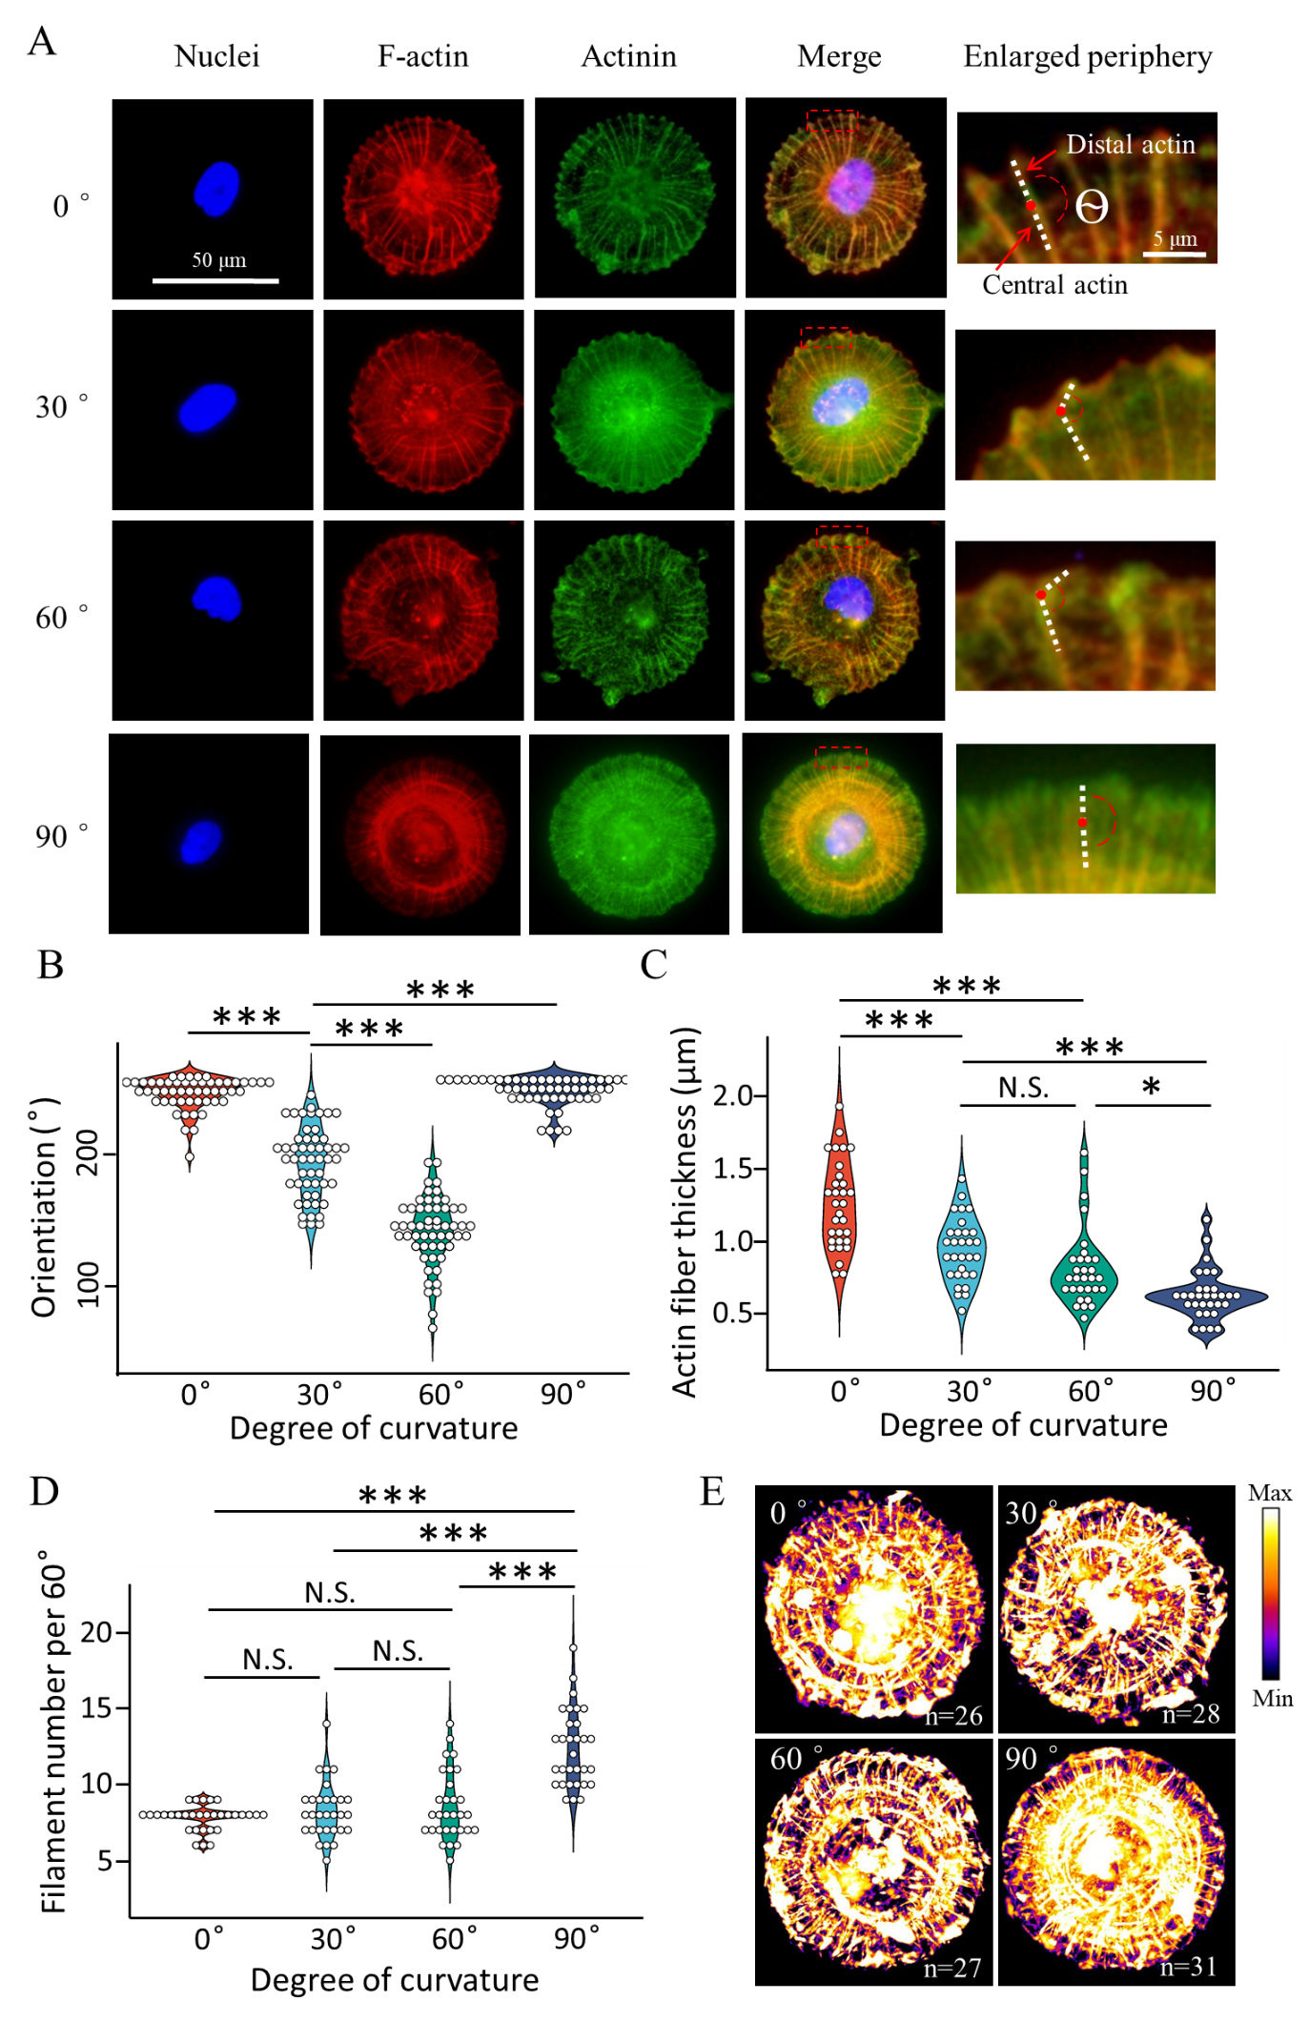
Figure 4. Cytoskeleton organization regulated by curvature degree of adhesive curves. More than 30 cells of 3 biological replicates were used for the analysis. (A) Typical F-actin (red) and actinin (green) staining images of the micropatterned cells with a curvature degree of 0°, 30°, 60° and 90°. Nuclei (blue) were stained to show the single cells. (B) Ɵ value was analyzed to estimate the actin orientation. (C) Average F-actin filament thickness and (D) average number of F-actin filament per 60 degrees of the micropatterned cells. More than 30 cells collected from 3 biological replicates were used for the analysis. Data are presented using violin plot, N.S. means no significant difference, *p < 0.05, ***p < 0.001.(E) Heatmap of F-actin. The staining images of cells on the same type of micropatterns were stacked along Z-axis and the max intensity was projected on a single image to show the distribution of F-actin structure.

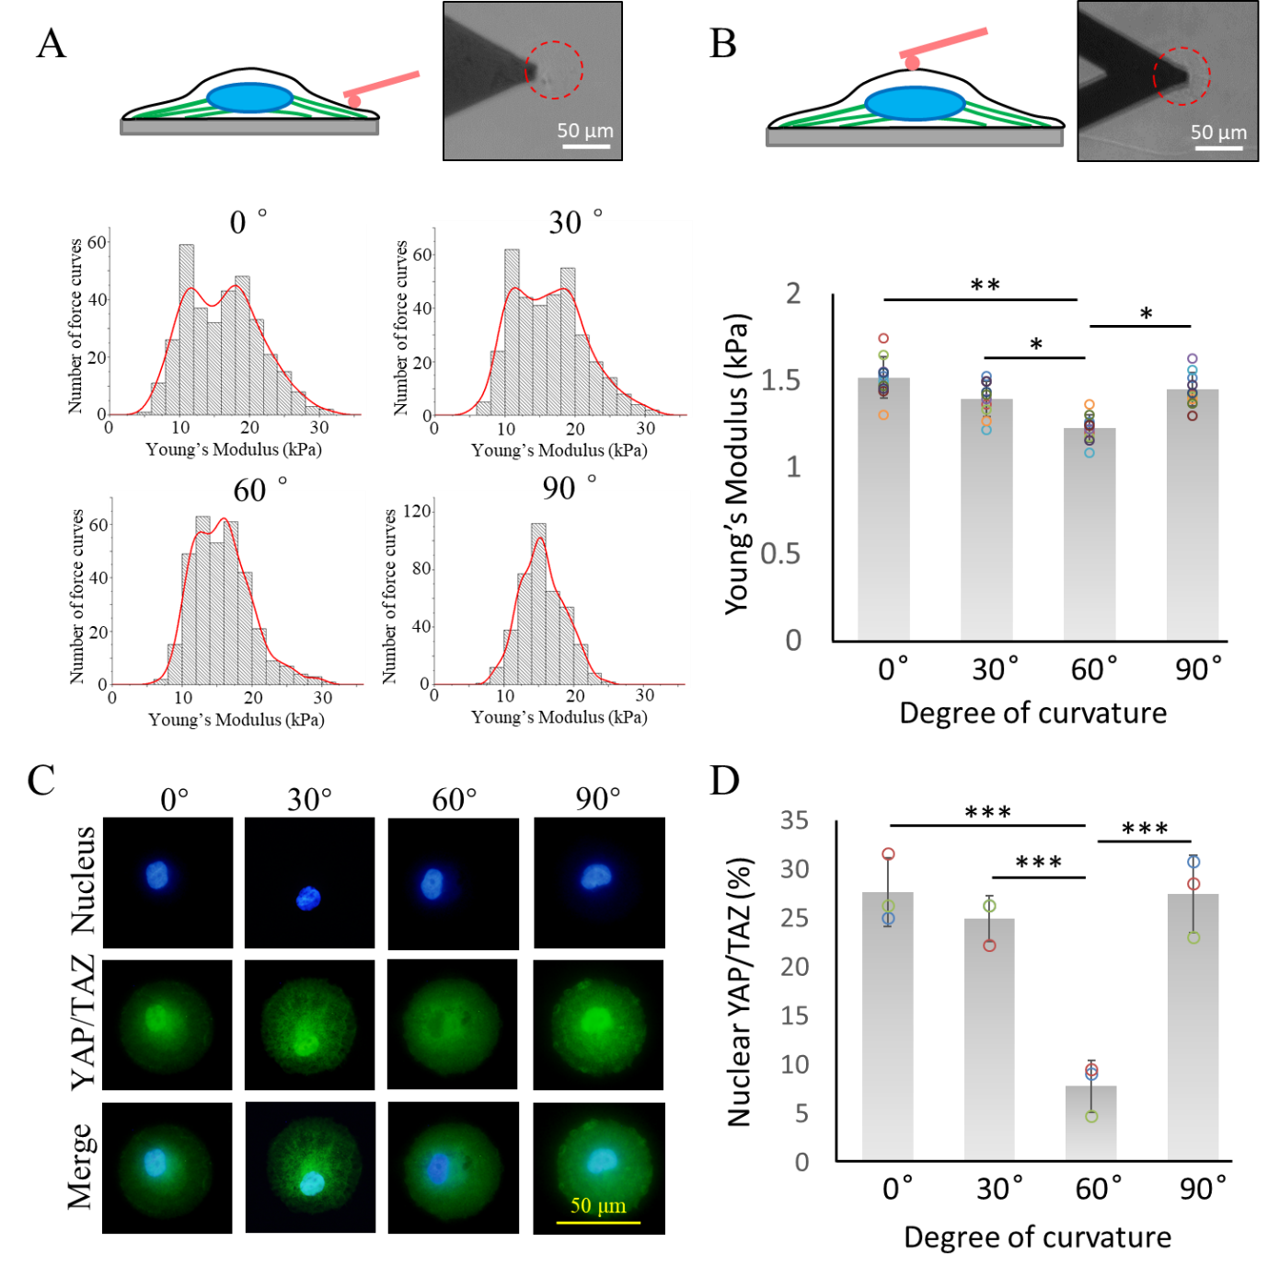
Figure 5. Influence of curvature degree on intracellular cytoskeleton force distribution and mechanotransduction. (A) Histograms of the Young’s modulus with Kernel density plot (red line) of micropatterned cells with a curvature degree of 0°, 30°, 60° and 90°. The measurement was performed at cell edge. (B) Average Young’s modulus of micropatterned cells tested at cell center around cell nuclei. More than 10 cells of 3 biological replicates were used for the analysis. Data are presented using violin plot, *p < 0.05, **p < 0.01. (C) Representative YAP/TAZ staining images of micropatterned cells with a curvature degree of 0, 30, 60, 90. (D) Percentage of micropatterned cells with nuclear localized YAP/TAZ. More than 300 cells collected from 3 biological replicates were used for the analysis. Data are presented as means ± SDs, **p < 0.01.

3.4. Adhesive curvatures govern intracellular nanomechanics
The Young’s modulus was measured using AFM indentation to evaluate the intracellular force of the micropatterned cells. The indentation was firstly performed at cell periphery region to show the influence of curvature degree on cytoskeleton force distribution. The histogram of the Young’s modulus of each type of micropatterned cells is shown in Figure 5A. The Kernel density estimation of each histogram was plotted to distinguish the local cytoskeleton force distribution resulted from various cytoskeleton structure [54]. According to the histogram, the Young’s modulus of the micropatterned cells showed distinct distribution profile. The micropatterned cells with small curvature degree had two separated peaks. The separated peaks became closer with increase of curvature degree. Only one peak was found for the micropatterned cells with a curvature degree of 90°.
The two peaks value of micropatterned cells with a curvature degree of 0° was 10.9 ± 3.6 kPa and 18.3 ± 9.4 kPa. That of micropatterned cells with a curvature degree of 30° was 11.0 ± 3.4 kPa and 17.7 ± 9.6 kPa. The micropatterned cells with a curvature degree of 60° had two peaks at 11.8 ± 3.9 kPa and 16.8 ± 6.8 kPa. And micropatterned cells with a curvature degree of 90° had one peak at 15.2 ± 7.5 kPa. In addition, the average stiffness of each cell population at cell edge was calculated from the Young’s modulus of the individual micropatterned cells (Figure S5). Although the histogram of Young’s modulus showed distinct distribution, there was no significant difference of average stiffness of the micropatterned cells at cell edge. We then performed the nanoindentation at cell center around cell nuclei which is commonly used to evaluate the global cellular mechanics. According to the results, the modulus decreased from 1.5 ± 0.2 kPa to 1.2 ± 0.1 kPa with increase of curvature degree from 0° to 60°, but increased to 1.4 ± 0.1 kPa when curvature degree was 90° (Figure 5B).

3.5. Peripheral cytoskeleton organization regulates mechanotransduction via nuclear transport of YAP/TAZ
Cells can sense and respond to the biophysical stimuli from their surrounding microenvironment through mechanotransduction process [55]. Although the complex process is still under investigation, progress has been made by revealing the role of YAP/TAZ as the sensor and mediator in mechanotransduction [43]. Nuclear accumulation of YAP/TAZ, accompanied with its transcriptional activation, is justified as the evidence of mechanical signal transduction [56]. This ON-OFF switch indicated by localization of YAP/TAZ makes it simple but robust to study the influences of mechanotransdcution on cell functions. Herein, we stained the YAP/TAZ and investigated their intracellular localization in micropatterned cells with various curvature degrees (Figure 5C). By counting the percentage of nuclear YAP/TAZ positive cells, it showed that the YAP/TAZ transferred from nucleus to cytoplasm with increase of curvature degree from 0° (27.6 ± 3.5% of the cells with nuclear localized YAP/TAZ) to 60° (7.8 ± 2.6% of the cells with nuclear localized YAP/TAZ), but re-accumulated in nucleus from 60° to 90° (27.4 ± 4.0% of the cells with nuclear localized YAP/TAZ). The results are consistent with the FA quantification and global intracellular force measurements (Figure 3 and Figure 5B). As mechanosensors and mediators, activated YAP/TAZ can enhance integrin-mediated focal adhesion assembly in MSCs, promoting F-actin remodeling and high mechanical signaling that further supports YAP/TAZ activity [57,58]. Additionally, inhibition of cytoskeleton assembly was achieved by treatment with cytochalasin D (cyto D) to test the influence of peripheral actin on nuclear shuttling of YAP/TAZ (Figure S6). After treatment, no nuclear accumulation of YAP/TAZ was observed on micropatterns, further confirming the important role of peripheral actin in the mechanotransduction process.

3.6. Osteogenic differentiation of MSCs is manipulated by the adhesive curvatures
Lastly, the cells seeded on micropatterns were cultured in osteogenic induction medium for 2 weeks and stained with ALP to show the influences of curvature degree on osteogenic differentiation of hMSCs (Figure 6A). By counting the percentage of positively stained cells, it showed that the osteogenic differentiation potential of hMSCs decreased with increase of curvature degree from 0° (38.8 ± 3.3% of the ALP positive cells) to 60° (28.0 ± 0.8% of the ALP positive cells), but increased from 60° to 90° (33.5 ± 1.7% of the ALP positive cells) (Figure 6B and Figure S7,8). In addition, analysis of ALP activity of individual cells showed similar results that the single cell staining intensity decreased with the increase of curvature degree from 0° (55.6 ± 28.4) to 60° (43.4 ± 30.7), but increased from 60° to 90° (55.3 ± 27.8) (Figure S9). Osteopontin (OPN) as another osteogenic marker was also stained to evaluate the osteogenesis of hMSCs (Figure 6C). According to the images, the relative intensity of OPN (normalized to 0°) decreased with the increase of curvature degree from 0° (1.00 ± 0.19) to 60° (0.76 ± 0.11), but increased from 60° to 90° (1.08 ± 0.18) (Figure 6D). These results are consistent with the mechanotransduction analysis, since high percentage of nuclear YAP/TAZ is associated with high osteogenic differentiation potential of MSCs as reported [59].
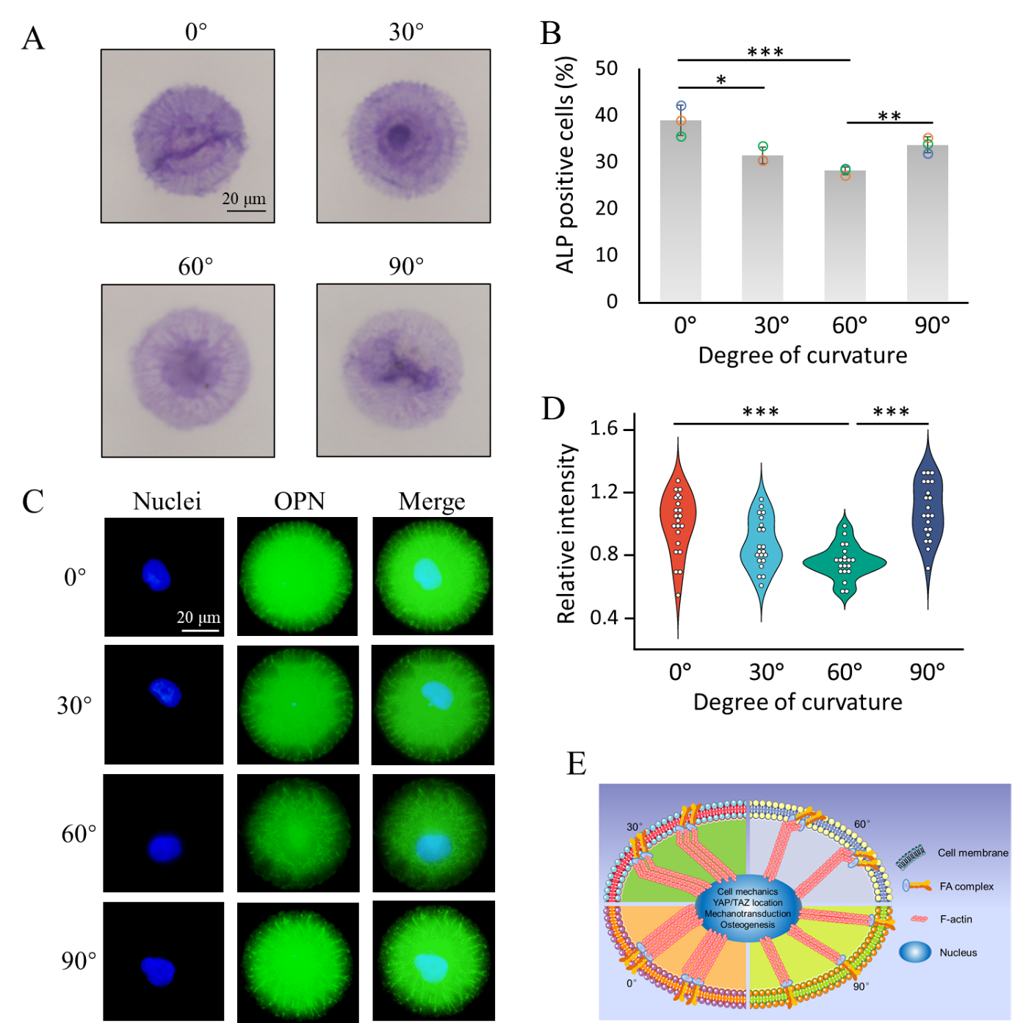
Figure 6. The influence of curvature degree on osteogenic differentiation of MSCs. (A) Representative ALP staining images of single cells on micropatterns with a curvature degree of 0, 30, 60, 90. (B) Percentage of ALP positively stained micropatterned cells. More than 300 cells collected from 3 independent experiments were used for the analysis. Data are presented as means ± SDs, n = 3 biological replicates, *p < 0.05, **p < 0.01, ***p < 0.001. (C) Representative OPN staining images of single cells on micropatterns with a curvature degree of 0, 30, 60, 90. (D) OPN staining intensity of single micropatterned cell. More than 20 cells of 3 biological replicates were used for the analysis, ***p < 0.001. (E) Schematic illustration of the influence of adhesion curvature degree on osteogenesis of hMSCs. From 0° to 60°, the FA length and actin fiber thickness reduced which hindered YAP-mediated mechanotransduction and osteogenesis. At 90°, FA and actin fibers were aligned the same direction, which increased the number of actin fibers and facilitated nuclear YAP accumulation and osteogenesis.

4. Discussion
The cell develops a cytoskeleton structure based on the surrounding niche which determines cell mechanics [60]. During this process, FAs serve as mechanical linkages to bridge the extra- and intracellular environment. Extracellularly, integrin proteins form clusters to strengthen binding to the ECM. Intracellularly, multiple proteins (e.g., vinculin, talin, etc.) form a complex to anchor F-actin filaments through which mechanical force and regulatory signals are transmitted to the nucleus. Previous studies have reported various factors that regulate FA formation and cytoskeleton development, such as substrate stiffness [61] and mechanical stimuli [62]. Microfabrication engineering further enables the regulation of cell adhesive geometry, which affects numerous cell functions including proliferation and differentiation. Plenty of studies have reported on how adhesive area [63], adhesive shape [64], and nano-/micro-arrangement of adhesive sites [65] impact cell functions. More recently, researchers have started to pay attention to the influence of surface curvatures on cell migration and differentiation at the single cell level [66]. However, to our best knowledge, no study has investigated the influence of adhesive curvatures on cell functions, especially at the subcellular level. Herein, we report that the curvature degree initially affected the orientation and development of FAs, which consequently regulated the cytoskeleton organization. The smallest and largest curvature degrees (0° and 90°) facilitated the elongation of FAs, which should be attributed to the similar growth direction of the FAs and the F-actin filaments at the cell periphery region. The peripheral adhesive lines were separated by non-adhesive intervals from 0° to 60°; thus, the FAs assembled only along the micro-curves. At 90°, the adhesive lines were fused at the edge which resulted in the radial assembly of FAs. Regardless of the curvature degree, FA-associated actin and linking actin filaments always assembled along the FAs and radially, respectively.
The formation of FAs and the organization of cytoskeleton, which are affected by the adhesion microenvironment, play critical roles in regulating cell mechanics [67]. Accurate measurement of force is highly required to fully understand the influence of the adhesion environment on intracellular force distribution. In this study, the mechanical properties of micropatterned cells were directly measured using AFM nanoindentation. The results indicated that the local distribution of cytoskeleton force was regulated by the curvature degree of adhesion curves, which has been overlooked. The interval arrangement of the adhesion curves and non-adhesion regions regulated the distribution of cytoskeleton structures, which determined the force distribution. The neighboring F-actin fibers were widely separated in micropatterned cells with a small curvature degree. According to the vinculin and F-actin staining images, micropatterned cells clustered more mature FAs and assembled relatively strong actin bundles on the adhesive region, which contributed to the high modulus peak of the fitting curves. On the other hand, FA formation and actin assembly were weak on the non-adhesive region, resulting in the low tension part of the fitting curves [52, 68]. Due to the large spacing between each adhesive curve in micropatterns with a curvature degree of 0°, the differences could be clearly distinguished from the analysis. With an increase in the curvature degree, the spacing decreased, leading to an indistinguishable modulus of micropatterned cells with a curvature degree of 90°. The results indicate that the local cell adhesion curvatures can regulate the distribution of cellular force, which is consistent with a previous simulation test [69]. In addition, we also observed disruption of filaments that span the entire cell on all micropatterns, contributing to ‘line tension’ within cells [69]. This can be attributed to the overall size and shape of the micropatterns. Comparing to a non-patterned surface, the 60 μm micropattern did not support fully spreading of hMSCs. And the round shape facilitated radial woven of F-actin toward to nucleus but suppressed fusion of filaments to form actin cap [70].
The global intracellular force tested at the cell center was also affected by adhesive curvatures, with a significantly lower modulus on micropatterns with a curvature degree of 60°. This may be attributed to the different FA orientation observed on the micropatterns. Commonly, FAs grow in the direction of the tensile force, and their length/stability increased with the increase of the stretch force [71]. However, regulation of adhesive curvatures resulted in angles between the FA orientation and the tensile stretch. On the circular micropatterns, F-actin filaments assembled at the cell periphery along the adhesive curves and grew radially toward the cell center to form an actin cortex that plays important roles in cell mechanics [72]. Thus, the angles between FA-associated actin and linking actin will divide the cytoskeleton tension into the tension at the radial direction and the tangential direction, respectively. Based on a previous report, the ligand-receptor bonds between FAs and the substrate can be considered as Hookian elastic springs [73]. Therefore, the radial direction tension can stabilize FAs, which will elongate FAs, while the tangential direction tension that causes FA displacement will lead to FA dissociation. This explains the decrease in FA length and global intracellular force from 0 to 60°. Subsequently, the reduced force exerted on the nucleus resulted in a decrease in nuclear project area and a change in nuclear morphology [74]. The intracellular force can be transduced into the nucleus via the LINC complex, which is an anchor structure connecting the cytoskeleton and the nuclear structure [75]. Inside the nucleus, the mechanical signal is initially received by the nuclear lamina, which supports nuclear shape and provides an anchor site for chromatin via the lamin-associated domain (LAD) [76]. Tethering of chromatin will affect its epigenetic state, which is intimately related to gene expression. At 90°, FAs were oriented in the same direction as the F-actin filaments again, which increased the FA length and intracellular force. Therefore, the results indicate that the curvature degree has pivotal roles in the regulation of cell mechanics. However, further simulation experiments are necessary to validate the hypothesis.
Interestingly, the mechanotransduction process was found to be affected by the distribution of intracellular force. Various factors such as substrate stiffness, adhesion size and arrangement, and external forces have been proven to affect the mechanotransduction process via regulating activation and localization of YAP/TAZ [56, 77, 78]. All these factors share the same pathway by affecting the global intracellular tension of the cells. The intracellular force establishes a mechanical connection between the nucleus and the cytoskeleton via the LINC complex, enabling forces exerted through focal adhesions to reach the nucleus. Subsequent force transmission results in nuclear flattening, stretching of nuclear pores, reducing their mechanical resistance to molecular transport, and enhancing YAP nuclear import [79]. Herein, we also found that the curvatures affected the global intracellular tension, which regulated the nuclear transportation of YAP/TAZ. In general, nuclear YAP/TAZ decreased with increasing curvature degrees, which reduced the osteogenic differentiation of hMSCs. However, it should be noticed that nuclear YAP/TAZ and osteogenic differentiation increased at 90° due to the fusion of peripheral adhesive curves, indicating that the arrangement of adhesive curves also plays a role (Figure 6E). Additional tests using hMSCs from different donors and originating tissues may further strengthen the results. Overall, this study revealed the importance of subcellular adhesive curvatures in stem cell fate determination, which is rarely reported in previous researches.

5. Conclusions
In conclusion, a series of photo-reactive PVA patterned TCPS micro-vortexes with various degrees of curvature were prepared using UV lithography. The micropatterns enabled the variation of cell adhesion geometry while maintaining the same adhesion area. The formation of FAs, as well as cytoskeleton orientation and distribution, were regulated by the curvature degree. In consequence, the local distribution of intracellular force and global intracellular tension were affected. Therefore, cells with a specific adhesion area and shape possessed a determined strength of cytoskeleton force that could be rearranged depending on the adhesion geometry. The distribution and strength of intracellular force showed obvious influence on cell functions (e.g. differentiation) via the YAP/TAZ-mediated mechanotransduction process. The use of micropatterned surfaces would be beneficial in regulating the organization of subcellular components and revealing the influence of the microenvironment on cell behaviors.

Declaration of competing interest
The authors declare no competing interests.

Acknowledgements
This research was supported by JSPS KAKENHI Grant Number 21H03830, 22K19926 and 24K03289.

Appendix A. Supplementary data
Supplementary data to this article can be found online.

Credit author statement
X.W., N.K. and G. C. contributed conception, formal analysis and revision and editing. X.W., Y.Y., Y.W., C.L., X.H., T.Y. and G. C. contributed investigation. X.W., Y.Y, Y.W, C.L., X.H., N.K., Y.Y. and G. C. contributed methodology and final approval of the revision. X.W., N.K., Y.Y. and G. C. contributed data curation. N.K. and G. C. contributed funding acquisition. G. C. contributed project administration, resources and supervision.

Data availability
Data will be made available on request.

References
[1] N. Wang, J.D. Tytell, D.E. Ingber, Mechanotransduction at a distance: mechanically coupling the extracellular matrix with the nucleus, Nat. Rev. Mol. Cell Biol. 10(1) (2009) 75-82.
[2] A.J. Ridley, M.A. Schwartz, K. Burridge, R.A. Firtel, M.H. Ginsberg, G. Borisy, J.T. Parsons, A.R. Horwitz, Cell migration: integrating signals from front to back, Science 302(5651) (2003) 1704-9.
[3] S.M. Wen, W.C. Wen, P.G. Chao, Zyxin and actin structure confer anisotropic YAP mechanotransduction, Acta Biomater 152 (2022) 313-320.
[4] D.W. Dumbauld, T.T. Lee, A. Singh, J. Scrimgeour, C.A. Gersbach, E.A. Zamir, J.P. Fu, C.S. Chen, J.E. Curtis, S.W. Craig, A.J. Garcia, How vinculin regulates force transmission, Proc. Natl. Acad. Sci. U S A 110(24) (2013) 9788-9793.
[5] Y. Wang, N. Wang, Y. Chen, Y. Yang, Regulation of micropatterned curvature-dependent FA heterogeneity on cytoskeleton tension and nuclear DNA synthesis of malignant breast cancer cells, J. Mater. Chem. B 11(1) (2023) 99-108.
[6] Y. Cho, Y. Choi, H. Seong, Nanoscale surface coatings and topographies for neural interfaces, Acta Biomater 175 (2024) 55-75.
[7] S. Huang, Z. Chen, X. Hou, K. Han, B. Xu, M. Zhang, S. Ding, Y. Wang, Y. Yang, Promotion of Melanoma Cell Proliferation by Cyclic Straining through Regulatory Morphogenesis, Int. J. Mol. Sci. 23(19) (2022) 11884.
[8] D.A. Fletcher, R.D. Mullins, Cell mechanics and the cytoskeleton, Nature 463(7280) (2010) 485-492.
[9] D. Hanein, B. Geiger, L. Addadi, Differential Adhesion of Cells to Enantiomorphous Crystal Surfaces, Science 263(5152) (1994) 1413-1416.
[10] T. Sun, D. Han, K. Rhemann, L. Chi, H. Fuchs, Stereospecific Interaction between Immune Cells and Chiral Surfaces, J. Am. Chem. Soc. 129(6) (2007) 1496-1497.
[11] X. Yao, Y. Hu, B. Cao, R. Peng, J. Ding, Effects of surface molecular chirality on adhesion and differentiation of stem cells, Biomaterials 34(36) (2013) 9001-9009.
[12] M. Levin, Left-right asymmetry in embryonic development: a comprehensive review, Mech. Dev. 122(1) (2005) 3-25.
[13] D.T. Grimes, R.D. Burdine, Left-Right Patterning: Breaking Symmetry to Asymmetric Morphogenesis, Trends. Genet. 33(9) (2017) 616-628.
[14] J.M. Martín-Durán, B.C. Vellutini, A. Hejnol, Embryonic chirality and the evolution of spiralian left-right asymmetries, Philos. Trans. R. Soc. Lond. B Biol. Sci. 371(1710) (2016).
[15] L.Q. Wan, K. Ronaldson, M. Park, G. Taylor, Y. Zhang, J.M. Gimble, G. Vunjak-Novakovic, Micropatterned mammalian cells exhibit phenotype-specific left-right asymmetry, Proc. Natl. Acad. Sci. U S A 108(30) (2011) 12295-300.
[16] S. Hozumi, R. Maeda, K. Taniguchi, M. Kanai, S. Shirakabe, T. Sasamura, P. Spéder, S. Noselli, T. Aigaki, R. Murakami, K. Matsuno, An unconventional myosin in Drosophila reverses the default handedness in visceral organs, Nature 440(7085) (2006) 798-802.
[17] J. Xu, A. Van Keymeulen, N.M. Wakida, P. Carlton, M.W. Berns, H.R. Bourne, Polarity reveals intrinsic cell chirality, Proc. Natl. Acad. Sci. U S A 104(22) (2007) 9296-300.
[18] Y.H. Tee, T. Shemesh, V. Thiagarajan, R.F. Hariadi, K.L. Anderson, C. Page, N. Volkmann, D. Hanein, S. Sivaramakrishnan, M.M. Kozlov, A.D. Bershadsky, Cellular chirality arising from the self-organization of the actin cytoskeleton, Nat. Cell Biol. 17(4) (2015) 445-457.
[19] Y.H. Tee, W.J. Goh, X. Yong, H.T. Ong, J. Hu, I.Y.Y. Tay, S. Shi, S. Jalal, S.F.H. Barnett, P. Kanchanawong, W. Huang, J. Yan, Y.A.B. Lim, V. Thiagarajan, A. Mogilner, A.D. Bershadsky, Actin polymerisation and crosslinking drive left-right asymmetry in single cell and cell collectives, Nat. Commun. 14(1) (2023) 776.
[20] Y. Wang, Y. Yang, X. Wang, T. Yoshitomi, N. Kawazoe, Y. Yang, G. Chen, Micropattern-controlled chirality of focal adhesions regulates the cytoskeletal arrangement and gene transfection of mesenchymal stem cells, Biomaterials 271 (2021) 120751.
[21] B. Weigelin, G.-J. Bakker, P. Friedl, Third harmonic generation microscopy of cells and tissue organization, J. Cell Sci. 129(2) (2016) 245-255.
[22] Y.P. Chen, Y. Shao, P.C. Chen, K. Li, J.Y. Li, J. Meng, C.L. Lv, H.Y. Liu, C. Lv, X.Q. Feng, B. Li, Substrate nesting guides cyst morphogenesis of human pluripotent stem cells without 3D extracellular matrix overlay, Acta Biomater 170 (2023) 519-531.
[23] S.A. Ruiz, C.S. Chen, Emergence of patterned stem cell differentiation within multicellular structures, Stem cells (Dayton, Ohio) 26(11) (2008) 2921-2927.
[24] J. Lee, A.A. Abdeen, K.L. Wycislo, T.M. Fan, K.A. Kilian, Interfacial geometry dictates cancer cell tumorigenicity, Nat. Mater. 15(8) (2016) 856.
[25] W.F. Zeno, A.S. Thatte, L. Wang, W.T. Snead, E.M. Lafer, J.C. Stachowiak, Molecular Mechanisms of Membrane Curvature Sensing by a Disordered Protein, J. Am. Chem. Soc. 141(26) (2019) 10361-10371.
[26] W. Shi, K.S. Cannon, B.N. Curtis, C. Edelmaier, A.S. Gladfelter, E. Nazockdast, Curvature sensing as an emergent property of multiscale assembly of septins, Proc. Natl. Acad. Sci. U S A 120(6) (2023) e2208253120.
[27] S. Shin, H. Ko, C.H. Kim, B.K. Yoon, S. Son, J.A. Lee, J.M. Shin, J. Lee, S.H. Song, J.A. Jackman, J.H. Park, Curvature-sensing peptide inhibits tumour-derived exosomes for enhanced cancer immunotherapy, Nat. Mater. 22(5) (2023) 656-665.
[28] Y. Wang, Y. Yang, X. Wang, N. Kawazoe, Y. Yang, G. Chen, The varied influences of cell adhesion and spreading on gene transfection of mesenchymal stem cells on a micropatterned substrate, Acta Biomater 125 (2021) 100-111.
[29] R.S. Fischer, X. Sun, M.A. Baird, M.J. Hourwitz, B.R. Seo, A.M. Pasapera, S.B. Mehta, W. Losert, C. Fischbach, J.T. Fourkas, C.M. Waterman, Contractility, focal adhesion orientation, and stress fiber orientation drive cancer cell polarity and migration along wavy ECM substrates, Proc Natl Acad Sci U S A 118(22) (2021) e2021135118.
[30] Y. Fang, H. Gong, R. Yang, K.W.C. Lai, M. Quan, An Active Biomechanical Model of Cell Adhesion Actuated by Intracellular Tensioning-Taxis, Biophys. J. 118(11) (2020) 2656-2669.
[31] D.N. Clarke, A.C. Martin, Actin-based force generation and cell adhesion in tissue morphogenesis, Curr. Biol. 31(10) (2021) R667-r680.
[32] Y. Yang, X. Wang, T.-C. Huang, X. Hu, N. Kawazoe, W.-B. Tsai, Y. Yang, G. Chen, Regulation of mesenchymal stem cell functions by micro–nano hybrid patterned surfaces, J. Mater. Chem. B 6(34) (2018) 5424-5434.
[33] X. Wang, X. Hu, J. Li, A.C.M. Russe, N. Kawazoe, Y. Yang, G. Chen, Influence of cell size on cellular uptake of gold nanoparticles, Biomater. Sci. 4(6) (2016) 970-978.
[34] X.L. Wang, X.H. Hu, N. Kawazoe, Y.N. Yang, G.P. Chen, Manipulating Cell Nanomechanics Using Micropatterns, Adv. Funct. Mater. 26(42) (2016) 7634-7643.
[35] X. Wang, V. Agrawal, C.L. Dunton, Y. Liu, R.K.A. Virk, P.A. Patel, L. Carter, E.M. Pujadas, Y. Li, S. Jain, H. Wang, N. Ni, H.M. Tsai, N. Rivera-Bolanos, J. Frederick, E. Roth, R. Bleher, C. Duan, P. Ntziachristos, T.C. He, R.R. Reid, B. Jiang, H. Subramanian, V. Backman, G.A. Ameer, Chromatin reprogramming and bone regeneration in vitro and in vivo via the microtopography-induced constriction of cell nuclei, Nat Biomed Eng 7(11) (2023) 1514-1529.
[36] X.L. Wang, T. Nakamoto, I. Dulinska-Molak, N. Kawazoe, G.P. Chen, Regulating the stemness of mesenchymal stem cells by tuning micropattern features, J. Mater. Chem. B 4(1) (2016) 37-45.
[37] J. Fukuda, A. Khademhosseini, Y. Yeo, X.Y. Yang, J. Yeh, G. Eng, J. Blumling, C.F. Wang, D.S. Kohane, R. Langer, Micromolding of photocrosslinkable chitosan hydrogel for spheroid microarray and co-cultures, Biomaterials 27(30) (2006) 5259-5267.
[38] D. Riveline, E. Zamir, N.Q. Balaban, U.S. Schwarz, T. Ishizaki, S. Narumiya, Z. Kam, B. Geiger, A.D. Bershadsky, Focal contacts as mechanosensors: externally applied local mechanical force induces growth of focal contacts by an mDia1-dependent and ROCK-independent mechanism, J. Cell Biol. 153(6) (2001) 1175-86.
[39] M.J.P. Biggs, R.G. Richards, S. McFarlane, C.D.W. Wilkinson, R.O.C. Oreffo, M.J. Dalby, Adhesion formation of primary human osteoblasts and the functional response of mesenchymal stem cells to 330 nm deep microgrooves, J. R. Soc. Interface 5(27) (2008) 1231-1242.
[40] M.J.P. Biggs, R.G. Richards, N. Gadegaard, C.D.W. Wilkinson, R.O.C. Oreffo, M.J. Dalby, The use of nanoscale topography to modulate the dynamics of adhesion formation in primary osteoblasts and ERK/MAPK signalling in STRO-1+enriched skeletal stem cells, Biomaterials 30(28) (2009) 5094-5103.
[41] K.K. Elineni, N.D. Gallant, Regulation of Cell Adhesion Strength by Peripheral Focal Adhesion Distribution, Biophys. J. 101(12) (2011) 2903-2911.
[42] K. Hayakawa, H. Tatsumi, M. Sokabe, Mechano-sensing by actin filaments and focal adhesion proteins, Commun. Integr. Biol. 5(6) (2012) 572-7.
[43] S. Dupont, L. Morsut, M. Aragona, E. Enzo, S. Giulitti, M. Cordenonsi, F. Zanconato, J. Le Digabel, M. Forcato, S. Bicciato, N. Elvassore, S. Piccolo, Role of YAP/TAZ in mechanotransduction, Nature 474(7350) (2011) 179-83.
[44] L. Ji, J. Lim, G. Danuser, Fluctuations of intracellular forces during cell protrusion, Nat. Cell Biol. 10(12) (2008) 1393-U38.
[45] P. Hotulainen, P. Lappalainen, Stress fibers are generated by two distinct actin assembly mechanisms in motile cells, J. Cell Biol. 173(3) (2006) 383-94.
[46] T. Vallenius, Actin stress fibre subtypes in mesenchymal-migrating cells, Open Biol. 3(6) (2013) 130001.
[47] M. Maninová, T. Vomastek, Dorsal stress fibers, transverse actin arcs, and perinuclear actin fibers form an interconnected network that induces nuclear movement in polarizing fibroblasts, FEBS J. 283(20) (2016) 3676-3693.
[48] S. Huelsmann, N.H. Brown, Nuclear positioning by actin cables and perinuclear actin Special and general?, Nucleus 5(3) (2014) 219-223.
[49] H.R. Thiam, P. Vargas, N. Carpi, C.L. Crespo, M. Raab, E. Terriac, M.C. King, J. Jacobelli, A.S. Alberts, T. Stradal, A.M. Lennon-Dumenil, M. Piel, Perinuclear Arp2/3-driven actin polymerization enables nuclear deformation to facilitate cell migration through complex environments, Nat. Commun. 7 (2016).
[50] M. Maninova, J. Caslavsky, T. Vomastek, The assembly and function of perinuclear actin cap in migrating cells, Protoplasma 254(3) (2017) 1207-1218.
[51] S.B. Khatau, C.M. Hale, P.J. Stewart-Hutchinson, M.S. Patel, C.L. Stewart, P.C. Searson, D. Hodzic, D. Wirtz, A perinuclear actin cap regulates nuclear shape, Proc. Natl. Acad. Sci. U S A 106(45) (2009) 19017-19022.
[52] M. Thery, A. Pepin, E. Dressaire, Y. Chen, M. Bornens, Cell distribution of stress fibres in response to the geometry of the adhesive environment, Cell Motil. Cytoskelet. 63(6) (2006) 341-355.
[53] J.H. Huang, S.V. Grater, F. Corbellinl, S. Rinck, E. Bock, R. Kemkemer, H. Kessler, J.D. Ding, J.P. Spatz, Impact of Order and Disorder in RGD Nanopatterns on Cell Adhesion, Nano Letters 9(3) (2009) 1111-1116.
[54] E. Canetta, A. Riches, E. Borger, S. Herrington, K. Dholakia, A.K. Adya, Discrimination of bladder cancer cells from normal urothelial cells with high specificity and sensitivity: combined application of atomic force microscopy and modulated Raman spectroscopy, Acta Biomater. 10(5) (2014) 2043-55.
[55] T. Jiang, X.Y. Tang, Y. Mao, Y.Q. Zhou, J.J. Wang, R.M. Li, X.R. Xie, H.M. Zhang, B. Fang, N.J. Ouyang, G.H. Tang, Matrix mechanics regulate the polarization state of bone marrow-derived neutrophils through the JAK1/STAT3 signaling pathway, Acta Biomater 168 (2023) 159-173.
[56] G. Brusatin, T. Panciera, A. Gandin, A. Citron, S. Piccolo, Biomaterials and engineered microenvironments to control YAP/TAZ-dependent cell behaviour, Nat. Mater. 17(12) (2018) 1063-1075.
[57] G. Nardone, J. Oliver-De La Cruz, J. Vrbsky, C. Martini, J. Pribyl, P. Skládal, M. Pešl, G. Caluori, S. Pagliari, F. Martino, Z. Maceckova, M. Hajduch, A. Sanz-Garcia, N.M. Pugno, G.B. Stokin, G. Forte, YAP regulates cell mechanics by controlling focal adhesion assembly, Nat Commun 8 (2017) 15321.
[58] A. Totaro, T. Panciera, S. Piccolo, YAP/TAZ upstream signals and downstream responses, Nat Cell Biol 20(8) (2018) 888-899.
[59] J.X. Pan, L. Xiong, K. Zhao, P. Zeng, B. Wang, F.L. Tang, D. Sun, H.H. Guo, X. Yang, S. Cui, W.F. Xia, L. Mei, W.C. Xiong, YAP promotes osteogenesis and suppresses adipogenic differentiation by regulating beta-catenin signaling, Bone Res. 6 (2018).
[60] D.A. Fletcher, R.D. Mullins, Cell mechanics and the cytoskeleton, Nature 463(7280) (2010) 485-92.
[61] B.L. Doss, M. Pan, M. Gupta, G. Grenci, R.-M. Mège, C.T. Lim, M.P. Sheetz, R. Voituriez, B. Ladoux, Cell response to substrate rigidity is regulated by active and passive cytoskeletal stress, Proc. Natl. Acad. Sci. U S A 117(23) (2020) 12817-12825.
[62] Y. Chen, A.M. Pasapera, A.P. Koretsky, C.M. Waterman, Orientation-specific responses to sustained uniaxial stretching in focal adhesion growth and turnover, Proc. Natl. Acad. Sci. U S A 110(26) (2013) E2352-61.
[63] W. Song, N. Kawazoe, G. Chen, Dependence of Spreading and Differentiation of Mesenchymal Stem Cells on Micropatterned Surface Area, J. Nanomater. 2011 (2011) 265251.
[64] W. Song, H. Lu, N. Kawazoe, G. Chen, Adipogenic Differentiation of Individual Mesenchymal Stem Cell on Different Geometric Micropatterns, Langmuir : the ACS journal of surfaces and colloids 27(10) (2011) 6155-6162.
[65] X. Wang, S. Li, C. Yan, P. Liu, J. Ding, Fabrication of RGD Micro/Nanopattern and Corresponding Study of Stem Cell Differentiation, Nano Lett. 15(3) (2015) 1457-1467.
[66] M. Werner, S.B.G. Blanquer, S.P. Haimi, G. Korus, J.W.C. Dunlop, G.N. Duda, D.W. Grijpma, A. Petersen, Surface Curvature Differentially Regulates Stem Cell Migration and Differentiation via Altered Attachment Morphology and Nuclear Deformation, Adv. Sci. 4(2) (2017) 1600347.
[67] F. Martino, A.R. Perestrelo, V. Vinarský, S. Pagliari, G. Forte, Cellular Mechanotransduction: From Tension to Function, Front Physiol. 9 (2018).
[68] B.R. Sarangi, M. Gupta, B.L. Doss, N. Tissot, F. Lam, R.M. Mege, N. Borghi, B. Ladoux, Coordination between Intra- and Extracellular Forces Regulates Focal Adhesion Dynamics, Nano Letters 17(1) (2017) 399-406.
[69]P.W. Oakes, S. Banerjee, M.C. Marchetti, M.L. Gardel, Geometry regulates traction stresses in adherent cells, Biophys J 107(4) (2014) 825-33.
[70] D.H. Kim, S. Cho, D. Wirtz, Tight coupling between nucleus and cell migration through the perinuclear actin cap, J Cell Sci 127(Pt 11) (2014) 2528-41.
[71] N.Q. Balaban, U.S. Schwarz, D. Riveline, P. Goichberg, G. Tzur, I. Sabanay, D. Mahalu, S. Safran, A. Bershadsky, L. Addadi, B. Geiger, Force and focal adhesion assembly: a close relationship studied using elastic micropatterned substrates, Nat. Cell Biol. 3(5) (2001) 466-472.
[72] T.M. Svitkina, Actin Cell Cortex: Structure and Molecular Organization, Trends. Cell Biol. 30(7) (2020) 556-565.
[73] R. De, A general model of focal adhesion orientation dynamics in response to static and cyclic stretch, Commun. Biol. 1(1) (2018) 81.
[74] P.M. Davidson, B. Cadot, Actin on and around the Nucleus, Trends in cell biology 31(3) (2021) 211-223.
[75] T. Bouzid, E. Kim, B.D. Riehl, A.M. Esfahani, J. Rosenbohm, R. Yang, B. Duan, J.Y. Lim, The LINC complex, mechanotransduction, and mesenchymal stem cell function and fate, J. Biol. Eng. 13(1) (2019) 68.
[76] B. van Steensel, A.S. Belmont, Lamina-Associated Domains: Links with Chromosome Architecture, Heterochromatin, and Gene Repression, Cell 169(5) (2017) 780-791.
[77] M. Bao, J. Xie, N. Katoele, X.Y. Hu, B.X. Wang, A. Piruska, W.T.S. Huck, Cellular Volume and Matrix Stiffness Direct Stem Cell Behavior in a 3D Microniche, ACS Appl. Mater. Interfaces 11(2) (2019) 1754-1759.
[78] A.E. Stanton, X.M. Tong, S. Lee, F. Yang, Biochemical Ligand Density Regulates Yes-Associated Protein Translocation in Stem Cells through Cytoskeletal Tension and Integrins, ACS Appl. Mater. Interfaces 11(9) (2019) 8849-8857.
[79] A. Elosegui-Artola, I. Andreu, A.E.M. Beedle, A. Lezamiz, M. Uroz, A.J. Kosmalska, R. Oria, J.Z. Kechagia, P. Rico-Lastres, A.L. Le Roux, C.M. Shanahan, X. Trepat, D. Navajas, S. Garcia-Manyes, P. Roca-Cusachs, Force Triggers YAP Nuclear Entry by Regulating Transport across Nuclear Pores, Cell 171(6) (2017) 1397-1410.e14.

