Flux Crystal Growth, Structure, and Optical Properties of LiLa₃Ti₂S₃O₆: an oxysulfide phase derived from K₂NiF₄-type structure

Hongbo Yuan,^{1,2} Hong Yan,^{1,2} Yu Meng,^{1,2} Yoshitaka Matsushita,³ Kazunari Yamaura,^{1,2} Yoshihiro Tsujimoto, *^{,1,2}
¹ Research Center for Materials Nanoarchitechtonics (MANA), National Institute for Materials Science (NIMS), 1-1 Namiki, Tsukuba, Ibaraki 305-0044, Japan
² Graduate School of Chemical Sciences and Engineering, Hokkaido University, North 10 West 8, Kita-ku, Sapporo, Hokkaido 060-0810, Japan
³ Materials Analysis Station, NIMS, 1-2-1 Sengen, Tsukuba, Ibaraki 305-0047, Japan

*Corresponding authors:
Yoshihiro Tsujimoto (E-mail: TSUJIMOTO.Yoshihiro@nims.go.jp)

ABSTRACT
Single crystals of a new titanium oxysulfide, LiLa₃Ti₂S₃O₆, were grown from a KI molten salt. Single-crystal X-ray diffraction analysis revealed that LiLa₃Ti₂S₃O₆ crystallizes in the space group Pnma with lattice parameters of a = 11.7319(4) Å, b = 3.94787(14) Å, and c = 20.6885(6) Å. In this structure, the one-dimensional chains of corner-sharing TiO₅S octahedra are further corner-linked via equatorial and apical oxygen atoms to form unique corrugated two-dimensional perovskite-type layers in the ab plane with one octahedral thickness. These layers were intervened along the c-axis by the LaS rock-salt layers corrugated concomitantly with the perovskite-type layers, and LiO₂S₂ tetrahedral chains were located between these two types of two-dimensional layers. LiLa₃Ti₂S₃O₆ can be viewed as a modified K₂NiF₄-type structure with TiO₅S octahedral layers stacked in a zigzag manner along the c axis. The oxysulfide has a direct-type band gap of 1.85 eV, based on UV-vis-NIR diffuse reflectance measurements. First-principles calculations showed that the conduction band minimum mainly consists of Ti 3d orbitals, and the valence band maximum consists of S 3p, O 2p, and Li 2s orbitals. The electronic structures near the Fermi level are similar to those of the structurally related photocatalytic oxysulfides Y₂Ti₂S₂O₅ and La₅Ti₂CuS₅O₇.

INTRODUCTION
Mixed-anion compounds, in which two or more different kinds of anions are incorporated into one crystal structure, have been extensively studied because the differences in the chemical and physical characteristics of anions, that is, ionic radius, oxidation state, electronegativity, and polarizability, can stabilize the crystal structure and local coordination geometries that differ from those of the corresponding mono-anionic compounds.¹ Understanding anion distribution patterns in mixed-anion compounds is particularly important because the connectivity of meta-centered polyhedra through anions can confine the transfer of spin, charge, and/or phonons within specific sublattices. BiCuSeO, which is a promising thermoelectric material, possesses an alternate stacking of (Cu₂Se₂)^{2–} and (Bi₂O₂)²⁺ fluorite-type layers.² The unusually low thermal conductivity has been assumed to result from weak bonding interactions within the (Cu₂Se₂)^{2–} layers.³ Sr₂MO₂Cl₂ (M = Co, Ni, Cu) with the K₂NiF₄-type structure has an alternate stacking of rock-salt-type (Sr₂Cl₂)²⁺ and perovskite-type (MO₂)^{2–} layers, making it good two-dimensional (2D) antiferromagnets.^{4–7}
Mixed-anion compounds containing anions of different periods, such as BiCuSeO and Sr₂MO₂Cl₂, tend to exhibit anion segregation in two dimensions. This behavior can be rationalized by considering the hard-soft acid-base (HSAB) theory, which states that highly electropositive/polarizable cations prefer to bond highly electronegative/polarizable anions.⁸ Guided by this concept, complex rare-earth titanium oxysulfides with 0D–3D arrangements of Ti-centered polyhedra were synthesized.^{9–18} Among them, particular attention has been paid to Ruddlesden-Popper phases, RE₂Ti₂S₂O₅ (RE = Y, Nd–Er), as visible-light-active photocatalysts for water splitting (Figure 1a).^{19–25} These compounds have alternate stacking of RE₂S₂ rock-salt-type layers and perovskite-type layers composed of corner-sharing TiO₅S octahedra (Figure 1a). Early theoretical studies on Y₂Ti₂S₂O₅ suggested that the local polarization of TiO₅S octahedra and the separated vibration modes in the (Y₂S₂)²⁺ and (Ti₂O₅)^{2–} layers facilitate electron-hole separated transport during the overall water splitting process.²⁶ Interestingly, photocatalytic water splitting activities were also observed for La₅Ti₂TS₅O₇ (T = Cu, Ag) with similar rock-salt-type and perovskite-type building blocks (Figure 1b)¹¹, although in the presence of sacrificial reagents.²⁷ In La₅Ti₂CuS₅O₇ and La₅Ti₂AgS₅O₇, the double chains of corner-sharing TiO₅S and TiO₄S₂ octahedra and the TS₄-tetrahedrahedral chains play an important role in the generation of photoexcited charge carriers.²⁸ It should be noted that the introduction of late transition metals favoring a homoleptic coordination environment with sulfur rearranges the anion segregation and the connectivity between Ti-centered octahedra, providing different photocatalytic water redox mechanism.
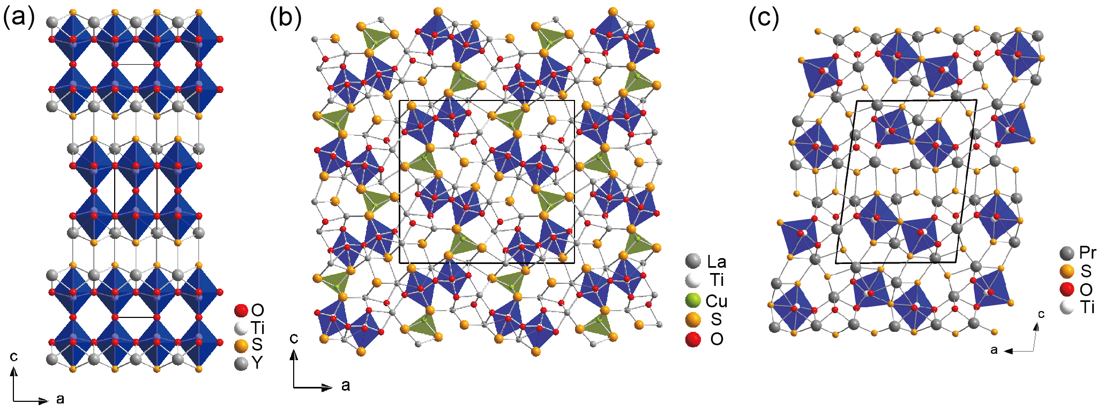
Figure 1. Crystal structures of (a) Y₂Ti₂S₂O₅, (b) La₅Ti₂CuS₅O₇, and (c) Pr₆Ti₂S₇O₆.

The initial aim of the authors, who first reported La₅Ti₂CuS₅O₇ and La₅Ti₂AgS₅O₇, was to obtain new types of layered structures led by Cu/Ag in sulfur-rich environments, but only fragments of layers were formed.¹¹ In fact, only two types of Ti-based oxysulfides with a layered intergrowth structure are known, namely RE₂Ti₂S₂O₅ and Pr₆Ti₂S₇O₆. Pr₆Ti₂S₇O₆ adopts PrS rock-salt layers that alternately stack with building units composed of perovskite-type and rock-salt-type, and fluorite-type fragments (Figure 1c).¹⁸ In this study, we investigated the impact of more electropositive monovalent metals, that is, alkali metals on intergrowth structures of the quaternary RE-Ti-S-O system. This paper reports the successful synthesis of a new layered oxysulfide, LiLa₃Ti₂S₃O₆, by the flux crystal growth method using KI molten salt. It adopts an orthorhombic cell in the space group Pnma with LaS rock-salt-type layers corrugated concomitantly with perovskite-type layers of corner-shared TiO₅S octahedra and one-dimensional chains of corner-shared heteroleptic tetrahedra LiO₂S₂. These orange crystals exhibited an experimental band gap of 1.85 eV. The calculated electronic structure near the Fermi level is similar to those observed for RE₂Ti₂S₂O₅ and La₅Ti₂TS₅O₇, suggesting that LiLa₃Ti₂S₃O₆ is capable of photocatalytic water splitting under visible-light irradiation.

EXPERIMENTAL SECTION
Reagents. Li₂S (Sigma-Aldrich, 4N), Li₂O (Sigma-Aldrich, 4N), La₂S₃ (Kojundo Chemical Laboratory, 3N), La₂O₃ (Rare Metallic, 4N), and TiO₂ (Rare Metallic, 4N) powders were used as received. KI (Sigma-Aldrich, 2N) was heated at 260 °C prior to use. All raw materials were stored in an argon-filled glovebox (moisture and oxygen levels less than 0.1 ppm), and all manipulations before starting the reaction were carried out in a glovebox or under vacuum.
Crystal Growth and Elemental Analysis. Single crystals of LiLa₃Ti₂S₃O₆ were obtained by the flux growth method using KI as the molten solvent. 1 mmol of Li₂S, 0.5 mmol of La₂S₃, 1 mmol of TiO₂, and 4.75 mmol of KI were loaded in an alumina crucible. The crucible was flame-sealed in fused silica tubes under a vacuum of 1 Pa. The raw materials were heated in a muffle furnace to 850 °C at 2.76 °C/min, held for 24h, cooled to 550 °C at 0.08 °C/min, and finally naturally cooled to room temperature. The product was then washed with sonicated water and extracted from the flux. Rod-shaped orange crystals of LiLa₃Ti₂S₃O₆ were collected via vacuum filtration with approximately 60% based on lanthanum (Figure 2). Elemental analysis of the single crystals was performed using a scanning electron microscope (SEM, HITACHI-TM3000) equipped with an energy dispersive X-ray (EDX) spectrometer (Oxford Instruments, Swift ED3000). The accelerating voltage was set to 15 keV. EDX analysis indicated a La:Ti:S atomic ratio of approximately 3:2:3, which was in good agreement with the chemical composition determined by single-crystal structure analysis. To quantitatively analyze the content of Li atom, an inductively coupled plasma-optical emission spectrometry (ICP-OES, Agilent 5800) measurements were performed. The mass ratio of Li:La:Ti was 1.26:53.7:14.8, which are also consistent with the results of EDX and single-crystal structure analysis.
Solid State Reaction. Polycrystalline powder samples of LiLa₃Ti₂S₃O₆ were synthesized using two sets of starting materials: (i) Li₂O, La₂O₃, La₂S₃, and TiO₂, and (ii) Li₂S, La₂O₃, La₂S₃, and TiO₂ in a stoichiometric ratio. Each mixture was ground with an agate mortar and pestle, pressed into a pellet, sealed in a silica tube under a vacuum of 5 Pa, and then heated in a furnace at temperatures ranging from 800 to 950 °C for 24h.
Single Crystal Structure Determination. X-ray intensity data of a single crystal (0.183 × 0.052 × 0.033 mm³) of LiLa₃Ti₂S₃O₆ were collected using a Rigaku XtaLAB mini II diffractometer (Mo Kα radiation). Data collection covered 96% of the reciprocal space to 2θ_{max} = 60.8° with R_{int} = 3.51% after absorption correction. The crystal structure was solved using a dual-space algorithm method (SHELXT) and refined using a full-matrix least-squares method with SHELXL using an Olex2 graphical user interface.
Powder XRD and UV-Vis-NIR. Powder XRD patterns were collected on a Rigaku MiniFlex-600 diffractometer (Cu Kα radiation) from the 2θ range of 5–70° with a step of 0.02° at room temperature. The UV-vis- NIR reflectance spectra were collected using a Shimazu UV- 2600 UV-vis-NIR spectrometer (used in the diffuse reflectance mode) equipped with an integrating sphere at the range of 220-1200 nm. Deuterium and halogen lamps were used as sources of UV and visible-NIR light, respectively. The recorded reflectance spectra were converted into the absorption data via the Kubelka−Munk function.
Density Functional Theory (DFT) Calculations. First-principles DFT calculations were performed on LiLa₃Ti₂S₃O₆ using the CASTEP software. The Perdew-Burke-Emzerchof generalized gradient approximation (PBE-GGA) was employed for the exchange and correlation functions. Projector augmented-wave potentials were used for Li, La, Ti, S, and O atoms. The cell parameters and atomic positions were optimized based on the experimentally determined crystal structure until the maximum force on each atom was less than 0.02 eV/Å, followed by a band structure and density of states calculations. Plane wave basis sets with a cutoff of 340 eV were used for the calculations. The self-consistent field tolerance was 1.0 × 10⁻⁶ eV/atom, and the k-point mesh was 2 × 6 × 1.

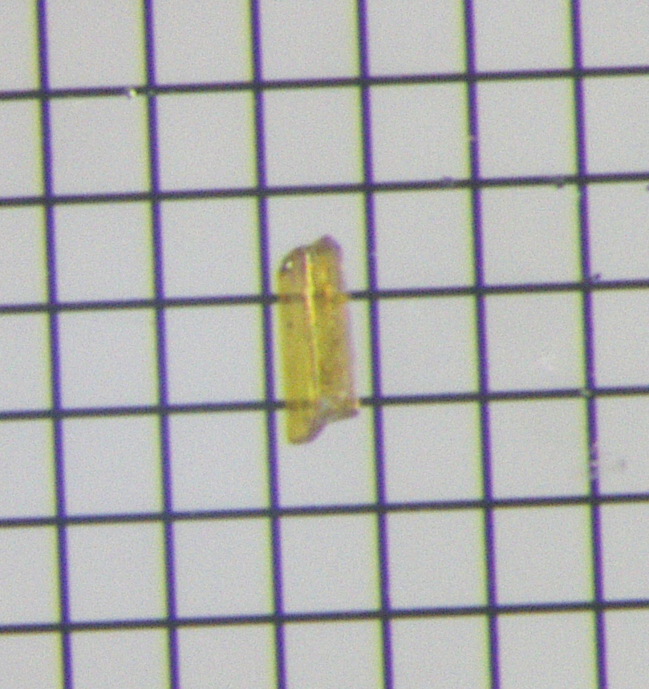
Figure 2. Photograph of a single crystal of LiLa₃Ti₂S₃O₆ on a 0.1 mm-grid glass plate. The single crystals grew preferentially along the crystallographic b-axis.

RESULTS AND DISCUSSION.
Crystal Structure. Single-crystal structure analysis revealed that LiLa₃Ti₂S₃O₆ crystallizes in the orthorhombic space group Pnma (no. 62) with lattice parameters of a = 11.7319(4) Å, b = 3.94787(14) Å, and c = 20.6885(6) Å. The asymmetric unit contains one Li atom at the Wycoff position 4c, three La atoms at 4c, two Ti atoms at 4c, three S atoms at 4c, and six O atoms at 4c. The details of the structural refinement are listed in Table 1. The atomic coordinates and atomic displacement parameters are listed in Table 2 and the anisotropic displacement parameters are listed in Table S1. Selected interatomic distances and angles are summarized in Table 3. Bond valence sum (BVS) calculations²⁹ were carried out, yielding the BVS values of 1.29 for Li, 2.81 for La1, 2.60 for La2, 3.49 for La3, 3.90 for Ti1, and 3.80 for Ti2: these values are consistent with the chemical formula determined by single-crystal structure analysis. However, the BVS values for La2 and La3 suggest that they are in under-bonding and over-bonding states, respectively, as discussed later.
Table 1. Results of Structure Refinement of LiLa₃Ti₂S₃O₆ Using Single-Crystal XRD Data
Formula | LiLa₃Ti₂S₃O₆
Formula weight | 711.585
T (K) | 293(2)
Crystal system | orthorhombic
Space group | Pnma
a (Å) | 11.7319(4)
b (Å) | 3.94787(14)
c (Å) | 20.6885(6)
α (°) | 90
β (°) | 90
γ (°) | 90
V (Å³) | 958.21(6)
Z | 4
ρ_{calc} (g/cm³) | 4.933
μ (mm⁻¹) | 15.325
F₀₀₀ | 1256
θ (°) | 1.97 - 30.41
R_{int} (%) | 3.51
no. of reflections  (collected/unique) | 5884/ 1582
goodness of fit on F² | 1.03
R₁, wR₂ [I > 2σ(I)] | 0.0226, 0.0466
R₁, wR₂ (all data) | 0.0276, 0.0477

Table 2. Crystallographic and Refinement Data Obtained from Single-Crystal Structure Analysis of LiLa₃Ti₂S₃O₆
atom | site | x | y | z | occupancy | U_{iso}/ Å²
La1 | 4c | 0.32135(3) | 1/4 | 0.51817(2) | 1 | 0.00854(9)
La2 | 4c | 0.69027(3) | 1/4 | 0.70416(2) | 1 | 0.01042(9)
La3 | 4c | 0.98972(3) | 1/4 | 0.60107(2) | 1 | 0.00699(8)
Ti1 | 4c | 0.22184(9) | -1/4 | 0.64600(5) | 1 | 0.0073(2)
Ti2 | 4c | 0.94030(9) | -1/4 | 0.73348(5) | 1 | 0.0080(2)
Li | 4c | 0.4975(8) | -1/4 | 0.6161(5) | 1 | 0.010(2)
S1 | 4c | 0.56719(12) | 1/4 | 0.56759(7) | 1 | 0.0088(3)
S2 | 4c | 0.12508(12) | -1/4 | 0.52497(6) | 1 | 0.0082(3)
S3 | 4c | 0.80080(12) | -1/4 | 0.61824(7) | 1 | 0.0092(3)
O1 | 4c | 0.3448(3) | -1/4 | 0.5927(2) | 1 | 0.0097(8)
O2 | 4c | 0.2002(3) | 1/4 | 0.6415(2) | 1 | 0.0112(8)
O3 | 4c | 0.2764(3) | -1/4 | 0.7311(2) | 1 | 0.0096(8)
O4 | 4c | 1.0502(3) | -1/4 | 0.6657(2) | 1 | 0.0090(8)
O5 | 4c | 0.9190(3) | -3/4 | 0.7213(2) | 1 | 0.0109(8)
O6 | 4c | 1.0456(3) | -1/4 | 0.7954(2) | 1 | 0.0108(8)

Table 3. Selected Interatomic Distances and Angles for TiO₅S and LiO₂S₂ in LiLa₃Ti₂S₃O₆
bond | distance/Å | bond angle | angle/°
Ti1–S2 | 2.749(2) | O1–Ti1–O4 | 154.2(2)
Ti1–O1 | 1.815(4) | O2–Ti1–O2 | 164.4(3)
Ti1–O2×2 | 1.9924(5) | O3–Ti1–S2 | 175.57(13)
Ti1–O3 | 1.874(4) | O3–Ti2–O4 | 153.5(2)
Ti1–O4 | 2.055(4) | O5–Ti2–O5 | 159.6(3)
Ti2–S3 | 2.893(2) | O6–Ti2–S3 | 170.52(14)
Ti2–O3 | 2.055(6) | Ti1–O3–Ti2 | 130.8(2)
Ti2–O4 | 1.904(6) | Ti1–O4–Ti2 | 144.2(3)
Ti2–O5×2 | 2.0054(7)
Ti2–O6 | 1.780(4)
Li–S1×2 | 2.360(5) | O1–Li–S1×2 | 102.9(3)
Li–O1 | 1.856(10) | O1–Li–O6 | 122.2(5)
Li–O6 | 1.915(10) | O6–Li–S1×2 | 107.7(3)

Schematic view of the crystal structure of LiLa₃Ti₂S₃O₆ is shown in Figure 3. The Ti1 and Ti2 atoms are surrounded by five oxygen atoms and one sulfur atom to form TiO₅S octahedra distorted along the Ti–S bonds. Each octahedron is corner-linked along the b axis with another octahedra via common oxygen atoms, O2 for Ti1 and O5 for Ti2. The Ti1-centered octahedra further share corners with the Ti2-centered octahedra via the apical O3 and equatorial O4 atoms along the a-axis. As a result, these corner-sharing Ti-centered octahedra form a 2D corrugated layer with one octahedral thickness in the ab plane. The 2D layers are intervened by LaS rock-salt layers corrugated in cooperation with the octahedral layers and LiO₂S₂ tetrahedral chains. The Li ion fills the space where the octahedral layers and rock salt layers bend to form a three-membered ring with Ti1 and Ti2 atoms through corner oxygen atoms.

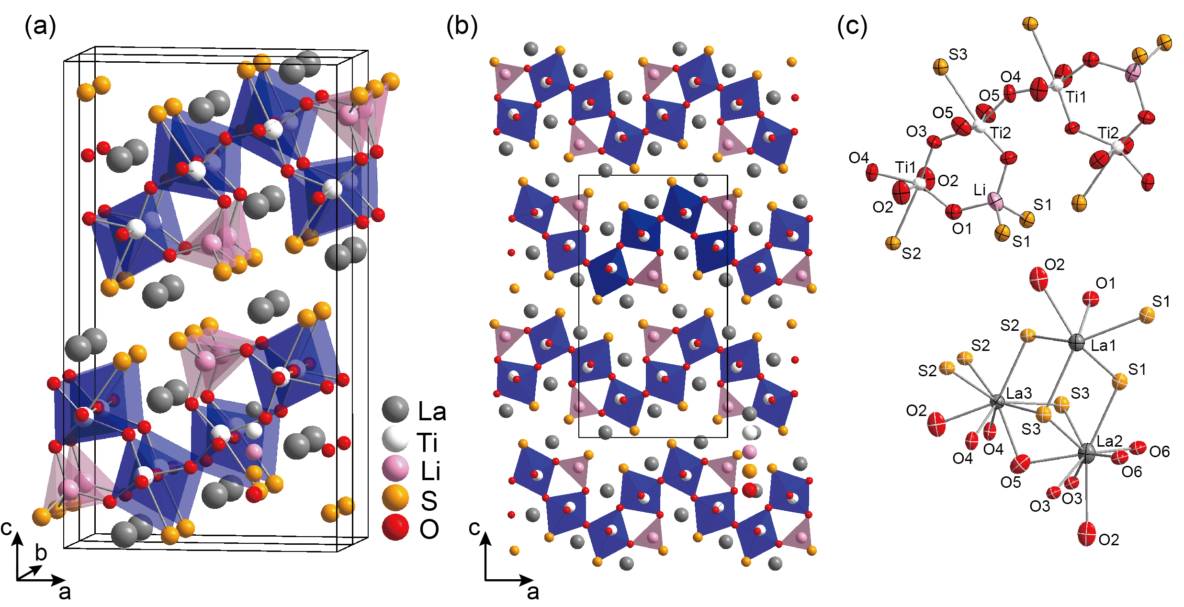
Figure 3. (a) Crystal structure of LiLa₃Ti₂S₃O₆. Grey, white, pink, yellow, and red spheres stand for La, Ti, Li, S, and O atoms, respectively. (b) 2D stacking of single layers consisting of corner-sharing Ti-centered octahedra and LaS rock-salt layers is highlighted. (c) Local coordination environment around Ti and La atoms. Displacement ellipsoids are shown at the 99% level.

TiO₅S octahedral coordination is observed in several related oxysulfides such as RE₂Ti₂S₂O₅¹⁰ and La₅Ti₂CuS₅O₇¹¹. Common to these oxysulfides, the TiO₅S octahedra are elongated along the Ti–S bond mainly because of the difference in ionic radius between oxide and sulfide ions (r_{O}^{2–} = 1.38 Å, r_{S}^{2–} = 1.84 Å). In LiLa₃Ti₂S₃O₆, the average bond distances between the Ti metal centers and the four equatorial oxide ions are 1.964 Å for Ti1 and 1.992 Å for Ti2, which are consistent with those expected from Shannon’s ionic radii (r_{Ti}⁴⁺ = 0.605 Å)³⁰. Each of the Ti metal centers is also bound to a sulfide ion at distances of d_{Ti1–S2} = 2.749(2) Å and d_{Ti2–S3} = 2.893(2) Å, and to an apical oxide ion at distances of d_{Ti1–O3} = 1.874(4) Å and d_{Ti2–O6} = 1.780(4) Å. The Ti–S/Ti–O bond distances are even longer/shorter than that expected from the ionic model and the titanium atoms are displaced from the basal oxygen square toward to the apical oxide ion, suggesting a weak covalent interaction between the Ti and S atom compared with those between the Ti and O atom. As a result, the coordination geometry of the Ti ions can be effectively viewed as square pyramidal. In fact, the contribution of sulfide ions to the BVS for Ti1 and Ti2 is less than 10%.
The LiO₂S₂ tetrahedron in LiLa₃Ti₂S₃O₆ is a quite unique coordination geometry. To the best of our knowledge, only two phases containing LiO₂S₂ tetrahedra have been reported: a complex molecule, [Li₂(D₂O)₆][Li(C₉H₂₇SSiO₃)₂]₂∙2D₂O³¹, and an inorganic solid, Li₂MoO₂S₂³². In both compounds, the LiO₂S₂ tetrahedra are isolated by chelating (t-BuO)₃SiS– ligands and (MoO₄)^{2–} tetrahedra, respectively, which differ from the 1D chain structure of the corner-sharing LiO₂S₂ tetrahedra in LiLa₃Ti₂S₃O₆. The Li atom in LiLa₃Ti₂S₃O₆ is bound to two oxygen atoms at 1.856(10) Å and 1.915(10) Å and to two sulfur atoms at 2.360(5) Å, which are consistent with the sum of the ionic radii. These values are in good agreement with those for [Li₂(D₂O)₆][Li(C₉H₂₇SSiO₃)₂]₂∙2D₂O, but not with those for Li₂MoO₂S₂ with approximately 2.0 Å of Li–O/S bond distances.
The La atoms in LiLa₃Ti₂S₃O₆ are eight and nine-coordinated, as typically observed in related La-Ti-S-O quaternary phases. The La1 and La2 atoms are in a trigonal prism of two O atoms and four S atoms for La1, and four O atoms and two S atoms for La2. These trigonal prisms are further capped with two S atoms for La1 and one O and one S atoms for La2. The La3 atoms are in a tricapped trigonal prism of two O atoms and four S atoms with two O and one S atoms as caps. The bond distances between the La and O/S atoms are consistent with the sum of the ionic radii³⁰. However, the La2–O5 (2.707(6) Å) and La2–S1 (3.714(2) Å) bonds are 6% longer than the ionic model, and the La3–O4 bond distance (2.490(4) Å) is 4% shorter, resulting in a deviation from the ideal BVS value. These over-bonding and under-bonding behaviors may result from the accommodation of the strain between the rock-salt and perovskite layers.
Comparison with Related Oxysulfides.
LiLa₃Ti₂S₃O₆ is a unique phase, and as far as we know, the second example of Li-RE-Ti-S-O (RE = rare-earth element) quinary phases after Li_{x}Y₂Ti₂S₂O₅ (0 < x < 2) with the Li ions inserted into yttrium deficient sites in the perovskite blocks of Y₂Ti₂S₂O₅.³³ The Li ions in Li_{x}Y₂Ti₂S₂O₅ form a square planar coordination with four oxide ions, unlike the LiO₂S₂ tetrahedra in LiLa₃Ti₂S₃O₆. However, both oxysulfide compounds have alternate stacking of 2D layers of corner-sharing TiO₅S octahedral units and LaS rock-salt units along the c-axis. As indicated by the dashed-line rectangular frames in Figure 4, the parallel stacking of two facing double chains of TiO₅S octahedra in LiLa₃Ti₂S₃O₆ resembles the stacking pattern in the K₂NiF₄-type structure (or the n = 1 Ruddlesden-Popper type structure). However, perovskite-like monolayers are stacked in a zigzag manner along the c-axis because of the presence of LiO₂S₂ chains and the switching of oxygen sites shared with the neighboring TiO₅S octahedra along the a-axis.
It is interesting to discuss the difference in the connectivity of corner-sharing TiO_{6–x}S_{x} octahedra between LiLa₃Ti₂S₃O₆ and La₅Ti₂CuS₅O₇, which cannot be simply understood by considering the ionic radii of Li⁺ (0.59 Å) and Cu⁺ (0.6 Å) for four-fold coordination.³⁰ A key factor for the stabilization of the 2D perovskite-type layers in LiLa₃Ti₂S₃O₆ would be the heteroleptic coordination geometry of Li⁺. For this coordination preference, the Li atom can occupy a space surrounded by oxygen atoms from the perovskite-type layers and sulfur atoms from the rock-salt-type layers. In contrast, the CuS₄ tetrahedra in La₅Ti₂CuS₅O₇ bridge between two adjacent perovskite-type fragments via common sulfur atoms. This is due to the fact that the distances between sulfur atoms in the CuS₄ tetrahedron are much shorter than that between the apical sulfur atoms of two adjacent TiO_{6–x}S_{x} octahedra. Consequently, the Cu atoms in a sulfur-rich environment cannot maintain layered intergrowth structures.
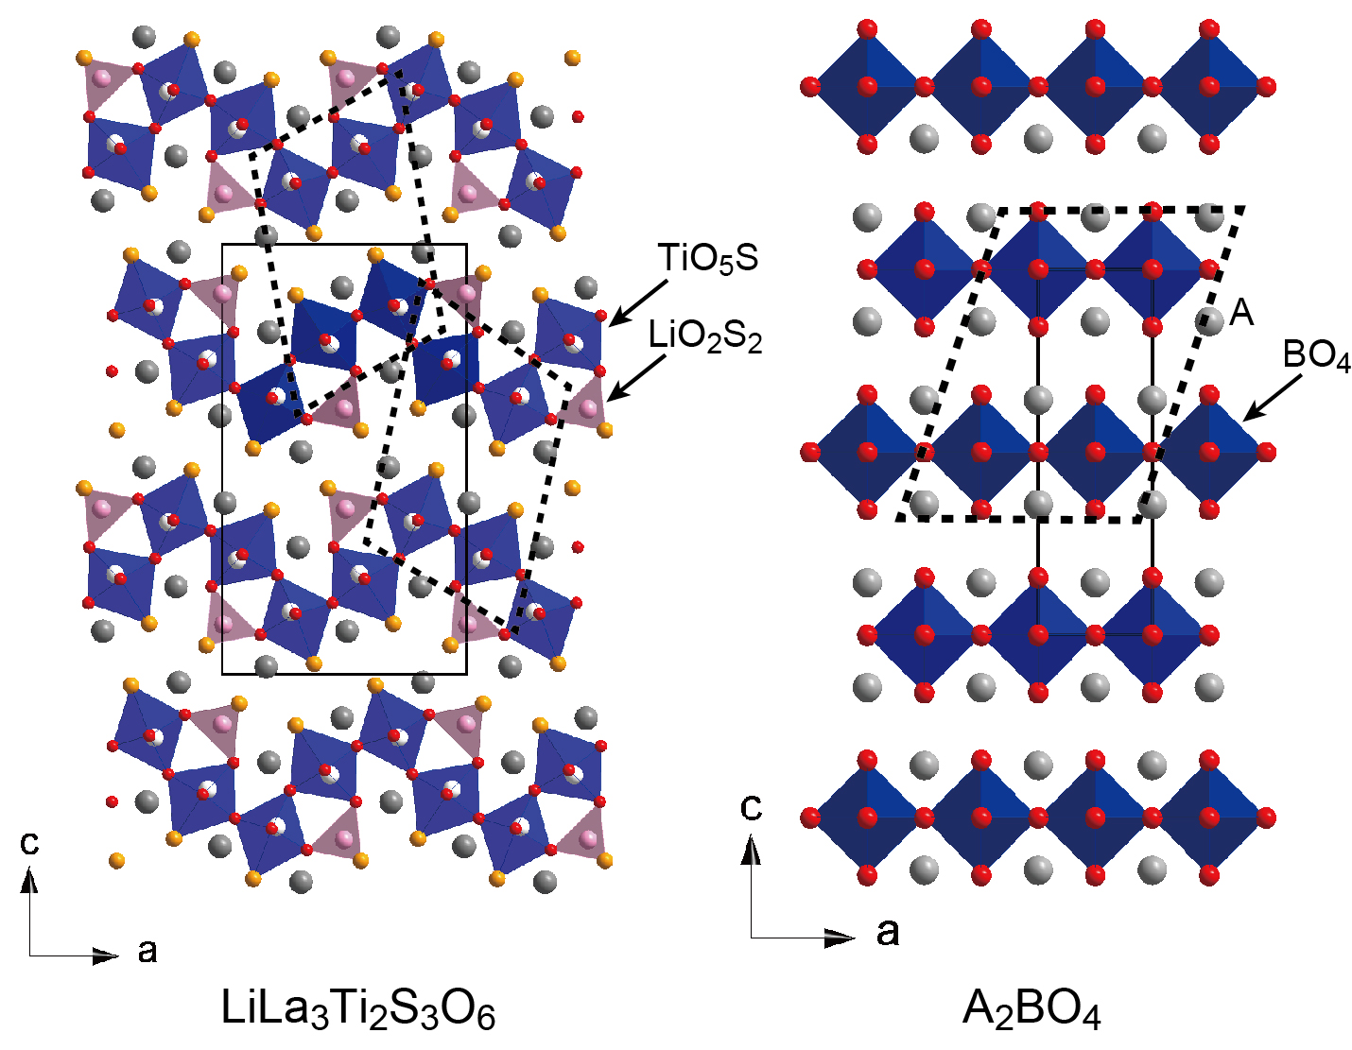
Figure 4. (Left) Crystal structure of LiLa₃Ti₂S₃O₆ view from the b-axis. The black dotted box is a di-octahedral pair of Ti₂S₂O₁₀, which forms 2-D waves in the zigzag direction along the ac plane. (Right) Crystal structure of A₂BO₄ which is the Ruddlesden-Popper phase with one layer of BO₆ octahedra separated by layers of AO adopting the rock-salt structure.

Polycrystalline Phase Analysis. Polycrystalline LiLa₃Ti₂S₃O₆ was obtained via a solid-state reaction using a stoichiometric mixture of Li₂O, La₂O₃, La₂S₃, and TiO₂. LiLa₃Ti₂S₃O₆ begins to form as the main phase above 850°C with a secondary phase La₂Ti₂O₇, which gradually disappears with increasing temperature. Figure 5 shows the powder XRD pattern of the product prepared at 900 °C and the powder sample obtained by finely grinding the handpicked single crystals. Similar to the XRD pattern of the single crystal sample, the major peaks of the XRD pattern of the polycrystalline sample could be assigned to LiLa₃Ti₂S₃O₆, while some minor peaks from La₂Ti₂O₇ and uncharacterized impurities remained in the product. The mass fraction of LiLa₃Ti₂S₃O₆ to La₂Ti₂O₇ was estimated to be 80:20 by Rietveld refinement. Reactions at higher temperatures resulted in a decomposition of the title compound.

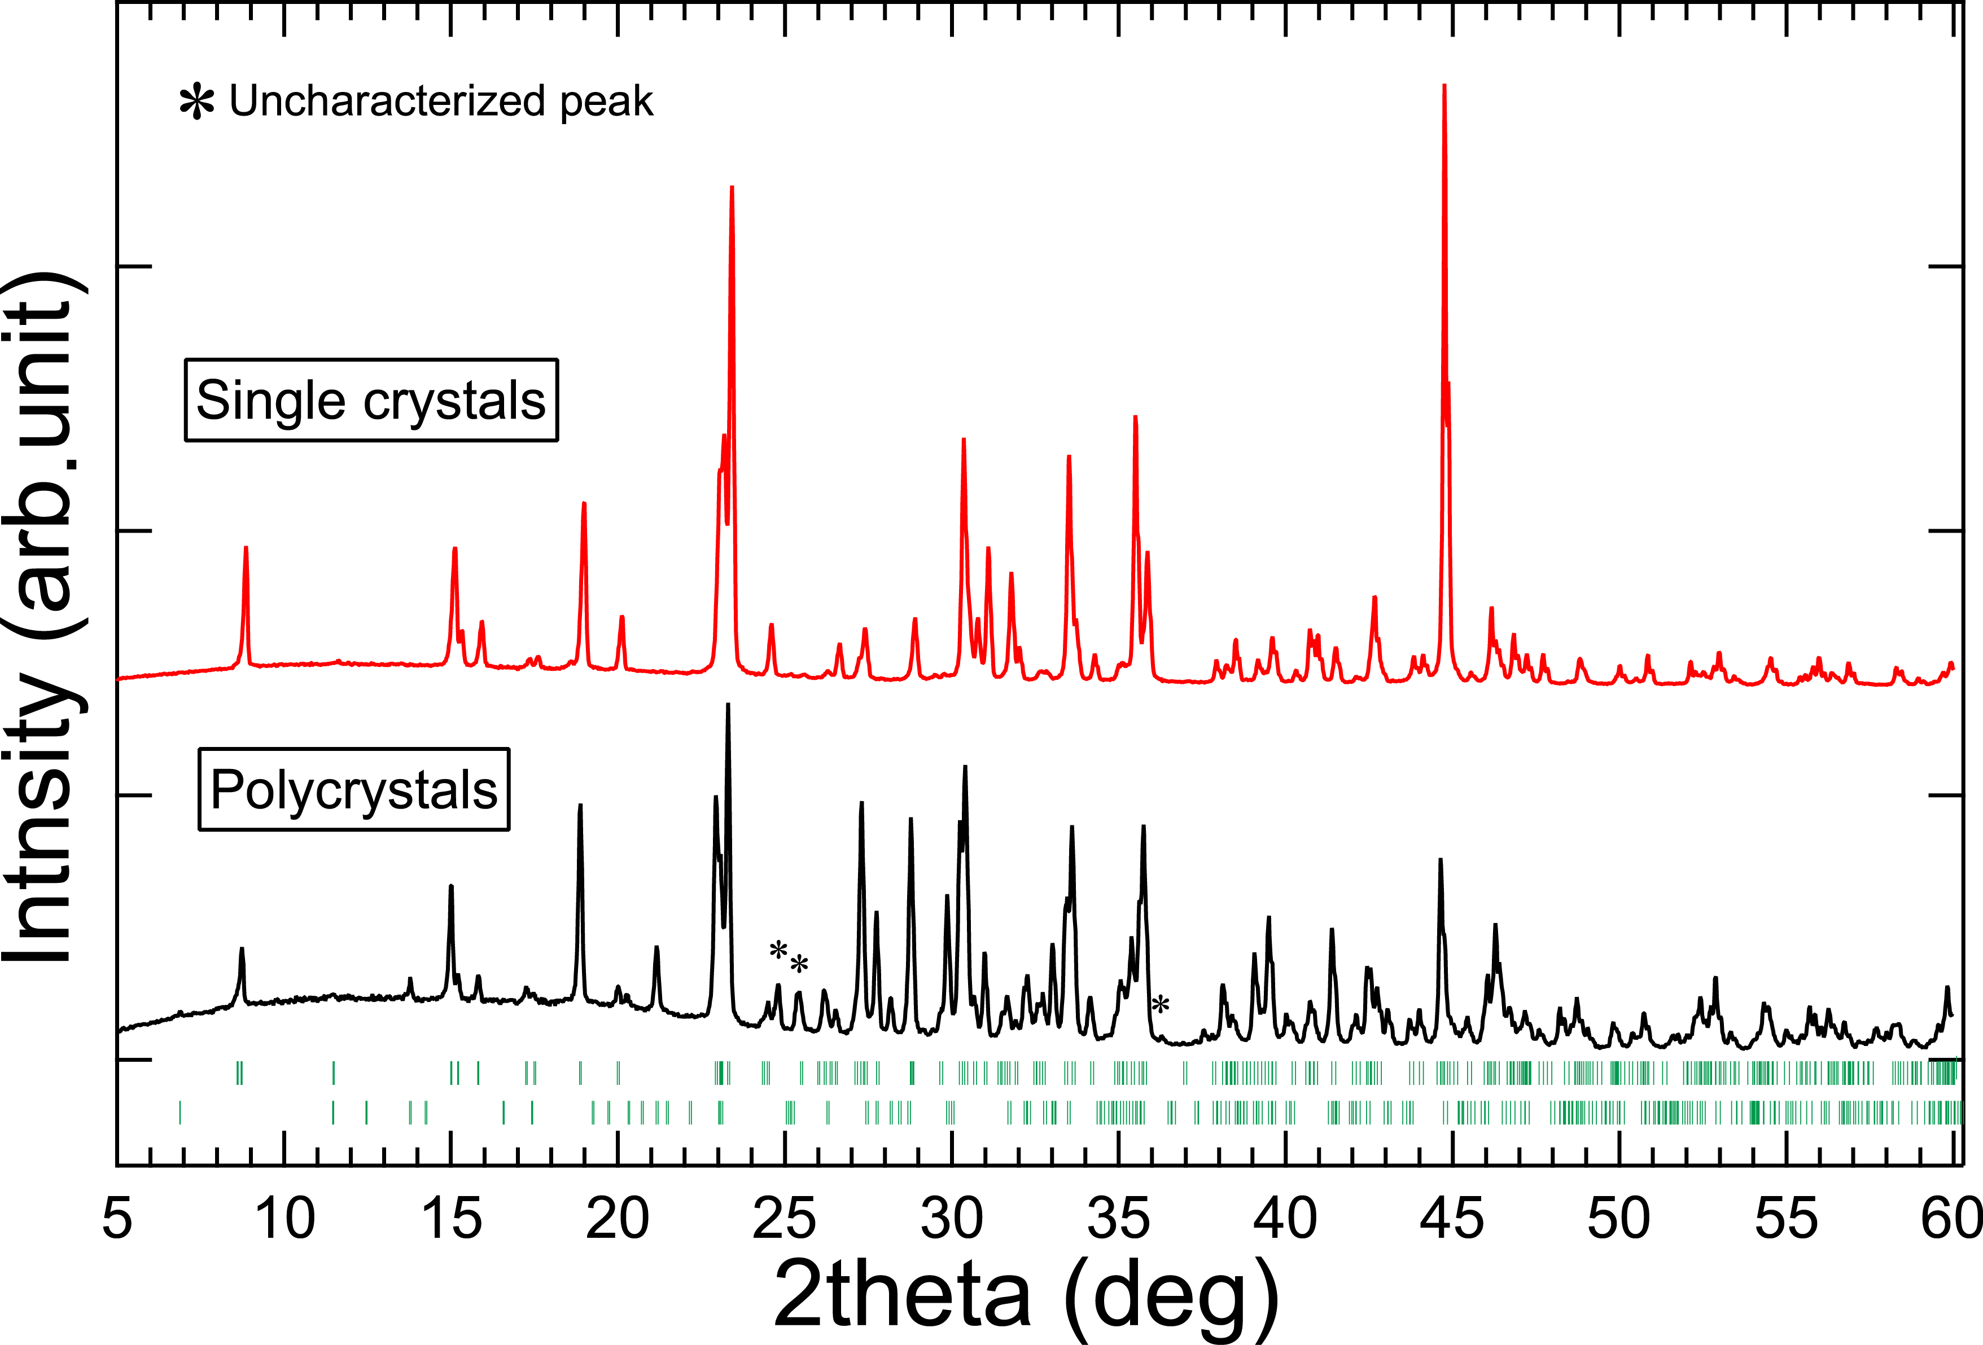

Figure 5. Comparison between the powder X-ray diffraction patterns collected from the polycrystalline sample prepared by the solid-state reaction and the single-crystal sample, which were ground into fine powders for the XRD measurement. The upper and lower vertical tick lines represent the expected Bragg peaks of LiLa₃Ti₂S₃O₆ and La₂Ti₂O₇, respectively.
Optical Measurement. Figure 6 shows the UV-vis-NIR absorption spectrum of the powdered LiLa₃Ti₂S₃O₆. The absorption data were obtained by converting the reflectance spectrum using the Kubelka-Munk transformation. The absorption curve exhibited two steep increases near 1.6 and 2.2 eV. Given the color of the single crystals, the optical absorption near the higher energy should be intrinsic to the oxysulfide phase. In contrast, the absorption at the lower energy can be attributed to an unidentified tiny black lump (as described in the Experimental Section) in the sample. The optical bandgap was estimated by extrapolating the linear portion of the absorption curve to the baseline, and the bandgap (E_{g}) was E_{g} = 1.85 eV. This value is very similar to those of visible-light-active photocatalytic Ti-based oxysulfides (for example, ~ 2.0 eV for Sm₂Ti₂S₂O₅²⁰, 2.02 eV for La₅Ti₂CuS₅O₇²⁷, 1.93 eV for Y₂Ti₂S₂O₅²²).
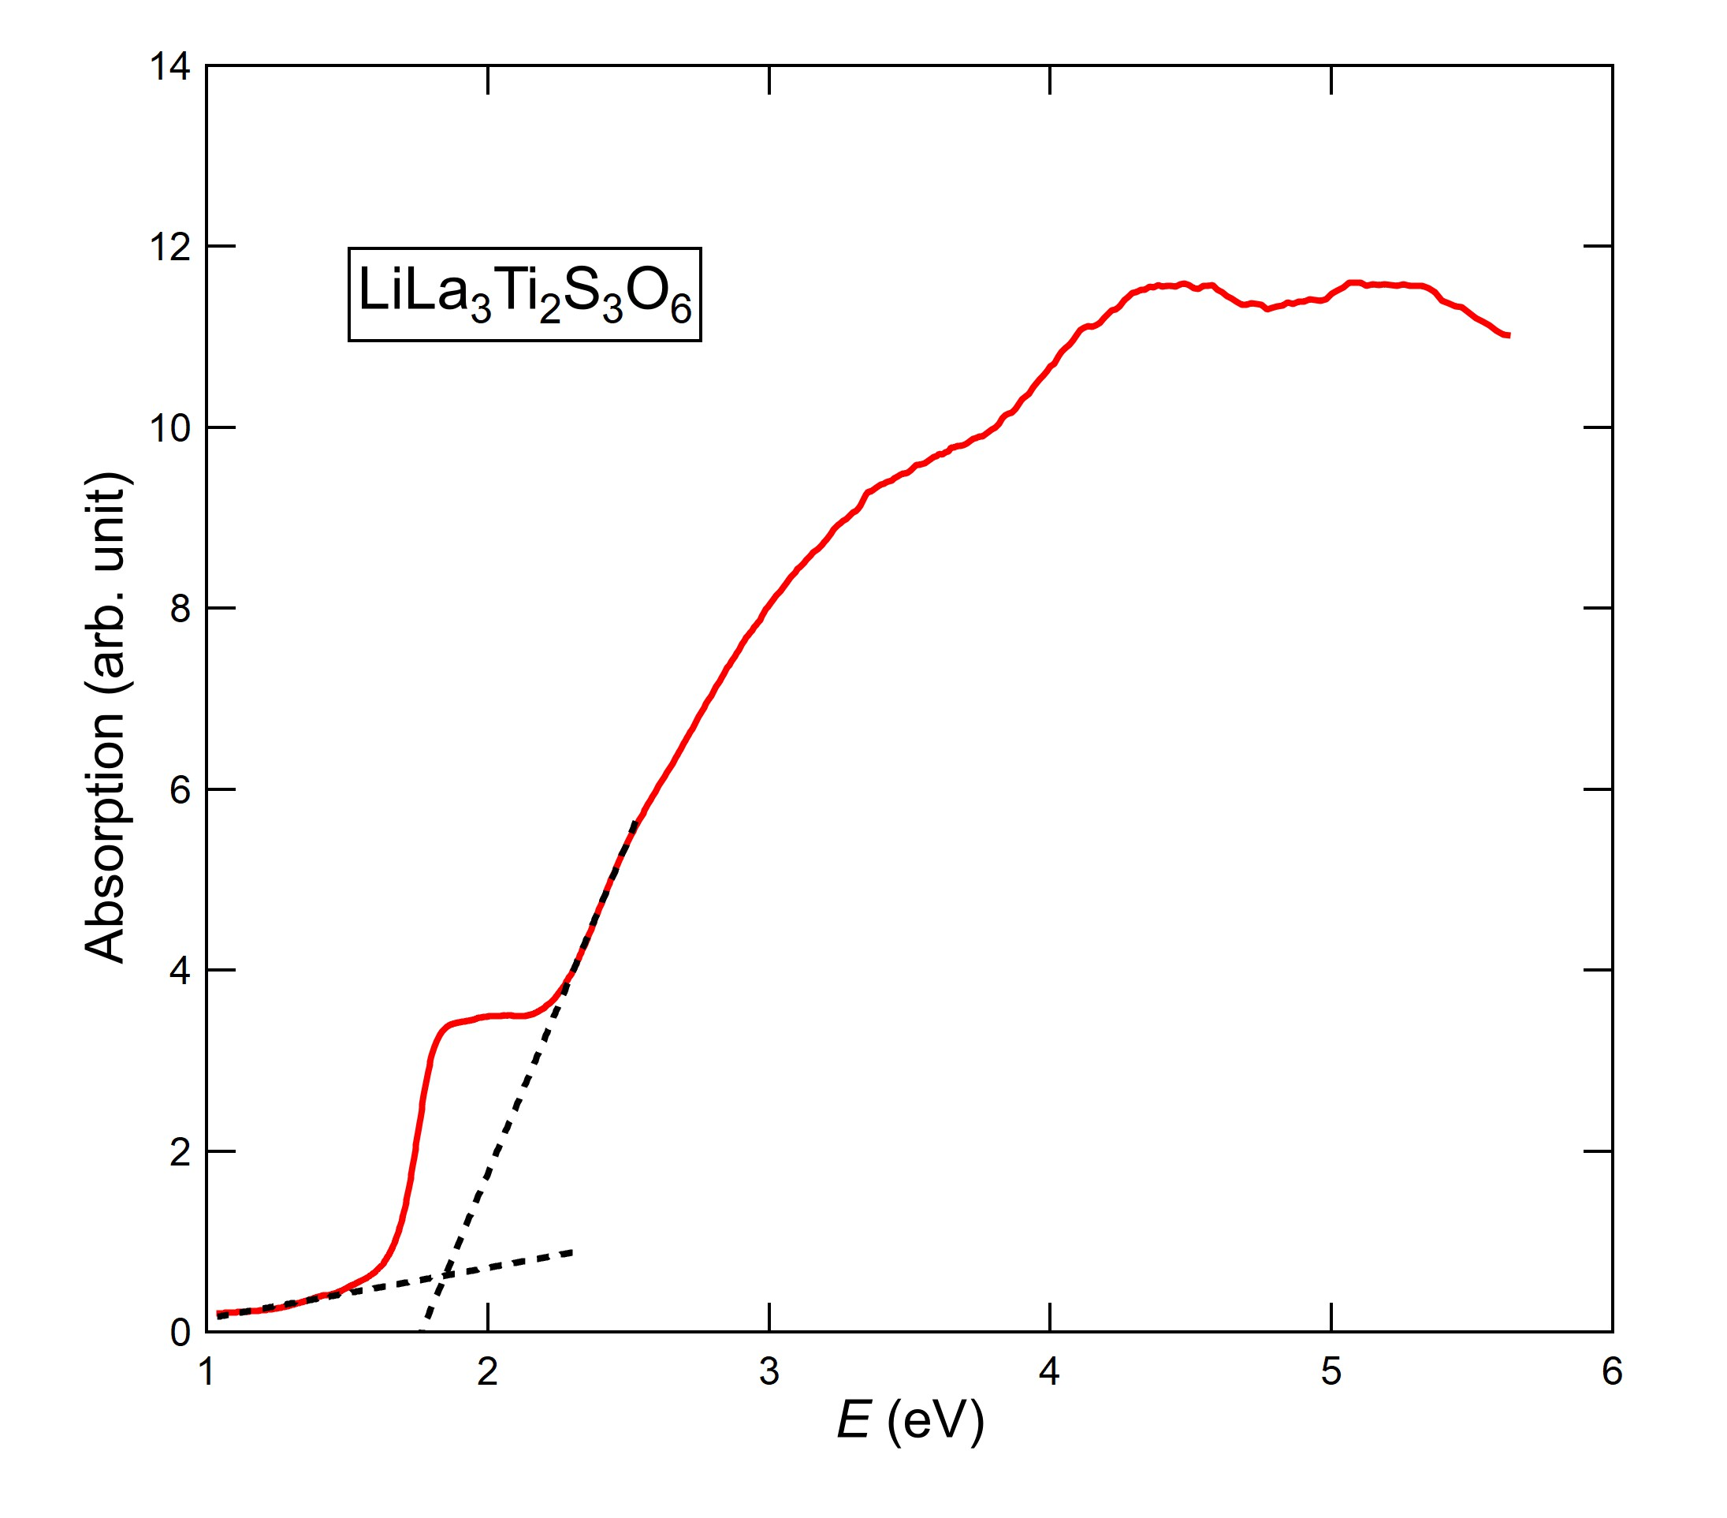
Figure 6. UV-vis-NIR absorption spectrum of LiLa₃Ti₂S₃O₆, which was converted from the diffuse reflectance data using the Kubelka-Munk transformation. The estimated bandgap is 1.85 eV.

DFT Calculation.
First-principles calculations were performed to gain a better understanding of the relationship between the electronic structure and the optical properties of LiLa₃Ti₂S₃O₆. The optimized lattice constants and internal atomic positions of the relaxed unit cell obtained by calculation were in good agreement with the refined crystallographic data (Table S2). Figure 7 shows the band dispersion of LiLa₃Ti₂S₃O₆. It reveals that the oxysulfide has a direct-type band gap energy of 1.46 eV at the Γ point. Underestimation of the bandgap energy is typical of DFT calculations using the standard GGA. The plot of the total and partial density of states (DOS) shown in Figure 8 highlights the region near the Fermi energy (E_{F}) level of the valence band (VB) and the conduction band (CB). The S 3p bands ranging from −3 to the E_{F} level dominate the valence band maximum (VBM), followed by the O 2p bands in the lower energy region, as often observed in oxysulfide compounds.^{34–39} The partial DOS plots also indicate that the Li 2s orbitals are strongly hybridized with both the S 3p and O 2p orbitals in the VB and the Ti 3d orbitals with O 2p orbitals. Meanwhile, the conduction band minimum (CBM) is mainly composed of Ti 3d orbitals, followed by La 5d, Li 2s, and O2p orbitals located at 1 eV higher energy levels. The electronic structures of LiLa₃Ti₂S₃O₆ near the E_{F} level are similar to those of La₅Ti₂CuS₅O₇⁴⁰ and Y₂Ti₂O₅S₂²², which mainly consist of Ti 3d orbitals in the CBM and Cu 3d (or Y 3d) and S 3p orbitals in the VBM. For La₅Ti₂CuS₅O₇, it has been assumed that the double chains of TiO_{6-x}S_{x} (x = 1, 2) octahedra and the 1D chains of CuS₄ tetrahedra facilitate the migration of photoexcited charges (holes and electrons) for photocatalytic reactions.^{27,28} Similarly, in LiLa₃Ti₂S₃O₆, the 1D chains of LiO₂S₂ tetrahedra and 2D layers of TiO₅S octahedra are expected to contribute to its photocatalytic properties.
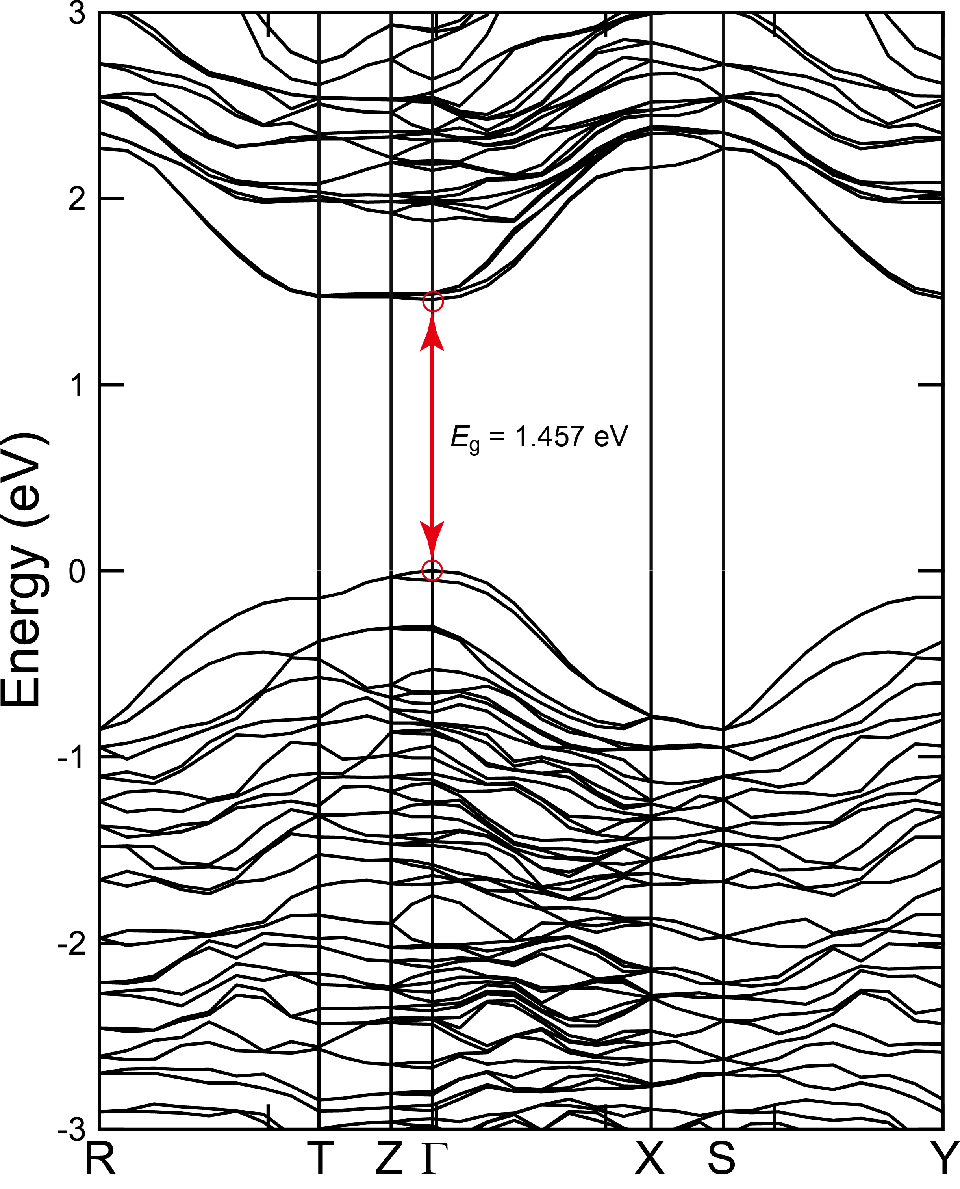
Figure 7. Electronic band dispersion curves of LiLa₃Ti₂S₃O₆. The energy gap at Γ is 1.457 eV.
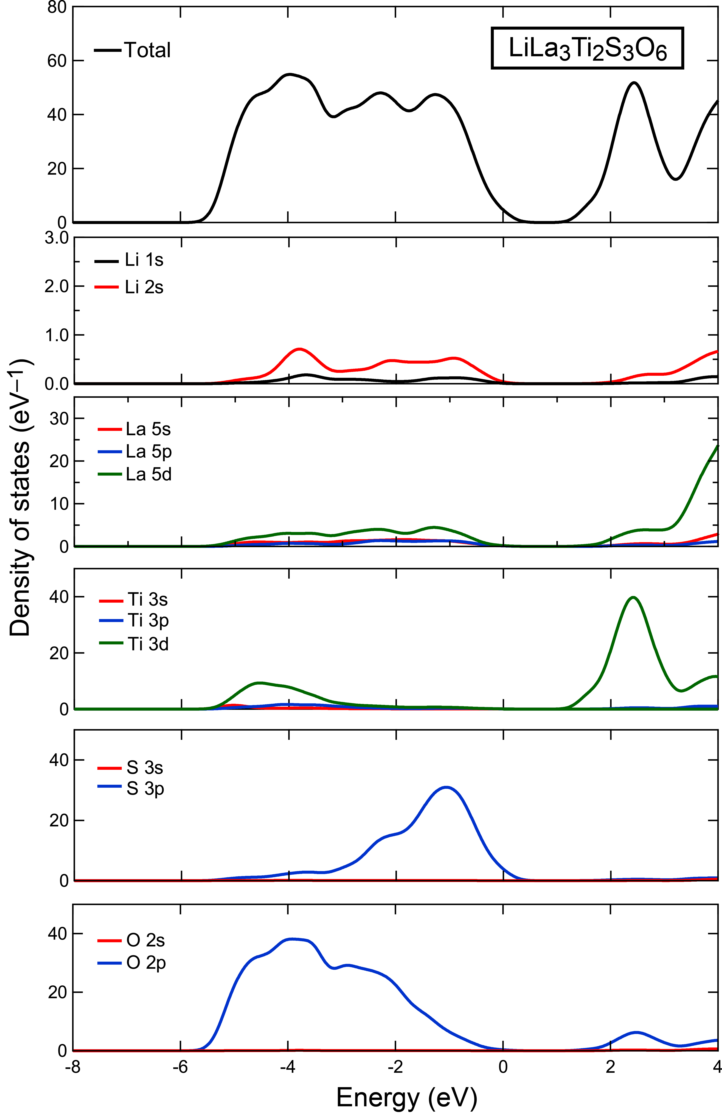
Figure 8. Total and partial density of states of LiLa₃Ti₂S₃O₆ obtained by first-principles calculations.

CONCLUSION
In this study, single crystals of a new orange rod-shaped oxysulfide, LiLa₃Ti₂S₃O₆, were successfully grown out of a KI molten salt. It exhibited a unique intergrowth structure composed of corrugated perovskite-type and rock-salt-type layers and one-dimensional fragments of LiO₂S₂ tetrahedra. From a comparison with related titanium-based oxysulfide compounds, it is likely that the unusual LiO₂S₂ tetrahedral geometry in LiLa₃Ti₂S₃O₆ plays an important role in stabilizing the layered intergrowth. Since LiLa₃Ti₂S₃O₆ possesses crystal and electronic structures similar to those of Y₂Ti₂S₂O₅ and La₅Ti₂CuS₅O₇ photocatalysts, we can expect the title compound to exhibit photocatalytic water splitting behavior under visible light irradiation, hopefully driven by electron-hole separation into perovskite-type layers and one-dimensional LiO₂S₂ tetrahedral fragments.
ASSOCIATED CONTENT
Acknowledgements
We thank A. Iwanade for supporting the ICP-OES measurements. This study was supported by World Premier International Research Center Initiative (WPI), Core-to-Core Program (JPJSCCA20200004), JSPS Bilateral Program (No. JPJSBP120237714), Y.T. acknowledges the grant from the Sumitomo Foundation.

Supporting Information.
CIF file of LiLa₃Ti₂S₃O₆, based on single crystal XRD data, anisotropic displacement parameters for LiLa₃Ti₂S₃O₆, crystallographic data estimated by first-principles calculations. This material is available free of charge online at http://pubs.acs.org (PDF).
AUTHOR INFORMATION
Corresponding Author
*Yoshihiro Tsujimoto. Email: TSUJIMOTO.Yoshihiro@nims.go.jp.
Notes
The authors declare no competing financial interests.

References
(1) Kageyama, H.; Hayashi, K.; Maeda, K.; Attfield, J. P.; Hiroi, Z.; Rondinelli, J. M.; Poeppelmeier, K. R. Expanding Frontiers in Materials Chemistry and Physics with Multiple Anions. Nat Commun 2018, 9 (1), 772. https://doi.org/10.1038/s41467-018-02838-4.
(2) Zhao, L. D.; Berardan, D.; Pei, Y. L.; Byl, C.; Pinsard-Gaudart, L.; Dragoe, N. Bi1-x Srx CuSeO Oxyselenides as Promising Thermoelectric Materials. Appl Phys Lett 2010, 97 (9). https://doi.org/10.1063/1.3485050.
(3) Vaqueiro, P.; Al Orabi, R. A. R.; Luu, S. D. N.; Guélou, G.; Powell, A. V.; Smith, R. I.; Song, J. P.; Wee, D.; Fornari, M. The Role of Copper in the Thermal Conductivity of Thermoelectric Oxychalcogenides: Do Lone Pairs Matter? Physical Chemistry Chemical Physics 2015, 17 (47), 31735–31740. https://doi.org/10.1039/c5cp06192j.
(4) Knee, C. S.; Weller, M. T. Neutron Diffraction Study of Crystal Structure and Antiferromagnetic Order in Sr2CoO2X2 (X=Cl, Br). Phys Rev B Condens Matter Mater Phys 2004, 70 (14). https://doi.org/10.1103/PhysRevB.70.144406.
(5) Greven, M.; Birgeneau, R. J.; Endoh, Y.; Kastner, M. A.; Matsuda, M.; Shirane, G. Neutron Scattering Study of the Two-Dimensional SpinS=1/2 Square-Lattice Heisenberg Antiferromagnet Sr2CuO2Cl2. Zeitschrift für Physik B Condensed Matter 1995, 96 (4), 465–477. https://doi.org/10.1007/BF01313844.
(6) Tsujimoto, Y.; Sathish, C. I.; Matsushita, Y.; Yamaura, K.; Uchikoshi, T. New Members of Layered Oxychloride Perovskites with Square Planar Coordination: Sr 2 MO 2 Cl 2 (M = Mn, Ni) and Ba 2 PdO 2 Cl 2. Chem. Commun. 2014, 50 (44), 5915–5918. https://doi.org/10.1039/C4CC01422G.
(7) Smyth, R. D.; Khalyavin, D.; Tsujimoto, Y.; Yamaura, K.; Clarke, S. J. Magnetic Ordering in the Layered Oxyhalide Sr2NiO2Cl2. Solid State Sci 2023, 144. https://doi.org/10.1016/j.solidstatesciences.2023.107297.
(8) Ralph Pearson, B. G. PHYSICAL AND INORGANIC CHEMISTRY Hard and Soft Acids and Bases; UTC, 2024; Vol. 01. https://pubs.acs.org/sharingguidelines.
(9) Goga, M.; Seshadri, R.; Ksenofontov, V.; Gütlich, P.; Tremel, W. Ln2Ti2S2O5 (Ln = Nd, Pr, Sm): A Novel Series of Defective Ruddlesden–Popper Phases. Chemical Communications 1999, No. 11, 979–980. https://doi.org/10.1039/a809737b.
(10) Boyer-Candalen, C.; Derouet, J.; Porcher, P.; Moëlo, Y.; Meerschaut, A. The Family of Ln2Ti2S2O5 Compounds (Ln=Nd, Sm, Gd, Tb, Dy, Ho, Er, and Y): Optical Properties. J Solid State Chem 2002, 165 (2), 228–237. https://doi.org/10.1006/jssc.2002.9492.
(11) Meignen, V.; Cario, L.; Lafond, A.; Moëlo, Y.; Guillot-Deudon, C.; Meerschaut, A. Crystal Structures of Two New Oxysulfides La5Ti 2MS5O7 (M=Cu, Ag): Evidence of Anionic Segregation. J Solid State Chem 2004, 177 (8), 2810–2817. https://doi.org/10.1016/j.jssc.2004.04.023.
(12) Meignen, V.; Meerschaut, A.; Cario, L.; Lafond, A. Synthesis and Crystal Structure of a New Oxychalcogenide La 5Ti∼3.25Zr∼0.25S5O 9.25. J Solid State Chem 2005, 178 (5), 1637–1643. https://doi.org/10.1016/j.jssc.2005.03.003.
(13) Guillot-Deudon, C.; Meignen, V.; Cario, L.; Lafond, A.; Meerschaut, A. Crystal Structure and Electrical Properties of the Mixed Valent Titanium Oxysulfide Sm2Ti2S2O4.5. J Solid State Chem 2004, 177 (7), 2464–2469. https://doi.org/10.1016/j.jssc.2004.04.012.
(14) Tranchitella, L. J.; Fettinger, J. C.; Heller-Zeisler, S. F.; Eichhorn, B. W. La 8+x Ti 8+y S 24 O 4 Compounds Where x + y e 2: A Series of Phases with Mixed-Valent Titanium; 1998. https://pubs.acs.org/sharingguidelines.
(15) Tranchitella, L. J.; Fettinger, J. C.; Eichhorn, B. W. Synthesis and Structural Analysis of Sr 5.8 La 4.4 Ti 7.8 S 24 O 4 and La 14 Ti 8 S 33 O 4 : Two New Oxysulfides Containing a Common ∞ 2 [(Ti 4 S 2 O 4 )(TiS 6 ) 4/2 ] 12-Layer; 1996. https://pubs.acs.org/sharingguidelines.
(16) Cario, L.; Deudon, C.; Meerschaut, A.; Rouxel, J. Synthesis and Structure Determination of La 8 Ti 10 S 24 O 4; 1998; Vol. 136.
(17) Cody, J. A.; Deudon, C.; Cario, L.; Meerschaut, A. SYNTHESIS AND STRUCTURE DETERMINATION OF A NEW CERIUM TITANIUM OXYSULFIDE [Ce2oTitlSuO6]; 1997; Vol. 32.
(18) Gardberg, A. S.; Ibers, J. A.; Ο, P. S. Crystal Structure of Hexapraseodymium Dititanium Septasulfide Hexaoxide, Pr 6 Ti2S706; 2001; Vol. 216.
(19) Ishikawa, A.; Takata, T.; Matsumura, T.; Kondo, J. N.; Hara, M.; Kobayashi, H.; Domen, K. Oxysulfides Ln2Ti2S2O5 as Stable Photocatalysts for Water Oxidation and Reduction under Visible-Light Irradiation. Journal of Physical Chemistry B 2004, 108 (8), 2637–2642. https://doi.org/10.1021/jp036890x.
(20) Ishikawa, A.; Takata, T.; Kondo, J. N.; Hara, M.; Kobayashi, H.; Domen, K. Oxysulfide Sm2Ti2S2O5 as a Stable Photocatalyst for Water Oxidation and Reduction under Visible Light Irradiation (λ ≤ 650 Nm). J Am Chem Soc 2002, 124 (45), 13547–13553. https://doi.org/10.1021/ja0269643.
(21) Yoshida, H.; Pan, Z.; Shoji, R.; Nandal, V.; Matsuzaki, H.; Seki, K.; Lin, L.; Kaneko, M.; Fukui, T.; Yamashita, K.; Takata, T.; Hisatomi, T.; Domen, K. An Oxysulfide Photocatalyst Evolving Hydrogen with an Apparent Quantum Efficiency of 30 % under Visible Light. Angewandte Chemie - International Edition 2023, 62 (46). https://doi.org/10.1002/anie.202312938.
(22) Wang, Q.; Nakabayashi, M.; Hisatomi, T.; Sun, S.; Akiyama, S.; Wang, Z.; Pan, Z.; Xiao, X.; Watanabe, T.; Yamada, T.; Shibata, N.; Takata, T.; Domen, K. Oxysulfide Photocatalyst for Visible-Light-Driven Overall Water Splitting. Nature Materials. Nature Publishing Group August 1, 2019, pp 827–832. https://doi.org/10.1038/s41563-019-0399-z.
(23) Brlec, K.; Savory, C. N.; Scanlon, D. O. Understanding the Electronic Structure of Y2Ti2O5S2 for Green Hydrogen Production: A Hybrid-DFT and GW Study. J Mater Chem A Mater 2023, 11 (31), 16776–16787. https://doi.org/10.1039/d3ta02801a.
(24) Zhang, J.; Liu, K.; Zhang, B.; Zhang, J.; Liu, M.; Xu, Y.; Shi, K.; Wang, H.; Zhang, Z.; Zhou, P.; Ma, G. Anisotropic Charge Migration on Perovskite Oxysulfide for Boosting Photocatalytic Overall Water Splitting. J Am Chem Soc 2024, 146 (6), 4068–4077. https://doi.org/10.1021/jacs.3c12417.
(25) Lin, L.; Kaewdee, P.; Nandal, V.; Shoji, R.; Matsuzaki, H.; Seki, K.; Nakabayashi, M.; Shibata, N.; Tao, X.; Liang, X.; Ma, Y.; Hisatomi, T.; Takata, T.; Domen, K. Flux-Assisted Synthesis of Y2Ti2O5S2 for Photocatalytic Hydrogen and Oxygen Evolution Reactions. Angewandte Chemie - International Edition 2023, 62 (42). https://doi.org/10.1002/anie.202310607.
(26) Yao, Y.; Li, Q.; Chu, W.; Ding, Y. M.; Yan, L.; Gao, Y.; Neogi, A.; Govorov, A.; Zhou, L.; Wang, Z. Exploration of the Origin of the Excellent Charge-Carrier Dynamics in Ruddlesden-Popper Oxysulfide Perovskite Y2Ti2O5S2. Physical Chemistry Chemical Physics 2023, 25 (48), 32875–32882. https://doi.org/10.1039/d3cp02860g.
(27) Suzuki, T.; Hisatomi, T.; Teramura, K.; Shimodaira, Y.; Kobayashi, H.; Domen, K. A Titanium-Based Oxysulfide Photocatalyst: La 5Ti 2MS 5O 7 (M = Ag, Cu) for Water Reduction and Oxidation. Physical Chemistry Chemical Physics 2012, 14 (44), 15475–15481. https://doi.org/10.1039/c2cp43132g.
(28) Brlec, K.; Kavanagh, S. R.; Savory, C. N.; Scanlon, D. O. Understanding the Photocatalytic Activity of La5Ti2AgS5O7 and La5Ti2CuS5O7 for Green Hydrogen Production: Computational Insights. ACS Appl Energy Mater 2022, 5 (2), 1992–2001. https://doi.org/10.1021/acsaem.1c03534.
(29) Brese, N. E.; O’Keeffe, M. Bond-Valence Parameters for Solids. Acta Crystallogr B 1991, 47 (2), 192–197. https://doi.org/10.1107/s0108768190011041.
(30) Shannon, R. D. Revised Effective Ionic Radii and Systematic Studies of Interatomic Distances in Halides and Chalcogenides. Acta Crystallographica Section A 1976, 32 (5), 751–767. https://doi.org/10.1107/s0567739476001551.
(31) Kloskowska, M.; Chojnacki, J.; Wojnowski, W.; Becker, B. The First Compound with an Unusual Type of Anion, [Li(SR)2] -: Bis(Μ2-Aqua-D2)Tetrakis(Aqua-d 2)Dilithium(I) Bis[Bis(Tri-Tert-Butoxysilanethiolato- Κ2O,S)Lithate(I)] Dihydrate-D2. Acta Crystallogr C 2006, 62 (11). https://doi.org/10.1107/S0108270106041746.
(32) Wang, X.; Li, Y.; Bi, X.; Ma, L.; Wu, T.; Sina, M.; Wang, S.; Zhang, M.; Alvarado, J.; Lu, B.; Banerjee, A.; Amine, K.; Lu, J.; Meng, Y. S. Hybrid Li-Ion and Li-O2 Battery Enabled by Oxyhalogen-Sulfur Electrochemistry. Joule 2018, 2 (11), 2381–2392. https://doi.org/10.1016/j.joule.2018.07.019.
(33) Hyett, G.; Rutt, O. J.; Gál, Z. A.; Denis, S. G.; Hayward, M. A.; Clarke, S. J. Electronically Driven Structural Distortions in Lithium Intercalates of the n = 2 Ruddlesden-Popper-Type Host Y2Ti2O 5S2: Synthesis, Structure, and Properties of Li XY2Ti2O5S2 (0 < x < 2). J Am Chem Soc 2004, 126 (7), 1980–1991. https://doi.org/10.1021/ja037763h.
(34) Yashima, M.; Ogisu, K.; Domen, K. Structure and Electron Density of Oxysulfide Sm ₂ Ti ₂ S ₂ O _{4.9} , a Visible-Light-Responsive Photocatalyst. Acta Crystallogr B 2008, 64 (3), 291–298. https://doi.org/10.1107/S0108768108007532.
(35) Miura, A.; Oshima, T.; Maeda, K.; Mizuguchi, Y.; Moriyoshi, C.; Kuroiwa, Y.; Meng, Y.; Wen, X. D.; Nagao, M.; Higuchi, M.; Tadanaga, K. Synthesis, Structure and Photocatalytic Activity of Layered LaOInS2. J Mater Chem A Mater 2017, 5 (27), 14270–14277. https://doi.org/10.1039/c7ta04440b.
(36) Yan, H.; Kuwabara, A.; Smith, M. D.; Yamaura, K.; Tsujimoto, Y.; zur Loye, H.-C. Flux Crystal Growth, Structure, and Optical Properties of the New Germanium Oxysulfide La ₄ (GeS ₂ O ₂ ) ₃. Cryst Growth Des 2020, 20 (6), 4054–4061. https://doi.org/10.1021/acs.cgd.0c00332.
(37) Yan, H.; Fujii, K.; Kabbour, H.; Chikamatsu, A.; Meng, Y.; Matsushita, Y.; Yashima, M.; Yamaura, K.; Tsujimoto, Y. La ₄ Ga ₂ S ₈ O ₃ : A Rare-Earth Gallium Oxysulfide with Disulfide Ions. Inorg Chem 2023, 62 (26), 10481–10489. https://doi.org/10.1021/acs.inorgchem.3c01524.
(38) Kabbour, H.; Sayede, A.; Saitzek, S.; Lefèvre, G.; Cario, L.; Trentesaux, M.; Roussel, P. Structure of the Water-Splitting Photocatalyst Oxysulfide α-LaOInS2 and: Ab Initio Prediction of New Polymorphs. Chemical Communications 2020, 56 (11), 1645–1648. https://doi.org/10.1039/c9cc09797j.
(39) Mvélé, L.-B.; Sasaki, S.; Latouche, C.; Deniard, P.; Janod, E.; Braems, I.; Jobic, S.; Cario, L. Revisiting the Crystal Structure of Layered Oxychalcogenides Ln ₂ O ₂ S ₂ (Ln = La, Pr, and Nd). Inorg Chem 2023, 62 (19), 7264–7272. https://doi.org/10.1021/acs.inorgchem.3c00147.
(40) Ma, G.; Suzuki, Y.; Singh, R. B.; Iwanaga, A.; Moriya, Y.; Minegishi, T.; Liu, J.; Hisatomi, T.; Nishiyama, H.; Katayama, M.; Seki, K.; Furube, A.; Yamada, T.; Domen, K. Photoanodic and Photocathodic Behaviour of La5Ti2CuS5O7 Electrodes in the Water Splitting Reaction. Chem Sci 2015, 6 (8), 4513–4518. https://doi.org/10.1039/c5sc01344e.

For Table of Contents Use Only
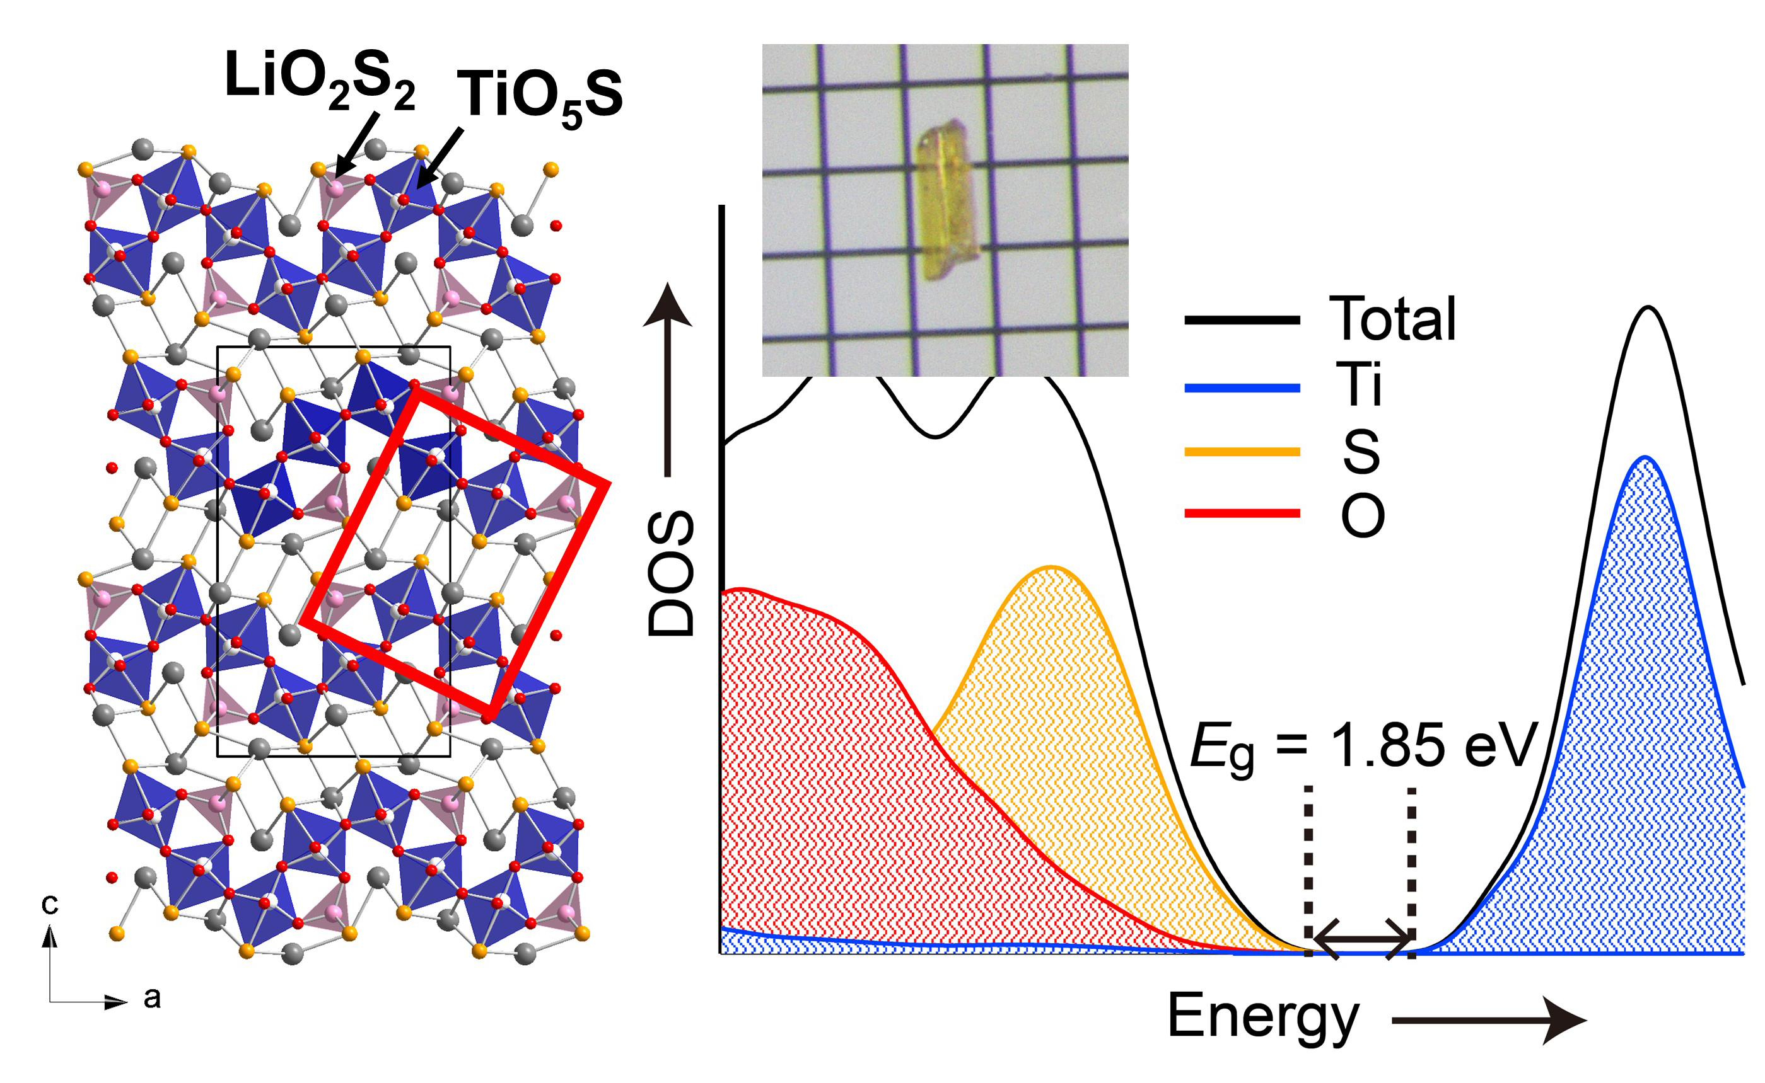
Single crystals of a new titanium oxysulfide with unusual LiO₂S₂ tetrahedra, LiLa₃Ti₂S₃O₆, were grown out of a KI molten salt. The S 3p states and Ti 3d states dominate the valence band maximum and conduction band minimum, respectively, making LiLa₃Ti₂S₃O₆ a direct-type semiconductor with an optical band gap of 1.85 eV.

