Noninvasive Needle-Free Cancer Vaccine Cream Patch Based on Fluorinated Chitosan

Zhisheng Xiao, Guangzhi Li, Dashi Deng, Ting Wei, Guoping Chen, Huiquan Tao, Yu Chao, Bo Liu, Qiaofeng Li, Yifan Yang, Zhuang Liu, Qian Chen *
Z. Xiao, T. Wei, H. Tao, Y. Chao, B. Liu, Q. Li, Y. Yang, Z. Liu, Q. Chen
Institute of Functional Nano & Soft Materials (FUNSOM), Jiangsu Key Laboratory for Carbon-Based Functional Materials and Devices, Soochow University, Suzhou 215123, China.
E-mail: chenqian@suda.edu.cn
G. Li, D. Deng
Institute of Urology, The Affiliated Luohu Hospital of Shenzhen University, Shenzhen University, Shenzhen 518000, China
G. Chen
Research Center for Macromolecules and Biomaterials, National Institute for Materials Science, Tsukuba, Ibaraki 305-0044, Japan

Keywords: cancer immunotherapy, fluorinated chitosan, needle-free vaccines, transdermal delivery

Abstract
In recent years, cancer vaccines that intend to specifically initiate host immune responses against cancer have achieved some clinical success. Delivery of vaccines with traditional needles is usually associated with the risk of infection and poor patient compliance. The development of needle-free vaccines may overcome these limitations. In this work, a needle-free patch is designed for effective cancer vaccination using a fluorine chain-modified cationic polymer, fluorinated chitosan (FCS), which is able to transdermatically deliver the antigen to antigen-presenting cells in the skin. Specifically, a transdermal carrier, FCS, and model antigen ovalbumin (OVA) can self-assemble into nanoparticles, which can reversibly open the tight junction-associated proteins of epithelial cells and penetrate across the epidermis. The needle-free cancer vaccine patch is fabricated by mixing FCS-OVA nanoparticles with the US Food and Drug Administration-approved immune adjuvant imiquimod (R837) in blank cream. Such a needle-free cancer vaccine can generate robust immune responses to protect mice against ovalbumin-expressing melanoma (B16-OVA). Compared to traditional intradermal injection, needle-free cancer vaccines achieved an even more efficient protection effect against B16-OVA cancer cells. This work indicated that the novel needle-free cancer vaccine may provide a compelling technology for simple and safe vaccination, which may help to increase vaccination coverage.

- Introduction
By boosting the body's immune system to against cancer cells, cancer immunotherapy, including immune checkpoint blockade (ICB), cytokine therapy, chimeric antigen receptor (CAR)-T-cell therapy, and cancer vaccines, has achieved tremendous progress and shown promising therapeutic results in the clinic^{[1-3]}. Among them, cancer vaccines exhibit many unique advantages, which usually raise specific T-cell or B-cell responses against cancer and may provide long-term immune-memory effects to protect the patient from cancer recurrence^{[4-6]}. Effective cancer vaccines usually contain specific antigens, which are expected to be overexpressed in cancer cells rather than normal cells, and adjuvants, which could improve the immunogenicity of antigens^{[7, 8]}. During cancer vaccination, resting dendritic cells (DCs) can be activated and loaded with antigen, programmed to migrate to nearby lymph nodes, and then present antigens in the form of small peptides bound within the major histocompatibility complex (MHC)^{[9, 10]}. Then, T cells can recognize the complex of specific peptide and MHC molecules, activate with additional signals provided by mature DCs, and then traffic widely through the body to attack their targeted cancer cells^{[11-13]}.
Typically, most vaccines are administered through needles due to their effectiveness in delivering the vaccines into the body. However, needle injections are usually associated with the risk of infection, poor patient compliance, especially for children, special training of medical staff to operate properly and subsequent needle handling^{[14-16]}. Additionally, there are a large number of antigen-presenting cells (APCs), also called Langerhans cells, in the epidermis of skin, which can enter draining lymph nodes and deliver antigens to T cells and trigger strong immune responses^{[17]}. Needle delivery of vaccines may bypass abundant APCs, resulting in inefficient immune responses. Thus, transdermal delivery of vaccines into the epidermis of skin may be an ideal strategy for vaccination^{[18, 19]}. Recently, various transdermal delivery systems based on chemical enhancers^{[20]} and physical enhancement devices such as cavitational ultrasound^{[21]}, iontophoresis^{[22]}, microdermabrasion^{[23]} and microneedles^{[24]} have been developed. Although these strategies could be used for the transdermal delivery of vaccines, they still face many challenges. For example, chemical enhancers, such as membrane penetrating peptides, usually show inefficient transdermal delivery efficiency^{[25, 26]}. Meanwhile, physical enhancement devices usually depend on large equipment to open the epithelial barrier through pulses with high energy, which may be inconvenient, expensive and invasive^{[27, 28]}. Moreover, although microneedles have shown great potential for vaccine delivery, they could still induce slight damage to the skin with many small needles, which also has the risk of infection^{[16, 29, 30]}. Thus, it is still vital to develop novel transdermal delivery systems to achieve needle-free vaccinations.
Chitosan (CS), a naturally degradable polysaccharide with good biocompatibility, has been reported to have the ability to cross the mucosal barrier^{[31, 32]}. In our recent works, we found that modifying chitosan with fluorine chains could effectively transport macromolecules, such as antibodies against biological barriers^{[7, 33-37]}. Thus, modifying chitosan with fluorine chains may be an effective strategy to transdermally deliver cancer vaccines. Taking advantage of the amino-rich nature of chitosan^{[38]}, perfluoroheptanoic acid was grafted onto chitosan via an amino-carboxylate coupling reaction. It was found that the obtained fluorinated chitosan (FCS) was able to self-assemble with the model antigen ovalbumin (OVA) to form stable nanoparticles, which could reversibly open the tight junction-associated proteins of epithelial cells and penetrate across the epithelial barrier into the dermis. We have demonstrated the excellent transdermal ability of FCS-OVA nanoparticles in both the Franz diffusion chamber assay^{[39]} in vitro and lymph node accumulation in vivo. To improve the immune stimulation effect achieved by FCS-OVA, a US Food and Drug Administration (FDA)-approved immune adjuvant, imiquimod (R837), was introduced to be mixed in the commercial cream containing FCS-OVA. With the help of FCS, the model antigen OVA can penetrate across the epithelial cell barrier, accumulate in nearby lymph nodes and trigger the antigen presentation process^{[40]}. The presence of R837, which is a potent TLR7 agonist, could further promote antigen presentation^{[41]}. Using this needle-free cancer vaccine, FCS-OVA/R837, robust antigen-specific cellular immune responses could be triggered, which could effectively protect mice against B16-OVA melanoma. Thus, our work provides a novel and efficient strategy to prepare needle-free cancer vaccine patches that effectively prevent cancer recurrence and metastasis.
- Results and discussion
Formation and characterization of FCS-OVA nanoparticles
First, a fluoroalkane chain was grafted to chitosan to form FCS via the amino-carboxylate coupling reaction with the help of N-ethyl-N′-(3-(dimethylamino)propyl) carbodiimide (EDC) and N-hydroxysuccinimide (NHS). Interestingly, the positively charged FCS could interact electrostatically with negatively charged proteins, forming stable FCS-OVA nanoparticles (Figure 1a). To optimize the formed FCS-OVA nanoparticles, various FCS-OVA nanoparticles were synthesized after adding FCS and OVA with different weight ratios from 2:1 to 1:4. Then, the size distribution and zeta potential of various FCS-OVA nanoparticles were characterized by a Zetasizer Nano ZS. As shown in Figure 1b, FCS-OVA with the ratio of FCS to OVA at 2:1 and 1:1 exhibited a uniform size distribution of approximately 150 nm. In contrast, FCS-OVA with other FCS and OVA ratios exhibited a relatively larger size, indicating the agglomeration of FCS-OVA. From the zeta potentials of different nanoparticles, we can see that as the weight ratio of OVA increased, the zeta potentials of nanoparticles decreased, further demonstrating that the successful self-assembly of FCS-OVA nanoparticles was induced by electrostatic interactions (Figure 1c). Considering that FCS-OVA nanoparticles with FCS and OVA weight ratio of 1:1 exhibited a suitable size and narrowest distribution, they were chosen in the following experiments.
Then, transmission electron microscopy (TEM) was employed to elucidate the morphological features of FCS-OVA with FCS and OVA weight ratio of 1:1. As shown in Figure 1d, FCS-OVA exhibited homogeneously spherical morphology with the average diameter about 180 nm. In addition to the morphology characterization, we then determined the biocompatibility of FCS-OVA nanoparticles using a standard 3-(4,5-dimethylthiazol-2-yl)-2,5-diphenyltetrazoliumbromide (MTT) assay. In this experiment, DC 2.4 cells were incubated with CS-OVA or FCS-OVA at varying concentrations. Excitingly, FCS-OVA revealed nearly no cytotoxicity to cells even at high concentrations up to 500 µg/ml. In contrast, the viability of DC 2.4 cells incubated with CS-OVA at the same concentration was only 50% (Figure 1e). Thus, FCS exhibited better biocompatibility, which may be attributed to the fluoroalkane chain replaced the amino group of CS, reducing the positive charge of CS.

Transdermal delivery of FCS-OVA nanoparticles
For effective cancer vaccines, the internalization, intracellular processing, and subsequent presentation of antigens by antigen-presenting cells play pivotal roles in eliciting effective immune responses. Therefore, we first investigated the cellular uptake profile of antigen by DCs. Here, DC 2.4 cells, which is a dendritic cell line that could be used to study the partial biology of DCs, were incubated with FCS-OVA-FITC and OVA-FITC and then analysed by confocal imaging and flow cytometry (OVA was labelled with FITC for in vitro tracking). As depicted in Figure 2a, the uptake of FCS-OVA nanoparticles by DC 2.4 cells was significantly augmented in comparasion with free OVA. The enhanced uptake of FCS-OVA nanoparticles was further substantiated through flow cytometry analysis, as illustrated in Figure 2b and Figure 2c. These findings unequivocally demonstrate that FCS-OVA nanoparticles effectively enhance the intracellular uptake of the antigen.Inspired by the effective cellular uptake of FCS-OVA nanoparticles by DCs, we then investigated their transdermal delivery efficiency. First, the standard Franz diffusion chamber was used to determine the transdermal delivery efficiency of FCS-OVA across the mouse skin layer (Figure 2d). We separated the skin of C57BL/6 mice, the stratum corneum was carefully preserved and subsequently positioned between the donor chamber and the receiver chamber. The donor chamber was loaded with OVA-FITC, FCS-OVA-FITC, and CS-OVA-FITC, and the fluorescence signals in the receiver chamber were assessed at various time intervals. As expected, FCS-OVA nanoparticles exhibited significantly higher transdermal delivery efficiency across the epithelial barrier (Figure 2e).
For a transdermal delivery vaccine, whether the antigen can be efficiently delivered into the dermis and migrate into lymph nodes determines its vaccine efficiency^{[40]}. Thus, we then investigated the lymph node accumulation of OVA after transdermal delivery of OVA in different formulations. Specifically, mice were covered with OVA-Cy5.5, FCS-OVA-Cy5.5, and CS-OVA-Cy5.5 (OVA was labelled with Cy5.5 for in vivo tracking), which were mixed in moisturizing cream (Aquaphor) at a weight ratio of 1:1 and covered with 3M Tegaderm Transparent Film Dressing (1624 W) for fixation and moisturization. 12 hours later, upon ethical sacrifice, the mice subjects were utilized for lymph node collection, followed by fluorescence imaging. The ex vivo fluorescence imaging of the lymph nodes revealed that the highest accumulation of OVA occurred in the lymph nodes of mice treated with FCS-OVA-Cy5.5 cream, confirming that efficient transdermal delivery of antigen was achieved by such a needle-free vaccine (Figure S1). The quantitative statistical analysis further confirmed the efficient antigen delivery into the lymph nodes obtained by FCS-OVA-Cy5.5 (Figure 2f). Confocal imaging of mouse skin slices further demonstrated the good skin penetration ability of FCS (Figure S2).

The mechanism of transdermal delivery
Encouraged by the effective transdermal delivery of OVA achieved by FCS in vitro and in vivo, we investigated the mechanism of such enhanced transdermal delivery ability. It is commonly known that the epithelial barrier is principally maintained by tight junctions, and CS derivatives have the ability to modulate the structure of tight junctions and improve the permeability of epithelial tissue ^{[42]}. To identify the mechanism of efficient transdermal delivery achieved by FCS, the Transwell assay was carried out to monitor the transepithelial electrical resistance (TEER), which is a standard parameter utilized to assess the integrity and functionality of tight junctions. ^{[43]}. In this experiment, the epithelial skin barrier were mimicked by culturing human skin dermis cells (HACAT) in the Transwell to form a monolayer, when the TEER value increased to a stable level at 300 (Figure 3a). Then, FCS-OVA nanoparticles were added into the Transwell, and the TEER value was monitored continuously. As shown in Figure 3b, the TEER value decreased to 45% after incubation with FCS-OVA nanoparticles for 4 hours, and the TEER value gradually returned to the normal level by removing the FCS-OVA nanoparticles, indicating that FCS might improve skin penetration by temporarily opening the tight connections between epithelial cells.
To further investigate the mechanism by which FCS opens cellular tight junctions, the distribution and quantification of four tight junction-related proteins, ZO-1^{[44]} (a scaffold protein that crosslinks and anchors tight junction strand proteins to the actin cytoskeleton), E-cadherin^{[45]} (a bridge between the actin cytoskeleton), claudin^{[46]} and occludin^{[47]} (a staple of the tight junction), were investigated^{[48]}. Following 6 hours culture of HACAT cells with or without FCS-OVA nanoparticles, proteins of HACAT cells were extracted and the amounts of tight junction-related proteins were quantified by western blotting. Interestingly, after culturing with FCS-OVA nanoparticles, the expression of the four tight junction-related proteins remained consistent (Figure 3c, d). Moreover, the distribution of tight junction-associated proteins was further investigated by immunofluorescence staining. The tight junction-associated proteins around the cell after treatment with FCS-OVA NPs changed from tight circles around the cells to circles with interruptions in the middle (Figure 3e). Thus, the total amount of tight junction proteins remained nearly unchanged, and the arrangement of proteins around the cells changed, demonstrating that FCS-OVA nanoparticles did not affect the expression of tight junction-associated proteins but created pathways through the cells by changing the distribution of tight junction-associated proteins. Considering that the phosphorylation level of myosin light chain 2 (pMLC) plays a key role in the regulation of cytoskeletal structure^{[49]}, the levels of myosin light chain 2 (MLC) and pMLC in HACAT cells were detected by western blotting. As shown in Figure 3f & g, after incubating with FCS-OVA nanoparticles, the amount of pMLC expressed in HACAT cells increased, showing that FCS may promote the phosphorylation level of MLC to improve actin contraction and tight junction relative protein rearrangement, leading to the opening of cellular tight junctions to allow the transdermal delivery of macromolecules.

In vitro immune responses
To enhance the immune responses induced by FCS-OVA nanoparticles, the potent TLR7 agonist R837, which is essential for the presentation of the antigen and triggering subsequent immunological responses^{[50]}, was mixed with FCS-OVA nanoparticles. To verify the immunostimulatory effect, healthy C57BL/6 mice were used to extracte bone marrow-derived dendritic cells (BMDCs) and studied the maturation of DCs after incubation with FCS, OVA, R837, OVA-R837, FCS-OVA and FCS-OVA nanoparticles with R837 (FCS-OVA-R837) (Figure 4a & b). The expression levels of CD80 and CD86, recognized as hallmark indicators of DC maturation, were quantified using flow cytometry analysis. As shown in Figure 4a & b, FCS-OVA-R837 obviously promoted DC maturation with CD80 and CD86 expression upregulated. The maturation of DCs was further confirmed by the increased secretion of interleukin-6 (IL-6, pro-inflammatory cytokine), interleukin-12p40 (IL-12p40, antigenic stimulation cytokine), and tumor necrosis factor-α (TNF-α, inflammatory response cytokine) (Figure 4-e). In addition to DC maturation, we further investigated the antigen cross-presentation ability of DCs after incubation with FCS, R837, OVA, OVA-R837, FCS-OVA and FCS-OVA-R837 by flow cytometry. The most abundant SIINFEKL peptide was found on the surface of BMDCs treated with FCS-OVA-R837 (Figure 4f), indicating that FCS-OVA-R837 could promote antigen cross-presentation by DCs and induce downstream immune responses.
Inspired by the effective antigen cross-presentation and maturation of DCs induced by FCS-OVA-R837, we further evaluated the efficiency of BMDCs activated by FCS-OVA-R837 to trigger subsequent OVA-specific T-cell responses. In this case, OT-1 mice were sacrificed, and OVA-specific T cells were extracted from the spleen and then cocultured with BMDCs pretreated with OVA, FCS-OVA, OVA-R837 or FCS-OVA-R837. Here, OVA-specific CD8+ T cells were separated by magnetic beads and prestained with carboxyfluorescein succinimidyl ester (CFSE), and evalued the proliferation. As expected, the OT-1 CD8+ T cells cultured with FCS-OVA-R837 showed much higher proliferation than that of other groups, indicating that FCS-OVA-R837 might efficiently activate BMDCs and cause ensuing OVA-specific T-cell responses (Figure 4g & h).

Prophylactic studies and immunological evaluation
To study the protective ability of such a needle-free vaccine patch, C57BL/6 mice were divided into five groups: FCS patch, FCS-OVA patch, OVA-R837 patch, FCS-OVA-R837 patch and intradermal injection of OVA-R837 (for patch groups: FCS was 25 μg, OVA was 25 μg and R837 was 200 μg per time for six times; for intradermal injection: OVA was 50 μg, R837 was 400 μg per time for three times). For the patch groups, FCS, FCS-OVA, OVA-R837 or FCS-OVA-R837 were first mixed with moisturizing cream, applied to the back of C57BL/c mice, and then covered with a 3 M dressing. For three weeks, the vaccine was administered twice a week. As the positive control, the mice were intradermally injected with OVA-R837 once a week for three weeks. Four days after the last treatment, every mouse was challenged with 3*10⁶ OVA-expressing B16-OVA melanoma tumor cells (Figure S3 & Figure 5a). Tumor growth was monitored every two days. Excitingly, compared to the mice with standard intradermal injection of OVA-R837, the mice treated with the FCS-OVA-R837 patch exhibited a much better protective effect to inhibit the growth of tumors, which might be because intradermal injection of the vaccine usually bypasses the abundant APCs in the epidermis of the skin, leading to inefficient antigen presentation. In addition, mice in the FCS-OVA-R837 patch-treated group exhibited significantly prolonged survival, with an 80% survival rate 60 days after tumor challenge (Figure 5c). In contrast, both the OVA/R837 patch, which has difficulty crossing the skin barrier, and the FCS cream, which lacks antigen, exhibited negligible protective effects against tumor growth (Figure 5b).
Next, we evaluated the immune responses induced by this needle-free FCS-OVA-R837 vaccine patch. In the parallel experiment, mice were vaccinated with the FCS-OVA patch, FCS-OVA-R837 patch, OVA-R837 patch and intradermal injection of OVA-R837 and then sacrificed, and their inguinal lymph nodes (LNs) were isolated for evaluation four days after the final treatment. Similar to the in vitro experiment, the highest levels of CD80 and CD86 expression were found in DCs taken from the lymph nodes of mice treated with the FCS-OVA-R837 patch, clearly demonstrating the maturation of DCs induced by FCS-OVA-R837 patch. Moreover, the CD11c⁺SIINFEKL-H-2Kb⁺ antigen cross-presented on the surface of DCs collected from the lymph nodes of in FCS-OVA-R837 treated mice was also significantly increased (Figure 5d-g). Meanwhile, T cells obtained from the spleens of mice in different groups were stimulated with OVA peptide (SIINFEKL) and then analysed. The relative ratio of IFN-γ⁺CD8⁺ T cells collected from mice immunized with the FCS-OVA-R837 vaccine was significantly increased (Figure 5h & i), demonstrating the strong in vivo T-cell responses induced by FCS-OVA-R837 vaccination patch.

- Conclusion
In conclusion, we developed a needle-free vaccination patch utilizing FCS, a cationic polymer modified with fluorine chains that can self-assemble with the model antigen OVA to form homogenous nanoparticles . Interestingly, this nanoparticles could reversibly open the tight junction between epithelial cells and facilitate the penetration of OVA through the epithelial barrier , and uptaken by antigen present cells in the dermic and eipderic, than accumulating into the nearby lymph nodes and triggering antigen presentation. Meanwhile, with the help of R837, which could promote DC activation by stimulating the TLR7 signaling pathway, effective antigen presentation was achieved. More importantly, compared to traditional intradermal injection of OVA-R837, such a needle-free vaccine patch could trigger more effective antitumor immune responses, exhibiting a much better protective effect to inhibit the growth of tumors. In addition to the model antigen OVA demonstrated in this work, such transdermal FCS may be extended to fabricate other types of important needle-free vaccines, such as vaccines against COVID-19.

Supporting Information
Supporting Information is available from the Wiley Online Library or from the author.

Acknowledgement
This article was partially supported by the National Research Programs of China (2020YFA0211100, 2021YFF0701800, 2022YFA1206500), the National Natural Science Foundation of China (21927803, 52032008, 52250002), Collaborative Innovation Center of Suzhou Nano Science and Technology, and the 111 Program from the Ministry of Education of China. Schematics were created with BioRender.com.

Conflict of Interest
The authors declare that they have no conflicts of interest.

Data Availability Statement
The data that support the findings of this study are available from the corresponding author upon reasonable request.

References:
[1] I. Mellman, G. Coukos, G. Dranoff, Nature 2011, 480, 480-489.
[2] Y. Wu, J. Li, P. Jabbarzadeh Kaboli, J. Shen, X. Wu, Y. Zhao, H. Ji, F. Du, Y. Zhou, Y. Wang, H. Zhang, J. Yin, Q. Wen, C. H. Cho, M. Li, Z. Xiao, Pharmacol. Res. 2020, 155, 104691.
[3] T. A. Chan, M. Yarchoan, E. Jaffee, C. Swanton, S. A. Quezada, A. Stenzinger, S. Peters, Annals of Oncology 2019, 30, 44-56.
[4] J. L. Tanyi, S. Bobisse, E. Ophir, S. Tuyaerts, A. Roberti, R. Genolet, P. Baumgartner, B. J. Stevenson, C. Iseli, D. Dangaj, B. Czerniecki, A. Semilietof, J. Racle, A. Michel, I. Xenarios, C. Chiang, D. S. Monos, D. A. Torigian, H. L. Nisenbaum, O. Michielin, C. H. June, B. L. Levine, D. J. Powell, D. Gfeller, R. Mick, U. Dafni, V. Zoete, A. Harari, G. Coukos, L. E. Kandalaft, Sci. Transl. Med. 2018, 10, eaao5931.
[5] A. Pavlick, A. B. Blazquez, M. Meseck, M. Lattanzi, P. A. Ott, T. U. Marron, R. M. Holman, J. Mandeli, A. M. Salazar, C. B. McClain, G. Gimenez, S. Balan, S. Gnjatic, R. L. Sabado, N. Bhardwaj, Cancer immunology research 2020, 8, 70-80.
[6] Y. Fan, S. M. Stronsky, Y. Xu, J. T. Steffens, S. A. van Tongeren, A. Erwin, C. L. Cooper, J. J. Moon, ACS Nano 2019, 13, 11087-11096.
[7] J. Xu, J. Lv, Q. Zhuang, Z. Yang, Z. Cao, L. Xu, P. Pei, C. Wang, H. Wu, Z. Dong, Y. Chao, C. Wang, K. Yang, R. Peng, Y. Cheng, Z. Liu, Nat. Nanotechnol. 2020, 15, 1043-1052.
[8] S. G. Reed, M. T. Orr, C. B. Fox, Nat. Med. 2013, 19, 1597-1608.
[9] J. Banchereau, R. M. Steinman, Nature 1998, 392, 245-252.
[10] H. Zhao, J. Xu, Y. Li, X. Guan, X. Han, Y. Xu, H. Zhou, R. Peng, J. Wang, Z. Liu, ACS Nano 2019, 13, 13127-13135.
[11] Y. Guo, K. Lei, L. Tang, Front. Immunol. 2018, 9, 1499.
[12] A. Aderem, D. M. Underhill, Annu. Rev. Immunol. 1999, 17, 593-623.
[13] G. F. Gao, J. Tormo, U. C. Gerth, J. R. Wyer, A. J. McMichael, D. I. Stuart, J. I. Bell, E. Y. Jones, B. K. Jakobsen, Nature 1997, 387, 630-634.
[14] N. R. Hegde, S. V. Kaveri, J. Bayry, Drug Discovery Today 2011, 16, 1061-1068.
[15] D. G. Koutsonanos, M. del Pilar Martin, V. G. Zarnitsyn, S. P. Sullivan, R. W. Compans, M. R. Prausnitz, I. Skountzou, PLoS One 2009, 4, e4773.
[16] E. L. Giudice, J. D. Campbell, Adv. Drug Delivery Rev. 2006, 58, 68-89.
[17] M. Merad, F. Ginhoux, M. Collin, Nat. Rev. Immunol. 2008, 8, 935-947.
[18] J.-F. Nicolas, B. Guy, Expert Review of Vaccines 2008, 7, 1201-1214.
[19] T. Warger, H. Schild, G. Rechtsteiner, Immunol. Lett. 2007, 109, 13-20.
[20] P. Karande, S. Mitragotri, Biochimica et Biophysica Acta (BBA) - Biomembranes 2009, 1788, 2362-2373.
[21] B. M. Becker, S. Helfrich, E. Baker, K. Lovgren, P. A. Minugh, J. T. Machan, Academic Emergency Medicine 2005, 12, 289-295.
[22] S. Rawat, S. Vengurlekar, B. Rakesh, S. Jain, G. Srikarti, Indian journal of pharmaceutical sciences 2008, 70, 5-10.
[23] G. M. Glenn, D. C. Flyer, L. R. Ellingsworth, S. A. Frech, D. M. Frerichs, R. C. Seid, J. Yu, Expert Review of Vaccines 2007, 6, 809-819.
[24] R. Jamaledin, C. K. Y. Yiu, E. N. Zare, L.-N. Niu, R. Vecchione, G. Chen, Z. Gu, F. R. Tay, P. Makvandi, Adv. Mater. 2020, 32, 2002129.
[25] X. Liu, T. Chen, X. Liu, Y. Chen, L. Wang, J. Oleo Sci. 2013, 62, 657-664.
[26] P. Karande, A. Jain, K. Ergun, V. Kispersky, S. Mitragotri, PNAS 2005, 102, 4688.
[27] M. Ogura, S. Paliwal, S. Mitragotri, Adv. Drug Delivery Rev. 2008, 60, 1218-1223.
[28] L. A. Jackson, G. Austin, R. T. Chen, R. Stout, F. DeStefano, G. J. Gorse, F. K. Newman, O. Yu, B. G. Weniger, Vaccine 2001, 19, 4703-4709.
[29] S. Indermun, R. Luttge, Y. E. Choonara, P. Kumar, L. C. du Toit, G. Modi, V. Pillay, J. Controlled Release 2014, 185, 130-138.
[30] A. Z. Alkilani, M. T. C. McCrudden, R. F. Donnelly, Pharmaceutics 2015, 7.
[31] A. Martirosyan, M. J. Olesen, K. A. Howard, Chapter Eleven - Chitosan-Based Nanoparticles for Mucosal Delivery of RNAi Therapeutics. In Advances in Genetics, Huang, L., Liu, D.; Wagner, E., Eds. Academic Press: 2014; Vol. 88, pp 325-352.
[32] M. Garcia-Fuentes, M. J. Alonso, J. Controlled Release 2012, 161, 496-504.
[33] G. Li, S. Wang, D. Deng, Z. Xiao, Z. Dong, Z. Wang, Q. Lei, S. Gao, G. Huang, E. Zhang, G. Zeng, Z. Wen, S. Wu, Z. Liu, ACS Nano 2020, 14, 1586-1599.
[34] G. Rong, C. Wang, L. Chen, Y. Yan, Y. Cheng, Sci. Adv. 2020, 6, eaaz1774.
[35] L. Chen, L. Zhang, R. Zhao, J. Shen, Y. Wang, J. Zhu, H. Fang, N. Liu, C. Wang, T. Wei, Y. Chai, M. Li, C. Wu, Q. Chen, Z. Liu, Nano Today 2023, 50, 101834.
[36] J. Shen, H. Gao, L. Chen, Y. Jiang, S. Li, Y. Chao, N. Liu, Y. Wang, T. Wei, Y. Liu, J. Li, M. Chen, J. Zhu, J. Liang, X. Zhou, X. Zhang, P. Gu, Q. Chen, Z. Liu, Sci. Adv. 9, eabq3104.
[37] W. Zhu, Y. Chao, Q. Jin, L. Chen, J.-j. Shen, J. Zhu, Y. Chai, P. Lu, N. Yang, M. Chen, Y. Yang, Q. Chen, Z. Liu, ACS Nano 2023, 17, 4373-4386.
[38] R. Antony, T. Arun, S. T. D. Manickam, Int. J. Biol. Macromol. 2019, 129, 615-633.
[39] R. Neupane, S. H. S. Boddu, J. Renukuntla, R. J. Babu, A. K. Tiwari, Pharmaceutics 2020, 12.
[40] S. De Koker, J. Cui, N. Vanparijs, L. Albertazzi, J. Grooten, F. Caruso, B. G. De Geest, Angew. Chem. Int. Ed. 2016, 55, 1334-1339.
[41] Q. Chen, J. Chen, Z. Yang, J. Xu, L. Xu, C. Liang, X. Han, Z. Liu, Adv. Mater. 2019, 31, 1802228.
[42] Y. Wu, C. Zhu, Z. Chen, Z. Chen, W. Zhang, X. Ma, L. Wang, X. Yang, Z. Jiang, Veterinary Immunology and Immunopathology 2016, 172, 55-63.
[43] K. M. McCarthy, I. B. Skare, M. C. Stankewich, M. Furuse, S. Tsukita, R. A. Rogers, R. D. Lynch, E. E. Schneeberger, J. Cell Sci. 1996, 109, 2287-2298.
[44] M. Itoh, A. Nagafuchi, S. Moroi, S. Tsukita, J. Cell Biol. 1997, 138, 181-192.
[45] S. Alimperti, S. T. Andreadis, Stem Cell Res. 2015, 14, 270-282.
[46] G. Krause, L. Winkler, S. L. Mueller, R. F. Haseloff, J. Piontek, I. E. Blasig, Biochimica et Biophysica Acta (BBA) - Biomembranes 2008, 1778, 631-645.
[47] M. Furuse, T. Hirase, M. Itoh, A. Nagafuchi, S. Yonemura, S. Tsukita, S. Tsukita, J. Cell Biol. 1993, 123, 1777-1788.
[48] J. M. Mullin, S. M. Skrovanek, M. C. Valenzano, Ann. N. Y. Acad. Sci. 2009, 1165, 99-112.
[49] A. MurÁNyi, J. A. MacDonald, J. T. Deng, D. P. Wilson, T. A. J. Haystead, M. P. Walsh, F. ErdÖDi, E. Kiss, Y. Wu, D. J. Hartshorne, Biochem. J 2002, 366, 211-216.
[50] D. N. Sauder, British Journal of Dermatology 2003, 149, 5-8.

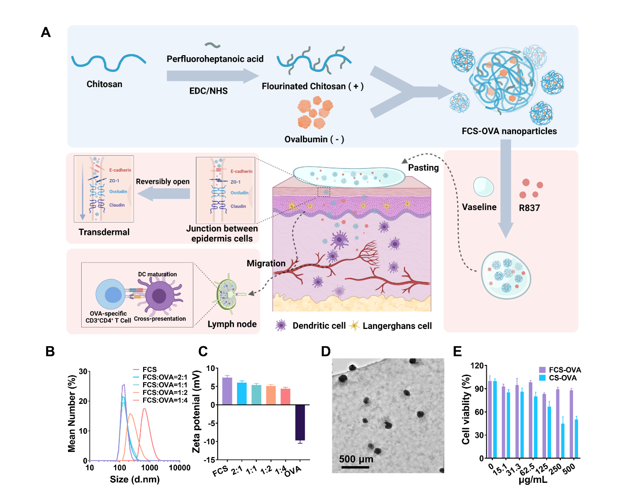
Figure 1 | Preparation and characterization of FCS-OVA nanoparticles. a, Schematic illustration showing the preparation of FCS-OVA nanoparticles. b, c, Size distribution and zeta potential of FCS-OVA nanoparticles with weight ratios ranging from 2:1 to 1:4. d, Transmission electron microscopy (TEM) image of FCS-OVA nanoparticles. e, Relative viabilities of DC2.4 cells after incubation with FCS-OVA or CS-OVA at different concentrations for 12 h (n = 5).

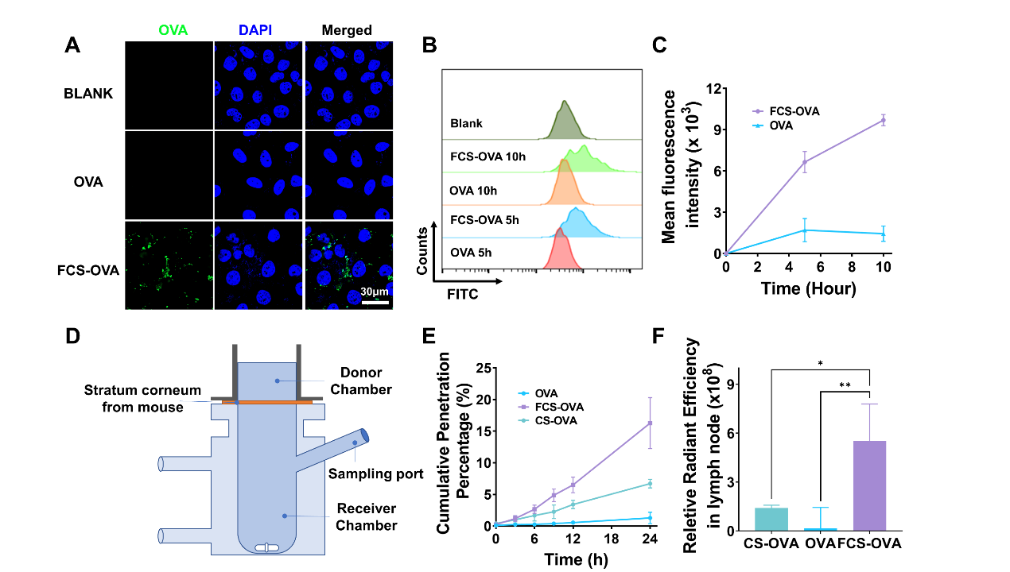
Figure 2 | In vitro transdermal delivery ability of FCS-OVA NPs. a, Confocal fluorescence images of DC2.4 cells treated with OVA-FITC (green) or FCS-OVA-FITC (green) for 6 h. b, c, Flow cytometry and statistical analysis showing the uptake of OVA-FITC and FCS-OVA-FITC by DC2.4 cells at 5 h and 10 h (n = 3). d, Schematic representation of the Franz diffusion assay. e, The cumulative penetration percentage of OVA in the receptor chamber at various time points (n = 3). f, Fluorescence intensity of OVA-Cy5.5 in the inguinal lymph nodes of mice after treatment with different patches (n = 3). P values were calculated by one-way ANOVA with Tukey’s post hoc test, *p < 0.05, **p < 0.01.

Figure 3 | Transdermal delivery mechanism of FCS-OVA. a, Schematic illustration showing the measurement of transepithelial electrical resistance. b, Effect of FCS-OVA on the TEER of monolayer cell model (n = 3). c, d, Western blotting images and statistical analysis of tight junction-associated proteins in HACAT cells (n = 3). e, Immunofluorescence images showing the distribution of tight junction-associated proteins, including E-cadherin, ZO-1, claudin, or occludin, on the cell surface after incubation with FCS-OVA NPs. f, g, Western blotting images and statistical analysis of the phosphorylated level of MLC in cells after incubation with FCS-OVA NPs.

Figure 4 | In vitro immune responses. a, b, Representative flow cytometry plots and statistical analysis of BMDCs after incubation with OVA, FCS, FCS-OVA NPs, OVA-R837, R837 and FCS-OVA NPs with R837 for 12 h (n = 3). c, d, e, The concentrations of IL-6, IL-12p40 and TNF-α secreted by BMDCs evaluated by enzyme-linked immunosorbent assay (ELISA) (n = 3). f, Cross-presentation efficiencies of BMDCs after incubation with different materials for 12 h. g, h, Representative flow cytometry plots and statistical analysis showing the proliferation of OT-I CD3⁺CD8⁺ T cells after incubation with BMDCs pretreated with OVA, FCS-OVA NPs, OVA-R837 or FCS-OVA NPs with R837 (n = 3). P values were calculated by one-way ANOVA with Tukey’s post hoc test, ***p < 0.001, ****p < 0.0001.

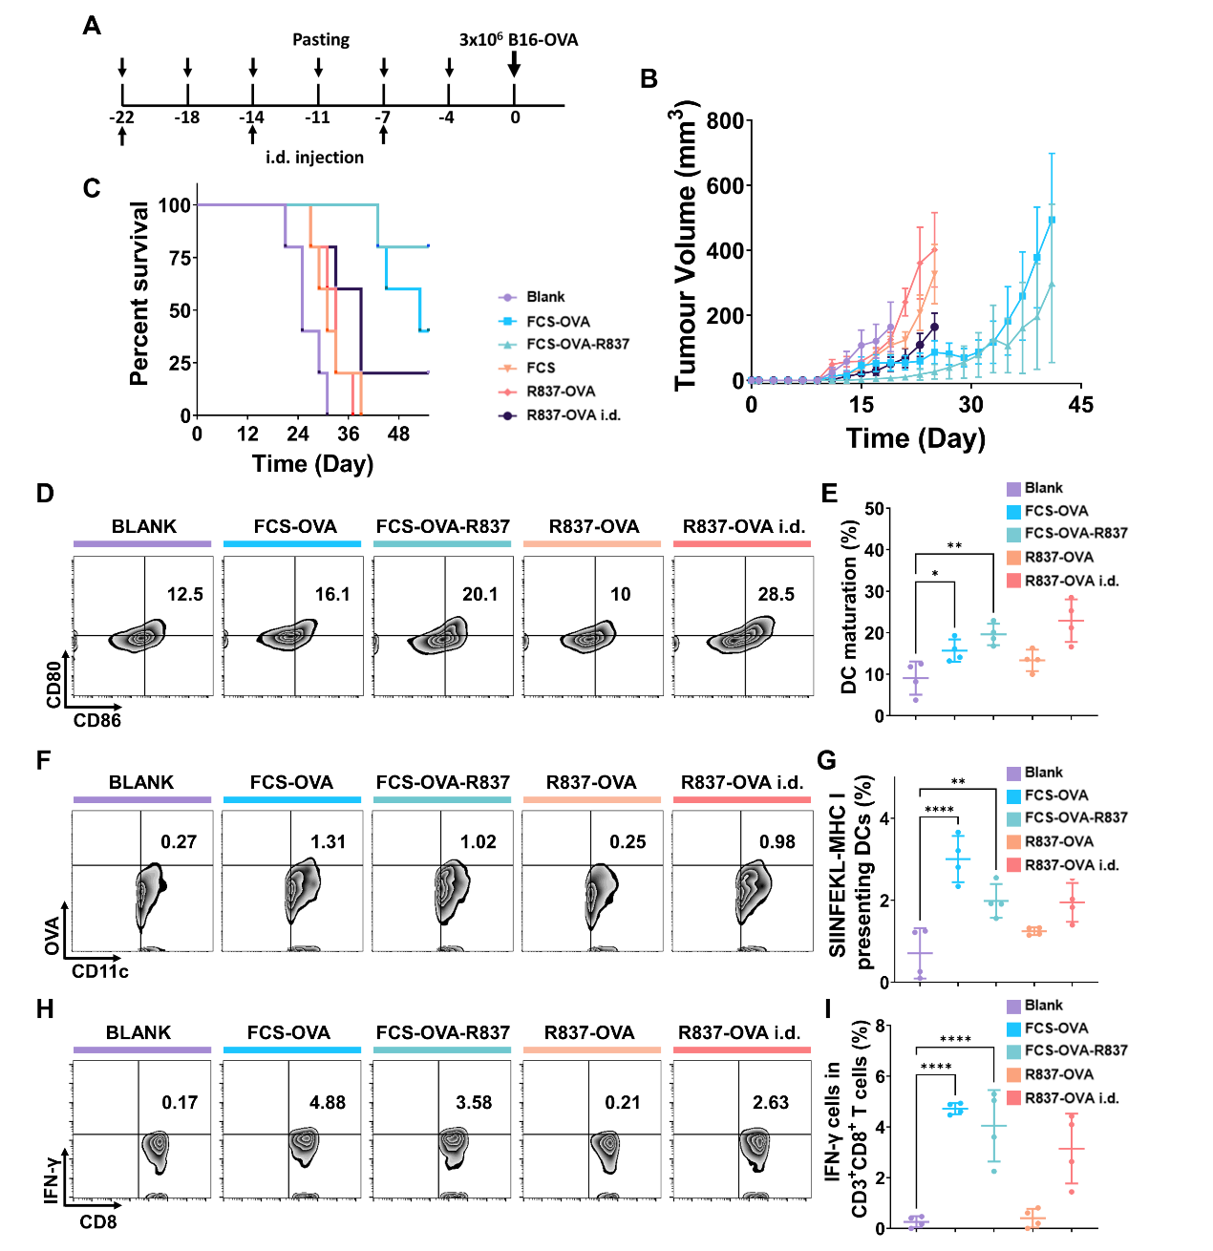
Figure 5 | Needle-free cancer vaccine patch to prevent tumor growth in vivo. a, Schematic illustration indicating the process of vaccination. b, c, Tumor growth curve and survival rate of mice after treatment with different vaccines (n = 5). d, e, Representative flow cytometry plots and statistical data showing DC maturation and f, g, cross-presentation in the LNs of mice in different groups (n = 4). h, i, Representative flow cytometry plots and statistical data showing the percentages of IFN-γ-positive cells in CD8⁺ T cells after restimulating post-immunized splenocytes (n = 4). P values were calculated by two-tailed Student’s t test, *p < 0.05, **p < 0.01, ****p < 0.0001.

