Received 00th January 20xx,
- National Institute for Materials Science, Tsukuba 305-0044, Japan. Email: YUAN.dongsheng@nims.go.jp, SHIMAMURA.Kiyoshi@nims.go.jp
- Graduate School of Advanced Science and Engineering, Waseda University, Shinjuku, Tokyo 169-8555, Japan.
Accepted 00th January 20xx
DOI: 10.1039/x0xx00000x

Bulk crystal growth and characterization of non-centrosymmetric single crystal CaTa₄O₁₁
Yueshen Zhou,^{ab} Dongsheng Yuan*ª and Kiyoshi Shimamura*^{ab}
Despite that the reported CaO-Ta₂O₅ phase diagram indicates its incongruent melting behavior, for the first time, we found that bulk single crystals of non-centrosymmetric CaTa₄O₁₁ can be grown successfully by the floating-zone method. The as-grown crystal rods (Ф 5-6 mm) have a black and colorless transparent appearance in Ar and O₂ growth atmospheres, respectively. Consequently, the O₂ atmosphere was selected to optimize its bulk crystal growth. The CaTa₄O₁₁ single crystals show a good crystallinity with a symmetric X-ray rocking curve for 004 diffraction with an FWHM of 72’’. For this new hexagonal bulk single crystal, its anisotropic optical, dielectric, and thermal properties were characterized. The crystal has a UV cut-off edge at 272 nm and a visible transmittance of ~75% till 800 nm . When excited by both 254 nm UV and X-ray, it shows a broad-band emission with a peak wavelength of around 427 nm. The dielectric constants ε₁₁ and ε₃₃ were found to be 30 and 52.3, respectively at 1 kHz. Meanwhile, the thermal conductivity along the c-axis is 5.69 Wm⁻¹K⁻¹, which is 1.8 times higher than that along the a-axis, which measures 3.19 Wm⁻¹K⁻¹ at room temperature.

Introduction
Single crystals of tantalates have garnered great attention across virous applications including nonlinear optics, scintillation, piezoelectricity and pyroelectricity, etc [1-4]. Among them, several single-crystal alkaline-earth tantalates have been grown by conventional melting techniques such as Czochralski, Bridgman, and floating-zone methods to explore their properties and applications. For instance, MTa₂O₆ (where M represents Mg, Ca, and Sr) crystals were studied as laser active media and microwave resonators [5-8]. The acoustic response of Sr₂Ta₂O₇ single crystals was investigated for employment in ferroelectric random-access memories [9]. As potential scintillators for high-energy X-ray radiography, Mg₄Ta₂O₉ single crystals were found to show bright intrinsic radioluminescence, promoting alkaline-earth tantalates as promising intrinsic scintillator candidates [10,11].
The CaO-Ta₂O₅ system was reported by K. T. Jacob et al. to have four stoichiometric compounds: CaTa₄O₁₁, CaTa₂O₆, Ca₂Ta₂O₇, and Ca₄Ta₂O₉ [12]. To explore functional properties in this family, their single crystals in bulk form are highly demanded. Although the binary phase diagramhad already been established through the high-temperature solid–solid reaction synthesis method, as shown in Fig. 1 [13], the melting behaviors of the stoichiometric compounds remained uncertain until their melting-growth study was conducted.

Fig. 1. The reported CaO-Ta₂O₅ phase diagram above 1200 °C [13].

CaTa₂O₆ and Ca₂Ta₂O₇ were observed to show polymorphs: orthorhombic & tetragonal & cubic structures for the former and trigonal & monoclinic for the latter, thus their crystal growths require quenching to avoid the corresponding phase transitions [14,15]. C. R. Ferrari et al. used the laser-heated pedestal growth (LHPG) method that can achieve rapid cooling but can only obtain thin and small samples in a diameter of ~700 μm, not to mention bulk single crystals over millimetre in size [6]. Regarding CaTa₄O₁₁ and Ca₄Ta₂O₉, the phase diagram indicates their incongruent melting behaviors. To the best of our knowledge, there has been no report of single-crystal form of Ca₄Ta₂O₉.
What interests us is the Ta-richest compound here, CaTa₄O₁₁, which shows a great potential as a scintillator due to its high density (7.57 g/cm³) and effective atomic number (68.4) [16]. Although Akashi et al. mentioned the synthesis of crystaline samples using the floating-zone technique in 1969 [17], however, no subsequent reports on either bulk single crystal growth or the basic physical properties of CaTa₄O₁₁ were seen. To answer the question that CaTa₄O₁₁ melts incongruently as reported in the phase diagram [13] or not and further investigate the potential properties of CaTa₄O₁₁ single crystals, we studied its crystal growth using the Xenon lamp floating zone method.
In this work, CaTa₄O₁₁ bulk single crystal growth in different atmospheres was investigated. The optimized high-quality crystal was characterized in terms of structural, anisotropic optical, thermal, and dielectric properties.

Experimental
Crystal growth
Polycrystalline CaTa₄O₁₁ rods were fabricated through the solid-state reaction method using high-purity (99.99%) Ta₂O₅ and CaCO₃ raw materials. Initially, the stoichiometric powders of raw materials were weighed and mixed thoroughly. A follow-up calcination was carried out at 1100 °C for 10 hours in air. After calcination, the powders were packed into a rubber tube and then pressed isostatically under 300 MPa. The pressed rods were subsequently sintered in air at 1300 °C for 10 hours, resulting in the production of dense ceramic rods.
Single-crystal growth of CaTa₄O₁₁ was conducted using a Xenon lamp floating-zone furnace. The growth rate was 6 mm/h. During the growth process, the feed rod rotated at a speed of 26 rpm, while the seed rod at 13 rpm in the opposite direction. Both argon (Ar) and oxygen (O₂) atmospheres were employed to optimize the crystal quality.

Characterization
The powder X-ray diffraction analysis was conducted by a Rigaku SmartLab3 diffractometer (Cu Kα X-ray radiation with a wavelength of 1.54059 Å). The crystal quality was evaluated by X-ray rocking curve measurement on a c-oriented sample, using a high-resolution X-ray diffractometer of PANalytical X’Pert PRO. Optical transmittance was measured with a JASCO spectrometer V-570. The photoluminescence (PL) spectrum was acquired using a JASCO FP-8650FDA fluorescence spectrometer. An X-ray generator was used for measuring the X-ray excited luminescence (XRL) spectrum [18]. Dielectric constants were determined at a frequency of 1 kHz utilizing an LCR meter (Hioki IM3536). The Dulong-Petit law was applied to estimate the specific heat capacity (C_{p}) [19], while thermal diffusivity measurements were carried out through a laser flash method using an LFA 467 instrument from NETZSCH.

Results and discussion
Crystals and Structure
Figure 2 shows the images of single-crystal CaTa₄O₁₁ grown in the Ar and O₂ atmosphere. To get single-crystal CaTa₄O₁₁, its growth was firstly conducted in Ar gas that is the most commonly used atmosphere for oxide single-crystal growth. We found that this neutral (neither reducing nor oxidizing) atmosphere results in a CaTa₄O₁₁ crystal with a black appearance. This phenomenon suggests that CaTa₄O₁₁ is quite sensitive to atmosphere, which probably originates from the variable valence change of Ta element at high temperature. In an oxygen-deficient atmosphere, formation of oxygen vacancies promotes the valence change from Ta⁵⁺ to Ta⁴⁺ [5]. To eliminate these defects and optimize further the single-crystal quality, subsequently O₂ atmosphere was employed and colorless and transparent CaTa₄O₁₁ single crystals were obtained. Therefore, the follow-up characterizations were carried out in the optimized colorless crystal samples. This is illustrated in Fig. 2(b), where a 1mm in thickness and two-side polished plate cut from the colorless and transparent portion is inserted.

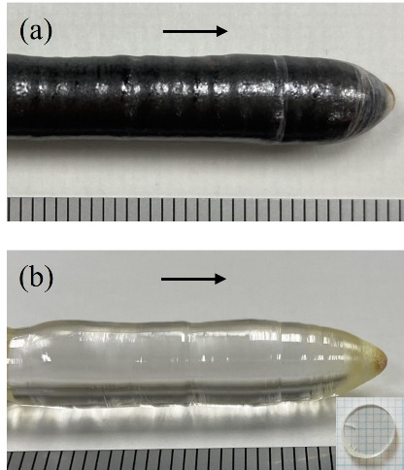

Fig. 2. Photographs of the CaTa₄O₁₁ crystals grown from (a) Ar and (b) O₂. The black arrows show the direction of the crystal growth.

Given the absence of reliable crystal structure reports from high-quality CaTa₄O₁₁ bulk single crystals, here the crystal structure was analyzed. The structure and refinement data of CaTa₄O₁₁ are listed in Table 1 with a more reasonable R-factor than all reported values [17, 20]. The corresponding cif file is given in the ESI‡. CaTa₄O₁₁ crystallizes in the hexagonal system with the space group of P6₃22 (a = b = 6.2127 Å, c = 12.2638 Å). Figure 3(a) shows an asymmetric unit and the corresponding bonding lengths of CaTa₄O₁₁. One of the Ta atoms, designated as Ta2, is coordinated by seven oxygen atoms, forming a pentagonal bipyramid. The remaining Ta (Ta1) and Ca atoms are surrounded by six and eight oxygen atoms, respectively. Figure 3(b) shows the crystal structure of CaTa₄O₁₁ single crystal projected to <110> direction. We can see that it contains an alternant structure with a layer formed by Ta2 pentagonal bipyramids and another layer formed by Ta1 and Ca atoms where both layers are parallel to the c-plane.

Table 1 Crystal data and structure refinement of CaTa₄O₁₁ single crystal
Empirical formula | CaTa₄O₁₁
Formula weights (g mol⁻¹) | 939.88
Temperature (K) | 297
Crystal system, space group | Hexagonal, P6₃22
Unit cell dimensions (Å) | a=b=6.2127 (2), c=12.2638(4)
V (Å³) | 409.94 (3)
Density (g cm⁻³) | 7.614
Z | 2
F₀₀₀ | 800
Radiation wavelength (Å) | 0.71073
Absorption coefficient (mm⁻¹) | 53.885
Theta range (deg.) | 3.753-29.169
Limiting indices | -8 ≤ h ≤ 7, -6 ≤ k ≤ 8, -15 ≤ l ≤ 15
Reflection number | 5531
Unique/collected reflection number | 355/349
R_{int} | 0.0402
Final R indices [I > 2σ(I)] | 0.0134/0.0299
R indices (all data) | 0.0141/0.03
Goodness-of-fit | 1.276
Largest diff. peak and hole (e/Å³) | 0.942/-0.931

Fig. 3 (a) An asymmetric unit formed by one TaO6 group, one TaO7 group, and the Ca atom in eightfold oxygen coordination, together with their corresponding interatomic distances, (b) crystal structure of CaTa₄O₁₁ single crystal projected to <110> direction.

The powder X-ray diffraction analysis confirms that a single phase was achieved under both Ar and O₂ atmospheres, without any detectable extra phase. The measured patterns match well with the simulated patterns based on the crystal structure derived from our own single crystal analysis, as shown in Fig. 4.
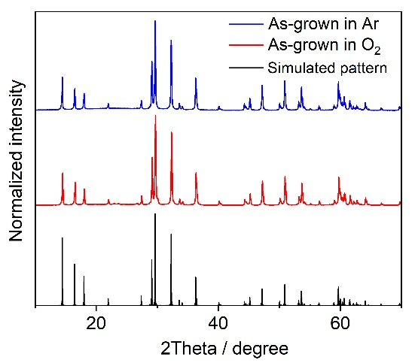

Fig. 4. Powder X-ray diffraction patterns of the as-grown single-crystal CaTa₄O₁₁.

Rocking curve was measured to evaluate the crystal quality based on the symmetry and full width at half maximum (FWHM) of the target diffraction peak. Defects and crystallographic imperfections can result in an asymmetric diffraction profile and a large FWHM value [21]. For high-quality single crystal oxides, the FWHM values are commonly below 100 arcseconds [22-24], although they also vary depending on the crystal structure and the diffraction instrument employed. The X-ray rocking curve of 004 diffraction peak is shown in Fig. 5. The curve is symmetric and has a FWHM of 72′′, indicating a good crystallinity of the as-grown crystals.

Fig. 5. X-ray rocking curve of O₂-grown CaTa₄O₁₁ crystal.

Optical and luminescence properties
The unpolarized optical transmission spectra of CaTa₄O₁₁ single crystals obtained in an O₂ atmosphere for the (100), (010) and (001) planes, with samples thickness of 1 mm, are displayed in Fig. 6(a).
They all show a good transmittance of around 75% across the wavelength range of 400 to 800 nm. However, while the (100) and (010) planes exhibit identical visible transmittance, the (001) plane displays a slightly higher value. This difference is attributed to the uniaxial hexagonal structure of CaTa₄O₁₁, with an optical anisotropy from the varying refractive indices of the three main crystallographic planes. Unfortunately, the polished samples cut from the floating-zone grown crystal rods are too small for refractive index measurement. Nevertheless, they can be approximately estimated based on the transmission spectrum method [25]. At the wavelength of 500 nm, CaTa₄O₁₁ exhibits refractive indices of 2.23 for (100) and (010) planes, and 2.18 for the (001) plane. To determine its optical band gap, the Tauc formula (αhν)^{1/n} = A^{1/n} (hν-E_{g}) was applied, and a better fitting was achieved with n = 1/2, as illustrated in Fig. 6(b) [26]. This finding suggests that it has a direct band gap of about 4.5 eV. Fig. 6(c) presents the PL excitation (blue curve) and emission (red curve) spectra where a dominant excitation band appears at 255 nm and the corresponding emission band shows a peak wavelength at 427 nm. It can be seen in the fitted emission spectrum that the dominant emission broad band was deconvoluted into only one peak as shown in Fig. S1‡. According to the previous research, this luminescence might be related to the charge transfer transition, which corresponds to the delocalization of electrons from the O²⁻-2p orbital to the Ta⁵⁺-5d orbital associated with the TaO₆/TaO₇ polyhedrons in CaTa₄O₁₁ [27,28]. Under X-ray excitation, CaTa₄O₁₁ also exhibits an emission-band (black curve) with a peak wavelength around 427 nm. The similarity of the XRL spectrum to the PL one implies the same emission center for both UV and X-ray excitation.
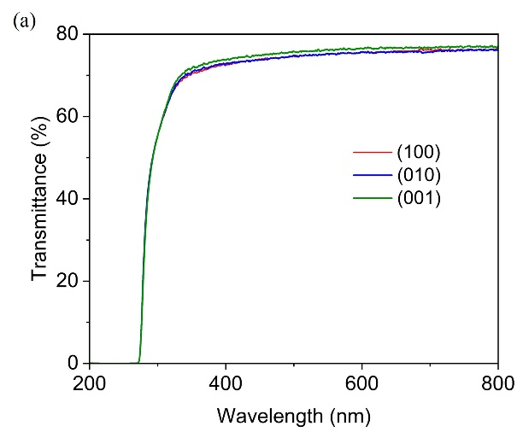
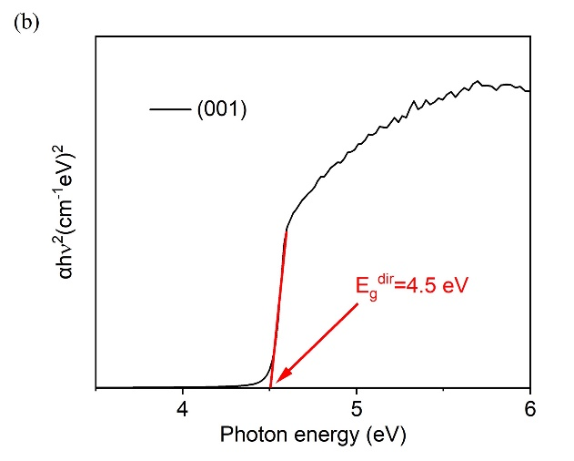
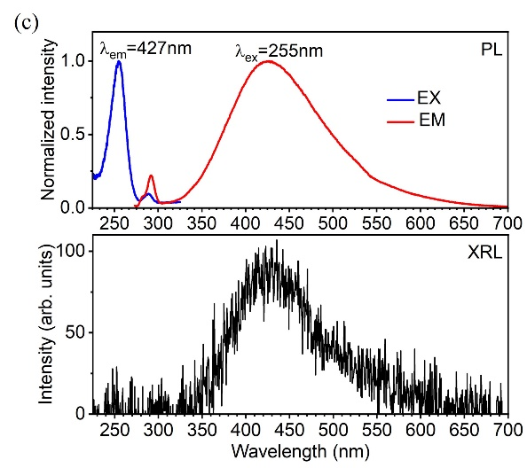
Fig. 6. (a) Transmission spectra of CaTa₄O₁₁, (b) the variation of (αhν)² vs. photon energy (hν), (c) PL excitation, emission and XRL spectra of CaTa₄O₁₁.

Dielectric constants
CaTa₄O₁₁ has two independent dielectric constants and were measured at 1kHz: ε₁₁ = 30 and ε₃₃ = 52.3. Table 2 lists the dielectric constants of CaTa₄O₁₁ crystal, in comparison with α-quartz, and some other tantalates crystals. The dielectric constant ε₃₃ of CaTa₄O₁₁ is larger than those of α-quartz, Ca₃TaGa₃Si₂O_{14,} and LiTaO₃, but lower than that of SrTa₂O₆.

Table 2 Dielectric constants of CaTa₄O₁₁ crystal in comparison with α-quartz, Ca₃TaGa₃Si₂O₁₄, LiTaO₃ and SrTa₂O₆ crystals
Crystal | ε₁₁ | ε₃₃
CaTa₄O₁₁ | 30 | 52.3
α-quartz [29] | 4.5 | 4.6
Ca₃TaGa₃Si₂O₁₄ [30] | 16.3 | 21.6
LiTaO₃ [31] | 54 | 43
SrTa₂O₆ [8] | 108 | 128

Thermal conductivity
The thermal conductivity can be calculated by the equation: k = λρC_{p}, where k, λ, ρ and C_{p} denote the thermal conductivity, thermal diffusivity coefficient, density, and specific heat capacity of the crystal, respectively [32]. The thermal conductivity k_{ij} of a crystal is also a symmetrical second-rank tensor like the electric permittivity, and for point group 622, the matrix controlled by Neumann’s principle is the following form [33, 34]:

So, the thermal diffusivity coefficients of the CaTa₄O₁₁ crystal were measured along the a-axis and c-axis by a laser flash method, and the results are shown in Fig. 7(a). The specific heat capacity was estimated by the Dulong-petit law, utilizing the equation C_{p} = 3rR/M, where r = 16 is the number of atoms in one formula, with the gas constant R being 8.314 J/(k·mol), and M for molar mass being 939.86 g/mol. The calculated C_{p} is approximately 0.42 J/(k·g). Note that the Dulong-petit law is not a sufficiently accurate measure, and the calculated C_{p} value might be a little bit higher than the real ones [18]. From the Fig. 7(b), we can see that as the temperature rises, the thermal conductivity of the CaTa₄O₁₁ crystal decreases. This phenomenon can be attributed to heightened phonon scattering due to vigorous atomic vibrations and the increased average interatomic distance resulting from lattice expansion. The thermal conductivity anisotropy, with a higher value along the c-axis, can be attributed to the alternant layer structure along this axis which promotes stronger atomic bonding and consequently increases thermal conductivity [35].

Fig. 7. Temperature dependence of the (a) thermal diffusivity, (b) thermal conductivity of single crystal CaTa₄O₁₁.

Conclusions
For the first time, high-quality bulk single crystals of CaTa₄O₁₁ were grown by the floating-zone method, and thus the current phase-diagram was revised for the stoichiometry CaO∙2Ta₂O₅, showing a congruently melting behavior. The crystal became black in an Ar atmosphere due to oxygen vacancies and recovered to the intrinsic colourless when grown in an O₂ atmosphere. Its crystallographic quality was characterized with a FWHM of 72′′ in XRC. The O₂-grown crystals have a transmittance of approximately 75% and a broad band emission centered around 427 nm when excited under UV and X-ray. Given its high stopping power of X- and γ-ray, this single crystal holds promise as a potential host for scintillation applications when it is properly activated. The dielectric constants ε₁₁ and ε₃₃ are 30 and 52.3, respectively, at 1 kHz. Additionally, the thermal conductivity along the c-axis is 1.8 times higher than along the a-axis, measuring 5.69 Wm⁻¹K⁻¹ and 3.19 Wm⁻¹K⁻¹ at room temperature, respectively.

Conflicts of interest
There are no conflicts to declare.

Acknowledgements
The authors would like to sincerely thank Mr. Satoshi Yamamoto for his kind support with crystal polishing and Dr. Yoshitaka Matsushita for his support of crystal structure analysis. This work was supported by "Advanced Research Infrastructure for Materials and Nanotechnology in Japan (ARIM)" of the Ministry of Education, Culture, Sports, Science and Technology (MEXT). Proposal Number JPMXP1223NM5337.

Notes and References
‡ Electronic supplementary information.

[1] A. Hossain and M. H. Rashid, IEEE Trans. Ind. Appl. 1991, 27, 824–829.
[2] J. G. Gualtieri, J. A. Kosinski, and A. Ballato, IEEE Trans. Ultrason. Ferroelectr. Freq. Control. 1994, 41, 53–59.
[3] R. Dou, Q. Zhang, J. Gao, Y. Chen, S. Ding, F. Peng, W. Liu and D. Sun, Crystals, 2018, 8, 1-21.
[4] E. D. Bourret, D. M. Smiadak, R. B. Borade, Y. Ma, G. Bizarri, M. J. Weber and S. E. Derenzo, J. Lumin., 2018, 202, 332-338.
[5] M. Higuchi, K. Ando, J. Takahashi and K. Kodaira, JCS-Japan, 1993, 101, 118-120.
[6] C. R. Ferrari, A. S. S. de Camargo, L. A. O. Nunes and A. C. Hernandes, J. Cryst. Growth, 2004, 266, 475-480.
[7] A. S. S. de Camargo, C. R. Ferrari, A. C. Hernandes and L. A. O. Nunes, J. Phy Condens. Matter, 2004, 16, 5915-5923.
[8] I. Tanaka, Y. Sato and H. Kojima, J. Cryst. Growth, 1990, 99, 837-840.
[9] A. Hushur and S. Kojima, Mater. Sci. Eng. A, 2006, 442, 35-38.
[10] D. Yuan, F. Moretti, D. Perrodin, G. Bizarri, T. Shalapska, C. Dujardin and E. Bourret, CrystEngComm, 2022, 22, 3497-3504.
[11] T. Hayashi, K. Ichiba, D. Nakauchi, K. Watanabe, T. Kato, N. Kawaguchi and T. Yanagida, J. Lumin, 2023, 255. 119614.
[12] K. T. Jacob and A. Rajput, J. alloys Compd, 2015, 620, 256-262.
[13] D. A. Reeve, J. Less-Common Met, 1969, 17, 215-222.
[14] N. G. Teixeira, R. L. Moreira, R. P. S. M. Lobo, M. R. B. Andreeta, A. C. Hernandes and A. Dias, Cryst. Growth Des., 2011, 11, 5567-5573.
[15] I. E. Grey, R. S. Roth, W. G. Mumme, J. Planes, L. Bendersky, C. Li and J. Chenavas, J. Solid State Chem, 2001, 161, 274-287.
[16] T. Yanagida, Proc. Jpn. Acad., Ser., 2018, 94, 223-231.
[17] M. Isobe, F. Marumo and S. Iwai, Acta Cryst., 1975, B31, 908-910.
[18] T. Yanagida, M. Koshimizu, G. Okada, T. Kojima, J. Osada and N. Kawaguchi, Opt. Mater., 2016, 61, 119-124.
[19] S. Tanusilp, Y. Ohishi, H. Muta, S. Yamanaka, A. Nishide, J. Hayakawa and K. Kurosaki, Phys. Status Solidi PRL, 2017, 12, 1700372.
[20] L. Jahnberg, J. Solid State Chem., 1970, 1, 454-462.
[21] F. Masiello, G. Cembali, A. Chumakov, S. Connell, C. Ferrero, J. Hartwig, I. Sergeev and P. Vaerenbergh, J. Appl. Cryst. 2014, 47, 1304-1314.
[22] H. Yang, F. Peng, Q. Zhang, C. Guo, C. Shi, W. Liu, G. Sun, Y. Zhao, D. Zhang, D. Sun, S. Yin, M. Gu and R. Mao, CrystEngComm, 2014, 16, 2480-2484.
[23] X. Fu, E. Víllora, Y. Matsushita, Y. Kitanaka, Y. Noguchi, M. Miyayama, K. Shimamura and N.Ohashi, , J. Cryst. Growth, 2018, 501, 38-42.
[24] A. Maljuk, J. Strempfer, C. Ulrich, M. Sofin, L. Capogna, C. T. Lin AND B. Keimer, J. Cryst. Growth,2004, 273, 207-212.

[25] W. Liu, Q. Zhang, W. Zhou, C. Gu and S. Yin, IEEE Transactions on Nuclear Science, 2010, 57, 1287-1290.
[26] P. Makula, M. Pacia and W. Macyk, J. Phys. Chem. Lett., 2018, 9, 6814-6817.
[27] J. Wu, K. Chen and D. Xue, J. Chin. Soc. Rare Earths. 2023, 41, 145-151.
[28] J. Wu, K. Chen and D. Xue, Nanotechnology 2024, 35, 425602.
[29] W. Dong, Y. Sun, B. Wang, M. Zhu, J. Li, X. Xu and J. Wang, Cryst. Growth Des. 2022, 22, 4243−4249.
[30] X. Fu, E. G. Villora, Y. Matsushita, Y. Kitanaka, Y. Noguchi, M. Miyayama, K. Shimamura and N. Ohashi, RSC Adv., 2017, 7, 56697-56703.
[31] Roditi International, Lithium Tantalate, https://roditi.com/SingleCrystal/Lithium-Tantalate/LiTaO₃ Properties.html, (accessed June 2, 2024).
[32] W. Zhang, X. Tao, C. Zhang, and M. Jiang, Cryst. Growth Des. 2009, 9, 2633-2636.
[33] R. E. Newnham, 'Tensors and physical properties', Properties of Materials: Anisotropy, Symmetry, Structure (Oxford, 2004; online edn, Oxford Academic, 12 Nov. 2020).
[34] R. Mckinney, P. Gorai, E. Toberer and V. Stevanovic, Chem. Mater., 2020, 32, 3320-3321.
[35] S. Mukhopadhyay, L. kindsay and D. J. Singh, Sci. Rep., 2016, 6, 37076.

