Supporting Information

Interfacial Reactions and Spacer-Dependent Ordering in
FePt-C/X-C/FePt-C (X = Ir, Pt, Ag) Trilayers Nanostructures

Daisuke Ogawa¹, Yusuke Matsuoka¹, Yuta Sasaki¹, Anton Bolyachkin¹, Shinji Isogami¹, Machiko Ode¹, Taichi Abe¹, Shinya Kasai¹, *Yukiko K. Takahashi^{1,2}
¹National Institute for Materials Science, 1-2-1 Sengen, Tsukuba, Japan
²RIEC Tohoku university, 2-1-1 Katahira, Sendai, Japan

Corresponding author : Y.K. Takahashi, takahashi.yukiko@nims.go.jp

S1. Latest Phase Diagram of Fe-Pt system
Fig. S1 shows the latest thermodynamic phase diagram of the Fe-Pt system¹. The diagram clearly indicates that the L1₀-FePt and L1₂-FePt₃ ordered phases are phase separation system.
A horizontal line corresponding to the substrate temperature used in the present thin-film experiments (500 °C) is drawn in the phase diagram. At this temperature, the equilibrium compositions of the L1₀ and L1₂ phases are Fe₄₆Pt₅₄ and Fe₃₀Pt₇₀, respectively. Experimentally, the compositions of the L1₀-FePt layers were determined to be Fe_{47.0}Pt_{53.0} and Fe_{46.4}Pt_{53.6} for the top and bottom FePt layers, respectively, while the composition of the L1₂ phase formed at the spacer position was Fe_{23.8}Pt_{76.2}. These experimentally observed compositions show reasonably good agreement with the equilibrium phase compositions predicted by the thermodynamic phase diagram, supporting the interpretation that the L1₂ phase observed in the Pt-spacer samples corresponds to a reaction-formed equilibrium phase stabilized under the present deposition conditions.
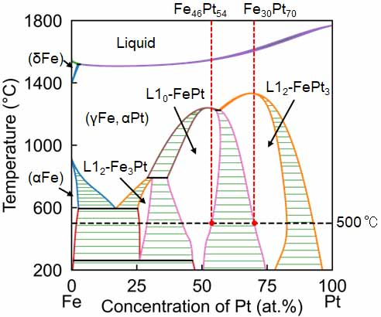
Figure S1 Latest phase diagram¹. L1₀-FePt and L1₂-FePt₃ show phase separation clearly. Considering the deposition temperature of 500°C, the composition of these two phases are Fe₄₆Pt₅₄ and Fe₃₀Pt₇₀ for L1₀ and L1₂, respectively.

S2. Two different Curie temperatures in Pt-spacer sample
The temperature dependence of magnetization in the Pt-spacer sample exhibited a kink around 400 K, indicating the presence of two Curie temperatures (T_{c}s), at approximately 400 K and 580 K. There are two possible reasons for the two T_{c}s, difference in the chemical composition³ and the degree of order⁴. Compositional analysis by EDS showed that the top and bottom FePt layers had compositions of Fe_{47.0}Pt_{53.0} and Fe_{46.4}Pt_{53.6}, respectively. This small compositional difference is insufficient to explain the large difference in T_{c}. The degree of L1₀ ordering (S) is usually estimated from the integrated intensity ratio of the (001) and (002) peaks in the XRD pattern. However, because the X-ray penetration depth is on the order of several hundred nanometers, the present XRD measurements of our trilayer films inevitably capture the combined signal from both the top and bottom FePt layers. In addition, L1₂-FePt₃ was also formed, and its diffraction peaks overlap with those of L1₀-FePt, making it impossible to determine S by XRD alone.
To address this limitation, we analyzed the demagnetization curves, which clearly exhibit two distinct magnetization reversal processes corresponding to the top and bottom FePt layers. By performing micromagnetic fitting of the demagnetizaion curve, we have estimated the magnetic anisotropy of each layer. Since magnetic anisotropy is known to correlate positively with the degree of L1₀ ordering, this analysis allows us to discuss the relative ordering between the top and bottom FePt layers.
Fig. S2 shows the micromagnetic fitting on the experimentally obtained demagnetization curve. The fitting result shown by the black solid line matches with the experimental result well. The estimated anisotropy energies of the bottom and top FePt layers were estimated to be 2 MJ/m³ and 0.55 MJ/m³, respectively. According to the previous paper reported by Okamoto et al. ⁵, the degree of order in the bottom FePt with 2.0 MJ/m³ is about 0.65. However, there have been no systematic reports on how magnetic anisotropy varies when the degree of order is less than 0.5. Therefore, we can say that the degree of order in the top FePt is less than 0.5. Based on these, we conclude that the big difference in the degree of order in the top and bottom FePt layers causes the large T_{c} difference in the two FePt layers. The reduced S in the top layer is consistent with its lower μ₀H_{c}, as observed in MOKE measurements described in the S5.

Methodology : Micromagnetic simulation
Micromagnetic simulations were performed by solving the Landau-Lifshitz-Gilbert equation with unit damping constant and sweeping rate of 0.4 T/ns using the Fastmag software. A finite element model of nanogranular FePt films with the trilayer structure was developed following a similar approach to that in Refs. 6, 7. The top and bottom FePt layers had the same saturation magnetization of 1.43 T and exchange stiffness of 10 pJ/m and were considered exchange decoupled. The remaining parameters of magnetic anisotropy and volume fraction of in-plane variants in both layers were varied until the experimental out-of-plane demagnetization curve was best fit via micromagnetic simulation.
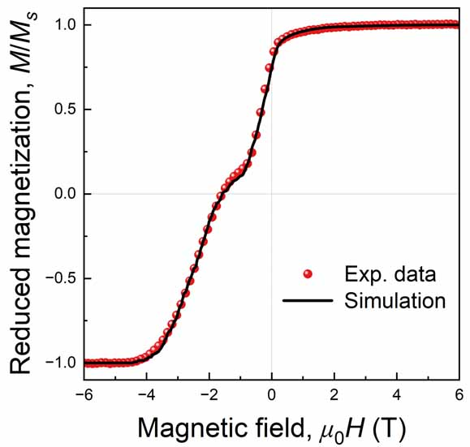
Figure S2 Micromagnetic fitting result of demagnetization curve of Pt spacer sample.

S3. Elemental mapping of C in the Ag-spacer sample
Fig. S3 shows the elemental distribution of carbon obtained by EDS mapping for the Ag-spacer trilayer film. Carbon is distributed throughout the granular FePt-C matrix and is preferentially segregated along grain boundaries, consistent with the characteristic microstructure of FePt-C granular films. No additional carbon enrichment is observed specifically at the Ag spacer interface. This observation indicates that the selective rejection behavior of Ag from the FePt grains is not caused by carbon segregation but is primarily governed by the intrinsic immiscibility between FePt and Ag.
These results support the interpretation presented in the main text that carbon contributes to the formation of the granular morphology but does not drive the spacer rejection behavior unique to the Ag system.
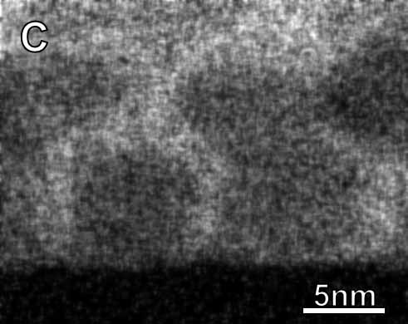
Figure S3 EDS elemental mapping of carbon in the Ag-spacer trilayer film. Carbon is distributed throughout the granular FePt-C matrix and is preferentially segregated at grain boundaries, while no additional enrichment is observed at the Ag spacer interface.

S4. Peak fitting of (002) in the XRD of Pt-spacer sample
To clarify the phase contributions in the Pt-spacer trilayer film, peak fitting analysis was performed in the (002) diffraction region of the XRD pattern. As discussed in the main text, the (002) reflection exhibits multiple overlapping components originating from the L1₀-FePt layers and the L1₂-FePt₃ spacer phase.
Fig. S4 shows the peak decomposition of the (002) region using Gaussian fitting. Three components are identified: one corresponding to the L1₂-FePt₃ phase formed at the spacer position and two components attributed to the L1₀-FePt layers located above and below the spacer. The higher-angle peak (~49.0°) is assigned to the bottom FePt layer, while the lower-angle peak (~48.4°) corresponds to the top FePt layer.
This assignment is consistent with the layer-resolved MOKE measurements presented in the S5, which shows that the bottom FePt layer exhibits higher coercivity than the top layer. In L1₀-FePt, higher chemical ordering is known to reduce the c-axis lattice parameter², resulting in a shift of the (002) reflection toward higher diffraction angles. The peak separation observed in the fitting analysis therefore supports the structural differentiation between the two FePt layers.

Figure S4 Peak fitting analysis of the (002) XRD reflection in the Pt-spacer trilayer film. The measured diffraction profile is decomposed into three components corresponding to the L1₂-FePt₃ spacer phase and the top and bottom L1₀-FePt layers.

S5. Magnetization behavior of the top and bottom FePt layers
To further examine the layer-resolved switching behavior discussed in the main text, additional magneto-optical Kerr effect (MOKE) measurements were performed for the Pt-spacer trilayer. While conventional magnetometry techniques such as SQUID or VSM measure the net magnetization of the entire multilayer stack, MOKE provides relative depth sensitivity due to the exponential decay of the Kerr signal with optical penetration depth.
By illuminating the sample from the film surface (front side) and the substrate side (back side), the relative magnetic contributions of the top and bottom FePt layers can be modulated, as schematically illustrated in Fig. 3(a) of the main text.
Fig. S5 shows representative out-of-plane MOKE hysteresis loops for the Pt-spacer trilayer films. Although the optical penetration depth exceeds the total film thickness, preventing complete separation of the two layer contributions, a measurable depth-dependent variation is observed. Back-side illumination yields slightly higher μ₀H_{c} compared to front-side illumination, indicating that the bottom FePt layer retains higher magnetic anisotropy and L1₀ ordering. The difference is less pronounced than in the Ir-spacer system shown in the main text, but remains consistent with the structural differentiation discussed therein.
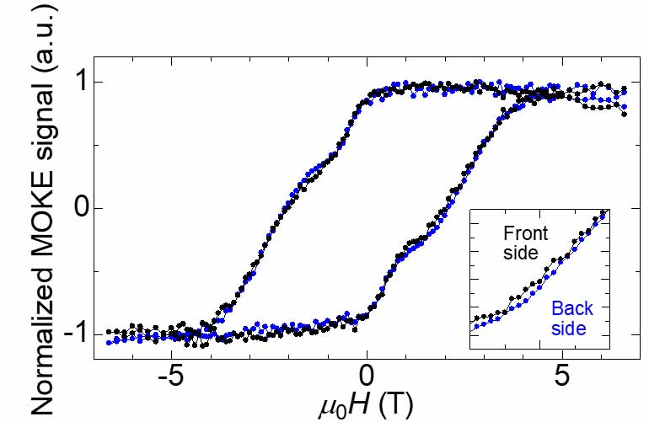
Figure S5 MOKE hysteresis loops with Pt spacer. Black and blues lines correspond to the MOKE hysteresis irradiated the probe beam from the back and the front sides, respectively. These hysteresis loops demonstrate layer-specific magnetization behavior, confirming decoupling of magnetization in top and bottom FePt layers.

Reference
- Tanaka, M.; Muramatsu, M. ; Ode, M.; Abe, T. Thermodynamic reassessment of the Fe-Pt system. Calphad 2025, 90, 102868.
- Barmak, K.; Kim, J. ; Lewis, L.H.; Coffey, K.R.; Toney, M.F.; Thiele, J.-U. On the relationship of magnetocrystalline anisotropy and stoichiometry in epitaxial L10 CoPfe(001) and FePt(001) thin films. J. Appl. Phys 2005, 98, 033904.
- Barmak, K.; Kim, J.; Berry, D.C.; Hanani, W.N.; Wierman, K.; Svedberg, E.B.; Howard, J.K. Calorimetric studies of the A1 to L1₀ transformation in binary FePt thin films with compositions in the range of 47.5-54.4 at%Fe. J. Appl. Phys.2005, 97, 024902.
- Isurugi, D.; Saito, T.; Kaneko, S.; Tham, K.K.; Ogawa, T.; Saito, S. Evaluation of blocking temperature and its distribution for L1₀-type FePt granular films. Jpn. J. Appl. Phys.2023, 62, 045503.
- Okamoto, S.; Kikuchi, N.; Kitakami, O.; Miyazaki, T.; Shimada, Y.; Fukamichi, K. Chemical-order-dependent magnetic anisotropy and exchange stiffness constant of FePt (001) epitaxial films, Phys. Rev. B. 2002, 66, 024413.
- Tozman, P.; Isogami, S.; Suzuki, I.; Bolyachkin, A.; Sepehri-Amin, H.; Greaves, S. J.; Sasaki, Y.; Chang, T. Y.; Kubota, Y.; Steiner, P.; Huang, P.-W.; Hono, K.; Takahashi, Y. K. Dual-Layer FePt-C Granular Media for Multi-Level Heat-Assisted Magnetic Recording. Acta Mater. 2024, 274 119996.
- Ogawa, D.; Bolyachkin, A.; Dilipan, A.R.; Kulesh, N. ; Sepehri-Amin, H.; Takahashi, Y.K. Exchange-Coupled FePt/Ru/FePt Nanogranular Films as Potential Heat-Assisted Magnetic Recording Media with Reduced Writing Temperature. Phys. Rev. Appl. 2024, 22, 054060.

