High Quality Factor Single-Crystal Diamond NEMS Cantilevers Fabricated by A Smart-Cut Method
Guo Chen, Wen Zhao, Keyun Gu, Satoshi Koizumi, Yasuo Koide, and Meiyong Liao
National Institute for Materials Science, Tsukuba, Ibaraki 305-0044, Japan
meiyong.liao@nims.go.jp

Micro- and nano-electromechanical systems (M/NEMS) have been rapidly developed over the past three decades because of their advantages such as high sensitivity, mass producibility, low power consumption, and ease of integration ^{[1-2]}. NEMS technology provides higher sensitivity and speed compared to larger micron-sized resonators owing to the superior mechanical characteristics. However, when device dimensions reach nanoscale, NEMS fabricated by traditional semiconductor materials exhibits issues such as high energy dissipation and poor thermal stability. These limitations constrain their sensitivity and reliability, posing significant challenges for high-yield mass production and practical applications. Single-crystal diamond (SCD), with the highest mechanical strength and Young’s modulus, can provide the highest resonance frequency (f) and quality (Q) factor, making it an ideal material for fabricating high-sensitivity and high-reliability M/NEMS ^{[3]}.

In this work, we investigated the resonance properties of SCD NEMS and their energy dissipation mechanisms at nanoscale. First, the SCD MEMS cantilevers with different length were fabricated by the ion-implantation assisted lift-off (IAL) technique based on our previous work ^{[4]}, as shown in Fig.1 (a). A smart-cut technique by effective oxygen etching was developed to fabricate nanometer-thick SCD NEMS. Besides, through the high-temperature oxygen annealing (685°C, 80 hours) and reactive ion etching (RIE) for 10.5 minutes, the thickness of SCD MEMS resonators was successfully reduced to the nanoscale. As depicted in Fig.1 (b), the results showed that when the thickness of the SCD cantilevers was reduced from approximately 450 nm to 50 nm, the Q-factor decreased with the thickness from 10⁵ to 10⁴, achieving SCD NEMS cantilevers with a thickness of approximately 50 nm and a high Q-factor (> 50,000).

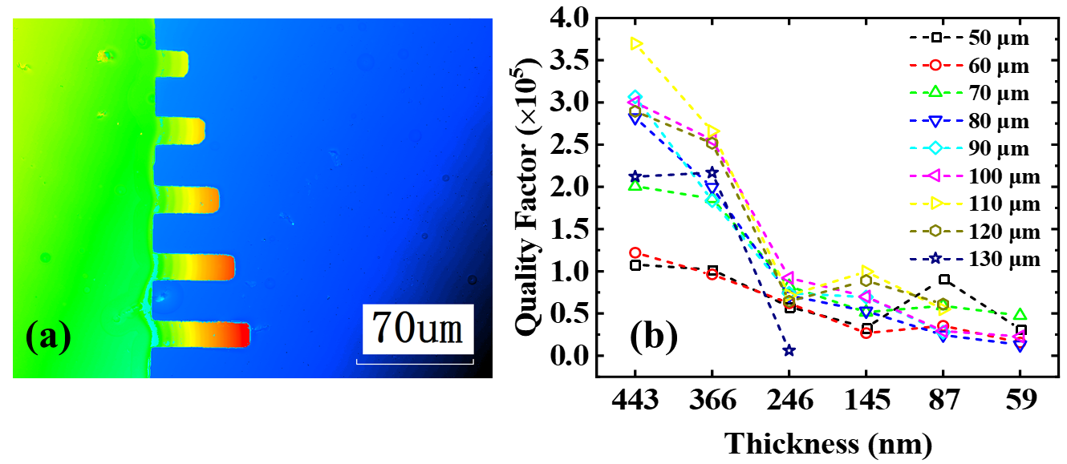
Fig.1 (a) The 2D height image of the fabricated diamond cantilevers. (b) Dependence of quality factors on the cantilever length (50 ~ 130 µm) and the thickness (443 ~ 59 nm) at nanoscale.

Reference:
[1] G. Chen, and Liao et.al, Acc. Mater. Res. 2024, 5, 1087−1096.
[2] G. Chen, and Liao et.al, Appl. Phys. Express. 2024, 17, 021001.
[3] G. Chen, and Liao et.al, Diam. Relat. Mater. 2023, 138, 110240.
[4] Liao et.al, Adv. Mat. 2010, 22, 5393.

