Bayesian Optimization for Controlled Chemical Vapor Deposition Growth of WS₂

Feng Zhang^{1,2}, Ryo Tamura^{3,4}, Fanyu Zeng¹, Daichi Kozawa¹ and Ryo Kitaura^{1,*}
¹ Research Center for Materials Nanoarchitectonics, National Institute for Materials Science, 1-1 Namiki, Tsukuba 305-0044, Japan
² Department of Chemistry, Nagoya University, Nagoya 464-8601, Japan
³ Center for Basic Research on Materials, National Institute for Materials Science, 1-1 Namiki, Tsukuba 305-0044, Japan
⁴ Graduate School of Frontier Sciences, The University of Tokyo, 5-1-5 Kashiwanoha, Kashiwa-city, Chiba 277-8568, Japan

ABSTRACT
We applied Bayesian optimization (BO), a machine learning (ML) technique, to optimize the growth conditions of monolayer WS₂ using photoluminescence (PL) intensity as the objective function. Through iterative experiments guided by BO, an improvement of 86.6 % in PL intensity is achieved within 13 optimization rounds. Statistical analysis revealed the relationships between growth conditions and PL intensity, highlighting the importance of critical conditions, including the tungsten source concentration and Ar flow rate. Furthermore, the effectiveness of BO is demonstrated by comparison with random search, showing its ability to converge to optimal conditions with fewer iterations. This research highlights the potential of ML-driven approaches in accelerating material synthesis and optimization processes, paving the way for advances in 2D material-based technologies.
KEYWORDS: Bayesian optimization, 2D materials, chemical vapor deposition, photoluminescence, growth conditions optimization

INTRODUCTION
Preparation of materials is the first step in materials research and the basis for exploring their properties and potential applications. For example, the successful preparation of monolayer graphene has opened up a new field of research, the science of two-dimensional (2D) materials, leading to the discovery of various intriguing properties, including the room-temperature quantum Hall effect¹, emergent topological phases^{2, 3}, etc. While these fundamental discoveries were made using micrometer-scale crystals prepared by the mechanical exfoliation method, large-area samples prepared by crystal growth methods, including chemical vapor deposition (CVD)^{4, 5}, are preferred for device applications. In particular, large-area growth of 2D semiconductors, such as transition metal dichalcogenides (TMDs including MoS₂ and WS₂ in the 2H form), is expected to lead to the next-generation electronics based on 2D materials^{6, 7}. This possibility has dramatically motivated the research of TMD growth techniques⁸, and CVD growth, one of the most promising approaches, is a focus of current investigation^{9, 10}.
While preparing materials is an essential process in materials research, it can simultaneously act as the bottleneck that limits research progress in fabricating materials with desired properties¹¹. CVD growth is a controllable process, but this controllability requires adjusting multiple experimental parameters¹². The relationship between growth conditions and results is usually not straightforward because the growth conditions are not independent and affect each other. For example, increasing growth temperature changes source decomposition dynamics and active species involved in a complex way, probably altering optimum values of other growth conditions. Also, growth substrates can alter surface reaction dynamics during the growth process, affecting optimum growth parameter values. As a result, optimization of growth conditions often requires tedious trial and error, and many growth experiments take a long time to complete¹³. Therefore, developing an effective method to obtain samples with desired properties is currently an important issue.
The situation has been changing since the development of artificial intelligence made the concept of machine learning (ML) known to researchers outside the field of data science^{14, 15}. ML is an emerging technique with great potential for multiple purposes, including searching for new materials¹⁶ and assisting material synthesis¹⁷. Rather than relying on the underlying physical and chemical processes, ML analyzes the correlation between conditions and results to predict the optimal conditions for the best results¹⁸. Its ability to maximize desired properties is a major force accelerating the development of materials science and is expected to become the fourth paradigm guiding scientific research, following theory, computation, and experiment¹⁹. The power of ML has motivated 2D materials research, and ML techniques, such as XGBoost-C and Random Forest, have been applied to optimize the synthesis of 2D materials and to predict the optical properties of 2D materials^{20, 21}. Although the application of ML techniques to 2D materials is still in its infancy, these successful implementations clearly demonstrate the potential to advance 2D materials research.
Here, we have applied another ML technique, Bayesian optimization (BO), for the CVD growth of a 2D material (monolayer WS₂). In general, model accuracy, essential for machine learning prediction, improves with increasing amounts of training data. However, the requirement for a large amount of training data to obtain an accurate model using popular ML algorithms, such as the aforementioned XGBoost-C and Random Forest, poses a dilemma for expensive and time-consuming experiments, including CVD growth. BO, in contrast, is an effective method for optimizing complex problems where evaluating the objective function is costly, and thus, accumulating large amounts of data is not feasible²². Using the built-in trade-off process between exploration and exploitation²³, BO can efficiently optimize the objective function in as few optimization rounds as possible with a few data sets and thus significantly reduces the cost of the learning process. In this work, we started BO processes from one initial data set with the objective function of photoluminescence (PL) intensity; plugging a data set of growth conditions and corresponding average PL intensity into the BO code suggested the next growth conditions to be tested. We found that the iterative process of experiments and BO-based suggestions efficiently increased PL intensity within limited rounds of iteration: around 86.6% improvement in PL intensity within 13 rounds. The reliability of our final model is further confirmed by comparison with the random search (RS) algorithm.

METHODS
CVD growth: We used a home-built cold-wall CVD system for the CVD growth of WS₂. First, we prepared a Na₂WO₄ (99.0%~100.5%, Kanto Chemical) solution using distilled water. Afterward, we cleaned a Si substrate with a 270 nm SiO₂ layer by sonicating it in acetone and treated it with oxygen plasma to make the surface hydrophilic. Next, we spin-coated the Na₂WO₄ solution onto the substrate at a fixed speed of 3000 rpm for 60 seconds. We purchased diethyl sulfide, (C₂H₅)₂S, from Gas-Phase Growth Ltd. and used it as it was received. In this work, all growth conditions were kept constant except for temperature, sulfur flow rate, spin-coating concentration, and Ar flow rate. (details see Table. S1).
Characterizations: Raman and PL measurements were performed using a home-built microspectroscopy system equipped with a spectrometer (IsoPlane SCT320, Teledyne Princeton Ins.) and a charge-coupled device camera (PyLoN, Teledyne Princeton Ins.). For Raman and PL measurements, 488 and 532 nm CW lasers, respectively, were focused on the samples with a ×50 objective lens (N.A. 0.7). The PL images were captured with an optical microscope equipped with a ×10 objective lens (N.A. 0.3) and a back-illuminated sCMOS camera (KURO, Teledyne Princeton Ins.). Five positions of each sample were measured, and the mean PL intensities were calculated using ImageJ software²⁴ (for detailed position and calculation methods, see Fig. S3).
Bayesian Optimization: In this work, we used an open-source Python library for BO (PHYSBO ver. 1.1, https://github.com/issp-center-dev/PHYSBO). In BO, the expected improvement, which corresponds to the difference between the predicted value from the Gaussian regression process and the current best value, was used as the acquisition function (also called score). Five candidate points were returned in one step, and the top two were tested in subsequent experiments.

RESULTS AND DISCUSSION
To obtain the initial data set, we first performed a CVD growth of WS₂ using Na₂WO₄ and diethyl sulfide as metal and sulfur sources, respectively. We use a vertical-type cold-wall CVD chamber²⁵, where (C₂H₅)₂S is supplied to a SiO₂/Si substrate on a susceptor through a showerhead; the metal source is deposited on the Si substrate before the growth process. Figure 1a shows a schematic representation of the CVD chamber. The mass spectrometer and the pressure regulator ensure identical (C₂H₅)₂S concentration and chamber pressure in every experiment. Moreover, Labview-based software automatically performs all valve operations for source supply, flow control, and heater control, eliminating human error and ensuring reproducibility. Additional experimental details of CVD growth are shown in the methods section. Note that the specific growth method selected for this study holds limited significance, as the primary objective is to demonstrate the efficient optimization of 2D materials growth using BO. BO serves as a versatile optimization method and can be extended to other forms of CVD growth based on specific requirements.
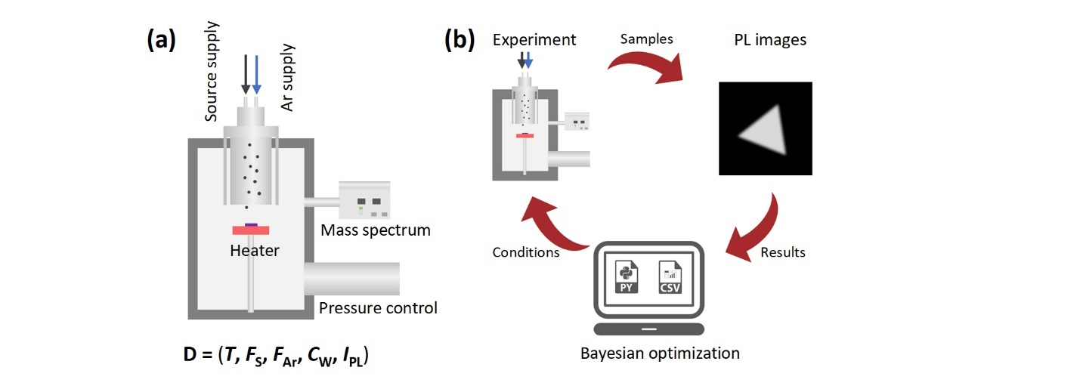
In the CVD growth for the initial dataset, we first defined a search space with 10,000 growth conditions and then conducted initial experiments with randomly selected conditions from this space; details about the search space are given below. This optimization process is not greatly affected by the initial dataset chosen, and this lack of sensitivity is clearly demonstrated in Fig. 4(a). For the following BO process, we performed PL imaging and analyzed the PL images to extract the averaged PL intensity (I_{PL}, see experimental section); a quantitative evaluation of the grown sample is required for BO²⁵. The resulting averaged intensity and selected growth conditions, growth temperature (T), sulfur source flow rate (F_{S}), Ar buffer flow rate (F_{Ar}), and metal source concentration (C_{W}), are the initial data set for the following BO.
Figure 1. An experimental setup and workflow of BO-guided optimization. (a) A home-built system for crystal growth, with all steps controlled automatically. (b) The key process of BO-guided optimization. From the experiment, characterization to BO prediction. The repetition of this loop can lead to continuous optimization.
After obtaining the first data set, we moved on to BO, where we set the objective function to I_{PL} (see methods). The PL intensity served as a figure of merit representing the sample quality and thus works as the objective function for optimizing growth conditions to realize high-quality TMD crystals for the next-generation photonic and optoelectronic devices^{27, 28}. To maximize I_{PL}, we selected T, F_{S}, F_{Ar}, and C_{W} as optimization parameters^{12, 29}. Other growth conditions, including growth time, substrate-showerhead distance, and ramping time, are fixed throughout BO processes. Given their role in reaction kinetics and source transport in the CVD growth process, all conditions affect each other and influence the results to varying degrees. In this study, however, to reduce the search space, also called the candidate data set, for effective optimization, we have focused on the selected four growth conditions (T, F_{S}, F_{Ar}, C_{W}), which are expected to affect growth results significantly²⁹⁻³¹; T determines the kinetic energy of active species and F_{S}, C_{W}, and F_{Ar} determines the concentration of active species in the gas phase. The search space is defined in the following ranges: T from 710 to 800 deg C; F_{S} from 10 to 55 sccm; F_{Ar} from 50 to 140 sccm; and C_{W} from 1 to 10 mg/ml. The step sizes for each growth condition are set to 10, 5, 10, and 1, respectively, resulting in 10,000 candidate parameter sets. Our purpose is to use BO to find a set of growth conditions within the 10,000 parameter sets that will yield the highest possible I_{PL} with the fewest number of experiments possible. The actual BO is carried out in three main steps as follows (Fig. 1b): (I) suggestion of the next experimental conditions by the BO code, (ⅠI) performing a CVD growth experiment with conditions suggested by the BO code, and (III) measurements of I_{PL} of the grown sample for the next suggestion from the BO code. The BO code can better predict PL intensity as BO cycles are repeated, and with improved prediction, BO suggests the next experimental conditions in a way that balances exploration and exploitation.
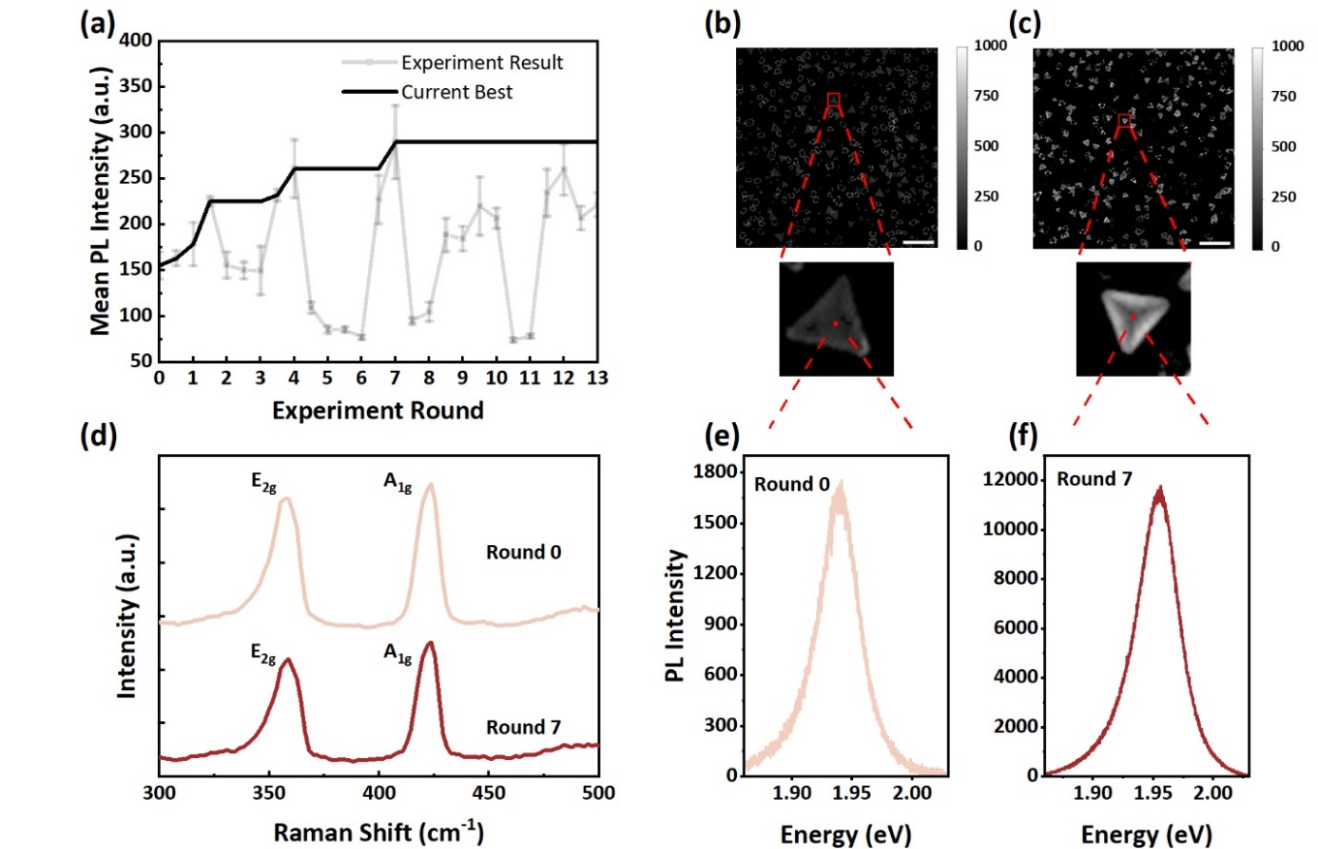
Figure 2. Optimization results under the BO guidance. (a) Experiment results of every step and the current best result of the latest experiment round. (b, c) PL images of round 0 (initial) and round 7 (best) under the same color bar. Scale bar: 100 μm. (d) Raman spectrum of round 0 and round 7. (e, f) PL spectrum of the typical crystals from round 0 and round 7.
The experimental results under the guidance of BO and their characterization results are shown in Figure 2. Figure 2a shows the evolution of I_{PL} throughout the BO process. The PL intensity gradually improves; round 0 represents the initial data with I_{PL} of 155.3 counts. It should be noted that although one dataset is used as the initial dataset, the BO works from the second round, where three datasets are collected. The current best I_{PL} in each round (black line in Fig. 2a) represents the strongest I_{PL} in the earlier rounds, while the experimental result represents the actual result of each experiment with standard deviation. Although 13 rounds of optimization are employed, the best conditions for the highest I_{PL} are found in round 7, with an 86.6 % improvement compared to the initial one. The key question here is when to stop BO. The stopping criterion³² is particularly significant when experimental costs are high. In the given search space, it is reasonable to assume that more favorable conditions exist for higher I_{PL}. However, considering the balance between optimization efficiency and experimental cost, we terminated the BO after 13 rounds because there was no improvement in the last five rounds; the total optimization round of our work is consistent with previous studies^{22, 33}. The significant variation in experimental results shown in Fig. 2a is considered as the trade-off between exploration and exploitation, which plays a crucial role in finding better solutions in unexplored regions and refining the search around promising regions³⁴. The balance between the two, exploration and exploitation, ensures BO does not prematurely converge on a local solution and continues to explore the search space effectively. The PL images of samples at rounds 0 and 7 are shown in Fig. 2b and c, respectively. When comparing images at the same grayscale, a significant increase in PL intensity is clearly seen in round 7, which is particularly impressive at a higher magnification, as shown in the insets. Figure 2d shows typical Raman spectra of WS₂ obtained at rounds 0 and 7, exhibiting Raman bands at 356 and 423 cm⁻¹ characteristics of monolayer WS₂³⁵. The PL spectra (Fig. 2 e and f) exhibit a strong peak at around 1.95 eV, consistent with the radiative recombination of optically generated excitons at K/K’ valleys³⁶. The improvement in PL intensity observed in the PL images is also apparent in the PL spectra, demonstrating quality improvement through the BO process. The PL intensity improvement in PL images is less pronounced than in PL spectra, probably due to lower spatial resolution that leads to more contribution from darker regions around WS₂ crystals.
Using the data sets obtained through BO, the relationships between T, F_{S}, F_{Ar}, C_{W}, and I_{PL} are analyzed statistically. Specifically, Pearson's correlation coefficients for each pair of T, F_{S}, F_{Ar}, C_{W}, and I_{PL} are calculated; Pearson's correlation coefficient represents the linear correlation between two variables. The small Pearson's correlation coefficients between experimental conditions shown in Fig. 3a demonstrate that independent conditions with low information redundancy have been selected, which is generally desired in the ML process because of the enhanced interpretability of the ML model. Also, Pearson's correlation coefficient between experimental conditions and I_{PL} indicates the importance of each experimental condition for crystal quality. The small positive (negative) correlation coefficients obtained between I_{PL} and T (F_{S}) indicate that changes in these two variables are not linearly related to changes in the obtained PL intensity. This non-linear relationship implies that we need to conduct a number of experiments using trial and error methods to maximize PL intensity. In contrast, the F_{Ar} (C_{W}) showed strong negative (moderate positive) correlations with I_{PL}, indicating that F_{Ar} (C_{W}) has an inverse (direct) relationship to the crystal quality. Interestingly, we found that both Fs and F_{Ar} show negative correlations against I_{PL}. The combination of Fs and F_{Ar} determines the total flow rate in our experiments, suggesting a possible negative correlation between the total flow rate and crystal quality. The feature importance analysis using random forest regression is conducted to quantify the relative importance of each condition in predicting the target PL intensity (Fig. 3b); the individual influence of each condition is displayed in Fig. S1. The C_{W} (0.61) plays the most critical role in determining I_{PL}, followed by F_{Ar} (0.27), while F_{S} (0.07) and T (0.05) contribute to I_{PL} to a lesser extent. Based on the extracted feature importance information, an additional trial is performed to find better/close PL intensity in a minimized dataset (Fig. S2).
Here, we will discuss the calculated feature importance from the experimental point of view. As shown in Fig. 3b, C_{W} and F_{Ar} are essential in determining the I_{PL} within the search space in the current BO. C_{W} should be important because it directly determines the concentration of the metal source on the substrate. Higher concentration means higher supersaturation, the driving force in crystal growth, significantly increasing the nucleation and growth rate. Since I_{PL} corresponds to the averaged PL intensity, it reflects the quality rather than the quantity of the grown crystals. However, altering the growth rate should also impact the quality of the crystals. In addition, high supersaturation can lead to nucleation on the monolayer and the formation of few-layer WS₂, whose indirect nature can lead to a smaller I_{PL}. Similarly, F_{Ar} impacts the growth rate of WS₂, but in a different way. F_{Ar} dominates the total flow rate and influences growth by varying the source supply dynamics. If F_{Ar} is too high, the precursor spends less time near the substrate surface, which is undesirable for generating active species through the thermal decomposition of sources. Conversely, if it is too low, the boundary layer becomes thicker, which may hinder the transport of the source to the substrate³⁷. Finally, to ensure reliable and robust model performance, the model accuracy is evaluated by using complete cross-validation, which involves training and evaluating the model multiple times in the subsets of the data. The calculated coefficient of determination (R²) of 0.629 demonstrates our final model's good prediction ability, especially given the ultra-small initial data (Fig. 3c), highlighting the ability to capture approximately 62.9% of the variation in the data.
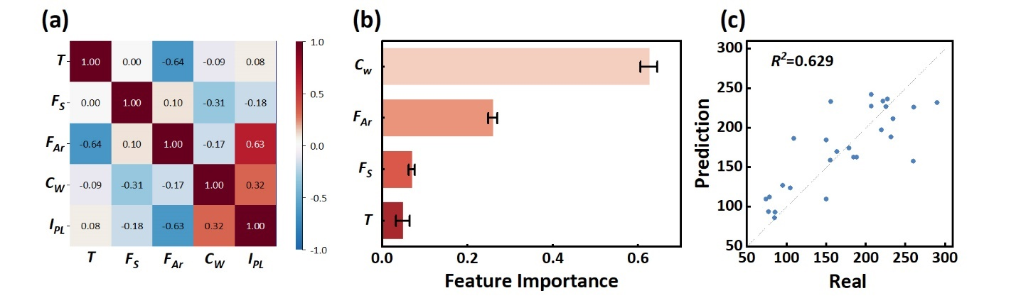
Figure 3. Analysis results of the BO model. (a) The heap map of Pearson's correlation coefficient with all data generated by BO expects the initial one. (b) Feature importance of four conditions. The error bar is roughly estimated by the difference between the feature importance with 13 rounds result and 12 rounds result. (c) Model accuracy verification using the random forest model.
Finally, we examined the superiority of BO over random search (RS). RS relies on random sampling, which is usually inefficient but can find the global optimal solution without being constrained by the local optimal solution³⁸. The comparison between BO and RS is carried out using a virtual dataset, including experimental conditions and corresponding mean PL intensities, predicted by the random forest regression model. First, applying the same strategy, we selected three points as the initial data and proceeded with 15 rounds of both BO and RS. We repeated BO and RS 10 times for each, and all results are presented in Fig. 4a and b, respectively. The optimization results of BO show fluctuation in the first serval rounds but converge from round 12, while the optimization results of RS show continuous and more significant fluctuation with no trend of convergence. Some trials in BO achieve high PL intensities in the beginning and keep high intensities in the subsequent optimization rounds, and other trials behave similarly to RS at first but soon converge to high PL intensities. The different performance among the BO results is due to the different choices of initial data, and all results become comparable as optimization progresses, demonstrating the robustness of BO. Figure 4c shows the current best I_{PL} with confidence intervals obtained from 10 trials with BO (Red) and RS (Black). In particular, BO converges from round 13, while RS converges earlier but requires more rounds to reach the same level of BO, highlighting the effectiveness of BO in finding the best growth conditions in limited iteration times.
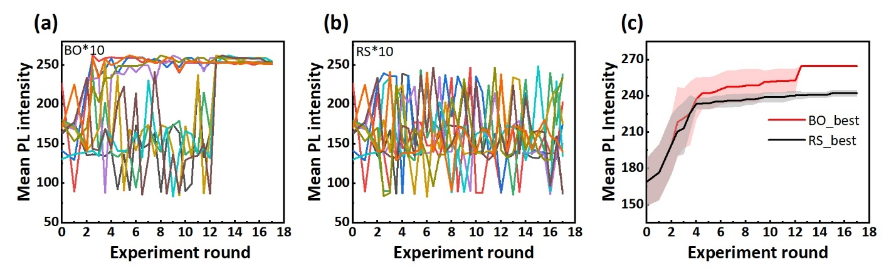Figure 4. Comparison of the optimization performance of BO and RS algorithms. Mean PL intensity optimization processes for (a) BO and (b) RS using a dataset created with the random forest regression model. (c) Current best mean PL intensity with a 95% confidence interval for the two algorithms.

CONCLUSION
In this work, we introduce BO as a solution to an optimization problem where obtaining experimental data is costly. We started BO with a few initial datasets, and BO efficiently improves the PL intensity of WS₂ by iteratively suggesting growth conditions based on previous experimental data. Through a systematic approach, including automated experimental setup and PL image analysis, we successfully demonstrate the effectiveness of BO in improving PL intensity, achieving an improvement of 86.6 % within 13 optimization rounds. Statistical analysis reveals the importance of growth conditions, particularly C_{W} and F_{Ar}, determining the crystal quality. Comparison with RS highlights the BO's superior convergence and efficiency in finding optimal growth conditions. This study underscores the potential of ML techniques such as BO to revolutionize controllable synthesis methods of 2D materials. In addition to maximizing PL intensities shown in this study, BO can be applied to optimize various material properties, such as crystal size, layer numbers, amounts, and carrier mobilities. Additionally, utilizing BO for material synthesis extends beyond the CVD growth of 2D materials. It can also be used for synthesizing various materials, such as molecules through organic chemical reactions, inorganic compounds via high-temperature annealing, and thin-film synthesis using molecular beam epitaxy. The feasibility of BO for black-box problems and expensive-to-evaluate experiments enables its application to optimize other materials synthesis processes, which can provide insights to advance materials research for future optoelectronic device applications.
ASSOCIATED CONTENT
Supporting Information.
Additional experimental details, analysis, and methods, including individual distribution of each parameter to PL intensity, additional optimization results, other growth parameters used in this work, and calculation method of I_{PL}.
AUTHOR INFORMATION
Corresponding Author
Ryo Kitaura – Research Center for Materials Nanoarchitectonics (MANA), National Institute for Materials Science (NIMS), 1-1 Namiki, Tsukuba, Ibaraki, 305-0044, Japan;
E-mail: KITAURA.Ryo@nims.go.jp
ACKNOWLEDGMENT
F.Z. was supported by China Scholarship Council scholarship.
R.K. was supported by JSPS KAKENHI Grant No. JP24H02218, JP23H05469, JP22H05458, JP21K18930, and JP20H05664, and JST SCICORP Grant No. JPMJSC2110 and PRESTO Grant No. JPMJPR20A2.
Notes
The authors declare no competing financial interest.
REFERENCES
(1) Novoselov, K. S.; Jiang, Z.-f.; Zhang, Y.-s.; Morozov, S.; Stormer, H. L.; Zeitler, U.; Maan, J.; Boebinger, G.; Kim, P.; Geim, A. K. Room-temperature quantum Hall effect in graphene. Science 2007, 315 (5817), 1379-1379
(2) Bao, C.; Tang, P.; Sun, D.; Zhou, S. Light-induced emergent phenomena in 2D materials and topological materials. Nature Reviews Physics 2022, 4 (1), 33-48
(3) Li, J.; Sanz, S.; Merino-Díez, N.; Vilas-Varela, M.; Garcia-Lekue, A.; Corso, M.; de Oteyza, D. G.; Frederiksen, T.; Peña, D.; Pascual, J. I. Topological phase transition in chiral graphene nanoribbons: from edge bands to end states. Nature communications 2021, 12 (1), 5538
(4) Zhang, J.; Wang, F.; Shenoy, V. B.; Tang, M.; Lou, J. Towards controlled synthesis of 2D crystals by chemical vapor deposition (CVD). Materials Today 2020, 40, 132-139
(5) Lau, C. S.; Chee, J. Y.; Cao, L.; Ooi, Z. E.; Tong, S. W.; Bosman, M.; Bussolotti, F.; Deng, T.; Wu, G.; Yang, S. W. Gate-defined quantum confinement in CVD 2D WS₂. Advanced Materials 2022, 34 (25), 2103907
(6) Cao, W.; Jiang, J.; Xie, X.; Pal, A.; Chu, J. H.; Kang, J.; Banerjee, K. 2-D layered materials for next-generation electronics: Opportunities and challenges. IEEE Transactions on Electron Devices 2018, 65 (10), 4109-4121
(7) Song, X.; Guo, Z.; Zhang, Q.; Zhou, P.; Bao, W.; Zhang, D. W. Progress of large-scale synthesis and electronic device application of two-dimensional transition metal dichalcogenides. Small 2017, 13 (35), 1700098
(8) Aras, F. G.; Yilmaz, A.; Tasdelen, H. G.; Ozden, A.; Ay, F.; Perkgoz, N. K.; Yeltik, A. A review on recent advances of chemical vapor deposition technique for monolayer transition metal dichalcogenides (MX2: Mo, W; S, Se, Te). Materials Science in Semiconductor Processing 2022, 148, 106829
(9) Konar, R.; Nessim, G. D. A mini-review focusing on ambient-pressure chemical vapor deposition (AP-CVD) based synthesis of layered transition metal selenides for energy storage applications. Materials Advances 2022, 3 (11), 4471-4488
(10) Zhang, X.; Huangfu, L.; Gu, Z.; Xiao, S.; Zhou, J.; Nan, H.; Gu, X.; Ostrikov, K. Controllable Epitaxial Growth of Large-Area MoS₂/WS₂ Vertical Heterostructures by Confined-Space Chemical Vapor Deposition. Small 2021, 17 (18), 2007312
(11) Wang, Q.; Shi, R.; Zhao, Y.; Huang, R.; Wang, Z.; Amini, A.; Cheng, C. Recent progress on kinetic control of chemical vapor deposition growth of high-quality wafer-scale transition metal dichalcogenides. Nanoscale Advances 2021, 3 (12), 3430-3440
(12) Choi, M.; Baek, J.; Zeng, H.; Jin, S.; Jeon, S. Toward high-quality graphene film growth by chemical vapor deposition system. Current Opinion in Solid State and Materials Science 2024, 31, 101176
(13) Heiserer, S.; Eder, P.; Ó Coileáin, C.; Biba, J.; Stimpel-Lindner, T.; Bartlam, C.; Rührmair, U.; Duesberg, G. S. Controllable and Reproducible Growth of Transition Metal Dichalcogenides by Design of Experiments. Advanced Electronic Materials 2023, 9 (10), 2300281
(14) Momeni, K.; Ji, Y.; Wang, Y.; Paul, S.; Neshani, S.; Yilmaz, D. E.; Shin, Y. K.; Zhang, D.; Jiang, J.-W.; Park, H. S. Multiscale computational understanding and growth of 2D materials: a review. npj Computational Materials 2020, 6 (1), 22
(15) Han, B.; Lin, Y.; Yang, Y.; Mao, N.; Li, W.; Wang, H.; Yasuda, K.; Wang, X.; Fatemi, V.; Zhou, L. Deep-Learning-Enabled Fast Optical Identification and Characterization of 2D Materials. Advanced Materials 2020, 32 (29), 2000953
(16) Moosavi, S. M.; Jablonka, K. M.; Smit, B. The role of machine learning in the understanding and design of materials. Journal of the American Chemical Society 2020, 142 (48), 20273-20287
(17) Morgan, D.; Jacobs, R. Opportunities and challenges for machine learning in materials science. Annual Review of Materials Research 2020, 50, 71-103
(18) Bikmukhametov, T.; Jäschke, J. Combining machine learning and process engineering physics towards enhanced accuracy and explainability of data-driven models. Computers & Chemical Engineering 2020, 138, 106834
(19) Hey, T.; Tansley, S.; Tolle, K. M., The fourth paradigm: data-intensive scientific discovery. Microsoft research Redmond, WA: 2009; Vol. 1.
(20) Tanaka, K.; Hachiya, K.; Zhang, W.; Matsuda, K.; Miyauchi, Y. Machine-Learning Analysis to Predict the Exciton Valley Polarization Landscape of 2D Semiconductors. ACS Nano 2019, 13 (11), 12687-12693.10.1021/acsnano.9b04220
(21) Tang, B.; Lu, Y.; Zhou, J.; Chouhan, T.; Wang, H.; Golani, P.; Xu, M.; Xu, Q.; Guan, C.; Liu, Z. Machine learning-guided synthesis of advanced inorganic materials. Materials Today 2020, 41, 72-80.10.1016/j.mattod.2020.06.010
(22) Ueno, T.; Rhone, T. D.; Hou, Z.; Mizoguchi, T.; Tsuda, K. COMBO: An efficient Bayesian optimization library for materials science. Materials Discovery 2016, 4, 18-21.10.1016/j.md.2016.04.001
(23) Shields, B. J.; Stevens, J.; Li, J.; Parasram, M.; Damani, F.; Alvarado, J. I. M.; Janey, J. M.; Adams, R. P.; Doyle, A. G. Bayesian reaction optimization as a tool for chemical synthesis. Nature 2021, 590 (7844), 89-96
(24) Ferreira, T.; Rasband, W. ImageJ user guide. Imagej/fiji 2012, 1, 155-161
(25) Ichinose, N.; Maruyama, M.; Hotta, T.; Liu, Z.; Canton-Vitoria, R.; Okada, S.; Zeng, F.; Zhang, F.; Taniguchi, T.; Watanabe, K. Two-dimensional atomic-scale ultrathin lateral heterostructures. arXiv preprint arXiv:2208.12696 2022,
(26) He, Z.; Wang, X.; Xu, W.; Zhou, Y.; Sheng, Y.; Rong, Y.; Smith, J. M.; Warner, J. H. Revealing Defect-State Photoluminescence in Monolayer WS2 by Cryogenic Laser Processing. ACS Nano 2016, 10 (6), 5847-55.10.1021/acsnano.6b00714
(27) Cheng, Z.; Cao, R.; Wei, K.; Yao, Y.; Liu, X.; Kang, J.; Dong, J.; Shi, Z.; Zhang, H.; Zhang, X. 2D materials enabled next-generation integrated optoelectronics: from fabrication to applications. Advanced Science 2021, 8 (11), 2003834
(28) Yang, X.; Zhu, Z.; Luo, F.; Wang, G.; Peng, G.; Zhu, M.; Qin, S. Strain-induced alternating photoluminescence segmentation in hexagonal monolayer tungsten disulfide grown by physical vapor deposition. ACS Applied Materials & Interfaces 2021, 13 (38), 46164-46170
(29) Zhang, J.; Wang, F.; Shenoy, V. B.; Tang, M.; Lou, J. Towards controlled synthesis of 2D crystals by chemical vapor deposition (CVD). Materials Today 2020, 40, 132-139
(30) Liu, F.; Li, P.; An, H.; Peng, P.; McLean, B.; Ding, F. Achievements and challenges of graphene chemical vapor deposition growth. Advanced Functional Materials 2022, 32 (42), 2203191
(31) Senkić, A.; Bajo, J.; Supina, A.; Radatović, B.; Vujičić, N. Effects of CVD growth parameters on global and local optical properties of MoS₂ monolayers. Materials chemistry and physics 2023, 296, 127185
(32) Nguyen, V.; Schulze, S.; Osborne, M. Bayesian optimization for iterative learning. Advances in Neural Information Processing Systems 2020, 33, 9361-9371
(33) Ohkubo, I.; Hou, Z.; Lee, J. N.; Aizawa, T.; Lippmaa, M.; Chikyow, T.; Tsuda, K.; Mori, T. Realization of closed-loop optimization of epitaxial titanium nitride thin-film growth via machine learning. Materials Today Physics 2021, 16, 100296.10.1016/j.mtphys.2020.100296
(34) Beckham, J. L.; Wyss, K. M.; Xie, Y.; McHugh, E. A.; Li, J. T.; Advincula, P. A.; Chen, W.; Lin, J.; Tour, J. M. Machine learning guided synthesis of flash graphene. Advanced Materials 2022, 34 (12), 2106506
(35) Barbosa, A.; Figueroa, N.; Giarola, M.; Mariotto, G.; Freire Jr, F. Straightforward identification of monolayer WS2 structures by Raman spectroscopy. Materials Chemistry and Physics 2020, 243, 122599
(36) Cui, Q.; Luo, Z.; Cui, Q.; Zhu, W.; Shou, H.; Wu, C.; Liu, Z.; Lin, Y.; Zhang, P.; Wei, S. Robust and high photoluminescence in WS₂ monolayer through in situ defect engineering. Advanced Functional Materials 2021, 31 (38), 2105339
(37) Seo, J.; Lee, J.; Baek, S.; Jung, W.; Oh, N. K.; Son, E.; Park, H. Liquid Precursor-Mediated Epitaxial Growth of Highly Oriented 2D van der Waals Semiconductors toward High-Performance Electronics. ACS Applied Electronic Materials 2021, 3 (12), 5528-5536
(38) Turner, R.; Eriksson, D.; McCourt, M.; Kiili, J.; Laaksonen, E.; Xu, Z.; Guyon, I. In Bayesian optimization is superior to random search for machine learning hyperparameter tuning: Analysis of the black-box optimization challenge 2020, NeurIPS 2020 Competition and Demonstration Track, PMLR: 2021; pp 3-26.

For Table of Contents Use Only
Bayesian Optimization for Controlled Chemical Vapor Deposition Growth of WS₂
Feng Zhang, Ryo Tamura, Fanyu Zeng, Daichi Kozawa, and Ryo Kitaura
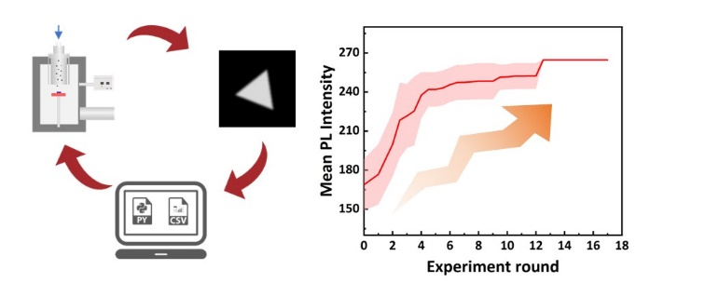
Bayesian optimization-guided experiments achieved robust and remarkable improvement in desired properties under only a few initial data.

Supporting Information
Bayesian Optimization for Controlled Chemical Vapor Deposition Growth of WS₂

Feng Zhang^{1,2}, Ryo Tamura^{3,4}, Fanyu Zeng¹, Daichi Kozawa¹ and Ryo Kitaura^{1,*}
¹ Research Center for Materials Nanoarchitectonics, National Institute for Materials Science, 1-1 Namiki, Tsukuba 305-0044, Japan
² Department of Chemistry, Nagoya University, Nagoya 464-8601, Japan
³ Center for Basic Research on Materials, National Institute for Materials Science, 1-1 Namiki, Tsukuba 305-0044, Japan
⁴ Graduate School of Frontier Sciences, The University of Tokyo, 5-1-5 Kashiwanoha, Kashiwa-city, Chiba 277-8568, Japan
*E-mail: KITAURA.Ryo@nims.go.jp

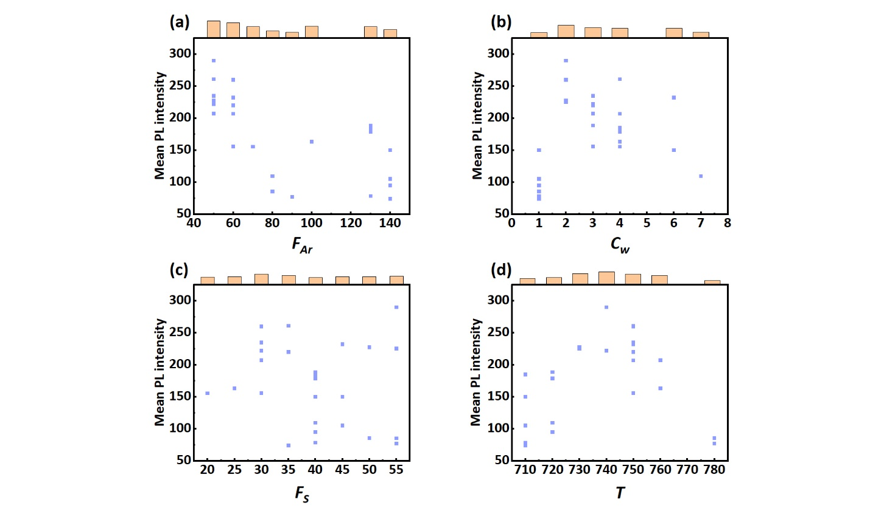
Figure S1. Individual distribution of each parameter to PL intensity. (a-d) Distribution of experimental results as the function of F_{Ar}, C_{w,} F_{S}, and T, respectively. The top histograms represent the average PL intensity at each condition.

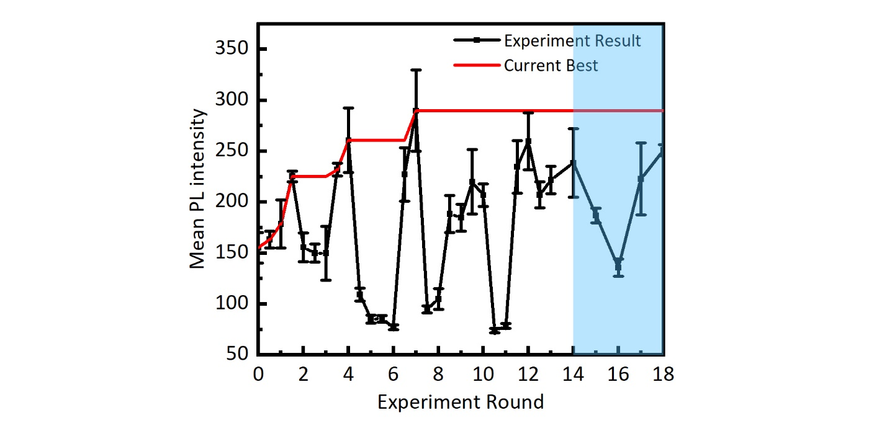
Figure S2. Results of an additional 5 optimization rounds (from round 14 to round 18, blue region) in the reduced dataset.
The search space was reduced from 10,000 to 42, and an additional 5 rounds of BO were conducted in this reduced space. Although there was no significant improvement in the PL intensity as anticipated, the best results obtained in this additional work are close to the second-best one (round 4), and the lower limit of fluctuations decreased compared to rounds 5, 6, and 11. This indicates that reducing the search space, based on Pearson’s correlation coefficient and feature importance, is useful for further improvement.
Table S1. Growth conditions used in this work.
Growth conditions | Value | Unit
Growth time | 15 | min
Growth pressure | 10 | kPa
Distance between showerhead and substrate | 5 | cm
Temperature ramp rate | 50 | deg/min
Water bath temperature (Sulfur source) | 15 | deg
Curtain gas (Ar) | 300 | sccm
Cooling time | 20 | min

The growth conditions listed here were kept constant for all CVD experiments in this study to narrow down the search space for efficient BO. We used a pressure regulator to keep the pressure in the growth chamber at 10 kPa. 300 sccm of Ar as a curtain gas is used to focus the sulfur source flow onto the growth substrate.

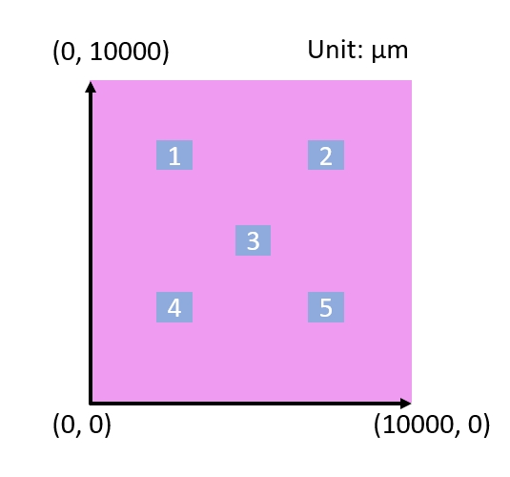
Figure S3. Selected measurement positions for PL intensity measurements for determining mean PL intensities. The pink square represents the growth substrate and five numbered squares correspond to locations for PL measurements.
We use 10,000 μm² silicon substrates for our growth study. To obtain reliable PL intensities, we used the fixed five coordinates, (2500, 2500), (2500, 7500), (5000, 5000), (7500, 2500), and (7500, 7500), in every PL image measurement. We did background subtraction for each image by subtracting a dark image measured without light excitation. In addition, to correct the PL intensity difference arising from inhomogeneous excitation light intensity, we captured an image of a gold-coated substrate as a reference image before each PL image measurement. Afterward, we divided the observed PL images by the reference image and then multiplied the mean intensity of the reference image to obtain the PL intensities of the grown WS₂.
To calculate the mean PL intensity, we apply a threshold to exclude the background region's contribution. In our research, we found that a lower threshold value of 65 effectively eliminates the background region and allows us to obtain PL intensities from the grown WS₂ selectively. We then calculate the mean PL intensity, I_{PL}, using the following equations:
,
$I_{PL}$= $\frac{\sum_{i=1}^{5}{I_{i}}}{5}$
$$I_{i}=\frac{Sum of the value of all pixels}{The number of pixels}$$

