Supporting Information of
“Electrochemical Lithiation and Delithiation of Amorphous Nonstoichiometric Silicon Oxide
Thin-Film Electrode Studied by Operando
X-ray Photoelectron Spectroscopy”
Tsukasa Iwama^{1,2}, Ryosuke Sugimoto³, Raimu Endo^{1,2}, Tsuyoshi Ohnishi¹, Masakazu Haruta⁴, Takayuki Doi³, and Takuya Masuda^{1,2,}*
- Research Center for Energy and Environmental Materials (GREEN), National Institute for Materials Science (NIMS), Tsukuba, Ibaraki 305-0044, Japan
- Graduate School of Chemical Sciences and Engineering, Hokkaido University, Sapporo, Hokkaido 060-0810, Japan
- Department of Molecular Chemistry and Biochemistry, Doshisha University, Kyotanabe, Kyoto 610-0321, Japan
- Department of Electric and Electronic Engineering, Kindai University, Iizuka, Fukuoka
820-8555, Japan
*Corresponding Author: Takuya Masuda MASUDA.Takuya@nims.go.jp

Experimental procedures.
An a-SiO_{x} thin film with a diameter of 10 mm and thickness of around 100 nm was deposited on a LLZT sheet (10 mm × 10 mm × 500 μm; Toshima Manufacturing Co., Ltd.) by radio frequency magnetron sputtering using Ar/O₂ gas mixtures.^{1, 2} Then, a Cu layer serving as a current collector was deposited on the sputter-deposited SiO_{x} layer by direct current sputtering. During the Cu coating, the center area with dimensions of 10 mm × 4 mm was masked by a stainless-steel stencil plate to produce an uncoated SiO_{x} region for XPS measurements. Finally, a Li metal layer with a thickness of around 1.5 μm was formed on the other surface of the LLZT sheet by thermal evaporation to yield a Cu/SiO_{x}/LLZT/Li all-solid-state (ASS) half-cell, as shown in Figure 1.
The electrochemical lithiation/delithiation and XPS measurements were simultaneously carried out using an operando XPS system.³⁻⁵ The ASS half-cell was mounted onto a sample holder in an Ar-filled glovebox and then transferred into the XPS apparatus (Kratos AXIS Nova, Shimadzu Corporation) without exposure to open air. The Cu layer on the a-SiO_{x} thin-film electrode and the Li metal layer were electrically connected to terminal A and B, respectively, with being insulated from each other by a polyimide film, as shown in Figure 1. After transferring the cell into the analysis chamber, terminal A and B were connected to a potentiostat (VSP-300, BioLogic Science instruments) at the outside by coaxial cables via a vacuum feedthrough, while terminal A was grounded with a hemispherical electron analyzer.
Electrochemical lithiation and delithiation of the ASS half-cell were carried out in constant-current (CC)–constant-voltage (CV) and constant-current (CC) mode, respectively. In the first lithiation with a CC–CV mode, the cell was first lithiated with a constant current of 4.9 μA cm⁻² (~0.134 C, 1 C = 3579 mA g⁻¹ for Li_{3.75}Si) until the cell voltage reached 0.02 V (109 min), and then the cell voltage was held constant at 0.02 V until the current density decreased to 0.49 μA cm⁻² (546 min). In the delithiation with a CC mode, constant current of 2.45 μA cm⁻² (~0.067 C) was applied until the cell voltage reached 1.5 V (285 min). The same procedure was applied in the subsequent lithiation/delithiation cycles, except that the current densities for CC and CV for lithiation were set to half of those for the first lithiation. In the present study, a low current density was used in order to obtain a sufficient number of photoelectron spectra during the lithiation/delithiation processes. In addition, it should be noted that, at higher current densities, the voltage immediately reaches the cutoff voltage due to a lower electric and ionic conductivity of SiO_{x}.
XPS measurements were performed in the analysis chamber kept under a pressure of 4 × 10⁻⁹ Torr. X-rays from a monochromatic Al Kα (1486.7 eV) source at a power of 300 W were incident to the exposed region of a-SiO_{x} thin-film electrode. The analysis area, takeoff angle, and pass energy of photoelectrons were fixed at 700 × 300 μm², 90°, and 80 eV, respectively. XPS measurements composed of Si 2p, C 1s, O 1s, and Li 1s regions were repeatedly applied to the a-SiO_{x} thin-film electrode throughout the lithiation and delithiation. The obtained spectra were calibrated by the hydrocarbon peak assignable to surface contamination at 285.0 eV in C 1s region as previously reported.⁵ After the background subtraction by using the Shirley method, the spectra were fitted using the Voight function.⁶ As for the Si 2p region, all the peaks were deconvoluted into Si 2p_{3/2} and 2p_{1/2} peaks and only the Si 2p_{3/2} peaks were used as the subject of discussion unless specified. In our previous study on an a-Si thin-film electrode sputter-deposited on a LLZT, a linear correlation between the peak position of Li_{y}Si in the Si 2p region and its Li content was obtained based on an assumption that all the electrochemical charge was consumed for the lithiation of Si.⁵ In the present study, Li content in Li_{y}Si was determined based on the refined linear correlation of our previous study on a-Si thin-film electrode⁵ as shown in Table S2 and Figure S2 for the first lithiation, and Table S3 and Figure S3 for the first delithiation.
Hard X-ray photoelectron spectroscopy (HAXPES) measurements were performed in the analysis chamber equipped with a hemispherical analyzer (EW4000, Scienta Omicron, Inc.) kept under a pressure of 2 × 10⁻⁸ mbar.⁷ Focused X-rays from a monochromatic Cr-Kα (5414.9 eV) source (ULVAC-PHI, Inc.) at a power of 50 W with a spot size of 200 μm were incident to the exposed area of a-SiO_{x} thin-film electrode. The takeoff angle, and pass energy of photoelectrons were fixed at 75° and 200 eV, respectively. HAXPES measurements composed of Si 2p and C 1s regions were applied to the pristine SiO_{x} thin-film electrode. The obtained spectra were calibrated and fitted in the same manner as those in the XPS measurements.
Elemental analysis of the a-SiO_{x} thin-film electrode in the pristine state was conducted using a SEM (SU8220, Hitachi) equipped with an energy dispersive X-ray spectroscopy (EDS, XFlash5060FQ, Bruker).

Estimation of oxygen content x in a-SiO_{x}
The oxygen content x in the a-SiO_{x} thin film was estimated from SEM-EDS, XPS and HAXPES. According to elemental analysis using SEM-EDS, the oxygen content x in the SiO_{x} thin film in the pristine state was estimated to be 0.53.
Figure S1 (a) and (b) show the Si 2p photoelectron spectra of the SiO_{x} thin-film electrode in the pristine state obtained using Al Kα (XPS) and Cr Kα rays (HAXPES), respectively. The curve fitting analysis was performed using five symmetric Voigt functions⁶ with each energy difference of 1 eV, corresponding to five species with the oxidation states of bulk Si (Si⁰), Si₂O (Si¹⁺), SiO (Si²⁺), Si₂O₃ (Si³⁺), and SiO₂ (Si⁴⁺).⁸⁻¹¹ The binding energy and the full width half maximum (FWHM) of Si 2p_{3/2} peak due to Si⁰ were set as variable parameters. In contrast, the FWHMs of peaks due to Si oxides such as Si¹⁺, Si²⁺, Si³⁺, and Si⁴⁺ species were fixed at the same value to reduce the number of refinement parameters. In addition, the intensity ratio and the difference of binding energy of the Si 2p_{1/2} to 2p_{3/2} peaks were fixed at 0.5 and 0.6 eV, respectively.⁸⁻¹¹ As a result, the best fit was obtained with Si⁰, Si³⁺ and Si⁴⁺ components. The formation of silicon suboxides is commonly observed in nonstoichiometric silicon oxide and at the SiO₂/Si interface, and their chemical structures have been studied in the field of semiconductor technologies.¹²⁻¹⁶
The oxygen content x in SiO_{x} was estimated from the following equation $\left(1\right)$;⁸

$$\begin{aligned}Oxygen content x=\frac{1.5×I_{{Si}^{3+}}+2×I_{{Si}^{4+}}}{I_{Si}+I_{{Si}^{3+}}+I_{{Si}^{4+}}}\#\left(1\right)\end{aligned}$$where $I_{Si}$, $I_{{Si}^{3+}}$, and $I_{{Si}^{4+}}$ are Si 2p_{3/2} peak intensities of Si⁰, Si³⁺, and Si⁴⁺, respectively. The intensity ratio of Si⁰, Si³⁺, Si⁴⁺, and estimated oxygen content x are summarized in Table S1. The estimated value of x = 0.50 from the photoelectron spectra using Cr Kα rays (HAXPES) was in good agreement with that of x = 0.53 estimated from SEM-EDS although value of x = 0.86 from the photoelectron spectra using Al Kα rays (XPS) was overestimated because Si surface is covered by a native oxide layer.
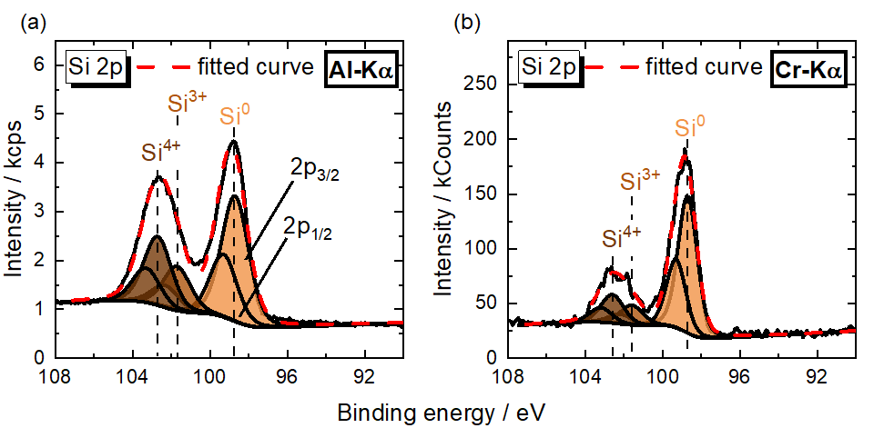
Figure S1. Si 2p photoelectron spectra of SiO_{x} thin film electrode in the pristine state obtained using (a) Al Kα and (b) Cr Kα rays.

Table S1. The oxygen content x in SiO_{x} estimated from the results of curve fitting of SiO_{x} thin-film electrode in the pristine state using equation $\left(1\right)$.
Intensity ratio  Techniques | $$I_{Si}$$ | $$I_{Si^{3+}}$$ | $I_{Si^{4+}}$ | x in SiO_{x}
Al Kα (XPS) | 0.52 | 0.19 | 0.29 | 0.87
Cr Kα (HAXPES) | 0.72 | 0.12 | 0.16 | 0.50
EDS |  |  |  | 0.53

The correlation between the position of Si 2p peaks due to Li_{y}Si and the Li content y during the first lithiation and delithiation of a-Si.⁵
In our previous study, electrochemical lithiation/delithiation reaction of an a-Si thin film electrode on a LLZT was dynamically analyzed by operando XPS.⁵ The correlation between the position of Si 2p and deconvoluted Si 2p_{3/2} peaks due to Li_{y}Si and the Li content y obtained from electrochemical charge density during the first lithiation and delithiation are shown in Table S2 and S3, respectively. Figure S2 and S3 show the Si 2p and Si 2p_{3/2} peak positions as a function of Li content y in Li_{y}Si and linear approximations generated from those plots during the first lithiation and delithiation, respectively.

Table S2. Curve fitting results of Si 2p and Si 2p_{3/2} peaks due to Si⁰/Li_{y}Si as a function of Li content y during the first lithiation.⁵
1st Lithiation | Si⁰/Li_{y}Si |  |  | Si⁰/Li_{y}Si
y in Li_{y}Si | Si 2p | Si 2p_{3/2} | y in Li_{y}Si | Si 2p | Si 2p_{3/2}
0 | 99.07 | 98.95 | 1.77 | 96.68 | 96.52
0.018 | 98.27 | 98.27 | 1.88 | 96.61 | 96.45
0.128 | 97.71 | 97.58 | 1.99 | 96.55 | 96.38
0.237 | 97.68 | 97.53 | 2.10 | 96.49 | 96.30
0.347 | 97.57 | 97.42 | 2.20 | 96.40 | 96.23
0.456 | 97.48 | 97.33 | 2.31 | 96.35 | 96.19
0.566 | 97.39 | 97.21 | 2.42 | 96.25 | 96.11
0.675 | 97.33 | 97.15 | 2.53 | 96.25 | 96.06
0.785 | 97.26 | 97.09 | 2.64 | 96.15 | 95.97
0.894 | 97.24 | 97.04 | 2.75 | 96.13 | 95.94
1.00 | 97.16 | 97.01 | 2.86 | 96.02 | 95.87
1.11 | 97.06 | 96.92 | 2.97 | 95.98 | 95.83
1.22 | 97.02 | 96.83 | 3.08 | 95.93 | 95.79
1.33 | 96.90 | 96.75 | 3.19 | 95.95 | 95.78
1.44 | 96.85 | 96.71 | 3.30 | 95.87 | 95.72
1.55 | 96.79 | 96.63 | 3.41 | 95.74 | 95.59
1.66 | 96.77 | 96.58 | 3.50 | 95.36 | 95.22

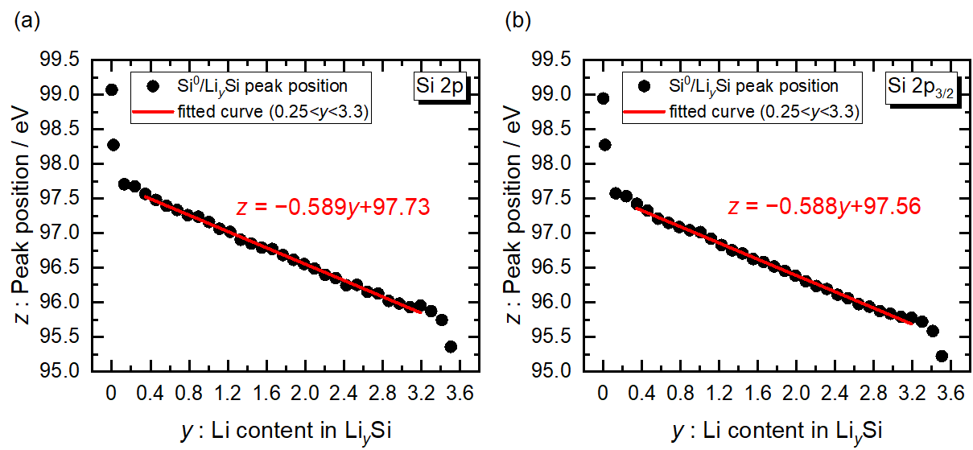
Figure S2. Positions of (a) Si 2p and (b) Si 2p_{3/2} peaks due to Si⁰/Li_{y}Si as a function of Li content y during the first lithiation. Red lines are linear fits to the data in a range of 0.25 < y < 3.3 [y : Li content in Li_{y}Si, z : Peak position / eV].

Table S3. Curve fitting results of Si 2p and Si2p_{3/2} peaks due to Si⁰/Li_{y}Si as a function of Li content y during the first delithiation.
1st Delithiation | Si⁰/Li_{y}Si |  |  | Si⁰/Li_{y}Si
y in Li_{y}Si | Si 2p | Si 2p_{3/2} | y in Li_{y}Si | Si 2p | Si 2p_{3/2}
3.502 | 95.36 | 95.22 | 1.844 | 96.08 | 95.91
3.484 | 95.41 | 95.24 | 1.735 | 96.72 | 96.56
3.374 | 95.48 | 95.33 | 1.626 | 97.08 | 96.91
3.265 | 95.48 | 95.33 | 1.516 | 97.12 | 96.96
3.155 | 95.51 | 95.37 | 1.352 | 97.19 | 97.04
3.045 | 95.50 | 95.37 | 1.214 | 97.17 | 97.00
2.935 | 95.59 | 95.41 | 1.101 | 97.23 | 97.05
2.825 | 95.61 | 95.43 | 0.991 | 97.28 | 97.10
2.717 | 95.60 | 95.44 | 0.882 | 97.31 | 97.14
2.608 | 95.63 | 95.44 | 0.773 | 97.34 | 97.20
2.499 | 95.61 | 95.47 | 0.664 | 97.45 | 97.26
2.390 | 95.63 | 95.49 | 0.555 | 97.47 | 97.29
2.281 | 95.69 | 95.52 | 0.446 | 97.44 | 97.32
2.172 | 95.75 | 95.57 | 0.337 | 97.53 | 97.36
2.063 | 95.75 | 95.60 | 0.228 | 97.55 | 97.41
1.954 | 95.85 | 95.69 | 0.189 | 97.59 | 97.45

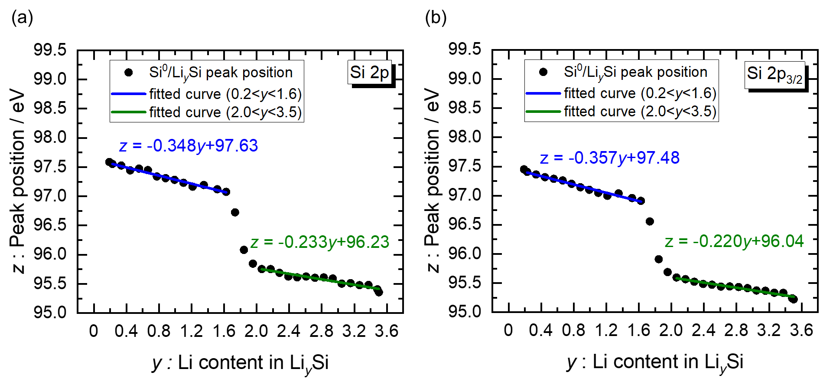
Figure S3. Positions of (a) Si 2p and (b) Si 2p_{3/2} peaks due to Si⁰/Li_{y}Si as a function of Li content y during the first delithiation. Bule and green lines are linear fits to the data in ranges of 0.2 < y < 1.6 and 2.0 < y < 3.5, respectively [y : Li content in Li_{y}Si, z : Peak position / eV].

Si 2p_{3/2} peak positions corresponding to Li_{y}Si at the end of the first lithiation.
Figure S4 shows the Si 2p_{3/2} peak positions of each chemical species obtained by the curve fitting of XPS spectra of the a-SiO_{x} thin film (Figure 4) during the first lithiation, and Si 2p_{3/2} peak positions corresponding to Li_{y}Si at the end of the first lithiation. The Li_{y}Si peak gradually shifted from 96.4 eV at the capacity of 2093 mAh g_{Si}⁻¹ to 96.1 eV at the capacity of 2591 mAh g_{Si}⁻¹.
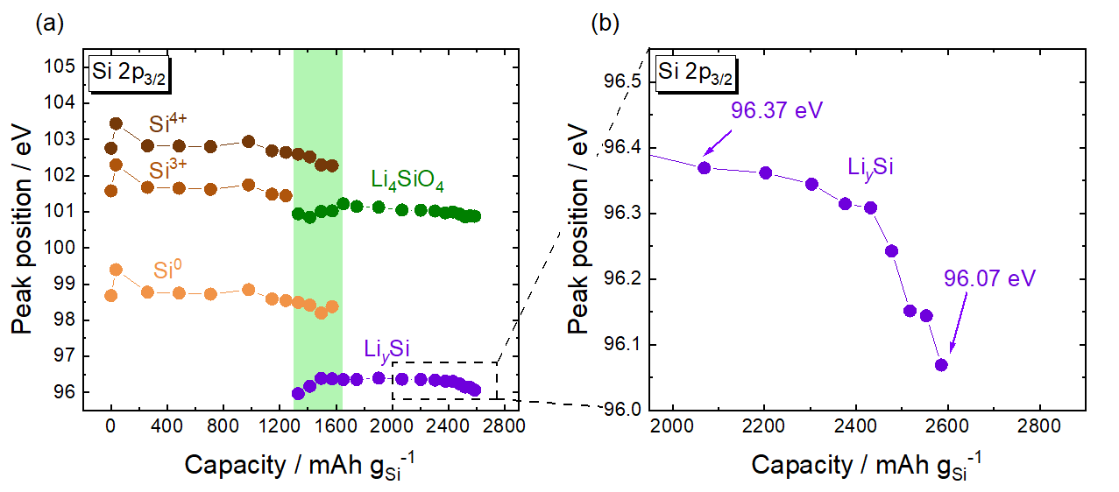
Figure S4. (a) Si 2p_{3/2} peak positions of each component with respect to capacity during the first lithiation. (b) Magnified graph of dashed box of (a). The green area shown in (a) and (b) represent the regions where Si⁰, Si³⁺, Si⁴⁺, Li₄SiO₄, and Li_{y}Si coexisted.

In the first lithiation, the Li content y in Li_{y}Si was estimated by the following equation $\left(2\right)$ (y: Li content y in Li_{y}Si, z: peak position / eV), as shown in Figure S2 (b);
$$\begin{aligned}z=-0.588y+97.56 \left(0.25<y<3.3\right)\#\left(2\right)\end{aligned}$$Here, the Li_{y}Si peak position, z was 96.40 eV when the capacity density reached 1427 mAh g_{Si}⁻¹ where Li_{y}Si and Li silicates were formed
$$∴y=1.97$$The Li_{y}Si peak position, z was 96.37 eV when the capacity density reached 2093 mAh g_{Si}⁻¹ where almost all of the Si⁰, Si³⁺, and Si⁴⁺ were lithiated
$$∴y=2.02$$In addition, the Li_{y}Si peak position, z was 96.07 eV when the capacity density reached 2591 mAh g_{Si}⁻¹
$$∴y=2.53$$
In the first delithiation, the Li content y in Li_{y}Si was estimated by the following equation $\left(3\right)$, as shown in Figure S3 (b);
$$\begin{aligned}z=-0.357y+97.48 \left(0.2<y<1.6\right)\#\left(3\right)\end{aligned}$$Here, the Li_{y}Si peak position, z was 97.05 eV after the first delithiation
$$∴y=1.20$$

Photoelectron spectra during the second lithiation and delithiation.
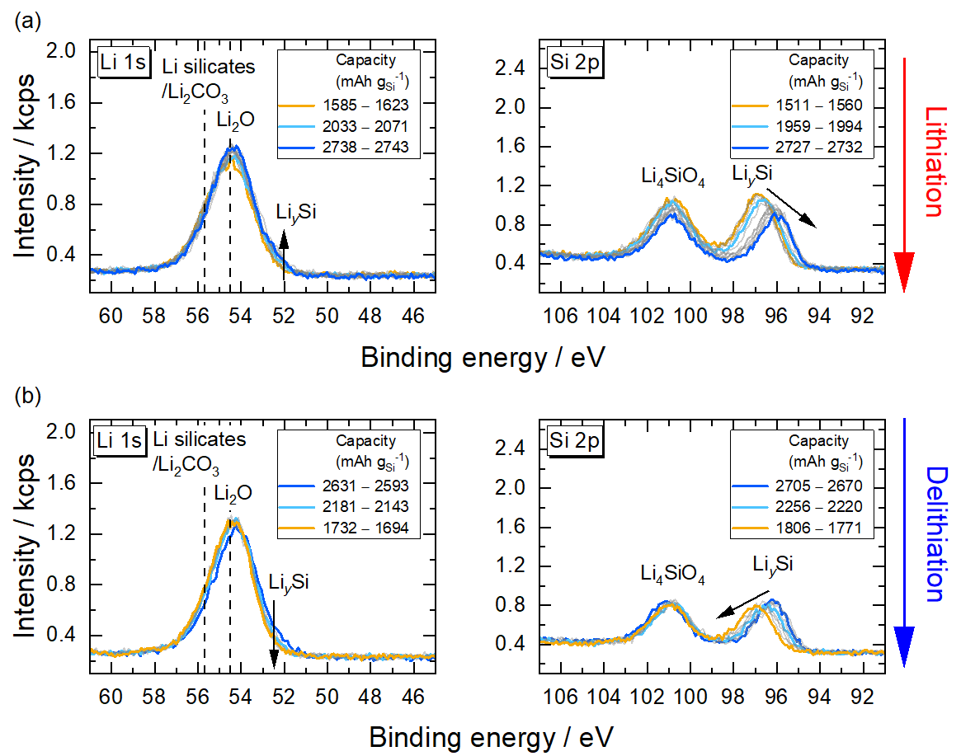
Figure S5. Li 1s and Si 2p photoelectron spectra of the a-SiO_{x} thin film electrode in a Cu/SiO_{x}/LLZT/Li ASS half-cell during the second (a) lithiation and (b) delithiation.
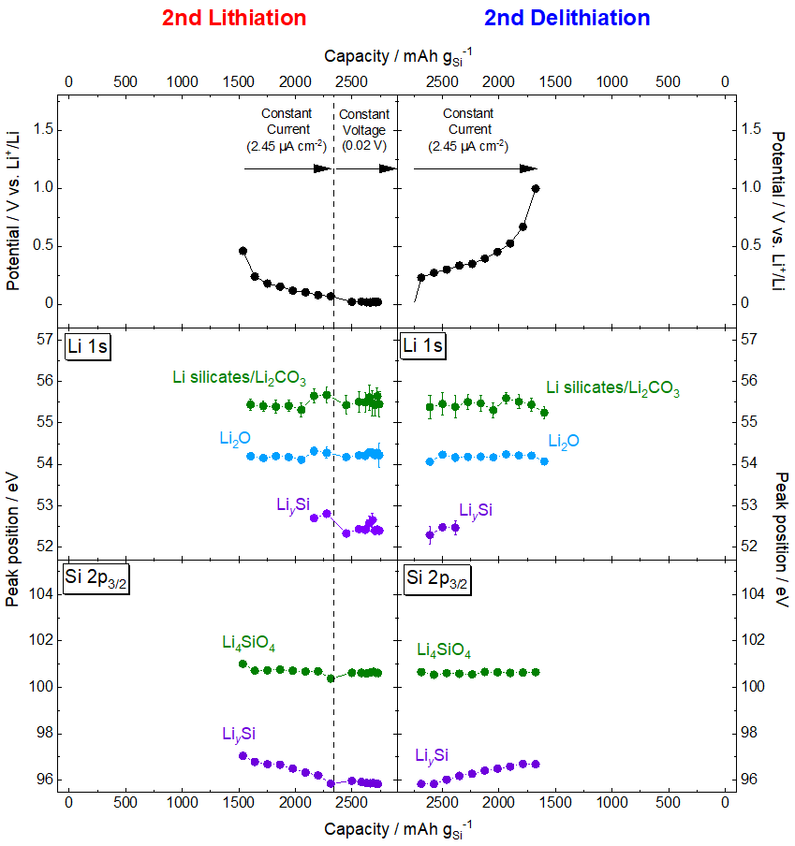
Figure S6. Potential profiles and Li 1s and Si 2p_{3/2} peak positions of each chemical species as a function of capacity density during the second lithiation and delithiation.

References
(1) Sugimoto, R.; Marumoto, K.; Haruta, M.; Inaba, M.; Doi, T. Quantitative Evaluation and Improvement of Interfacial Li⁺ Transfer Between SiO_{x} Electrode and Garnet‐Type Ta‐Doped Li₇La₃Zr₂O₁₂ Electrolyte. ChemElectroChem 2022, 9 (17), e202200491. DOI: 10.1002/celc.202200491.
(2) Haruta, M.; Doi, T.; Inaba, M. Oxygen-Content Dependence of Cycle Performance and Morphology Changes in Amorphous-SiO_{x} Thin-Film Negative Electrodes for Lithium-Ion Batteries. J. Electrochem. Soc. 2019, 166 (2), A258-A263. DOI: 10.1149/2.0861902jes.
(3) Endo, R.; Ohnishi, T.; Takada, K.; Masuda, T. Instrumentation for tracking electrochemical reactions by x-ray photoelectron spectroscopy under conventional vacuum conditions. J. Phys. Commun. 2021, 5 (1), 015001. DOI: 10.1088/2399-6528/abd617.
(4) Endo, R.; Ohnishi, T.; Takada, K.; Masuda, T. In Situ Observation of Lithiation and Delithiation Reactions of a Silicon Thin Film Electrode for All-Solid-State Lithium-Ion Batteries by X-ray Photoelectron Spectroscopy. J. Phys. Chem. Lett. 2020, 11 (16), 6649-6654. DOI: 10.1021/acs.jpclett.0c01906.
(5) Endo, R.; Ohnishi, T.; Takada, K.; Masuda, T. Electrochemical Lithiation and Delithiation in Amorphous Si Thin Film Electrodes Studied by Operando X-ray Photoelectron Spectroscopy. J. Phys. Chem. Lett. 2022, 13 (31), 7363-7370. DOI: 10.1021/acs.jpclett.2c01312.
(6) Schmid, M.; Steinrück, H.-P.; Gottfried, J. M. A new asymmetric Pseudo-Voigt function for more efficient fitting of XPS lines. Surf. Interface Anal. 2014, 46 (8), 505-511. DOI: 10.1002/sia.5521.
(7) Iwama, T.; Ohnishi, T.; Masuda, T. Operando Observation of Lithiation and Delithiation Reactions of a LiCoO₂-Li₃BO₃ Composite Electrode Formed on a Li_{6.6}La₃Zr_{1.6}Ta_{0.4}O₁₂ Solid Electrolyte Sheet by Laboratory-based Hard X-ray Photoelectron Spectroscopy. Electrochemistry 2023, 91 (11), 117005. DOI: 10.5796/electrochemistry.23-00090.
(8) Alfonsetti, R.; De Simone, G.; Lozzi, L.; Passacantando, M.; Picozzi, P.; Santucci, S. SiO_{x} surface stoichiometry by XPS: A comparison of various methods. Surf. Interface Anal. 2004, 22 (1-12), 89-92. DOI: 10.1002/sia.740220122.
(9) Miyazaki, R.; Ohta, N.; Ohnishi, T.; Takada, K. Anode properties of silicon-rich amorphous silicon suboxide films in all-solid-state lithium batteries. J. Power Sources 2016, 329, 41-49. DOI: 10.1016/j.jpowsour.2016.08.070.
(10) Nguyen, C. C.; Choi, H.; Song, S.-W. Roles of Oxygen and Interfacial Stabilization in Enhancing the Cycling Ability of Silicon Oxide Anodes for Rechargeable Lithium Batteries. J. Electrochem. Soc. 2013, 160 (6), A906-A914. DOI: 10.1149/2.118306jes.
(11) Bell, F. G.; Ley, L. Photoemission study of SiO_{x}(0≤x≤2) alloys. Phys. Rev. B 1988, 37 (14), 8383-8393. DOI: 10.1103/physrevb.37.8383.
(12) Keister, J. W.; Rowe, J. E.; Kolodziej, J. J.; Niimi, H.; Tao, H. S.; Madey, T. E.; Lucovsky, G. Structure of ultrathin SiO₂/Si(111) interfaces studied by photoelectron spectroscopy. J. Vac. Sci. Technol., A 1999, 17 (4), 1250-1257. DOI: 10.1116/1.581805.
(13) Grunthaner, F. J.; Grunthaner, P. J.; Vasquez, R. P.; Lewis, B. F.; Maserjian, J.; Madhukar, A. Local atomic and electronic structure of oxide/GaAs and SiO₂/Si interfaces using high‐resolution XPS. J. Vac. Sci. Technol. 1979, 16 (5), 1443-1453. DOI: 10.1116/1.570218.
(14) Hollinger, G.; Himpsel, F. J. Probing the transition layer at the SiO₂-Si interface using core level photoemission. Appl. Phys. Lett. 1984, 44 (1), 93-95. DOI: 10.1063/1.94565.
(15) Grunthaner, F. J.; Lewis, B. F.; Zamini, N.; Maserjian, J.; Madhukar, A. XPS STUDIES OF STRUCTURE-INDUCED RADIATION EFFECTS AT THE Si/SiO₂ INTERFACE. IEEE Trans. Nucl. Sci. 1980, 27 (6), 1640-1646. DOI: 10.1109/TNS.1980.4331082.
(16) Barranco, A.; Yubero, F.; Holgado, J. P.; Caballero, A.; Gonzalez-Elipe, A. R.; Mejias, J. A. Structure and chemistry of SiO_{x} (x<2) systems. Vacuum 2002, 67 (3-4), 491-499. DOI: 10.1016/S0042-207X(02)00218-X.

