Interplay among spin, orbital and lattice degrees of freedom in magnetocaloric compound HoB₂

Noriki Terada^{1*}, Simon R. Larsen¹, Takafumi D. Yamamoto¹, Daisuke Okuyama², and Hironori Nakao², Ginga Kitahara³, Shuki Torii³, Hiraku Saito⁴, Taro Nakajima^{3,4,5}, Osamu Sakai⁶, Hiroaki Mamiya¹, Kensei Terashima¹, Hiroyuki Takeya¹, Yoshihiko Takano^{1,7}, and Hideaki Kitazawa¹

¹National Institute for Materials Science (NIMS), Sengen 1-2-1, Tsukuba, Ibaraki 305-0047, Japan
²Institute of Materials Structure Science, High Energy Accelerator Research Organization(KEK), Oho 1-1, Tsukuba, Ibaraki 305-0801, Japan
³Institute of Materials Structure Science, High Energy Accelerator Research Organization (KEK), Tokai, Ibaraki, 319-1106, Japan
⁴Institute for Solid State Physics, The University of Tokyo, Kashiwa, 277-8581, Japan
⁵RIKEN Center for Emergent Matter Science (CEMS), Wako, Saitama 351-0198, Japan
⁶Neutron Science and Technology Center, Comprehensive Research Organization for Science and Society, Tokai, Ibaraki, Japan
⁷University of Tsukuba, Tsukuba, Ibaraki, Japan
(Dated: Feb 2, 2026)
Abstract
We investigated the magnetic ordering, crystal lattice distortion, and spin dynamics in the magnetocaloric material HoB₂ using neutron and X-ray diffraction (XRD), along with AC susceptibility measurements. Although HoB₂ exhibits a ferromagnetic phase transition at T₁ = 15 K, the phase transition at T₂ = 11 K has not yet been elucidated. In the high-resolution powder neutron diffraction and single-crystal XRD experiments, we observed a structural phase transition from hexagonal (P6/mmm) to monoclinic (C2/m) at T₂. The structural change occurred concomitantly with a change in the moment size and the fixing of the spin orientation angle of the Ho³⁺ moments below T₂. Analyzing the structural distortion mode coupled to spin direction, we found that the ferromagnetically ordered moments lie in the hexagonal (x, -x, z) plane. In the AC susceptibility measurements, we observed a large enhancement in susceptibility along the ab plane for T₂ < T < T₁, indicating that the ferromagnetic state in the intermediate temperature region is characterized by large spin fluctuations. Considering the observed symmetry lowering in the crystal structure combined with the previously reported crystal electric field levels for the 4f orbitals of Ho³⁺, we propose that the lower-temperature phase transition can be understood by the rearrangement of the 4f orbital state with monoclinic symmetry.

e-mail address: TERADA.Noriki@nims.go.jp

- Introduction
Magnetic refrigeration (MR), an alternative refrigeration technique for gas compression, has been intensively studied for 50 years, particularly for near-room-temperature cooling [1]. Recently, the MR research field has been extended to lower temperatures owing to its potential to efficiently store liquid hydrogen, which condenses at 20 K [2]. In fact, the MR system has been demonstrated to cool hydrogen gas to the condensation temperature [3].
HoB₂ is one of the most promising candidates for practical application in MR systems for hydrogen liquefaction owing to its substantial magnetocaloric effect (MCE)—the highest reported to date—with a magnetic entropy change of ΔS_{M} = 40 J/kg K [4]. HoB₂ exhibits two phase transitions at 15 K (T₁) and 11 K (T₂), which were confirmed by the sharp peaks of the specific heat (Fig. 1(a)). Although the higher-temperature phase transition is associated with a paramagnetic-to-ferromagnetic phase transition, the origin of the lower transition remains unclear. In a previous powder neutron diffraction experiment [5], the temperature variation of the magnetic moments of Ho³⁺ showed an anomaly at T₂, and the spin-canting angle became constant below the phase transition temperature. Therefore, orbital degrees of freedom in Ho³⁺ were suggested to play an important role in the emergence of the phase transition at T₂ [5]. In such orbitally ordered systems, the so-called quadrupole systems, the crystal lattice symmetry is expected to decrease when quadrupole ordering occurs [6,7]. However, no crystal structure changes have been detected in previous low-resolution neutron diffraction experiments on HoB₂. In previous inelastic neutron scattering experiments, the crystal electric field (CEF) level scheme in the paramagnetic phase was determined using a singlet ground state and two nearly degenerate doublet excited states at ~0.93 meV [8]. Although the CEF level scheme is modified by the ferromagnetic internal field below the magnetic ordering temperature, the variation in the CEF level scheme at low temperatures is not yet understood.
The crystal structure of HoB₂ belongs to the hexagonal P6/mmm space group (Fig. 1(b)). Taking into account the monoclinic magnetic space group C2’/m’ of the ferromagnetic phase in HoB₂ [5], the hexagonal-to-monoclinic crystal lattice distortion can be anticipated to occur in the ferromagnetic phases.
Recently, Yamamoto et. al. grew high-quality single crystals of HoB₂ and reported anisotropic phase diagrams [9]. In our study, to investigate the relationship among magnetic ordering, crystal lattice distortion, and spin dynamics in HoB₂, we performed high-resolution neutron and X-ray diffraction (XRD) experiments and conducted AC susceptibility measurements in single-crystal and powder samples.

- Experimental details
A polycrystalline sample of HoB₂ was synthesized in a water-cooled copper-hearth arc-melting furnace. Stoichiometric amounts of Ho (99.9% purity) and the ¹¹B-enriched boron (99.5% ¹¹B) were melted under an argon atmosphere because natural boron contains 20% ¹⁰B, which strongly absorbs neutrons. Further details on the preparation of the powder sample of Ho¹¹B₂ are described in a previous paper [5]. We evaluated the sample quality using XRD and confirmed that the main phase was HoB₂. A trace amount of Ho₂O₃ (<8 vol%) was detected as an impurity. Single crystals were grown from a large amount (≈100 g) of an arc melt of a stoichiometric mixture of Ho (3N) and B (3N) using the conventional arc-melting method under an argon atmosphere [9]. For the neutron diffraction experiments with a single crystal, ¹¹B-enriched boron was used as a starting material.
The powder neutron diffraction experiments were performed using Super HRPD (BL08) [10] at the Material and Life Science Facility (MLF) of the Japan Proton Accelerator Research Complex (J-PARC) in Tokai, Japan. A 6 mm diameter vanadium cell was used as the sample holder, which was sealed in a He atmosphere. Z-Rietveld [11] was used to refine the crystal and magnetic structure parameters of the powder diffraction patterns. A single-crystal neutron diffraction experiment was performed using the PONTA triple-axis spectrometer at the 5G beam port [12] at JRR-3 in Tokai, Japan. A single crystal with approximate dimensions of 1.0 × 1.0 × 0.5 mm³ was mounted in the closed-cycle He gas refrigerator. An electromagnet was used to apply a vertical magnetic field of up to 1 T parallel to one of the hexagonal a-axes. The hexagonal (H0L) scattering plane was employed to access Bragg reflections parallel and perpendicular to the hexagonal ab plane. We used two-axis mode with an incident neutron energy of 34.05 meV, monochromatized by pyrolytic graphite single crystals.
XRD experiments were performed using BL-8A and BL-4C at the Photon Factory, KEK (Tsukuba, Japan). A monochromatic incident X-ray energy of 18 keV was used in the experiments. We used a Weissenberg camera-type imaging-plate diffractometer (Rigaku Corp., Japan) for the BL-8A experiments and a four-circle diffractometer for the BL-4C experiments. The single-crystal sample with approximately 20 × 20 × 20 mm³ was mounted on a sapphire rod for the BL-8A experiment, and a separate crystal with approximate dimensions of 1.0 × 1.0 × 0.2 mm³ was mounted on a copper sample holder for the BL-4C experiment. A closed-cycle He refrigerator was used to cool the samples.
The AC susceptibility measurements were performed using a physical property measurement system manufactured by Quantum Design. A single crystal with a mass of 3.1 mg and dimensions of approximately 1.0 × 1.5 × 0.2 mm³ was used. We confirmed that the demagnetizing field did not significantly affect the magnetic susceptibility data. An excitation field was applied parallel and perpendicular to the hexagonal c axis at 1778 Hz. We measured the AC susceptibility at other frequencies as well as at 1778 Hz. We did not observe a significant frequency dependence of susceptibility from 10 Hz to 10,000 Hz.

- Results
- Powder neutron diffraction
First, we performed high-resolution neutron powder diffraction experiments to investigate the crystal lattice structure below the magnetic phase transitions. Typical diffraction patterns in the paramagnetic phase at T = 20 K and ferromagnetic phase at T = 4 K with Rietveld refinement are shown in Figs. 2(a) and 2(b), respectively. At 20 K, the diffraction pattern was attributed to the crystal structure of the hexagonal P6/mmm space group. The data obtained at 4 K can also be explained well by the magnetic structure model based on the previously reported ferromagnetic structure (magnetic space group C2’/m’), in which the spins are canted by 50.9(1)° from the hexagonal ab plane. The temperature dependence of the ferromagnetically ordered moment of Ho³⁺ ions is shown in Fig. 2(c). A slight step-like anomaly is evident at T₂ ~ 11 K, suggesting a change in the Ho³⁺ 4f orbital states, which is discussed in detail in the next section. The canting angle of the spins (canted from the hexagonal ab plane) mainly depends on the temperature, particularly in the range of T₂ < T < T₁, and is almost constant below approximately 8 K, as shown in Fig. 2(d). These results are consistent with those of a previous study [5].
We detected a slight peak broadening in the higher-angle data at 4 K, as shown in Fig. 2(e). By fitting the data to a Gaussian function, we extracted the half-width at half-maximum (HWHM) and its temperature dependence. As shown in Fig. 2(f), the HWHM starts to increase around the lower phase-transition temperature of T₂ = 11 K, suggesting that crystal structure symmetry lowering occurs below T₂. However, in the Rietveld analysis, we could not distinguish the monoclinic C2/m model from the paramagnetic hexagonal P6/mmm model owing to the imperfect splitting of nuclear reflections in the neutron diffraction experiment.

- Single crystal neutron diffraction
Recently, Yamamoto et al. succeeded in growing high-quality single crystals of HoB₂ [9]. To confirm that the magnetic phase transition observed in the powder sample also occurred in the single-crystal sample, we performed neutron diffraction experiments on samples isotopically enriched with ¹¹B, avoiding the extremely large absorption of neutrons by ¹⁰B in naturally occurring boron. As shown in Figs. 3(a), 3(b), and 3(c), the intensities of the Bragg reflections 001, 002, and 100 start to increase below T₁ = 15 K, which corresponds to the emergence of ferromagnetic ordering.
Upon further sample cooling, we unexpectedly observed an enhancement in the intensities of all the measured reflections. The temperature dependence of the intensity of the Bragg reflections for the single-crystal sample was inconsistent with that observed in the powder diffraction experiment below T₂ = 11 K, as shown in Figs. 3(a), 3(b), and 3(c). Comparing the observed structure factors with those calculated for the paramagnetic phase at T = 20 K and ferromagnetic phase at T = 4 K, we found large differences in the nuclear and magnetic structure factors between the observed ($\left|F_{obs}\right|$) and calculated ($\left|F_{cal}\right|$) values in the single-crystal data (Fig. 3(d)). This tendency is generally seen in single-crystal diffraction experiments as extinction effects that depend on the crystallinity and reduce Bragg reflection intensity [13]. The degree of deviation between the calculated and observed structure factors was lower for the data obtained at 20 K than at 4 K. We thus found that the unexpectedly large intensity enhancement of the Bragg reflections was caused by the change in the extinction effect, where the degree of this effect was reduced below T₂ = 11 K owing to worsening crystallinity upon phase transition from hexagonal to monoclinic.
When a magnetic field was applied along one of the hexagonal a-directions, the Bragg intensities of the 001 and 002 reflections were significantly reduced at 4 K, as shown in Fig. 3(e). This suggests that the crystallinity was partially retrieved owing to the realignment of the monoclinic domains by applying a magnetic field in the basal plane. However, for the paramagnetic phase, the intensities monotonically increased at 16 K, following the uniform magnetization curve [9] (Fig. 3(e)). This is consistent with the fact that the degree of the extinction effect does not change in the paramagnetic hexagonal phase without crystal lattice symmetry lowering. Consequently, we indirectly observed signs of crystal symmetry reduction in the single-crystal sample through changes in the extinction effect degree.

- Single crystal X-ray diffraction
To directly detect the lowering of the crystal lattice symmetry in HoB₂, we performed a high-resolution XRD experiment on single-crystal samples using BL-4C. In the paramagnetic phase at T = 20 K, the contour plot of the X-ray intensity around the hexagonal 006 reflection exhibits a single peak. (Fig. 4(a)). Upon cooling to T = 4.6 K, the 006 reflection splits into several reflections. The two strong reflections at T = 4.6 K shifted along the [H-H0] and [-HH0] directions from the position at T = 20 K (Fig. 4(b)), whereas the two weak reflections shifted along the [H00] and [K00] directions. As clearly seen in the schematic of the shifting directions in the reciprocal lattice [HK0] plane shown in Fig. 4(c), the c* axis is tilted away from 90° along one of the hexagonal a* directions, which corresponds to a hexagonal-to-monoclinic lattice distortion. The monoclinic unit cells and bases in each monoclinic domain in the ab plane are illustrated in Figs. 5(a) and 5(b). In this study, we observed peak splitting for other accessible reflections in the reflection setup in the present experiment. For example, the 306 reflection at T = 20 K also splits into monoclinic reflections at T = 4.6 K, as shown in Figs. 4(d), 4(e), and 4(f). By comparing the observed d-spacings in the monoclinic reflections at T = 4.6 K to the present monoclinic structure model (Fig. 5(a)), we found that the model explained the experimental values well, as shown in Fig. 6. The refined monoclinic lattice constants are a = 5.680(1) Å, b = 3.2774(2) Å, c = 3.8138(2) Å, and b = 89.946(6)° at T = 4.6 K. In a separate single-crystal XRD experiment on BL-8A using a large-coverage Weissenberg camera detector, we did not observe any additional superlattice reflections below T₂. Thus, we found that the low-temperature crystal structure belonged to C2/m.
The temperature dependence of the lattice constants is shown in Figs. 7(a), 7(b), and 7(c). Below T₂, the b angle, which directly corresponds to the monoclinic distortion, deviated from 90°. This is also proven by the temperature dependence of the peak splitting at the 006 reflection in the w-scan, the scan along the crystal angle when the scattering angle is fixed (Fig. 7(d)). The ratio of $a/√3$ and b also shows the difference (Figs. 7(a) and 7(b)). No change in the lattice constant c was observed within the experimental accuracy (Fig. 7(c)). The results prove that the hexagonal-to-monoclinic phase transition occurs at T₂ = 11 K. We should mention here that the lattice constants around 11 K could not be derived from the experimental data, due to the several Bragg peaks superposed each other. Seeing the data shown in Figs. 7(a) and 7(b), the phase transition at T₂ looks discontinuous like a first order phase transition. However, due to a lack of experimental evidence at this stage, no definitive conclusion can be drawn as to whether the phase transition at T₂ is of the first-order or second-order.
From a symmetry perspective, we consider how monoclinic crystal lattice distortion can be coupled to the ferromagnetic spin structure. The parent P6/mmm space group has two possible monoclinic distortion modes that possess two inequivalent sets of mirror plane and twofold axis symmetry operations in the C2/m space group, either case 1 or case 2, as illustrated in Figs. 8(b) and 8(c), respectively: in case 1, a mirror plane is parallel to the hexagonal [1-10]-[001] plane, m (x, -x, z), and a two-fold axis lies parallel to the hexagonal [110] axis, 2 (x, x, 0); in case 2, a mirror plane is parallel to the [100]-[001] plane, m (x, 0, z), and a two-fold axis is parallel to the [120] axis, 2 (x, 2x, 0). These XRD results prove that case 1 distortion occurred below T₂. In the powder neutron diffraction experiment, we could not determine the spin direction of the ferromagnetic spins either parallel to the hexagonal (x, -x, z) plane or (x, 0, z) plane (Fig. 8(c)). Although both magnetic structures belong to the magnetic space group C2’/m’ [5], they can be coupled to two different distortion modes, either case 1 or case 2 (Fig. 8(b)). The experimentally observed case 1 distortion preserves the symmetry operations m (x, -x, z) and 2 (x, x, 0), thus confining the spin direction to the (x, -x, z) plane (in the case 2 distortion, the spin direction is restricted to the (x, 0, z) plane). Thus, we indirectly determined the spin direction below T₂ by analyzing the crystal structure distortion with symmetry considerations. However, for the intermediate temperature phase T₂ < T < T₁, the spin-canting direction remains unclear owing to the absence of monoclinic distortion.

- AC susceptibility measurements
In the XRD experiment, we found that the crystal structure remained hexagonal in the intermediate temperature region T₂ < T < T₁. However, neutron diffraction experiments showed long-range ferromagnetic ordering with monoclinic symmetry in this temperature region. We anticipated that the monoclinic magnetic domains would fluctuate dynamically to avoid static structural distortion. Although the answer is currently unclear, we expected that intermediate phase-specific characteristics would appear in the spin dynamics.
To investigate the spin dynamics associated with the successive magnetic phase transitions in HoB₂, AC magnetic susceptibility measurements were performed on a single-crystal sample. Fig. 9 clearly shows a significant enhancement in χ’_{||ab}, which is associated with the transition from the paramagnetic to ferromagnetic phase at T₁. By contrast, χ’_{||c} does not show any enhancement apart from the tiny shoulder anomaly observed only in the magnified figure. This indicates only the ab component of the spin order just below T₁. According to the neutron diffraction results, the spin direction starts to change from an angle close to the ab plane just below T₁ (for example, f ≈15º at T = 14 K). For T₂ < T < T₁, the χ’_{||ab} value remains high, corresponding to large spin fluctuations. By contrast, χ’_{||c} gradually increases with decreasing temperature, which is consistent with the c component of the spin growing in the intermediate temperature range. Below T₂, both χ’_{||ab} and χ’_{||c} start to decrease, suggesting that the spin fluctuation is significantly suppressed by the structural phase transition at T₂. Thus, we found that the intermediate phase (T₂ < T < T₁) and low-temperature phase (T < T₂) possessed significantly different spin dynamic characteristics. In particular, the intermediate temperature phase is characterized by a large spin fluctuation in the ab component. When a magnetic field was applied along the ab plane, the high χ’_{||ab} values were significantly suppressed by the field, as the orientation of the spins fluctuating in the ab plane was uniquely fixed by applying the in-plane magnetic field. By contrast, the magnetic field along the c direction had a limited effect on suppressing χ’_{||c}.

- Discussion
Here, we discuss the origin of the phase transitions in HoB₂ based on the present results and a previously reported CEF level scheme [8]. First, we briefly review the CEF levels in the paramagnetic phase of HoB₂, as determined by inelastic neutron scattering experiments, as shown in Fig. 10(a). In this level scheme, the energy difference between the ground state Γ₁^{B} and the first (second) excited state Γ₆^{B} (Γ₆^{C}) is less than 1 meV, isolated from other high-energy excited states. Thus, we consider three levels in the discussion. The ground state Γ₁^{B}, when expressed as an eigenstate of J_{z}, is the $\left|\left.0\right\rangle \right.$ state with a zero eigenvalue of J_{z}, and the state has spins parallel to the ab plane. On the other hand, the first excited state Γ₆^{C} can be expressed as $\left|\left.±7\right\rangle \right.$ with a large eigenvalue of J_{z}, leading to alignment of the moment along the c axis.
At T₁, HoB₂ undergoes a phase transition from paramagnetic to ferromagnetic while maintaining its hexagonal symmetry. Neutron diffraction experiments revealed a ferromagnetic long-range order even in the temperature range T₂ < T < T₁, where the spins align in a direction tilted from the ab-plane. If a static long-range order occurred in this temperature range, a reduction in symmetry from hexagonal to monoclinic would be observed in the XRD pattern. However, the crystal structure remained hexagonal within experimental accuracy. This may be explained by the competition between the two magnetic states: one occurs when the spins point along the a axis (or [a, -a, 0] axis), and the other occurs when the spins point along the c axis. Figures 10(b) and 10(c) show schematics of the splitting of the crystal-field excitations when the spins are aligned in the ab plane and c axis, respectively. While spins aligning parallel to the a axis (or [a,-a,0] axis) mainly decrease the energy of the $\left|\left.0\right\rangle \right.$ state (Fig. 10(b)), the alignment of spins along the c axis instead significantly reduces the energy of one of the $\left|\left.±7\right\rangle \right.$ states ($\left|\left.-7\right\rangle \right.$) (Fig. 10(c)). Because the $\left|\left.0\right\rangle \right.$ and $\left|\left.±7\right\rangle \right.$ states are nearly degenerate in the paramagnetic phase, they are energetically close and competing, even in the ferromagnetic state. Although the $\left|\left.±1\right\rangle \right.$ states also change their energy, the degrees of change are smaller than the other two states, as illustrated in Figs. 10(b) and 10(c); therefore, either the $\left|\left.0\right\rangle \right.$ or $\left|\left.-7\right\rangle \right.$ state may appear. In fact, immediately below T₁, the spins align in the ab plane with the $\left|\left.0\right\rangle \right.$ state. However, to gain more exchange energy, the $\left|\left.-7\right\rangle \right.$ state with a larger moment along the c axis might mix with the $\left|\left.0\right\rangle \right.$ state, leading to the oblique magnetic moments observed in T₂ < T < T₁.
Upon further cooling from the intermediate phase, a structural phase transition occurred from hexagonal to monoclinic symmetry at T₂. The value of χ’_{||ab} is significantly reduced below T₂ owing to static ferromagnetic ordering. From the point of view of exchange energy, a larger magnetic moment results in lower energy. For the above two orthogonal cases, the maximum magnetic moments are limited to 7 m_{B} for the $\left|\left.-7\right\rangle \right.$ state. To gain more exchange energy, the orbital states with a lower symmetry must be rearranged. Considering that the spin points in an oblique direction below T₂, we suggest that orbital rearrangement occurs, resulting in anisotropy in that direction. Thus, this orbital rearrangement increases the moment size and gains exchange energy as the origin of the structural phase transition. This is also consistent with recent magnetization measurements in a HoB₂ single crystal, which indicated that the saturation magnetic moment is maximized when a magnetic field is applied in the direction canted from the hexagonal ab plane by 50°, which is parallel to the spin direction [9].
We should mention that we could not observe a distinct anomaly in the temperature dependence of the spin canting angle at T₂ measured by the powder neutron diffraction experiment. (Fig. 2(d)) It seems to be inconsistent with the clear change in the crystal structure observed in the single crystal x-ray diffraction experiment. At the present stage, the exact reason why a distinct spin-canting transition was not observed at T₂ is currently not fully understood; however, it is likely that the use of a powder sample is broadening the phase transition. To clarify this point, it is necessary to perform single-crystal neutron diffraction experiments, which provide a larger number of observable reflections, along with a precise analysis of extinction effects.
Finally, as mentioned in the introduction, HoB₂ is being developed as one of the most promising materials for the magnetocaloric effect used in hydrogen liquefaction. When HoB₂ is considered as a representative rare-earth compound exhibiting a large magnetocaloric effect in the low-temperature region around 20 K, it is significant to note, as revealed in this study, that not only the spin degree of freedom but also the orbital and lattice degrees of freedom are intricately intertwined and play an important role. In particular, the fact that the CEF states exhibit highly pseudo-degenerate states[8] can be considered to contribute to the large entropy change observed at low temperatures and induced by applied magnetic fields. We hope that this study will serve as a guideline for the future development of magnetocaloric materials for hydrogen liquefaction.

- Summary
HoB₂ is known to exhibit a giant MCE near the hydrogen liquefaction temperature and exhibits two types of phase transitions at T₁ = 15 K and T₂ = 11 K. While the higher-temperature phase transition was found to be ferromagnetic, the lower-temperature transition was unclear. To study the phase transition at T₂, we investigated the magnetic ordering, crystal lattice structure, and spin dynamics in single-crystal and powder samples using neutron diffraction, XRD, and AC susceptibility measurements. The high-resolution neutron and XRD experiments revealed that a structural phase transition occurred from hexagonal (P6/mmm) to monoclinic (C2/m) at T₂. The structural changes occurred concomitantly with changes in the moment size and fixing of the spin orientation angle of the Ho³⁺ moments below T₂. Analyzing the structural distortion mode coupled to spin direction, we found that the ferromagnetically ordered moments are in the hexagonal (x, -x, z) plane. The AC susceptibility measurements revealed a large enhancement only in χ’_{||ab} for T₂ < T < T₁ as well as at the phase transition point T₁, indicating that the ferromagnetic phase in the intermediate temperature region was characterized by large spin fluctuations. Considering the observed symmetry lowering in the crystal structure combined with the previously reported CEF levels for the 4f orbitals of Ho³⁺, we suggest that the lower-temperature phase transition can be explained by the rearrangement of the 4f orbital state of Ho³⁺ with monoclinic symmetry.

Acknowledgements
The neutron scattering experiments in JRR-3 were conducted as a joint research project at the Institute for Solid State Physics, University of Tokyo (Nos. 24510, 23802). This work is based on experiments performed at Materials and Life Science Experimental Facility (MLF) in Japan Proton Accelerator Research Complex (J-PARC) (Proposal No. 2025A0018). The x-ray diffraction experiments were performed at Photon Factory, KEK (Proposal No. 2023G510). This work was supported by JSPS KAKENHI Grants No. 22H00297, and JST-Mirai Program Grant No. JPMJMI18A3 from Japan Science and Technology Agency.

References
[1] K.A. Gschneidner Jr. and V.K, Pecharsky Thirty years of near room temperature magnetic cooling: Where we are today and future prospects, Int. J. Refrigeration 31, 945–961 (2008).
[2] T. Numazawa, K. Kamiya, T. Utaki, & K. Matsumoto, Magnetic refrigerator for hydrogen liquefaction, Cryogenics 62,185–192 (2014).
[3] K Kamiya, K Natsume, A Uchida, T Numazawa, T Shirai, A. T. Saito, K. Matsumoto, and S. Masuyama, Hydrogen liquefaction by active magnetic regenerative refrigeration, Cryogenics 152, 104205 (2025).
[4] P. Baptista de Castro, K. Terashima, T. D. Yamamoto, Z. Hou, S. Iwasaki, R. Matsumoto, S. Adachi, Y. Saito, P. Song, H. Takeya, and Y. Takano, Machine-learning-guided discovery of the gigantic magnetocaloric effect in HoB2 near the hydrogen liquefaction temperature, NPG Asia Mater. 12, 35 (2020).
[5] N. Terada, K. Terashima, P. Baptista de Castro, C.V. Colin, H. Mamiya, T.D. Yamamoto, H. Takeya, O. Sakai, T. Takano, & H. Kitazawa, Relationship between magnetic ordering and gigantic magnetocaloric effect in HoB2 studied by neutron diffraction experiment, Phys. Rev. B 102, 094435 (2020).
[6] T. Matsumura, D. Okumura, T. Mouri, and Y. Murakami, Successive Magnetic Phase Transitions of Component Orderings in DyB₄, J. Phys. Soc. Jpn. 80, 074701 (2011).
[7] K. Indoh, A Tobo, H. Yamauchi, K. Ohoyama, and H. Onodera, Magnetic Phase Diagrams of Antiferroquadrupolar Ordering Compound DyB₂C₂, J. Phys. Soc. Jpn. 73, 669 (2004).
[8] N. Terada, H. Mamiya, H. Saito, T. Nakajima, T.D. Yamamoto, K. Terashima, H. Takeya, O. Sakai, S. Itoh, Y. Takano, M. Hase, H. Kitazawa, Crystal electric field level scheme leading to giant magnetocaloric effect for hydrogen liquefaction, Commun. Mater. 4, 13 (2023).
[9] T.D. Yamamoto, H. Takeya, K. Terashima, A.T. Saito, and Y. Takano, Highly anisotropic magnetic phase diagram of the ferromagnetic rare-earth diboride HoB2, Phys. Rev. B 112, 024423 (2025).
[10] S. Torii, M. Yonemura, T. Putra, J. Zhang, P. Miao, T. Muroya, R. Tomiyasu, T. Morishima, S. Sato, H. Sagehashi, Y. Noda, and T. Kamiyama, Super high resolution powder diffractometer at J-PARC, J. Phys. Soc. Jpn. 80, SB020 (2011).
[11] R. Oishi-Tomiyasu, M. Yonemura, T. Morishima, A. Hoshikawa, S. Torii, T. Ishigaki, T. Kamiyama, Application of matrix decomposition algorithms for singular matrices to the Pawley method in Z-Rietveld, J. Appl. Cryst. 45, 299–308(2012).
[12] T. Nakajima, H. Saito, N. Kobayashi, T. Kawasaki, T. Nakamura, H. Kawano-Furukawa, S. Asai, and T. Masuda, Polarized and unpolarized neutron scattering for magnetic materials at the triple-axis spectrometer PONTA in JRR-3, J. Phys. Soc. Jpn. 93, 091002 (2024).
[13] W. H. Zachariasen, The secondary extinction correction, Acta Cryst 16, 1139 (1963).

Figures

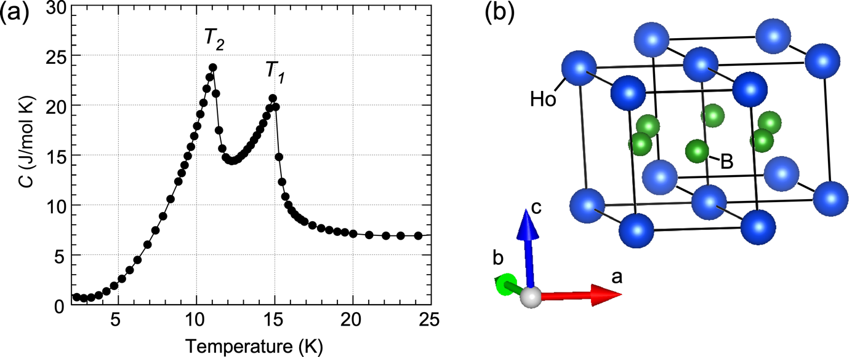

Fig. 1 (a) Temperature dependence of specific heat for a single crystal sample of HoB₂. The data was taken from Ref. [8]. (b) Crystal structure of HoB₂. Ho is placed at the Wyckoff position 1a (0, 0, 0) and B is at 2d (1/3, 2/3, 1/2) in the hexagonal space group P6/mmm.

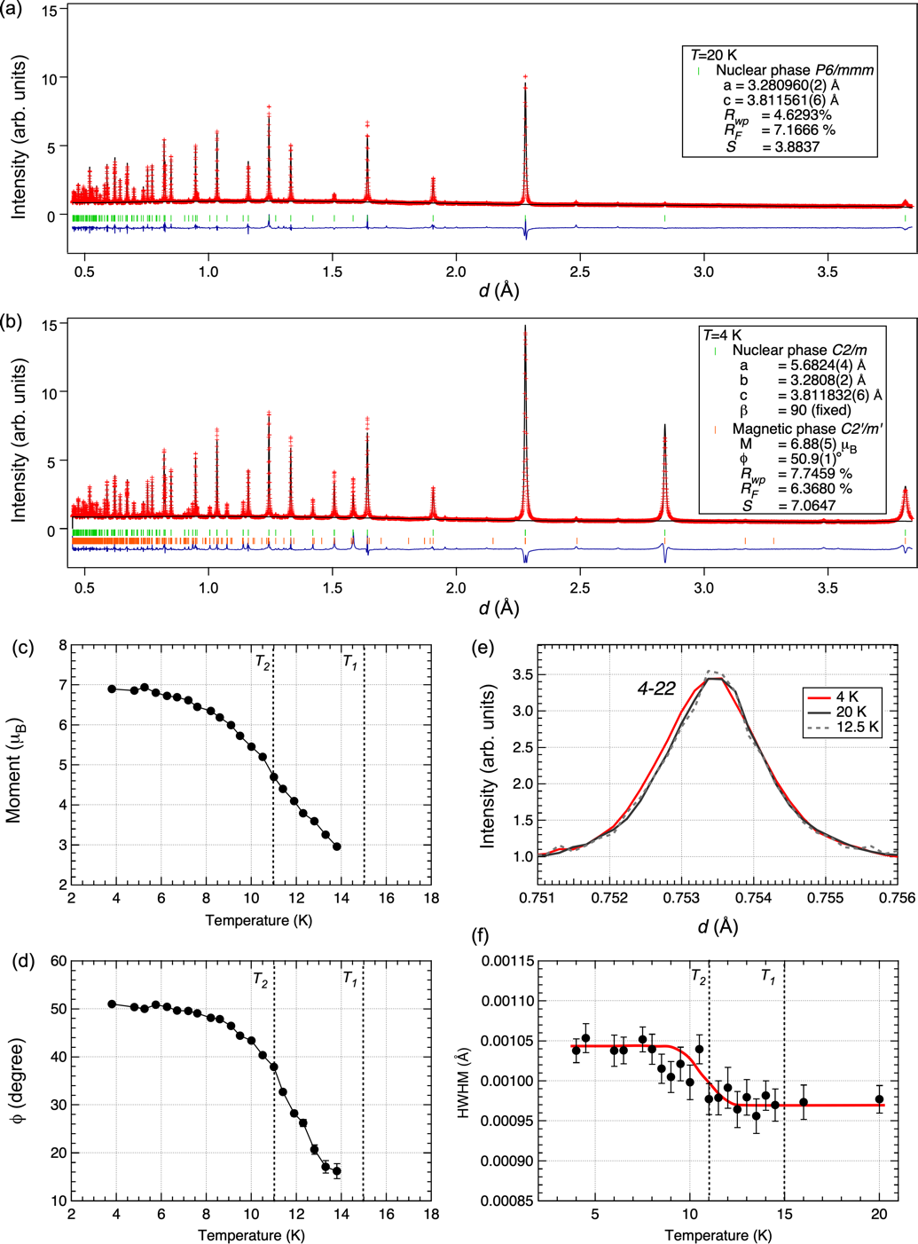

Fig. 2 Rietveld refinement results of the neutron diffraction data measured at (a)T=20 K and (b)T=4 K. The insets in (a) and (b) show the refined parameters and the reliable factors for the nuclear and magnetic phases. Temperature dependence of the refined parameters, (c) the magnetic moment of Ho³⁺ and (d)the canting angle φ from the hexagonal ab-plane. (e) Comparison in the 4-22 Bragg reflection profile among typical temperatures. (f) Temperature dependence of the half width at the half maximum for the 4-22 reflection. The solid line in (f) serves as a visual guide.

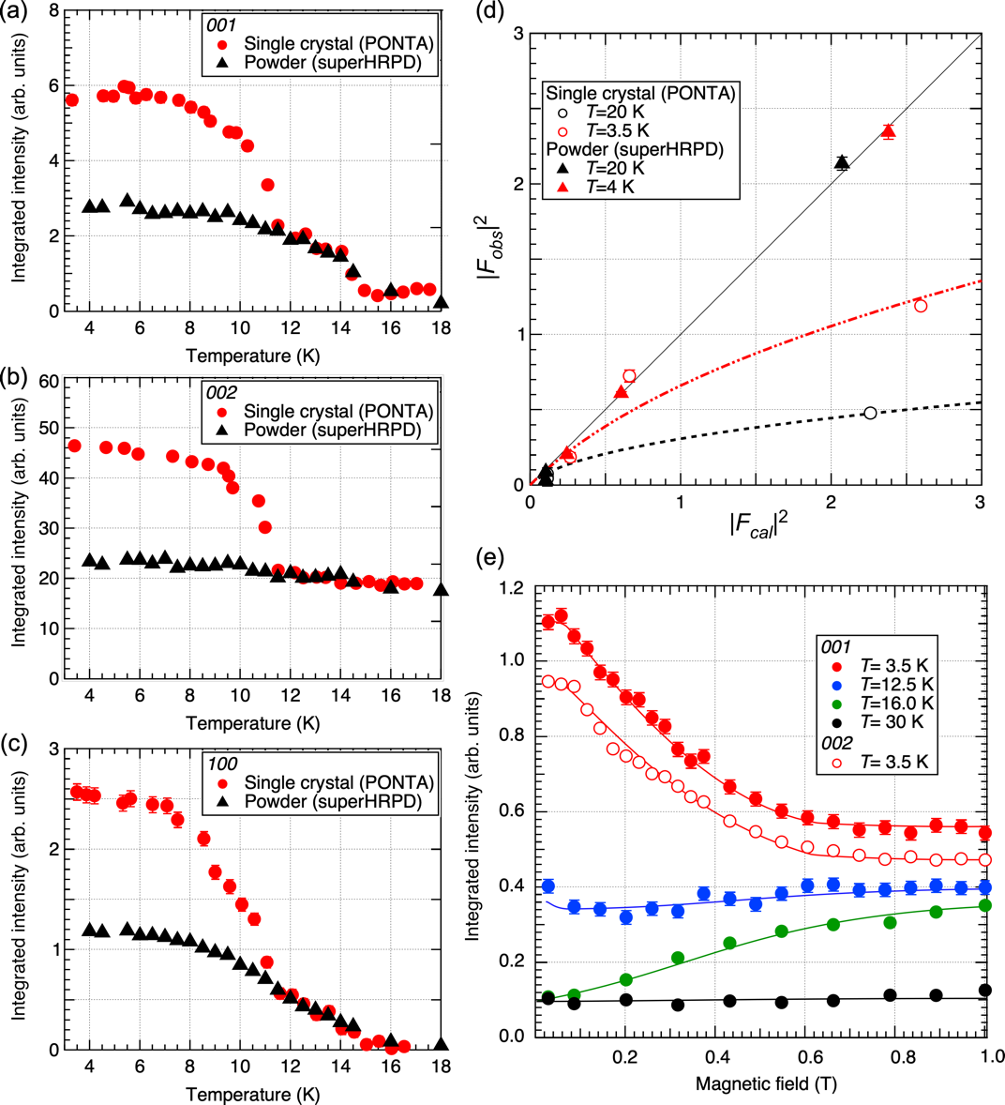

Fig. 3 Temperature dependence of the integrated intensity for (a) 001, (b) 002 and (c) 100 reflections. (d) Comparison of the square structure factors between observed and calculated values. The circle and triangle symbols denote the data collected for the single crystal and the powder samples, respectively. The solid, broken and dotted lines in (d) serve as visual guides. (e) Magnetic field dependence of the integrated intensity for 001 and 002 reflections at typical temperatures.

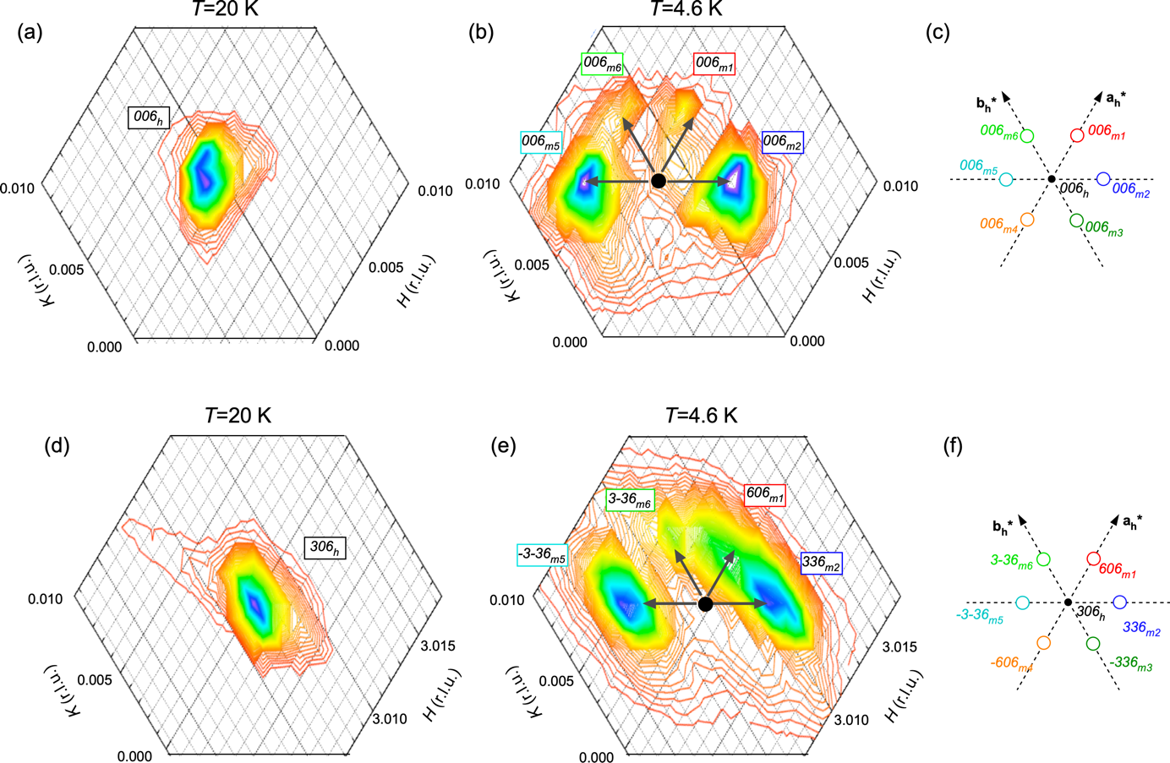
Fig. 4 Contour maps of XRD intensity around the Bragg points at the hexagonal (a) (b) 006 and (d) (e) 306 reflections in the paramagnetic phase at 20 K and the ferromagnetic phase at 4.6 K. The axes in the contour maps are based on the hexagonal setting. (c) (f) Schematics of the split peak positions with the monoclinic indices and domain numbers.

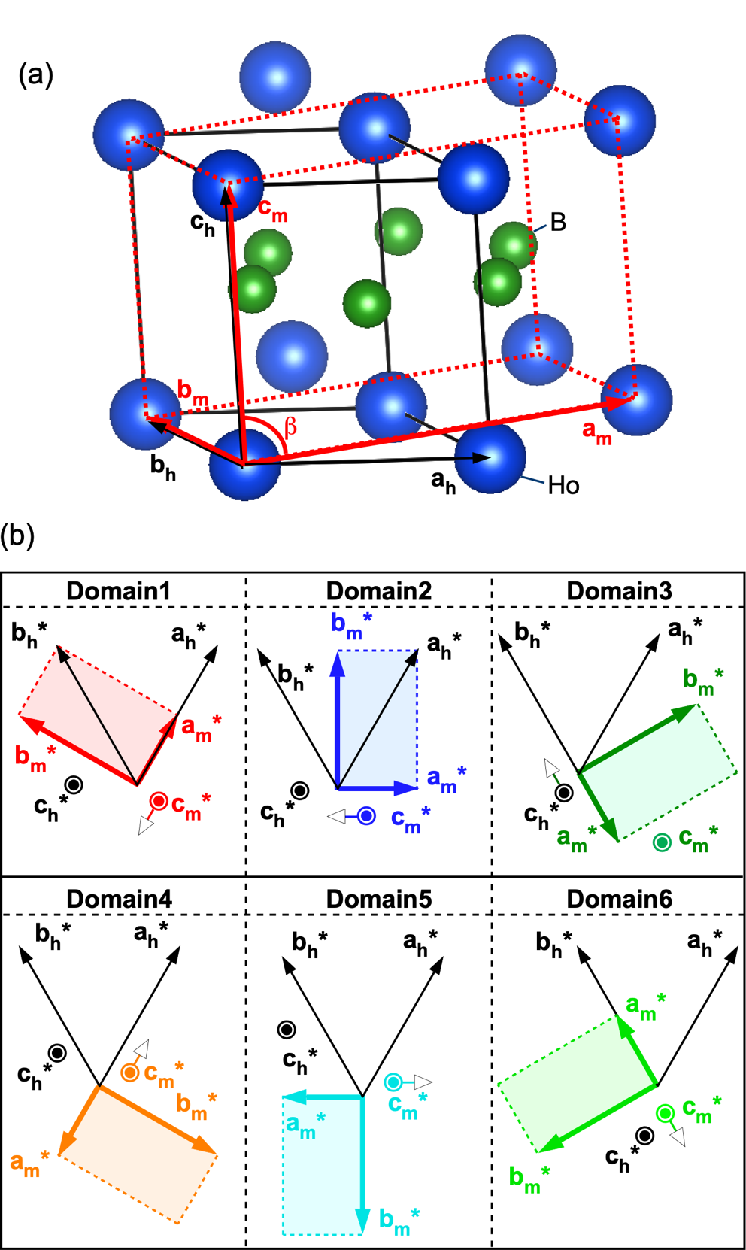
Fig. 5 (a) Illustration of the monoclinic unit cell for the low temperature ferromagnetic phase. The monoclinic unit vectors, a_{m}, b_{m} and c_{m} are described as a_{m}=2a_{h}+b_{h}, b_{m}=b_{h}, and c_{m}=c_{h,} by using the hexagonal unit vectors, a_{h,} b_{h,} and c_{h}. (b) Six possible monoclinic domains in the reciprocal lattice space. White arrows denote the tilting direction of c*-axis in each domain.

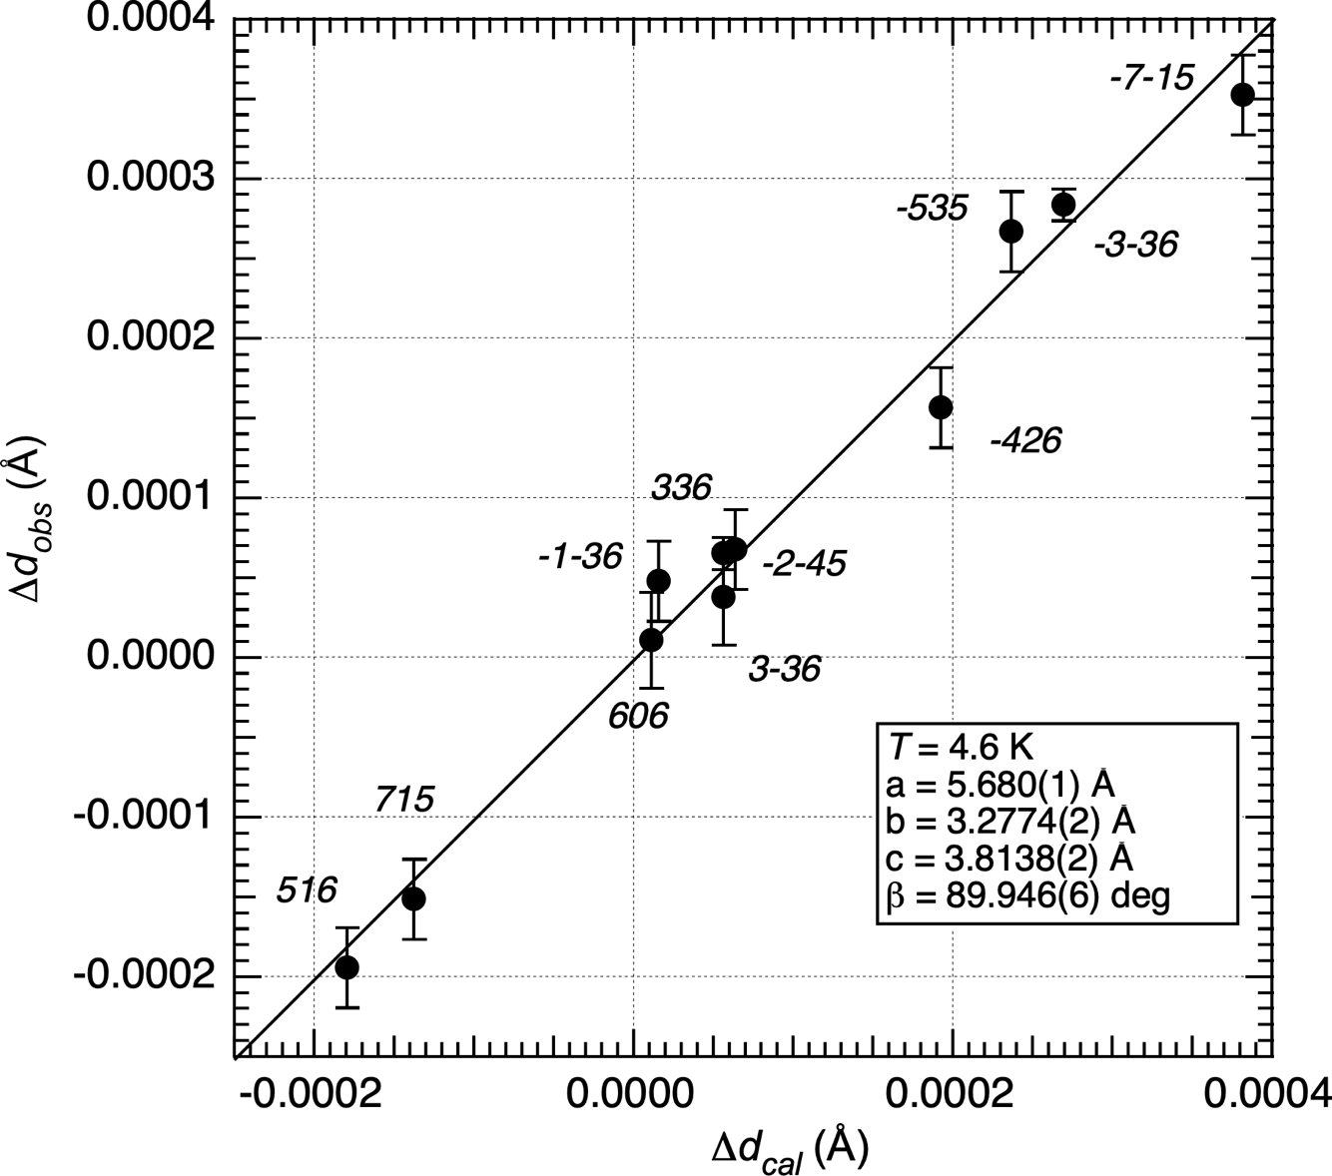

Fig. 6 Comparison in the relative changes of d-values between 20 K and 4.6 K, Δd_{obs}=d(20K) - d_{obs}(4.6K) for the observed value and Δd_{cal}=d(20K) - d_{cal}(4.6K) for the values calculated using the monoclinic distortion model of case-1 described in Fig. 8 and the main text.

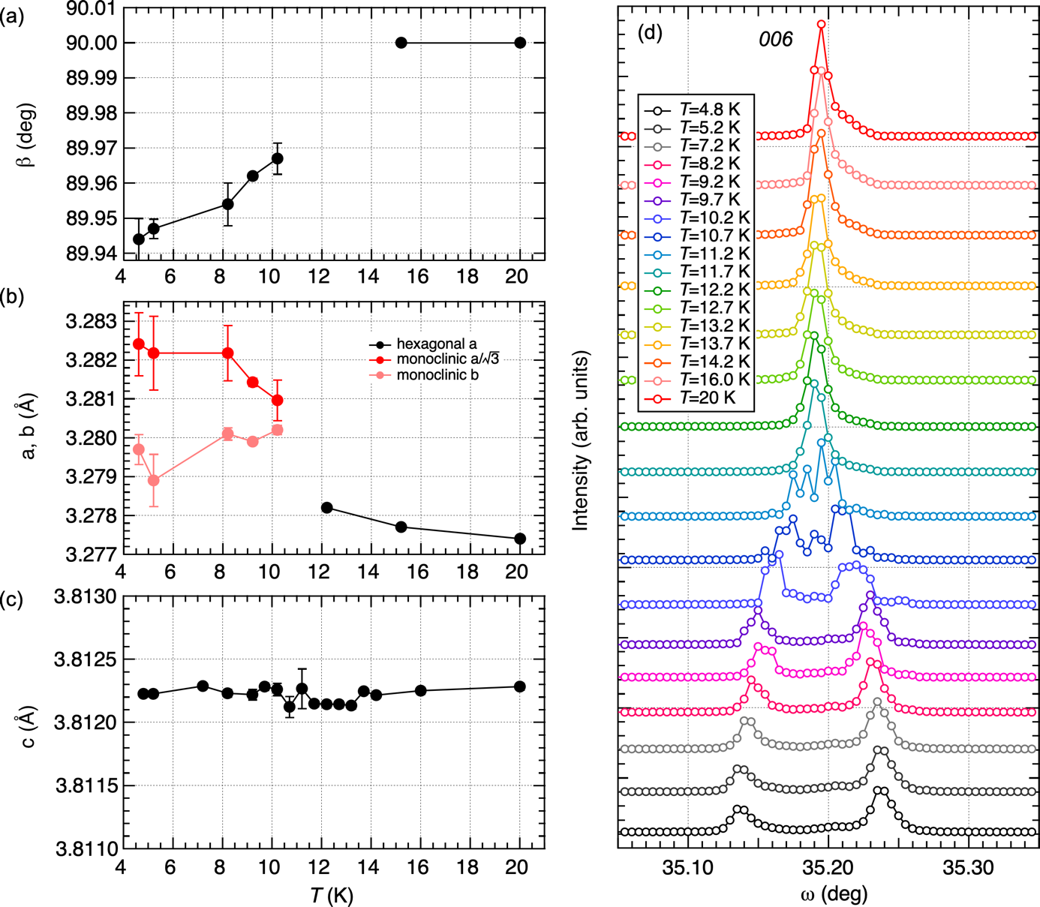
Fig. 7 Temperature variations of the lattice constants, (a)β, (b)$a/\sqrt{3}$ and b and (c)c. Temperature dependence of the ω-scan profile for the 006 reflection. The ω-scan direction is approximately parallel to the reciprocal lattice [1-10] direction in the hexagonal setting.

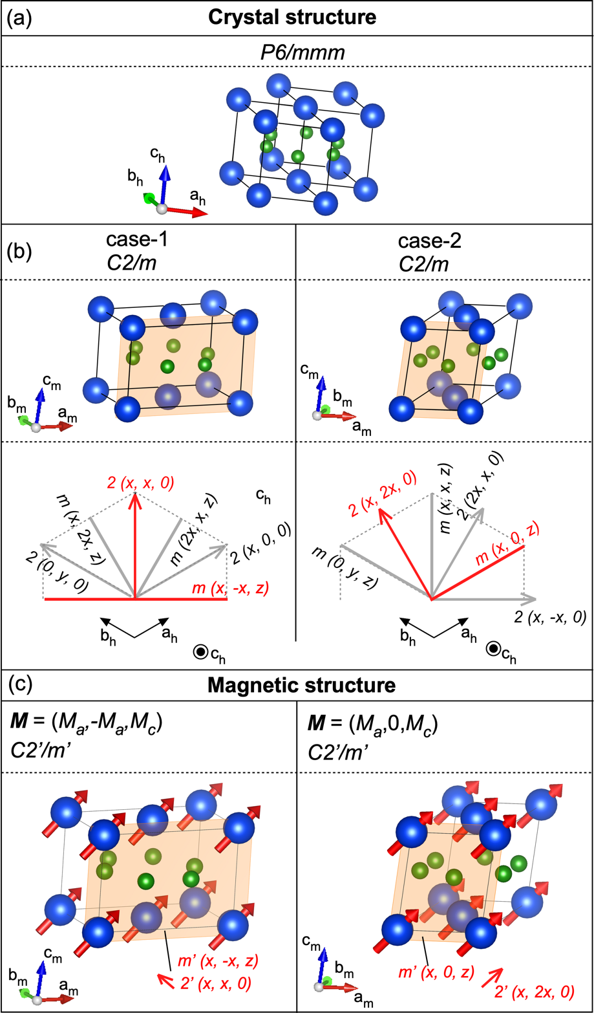

Fig. 8 Illustrations of (a) hexagonal crystal structure from two different view points, (b)two types of monoclinic distortion modes with remaining symmetry elements, mirror planes and two-fold axes. (c) Corresponding ferromagnetic structures with spins parallel to the hexagonal [1-10]-[001] plane (case-1) and the [100]-[001] plane (case-2). The shaded planes in (b) and (c) represent mirror symmetry planes.
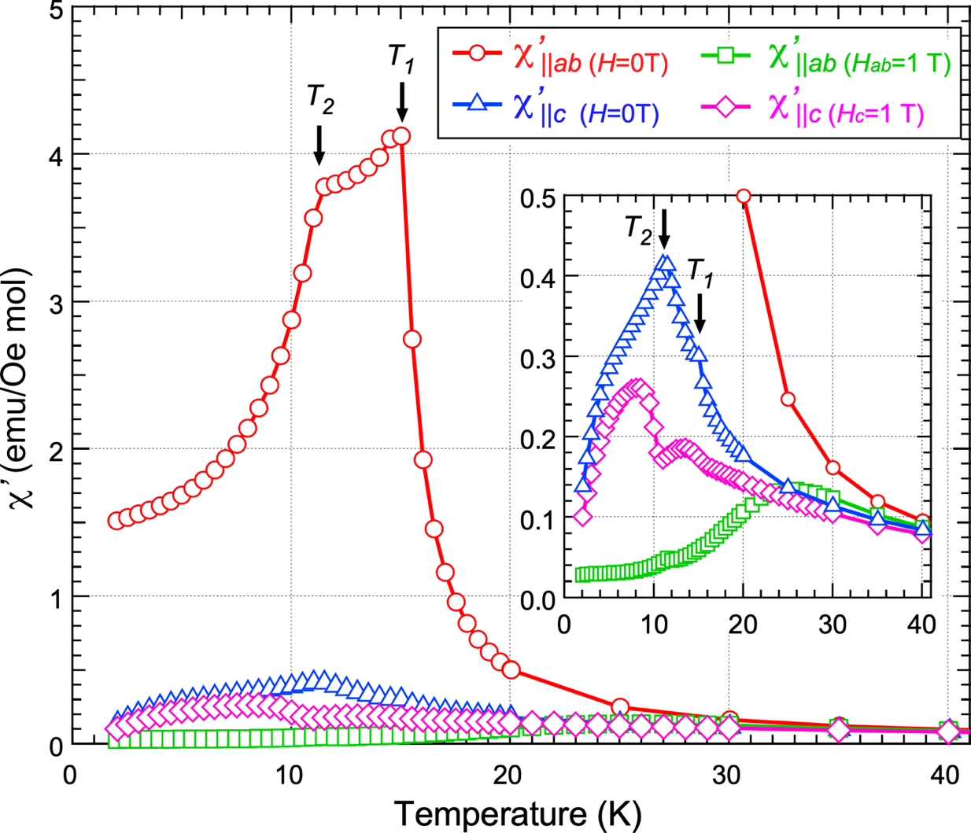
Fig. 9 Temperature dependence of AC magnetic susceptibility χ’ parallel to the hexagonal ab-plane (χ’_{||ab}) and the c-axis (χ’_{||c}) under zero field and applied external magnetic field of 1 T. The inset shows the magnification for the lower value region. A frequency of 1778 Hz was employed.
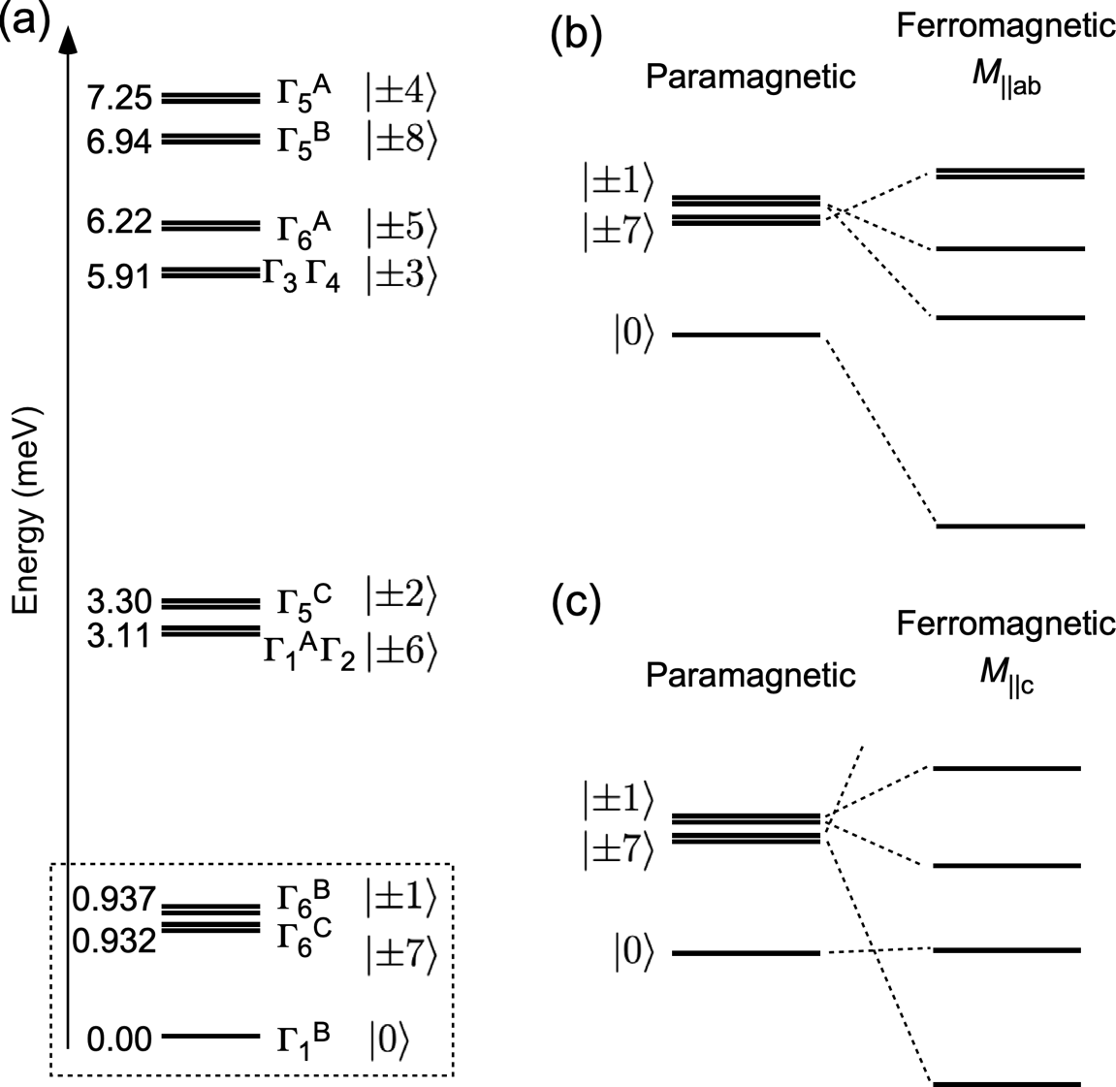

Fig. 10 (a) Schematic illustrations of the crystal electric field level scheme in HoB₂.[8] (b), (c) Drawings of the expected splitting of crystal field excitations when spins align in the hexagonal ab plane and the c axis, respectively.

