Effect of grain boundary serrations on creep deformation of Udimet-720Li superalloy
Tso-Wei Chen^{1, 2}, Bo-Chen Wu³, Yung-Chang Kang⁴, Hideyuki Murakami⁵, Yoshiaki Toda⁵, An-Chou Yeh^{1, 2, 6*}
¹ Ph.D. Program in Prospective Functional Materials Industry, National Tsing Hua University, 101, Sec. 2, Kuang-Fu Road, Hsinchu, 30044, Taiwan R.O.C.
² High Entropy Materials Center, National Tsing Hua University, 101, Sec. 2, Kuang-Fu Road, Hsinchu 300044, Taiwan, ROC
³ S-Tech Corporation, 15, Gong 1st Road, Environmental Science and Technology Park, Liouying District, Tainan. 73659, Taiwan R.O.C.
⁴ Gloria Material Technology Corporation, 10, Gong 2nd Road, Liuying District, Tainan. 73659, Taiwan R.O.C.
⁵ Research Center for Structural Materials, National Institute for Materials Science, 1-2-1 Sengen, Tsukuba 305-0047, Japan
⁶ Department of Materials Science and Engineering, National Tsing Hua University, 101, Sec. 2, Kuang-Fu Road, Hsinchu, 300044, Taiwan R.O.C.
*Corresponding Author: yehac@mx.nthu.edu.tw
Keywords: superalloys; heat treatment; serrated grain boundary; creep properties

Abstract
This article investigates grain boundary serration and its effects on high-temperature creep behavior of Udimet-720Li. Grain boundary serration is induced by controlled cooling during heat treatments, with continuous and discontinuous precipitation of γ′ phase identified as the competing mechanisms affecting serration formation. Continuous precipitation of coarse γ′ particles pin grain boundaries and leads to a slight serration termed the continuous precipitation type (type-I) boundary, while discontinuous reaction forming cellular γ/γ′ behind the mobile grain boundary causes larger serration known as the discontinuous precipitation type (Type-II) boundary. Samples with straight (STB), Type-I (SRB-1), Type-II (SRB-2) grain boundaries were produced, and creep behaviors under 700 °C/700MPa were investigated.
The SRB-1 sample exhibits a notably lower minimum creep rate at about 2.66 × 10⁻⁷ s⁻¹ and a prolonged 17% rupture lifetime compared to the STB sample. These improvements are primarily attributed to the different size distribution of γ′ precipitates, which contributes to a higher hindrance to dislocation movements. The presence of Type-I serration also hinders intergranular crack propagation, thereby extending creep life. In contrast, the SRB-2 sample exhibited a higher minimum creep rate, around 1.74*10⁻⁶ s⁻¹, and a considerable 42% reduction in rupture lifetime in contrast to the STB sample. This is attributed to the enhanced grain boundary fractions through the formation of Type-II serration in the SRB-2 sample, promoting grain boundary diffusion creep. Additionally, the presence of incoherent cellular γ/γ′ interface associated with Type-II serration facilitates void nucleation, leading to increased creep damage and a shortened creep lifetime for the SRB-2 sample.

Introduction
Ni-based superalloys widely used in the fabrication of components in aircraft engines undergo continuous advancements aimed at better temperature capability and improved mechanical properties. Udimet-720Li is a γ′-strengthened alloy renowned for its promising high-temperature properties, such as creep, fatigue, oxidation, and corrosion resistance [1-4]; it is currently utilized in the turbine disk components of aerospace engines. In polycrystalline alloy, grain boundaries play a crucial role in determining the creep properties[5-9]. The fast atomic diffusion path facilitates dislocation movement which enhance deformation rate during high temperature creep. Moreover, grain boundaries can act as source and sink for dislocation, and the accumulation of defects at these sites can initiate cracks, ultimately contributing to intergranular fracture. To control the intergranular brittleness of engineering alloy, grain boundary serration process has attracted lots of attention. Several studies have proposed that serrated grain boundary can be induced by the interaction between grain boundaries and secondary phases precipitation, such as γ′ [10, 11], δ [12], MC-carbide[13] and M₂₃C₆-carbide [14], thereby contributing to the serrated features. Additionally, by adding nano-sized inclusions during the vacuum induction melting (VIM)[15] or selective laser melting (SLM)[16, 17] processes can alter the grain boundary structure through its strong pinning effect. Furthermore, in alloys without precipitates, serrated grain boundaries can also be controlled by local grain boundary migration during hot deformation or annealing process[18, 19]. Several studies have suggested that the formation of serrated grain boundaries offers potential enhancements to creep properties in several alloys. For Waspaloy [6], the presence of serrated grain boundaries extended creep life from 1200 to 1400 hours under 705 °C/550 MPa condition. For Inconel 718 [12], the zigzag grain boundary morphology, developed by the precipitation and growth of the δ phase, can prolong the creep life by 400 hours under 650 °C/625 MPa condition. In addition, for IN600 [7], an improvement in creep life and creep strain at 815 °C/70 MPa has been confirmed due to grain boundary serration induced by the precipitation of MC-carbide.
In our previous work [20], we have identified two types of grain boundary serrations in U720Li; the first type, referred to as Type-I boundary and it involves continuous precipitation and coarsening of γ′ particles that can pin grain boundaries and result in a small degree of serration. The second type, termed Type-II boundary, can form due to discontinuous precipitation of cellular γ/γ′ behind the mobile grain boundary, and it can exhibit a more significant degree of serration than that of Type-I boundary. Notably, the presence of serrated grain boundaries, particularly the Type-II boundary, could effectively alleviate strain concentration and prevent the occurrence of intergranular cracking. Consequently, a significant enhancement in hot formability at 1000 °C due to Type-II grain boundary serration was observed. Despite these findings, the effects of the two distinct types of serrated boundaries observed in U720Li on creep properties have remained unknown to-date, especially the deformation behavior of cellular γ/γ′ formed due to discontinuous precipitation associated with Type-II serration still requires clarification. Therefore, the present study aims to investigate the effect of Type-I and Type-II grain boundary serrations on creep in U720Li.
Experimental Procedure
U720Li ingot, fabricated by vacuum induction melting (VIM furnace, Consarc corp.) followed by vacuum arc remelting process (V700, Consarc corp.), was supplied by S-Tech Corporation, Taiwan (R.O.C.). The chemical composition in weight percentage is shown in Table. 1. Homogenization treatment was conducted at 1180 °C for 16 h to minimize elemental segregation and fully dissolve the γ′ phase. For microstructural control, the homogenized ingots were cold rolled 40% and annealed at 1170 °C for 30 min. Different heat treatments were then performed to induce various grain boundary characteristics; the heat treatment profiles are shown in Fig. 1. In the straight boundary treatment, air cooling was conducted after annealing, and a solution treatment at 1105°C was performed for 2h, followed by air cooling. This specimen is referred to as STB sample. For serrated boundary treatment, slow cooling was performed after annealing at 1170°C to 1105°C, followed by air cooling. Two different cooling rates, 0.1 and 0.01°C/s, were conducted, termed SRB-1 and SRB-2 samples. Two-stage aging process at 760°C for 16h and 650°C for 24h was further employed for all specimens.

Table 1. Chemical composition of U720Li ingot (in weight percentage).
Al | B | C | Co | Cr | Mo | Ni | Ti | W | Zr
2.55 | 0.014 | 0.006 | 14.72 | 16.42 | 2.97 | 57.17 | 4.88 | 1.24 | 0.029

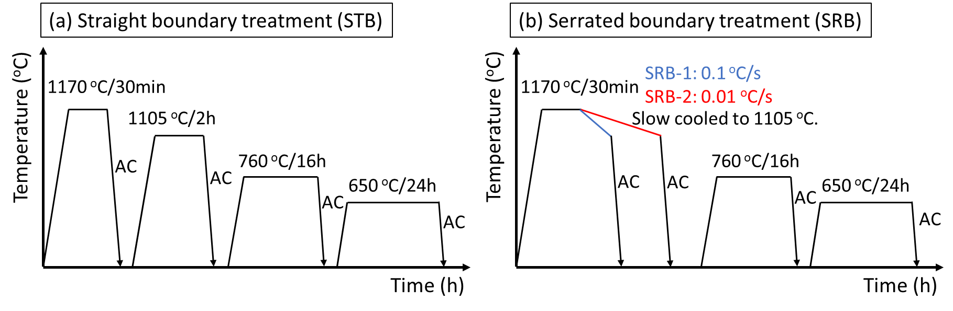
Figure 1. Heat treatment profiles in present work. (a) straight boundary treatment, (b) serrated boundary treatment
The heat-treated STB, SRB-1 and SRB-2 samples were machined into creep specimens for creep tests under a condition of 700 °C/700 MPa. The dimensions of the specimens are shown in Fig. 2. Comparisons of the results between three sets of samples can reveal the effect of grain boundary morphology on creep behavior.

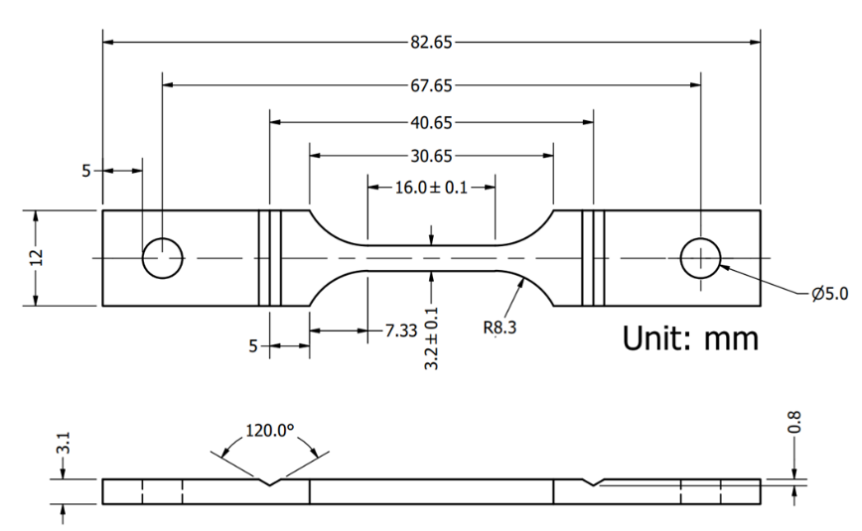
Figure 2. Dimension of test specimens for creep test.

Microstructure observations were conducted by using transmission electron microscopy (TEM, JEOL JEM-F200), scanning electron microscopy (SEM, JEOL JSM-IT100 and Zeiss Gemini 300) and optical microscopy (OM, Olympus BX-51M). Metallographic samples of STB, SRB-1 and SRB-2 specimens were prepared using grinding and polishing methods followed by electrolytic etching with 20% H₃PO₄ in C₂H₅OH at 2V for 5s. Twin jet polishing was performed in a solution of 90% C₂H₅OH + 10% HClO₄ at −20 °C/25 V to prepare TEM specimens. ImageJ software [21] was used to measure the grain sizes and quantify the size distributions of γ′ precipitates of three different specimens. Electron Backscatter Diffraction (EBSD) analysis was conducted along the normal direction to investigate internal strain distribution of the crept specimens. The analysis was carried out using a Zeiss Gemini 300 scanning electron microscope equipped with a Symmetry S2 EBSD detector and Aztec Crystal software. An acceleration voltage of 20 kV was used, and the aperture size was set to 120 μm-diameter in a high current mode with a probe current of 12 nA.

Results and Analysis
Microstructure Characterization
The microstructures of the as-heat treated U720Li are shown in Fig. 3. Both the STB and SRB-1 samples exhibit an equiaxed grain structure with random orientation (Fig. 3(a, b)). The determined average grain sizes, obtained using the line intercept method, are 418 and 427 μm for the STB and SRB-1 samples, respectively. The application of air cooling to 1105°C after annealing resulted in straight grain boundaries (Fig. 3(d)), while the controlled cooling at 0.1 °C/s led to a finely serrated morphology (Fig. 3(e)). Moreover, a further reduction in the cooling rate to 0.01 °C/s intensified the grain boundary serration, leading to a more complex-shaped grain structure. As measured on the 2D sections, the grain size of the SRB-2 sample is approximately 85 μm, notably smaller than the other two sample conditions.

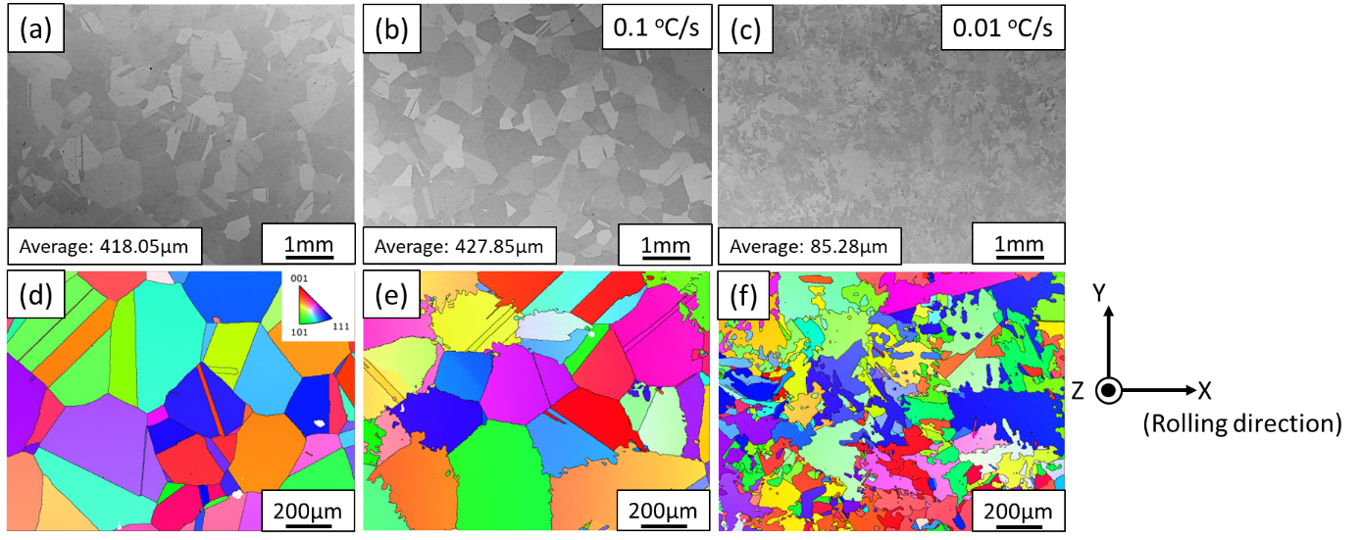
Figure 3. OM and EBSD IPF-Z images of (a, d) STB, (b, e) SRB-1 and (c, f) SRB-2 sample showing the grain structures.

Microstructural analysis reveals a trimodal size distribution of γ′ precipitates in all samples, as shown in Fig. 4. Based on the heat treatment profile (Fig. 1), coarse secondary γ′ particles persist within the microstructure prior to air cooling from 1105 °C (Fig. 4(a-c)). Subsequent air cooling and double-step ageing lead to the formation of fine secondary and tertiary γ′ located within the interspaces of coarse secondary γ′ precipitates, as shown in Fig. 4(d-f). In the STB sample, a dispersion of cuboidal γ′ is evident (Fig. 4(a)), and the grain boundary remained straight (Fig. 5(a)). On the other hand, the reduced cooling rates following annealing at 1170 °C led to the growth of γ′ particles with lower density and larger interparticle spacing. In the SRB-1 sample, cooling at a rate of 0.1°C/s resulted in the coarsening of γ′ particles(Fig. 4(b)), these particles simultaneoulsy impede the motion of grain boundaries and resulted in the formation of Type-I serrated boundary (Fig. 5(b)). Furthermore, in the SRB-2 sample cooled at 0.01°C/s, the coarse γ′ particles further enlarged, transforming into a fan structure. The wider particle interspacing enabled segments of mobile grain boundary to bend through the supersaturated matrix in-between particles. This grain boundary migration process enhanced discontinuous precipitation, leading to the formation of cellular structure and more pronounced serration of grain boundaries, identified as Type-II boundary.

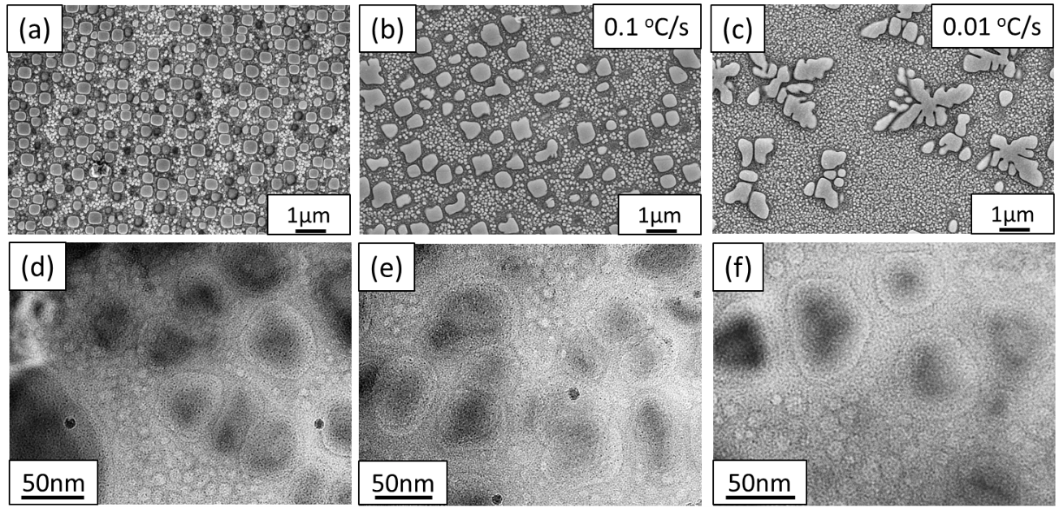
Figure 4. SEM and TEM bight field images of (a, d) STB, (b, e) SRB-1 and (c, f) SRB-2 sample showing the γ′ precipitates.
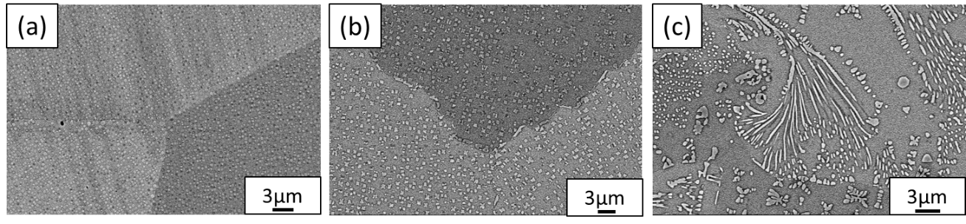
Figure 5. SEM BEI images of (a) STB, (b) SRB-1 and (c) SRB-2 sample showing the grain boundaries.

Creep Properties
Fig. 6 shows creep curves under 700 °C/700MPa for three samples. The creep lives of STB, SRB-1, and SRB-2 samples were about 545, 640, and 315 hours, respectively. Furthermore, the minimum creep rates were about 3.74*10⁻⁷, 2.66*10⁻⁷, and 1.74*10⁻⁶ s⁻¹, respectively. Although previous study suggested Type-II serration could be beneficial to the hot formability of U720Li [20], it appeared to be detrimental to creep resistance. The SRB-2 sample exhibited a significantly higher creep strain rate, which shortens the creep lifetime. Interestingly, Type-I grain boundary serration was shown to enhance the creep resistance as the SRB-1 sample performed a lower minimum creep strain rate and extended secondary and tertiary creep, which outperformed not only SRB-2 but also the STB sample.

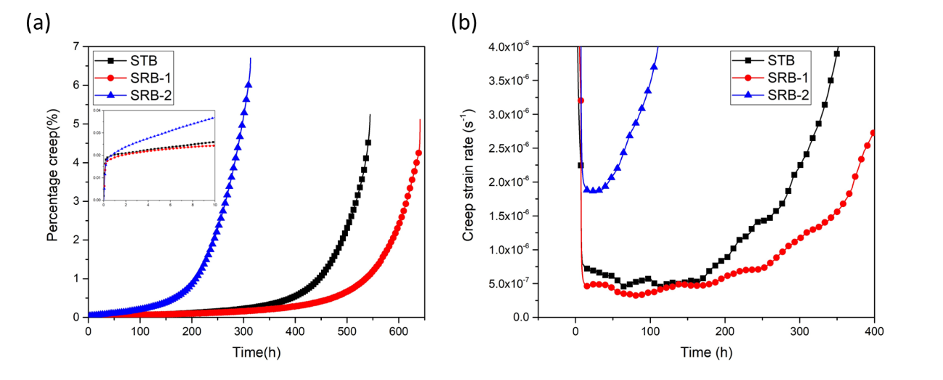
Figure 6. Creep curves showing (a) Creep strain vs. time and (b) Creep strain rate vs. time of three specimens under 700 °C/700MPa.
Longitudinal sections of crept specimens were examined to investigate the effect of serrated grain boundary on crack propagation during creep, as shown in Fig. 7. According to the kernel average misorientation (KAM) maps, in-grain slip lines were observed in all crept specimens (Fig. 7g -i), confirming the occurrence of dislocation slip under the applied testing condition. In addition, increased KAM values are often observed along grain boundaries, the strain concentration contributed to grain boundary cavitation that subsequently propagated into cracks. Intergranular fracture is the main fracture mechanism in all three specimens. In the STB and SRB-2 sample, intergranular cracks were observed continuously (Fig. 7(a, c)). In contrast, intergranular cracks observed in the SRB-1 sample often appeared in segments ahead of the main crack (Fig. 7(b)). KAM analysis also shows internal strain more localized at each protrusion along the serrated grain boundary (Fig. 7(h)). This indicates that the fine serrated morphology of Type-I boundary could provide resistance against shearing and retard the propagation of microcracks during creep test.
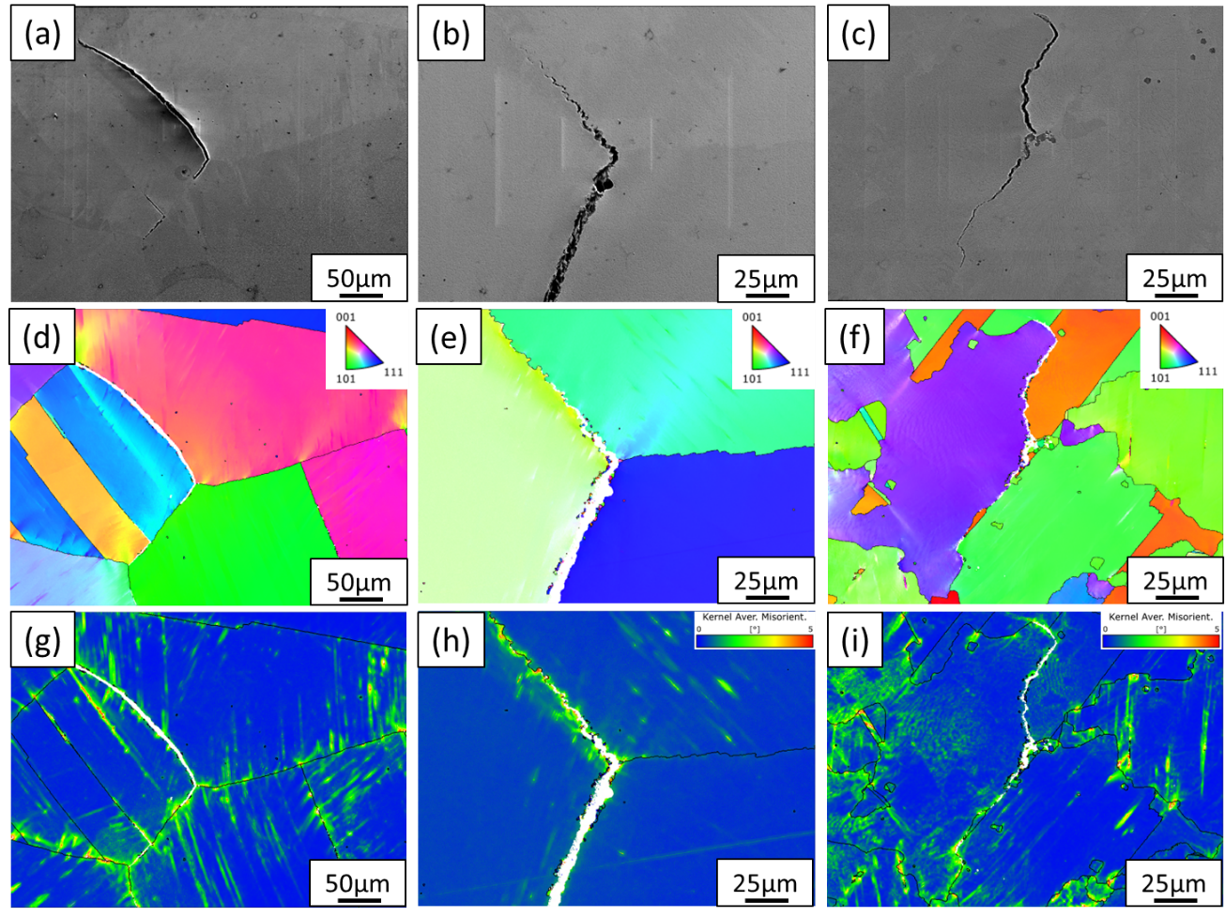
Figure 7. SEM SEI images and EBSD IPF and KAM maps showing the longitudinal sections of crept samples. (a, d, g) STB, (b, e, h) SRB-1 and (c, f, i) SRB-2 sample.

Discussions
In this study, different type of grain boundary serration and its effect on creep behavior in U720Li alloy was investigated. Grain boundary serration can be induced in U720Li by controlled cooling at 0.1 °C/s and below to 1105°C from temperature above γ′ solvus. Two important conditions are necessary for the serration to proceed; first is the mobile grain boundaries, second-phase particles such as carbides or γ′ along the grain boundaries may impede grain boundary serration. Secondly, supersaturated matrix is required, as it provides the driving force for the precipitation of γ′ phase to interact with the mobile grain boundary. Therefore, the serration process primarily occurs at temperature close to the γ′ solvus cooling from supersolvus temperature. Continuous and discontinuous precipitation of γ′ phase plays significant roles in different forms of grain boundary serration, causing Type-I and Type-II serration, respectively. Type-I boundary is attributed to the Zener drag effect of the coarse γ′ particles formed during slow cooling, which pin the mobile grain boundary and lead to the small serration of grain boundary. Type-II boundaries are formed due to the discontinuous precipitation occurring behind the mobile grain boundary. The migration of grain boundaries relaxes the metastable state of supersaturated matrix, accompanied by cellular precipitation leading to large boundary serration.
The nucleation and growth of γ′ phase is strongly affected by the cooling rate. As a lower cooling rate contributes to a smaller undercooling and supersaturation, the nucleation rate of γ′ is reduced. Coarse precipitates with low number density and high particle interspacing are produced. This provides more space for grain boundaries to migrate freely and allows grain boundaries to pass through more supersaturated matrix. Therefore, discontinuous reaction is enhanced with reducing cooling rate, resulting in higher fractions of cellular structure and grain boundaries. Consequently, this process contributes to the observed refinement in grain size of SRB-2 specimen as measured from the 2D sections.
According to the creep test results (Fig. 6), all specimens exhibited a short primary creep regime in the first 10 h before the transition into secondary creep stage. This phenomenon is common in nickel-based superalloys with a high volume fraction of γ′ precipitates[22], dislocations are generated from sources within the γ matrix, subsequently undergoing multiplication during glide and eventually being deposited onto the γ/γ′ interfaces. Dislocation movement is hindered, reducing the creep deformation and leading to a rapid transition to secondary creep.
In the present study, the SRB-2 sample had a notably high minimum creep rate and a shortened creep life, indicating the detrimental effect of Type-II boundary on creep properties. Grain boundaries and γ′ distribution might play important roles in affecting creep strain rate. At temperatures below 0.7 T_{m}, creep can be controlled by the diffusion of vacancies along grain boundaries[23], thereby affecting the minimum creep rate during the early creep stage. EBSD results show a much finer 2D-grain size in the SRB-2 sample comparing with other two samples (Fig. 3), the higher fraction of grain boundaries offers more pathways for grain boundary diffusion. In addition, U720Li contains several grain boundary strengtheners (e.g., C, B, and Zr), which can decrease grain boundary diffusivity and enhance creep strength[24-26]. However, the concentrations of these strengtheners along the grain boundaries become diluted due to the higher fraction of grain boundary in the SRB-2 sample. Consequently, the creep strain rate of the SRB-2 sample is effectively enhanced. On the other hand, the SRB-2 sample exhibits a larger interspacing of coarse secondary γ′ particles, which allow dislocations to bypass more easily[27, 28], this could lead to a higher creep strain rate. Previous study has also pointed out that the overgrowth of γ′ into a flowery or cellular structure results in the loss of coherency with the γ matrix to form a smoother interface[29]. The strengthening stress caused by the coherency strain at the γ/γ′ interface disappears, therefore allowing dislocations to shear into the γ′ phase more easily [30]. This phenomenon further contributes to the enhanced creep strain rate of SRB-2 sample.
Besides, by comparing the STB and SRB-1 sample with identical grain size, the SRB-1 sample performed a relatively low minimum creep rate. Since the grain size of the sample is as large as 400 μm, the grain boundaries may have no significant effect on the creep strain rate, while the size distribution of γ′ phase is the main reason for the different minimum creep rates. A common formulation (eq.1) can be used to describe the minimum creep rate for particle-strengthened alloys[31]:
$$\dot{ε}=AD_{eff}{\left[\frac{γ_{SFE}}{Gb}\right]}^{3}{\left[\frac{σ-σ_{p}}{E}\right]}^{4}$$ | (1)

Where $\dot{ε}$ is the minimum creep rate, A is a material dependent parameter, D_{eff} is the effective
diffusion coefficient, $γ_{SFE}$ is the stacking fault energy of the matrix, b is the burgers vector, σ is the applied stress, σ_{p} is the resistance stress caused by particle strengthening, with G and E the shear and Young′s modulus of the matrix phase at the creep temperature, respectively. According to this equation, the major factor affecting the minimum creep rate is the term σ_{p}, which is contributed by the strengthening contributions of γ′ precipitates.
The strengthening contributions of γ′ precipitates with multimodal distribution are calculated using the model proposed by Galindo-Nava et al.[32]:

$$σ_{p}=τ_{p}×M$$ | (2)

$$τ_{p}=w_{p}\frac{3Gb}{2L_{p}}+\frac{γ_{APB}}{2b}(w_{s}\frac{l_{s}}{{(Λ}_{s}+2r_{s})}+w_{t}\frac{l_{t}}{{(Λ}_{t}+2r_{t})})$$ | (3)

Where τ_{p} is the critical resolved shear stress, M is the Taylor orientation factor and it is equal to 3.06[33], G is the shear modulus of the matrix (~67 GPa at 1000 °C calculated using simple pair-wise mixture model [34]), b is Burgers vector (~0.257nm calculated from Thermo-Calc software [35]), w_{c}, w_{s} and w_{t} is the normalised particle number of coarse, secondary and tertiary γ′, respectively, (w_{c} + w_{s} + w_{t} = 1), γ_{APB} is the antiphase boundary energy (~0.279 J/m² at 700 °C[32]), L_{i} is the mean particle spacing and r_{i} is the average radius of γ′ precipitates. l_{i} is the length of the dislocation cutting the ordered particle and Λ_{i} is the effective length of the dislocation driving particle cutting. The expressions of l_{i} and Λ_{i} are as follows:
$$l_{i}=\left\{\begin{aligned}2r_{i} if r_{i}<\frac{Gb^{2}}{2γ_{APB}}\left(weak pair-coupling\right) \\ 2{\left({r_{i}}^{2}-\left(r_{i}-\frac{Gb^{2}}{2γ_{APB}}\right)\right)}^{1/2} if r_{i}>\frac{Gb^{2}}{2γ_{APB}} \left(strong pair-coupling\right)\end{aligned}\right.$$ | (4)
$$Λ_{i}=max\left({\left(\frac{Gb^{2}}{2γ_{APB}r_{i}}\right)}^{1/2}L_{i}, L_{i}-l_{i}\right)$$ | (5)
In the present study, the size distribution of γ′ precipitates in the STB and SRB-1 samples were measured through analysis of SEM and TEM images, as shown in Fig. 4 . The coarse γ′ particles are measured from SEM images and the fine secondary and tertiary γ′ particles are measured from TEM images, at least five micrographs and 200 particles were measured to acquire reliable data. The quantified data and the calculated strengthening stress are shown in Table. 2. The SRB-1 sample exhibited a lower fraction of coarse γ′ and a higher proportion of fine secondary and tertiary γ′ precipitates, leading to a higher precipitation strengthening stress. This provides SRB-1 sample with higher creep resistance and results in a lower creep rate. The strain rate ratio between the SRB-1 and STB sample calculated from equation (1) is 0.66, which is in good agreement with the actual creep data at about 0.7 and confirms the major contribution of precipitation strengthening on the minimum creep rate.
Table. 2. Average size, normalized particle number of γ′ phase, and the calculated precipitation strengthening stress of different heat treatments.
 | r_{c} (nm) | w_{c} | r_{s} (nm) | w_{s} | r_{t} (nm) | w_{t} | τ_{p} (MPa) | σ_{p} (MPa)
STB | 176.6 | 0.0066 | 31.3 | 0.1112 | 6.2 | 0.8822 | 66.34 | 199.03
SRB-1 | 247.9 | 0.0018 | 26.6 | 0.1654 | 5.9 | 0.8328 | 82.84 | 248.52

The extension of tertiary creep region in SRB-1 sample is attributed to the hindrance effect caused by serrated grain boundary on crack propagation. These boundaries are observed to serve as deflectors of cracks, impeding the connection of microcracks. Consequently, the acceleration in creep strain rate during the later stages of creep is delayed, leading to a prolonged tertiary creep region. However, with respect to SRB-2 sample, the formation of the Type-II boundary is associated with the formation of incoherent cellular γ/γ′ structures. Previous studies have pointed out that the existence of incoherent coarse γ′ may facilitate dislocations accumulation and void nucleation at the interface between γ and γ′ phase [36, 37]. These incoherent cellular γ/γ′ interfaces were potential sites to form creep damage during the later stages of creep (Fig. 7(f)), which accelerated creep failure. Furthermore, the finer 2D-grain size observed in the SRB-2 sample provides higher fractions of grain boundary, which also enhances cavity nucleation and crack propagation during the later stages of creep[38].
This study confirms the enhancement of creep resistance by minor adjustments on heat treatment to induce grain boundary serration. Type-I serration could decrease the creep strain rate and prolong the creep life of U720Li alloy. However, the presence of Type-II boundary could induce more creep damage and result in a decrease in creep resistance.

Conclusions
This study investigated the influence of grain boundary serration on the high-temperature creep behavior of an advanced superalloy. The key findings of the study are as follows:
- Air cooling from supersolvus annealing led to the formation of straight boundaries. By controlling cooling conditions, two distinct grain boundary serrations, Type-I and Type-II boundary, were induced, each impacting the creep properties differently.
- The SRB-1 sample, characterized by Type-I serration due to continuous precipitation of γ′, demonstrated enhanced creep resistance. It exhibited a reduced minimum creep rate and prolonged rupture lifetime by 17% compared to the sample with straight boundaries (STB sample) during creep tests at 700°C/700MPa. This enhancement was primarily attributed to two factors: the higher fractions of fine secondary and tertiary γ′, providing higher resistance to dislocation movements, and the presence of Type-I serration, which effectively deflected crack propagation.
- In contrast, the SRB-2 sample exhibited Type-II boundaries due to discontinuous precipitation of γ′, resulting in a 42% decrease in rupture life compared to the STB sample. The enhanced grain boundary fraction associated with Type-II serration promoted grain boundary diffusion creep, while the incoherent cellular γ/γ′ interface accelerated void nucleation, causing increased creep damage and a shortened creep life.

Acknowledgments
Authors would like to acknowledge funding support from Gloria Material Technology Corporation and S-Tech Corporation. This work was financially supported by the “High Entropy Materials Center” from The Featured Areas Research Center Program within the framework of the Higher Education Sprout Project by the Ministry of Education (MOE) in Taiwan. This work was also supported by National Science and Technology Council (NSTC) in Taiwan under Grant NSTC 112-2927-I-007-504, NSTC 110-2221-E-007-020-MY3, NSTC 112-2224-E-007-003. Tso-Wei Chen would like to thank NIMS for the provision of the international collaborative graduate program (ICGP) scholarship.
References
[1] W.J. Evans, J.P. Jones, S. Williams, The interactions between fatigue, creep and environmental damage in Ti 6246 and Udimet 720Li, International Journal of Fatigue, 27 (2005) 1473-1484.
[2] M. Marchionni, G.A. Osinkolu, G. Onofrio, High temperature low cycle fatigue behaviour of UDIMET 720 Li superalloy, International Journal of Fatigue, 24 (2002) 1261-1267.
[3] F. Sczerzenie, G. Maurer, Development of Udimet 720 for High Strength Disk Applications, Superalloys 1984, (1984).
[4] J.H. Chen, P.M. Rogers, J.A. Little, Oxidation behavior of several chromia-forming commercial nickel-base superalloys, Oxidation of Metals, 47 (1997) 381-410.
[5] Y. Wang, D. Wang, G. Zhang, L. Lou, J. Zhang, J. Zhang, Characterization of Tilt and Twist Low Angle Grain Boundaries and Their Effects on Intermediate‐Temperature Creep Deformation Behaviour, in: Superalloys 2016: Proceedings of the 13th Intenational Symposium of Superalloys, Wiley Online Library, 2016, pp. 757-762.
[6] A. Wisniewski, J. Beddoes, Influence of grain-boundary morphology on creep of a wrought Ni-base superalloy, Materials Science and Engineering: A, 510-511 (2009) 266-272.
[7] Y.T. Tang, A.J. Wilkinson, R.C. Reed, Grain Boundary Serration in Nickel-Based Superalloy Inconel 600: Generation and Effects on Mechanical Behavior, Metallurgical and Materials Transactions A, 49 (2018) 4324-4342.
[8] J.-L. Lee, P.-T. Wang, K.-C. Lo, P.-K. Shen, N.-T. Tsou, K. Kakehi, H. Murakami, C.-W. Tsai, S. Gorsse, A.-C. Yeh, Effect of serrated grain boundary on tensile and creep properties of a precipitation strengthened high entropy alloy, Science and Technology of Advanced Materials, 24 (2023) 2158043.
[9] S. Wu, H. Song, H. Peng, P. Hodgson, H. Wang, X. Wu, Y. Zhu, M. Lam, A. Huang, A microstructure-based creep model for additively manufactured nickel-based superalloys, Acta Materialia, 224 (2022) 117528.
[10] H.L. Danflou, M. Marty, A. Walder, Formation of serrated grain boundaries and their effect on the mechanical properties in a P/M nickel base superalloy, Superalloys, (1992) 63-72.
[11] B. Alabbad, L. Li, S. Tin, Controlling the grain boundary morphology and secondary γ′ precipitate size distribution in Ni-base superalloys, Journal of Alloys and Compounds, 775 (2019) 931-941.
[12] A.-C. Yeh, K.-W. Lu, C.-M. Kuo, H.-Y. Bor, C.-N. Wei, Effect of serrated grain boundaries on the creep property of Inconel 718 superalloy, Materials Science and Engineering: A, 530 (2011) 525-529.
[13] Y.T. Tang, P. Karamched, J. Liu, J.C. Haley, R.C. Reed, A.J. Wilkinson, Grain boundary serration in nickel alloy inconel 600: Quantification and mechanisms, Acta Materialia, 181 (2019) 352-366.
[14] H.U. Hong, I.S. Kim, B.G. Choi, M.Y. Kim, C.Y. Jo, The effect of grain boundary serration on creep resistance in a wrought nickel-based superalloy, Materials Science and Engineering: A, 517 (2009) 125-131.
[15] H. Sakasegawa, S. Ohtsuka, S. Ukai, H. Tanigawa, M. Fujiwara, H. Ogiwara, A. Kohyama, Microstructural evolution during creep of 9Cr-ODS steels, Fusion Engineering and Design, 81 (2006) 1013-1018.
[16] I.T. Ho, Y.-T. Chen, A.-C. Yeh, C.-P. Chen, K.-K. Jen, Microstructure evolution induced by inoculants during the selective laser melting of IN718, Additive Manufacturing, 21 (2018) 465-471.
[17] I.T. Ho, T.-H. Hsu, Y.-J. Chang, C.-W. Li, K.-C. Chang, S. Tin, K. Kakehi, A.-C. Yeh, Effects of CoAl2O4 inoculants on microstructure and mechanical properties of IN718 processed by selective laser melting, Additive Manufacturing, 35 (2020) 101328.
[18] H.-W. Son, J.-W. Lee, S.-K. Hyun, Mechanism of grain boundary serration during hot deformation of AZ31 alloy: Role of grain boundary dislocations and grain boundary sliding, International Journal of Plasticity, 125 (2020) 118-132.
[19] J.W. Lee, M. Terner, H.U. Hong, S.H. Na, J.B. Seol, J.H. Jang, T.H. Lee, A new observation of strain-induced grain boundary serration and its underlying mechanism in a Ni–20Cr binary model alloy, Materials Characterization, 135 (2018) 146-153.
[20] T.-W. Chen, P.-T. Wang, Y.-C. Kang, B.-C. Wu, N.-T. Tsou, U. Glatzel, S. Gorsse, A.-C. Yeh, Grain boundary serration tuning and its effect on hot workability of a wrought superalloy, Journal of Alloys and Compounds, 960 (2023) 170620.
[21] J. Schindelin, I. Arganda-Carreras, E. Frise, V. Kaynig, M. Longair, T. Pietzsch, S. Preibisch, C. Rueden, S. Saalfeld, B. Schmid, J.-Y. Tinevez, D.J. White, V. Hartenstein, K. Eliceiri, P. Tomancak, A. Cardona, Fiji: an open-source platform for biological-image analysis, Nature Methods, 9 (2012) 676-682.
[22] B.F. Dyson, M. McLean, Creep Deformation of Engineering Alloys: Developments from Physical Modelling, ISIJ International, 30 (1990) 802-811.
[23] G.E. Dieter, D. Bacon, Mechanical metallurgy, McGraw-hill New York, 1976.
[24] T.J. Garosshen, T.D. Tillman, G.P. McCarthy, Effects of B, C, and Zr on the structure and properties of a P/M nickel base superalloy, Metallurgical Transactions A, 18 (1987) 69-77.
[25] K. Laha, J. Kyono, T. Sasaki, S. Kishimoto, N. Shinya, Improved creep strength and creep ductility of type 347 austenitic stainless steel through the self-healing effect of boron for creep cavitation, Metallurgical and Materials Transactions A, 36 (2005) 399-409.
[26] K. Laha, J. Kyono, N. Shinya, An advanced creep cavitation resistance Cu-containing 18Cr–12Ni–Nb austenitic stainless steel, Scripta Materialia, 56 (2007) 915-918.
[27] D. Locq, P. Caron, S. Raujol, F. Pettinari-Sturmel, A. Coujou, N. Clément, On the Role of Tertiary γ' Precipitates in the Creep Behaviour at 700C of a PM Disk Superalloy, Proceedings of the International Symposium on Superalloys, (2004).
[28] L. Xu, C.Q. Sun, C.Y. Cui, C. Zhang, Effects of microstructure on the creep properties of a new Ni-Co base superalloy, Materials Science and Engineering: A, 678 (2016) 110-115.
[29] T. Grosdidier, A. Hazotte, A. Simon, Precipitation and dissolution processes in γ/γ′ single crystal nickel-based superalloys, Materials Science and Engineering: A, 256 (1998) 183-196.
[30] L. Shui, T. Jin, S. Tian, Z. Hu, Influence of precipitate morphology on tensile creep of a single crystal nickel-base superalloy, Materials Science and Engineering: A, 454-455 (2007) 461-466.
[31] X.S. Xie, G.L. Chen, P.J. McHugh, J.K. Tien, Including stacking fault energy into the resisting stress model for creep of particle strengthened alloys, Scripta Metallurgica, 16 (1982) 483-488.
[32] E.I. Galindo-Nava, L.D. Connor, C.M.F. Rae, On the prediction of the yield stress of unimodal and multimodal γ’ Nickel-base superalloys, Acta Materialia, 98 (2015) 377-390.
[33] T.H. Courtney, Mechanical behavior of materials, Waveland Press, 2005.
[34] Z.L. Guo, N. Saunders, P. Miodownik, J.P. Schillé, Modeling Material Properties of Lead-Free Solder Alloys, Journal of Electronic Materials, 37 (2008) 23-31.
[35] J.O. Andersson, T. Helander, L. Höglund, P. Shi, B. Sundman, Thermo-Calc & DICTRA, computational tools for materials science, Calphad, 26 (2002) 273-312.
[36] P.S.M. Jena, S. Tripathy, B. Mahato, N. Paulose, D.C. Fernando, J.K. Sahu, Role of void nucleation at primary-γ'/γ interface on strain softening of nickel base superalloy 720Li, Journal of Alloys and Compounds, 958 (2023) 170388.
[37] P.S.M. Jena, S.K. Pradhan, S. Tripathy, B. Mahato, C. Fernando, N. Paulose, J.K. Sahu, Evolution of geometrically necessary dislocation at the γ-γ′ interface and its effect on tensile deformation behaviour of disk super alloy, Materials Science and Engineering: A, 807 (2021) 140855.
[38] A.J. Perry, Cavitation in creep, Journal of Materials Science, 9 (1974) 1016-1039.

